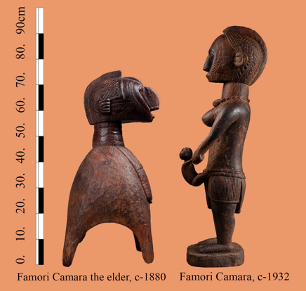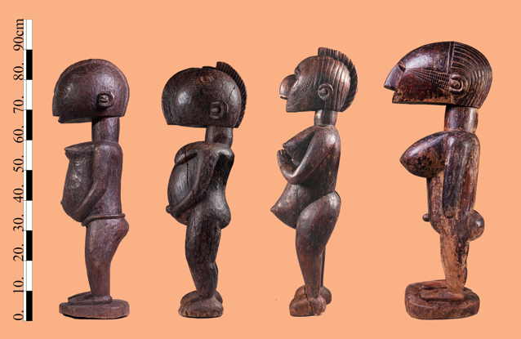**Amani Famori Camara**

**Amadi Famori Camara born in Faraba Guinea in 1885.**

Four statues with outstanding abstract characteristics emerged out of the Katako hoard, they were later joined by two additional exceptional pieces from Henriette Conte’s estate, A close examination revealed that all six bear characteristics of a unique master hand, a mature artist with a personal vocabulary, commanding in addition a technique to mach. five were dated by ( i.r.s spectrography ) to ~ 1930-50 , an aged small Nimba of extreme condense wood was dated to 1880.

they were all executed from dense and heavy African teak, nearly all in the same height of 80-90cm, all were immediately recognized by the Baga elders, as well as by master Bangoura and attributed to master Famori Camara, a renowned Baga sculptor participating in the Faraba creative hub prior to the Guinean independence. Master Bangoura proudly aligned himself and his work to Camara’s and proclaimed to be one of his descendants.

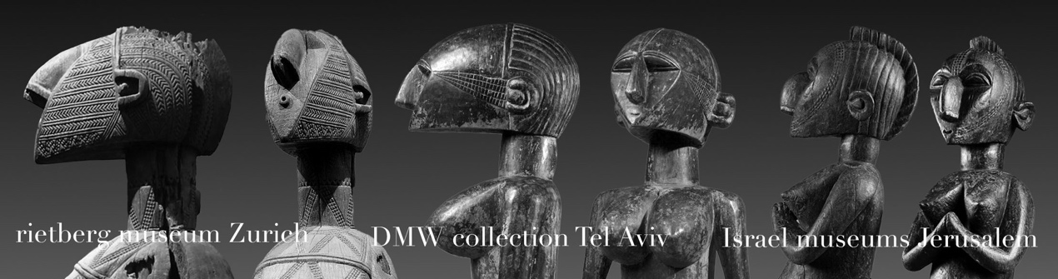analysis of Camara’s work clearly demonstrate his language. An ability to reinterpret and modernize the traditional Baga cannon, using semi abstract volumes and a mirage of geometric patterns to depict age old forms.

He developed a language in which the traditional ornate vocabulary was gradually reduced to a collage of primary volumes, and the orthodox Nimba’s “Fulani” face decoration was depicted by using rigorous geometric straight lines. the ear was reduced to a circle surrounded by a concave half moon, all the Baga informants described this feature as “Famori’s personal mark”, an observation further supported by comparing the ear design of additional works similar to Camara’s manner which are currently in western museums, such as the Rietberg museum, Yale African art gallery and Berg en dal Netherlands. Works Which 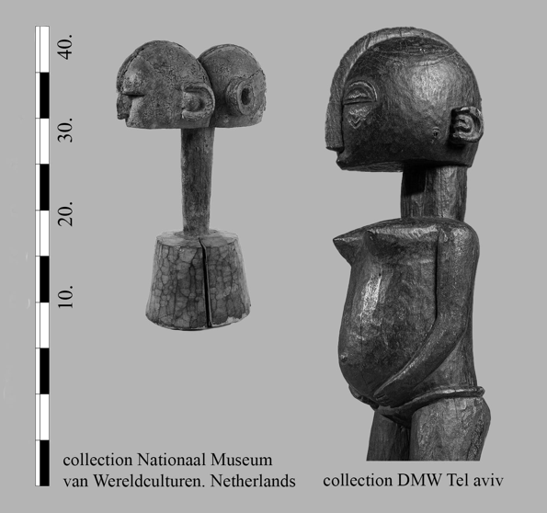therefore might be claimed to be of Famori Camara’s oeuvre.

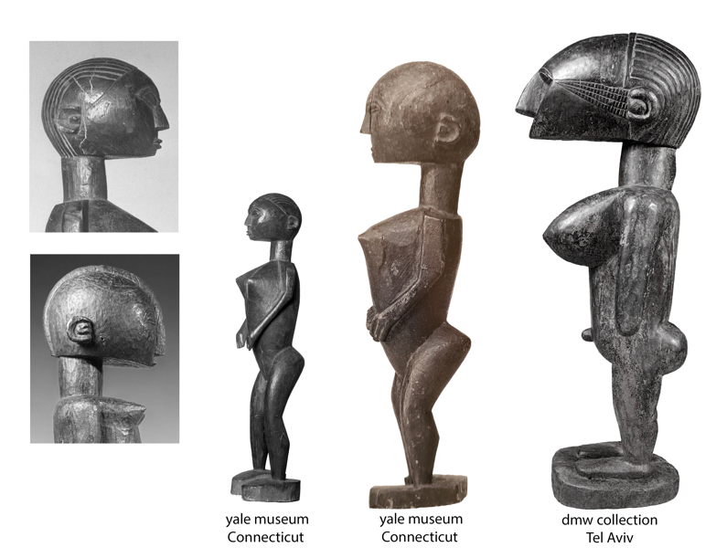

The wonderful 19th century small Nimba, whose right face was leveled by countless caressing hands during it’s long years of devotion, and was attributed to Camara’s father. ( An artist considered by all as an ancestor to the katako sculptors ), has a slightly different ear mark.

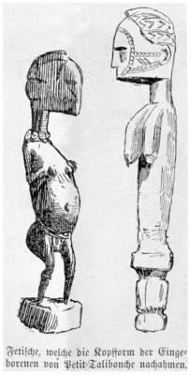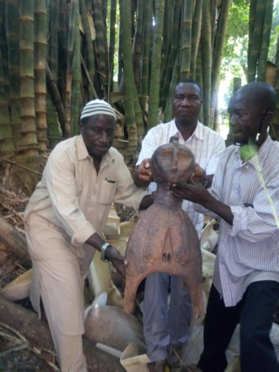A Drawing of additional works resembling such a hand was published in 1886 by G.Caspar Felix in the accounts of his trip down River Nunez , a trip embarked again only half a century later by Fred Bowald.

Master Famori Camara worked during the thirties and forties of the last century, a time in which the colonial regime and it’s representatives in Katako, the French catholic mission were at their zenith of their power, Christianity was slowly being incorporated into Baga life, a glimpse to where Camara’s art could have evolved if the jihad and the following destruction of Baga culture would not have happened can be glimpsed by comparing his novel interpretation of a standing Nimba , portrayed with hands clasped in a classic Christian praying posture, eyes looking upwards and a smiling mouth, to the traditional Nimba, with hands clasped beneath the chin in a wow of silence, eyes downcast and a mouth closed, signifying secrecy. An entity of power, to whom worship is due, to a one of a mediator between God and her community.

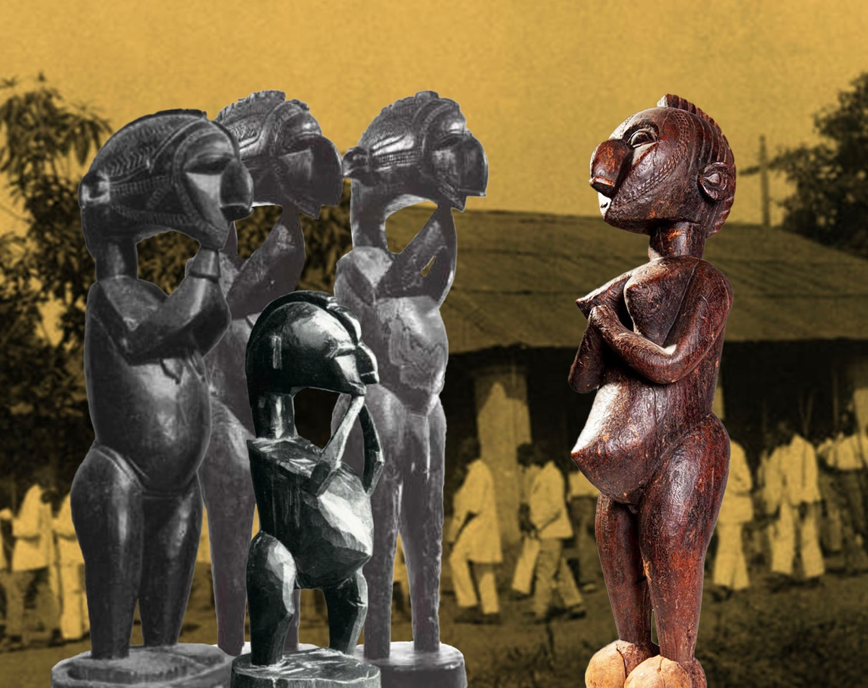

Camara’s work clearly shows that he was preoccupied with formalistic and conceptual problems similar in nature to those of fellow western artists in the modern European movement.

His oeuvre challenges last centuries boundaries and definitions of traditional versus Modern, White and Black, western and African.