**Fote’ Camara**

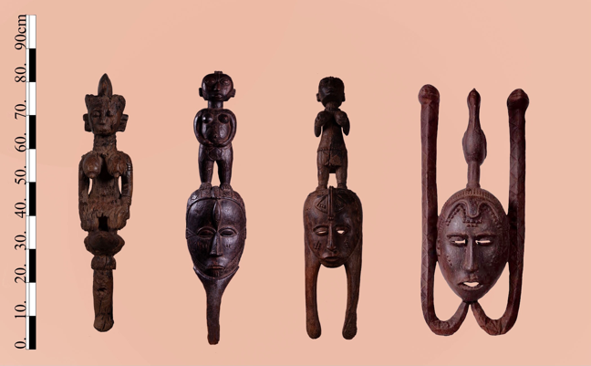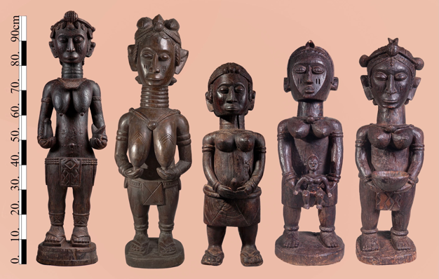

**Barbady Fote’ Camara born in tolkotch-Taigbe’ Falaba 1885**

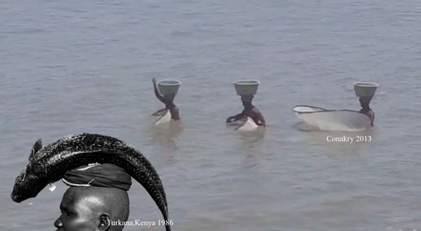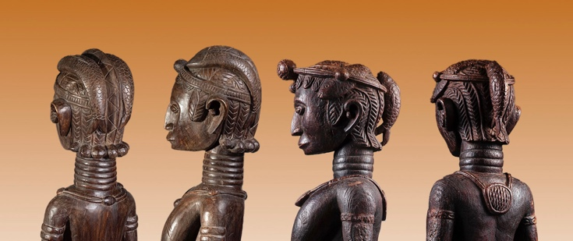master Fote’ Camara was one of the most prolific and renown Baga artists in the first half of the 20th century. His fame was widespread throughout the Bagaland , Camara’s distinctive figurative style became extremely popular with the women’s secret associations, which acting as the artist patrons, commissioned him to create numerous works for their paraphernalia, having a piece of such caliber and presenting it during the ceremonies to the new initiates was considered a major status and power symbol for the whole secret society. in many of his surviving works, fish are depicted interlocking in the women’s elaborate coiffeurs. Such figures with their elongated ringed neck which stands for beauty, eyes downcast and a closed a mouth symbolizing secrecy and unity,a braided hair advocating care and cultivation, and the fishing image of an abundance in game and fertility ( fishing was one of the women’s societies roles ).. Camara’s ability to combine all these symbols into a unified 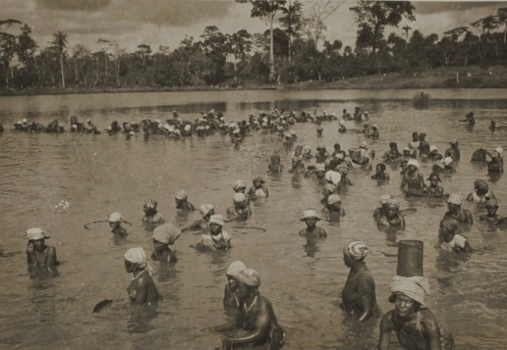sculptural figure is indeed unique.

*George labitte , Nezekore,Guinea- 1940*

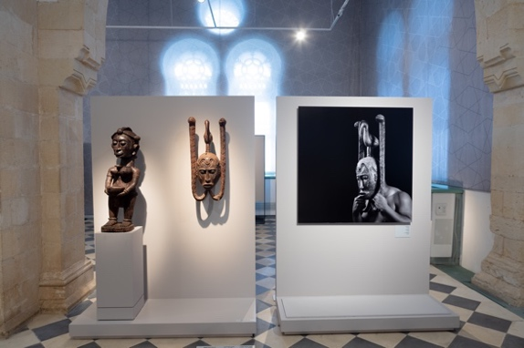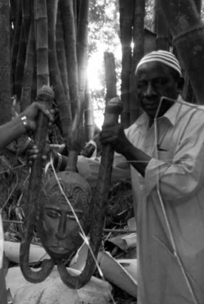Most of the men’s associations masks were destroyed during the 1958 jihad, being considered as armaments, they were targeted by the rebellious youth, and their destruction was one of the first steps in the revolution. The importance of the surviving ones ( mask museum, Scotland ) was never realized. Three such masks by Camara emerged at the Katako hoard. Two of which featured in the Israel Museum Jerusalem exhibition – *Nimba, baga art and the great mother.* And a third one in the In the Ber Sheba Islamic art museum - *gold road encounters,* exhibition.

Camara’s hand and manner are easily recognized, his compositions are static, frontal and lavishly decorated. recalling classical European portraiture paintings. His beautiful rendered creations Embody a sense of archaic monolithic omnipotent beings.

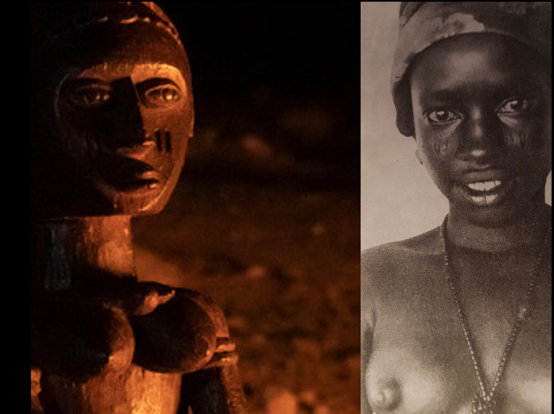His talent was so unique that his Art was recognized by all without the need of a distinctive mark for a signature. nevertheless one is always drawn to his naturalistic all consuming eyes which at the moment when they are lite by the red cascade of flickering flames as was practiced at the women’s sacred forest ,they immediately spring back to life. ( in contrast to the even monochrome museum lighting ).

Fote Camara greatness is evident in his ability to create several archetypical portraitures of Baga females, each representing a specific age group.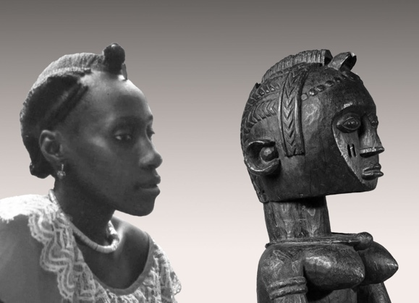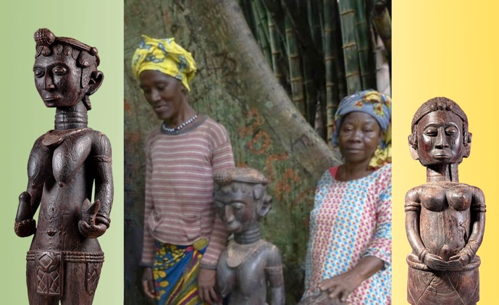 young initiates, members and elders, each typical to the group, not a portraiture of a specific individual,

when placing these idealized images alongside actual photos of Baga members taken years away, ( the statues were created in the thirties, years before the elder and the young member posing with them in the Katako’s wood were ever born) .Camara ability to catch the essence of his Baga patrons becomes apparent.

Demonstrating incredible eidetic ability, especially when bearing in mind that all these statues were carved from extremely hard wood using only one hand equipped with a traditional adze, no preparation sketches were ever conceived. His figurative aspirations were a clear break from the tradition, which was usually strictly observed, for instance the sound of the modern flute was banned from all festivities due to It’s similarly to the spirit’s sound. But nevertheless Fote Comara’s Art was praised by his peers. And achieved immense popularity.

Post independence his art was carefully guarded, kept for more then half a century away from uninitiated sight and was made public only at Henriette Conte’s death.

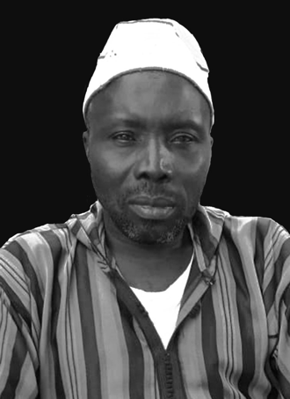Master Camara was succeeded by a son, born in 1930. with whom the practice ended. His grandson ander Fote Camara who was happy to recall his illustrious grandfather is a devout Muslim and finds his living by Fishing in River Nunez delta to the ocean .

*Andre fote Camara, faraba, guinea , 2020.*