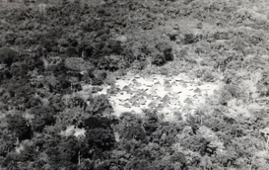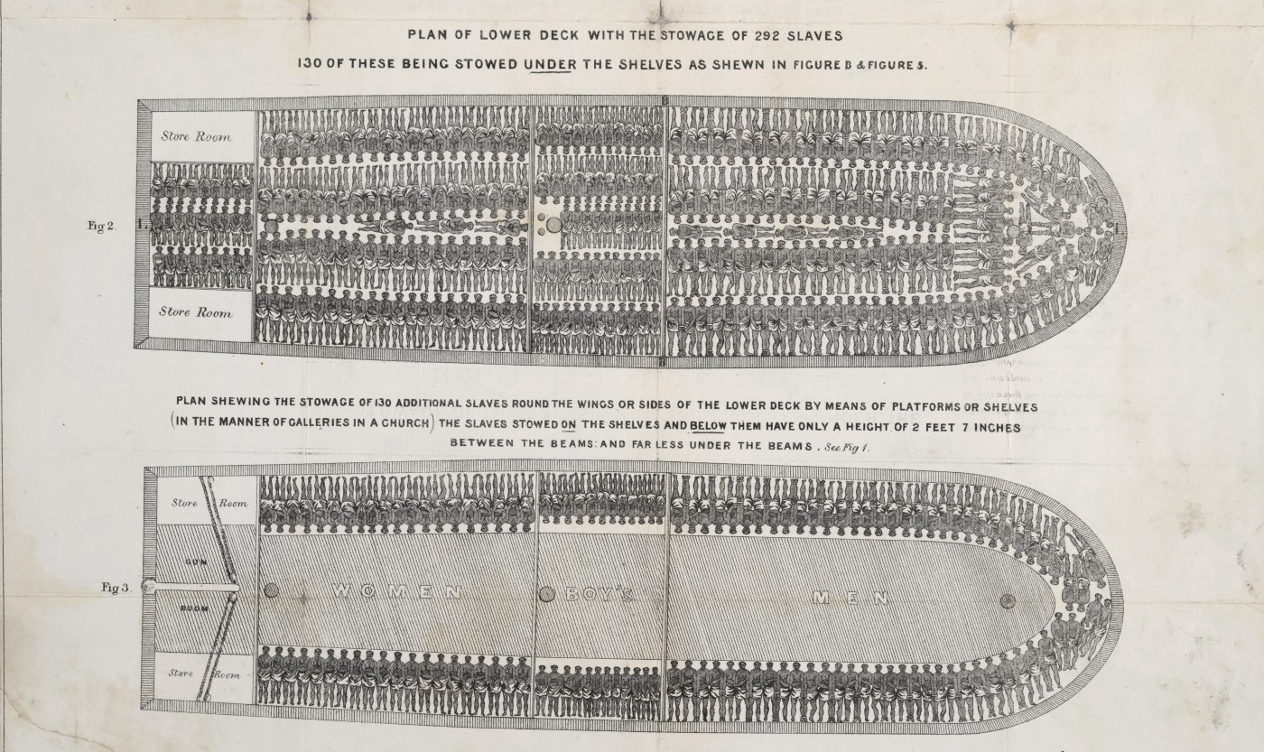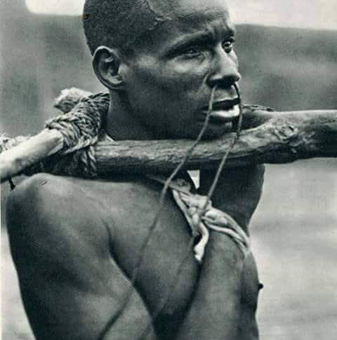From 1700 to 1900 Africa’s demographics was a constant of 140 million, the onslaught of mass enslavement and industrial hunting of youngsters reduced in the span of 200 years the African percentage in world population from 20 % to 8 %.

This 12% gap encapsulates the terror and hardship which were experienced in the Guinean coast on a daily basis for those 200 years.

Most groups of the sub Saharan rain forest lived, in order to survive in isolated small hamlets, each perched strategically on secluded mountain top, warfare and violence were constant, the threat of being hunted or sold to slavery were eminent. Peaceful a-materialistic agriculture cultures which flourished before the slave trade were of the distant past. The west African societies as well as the women’s Sande association totemic animal the tortoise were ill prepared to the arrival of the notorious three C’s - Christianity, capitalism & Colonialism.

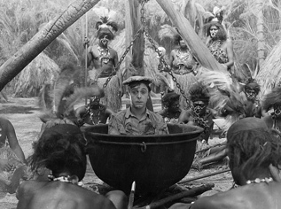massive migration from the savanna to the inhospitable forest in a quest for a refuge from the Muslim hunting cavalry resulted in two hundred years of violence in which hunger, warfare, blood feuds, bride kidnapping and reciprocal raids were part of the daily routine, Colorful descriptions of which fueled the colonial “pacification” agenda which in the commence of the industrial area enabled colonialism and mass subjection.

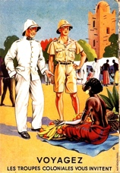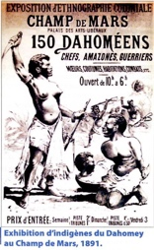

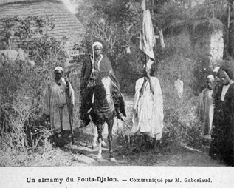The Baga which were indigenous to the Inaccessible rio Nunez delta, in which no domestic animal could survive were always short of working hands, gladly incorporated into their ranks larger and more politicly structured groups, such as the Sierra Leon’s Sapi, or the Baga groups escaping the the Fouta Djallon mountains in fear of the Fulbe jihad.

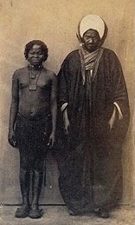

The mangrove swamps which were inaccessible to Cavaliers allowed a relative security, enabling the Developtment of much larger regional corporations.in which every extended household had a corresponding host family in an adjacent village, this allowed political alliances as well as mobilization of large work groups required for the infrastructure projects of the Baga’s intensive rice farming.

The magnitude and sheer complexity of the social structures and visual language which developed can be glimpsed from G. Labitte’s photo of a coming out ceremony taken in the forties. And in a Timba drum photo taken in Katako in the thirties,

A highly structured ceremony with abundance paraphernalia.

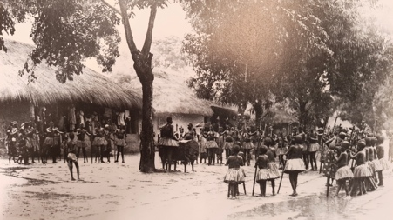The participants of the coming out ceremony are all clad in identical uniform of “forest” dress. While the s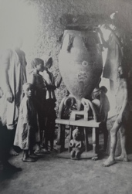pectators “city folk” are all looking from the Surrounding verandah.

The fact that the Baga were the only Guinea forest group able to pursue and develop their distinctive culture nearly unobtrusively till the late fifties can not be overstated.

Especially bearing in mind that all that splendor was lost in the late fifties due to the youth revolt, the jihad of 1958 and the following 25 years of totalitarian Marxist regime and Cultural revolution .

