COURSE BOOK

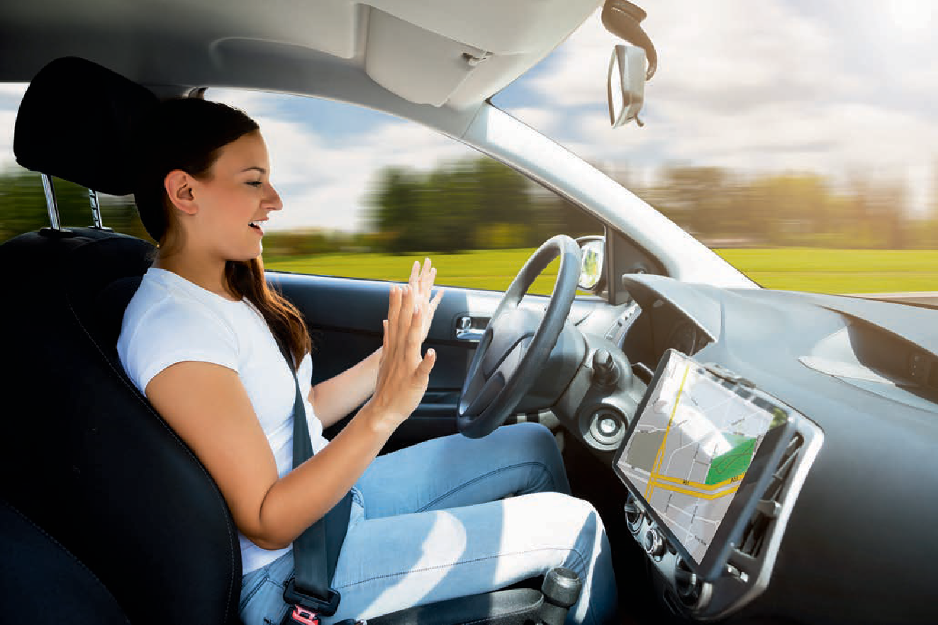

## Architectures of Self-Driving Vehicles

DLMDSEAAD01



Learning Objectives

##### Introduction 9

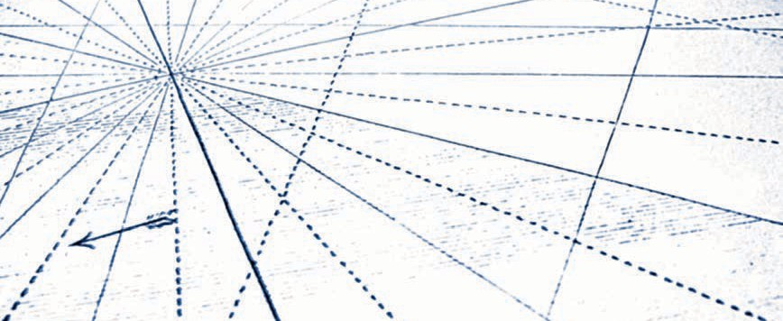

The course Architectures of Self-Driving Vehicles gives an overview of the main architectural aspects of a self-driving car. After introducing the hardware and software platforms, the course presents the sensor solutions necessary to provide environment perception for autonomous vehicles. Such perception yields the information used for motion control, including braking and steering. The fundamental concepts for the realization and implemen- tation of motion control are presented alongside related safety issues, such as motion con- trol under false information. The way that a self-driving car exchanges information with the outside world is also discussed, and the main technologies and protocols are introduced. The last part of the course elaborates on the social impact of self-driving cars, investigating aspects such as ethics, mobility, and design.

[www.iubh.de](http://www.iubh.de/)

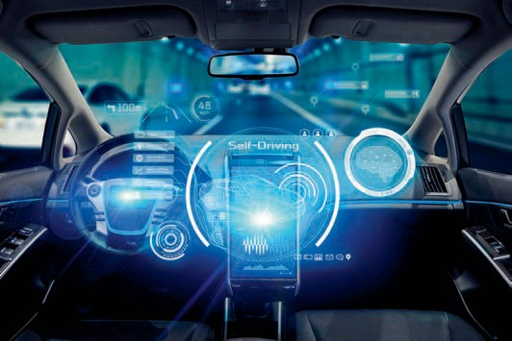

# Unit 1

## Introduction

#### STUDY GOALS

On completion of this unit, you will have learned …

… the basic concepts and technologies of self-driving vehicles.

… the main hardware components of self-driving vehicles.

… which software modules build up the software stack needed for autonomous driving.

… the current challenges and future trends of autonomous driving.

DL-E-DLMDSEAAD01-U01

1. Introduction

### Introduction

Autonomous driving is getting an increasing amount of attention from the media and has aroused public interest for a long time. The rise of artiﬁcial intelligence and new sensor technologies has enabled new possibilities, and almost all of the large automo- tive companies have joined the research and development process, but what is the general concept of autonomous driving? What kinds of autonomy exist and how do they differ? To get a basic understanding of the topic, it is essential to have an overview of current hardware setups such as sensors and actuators. Furthermore, the software behind the functionality has to be understood in order to know exactly what happens at which state. After presenting the topics that build a solid basis for further studies, some current challenges and future trends will be discussed.

### Basic Concepts and Key Technologies

In recent years, self-driving technologies have attracted a lot of attention from researchers and the media. Motivated by an increase in safety and comfort, several concepts have been developed, resulting in the public becoming accustomed to terms such as “autonomous” or “self-driving vehicles.” Nevertheless, despite the predictions and promises from different companies such as Google, Toyota, Honda, and Tesla, real autonomous behavior is still currently out of reach. Before these companies can pro- vide autonomous vehicles, the word “autonomous” must be deﬁned. Different descrip- tions and characterizations have been developed, but the classiﬁcation system from the Society of Automotive Engineers (SAE), published in 2014 and updated in 2018, is the most common way to deﬁne autonomy (SAE International, 2018). The system con- sists of six different levels of autonomy ranging from level 0 to level 5.

###### Levels of Autonomous Driving

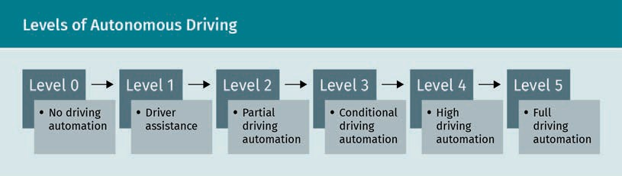

Level 0 (no driving automation)

Vehicles with level 0 autonomy are controlled manually. They do not exhibit any ele- ments of autonomous behavior, so the driver must take care of all aspects of driving without any assistance.

Introduction

Level 1 (driver assistance)

Vehicles with level 1 autonomy have the lowest level of automation. The driver is assis- ted by a single automated system, such as cruise control or steering. All other aspects are controlled by the driver. Another example of level 1 automation is adaptive cruise control, which is used to keep a certain distance from other vehicles. Because the driver controls all other aspects, for example, braking and steering, it belongs to the classiﬁcation of driver assistance systems.

Level 2 (partial driving automation)

Systems with level 2 automation are called advanced driver-assistance systems (ADAS). Vehicles with this level of automation are able to control multiple aspects of driving such as steering, accelerating, and braking. The perception of the environment is still the responsibility of the driver, who can take control at any time.

Level 3 (conditional driving automation)

Level 3 is the ﬁrst automation level where the vehicle has perception ability, meaning that it monitors the driving environment itself. Vehicles of this level perceive and detect aspects of the environment and make decisions based on the results of their monitoring. The driver’s attention is still needed so that they can take control in the case that the vehicle cannot execute a task. Because of this, the driving automation is only conditional.

Level 4 (high driving automation)

In addition to the features of level 3 automation, vehicles with level 4 automation can react to anomalies or system failures and are therefore independent from human driv- ers in most situations. The human can still intervene manually, but the vehicle is able to operate in self-driving mode. Due to legal restrictions and infrastructure, this mode is mostly limited to a certain area, which is called geofencing.

Level 5 (full driving automation)

The highest level of automation is level 5, which is the level given to vehicles with full driving automation. Human attention is no longer necessary. Because the driver does not need to intervene at any time, these vehicles do not have any manual driving inputs such as steering wheels, acceleration, or braking pedals. Geofencing is elimina- ted because the self-driving car is able to perform as well as, or even better than, any experienced human driver in any situation.

Of the six automation level descriptions, vehicles of the ﬁrst three levels do not incor- porate any environmental perception and do not “see” what happens around them. In comparison, vehicles of levels 3, 4, and 5 actively perceive the scenery through which they drive and are therefore capable of making decisions based on their observations. The perceptual aspect of the different automation levels is depicted in the following ﬁgure.

Geofencing

The word “geofenc- ing” is a combination of the words geo- graphic and fence.

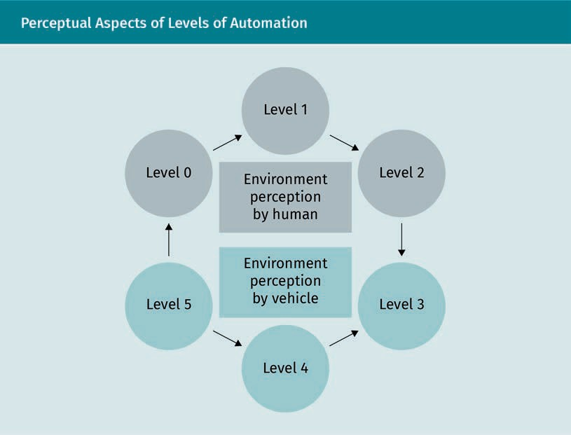

At a glance, the difference between level 2 and level 3 seems small, however, the differ- ence in their technical aspects is large. The technology involved with scenery percep- tion, understanding, and decision-making based on that information is challenging. The key technologies of a self-driving vehicle with level 3 to level 5 automation have four key parts—localization, perception, trajectory planning, and car control (Pendleton et al., 2017).

###### Key Technologies of a Self-Driving Vehicle

Ego vehicle The self-driving vehicle itself is called an ego vehi-

cle.

Localization

The ﬁrst key component of the architecture of self-driving vehicles is localization, which estimates the state of the ego vehicle including, among other parameters, its position, velocity, acceleration, orientation, and turning rate. Because different sensor sources and information from the vehicle dynamics are needed, such as wheel speed and steering angle, the estimation always has underlying uncertainties, which must be accounted for.

Perception

The perception component can be seen as the “eye” of a self-driving car. By using dif- ferent kinds of sensors, such as radio detection and ranging (RADAR), light detection and ranging (LIDAR), and cameras, a detailed representation of the car’s surveillance area is generated. The ﬁrst important step towards generating this detailed representa- tion is the object detection. Both static and dynamic objects (other trafﬁc participants)

Introduction

are detected, which is essential to guarantee safety. This step is followed by object tracking of each detected dynamic object, which estimates their states. The state con- sists of the position and velocity alongside higher derivatives of the position such as acceleration, jerk, orientation, and turning rate. To obtain a highly accurate estimation, the measurements of different sensor sources are fused together to reduce uncertain- ties. Different kinds of Bayes ﬁlters are used for this step, for example, Kalman, exten- ded Kalman, and unscented Kalman ﬁlters (Chen, 2003). The task of tracking multiple objects simultaneously is called multi-object tracking. It highlights the probability that different situations will occur, such as the appearance of new objects, disappearance of objects, or probability of existence (Luo et al., 2014).

Trajectory planning

The third key component of self-driving vehicle architecture is the trajectory planning. The idea is to plan a safe, comfortable, and efﬁcient trajectory through trafﬁc in order to reach a destination. For this task, a route planner generates paths through the road network. The perceived environment, including features such as detected static and dynamic objects, is taken into consideration to generate an appropriate speciﬁcation for the trajectory. The motion planning is based on these speciﬁcations. Common approaches for the trajectory planning are the model predictive control and the behav- ior-based model, although other approaches exist (Nolte et al., 2017; Xiu & Chen, 2010).

Motion control

The fourth key component of a self-driving vehicle is motion control, which converts the intentions that were generated during the planning into actions. Here, the inputs for the vehicle’s hardware, the controllers, are determined and provided in order to execute the planned motions. Therefore, the throttle and brake state and the steering angle position are determined in a control loop to correct tracking errors, which are inﬂuenced by inaccuracies of the vehicle’s model (Paden et al., 2016).

### Hardware Overview

Appropriate hardware components must be integrated so that a car can perform autonomous actions. These can be subdivided, analogous to a human driver, into three main groups: sensors, actuators, and Car2X/V2X (Yurtsever et al., 2020). The properties and purposes of each subgroup will be presented in this section.

###### Sensors

Using sensors as input sources, a vehicle is able to gain information from the environ- ment or from itself. Sensors used for perception of the environment through which the vehicle is maneuvering are called exteroceptive sensors, whereas sensors used for internal vehicle state measurements are called proprioceptive sensors (Yurtsever et al., 2020). Perceiving the environment is a key aspect of vehicles classiﬁed as level 3 and above. Sensors can be compared to the sensory organs of a human, such as the eyes, ears, or nose, and work on different physical principles in order to build a representa-

Fusion

Sensor fusion is the combination of mul- tiple sensor data.

Fusion is performed to obtain informa- tion with less uncer- tainty.

Bayes ﬁlter

The Bayes ﬁlter is a recursive probabilis- tic method used to estimate probability distributions of unobserved states by predicting and measuring.

Exteroceptive The preﬁx “extero” comes from the Latin word “exter” and means “outer”

or “external.”

Proprioceptive The preﬁx “pro- prio’”comes from Latin “proprius” and means “one’s own.”

tion of the surveillance area as accurately as possible. This is essential for detecting dynamic objects as well as static obstacles, such as signposts, curbs, or trafﬁc islands. The dynamic objects are mainly trafﬁc participants, but can also be other objects with dynamic behavior, for example, animals. The most commonly used exteroceptive sen- sors are cameras, light detection and ranging (LIDARs), radio detection and ranging (RADARs), and global positioning systems (GPS), which all have their own advantages and disadvantages and are mainly used for the vehicle’s perception (with the exception of GPS, which is used for the global positioning of the ego vehicle). The strength of a self-driving car’s perception comes from the manner in which it processes each sen- sor’s information. The use of multiple sensors, either the same or different types, results in a redundancy. However, this very redundancy is used to obtain a highly accu- rate perception using sensor fusion. By considering the measurements of multiple sen- sors and the uncertainties associated with them, better estimations can be obtained than when only one source is taken in to consideration. Furthermore, each sensor type brings its own properties. LIDARs have a very high spatial resolution and can therefore be used to build an accurate 2D or 3D representation of the environment, and, in com- parison, RADARs show a much lower resolution but can operate over much longer dis- tances. While LIDARs have problems working in snowy, rainy, and cloudy conditions, RADARs show no decrease in performance due to the long wavelengths used for the technology. Cameras, on the other hand, show weakness in depth information but are optimal for object detection tasks. By fusing the information of each sensor, the advan- tages can be combined to achieve the performance needed for a self-driving vehicle.

The proprioceptive sensors are the other part of the sensory systems. These serve as an input source for information coming from the vehicle itself and are mostly used for the self-localization of the ego vehicle. Common information gathered is, for example, the wheel speed, wheel load, and inertia. Inertial measurement units (IMUs) are used to measure the three acceleration components of the ego vehicle and its three rota- tional rate components. They consist of three accelerometers and three axis-rate sen- sors, and they enable the vehicle to estimate its location relative to its starting point. Thus, compared to the GPS, it is used for local rather than global positioning. Wheel speed sensors detect the rotational wheel speed of the vehicle and serve as an infor- mation source to estimate the local position of the ego vehicle. Analogous to the sen- sor fusion approach for perception, this principle is also used for localization.

Introduction

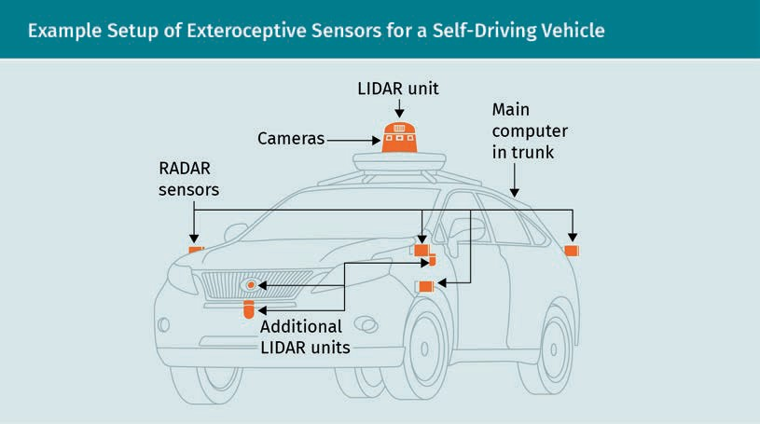

###### Actuators

While the sensors serve as input sources for the self-driving vehicle, the group of actuators is responsible for generating outputs. They can be compared to the hands and feet of a human driver, and they are necessary to control and move the system physically. The most important actuators when performing the actions of a vehicle are responsible for the throttle, brake, steering, and gear-shifting systems. Motion control runs the actuators and executes the previously calculated motions to maneuver the planned trajectory.

###### Car2X/V2X

Car2X and V2X stand for “car-to-everything” and “vehicle-to-everything,” respectively. This technology enables a communication between the ego vehicle and any entity in the environment through which it is maneuvering (Demba & Möller, 2018). It incorpo- rates different subtypes of vehicle communications such as vehicle-to-infrastructure (V2I), vehicle-to-network (V2N), vehicle-to-vehicle (V2V), vehicle-to-pedestrian (V2P), vehicle-to-device (V2D), and vehicle-to-grid (V2G). Road safety and trafﬁc efﬁciency are the main motivations behind these communications. Today, WLAN-based and cellular- based systems are mainly used (Ahn et al., 2018; Chen et al., 2017). By using vehicle-to- infrastructure communication, a vehicle is able to communicate with components of the street system, such as cameras, trafﬁc lights, and streetlights. Vehicle-to-network communication is used to share information between the vehicle, the cellular infra- structure, and the cloud, which can be useful for trafﬁc updates. Through vehicle-to- vehicle communication, vehicles can share information with each other to signal dan- gerous or critical situations. The same is done with vehicle-to-pedestrian communication, as the information is shared between the vehicle and a pedestrian as

a trafﬁc participant. Vehicle-to-device is used for the information exchange between the vehicle and any electronic device, which makes use of different mobile applications for increasing driving safety. The last subtype, vehicle-to-grid communication, is used to enable communication between the vehicle and the power grid to allow a bidirec- tional sharing of electrical power. By means of this technique, an intelligent energy sys- tem can be established (Lund & Kempton, 2008).

Of course, the complete hardware of a self-driving vehicle is useless without a powerful computer behind it. The computer acts like the “brain” of the car and is the place that all calculations needed for the autonomous behavior are carried out. Graphics process- ing units (GPUs) play a signiﬁcant role due to the rise of artiﬁcial intelligence, in partic- ular, deep learning. The enormous amount of calculations needed is signiﬁcantly less time-consuming when using GPUs compared to central processing units (CPUs). The vehicle’s computer is the platform for the whole software stack.

### Software Overview

The software stack yields the automation of a car. Even if a vehicle is equipped with the best sensors and actuators, without a deﬁned functionality, it cannot drive autono- mously. Different modules produce reasonable output from a certain input, such as accelerating, braking, and steering. The general data ﬂow within a self-driving vehicle’s software is depicted in the following ﬁgure.

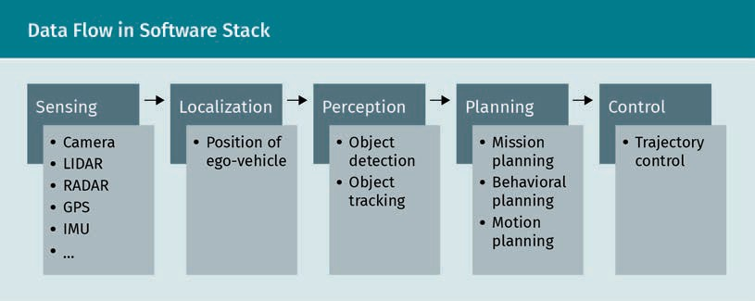

###### Sensing

The sensing module is the ﬁrst part of the software stack and is crucial to the self-driv- ing vehicle’s functionality. It represents the interface of all of the sensors and is responsible for reading the sensor data. The data can be preprocessed in this step, but the features are not extracted, meaning that the car does not “know what it sees.”

Introduction

###### Localization

The ﬁrst module of the software stack that uses of the data captured by the exterocep- tive and the proprioceptive sensors is the localization module. The task is to estimate the state of the ego vehicle accurately, which is crucial to the complete functionality because all following modules make their calculation based on the ego state. Position, velocity, orientation, and turning rate are the fundamental parameters, but higher derivatives of the position, such as acceleration or jerk, can also be beneﬁcial. Many different approaches exist to estimate the state and generally make use of different derivations of Bayes ﬁlters such as Kalman, extended Kalman, unscented Kalman, or particle ﬁlters (Särkkä, 2013). Bayes ﬁlters are recursive probabilistic methods used to estimate probability distributions of parameters following the general principle. An example is shown in the following ﬁgure.

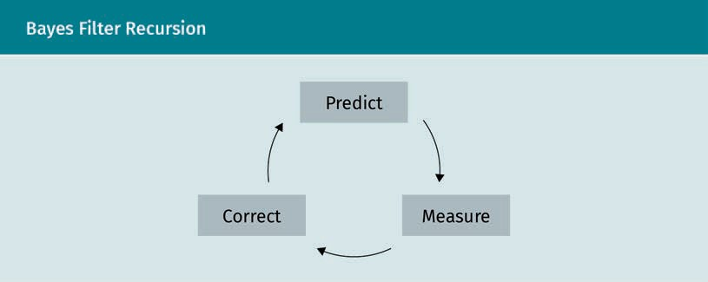

The intention is to continuously update the most probable state based on the most recent measurements. In the ﬁrst step, a prediction is made following a certain mathe- matical model depending on the underlying process, which leads to the prior distribu- tion. This could be a linear motion with constant velocity in the simplest case, but it is likely that a more dynamic model will be assumed. A good overview of different motion models can be found in literature by Bar-Shalom and Li (1993). In the second step, new measurements are used and the state is corrected accordingly to yield the . In Bayesian statistics, the true state of a process is assumed to be an unobserved Markov process, which means that the probability only depends on the current state x. Thus, the current state contains all previous information (Gagniuc, 2017). The measurements, on the other hand, are assumed to follow a hidden Markov model (HMM), where the measure- ments z depend on the state x (Zucchini et al., 2016). Kalman ﬁlters represent a deriva- tive of the Bayes ﬁlter that is often used, assuming the state and measurement to be Gaussian distributions. Particle ﬁlters, also called Sequential Monte Carlo (SMC), are used if the state assumption of a Gaussian distribution is not appropriate (Chen, 2003). The idea is to generate a swarm of particles, each consisting of a weight and a point in the state space. The sum of all particles should model the probability distribution of the state. For a detailed description of this approach, refer to the literature by Chen (2003).

Prior distribution The prior distribu- tion represents sub- jective beliefs about the state.

Dead Reckoning In biology, dead reckoning—the proc- ess of updating esti- mates of position or heading—is also known as path inte-

gration.

Two different types of localization are important for a proper state estimation: global and relative localization. Global localization is necessary for a vehicle to know its abso- lute position in the world. Without knowing its state in a global sense, knowledge of the immediate surrounding does not help it to maneuver to a given destination. Usage of global navigation satellite systems (GNSS), of which the global positioning systems (GPS) is the most common representative, in combination with digital maps is the easi- est and most commonly applied technique for that task. Thereby, the coordinates given by the satellite are often matched to the digital map to constrain the position to exist- ing streets, which is called map matching (Quddus et al., 2007). Due to certain limita- tions, such as signal scattering or attenuation in environments with high buildings, trees, and inside tunnels (i.e., the need for a clear view of the sky), this approach is not a recommended solution (Woo et al., 2019). Relative localization, in comparison, esti- mates the position relative to an initial position using onboard sensor information such as wheel sensors (odometry), steering angle, and inertial measurement units (IMU). For an accurate estimation of the state of the ego vehicle, the information of multiple sensors is used to reduce uncertainties—a technique called sensor fusion. This method of estimating the relative position is called dead reckoning and is a proper approach for urban areas with high buildings and tunnels where signal inter- vention is present. Relative localization suffers from drift over time due to error accu- mulation but is jump-free, which means that there is an approximately continuous state estimation because measurements are generated at high frequencies by IMUs (Zhang et al., 2020). In comparison, global localization suffers from jumps due to low update rates, but is drift-free. Because of this, a combination of both localization tech- niques is a common solution for self-driving vehicles. Additional information gain can be achieved by integrating visual odometry, which uses successive camera images to measure translational and rotational changes.

###### Perception

The purpose of the perception module of the software stack of a self-driving vehicle is to generate an accurate representation of the environment through which the vehicle is maneuvering. Generally, it can be subdivided into two parts: object detection and object tracking. Object detection is the task of detecting all objects in the environment around the vehicle as accurately as possible. Both static obstacles—objects that do not move but have to be considered during the maneuvering—and dynamic objects, for example, other trafﬁc participants like vehicles, bicycles, and pedestrians must be detected. Detection consists of classiﬁcation and localization. This can be done by clas- sical image processing methods, but with the rise of deep neural networks, they have more representation. Several datasets exist for the training of neural networks, such as the KITTI, nuScenes, and Cityscape dataset (Geiger et al., 2013; Caesar et al., 2020; Cordts et al., 2016). Each dataset consists of different sensor data, sensor conﬁguration, and calibration. Using a particular dataset for one’s own project, the conﬁguration either needs to be identical or a recalibration has to be applied. The following ﬁgure shows exemplary object detection from the KITTI dataset.

Introduction

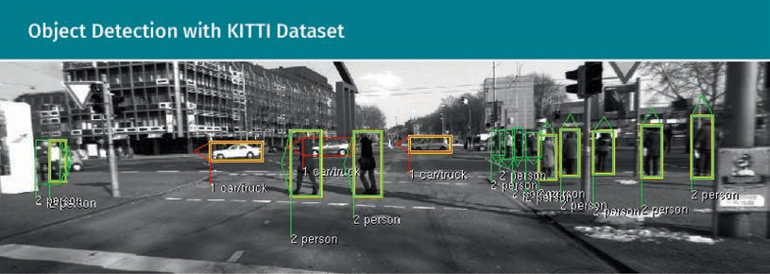

Many sensors used in self-driving cars are already equipped with object detection algo- rithms such as cameras, LIDARs, and RADARs. With sensor fusion, the information from all sensors is used, which leads to lower uncertainties than using data from each sen- sor alone. Different fusion approaches exist depending on when the fusion is per- formed (Ebersbach et al., 2017). When performing late fusion, the detections of each sensor are used and combined. Early fusion takes the raw or preprocessed data of the sensors and applies an object detection to the fused data in a high-dimensional fea- ture space. By doing this, relations between the sensor data can be considered by the object detection method, which could be lost in the late fusion approach. Different stages between early and late fusion exist, which are not further discussed at this point. The interested reader can get a more detailed overview in (Ebersbach et al., 2017; Peng et al., 2017; Seeland et al., 2017).

Object tracking is, in short, keeping track of each detected dynamic object. Each meas- urement is inﬂuenced by uncertainties due to, for example, inaccuracies or sensor errors, thus, considering a detected position of an object as its real position would lead to inaccurate estimations. For that reason, just as for the localization task, probabilistic methods represent a common solution. Extended or unscented Kalman ﬁlters, which can, in comparison to the standard Kalman ﬁlter, handle non-linearities of the state transition (motion) and the measurement model, or other derivatives of the Bayes ﬁlter are used to continuously predict and correct the state of the objects (Roth et al., 2014). By performing this process over time, accurate state estimations can be obtained, which are more likely to represent the reality. Tracking a single object is trivial because it is known that exactly one object exists. Tracking an unknown number of objects becomes very difﬁcult due to object births (new objects that appear in the surveillance area of the vehicle), object deaths (objects that disappear from the surveillance area), and clutter measurements. All of those factors are handled by multi-object tracking. Common methods are the probability hypothesis density (PHD) ﬁlter, the multihypothe- sis tracking (MHT), and the multi-target multi-Bernoulli ﬁlter and their derivations (Vo & Ma, 2006; Blackman, 2004; Vo et al., 2009). A good overview and comparison of multi- object tracking approaches can be found in literature by Luo et al. (2014).

###### Planning

The aim of the planning task is to ﬁnd a safe, convenient, and economically beneﬁcial trajectory from a starting point to an end point. For this, a reliable and highly accurate perception of the environment through which the vehicle is maneuvering is essential because it has to bypass all static and dynamic objects present in the surrounding. A proper representation of the environment is needed to search for paths and it is there- fore transformed in to a state space where drivable free space and corridors can be found. Common approaches for free space detection are the occupancy grid algorithm, the Voronoi diagram algorithm, the cost maps algorithm, the state lattices algorithm, and the driving corridors algorithm (Lau, 2013). Path planning can be represented as a hierarchical model consisting of the following layers: mission planning, behavioral planning, and motion planning. The mission, as the higher-level input for the planner, is split into sub-missions and then split again into motions that are handled by the motion planner. This way, the workload of motion planning for long-term missions can be reduced because complicated problems are divided into smaller, less complicated ones. On the other hand, this hierarchical model slows down the process.

Some popular trajectory planning algorithms are the artiﬁcial potential ﬁeld, sampling- based planning, grid-based planning, and reward-based planning (Park et al., 2001; Branicky et al., 2006; Saranya et al., 2014; Xiao et al., 2019). Within the behavioral plan- ning layer, an appropriate behavior of the vehicle (motion speciﬁcation) is generated by evaluating the surrounding environment for the path that was planned in the mission planning layer. The task of the motion planning layer is to work out a feasible driving mode that ﬁts the speciﬁcations.

It is essential to have good predictions for the dynamic objects in the environment through which the path is generated. For this reason, a lot of research is done investi- gating new behavior prediction models, mainly based on deep neural networks (Shok- rolah Shirazi & Morris, 2019; Heyns et al., 2019).

###### Control

During the control part of the software stack, appropriate actuator inputs are selected to execute the motions in the motion planning layer—this all works towards executing the planned trajectory (Paden et al., 2016). A common approach is to use feedback con- trollers to correct tracking errors that occur because of inaccuracies between the vehi- cle model and the real motions. For a good performance, special attention should be given to an effective feedback control system and an appropriate vehicle model. The most common type of feedback controller is the proportional-integral-derivative (PID) controller. One limitation of this type of controller is a delayed response to errors because it only responds to errors at the time they occur. Another issue is the problem of coupled response because disturbances, modelling errors, and measurement noise are all handled in the same way (Pendleton et al., 2017). The two-degree-of-freedom

Introduction

controller, the combination of a feedback, and a feedforward term help to overcome the limitations but need a good understanding of the physical system and thus, an accurate model.

Another control mechanism is the model predictive control, which has been widely used for automotive applications such as braking, steering, lane keeping, and traction control (Hrovat et al., 2012). For the prediction horizon, which represents the time taken to complete the prediction, the model predictive controller computes the optimal solu- tion. For a detailed description of the functionality, reference is made to (Camacho & Bordons, 2007).

### State of the Art and Open Challenges

Despite the high research focus on the technology of autonomous driving, there are currently no companies offering vehicles with full driving automation (level 5). Accord- ing to predictions made by different sources, 2020 should have been the year of self- driving cars. Four big players in the technological race (General Motors, Toyota, Honda, and Google’s Waymo) announced available products in 2020. Tesla predicted them by 2018 and Uber wanted to give rides in self-driving cars in 2019, but at this point, availa- ble technologies are limited (Davies, 2019; Madrigal, 2018; Kubota, 2015; Heaps, 2017;

Thompson, 2018; Matousek, 2019).

While there are already solutions and working systems for autonomous highway driv- ing, urban scenarios, which are much more dynamic, still fail to be solved in a reliable manner. It may be attributed to the rise of artiﬁcial intelligence (AI) in the decade of 2010 that these forecasts have been made. Ground-breaking achievements, especially for deep neural networks, have been made in areas such as classiﬁcation, segmenta- tion, object detection, and natural language processing, and researchers hoped to see those results in other applications like autonomous driving. However, the progress of AI did not continue at the same speed with the ground-breaking results that were hoped for, and the hype has led to inﬂated expectations. The following ﬁgure depicts the Gart- ner hype cycle for emerging technologies.

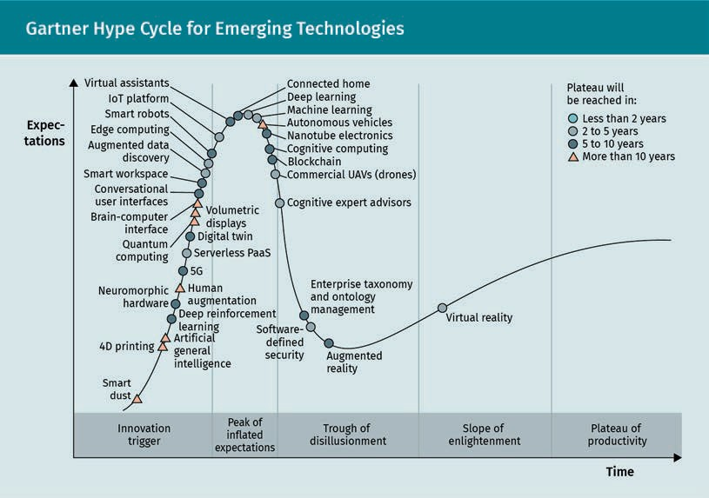

The graph shows emerging technologies and their state within the hype cycle. It can be observed that the technology of autonomous vehicles has already reached its peak of inﬂated expectations and is predicted to reach its plateau of productivity in more than 10 years. It can safely be said that the perception of a self-driving car is both the most critical and the most complex task for its functionality (Cunneen et al., 2020), and this very task relies on artiﬁcial intelligence the most. Since machine learning systems such as deep neural networks, which are most common in current applications, need enor- mous amounts of training data, problems arise for self-driving applications. Even with data being collected and used for training, there will always be situations that the sys- tem has rarely (or never) seen, such as special maneuvers and accidents. An accurate understanding of the environment is one of a number of open questions in the research ﬁeld of self-driving vehicles, which is highly dependent on improving percep- tion accuracy. One solution for the problem could be the use of simulation software, such as CarMaker, Carsim, Carla, and Airsim, to generate the data needed for training. This has already been done successfully (Nowruzi et al., 2019). Predicting future states of detected dynamic objects that represent other trafﬁc participants is carried out in a highly important research ﬁeld that evaluates situational risks (Cunneen et al., 2020). Different risk indicators, such as probability of a collision, time-to-collision (TTC) or time-to-react (TTR), can be taken into consideration (Lefèvre et al., 2014).

The most technologically advanced projects that come close to desired autonomy may be those by Waymo and Yandex, who have developed, and currently operate, autono- mous robot taxi services that are considered to be level 4 automation. However, even the head of Waymo stated that self-driving cars would always have some restrictions, and thus doubted the possibility of full driving automation (level 5 automation) (Vogel, 2020).

Introduction

### Trends

Despite the fact that level 5 automated vehicles are still just a concept, there are sev- eral emerging trends in that research area. One of those is the introduction of self-driv- ing shuttle services, which was done in New York City in 2019 by Optimus Ride (Ether- ington, 2019). Despite the fact that it only operates within an area of 300 acres in the Brooklyn Navy Yard and thus has no contact with bicycles, cars, or pedestrians, it brings the technology closer to the public. Additionally, self-driving taxi services, such as those presented by Waymo and Yandex, are already a reality. Robo-taxis are expected to be the top use case for self-driving vehicles and the market size is expected to be approximately $1.161 billion by 2030 (Statista, 2020). The demand-side behavior of the automotive industry is already subject to a behavioral change. While vehicles were pre- viously considered to be an extension of a customer’s personality, younger generations have shifted to carpooling, cab services, and car rentals to overcome trafﬁc congestion or parking situations (Statista, 2020). Most of the large car manufacturers have adapted to this change in behavior and demand, and are focused on driverless vehicle con- cepts. An urban mobility report states that trafﬁc congestion wastes over 4.8 billion hours of productivity, which could be drastically decreased by the rise of self-driving shared vehicles (Schrank et al,. 2019).

In addition to the change of end-user behavior, a decrease in the number of accidents is expected. No driver means no accidents due to texting or drunk driving, which would mean less vehicle related deaths per year. A decrease in accident rates by more than 80 percent is expected due to self-driving technologies (Keeney, 2015). However, the ques- tion of who would be responsible for accidents if no driver is present is still unan- swered. Would it be the passenger, the manufacturer, or someone else?

The rise of car communication technology such as Car2X/V2X is likely to make driving much smoother and less dangerous. Technologies that establish communication between vehicles and infrastructure are already being developed. They are called vehi- cle-to-infrastructure (V2I) and can, for example, inform the trafﬁc participants when it is their turn to move. Thus, it is essential to put as much research focus on the infrastruc- ture through which the autonomous vehicles will maneuver as on the vehicles them- selves. The following ﬁgure shows the estimated growth of V2X technology in millions of dollars according to a market research report (Grand View Research, 2017).

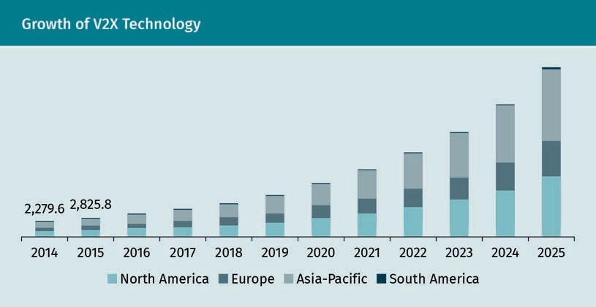

In conclusion, the future is bright for the technology of self-driving vehicles and it is likely that we will experience fundamental changes in the target groups of car manu- facturers, leaning towards carpooling, car sharing, and taxi services.

Summary

Self-driving vehicles can be classiﬁed based on their level of automation. Generally, six different levels (ranging from level 0 to level 5) of automation are distinguished: no driving automation, driver assistance, partial driving automation, conditional driving automation, high driving automation, and full driving automation. While the ﬁrst three levels still rely on human environmental perception, the latter rely on vehicle perception.

The hardware of autonomous vehicles can be separated into three main groups: sensors, actuators, and Car2X/V2X. Sensors consists of the subgroups of proprio- ceptive sensors, which capture information from the vehicle itself, and exterocep- tive sensors, which perceive information from the external world. Inertial measure- ment units (IMUs) or wheel speed sensors are examples of the ﬁrst subgroup, while LIDARs, RADARs, and cameras belong to the second. Actuators are used to generate outputs such as steering, braking, and accelerating, and Car2X/V2X technology is a collective term for several systems.

To achieve any level of automation, appropriate software is necessary. The common software stack consists of sensing, localization, perception, trajectory planning, and control. During the sensing stage, the information from all exteroceptive and pro- prioceptive sensors is gathered. The localization module estimates the current state of the ego vehicle, while the perception stage generates an accurate and reliable representation of the environment including object detection and tracking. The tra- jectory of the self-driving vehicle is planned during the trajectory planning and executed at the control stage.

Introduction

Perception is the most critical stage of the software stack of self-driving vehicles and is the basis for all other software components. This module is responsible for a reliable understanding of the environment and relies the most on training data, which is currently a challenge. Simulation software such as CarMaker or Carsim could be a solution for the generating of huge amounts of data and are already used successfully.

Studies show that the top use case of self-driving vehicles is likely to be robo-taxis. There will be a change of end-user behavior that the industry must adapt to, from car property to carpooling, cab services, and car rentals in order to overcome trafﬁc congestion and parking situations.

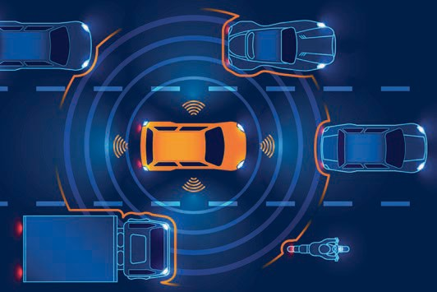

# Unit 2

## Environment Perception

#### STUDY GOALS

On completion of this unit, you will have learned …

… the purpose of environmental perception in self-driving vehicles.

… how global positioning systems work and how they can be used for global localization.

… the types of inertial sensors that exist and how they can be composed to build an inertial measurement unit (IMU).

… how relative localization can be achieved using IMUs.

… how the most common exteroceptive sensors LIDARs, RADARs, and cameras work, what subtypes exist, and the purpose they serve in the application of self-driving vehicles.

DL-E-DLMDSEAAD01-U02

1. Environment Perception

### Introduction

Environment perception is the most basic yet the most critical part of the functionality of self-driving vehicles. The whole software stack relies on an accurate and reliable representation and understanding of the environment, which is acquired during the perception stage. There are several different sensors used for this, and a combination of those can lead to more accurate results.

This unit gives an overview of the most common extero- and proprioceptive sensors used in current self-driving car technologies. After presenting different sensor setups and coordinate systems, a detailed introduction of each type of sensor is given. The two basic components for ego vehicle localization—the global navigation systems (GPS) and the inertial measurement unit (IMU)—are discussed, and the three most common sensors used for scene perception are described and compared in detail.

### Basic Concepts

Accurate perception and interpretation of the environment through which a vehicle is maneuvering is one of the most critical parts of the functionality of self-driving vehi- cles. It is essential to reduce uncertainties associated with predictions and measure- ments of multiple sensors as much as possible in order to build up a reliable represen- tation of the environment. Although the self-localization can be considered a separate module of the software stack, it is also a kind of perception. Different proprio- and exteroceptive sensors are used to estimate the pose, or position, over time, and pro- vide robust results, even in the absence of measurements, by predicting the motion. The perception of the environment can be separated into two main parts: object detec- tion and object tracking. Object detection is the task of detecting all static and dynamic objects within the surveillance area. While dynamic objects represent other trafﬁc par- ticipants or moving objects in general, static objects provide spatial information, which belongs to the environment or the infrastructure like trafﬁc lights or signs. Object track- ing takes care of the state estimation of all dynamic objects, which are often collected in a kind of trafﬁc participant list. Therefore, the information of multiple sensors is fused together to reduce the uncertainty of the estimation, which is called sensor fusion.

Different sensors are used for different purposes. GPS and inertial sensors are used for self-localization, radio detection and ranging (RADARs), light detection and ranging (LIDARs), and cameras are used for environmental perception. Each sensor has its own advantages and disadvantages and, by combining these, more reliable information can be obtained. RADARs, for example, are very robust, even when faced with weather con- ditions such as rain, snow, and fog, but their resolution is not very high. On the other hand, information about the shape of objects cannot be obtained by these sensors. Another advantage is the use of the Doppler-effect, which can be used to measure the radial velocity of objects. In comparison, LIDARs provide a high spatial resolution and

Environment Perception

give multiple measurement points of objects, which can be used to estimate their shape. Their performance under difﬁcult weather conditions, on the other hand, is much worse due to the smaller wavelengths used for that physical principle. The most important advantage of cameras is the suitability for object detection, but their depth perception is very bad.

Different kinds of sensors are used for environmental perception, but the same type of sensors can also be used at different positions. There is no perfect sensor setup and every project uses vehicles that are equipped differently. The following ﬁgure shows a sensor setup of the vehicle using the KITTI dataset (Geiger et al., 2013). All heights have been measured with respect to road surface.

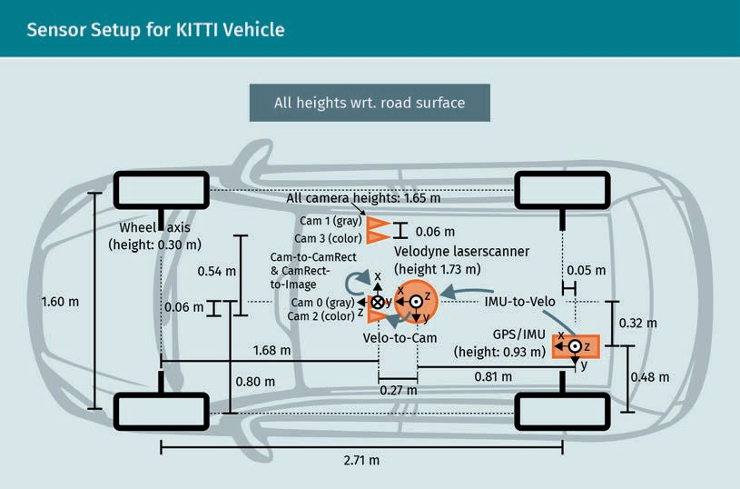

For localization purposes, the combination of GPS and IMU is integrated. Environmental perception is achieved by using one LIDAR, two gray-scale, and two color cameras. RADAR is not integrated in the setup.

In comparison, the vehicle for the nuScenes dataset, as depicted in the following ﬁgure, is equipped with a richer sensor suite containing six cameras, one LIDAR, and ﬁve RADARs to enhance environmental perception (Caesar et al., 2020).

Radial velocity Observed velocity can be differentiated by the radial and the tangential velocity. While the former moves along the direction of observa- tion, the latter is found perpendicular to it.

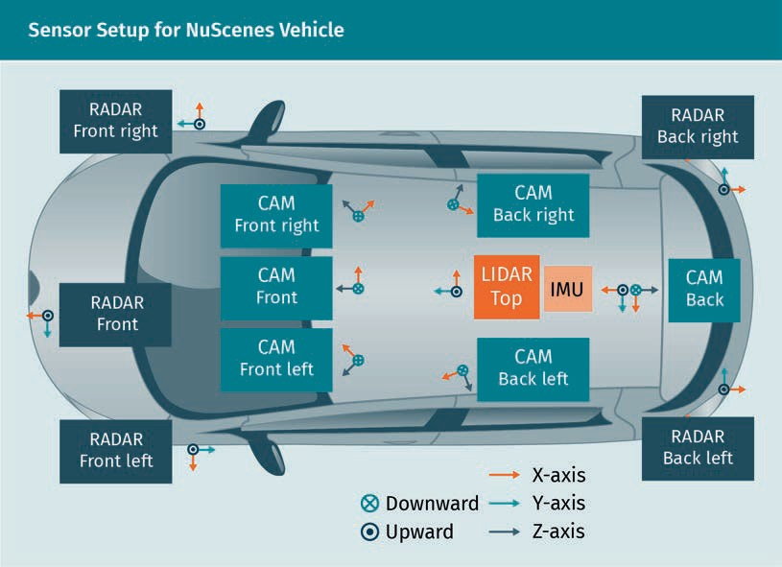

These are only two examples of possible sensor setups used for publicly available datasets. Of course, adaptations to meet one’s own demands must be carried out in order to achieve the desired behavior. Attention must be given to the different coordi- nate systems that are used for self-driving vehicles. The global coordinate system deﬁnes the global position of the vehicle and is needed for global self-localization and global path planning. Different conventions are used, for example, the right-handed Cartesian world coordinate system is the most common convention, which is deﬁned in ISO 8855 (International Organization for Standardization, 2011). Here, the Z-axis points up from the ground. The vehicle, or local, coordinate system communicates with the ego vehicle and all sensor measurements are sent to it. Localization by IMU uses the local frame and thus, a global position in the world cannot be derived without an initial position.

Mostly, the origin of the vehicle coordinate system is on the ground below the center of the rear axis. Positive X-direction points to the driving direction, positive Y-direction to the left, and positive Z-direction to the top. Rotations around the X-, Y-, and Z-axis are called roll, pitch, and yaw, respectively. Positive rotation is indicated clockwise. Gener- ally, in ﬂat environments, only the yaw is important, which is identical to the orienta- tion of the vehicle. In areas with hills, the pitch also becomes important, but the roll can mostly be ignored. Each sensor provides measurements related to its own sensor coordinate system, which must be transformed to the vehicle coordinate system. The position of each sensor on the vehicle is mostly based on the origin of the sensor frame. Properly handling all of the different coordinate systems is essential for the whole functionality of a self-driving vehicle.

Environment Perception

### GPS

Global navigation satellite systems (GNSS) are used for localization and positioning on the earth and in the air by receiving the signals of navigation satellites and pseudo- lites. Pseudolites (contraction of the word pseudo-satellite) are terrestrial transmitters and transmit signals that imitate those transmitted by satellites (Ndili, 1994). For GNSS receivers, these systems are seen as additional satellites and are used to increase the accuracy of GNSSs. While the terms “localization” and “positioning” are often used interchangeably and seem to describe the same thing, there is a difference that must be considered. Localization is determining the location of an object, which has to be equipped with a receiver and a transmitter. By means of the receiver, the position of the object is identiﬁed and transmitted to the seeker by means of the transmitter.

Positioning is only one part of localization and does not need a transmitter. Global nav- igation satellite system is a collective term for several different global satellite systems, such as NAVSTAR global positioning system (GPS) from the United States of America, GLONASS from the Russian federation, Galileo from the European Union, or Beidou from the People’s Republic of China (Petrovski, 2014). Because of the missing feedback chan- nel, the transmitter, those systems are not localization systems, but rather positioning systems. GPS is the most prominent positioning system known for navigation, but it must be clear that it is only one type of global navigation satellite system. It was devel- oped by the US Department of Defense in the early seventies and has been fully func- tional since the middle of the nineties. Initially restricted to military use, it was later made publicly available for civilian applications.

Generally, GNSSs consist of three main components called segments. They are the space segment, the control segment, and the user segment. The space segment repre- sents the satellites, which are orbiting above the earth at an altitude of between 20,000 and 25,000 km in a special constellation to guarantee the desired coverage. GPS speciﬁ- cally consists of 24 satellites, which are depicted in the following graphic.



Each of the satellites transmits microwave signals consisting of multiple components. The sinusoidal carrier frequencies (called L1 and L2), transmitted on 1575.42 MHz and 1227.60 MHz center frequencies respectively, are generated from the fundamental L- band frequency of 12.23 MHz produced by atomic clocks located on the satellites (El- Rabbany, 2002). Therefore, the L-band frequency is multiplied by 154 and by 120 to obtain the L1 and L2 frequencies. The carrier frequencies are modulated by adding digi- tal pseudorandom noise (PRN) codes and a navigation message using a technique called binary biphase modulation, which means that the switching from zero to 1 and vice versa is done by changing the phase of the carrier waves by 180° (Wells & Cana- dian GPS Associates, 1987). This means that the carrier wave is reversed at its zero- crossing every time the digital code changes its state. The modulation principle is illus- trated for the L1 carrier frequency (blue signal) in the ﬁgure below. The digital code that is one part of the modulation of the L1-frequency is called coarse-acquisition (C/A) code (green signal) and is transmitted at 1.023 Mchip/s, meaning a wavelength of 1 ms and thus a repetition of the code every millisecond. As previously mentioned, the C/A code is a pseudorandom noise and each satellite has a PRN that has a low correlation

Environment Perception

with the PRNs of the other satellites. Thus, the orthogonality of all PRN codes is very high. The navigation message (red signal) itself is transmitted at 50 Bit/s and contains information about the position and velocity of the satellite, known as ephemeris, its health status, clock bias, and the almanac, which contains low resolution orbital infor- mation (Powell, 2013). The almanac is not needed, but it helps to ﬁnd the satellite sig- nals when starting the receiver by narrowing down the search area. In comparison to the ephemeris, the almanac is less accurate but valid for a longer time. A modulo-2 addition of the navigation message and the C/A code is done before the carrier fre- quency L1 is modulated, which means that an equal message bit and C/A code bit, also known as a chip, results in a zero and a one if they differ. The L1 frequency is then modulated by the resulting bit stream in the above-mentioned manner to obtain the complete GPS signal of one satellite.

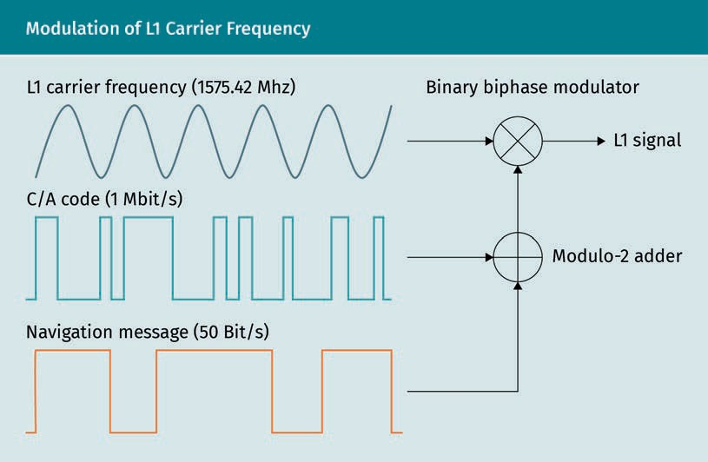

The navigation message is 1500 bits long and is subdivided into ﬁve frames, each one being 300 bits long and divided into ten words consisting of 10 bits. Theoretically, it would need 30 seconds for a transmission but in fact, it takes 750 seconds. This is because subframes four and ﬁve are sub commuted and contain pages one to 25 of the 25-page long almanac, which is 15,000 bits long. The following table shows the struc- ture of the navigation messages.

Orthogonality

The orthogonality of functions is deﬁned via the inner prod- uct. Two signals are orthogonal if they are uncorrelated.

Ephemeris

The word ephemeris comes from the Greek, meaning diary or journal, and is used because posi- tions were given as printed tables of val- ues in ancient times.

|  |  |  |
| --- | --- | --- |
| Structure of GPS Navigation Message | | |
| Subframe | Word | Description |
| 1 | 1—2 | Telemetry and handover words |
| 3—10 | GPS date (week number), satellite clock correction information, satellite status, and satellite health |
| 2—3 | 1—2 | Telemetry and handover words |
| 3—10 | Satellite’s ephemeris data |
| 4—5 | 1—2 | Telemetry and handover words |
| 3—10 | Almanac |

Ionospheric effect When a signal com- ing from a satellite passes through the atmosphere of the earth, its speed changes due to refraction and dif- fraction, resulting in non-constant delays.

The telemetry word sent at the beginning of each subframe signals the beginning of a subframe and the handover word contains the GPS time when the ﬁrst bit of the next subframe will be sent. While the C/A code is used for civilian applications, the second digital PRN code (the restricted precision/encrypted (P/Y) code) is reserved for military purposes and is not publicly available. Both carrier frequencies are modulated with the P/Y code, and ionospheric effects can be deducted to obtain higher accuracies. Gener- ally, the L2 carrier frequency is only modulated by the P/Y code, but the C/A code can be added if desired. The navigation message itself is equal for both the L1 and L2 sig- nal. Because this code currently has no purpose for civilian autonomous vehicles, we will not include further details at this point. A third carrier frequency (L5) is currently being built for civilian use. It will be used mainly for aerospace and rescue services as safety-of-life (SoL) data signal. The L2 frequency is used for nuclear detonation detec- tion system payloads to enforce nuclear test ban treaties and L4 is considered for addi- tional ionospheric correction (Penttinen, 2015).

An interesting fact is that the selective availability (SA) was directed by the Department of Defense to intentionally corrupt the GPS system clocks and the ephemeris, resulting in much lower positioning accuracy than theoretically possible. This was done because much better positioning results than expected were being calculated, so by lowering the positioning accuracy, it was possible to deny full accuracy when questioned by unauthorized people (El-Rabbany, 2002). A worldwide infrastructure of tracking stations with a master control station (MCS) located at Colorado Springs in the US builds the control segment of the GPS system. The purpose of this segment is to track the satel- lites and determine their location, almanac, and atmospheric data (El-Rabbany, 2002). While the L-band is used to transmit data from satellites to the control network, the S- band is used to upload data from the control stations to the satellites. During normal operation, a new almanac is transmitted at least every six days using this process.

Environment Perception

The third and ﬁnal segment of the GPS system is the user segment, which consists of all GPS receivers and antennas that receive the L-band GPS signals to execute the posi- tioning task. Therefore, the estimated distance between the receiver and the satellites is calculated by multiplying the transit time with the velocity of light. These calculated distances are called pseudo ranges and have errors due to receiver clock inaccuracies. Because these errors are equal for all observations, they can be deducted by means of the navigation equations. These equations are used to determine the pseudo range errors and thus lead to the real position determination of the GPS receiver. To ensure accurate position estimation, at least four satellites should be taken into consideration for GPS positioning. The navigation equations for four satellites can be formulated as

X − R 2 + Y − R 2 + Z − R 2 = P − c · ∆T 2

1 X 1 Y 1 Z 1 B

X − R 2 + Y − R 2 + Z − R 2 = P − c · ∆T 2

2 X 2 Y 2 Z 2 B

X − R 2 + Y − R 2 + Z − R 2 = P − c · ∆T 2

3 X 3 Y 3 Z 3 B

X − R 2 + Y − R 2 + Z − R 2 = P − c · ∆T 2

4 X 4 Y 4 Z 4 B

( 2.1 )

The parameters RX, RY, and RZ represent the X-, Y-, and Z-position components of the GPS receiver. Xi, Yi, and Zi are the X-, Y-, and Z-position components of the i-th satellite and Pi the exact distance between receiver and the i-th satellite. The receiver’s clock bias from the GPS satellites clocks, which are assumed to be much more accurate and synchronized for all satellites, is represented by ∆TB, and c is the velocity of the light (Rahemi et al., 2014). Here, it becomes clear why at least four satellites are needed for position determination. One equation consists of four unknown variables RX, RY, RZ, and ∆TB, meaning that four equations are needed to solve the equation system. Dif- ferent approaches exist for the calculation of the parameters such as method of least squares, iterative methods like the Gauss-Newton algorithm, closed-form solutions like Bancroft’s method and observation weighting models (Rahemi et al., 2014; Bancroft, 1985; Marais & Tay, 2013). While originally, positioning was done using only one type of GNSS, there are many studies regarding multi-constellation global navigation satellite systems to improve positioning accuracies (Cai et al., 2015; Tegedor et al., 2014; Li et al., 2015).

### Inertial Sensors

Inertial measurement units (IMUs) are an interesting way to measure both translational and rotating motions in all directions; they can capture all six kinematic degrees of freedom and are the sensory part of inertial navigation systems (INS), which ﬁnds

application for ﬂight navigation in airplanes and rockets, motion detection in robotics, and self-localization in self-driving vehicles. In comparison to GNSSs, which need a connection to the external world, IMUs are independent from the environment and belong to the group of proprioceptive sensors. The independence from the external world enables localization when environmental conditions are not ideal for the func- tionality of other positioning sensors, such as GNSS. Conditions where GNSSs fail to operate include tunnels and high buildings, which can lead to a loss of knowledge of the ego-position. IMUs do not suffer from such a problem because they measure the vehicle’s kinematics directly without external signals.

IMUs usually consist of two types of inertial sensors: acceleration sensors, also called accelerometers, and rotational sensors, also called angular rate sensors. Other compo- nents of an IMU are three accelerometers to detect translational motions in X-, Y-, and Z-direction and three angular rate sensors to measure angular velocities around the three axes. The following ﬁgure shows the principle structure of an IMU.

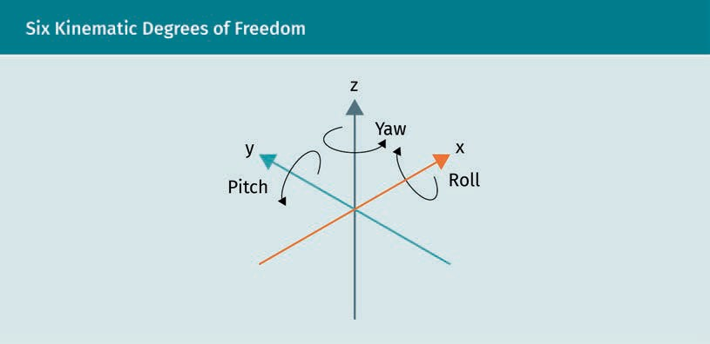

As previously mentioned, positive X-direction points to the driving direction, positive Y- direction to the left, and positive Z-direction to the top. Rotations around the X-, Y-, and Z-axis are called roll φ, pitch θ, and yaw ψ, respectively. Positive rotation is indicated clockwise for all components. The intention of localization is to determine the pose in which the vehicle is positioned at the moment of measurement. This is also known as pose estimation. Accelerometers measure accelerations while angular rate sensors measure the angular velocities, so how do we obtain the pose from those measure- ments or, more mathematically expressed, how do we obtain the state vector

sx sy

x = sz

φ

θ ψ

Environment Perception

from the measurement vector

s¨x s¨y

x = s¨z

φ˙

θ˙ ψ˙

The basic principle is based on the fact that both outputs, acceleration and angular velocity, are derivatives of the position (second derivative) and the angle (ﬁrst deriva- tive), respectively. Thus, sx, sy, and sz can be obtained by integrating the acceleration components s¨x, s¨y, and s¨z twice. The calculated pose is only related to a particular ini- tial pose, which has to be ﬁxed. Because of this, the inertial navigation system alone is not capable of global navigation and has to be combined with sensors that give initial pose estimations such as GNSS. The procedure for the translational components is also used to determine the rotational components; however, it has one single integration step because angular rate sensors deliver ﬁrst-order derivatives of the position. Next, the general physical principles of the two main components of an IMU, the accelerome- ter and the angular rate sensor, will be presented.

###### Accelerometer

Accelerometers are sensors used to measure the inertial acceleration, also called the speciﬁc force, in a speciﬁc direction. There are different measuring principles used for this, which mostly rely on Newton’s law of inertia. This law is as follows (Newton, 1833):

F = m · a

( 2.2 )

F, m, and a represent the force, mass, and acceleration, respectively. The ﬁrst setups that were developed consisted of a sensitive axis, on which a seismic sprung mass was mounted to move over a slide resistance. Those systems were later replaced by more precise implementations such as quartz ﬂexure suspension technology (Q-ﬂex) or mag- netically stabilized mass (Foote & Grindeland, 1992). The ongoing process of miniaturi- zation needed for most technical applications results in setups relying either on the piezoelectric principle, where dynamic pressure ﬂuctuations are converted to electrical signals, or micro-electro-mechanical systems (MEMS), which are micrometer sized spring-mass-systems (Tadigadapa & Mateti, 2009). An understanding of the physical principle can be obtained from the following illustration.

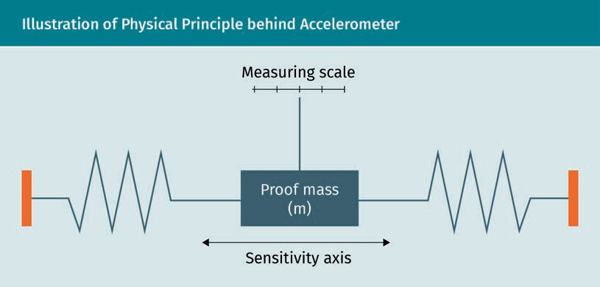

As previously mentioned, an accelerometer can be seen as a weight, called the proof mass, which is located between two springs. Linear acceleration along the sensitivity axis, the direction in which the mass is allowed to move, results in a compression of one of the springs due to Newton’s ﬁrst law, the law of inertia. Thus, the proof mass wants to stay at its place to remain at rest. The acceleration applied along the sensitiv- ity axis is proportional to the amount of compression of the particular spring and can be measured using different principles, such as slide resistors. The following ﬁgure shows the principle of applied acceleration.

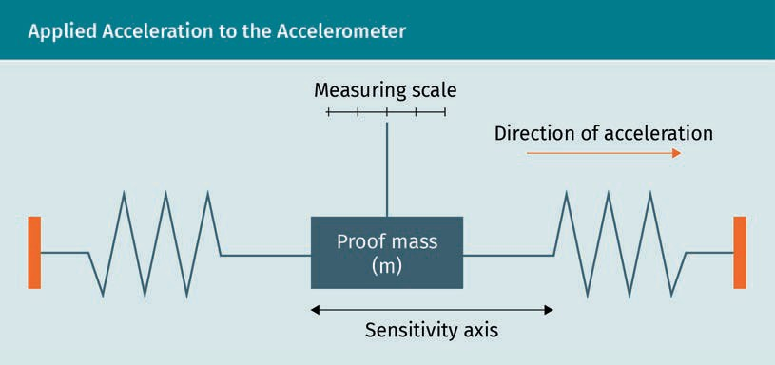

A rotation of the setup of 90°, so that the sensitivity axis is aligned with the direction of gravity, leads to a pseudo-acceleration due to gravity. This means that acceleration is measured without any change to the velocity and position. Thus, the measurement out- put of the accelerometer consists of the sum of linear acceleration and pseudo-accel- eration, which has to be considered for interpretation of the results. Inertial measure- ment units consist of three almost perfectly orthogonal accelerometers, which, together, are called a triad. Using that setup, the three existing acceleration compo- nents can be measured.

Environment Perception

###### Angular Rate Sensor

In addition to the measurement of linear accelerations by the three accelerometers, the three rotational components around the three motion directions can be measured using angular rate sensors. As for the accelerometers, there are many different princi- ples used for the measurement of the angular rate, such as ring laser gyroscopes, ﬁber optic gyroscopes, electromechanical sensors, and vibrating structure gyroscopes (Fan et al., 2011; Culshaw & Giles, 1983; Wu & Wood, 2004; Langmaid, 1996). Vibrating structure gyroscopes have become very prominent in recent years because of low production costs and a simpler functional principle than conventional rotating gyroscopes. The physical principle behind that is the Coriolis force, which is applied to a vibrating mass (Persson, 1998). The following ﬁgure depicts the functionality of one possible imple- mentation of the vibrating structure gyroscope.

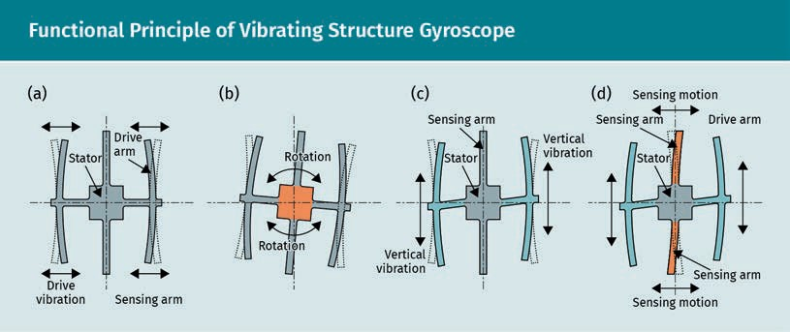

The setup consists of a stator, two drive arms, and a sensing arm. Without applied angular velocity, the drive arms vibrate horizontally (a). If a rotation, and thus an angu- lar velocity, is applied to the system (b), the Coriolis force causes vertical vibration of the driving arms (c), which leads to a bending of the stator and ﬁnally to a motion of the sensing arm (d). Analogous to the accelerometer setup, three angular rate sensors are used orthogonally to each other to enable the measurement of every possible rota- tion. As previously mentioned, both main components of an IMU—accelerometer and angular rate sensor—measure derivatives of the translational and rotational motions, respectively. Thus, the ﬁnal parameters are obtained by integration as shown in the fol- lowing block diagram.

Corriolis force

The Corriolis force leads to a deﬂection of a mass perpendic- ular to the direction of movement, when moving on a rotating reference system.

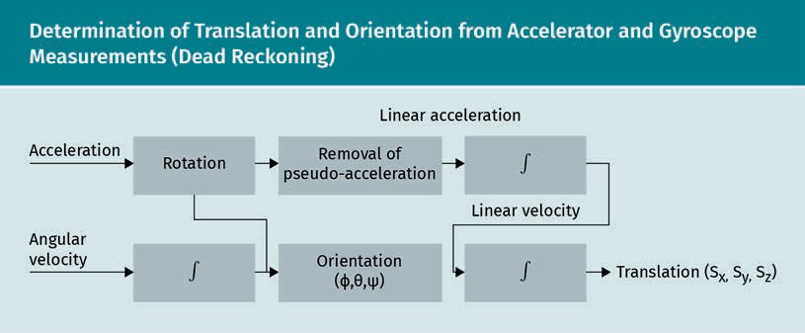

Bias A bias is the pres- ence of a constant value that is super- imposed to a signal.

Heading The heading is the direction in which the vehicle’s “nose”

is pointed.

The process is called dead reckoning and consists of integration and correction steps. First, the rotational components are determined by integrating the angular velocities. The output then rotates the measured accelerations and obtains the acceleration com- ponents in the direction of the reference frame by multiplying the inverse of the rota- tion matrix containing the three orientation angles. Afterwards, the pseudo-accelera- tion caused by gravity is removed and the ﬁnal translational components are obtained using double integration. Due to several integrations relating to time, any errors in the measurements also grow over time (Kok et al., 2017). Generally, accelerometers and angular rate sensors suffer from biases (Tereshkov, 2013). Due to integration, a constant bias in acceleration becomes a linear error in the velocity and a quadratic error in the translation. A constant bias in the angular velocity becomes a linear error in the orien- tation and, because the orientation is used for transforming the acceleration compo- nents to the reference frame, a cubic error in the translation. This effect is called bias drift and, without error correction, the IMU measurements become useless. While Kal- man ﬁlters are preferable for bias estimation, several different approaches exist, such as the inclusion of magnetometers (Lee et al., 2016; Wittmann et al., 2019). By sensing the ﬁeld strength relative to the Earth’s magnetic North, information about the vehicle’s heading can be gained and the accelerometer can be used by fusion algorithms to improve state estimation accuracy.

### LIDAR

Perceiving the environment is the ﬁrst and probably the most critical step within the software stack of self-driving vehicles. For this task, several different exteroceptive sen- sors are used, each of which have their own advantages and disadvantages. Two rela- ted technologies are LIDAR and RADAR, which will be presented in the following sec- tions.

LIDAR systems use optical signals with wavelengths around the near infrared range to measure distances. The general physical measurement principle emits light and meas- ures the time delay between emission and reception, which is known as time of ﬂight

Environment Perception

principle. Two different techniques are most commonly used for the measurement: the pulsed and the continuous wave amplitude modulated approach. The following graphic shows both measurement approaches in principle.

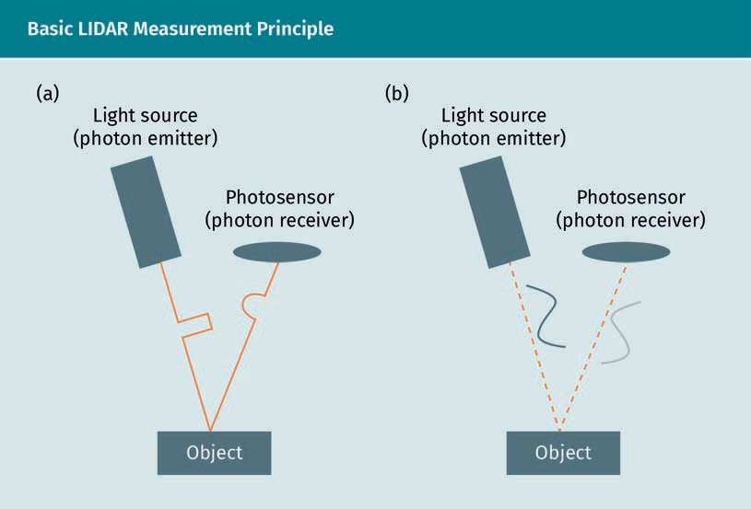

The ﬁrst main component of LIDAR systems is the emitter, which is shown in the ﬁgure as an electronically controllable photon emitter (a light source that emits light pulses). While the main technology used in the past was the pulsed laser diode operating at a wavelength of approximately 950 nm, recent years have led to the use of infrared (IR) LEDs, which are eye-safe under all conditions. Lower electrical power consumption and easier control are two advantages of infrared technology. The second main component of LIDAR systems is the photon receiver, which captures the photons reﬂected by an object and converts them into electrical signals. Two main types of photon receiver are used: the positive-intrinsic-negative (PIN) photodiode and the silicon avalanche photo- diode (APD) (Doherty, n.d.; Tsang, 1985). In simpler terms, PIN diodes rely on the photo- electric effect and create hole-electron pairs, otherwise known as charge carriers, which generate a photocurrent. The sensitivity is quite low, meaning that a higher num- ber of photons are needed for proper measurement. By comparison, the photoelectric effect in silicon avalanche photodiodes is supplied by an electric ﬁeld that leads to more hole-electron pairs due to the acceleration of the charge carriers, which is known as impact ionization (Märk & Dunn, 1985). This effect results in increased photon sensi- tivity, meaning that a single photon can create a high number of hole-electron pairs, which can be measured as a higher photocurrent. Avalanche photodiodes are often used in arrays, a combination of multiple photodiodes, to increase the resolution.

Infrared

The infrared spec- trum consists of wavelengths that are longer than those of the visible light. The range extends from 700 nm to 1 mm.

How are the emission and reception of photon impulses used for a measurement of range? The time difference between emitting and receiving time can be measured with the setup. That is where the name of the principle time of ﬂight comes from. We meas- ure the time that it takes for the photons to “ﬂy” from emitter to receiver. The distance that a light impulse travels from one point to another can be calculated by the product of the time of ﬂight and the light velocity d = tof · c. However, in the case of LIDAR, the light has to travel from the emitter to the reﬂecting object and then back to the receiver. Assuming the same distance between emitter and object and receiver and object, the calculated distance has to be divided by two to obtain the ﬁnal distance:

d = tof · c

2

( 2.3 )

Signal noise and jit-

ter While jitter means the variation of the timing of a signal from its nominal value, noise is the variation of the amplitude from its

nominal.

We will now look at an example. You measure a time of ﬂight of 40 ns (nanoseconds)

between emitting and receiving. Multiplying the time by the velocity of light, 3 · 108 m , and dividing the product by two, we obtain a distance of 6 m. The calculated distance is

s

directly proportional to the measured time, hence, the distance resolution ∆d directly depends on the resolution of time measurement ∆tof, which is affected by several fac- tors such as noise and jitter within the time counting electronics (Royo & Ballesta-Gar- cia, 2019). Values in the 0.1 ns range are common for current technologies, which ena- bles resolutions of approximately 1.5 cm (Royo & Ballesta-Garcia, 2019). The maximum range that can be measured is affected by the fact that the photons lose energy during their travel. Practically, the signal-to-noise ratio (SNR) of the reception circuit (weaker reﬂected signal versus noise and jitter in detection circuit due to high bandwidth) is the limiting factor. For a detailed study of this topic, the interested reader is referred to Koskinen et al. (1992).

Until now, we only talked about the pulsed measurement principle. How can the con- tinuous wave amplitude modulated approach be compared to that? Instead of using single light pulses, continuous light waves are used. The principle behind this is called continuous wave (CW), phase-measurement, or amplitude-modulated continuous-wave (AMCW) (Royo & Ballesta-Garcia, 2019). Therefore, a continuous sinusoidal or square wave of constant modulation frequency fm is emitted and, after reﬂection, the phase- shift ∆Φ between emitted and received signal is measured to obtain the distance to an object. The equation for the calculation of the distance d can be derived from the rela- tion between phase shift, total distance dt, and wave number km

� Φ = km

·d = 2d · 2πfm

c

( 2.4 )

Transposing the equation leads to

d = � Φ ·c

4πfm

Environment Perception

( 2.5 )

Let us also examine an example for that approach. Assume that our phase detector cir- cuit detects a phase shift ∆Φ of π with a used frequency f of 5 MHz. Inserting the val-

m

3

ues into the equation leads to a distance of 5 m between LIDAR and an object. It is

obvious that the phase-shift repeats itself every 2π due to the frequency of sinusoidal

or square wave modulated signals. Thus, a detected phase of � Φ = π

could also be a

shift of 7π or 13π

3

. The resolution of the (AM)CW approach depends on the emitted fre-

3 3

quency and the resolution of the phase shift detection electronics. Higher frequencies lead to a higher resolution but also to a shorter unambiguous range, which means that the phase-shift repeats itself after a shorter range. Hence, a tradeoff between maxi- mum non-ambiguous range and measurement resolution has to be made. Common setups use frequencies of a few tenths of a MHz (Royo & Ballesta-Garcia, 2019).

We have discussed the static time of ﬂight measuring and hence, the measurement of the distance in a particular direction of the emitted light. This may be sufﬁcient if the location of a target is known and the surrounding environment is of no interest. In most applications, especially in the area of self-driving vehicles, accurate and reliable environmental perception is essential. For that task, conventional LIDAR systems con- sist of an optical ﬁxture, galvanometers, or derivations with spinning mirrors, to move the light beams around (Lindley, 2004). These are called scanning LIDARs. Instead of spinning the laser itself, mirrors are used for emission into particular directions, either around the full 360° circle or back and forth over a particular range of interest. The fol- lowing ﬁgure shows different exemplary setups for the scanning process.

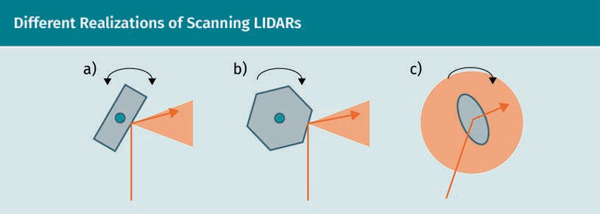

The main realizations of laser beam deﬂections are the oscillating (a), the rotating pol- ygon (b), and the rotating slant mirror (c). Each one has its own scanning range, which is generally less than 90° for the oscillating and the rotating polygon and 360° for the rotating slant mirror. A detailed overview of different scanning approaches can be found in Kukko (2013). Both two-dimensional (2D) and three-dimensional (3D) LIDAR systems exist—the 3D systems mainly consist of multiple layers of 2D-LIDARs. For self- driving vehicles, a 2D-LIDAR in the bumper, for example, helps to obtain basic distance measurements of obstacles that are located at the same height. In comparison, 3D- LIDARs on the roof have a much greater impact. With these, it is possible to perceive a huge part of the environment, including lanes, and build up a detailed three-dimen- sional environmental representation.

Galvanometer

A galvanometer gen- erates a mechanical rotational motion proportional to an electrical current.

In addition to the scanning LIDAR, a new principle has been investigated in recent years. The ﬂash LIDARs work without moving the emitted light and instead, they work like a camera. Light is emitted to and received from all directions of the ﬁeld of view at the same time, so this technology does not suffer from time delays between two meas- urement directions. Let us have a look at the two principles.

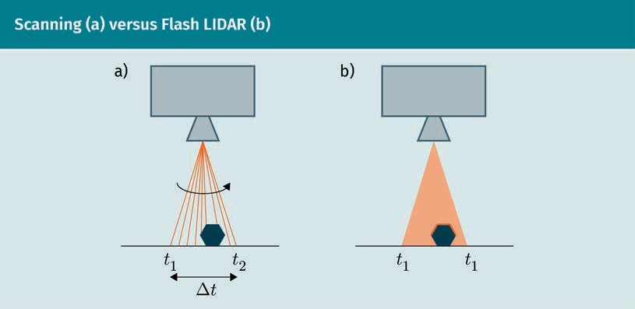

The scanning LIDAR can be seen on the left side of the ﬁgure above. As previously dis- cussed, the laser beam is moved to scan a range starting at the time t1 and ending at the time t2. Naturally, a time difference ∆t occurs because of the ﬁnite motion speed of the interior apparatus to move the beam. While this has no negative effects for static objects, this can lead to errors when objects are moving with a high velocity. In con- trast, ﬂash LIDARs emit the light in all directions at the same time. As a result, there is no time difference between two measurements and thus no negative effects when measuring moving objects. Until now, the ﬁeld of view of ﬂash LIDARs is still smaller than that of scanning LIDARs and, as of August 2020, no system can capture 360°. At this time, the widest vertical ﬁeld of view is 75 degrees, achieved by the Osprey LIDAR from Sense Photonics (Sense Photonics, 2020). We must await further developments to eval- uate the impact on applications such as autonomous driving.

LIDAR systems generate point clouds, which generally consist of, at least, position and intensity values. Intensity values give information about the strength of the reﬂected light. Due to the measurement principle of measuring the distance related to a particu- lar angle, the measurement space is more precise in polar coordinates, which has to be taken in to account when considering associated uncertainties for object tracking (Gie- fer et al., 2020a).

### RADAR

RADAR technology was developed much earlier than LIDAR and makes use of a similar principle with different electromagnetic waves. In comparison to laser beams, RADARs use radio waves or microwaves to measure distances and velocities. Two types of

Environment Perception

RADAR can generally be considered: monostatic and bi-static. The emitting (transmitter) and receiving (receiver) aspects are collocated monostatic RADAR, while they are sepa- rated in bi-static RADAR. Modern RADAR transmitters use semiconductors to generate and emit waves but originally, Magnetrons were used (Meikle, 2008; Hull, 1923). The main modulation approaches are, as for LIDARs, the pulsed wave approach, the contin- uous wave approach, and the frequency modulated continuous wave (FMCW). The measurement principles for the pulsed and continuous approaches can be directly translated from LIDAR technology. RADARs using FMCW also transmit continuous waves but apply a frequency modulation to the emitted waves. Simple continuous wave RADARs have the disadvantage that a distance measurement is technically not possible because of a missing time reference. Instead, they can be used to measure velocities in a known azimuth; a typical application is trafﬁc speed measurement. By modulating (linear increasing) the frequency of the emitted signal, a time reference is created and thus, a received signal shows a time difference as for the pulsed approach. This time difference is obtained from the discrepancy of the frequency deviation’s linearity and used to calculate the distance. The following ﬁgure shows the process in principle.

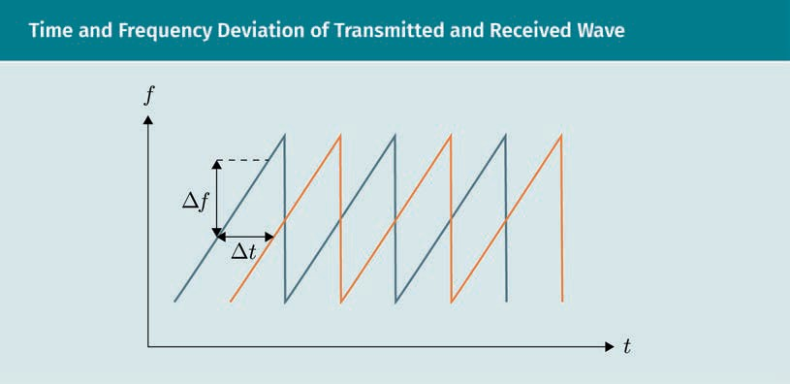

The diagram shows the transmitted (blue) and received (orange) frequency over time and must not be mixed up with the signal’s amplitude over time. Generally, the dis- tance of an object can be calculated using the following equation:

d = � f ·c

2f˙

( 2.6 )

The differential f˙ indicates the change of the emitted wave’s frequency over time, and

∆f indicates the frequency difference between the emitted and the received signal. When the frequency difference is linear over a particular range, the distance can be directly calculated with that equation. Static objects lead to the same result for a linear rising and a linear falling frequency deviation because only the absolute of the fre- quency deviation can be measured. The true power of this technique is shown for mov-

Magnetron

A Magnetron is a vacuum drift tube used to generate electromagnetic waves in the micro wave spectrum.

Azimuth

The angle between a reference system and the direction from an observer to an object is called azimuth.

ing objects (i.e., objects that exhibit a radial velocity component related to the radar antenna). The radial velocity points in direction of the emitted wave, while the tangen- tial velocity is perpendicular to that. Radial velocities for objects result in a Doppler- frequency fD, which is added to the frequency difference ∆f. In this case, the measure- ment contains the sum of the difference frequency and the Doppler-frequency. The former carries information about the distance and the latter carries information about the (radial) velocity. An object with a radial velocity component pointing away from the RADAR system decreases the echo frequency and leads to a shift of the received fre- quency wave downwards and to the right due to the distance. The following ﬁgure shows the impact of the Doppler-frequency on the received wave in relation to the emission.

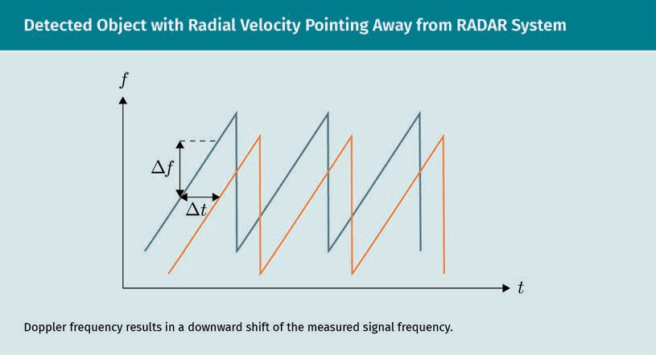

Accordingly, a radial velocity pointing in the direction of the RADAR leads to a shift upwards and thus to an increase of the frequency. There are several approaches that can be used when estimating the Doppler-frequency from the measurement. These approaches are explained in more detail by Skolnik (2007) and Song et al. (2014).

In automotive applications, two categories of RADAR systems are used: long-range RADARs (LRR) and short-range RADARs (SRR). Long-range RADARs work with frequencies of the W band of the microwave part of the electromagnetic spectrum between 76 and 77 GHz, whereas short-range RADARs mostly use the ISM band, also known as the nar- rowband (NB), ranging from 24.0 to 24.25 GHz. The wavelength of a given electromag- netic wave can be obtained by the equation

f = c

λ

( 2.7 )

Environment Perception

where f, c, and λ represent the frequency, light velocity, and the wavelength, respec- tively. Thus, the wavelength of long-range RADARs is approximately 4 mm and the wavelength of short-range RADARs is approximately 12.5 cm. LRRs show a better accu- racy and resolution than SRRs and are used to measure distances and velocities as well as detect objects in their ﬁeld of view, which is generally wider than that of SRRs. While long-range RADARs can cover distances between 10 m and 200 m, the measura- ble distance of short-range RADARs lies between 15 cm and 30 m (Greco, 2012). Both types use different modulation approaches for their purpose in self-driving vehicles. While LRRs use the FMCW modulation, SRRs work with CW modulation. The following ﬁgure shows a possible RADAR setup for self-driving vehicles.

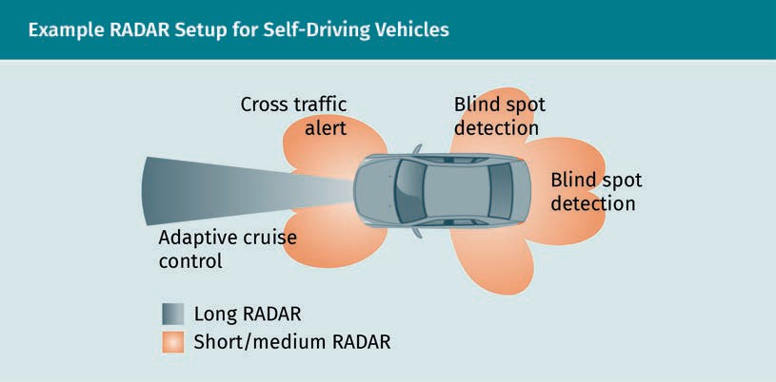

The combination of both RADAR types enables reliable safety coverage around the vehicle for early detection of possibly dangerous situations. By integrating SRRs around a vehicle, tasks such as cross trafﬁc alert, blind spot detection, and rear collision warn- ing can be implemented, while LRRs are responsible for detecting objects that are fur- ther away. Despite the fact that the resolution of LIDAR systems is generally much higher compared to RADAR systems, both technologies have a reason for existence. The ranges and the immediate velocity detection obtained by long-range RADARs is not achievable with current LIDAR technologies. Furthermore, cloudy or foggy weather con- ditions are no problem for RADARs because of the larger wavelengths used. However, the disadvantage is that the detection of small objects is only possible with LIDARs and thus, RADARs are not suitable for an accurate scan of the environment with detailed topology.

### Cameras

The most common type of exteroceptive sensor is the camera, which produces an accu- rate and reliable environmental representation. While LIDAR and RADAR sensors are capable of measuring distances and velocities more or less accurately, cameras can perceive colors and are therefore most suitable for object detection tasks. The key

component of modern cameras is the image sensor, which converts light to electrons, or more precisely, variable attenuation of light waves into electrical current. Modern image sensors mainly rely on two types of technology: the charge-coupled-device (CCD) and the active-pixel sensor (CMOS sensor).

CCD image sensors consist of an array of photodiodes, which are components that con- vert light to an electrical current by means of the photoelectric effect (Vavilov & Ukhin, 1995). The generated amount of charge is proportional to the incident light and the more single photodiodes connected with each other within that array, the higher the resolution of the sensor. To read out the charge of each photodiode cell, vertical and horizontal shift registers are used, which forward the charges sequentially to the out- put ampliﬁer where the ﬁnal signals are generated. In comparison, CMOS sensors con- sist of arrays of pairs of photodiodes and ﬁeld-effect transistors that produce an elec- trical voltage proportional to the incident light. Every cell contains its own ampliﬁer and thus, the charge does not have to be shifted to obtain the signals. Instead, the vol- tages are read out by a selecting transistor (Chouinard, n.d.). The following ﬁgure shows the two technologies in principle.

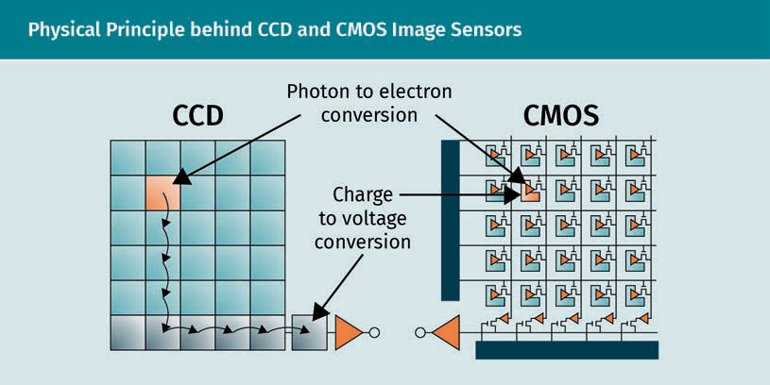

Generally, CCD sensors show lower noise behavior and higher light sensitivity in com- parison to CMOS sensors. The latter suffer from the problem that many photons do not hit the photosensitive area, but rather the transistors, leading to no additional charge. In terms of energy efﬁciency and production costs on the other hand, CMOS sensors are superior. Because of these factors, CCD image sensors are still most commonly used in high-quality cameras while CMOS sensors are mainly found in smartphone or tablets with lower quality requirements. Nevertheless, CMOS-technology is improving rapidly, so we have to wait and see what the future holds.

After having presented the two main basic technologies of image sensors, we now know how light is converted to electric signals. But how do we obtain colors or, more precisely, how can we separate the different wavelengths of incoming light from each other? There are several mechanisms that can carry out the separation. The Bayer ﬁlter,

Environment Perception

for example, uses a color ﬁlter array, where each sensor cell is made sensitive to a par- ticular color component: red, green, or blue. With this method, the photodiodes only react to the wavelength they are made sensitive to. The 3CCD sensor uses three differ- ent image sensors for the three-color channels for each pixel, where the color separa- tion is achieved by means of dichroic prism (Sergiyenko et al., 2020). In contrast to a Bayer ﬁlter, where each pixel is only sensitive to one color channel, 3CCD sensors have three separate image sensors for each pixel. Besides color separation, wavelengths out- side of the visual spectrum become interesting for automotive applications, such as the infrared spectrum, which is used by thermal cameras and is especially interesting when detecting living objects or objects that produce heat. This technology could allow a self-driving vehicle to “see” at night (Thakur, 2018).

Cameras in self-driving vehicles can be set up in different ways. A common example is the surround-view camera, which consists of multiple cameras pointing in different directions to capture different parts of the environment. When this method is used, up to the whole 360° ﬁeld of view can be perceived. The different camera streams with overlapping ﬁelds of view are merged by stitching algorithms to produce a panorama- like high-resolution image. For an overview of common image stitching approaches, refer to Arya (2015). Another common camera setup, the stereo camera, consists of two cameras imitating the human visual system. The two streams enable a depth percep- tion of the environment to allow a car to calculate distances, which is generally not possible with a single camera. Therefore, the environment is captured simultaneously from two perspectives and the images are used for triangulation to obtain the depth value of each pixel. The mechanism can be further improved by projecting structured light, which means that a certain structure is projected to the ﬁeld of view. Using this, the depth of objects can be derived from the structure’s deﬂection (Jang et al., 2013; Giefer et al., 2020b). The process is illustrated in the following ﬁgure.

Dichroic prism

A prism that splits incoming light into two different wave- lengths. A combina- tion of two dichroic prisms is called tri- chroic prism and splits light into three wave lengths.

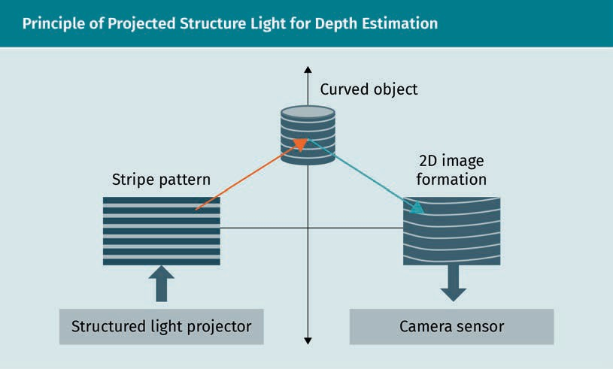

Time of ﬂight (ToF) cameras use the same physical principle as scanning LIDAR systems and are also known as ﬂash LIDARs. By measuring the time difference between emis- sion and reception of light pulses, the distance to objects is calculated. This is done for each pixel, resulting in image data consisting of intensity and depth values.

Generally, it can be said that every exteroceptive sensor used for environmental per- ception has its own advantages and disadvantages, which make them suitable for par- ticular situations and under speciﬁc conditions. The following table summarizes the properties of each technology, where green, yellow, and red represent good, medium, and bad suitability, respectively.

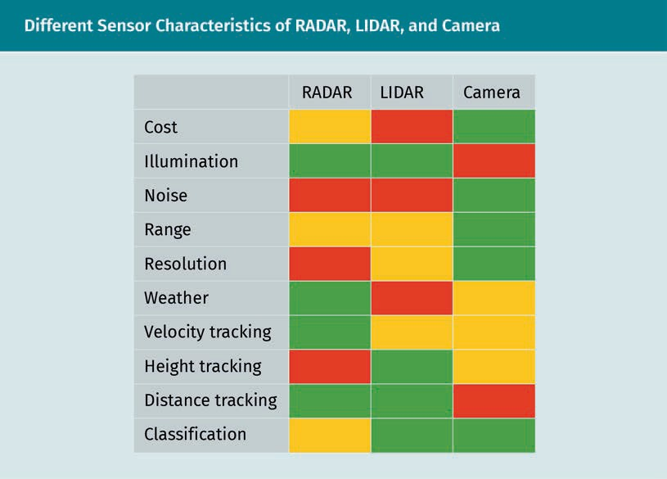

Due to those different sensor characteristics, autonomous driving technology makes use of a combination of multiple different sensors to enable the highest possible accu- racy and reliability. This is enabled by fusion of the information, which can be done at different stages of the data processing. Early fusion is applied to the raw or prepro- cessed data. Preprocessing in this sense does not contain detection algorithms or any- thing similar. It rather means, for example, the clustering process of RADAR-data (Schu- bert et al., 2015). By fusing data at an early stage, low level features and relations between the separate sensor data may be detected that would otherwise go unnoticed by single-sensor algorithms. By comparison, late fusion algorithms fuse the detection outputs of sensor data and generate a common estimation that is more precise than the single ones and has lower uncertainties. Steps between early and late fusion can be applied to all possible stages during the data processing. For a detailed study of sensor fusion, the interested reader is referred to the literature by Ebersbach et al. (2017).

Environment Perception

Summary

There is still no perfect sensor setup used for self-driving vehicles, so every project uses its own. An integration of multiple different sensors uses the strengths of each type to obtain a higher level of accuracy.

For global positioning of a vehicle, global navigation satellite systems are an opti- mal technology. Different variants exist, such as GALILEO, Beidou, GLONASS, and GPS, but GPS is currently the most commonly used. The technology consists of three segments: the space segment, the control segment, and the user segment. The space segment is represented by the satellites, the control segment by a world- wide infrastructure of tracking stations, and the user segment by the GPS receivers all over the world. Two carrier frequencies, L1 and L2, are used for civilian and mili- tary purposes, respectively, consisting of different digital codes and a navigation message.

Inertial measurement units (IMUs) consist of accelerometer and angular rate sen- sors and can be supported by magnetometers. The purpose is to measure the six kinematic degrees of freedom and thus, to determine a relative translational and rotational movement of an object in which it is integrated. Bias leads to a continu- ous drift, which has to be taken care of in order to establish a reliable inertial navi- gation. The combination of GPS and IMU, for example, can be used for ego vehicle localization.

Two related exteroceptive sensors used for self-driving vehicles are LIDARs and RADARs. While LIDARs rely on the emission and reception of light, RADARs use microwaves to determine distances. RADARs are also able to detect radial velocities when using a proper modulation technique, such as the continuous wave or fre- quency modulated continuous wave. LIDARs can be used to generate an accurate representation of the direct surrounding environment of autonomous vehicles with high spatial resolution, but are not suitable for long distances. RADARs, by compari- son, can detect objects that are further away due to the longer wavelengths. They are also not impacted by difﬁcult weather conditions. One disadvantage of RADARs is their lower spatial resolution.

Cameras are the most common type of exteroceptive sensor and are widely used in automotive applications. CCD and CMOS image sensors are the most commonly used technologies. CCDs show lower noise behavior and have a higher light sensi- tivity, whereas CMOSs are cheaper. Cameras in self-driving vehicles can be integra- ted on their own or as compositions such as surround view or stereo cameras.

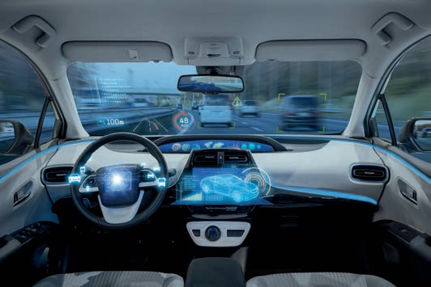

# Unit 3

## Moving, Braking, Steering

#### STUDY GOALS

On completion of this unit, you will have learned …

… the fundamentals of moving, steering, and braking in automated vehicles.

… the different braking technologies that exist.

… how the dynamics of a moving vehicle can be modeled.

… approaches that control the longitudinal and lateral motion of an automated vehicle.

… the possible safety issues that exist when a vehicle is controlled automatically.

DL-E-DLMDSEAAD01-U03

1. Moving, Braking, Steering

### Introduction

In this unit, we will present the fundamentals of automated vehicles’ motion genera- tion, including moving, braking, and steering. First, we will discuss control technologies that are used, including X-by-wire systems. Then, we will explore the different dynamic vehicle models that are used, which can be divided into longitudinal, lateral, and verti- cal models. An explanation of different braking technologies and an exemplary longitu- dinal and lateral motion control will complement this unit and build the foundations to implement control algorithms for one’s own applications. At the end of the unit, a short overview of possible safety issues will be presented.

### Fundamentals

The control of self-driving vehicles can be seen as the counterpart of the perception. Both of them act with the external environment but in different ways. While the former works as the input interface and gathers as much useful information as possible, the latter is the output and generates movements such as braking, steering, gear-shifting, and accelerating using different kinds of actuators. It is obvious that the performance of the control system is highly dependent on the preceding modules because it is only the executor of actions that were planned beforehand in the trajectory planner based on perceived information. Several existing vehicles with different levels of automation already contain systems for automatic control such as cruise control for the throttle, adaptive cruise control for throttle, and brakes or lane keeping assistants for control- ling the steering wheel. But what happens when we achieve level 5 automation and the driver becomes a passenger with no chance to intervene? Can the self-driving vehicle take over physical systems that were originally controlled by humans, such as the steering wheel or the brakes?

X-by-wire systems play an essential role in establishing high automation levels (Kelling & Leteinturier, 2003). The term refers to the replacement of mechanical or hydraulic control systems like steering (steer-by-wire), braking (brake-by-wire), and gear-shifting (shift-by-wire) with electrical or electro-mechanical ones (Wilwert et al., 2005). While shift-by-wire already ﬁnds application in many present vehicles and may be the least critical to safety, other X-by-wire systems have a higher safety-requirement because system failures can directly cause accidents. In 2013, steer-by-wire systems were inte- grated into the Inﬁniti Q50 and Q60, but customers did not widely accept them due to safety concerns (Orlov et al., 2019). A drive-by-wire system, a combination of multiple X- by-wire systems such as brake-by-wire and steer-by-wire, called Flex-0 was developed by AB Dynamics and integrated by Volvo in 2018 to enable direct driving through the controller area network (CAN)-bus without any human control. It can safely be stated that it will be essential to establish safe and reliable X-by-wire systems for self-driving vehicles.

Moving, Braking, Steering

Safety is highly dependent on redundancy, which can be established in two different ways: fail-safe and fail-operational. Most current safety systems in vehicles have a sys- tem state, which is there in case of an overall system failure and does not cause any risk. These are called fail-safe systems and only know two states of the underlying con- trolled system, which is also known as fail-silent: either it shows a fault-free operation or a total failure. This can be implemented for systems where a shutdown is harmless, such as electrically assisted power-steering, where steering can still be done mechani- cally. Systems where a shutdown leads to danger because safety criteria cannot be maintained need an emergency operation in case of a system failure and are called fail-operational systems. When a failure occurs, the remaining part of the system should continue to work to prevent dangerous situations. These systems are essential for self-driving vehicles, because human intervention will no longer be possible. Thus, there always has to be a redundant functionality, which can be established by different redundancy techniques. Structural redundancy, for example, is characterized by the extension of the system by additional similar components such as multiple processors, memory, sensors, and actuators. Functional redundancy, on the other hand, means the integration of multiple different components. Through this, the same functionality is achieved using different approaches. Information redundancy is the use of additional information such as checksums to gather redundant information. The time needed to execute functional redundancy is called temporal redundancy, e.g., the time to calcu- late error codes or checksums. Detailed information about redundancy techniques can be found in Echtle (1990).

### Dynamics of a Mobile Vehicle

Before examining the different motion techniques, it is necessary to understand how a vehicle behaves and reacts to driver inputs. The study of this ﬁeld is called vehicle dynamics and can be divided into three main categories: longitudinal dynamics, such as propulsion and braking, lateral dynamics, such as steering, and vertical dynamics, such as suspension (Jacobson, 2016). The following table shows the topics covered by the different parts.

Controller area net- work

The controller area network (CAN) is a serial bus system, which is the stand- ard for communica- tion within vehicles.

|  |  |  |
| --- | --- | --- |
| Topics of Different Parts of Vehicle Dynamics | | |
| Longitudinal vehicle dynamics | Lateral vehicle dynamics | Vertical dynamics |
| Driving resistances | Steering | Axle and suspension |
| Driving performance | Driving agility | Comfort behavior |
| Acceleration | Oversteering, under- steering | Driving in uneven roads |

|  |  |  |
| --- | --- | --- |
| Longitudinal vehicle dynamics | Lateral vehicle dynamics | Vertical dynamics |
| Braking | Lateral tire behavior |  |
| Fuel consumption |  |  |
| Emission |  |  |
| Longitudinal tire slip |  |  |
| Propulsion layout |  |  |

###### Longitudinal Vehicle Dynamics

All forces that act on a moving vehicle along the axis of driving direction are covered by the longitudinal vehicle dynamics. The following ﬁgure gives an overview of the differ- ent physical quantities.

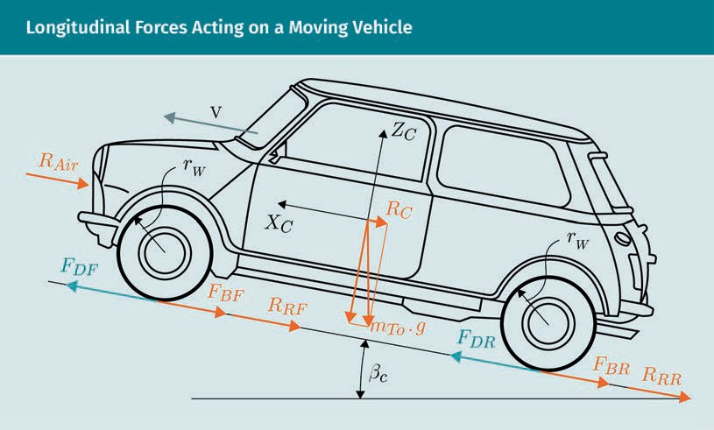

The driving direction and velocity are characterized by xc and v, respectively, and the climbing angle, the angle between driving direction and ground plane, is represented by βc. Gravity force FG of the vehicle is determined by the product of vehicle mass mTo and gravitational constant g. FDF and FDR represent the driving forces acting on the front and rear of the vehicle, respectively, while the braking forces FBF and FBR act in

Moving, Braking, Steering

the opposite direction. The wheel radius is shown by rw and resistances that occur are the rolling resistances of the front RRF and rear tires RRR, which we summarize in the following as RR, the aerodynamic drag RAir, and the climbing resistance RC.

To calculate the generalized vehicle mass m*, we ﬁrst have to calculate the drivetrain moment of inertia, Ij, of each wheel, j, which consists of the moments of inertia of the wheel, Iwj, the gear box, Ig, and the engine, Ie. The equation is as follows:

I = I

+ i2

Ig + i 2 Ie

j wj

fj 2 g 2

( 3.1 )

Here, ifj and ig represent the transmission ratio of the ﬁnal drive and of the gear box, respectively. The generalized mass can now be calculated by the sum of vehicle mass and drivetrain moments of the wheels divided by the squared wheel radius rw, which is assumed to be equal for the front and rear wheels. The equation is as follows:

m* = mTo +

∑Ij 2

W

r

( 3.2 )

By assuming equal moments of inertia for both front and rear wheels, we can simplify equation 3.2 to

m* = mTo

+ 2 IF + IR

W

r

2

considering that

∑Ij = 2IF + 2IR

where IF and IR represent the moment of inertia of a front and a rear wheel, respec- tively. We will now introduce the equations to obtain the driving and braking torque from the respective forces. The equation for driving torque is

MD = rW FDF + FDR

( 3.3 )

and the equation for brakng torque is

MB = rW FBF + FBR

( 3.4 )

Neglecting slip, the simpliﬁed longitudinal vehicle model can now be described by the following equation using Newton’s second law:

m* · x¨ = MD − MB − R − R − R

rW R Air C

( 3.5 )

where x¨ is the second derivative of the translation in the x-direction with respect to time, thus the longitudinal acceleration. In our model, we assume that there are no los- ses between the engine and the ﬁnal driveshaft, so the driving torque is proportional to the engine torque with the gearbox ratio RG as the factor. The same proportionality factor exists between the wheel and engine speed, demonstrated in the following equations:

ME = RG · MD

( 3.6 )

ω = RG · ωE

( 3.7 )

Replacing the driving by the engine torque results in the following equation:

rW · RG · m* · x¨ = ME − RG MB + rW RR + RAir + RC

( 3.8 )

The climbing resistance can be obtained by multiplying the gravity force FG by the sine of the climbing angle βc. The equation is as follows:

RC = FG · sinβc = mTo · g · sinβc

( 3.9 )

Aerodynamic drag The aerodynamic drag, also known as aerodynamic resist-

ance, is a force that

The aerodynamic drag results from the aerodynamic resistance factor cAir and the lon- gitudinal airﬂow surface AF (which are different for each vehicle), the air density ρAir, and the velocity of the vehicle v. The equation is

cAir · AF · ρAir ·v · v

acts in the oppo- site direction to the relative motion of an

object.

RAir = 2

( 3.10 )

Moving, Braking, Steering

To approximate the rolling resistance, the rolling resistance factor cR can be incorpora- ted as follows:

RR ≈ cR · mTo · g · cosβc · sign(v

( 3.11 )

With these equations, the motion of a vehicle can be described simply. In reality, fac- tors such as the friction potential on the road, tire contact, longitudinal slip, and accel- eration noise distort the values and have to be taken into consideration for detailed calculations (Bernsteiner, 2016).

###### Lateral Vehicle Dynamics

Lateral vehicle dynamics cover motions and underlying forces perpendicular to the driving direction, exploring topics such as steering, including over- and understeering, driving agility, and lateral tire behavior. Often, the bicycle model is used to model the lateral dynamics, which can be seen in the following ﬁgure.

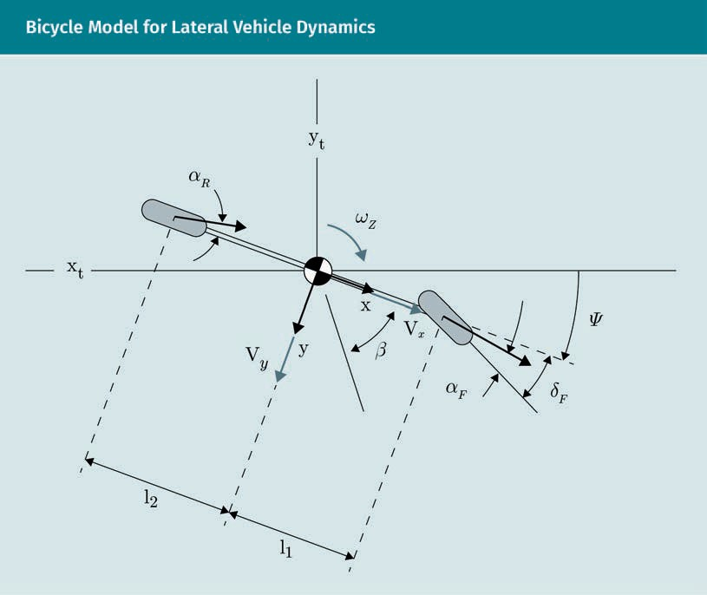

Here, l1 and l2 represent the distances from the center of the front and rear wheel to the center of the vehicle. Translation, denoted by the body frame in the center of the vehicle, and orientation of the model, represented by the angle ψ and also known as the yaw angle, are referred to by the global reference frame denoted by xt and yt. The driving direction of a vehicle is inﬂuenced by the yaw angle ψ, the steering angle δF, and the front slip angle αF, which is the angle between the driving direction and the orientation of the steering wheel δF (Pacejka & Besselink, 2012). Each wheel has its own velocity vector. While the direction of the front wheel velocity vF is calculated from the sum of the steering wheel angle δF and the front slip angle αF, the rear wheel veloc- ity vr points in the direction of the rear slip angle αR. Generally, the slip angle can be represented as follows.

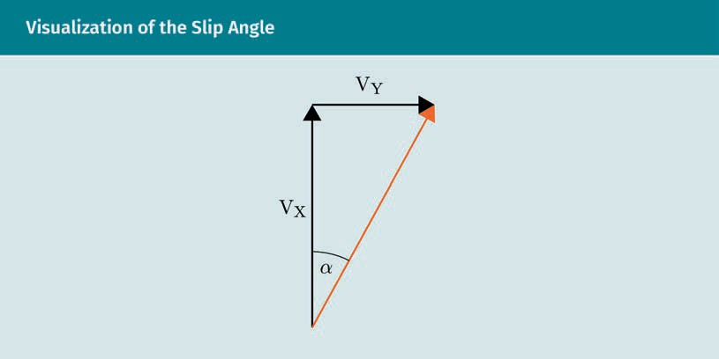

It can be calculated by

α = tan–1 vy

vx

( 3.12 )

and is a result of tire deformations. Transferred to the bicycle model, the slip angles

αF and αR can be calculated by

αF = δF − tan

−1 vy + l1 · ψ˙

vx

( 3.13 )

and

−1 l2 · ψ˙ − vy

αR = tan vx

Moving, Braking, Steering

( 3.14 )

respectively, with ψ˙ representing the yaw rate, thus the derivative of the yaw angle with respect to time.

The lateral acceleration of the vehicle ay is composed of the acceleration along the y- axis ÿ and the centripetal acceleration deﬁned by the product of velocity along the x- axis vx and the yaw rate ψ˙ :

aY = y¨ + vx · ψ˙

( 3.15 )

The forces that act on the vehicle in a lateral direction are the lateral tire forces of the front and rear wheels FYtF and FYtR, respectively. As previously done for the longitudi- nal dynamic vehicle model, we now use Newton’s second law to derive the relationship between vehicle mass mTo, lateral forces, and the longitudinal and lateral translational momentum ax and ay:

mTo · ax = mTo · x¨ − vy · ψ˙ = FXtFcosδF + FXtR − FYtFsinδF

mTo · ay = mTo · y¨ + vx · ψ˙ = FYtFcosδF + FYtR − FXtFsinδF

( 3.16 )

( 3.17 )

To derive the equation of the angular acceleration ψ¨, the lateral tire forces, the distan- ces l2 and l1, and the moment of inertia Iv must be incorporated as follows:

Iv · ψ¨ = l1 · FYtFcosδF − l2 · FYtR + l1 · FXtFsinδF

( 3.18 )

If we restrict our model to have a constant velocity, thus no longitudinal front tire forces, we obtain the following equations for the lateral vehicle dynamics:

mTo · y¨ + vx · ψ˙ = FYtFcosδF + FYtR

( 3.19 )

and

Iv · ψ¨ = l1 · FYtFcosδF − l2 · FYtR

With those equations derived, we can now describe the lateral dynamics of a moving vehicle. Of course, the bicycle model is only an approximation of the real underlying dynamics. The double-track model represents a more accurate description of the lat- eral dynamics by adding the second track of tires that is neglected by the bicycle model. Because a deeper investigation of this rather complicated topic would go beyond the purpose of this course book, the interested reader is referred to the litera- ture by Jin et al. (2019).

###### Vertical Vehicle Dynamics

The vertical vehicle dynamics are mainly of interest when considering the suspension system of a vehicle and can be modelled using vertical vehicle models that describe acceleration along the z-axis and angular acceleration around the x- and y-axes. Com- ponents that the model must incorporate are springs, dampers, and actuators located between the vehicle’s body and axle. The model that is often used for the vehicle’s sus- pension is the passive vertical quarter-car model where only one quarter of the car is considered (Savaresi et al., 2010). The general form of this model takes suspension spring, damper, tire stiffness, and tire damping vertical forces (Fk, Fd, Fkt, and Fdt, respectively) into consideration, while the simpliﬁed form reduces that to the use of suspension spring stiffness, damper, and tire stiffness constants k, c, and kt. The fol- lowing ﬁgure illustrates both forms of the passive quarter-car model.

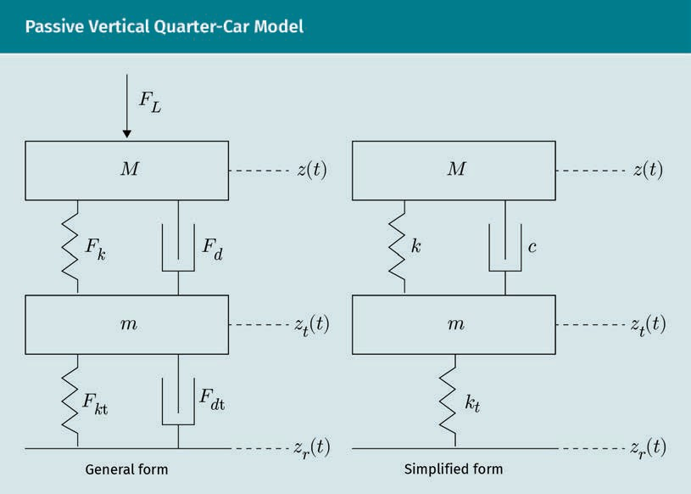

Moving, Braking, Steering

The vertical chassis and wheel bounce absolute displacements are represented by z(t) and zt(t), while zR(t) and FL are the road vertical disturbance and the vertical load disturbances. Using Newton’s law, we can represent the relation between vertical accel- eration ¨z, mass, and forces for the general form of the quarter-car model by

M¨z = Fk + Fd + FL − M· g

( 3.21 )

and

m¨zt = −Fk − Fd + Fkt + Fdt − m· g

( 3.22 )

with M and m representing the chassis and wheel masses, respectively. It must be con- sidered that all forces are functions of time and, thus, it is convenient to rather con- sider the simpliﬁed form of the model if it has the following criteria: the wheel does not lose contact with the ground at any time, and the only disturbances are small road disturbances leading to small deﬂections of the suspension to guarantee that the lin- earization of the stiffness holds.

The equations can then be expressed by

M¨z = − k · z t − zt t − L − c · z˙ t − z˙t t − M ·g

( 3.23 )

and

m¨zt = k· z t − zt t − L +c · z˙ t − z˙t t − kt · zt t − zr t − Rt − m ·g

( 3.24 )

where L and Rt are the nominal lengths of the suspension spring and the tire spring, respectively.

Extending the vertical quarter-car model to the vertical half-car model leads to the possibility to incorporate the pitch dynamics, thus the rotations around the x-axis of the vehicle. It can be constructed by merging two quarter-car models together as illus- trated simply in the following ﬁgure.

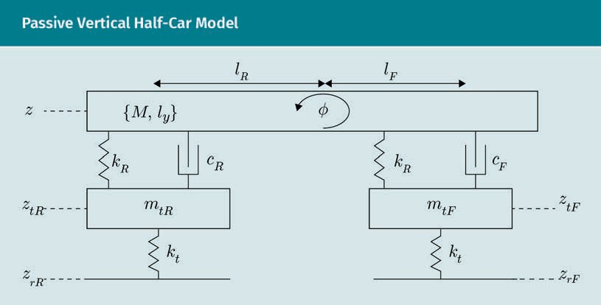

The distances from the front and rear axles to the center of gravity are represented by lF and lR, respectively, and produced inertia Iy is the pitch inertia. An additional dis- turbance captured by this model is the pitch moment Mdy. The vertical chassis dis- placement now consists of the front and rear parts zF and zR, which can be calculated by the distances lF and lR and the pitch angle . using the following equations:

zF = z+ lF · cos.

( 3.25 )

zR = z − lR · cos.

( 3.26 )

Analogously to the simpliﬁed quarter-car model, the equations describing vertical dynamics considering the appropriate displacements and constants are

M¨z = − kF · zF t − ztF t − kR · zR t − ztR t − cF · z˙F t − z˙tF t − cR z˙R t − z˙tR t

. ˙ = k · z t − z

t +c · z˙ t − z˙

t − k · z t − z

( 3.27 )

t t

mtF ztF F F tF

F F tF

t tF rF

m . ˙

= k · z

t − z

t +c

· z˙

t − z˙

t − k · z

t − z

( 3.28 )

t t

tR ztR R R tR

R R tR

t tR rR

( 3.29 )

Moving, Braking, Steering

Iyφ¨ = lF kF · zF t − ztF t + cF · z˙F t − z˙tF t

— lR kR · zR t − ztR t + cR · z˙R t − z˙tR t + Mdy

( 3.30 )

It is obvious that the half-car-vehicle model can still be extended to the passive verti- cal full-car model, which consists of two half-car models (Saveresi et al., 2010).

### Braking Technologies

It can safely be said that braking is the most critical aspect of a vehicle. Without prop- erly working brakes, dangerous situations and accidents are guaranteed and it is there- fore essential to investigate safe and reliable braking technologies for self-driving vehi- cles. At the beginning of this unit, it was mentioned that X-by-wire technologies will be part of automated vehicles due to the omission of manual control systems for highly automated vehicles. Brake-by-wire is one important group of X-by-wire systems, where the operating and transmission units are separated from each other. Conventionally, the operating and the transmission units are the brake pedal and the hydraulic or pneumatic, respectively. There are currently two main types of brake-by-wire systems that are relevant for self-driving vehicles.

###### Electro-Hydraulic Braking System

In electro-hydraulic brake systems, the brake booster is removed, and a special hydraulic brake master cylinder, which is coupled with an ABS actuator (antilock brake system), is integrated. By adding a brake control unit, a hydraulic system is created. When the brake pedal is pressed, hydraulic force is generated, but it is only measured by sensors and used as an input for the control unit. Additionally, it works as a back-up solution in case of system failures. The actuator transfers the force needed to brake from the master cylinder to the slave cylinders, which enables much higher pressures than those that could be achieved by traditional brakes (2000 psi versus 800 psi) (Autodata Group, 2017).

###### Electro-Mechanical Braking System

In electronic braking systems, all hydraulic components are removed and replaced by electronic components. The brake pedal is only needed to measure the displacement by means of displacement sensors and the signal is used as an input for a control unit, which controls electronic actuators attached to the brake calipers. With this technology, the brake system reaction time can be dramatically decreased from approximately 300 ms (the average for a traditional brake system) to approximately 90 ms.

Approaches for a combination of electro-hydraulic and electro-mechanical braking sys- tems also exist—electro-hydraulic systems are used at the front and electro-mechanical systems are used for the rear wheels. This is used, for example, in vehicles with large front brakes. The electro-pneumatic braking systems are another approach, which has been used for trucks where pneumatic systems are the standard. Here, just like for the electro-hydraulic system, the pneumatic pressure is not directly generated by the brake pedal, but rather proportionally to the measured distortion, generated by the combina- tion of a control unit and a compressor.

A general problem for the use of brake-by-wire systems comes from laws that demand a fallback solution when the system fails to operate correctly. For the electro-hydraulic braking system, this can be achieved by integrating an additional valve that opens the hydraulic circuit and enables manual braking. Because the electro-mechanical system relies completely on electronic and electro-mechanical components, it is necessary to add redundant electrical lines and a second backup battery, which leads to a signiﬁ- cant increase in the vehicle’s weight.

### Lateral and Longitudinal Control

To execute desired maneuvers in self-driving vehicles, lateral and longitudinal vehicle control is needed to control lateral and longitudinal motions with feedback laws. Two essential requirements for the control of self-driving vehicles are safety and perform- ance. One main part of the safety requirements is robustness. Even in difﬁcult environ- ments, a basic performance has to be ensured. If that is no longer guaranteed, the driv- ing assistance should be deactivated and the control should be given to the driver. Fault detection and fault management are important in these situations as they can determine appropriate strategies. Accuracy and consistency of an automated vehicle control are two main performance requirements as they achieve small deviations in desired speed and distance and enable consistent operation under all expected condi- tions. An additional point is the ride comfort—passengers should experience as little acceleration and deceleration as possible in order to guarantee a smooth and comfort- able ride. Furthermore, efﬁcient utilization of the capabilities of the vehicle such as fuel consumption or possible acceleration is important.

While the task of longitudinal control is to follow a planned speed proﬁle, and there- fore to adjust the throttle and brakes to accelerate and decelerate, the lateral controller steers the vehicle to follow a path (Xiong et al., 2019). An additional challenge for the longitudinal control is the interaction between multiple vehicles, which can be handled with three main approaches: ﬁxed block control, point following control, and vehicle- following control (Eskandarian, 2012). Vehicle-following control experienced the largest amount of research interest within the last decades and thus will be the focus of this section. In the approach of vehicle-following control, the longitudinal state of the ego vehicle is considered with respect to other trafﬁc participants in order to apply the control. We want to reduce the problem formulation within this section to the simplest case, when only the ego state of the nearest lead vehicle is considered for control. The main function of the longitudinal control is the control of the ego vehicle’s speed and

Moving, Braking, Steering

how to keep a certain distance from the leading vehicle (Eskandarian, 2012). Additional safety requirements, other than the general requirements mentioned at the beginning of this unit, are capable of detecting and avoiding collisions and can generate an emer- gency response as a last resort in a highly dangerous situation. The string stability is a performance requirement associated with the longitudinal control of self-driving vehi- cles in vehicle-following applications. The following ﬁgure depicts a string stable (a) and a string unstable situation (b).

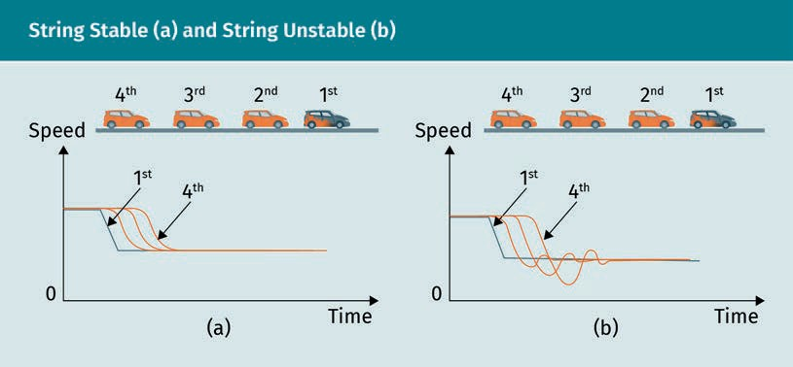

It is obvious that string instability (b) can easily lead to trafﬁc jams due to the down- stream ampliﬁcation of spacing errors because of ampliﬁed decelerating from vehicle to vehicle. In comparison, string stabilities enable a smooth trafﬁc ﬂow (a).

The perception of an automated vehicle plays an essential role in the functionality of longitudinal vehicle control. Accurate and reliable estimation of the state of the pre- ceding vehicle is the ﬁrst step for the control of the ego vehicle and therefore, it is obvious that vehicle control cannot work without proper environmental sensing. Longi- tudinal control inputs are the throttle position, more precisely the throttle opening ratio, and the brake torque (Eskandarian, 2012). The controller outputs are used to con- trol actuators that apply the desired longitudinal movement to the vehicle. In that sense, it is important to distinguish between different levels of automation. While fully automated vehicles (level 5) are not equipped with a manual actuating system such as brake or accelerator pedals and can replace them with automated ones, lower levels of automation require a dual use in which new actuators are added to the existing ones.

To establish a longitudinal vehicle control for a vehicle-following application, the fol- lowing three inputs are needed:

1. Speed and acceleration of the ego vehicle
2. Speed and acceleration of the preceding vehicle
3. Distance to the preceding vehicle

The state of the ego vehicle (including position, velocity, and acceleration) is estimated in the localization module of the software stack of self-driving vehicles by means of GPS, IMUs, wheel sensors, etc. The distance to, speed of, and acceleration of the pre- ceding vehicle are estimated in the perception module by means of object detection and object tracking. Therefore, it is important to have a reliable and accurate tracking algorithm that incorporates multiple sensors (e.g. LIDARs, RADARs, and cameras) to reduce the uncertainty of state estimation as much as possible.

Let us resume work with the following equation for the longitudinal dynamics:

rW · RG · m* · x¨ = ME − RG MB + rW RR + RAir + RC

( 3.45 )

The engine torque ME is the controlled input in longitudinal vehicle control and depends on the throttle opening α and the current engine speed ωE. The relationship between engine torque and engine speed is nonlinear and is, therefore, often charac- terized by static engine maps as illustrated in the following ﬁgure.

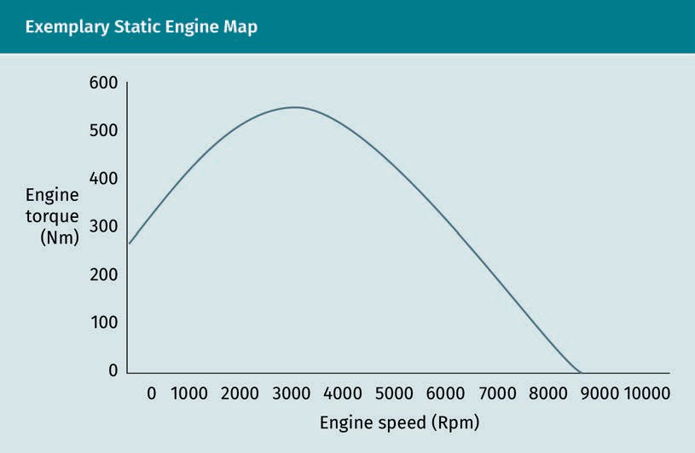

Mathematically, the engine power PE is the product of engine torque and engine speed

PE = ωE · ME

( 3.46 )

and it can be approximated by means of the quadratic polynomial (Guzzella & Onder, 2010)

Moving, Braking, Steering

PE = a0 + a1ωE +a ω 2

2

E

( 3.47 )

The maximal engine torque can be calculated by dividing the maximal engine power by the current engine speed as follows:

ME, max

= PE, max

ωE

( 3.48 )

and the throttle opening angle α for a desired engine torque ME,ref follows from

α = ME, ref · ωE

PE, max

( 3.49 )

We ﬁrst assume that we want to control our ego vehicle’s speed according to a refer- ence speed vref. The brakes should be activated when the throttle opening ratio equals zero and the reference speed is exceeded. We can describe our tracking error by the difference between reference and current speed:

e = vref − v

( 3.50 )

The dynamics of the tracking error can be stated by deriving each component with respect to time

e˙ = v˙ref − v˙ = v˙ref − x¨

( 3.51 )

We can rearrange our equation for the longitudinal dynamics and replace the longitu- dinal acceleration x¨, which results in

e˙ = v˙

ref

— ME − RG MB + rW RR + RAir + RC

rW · RG · m*

( 3.52 )

Using this, we can calculate our error by incorporating longitudinal dynamics. A com- mon approach that is used to ensure convergence of the tracking error is the Lypunov approach. It is used to determine whether or not solutions of differential equations

that describe dynamical systems are stable. A detailed overview of this rather compli- cated method can be found in the literature by Bhatia & Szegö (1970). We consider the positive Lyapunov candidate function

1 2

V = 2 e t

( 3.53 )

which is always a natural candidate due to the fact that it is always positive. Its time derivative is calculated using the chain rule

V˙ = e t e˙ t = ee˙

( 3.54 )

The tracking error converges towards zero if the following inequation is true (Attia et al., 2012):

V˙ ≤ − kV

( 3.55 )

with the decay rate k. Inserting the derivative of our error function into the time deriva- tive of the Lyapunov candidate function results in

V˙ = e·

v˙ref

— ME − RG MB + rW RR + RAir + RC

rW · RG · m*

( 3.56 )

which, considering the convergence inequation and that the brake torque equals zero, leads to the control law of the engine torque

M = α · Pmax = r ·R · m* ke + v˙

+R r R + R +R

E, ref ωE W G

ref

G W R

Air

C

( 3.57 )

This equation can be used to control the throttle opening angle and the engine torque according to a desired reference speed v˙ref. The same procedure can be used to derive the control law of the brake torque by setting the throttle opening angle α=0. We have now derived the control equations for longitudinal vehicle control, which is a cruise control system. For a vehicle-following application, the distance from the ego vehicle to the preceding vehicle has to be considered. However, the derived equations do not have to be changed, only the reference speed generation. It is calculated from the speed of the preceding vehicle and the safety distance that can be derived.

Moving, Braking, Steering

The main task of lateral vehicle control is the steering control system, which is respon- sible for tracking a path and controlling the steering actuator based on the ego vehicle state and reference path. As for the longitudinal vehicle control, steering actuators can fully replace, or just be added to, the manual steering system depending on the level of automation. Generally, the lateral control system consists of a path tracker, including velocity planning, look-ahead distance decision, path tracking, and the steering con- troller (Park et al., 2015). In the velocity planning module, the appropriate velocity of the ego vehicle is calculated incorporating the curvature of the path, super-elevation, and side-friction, while the look-ahead distance, which depends on the vehicle’s velocity, is calculated in the look-ahead module. Finally, the path tracker determines a goal point on the reference path and calculates the appropriate steering angle. The steering actuator is controlled by the steering controller to adjust the steering angle δ. The fol- lowing ﬁgure illustrates the general steering control system.

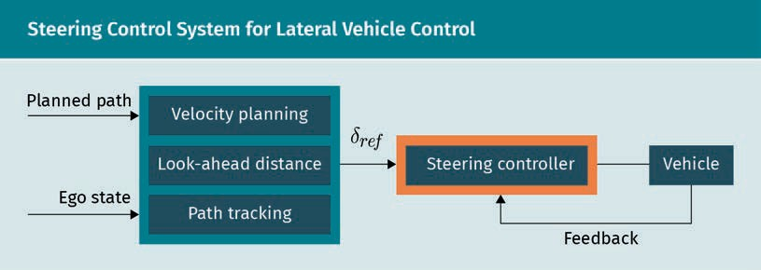

The maximum velocity of a vehicle at which you can safely drive without rolling over or slipping can be calculated by

Super-elevation

A slope of the road in curves to counter- act the centripetal force.

Side-friction

The side friction rep- resents the coefﬁ- cient of the friction between the wheels and the road.

vmax ≤

g· i+ f

κ

( 3.58 )

with g, i, f, and κ representing the gravitational constant, super-elevation, side-friction factor, and road curvature, respectively. A derivation of that equation can be found in (Park et al., 2015). To determine the curvature of a road, curve ﬁtting techniques can be used (Zhao & Farrell, 2011; Eidehall & Gustafsson, 2006).

The look-ahead distance dl depends on the velocity of the ego vehicle. While small magnitudes of the distance result in more accurate path tracking and oscillations, large magnitudes reduce oscillations and enable turning before a curve is reached. Thus, the path can be followed more smoothly, but it has to be considered that values that are too large result in problems such as the cutting corners phenomenon (Chen & Tan, 1999). It is obvious that a highly accurate environmental representation is also essential for lateral vehicle control. Errors in the generated road model result in potentially incorrectly calculated curvatures of the road and, therefore, possibly dangerous situa- tions.

Cutting corners phe-

nomenon When the shortcut from one point to another is taken rather than following the curve’s path.

Within the path tracking algorithm, the connection curve from the current vehicle’s position to a goal point on the path, which is determined from the look-ahead distance ld, is calculated. This is known as pure pursuit. The center of the rear axle of the vehicle is the reference point and the connection is modeled as a circular arc, which can be seen in the following ﬁgure.

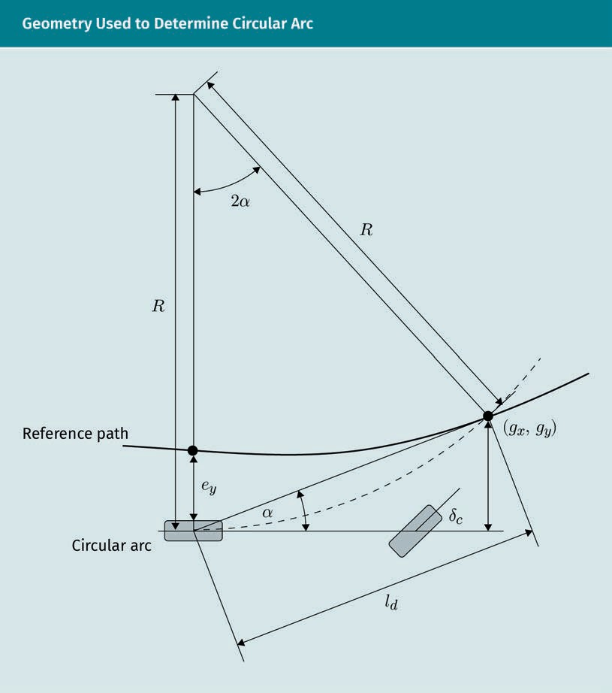

Here, R represents the radius of the imaginary cycle from which the circular arc of the connection is calculated. The angle α between the current heading of the vehicle and the vector pointing to the goal point (gx, gy) in the look-ahead distance ld is used to determine the arc κ of the imaginary circle (represented by the dotted line). From sim- ple trigonometric relations follows

Moving, Braking, Steering

κ = 2sinα

ld

( 3.59 )

Now, how can we calculate the appropriate steering angle needed to drive that curva- ture? The most common model of the steering geometry is the Ackermann model. According to this model, each front wheel has its own steering angle in order to guar- antee that it moves tangential to the circle. The straight lines that are perpendicular to each wheel meet in a common point called the instant center of rotation. As we sim- plify the lateral vehicle model by a simple bicycle model, the two front wheels and back wheels are combined to one front and one back wheel resulting in the following relationship called the Ackermann angle:

δ = tan−1 L = tan−1 κL

R

( 3.60 )

with L being the wheelbase. From inserting our representation of κ, the desired steer- ing angle follows based on the look-ahead distance ld:

δld

= tan−1 2Lsinα

ld

( 3.61 )

Another method for path tracking is the Stanley method, which is a nonlinear feedback function of the cross track error between the nearest point on the path and the center of the front axle. The interested reader is referred to the literature by Thrun et al. (2006). The control of the steering angle can be easily implemented by means of a pro- portional-integral-derivative (PID) controller, which applies correction to an error e(t) between the desired and measured values based on proportional, integral, and derivative gain (Araki, 2009). Mathematically, it can be formulated as

u t = K e t +K

t

e t′ dt′ + K

∫

de t

p i d dt

0

( 3.62 )

with the proportional, integral, and derivative coefﬁcients Kp, Ki, and Kd. The error e(t) between desired and measured steering angles is used as the input for the PID- controller, which calculates the appropriate signals for the steering actuator to correct the steering angle.

### Safety Issues

Automatically controlled vehicles seem to be the perfect solution to allow comfortable travel, but how safe are they now and how safe can they become? It is a legal require- ment to establish a fallback solution in case of system failures, but that fallback system could also fail, which could lead to unavoidable accidents. It is certain that automatic control highly depends on an accurate and reliable representation of the environment through which the vehicle is navigating. Sensor inaccuracies, wrong detections, or occlusions are some impacts that can lead to wrong decisions of the system and thus, to possible accidents. Because environmental perception depends on artiﬁcial intelli- gence, especially on deep neural networks, it can only be as good as the data with which it has been trained. It is also conceivable that cyber attacks inﬂuence the behav- ior and thus the safety of self-driving vehicles. Due to V2X technology, for example, a car becomes vulnerable to external entities and can therefore be a victim of different kinds of attacks. Malicious code can be injected to provoke faulty measurements or faulty control of the vehicle, which directly inﬂuences safety.

Even if the perception of a self-driving vehicle is 100 percent accurate (which can never be guaranteed) and cyber attacks can completely be prevented, there are always situa- tions that prevent complete safety. Imagine the following situation: A self-driving vehi- cle drives at a certain speed on a two lane road. Suddenly, beyond a curve, a barrier appears in the lane in which you are driving and a person appears in the second lane. The speed is too high to stop and a collision is unavoidable. What does the vehicle decide to do? Will it sacriﬁce itself and the passenger in favor of the pedestrian on the road, or is its own safety of the highest importance? Does it decide based on ethics? There will always be decisions in real-life situations that switch the risk from one trafﬁc participant to another and predeﬁned rules concerning the behavior of an automated vehicle cannot be the solution for this problem. The Moral Machine has been devel- oped by scientists, and it is used so that people can evaluate such situations based on their own ethics (Awad et al., 2018). The following ﬁgure shows the previously described situation.

Moving, Braking, Steering

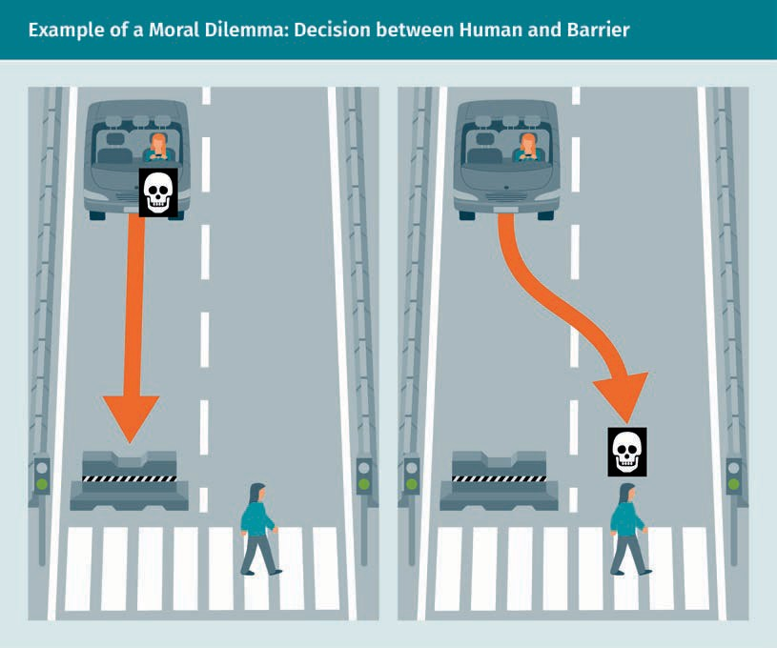

It is extremely difﬁcult to ﬁnd a solution for the responsibility of accidents caused by autonomous vehicles. If no driver is present, who will be liable? The car? The passen- ger? The car manufacturer? That remains an unanswered question and it is unclear, if it even can be answered.

Summary

Automatic control of a self-driving vehicle is a challenge due to the highly dynamic behavior. Fortunately, vehicle models can recreate the dynamics of a moving vehi- cle more or less accurately enough to study motion control techniques. Generally, three different groups of dynamic models are used: longitudinal, lateral, and verti- cal models. While longitudinal models are used to describe the vehicle’s dynamic behavior in driving direction such as accelerating or braking, lateral models are used for lateral dynamics, such as steering. The suspension system of a vehicle is captured within vertical vehicle models. For all groups, different degrees of abstrac- tion exist, which only model parts of the car with certain assumptions of symmetry. Hence, the appropriate model can be chosen for a particular application that describes the dynamics as accurately as needed.

Brake-by-wire belongs to the X-by-wire systems and is a key technology for auto- mated vehicles. X-by-wire means that the operating and the transmission modules are separated from each other, so the applied force from a human is not directly used for actuating. Brake-by-wire systems can be divided into two main groups: electro-mechanical and electro-hydraulic braking systems. While the former repla- ces all hydraulic components with electro-mechanical ones, the latter keeps the hydraulic transmission of the force by mean of the brake pedal, but only uses it to measure the force for braking. The brake force is generated by special components. Redundancy plays an important role in the context of automated control, thus there always has to be a fallback solution in case of an emergency.

The vehicle-following application is one important case of longitudinal control for automated vehicles. Therefore, the speed and acceleration of the ego vehicle, the speed and acceleration of the preceding vehicle, and the distance between the two are needed. The error between desired speed, distance, and measured values can be used to establish a control loop to control the engine torque by adjusting the opening angle of the throttle. The main task of lateral vehicle control is the steering control system, which is responsible for tracking a path and thus controlling the steering actuator based on the ego vehicle’s state and reference path. From this, a look-ahead distance depending on the vehicle’s speed is determined. In the pure pursuit approach, a circular arc between the vehicle and a goal point on the path is calculated and used to adjust the steering angle. The Ackermann model is an approach that determines appropriate values by assuming a wheel orientation tan- gential to a circular arc.

Safety of automatically controlled vehicles is highly dependent on the vehicle’s ability to perceive the environment and its different entities. Additionally, fallback control systems are necessary to establish a certain degree of safety. Cyber attacks are always a danger as they can inject malicious code, which can lead to undesired actions and accidents. Apart from that, even if everything works 100 percent per- fectly, moral dilemmas will always exist, during which the vehicle has to decide what to do.

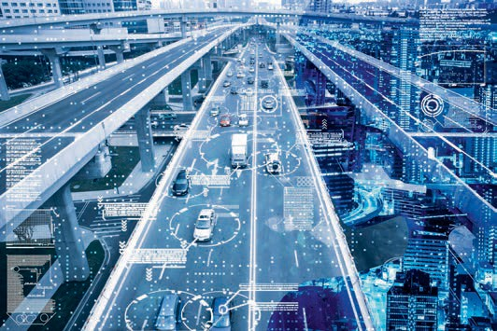

# Unit 4

## Communication

#### STUDY GOALS

On completion of this unit, you will have learned …

… about Car2X/V2X and its different forms.

… which protocols are common and how they differ from each other.

… possible safety issues in V2X technology and the different kinds of potential attacks on the system and the user.

DL-E-DLMDSEAAD01-U04

1. Communication

### Introduction

In addition to sensors, the input source, and actuators, which are used to generate out- puts, there is a third type of interfacing for automated vehicles. Vehicle-to-everything or car-to-everything (V2X or Car2X) technology is used to establish communication between a vehicle and all other entities in its surrounding environment. It is hoped that the implementation of different subtypes of this technology, such as vehicle-to- vehicle and vehicle-to-infrastructure, will improve the conﬁdence of the automated vehicles’ perception in difﬁcult and precarious situations. In the following section, we will be presented with V2X, alongside its subgroups, and will examine the various com- mon protocols that are used in detail. Furthermore, we will look at possible safety issues, including different kinds of attacks.

### Car2X Communication

One technology that enables communication among trafﬁc participants and any entity in their environment is Car2X (car-to-everything), also known as V2X (vehicle-to-every- thing) (Demba & Möller, 2018). It incorporates different subtypes of vehicle communica- tions such as vehicle-to-infrastructure (V2I), vehicle-to-network (V2N), vehicle-to-vehi- cle (V2V), vehicle-to-pedestrian (V2P), vehicle-to-device (V2D), and vehicle-to-grid (V2G), which are all motivated by road safety and trafﬁc efﬁciency. The most common imple- mentation of this technology mainly uses WLAN-based and cellular-based systems (Ahn et al., 2018; Chen et al., 2017). With vehicle-to-infrastructure communication, the self-driving car would be able to communicate with the existing trafﬁc system, for example, using cameras, trafﬁc lights, or streetlights. However, to get the full beneﬁt of automated and connected vehicles, this infrastructure has to evolve from analog to digital. This means enabling the existing infrastructure to send digital messages to the car that can be interpreted to build the fullest picture of the car’s environment and, as such, a redundancy could be generated to increase the conﬁdence of the vehicle to make critical driving decisions. The following technologies could be used to improve safety with V2I.

###### Smart Trafﬁc Signs and Lights

Visual approaches to state of the art lane detection and road model generation still suffer from inaccuracies as a result of occlusion or difﬁcult environmental conditions. By using digital information taken from lane markings, the accuracy and reliability of generated models could increase dramatically, thus creating the same redundancy as for smart trafﬁc signs and lights.

Communication

###### Smart Wireless Communication

Automatic connection between vehicles and infrastructure could also lead to an improvement of trafﬁc ﬂow: information about construction zones or trafﬁc jams could be directly transmitted to all trafﬁc participants. Vehicle-to-network communication can be used to share information among the vehicle, the cellular infrastructure, and the cloud, creating alerts to accidents, trafﬁc jams, or construction zones, which can be received to prevent additional delay. Using vehicle-to-vehicle communication, vehicles can share information with each other to signal dangerous or critical situations by broadcasting and receiving messages from all directions to enable a 360° awareness window. The information can be used to reduce uncertainties in the vehicles’ detection abilities and lowers the risk of dangerous situations.

The same can be achieved by vehicle-to-pedestrian communication in which the infor- mation is shared between the vehicle and a pedestrian, just one of the categories of vulnerable road user. Both inattentive drivers and pedestrians can be alerted to dan- gerous situations when crossing the road or at intersections. Vehicle-to-device commu- nication is used to exchange information between the vehicle and any electronic device that makes use of different mobile applications. Because of this communication, driving safety is increased. Additional information acquired from surrounding vehicles and the environment can be gathered and passed on to the driver or the vehicle’s con- trol algorithms meaning that higher automation levels can be reached. Many car manu- facturers already take mobile communication into consideration when designing their cars. The last subtype, vehicle-to-grid communication, is used to enable communica- tion between the vehicle and the power grid. This allows a bidirectional sharing of electrical power, building a smart grid, and establishing an intelligent energy system (Lund & Kempton, 2008). This will be especially important for bidirectionally chargeable vehicles that not only take energy from the grid, but can give it back at moments of high grid loads. This system would beneﬁt, for example, the supply of electricity to houses with a power failure.

A theoretical concept of a network of vehicle-to-vehicle and vehicle-to-infrastructure connections is known as a vehicular ad-hoc network (VANet), which represents the same principle of a mobile ad-hoc network with vehicles as nodes. At this point, there is no established VANet and therefore, it remains a research topic for computer sci- ence.

### Protocols

The communication technologies used for V2X can be divided into two main types: dedicated short range communication (DSRC) and long term evolution for V2X (LTE-V2X), which was recently renamed C-V2X due to the expected update from LTE to the new mobile standard 5G. Both technologies use the 5.9 GHz spectrum for communication between two devices, but the interesting property of C-V2X is that it can also communi- cate over the common cellular network frequencies. In this way, it can operate in a

vehicle-to-network mode to exchange information over a cellular network. DSRC was speciﬁcally developed for V2X applications and is a much older technology than C-V2X (which is still under development) but it has been shown that the latter can achieve better communication ranges at higher speed than the former. Generally, a communi- cation protocol can be characterized by the open system interconnection model (OSI model), which is divided into seven layers: the physical layer, the data link layer, the network layer, the transport layer, the session layer, the presentation layer, and the application layer.

Transmission

Medium A transmission medium is used for the propagation of

signals.

Segmentation Data segmentation is the division and grouping of data based on parame-

ters.

The physical layer is the lowest level of data representation and is responsible for transmitting and receiving raw data. Digital bits are converted to the appropriate signal according to deﬁned layer speciﬁcations such as timing, data rates, and transmission distances. The data link layer takes care of a reliable transmission of data and controls the access to the transmission medium. Here, the bit data stream is separated into frames and equipped with checksums to allow the detection of faulty messages. The data link layer can be subdivided into the logical link control (LLC) and the media access control (MAC) layers. The third level is the network layer, which takes care of the transmission of establishing connections and data packages. Additionally, the routing between two network nodes is handled. The transport layer is responsible for data congestion avoidance, and the segmentation of data streams guarantees the correct data transmission. The session layer controls communication between two systems and provides services to allow a synchronized data exchange. In the presentation layer, dependent system representations are converted to independent system representa- tions to enable the data exchange between different systems. Additionally, data com- pression and encryption are handled. Finally, the application layer provides functions such as data input and output. The following ﬁgure summarizes the OSI model.

|  |  |
| --- | --- |
| OSI Model for Network Protocols | |
| Application layer | Connection to user applications |
| Presentation layer | Encryption, compression, and usable data format |
| Session layer | Process communication and control of data exchange |
| Transport layer | Correct transmission of data |
| Network layer | Decision of physical path |
| Data link layer | Format of data |
| Physical layer | Transmission of raw bit stream |

Communication

We will now look at the details of each protocol to provide a deeper understanding of their functionalities. Dedicated short range communication is a WLAN network based on different IEEE and SAE standards, such as IEEE 802.11p, IEEE 802.11 (WiFi), IEEE 1609 WAVE, and SAE J2735 (Wang et al., 2019). Although DSRC operates in the 5.9 GHz spec- trum, there are different incompatible speciﬁcations in the USA, EU, and Japan (Lembke, 2018). A vehicle using the DSRC protocol transmits its location, heading, and speed ten times per second, which can be received by the surrounding vehicles within a range of 300 m to 1 km and used to estimate future risks that arise from all vehicles. One advantage of dedicated short range communication technology is the ability to operate around corners (non-line-of-sight), which is not possible with any other type of sensor (Mangel et al., 2011). Moreover, protocol optimization allows the technology to function reliably at high speeds of up to 500 km/h.

C-V2X, by comparison, is based on the cellular network and is part of the 3rd Genera- tion Partnership Project (3GPP). Two different operation modes are used: Uu-based and PC5-based (Shimizu, 2019). Uu-based communication is the transfer of information between user equipment (UE) devices and a base station, called evolved node B (eNB), while PC5-based communication is between user equipment devices as illustrated in the following ﬁgure.

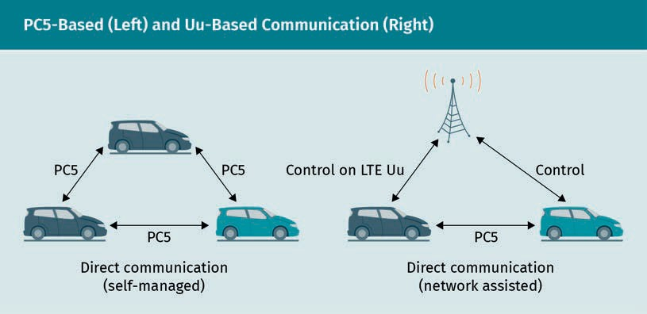

While Uu-based communication uses downlink and uplink of cellular networks, PC5- based communication uses sidelinks. The latter can be divided into mode three, which includes the resource allocation by eNBs, and mode four, in which the UEs select the sidelink resources autonomously. Therefore, mode four of PC5-based communication is directly comparable to the functionality of DSRC. Recent studies based on freeway sce- narios show that DSRC generally achieves signiﬁcantly lower end-to-end latencies than C-V2X and, while both protocols show similar performances under low-vehicle density conditions, DSRC outperforms C-V2X in situations of high vehicle density (Shimizu, 2019).

Even though these two protocols represent different technologies of V2X, it does not mean that one should be favored over the other, rather it is conceivable that a combi- nation of both techniques could lead to the optimal solution by substituting the lower

Downlink

The connection between the data ﬂow from the base station to the user equipment is known as a downlink.

Uplink This is the connec- tion with dataﬂow from the user equip- ment to the base

station.

Sidelinks These are the com-

munications between two user

equipments.

layers of DSRC (physical and MAC-layer) by equivalents deﬁned by the 3GPP standard. Only the future can determine whether one technology will prevail or if coexistence will be the solution.

### Safety Issues

Every new technology is subject to critical review at the beginning of the process and possible safety and security issues are highlighted. In this section, we will explore pos- sible risks of V2X technology. One major safety issue associated with V2X technology is the future support of different kinds of applications and services that make the trans- mission of critical data necessary. This risk could make the systems more susceptible to cyber attacks, in particular, attacks on the system and attacks on the user (Ghosal & Conti, 2020). Attacks on the V2X system itself could be the injection of false data or denial-of-service (DoS), or the alteration of transmitted data leading to possible sanc- tions against innocent drivers (Hasan et al., 2020). User attacks, however, aim to harm the driver, for example, by instigating crashes or congestion. In addition to the broader classiﬁcations of user and system attacks, we can categorize the attacks into ﬁve types based on behavioral pattern, software and hardware, infrastructure, and privacy and data trust (Hasrouny et al., 2017). We will summarize the main subtypes and give a brief overview of existing attacks, however, we will not invest too much time learning about these processes as this would go beyond the scope of this course book. Those who wish to learn more should refer to the literature by Hasrouny et al. (2017) and Ghosal and Conti (2020).

Attacks based on the behavioral pattern of the user are carried out to affect the net- work’s behavior either for selﬁsh or malicious reasons. Among these selﬁsh attacks are message spooﬁng, movement tracking, eavesdropping, and repudiation. Message spoof- ing is providing false location information. In movement tracking, transmitted messages are collected and analyzed to track a user’s movements; eavesdropping is the intercep- tion of communication without the user’s awareness; and repudiation is when an attacker denies engaging in communication in case of disputes. Malicious attacks, on the other hand, represent techniques to modify or replace messages and include, for example, message replay, Sybil attacks, denial-of-service, malicious code, and black hole attacks. The message replay attack is the replaying of a message that has already been sent at regular intervals to trace the location of vehicles. A Sybil attack is the gen- eration of multiple vehicles with the same identity used to disrupt the communication among the vehicles. Denial of service attacks are designed to disrupt the communica- tion networks, for example, by ﬂooding them with lots of messages. Consequently, nor- mal service functionality becomes compomised and unavailable for users to access. In the malicious code attack, viruses, worms, or spyware are injected into the messages using malicious code in order to disrupt functionality or to gain information. The black hole attack utilizes the denial of participation by discarding packets, thus preventing other users from receiving potentially important information.

Communication

Special attacks on the hardware and software include, but are not limited to, the man- in-the-middle attack and the brute-force attack. In a man-in-the-middle attack, the attacker positions themself between two communication partners and takes control to gain data. With a brute-force attack, an attacker uses trial and error to get information about the identity of a certain vehicle.

Attacks on infrastructure include session hijacking, distributed denial of service (DDoS), unauthorized access, hardware tampering, and masquerade attacks. Session hijacking means that an attacker takes over the control of the session. DDoS is a derivation of DoS, whereby the attack is distributed over the network to disturb it. Unauthorized access means the access of an unauthorized user to spy on the legitimate user(s) or to cause disturbances. Hardware tampering is put into vehicles by employees of vehicle manufacturers during maintenance in order to gather or inject data at a later point. During a masquerade attack, an attacker pretends to be a valid vehicle, such as an emergency vehicle, to hide their identity and disturb the trafﬁc ﬂow.

Some examples of attacks on privacy are identity revealing attacks, whereby the per- sonal information of a user is revealed, and location tracking, in which an attacker tracks a particular vehicle. Finally, data trust attacks contain message tampering, hid- den vehicle, and illusion attacks. Message tampering reconstructs parts of a communi- cation to support the attacker’s intentions. In a hidden vehicle attack, a false position of a vehicle is generated, which leads to possible accidents. The illusion attack is when an attacker generates false data that appears to be authentic, which is then injected into the network to interact with vehicles.

It becomes clear that the different types of techniques cannot always be differentiated from each other completely. Generally, we can say that V2X technology represents an essential part of self-driving cars. Safety highly depends on reliable and accurate com- munication between trafﬁc participants because the trafﬁc network is only as safe as its weakest component. Future research will show how cyber attacks can be prevented completely to minimize the risk of fatalities.

Summary

Car2X/V2X is a technique used for the communication between a vehicle and differ- ent external entities. It incorporates different subtypes of vehicle communications such as vehicle-to-infrastructure (V2I), vehicle-to-network (V2N), vehicle-to-vehicle (V2V), vehicle-to-pedestrian (V2P), vehicle-to-device (V2D), and vehicle-to-grid (V2G). These communications are motivated by road safety and trafﬁc efﬁciency.

There are two main technologies used for V2X: dedicated short range communica- tion (DSRC), which is WLAN-based, and long term evolution for V2X (LTE-V2X), which was recently renamed to C-V2X and is based on cellular networks. Communication protocols are, according to the OSI-model, divided into seven layers: physical layer, data link layer, network layer, transport layer, session layer, presentation layer, and

application layer. C-V2X technology can be divided into Uu-based and PC5-based communication. Uu-based communication is the communication between a user equipment (UE) device and a base, which is also called evolved node B (eNB), by means of downlinks and uplinks. The PC5-communication describes the communi- cation between UEs directly, either with the help of eNBs (mode 3) or completely autonomously (mode 4), by means of sidelinks, and is directly comparable with the functionality of DSRC.

V2X technology is susceptible to security threats as a result of cyberattacks, which can be divided by attacks on the system and the user. These attacks can be further categorized in the following ways: behavioral pattern, software and hardware, infra- structure, privacy, and data trust.

Knowledge Check

Did you understand this unit?

You can check your understanding by completing the questions for this unit on the learning platform.

Good luck!

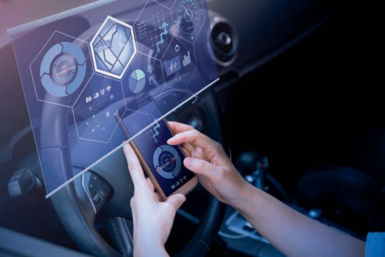

# Unit 5

## Social Impact

#### STUDY GOALS

On completion of this unit, you will have learned …

… how behaviors of autonomous vehicles can be evaluated by different ethical theories.

… what are typical moral dilemmas in autonomous driving.

… what kinds of new mobility concepts will rise due to autonomous driving.

… how use cases can be differentiated by means of the level of automation.

… how the vehicle’s interior and exterior will change due to the omission of human drivers.

DL-E-DLMDSEAAD01-U05

1. Social Impact

### Introduction

In this unit, we will present the ethical issues related to autonomous vehicles and for- mulate some well-known moral dilemmas and possible solutions based on different ethical theories. We will outline some concepts of new mobility and present some pos- sible use cases, for example, autonomous valet parking, full automation using driver for extended availability, and vehicle on demand and we will explore how current stud- ies predict main applications will be for commercial rather than private use. Finally, we touch on the subject of autonomous vehicle design, which will show how both the inte- rior and exterior of future cars will undergo a change due to the removal of the need for a human driver and the signiﬁcant increase of exterior sensors.

### Ethics for Autonomous Vehicles

Utilitarianism This is a theory ﬁrst fully articulated by John Stuart Mill in 1861; the term itself is derived from from the Latin word “utili- tas,” meaning “bene- ﬁt” or “advantage.”

Deontology The Greek word “δέον (deon)” means “necessary” or duty.

A key question when thinking about the ethics of autonomous vehicles is: How does a self-driving vehicle decide who will live and who will die in critical situations with two fatal outcomes? This question can be answered through the application of the trolley problem, one of the ﬁrst thought experiments of trade-off situations between life and death, devised by the British philosopher Foot (1967). The experiment is as follows: imagine a trolley that has a failure and cannot be controlled anymore. Five people are in its way (tied to the track and cannot move), but by switching the points, the trolley can be redirected to another track with only one single person on it, prompting the controller (you) to question whether it is ethical to change tracks, killing only one per- son and saving ﬁve, or to allow the train to continue on its intended path, killing those ﬁve people to save the life of one. We can evaluate the problem using different ethical theories. The ﬁrst is utilitarianism, which belongs to the consequentialist ethical theo- ries. This theory encourages decisions and actions that maximize happiness and, by implication, reduce bad consequences (Smart & Arthur, 2008). Therefore, in the utilitar- ian’s view it would be reasonable to switch the points because overall, there would fewer bad consequences. In comparison, deontology evaluates situations based on the action itself. Therefore, the consequences of the action are less important than if the action is right or wrong morally. Followers of this theory would state that, despite the safety of others being a collective obligation, a switching of the points would violate the commitment not to harm anybody, which would be the stronger instinct. Such deci- sions are not made universally in the same way or with the same judgement: There are many other factors which should be taken into consideration. However, for our purpo- ses, we will focus on the basic principle of this theory.

This same dilemma could be applied to self-driving vehicles. Imagine the following sit- uation: A self-driving vehicle is driving at a certain speed on a two-lane road. Suddenly, around the bend, a child steps onto the one of the lanes, while another person is walk- ing across the other. The speed is too high to stop and a collision is unavoidable. With whom does the car decide to collide? Does it decide based on ethics and who pro- grammed that behavior? Even if such situations may not regularly occur in real life,

Social Impact

there will always be decisions that put one trafﬁc participant or another at risk. There- fore, constant rules about how a car should behave cannot be the solution for this problem. As a result of moral dilemmas such as this one, scientists invented the Moral Machine with examples of such situations that can be evaluated by the user as illustra- ted in the following ﬁgure (Awad et al., 2018).

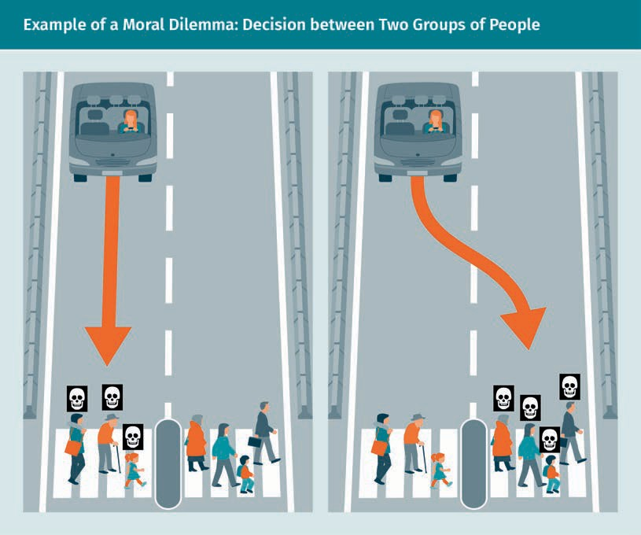

Of course, these situations can also occur for human drivers, but who would be responsible in the case that no driver is present? The car? The passenger? The car man- ufacturer? Certain ethical and legal guidelines are needed to deﬁne how to behave when trade-offs occur such as encountering life or death decisions. A potentially more complicated dilemma would be the decision between saving the lives of the self-driv- ing vehicle’s driver, passengers, and other road users. Imagine a vehicle fails to operate and braking is impossible. Ahead is a group of people on a direct collision course, which can only be prevented by swerving into another obstacle on the road. Would the car decide to save its “own existence” and thus the life of its driver, or the larger num- ber of people?

The answer to these ethical questions may lie in the interest of the customer. Would they rather take a utilitarian approach and risk their own lives to save the others, or a deontological approach, which would not put their own lives in danger? It is conceiva- ble that car manufacturers will develop self-driving cars’ responses to these dilemmas based on the preferences of the customers, and if the majority demand a utilitarian

approach (which is most likely the case), then they will be forced to meet this demand in order to sell their products. However, it may also be possible that manufacturers will not succumb to such pressures and instead will leave such moral decisions to the car itself based on a set of predetermined basic ethical rules. In his short story *Runaround*, Asimov (1942) proposed the three laws of robotics and perhaps something similar could be developed for real life applications. Still, there is no explicit solution for those ethical considerations and only the development and manufacture of self-driving vehi- cles will determine the strategy.

### New Mobility

Customer behavior in the automotive industry has been the subject of discussion for some time. According to studies, traditionally, there have been two groups of vehicle users: people who prefer to use private vehicles, and people who would rather use public transport, combined with walking and cycling (*Institut für angewandte Sozialwis- senschaft GmbH, Deutsches Zentrum für Luft- und Raumfahrt e.V. Institut für Verkehrs- forschung & Bundesministeriums für Verkehr, Bau und Stadtentwicklung*, 2010). Recently, a mix of these two modalities has evolved that is not restricted to a particular kind of transportation, which has been accompanied by new mobility concepts. While vehicles were considered as an extension of a customer’s personality in the past, the newer generations have shifted toward models such as carpooling, cab services, and car rentals to overcome trafﬁc congestion or parking situations (Statista, 2020). Several car sharing ﬂeets, such as car2go, DriveNow, and cambio, have already established themselves in the transportation network and have seen signiﬁcant growth in both the number of cars and of users since their market launches, as illustrated in the following ﬁgure (Turoń et al., 2019).

Social Impact

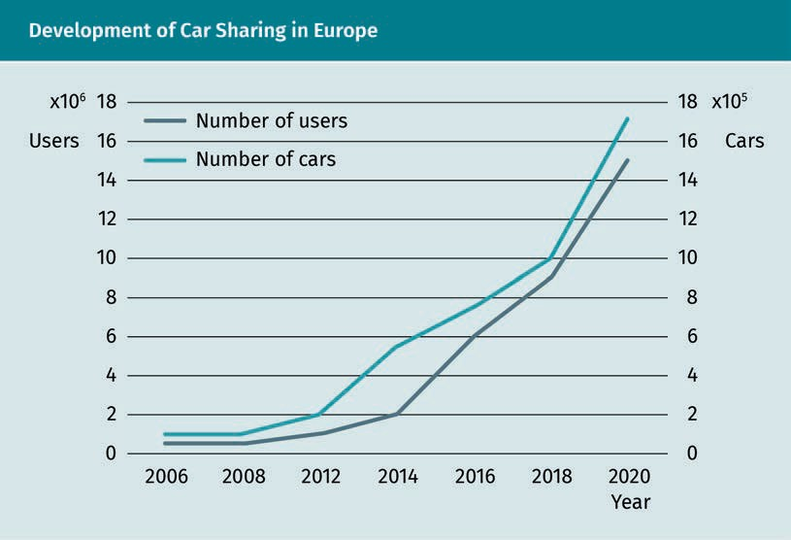

A similar behavior can be observed in the case of peer-to-peer services, in which pri- vate car owners offer rides to people over internet platforms, sharing the ride because they are going in that direction or to that location anyway (Hampshire & Gaites, 2011). Different platforms are available, such as BlaBlaCar and fahrgemeinschaft.de, the latter is the successor to one of the ﬁrst platforms of that type mitfahrgelegenheit.de. With this continued trend of ride-sharing, more private taxi services such as Uber or Lyft are growing; however, these can be separated from peer-to-peer services because they function like traditional taxi services, rather than car-sharing out of convenience. If the driver is travelling anyway, it is a peer-to-peer service; if the travel is done only with the purpose to earn money, it is a private taxi service. The new aspects of these different models of new mobility lie in the ﬂexibility they offer, which is highly dependent on the premise that users, vehicles, and operators are connected by information and commu- nication networks (Lenz & Fraedrich, 2016). It is through this connection that access to particular services is made possible.

We must now consider whether these new mobility concepts can beneﬁt from further automation. Most of the big car manufacturers have adapted to the aforementioned changes in consumer behavior and demand, and, as a result, have set their research focus on driverless vehicle concepts. There are different use cases based on user needs that could experience positive changes by introducing autonomous vehicles, these include: autonomous valet parking, vehicle on demand, and full automation using the driver for extended availability (Lenz & Fraedrich, 2016). While the vehicles have to be picked up and parked before and after a ride in traditional car-sharing services, auton- omous valet parking would improve comfort aspects dramatically, and allow a kind of door-to-door service. That would especially be attractive for regions with a low density of available car sharing vehicles and where travel to a car-sharing station might be

considered too much effort. One solution to this limited accessibility might be a main service station that the entire ﬂeet leaves from and returns to, or multiple smaller col- lection points from which the vehicles are distributed and returned.

The next automation level is full automation using the driver for extended availability, whereby the vehicle is able to drive entirely autonomously in certain areas (level 4 automation), but it is still possible, and sometimes necessary, for the passenger to take control. In fact, this use case would change fewer aspects of car sharing services than the autonomous valet parking, due to the necessity of a human driver. In urban areas, which are currently the main areas of operation, an autonomous driving mode would mostly be prohibited because the environments are too dynamic, with lots of bicycles and pedestrians presenting uncertain risks. Hence, this service would be a possible sol- ution more suited to rural areas, which are currently not the focus of most services.

A concept for the integration of fully-automated vehicles (level 5 automation) in car sharing would be realized by the vehicle-on-demand concept, where no intervention of the passenger is needed at any time. In addition to the advantages associated with the autonomous valet parking use case, i.e., autonomous picking-up and parking, this con- cept would increase comfort. This is the scenario where the driver ceases to be the driver and becomes a passenger entirely, making other activities such as reading, work- ing, or even sleeping, possible during the ride. The vehicle-on-demand concept would be similar to taking a taxi and as such, to ensure acceptance by a majority of people, the costs should be comparable.

Apart from car sharing use cases, there is a great interest in autonomous vehicles and their application in logistics. There are already autonomous forklifts and robot arms in operation that load and unload trucks with goods. Autonomous trucks are already a focus of some truck manufacturers such as Volvo, Daimler, and Embark Trucks. The future of logistics is likely to be a connection of different autonomous entities used to establish a fully automated process from the manufacturers to end users. In an article published on the McKinsey website, Chottani et al. (2018) estimate a reduction of logis- tics costs by up to 40 percent with the introduction of autonomous supply chains. Of course, we must ask what will happen to the human workers who will be replaced by machines. Although human drivers will disappear, new jobs will be created due to the necessity of monitoring and assistance tasks. Generally, it is believed that autonomous vehicles will be applied mainly in commercial, rather than personal, use cases. It remains the task of the car manufacturers to highlight the real consumer beneﬁts of owning an autonomous vehicle privately.

### Autonomous Vehicles and Design

With human drivers becoming unnecessary due to fully automated vehicles (level 5 automation), new possibilities for vehicle designs arise, altering the traditional aesthet- ics. Traditionally, the vehicle’s interior is centered around the driver to allow optimal control and view of the environment, and it has not undergone any signiﬁcant changes in the last decades. Since manual control will not be needed at any point of a ride,

Social Impact

steering wheels, gear shifters, accelerators, and braking pedals will be a thing of the past, meaning that the interior of autonomous vehicles will be based on the needs of the passengers and will resemble living rooms on the road.

One of the main changes to the interior of autonomous vehicles will be the seating conﬁguration due to the removal of the driver’s seat, which will no longer be necessary and will allow for a ﬁxed seating arrangement. The possibility of more ﬂexible seats that are able to rotate or be put into a sleeping position because of the newly available space is also conceivable. Focus is likely to be placed on enhancing comfort and devel- oping ways to reduce noise from outside the vehicle and vibrations from the road sur- face to allow for the most comfortable ride possible.

A main part of a vehicle’s interior is the dashboard, which is traditionally located in the front near the driver. However, due to the newly ﬂexible seating conﬁguration in future autonomous vehicles, it is possible to rearrange or integrate the dashboard in other ways. For example, each passenger could be allowed to control the air conditioning or the radio by building these features into their seats individually.

The exterior will also undergo changes. Due to the signiﬁcant increase of exterior sen- sors such as LIDARs, RADARs, and cameras, the car body has to be adapted due to aer- odynamic speciﬁcations or requirements and to ensure the vehicle is still attractive to the customer. Special attention must be given to the LIDAR, which functions optimally when located on the vehicle’s roof. Current autonomous vehicle setups are standard cars with sensors attached to the body without much consideration given to design, and it remains a future task to incorporate them into the chassis to obtain attractive designs.

Summary

Even if an autonomous vehicle works perfectly, there will always be situations where it faces decisions in which either outcome is potentially life-threatening. How a vehicle should behave in such situations can be described as a moral dilemma. The trolley problem is a famous example of such a dilemma: A trolley fails to operate and, by continuing on its trajectory, would kill ﬁve people who have been tied to the track, unable to move. It can only be prevented by switching the points to another track with only one person on the track, forcing the operator to make a moral decision and act so that they either kill one person or ﬁve people.

Different ethical theories can be used to evaluate this problem: utilitarianism and deontology. Utilitarianism, which belongs to the consequentialist ethical theories, encourages decisions and actions that maximize happiness and reduce bad conse- quences. Therefore, in the eyes of the utilitarian, it would be reasonable to switch the points because fewer deaths would occur. Deontology, in comparison, evaluates situations based on the action itself, meaning that the consequences of the action are less important than whether the action is morally right or wrong. Switching the

points would therefore be wrong in the deontologist’s eyes because the action itself is morally wrong. Moral dilemmas are also evaluated differently by different cultures.

Autonomous vehicles will be accompanied by new mobility concepts, some of which are already available, such as car sharing, peer-to-peer services, and private taxis. Autonomous valet parking will simplify the picking up and parking of vehicles in car sharing services by automating the process. The next step would be full auto- mation (only using the driver for extended availability) whereby the vehicle is already able to drive autonomously in most environments, but the driver is still needed for certain situations (such as trafﬁc with many pedestrians or bicycles).

The vehicle on demand scenario automates car sharing completely and thus trans- forms the driver into a passenger.

In addition to the use cases related to transportation of people, logistics will also proﬁt from autonomous vehicles. While autonomous forklifts and robots are already available, the creation of autonomous trucks will completely change the whole supply chain from the manufacturers to the customers.

The technological revolution of vehicles will be accompanied by design changes to the interior and the exterior. This is mainly inﬂuenced by the removal of the need for a human driver, which brings additional space and new possibilities for seating conﬁgurations. Furthermore, the high number of exterior sensors will be a chal- lenge when creating the exterior design.



# Appendix 1

## List of References

List of References

Ahn, J., Kim, Y., & Kim, R. (2018). A novel WLAN vehicle-to-anything (V2X) channel access scheme for IEEE 802.11p-based next-generation connected car networks. *Applied Scien- ces*, *8*(11), 2112. https://doi.org/10.3390/app8112112

Araki, M. (2009). PID control. *Control Systems, Robotics and Automation: System Analysis and Control: Classical Approaches*, *2,* 58—79. <http://gpdlpune.ac.in/mainEN/IAM/> E6-43-03-03.pdf

Arya, S. (2015). A review on image stitching and its different methods. *International Jour- nal of Advanced Research in Computer Science and Software Engineering*, *5*(5), 299—303. <http://ijarcsse.com/Before_August_2017/docs/papers/Volume_5/5_May2015/>

V5I5-0168.pdf

Asimov, I. (1942). Runaround. *Astounding Science-Fiction*, *29*(1), 94—103.

Attia, R., Orjuela, R., & Basset, M. (2012). Longitudinal control for automated vehicle guidance. *IFAC Proceedings Volumes*, *45*(30), 65—71. https://doi.org/10.3182/20121023-3- fr-4025.00049

Autodata Group. (2017, August 11). *Brake-by-wire... the future?* https://www.autodata- group.com/uk/news/company/brake-wire-future/

Awad, E., Dsouza, S., Kim, R., Schulz, J., Henrich, J., Shariff, A., Bonnefon, J., & Rahwan, I. (2018). The Moral Machine experiment. *Nature*, *563*, 59—64. https://doi.org/10.1038/ s41586-018-0637-6

Bancroft, S. (1985). An algebraic solution of the GPS equations. *IEEE Transactions on Aerospace and Electronic Systems*, *AES*-*21*(1), 56—59. https://doi.org/10.1109/ taes.1985.310538

Bar-Shalom, Y., & Li, X.-R. (1993). *Estimation and tracking: Principles, techniques, and software*. Artech House.

Bernsteiner, S. (2016). *Integration of advanced driver assistance systems on full-vehicle level: Parametrization of an adaptive cruise control system based on test drives* [Doc- toral dissertation, Graz University of Technology]. <http://lamp.tugraz.at/~karl/> verlagspdf/buch_bernsteiner_25052016.pdf

Bhatia, N. P., & Szegö, G. P. (1970). *Stability theory of dynamical statements*. Springer.

Blackman, S. S. (2004). Multiple hypothesis tracking for multiple target tracking. *IEEE Aerospace and Electronic Systems Magazine*, *19*(1), 5—18. https://doi.org/10.1109/ maes.2004.1263228

List of References

Branicky, M. S., Morgan, S., Levine, J., & Curtiss, M. M. (2006). Sampling-based planning, control, and veriﬁcation of hybrid systems. *IEE Proceedings*—*Control Theory and Appli- cations*, *153*(5), 575—590. https://doi.org/10.1049/ip-cta:20050152

Caesar, H., Bankiti, V., Lang, A. H., Vora, S., Liong, V. E., Xu, Q., Krishnan, A., Pan, Y., Baldan, G., & Beijbom, O. (2020). nuScenes: A multimodal dataset for autonomous driving. *2020 IEEE/CVF Conference on Computer Vision and Pattern Recognition (CVPR)*, 11618—11628. https://doi.org/10.1109/CVPR42600.2020.01164

Cai, C., Gao, Y., Pan, L., & Zhu, J. (2015). Precise point positioning with quad-constella- tions: GPS, BeiDou, GLONASS and Galileo. *Advances in Space Research*, *56*(1), 133—143. https://doi.org/10.1016/j.asr.2015.04.001

Camacho, E. F., & Bordons, C. (2007). Model predictive control (2nd ed.). Springer.

Chen, C., & Tan, H.-S. (1999). Experimental study of dynamic look-ahead scheme for vehicle steering control. *Proceedings of the 1999 American Control Conference*, *5,* 3163— 3167. https://doi.org/10.1109/acc.1999.782347

Chen, S., Hu, J., Shi, Y., Peng, Y., Fang, J., Zhao, R., & Zhao, L. (2017). Vehicle-to-everything (v2x) services supported by LTE-based systems and 5G. *IEEE Communications Standards Magazine*, *1*(2), 70—76. https://doi.org/10.1109/mcomstd.2017.1700015

Chen, Z. (2003). Bayesian ﬁltering: From Kalman ﬁlters to particle ﬁlters, and beyond. *Statistics: A Journal of Theoretical and Applied Statistics*, *182*(1), 1—69. https://doi.org/ 10.1080/02331880309257

Chottani, A., Hastings, G., Murnane, J., & Neuhaus, F. (2018, December 10). *Distraction or disruption? Autonomous trucks gain ground in US logistics*. McKinsey & Company. https://[www.mckinsey.com/industries/travel-transport-and-logistics/our-insights/](http://www.mckinsey.com/industries/travel-transport-and-logistics/our-insights/) distraction-or-disruption-autonomous-trucks-gain-ground-in-us-logistics

Chouinard, J. (n.d.). *The fundamentals of camera and image sensor technology* [Power- Point slides]. Baumer, Ltd. https://[www.visiononline.org/userassets/aiauploads/ﬁle/](http://www.visiononline.org/userassets/aiauploads/ﬁle/) cvp_the-fundamentals-of-camera-and-image-sensor-technology_jon-chouinard.pdf

Cordts, M., Omran, M., Ramos, S., Rehfeld, T., Enzweiler, M., Benenson, R., Franke, U., Roth, S., & Schiele, B. (2016). The cityscapes dataset for semantic urban scene understanding. *2016 IEEE Conference on Computer Vision and Pattern Recognition (CVPR)*, 3213—3223. https://doi.org/10.1109/CVPR.2016.350

Culshaw, B., & Giles, I. P. (1983). Fibre optic gyroscopes. *Journal of Physics E: Scientiﬁc Instruments*, *16*(1), 5—15. https://doi.org/10.1088/0022-3735/16/1/001

Cunneen, M., Mullins, M., Murphy, F., Shannon, D., Furxhi, I., & Ryan, C. (2019). Autono- mous vehicles and avoiding the trolley (dilemma): Vehicle perception, classiﬁcation, and the challenges of framing decision ethics. *Cybernetics and Systems*, *51*(1), 59—80. https://doi.org/10.1080/01969722.2019.1660541

Daft, C. (2019, June 5). *Self-driving cars expert witness: Physics drives the technology*. River Sonic Solutions. https://riversonicsolutions.com/self-driving-cars-expert-witness- physics-drives-the-technology

Davies, A. (2019, July 24). GM’s Cruise rolls back its target for self-driving cars. *Wired*. https://[www.wired.com/story/gms-cruise-rolls-back-target-self-driving-cars](http://www.wired.com/story/gms-cruise-rolls-back-target-self-driving-cars)

Demba, A., & Möller, D. P. F. (2018, May 1). Vehicle-to-vehicle communication technology. *2018 IEEE International Conference on Electro/Information Technology (EIT)*, 459—464. https://doi.org/10.1109/EIT.2018.8500189

Doherty, B. (n.d.). PIN diode fundamentals. *Silicon & GaAs PIN Diodes*. https:// [www.microsemi.com/product-directory/rf-microwave-a-millimeter-wave/1526-diodes-](http://www.microsemi.com/product-directory/rf-microwave-a-millimeter-wave/1526-diodes-) pin#resources

Ebersbach, M., Herms, R., & Eibl, M. (2017, September 11—14). *Fusion methods for ICD10 code classiﬁcation of death certiﬁcates in multilingual corpora* [Conference paper]. Conference and Labs of the Evaluation Forum (CLEF) 2017, Dublin. <http://ceur-ws.org/> Vol-1866/paper_66.pdf

Echtle, K. (1990). *Fehlertoleranzverfahren* [Fault tolerance procedure]. Springer.

Eidehall, A., & Gustafsson, F. (2006). Obtaining reference road geometry parameters from recorded sensor data. *2006 IEEE Intelligent Vehicles Symposium*, 256—260. https:// doi.org/10.1109/ivs.2006.1689638

El-Rabbany, A. (2002). *Introduction to GPS : the global positioning system*. Artech House.

Epson (2020). *Gyro sensors*—*How they work and what’s ahead*. Epson. https:// www5.epsondevice.com/en/information/technical_info/gyro/

Eskandarian, A. (2012). *Handbook of intelligent vehicles*. Springer.

Etherington, D. (2019, August 6). *Optimus ride’s Brooklyn self-driving shuttles begin picking up passengers this week*. TechCrunch. https://techcrunch.com/2019/08/06/ optimus-rides-brooklyn-self-driving-shuttles-begin-picking-up-passengers-this-week/

Fan, Z., Luo, H., Hu, S., & Xiao, G. (2011). Research on lock-in correction for mechanical dithered ring laser gyro. *Optical Engineering*, *50*(3), 34—403. https://doi.org/ 10.1117/1.3554393

Foot, P. (1967). The problem of abortion and the doctrine of the double effect. *Oxford Review*, *5*. https://philpapers.org/archive/FOOTPO-2.pdf

Foote, S. A., & Grindeland, D. B. (1992). Model QA3000 Q-Flex accelerometer high per- formance test results. *IEEE Aerospace and Electronic Systems Magazine*, *7*(6), 59—67. https://doi.org/10.1109/62.145120

List of References

Gagniuc, P. A. (2017). *Markov chains : From theory to implementation and experimenta- tion*. Wiley & Sons.

Gartner. (2017, August 15). *Gartner identiﬁes three megatrends that will drive digital business into the next decade*. https://[www.gartner.com/en/newsroom/press-releases/](http://www.gartner.com/en/newsroom/press-releases/) 2017-08-15-gartner-identiﬁes-three-megatrends-that-will-drive-digital-business-into- the-next-decade

Geiger, A., Lenz, P., Stiller, C., & Urtasun, R. (2013). Vision meets robotics: The KITTI data- set. *The International Journal of Robotics Research*, *32*(11), 1231—1237. https://doi.org/ 10.1177/0278364913491297

Ghosal, A., & Conti, M. (2020). Security issues and challenges in V2X: A survey. *Computer Networks*, *169*. https://doi.org/10.1016/j.comnet.2019.107093

Giefer, L. A., Arango, J. D., Faghihabdolahi, M., & Freitag, M. (2020a). Orientation detection of fruits by means of convolutional neural networks and laser line projection for the automation of fruit packing systems. *Procedia CIRP*, *88*, 533—538. https://doi.org/ 10.1016/j.procir.2020.05.092

Giefer, L. A., Clemens, J., & Schill, K. (2020b, July 6—9). *Extended object tracking on the afﬁne group Aff(2)* [Conference paper]. 23rd International Conference on Information Fusion (FUSION).

Grand View Research. (2017). *Automotive vehicle-to-everything market size, share & trends analysis report by communication type, by connectivity type, by vehicle type, by region (North America, South America, Asia Paciﬁc, Europe), and segment forecasts, 2018*

—*2025*. https://[www.grandviewresearch.com/industry-analysis/automotive-vehicle-to-](http://www.grandviewresearch.com/industry-analysis/automotive-vehicle-to-) everything-v2x-market

Greco, M. S. (2012, May 7—11). *Automotive radar* [Conference paper]. IEEE Radar Confer- ence, Atlanta. <http://www.iet.unipi.it/m.greco/esami_lab/Radar/automotive_radar.pdf>

Guzzella, L., & Onder, C. H. (2010). *Introduction to modeling and control of internal com- bustion engine systems*. Springer. https://doi.org/10.1007/978-3-642-10775-7

Haider, A., & Hwang, S.-H. (2019). Adaptive transmit power control algorithm for sensing- based semi-persistent scheduling in C-V2X mode 4 communication. *Electronics, 8*(8), 846. https://doi.org/10.3390/electronics8080846

Hampshire, R. C., & Gaites, C. (2011). Peer-to-peer carsharing: Market analysis and poten- tial growth. *Transportation Research Record, 2217*(1), 119—126. https://doi.org/ 10.3141/2217-15

Hasan, M., Mohan, S., Shimizu, T., & Lu, H. (2020). Securing vehicle-to-everything (V2X) communication platforms. *IEEE Transactions on Intelligent Vehicles.* https://doi.org/ 10.1109/tiv.2020.2987430

Hasrouny, H., Samhat, A. E., Bassil, C., & Laouiti, A. (2017). VANet security challenges and solutions: A survey. *Vehicular Communications*, *7*, 7—20. https://doi.org/10.1016/ j.vehcom.2017.01.002

Heaps, R. (2017, June 21). *Self-driving cars: Honda sets 2020 as target for highly automa- ted freeway driving*. Autotrader, Inc. https://[www.autotrader.com/car-shopping/self-](http://www.autotrader.com/car-shopping/self-) driving-cars-honda-sets-2020-as-target-for-highly-automated-freeway-driving-266836

Heyns, E., Uniyal, S., Dugundji, E., Tillema, F., & Huijboom, C. (2019). Predicting trafﬁc pha- ses from car sensor data using machine learning. *Procedia Computer Science*, *151*, 92— 99. https://doi.org/10.1016/j.procs.2019.04.016

Hirz, M. (2015, May). *Basics of longitudinal vehicle dynamics* [Conference Paper]. Auto- motive Workshop, Tongji University, School of Automotive Studies. https:// [www.researchgate.net/publication/280303367_Basics_of_longitudinal_vehicle_dynamics](http://www.researchgate.net/publication/280303367_Basics_of_longitudinal_vehicle_dynamics)

Hrovat, D., Di Cairano, S., Tseng, H. E., & Kolmanovsky, I. V. (2012). The development of model predictive control in automotive industry: A survey. *2012 IEEE International Con- ference on Control Applications*, 295—302. https://esheetz.github.io/content/CATVehi- cle_related_work/MPCauto.pdf

Hull, A. W. (1923). The measurement of magnetic ﬁelds of medium strength by means of a magnetron. *Physical Review*, *22*(3), 279—292. https://doi.org/10.1103/physrev.22.279

Institut für angewandte Sozialwissenschaft GmbH, Deutsches Zentrum für Luft- und Raumfahrt e.V. Institut für Verkehrsforschung & Bundesministeriums für Verkehr, Bau und Stadtentwicklung. (2010). *Mobilität in Deutschland 2008; Ergebnisbericht: Struktur, Aufkommen, Emissionen, Trends* [Mobility in Germany 2008; Results report: Structure, volume, emissions, trends]. <http://www.mobilitaet-in-deutschland.de/pdf/> MiD2008_Abschlussbericht_I.pdf

International Organization for Standardization. (2011). *Road vehicles—Vehicle dynamics and road-holding ability—Vocabulary (ISO/IEC 8855:2011)*. https://[www.iso.org/stand-](http://www.iso.org/stand-) ard/51180.html

Jacobson, B. J. H. (2016). *Vehicle dynamics compendium for course MMF062.* Chalmers. <http://publications.lib.chalmers.se/records/fulltext/244369/244369.pdf>

Jang, W., Je, C., Seo, Y., & Lee, S. W. (2013). Structured-light stereo: Comparative analysis and integration of structured-light and active stereo for measuring dynamic shape. *Optics and Lasers in Engineering*, *51*(11), 1255—1264. https://doi.org/10.1016/j.optla- seng.2013.05.001

Jin, X., Yin, G., & Chen, N. (2019). Advanced estimation techniques for vehicle system dynamic state: A survey. *Sensors*, *19*(19), 4289. https://doi.org/10.3390/s19194289

List of References

Keeney, T. (2015, August 18). *Autonomous vehicle safety: Reduce auto accidents by 83%*. ARK Investment Management. https://ark-invest.com/research/autonomous-vehicle- safety

Kelling, N. A., & Leteinturier, P. (2003). X-by-Wire: Opportunities, challenges and trends.

*SAE Technical Paper Series*. https://doi.org/10.4271/2003-01-0113

Kok, M., Hol, J. D., & Schön, T. B. (2017). Using inertial sensors for position and orienta- tion estimation. *Foundations and Trends in Signal Processing*, *11*(1—2), 1—153. https:// doi.org/10.1561/2000000094

Koskinen, M., Kostamovaara, J. T., & Myllylae, R. A. (1992). Comparison of continuous- wave and pulsed time-of-ﬂight laser range-ﬁnding techniques. *Optics, Illumination, and Image Sensing for Machine Vision VI*. https://doi.org/10.1117/12.57989

Kubota, Y. (2015, October 6). Toyota aims to make self-driving cars by 2020. *The Wall Street Journal*. https://[www.wsj.com/articles/toyota-aims-to-make-self-driving-cars-](http://www.wsj.com/articles/toyota-aims-to-make-self-driving-cars-) by-2020-1444136396

Kukko, A. (2013). *Mobile laser scanning*—*system development, performance and applica- tions* [Doctoral dissertation, Aalto University School of Engineering]. https:// [www.researchgate.net/publication/261295727_Mobile_laser_scanning_-_system_devel-](http://www.researchgate.net/publication/261295727_Mobile_laser_scanning_-_system_devel-) opment_performance_and_applications

Langmaid, C. (1996). Vibrating structure gyroscopes. *Sensor Review*, *16*(1), 14—17. https:// doi.org/10.1108/02602289610108357

Lau, B. (2013). *Techniques for robot navigation in dynamic real-world environments* [Doctoral dissertation, University of Freiburg]. https://freidok.uni-freiburg.de/fedora/ objects/freidok:9259/datastreams/FILE1/content

Lee, C.-G., Dao, N.-N., Jang, S., Kim, D., Kim, Y., & Cho, S. (2016). Gyro drift correction for an indirect Kalman ﬁlter based sensor fusion driver. *Sensors*, *16*(6), 864. https://doi.org/ 10.3390/s16060864

Lefèvre, S., Vasquez, D., & Laugier, C. (2014). A survey on motion prediction and risk assessment for intelligent vehicles. *Robomech Journal*, *1*(1). https://doi.org/10.1186/ s40648-014-0001-z

Lembke, R. (2018, March 6). *DSRC und C-V2X im Vergleich* [DSRC and C-V2X in compari- son]. Springer Professional. https://[www.springerprofessional.de/automatisiertes-fah-](http://www.springerprofessional.de/automatisiertes-fah-) ren/automobilelektronik---software/dsrc-und-c-v2x-im-vergleich/15476434

Lenz, B., & Fraedrich, E. (2016). New mobility concepts and autonomous driving: The potential for change. *Autonomous Driving*, 173—191. https://doi.org/ 10.1007/978-3-662-48847-8_9

Li, X., Zhang, X., Ren, X., Fritsche, M., Wickert, J., & Schuh, H. (2015). Precise positioning with current multi-constellation global navigation satellite systems: GPS, GLONASS, Gali- leo and BeiDou. *Scientiﬁc Reports*, *5*(1). https://doi.org/10.1038/srep08328

Lindley, W. (2004). *Degrees Kelvin : A tale of genius, invention, and tragedy*. J. Henry Press.

Lund, H., & Kempton, W. (2008). Integration of renewable energy into the transport and electricity sectors through V2G. *Energy Policy*, *36*(9), 3578—3587. https://doi.org/10.1016/ j.enpol.2008.06.007

Luo, W., Xing, J., Milan, A., Zhang, X., Liu, W., Zhao, X., & Kim, T.-K. (2014). *Multiple object tracking: A literature review*. https://arxiv.org/pdf/1409.7618.pdf

Madrigal, A. C. (2018, March 28). The most important self-driving car announcement yet. *The Atlantic.* https://[www.theatlantic.com/technology/archive/2018/03/the-most-](http://www.theatlantic.com/technology/archive/2018/03/the-most-) important-self-driving-car-announcement-yet/556712/

Mangel, T., Michl, M., Klemp, O., & Hartenstein, H. (2011). Real-world measurements of non-line-of-sight reception quality for 5.9GHz IEEE 802.11p at intersections. In T. Strang,

A. Festag, A. Vinel, R. Mehmood, & C. Rio Garcia (Eds.), *Lecture Notes in Computer Sci- ence: Volume 6596. Communication Technologies for Vehicles* (pp. 189—202). Springer. https://doi.org/10.1007/978-3-642-19786-4_17

Marais, J., & Tay, S. (2013, December). *Weighting models for GPS pseudorange observa- tions for land transportation in urban canyons* [Conference paper]. 6th European Work- shop on GNSS Signals and Signal Processing, Munich. https://[www.researchgate.net/](http://www.researchgate.net/) publication/260200581_Weighting_models_for_GPS_Pseudorange_observa- tions_for_land_transportation_in_urban_canyons

Märk, T. D., & Dunn, G. H. (1985). *Electron impact ionization*. Springer.

Matousek, M. (2019, December 21). *Tesla and rivals like Waymo and GM are locked in a battle over the future of self-driving cars*. Business Insider. https://www.businessin- sider.com/tesla-rivals-waymo-locked-in-battle-over-self-driving-cars-2019-12? r=DE&IR=T

Meikle, H. (2008). *Modern radar systems*. Artech House.

National Instruments Corp. (2015, December 22). *Dynamics of bicycle model in LabVIEW and ADAMS—National Instruments*. <http://www.ni.com/tutorial/13020/en/>

Ndili, A. (1994, September). *GPS pseudolight signal design* [Conference paper]. ION- GPS-94, Salt Lake City. https://web.stanford.edu/group/scpnt/gpslab/pubs/papers/ Ndili_IONGPS_1994_pl_signal_design.pdf

Newton, I. (1833). *Philosophiae naturalis principia mathematica* [Mathematical princi- ples of natural philosophy] (Vol. 1). G. Brookman.

List of References

Nolte, M., Rose, M., Stolte, T., & Maurer, M. (2017). Model predictive control based trajec- tory generation for autonomous vehicles: An architectural approach. *2017 IEEE Intelli- gent Vehicles Symposium (IV)*. https://doi.org/10.1109/ivs.2017.7995814

Noureldin, A., Karamat, T. B., & Georgy, J. (2013). *Fundamentals of inertial navigation, sat- ellite positioning and their integration*. Springer.

Nowruzi, F., Kapoor, P., Kolhatkar, D., Al Hassanat, F., Laganiere, R., & Rebut, J. (2019). *How much real data do we actually need: Analyzing object detection performance using syn- thetic and real data*. ICML Workshop on AI for Autonomous Driving. https://openac- cess.thecvf.com/content_CVPR_2020/papers/Caesar_nuScenes_A_Multimodal_Data- set_for_Autonomous_Driving_CVPR_2020_paper.pdf

Orlov, S., Korte, M., Oszwald, F., & Vollmer, P. (2019). Automatically reconﬁgurable actua- tor control for reliable autonomous driving functions. In P. Pfeffer (Eds.), *10th Interna- tional Munich Chassis Symposium 2019, Proceedings* (pp. 355—368). Springer Vieweg. https://doi.org/10.1007/978-3-658-26435-2_26

Pacejka, H. B., & Besselink, I. (2012). *Tire and vehicle dynamics*. Butterworth-Heinemann.

Paden, B., Cap, M., Yong, S. Z., Yershov, D., & Frazzoli, E. (2016). A survey of motion plan- ning and control techniques for self-driving urban vehicles. *IEEE Transactions on Intelli- gent Vehicles*, *1*(1), 33—55. https://doi.org/10.1109/tiv.2016.2578706

Park, M. G., Jeon, J. H., & Lee, M. C. (2001, February). *Obstacle avoidance for mobile robots using artiﬁcial potential ﬁeld approach with simulated annealing* [Conference presen- tation]. 2001 IEEE International Symposium on Industrial Electronics, Busan, South Korea. https://doi.org/10.1109/isie.2001.931933

Park, M., Lee, S., & Han, W. (2015). Development of steering control system for autono- mous vehicle using geometry-based path tracking algorithm. *ETRI Journal*, *37*(3), 617— 625. https://doi.org/10.4218/etrij.15.0114.0123

Patil, H., Kothari, A., & Bhurchandi, K. (2015). 3-D face recognition: features, databases, algorithms, and challenges. *Artiﬁcial Intelligence Review*, *44*(3), 393—441. https:// doi.org/10.1007/s10462-015-9431-0

Pendleton, S., Andersen, H., Du, X., Shen, X., Meghjani, M., Eng, Y., Rus, D., & Ang, M. (2017). Perception, planning, control, and coordination for autonomous vehicles. *Machines*, *5*(1), 6. https://doi.org/10.3390/machines5010006

Peng, M., Wang, C., Chen, T., Liu, G., & Fu, X. (2017). Dual temporal scale convolutional neural network for micro-expression recognition. *Frontiers in Psychology*, *8*(1745). https://doi.org/10.3389/fpsyg.2017.01745

Penttinen, J. T. J. (2015). *The telecommunications handbook: Engineering guidelines for ﬁxed, mobile and satellite systems*. Wiley & Sons.

Persson, A. (1998). How do we understand the Coriolis force? *Bulletin of the American Meteorological Society*, *79*(7), 1373—1385. https://doi.org/ 10.1175/1520-0477(1998)079<1373:hdwutc>2.0.co;2

Petrovski, I. G. (2014). *GPS, GLONASS, Galileo and BeiDou for mobile devices: From instant to precise positioning*. Cambridge University Press.

Powell, S. (2013). *Altimetry with GNSS bistatic radar* [Master’s thesis, Lulea University of Technology]. https://[www.researchgate.net/publication/281652888_Altime-](http://www.researchgate.net/publication/281652888_Altime-) try_with_GNSS_Bistatic_Radar

Pueboobpaphan, R., & van Arem, B. (2010). Understanding the relation between driver/ vehicle characteristics and platoon/trafﬁc ﬂow stability for the design and assessment of cooperative adaptive cruise control [paper 10-0994 on DVD]. In Transportation Research Board (TRB) (Ed.), *Compendium of Papers TRB 89th Annual Meeting*. Mira Digi- tal Publishing.

Quddus, M. A., Ochieng, W. Y., & Noland, R. B. (2007). Current map-matching algorithms for transport applications: State-of-the art and future research directions. *Transporta- tion Research Part C: Emerging Technologies*, *15*(5), 312—328. https://doi.org/10.1016/ j.trc.2007.05.002

Rahemi, N., Mosavi, M. R., Abedi, A. A., & Mirzakuchaki, S. (2014). Accurate solution of nav- igation equations in GPS receivers for very high velocities using pseudorange measure- ments. *Advances in Aerospace Engineering*, *2014*, 1—8. https://doi.org/ 10.1155/2014/435891

Roth, M., Hendeby, G., & Gustafsson, F. (2014, July 7–10). *EKF/UKF maneuvering target tracking using coordinated turn models with polar/Cartesian velocity* [Conference pre- sentation]. 17th International Conference on Information Fusion (FUSION), Salamanca. https://ieeexplore.ieee.org/document/6916122

Royo, S., & Ballesta-Garcia, M. (2019). An overview of lidar imaging systems for autono- mous vehicles. *Applied Sciences*, *9*(19), 4093. https://doi.org/10.3390/app9194093

SAE International. (2018). *Taxonomy and deﬁnitions for terms related to driving automa- tion systems for on-road motor vehicles*. On Road Automated Driving Committee. https://saemobilus.sae.org/content/j3016_201806

Saranya, C., Rao, K. K., Unnikrishnan, M., Brinda, D. V., Lalithambika, V. R., & Dhekane, M. V. (2014). Real time evaluation of grid-based path planning algorithms: A comparative study. *IFAC Proceedings Volumes*, *47*(1), 766—772. https://doi.org/10.3182/20140313-3- in-3024.00050

Särkkä, S. (2013). *Bayesian ﬁltering and smoothing*. Cambridge University Press.

Savaresi, S., Poussot-Vassal, C., Spelta, C., Sename, O., & Dugard, L. (2010). *Semi-active suspension control design for vehicles*. Elsevier. https://doi.org/10.1016/c2009-0-63839-3

List of References

Schrank, D., Eisele, B., & Lomax, T. (2019). *Urban mobility report 2019*. Texas A&M Trans- portation Institute. https://static.tti.tamu.edu/tti.tamu.edu/documents/mobility- report-2019.pdf

Schubert, E., Meinl, F., Kunert, M., & Menzel, W. (2015, June 24—26). *Clustering of high res- olution automotive radar detections and subsequent feature extraction for classiﬁca- tion of road users* [Conference paper]. 2015 16th International Radar Symposium (IRS). https://doi.org/10.1109/irs.2015.7226315

Seeland, M., Rzanny, M., Alaqraa, N., Wäldchen, J., & Mäder, P. (2017). Plant species classi- ﬁcation using ﬂower images—A comparative study of local feature representations. *PLOS ONE*, *12*(2). https://doi.org/10.1371/journal.pone.0170629

Sense Photonics. (2020, January 6). Sense Photoonics introduces Osprey, the ﬁrst modu- lar FLASH LiDAR for autonomous vehicles. https://sensephotonics.com/osprey-modu- lar-ﬂash-lidar-press-release/

Sergiyenko, O., Flores-Fuentes, W., & Mercorelli, P. (2020). *Machine vision and navigation*. Springer.

Shimizu, T., Lu, H., Kenney, J., & Nakamura, S. (2019, October). *Comparison of DSRC and LTE-V2X PC5 mode 4 performance in high vehicle density scenarios* [Conference paper]. 26th ITS World Congress, Singapore. https://[www.researchgate.net/publication/](http://www.researchgate.net/publication/) 336768425_Comparison_of_DSRC_and_LTE-V2X_PC5_Mode_4_Perform- ance_in_High_Vehicle_Density_Scenarios

Shokrolah Shirazi, M., & Morris, B. T. (2019). Trajectory prediction of vehicles turning at intersections using deep neural networks. *Machine Vision and Applications*, *30*(6), 1097

—1109. https://doi.org/10.1007/s00138-019-01040-w

Silver, D. (2017, July 8). *A comparison of self-driving sensors*. Medium. https:// medium.com/self-driving-cars/a-comparison-of-self-driving-sensors-2bb7702a85af

Skolnik, M. I. (2007). *Introduction to radar systems*. McGraw-Hill.

Smart, J. J. C., & Arthur, B. (2008). *Utilitarianism : For and against*. Cambridge University Press.

Song, M., Lim, J., Shin, D.-J., & Sohn, J. (2014, October 22—24). *Enhancing Doppler estima- tion via Newton interpolation for automotive FMCW radars* [Conference paper]. 2014 International Conference on Information and Communication Technology Convergence (ICTC), Busan. https://doi.org/10.1109/ictc.2014.6983228

Statista. (2020, June 2). *By 2030, one in 10 vehicles will be self-driving globally*. Statista. https://[www.statista.com/press/p/autonomous_cars_2020/](http://www.statista.com/press/p/autonomous_cars_2020/)

Stefano, M. (n.d.). *CMOS vs CCD sensor. Who is the clear winner?* Meroli. https:// meroli.web.cern.ch/lecture_cmos_vs_ccd_pixel_sensor.html

Syndicated Maps. (n.d.). *Driverless Uber cars in San Francisco & Pittsburgh*. https:// blog.badintersections.com/2016/12/driverless-uber-cars-in-san-francisco.html

Tadigadapa, S., & Mateti, K. (2009). Piezoelectric MEMS sensors: state-of-the-art and per- spectives. *Measurement Science and Technology*, *20*(9), 092001. https://doi.org/ 10.1088/0957-0233/20/9/092001

Tegedor, J., Øvstedal, O., & Vigen, E. (2014). Precise orbit determination and point posi- tioning using GPS, Glonass, Galileo and BeiDou. *Journal of Geodetic Science*, *4*(1). https://doi.org/10.2478/jogs-2014-0008

Tereshkov, V. M. (2013). An intuitive approach to inertial sensor bias estimation. *Interna- tional Journal of Navigation and Observation*, *2013*, 1—6. https://doi.org/ 10.1155/2013/762758

Thakur, R. (2018). Infrared sensors for autonomous vehicles. In R. Srivastava (Ed.), *Recent Development in Optoelectronic Devices*. IntechOpen. https://doi.org/10.5772/inte- chopen.70577

Thompson, C. (2018). Elon Musk says Tesla will launch its cross-country road trip in a self-driving car in 3 to 6 months. *Business Insider*. https://[www.businessinsider.com/](http://www.businessinsider.com/) elon-musk-tesla-road-trip-in-autonomous-car-mid-2018-2018-2?r=DE&IR=T

Thrun, S., Montemerlo, M., Dahlkamp, H., Stavens, D., Aron, A., Diebel, J., Fong, P., & Gale, J. (2006). Stanley: The robot that won the DARPA Grand Challenge. *Journal of Field Robot- ics*, *23*(9), 661—692. https://doi.org/10.1002/rob.20147

Tsang, W. T. (1985). *Semiconductors and semimetals: Lightwave communications tech- nology part A, material growth technologies*. Academic Press.

Turoń, K., Kubik, A., & Chen, F. (2019). Operational aspects of electric vehicles from car- sharing systems. *Energies*, *12*(24), 4614. https://doi.org/10.3390/en12244614

Vavilov, V. S., & Ukhin, N. A. (1995). *Radiation effects in semiconductors and semiconduc- tor devices*. Springer.

Vo, B.-N., & Ma, W.-K. (2006). The Gaussian mixture probability hypothesis density ﬁlter. *IEEE Transactions on Signal Processing*, *54*(11), 4091—4104. https://doi.org/10.1109/ tsp.2006.881190

Vo, B.-T., Vo, B.-N., & Cantoni, A. (2009). The cardinality balanced multi-target multi-Ber- noulli ﬁlter and its implementations. *IEEE Transactions on Signal Processing*, *57*(2), 409

—423. https://doi.org/10.1109/tsp.2008.2007924

Vogel, M. (2020, February 27). *Die Utopie von Level 5* [The utopia of level 5]. Car IT. https://[www.car-it.com/exklusiv/die-utopie-von-level-5-230.html](http://www.car-it.com/exklusiv/die-utopie-von-level-5-230.html)

List of References

Wang, J., Shao, Y., Ge, Y., & Yu, R. (2019). A survey of vehicle to everything (V2X) testing.

*Sensors*, *19*(2), 334. https://doi.org/10.3390/s19020334

Wells, D., & Canadian GPS Associates. (1987). *Guide to GPS positioning*. Canadian GPS Associates.

Wilwert, C., Navet, N., Song, Y., & Simonot-Lion, F. (2005). *Design of automotive X-by-Wire systems*. CRC Press. https://hal.inria.fr/inria-00000562/document

Wittmann, F., Lambercy, O., & Gassert, R. (2019). Magnetometer-based drift correction during rest in IMU arm motion tracking. *Sensors*, *19*(6), 1312. https://doi.org/10.3390/ s19061312

Woo, A., Fidan, B., & Melek, W. W. (2019). Localization for autonomous driving. In A. Seyed, R. Zekavat, & R. M. Buehrer (Eds.), *Handbook of Position Location* (pp. 1051—1087). Wiley. https://doi.org/10.1002/9781119434610.ch29

Wu, W.-C., & Wood, R. (2004). *Angular rate sensor using micro electromechanical haltere*. https://patents.justia.com/patent/7107842

Xiao, X., Dufek, J., & Murphy, R. (2019). *Explicit-risk-aware path planning with reward maximization*. https://[www.researchgate.net/publication/331645166_Explicit-risk-](http://www.researchgate.net/publication/331645166_Explicit-risk-) aware_Path_Planning_with_Reward_Maximization

Xiong, S., Xie, H., Song, K., & Zhang, G. (2019). A speed tracking method for autonomous driving via ADRC with extended state observer. *Applied Sciences*, *9*(16), 3339. https:// doi.org/10.3390/app9163339

Xiu, C., & Chen, H. (2010). A behavior-based path planning for autonomous vehicle. *Intel- ligent Robotics and Applications*, 1—9. https://doi.org/10.1007/978-3-642-16587-0_1

Yurtsever, E., Lambert, J., Carballo, A., & Takeda, K. (2020). A survey of autonomous driv- ing: Common practices and emerging technologies. *IEEE Access*, *8*, 58443—58469. https://doi.org/10.1109/access.2020.2983149

Zhang, M., Xu, X., Chen, Y., & Li, M. (2020). A lightweight and accurate localization algo- rithm using multiple inertial measurement units. *IEEE Robotics and Automation Letters*, *5*(2), 1508—1515. https://doi.org/10.1109/lra.2020.2969146

Zhao, S., & Farrell, J. A. (2011, December 12-15). *Optimization-based road curve ﬁtting* [Conference paper]. IEEE Conference on Decision and Control and European Control Conference, Orlando. https://doi.org/10.1109/cdc.2011.6161024

Zucchini, W., Macdonald, I. L., & Langrock, R. (2016). *Hidden markov models for time ser- ies : An introduction using R* (2nd ed.). CRC Press.