How and When the Seventh Day Became Shabbat

[Prof. Jacob L. Wright](https://www.thetorah.com/author/jacob-l-wright)

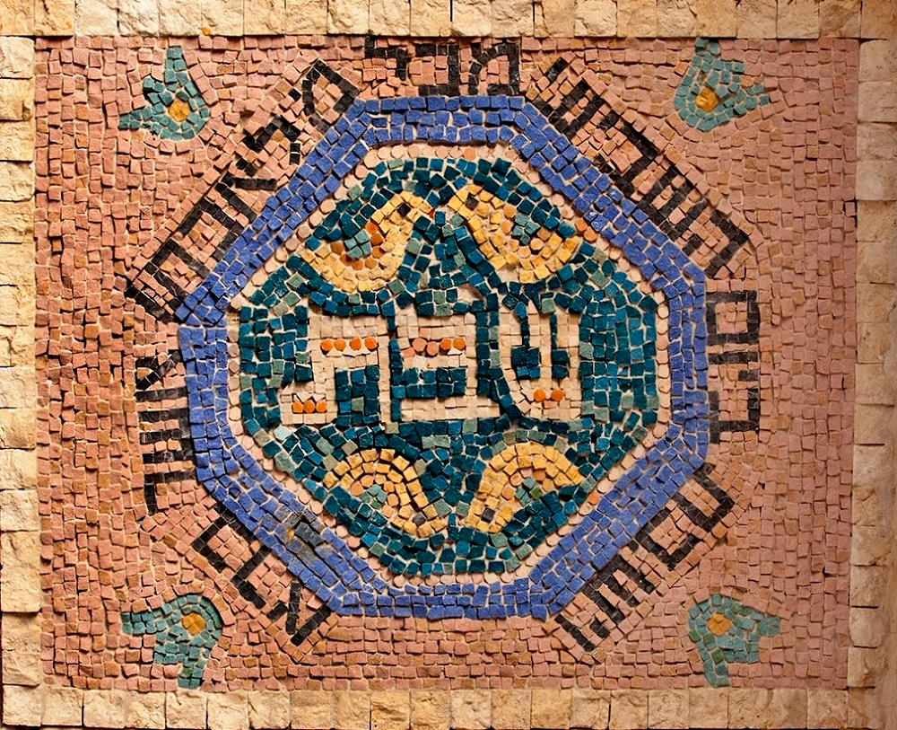

By Yael Portugheis, Beit Habad Gallery, Jerusalem. Wikimedia/zeevveez

Full Moon and the Cessation of Labor

Our earlier discussion in [“Shabbat of the Full Moon”](https://www.thetorah.com/article/shabbat-of-the-full-moon/) has revealed two things. First, texts that are commonly identified as older (for independent reasons) appear to reflect a Chodesh-Shabbat monthly cycle, revolving around the antipodes of New Moon and Full Moon. These texts suggest that some in pre-exilic Israel commemorated Shabbat on the Full Moon. [1]

Second, a statute in Exod 23:12, which biblical scholars agree belongs to an older (if not the oldest) law code of the Torah, requires landowners to cease from fieldwork every seven days in order to give those toiling on their behalf a time to recuperate. The mandated seven-day rest cycle, however, did not have to begin and end on the same day for all households. This day was not called Shabbat.

The Convergence of Weekly Cycles – Counting from Chodesh

It would not be surprising if the seven-day cycles from different individuals and communities converged over time. This convergence would have been driven in part by the need to agree on a common calendar to attend to mercantile, organizational, and cultic matters. For agrarian communities, shared work and market cycles are more practical, which would have motivated communities to keep a common seven-day cycle.

Another reason for the convergence could have been calendrical convenience. Picture a world without common calendars. (We take our calendars so much for granted that it is difficult to imagine a world without them.) A New Moon (Chodesh) and the Full Moon (Shabbat) holiday make sense, since they are easy to track. Assuming people were attempting to integrate the seven-day rest law into their schedules, they would opt first for an existent cycle.

Thus, people may have planned to have their seventh day coincide with the celebration of communal festivals and sacred days, such as New Moon (Chodesh) and the Full Moon (Shabbat), i.e., their vacation days. If the counting began after the New Moon, then the seventh day of rest cycle would be day 8, 15, 22, and 29. The second rest day would coincide with Shabbat, and the final one either with Chodesh or the day before Chodesh. [2]

Before moving on to the final stage, when the universal seven-week cycle becomes independent of the month, it would be useful to take a step back and look at the uncanny similarity between what I have described here and what we find in the Mesopotamian monthly cycle.

Shabbat and *šapattu*: Full Moon Holidays

Like the Israelite holiday cycle outlined above, the Mesopotamian calendar also contained New Moon and Full Moon holidays. The name of this Full Moon holiday was *šapattu.* The connection between this term and the Hebrew holiday of Shabbat seems hardly coincidental.

Although it is unclear whence the word Shabbat derives,[3] the newest investigations make a strong case that, despite protestations to the contrary, this term is a loanword from the Akkadian *šapattu*or*šabattu.*[4] (The letters “b” and “p” are very similar in pronunciation, and often interchange between and within Semitic languages.) As noted above, the Akkadian term, attested from Old-Babylonian to Neo-Babylonian times, refers to the Full Moon holiday celebrated on the 15th of the month.

A text from the library of Ashurbanipal (685-627 BCE) calls this a “day for the resting of the heart” (*ūm nuḫ* *libbi*). *Enuma Elish*, a Babylonian creation epic, describes how Marduk appointed the moon-god Nannar as the jewel of the night to fix the days. The place of the seven-day periodization of the month parallels the Israelite cycle outlined above:

Shine over the land at the **beginning of the month (*arḫu*)**,  
Resplendent with horns to fix six days.  
On the **7th day** **(*sebutu*)** the crown will be half size,  
On the **15th day (*šap/battu*)**, halfway through each month, stand in opposition.

When Šamaš [sees] you on the horizon,  
Diminish in the proper stages and shine backwards.  
On the 29th day, draw near to the path of Šamaš,  
. [ . . ] the 30th day, stand in conjunction and rival Šamaš. ([Enuma Elish](http://www.ancient.eu/article/225/" \t "_blank), Tablet 5)

This same sequence—with first day or new moon (*arḫu*, cognate to Hebrew *yareach*), seventh day (*sebutu*, cf. Hebrew *sheviʿi*), and fifteenth day (*šapattu*)—is found in a number of other Mesopotamian contexts, ranging from the Atraḫasis Epic (I 206-207 and 221-222) to economic documents. The celebration of these three days can be traced back as far as the Sargonic period (22nd cent. BCE).

This offers a close parallel to the holiday cycle as it was celebrated in ancient Israel. The *arḫu*parallels Israelite Chodesh, and *šapattu* the Israelite Shabbat. Moreover, the fact that the seventh day (*sebutu*) was also celebrated serves as a tantalizing parallel to what I suggested above, namely that the seven-day counting may have begun as a count from the new moon celebration.

Shabbat in Response to Defeat – Why the Shift?

At some point, the cycle of seven days took on a life of its own and became independent of the Chodesh-Shabbat calendar. Thus, Israel developed two systems of time that run independently of—and even compete with—each other; one was lunar, and the other was based on seven-day periods of time.[5] It is, however, not clear to what extent all the seventh-day laws in the Torah presuppose this independent weekly time-reckoning or whether they work with an older Chodesh-based counting.[6] Following the shift from Chodesh based to the independent weekly cycle, the seventh-day of rest merged with the (now-defunct) holiday of Shabbat.

To understand how the term Shabbat came to refer to the seventh day of the week, we must consider not only factors that shaped the societies of Israel and Judah over the duration of their kingdoms but also those that brought about the downfall of these kingdoms.

Shabbat Discontinued and Reinvented

Initially defeat would have meant the cessation of Shabbat (=Full Moon) observance. Various inner-biblical clues and comparative evidence show how both the observation of the lunar phases and the celebration of New Moon (*rosh chodesh*) and Full Moon (Shabbat) were very much tied to the Temple and the state.[7] The destruction of the kingdom thus meant the cessation of Shabbat:

איכה ב:ה הָיָה אֲדֹנָי כְּאוֹיֵב בִּלַּע יִשְׂרָאֵל בִּלַּע כָּל אַרְמְנוֹתֶיהָ שִׁחֵת מִבְצָרָיו וַיֶּרֶב בְּבַת יְהוּדָה תַּאֲנִיָּה וַאֲנִיָּה.

Lam 2:5 The Lord has become like an enemy; he has destroyed Israel. He has destroyed all its palaces, laid in ruins its strongholds, and multiplied in daughter Judah mourning and lamentation.

ב:ו וַיַּחְמֹס כַּגַּן שֻׂכּוֹ שִׁחֵת מוֹעֲדוֹ **שִׁכַּח**יְ־הוָה בְּצִיּוֹן מוֹעֵד **וְשַׁבָּת**וַיִּנְאַץ בְּזַעַם אַפּוֹ מֶלֶךְ וְכֹהֵן.

2:6 He has broken down his booth like a garden, he has destroyed his tabernacle. YHWH has **abolished** in Zion festival and **Shabbat**, and in his fierce indignation has spurned king and priest.

The Temple vision in Ezekiel (chaps. 40-48) assigns to *the prince*(*ha-nasi*) the duties of burnt offerings, grain offering, and drink offerings, as well as the festivals, the new moons, the Shabbats, and all the appointed festivals.[8]

Moreover, the national festivals that we witness in the Torah and Prophets are all thoroughly spatial in character. They are intimately linked to the land, its seasons, its harvests, its agrarian communities, its sacred places, its altars, and ultimately its Temple. Conquest meant therefore a radical disruption of the festival calendar. For Shabbat to survive conquest, it had to be reinvented.

How Shabbat Was Reinvented

The transition from the monthly to the weekly Shabbat would have been a protracted one, with both understandings competing in many of the relevant biblical references to Shabbat.[9] Yet it seems most likely that the transition began very late in Israel’s history. This realization brings us to several other factors that must be considered when retracing the shift from full moon to week.

The Word Shabbat

Several biblical texts feature various kinds of wordplay on the noun *Shabbat,* connected to the likely unrelated verb, *sh-b-t* “to (cause to) cease.”[10] The early statutes from Exodus (see above) culminate with the verb *tishbot*, “you shall cease [from your six days of labor].” These statutes originally had nothing to do with Shabbat, as we saw in [part one of this article](http://thetorah.com/shabbat-of-the-full-moon/). But the use of the verb may well have contributed to the shift from the monthly to weekly Shabbat.

This development helps us appreciate the elliptical play on the word Shabbat in Genesis 2:2-3 (וַיִּשְׁבֹּת**,** כִּי בוֹ שָׁבַת), a text that never actually uses the word Shabbat but the older term, “Seventh Day [11](יום השביעי).” Perhaps the simultaneous wordplay with *tishbot* and avoidance of the proper name Shabbat implies that this text was written during the period of transition where the idea of calling the seventh day Shabbat may still have been controversial.

*ūmū-lemnutū*(Inauspicious Days)

In addition to the biblical evidence about word play, we need to consider the role of inauspicious days in Mesopotamian culture from the first millennium. Members of all sectors of society consulted calendrical handbooks (similar to our horoscopes today) that listed unfavorable days for certain activities. Beginning in the Neo-Assyrian period, the most ominous days (*ūmū-lemnutū*) were the 7th, 14th, 19th/21st and 28th. (The 19th is strangely more often listed than the 21st.)

The introduction of the *ūmū-lemnutū*into Israelite consciousness around the time of the exile would have worked in tandem with the biblical law of rest every seven days to solidify the new calendar cycle of the weekly holiday of rest. When combining this point with the above observation about the word play of *tishbot*-Shabbat, we can appreciate how various external factors contributed to the transition of Shabbat from the Full Moon celebration to an independent seventh day of rest.

The shift from the monthly to the weekly Shabbat was done under the influence of Mesopotamian culture. This influence began with the incursions of the Neo-Assyrian and Neo-Babylonian armies in the southern Levant (in the seventh and sixth centuries), though more direct and sustained contact with Mesopotamian culture began after the conquest of Judah in 587. The synergies produced by Judean interactions with these Mesopotamian cultures reverberate throughout the late biblical writings they authored and redacted.

The Shabbat of Creation and the *Berit Olam*: How Shabbat Became So Fundamental

Biblical texts from the post-exilic period make (the weekly) Shabbat the primary and most fundamental institution for the people of Israel. A passage from “Third-Isaiah” (chaps. 56-66) proclaims that fidelity to Shabbat (“holding fast my covenant”) is the basis for permitting non-natives and eunuchs to enter the community.[12] The (post-exilic) P text of the Torah (Exodus 31:16-17) declares Shabbat to be a *brit olam,*an “eternal covenant.” Failing to observe it is punished with expulsion (*karet*) and death.

Why does Shabbat become so central to the nation’s identity at this time?

A Torah for Exile

The Torah, in its transmitted forms, is conceived for communities that already have been, or soon will be, exiled from their land. Dispersed communities can observe the weekly Shabbat—similar to circumcision, dietary restrictions, and a host of similar laws.[13]

Yet Shabbat is the Torah’s “super-law,” one that trumps all others in the attention assigned to it. Notice, for example, how it stands alone in a special literary unit (*piskah*) that begins the *Vayakhel* Torah-portion (Exod 35:1-3).[14] Why does it figure so prominently within the Torah?

Shabbat is distinctive because in both biblical and post-biblical Judaism, time transcends space. The Temple may have been destroyed and national sovereignty forfeited, but Shabbat survives. The natural cycles of the day, moon, seasons, and year, which were created by Israel’s God, have not been eradicated by the vanquishing power of the Babylonian high-god Marduk. Above all, the non-natural covenantal cycle of the seven-day week persist after nation’s defeat. This is the message of Genesis 1:1-2:3.

Shabbat in the Torah’s Prologue

In contrast to the New Moon and the full-moon Shabbat (as well as days, seasons, and years), the independent weekly cycle does not correspond to any natural cycle. For this reason, it could easily become a point of contention for rival communities, since there is no objective way to determine when the seventh day “really” is (a problem Shabbat did not face when it was a full moon celebration.)

Imagine what Judaism would look like—or the western world for that matter—if no consensus had ever been formed about converging the Shabbat/weekly cycles. How would it be if Jews from different communities—including Karaites, Samaritans, and Ethiopians—all kept Shabbat on different days? What if the Ashkenazi Shabbat was the Sephardic or Yemenite Wednesday? (The same thought experiment can be done with Christians and Sundays.) Needless to say, such a calendrical mess would destroy any possibility of large-scale community cohesion around the holiday. This is what was at stake when the Priestly authors were writing.

Thus, the Priestly authors of the Torah’s prologue (Genesis 1:1-2:3), who presuppose the shift from monthly to weekly Shabbat, responded to this problem by tracing the seven-day cycle back to the beginning of time. These authors were likely writing just before or already after the exile in 587 BCE. Even though they do not mention Shabbat directly (see above), they play on this word and presuppose its shift to a weekly cycle.

When God designs the natural order, God rests from six days of creative exertion and sanctifies the seventh day, initiating a holy rhythm that cannot be discerned from nature. Hence Shabbat had to be revealed to the nation at some point in their history, and such is precisely what we find in the Torah’s narrative.

The nation has no knowledge of Shabbat until it is made known to them in Exodus 16.[15] But it was this very non-natural character that predestined the week, ending in Shabbat, to become a distinctive identity marker for the covenantal order established with Israel alone. It had to be revealed to the nation.

Similar to what happened with tales (such as the flood account) and laws (such as goring ox) that began as adaptations of Mesopotamian institutions, the prologue to the Torah (1:1-2:3) and the related Shabbat laws set forth for Israel the proper understanding of Shabbat. These laws trace its inception to Israel’s God, and infuse it with an ethos that is in keeping with the various theological and legal principles that inform the Torah.

Shabbat in Relation to Space and Time

Throughout the Torah the possession of the Land is still a promise waiting to be fulfilled, just as it was for the communities that read the Torah after the destruction of the First Temple. But in the meantime, one could observe the special temporal order of the weekly Shabbat that Israel’s God established at creation, revealed to the nation soon after they leave Egypt (Exodus 16), and expanded upon as they make their way to the Promised Land.

The Israeli national poet Hayim Nahman Bialik compared the laws of Shabbat to great works of art and architecture. What others do with stones in space, the Tannaim and Amoraim—and we may add, the biblical authors long before them—did with words in time.[16]

**Overview**

The Origins of Shabbat

Our investigation has revealed the following points:

1. Shabbat originally designated Full Moon, which explains why it is mentioned after New Moon in a number of older biblical texts. Full Moon was celebrated throughout the ancient Near East, so that it would be surprising if it were not observed in ancient Israel and Judah.
2. The number seven had special significance for ancient Israel and her neighbors in the ancient Near East. Many symbolic and ritual activities lasted seven days. But we lack comparative evidence for time reckoning according to seven-day (weekly) cycles.
3. An older law from the Covenant Collection (Exod 23:12) requires landowners to give a day of rest to their animal and human laborers every seven days. The law does not refer to Shabbat. Nor does it require a general community-wide reckoning of the seven days. One was simply to count seven days, similar to the counting of seven years for the manumission of the Hebrew Slave (Exod 21:2).[17]
4. Over time the individual labor cycles would tend to coalesce. Before it took on a life of its own, the seven days were likely counted from New Moon (*Rosh Chodesh*).
5. Various clues suggest that the monthly Shabbat would not have merged with seven-day labor rhythms had it not been for Mesopotamian influence. This influence made itself felt with the incursions of the Neo-Assyrian in the southern Levant. But more direct and sustained contact with Mesopotamian culture began after the onslaught of Babylonian armies in 597 and 587.
6. Other factors that may have contributed to the transition from the monthly to the weekly Shabbat are the use of the verb *tishbot* (“cease”) in Exod 23:12 as well as possible polemics against moon veneration. Whatever the case may be, the tensions between weekly and monthly time-reckonings, as well as the very different conceptions of Shabbat (the cultic versus the ethical: a holy time versus a day of rest), have their origins in this consequential transition.[18]
7. Eventually Shabbat was traced back to creation and became fully independent as a system of time-reckoning. After the reinvention of Shabbat in the wake of the destruction of the kingdom of Judah in 587 BCE, its observance became one of the primary identity markers for the people of Israel.

[View Footnotes](https://www.thetorah.com/article/how-and-when-the-seventh-day-became-shabbat)

For a Spanish-language version of this essay, see [¿Cómo y Cuándo el Séptimo Día se Convirtió en Sabbat?](http://thetorah.com/como-y-cuando-el-septimo-dia-se-convirtio-en-sabbat/)

1. After publishing the original essay, a friend (Albert Dov Friedberg) called my attention to a possible support for this thesis. Leviticus 23:15 states that the counting of the omer should begin ממחרת השבת (on the day after Shabbat.) This obscure phrase gave rise to various sectarian interpretations. The Qumran sect and the Sadducees interpreted this to mean literally the day after Shabbat, i.e. Sunday, and assumed it referred to either the Shabbat of Chag HaMatzot or the Shabbat afterwards (the Torah does not specify.) The rabbis interpreted it as the day after Yom Tov, but then why would it be called the day after Shabbat? If we assume that the Priestly author was using the older term, then Shabbat would refer to Full-Moon precisely when the first day of Passover fell ( the 15th of Nisan). The next day would then properly be called “the day after Shabbat”! Interestingly, this actually supports*the rabbinic position*, against those who began counting the Omer on Sunday. (The rabbinic position is also supported by the account of the first Pesach in the land in Joshua 5:11-12 – but a discussion of this would lead us too far afield.) See also the discussion, and the quote of Beer’s words, in Theophile James Meek, “The Sabbath in the Old Testament,” *Journal of Biblical Literature* 33 (1914): 201-12.
2. The possibility of a two-day Chodesh celebration in ancient times is implied in the story of Jonathan and Saul in 1 Samuel 20:27, when Saul notes that David missed the feast two days in a row. This interpretation of the verse is uncertain (the NJPS translates the phrase as “the day after the Chodesh”), but if correct, the fourth rest day would thus coincide with the first day of Chodesh in this model.
3. I will deal with the midrashic connection to the verb ש-ב-ת later in the essay.
4. See discussion in Grund, *Entstehung*, pp. 106-110.
5. The full-moon celebration was folded into holidays that begin in the middle of the month.
6. The challenge to create an aesthetically pleasing calendar where weeks and months would work together and not independently of each other was one of the motivations for the sectarian 364 day calendar adopted by the book of Jubilees and the Qumran community. For more details, see Michael Segal’s TABS essay, [“The Jewish Calendar in Jubilees.”](http://thetorah.com/jewish-calendar-in-jubilees-a-solar-year/)
7. A number of biblical texts link Shabbat to the king. For example, 2 Kings 16:18 refers to a portal that had been built in the palace for Shabbat. See also 2 Kings 11:4-12.
8. וְעַֽל־הַנָּשִׂ֣יא יִהְיֶ֗ה הָעוֹל֣וֹת וְהַמִּנְחָה֘ וְהַנֵּסֶךְ֒ בּחַגִּ֤ים וּבֶחֳדָשִׁים֙ וּבַשַּׁבָּת֔וֹת בְּכָֽל־מוֹעֲדֵ֖י בֵּ֣ית יִשְׂרָאֵ֑ל
9. This placement of the (full-moon) Shabbat after New Moon is found also in a late post-exilic passage from Third-Isaiah (see 66:23 and the discussion in part one on “New Moon and Shabbat).
10. See esp. Hosea 2:13 (see part one of this article) and Leviticus 26:34-35.
11. וַיִּשְׁבֹּת֙ בַּיּ֣וֹם הַשְּׁבִיעִ֔י מִכָּל־מְלַאכְתּ֖וֹ… כִּ֣י ב֤וֹ שָׁבַת֙ מִכָּל־מְלַאכְתּ֔וֹ
12. See e.g. Isaiah 56, and well as Isaiah 58, Jeremiah 17, and Nehemiah 13. On the first text, see the article I wrote with Michael Chan, “King and Eunuch: Isaiah 56:1-8 in Light of Honorific Royal Burial Practices,” *JBL* 131 (2012): 99-119, which can be read [here](https://www.academia.edu/1487048/King_and_Eunuch_Isaiah_56_1_8_in_Light_of_Honorific_Royal_Burial_Practices).
13. This explains the shift from agricultural activities in the two laws from Exodus examined above to the Priestly prologue (Gen 2:1-3) that depicts God sanctifying the seventh day and resting from all his creative labors, using the most general word for “work” (*mlachah).*
14. Rashbam, Ibn Ezra, and other *mefarshim* (as well as critical scholars such as Wellhausen) explained the presence of this isolated unit (at the beginning of the instructions for setting up the Mishkan) as an attempt to affirm that Shabbat trumps even the sacred work on building the Mishkan. Here we see how time (the observance of Shabbat) takes precedence over place (the building of the sanctuary, even if it is a transportable one).
15. The editing of this chapter seeks to resolve the problems posed by the presence of the Shabbat laws later in the book: If Shabbat no longer designates the full-moon phase, it cannot be discerned in nature and thus must be revealed. This larger meta-narrative concern can best explain the formulation of the (supplementary) lines pertaining to Shabbat in Exodus 16. One could however read this text under the assumption that they were counting seven days from New Moon (instead of from some fixed point such as creation).
16. This temporal dimension of Shabbat lends itself to teleological and eschatological interpretations: A long period of labor culminates in rest. A future age (the world to come) erupts in the here and now, interrupting our natural, quotidian cycles. Here the holy and profane origins of Shabbat, which I treated in part one of this article, are fully integrated: the sacred, auspicious feast-time (*chag*) of Full Moon, on the one side, and the forward-moving rhythm of weekly labor, on the other.
17. See footnote 27 in part one of this article.
18. The cultic-sacral versus the ethical character of Shabbat is reflected in the fundamental differences between the famous sayings of Achad Ha-Am and Jesus. To the first is attributed the statement: “More than Israel has kept Shabbat, Shabbat has kept Israel.” This sacred identity-shaping character of Shabbat contrasts with the emphasis on social justice in the saying attributed to Jesus: “The Sabbath was created for man, and not man for the Sabbath” (Mark 2:27).