**Thyroglobulin is a poor predictor of differentiated thyroid cancer in patients operated for thyroid nodular diseases**

**Thyroglobulin for DTC prediction**

Shoham Rigbi1*, Ben- Zion Joshua 3*, Lior Baraf2*, Uri Yoel2*¥, Merav Fraenkel2*€¥

1 Goldman School of Medicine Ben-Gurion University of the Negev, P.O. Box 151, Beer-Sheva, Israel

2 Endocrine unit, Soroka University Medical Center, Beer Sheva, Israel

3 Department of Otolaryngology Head and Neck Surgery, Barzilai Medical Center, Ashkelon, Israel

*Faculty of Health Sciences, Ben-Gurion University of the Negev, P.O. Box 151, Beer-Sheva, Israel

¥ Equal contribution as last co-authors

€ **Corresponding author**

Address for correspondence:

Merav Fraenkel MD

Endocrine Unit

Soroka Medical Center

Yitzchak Rager

Beer Sheva

Israel

meravfra@gmail.com

**Keywords:** Thyroglobulin, Differentiated Thyroid Cancer, multinodular goiter, indeterminate cytology, Bethesda System

**Abstract**

**Objective**: Thyroglobulin, produced exclusively by thyroid follicular cells, serves as a specific tumor marker for the follow up of differentiated thyroid cancer (DTC) patients after thyroidectomy. However, its role as a predictor for malignancy in patients with thyroid nodules is controversial. We aimed to assess the potential role of preoperative serum thyroglobulin concentration to predict DTC in patients who were referred to partial or total thyroidectomy without preoperative diagnosis of malignancy.

**Methods**: This retrospective study included patients who had partial or total thyroidectomy between January 2014 and May 2019, with preoperative diagnosis of benign multinodular goiter (MNG) or a thyroid nodule with indeterminate cytology (INC) (Bethesda system categories 3/4). We compared patients for demographic, clinical, imaging, and biochemical data according to their final diagnosis: DTC or benign thyroid nodular disease. Further statistical analysis included odds ratios calculation and receiver-operator curves (ROC) analysis.

**Results**: Of 131 patients who met inclusion and exclusion criteria, the indication for surgery was benign MNG in 69, and thyroid nodule with INC in 62 patients. Final diagnosis of DTC was reported in 18/69 (26%) and 30/62 (48%) of patients with preoperative diagnosis of benign MNG and INC thyroid nodule, respectively. Preoperative measurement of nodule diameter, TSH, and thyroglobulin serum concentration did not differ between patients with final diagnosis of DTC versus those with benign histology.

**Conclusion**: Preoperative serum thyroglobulin alone is insufficient to differentiate preoperatively between malignant and benign thyroid nodular disease. **Introduction**

Thyroid nodules (TN) are a common finding on neck imaging and physical examination (1). Solitary TN or those identified in multinodular goiter (MNG) are usually benign and their prevalence depends on the method of detection: palpitation (2-6%), ultrasonography (19-68%), or autopsy (8-65%) (2). The prevalence of differentiated thyroid cancer (DTC) is 7-15% of all TN (3).

The evaluation of TN begins with neck ultrasound (US) accompanied by the measurement of serum thyroid-stimulating hormone (TSH) levels. According to their diameter and specific ultrasonographic features (e.g., hypoechoic or the presence of microcalcifications) TN should be further investigated using fine needle aspiration (FNA) biopsy for cytological assessment(3,4). The Bethesda System for reporting thyroid cytopathology is the standard for interpreting FNA specimens; category II signifies benign nodule while categories V and VI have very high malignancy rates (75 and above 95% respectively). The malignancy risk for Bethesda III category (defined as atypia of undetermined significance/follicular lesion of undetermined significance) is 10-30%, while the risk for Bethesda IV category (follicular neoplasm/suspicious for follicular neoplasm) is 25-40%. These two categories are commonly defined as indeterminate cytology (INC) (5,6).

Evaluation of malignancy risk in INC nodules includes consideration of worrisome clinical and sonographic features and repeat of FNA with or without molecular testing. Surgery is a valid option when repeat FNA for cytology and/or molecular testing are inconclusive or not preformed (6). Indications for surgical intervention in cases of MNG are not as clear-cut. Surgery may be considered for patients with large MNG causing respiratory or swallowing compromise or for esthetic deformation (3,4).

Thyroglobulin (Tg), a storage protein, crucial for thyroid hormones biogenesis, is synthesized exclusively by thyroid follicular cells and released to the serum along with thyroid hormones. In patients after thyroidectomy for DTC it serves as a specific tumor marker (7). Elevated serum Tg concentration can be the result of several thyroid pathologies other than DTC including Grave’s disease, toxic adenoma, thyroiditis and benign nodular thyroid disease (3,4,8). Importantly, anti-Tg- antibodies (Tg-Ab) may interfere with Tg measurements producing falsely low Tg concentration (9). Whether serum Tg concentration may serve as a predictor for DTC in patients evaluated for a TN or MNG is controversial. Different cut-off values for Tg which may discriminate malignant from benign nodules were offered by several research groups. However, these suggested Tg cut-off values differed significantly from 75 to 1000 ng/ml (10–13). A systemic review by Trimboli et al., which addressed specifically this question, included 13 studies, 9 of them included data of TN with INC. The pulled analysis demonstrated that preoperative serum Tg concentration had suboptimal accuracy in discriminating malignant from benign nodules with a significant overlap of values between these groups. However, the authors signified that most studies showed a statistically significant higher preoperative serum Tg concentration in patients with DTC compared with those with final histology reporting benign TN. Accordingly, they conclude that Tg is an independent preoperative predictor of DTC in patients with INC (8). Nevertheless, the 2015 American Thyroid Association (ATA) differentiated thyroid cancer guidelines, published shortly thereafter, strongly recommended against (with moderate-quality evidence) the routine measurement of serum Tg for the initial evaluation of TN, stating that “serum Tg levels can be elevated in most thyroid diseases and are an insensitive and nonspecific test for thyroid cancer”(3). This recommendation however addresses TN as a whole and does not discuss specific clinical scenarios where preoperative Tg measurement may have a role.

Regarding this controversy and in the absence of ‘high-quality evidence’, we aimed to assess the association between preoperative serum Tg concentration and final histology of DTC in two distinct groups of patients, who had thyroid lobectomy or total thyroidectomy; first, patients with MNG who were operated for an indication other than suspected DTC and second, patients with TN who had an FNA result classified as INC.

**Methods**

Study population

This retrospective cohort study included patients, who were admitted to the Otolaryngology department of Soroka University Medical Center (SUMC), a tertiary referral center, for total thyroidectomy or thyroid lobectomy between January 2014 and May 2019, with preoperative diagnosis of benign MNG (group 1) or with TN with INC (group 2). Patients with both MNG and INC were included in group 2 only. Each group was divided according to the final histological diagnosis DTC or benign thyroid nodular disease. Inclusion criteria were at least one preoperative serum measurement of Tg and TSH, dated up-to one year prior to surgery, and available preoperative neck US. Patients with known DTC prior to the operation, and those with positive anti-Tg antibodies (Tg-Ab) were excluded.

Data collection

Data were collected from the patient’s electronic medical records, including age, sex, type of surgery and pathology reports, and preoperative measurements of Tg, TSH and Tg-Ab. If more than one Tg measurement was available in the year prior to surgery, the most recent was recorded. Tg-Ab were classified as either positive or negative, based on the lab reference ranges. FNA-cytology based on the Bethesda system for reporting thyroid cytopathology (6) was recorded from the pathology report following the FNA procedure. Histological results were recorded from final pathology reports and classified as malignant or benign. For malignant results the histological type of DTC was recorded as well, classified as papillary thyroid carcinoma (PTC) or follicular thyroid carcinoma (FTC).

All lab tests were performed in authorized laboratories. Most lab results were performed at the endocrinology lab in SUMU as follow: TSH- TSH3-UL- a Third-generation, two-site sandwich immunochemiluminescent assay, Advia CENTAYR XP, SIEMENS. Tg- a 2-site sandwich, solid-phase Immunometric IMMULITE Xpi, SIEMENS. Tg-Ab- a solid-phase chemiluminescent enzyme sequential immunometric assay, IMMULITE Xpi, SIEMENS.

Thyroid nodule ultrasound (US) reports

Maximal diameter of the dominant nodule of the MNG (group 1), and of the nodule from which the FNA was performed (group 2) were recorded based on the formal US report. The US examinations were conducted in SUMC or in other medical imaging centers and interpreted by authorized clinical radiologists.

Statistical analysis

Baseline characteristics of the study population were summarized using descriptive statistics. Continuous variables were compared using t test for normally distributed variables, and Mann-Whitney U test for non-normally distributed variables. Chi square test was used for categorical variables. Results are presented as means ± SDs (standard deviation) for normally distributed continuous variables and as medians and quartile 1 (Q1) and 3 (Q3) for non-normally distributed variables. Odds ratios (ORs) were calculated using logistic regression and are presented with 95% confidence intervals (CI). The Receiver-operating characteristic (ROC) was used to evaluate the performance of preoperative serum Tg concentration as diagnostic test to differentiate between malignant and benign nodules. For all analyses, a 2-sided p<0.05 was considered statistically significant. Statistical analyses were conducted using SPSS software (ver. 26.0 for Windows; SPSS Inc., Chicago, IL, USA).

The study was approved by SUMC IRB committee authorization number 0352-15-SOR.

**Results**

Between September 2014 and May 2019 one hundred and seventy-seven patients had thyroidectomy or lobectomy for MNG or thyroid nodule with INC at the SUMC Otolaryngology department. Of these, 131 fulfilled inclusion criteria without any exclusion criteria and consisted of the final study cohort. Sixty-nine patients were operated for benign MNG (group 1) and 62 patients were operated due to TN with INC (group 2). Pathology reports confirmed the presence of DTC in 18 patients (26%) in group 1, and in 30 patients (48%) in group 2 (figure 1). In the entire cohort 41 (31.3%), 7 (5.3%), and 83 (63.4%) patients had post-operative diagnosis of PTC, FTC, and benign thyroid nodular disease, respectively (table 1). ROC curve analysis of the entire cohort showed area under the curve (AUC) of 0.5, (p=0.89), demonstrating that preoperative Tg did not distinguish between malignant and benign TN when patients of both study groups were included in the analysis (Figure 1A).

*Group 1- MNG without preoperative diagnosis of DTC*

Table 2 summarizes the characteristics of 69 patients operated for apparently benign MNG, stratified by the postoperative diagnosis being DTC (18, 26%) or benign MNG (51, 74%). Mean age (49 ±15.69 and 41.5 ±14.27 years, *p*=0.06) and female gender 94.4% and 82.4%, (*p*= 0.27) did not differ between groups. Maximal TN diameter as reported by the preoperative US was 4.03 ±1.77 centimeters in patients with post-operative diagnosis of DTC versus 4.63 ±1.59 centimeters in those with post-operative diagnosis of benign MNG (p=0.28). Preoperative serum Tg concentration did not differ between patients with final diagnosis of malignant or benign MNG (median (Q1,Q3)): 148.5 ng/mL (67.8,1158.5) and 190 ng/mL (62.4,574), respectively, p= 0.97. Similarly, preoperative serum TSH concentration were comparable in both sub-groups; 1.5 ±0.84 mIU/L and 1.98 ±1.38 mIU/L, respectively (*p*=0.3). The ROC analysis for Tg as a potential predictor of DTC in patients who were operated for apparently benign MNG showed AUC of 0.49, (*p*=0.97), demonstrating that preoperative Tg did not distinguish between patients with postoperative diagnosis of DTC and benign MNG (Figure 2B). In addition, the ORs of group 1 patients for final diagnosis of DTC were not statistically significant for any of the assessed parameters, including preoperative serum Tg and TSH concentration or maximal nodule diameter (table 4).

*Group 2- Indeterminate cytology*

Table 3 summarizes the characteristics of 62 patients operated for TN with INC, stratified by the postoperative pathology diagnosis of DTC (30, 48%) or benign (32, 52%). Mean age (46.80 ±12.83 and 48.93 ±13.93 years, *p*=0.56) and female gender 63.3% versus 71.9% (*p*= 0.47) did not differ between patients with final diagnosis of DTC or benign TN. Maximal TN diameter as reported in a preoperative US was comparable between the two sub-groups: 3.36 ±1.92 for postoperative DTC diagnosis vs. 3.64 ±1.75 centimeters for benign TN (p=0.5). Last preoperative serum Tg concentration was lower, though not statistically significant, in patients with postoperative DTC diagnosis compared with those diagnosed with benign TN (median (Q1,Q3)): 160.5 ng/mL (82.2,536.7) and 205.5 ng/mL (65.2-821.5), *p*= 0.93. The ROC analysis for Tg as a potential predictor of DTC in patients who were operated for TN with INC showed an AUC of 0.49 (*p*=0.93), demonstrating that preoperative Tg did not distinguish between patients with postoperative diagnosis of DTC and benign TN (Figure 2C). Among patients with INC results, the odds ratio of the TN in question being malignant were not statistically significant for any of the assessed parameters, including preoperative Tg level, TSH level or nodule diameter (table 4).

We further compared preoperative serum Tg concentration among patients in group 2 according to their Bethesda system subcategory (table 1). Of 62 patients, 33 and 29 patients had a cytology report of Bethesda III and IV, respectively. Among the 33 patients with Bethesda III cytology, 13 (39%) and 20 (61%) had final diagnosis of DTC and benign TN, respectively. Pre-operative Tg did not discriminate between patients with final diagnosis of DTC or benign TN (mean±SD, 694.7 ng/mL±1584.35 versus 1012.75 ng/mL±1874.61, respectively, p=0.61). The same was found among the 29 patients with Bethesda IV cytology. Seventeen (59%) patients with final diagnosis of DTC had mean preoperative Tg of 523.77 ng/mL ±587.04 and in12 (41%) patients with final diagnosis of benign TN the mean preoperative Tg was 563.77 ng/mL ±1427.71 (p=0.91).

In addition, we analysed the potential role of preoperative Tg to predict postoperative diagnosis of DTC within the INC group (62 patients), according to the histological subtypes of DTC (PTC, FTC) compared with benign TN. PTC was diagnosed in 24 (38.7%) patients, FTC in 6 (9.7%) patients, and benign TN in 32 (51.6%) patients (table 1). Preoperative serum Tg concentration of patients with PTC or of those with FTC did not differ from the preoperative serum Tg concentration of patients with final histology of benign TN (405.38 ng/mL ±478.7 [PTC] and 1367.81 ng/mL±2286.2 [FTC] versus 844.38 ng/mL±1710.53 [benign TN], p=0.17 and 0.51, respectively).

**Discussion**

In the current retrospective study, we evaluated the potential role of preoperative serum Tg concentration to predict final DTC diagnosis in patients who were operated (partial or complete thyroidectomy) for apparently benign MNG (group 1) or for a TN with INC (group 2). In general, preoperative Tg concentration was significantly elevated in both groups. This may suggest that elevated serum Tg concentration was a consideration in those who were referred for thyroid surgery. In our surgical cohort with malignancy rate of 18% in group 1 and 48% in group 2, neither preoperative serum Tg concentration nor preoperative serum TSH concentration or TN diameter could discriminate benign from malignant thyroid nodular disease in both groups. Furthermore, these findings were consistent when we analyzed separately Bethesda 3 and 4 categories within group 2, and when we grouped and investigated patients who were diagnosed with FTC or PTC against those with benign final histology. Importantly, to the best of our knowledge there were no studies which investigated preoperative Tg as a predictor of DTC in patients who were operated for MNG. Our results support the notion that in this group of patients that thyroid mass in the main component determining Tg concentration and not the presence of DTC within a large MNG (7).

Several studies investigated the potential role of preoperative Tg concentration in patients with TN resembling INC, mainly of Bethesda 4 category. The results of these studies were conflicting. Among those, few supported our results. A study by Suh et al., included 39 TN that were classified by cytology as follicular or Hurtle cell neoplasms (Bethesda IV), found no correlation between preoperative serum Tg concentration and postoperative DTC diagnosis (14). Kihara et al. also investigated preoperative serum Tg concentration in 137 patients with INC nodules who underwent surgery (15). The included patients had serum Tg concentration which was comparable with that observed in our cohort. There was no statistically significant difference in serum Tg concentration between patients with final histology of DTC and benign TN. In contrast with our results, Lee et al. examined 164 Korean patients with INC, who underwent thyroidectomy. They found that preoperative Tg concentration had a significant role as a predictor of FTC, and suggested additional risk factors for DTC such as younger age, male gender, and specific sonographic features including larger TN (10). All these parameters were not found to be valuable predictors of DTC in our cohort. Interestingly, mean serum Tg concentration in this study was lower than most similar studies including ours. This difference may be explained by surgical intervention for relatively small TN, reported in Korea, where this study was conducted (16,17).

Two other studies which addressed specifically TN with cytology reported follicular or Hürthle cell neoplasms, supported the role of higher preoperative serum Tg concentration as a predictor of DTC. Petric et al. suggested three independent predictors of DTC in a cohort of 388 patients: age (younger than 45), solitary tumor and preoperative serum Tg concentration above 400 ng/mL (13). Besic et al. evaluated preoperative serum Tg concentration in a cohort of 244 patients with follicular or Hurtle cell neoplasm < 2 centimeters. This group suggested a much lower cut-off, of 80 ng/mL, as a discriminator for DTC diagnosis, with somewhat low sensitivity (54.8%) and specificity (31.1%) (12). A recent prospective study by Hulikal et al. included 92 patients who were evaluated and operated for TN. The authors used ROC analysis to assess the role of preoperative serum Tg concentration as a potential predictor for DTC. They found that a Tg cut off value of 53ng/ml predicted malignancy risk with a sensitivity and specificity of 72% and 73% respectively (p<0.001). This study included only 33 patients with INC. In this sub-group, 13/17 patients (76%) with preoperative serum Tg concentration above 53 ng/ml had final histology of DTC compared to 20/33 patients (60%) with Tg concentration below this cut-off. The authors however, did not calculate the sensitivity and specificity of preoperative serum Tg concentration of for this subgroup (11).

The conflicting results between our study and most other cohorts may be explained by different inclusion criteria and time periods. For example, the largest reported cohort by Petric et al (15) included patients with Bethesda 4 sub-category only, while we included patients with Bethesda 3 and 4 categories. Moreover, their study reported on data from as early as 1988. Thus, the patients that were included may differ from patients undergoing thyroidectomy nowadays, as imaging modalities and cytopathology reporting systems have been changed considerably. In addition, with the tendency to report on ‘positive’ results more frequently than on ‘negative’ ones, a publication bias cannot be excluded (18). Considering the large range of reported Tg cut-offs, a main question is the reproducibility of these values from one cohort to another. To address this question, we tested the cut-off of 400 ng/mL, suggested by largest cohort reported by Petric at al (15) on our 29 patients of Bethesda 4 sub-category. Using 2X2 table (Supplementary table 1) we found that this cut-off had positive and negative predictive values of 75% and 47% respectively. Hence, this cut-off missed approximately 50% of patients in our cohort with preoperative serum thyroglobulin below 400 ng/mg, classifying them as having benign TN, while they truly harbored DTC.

Our study has several limitations, the most important being its retrospective nature and relatively small sample size. In addition, this study is a surgical series, which introduces a selection bias. It may be assumed that the size of the TN, suspicious US features, and possibly preoperative Tg levels were a consideration for surgical treatment. The current study did not include patients with TN with INC or MNG who were not operated, where serum Tg concentration may be significantly lower than that seen in our study cohort. We did not consider the number of nodules each patient had or thyroid and nodule volume prior to Tg measurement, rather we focused on the suspicious nodule which the FNA was obtained from. It is important to note that most of the studies reviewed here did not mention whether the dominant nodule was solitary or part of MNG.

Despite of its limitations, this study has few significant strengths. First, this is a real-life study which reflects the management of patients with MNG or INC TN in a single institution. This allowed for uniform blood testing and implied that the study population was relatively homogenous. In addition, we excluded patients with positive anti Tg antibodies thus eliminating the possibility for falsely low Tg levels. To increase the credibility of our results, larger prospective studies, preferably multi-central, incorporation preoperative serum Tg concentration in the diagnostic algorithm of patients evaluated for nodular thyroid diseases may be warranted.

In conclusion, consistent with the current ATA (3), our results demonstrated that preoperative serum Tg concentration alone is insufficient to differentiate preoperatively malignant from benign nodular thyroid disease. Thus, currently presurgical measurement of Tg cannot be recommended for this purpose.

**Acknowledgements**

This study was conducted as part of the requirements for graduation from the medical school of the faculty of health sciences, Ben-Gurion university of the Negev, Israel.

**Conflict of interest**

The authors declare that they do not have any conflicts of interest.

**Funding**

This research did not receive any grant from funding agencies in the public, commercial, or not-for-profit sectors.

**Figures and tables**

177 patients were operated for the following indications:

1. Pre-operative diagnosis of benign MNG
2. A thyroid nodule with INC

**Final Study Cohort- 131 patients**

Excluded: 46

32: Missing preoperative Tg

4: Missing preoperative cytology

10: Missing preoperative imaging

Final histology DTC 30 (48%)

Final histology benign TN 32 (52%)

Group 1: 69 patients

Pre-operative diagnosis of benign MNG

Group 2: 62 patients

Pre-operative diagnosis of TN with INC

Final histology DTC 18 (26%)

Final histology benign MNG 51 (74%)

**Abbreviations**: MNG- multinodular goiter, INC- indeterminate cytology, Tg- thyroglobulin, TN- thyroid nodule, DTC- differentiated thyroid carcinoma.

**Figure 1.** Flowchart summarizing study design, population selection and exclusion.

|  |  |  |  |  |  |
| --- | --- | --- | --- | --- | --- |
| **Table 1.** Postoperative diagnosis of patients with preoperative diagnosis of benign MNG or INC thyroid nodule | | | | | |
| **Preoperative diagnosis** | | **Postoperative diagnosis** | | | **Overall** (category) |
| **PTC** | **FTC** | **Benign** |
| **Benign MNG** | | **17** | **1** | **51** | **69** |
| **INC thyroid nodule** | **Bethesda III** | **12** | **1** | **20** | **33** |
| **Bethesda IV** | **12** | **5** | **12** | **29** |
| **Overall** (final histology) | | **41** | **7** | **83** | **131** |
| **Abbreviations:** MNG- multinodular goiter, INC- indeterminate cytology, PTC- papillary thyroid carcinoma, FTC- follicular thyroid carcinoma, TN- thyroid nodule | | | | | |

|  |  |  |  |  |
| --- | --- | --- | --- | --- |
| **Table 2**. Baseline characteristics of group 1- patients with preoperative diagnosis of benign multinodular goiter (MNG), according to the final diagnosis DTC or benign MNG | | | | |
|  | **All** | **DTC** | **Benign MNG** | p value |
| (N=69) | (N=18) | (N=51) |
|  | |
| **Demographics** | | | | |  |
| Age, years Mean ± SD (n)  Median   Min;Max | 43.46 (±14.91) 42 10;76 | 49 (±15.69) 50 17;69 | 41.5 (±14.27) 39 10;76 | 0.06 |  | |
| Female Gender, % (n/N) (n= % within Gender, N= % within category) | 59 (100%. 85.5%) | 17 (28.8%, 94.4%) | 42 (71.2%, 82.4%) | 0.274 |  | |
| **Preoperative parameters** | | | | |  |
| Maximal thyroid nodule size by US  centimeters (Mean(SD)) | 4.48 (±1.64) (n=64) | 4.03 (±1.77) (n=16) | 4.63 (±1.59) (n=48) | 0.28 |  | |
| Last Preoperative serum Tg value, ng/mL  Mean ± SD (n)  Median   Min;Max | 925.25 (±1975.08) (n=69)  171  7.68;12842 | 904.01 (±1569.88) (n=18)  148.5  14.9;5272 | 932.75 (±2113.56) (n=51)  190  7.68;12842 | 0.97 |  | |
| Last Preoperative serum TSH value, mIU/L (Mean(SD)) | 1.85 (±1.27) (n=69) | 1.5 (±0.84) (n=18) | 1.98 (±1.38) (n=51) | 0.3 |  | |
| **Abbreviations:** DTC- differentiated thyroid carcinoma, MNG- multinodular goiter, US- ultrasound, Tg- thyroglobulin, TSH- thyroid-stimulating hormone. | | | | |  | |

|  |  |  |  |  |
| --- | --- | --- | --- | --- |
| **Table 3**. Baseline characteristics of group 2- patients with preoperative diagnosis of thyroid nodule with INC according to the final diagnosis of DTC or benign thyroid nodule | | | | |
|  | **All** | **DTC** | **Benign TN** | p value |
| (N=62) | (N=30) | (N=32) |
|  |
| **Demographics** | | | | |  |
| Age, years Mean ± SD (n)  Median   Min;Max | 47.74 (±13.33) 45 21;78 | 46.80 (±12.83) 44 28;73 | 48.93 (±13.93) 45.5 21;78 | 0.56 |  |
| Female Gender, % (n/N) (n= % within Gender, N= % within category) | 42 (100%, 67.7%) | 19 (45.2%, 63.3%) | 23 (54.8%, 71.9%) | 0.47 |  |
| **Preoperative parameters** | | | | |  |
| Maximal thyroid nodule size by US  centimeters (Mean(SD)) | 3.51 (±1.82) (n=60) | 3.36 (±1.92) (n=29) | 3.64 (±1.75) (n=31) | 0.5 |  |
| Last Preoperative serum Tg, ng/mL  Mean ± SD (n)  Median   Min;Max | 725.1 (±1445.71) (n=62)  179  0.45;7838 | 597.87 (±1111.87) (n=30)  205.5  0.45;5895 | 844.38 (±1710.53) (n=32)  160.5  35.8;7838 | 0.93 |  |
| Last Preoperative serum TSH, mIU/L (Mean(SD)) | 1.65 (±0.97) (n=62) | 1.72 (±1.17) (n=30) | 1.59 (±0.75) (n=32) | 0.73 |  |
| **Abbreviations:** DTC- differentiated thyroid carcinoma, MNG- multinodular goiter, INC- indeterminate cytology, US- ultrasound, Tg- thyroglobulin, TSH- thyroid-stimulating hormone, TN- thyroid nodule | | | | |  |

|  |  |  |  |  |  |  |
| --- | --- | --- | --- | --- | --- | --- |
| **Table 4**. Odds ratio for postoperative diagnosis of DTC among patients with preoperative diagnosis of benign MNG or thyroid nodule with INC. | | | | | | |
| Preoperative diagnosis | | **Demographic characteristics** | | **Selected preoperative sonographic and biochemical features** | | |
| Age | Female gender | Maximal nodule size | Last Preoperative serum Tg | Last Preoperative serum TSH |
| **Benign MNG** | Odds ratio; 95% CI | 1.03; 0.99-1.07 | 3.64; 0.42-31 | 0.79; 0.56-1.13 | 1; 0.99-1 | 0.71; 0.43-1.17 |
| **INC** | Odds ratio; 95% CI | 0.99; 0.95-1.02 | 0.67; 0.23-1.97 | 0.91; 0.69-1.21 | 1; 0.99-1 | 1.14; 0.68-1.92 |
| **Abbreviations:** DTC- differentiated thyroid carcinoma, MNG- multinodular goiter, INC- indeterminate cytology, Tg- thyroglobulin, TSH- thyroid-stimulating hormone. | | | | | | |

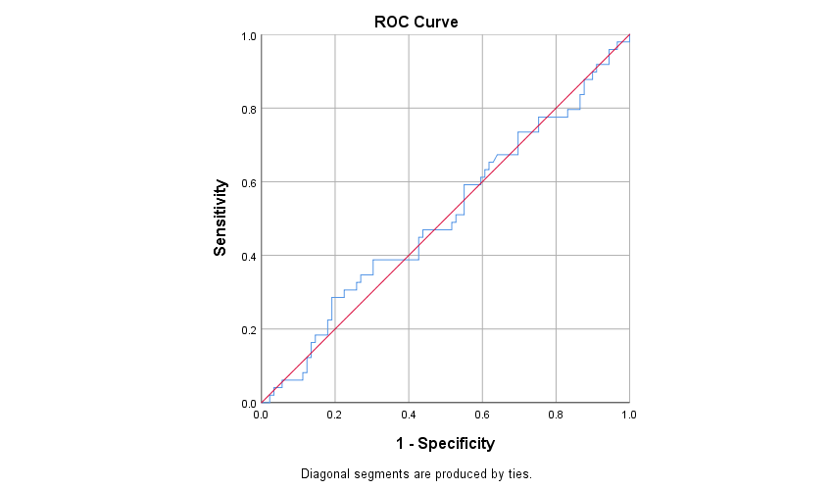

Entire cohort

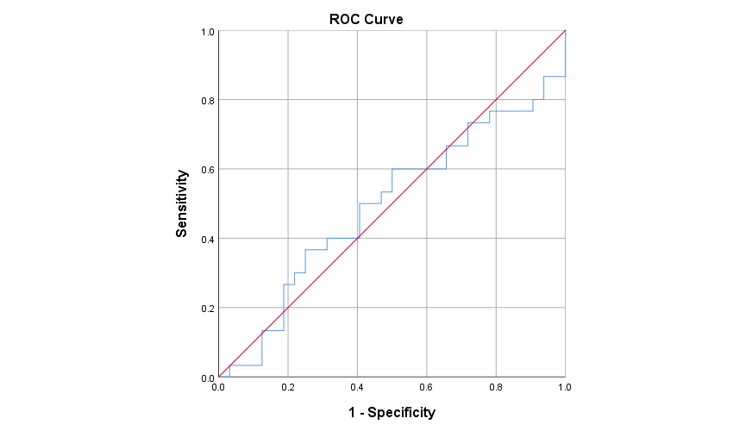

B

**Figure 2**. ROC curve of preoperative Tg concentration as a predictor of final diagnosis of differentiated thyroid cancer (DTC). A. Entire cohort. .B. Patients with preoperative diagnosis of benign multinodular goiter (MNG). C. Patients with indeterminate cytology (Bethesda III and IV).

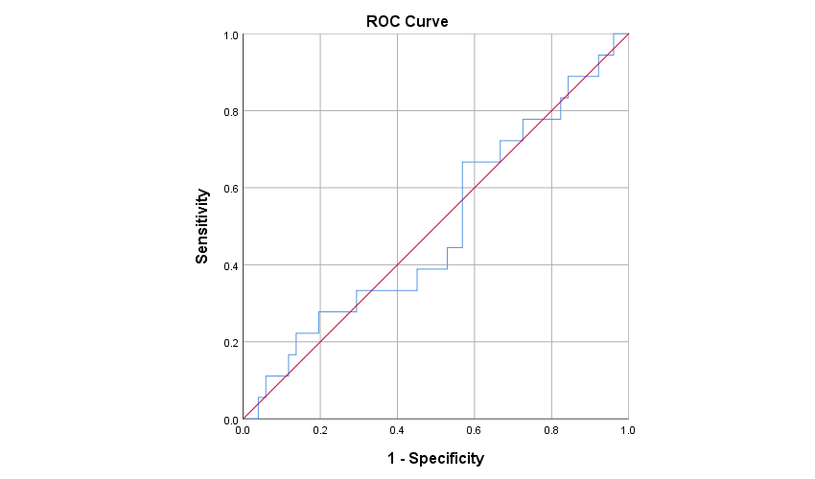

benign MNG

C

Benign MNG

Indeterminate cytology

**Supplementary**

|  |  |  |  |
| --- | --- | --- | --- |
| **Table S1**. Evaluation of the reproducibility of the cut-off value, (suggested by Petric et al) of Bethesda IV patients in our cohort. | | | |
|  | **Postoperative malignant diagnosis** | **Postoperative benign diagnosis** |  |
| **Tg>400 ng/ml** | 6 | 2 | PPV 75% |
| **Tg<400 ng/ml** | 11 | 10 | NPV 47.62% |
|  | Sensitivity 35.29% | Specificity 83.33% |  |
| **Abbreviations**: Tg- Thyroglobulin, PPV- Positive Predictive Value, NPV- Negative Predictive Value. | | | |

**References**

1. Meltzer CJ, Irish J, Angelos P, Busaidy NL, Davies L, Dwojak S, et al. American Head and Neck Society Endocrine Section clinical consensus statement: North American quality statements and evidence‐based multidisciplinary workflow algorithms for the evaluation and management of thyroid nodules. Head Neck [Internet]. 2019 Apr 18 [cited 2019 Jun 9];41(4):843–56. Available from: https://onlinelibrary.wiley.com/doi/abs/10.1002/hed.25526

2. Dean DS, Gharib H. Epidemiology of thyroid nodules. Best Pract Res Clin Endocrinol Metab [Internet]. 2008;22(6):901–11. Available from: http://dx.doi.org/10.1016/j.beem.2008.09.019

3. Haugen BR, Alexander EK, Bible KC, Doherty GM, Mandel SJ, Nikiforov YE, Pacini F, Randolph GW, Sawka AM, Schlumberger M, Schuff KG, Sherman SI, Sosa JA, Steward DL, Tuttle RM, Wartofsky L. 2015 American Thyroid Association Management Guidelines for Adult Patients with Thyroid Nodules and Differentiated Thyroid Cancer: The American Thyroid Association Guidelines Task Force on Thyroid Nodules and Differentiated Thyroid Cancer. Thyroid. 2016 Jan;26(1):1-133. doi: 10.1089/thy.2015.0020. PMID: 26462967; PMCID: PMC4739132.

4. Durante C, Grani G, Lamartina L, Filetti S, Mandel SJ, Cooper DS. The Diagnosis and Management of Thyroid Nodules: A Review. JAMA. 2018 Mar 6;319(9):914-924. doi: 10.1001/jama.2018.0898. Erratum in: JAMA. 2018 Apr 17;319(15):1622. PMID: 295098715.

5. Wu H, Swadley M. The Bethesda system for reporting thyroid cytopathology: into the clinic. Pathol Lab Med Int [Internet]. 2015 Jul 31 [cited 2019 May 24];7:47. Available from: http://www.dovepress.com/the-bethesda-system-for-reporting-thyroid-cytopathology-into-the-clini-peer-reviewed-article-PLMI

6. Edmund S. Cibas and Syed Z. Ali. The 2017 Bethesda System for Reporting Thyroid Cytopathology. 2017;27(11):1341–6.

7. Indrasena BSH. Use of thyroglobulin as a tumour marker. World J Biol Chem. 2017;8(1):81.

8. Trimboli P, Treglia G, Giovanella L. Preoperative Measurement of Serum Thyroglobulin to Predict Malignancy in Thyroid Nodules: A Systematic Review. Horm Metab Res [Internet]. 2014 Nov 10 [cited 2019 Mar 12];47(04):247–52. Available from: http://www.thieme-connect.de/DOI/DOI?10.1055/s-0034-1395517

9. Jo K, Lim DJ. Clinical implications of anti-thyroglobulin antibody measurement before surgery in thyroid cancer. Korean J Intern Med. 2018;33(6):1050–7.

10. Lee EK, Chung K-W, Min HS, Kim TS, Kim TH, Ryu JS, et al. Preoperative serum thyroglobulin as a useful predictive marker to differentiate follicular thyroid cancer from benign nodules in indeterminate nodules. J Korean Med Sci [Internet]. 2012 Sep [cited 2019 Feb 26];27(9):1014–8. Available from: http://www.ncbi.nlm.nih.gov/pubmed/22969246

11. Hulikal N, Azhagamuthu RE, Banoth M, Chowhan AK, Yutla M, Sachan A. Can preoperative serum thyroglobulin levels predict the risk of malignancy? Results from prospective analysis of biochemical predictors of malignancy in thyroid nodules. Acta Otorhinolaryngol Ital. 2020;40(1):33–7.

12. Petric R, Besic H, Besic N. Preoperative serum thyroglobulin concentration as a predictive factor of malignancy in small follicular and Hürthle cell neoplasms of the thyroid gland. World J Surg Oncol. 2014;12(1):1–7.

13. Petric R, Perhavec A, Gazic B, Besic N. Preoperative serum thyroglobulin concentration is an independent predictive factor of malignancy in follicular neoplasms of the thyroid gland. J Surg Oncol. 2012;105(4):351–6.

14. Suh I, Vriens MR, Guerrero MA, Griffin A, Shen WT, Duh Q-Y, et al. Serum thyroglobulin is a poor diagnostic biomarker of malignancy in follicular and Ḧurthle-cell neoplasms of the thyroid. Am J Surg [Internet]. 2010 Jul [cited 2019 Mar 21];200(1):41–6. Available from: https://linkinghub.elsevier.com/retrieve/pii/S0002961009007107

15. Kihara M, Ito Y, Hirokawa M, Masuoka H, Yabuta T, Tomoda C, et al. Role of ultrasonography in patients with cytologically follicular thyroid tumor. Auris Nasus Larynx [Internet]. 2011 Aug [cited 2019 May 24];38(4):508–11. Available from: http://www.ncbi.nlm.nih.gov/pubmed/21269788

16. Korea’s Thyroid-Cancer “Epidemic” — Screening and Overdiagnosis. Hyeong Sik Ahn, M.D., Ph.D., Hyun Jung Kim, M.P.H., Ph.D., and H. Gilbert Welch, M.D., M.P.H. T. N Engl J Med. 2014;371(19):1763–5. N Engl J Med. 2014;371(19):1763–5.

17. Miranda-Filho A, Lortet-Tieulent J, Bray F, Cao B, Franceschi S, Vaccarella S, et al. Thyroid cancer incidence trends by histology in 25 countries: a population-based study. Lancet Diabetes Endocrinol [Internet]. 2021 Apr 1 [cited 2021 Dec 23];9(4):225–34. Available from: http://www.thelancet.com/article/S2213858721000279/fulltext

18. Mlinarić A, Horvat M, Smolčić VŠ. Dealing with the positive publication bias: Why you should really publish your negative results. Biochem medica [Internet]. 2017 Oct 1 [cited 2022 Apr 9];27(3). Available from: https://pubmed.ncbi.nlm.nih.gov/29180912/