**Productivity of sheep in different climatic zones**

*Amantur* Bekturov1, *Tyrgoot* Chortonbaev1 Uran *Shergaziev*1*, Chinara* Kadyrova1 and *Samir* Osmonaliev2

1Kyrgyz National Agrarian University named after K.I. Scriabin, 720005, Bishkek, 68 Mederova Street, Kyrgyzstan

2Kyrgyz Research Institute of Livestock, Bishkek, Kyrgyzstan

**Abstract.** The problem of global climate change on the planet requires the most effective use of the bioclimate in order to develop a production technology that meets the natural potential. This study is aimed at studying the impact of climate zones on sheep productivity in order to identify resources for wool and lamb production. The research was conducted on fine wooled sheep. The study used analysis and methods of variation statistics of digital data. The criterion for the reliability of the difference between the average indicators is calculated using the MS Excel 2000 software. We used exterior and phenotypic indicators, meat (live-weight) and wool (wool cut), productivity in 8056 heads of sheep in 13 herds of Issyk-Kul, 24 herds of Talas and 10 herds of South kyrgyz type of sheep for the period from 2012 to 2016. In terms of live weight (X±SX=58.20±0.31; CV=4.98), Issyk-Kul ewes outperform their counterparts from other climatic zones with a significant difference (P<0.01; P<0.05). The research results allow farmers and livestock breeders to make the best use of existing sheep adaptation strategies and take climate change into account when developing and implementing agricultural policies.

**Introduction.** Kyrgyzstan is a mountainous country. More than three-quarters of the territory is occupied by mountains and is located in the Western and Central parts of the Tien-Shan and Pamir-Alai mountain systems. The average height above sea level is 2750 m. more than half of its territory is located at altitudes from 1000 to 3000 meters. Therefore, about 83% of agricultural land is occupied by natural mountain pastures, and only 6.8 % of the total land area is used for cultivation of agricultural crops [1].

The main areas of sheep farming are located within 35-55 degrees North latitude in Europe and Asia and between 30- and 45-degrees South latitude in South America, Australia and New Zealand notes S. T. Morris [2]. Domesticated sheep (Ovis aries) have a variety of genotypes that are adapted to a wide range of environments - from the tropics to extreme seasonal variations in high latitudes and from deserts to areas with high rainfall. This diversity of genotypes (numbering more than 2000 breeds) means that this species easily adapts to extreme environmental / climate conditions says G. N. Hinch [3]. The same opinion is expressed by researchers D. Petit, I. Boujenane [4] and I. Hoffmann [5].

The results show, writes S. N. Seo and others [6] that climate variables are very significant determinants of the choice of primary species after controlling for soils, geography, household characteristics, and fixed country effects. The effects of climate change will vary depending on species and climate scenarios.

Discussions on agriculture are continuing to find an acceptable approach to addressing the climate change challenges facing agriculture worldwide and to ensure that food production is not under threat [7-9]. Globally and in an unstable climate, the agricultural sector will need to feed more people without impairing the ecosystem services that production depends on [10].

Therefore, the relevance of our research lies in the fact that we are studying for the first time the productive qualities of the Kyrgyz mountain Merino breed in the highlands of Kyrgyzstan. M.Budolfson, T. McPherson, and D. Plunkett [11] argue that animals matter for climate change and that climate change matters for animals. Food and nutritional security in a changing climate depends on our ability to adapt livestock systems to climate change [12].

Sheep breeding is a traditional and leading industry in Kyrgyzstan. Sheep are bred in all regions and there are mixed systems of keeping. Natural and climatic conditions contribute to the development of sheep breeding and the production of cheap, environmentally friendly products.

The main goal of our research was an adaptive approach to sheep breeding in high-altitude conditions that could effectively use the climate conditions and meet the natural potential.

**Place of research and methods.** The study was conducted on the basis of three state breeding plants located in different climatic zones.

The state breeding plant named after M. N. Lushihina is located in the North-Western part of Kyrgyzstan, in the Talas valley. In the North-West, the valley widens and borders with semi-deserts and deserts of the Turan lowland. The climate of the Talas region is dry and continental. The average temperature in July is 15-25°C, in January -6...-14°C. The duration of the frost-free period is 157-163 days. The average annual precipitation is 300-400 mm and increases from West to East, from the foot of the mountains up the slope. Summers are dry, and permanent snow cover is formed on the plain in December, and in the foothills in November [12].

State breeding plant “Orgochor " is located in the Eastern part of the country of the Issyk-Kul valley. In the southern part, high-altitude plains stretch at an altitude of more than 3000 meters above sea level. The climate of the Issyk-Kul valley is determined by the isolation of the valley and the presence of a large ice-free lake. The lake makes the climate of the valley milder, there is no sweltering heat in summer and severe frosts in winter. The average temperature in July is about 18°C, in January -2...-4°C. The average annual precipitation in the East of the valley is about 600 mm, in the West - only 115 mm. The main amount of precipitation falls in the summer. On the slopes of the ridges surrounding the basin, climatic conditions are subject to vertical zoning: with increasing altitude, the temperature decreases and precipitation increases. It has a sharply continental climate. The average annual temperature is 3-7°C, and precipitation is 200-300 mm [13].

The state breeding plant “Katta-Taldyk" is located in the southern part of the country. A significant part of the region is covered by the Pamir-Alai and Western Tien Shan mountains. Altitude variations range from 500 m in the North to 7000 m in the South. In General, the region has a continental climate. At an altitude of 600-1100 m, the climate is warm and semi-desert. Winter is moderately warm - the average temperature in January is -3 - +4°C, and short. Summer is hot and dry - the average temperature in July is 24-25°C. The vegetation of the region is also subject to the altitude zone [14].

Sheep of fine wool breed - Kyrgyz mountain merino served as research material. The conditions for feeding and keeping sheep in all three zonal types were normal, adapted in the herds of state breeding plants throughout the entire period of our research. The indicators of meat and wool productivity were used for 8056 sheep heads in 13 herds of Issyk-Kul, 24 herds of Talas and 10 herds of South kyrgyz sheep type for the period from 2012 to 2016.

The study used zootechnical methods and techniques. Typical animals that meet the requirements for productivity indicators of zonal types were selected for the study groups. To assess the variation statistics method and determine the relationship between climate zones, 20 heads of main rams and repair rams, and 30 heads of Queens and young ewes during the spring assessment, body mass and measurements were measured.

Assessment was carried out according to the instructions for sheep of fine-wool breeds [15]. The Physical, mechanical and technological properties of wool were studied during assessment according to GOST 17514-93 [16], GOST 28491-90 [17].

Live body weight was studied by weighing on a scale with an accuracy of 500 g. The data obtained were compared with the body weight depending on the sex and age of the sheep.

The physique of animals was studied on the basis of taking measurements of the trunk. Animals from each sex and age group were selected typical, taking into account six main body measurements-heights at the withers, oblique length of the body, chest width, chest depth, chest girth behind the shoulder blades and pastern girth. The body measurements of sheep were used to calculate body composition indices, such as long-legged, stretched, thoracic, downed, massive, and bony, in % [18].

Wool samples were taken before shearing from the area of the side (behind the shoulder blade) during assessment and in period of shearing during classification of wool to determine the yield of pure fiber. To take samples of wool, we used a stencil mesh with round cells. During the shearing period, wool shearing was taken into account individually.

The main parameters of wool quality, such as tone and length and their biometric constants, were carried out on the Australian device "OFDA-2000". The yield of pure wool was determined for each animal using a hydraulic device GPOSH-2M.

The results of the study were processed by methods of variational statistics [19], with the calculation of criteria for the reliability of the difference between the average indicators using MS Excel 2000 software.

**Results and discussions.** Adaptation of breeds occurs in accordance with their natural history of territorial settlement [20]. Depending on the territorial settlement of the Kyrgyz mountain merino breed, we have identified three zonal types of sheep – Talas, Issyk-Kul and South kyrgyz.

Sheep of different zonal types differ in body weight. Ewes of the Issyk-Kul type are superior to their counterparts from other climatic zones (Table 1). South kyrgyz ewes are 2.15 kg or 3.8% lower in body weight, with a high significant difference of P<0.01, with a small difference of CV=0.23. At the same time, Talas-type ewes are inferior by 0.85 kg, or 1.5% with an unreliable difference (P>0.05). The difference between the Talas and South kyrgyz types is 1.3 kg, or 2.3% (P<0.05) and here there is a big difference in the coefficient of variation (CV=1.5) between them.

**Table 1.** Live weight of sheep from different climatic zones, kg

|  |  |  |  |
| --- | --- | --- | --- |
| Zonal types of ewes | n | Х±SX | Coefficient,  CV |
| Talas | 30 | 57.35±0,34 | 3.25 |
| Issyk-Kul | 30 | 58.20±0,31 | 4.98 |
| South Kyrgyz | 30 | 56.05±0,49 | 4.75 |

For comparative characteristics of the exterior and constitutional qualities of ewes of different zonal types, we compared them with Australian merino ewes, which are shown in figure 1. For example, Issyk-Kul ewes are 0.20 cm or 0.3% higher (P>0.05) than Talas and 0.42 cm or 0.6% higher (P>0.05) than South Kyrgyz type. The difference between the Talas and South Kyrgyz zonal types is 0.22 cm, or 0.3% (P>0.05). The maximum difference between Australian merino queens and zonal types of Kyrgyz mountain merino is 1.69 cm, or 2.5% (this is between the South kyrgyz type), and the minimum difference is 1.27 cm, or 1.8% between the Talas type.

In terms of oblique body length among queens, the minimum and maximum difference compared to Australian merino queens and between zonal types was 5.70 and 6.43 cm, or 8.2 and 9.4 percent.

The chest depth trend continues. Thus, by 3.16 cm, or 9.4% (P<0.001) and by 1.96 cm, or 5.8% (P<0.001), there was a difference between the Issyk-Kul and Talas types over the South kyrgyz type. The difference between the Issyk-Kul and Talas types was 1.20 cm, or 3.4% with a significant difference (P<0.05). It should be noted that the chest depth shows a tendency of superiority of two types of Kyrgyz mountain merino breed over Australian merinos, except for the South kyrgyz type. This difference is 0.63 and 1.83 cm, respectively, or 1.8 and 5.2%. This is probably due to the fact that Kyrgyz mountain merino sheep are adapted to high-altitude conditions where more oxygen is required.

Thus, our research shows that the exterior zonal types of the Kyrgyz mountain merino breed have well-developed latitudinal measurements, with an average height of and sufficiently developed limbs.

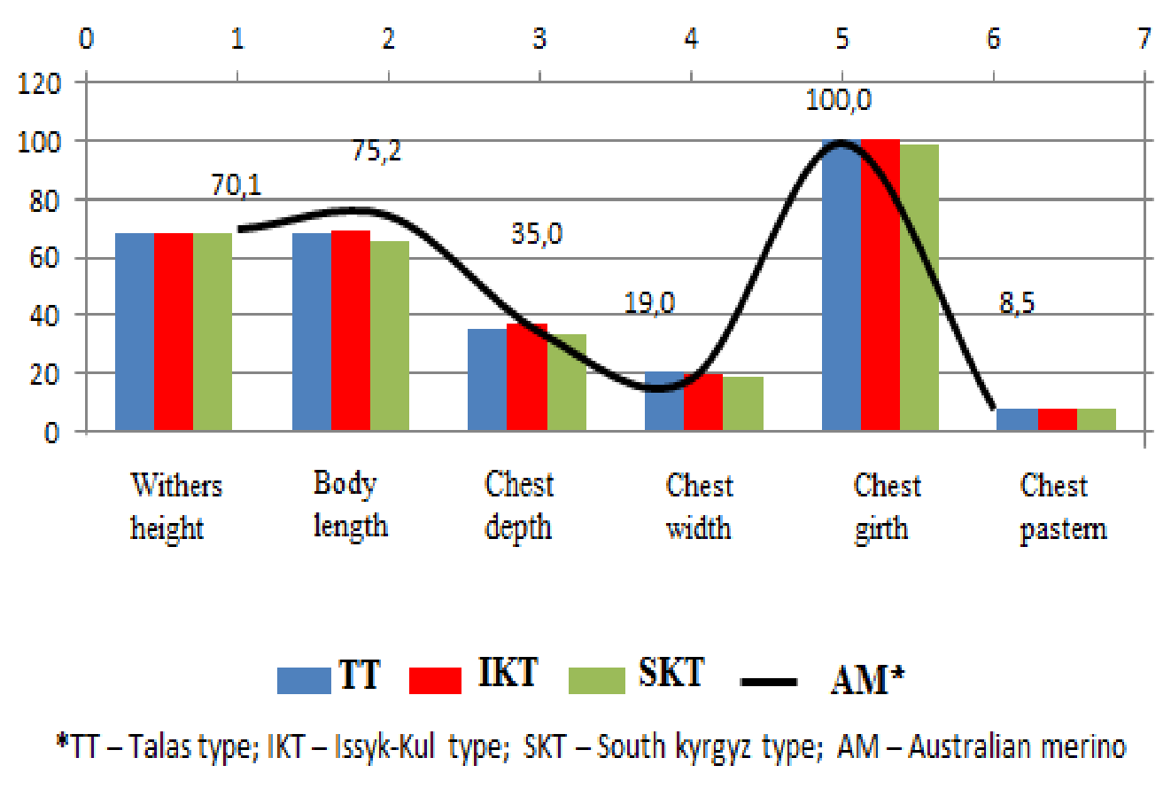

**Figure 1.** Exterior profile of zone-type ewes

The noted phenotypic differences in zonal types create a certain heterogeneity of the Kyrgyz mountain merino breed and allow maintaining good animal vitality. Considering also that phenotypic traits are determined by heredity, i.e. genotype, therefore they are directly or indirectly related to biochemical processes and metabolism, and therefore-with productivity.

The wool productivity of zonal types is quite high and meets the requirements of the Kyrgyz mountain merino breed standard.

It is known that the cut of pure wool is an important indicator that characterizes the true value of wool productivity of sheep. We found that the yield of pure fiber (60.0%) of the Talas type is inferior to other zonal types. Thus, the difference between the Issyk-Kul type was 4.1% and the South kyrgyz type-3.8%. These fluctuations seem to be due to the clogging of wool, and not to the individual characteristics of sheep of the Talas type. This is evidenced by the indicators of the physical mass of washed fiber, where there is no significant difference between the Talas and Issyk-Kul types, but they are superior to the South kyrgyz type, respectively, by 0.27 kg, or 10.6% , and by 0.4 kg,or 15.7% with an unreliable difference (P>0.05).

The Issyk-Kul type has a high yield of pure fiber-64.1%. This can be explained by the fact that during the period of transformation of the Kyrgyz fine-wool breed, mainly Australian sheep of the "strong" type were selected for crossing the queens of the Orgochor. On this occasion, academician V. A. Moroz [21] in his article writes that in Australia there are four distinct main types of Merino sheep. At the same time, there is a clear superiority of sheep in the "strong" type in the yield of washed fiber, which was achieved due to the fact that these sheep are larger and give a longer wool fiber than other types. This is noted by S. I. Biltuev et al. [22], that animal lines with the blood of Australian Merino type "strong" are characterized by high shearing and output of washed wool, longer length and thickness of wool fibers.

However, South kyrgyz sheep have a slightly low shearing rate in pure fiber [23]. Apparently, this is due, in addition to heredity, and even with the density of wool, which is confirmed by our research. Only 74.1% of the wool mass of the South kyrgyz type is of satisfactory quality, and 84.8% and 85.1% of the Talas and Issyk–Kul types, respectively.

**Conclusion.**  The results of the study revealed the resources for obtaining high-quality wool and lamb from sheep in high-altitude conditions, taking into account the climatic conditions of Kyrgyzstan. Based on the conducted research, three pure - bred zonal types of the Kyrgyz mountain merino breed were identified - Talas (North-Western), Issyk-Kul (Eastern) and South kyrgyz (Southern)

Studies have shown that in the conditions of the Issyk-Kul zone, the advantage in breeding is with a large mass of sheep-58.20 kg. An animal of the southern zone occupies an intermediate position between animals breeding plants Lushihina and "Orgochor".

It was found that according to the requirements of the standard, the wool productivity of purebred zonal types for the minimum productivity indicators of breeding sheep of meat-wool breeds and the requirements for purebred zonal types of the Kyrgyz mountain merino breed exceeds by 17.4-20.0 percent.

The research results will help practicing farmers and livestock breeders learn how to best use existing sheep adaptation strategies and take climate change into account when developing the best management strategies in the sheep industry.

**Keyword.** Ecology; Climate; Adaptability; Live weight; Exterior; Merino wool

**References**

1. *History of Kyrgyzstan* <http://www.allkyrgyzstan.com/kyrgyzstan/history.htm>,
2. Morris, S.T. *Advances in Sheep Welfare, Overview of sheep production systems* P.19-35 (2017) <https://doi.org/10.1016/B978-0-08-100718-1.00002-9>
3. Hinch, G.N. *Advances in Sheep Welfare, Herd and Flock Welfare, Understanding the natural behaviour of sheep,* P.1-15 (2017) <https://doi.org/10.1016/B978-0-08-100718-1.00001-7>
4. Petit, D., Boujenane, I. *Importance of determining the climatic domains of sheep breeds, Animal, Volume 12, Issue 7, 2018, P. 1501-1507,* <https://doi.org/10.1017/S1751731117002944>.
5. Hoffmann, I. *Animal, Adaptation to climate change – exploring the potential of locally adapted breeds,* **V. 12, I. 7,** (2018)
6. Seo, S.N., McCarl, B.A., S.N. Seo, B.A. McCarl, R. Mendelsohn, *Ecological Economics, From beef cattle to sheep under global warming? An analysis of adaptation by livestock species choice in South America,* **V. 69, I. 12,** P. 2486-2494 (2010) <https://doi.org/10.1016/j.ecolecon.2010.07.025>
7. Muldowney, J., Mounsey, J., Kinsella, L. *Animal,* *Agriculture in the climate change negotiations; ensuring that food production is not threatened,* **V. 7 I. s2,** pp. 206-211 (2013) <https://doi.org/10.1017/S175173111300089X>
8. Henry, B.K., Eckard, R.J., Beauchemin, K.A. *Animal,* *Adaptation of ruminant livestock production systems to climate changes,* **V. 12, I. s2,** pp. s445-s456 (2018) <https://doi.org/10.1017/S1751731118001301>
9. Concu, G.B., Atzeni, G., Meleddu, M., Vannini, M. *Environmental Science & Policy, Policy design for climate change mitigation and adaptation in sheep farming: Insights from a study of the knowledge transfer chain,* **V. 107,** P. 99-113 (2020) <https://doi.org/10.1016/j.envsci.2020.02.014>
10. Sherrena, K., Fischer, J., Fazey, I. *Agricultural Systems, Managing the grazing landscape: Insights for agricultural adaptation from a mid-drought photo-elicitation study in the Australian sheep-wheat belt,* **V. 106, I. 1,** P. 72-83 (2012) <https://doi.org/10.1016/j.agsy.2011.11.001>
11. Budolfson, M., McPherson, T., and Plunkett, D. *Philosophy and Climate Change, Print ISBN-13: 9780198796282, Published to Oxford Scholarship Online: April 2021* <http://dx.doi.org/10.1093/oso/9780198796282.003.0003>
12. Pankaj, P.K., Guddanti, N., Kuma, R.N., Pushpanjali, P*. Climate Resilient Animal Husbandry, Publisher: ICAR-Central Research Institute for Dryland Agriculture, Santoshnagar, Hyderabad & National Institute of Agricultural Extension Management (MANAGE), Hyderabad, India ISBN: 978-93-91668-18-1, September 2021,* <https://www.researchgate.net/publication/354831118_Climate_Resilient_Animal_Husbandry>
13. <https://www.open.kg/about-kyrgyzstan/territory-geography-and-administrative-division/talas-region/94-talasskaya-oblast.html>
14. <https://www.open.kg/about-kyrgyzstan/territory-geography-and-administrative-division/issyk-kul-region/37-issyk-kulskaya-oblast.html>
15. <https://www.open.kg/about-kyrgyzstan/territory-geography-and-administrative-division/osh/49-oshskaya-oblast.html>
16. Amirkhanov. X.A. *Production and practical edition, The Procedure and conditions for conducting bonitation of breeding sheep of fine-wool breeds, semi-fine-wool breeds and breeds of meat productivity* 60 p. (2013) <https://www.twirpx.com/file/2362919/>
17. GOST 17514-93, *Natural wool. Methods of determination of the fineness, Standards publishing house,* 16 p. (1999) <https://files.stroyinf.ru/Data/279/27924.pdf>
18. GOST 28491-90, *Wool of sheep unwashed with the separation of parts of the rune. Technical conditions,* 16 p. (2006) <https://files.stroyinf.ru/Index2/1/4294826/4294826285.htm>
19. N.I. Kulikova, *Sheep and goats: studies.method*, 193 P. (2017) <https://www.twirpx.com/file/2480293>
20. Merkur'eva, E.K. *Biometrics in breeding and genetics of farm animals,* 424 p. (1970) <https://www.ozon.ru/product/biometriya-v-selektsii-i-genetike-selskohozyaystvennyh-zhivotnyh-155281167/?sh=HN09HrIO>
21. McManus, C., Dallago, B.S., Lehugeur, C., Ribeiro, L.A., Hermuche, P., Guimarães, R.F., Júnior, O.A., Paiva, S.R. *Small Ruminant Research, Patterns of heat tolerance in different sheep breeds in Brazil,* **V. 144,** P. 290-299 (2016) <https://doi.org/10.1016/j.smallrumres.2016.10.004>
22. V. A. Moroz, I. S. Ismailov, *Bulletin of the Stavropol agro-industrial complex, On the issue of breeding sheep of the Grozny breed,* **№ 2,** Pp. 72-75 (2013) <https://www.elibrary.ru/download/elibrary_20182259_64285867.pdf>
23. S. I. Biltuev, G. M. Zhilyakova, V. V. Tsyrenova, *On the fineness of wool in fine-wool sheep in the conditions of Transbaikalia,* **№ 3,** Pp. 56-59 (2016) <https://www.elibrary.ru/download/elibrary_26902019_34305550.pdf>
24. A.B. Bekturov, T.J. Shortanbaev, D.V. Chebotaev, *The Herald of Kyrgyz national agrarian University named after K.I. Scriabin, Adaptive productivity of the southern type breed of sheep Kyrgyz mountain Merino,* **№ 1(42),** Pp. 55-57 (2017) <https://www.elibrary.ru/download/elibrary_28961345_29048592.pdf>