What Was the Tachash Covering in the Tabernacle?

Animal, vegetable or mineral? Assyriology and archaeology provide an answer to an ancient question.

[Dr. Rabbi Norman Solomon](https://www.thetorah.com/author/norman-solomon)

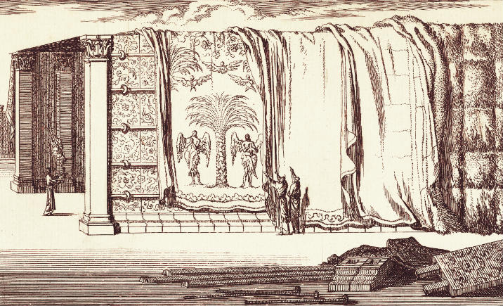

The making of the Tabernacle, Jan Luyken 1649 – 1712. Rijksmuseum

Exotic Animals in the Wilderness?

Exodus describes how the Israelites in the wilderness were instructed to make contributions toward the construction a tabernacle (משכן, *mishkan*), within which the Glory (כבוד) of God was to dwell. In addition to the precious metals gold, silver, copper, they brought, as commanded:

שמות לה:ו וּתְכֵלֶת וְאַרְגָּמָן וְתוֹלַעַת שָׁנִי וְשֵׁשׁ וְעִזִּים: לה:ז וְעֹרֹת אֵילִם מְאָדָּמִים וְעֹרֹת תְּחָשִׁים וַעֲצֵי שִׁטִּים:

Exod. 35:6 Blue, purple and crimson yarns, fine linen, goats’ hair, 35:7 tanned ram skins, *teḥashim* skins and acacia wood.

What are *Tachash* skins?

Meanings of *Tachash* in the Bible

The word תחש occurs in three different contexts in Tanakh.

1. Personal name – *Tachash* it is the name of a son of Nahor’s concubine, Reumah (Genesis 22:24).
2. Cover – It is used as a covering for the *mishkan* and its objects (Exod. 25:5, 26:14, 35:7, 23 36:19, 39:34; Num. 4:6, 8, 10, 11, 12,14, 25).
3. Material for shoes – In a parable, Ezekiel (16:10) has the husband (God) say that he made his wife (Israel) high-end shoes, after finding her abandoned in the wilderness:

וָאַלְבִּישֵׁךְ רִקְמָה וָאֶנְעֲלֵךְ תָּחַשׁ וָאֶחְבְּשֵׁךְ בַּשֵּׁשׁ וַאֲכַסֵּךְ מֶשִׁי.

I clothed you with embroidered garments, and gave you sandals of *Tachash* to wear, and wound fine linen about your head, and dressed you in silks.

Whatever *Tachash* is, it must be suitable for covering the *mishkan* and its objects, as well as a material for quality shoes

LXX and Josephus – Hyacinth Blue

Our earliest source for interpretation of the word *Tachash* is the Septuagint, the ancient Greek translation of the Torah. (The Pentateuch translation dates back to the third century BCE.) Throughout Exodus and Numbers, and in Ezekiel, the Septuagint consistently translates *Tachash* by derivatives of hyacinth (*huakinthos*). עורות תחשים is rendered “hyacinth skins” (δέρματα ὑακίνθινα; *dermata huakinthina*) i.e., hides, presumably of goats or sheep, dyed the color of hyacinths. *Tachash*, then, is not an animal but a dye. Josephus, too, lists among the materials provided for the Tabernacle “goats’ hair and sheepskins, some dyed blue (*huakinthos)*” (*Antiquities* 3:102).

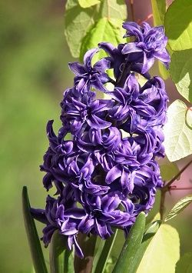

Hyacinth (*Hyacinthus orientalis* )

The Color of Hyacinths

Hyacinths are native to the Eastern Mediterranean, and the wild stock, unlike our modern cultivars, is rarely red or white, but ranges in color from violet blue to bluish purple. “Hyacinth blue” was a well-known ancient dye made, not from the flower, but from a substance extracted from molluscs, and which was processed to produce the same color. No doubt for generations Jews in Alexandria and elsewhere in the diaspora, wherever the Torah was read in Greek, were nurtured by this translation to imagine hyacinth-blue sheets of leather covering the *mishkan* and being used by the Levites to wrap its utensils for transport.

*Techelet* is also Hyacinth

One problem with the LXX’s translation is that it also uses *huakinthos* as a translation for *techelet* (תכלת) – the blue-dyed thread in the *mishkan*, in the clothes of the *kohanim* (priests), and most notably on the fringes (ציצית) on the corners of men’s garments.[1] If the *mishkan*covers and other parts of the *mishkan* were to have been dyed with the identical dye, why use two different terms?

Rabbinic Interpretations: The Introduction of Animals

The Talmudic Rabbis offered a number of interpretations for *tachash*. Yerushalmi *Shabbat*2:3 (4c) discusses the problem of *tachash* in the context of discussing a question of tent purity:

רבי אלעזר שאל מהו לעשות אוהל מעור בהמה טמאה.

R. Eleazar asked: “May one make a tent out of the hide of an unclean animal?” (i.e., would it convey and be subject to impurity like a normal tent?)

והכתיב ועורות תחשים.

Is it not written (Exod. 36:19), “Skins of *techashim*?”

As is well known, טומאה (impurity) may be conveyed to a person or object by simply being under the same אהל (“tent,” i.e. covering) with the source of the impurity. R. Eleazar’s questions whether a “tent” made from the hide of an impure animal would itself render everything beneath it impure. The Talmud attempts to settle the question by referencing the use of *tachash* skins in covering the tent of meeting. If “tents” made from the skin of impure animals would really have that effect, would that not render the entire *miskhan* impure?

The Talmud then offers three answers:

ר’ יהודא אומר טיינין לשם צובעו נקרא.

R. Judah says: “[It was] *ianthinon* (violet), and named for its dye.”[2]

ור’ נחמיה אמר גלקטינין.

R. Nehemiah said: “[It was the fur of] the [ermine] weasel imported by the Axeinoi[3] (γαλῆ Ἀξεινῶν).”

ורבנן אמרין מין חיה טהורה. וגדילה במדבר.

The [other] Rabbis said: “It was a clean animal, and it lived in the wilderness.”

R. Judah’s opinion agrees with the LXX and Josephus, that *tachash* is a dye, and the skins being dyed were from a kosher animal. R. Nehemiah’s answer is puzzling. Ermine – the pure white winter coat of the stoat – is certainly not from a kosher animal, and thus doesn’t seem to answer the question. Thus, it seems that he must be partially agreeing with R. Judah, but claiming that the (kosher) animal skins were not died violet, but were dyed to look like ermine. The third position solves the problem by positing, or more likely inventing, a kosher animal that lives in the wilderness.

From Mythic Creatures to the Unicorn

The Talmud then connects this final view with descriptions of mythic creatures:

ותיי כיי דמר ר’ לעזר בי ר’ יוסי ר’ אבהו בשם רבי שמעון בן לקיש בשם ר’ מאיר כמין חיה טהורה ברא הקדוש ברוך הוא למשה במדבר כיון שעשה בה מלאכת המשכן נגנזה.

This fits with that which R. Eleazar b. Yosé stated, R. Abbahu in the name of R. Simeon b. Laqish in the name of R. Meir: The Holy One, blessed be He, created a clean animal for Moses in the wilderness. Once [Moses] had constructed the *mishkan* with it, it was hidden away.

ר’ אבון אמר קרש היה שמה.

R. Abun said, It was called קרש (*qeresh*).

תני רבי הושעיה דחדא קרן [תהלים סט לב] ותיטב לה’ משור פר מַקְרִן ומפריס. מקרן כתב רחמנא.

R. Hoshaya taught, It had [only] one horn. “It shall please the Lord better than a bullock with horn and hoof” (Psalm 69:32) –and מַקְרִן (a *hiphil* participle) is written defective (i.e., without a *yod* between the *resh* and the final *nun*, suggesting the singular noun קֶרֶן, “horn”).

The Talmud moves from speculation, i.e., some unknown kosher animal that lives in the wilderness, to a miraculous creature, created specifically for this purpose, and finally to the legendary unicorn.[4] The Babylonian Talmud (*Shabbat* 28a) comes to a similar conclusion, though it prefers a multi-colored creature to the unicorn.[5]

Badgers, Seals, and Dolphins

The animal interpretation continued to develop. I have lost count of how many times, when we have read the Tabernacle Torah portions in the synagogue, people have questioned me about the תחש *tachash*. Depending on the translation they use, they want to know what were badgers (KJV translation), seals (JPS 1915), or dolphins (NJPS 1985) doing in the wilderness.

Badgers

In the Renaissance period, many scholars believed that the original human language was Hebrew, and that other languages retained elements of it, if corrupted (after all, *gamal* and camel are the same word, denoting the same animal). Someone noticed that the consonants T, Ḥ, Š of *tachash* resemble D, CH, S in German *Dachs* (‘badger’). Accordingly, Martin Luther, possibly on the advice of his friend and supporter, the humanist Georg Spalatin, translated *tachash* as *Dachsfelle* (“badger skins”) (Dalley 2000, 1). Luther’s German translation appeared in 1534, and influenced translations into other European languages including English.

Sea Mammals

The German scholar Gesenius, the first edition of whose Hebrew Lexicon appeared in 1812, offered “seal” as a possible translation, on the basis of Arabic تُخَسْ *tuḥash* “porpoise,” explaining that the ancient Hebrews would have used this term as a catch-all for many different creatures that “they neither knew nor distinguished with accuracy.” In 1907, Oxford’s Brown, Driver, Briggs *Hebrew and English Lexicon of the Old Testament* suggested “porpoise.” Nevertheless, in keeping with Genesius’ suggestion that the Hebrews were merely “approximating” with this term, “porpoise” has been modified by subsequent translators of the Bible to assorted aquatic mammals—not only Gesenius’ “seals” but “dolphins” (a kind of porpoise at least) and even “dugongs.”

Beaded Leather – A Luxury Product



[Stephanie M. Dalley](https://en.wikipedia.org/wiki/Stephanie_Dalley)

Stephanie Dalley, an Assyriologist at Oxford University, argues that *duchsu*, and by analogy *tachash*, refers neither to an animal nor to a specific material, but to the profession of attaching faience (ceramic) beads to leather.[6] Thus, William C. Propp, in his Anchor Bible commentary on Exodus, translates *tachash* as “beaded leather.”[7]

The Making of *Duhsu* Leather in the ANE

Archaeologists have shown that the making of faience beads and their use in decorating leather was already an ancient skill by the time Exodus was written. Faience is “a composite material consisting of a sintered quartz body and a glaze,” and such beads have been found in Mesopotamia dating back to the fourth millennium BCE.[8]

Dalley cites cuneiform texts on the uses of *duhsu*-leather:

The leather was used for sandals in the craft texts from Isin of the early second millennium BCE, and in Old Babylonian texts from Mari … In the Isin craft archive it was particularly interesting that the word was found in connection with goat or sheep hide (not ox-hide) and is often listed together with madder-red-dyed hides,[9] especially ox-hide This is the same combination as we find for the covering of the tabernacle in Exodus, and the covering of the table of offerings in Numbers. This similarity, together with the use for sandals, gives substance to the idea of reviving a link between the two words (pp. 10-11).

All this seems very far from the Septuagint’s translations of *tachash* as hyacinth, but Dalley observes that the hyacinth is somewhat variable in color, and suggests that,

[If we think of] the surface effect of the hyacinth flower rather than its colour, it is evident that it resembles a beaded surface. It is most commonly blue, varying in shade, but can also be white or pink. *Huakinthinos* in other Greek texts is used of fringes, selvedges and coats of mail, giving a range of context similar to that of Akkadian *duhsu*(p. 12).

This is likely the meaning of the name Nahor’s son, Tachash (Gen 22:24), i.e., “bead maker” or “embroiderer of leather with beads.” (This fits with his brother’s name, Tebaḥ, meaning butcher.) It would be nice to think that our father Abraham had a nephew who was skilled in an art which would one day adorn the Tabernacle, but that must remain in the realm of midrash.

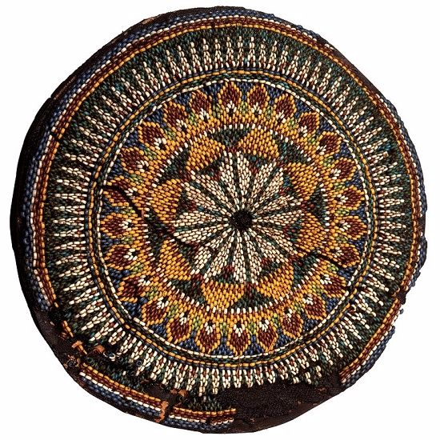

This decorative piece of cloth contains blue and green faience beads with copper rondos, or doughnut-shaped jewelry, in the middle. The beads are attached to each other by wire. This form of a beaded net covered the front part of the mummy for magical protective purposes. Dating: New Kingdom: 18th Dynasty. globalegyptianmuseum.org

Duḥsu Shoes

Dalley further reports a striking archaeological finding:

Dr Gillian Eastwood-Vogelsang in Leiden, working on the clothing in the tomb of Tutankhamun, has identified specific items imported from western Asia, by certain features of design. One of those items consists of beaded sandals which she describes as ’embellished with an intricate design of gold bosses and beadwork in carnelian, turquoise and possibly lapis lazuli’.

In the Amarna letter EA 22 the Mittanian king sent to Akhenaten one pair of duhsu-shoes, studded with ornaments of gold, of hiliba stone, etc. If duhsu here means some kind of beadwork, the description would match not only Tutankhamun’s sandals but also certain beaded objects which have been found intact on excavations in Mesopotamia. (Dalley 2000, 12)

This find ties up beautifully with Ezekiel’s “I provided you with shoes of *tachash*” (ואנעלך תחש). Pseudo-Jonathan (Ezekiel 16:10) translates מסן דיקר, “precious shoes.” If Dalley is indeed correct, and I believe she is, Ezekiel is telling us that God shod Israel with shoes worthy of an Egyptian king.[10]

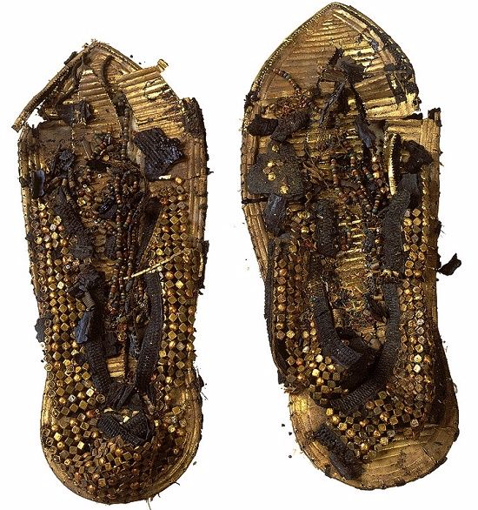

One of many slippers found in the tomb of Tutankhamun. Some of them were never used in the king’s lifetime, but this pair appears to have been favored by the king. The soles of the slippers are made of papyrus leaves covered with sheets of gold while the upper parts are made of variously shaped small gold beads with smaller colored beads. New Kingdom 18th Dynasty, globalegyptianmuseum.org

Evidence Coming Together

Dalley sums up:

Hebrew *tahas*is cognate with Hurrian / Akkadian / Sumerian *duhsu.*It denotes beading and attaching pendants, and inlaying in stone, metal, faience and glass, and is usually made on leather but sometimes also wool or linen, or as cloisonné in precious metals, timber, etc.

The profession which manufactured them was not involved in dyeing leather, but was a refiner of frit, faience and glass, who shaped beads and inlays, and designed the iconography of ceremonial armour and harness, awnings for royal boats, ceremonial necklaces and headdresses, luxury sandals and royal headrests. His status was far higher than that of a mere dyer of leather, and the range of his expertise accounts for his high rank at the neo-Assyrian court…

Both the colour and the surface effect of beading are taken up in the Greek translation of the Hebrew as *huakinthinos.*The covering for the tabernacle in the Pentateuch with its underlay of red, madder-dyed leather has its precise counterpart in craft materials from Isin and Mari around 2000-1800 BCE. The sandals in Ezekiel have their counterpart in the Amarna letters and in the grave goods from Tutankhamun’s tomb.

Therefore it is not simply a matter of proposing a new cognate, as has been done in the past, but of gathering together a range of evidence which confirms the proposal. (pp. 16-17)

A Worthy Material to Cover the Tabernacle

Beaded hides are, from many points of view, the ideal material with which to cover a Tabernacle; they are aesthetically pleasing, fit for royalty, strong, and resist sun, rain, dust and probably arrows too.

It has taken a couple of thousand years to unravel the mystery, but the answer appears to be that no badgers, seals, dolphins or unicorns were necessary to construct the *mishkan*. Rather like many of the elements in *mishkan* account, it was a standard luxury product of the ANE.

[View Footnotes](https://www.thetorah.com/article/what-was-the-tachash-covering-the-tabernacle)

1. Baruch and Judy Taubes Sterman have vividly recounted the chronicle of its rediscovery and its method of production in their prize-winning book, *The Rarest Blue* (Guilford CT: Lyons Press, 2012).
2. This and the next translation follow Marcus Jastrow in his dictionary entries on these terms.
3. A people living around the Pontus Exenus or Euxenus that were involved in the fur trade.
4. Unicorns are mentioned by a number of ancient Greek writers on nature, from Aristotle onwards, and often associated with India; perhaps the legends can be traced back to accounts of the rhinoceros, a beast not native to the Near East. A Christian writer of about the time of the Mishna, known as the Physiolologos, compiled an allegory in which the unicorn figures as an animal which only permits itself to be captured in the lap of a pure virgin – he was probably not thinking of a rhinoceros. Like the rabbinic identification with the *taḥash*, his allegory is an adaption of a widespread legend to religious purposes.  Cf. lxx to Ps. 92.12.

בעי רבי אלעזר: עור בהמה טמאה, מהו שיטמא טומאת אהלין?

R. Eleazar asked, Does the skin of an unclean animal [function as a tent] to convey uncleanness?

מאי קמיבעיא ליה?

What is he asking?

אמר רב אדא בר אהבה: תחש  שהיה בימי משה קמיבעיא ליה, טמא היה או טהור היה?

R. Ada bar Ahava says, He is asking about the *taḥash* in the days of Moses. Was it clean or unclean?

אמר רב יוסף: מאי תיבעי ליה? תנינא: לא הוכשרו למלאכת שמים אלא עור בהמה טהורה בלבד!

R. Yosef says, What sort of a question is that? A *baraita*states, Only skins of clean animals were acceptable for the work of heaven [viz. the Mishkan]

מתיב רבי אבא, רבי יהודה אומר: שני מכסאות היו, אחד של עורות אילים מאדמים ואחד של עורות תחשים.

R. Abba objected: R. Judah says, there were two covers, one of rams’ skins dyed red, and one of *teḥashim* skins*.*

רבי נחמיה אומר: מכסה אחד היה, ודומה כמין תלא אילן.

R. Nehemiah says, There was one cover, and it was like *telé ilan* (Rashi: an [unspecified] unclean animal with patches of color; Jastrow: squirrel)

והא תלא אילן טמא הוא!

But isn’t *telé ilan* unclean?

הכי קאמר: כמין תלא אילן הוא, שיש בו גוונין הרבה, ולא תלא אילן, דאילו התם – טמא, והכא – טהור.

What he means is, it was like *telé ilan* in having many colors, but it was not a *telé ilan*, for that is an unclean [animal], but this was clean.

אמר רב יוסף: אי הכי היינו דמתרגמינן ססגונא – ששש בגוונין הרבה.

R. Yosef said, If so, that is why we translate [*taḥash* into Aramaic] as ססגונא – it rejoices in [its] many colors.

Rabbi Judah, in this version, states that the second cover is *teḥashim*, but he does not tell us what *teḥashim* are. Nor can we be certain what R. Nehemiah’s view is; his comparison with a many-hued creature suggests a dye, but on the other hand he may be thinking of a legendary beast, which is certainly what Targum Onkelos has in mind when, as R. Yosef states, it translates *taḥash* as ססגונא. The animal idea has become entrenched and the Bavli, redacted later than the Yerushalmi, seems to find it difficult to recognize that R. Judah or R. Nehemiah might have understood *taḥash* to be a dye rather than an animal.

Whatever the true opinions of Rabbis Judah and Nehemiah, the idea of a specially created, exotic, “clean” beast took root within rabbinic circles, and is repeated and developed in many midrashim and in later tradition without question.

1. Stephanie Dalley, “Hebrew *Tahas,*Akkadian *Duhsu,*Faience and Beadwork,” *Journal of Semitic Studies* 45/1 (Spring 2000): 1-19. Her research solved a problem not just in biblical studies but in Assyriology as well. Reflecting the confusion in cuneiform philology she writes, “I am sure I am not the only Assyriologist whose heart has sunk every time any form of the word [*duhsu*] appeared” (p. 8).
2. He explains:

Dalley (2000), in a *tour de force* marshalling of philological and archaeological evidence, proves that *dušū/duḫšû/taḥaš* is neither a substance nor a color, but a technique of sewing blue faience beads onto leather to attain various chromatic effects.

William C. Propp, *Exodus 19-40* (Anchor Bible; New York: Doubleday, 2006), 375.

1. Moorey 1999, 167, 172.
2. A dye made from the roots of the madder herb.
3. A further question is whether such elevated footware would function for the ceremony of *ḥalitza*, as mooted in b. *Yevamot* 102b?