**Just talk to them! The Importance of child sexual abuse and assault Teacher-pupils mediation**

**INTRODUCTION**

Child sexual abuse (CSA) is a worldwide health problem with long-term outcomes on survivors’ mental, psychological, physical, and sexual health. While researchers have focused extensively on estimating the prevalence of CSA (Barth et al., 2013; Singh et al., 2014; Stoltenborgh et al., 2011; Vogeltanz et al., 1999). According to the World Health Organization (WHO, 1999), child sexual abuse is defined as “the involvement of a child in sexual activity that he or she does not fully comprehend, is unable to give informed consent to, or for which the child is not developmentally prepared and cannot give consent, or that violates the laws or social taboos of society. Child sexual abuse is evidenced by this activity between a child and an adult or another child who by age or development is in a relationship of responsibility, trust or power, the activity being intended to gratify or satisfy the needs of the other person.” To stress that CSA in the present study includes offenses conducted by juvenile/peer offenders, the word “assault” is added to the term CSA (CSAA).

Estimates of child sexual abuse prevalence worldwide range from 8-31% for girls and 3-17% for boys (Barth et al., 2013). Pereda et al., in their meta-analysis of the worldwide prevalence of child sexual abuse, found the rate to be 7.9% of men and 19.7% of women (Pereda et al., 2009). In Israel, one out of four adults reports having been sexually abused as a child (Schein et al., 2000). In the Jewish population, no gender differences have been found in child sexual abuse rates (17.6% for boys and 17.7% for girls), whereas among the Arab population, these rates have been found to be significantly higher among boys (28.4%) than among girls (18.7%) (Lev-Wiesel et al., 2018). In a recent national study conducted among Israeli children, 18.7% of children ages 12-17 reported being sexually abused (Lev-Wiesel et al., 2018). Prior research has indicated that child sexual abuse has significant negative effects both in the short and long term, including post-traumatic stress disorder (PTSD), various psychiatric disorders such as depression, anxiety, suicide and suicide attempts, and substance use, neurobiological effects, poor physical health, eating disorders, and psychosomatic physical complaints and conditions (Briere & Runtz, 1993; Putnam, 2003).

Teachers have key role in the prevention and disclosure of CSAA. In fact, in a recent study, Goldschmidt-Gjerløw argues that it is the “children’s rights and the teachers’ responsibility” to discuss CSAA in schools (Goldschmidt-Gjerløw, 2019). As teachers spend several hours a day with pupils, it is important they will discuss CSAA with pupils. When teachers address CSAA with their pupils, pupils become informed about what CSAA is, what relationships are characteristic between the abuser and the victim, and what they can do to break out of this pattern. The discussions over CSAA between teachers and pupils gives pupils greater protection and safety. By openly discussing CSAA, teachers can alert to signs that a pupil may be subjected to violence or abuse, and promote disclosure of children who are victims of CSAA.

A timely disclosure of CSAA, which is appropriately responded to, has the potential to reduce the risk for subsequent sexual exploitation/revictimization, and to foreshorten the predations of offenders. To achieve this, responsible and trusted adults in the lives of children need to learn how to invite a genuine disclosure of CSAA. Previous research shows that children do not often disclose their CSAA experience with teachers. In a national study conducted in the United States among youth aged 10-17, 66.3% did not disclose the abuse to a parent or any other adult, however, from those who did disclose the abuse, 31% disclosed to their parents, 19.1% to the police, and 21.8% to a teacher (Gewirtz-Meydan & Finkelhor, 2019). Similarly, in another study conducted among CSAA survivors, 75% of the respondents did not disclose the abuse during their childhood. Of the 25% of the survivors who reported that they told someone about the abuse; only 7% disclosed the abuse to their teacher (Wager, 2015). Findings from Alaggia’s (2010) study with adult survivors suggest that there is an expectation that teachers would recognize distress in their pupils, and that if they were to directly ask about the cause, this would have provoked a disclosure.

It is unfortunate that children do not feel comfortable discussing or disclosing CSAA with their teachers (Schönbucher et al., 2012). Children and adolescents need adults from all spheres of their life to openly discuss and sensitively respond to CSAA, including parents, teachers, police, magistrates, and treatment-providing workers. The current study sought to examine the factors that enable such an open discussion between teachers and pupils. While previous research on the discussion of CSAA between teachers and pupils mainly focused on the perspective of either the pupils (Schönbucher et al., 2012) or the teachers (Goldman & Bradley, 2011; Tener & Sigad, 2019), there is a growing need for a study that integrates both the perceptions of pupils and teachers and examine the gap between them. The current study addresses this gap by examining the perceptions of both pupils and their homeroom teacher on the discussion regarding CSAA.

In the current study we will examine the teacher’s mediation strategies when discussing CSAA and how it correlates with the perceived teacher’s support and acceptance among pupils. The mediation of CSAA by teachers relates to a set of strategies used to discuss CSAA with pupils. It is based on three core strategies of mediation: Restrictive, negative-active, and positive-active (Boniel-Nissim et al., 2020; Efrati & Boniel-Nissim, 2021; Nathanson, 2016) Restrictive mediation focuses on rules and boundaries and is not really open for discussion but rather setting a clear message that sexual harassment is illegal and against the law. Discussions on CSAA from a negative-active mediation approach, illustrates CSAA from a negative aspect (i.e., as dangerous and bad). Finally, a positive-active approach discusses CSAA by focusing on healthy and beneficial sexual behaviors (e.g., saying sex is wonderful and joyful, and if someone ever touches us without consent, or if sex ever feels unpleasant we should approach an adult).

Research examining mediation strategies mostly focus on parents (Chen & Chng, 2016; Shin & Li, 2017) and with regard to media usage and risk behaviors online (Livingstone & Helsper, 2008). Finding on different mediation styles are mixed, with some studies suggesting active positive are associated with the most positive outcomes (Nathanson, 2001) and other studies suggesting combining different mediation strategies are most beneficial (Chen & Chng, 2016).

**The current study**

Acknowledging the importance and benefits of an open discussion about CSAA between teachers and their pupils (Goldschmidt-Gjerløw, 2019; Goldschmidt-Gjerløw & Trysnes, 2020), and with data indicating limited disclosure of CSAA to teachers (e.g., Wager 2015; Gewirtz-Meydan and Finkelhor 2019), the current study sought to understand what are the factors that predict an open, effective and supportive conversation about CSAA between middle and high-school pupils and their teachers, from both the perspective of pupils and their teachers. Specifically, we will examine the perception of both middle and high school pupils and their teachers on the teacher’s mediation strategies of CSAA (restrictive, negative and positive active,) how severely the teacher perceives CSAA, does the teacher’s perceived susceptibility of CSAA, the quality of teacher-pupil communication in general and specifically about CSAA, and the teacher’s support of CSAA. Pupils were also asked about the appraisal of their teacher as a secure base.

**METHOD**

**Participants**

**Pupils**

The study population comprised 756 pupils (341 boys and 415 girls), age 11-18 (M = 15.32, SD = 1.82), all enrolled in the sixth (n= 28), seventh (n= 32), eighth (n= 135), ninth (n= 148), tenth (n = 79), eleventh (n = 108), and twelfth (n = 226) grades. Most (94%) were native Israelis. Socioeconomically, 6.1% reported being lower than average, 58% average, and 36% above average. The sample comprised 299 (39%) self-defined religious individuals and 457 (70%) secular ones.

**Teachers**

Participants were recruited among teachers. Sample consist 66 individuals (21 male and 45 women), age 25-64 (*M* = 41.88, *SD* = 8.93). Each of the participants provided informed consent and study was approved by the ethical committee. Among the participants, 2 (3%) reported that they were single, 62 (94%) married, 2 (3%) divorced. Most of the participants (95%) were native Israelis. Financially, 17 (26%) reported to be in a very good state, 47 (72%) reported that their financial state is good, 2 (2%) – poor. The sample comprised 40 (60%) self-defined religious individuals and 26 (40%) secular ones. Participants’ years of education ranged from 12 to 26; the mean number of years of schooling was 17.09 (*SD =* 2.58). Finally, Participants’ years of teaching seniority ranged from 2 to 34; the mean number of years of teaching seniority was 15.34 (*SD =* 8.86).

**Measures**

*Teachers’ measures*

***Teacher Mediation of CSAA***(PMP; based on Boniel-Nissim et al., 2020). For this research we adapted the questionnaire to teachers. To assess teachers' mediation strategies of sexual protection (restrictive, negative, and positive active,) we administrated the PMP scale. *Restrictive Mediation* was measured using two items (α = 0.81) (e.g., " I set clear rules for my pupils regarding sexual harassment"); *Negative Active Mediation* was measured using three items (α = 0.79) (e.g., " I try to explain to my pupils why sexual harassment is a bad and dangerous thing"). *Positive Active Mediation* was measured using two items (α = 0.83) (e.g., " I try to explain to my pupils about the need to tell and not keep "secrets" with an emphasis on healthy and beneficial sexual behavior"). In this study we have omitted the Co Use Mediation because it makes no sense to the medium. Teachers were asked to report their agreement with each item on a 5-point scale ranging from 1 "not at all" to 5 "very much". For each teacher, we calculated three scores of mediation strategies of Sexual harassment by averaging the answers in the relevant items.

***Teacher Perceived Severity of CSAA*** (adapted from previous research: Hwang et al., 2017; Kim et al., 2012). To measure threat appraisal, perceived severity was measured using two items (α = 0.81). Adjustments were made to adapt the items to the subject matter of Sexual harassment. Sample items included “Sexual harassment is a serious problem” and “Sexual harassment can lead to severe consequences.” The items were rated on a 5-point Likert scale ranging from Strongly disagree to Strongly agree.

**Teacher Perceived Susceptibility of *CSAA*** (adapted from previous research: Hwang et al., 2017; Kim et al., 2012). Threat appraisal also includes perceived susceptibility. It was measured using two items (α = 0.83) adapted from previous research (Hwang et al., 2017; Kim et al., 2012). Adjustments were made to the items to adapt them to the subject matter of Sexual harassment. Sample items included “My pupils were susceptible to sexual harassment” and “My pupils were at risk of Sexual harassment and sexual assault” rated on a 5-point Likert scale ranging from Strongly disagree to Strongly agree.

***The Teacher-Pupil CSAA Communication Scale***(PCS; based on Jaccard et al., 2000). To assess the quality of teacher-pupil communication about sexual harassment, we administrated the Hebrew version of the PCS scale. The scale comprises 16 items (e.g., “My pupils would not want to answer my questions about sexual harassment”) on which each pupil is asked to describe the extent that he or she agrees with the item on a 5-point Likert scale ranging from 1 – *strongly disagree*to5 – *strongly agree*. According to Jaccard and colleagues (Jaccard et al., 2000), the scale is highly reliable. The scale was translated to Hebrew by Efrati and Gola (2019). In the current study, we adapted the questionnaire to teachers and focus on sexual harassment. Accordingly, we will be calculated for each teacher a score of communication about sexual harassment by averaging his or her answers. Cronbach’s alpha of the PCS in this sample was 0.87.

**The Teacher-Pupil Communication Scale** (based on Barnes & Olson, 1982) is constructed of two 10-item subscales – the degree of openness in Teacher-Pupil communication, and the extent of problems in family communication. The Open Teacher Communication (OTC) subscale reflects feelings of free expression and understanding in teacher-pupil interactions (e.g., “When I ask questions, I get honest answers from my pupils”). The Problems in teacher Communication (PTC) subscale measures negative interaction patterns and hesitancy to disclose concerns (e.g., “My pupils are careful what they tell me”). Respondents rate their answers on a five-point Likert scale (1 – *Strongly disagree,*5 – *Strongly agree*) to indicate the degree of their agreement with the items. Scores can range from 10 to 50 for both subscales. For the OTC subscale, a higher score indicates a higher degree of openness in teacher-pupil communication. The scores for items on the PTC subscale are reversed, so that a high score is indicative of communication problems, and a low score indicative of a lack of perceived problems in teacher-pupil communication. For the present study, we adapted the questionnaire to teachers and focus on sexual harassment. Cronbach’s alpha of the scale in this sample was 0.83.

**The Teacher Support**. The questionnaire adapted from Multidimensional Scale of Perceived Social Support (MPSS; based on Zimet et al., 1988). The Scale of Perceived Teacher Support have 10-item self-report scale measuring perceived support from teachers (e.g., “My pupil trusts me when things go wrong”), (e.g., “My pupils receive the help and emotional support he/she needs from me”). Participants were asked to rate their answers on a 6-point Likert (1 – *strongly disagree,*6 – *very strongly agree*). We will be computed a total *Teacher support* score by averaging the 10 items (Cronbach's alpha =.96).

**The Teacher *CSAA* Support**. The questionnaire adapted from Multidimensional Scale of Perceived Social Support (MPSS; based on Zimet et al., 1988). The Scale of Perceived Teacher Sexual Assault Support have Ten item self-report scale measuring perceived sexual assault support from teachers (e.g., “I am always around when pupils need me about harassment and sexual assault”), (e.g., “My pupils talk about his/her problems with me when it comes to harassment and sexual assault”). Participants were asked to rate their answers on a 6-point Likert (1 – *strongly disagree,*6 – *very strongly agree*). We will be computed a total *Teacher* sexual assault *support* score by averaging the 10 items (Cronbach's alpha =.94).

*Pupils’ measures*

***Teacher Mediation of CSAA*** (PMP; based on Boniel-Nissim et al., 2020). The same questionnaire that was given to teachers but was adapted to the perspective of pupils. Cronbach’s alpha of the PMP in this sample was 0.78 for Restrictive Mediation, 0.81 for Negative Active Mediation and 0.80 for Positive Active Mediation.

*T****he Teacher-Pupil CSAA Communication Scale***(PCS; based on Jaccard et al., 2000).The same questionnaire that was given to teachers but was adapted to the perspective of pupils. Cronbach’s alpha of the PCS in this sample was 0.90.

**The Teacher-Pupil Communication Scale** (based on Barnes & Olson, 1982). The same questionnaire that was given to teachers but was adapted to the perspective of pupils. Cronbach’s alpha of the DASS-T in this sample was 0.84.

**The Teacher Support** (MPTS; based on Zimet et al., 1988). The same questionnaire that was given to teachers but was adapted to the perspective of pupils. Cronbach’s alpha of the MPSS-T in this sample was 0.93.

**The Teacher *CSAA* Support** (MPTS; based on Zimet et al., 1988). The same questionnaire that was given to teachers but was adapted to the perspective of pupils. Cronbach’s alpha of the MPSS-T in this sample was 0.94.

**Children’s Appraisal of Teacher as a Secure Base (CATSB**; Al-yagon & Mikulincer, 2006). This 25-item scale assessed adolescents’ perceptions of their homeroom teacher as an attachment figure along a 7-point scale ranging from does not apply at all (1) to applies very much (7). Previous findings demonstrated the validity and reliability of this scale (Al-yagon & Mikulincer, 2006) Barnes, H., & Olson, D. H. (1982). Parent-adolescent communication, family inventories. *Family social science, University of Minnesota*.‏. The availability and acceptance subscale comprised 17 items assessing the teacher as caring and as available in times of need (e.g., “My teacher is always there to help me when I need her”). Reliability was high α = .95. The rejection subscale comprised 8 items assessing the extent to which the adolescent perceived the teacher as rejecting (e.g., “My teacher makes me feel unwanted”). Reliability for this scale was also good (α = .90).

**Procedure**

The study was presented as a research project on Teacher-Pupil Sexual harassment Communication and mediation among 11–18-year-old pupils and their teacher. The participants constituted a convenience sample. They were recruited from a variety of sources (postings on bulletin boards and in online forums). Questionnaires were uploaded to Qualtrics – an online platform for questionnaires – and distributed by several research assistants. The referral was made in the class WhatsApp and sent on a personal communication to the parents and the class teacher respectively by the research assistants. Parents of pupils and teachers who agreed to participate in the study were contacted via email and/or phone and were asked to review the questionnaires and sign an informed parental consent form, which was sent back to the research assistants by email. Upon agreement, a link for the online survey was sent to the pupils who was assured as to the anonymity of the survey. Participants were then asked to complete the survey in private, in a quiet room in their home (i.e., without the presence of others). Following an informed consent form, questionnaires were presented in random order. All questionnaires were in Hebrew – the native language in Israel. Lastly, an online debriefing was given, and participants were thanked for their participation. The procedure was approved by Institutional Review Board of [masked for review].

**Data Analysis**

Overall, the data comprised 757 pupils and their 66 teachers (number of pupils in each class ranged from 1 to 28, *M* = 11.45, *SD* = 7.38). ICC(1) coefficients (i.e. proportion of the total variance explained by the grouping structure) of the main outcome measures [i.e. pupils’ perceived mediation of sexual harassment (restrictive, active negative and active positive)] indicated that between 9.44% and 14.37% of the variance in the outcome measures was accounted for by teacher-level data. Accordingly, multilevel analyses were selected as the main analytical approach. First, to examine the pattern of associations between main study measures, we conducted a series of Pearson correlations. Next, to examine whether pupils’ perceived mediation of sexual harassment is different from their teachers’ reported level of mediation, we conducted a series of nested t-tests using *lme4* (Bates et al., 2015) and *lmerTest* (Kuznetsova et al., 2017) R packages. Finally, we conducted a series of hierarchical mixed-effect models to examine the predictors of pupils’ perceived mediation of sexual harassment. In the first step of the models, we included the socio-demographic measures of pupils [biological sex (boys, girls), age, religiosity (religious, secular), and economic status] and teachers [biological sex (boys, girls), age, religiosity (religious, secular), economic status, years of education, and seniority years], each in its own level of analysis. In each model, we retained the significant socio-demographic measures for the second step of the models. In these steps, we added the measures of pupils’ and teachers’ quality of communication, quality of communication on sexual harassments, general support, and sexual-harassment-related support, each in its own level of analysis. In addition, we included teachers’ perceived severity of sexual harassments among pupils and susceptibility of pupils to sexual harassments. We also included the measures of pupils’ sense of acceptance and rejection by teachers as predictors. Models were performed by *lme4* and *lmerTest* packages. In all the models, random effects were entered only if they significantly improved the models’ fit, which was based on ANOVA-like likelihood ratio tests (via the *ranova* function).

**RESULTS**

Pattern of associations between main study measures are reported in Figure 1.

**Do teachers’ reports on the level of sexual harassment mediation differ from pupils’ perception of sexual harassment mediation?**

Descriptive statistics of mediation measures are presented in Table 1. The nested t-tests indicated that teachers’ reported on significantly more mediation of sexual harassment (via all strategies) than pupils’ perceived it to be so, *t*(51.17) = 3.83, *p* = .0004 for restrictive mediation, *t*(54.75) = 3.56, *p* = .0008 for active negative mediation, and *t*(53.82) = 6.16, *p* = 9.68-8 for active positive mediation.

**What predicts pupils’ perception of sexual harassment mediation?**

Results of the hierarchical mixed-effect models are presented in Table 2a-c. The models indicated that the better pupils’ perceived quality of sexual-harassment-related support from teachers, the more sexual-harassment-related mediation were perceived by them, via all strategies – restrictive, active negative and active positive (see Figure 2). Teacher’s own reports of better sexual-harassment-related support were also linked with more perceived active negative mediation but not with the other types of mediation. In addition, greater sense of acceptance from teachers, was related to more active types of mediation, both positive and negative. It was only nominally related to more restrictive sexual-harassment-related mediation (see Figure 3). Finally, boys perceived the restrictive-type of mediation to be higher than girls. Other results were not significant.

**DISSCUSSION**

The current study highlights the mediation of teachers in the discussion on CSAA as the key factor that could contribute to prevention and disclosure of CSAA. In the current study, we focused on two questions: (a) Do teachers’ reports on the level of CSAA mediation differ from pupils’ perception of CSAA mediation? (b) What predicts pupils’ perception of CSAA mediation? To do so, we conducted a study among pupils and their homeroom teacher. By doing so we were able to examine the perception of CSAA mediation of both the homeroom teacher and the pupil separately. We also examined what predicts pupils’ perception of CSAA mediation by teacher’s perceived susceptibility of CSAA, quality of teacher-pupil communication in general and specifically about CSAA, teacher’s support in general and specifically about CSAA, and acceptance or rejection (attachment) by teachers.

Unsurprisingly and in keeping with predictions teachers reported on significantly more mediation of CSAA (via all strategies) than pupils. In other words, teachers believe they discuss and mediate CSAA with their pupils, much more than their pupils perceive these conversations occur. However, when these conversations do occur, the quality of sexual-harassment-related support among pupils is higher. Also, surprisingly, and in contradiction with hypothesis, there was not significant difference in the mediation strategies used by teachers (restrictive, active positive or negative mediation) in predicting the perceived quality of sexual-harassment-related support among pupils. In other words, as long as teachers discuss CSAA related issues, regardless of the way they do so, these discussions have a positive effect on pupils. This finding corresponds with earlier studies indicating both active and restrictive mediation are found to be positively predictive of youths' online self-regulation and emotion regulation, and negatively predictive of impulsivity levels in a longitudinal study (Chen & Chng, 2016). This was also found in a study examining the mediation of teachers with regard to risks and opportunities of the media (Berger, 2020) – suggesting different mediation strategies do not compete with each other in teachers’ practice.

These findings correspond with previous studies indicating the importance and positive effects of the discussions between teachers and pupils on CSAA (REF). It is important to note that while these conversations are highly important, they are rarely initiated by pupils. Previous research shows that pupils do not approach their teachers with CSAA issues in part because they believe that their teachers tolerate such behavior (Doty et al., 2017) or because CSAA is a taboo (REF), It is also possible if teachers feel anxious about CSAA, they may convey nervousness to their young students and lack experience referring to child welfare authorities should the need arise (Scholes et al., 2012). Teacher’s own reports of better CSAA-related support were linked with more perceived active-negative mediation. In other words, when teachers describe the risks of CSAA they perceive themselves as being more supportive. Perhaps the taboo around sexuality, and the embarrassment teachers have around these issues, leads them to discuss CSAA by embedding it in laws and guidelines.

Finally, we found that when the teacher is perceived as accepting and available to the pupil, the mediation of CSAA is perceived as active (positive or negative) and not restrictive. While this association can be bidirectional, a clear picture rises from this association in which active mediation is also associated with higher acceptance and availability of the teacher. Restrictive mediation in which the teacher only focuses on rules and laws can seem formal, impersonal, and emotionless. Thus, it makes sense that when the teacher is seen as a “safe-place,” and emotionally available to the student, the mediation perceived will also seem active.

Overall, the findings from the current study give much courage. While we assumed only a specific type of discussion between teachers and pupils in relation to CSAA would be beneficial, our findings show that any type of discussion is beneficial to pupils and predicts both a feeling of support and acceptance among the pupil. Perhaps pupils are eager to discuss CSAA with their teachers, and the discussion itself, no matter the mediation and the focus, gives the pupil a sense of security, and a feeling of being seen.

Finally, boys perceived the restrictive-type of mediation to be higher than girls. This is perhaps because of gender constructs in which boys are perceived as “perpetrators” more often as they are seen as “victims.” IDEA FOR REFERENCEE? Thus, it makes more sense that either teachers approach them in a more restrictive mediation in relation to CSAA, or they are perceiving this type of message from teachers. This finding corresponds with other studies examining parents’ communication with their adolescent children about sex, which found that the largest discrepancy between discussing sexual risks and positive sexual topics was found in mother-daughter communication and the least discrepancy for father-son communication.

**Limitations and future studies**

The results of the current study should be considered in light of its limitations. The study was based on self-report measures, which may have been subject to response bias. This is especially relevant for items that address intimate subjects such as sexual-related discussions and CSAA. The design was cross-sectional. Hence, causal relations between the study variables could not be inferred. Longitudinal studies are necessary to determine the directionality of the associations between teacher mediation of CSAA, teacher’s perceived susceptibility of CSAA, quality of teacher-pupil communication in general and specifically about CSAA, teacher’s support in general and specifically about CSAA, and acceptance or rejection (attachment) by teachers during adolescence. Finally, the research population was comprised Jewish Israeli schools. Future studies should examine other schools and diverse ethnic and cultural populations to ascertain the replicability and generalizability of the findings.

**Clinical implications**

Teachers have been recognized as the one of the most important adults that interact with pupil in their daily social environment (Farmer et al. 2011) and therefore may be in a unique position to identify high-risk pupils involved in CSAA and operate tailored mediation.

,

**REFERENCES**

Al-yagon, M., & Mikulincer, M. (2006). Adjustment in middle childhood. *Research in Education*, *75*, 1–18.

Alaggia, R. (2010). An ecological analysis of child sexual abuse disclosure: Considerations for child and adolescent mental health. *Journal of the Canadian Academy of Child and Adolescent Psychiatry*, *19*(1), 32–39. https://www.ncbi.nlm.nih.gov/pmc/articles/PMC2809444/pdf/ccap19_1p0032.pdf

Barnes, H., & Olson, D. H. (1982). *Parent-adolescent communication, family inventories. ‏*. Family social science, University of Minnesota.

Barth, J., Bermetz, L., Heim, E., Trelle, S., & Tonia, T. (2013). The current prevalence of child sexual abuse worldwide: A systematic review and meta-analysis. *International Journal of Public Health*, *58*(3), 469–483. https://doi.org/10.1007/s00038-012-0426-1

Bates, D., Maechler, M., Bolker, B., Walker, S., Christensen, R. H. B., Singmann, H., & Dai, B. (2015). Fitting Linear Mixed-Effects Models Using lme4. *Journal of Statistical Software*, *67*(1), 1–48. https://doi.org/https://doi.org/10.18637/jss.v067.i01

Berger, P. (2020). Teachers’ mediation practice: Opportunities and risks for youth media behavior. *Comunicar*, 47–56. www.revistacomunicar.com%7Cwww.comunicarjournal.com

Boniel-Nissim, M., Efrati, Y., & Dolev-Cohen, M. (2020). Parental Mediation Regarding Children’s Pornography Exposure: The Role of Parenting Style, Protection Motivation and Gender. *Journal of Sex Research*, *57*(1), 42–51. https://doi.org/10.1080/00224499.2019.1590795

Briere, J., & Runtz, M. (1993). Childhood sexual abuse: Long-term sequelae and implications for psychological assessment. *Journal of Interpersonal Violence*, *8*(3), 312–330.

Chen, V. H. H., & Chng, G. S. (2016). Active and restrictive parental mediation over time: Effects on youths’ self-regulatory competencies and impulsivity. *Computers and Education*, *98*, 206–212. https://doi.org/10.1016/j.compedu.2016.03.012

Efrati, Y., & Boniel-Nissim, M. (2021). Parents’ Psychopathology Promotes the Adoption of Ineffective Pornography-Related Parenting Mediation Strategies. *Journal of Sex and Marital Therapy*, *47*(2), 117–129. https://doi.org/10.1080/0092623X.2020.1835759

Efrati, Y., & Gola, M. (2019). Adolescents’ compulsive sexual behavior: The role of parental competence, parents’ psychopathology, and quality of parent–child communication about sex. *Journal of Behavioral Addictions*, *8*(3), 420–431. https://doi.org/10.1556/2006.8.2019.33

Gewirtz-Meydan, A., & Finkelhor, D. (2019). Sexal abuse and assault in a large national sample of children and adolescents. *Child Maltreatment*. https://doi.org/10.1177/1077559519873975

Goldman, J. D. G., & Bradley, G. L. (2011). Assessing primary school student-teachers’ pedagogic implementations in child sexual abuse protection education. *European Journal of Psychology of Education*, *26*(4), 479–493. https://doi.org/10.1007/s10212-011-0059-4

Goldschmidt-Gjerløw, B. (2019). Children’s rights and teachers’ responsibilities: reproducing or transforming the cultural taboo on child sexual abuse? *Human Rights Education Review*, *2*(1), 25–46. https://doi.org/10.7577/hrer.3079

Goldschmidt-Gjerløw, B., & Trysnes, I. (2020). #MeToo in school: teachers’ and young learners’ lived experience of verbal sexual harassment as a pedagogical opportunity. *Human Rights Education Review*, *3*(2), 27–48. https://doi.org/10.7577/hrer.3720

Jaccard, J., Dittus, P. J., & Gordon, V. V. (2000). Parent-teen communication about premarital sex: Factors associated with the extent of communication. *Journal of Adolescent Research*, *15*(2), 187–208. https://doi.org/10.1177/0743558400152001

Kuznetsova, A., Brockhoff, P. B., & Christensen, R. H. (2017). lmerTest package: tests in linear mixed effects models. *Journal of Statistical Software*, *82*(1), 1–26.

Lev-Wiesel, R., Eisikovits, Z., First, M., Gottfried, R., & Mehlhausen, D. (2018). Prevalence of Child Maltreatment in Israel: A National Epidemiological Study. *Journal of Child and Adolescent Trauma*, *11*(2), 141–150. https://doi.org/10.1007/s40653-016-0118-8

Livingstone, S., & Helsper, E. J. (2008). Parental mediation of children’s internet use. *Journal of Broadcasting and Electronic Media*, *52*(4), 581–599. https://doi.org/10.1080/08838150802437396

Nathanson, A. I. (2001). Parent and child perspectives on the presence and meaning of parental television mediation. *Journal of Broadcasting and Electronic Media*, *45*(2), 201–220. https://doi.org/10.1207/s15506878jobem4502_1

Nathanson, A. I. (2016). Identifying and Explaining the Relationship Between Parental Mediation and Children’s Aggression: *Http://Dx.Doi.Org/10.1177/009365099026002002*, *26*(2), 124–143. https://doi.org/10.1177/009365099026002002

Pereda, N., Guilera, G., Forns, M., & Gómez-Benito, J. (2009). The international epidemiology of child sexual abuse: A continuation of Finkelhor (1994). *Child Abuse & Neglect*, *33*(6), 331–342. https://doi.org/10.1016/J.CHIABU.2008.07.007

Putnam, F. W. (2003). Ten-year research update review: Child sexual abuse. *Journal of the American Academy of Child and Adolescent Psychiatry*, *42*(3), 269–278. https://doi.org/10.1097/01.CHI.0000037029.04952.72

Schein, M., Biderman, A., Baras, M., Bennett, L., Bisharat, B., Borkan, J., Fogelman, Y., Gordon, L., Steinmetz, D., & Kitai, E. (2000). The prevalence of a history of child sexual abuse among adults visiting family practitioners in Israel. *Child Abuse & Neglect*, *24*(5), 667–675. https://doi.org/10.1016/S0145-2134(00)00128-9

Scholes, L., Jones, C., Stieler-Hunt, C., Rolfe, B., & Pozzebon, K. (2012). The teachers’ role in child sexual abuse prevention programs: Implications for teacher education. *Australian Journal of Teacher Education*, *37*(11), 104–131. https://doi.org/10.14221/ajte.2012v37n11.5

Schönbucher, V., Maier, T., Mohler-Kuo, M., Schnyder, U., & Landolt, M. A. (2012). Disclosure of child sexual abuse by adolescents: A qualitative in-depth study. *Journal of Interpersonal Violence*, *27*(17), 3486–3513. https://doi.org/10.1177/0886260512445380

Shin, W., & Li, B. (2017). Parental mediation of children’s digital technology use in Singapore. *Journal of Children and Media*, *11*(1), 1–19. https://doi.org/10.1080/17482798.2016.1203807

Singh, M. M., Parsekar, S. S., & Nair, S. N. (2014). An epidemiological overview of child sexual abuse. *Journal of Family Medicine and Primary Care*, *3*(4), 430–435. https://doi.org/10.4103/2249-4863.148139

Stoltenborgh, M., Van Ijzendoorn, M. H., Euser, E. M., & Bakermans-Kranenburg, M. J. (2011). A global perspective on child sexual abuse: Meta-analysis of prevalence around the world. *Child Maltreatment*, *16*(2), 79–101. https://doi.org/10.1177/1077559511403920

Tener, D., & Sigad, L. (2019). “I felt like I was thrown into a deep well”: Educators coping with child sexual abuse disclosure. *Children and Youth Services Review*, *106*(April), 104465. https://doi.org/10.1016/j.childyouth.2019.104465

Vogeltanz, N. D., Wilsnack, S. C., Harris, T. R., Wilsnack, R. W., Wonderlich, S. A., & Kristjanson, A. F. (1999). Prevalence and risk factors for childhood sexual abuse in women: National survey findings. *Child Abuse and Neglect*, *23*(6), 579–592. https://doi.org/10.1016/S0145-2134(99)00026-5

Wager, N. M. (2015). Understanding children’s non-disclosure of child sexual assault: Implications for assisting parents and teachers to become effective guardians. *Safer Communities*, *14*(1), 16–26. https://doi.org/10.1108/SC-03-2015-0009

Zimet, G. D., Dahlem, N. W., Zimet, S. G., & Farley, G. K. (1988). The Multidimensional Scale of Perceived Social Support. *Journal of Personality Assessment*, *52*(1), 30–41. https://doi.org/10.1207/s15327752jpa5201_2

Table 1

Means, standard mediations as well as medians and inter-quartile ranges of pupils’ and teachers’ sexual harassment mediation measures

| Measure | Mean (SD) / Median (IQR) |
| --- | --- |
| Pupils’ perceived restrictive mediation | 2.92 (1.11) / 3.00 (2.00-4.00) |
| Teachers’ reported restrictive mediation | 3.48 (0.88) / 4.00 (3.00-4.00) |
| Pupils’ perceived active negative mediation | 3.11 (1.01) / 3.00 (3.00-4.00) |
| Teachers’ reported active negative mediation | 3.54 (0.96) / 4.00 (3.00-4.00) |
| Pupils’ perceived active positive mediation | 3.22 (1.10) / 3.00 (3.00-4.00) |
| Teachers’ reported active positive mediation | 3.80 (0.79) / 4.00 (4.00-4.00) |
|  | |

Table 2a

Mixed-effects model predicting pupils’ perceptions of restrictive sexual-harassment-related mediation

|  |  |  |  |
| --- | --- | --- | --- |
|  | **Restrictive Mediation** | | |
| *Predictors* | *Estimates* | *Beta* | *95% CI for Beta* |
| Intercept | 2.19 * | 0.16 | 0.03 – 0.28 |
| Student’s sex | -0.32 *** | -0.29 | -0.45 – -0.13 |
| Student’s SES | -0.01 | -0.00 | -0.07 – 0.07 |
| Teacher’ age | -0.00 | -0.01 | -0.10 – 0.09 |
| Teacher’s communication | -0.17 | -0.05 | -0.18 – 0.07 |
| Teacher’s sexual communication | 0.04 | 0.02 | -0.08 – 0.11 |
| Teacher’s severity | -0.08 | -0.04 | -0.13 – 0.06 |
| Teacher’s susceptibility | -0.01 | -0.01 | -0.10 – 0.09 |
| Teacher’s support | -0.04 | -0.03 | -0.17 – 0.11 |
| Teacher’s sexual support | 0.11 | 0.11 | -0.02 – 0.24 |
| Communication | -0.07 | -0.04 | -0.15 – 0.07 |
| Sexual communication | 0.01 | 0.00 | -0.09 – 0.10 |
| Support | -0.02 | -0.03 | -0.16 – 0.11 |
| Sexual support | 0.31 *** | 0.43 | 0.33 – 0.54 |
| Acceptance | 0.11 | 0.12 | -0.01 – 0.26 |
| Rejection | 0.03 | 0.03 | -0.06 – 0.12 |
| **Random Effects** | | | |
| σ2 | 0.87 | | |
| τ00 id | 0.05 | | |
| ICC | 0.05 | | |
| Marginal R2 / Conditional R2 | 0.246 / 0.285 | | |
| *\* p<0.05   ** p<0.01   *** p<0.001* | | | |

Table 2b

Mixed-effects model predicting pupils’ perceptions of active negative sexual-harassment-related mediation

|  |  |  |  |
| --- | --- | --- | --- |
|  | **Active Negative Mediation** | | |
| *Predictors* | *Estimates* | *Beta* | *95% CI for Beta* |
| Intercept | 1.77 * | -0.01 | -0.09 – 0.07 |
| Student’s SES | -0.08 | -0.05 | -0.11 – 0.02 |
| Teacher’s age | -0.01 | -0.07 | -0.17 – 0.04 |
| Teacher’s education | 0.04 | 0.11 | -0.01 – 0.23 |
| Teacher’s communication | -0.22 | -0.08 | -0.20 – 0.05 |
| Teacher’s sexual communication | -0.00 | -0.00 | -0.10 – 0.09 |
| Teacher’s severity | 0.00 | 0.00 | -0.08 – 0.09 |
| Teacher’s susceptibility | -0.08 | -0.06 | -0.15 – 0.03 |
| Teacher’s support | -0.05 | -0.05 | -0.19 – 0.09 |
| Teacher’s sexual support | 0.13 * | 0.14 | 0.01 – 0.27 |
| Communication | -0.12 | -0.07 | -0.17 – 0.03 |
| Sexual communication | 0.08 | 0.06 | -0.02 – 0.14 |
| Support | -0.05 | -0.07 | -0.20 – 0.05 |
| Sexual support | 0.35 *** | 0.53 | 0.43 – 0.63 |
| Acceptance | 0.16 ** | 0.19 | 0.07 – 0.32 |
| Rejection | 0.05 | 0.06 | -0.03 – 0.14 |
| **Random Effects** | | | |
| σ2 | 0.58 | | |
| τ00 id | 0.03 | | |
| ICC | 0.05 | | |
| Marginal R2 / Conditional R2 | 0.390 / 0.423 | | |
| *\* p<0.05   ** p<0.01   *** p<0.001* | | | |

Table 2c

Mixed-effects model predicting pupils’ perceptions of active positive sexual-harassment-related mediation

|  |  |  |  |
| --- | --- | --- | --- |
|  | **Active Positive Mediation** | | |
| *Predictors* | *Estimates* | *Beta* | *95% CI for Beta* |
| Intercept | 1.83 * | 0.00 | -0.07 – 0.08 |
| Student’s SES | -0.08 | -0.04 | -0.10 – 0.02 |
| Teacher’s age | -0.01 | -0.06 | -0.15 – 0.02 |
| Teacher’s communication | 0.11 | 0.04 | -0.08 – 0.15 |
| Teacher’s sexual communication | -0.01 | -0.01 | -0.09 – 0.08 |
| Teacher’s severity | 0.00 | 0.00 | -0.08 – 0.08 |
| Teacher’s susceptibility | -0.02 | -0.02 | -0.10 – 0.06 |
| Teacher’s support | -0.06 | -0.05 | -0.17 – 0.08 |
| Teacher’s sexual support | 0.05 | 0.05 | -0.06 – 0.16 |
| Communication | 0.03 | 0.02 | -0.08 – 0.11 |
| Sexual communication | -0.06 | -0.04 | -0.14 – 0.06 |
| Support | -0.08 | -0.11 | -0.23 – 0.01 |
| Sexual support | 0.40 *** | 0.57 | 0.48 – 0.67 |
| Acceptance | 0.13 * | 0.15 | 0.03 – 0.26 |
| Rejection | -0.04 | -0.05 | -0.13 – 0.03 |
| **Random Effects** | | | |
| σ2 | 0.60 | | |
| τ00 id | 1.20 | | |
| τ11 id.pupils’ sexual-harassment communication | 0.10 | | |
| ρ01 id | -0.99 | | |
| ICC | 0.13 | | |
| Marginal R2 / Conditional R2 | 0.396 / 0.471 | | |
| *\* p<0.05   ** p<0.01   *** p<0.001* | | | |

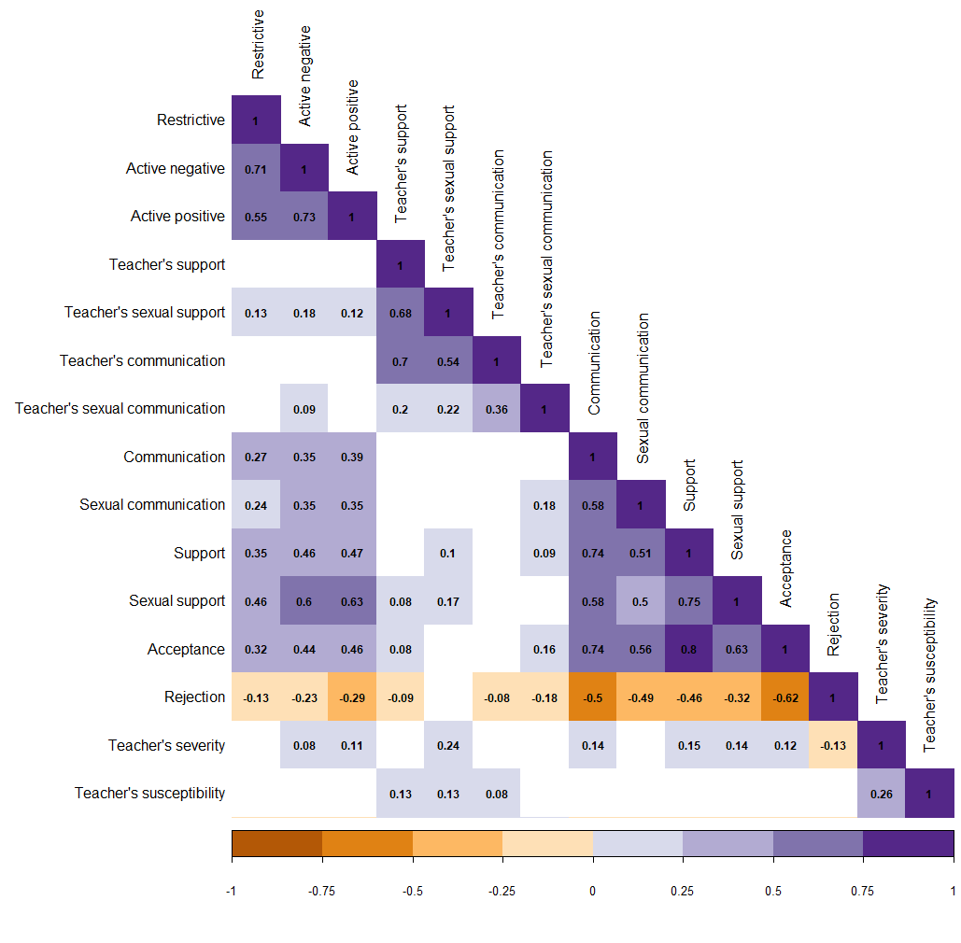

Figure 1. Pattern of associations between main study measures.

Figure 2. Pattern of associations between pupils’ perceived quality of sexual-harassment-related support from teachers and mediation strategies.

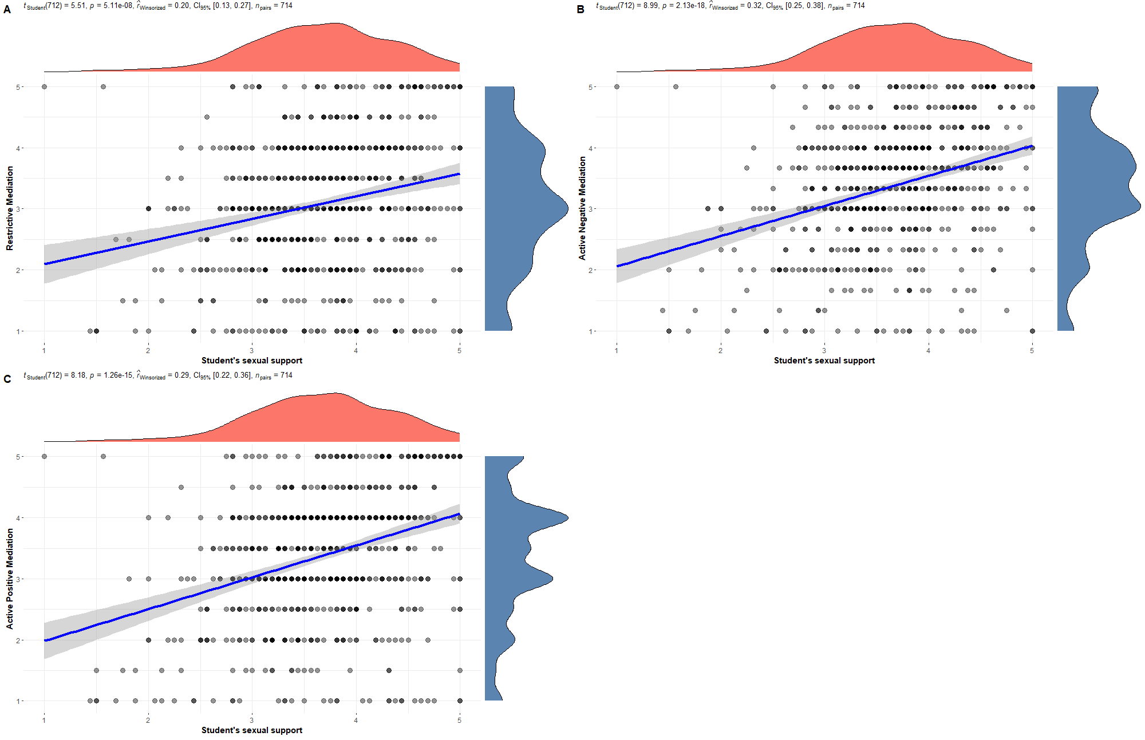

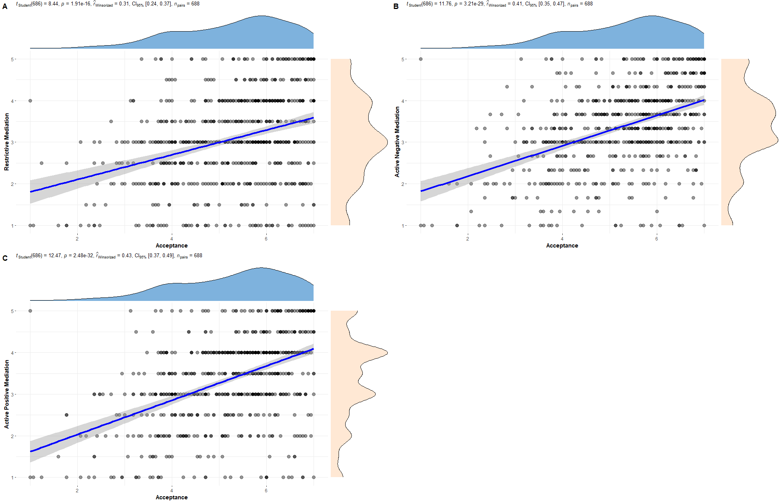Figure 3. Pattern of associations between pupils’ sense of acceptance from teachers and mediation strategies.