**Figure 1:  Screen shot of the virtual dissection of the anatomy of the foot.**

The lecture is delivered by “Zoom” application; the main screen presents the TA's board with a picture of a photographed dissection. As demonstrated in the picture, the TA can draw and mark on the board. In the right upper corner of the screen the students can see the TA in real time, and the TA can see the students upon choice.

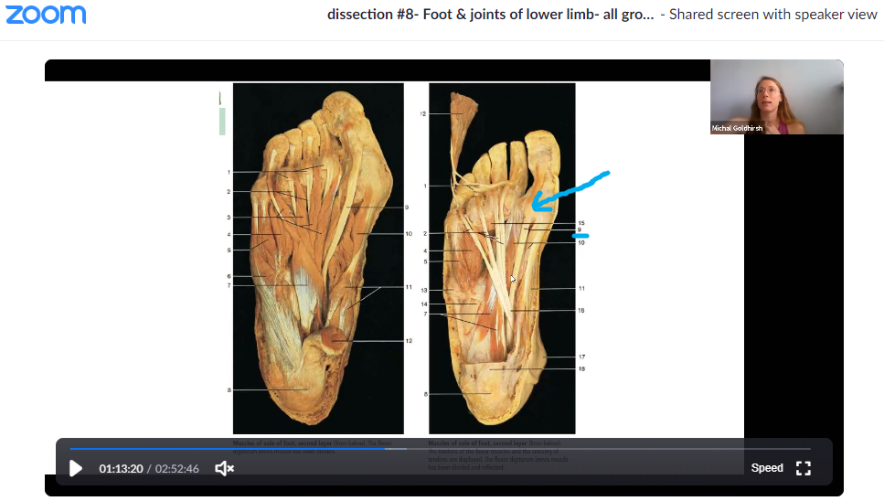

**Figure 2: an example of one test station from the online practical test.**

Each arrowhead points on an anatomical structure that the students are requires to identify and write the full anatomy name. the test contained 25 stations in this manner.

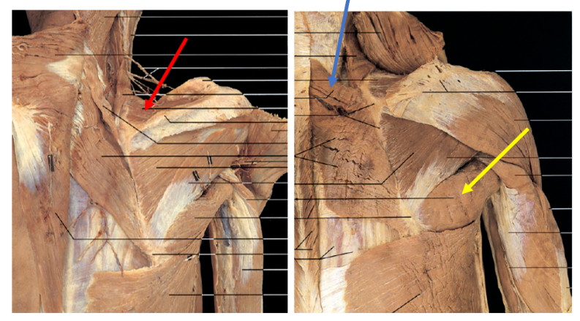

**Figure 3: Means and SDs of course evaluations (measured by seven items): a comparison between the** **online and the conventional methods.  
**

Note: The bars displaying mean ± SD of the course evaluation. Paired-samples t-tests showed significant differences in all items: Specifically, for items 1, 2, 4, 5, & 7 p<.01; and for items 3 & 6 p<.02. N=24.

**Figure 4: Percentages of students’ preferences between the online and the conventional methods on five aspects of learning.**



Note: N=24.

**Figure 5: Grades in the theoretical and practical limbs exams versus the mean grades in the other anatomical exams (i.e., abdomen & pelvis, head & neck, and thorax) throughout the years of 2018, 2019, and 2020.**

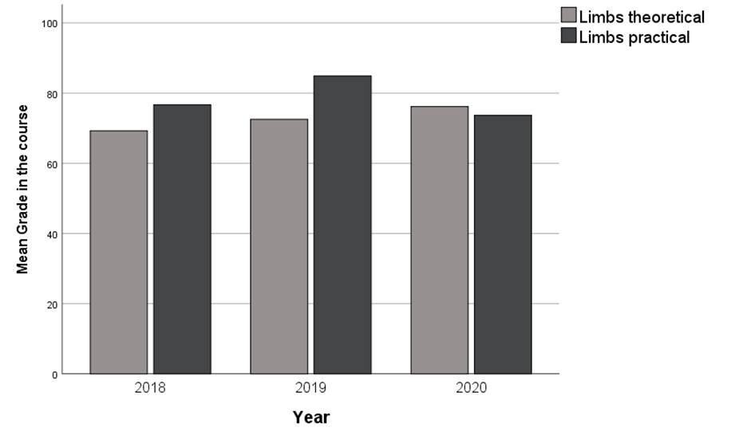

Note: The limbs module was taught online in 2020 while it was conventionally taught in the other years. N=29 in 2020; N=33 in 2019; N=26 in 2018.