Figure 1. The theoretical structure of the proposed framework
Incivility bystander scale

Incivility formative scale

Incivility perpetrating scale

Perceived incivility—reflective scale

Moral disengagement scale

Figure 2. Model coefficients and explained variance

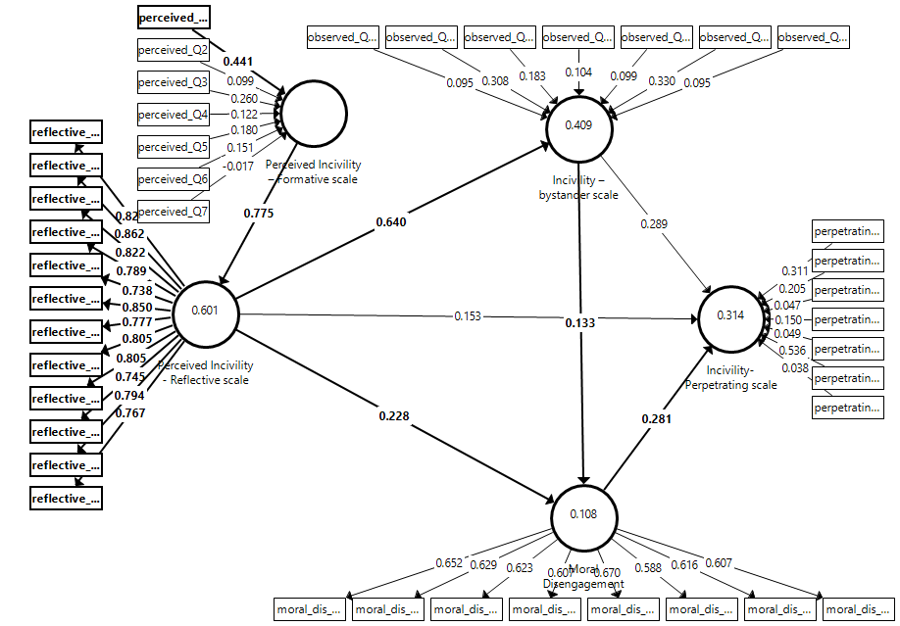

Figure 3. Convergent and discriminant validity of the newly developed reflective scale

