COURSE BOOK


Technical Drawing
DLBROTD01_E



Learning Objectives

Introduction 9

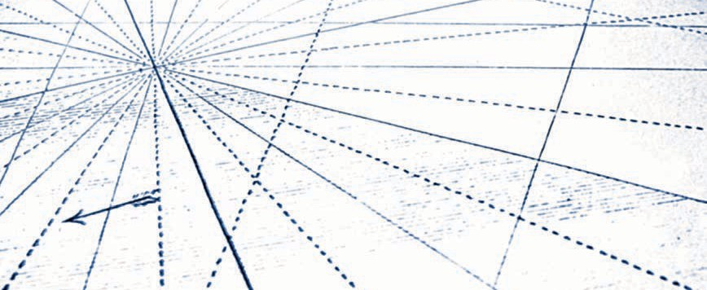

Designers wishing to learn how to bring their ideas into reality need to know how to produce technical drawings. The course Technical Drawing will demonstrate the importance of these drawings, including their use in preliminary sketches for ideation and ﬁnal constructible plans. Technical drawings are most often used in documents that convey the intent of the designer, primarily for the ﬁeld of mechanical engineering and associated disciplines.

At the end of this course, you will be able to read and understand technical drawings; there are critical skills required for estimating costs, reviewing speciﬁcations, and understanding assembly or machining processes. Using examples from various ﬁelds of practice, you will learn how drawings are used for technical communication across multiple professions in dif- ferent stages of the design process. You will gain insight into the design process, acquiring an understanding of how different drawing types are utilized within each phase. The course will also cover the skills necessary for manual sketching and drawing, as well as for computerized sketching and drafting. Additionally, methods for drawing various views to illustratively describe a product or design element will be taught.

Readers will understand the relevance of design as a tool used to analyze and optimize design solutions in product development. After learning descriptive geometry and critical dimensioning techniques, you will be able to add detail to a design project. As a basic quali- ﬁcation for engineering work, you will be introduced to the study of surfaces and tolerances needed for mechanical engineering and product speciﬁcation.

References are provided for industry standards and rules governing technical drawings, which will give a more in-depth understanding of the role and responsibilities of the techni- cal drafter. Accessing the resources provided for professional organizations will allow you to familiarize yourself with opportunities within the industry. The course will end with a presen- tation of standards typically used in the ﬁeld of mechanical engineering.

www.iubh.de



Unit 1

Illustration in Technical Drawings

STUDY GOALS

On completion of this unit, you will be able to …

… understand what technical illustration entails.
… explain why and how to use sketches effectively as a creator of technical drawings.
… describe the best choices for hand-sketching methods.
… name the axonometric projections used for technical illustration.

DL-E-DLBROTD01_E-U01

- Illustration in Technical Drawings

Introduction
Professional drafters, engineers, architects, and designers use many types of drawings to add meaning and clarity to their communication. An illustration is a graphic repre- sentation of something; it can include charts, graphs, images, and drawings. In techni- cal drawing, illustrations are the parts of the drawings that visually clarify information; they effectively and accurately describe a plan, part, or component. They can explain meaning through visual terminology, show the relationship between parts, or diagram a process. Additionally, illustrations further deﬁne how something ﬁts together or oper- ates through the use of symbols, measurements, and annotations. More often, archi- tects may consider illustration as a rendering, a drawing enhanced with color. However, illustration may also refer to black-and-white diagrams, schematics, and drawings or elaborate renderings created for presentation and marketing. Accurately shaded or col- ored drawings may give a more complete description of the illustrated item.

All technical illustrators beneﬁt from the ability to hand sketch and make use of axono- metric projection, which are two ways that technical drawings illustrate an item, assem- bly, or operation. Sketching is a critical skill for designers and drafters to master because hand-drawn sketches can be the preliminary basis for a computer drawing. This unit brieﬂy addresses computer sketching, but hand sketching and the use of axo- nometric projection will be the primary focus.

Furthermore, it is important to recognize that anyone involved in the design process, whether a client, designer, engineer, or other stakeholder, may participate in drawing as communication. Many of these people might not have the access to computer sketch- ing or the ability to use this equipment, but may be able to do a rough sketch by hand to explain their meaning. Responding by drawing the axonometric views needed for a full understanding may fall on the shoulders of the technical illustrator. At times, tech- nical illustrations can convey mechanical information to those with a non-technical background, thereby improving communication.

Sketches (by Hand)

Sketch A quickly drawn, freehand expression of an idea without the use of drafting tools results in a
sketch.
A manual or hand sketch may be more similar to a stylized painting than to a photo- graph. A painting provides the essence of what it represents, whereas a photograph will provide details of the item it illustrates. Sketches may be quite loose or rough and are a good way for a designer to work out their thoughts during the concept phase of the design process. Most observers would easily understand more carefully constructed sketches; however, providing too much detail may not always be necessary. In the sche- matic phase of the design process, both manual and computer sketches can be used to quickly analyze various options without extensive detailing. For ﬁnal construction draw- ings, an engineer may provide a more detailed sketch for a drafter to convert to a com- puter drawing. Computerized sketching as a basis for 3-D modeling is now becoming the norm. This requires that technical illustrators ﬁrst consider how much information

Illustration in Technical Drawings

should be revealed at any time. There is no point in putting a lot of time and effort into a drawing if one only needs a rudimentary sketch to convey its essential meaning. Time equals money, so the consideration of both is important to the technical draftsperson or illustrator.

Drawing well is a learned skill, and quality sketching is a skill that depends upon the condition of the tools used and the level of care and technique used by the illustrator. Techniques used by illustrators include “characteristics of visual perception, such as edge detection strokes, contrast sensitivity, clutter reduction, and focus to more effec- tively convey information” (Hansen & Johnson, 2004, p. 774). To the technical illustrator, this refers to lines and line weights, shading, and clear organization of views to reduce clutter, as well as use of the best view on which to focus.

Tools for Hand Sketching

Illustration in the design ﬁeld can be a profession in its own right. However, for the basic needs of the designer, the following items will sufﬁce:

- A drawing board with T-square is helpful if a drawing table is not used; however, any hard surface, e.g., a clipboard, will do. Shown below is a portable drawing board, T- square, and a 45° triangle. A 30°—60° triangle is also a standard tool of the techni- cal illustrator.

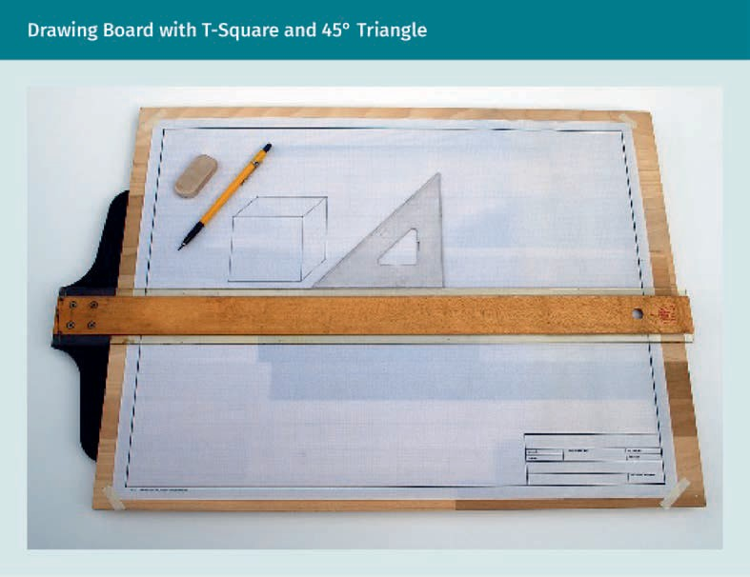

  - Pencils with soft leads rated F and HB are required for initial sketching, with addi- tional softer (2B—4B) leads for shading. Pencils may be wood-cased, in a lead holder, or ﬁne-line mechanical pencils.
  - A thicker and softer lead (4B—6B) in a thick lead holder is optional.
  - A soft eraser made of white, latex-free vinyl (polymer) or plastic is preferred over pink “rubber,” which is more abrasive. White erasers also work well for colored pen- cils. Electric erasers or holders come in stick form; a small portable electric eraser is good for sketching away from the ofﬁce.

Illustration in Technical Drawings


- Paper for drawing has a surface with some tooth. Sketchbooks are available with paper designed for pencil or ink drawing. Pencil drawing needs more tooth, while smoother paper, such as Bristol, is better for ink. Vellum is a good choice for repro- ducing drawings.



Opaque drawing paper is shown above. If reproducing with traditional methods, rather than a copy machine, use vellum or tracing paper, as they are more translu- cent than drawing paper. Architects often use rolls of tracing paper known as “bum wad” since it is often wadded up and thrown away.
  - Other useful tools include ink markers in a variety of widths or an ink fountain pen. Affordable fountain pens with replaceable ink cartridges are particularly convenient. Pigment liners are available individually or in sets of assorted sizes.

Caring for Tools

Store paper in a dry, ﬂat, clean environment until ready to use, being careful to protect the edges. Damp paper can wrinkle, and tattered or bent edges detract from the draw- ing. When drawing, keep it free of pencil and eraser residue and oils from the hand. In order to keep the paper clean, remove any lead or eraser crumbs with a drafting brush. With heavy use, graphite lead can blacken erasers. Carefully shave off any blackened areas with a knife or other blade away from the drawing. Place a blank sheet of paper under your hand to protect it from smearing as you draw.

Illustration in Technical Drawings

Sharpen pencils away from the paper surface. Use a knife or traditional hand-held pen- cil sharpener to sharpen wood-cased pencils. Electric sharpeners usually create too ﬁne a point that will break easily, so, to sharpen a standard mechanical lead pencil for sketching, use a sandpaper pad or pencil pointer designed for standard lead holders. Do not sharpen the lead tip excessively or it can break. For sketching, a curved or cone- shaped tip is desired. You can dull a tip that is too sharp by rubbing it back and forth on a piece of paper while rotating it. You can also create a chiseled or wedge-shaped pencil point by rubbing the pencil lead back and forth across the sandpaper pad. A ﬂattened pencil point creates wider lines. To prevent graphite residue from falling onto the paper, clean the sharpened pencil by inserting it into the soft cleaner provided on the lead pointer or wipe with a soft lint-free cloth.

When making thin light lines, it may be easier to use a ﬁne line mechanical pencil (.03), preferably with a harder lead (F or H) rather than a wood-cased pencil or standard lead holder. For heavier sketching with a mechanical pencil, use a soft-lead pencil (.07). Store ink instruments with caps. Protect the nibs by replacing the cap or retracting the tip immediately when not in use as this will also prevent the ink from drying out. Tech- nical inking pens may require the use of a humidiﬁer and an ultrasonic pen cleaner.

Techniques for Hand Sketching

Illustrators have developed the ability to detect information through their acute visual perception. Notice that everything is made of shapes, either circles, ellipses, squares, or other polygons. Consider the overall shape of an item and its size in comparison to something larger and smaller nearby. Visually gauge the size of an object in relation to its surroundings. This ability will help you to create proportionally correct drawings. Pay attention to how light and shadow affect color. Discern differences in value, becoming aware of the darkness or lightness of an item in relation to things around it. To improve and maintain your special visual and drawing skills, you could start a lunchtime sketch group in your ofﬁce or get involved with a group of sketchers who enjoy being outside and sharing their techniques and sketches.

As with any design effort, take care of physical needs ﬁrst and create an environment conducive to focusing on your drawing whenever possible. Provide good lighting for your work. As you become more comfortable with drawing, it will be easier to adapt any environment to your needs. If you ﬁnd yourself tightening up, hunching your shoulders, or holding your breath, stop and relax. Take a break and do something else for a few minutes. Stretch your shoulders and arms and take a few deep breaths before resum- ing your drawing.

Holding the pencil or drawing instrument
Both right- and left-handed people will need to adjust their skills and posture for the best comfort and ease when drawing. Hold the pencil or pen with a medium-ﬁrm grip near the pencil tip while the arm remains ﬂexible at the shoulder and elbow. Check this ﬁrst by writing or drawing large imaginary lines and circles in the air above your head. Keep the same looseness in your arm as you gradually lower it to the paper and make smaller marks. Students are encouraged to practice and complete the suggested techniques and assignments. To advance drawing skills, consistent practice is neces- sary. The assignments and practice lessons provide opportunities to improve your skills. Once complete, you can share the results with other students or review thhem with your tutor.

Experiment with ﬁnding a comfortable angle between the pencil and the paper. Typi- cally, illustrators use approximately a 45—60° angle to the surface. Holding a pencil at a higher angle may reduce the sketch’s quality. However, if using technical pens or ﬁne line mechanical pencils for more formal mechanical sketches, the pen or pencil needs to be sharp and held vertically. Rotating the pencil as you sketch will help keep an even hand to your mechanical pencil work. For shading, you may use a soft lead pencil similar to a paintbrush. Hold the soft lead pencil further away from the tip at a low angle with a light touch between your thumb and ﬁrst two ﬁngers. Move it as you draw, keeping it at a low angle. Learn what works best for you by using different drawing tools and techniques.

Illustration in Technical Drawings

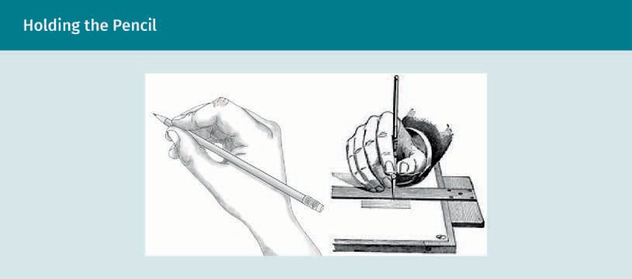

Vary the pencil angle depending on the type of sketching or drawing. In the ﬁgure above, the left image shows the recommended angle for most writing and sketching, holding the pencil close to the tip. The center image demonstrates a low pencil angle held further from the tip for shading and loose sketching. When using a technical instrument against a straight edge or triangle, use a more vertical angle (as shown in the image on the right). Adjust your lighting so it does not cast shadows from the straightedge or triangle onto the line work.

Drawing straight lines
A drafter uses speciﬁc line types. Learn to draw a thin light line, a medium weight line, and a heavy dark line. When using a pencil, rotate it between your ﬁngers as you draw a line to keep the point evenly sharpened, maintaining a uniform line width. Be methodical at the beginning and end of the line, allowing the arm to pull the pencil across the paper. This means using physics, as less effort is required to pull something than to push it. Adjust your pressure to create a dark line. Practice drawing consistent horizontal, vertical, and diagonal lines of the same weight (width and darkness). Tracing is a good way to learn, so feel free to try tracing over grid or lined paper. With sketch- ing, remember to pull the pencil when creating the line. If necessary, change the angle of the paper to take advantage of the physics of drawing. Whether right- or left-handed, practice drawing vertical lines from the top down and horizontal lines from the left to the right. Draw diagonal lines from the top left to the bottom right, for which you may need to turn the paper when drawing lines angling in the opposite direction from the bottom left to the top right. Of course, it is possible to draw in other directions, like when mechanically drawing with a straightedge. Keep practicing and ﬁnd what works best for you to maintain the desired sketching effect.

To give your drawings a more natural, sketchy look, employ the techniques described by Lin (1993), such as “hit go hit,” “professional gap,” and “professional dot.” To add emphasis to the beginning and end of a line, use “hit go hit.” According to Lin, it serves to “develop interest and depth within a drawing” (p. 6). The technique is to start draw- ing back and forth for a short distance at the beginning of the line (hit), giving inten- tion and pause before quickly drawing the length of the line (go) and repeat the back- and-forth strokes again as a “hit” at the end of the line. The “professional gap” and

“professional dot” techniques are just what they imply, i.e., creating a line with a short gap periodically as a pause and ending a line with a dot, much like a period at the end of a sentence.

Shape An illustration repre- senting only two dimensions of height, width, or length creates
shape.
When sketching a corner, lines should slightly overlap for deﬁnition. The intersection of the lines clearly deﬁnes the corner point. Draw some squares, rectangles, and triangles, crossing the corner lines. Have fun and draw lines of differing weights and styles to add creativity to your ability. Find your own free, organic style to sketching lines, and con- nect lines to create a shape.

Drawing curved lines
Once you have mastered drawing straight lines, expand to drawing curved lines, always keeping consistent weight. While a sketch does not have to be accurate, the sketcher needs to understand the geometry of a circle. Curved lines are either irregular or con- structed of arcs.
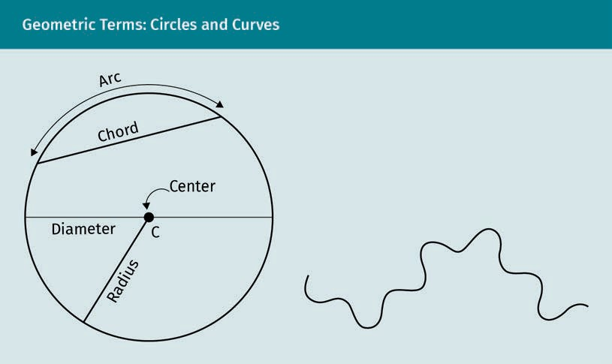

The radius deﬁnes the circle size, the distance from the center to the outer boundary, and the circumference. The diameter is twice the length of the radius and it is the dis- tance across the center of the circle. An arc is a portion of the circumference. A chord is the distance between two points on the circumference, deﬁning the ends of the arc. A squiggly line is made of curves without a distinct uniform arc deﬁned by a radius. The ﬁgure above provides a visual understanding of these terms.

One way to draw a circle is to construct a square using light erasable construction lines and then to draw the circle within the square. A non-photo blue pencil is available for drawing construction lines, omitting the need to erase because lines drawn with it will not photocopy. You may also leave lightweight construction lines visible in some draw- ings, adding character deﬁnition to the drawing by showing the process. Find the center

Illustration in Technical Drawings

of the square ﬁrst by drawing diagonal construction lines from opposite corners. The center is where the lines intersect. Draw the circle by just touching the edges of the square at the top, sides, and bottom. An easy, quick way to create a circle without think- ing about geometry is to draw the letter O. If the circle is not uniformly round, try draw- ing a semicircle from the top center down to the bottom center and then mirror it on the other side.

Two other methods for constructing a circle use the center point. Draw a dot where you want to locate the center. Draw radial lines straight through the center, creating two radial lines, one on each side of the center dot. Then draw another line perpendicular to the ﬁrst. Using six or eight radial lines will increase the accuracy of the circle. Create a small tick mark on each radial line equidistant from the center point. Finally, draw curves connecting the points. A different process using the center point is to use a piece of paper or string cut or marked to the length of the radius. Rotate it around the center point as you sketch and you will see that it works a bit like a handmade com- pass. When drawing more deﬁned mechanical circles, use an actual compass.

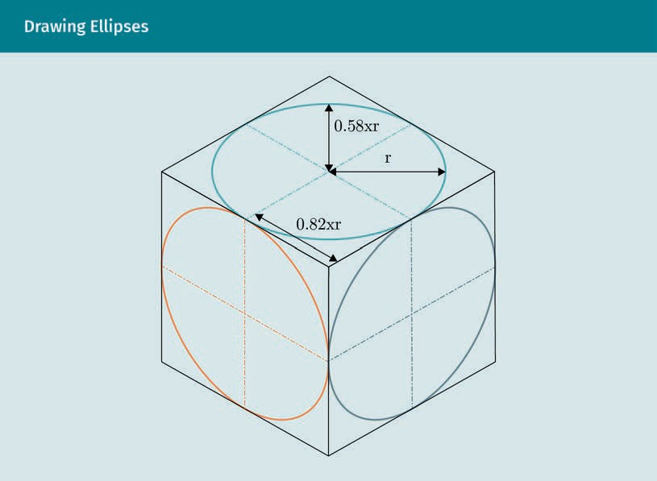
To sketch an ellipse, ﬁnd the center of a rectangle in the area that will become the ellipse by intersection of diagonals. Draw the arcs connecting the points where the radials meet at the top and sides of the rectangle. By deﬁnition, all ellipses are ovals, but not all ovals are ellipses. The image below shows ellipses drawn within an isomet- ric cube.
Construction lines Very thin, light, eras- able lines, drawn as a guideline, are called construction lines.

Ellipse
A section of a cone cut at an angle that retains uniformity with two symmetri- cal axes becomes an ellipse, which, unlike an oval, only requires one axis of symmetry.

Practice lesson
Please draw the image above in your sketchbook. You may ignore the radius notations. If helpful, ﬁrst locate the center by sketching construction lines for the diagonals of the faces.

Drawing shapes
Pay attention to shapes as you observe the surrounding world. Look for familiar shapes in everything you see to enhance your visual acuity for technical perception. Hansen and Johnson (2004) state that “shape recognition allows quick analysis of shapes and provides useful dimensions for comprehensible visualization” (p. 773). Notice the angles of lines or a particular curvature that creates the shapes. Be comfortable sketching sev- eral squares, circles, rectangles, ellipses, and triangles, then draw some imaginary shapes that you visualize in your mind. Do not be concerned with drawing more than two dimensions. Practice controlling the weight, width, direction, and length of lines while sketching lines and curves. Experiment with different tools and techniques until you can easily create the shape that you want. Accurately sketch irregularly shaped objects by using proportions and following the six steps outlined below:

- Use a grid underneath or lightly draw one made of construction lines that divides the object in to equal-sized squares.
- Identify any regular shapes. Draw them in the correct size with a light line.
- To determine the contours for oddly shaped objects, look at their proportions in relation to the grid or other regular-shaped portions.
- Lightly sketch in the contours, with the ends just barely intersecting or meeting at lines previously drawn, thereby deﬁning parts of the object.
- Reﬁne the sketch with light lines until it resembles the actual object.
- Draw over the reﬁned light lines with a darker line.

Form Adding the third dimension to a shape gives it a
form.
Drawing forms
Form is three-dimensional. A three-dimensional sketch gives more information than the two-dimensional shape. Illustrators draw form and add shading to provide more information with their sketches. As with seeing shapes in everything, you may also have begun to see different forms, such as spheres, cylinders, cones, and pyramidal forms, as well as cubes and rectangular blocks. With practice, you will be able to sketch any- thing using the underlying invisible shapes and forms. Look at drawings and sketches made by illustrators and draftspersons in your particular ﬁeld or industry. Pay attention to the underlying structure and to the shading. When beginning to draw forms, lightly sketch the full shape that creates the structure. Block out obvious shapes with con- struction lines. Then reﬁne, draw over the sketch with darker lines, and erase the light lines or leave them if they are not detracting. Finally, add shading to enhance the form.

Illustration in Technical Drawings

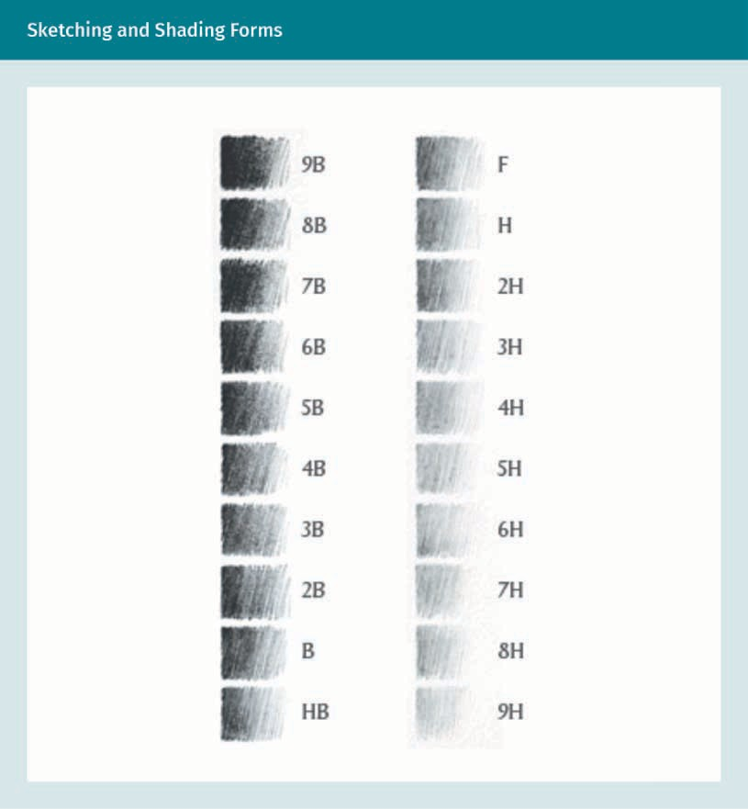

Various shade levels are shown in the ﬁgure above with corresponding pencil hardness. Shading techniques may vary. Try smudging an area by rubbing the pencil lead back and forth across the area using different methods. Hatching of short lines and stippling dots are other ways to add shading. Look at various drawings and try to copy the tech- niques that work well for clearly deﬁning objects.

Practice lesson
Please complete the following tasks:

  - Add shading to spheres to resemble balls or oranges. Add shading to circles until the form is recognizable.
  - Sketch a can, ﬁrst at an angle lying on its side with top showing, and then upright. Add shading along the edges to deﬁne the form. Notice that the sketch needs an ellipse instead of a circle.
  - Sketch some blocks showing the end or sides, and others showing the top or bot- tom. Imagine a light shining from one direction and shade an area on the ground plane to reﬂect the form.

Picture plane When drawing, imag- ine a glass window between yourself and the viewer. The picture plane is ver- tical to you and per- pendicular to your
line of sight.
Perspective sketching
Presentation renderings are usually drawings of one-, two-, or three-point perspectives offering the most realistic view. The number refers to the number of vanishing points in the drawing, which may contain more than three. The vanishing points for one- and two-point perspectives are on the horizon line as if a person were looking at the item through a picture plane. Bird’s-eye views and worm’s-eye views are perspective draw- ings using a third point above or below the horizon line. Simple sketches can also take advantage of a realistic perspective view with a horizon line at eye level. Vertical lines will always be perpendicular to the horizon line.

Illustration in Technical Drawings

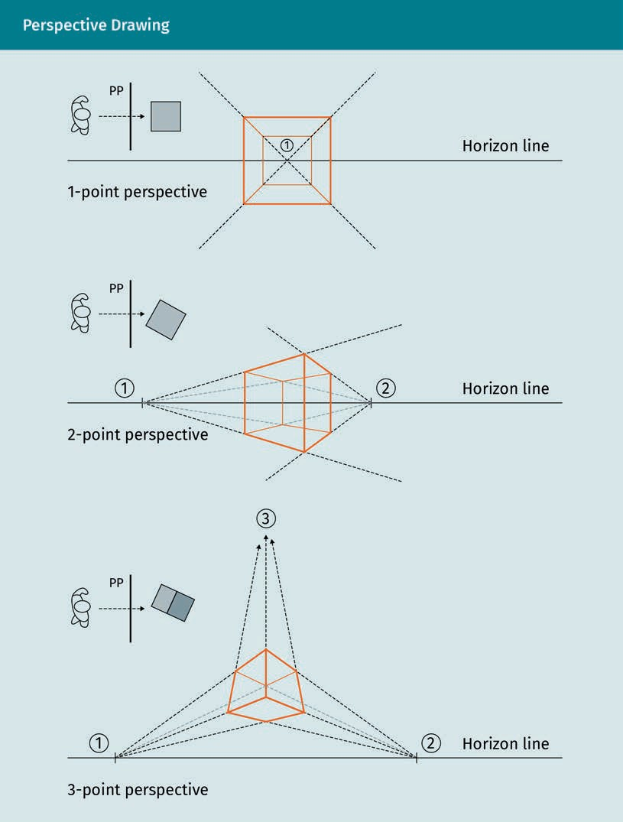
Practice lesson
The ﬁgures above show three different perspectives of a simple cube. Hand sketch it yourself for practice, adding the construction lines. Use a darker, wider line width for the visible edges. Then, apply the experience to sketch an actual item into your sketch- book. Draw a mug, glass, cell phone, or your computer in three different views.

Computer Sketching

While many computer programs include sketching software, the technical illustrator for mechanical and robotic engineering will take advantage of sketching in 3-D modeling software. You will undoubtedly use a computer-aided three-dimensional interactive application (CAITA), which is state-of-the-art software. You will encounter this technol- ogy in your professional career, as “sketches are an essential piece of modern 3-D modeling software programs” (Madsen & Madsen, 2016, p. 187). The computer can extract most of the multi-view drawings from the 3-D model. However, drafters and engineers may still require separate drawings for geometric dimensions and tolerances. Only a few commands create a simple 3-D model.

Understanding the conventions used in sketching 2-D shapes will allow you to create the basis for the computer model. It is the software’s power of the extrude command that turns 2-D drawings into 3-D models. With its extrapolating ability, when one view changes, the computer will also make changes to all the related views. Then, you can sit back and watch as the 3-D modeling software generates various axonometric projec- tions. Select only the views needed; the duplication of information can be confusing and is not good practice. Learning the basics manually will assist the computer-aided deisgn (CAD) drafter in knowing which views to include.

Professional and student organizations
Organizations such as the AutoCAD User Group International (AUGI), the American Design Drafting Association (ADDA), and the Association for Computer Aided Design in Architecture (ACADIA), among others, offer opportunities for connection among peers worldwide throughout the industry. Local and school chapters are available in some areas. Membership is rewarded by furthering education, support, idea exchanges, and job opportunities through online access, seminars, and conferences; most offer student membership rates.

Practice lesson
Set up your CAD software, if you have not done so already. Learn the difference between paper and model space. Begin practicing with your chosen CAD software so you can draw lines, circles, ellipses, and simple shapes. Learn to use the object snap commands. In AutoCAD, you can use the xline command on a separate layer for con- struction lines. After drawing the object lines, turn off the xline layer. Learn to use the chamfer and ﬁllet commands. Find the 3-D commands and try drawing a simple shape, such as a square, and model it into a cube. Explore further by trying out different com- mands within your software program. The best way to accomplish both manual and computer illustration is practice.

Illustration in Technical Drawings

Axonometric Projection

Axonometric projections graphically depict three dimensions on a two-dimensional surface, such as a sheet of paper or computer screen. It is imperative for technical illustrators to know how to read and create axonometric projections. Technical analysis is required to visualize orthographic projections as 3-D components. Axonometric pro- jections are easier to read and understand; often, 3-D axonometric views supplement multi-view orthographic drawings. There are three primary views of axonometric projec- tion. Mechanical and robotic engineers use scalable isometric, dimetric, or trimetric views. Isometric and dimetric drawings are both equally foreshortened, while the tri- metric drawing is unequally foreshortened.

Architects commonly use scaled elevations and plans for working drawings, i.e., multi- view or orthogonal drawings. Section and detail drawings provide additional speciﬁc information. Perspectives are not true to scale, but axonometric drawings may be, which is why they are of more use to the technical illustrator, draftsperson, and engi- neer.

Foreshortened When an object appears shorter or closer in distance than it actually is, it is considered fore- shortened.

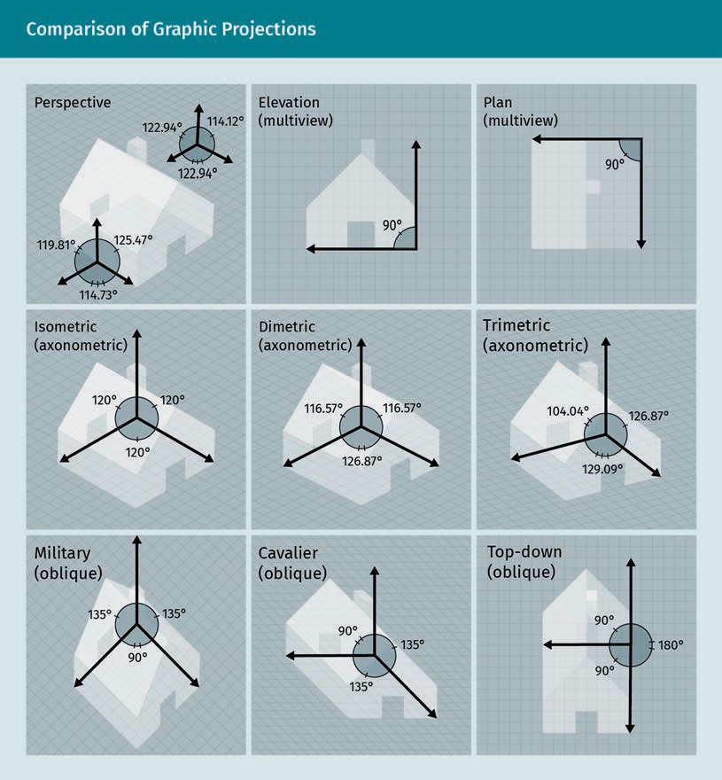

The nine images above show the same building drawn with different approaches. Look carefully at each to understand how they are different. Military, cavalier, and top-down drawings are oblique, each including a 90° angle. One plane or side of the object is to scale. A single existing orthogonal drawing, such as a scaled ﬂoor plan or front view, can be the basis for an oblique drawing. The oblique cavalier uses a full-depth scaled measurement of 45° to the front view. As a result, the oblique cavalier results in the correct scale in all directions but is not as seen in perspective.

Pay attention to the angles and directions of the axes for all drawings. Notice that the unequal foreshortening of the dimetric appears oddly skewed, even though two axes are equal. Viewing all three axonometric projections of a piece of furniture may help to discern the differences.

Illustration in Technical Drawings

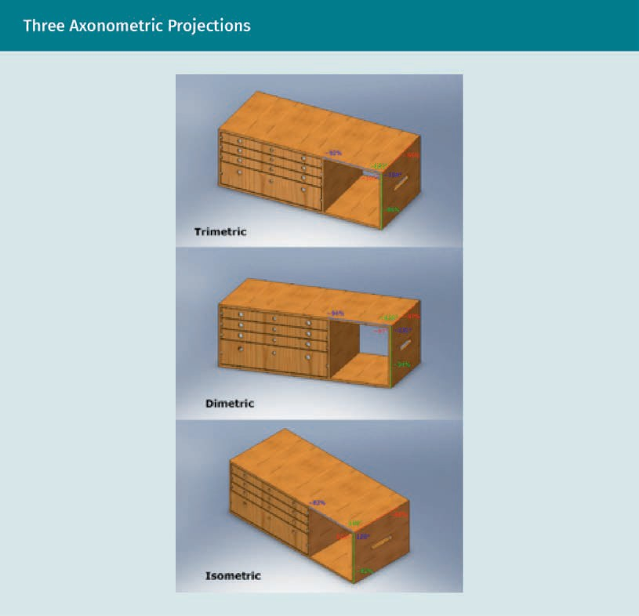

Isometric Sketching

Isometric drawings have three axes separated by a common 120° angle. The central axis is vertical and two axes are each at 30° from the baseline. They are easily constructible with a protractor or 30°—60° triangle. All the vertical edges of the item remain vertical in the drawing, whereas all horizontal lines are drawn 30° to the horizon. All lines on the axis and parallel to the axis are true to scale. Therefore, the isometric view provides valuable information in three directions. Comparing sizes of sides is proportionately accurate, but visually distorted from what a photograph would depict or from what the eye would see. The best use of isometric drawings is to accurately represent principal dimensions when it is desirable to include dimensional information on a single draw- ing.

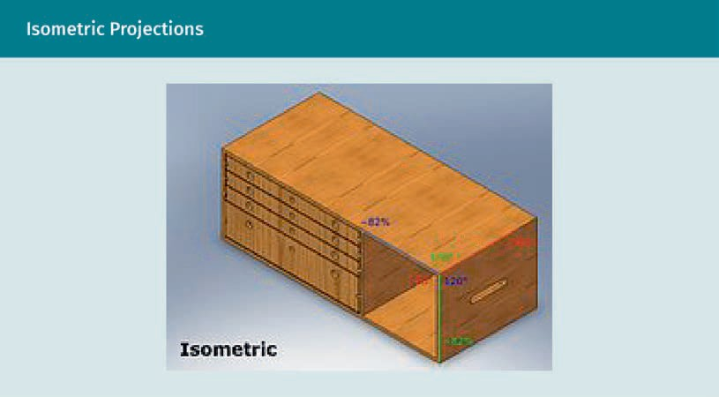

Illustration in Technical Drawings

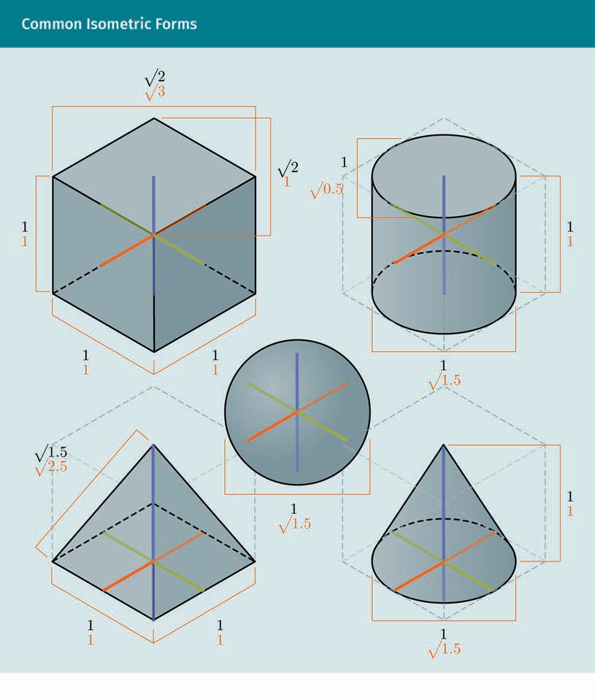

Shading further deﬁnes the forms above. Dotted lines convey the hidden backsides of the forms. Hidden lines are medium dark lines compared to the heavier dark outline of the object.



Isometric drawings provide a visual representation that makes complex objects easy to understand. The addition of color to this drawing creates a realistic rendering suitable for presentation and is understandable to a non-technical audience.

Illustration in Technical Drawings

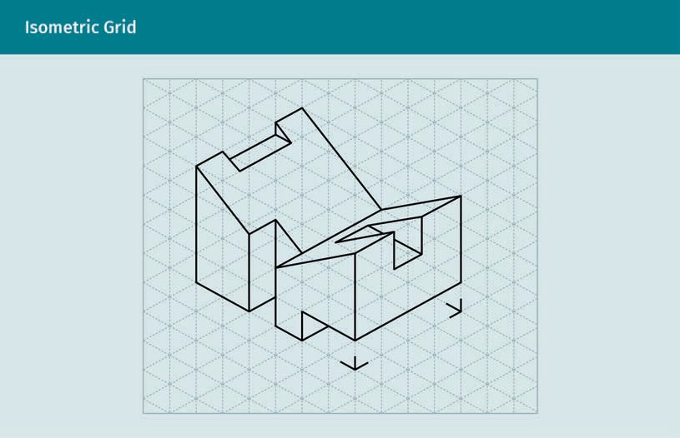

The grid shown above with non-photo blue lines will reproduce only the black lines of the drawing. It is possible to purchase isometric grids or create them on a computer.

Practice lesson
Please complete the following tasks:

- Sketch the item below to scale, using an isometric grid underlay for uniformity.

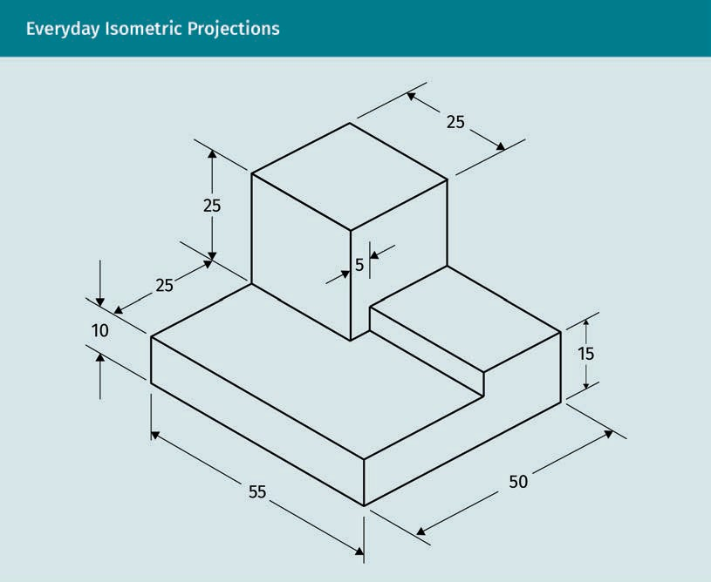

  - Try drawing the items below. Block out the drawings as shown with construction lines ﬁrst.
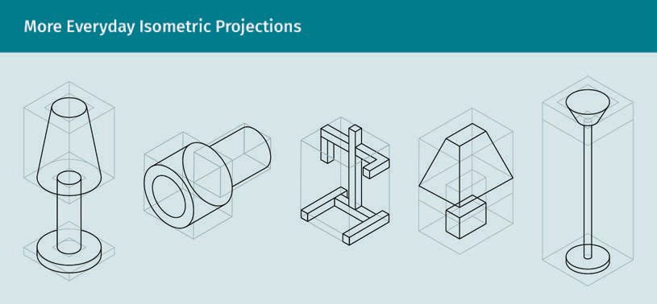

Illustration in Technical Drawings

Dimetric Sketching

The dimetric view contains two angles of the same degree, with a third differing angle. Only two of the three axes are equally foreshortened in a diametric sketch. To show emphasis or detail on one side, a dimetric view is used.
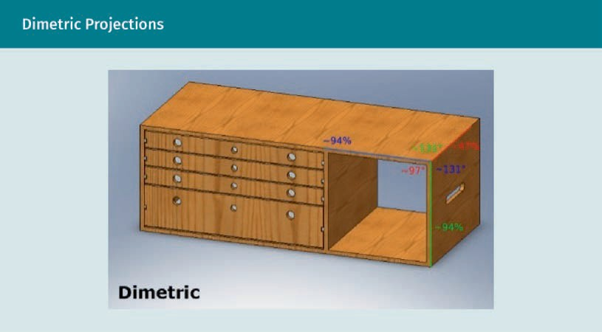

Trimetric Sketching

Three angles in the trimetric sketch all differ. All three axes may be on a different scale and are less frequently used. It is best to use trimetric sketches when dimensioning is not required in the drawing.

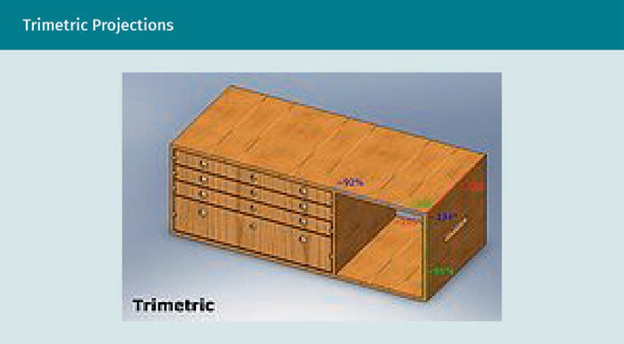

Practice lesson
Please complete the following tasks:

  - Draw a trimetric cube based on angles of 25° and 20°. Draw two more trimetric cubes with varying angles.

  - Sketch by hand, and then in CAD.

  - Try drawing the clock face below.

Illustration in Technical Drawings

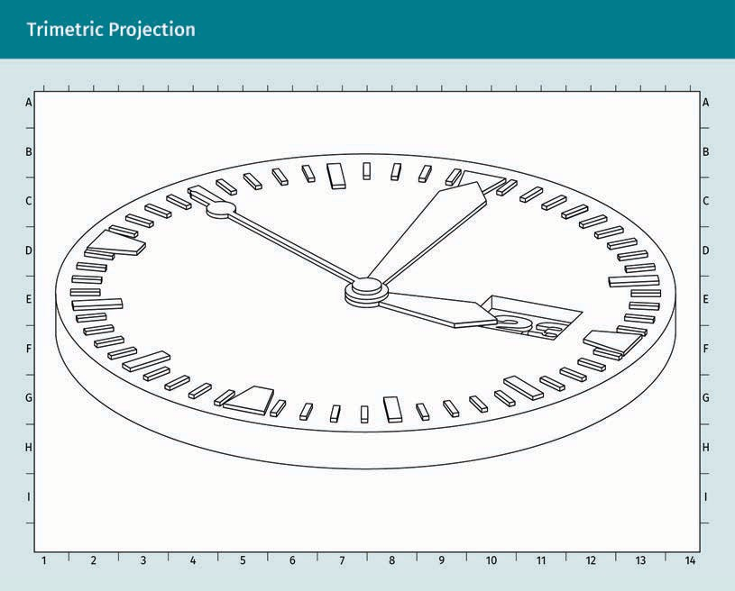

- Keep up with your sketchbook by adding sketches each day. Manually sketch the suggested items previously shown in this unit, and draw an actual lamp in perspec- tive, carefully choosing line weight to improve the readability of your sketch.
- Sketch the drawing below, carefully using different pencil weights to depict impor- tant lines. Draw the height at about six inches and keep other parts in correct pro- portion to each other.

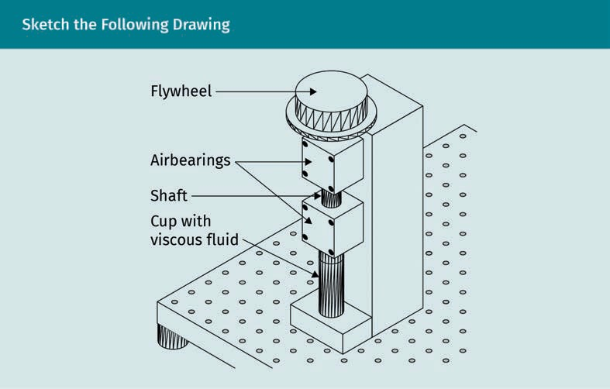
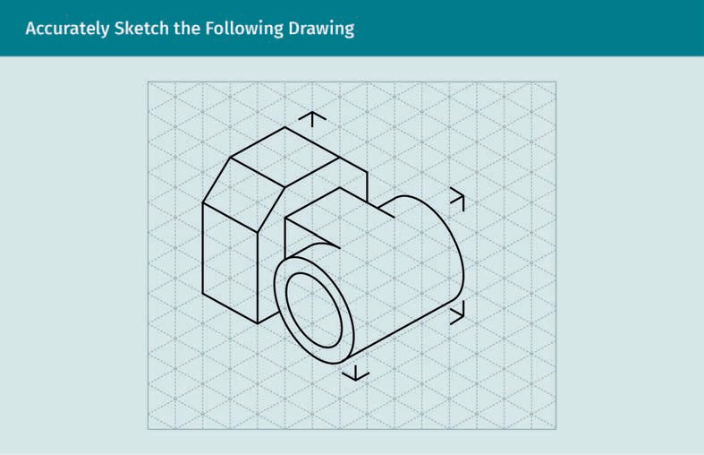
  - Accurately sketch the drawing below.
  - Create a sketch based on the drawing shown above and then add shading. The lines may be hand sketched or drawn with mechanical pencils and a straightedge or tri- angle. Use an isometric grid underlay if desired. Shade it.

Illustration in Technical Drawings

Summary
Technical illustration includes many aspects of visual communication. Illustrations consist of tables, charts, diagrams, photos, symbols, annotations, and drawings.
Conveying the intent of the designer and visual communication are the critical pur- poses of technical drawing. Sketching and axonometric projections are two primary types of illustrations used by professionals in the mechanical engineering ﬁelds and associated disciplines. Architects, innovators, and inventors roughly sketch conceptual ideas. Sketches are valuable throughout several phases of the design process; everyone involved in a project may communicate through sketches.

Quality sketching is a learned skill that depends on the condition of the tools used and the level of care and technique used by the illustrator. Hand sketching involves observation and paying attention to shapes, forms, and their relationships to each other. Take time to study sketches and drawings used in your ﬁeld of design. Learn the methods for drawing simple things ﬁrst, such as consistent line weights. Then, progress from shapes to forms, and eventually add objects that are more complex. Experiment with various tools and techniques to become comfortable while also improving your ability. Hand-drawn sketches can be scanned, traced into a com- puter, and reﬁned. Computer sketching is possible and is used in the 3-D modeling software to design a model, which generates axonometric views. Shading adds deﬁ- nition to both hand-drawn and computer-generated sketches.

There are several axonometric views that designers and drafters need to recognize; however, the three most commonly used for details and mechanical illustration are isometric, dimetric, and trimetric views. They all have a vertical axis, but vary with the angle from the horizontal. Underlays of grids may help when drawing axono- metric sketches. Technical illustrations enable the understanding of complex mechanical components, assemblies, and processes. Professionals in the design ﬁeld beneﬁt from sketching and axonometric drawing skills.

Knowledge Check
Did you understand this unit?

You can check your understanding by completing the questions for this unit on the learning platform.

Good luck!

Unit 2

Basics of Technical

Drawing



STUDY GOALS

On completion of this unit, you will be able to …

… recognize types of technical drawings and several of their variations.
… understand what the design process entails.
… name the organizations that provide standard drawing formats.
… understand what information is necessary to create the drawing format.

DL-E-DLBROTD01_E-U02

- Basics of Technical Drawing

Introduction
Many people and professions make use of technical drawings. A designer may create their own technical drawings to ensure their product is created according to their design intent, and a draftsperson may create technical drawings based on information provided by an architect or engineer. An estimator may never draw anything, but might need to understand how to read drawings in order to calculate costs. A carpenter may need to interpret drawings in order to understand the assembly process. A builder or engineer may review drawings to ensure that they are following the most effective method of construction. Whether a person needs to read or create technical drawings, being able to understand them is key. The use of descriptive geometry and industry vocabulary are some of the skills needed for technical communication. These skills are necessary in the design ﬁelds, so interns typically begin as a draftsperson under a pro- fessional designer, architect, or engineer. In complex systems involving thousands of engineers, drawings are used to exchange information and ensure that all parts in an assembly or system work well together. The value and relevance of technical drawing skills is paramount to the designer and everyone involved in the industry.

In this unit, signiﬁcant drawing types will be presented for various uses. Mastering the key concepts of the design process will certainly enable you to use technical drawing effectively in the professional world, but it may also help you discover the value of technical drawing for personal enjoyment. Furthermore, considerations regarding man- ual and computer drawing will be addressed and a discussion on how to select and create a technical drawing format will provide you with the basics of technical drawing and illustration.

Types of Drawings

Technical drawings These drawings describe something in detail, such as an object or structure, and are a tool of communication.
They are also called mechanical or meas-
ured drawings.
Technical drawing, as an activity, is part of the creative process. It can be used to com- municate ideas, analyze and solve problems, and optimize design processes. Technical drawings also serve as documentation for contracting, as well as construction or fabri- cation. Most importantly, the purpose of technical drawings is to convey the intent of the designer. The drawings must provide all of the information necessary to fabricate a part or assemble different parts. The ﬁnal drawings must accurately depict the size, form, and materials of the object described. This ensures that the product, building, or system will be built in accordance with the designed plan.

Plan sets consist of many types of constructible working drawings and, for this reason, being able to recognize various types of technical drawings is imperative in order to create a cohesive, readable set of plans. These drawings are all considered to be tech- nical drawings and are often referred to as mechanical drawings; they communicate ideas and establish the foundation to design. Fundamentally, drawing is the universal language of building and manufacturing.

Basics of Technical Drawing

Initial drawings may be hand-drawn sketches. Technical drawings used for ﬁnal design are created with precision drafting tools, manually, or digitally with computer software. When drafting for complex technical systems, such as automobile design or robotics engineering, the drawings serve as the language for information exchange among the many engineers involved in the design process. All of the components must ﬁt together and many must also be interchangeable. This means that engineers must be able to read all types of drawings to ascertain whether all parts ﬁt together, thereby ensuring a working system of assemblies.

For artists, there are numerous types of drawing (e.g., zentangles, scribbles, cartoons, and life-like representations); however, technical drawings are more restricted in type. They are two-dimensional representations of detailed information deﬁning something’s size, shape, form, and material, and they may also include information about its rela- tionships to other things. While artists’ works are open to interpretation and may have different meanings, a technical drawing must precisely deﬁne its meaning, which can- not be left open to interpretation.

People undertaking technical drawing as a vocation or profession are called drafters. Experienced drafters prepare drawings of unusual, complex, or original designs with a high degree of precision. The work of creating such drawings as an activity or discipline is also called technical drawing. Those taking on technical drawing as a vocation, or using the skill in a profession such as engineering, need to be able to formulate ideas quickly. For this reason, the ability to create sketches by hand is important to a techni- cal illustrator and freehand sketching is included in the ﬁeld of study for technical drawing.

While this course includes informal sketch drawings, drawings of a technical nature will be more precision-based. Whether they are informal sketches or ﬁnal dimensioned drawings, technical drawings are a universal language used to describe something and convey the designer’s intent. When complex systems have to be explained with numer- ous drawings, technical drawings are particularly valuable because they break down the system into smaller pieces of information that are more easily understood. As an exam- ple, an engineering set of drawings for a technical mechanical system could include over 1,000 drawings breaking down a very complicated process that includes many components and numerous assemblies. Each part of the complex technical system, as well as the assembly process, needs to be represented in an order that makes sense. It is imperative for the technical illustrator to understand their importance in the indus- try and to be able to choose which drawings will most clearly convey the information required for each speciﬁc part and assembly. Knowing who will use the drawings and for what purpose helps to deﬁne the type of drawing that will be needed and the infor- mation that should be included.

In the ﬁeld of technical drawing, there are two types of descriptive drawings: two- dimensional (2-D) and three-dimensional (3-D). A 2-D drawing is a single view showing only one face or side of the object being drawn. A “stick drawing” of someone facing straight ahead is an example of 2-D drawing. The eyes and mouth are drawn, but we cannot tell how deep the eyes are set or how far the nose protrudes unless they are drawn from the side. Instead, a portrait showing someone at a slight angle to the plane

of the viewer allows us to see the depth of the eyes and the protrusion of the nose, along with the ears and the side of the head. The view shows both the front and the side in the same drawing.
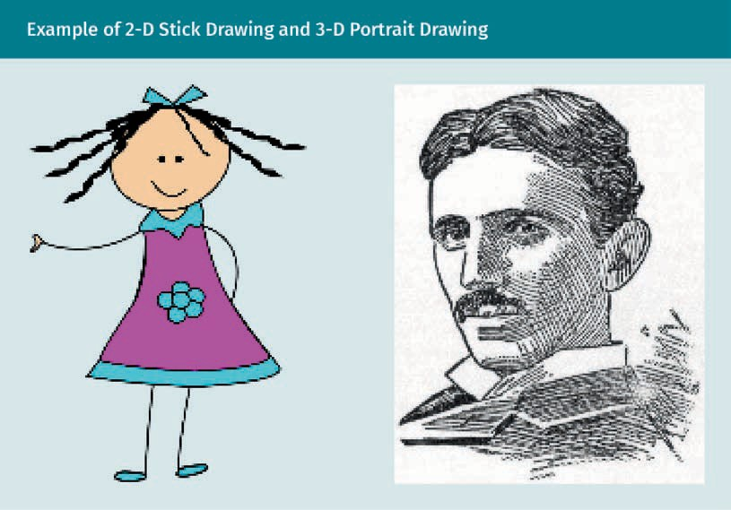

The more descriptive view of Nikola Tesla in perspective illustrated above is an exam- ple of a 3-D drawing. More than one 2-D drawing is required to provide the same amount of information as a single 3-D drawing. Another example using the human form is the difference between ancient Egyptian drawings and the more developed Greek and Roman drawings of human forms. Basically, a 2-D drawing depicts a shape only in one dimension on a single plane, whereas a 3-D drawing shows the form of the shape in two or more dimensions on multiple planes. In the ﬁgure below, the Egyptian draw- ing on the left appears ﬂat and is 2-D, whereas the mosaic on the right is 3-D, showing both the front and sides of faces.

Basics of Technical Drawing



Now, consider the faces of a technical object. In 2-D, graphically illustrating a simple hex nut requires at least two views in two dimensions. A single 3-D view, however, allows the viewer to understand the item more quickly. Being able to envision both 2-D and 3-D views will help the technical drafter to choose the best illustration methods for any project. As projects become more complicated, involving many components and assemblies, it is important to select the best illustration methods to clearly identify parts and simplify processes and assemblies. For example, in the ﬁgure below, the 2-D drawings on the left require two views to describe the information shown on the right in a single 3-D drawing.
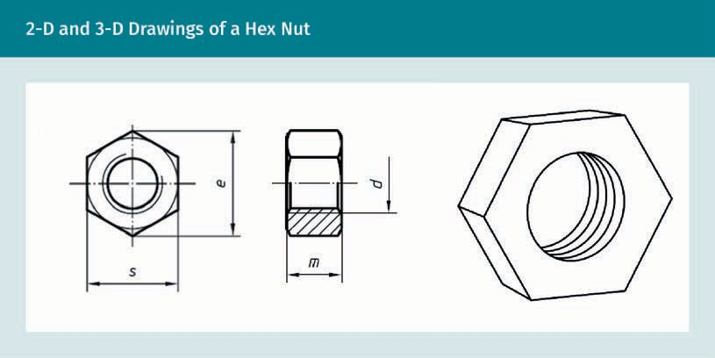

The drawings in the ﬁgure below are both 2-D. However, since the circular view on the right does not provide enough information, the side view is also shown with dimen- sions, providing the viewer with a better understanding of the part.

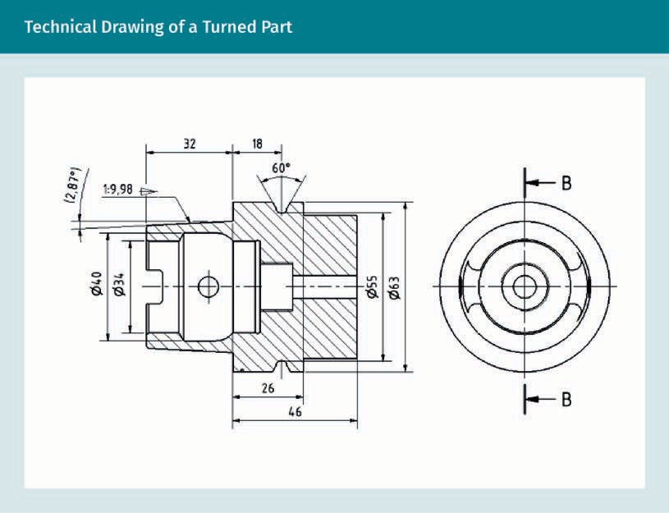

In technical or mechanical drawing, speciﬁc types of drawings provide either 2-D or 3-D information. 2-D drawings are orthographic projections and include plans and eleva- tions for buildings, while multi-view drawings for objects show multiple faces or sides. Both building and object drawings may be shown as sections. 3-D drawings include projections, axonometric sections (including isometric drawings), and exploded views.


Basics of Technical Drawing

A plan view looks down onto the top of an item, building, or entire site. This site plan shows a complex of several buildings surrounded by many trees. You may see the rela- tionship of the buildings to each other, as well as the location of the trees and walks connecting the site.
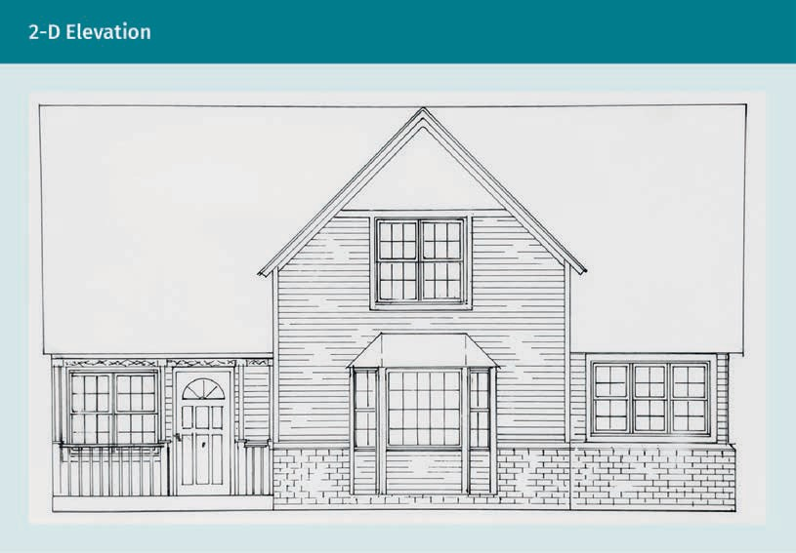

An elevation plan shows one side of a building or item. An example of an elevation plan in shown in the ﬁgure above. This 2-D drawing of the front elevation has some tex- ture but omits dimensional measurements and details.

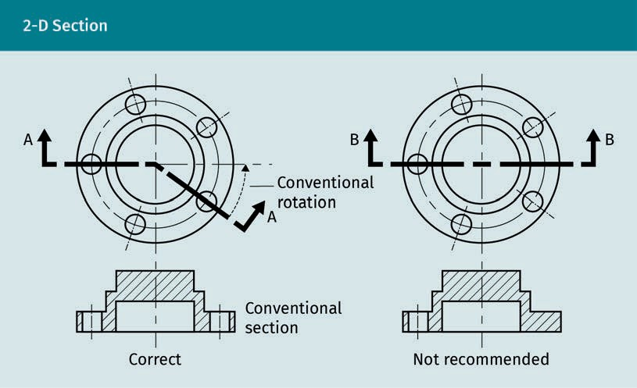

A section drawing, as depicted above, will consist of the section cut with a bold dark line and arrows that show the direction of view shown in the section elevation drawing. The drawing on the left shows the section cut taking a turn to go through two holes in this part, which is the preferred method because it provides more information about the holes.

Basics of Technical Drawing

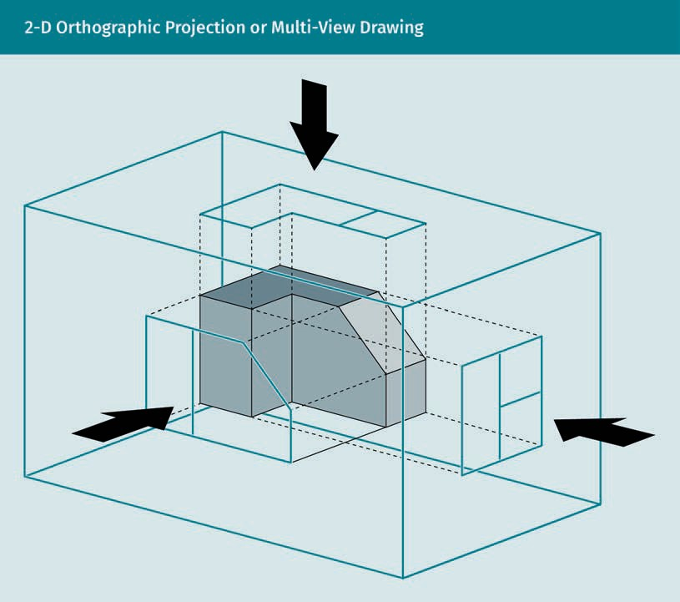

In the image above, an object is shown centrally in 3-D, while the top and two sides are drawn in 2-D as projected onto an imaginary picture plane parallel to each face of the object. Imagine that you are the observer, looking straight at it from only one side at a time. The three 2-D drawings describe what you would see and create the multi-views.

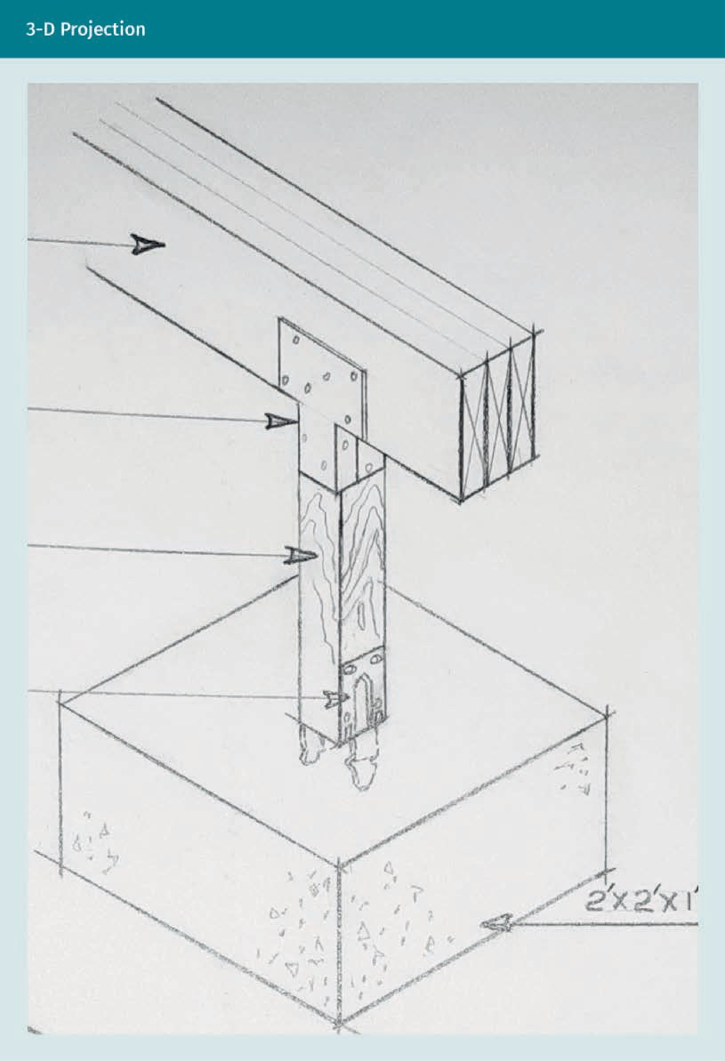

Basics of Technical Drawing

The drawing of the beam, post, and pad above shows the details of several items in the construction, including the connections. If only a 2-D view of one side were shown, more drawings would be required. Using the 3-D projection provides information about all of the parts, saving drafting time and space on the drawing sheet. Therefore, the 3-D projection reveals more information than a front or side view.
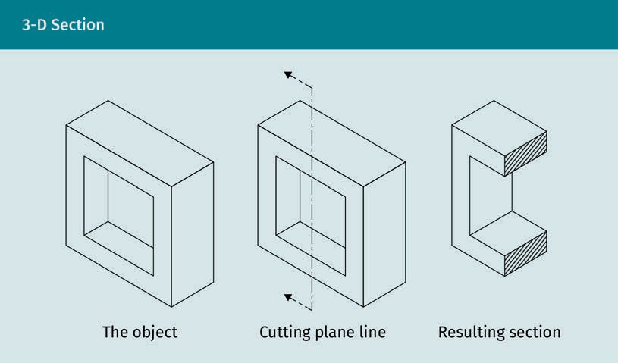

These drawings show how an object can be sectioned in 3-D, providing more informa- tion in a single resulting section cut. Notice that the 3-D section cut is shaded with diagonal lines on the cut portions.
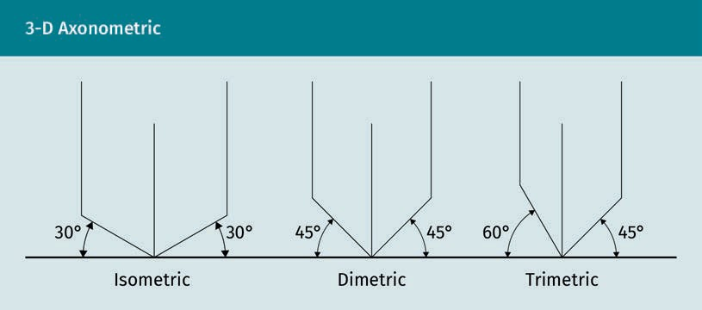

Notice that each view is deﬁned by the angle between the vertical axis and the hori- zontal baseline. Isometric drawings always use 30° angles, while dimetric drawings are based on equal angles using other degrees and can differ from those shown. The tri- metric is based on two different angles, not necessarily the ones shown.

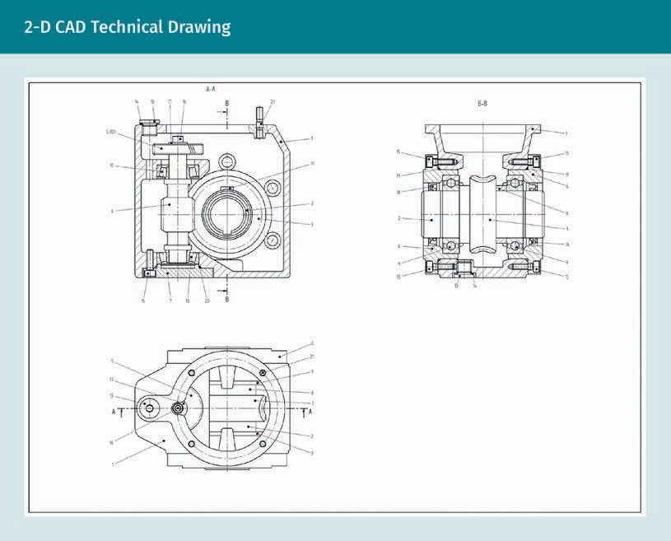

With 3-D modeling, the model is ﬁrst designed on a computer, which is able to create any additional drawings needed to clearly identify the individual components of the assembly. The 2-D computer-aided design (CAD) drawing could have been generated by a 3-D model previously entered into the system. Complicated systems showing the placing of parts in order of assembly can also be created from drawings. Individual components of each assembly are shown separately. The 3-D modeling can separate the items as though they had exploded, giving this type of drawing its name.

Basics of Technical Drawing

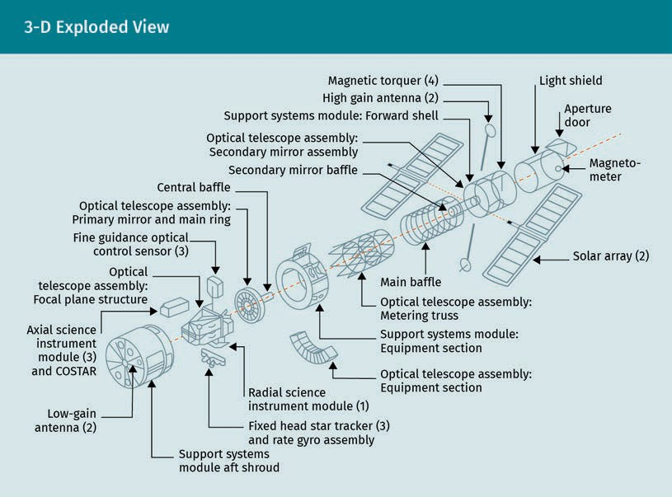

Both 2-D and 3-D drawings can either be drawn manually or created as a computer- generated drawing. Manual drawings may be freehand doodles and sketches, or draw- ings that are created with precision tools and are more accurately descriptive. Com- puter-generated drawings are usually referred to as CAD drawings. CAD is an acronym for computer-aided design or drafting, whereas CAE refers to computer-aided engineer- ing and CAM refers to computer-aided manufacturing. CAD drawings can be drawn to scale with great precision. With the advent of 3-D modeling programs, software is now able to generate many drawings that had previously been tediously drawn separately by designers. This reverses the method of producing drawings.

Initially, 2-D drawings were created, and 3-D drawings were developed based on the information provided in the 2-D drawings. Now, it may only be necessary to design a 3- D model on the computer and allow it to automatically generate other 2-D drawings needed for the fabrication process. Drawing can consume a large part of an engineer’s time; this new method can save time, and is therefore very cost-effective. Additionally, models may be printed. The authors of the Manual of Engineering Drawing explain that rapidly prototyped models derived from 3-D printing “are relatively inexpensive and are ideal for producing good quality” (Simmons et al., 2009, p. 19).

Many people in the industry use technical drawings for various purposes. Knowing who will use the drawings and for what purpose helps the drafter or designer to choose which views and data are needed to best communicate information. An architect or engineer can quickly sketch out a detail with a few notations to give to the drafter so they can create a precise drawing. The draftsperson may, in turn, sketch an alternative for review before committing the design to a ﬁnal set of plans. Estimators must be able

Take-offs These pieces of information, such as quantities and measurements for materials, are derived from techni- cal drawings for the purpose of estimat-
ing costs.

Right-brained/left-
brained The brain has two hemispheres or sides. The right side controls the left side of the body and cre- ative thought pro- cesses, and the left side controls the right side of the body and processes involving logic.
to understand how to read the drawings to gain information used to estimate costs. Pieces of information gleaned from drawings, such as material quantities and sizes, are called quantity take-offs. Industry standards help the technical draftsperson to know what information is required and how it is to be presented. Standardized conventions for notations, symbols, and styles create a visual language that is particular to each ﬁeld of design for our built environment.

The Design Process

In the ﬁeld of design, the term “design process” refers to the order in which designs are developed. As a general rule, a need is ﬁrst identiﬁed and then ideas are developed to satisfy that need. The process ends when one idea is presented as the ﬁnal solution together with technical drawings. Generally, four to ﬁve phases are identiﬁed in the design process and are used for scheduling and contracting. Engineering more complex projects, such as robotics, will include several subcategories within each design phase. Several additional steps in the analysis and testing process will often be required in order to ﬁnd the best solution. The different phases of the design process are outlined below (Richards, 2020).

Specify the need
Assessing and deﬁning the need is the initial activity of the design process. Activities are sometimes grouped with concept development, which follows the speciﬁcation of the need. In the ﬁrst phase of the design process, needs and wants are clariﬁed and opportunities and constraints are identiﬁed. Budgets play an important role and may quickly determine a material choice; they are also vital when determining the amount of time dedicated to each phase of the design process. After this initial step, a state- ment of intent (or problem statement) can be written as a requirement that the design must meet. In the ﬁeld of engineering, this may be referred to as the project speciﬁca- tions. Speciﬁcations include information about budget, materials, colors, sizes, and per- formance criteria. As ideas begin to ﬂow, referring to the statement or speciﬁcations will help to narrow down the choices.

Concept development
The designer may then embark upon the mental activity of ideation, during which no drawing is necessary. This can be a totally right-brained or left-brained activity, but is most productive when the entire brain is activated. In Betty Edwards’ (1999) classic book for artists and others learning to draw, The New Drawing on the Right Side of the Brain, she recommends taking quiet alone time to allow this process to take place. Her reasoning is that “creative solutions to problems, whether personal or professional, will be accessible through new modes of thinking and new ways of using the power of your whole brain” (p. 6).

Basics of Technical Drawing



Creating space for thought can be achieved through meditation or a physical activity, such as yoga or a walk in nature. Each designer discovers what works best to rid their brain of distractions and unleash their imagination. This is not a new idea, but we seem to need reminders. The early inventor Leonardo da Vinci gave the following advice: “Every now and then go away, have a little relaxation, for when you come back to your work, your judgment will be surer” (as cited in Bellis, 2020, “Engineering & Inno- vation” Section).

After taking some time for “thought space” to visualize several ideas that respond to the initial need, sketching can supplement and advance the process. In fact, some- times, allowing time for doodling or mindless freehand sketching helps to activate both sides of the brain. This way, one begins to move from imagination to visualization. Con- ceptualization may include “brainstorming” alone or with an entire team. When ideas begin to take shape, more formal sketching can commence and the third phase begins. The basis for the design has been determined based on the need and the resulting concept. A basis of design report (BODR) is commonly used in some ﬁrms; it is reviewed by the client and used as a reference for the design team.

Schematic design
Moving from concept development into schematic design can include overlapping activities as the analysis of several different ideas continues. This phase can also be considered preliminary design. Hand sketching is a good tool to continue to employ during this phase because it is quick and can easily be shared with others. Computer sketching may also be used. Clients can quickly respond to the more thought-out ideas at this stage when provided with drawings that do not require ﬁne detailing and geo- metries.

When ideas are combined into one preferred idea or design, a formalized drawing may be produced to generate a better understanding. This is where additional sketching with a computer may also be helpful. If a designer is good at using a laptop or tablet for sketching, they can easily share ideas with others on the design team from any location. Manual drawings or CAD drawings may be further developed into diagram- matic drawings explaining future processes or assemblies.

Design development
The drafting of the technical drawing continues as more details are added. Further analysis and optimization of the design occur during design development. This is the phase when geometries, dimensioning, and details are worked out; the process can be quite time-consuming. Testing and prototyping can be part of the design development phase and may be a reiterative process. 3-D printers may also be used. They make the prototyping of many products more economical than previously possible, and “in the last decade, 3-D models and rapid prototypes have also become a common way of con- veying design intent” (Simmons et al., 2009, p. 1).

Construction drawings
Construction drawings (sometimes referred to as working drawings) are created in the ﬁnal phase of the design process. They are manually drafted or computer-generated drawings required to create the ﬁnal project. They provide all of the information describing and detailing aspects of the product or project to be built. In other ﬁelds, these may also be referred to as installation or assembly drawings.
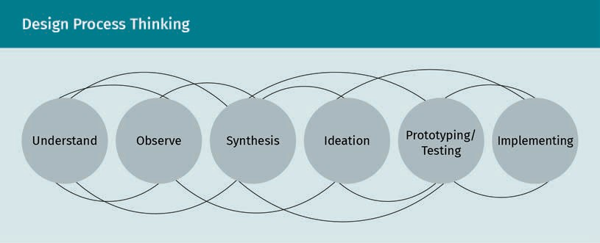

As indicated in the graphic above, design process thinking can be a reiterative process. In his online course at Massachusetts Institute of Technology (MIT) in 2009, Dan Frey brieﬂy described the mechanical design process as beginning with a clearly deﬁned cli- ent statement or need, moving to conceptual design, followed by preliminary design (modeling, testing, evaluating), then onto detailed design (reﬁning and optimizing), ending with ﬁnal document design and fabrication (Frey & Gossard, 2009). This descrip- tion also works well with architectural design processes. Each ﬁeld of design and engi- neering follows a particular order, which is somewhat linear but often has reiterations within a phase and may differ between ﬁrms. Respecting that design is a process and understanding which efforts within each phase will move the project forward is gener-

Basics of Technical Drawing

ally a good guide for budgeting the design of the project and scheduling dates for deliverables. With 3-D modeling, concept, schematic, and design development all hap- pen within the computer model. It is therefore essential to understand how your project will be planned and when deliverables or milestones are scheduled.
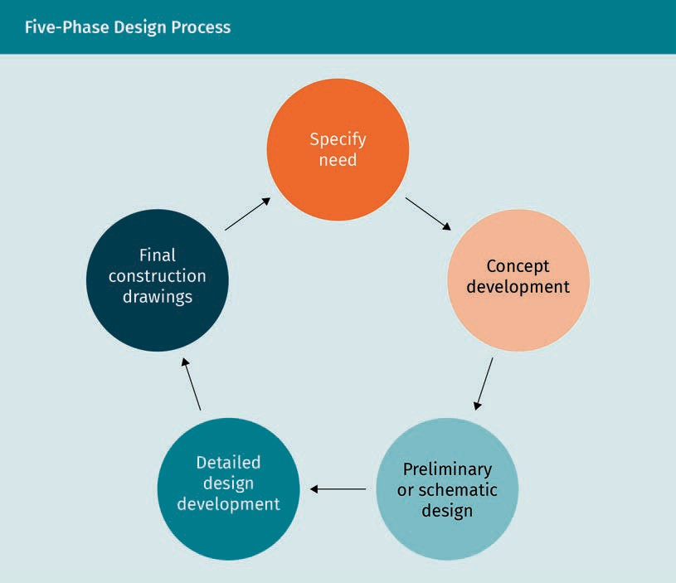

Shop drawings are drawings supplied by specialty trades or pre-fabricated components. They become part of the working drawings. A full set of working drawings required to build a machine part or complete a project is called the plan set. After a project is completed, drawings may be created to show how it was actually built or manufactured. These drawings are called as-built or as-made. Sometimes an as-built drawing is used to begin work on an existing project that has to be disassembled or renovated.

Manual drawing and drafting
Sketching may also be implemental in other aspects of the design process. It is com- mon for a sketch to be used to communicate details that a drafter then draws in CAD. When changes are required, whether in the studio or in the ﬁeld, it is often necessary to quickly sketch out an idea to convey the needed alterations or additions to the design. Therefore, it is beneﬁcial for every designer to become comfortable with man- ual sketching, if not accomplished in it.



Learning how to detail and draw manually is a valuable skill. Designers that are able to use compasses and triangles on a drawing board to create working drawings have an in-depth understanding of what is needed from the CAD program and CAD drafter. The director emeritus of the American Design Drafting Association, who is also a CAD instructor, agrees that there are certain beneﬁts to hand drafting and states that “if you work in a modern CADD environment, manual drafting tools, such as compasses, divid- ers, triangles, templates, and scales have less importance but are still valuable for sketching, taking measurements, and other related activities” (Madsen & Madsen, 2016, p. 41).


Computer sketching and drafting

Basics of Technical Drawing

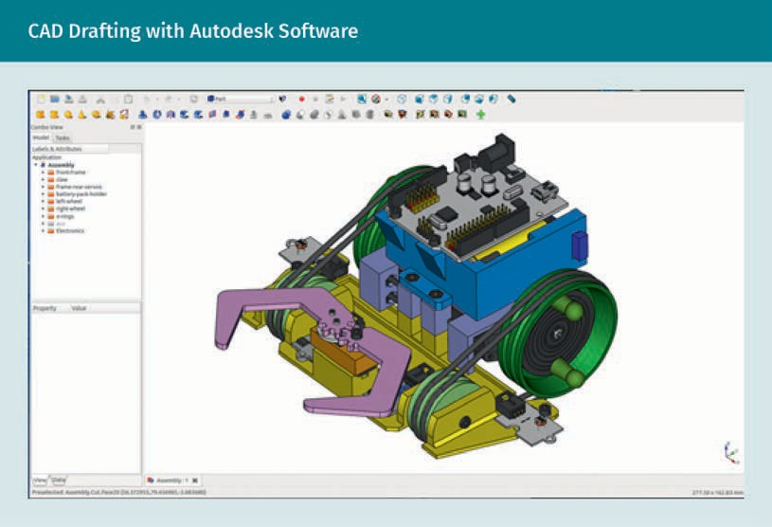
A model designed with CAD software, as shown above, could have been generated from previous computer sketches, from precisely drafted plans, or initially designed as a model. Sometimes CAD drawings are drafted when a more accurate drawing is required after the initial design idea has been mapped out roughly by hand. In CAD programs, drawings are created on a 1:1 scale but can be plotted to any scale. CAD is an extremely powerful drawing tool. If one view in CAD changes dimensions, other views can be automatically adjusted to conform. This allows the various design elements to change simultaneously, adjusting all parts to ﬁt together.

Various materials and their parameters can be explored using CAD software. In CAD, materials may be speciﬁed in building information modeling (BIM) software used for structural design. Since material choices may alter the design measurements, CAD automatically makes the necessary changes. CAD drawings are nearly always required for the ﬁnal production or build due to their precision. With modeling capabilities, many designers create a model ﬁrst and then quickly generate multiple views and drawings. In the case of a mechanical assembly, the model can ensure that there are no undercuts and the parts can be mounted. The simulation of the model demon- strates movement of the parts, which gives the 3-D model a distinct advantage over hand drawing.

Tools for Technical Drawing

A sketchbook with either blank or grid lined pages for pen and pencil use is a constant companion of the designer. Engineers sometimes prefer to use grid or dotted pages and may refer to their notebook as a logbook. It is good to have a general logbook for personal use and, in addition, another one for each project, depending on their com- plexity.

Manual sketching and drawing tools
Artists and inventors have used sketchbooks for a long time. Leonardo da Vinci is famous for his art, design, and his sketchbooks, which are shown in the ﬁgure below. Drawing and writing utensils may vary in price depending on what the user wants. Basic 2B—4B (soft lead) pencils and/or several black ink markers sufﬁce. Experiment with several as you begin your drawing exercises so that you are able to create very ﬁne lightweight or faint lines and more deﬁned, darker precision lines. Additionally, it is good to have a marker with a wider tip. Mechanical pencils and colored leads may also be used but they are not necessary to begin sketching. Erasing is allowed; however, many sketchers do not take time to erase. The preliminary light lines give the sketch an artistic character that reveals part of the designer’s visual thinking process.
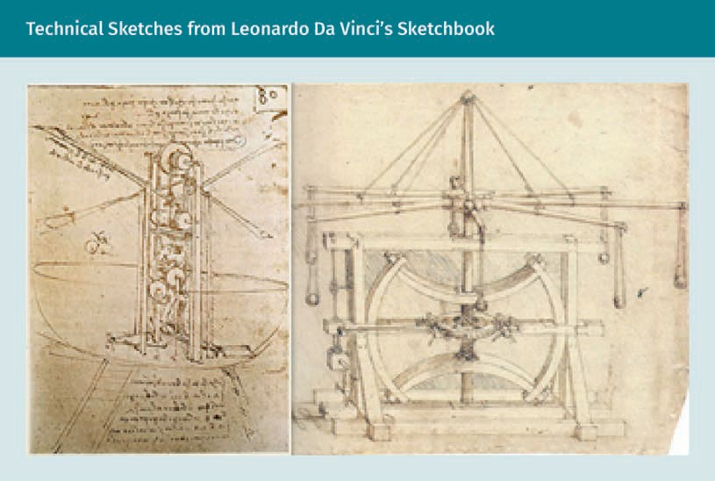

Basics of Technical Drawing

Hand drafting
Mechanical pencils with harder leads and precision ink instruments are required for manual drafting. Vellum paper for pencil work and Mylar for ink work are the preferred drawing sheets for best reproduction. It is critical that when reproduced, the line weights, symbols, and written information remain readable. With digital scanning, as with reproduction copies, the readability of the scanned document must be checked.

Triangles are used as a 90° straight edge for creating vertical lines against a T-square or parallel bar afﬁxed to the lower edge of the drafting board or table. Scales and trian- gles are required instruments for precision hand drafting. An adjustable triangle is also available; however, only two main types are needed based on their angles: a 45°and a 30°—60° triangle. Electric erasers are a time-saving friend of a dedicated hand drafter, as are an eraser and a brush for removing eraser crumbs. Keeping drawings clean is important to ensure that copies show only the intended lines, symbols, and text.

Drafting arms are attached to some drafting tables, replacing the need for a parallel bar. Accurate angles can be created with the use of the drafting arm or by combining the triangles and protractors. Scales are typically three-sided and can be in inches, decimal scale, or metric scale. A compass and proportional dividers used for measuring are also tools that are frequently employed as drawings become more precisely deﬁned. Templates, lettering guides, other specialty devices (such as French curves), and other commonly used items can be added to a drafter’s tool kit as needed. Finally, a drafter must also have access to a calculator.

Manual and computer drafting
An ergonomically designed space will aid in your productivity. Good lighting is impor- tant for any type of drawing work, so take good care of your eyes by making sure you have adequate and proper lighting. Similarly, comfort is vital, so use an adjustable chair that will accommodate different positions as you draw. Drawing for long periods of time requires drafters to maintain good posture and take breaks to stretch. When using the computer, be sure to allow visual breaks for the eyes to focus on larger and distant objects. It is easy to lose track of time when doing small-scale work, so setting a reminder to take breaks or stop for the day is a good habit.

Computer drawing and drafting process and software
For computer drawing and drafting, the design process can appear slightly different when using 3-D modeling. Concept design still takes advantage of sketching (either by hand or computer), but moves to an initial CAD model and the ﬁnite element analysis (FEA), a built-in computer tool used for analysis. This can be a reiterative process before moving further into design development and optimization with the model and possibly subsequent FEA, which can also include several iterations that are easily han- dled by the CAD modeling software. The ﬁnal FEA leads to the design deliverables, which may produce an actual 3-D product or the technical drawings depending on what deliverables are speciﬁed in the contract. Familiarizing yourself with CAD software—par- ticularly 3-D modeling software—is a requirement for today’s technical drafter or designer. Some companies offer free introductory or student versions, so it is a good

idea to call a few ﬁrms and ask which software they prefer using ﬁrst, and then contact that company for a student version. A primary rule when using CAD is to make it a habit to save your work often.

Autodesk offers many different CAD software programs catering to the speciﬁcs of spe- cialized design and engineering ﬁelds. Students and instructors can get educational renewable access to Autodesk products and services (Autodesk, n.d.-a). Sketchbook is Autodesk’s software for computer sketching used in many disciplines; AutoCAD is the basic CAD used across many disciplines; and Inventor® is their professional-grade 3-D CAD software designed for mechanical design, documentation, and product simulation tools. According to their description, it will “work efﬁciently with a powerful blend of parametric, direct, freeform, and rules-based design capabilities” (Autodesk, n.d.-c, “Overview” Section). Their cloud-based software for product design, Fusion 360, integra- tes CAD, CAM, CAE, and PCB software into one package. It is designed to eliminate any disconnects in the product development process by unifying design, engineering, elec- tronics, and manufacturing into a single platform (Autodesk, n.d.-b).
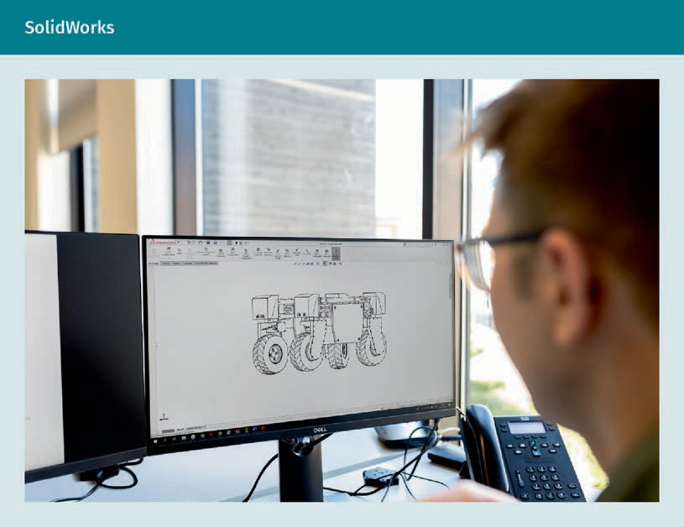
The Dassault System SolidWorks Corporation produces SolidWorks for the manufactur- ing industry. It also has specialized software for speciﬁc engineering needs and has an educational department for students to contact. Several other excellent software com- panies offering 3-D modeling can be found online (SolidWorks, n.d.).

Basics of Technical Drawing

Documentation of drawings
All drawings for a project, whether manual sketches, manual drafts, or CAD-drafted drawings, must be documented. Firms often customize and decide upon a documenta- tion reference system for use in their drawing library. The International Organization for Standardization (ISO) also provides standard project documentation methods providing a consistent order for naming and cataloging documents (International Organization for Standardization [ISO], n.d.-j). With many teams working together on the same project, version control becomes an important tool to have in place. Solidworks® prod- uct data management (PDM) is a software program used by ﬁrms to organize the com- plex task of drawing ﬁles for the technical drawing industry (SolidWorks, n.d.). ISO 9001 requires that document information be accounted for in some type of quality manage- ment system, but does not specify how ﬁles should be named (ISO, n.d.-l). Since “ﬁle name characteristics vary greatly, depending on the product, speciﬁc drawing require- ments, and drawing standard interpretation and options” (Madsen & Madsen, 2016, p. 101), each drafter must make sure they understand their ﬁrm’s system for ﬁle naming, saving, and storage.

Practice lesson
Please complete the following tasks:

- Begin a sketchbook dedicated totally to your technical drawing projects. Share your progress with other students or discuss it with your tutor. In your sketchbook, make a loose sketch of a simple item that caught your eye or interests you. Draw it from both a 2-D and a 3-D perspective. Experiment with various pencils and pens to determine which you prefer for quick sketching. Each day, add another sketch. Be sure to include some technical sketches of parts.
- Set up a manual drafting board with basic tools: two triangles (a 45°and a 30—60°), scales used in your ﬁeld, a compass, and mechanical pencils with several different lead weights. Practice drawing horizontal and vertical lines, keeping the line weight consistent. Print, copy, or scan it to check for quality.
- Learn to use the scale. Refer to chapter two of Engineering Drawing and Design by Madsen and Madsen (2016, pp. 48—49).
- Choose an online CAD software and obtain a free trial or student version. Use a tutorial, such as Sketch Up or Sketchbook, to sketch a mechanical part.

Drawing Format
The following questions must be asked when ﬁrst deciding upon the technical drawing format to be used:

- What information needs to be taken into consideration when creating technical drawings?
- Who will be using the drawings and for what purpose?
- What needs to be considered prior to choosing a drawing format?

It is good to begin with the presentation of the drawing deﬁned by the paper size (or sheet size), border, and title block. Often this information will be provided by the ﬁrm for which you are working. Europe usually uses a different paper size and drawing con- vention than the US and Canada.

ASME
The paper size most commonly used in North America is set by the American Society for Mechani- cal Engineers (ASME).
The American Society of Mechanical Engineers (ASME) has established speciﬁcation standards for engineering drawings, including paper sizes (American Society of Mechanical Engineers [ASME], n.d.-c). ASME Y14.1 is the speciﬁcation for engineering paper sizes that has been adopted by ANSI, the American National Standards Institute (“ANSI/ASME Y14.1,” 2021). The ANSI system is more commonly used in North American countries, such as Canada, the US, and some parts of northern Mexico. It is based on the common letter size of 8.5” x 11” referred to as ANSI A; paper sizes in inches are indi- cated using letters A through E. The ASME Y14.1M standard gives sizes for papers using metric measurements, indicated by the letter A adjoined with numbers from A0 to A4 (“ANSI/ASME Y14.1,” 2021). Larger, elongated sizes are also available with speciﬁed desig- nations, but they are not typically used.

In most of the world, the ISO sets the standards. The ISO is an international organiza- tion comprised of worldwide standards institutions (ISO, n.d.-j). The national organiza- tions and regulatory agencies can adopt the ISO as national regulations. Its overreach- ing inﬂuence can be seen in the many organizations that have become members, of which only a few are listed here. The Deutsches Institut für Normung (German Institute for Standardization) (DIN) introduced the standard for paper sizes now used by the ISO and represents Germany in the ISO (Deutsches Institut für Normung [DIN], n.d.-a). India’s member representative is the Bureau of Indian Standards (BIS) (Bureau of Indian Standards, n.d.); the Saudi Standards, Metrology and Quality Organization (SASO) has been a member of ISO since 1972 (ISO, n.d.-m); Japan is represented in the ISO by the Japanese Industrial Standards Committee (ISO, n.d.-k); and the US is represented by ANSI (American National Standards Institute [ANSI], n.d.) Both the Japanese Standard Association (JSA) and the China National Institute of Standardization (CNIS) are in cooperation with the ISO; however, they are not listed as ofﬁcial members and have no liaisons. In 2000, Britain published BS 8888 as their engineering standard or technical product speciﬁcations (TPS), which provides routing to 150 ISO standards (“BS 8888,” 2020). The ISO 216 system used for paper sizes was reviewed and conﬁrmed in 2016 and is still current as of April 2021. This system uses the international A4 as the metric basis for the paper sizes with each sheet doubling in size (ISO, n.d.-v).

ISO standards may be revised every ﬁve years and may include amendments prior to approval of standards being rewritten. Be sure that you know which standard conven- tion to use for your project and that you are using the current, most accepted standard. This may depend more on where the product will be manufactured or where the CAD drawings will be plotted, rather than where it is designed. Plotter requirements for the width of the roll size may determine which size a ﬁrm uses. Due to our global market, it may become more common for everyone to use the ISO sizes because these are also easier to reduce or enlarge. However, it is helpful for North Americans to know that an 11” x 17” ledger or tabloid size speciﬁed by ASME and known as ANSI B does relatively well when enlarged to a sheet size of 24” x 36”, known as Arch D and commonly used in the architectural ﬁeld. ASME Y14.1 designates the size 22” x 34”—more typically used in

Basics of Technical Drawing

engineering—as D. You may only ever use one of these, but it is good to be aware that there are numerous designations for sheet sizes and to know which country will be plotting and using your designs.
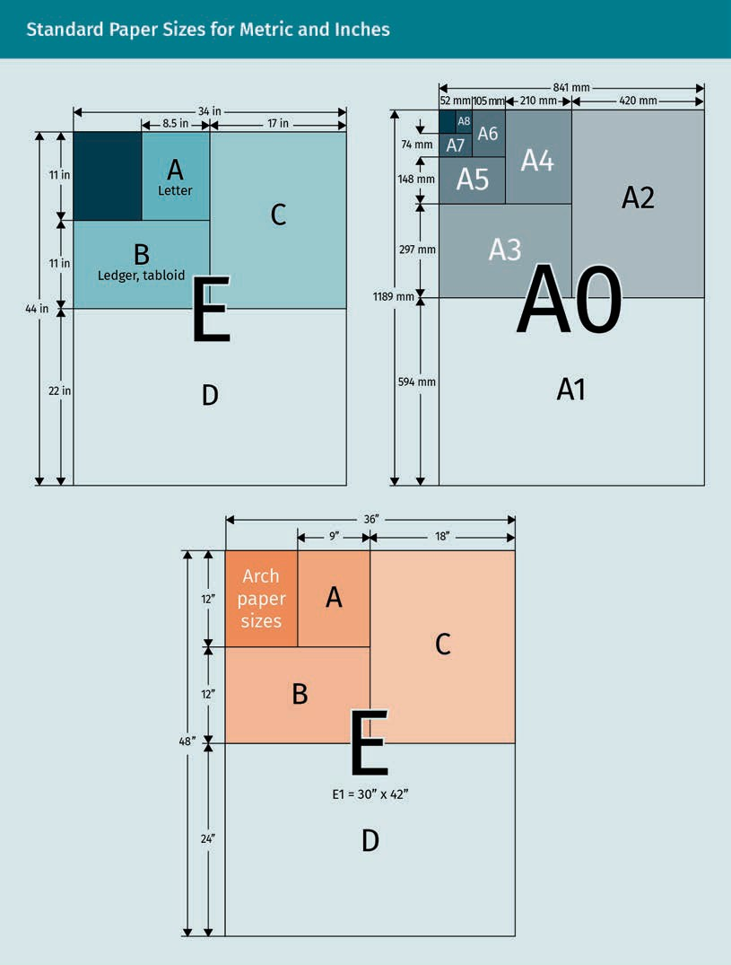

Three different paper size formats are shown in the ﬁgures above. On the left is the ANSI/ASME system based on 8.5” x 11” letter-size paper. In the center image, the ASME Y14.1M for metric is shown, i.e., the ISO 216 most commonly used around the world. It shows the comparison between sizes of the ANSI/ASME system in blue. The right image shows the architectural paper size standards based on the 9” x 12” sheet.

Creating a Drawing Format

There are instances where a drawing will need to be submitted for approval to a juris- dictional agency, such as a city or county building department. In these cases, check their requirements to see if any speciﬁc sheet sizes or layouts are needed for the draw- ing. If there are no requirements and the ﬁrm does not have a standard layout for the drawings, you will need to decide on a drawing format. Selecting the paper size is the ﬁrst order of business and you will need to consider several aspects.

Border
Typically, a border needs to be simple so it does not detract from the important infor- mation and to avoid reducing the area too much. However, allowing for a border on all four sides will still somewhat reduce the drawing area. Typically, a maximum of 1/2” or 20mm on all four sides is considered an adequate border.

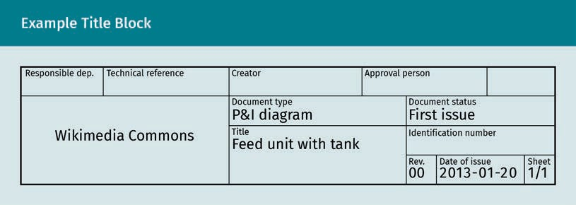
Title block
Title blocks include a large amount of information and may vary from ﬁrm to ﬁrm. It is common for a ﬁrm to have an area for contact information that includes the company logo within the title block. A square for the engineer or architect seal (stamp) will be left blank until the ﬁnal drawings are approved. The seal includes the date and signa- ture of the professional that “signs off” on the plans, taking full responsibility for their accuracy. Other blocks include the name of the engineer or designer and, if different, the drafter, along with contact information if it is not included in the space for the company logo. Also included is a place for the checker or approver of plans to initial. The title of the drawing, date of work, scale of drawing, and sheet and drawing number are all placed in the title block. A place to denote revisions also needs to be part of the title block if there is no separate revision block. Speciﬁcally, the revision block needs to include the date of revision, drawing and sheet number, and the person who revised the drawing together with a reason for the change. Additionally, an angle of projection

Basics of Technical Drawing

block is typically included for mechanical drawings. Finally, the title block may also include the part name and number, quantity, coating, and other pertinent information required for manufacturing.

The title block and the border need to be blocked out ﬁrst. A bill of materials (BOM) may also be required. ASME recommends sizes for title blocks and the information required (Engineering Essentials, n.d.), while ISO 9431:1990 covers layout, title blocks, and text for construction drawings (ISO, n.d.-e). A table of items to include in the title block is also given. Mandatory items include the title, owner, identiﬁcation, date of issue, and sheet number. Optional items are the approval person, creator, and docu- ment type. If needed, a revision index is included, but this may be separate from the title block. It is recommended that title blocks be located in the bottom right corner of the drawing, although other options are used and accepted. As of April 2021, this ISO standard is current, but ready for review. If you do not have a pre-approved sheet lay- out in the ﬁrm, it is best to follow the ASME or most current ISO guidelines for sheet layout.

Binding
As a general rule, for Arch D (24” x 36”), Arch E (30” x 42”), A1 (594mm x 84 mm), and A0 (841 mm x 1189 mm) allow an extra 1/2”—1” or an additional 20 mm on the left side of the sheet for binding. If smaller sheet sizes are used, determine whether they will be bound or published, and if so, how. Allow for any required space (typically the left or top edge) needed for printing and compiling the drawings.

Overall size
Before ﬁnalizing the sheet size, it is necessary to determine the overall resulting size of the completed plan or layout for your drawing. You should use the following criteria:

- Typically, product and packaging plans may be plotted at 1/2” to 1:1 scale; architec- tural plans are 1/4” scale with detail drawings at a larger scale; and civil engineering plans for roadwork may be 1:20 scale, or smaller.
- Notes are needed on most drawings. For engineering drawings, ASME recommends that they be located on the bottom left corner of the drawing sheet.
- Consider the amount of space that will be needed for the dimension lines and material identiﬁcation information (call-outs).
- Decide whether your drawing will need more than one sheet. Take into considera- tion that drawings may only be of one part or that they may be of a part and group component and their assemblies. Consider how many different views will be required to convey all the information needed. Deciding how much information needs to be included on each sheet will help to determine the paper size required.

Once the paper size has been selected, the font used for the drawings will be set. Again, it is typical for standard fonts to be used. Find out which font is the standard used in your industry. Instructions are available for learning manual architectural and mechanical lettering styles. Making mechanical lettering styles look uniform requires practice, and it is not necessary to use them for sketching; however, they add a touch of professionalism to your drawings. CAD software includes lettering styles and font sizes,
BOM
Drafters and design- ers are sometimes required to include a bill of materials with technical drawings.

thereby minimizing effort, saving time, and making drawings look professional. Some of the strength, weaknesses, and opportunities that different types of drafting offer are outlined in the table below.

Different Types of Drafting
Sketching | Strengths | Weaknesses/opportuni- ties
 | - Quick  - May help the thought process  - Easy communication | - Does not offer a pro- fessional or ﬁnished look  - Lettering may add to professional look  - Adding texture or color may enhance sketch
Manual drafting | - Off the grid back-up  - Better understanding of construction meth- ods and design pro- cesses  - Can be personally rewarding | - Consumes time (time is money)  - May not be as accu- rate as computer drafting  - Useful when electron- ics or computers are not available
Computer drafting | - Most accurate  - Less time-consuming than manual drafting  - Can create prototypes or products using CAM | - Errors possible when inexperienced  - Computer can crash and lose work
Practice lesson
Please complete the following tasks:

Basics of Technical Drawing

- Contact an engineering ﬁrm in your region and ask to learn about what is required of a draftsperson in their ﬁrm. Ask what standards they use for paper size. Examine their title block to ﬁnd out what standards they follow for formatting the layout of the drawings.
- Download AutoCAD, SolidWorks, or another 3-D modeling software that you will use in the future. Use it to learn the basics of setting up a drawing format. Create a sheet with a title block for technical drafting.
- Continue to add daily drawings to your sketchbook.

Summary
From the ﬁrst idea to the ﬁnal completion of a product or project, technical draw- ings play an important role. They are critical tools in the design process and, most importantly, they convey the designer’s intent. They also provide a communication device for all people involved in the design process and its ﬁnal execution.

Two basic types of technical drawings are described as either 2-D or 3-D. 2-D draw- ings include orthographic or multi-view drawings, and 3-D drawings are axonomet- ric. Both manual and computer-aided drafting (CAD) techniques may be used to create a design and the ﬁnal drawings. Most ﬁnal construction drawings are created in CAD.

The design process is the order in which designs are developed. It begins with care- ful identiﬁcation of a need. Sketches can be initially used for design ideation and visualization during the concept phase. As the design progresses, more formalized drawings are utilized through the schematic phase of analysis and the design development phase. Construction drawings are the ﬁnal technical drawing in the design development process. For 3-D modeling, the design process begins with a problem statement and, after sketching, it is completed within the 3-D modeling and subsequent ﬁnite element analysis (FEA), sometimes with reiterations until the ﬁnal FEA results in an approved deliverable.

In order to create the drawing format, many considerations should be taken into account. Determining sheet size and layout may depend upon the ﬁrm or agency requirements. Additionally, allowances for the border and title block must be con- sidered, as well as any binding requirements. The scale of the drawing and overall size—including dimensions and notes—will ﬁnalize the choice of sheet size. The selection of the font for lettering will complete the format decision-making process.

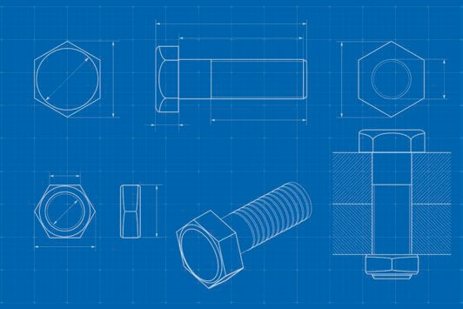

Unit 3

Views

STUDY GOALS

On completion of this unit, you will be able to …

… understand why and how to use three-panel projection.
… name the differences between ﬁrst- and third-angle projections.
… identify which information is included with cuts and breakouts.
… explain the purposes of cuts and breakouts.

DL-E-DLBROTD01_E-U03

- Views

Introduction
Technical drawing requires innovators, such as drafters, designers, inventors, architects, and engineers, to visualize objects, their functions, and assembly processes. Many drawings are required to explain the complicated information needed to build or man- ufacture projects. They are broken down piece by piece into smaller portions that are more easily understandable, a step that requires a comprehensive understanding of the project and of the minute details that make up the components. Each drawing sheet presents speciﬁc graphic information read by the users. Just as an author writes a book using chapters, paragraphs, sentences, and words, the technical illustrator uses sheets, views, details, and annotation to convey information to the reader of the plans. Drawing views organize a very technical, complex system of many functions. The func- tion of individual parts or components deﬁnes how they are grouped, whereas assem- bly views show how the parts ﬁt together.

When considering views, it is important to understand several technical aspects. Learn which views deﬁne a three-panel projection, how to create one, and when it is used. Knowing the difference between ﬁrst- and third-angle projection methods is critical. Complex situations require the use of cuts and breaks, and analyzing which views to use for them is the mark of a professional in the ﬁeld of technical drawing.

Views

Three-Panel Projection
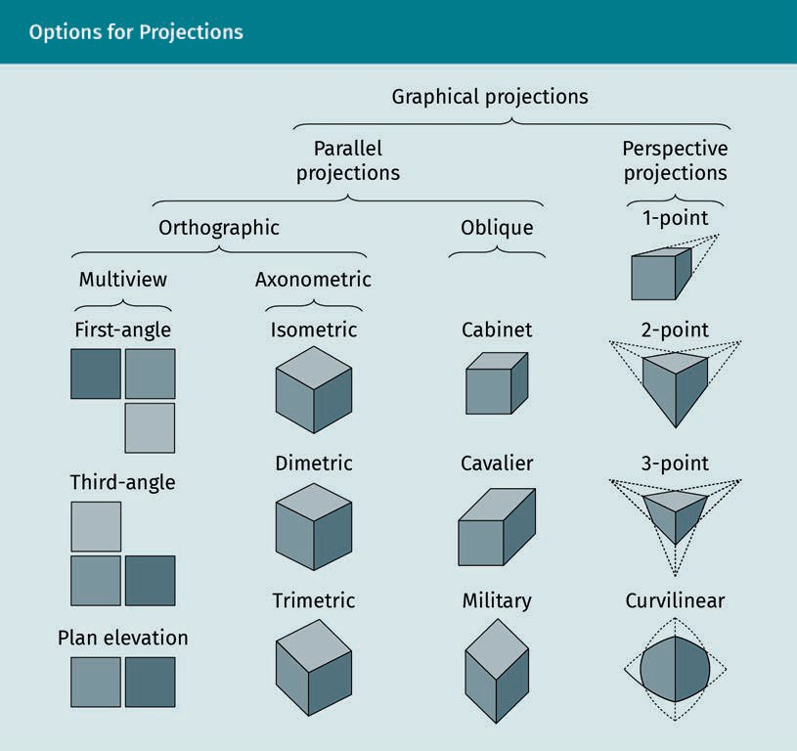

The ﬁgure above presents numerous options for graphical projections, each offering a different view. This unit will address the differences so that you can learn how to create them and which one to choose. In technical drawing, a projection is a representation of one side of an object transferred (or projected) onto a ﬂat surface perpendicular to it, such as a picture plane. Imagine a box made of clear material; each side would be a picture plane for the sides of the object inside.

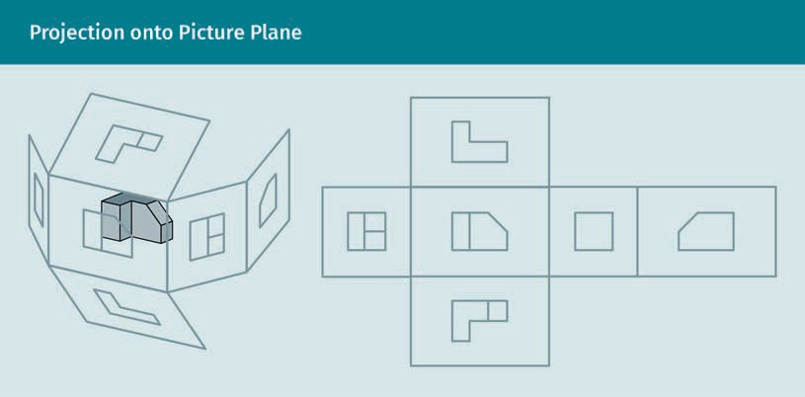

A projection view shows only one side so the reader can more easily understand how it looks from different perspectives. Imagine an object enclosed in a clear six-sided box with each side projected onto the corresponding side of the box. When the box is unfolded, the result is six primary views that are all a part of the original object. Projec- tion drawing views grouped together, as in three-panel projection, show the relation- ships between the different faces or sides. Using this method, “there is always one dimension that is the same between views” (Madsen & Madsen, 2016, p. 266). As an example, architects commonly use plans and elevations showing the relationship between the ﬂoor plan and the wall plans.

In the cabin plan below, the different sides are labeled according to their cardinal directions: south, east, and west. The north elevation is not necessary, as it is an exact opposite of the south elevation. The cabin plan does not, however, align the views as in a three-panel projection. The ﬂoor plan has section cuts AA and BB that are not inclu- ded on the same sheet. In a true three-panel projection, each side aligns with a corre- sponding edge of an adjacent side.

Views

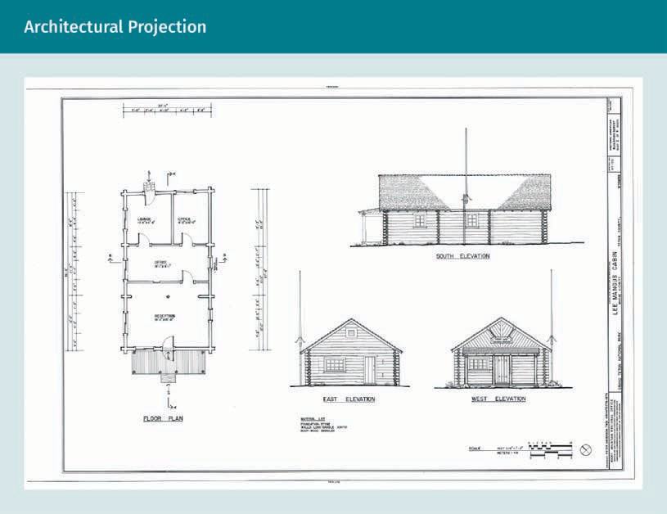

As shown below, drawings typically name the views according to their relationship to each other rather than to cardinal directions.
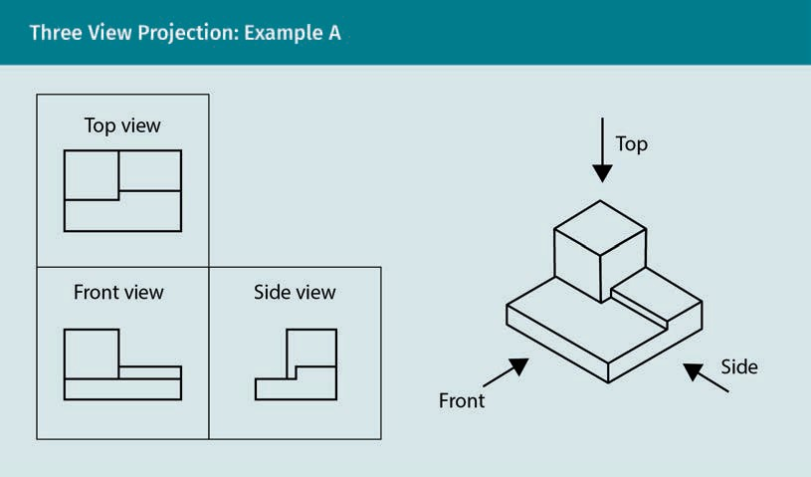

The projection lines shown below illustrate the relationship between the views. The drafter aligns the drawings with each other but does not draw the projection lines. A very light construction line could be used if needed.
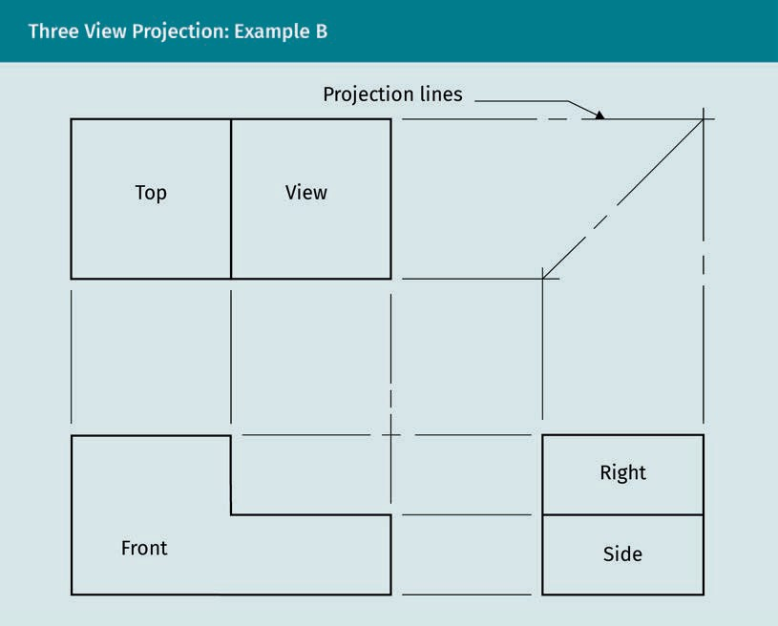

In the microchip image below, the three views are correctly aligned with each other and the projection lines are not visible. Three-panel projection layouts derive from the per- spective or axonometric view of an object. Even though six primary views exist, not all six are typically needed. Usually, a plan needs fewer views to describe the object. Therefore, three-panel projection is the most common drawing layout for architectural details, mechanical, and robotic engineering. Deciding which view or projection to use as the basis for the layout views is critical because it will save costs in terms of time spent drawing and analyzing, simplify the understanding of the object, eliminate dupli- cate information, and most clearly identify all aspects of the object.

Views

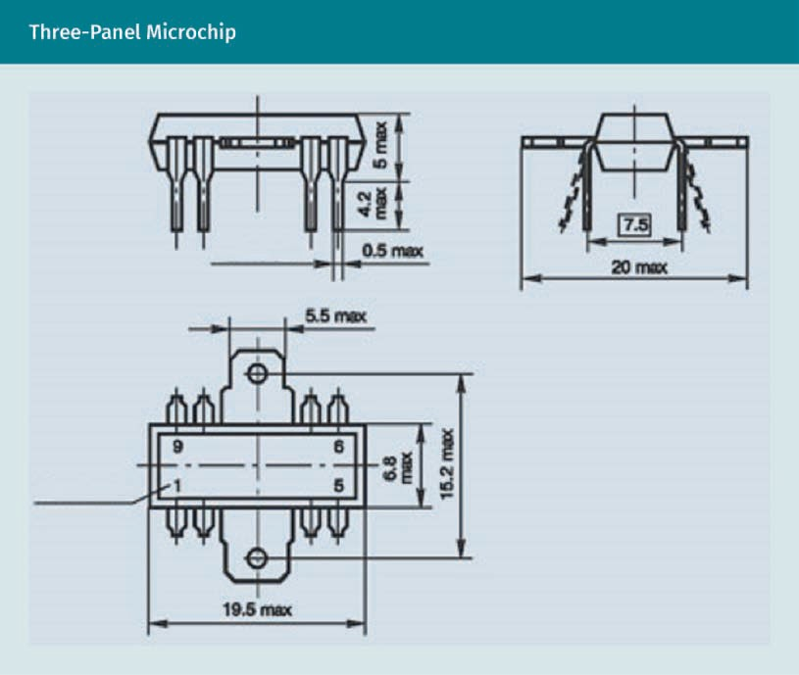

Choosing the Panel Views

To choose the ﬁrst view, look carefully at the object or visualize it from all angles. Imag- ine that it ﬁts into a cube of six faces, then pretend to look through each to understand what is visible in each of the six views and what is not.

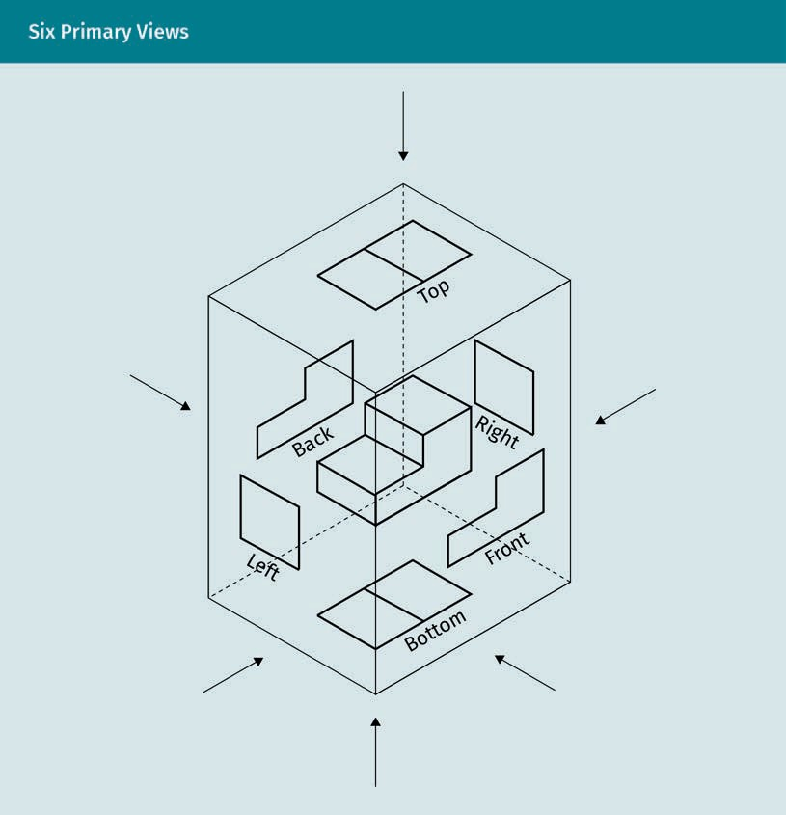

Envision the complex object forms within a box to decide on the view to begin with. What forms and shapes do you see in the object below?

Views

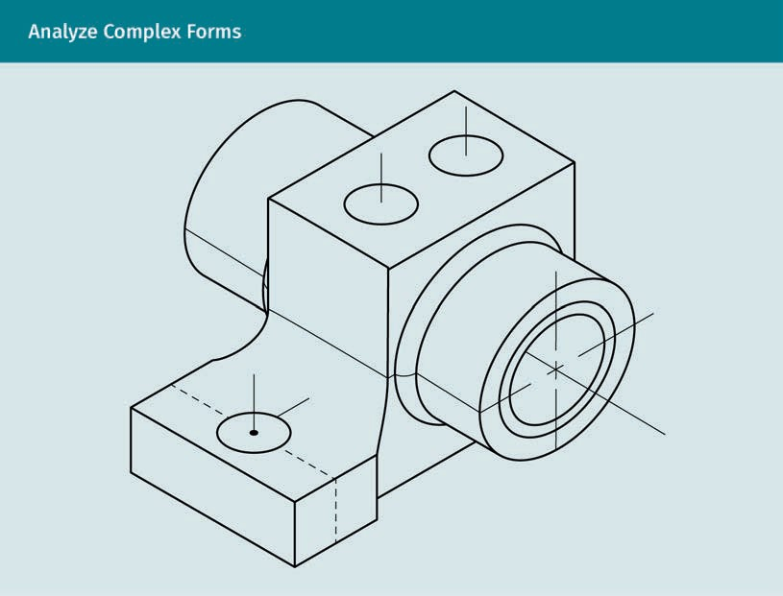

Consider the following questions:

- Which side or view has the longest and tallest dimensions?
- Which side has the most visible features?
- Which view shows what the other views do not?
- Which two or three views can show all the information?
- Can an annotation serve to describe a thickness, eliminating the need for another view?

Practice lesson
Please try to draw a three-panel view for the image below. Does the axonometric view provide enough information? (Hint: the dimensions help.)

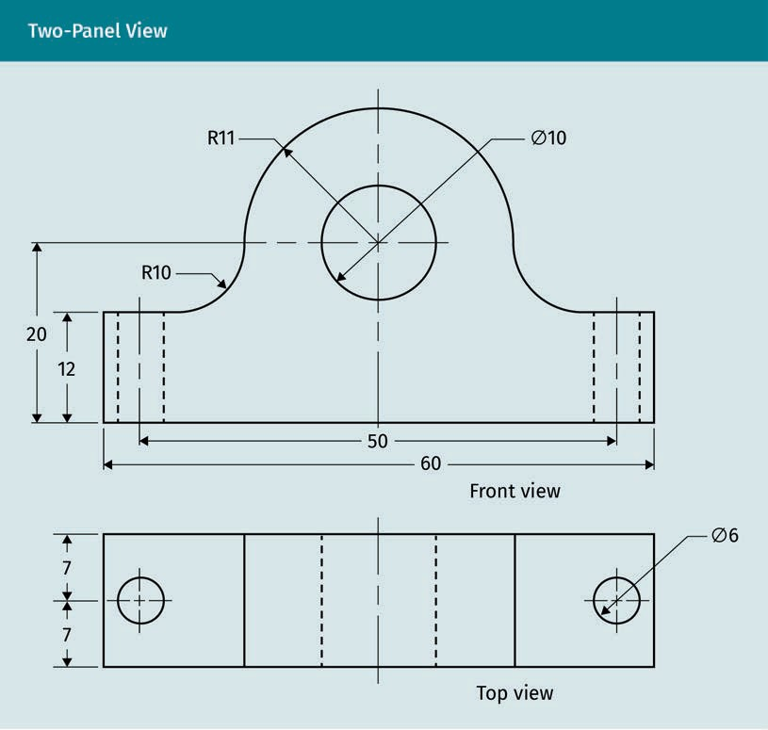

When objects are symmetrical, a two-view drawing works. Look carefully at the ﬁgure above. To read it, ﬁgure out where the centerline is. The small dashed lines are hidden lines; they show the edges of features that are not visible in the view. The holes appear as circles on one view and hidden lines in the other. Notice how the dimensions and arrows deﬁne the object. The outer object lines are the darkest and widest.

Views

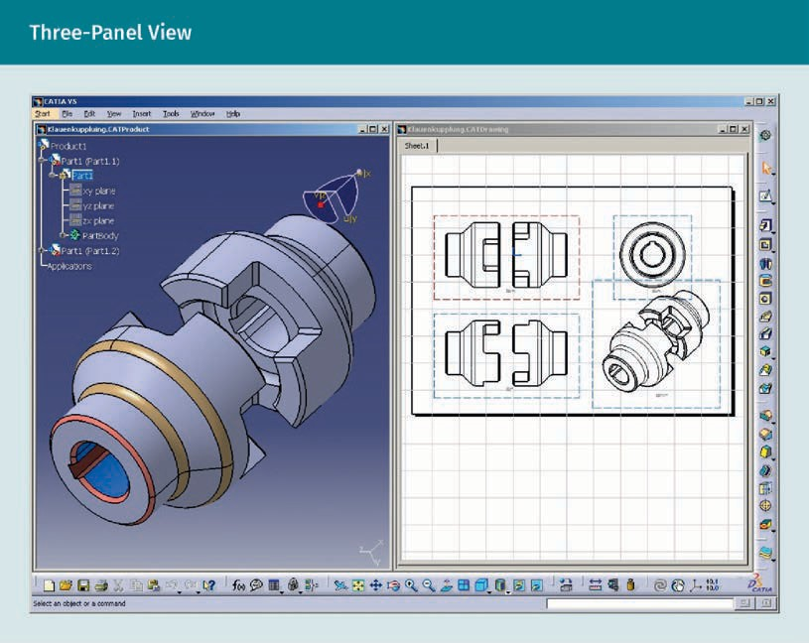

While the two-panel view is sufﬁcient for simple symmetrical objects, in a three-panel projection, the front view is often the primary view upon which the other views align. Other views include the left- or right-side view and the rear (or back) view with an optional bottom view, depending on the need. Each view requires a label. 3-D modeling software produces three-panel orthographic views from the 3-D model.

Projection Methods (1 & 3)
To describe 3-D forms with 2-D drawings, more than one drawing is required. Multi-view sketching uses two or more 2-D drawings of an object drawn perpendicularly to a plane parallel to that side. Position or lay out orthographic views in order. Align the views in either of two ways, ﬁrst- or third-angle projection. Most of the world uses the ﬁrst- angle method that is the ISO standard. In the US, the third angle is the most popular as an American National Standards Institute (ANSI) standard (Simmons et al., 2009). The ﬁrst or third angles are named for the quadrant in which they are located. The symbol denoting ﬁrst or third angle must be included in the drawings.

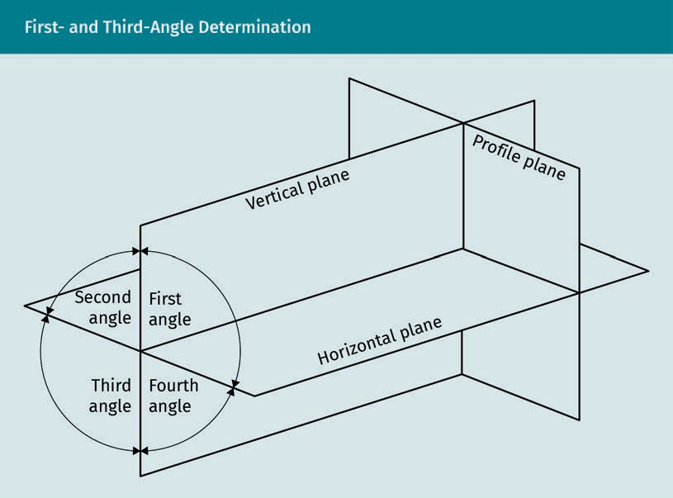

First- and third-angle projections are named for the quadrant in which the object is oriented to the horizontal plane. In ﬁrst-angle, the horizontal plane is below the object, while in third-angle, it is above the object.

Computer-aided design (CAD) drafters sketch a layout of multi-views to determine their placement before committing them to the computer. Sketch quickly without need for precision, yet be generally accurate with the graphic description to draw the align- ments. Designers and drafters need strong visualization skills to select the layout that best represents the object. Grid paper is good for sizing and aligning views when sketching a layout. The standards used determine the order of the layout. Drafters must choose ﬁrst- or third-angle layout and label them correctly. Experts agree that, for all practical purposes, advances in technology will eliminate the need to choose. They also agree that “orthographic projection is and will remain important for sketching prelimi- nary design concepts and for manual machinists, neither of which will become extinct in the near future” (Melton & Stewardson, 2008).

Projection Method 1

In ﬁrst-angle projection, directly align the views with the front view in center. The left side and back or rear view are to the right of center. The bottom view is above center with the top view below center. The right side aligns with the left side of the primary front view. The symbol for ﬁrst angle, on the right, must be included on the drawing sheet.

Views

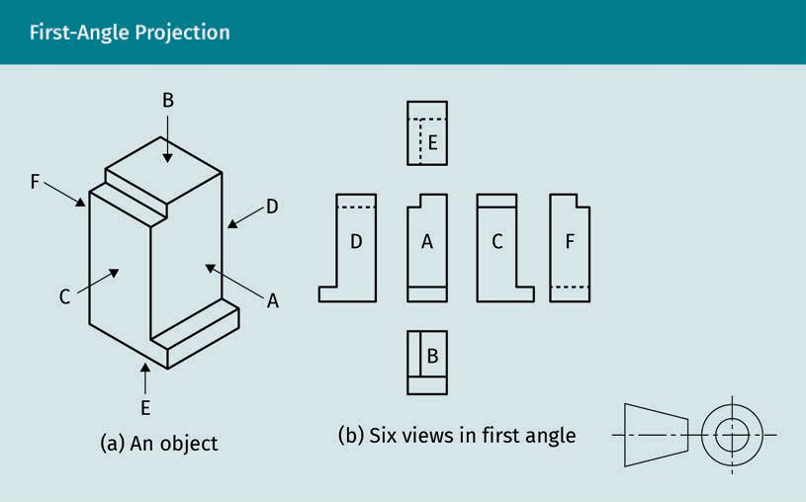

Projection Method 3

In third-angle projection, the front view is the basis for the layout. Align each subse- quent view directly with the front one. Place the top view above the front view with the side views to either side, the back or rear view to the left of the left side view, and the bottom view beneath the front view. The symbol for the third-angle projection is a reverse of the ﬁrst-angle symbol.

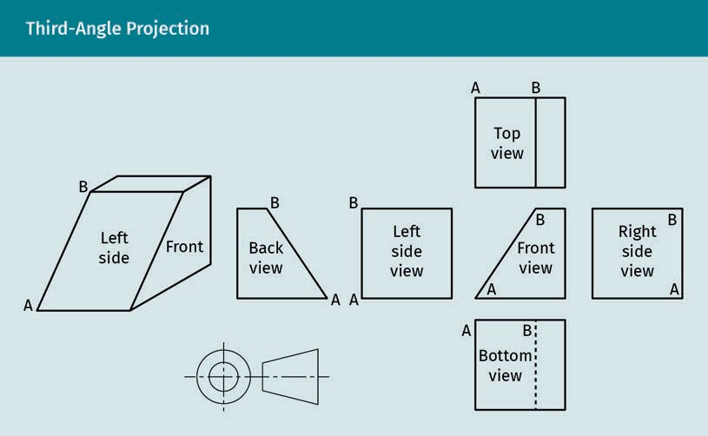

Layouts must show all of the information needed to understand an object. Some objects have angled parts that are not perpendicular to any of the six box sides. Auxili- ary views are additional views that are perpendicular to inclined surfaces. Experienced professionals and educators recognize that visualizing multi-view and auxiliary views can be difﬁcult. That is why “it is important for you to practice looking at three-dimen- sional (3-D) objects and try to visualize them in two-dimensional (2-D) views in your mind” (Madsen & Madsen, 2016, p. 295). In the case of inclined surfaces, imagine the box having an extra side perpendicular to the inclined plane. This becomes the picture plane for the auxiliary view.
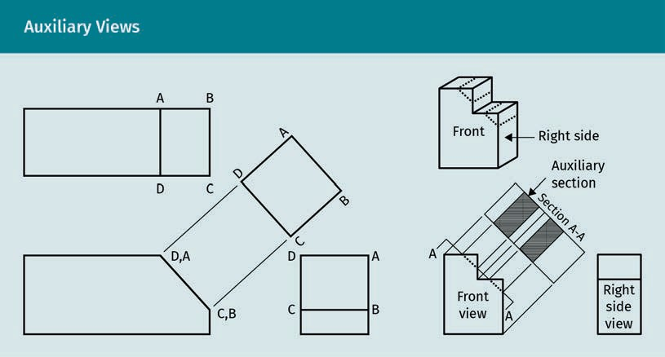

Views

On the right of the ﬁgure above, the example combines a section cut as part of the aux- iliary view. Notice the use of projection lines. Auxiliary views can be included with the ﬁrst- and third-angle projection layouts if only one or two additional simple drawings are needed. At times, it is necessary to present them separately.

Commonly, an auxiliary view will be a partial view, only showing the shape of the inclined surface for correct dimensioning. A full auxiliary view would include hidden lines graphically explaining information already contained in the standard views paral- lel to one of the six primary views. Typically, there is no need for a full auxiliary view because it shows duplicate information. Keep the layout as simple and clean as possi- ble. If necessary, for clarity, show a projection line for an auxiliary view from the object’s edge or centerline.

Practice lesson
Please complete the following tasks:

- Sketch a ﬁrst- and third-panel view of the same object, label the views, and use the correct view symbol. Share the sketch with your colleagues or tutor.

- Sketch a simple item with an inclined surface and create a multi-view layout for it, including an auxiliary view.

Cuts/Breakout
Cuts and breakouts show additional information of components. American Society of Mechanical Engineers (ASME) standard 14.3, Multi and Sectional View Drawings, pro- vides direction for drawing (American Society of Mechanical Engineers [ASME], n.d.-i). Graphic drafting standard ASME Y14.2 recommends different line types and lettering conventions for cuts, sections, and breakouts (ASME, n.d.-f). The purpose of sectioning is to show hidden features revealing parts to be dimensioned. Although hidden lines may indicate an interior aspect, do not use them for dimensioning. Create section drawings for clarity. Several options are possible when drawing a section; the complex- ity of the object will determine which type to choose.

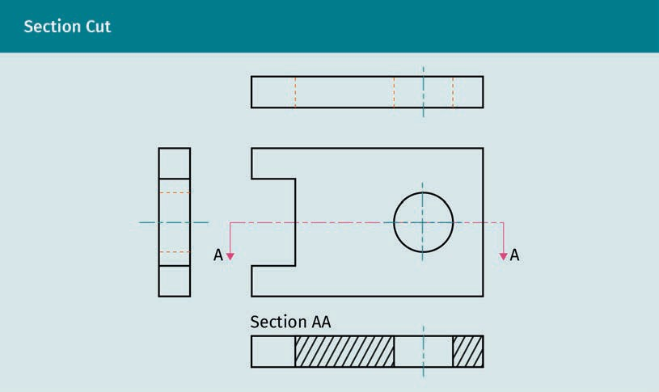

In this CAD drawing, the cut is oriented to the orthographic views. The different CAD line weights appear in color, but will all plot black. Notice that the letter A labels the section cut, and the corresponding section is labeled AA. If there is only one cut, how- ever, labels are not required.
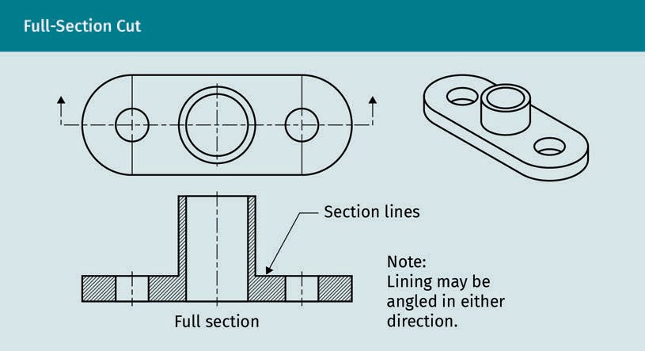

Simple full-section cuts work well for symmetrical objects. Notice the use of four line types in the section cut. The boldest line is the object line, followed by the dashed sec- tion cut line with arrows. The object lines are also dark with the centerlines being much lighter and broken with a single dash. In general, the use of diagonal section lines indi- cates the solid cut area. When materials require identiﬁcation (e.g., steel, concrete, and

Views

wood), use coded section lines of various conﬁgurations. See Engineering Drawing and Design by Madsen and Madsen (2016, p. 443) for a complete list of materials. In archi- tecture, such graphic symbolism is known as poché.
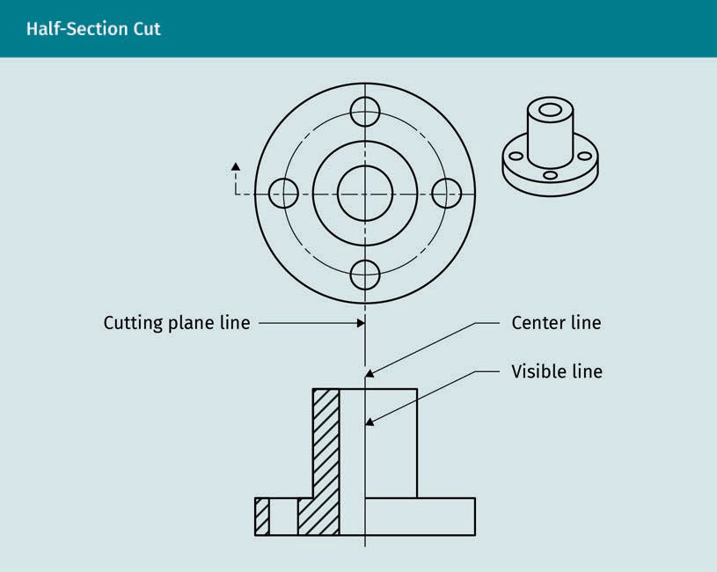

Half-section cuts are for symmetrical objects. The section cut includes a 90° change of direction to cut one quarter of the object. This section cut eliminates the need for two separate cuts by including two directions in a single cut. In the half-section cut above, the cut portion is to the left of the visible line, with the non-cut exterior view to the right of the line. The standard convention for the section line is used to indicate the cutting plane. Since only one cut is used, no letter annotation is required.

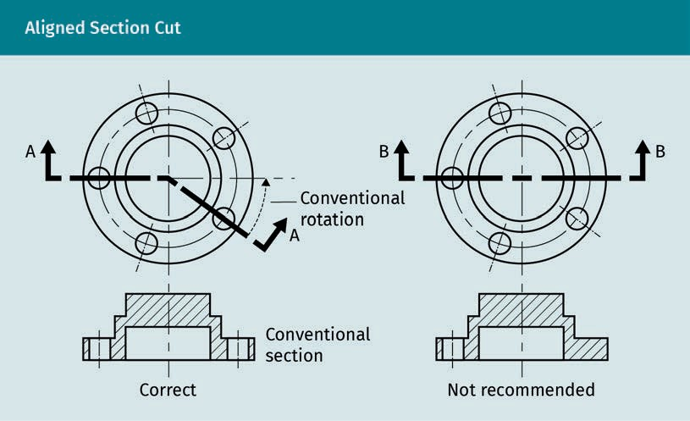

Above is the correct method for cutting through a circular object with asymmetrical holes. If the holes were symmetrical and opposite to each other, section B would work; however, only a half section would sufﬁce. Notice that because there are two section cuts, both have letter labels. Line weight differences are clearly deﬁned.

Practice lesson
Please sketch the correct method for creating a section cut through the part as shown in the previous ﬁgure. Remember to pay attention to the lines used and carefully place the diagonal lines to denote the cut area.

Views

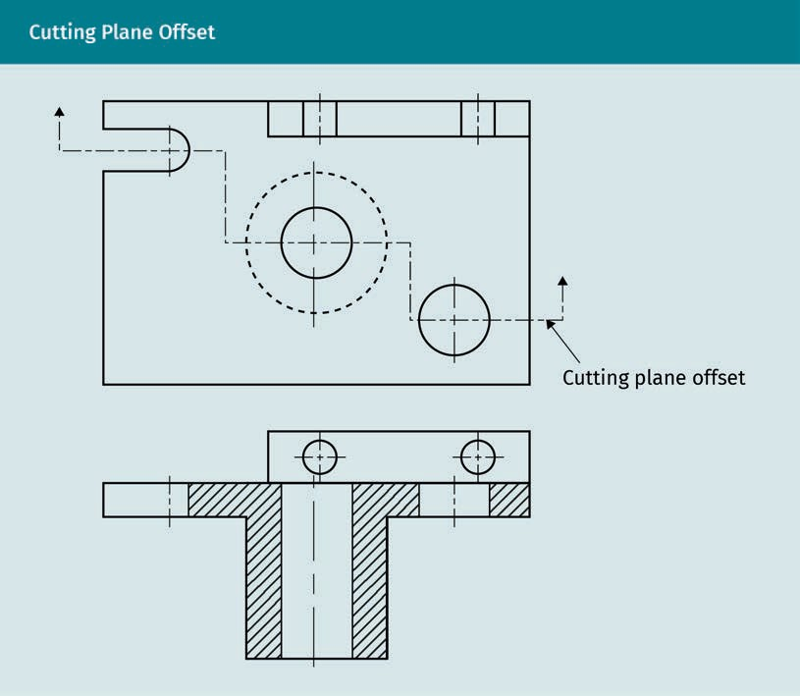

This offset showing cuts through several features eliminates the need for multiple sec- tion cuts. With only one cut, there is no letter label required. Architectural plans com- monly use aligned section cuts. Below is a working sketch in the process of planning the aligned cuts. Notice that proper cut lines, line weights, and labels are not yet estab- lished.

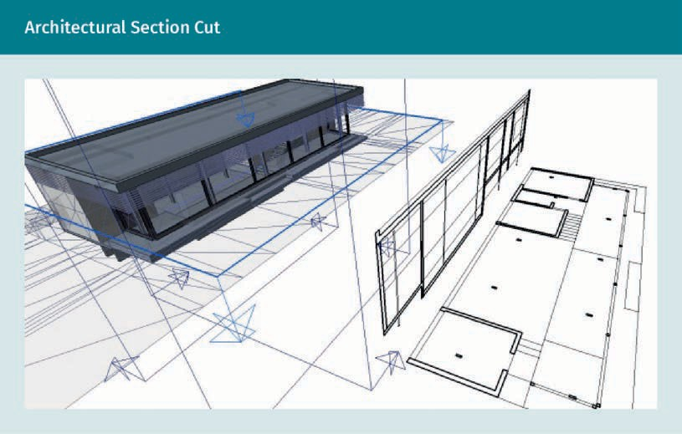

A removed section cut details the removed or cutaway portion, rather than the cut area of the main object. Below is a screen from a CAD project showing a command for cut- ting away a removed 3-D section. CAD and 3-D modeling software can both draw the cut object and remove the cut to show as a separate drawing.
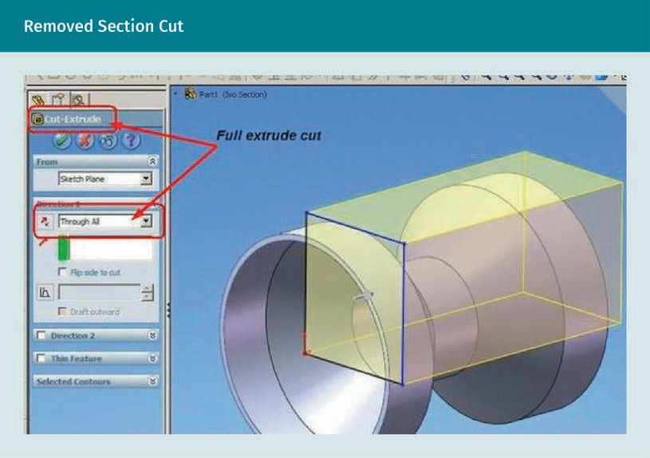

Views

Isometric Drawing Cuts

As we have already mentioned, isometric drawings have three axes: vertical central, and two angles 30° from the baseline. The three axes are each separated by 120°. All three axes contain scaled measurements; the isometric view provides valuable infor- mation in three directions. Cutting sections in isometric views may save drawing time and create plans that are easier to read. Visualize parts in 3-D and consider whether using an isometric section is warranted for your project.
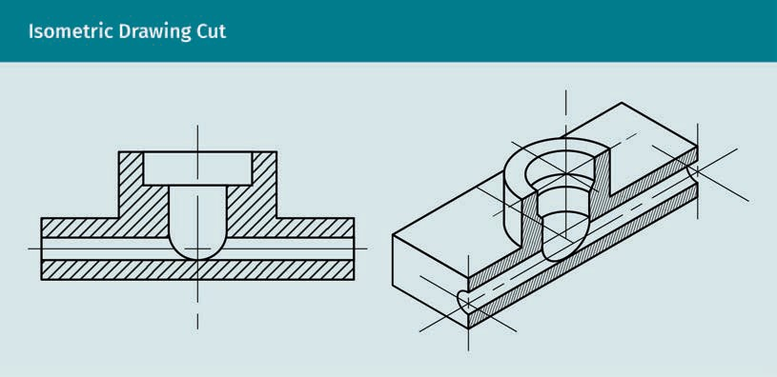

The 2-D section cut on the left is shown as a 3-D isometric section cut on the right. The diagonal lines denote the cut area of the solid material. Consider which view provides more information. Do you need both views? The left ﬁgure could more easily show dimensional information, yet the right side offers a quick visual understanding of the object. The technical drafter needs to discern how to best present all the information needed with the least number of drawings. Careful labeling is critical. You can learn this skill by studying many drawings of completed projects.
Isometric
Angles of 30° from the ground plane deﬁne an isometric drawing.

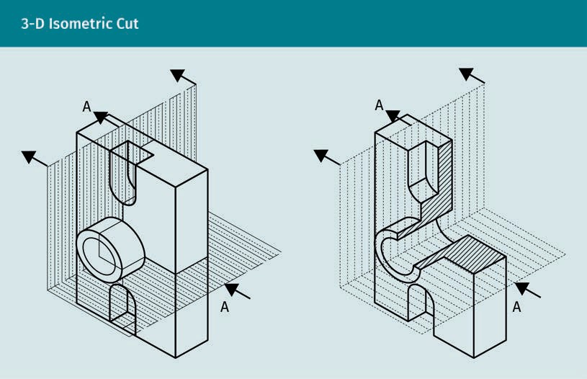
The isometric object on the left shows a cutting plane denoted by the heavy, bold, dark lines and arrows depicting the viewing direction. On the right, the cut section is broken out or cut away, revealing the interior cut material shown with diagonal section cutting lines; this is a breakout view. This one view shows the interior formation of both hori- zontal and vertical planes, eliminating the need for two additional views. If you can clearly deﬁne information in one view, rather than two or more, you should do this. Take time to visualize what is important. If necessary, manually sketch different views and layout options. In the end, it saves time, and time is money.

Practice lesson
Please use the computer to draw a section cut of a simple object. Use 2-D CAD or 3-D modeling software.

Exploded Views

Detailed illustrations of individual parts and components are grouped together accord- ing to their function in the mechanical engineering project plans. Exploded views show how they work together.

Views

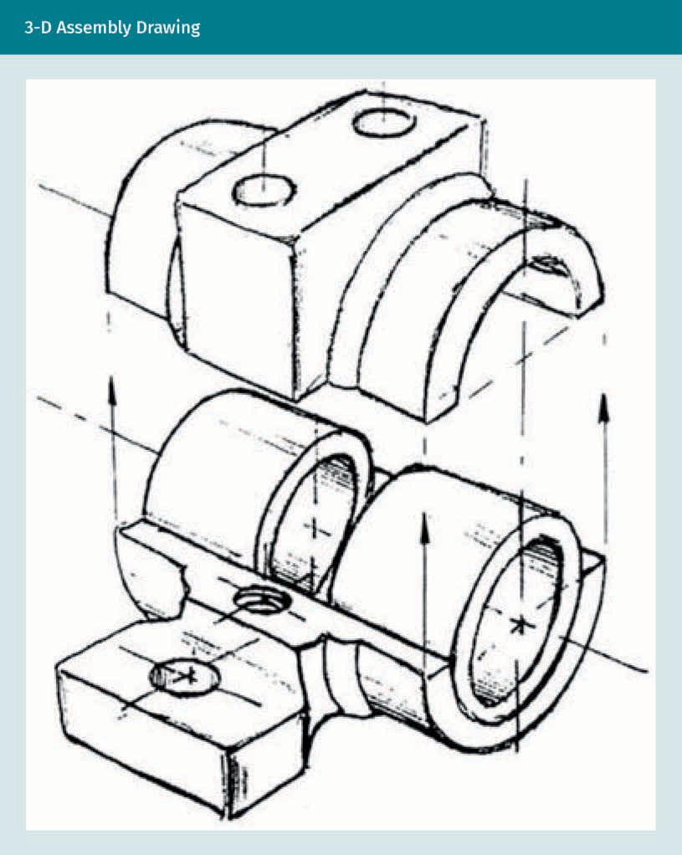

The 3-D view illustrates the assembly of two parts by aligning two drawings. The lack of diagonal section lines indicates that these are two separate parts, and not cut sections.

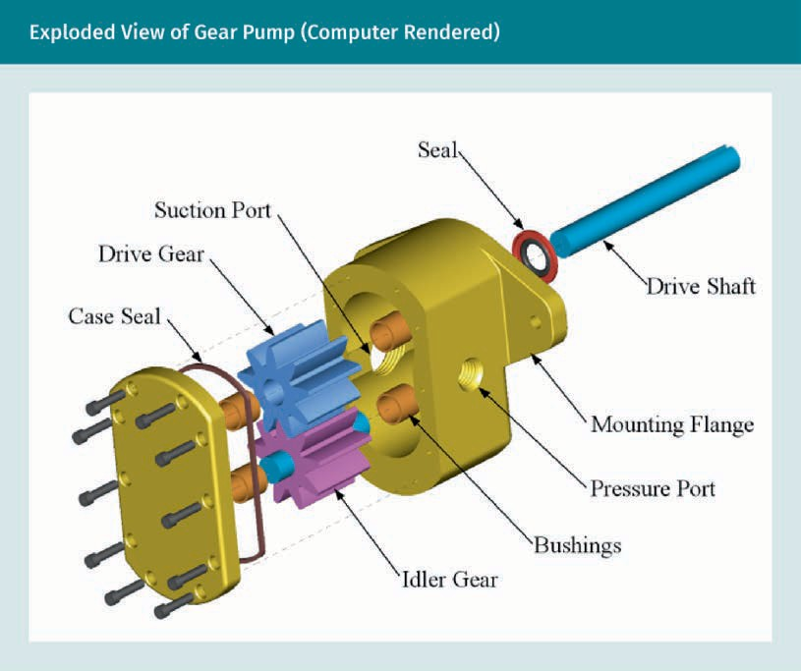

Exploded views show the relationship between parts and assembly processes. Signiﬁ- cant parts are labeled. Other drawings provide speciﬁc detailed information of each part.

Views

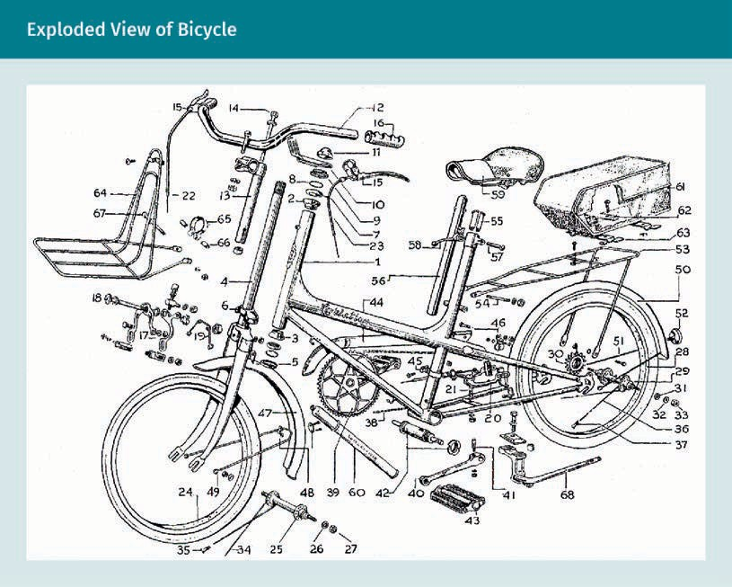

The purpose of this layout of an exploded view is to show all the separate parts of the assembly and their relationship. There is a need for additional drawings illustrating the size and materials of each part.

The assembly drawing depicts how the parts align to ﬁt together. The assembly process is the purpose for this drawing because the parts lack identiﬁcation, but the relation- ship of parts is evident. Many more drawings are required for complete understanding of the complex assembly of components.

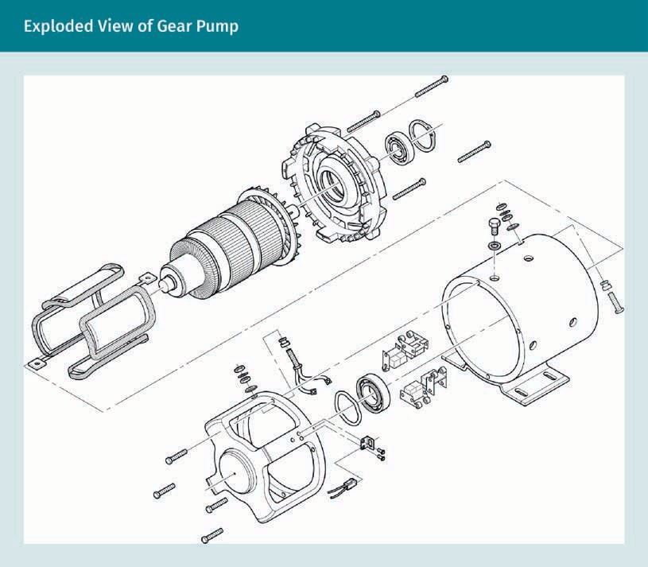


In a cutaway view, the entire object is visible with a portion of the exterior peeled or cut away to reveal the interior. Cutout views may minimize the need for extra views. In some cases, as with working drawings, they may even negate the need for section views. Cutaway views can be intriguing and ﬁre your imagination. Keep your imagina- tion alive and increase spatial visual skills by studying as many types of technical drawings as you can. Look through other technical drawing textbooks in your school or ﬁrm’s library and read professional journals to learn more about the latest technologi- cal presentation methods.

Views

Practice lesson
Please complete the following tasks:

- Sketch a three-panel projection of a chair.
- Sketch a three-panel projection of an item with an inclined view and add an auxili- ary view (you may use a simple cube with a corner cut off if you do not ﬁnd any- thing else).
- Draw a full-section cut of a car wheel using the computer.
- Draw a half-section cut of your choosing using 3D isometric view.
- For a better understanding, review the purpose of section cuts, when an aligned cut and half cuts are used, and the purpose of exploded drawings.

Summary
Drawing views organize the very technical complex system of many functions. Many types of views make up a technical drawing. Technical illustrators must familiarize themselves with orthographic views, three-panel projections, auxiliary views, pro- jected views, and numerous sections, cuts, breakouts, assemblies, and cutaways.
Computerized 3-D modeling programs produce many of the views from a single model created by the draftsperson. However, specialized visualization abilities increase when a person learns how to draw differing views manually. Professionals in the innovative design ﬁelds study many types of drawings and views so they can discern which ones to use for their projects.

Three-panel projections are commonly used by architects, engineers, and related industries, such as mechanical and robotic engineering. The three-panel views are always projected perpendicularly to the viewing plane. For inclined planes that are not perpendicular to the cardinal axis, add auxiliary views. Often, a 3-D axonometric view accompanies orthographic drawings and any auxiliary views for quick visual understanding of an object or building. Three-panel views are presented in one of two projection methods. They are named according to the quadrant in which the object is visually located. Technical illustrators must label the three-panel projects with a symbol denoting which method forms the layout.

Detail drawings depict the interior of objects with cut and breakout views. Many types of section drawings describe complex parts, groups, and assemblies. Explo- ded views are used to explain the relationship of parts or to itemize all parts. Cut- away views can highlight an entire assembly, vehicle, or building so the complexity is visually described, yet presented in a way that is easy to understand. Views are part of the language of technical drawing and need to include symbols, specialized line types and graphic conventions to convey the clear intentions of the designer.



Unit 4

Dimensioning

STUDY GOALS

On completion of this unit, you will be able to …

… understand why and how to use line types effectively.
… name the line types used for dimensioning.
… make the best choices for dimensioning methods.
… understand what information needs to be considered when dimensioning.

DL-E-DLBROTD01_E-U04

- Dimensioning

Introduction
Dimensioning refers to the accurate notation of measurement in technical drawings. It requires careful consideration of many aspects of technical drawing and a comprehen- sive understanding of the manufacturing or building process. For example, a wood- worker may need dimensions given to a very small measure, such as 1/8” (0.3 mm), while a civil engineer may only require measurements to the nearest inch (2.54 mm). Dimension scales can range from sub-mm to hundreds of meters for different profes- sions. A contractor needs the measurements from the building to the property line, but an interior framer does not. What might a robotic engineer need to know before tack- ling dimensioning?

The purpose of technical drawing is to convey the designer’s intent, which cannot be done without specifying measurements. Dimensions are critical when constructing an object or building according to the plan. Only written notes carry precedence over dimension line information. Accuracy is paramount for dimensioning; however, if there is a discrepancy, the written word rules.

The proper placement of dimension information can be challenging. With complicated drawings, standardized conventions assist the drafter in the decision-making process. Speciﬁcally, line types and rules for dimensioning provide essential guidance to the drafter in delivering clear technical drawings with clarity.

Line Types
In technical drawing, the different types of lines used by drafters are referred to as the “alphabet of lines.” Using these standardized lines enables engineers and other indus- try professionals to clearly express the features of the designed products. Drafters should have very good technical knowledge of these various line characteristics in order to successfully produce accurate drafts (Anderson, 2019).

Line types Different line widths, weights (darkness or lightness), and pat- terns are used within technical drawing.
A line type is a line within the alphabet of lines used by technical illustrators. For the sake of clear communication, there are standard line type conventions used across many ﬁelds of design. Each line type is given signiﬁcant meaning and is named accord- ingly; the meanings are universally understood in the industry of design and fabrica- tion. The alphabet of lines can be categorized into three basic groups: primary, secon- dary, and supplementary. When sketching, this rudimentary level of line deﬁnition is usually adequate to convey the technical aspects of the drawing.

Primary lines deﬁne the object, i.e., the most important item on the sheet. They are the heaviest, darkest lines and may also be used for arrow heads or tick marks for dimen- sions. Use an H, HB, or softer pencil of 0.7 mm width. Secondary lines relay information about the primary object and are important for dimensions and callouts. Use H or 2H pencils with 0.5 mm or 0.3 mm width.

Dimensioning

Supplementary lines are the least important, yet also valuable to the drawing. They are used for material designations, such as poché, and sometimes for construction lines, guidelines, or shading. Use a light pressure with 4H—6H lead and 0.3 mm width. Con- struction and guidelines may be very light for erasing; they can be grey instead of black, or be created with a non-photo blue pencil that does not reproduce when cop- ied. All other lines should be clear and black for ease of readability.

A line used to frame the drawing—the border line—is often a double line or wider than all other lines. Border lines, which may be customized more, are not typically consid- ered part of the alphabet of lines. Additional line types may be used and require iden- tiﬁcation in a legend. When drafting mechanical and ﬁnal drawings, or in computer- aided drafting (CAD), the alphabet of lines is mainly deﬁned according to the standards set by ISO and the American Society of Mechanical Engineers (ASME). The ﬁgure below illustrates the standards for speciﬁcations.
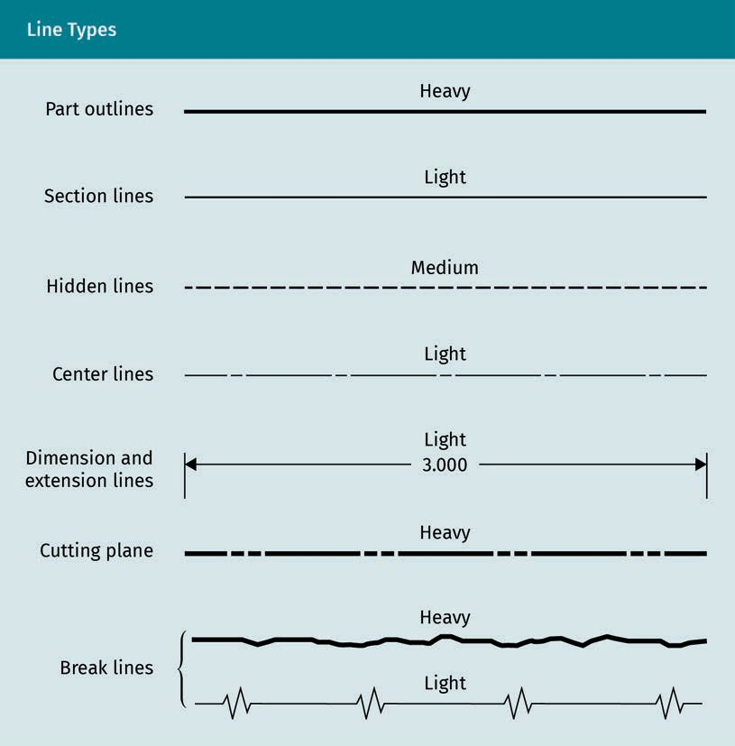

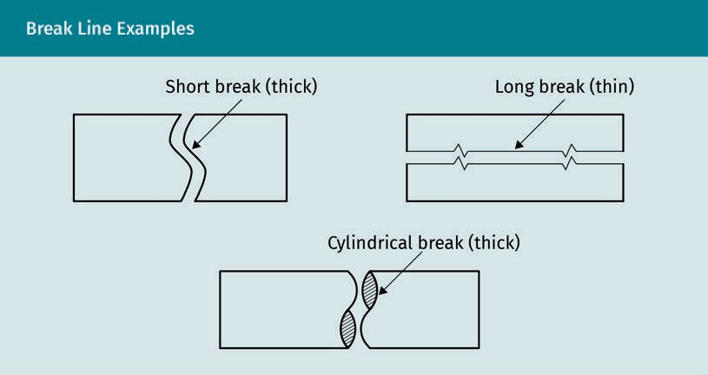

There is also a hierarchy of line types, which begins with the basics shown in the ﬁgure above. When drawing manually, place the pencil above the straight edge and hold it vertically against it, applying even pressure and rotating the pencil as you draw. Lines should be uniformly drawn for the whole length of the line and for all lines of the same type within a drawing.

Ten line types are described below, but not all of them need to be used in every draw- ing. Each is characterized by the line weight, width and length of dashes, and width of spaces, where applicable. Use the following information to correctly draw or identify each line type using a technical pen of the given width for precision inked lines or the lead type that works best with your natural pencil point pressure:

- visible line. Use an F, H, or dull HB with 02 (0.6 mm) width. This line has a thick, heavy weight. It is used to deﬁne objects or the outer edges of a part (part outlines), as well as the lines closest to the viewer.
- hidden line. Use an H or HB with 015 (0.45 mm) width. This line has a medium weight and dashes that measure 1/8” (0.125 in or 3 mm) and are long-spaced, usually 1/32” (0.03 in or 0.79 mm) apart. Keep dashes at an equal length and evenly spaced.
- section line. Use a sharp H or 2H—6H. This line has a .01 (0.3 mm) width and a thin, lighter weight. Dashes should be equally spaced parallel to each other at a 45° angle; this line is used to indicate a cut area on a section view.
- center line. Use a sharp H or 2H—6H with a .01 (0.3 mm) width. This line has a thin, light weight. It should have long dashes of 3/4”—1 1/2” (0.75—1.75 in or 19—38 mm) separated by short dashes of 1/8” (0.125 in or 3 mm) and a space measuring 1/16” (0.06 in or 1.5 mm). It is used to indicate the centerline of an object or area that is being dimensioned.
- dimension line, extension line, and leader line. Use a sharp H or 6H with a .01 (0.3 mm) width. This will produce a solid, thin, medium weight line. It is used to note measurements. Numerical measurement is placed within the dimension line. Leader

Dimensioning

lines end with a dark dot or arrow. If dimension lines cross the extension line, a dark angular tick mark is placed over the line intersection. If the dimension lines meet at the extension line, the dimension lines end in arrows.
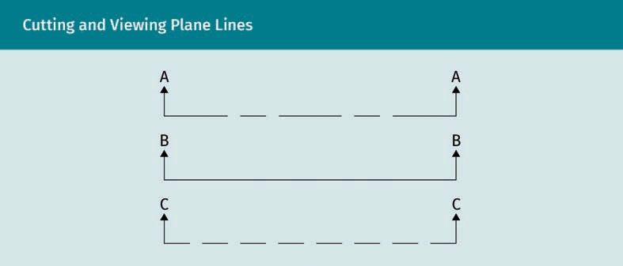
- cutting-plane and viewing plane line. Use an F or HB with a .02 (0.6 mm) width. The result will be a thick, medium, dark line distinguished by dashes spaced 1/16” (0.06 in or 1.5 mm) apart. Cutting planes and viewing lines need to be primary but distin- guished from the visible object lines. Both terminate in arrows indicating the direc- tion of the cut or view and are typically labeled with letters. The cutting plane has two dashes 1/8” (0.125 in or 3 mm) wide between longer line sections of 3/4”—1 1/2” (0.75—1.75 in or 19—38 mm). They end in arrows that indicate the direction from which the view is cut. The label is located with the arrow. They are sometimes solid or separated and only indicated at the ends of the cut area. They are used to indi- cate a cut shown on the accompanying section drawing. The viewing plane is made of consistent dashes 1/4” (0.25 in or 6 mm) long. Section C—C, which is shown below, is a viewing plane line, not a cut line, as one can see from the difference in the dashes. This is used to indicate the view shown in the ﬁgure below.
- short-break line. Use an F or HB with a .02 (0.6 mm) width. This will result in a thick, medium line. This dark, wavy line is also more solid and irregular. It is often used with short axonometric breaks, which is why it reads as a pictorial break in a sur- face.
- long-break line. Use a 6H with a .01 (0.3 mm) width. This will result in thin, medium, dark sections measuring 3/4”—1 1/2” (0.75—1.75 in or 19—38 mm), connected by a consistent and well-deﬁned jagged line. This line type is used to indicate a break. The jag is angled at 60°, extending 1/8” (0.125 in or 3 mm) from the line on each side as shown above.
- phantom line. Use a 6H with a .01 (0.3 mm) width. This will result in a thin, light line similar to a cutting plane line, but much lighter. It is used to indicate an alternate position, rotation, repetitive detail, or rounded edges. You can see an example of phantom line in the ﬁgure below.

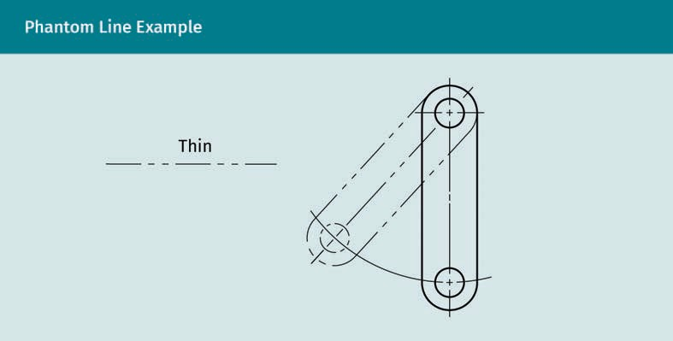
  - stitch line. Use an H or HB with a .015 (0.45 mm) width. This will produce a medium- weight line made of short dashes measuring 1/16” (0.06 in or 1.5 mm) and evenly spaced apart by 1/16” (0.06 in or 1.5 mm). Alternatively, this line can be drawn using a consistent repetition of thin, equally spaced dots. This line type is used to indicate a stitch line or detail that is identiﬁed or noted in the legend, such as a fold-line. If both stitching and folds are indicated, separate line types need to be created.
  - arrows. If used instead of dark dashes, tick marks, or dots, arrows should be three times as long as they are wide at their base.

Other lines for speciﬁc needs may also be used and are identiﬁed in a legend. Such lines may include a match-line, which is a very heavy, wide, and dashed line used to denote where two views match up with each other. Architects, landscape architects, and civil engineers use a line of dashes separated by three dots to denote waterways. They use speciﬁc line types for property and lot lines, right-of-way and easements, building envelopes, and other lines speciﬁc to their needs. A chain line with speciﬁed dashes and a line of symmetry, as well as two dark, heavy bars perpendicular across the line, is commonly used for mechanical engineering and manufacturing production.

In mechanical engineering and related disciplines, screws are a common element, so they are also included in the description of the line types used. ISO 128-24:2014 speci- ﬁes general rules and basic conventions for the types of lines on mechanical engineer- ing drawings (ISO, 2014). If the thread of a screw is engaging, then a thin line is used for the outer line and a thick line for the inner line. For the thread of the boring hole with areas that are not engaged it is the opposite. The area of the boring hole thread is also shaded. The ﬁgure below shows a screw connecting two plates on the left, and a pull-in screw with internal thread in the lower plate on the right.

Dimensioning

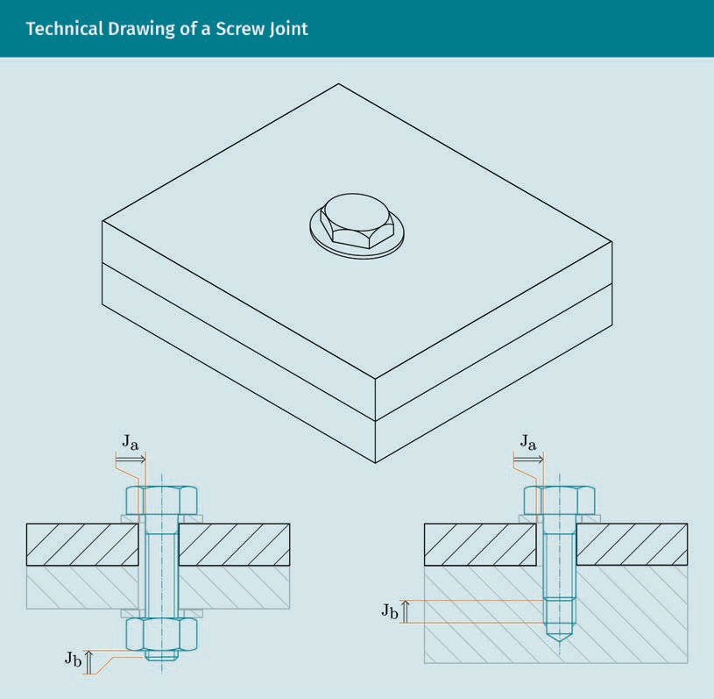
The two examples in the ﬁgure above illustrate the kind of information that can be included in the different line widths. The line thickness is used to illustrate the threads of both the hole and the screw; it shows that there is a rotational symmetry of the screw and the hole and also indicates whether the two components are engaging. In the ﬁgure on the right, the areas of the threads in the hole that are engaged can be clearly distinguished from the ones that do not engage. This example shows that, by applying different line types, a lot of additional information can be included in a tech- nical drawing.

CAD software allows the drafter to develop a line type menu or use pre-set line types. When drawing in CAD, each line type and associated line weight is assigned a color on the computer screen and should be on a separate layer. The lines should be plotted in black so that the associated line characteristics will be highlighted. Layers for construc- tion lines may also be frozen or turned off if they are not needed on the ﬁnal plot.

Practice lesson
Please complete the following tasks:

  - Using recommended pencil leads, practice drawing each line type ten or more times until you are able to draw each consistently and with ease.
  - Next, try sketching them with just one or two pencils or pens.
  - Look at several drawings in your discipline to learn to recognize different line types. Review the drawings and decide if the line types are used correctly.
  - Draw a screw joint with correct line types in full cut.

Among all the line types we have previously encountered, a few of them deserve spe- cial attention. These are cutting plane and section lines, hidden lines, leader lines and local notes, and dimension lines. These line types will be further explored below.

Cutting Plane Lines and Section Lines

If there is a cutting plane line on a view, a section drawing must accompany it on the page or be referenced and shown elsewhere in the plans. The cutting plane line indi- cates where the cut will be on the projection view of the face or side being cut. Cutting plane lines may turn corners and be offset. Sometimes, these lines are separated or shown only on the ends of the area to be cut. To label them, one begins with cut AA and then uses subsequent letters of the alphabet to name the following cuts. If there is only one cutting plane line, a label is not required. The corresponding section will also be labeled with the same letters separated by a dash, e.g., A-A.

Section lines are used to indicate the interior cut area on the accompanying section drawing. Such lines should be drawn at a 45° angle parallel to each other and spaced apart by a distance varying based on compatibility with the size and scale of the view. A minimum section spacing of .06” (1.5 mm) is recommended (Madsen & Masden, 2016). Cutting plane lines and center lines may be used together, with the cutting plane line taking precedence. Observe how the cutting plane line takes prominence in the three drawings below. The center image is an example of proper labeling.
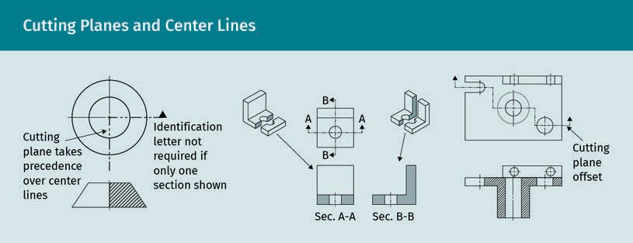

Dimensioning

Hidden Line Use

Hidden lines are only provided if they add clarity to the drawing. Avoid cluttering a drawing with unnecessary lines; this can add confusion and become problematic when dimensioning. Follow the guidelines below when using hidden lines:

- Visible object lines have priority, so always use a full dash on both sides of the visi- ble line to “jump” over it.
- Begin and end with a full length dash, only shortening or lengthening it when abso- lutely necessary. The only exception to this is if it would appear as a continuation of a visible object line. If this happens, do not join a hidden line to an object line if they do not actually connect.
- Begin the hidden line with a gap if a visible object line and a hidden line appear as an extension of each other.
- Use a dash when joining two hidden lines that connect, continuing it around a cor- ner where hidden lines turn a corner.
- Offset or stagger two parallel hidden lines so they do not look like a sequence of equal signs (e.g., =======).
- Do not cross two dashes. For two crossing hidden lines, the closest line should be carried with the dash, while the farther line “jumps” over with a space on each side.
- Begin a curved hidden line with a dash when it joins a straight hidden line, and begin a straight hidden line with a space when it joins a curved hidden line.
- When hidden lines intersect or meet, they should connect with the dashes rather than leave spaces.
- Allow a center line to run through a hidden line dash, and avoiding ending a hidden line dash on a center or any other non-corner line.
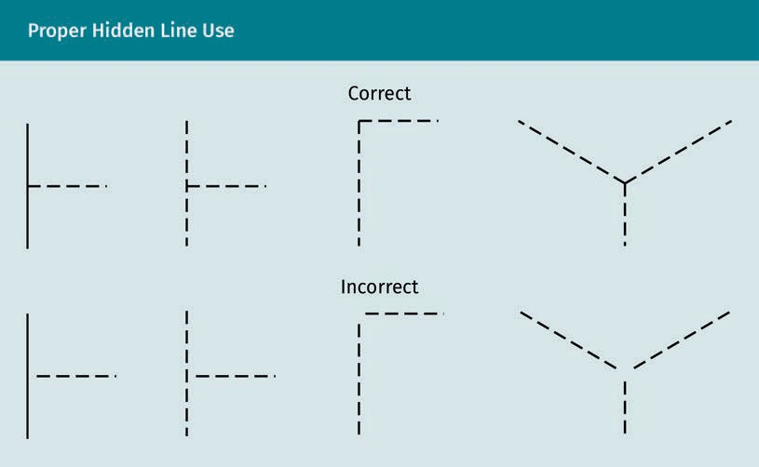

Leader Lines and Local Notes

Leader lines establish “a connection between a graphical representation of an item and some text” (Munford, 2010, para. 1). They also lead to notes that are speciﬁc to a view or a simple call-out text. An example is calling out a material that is not graphically indi- cated with a leader line or leader. Leaders may point to symbols and other annotations, such as part numbers. Leader lines should not be vertical or horizontal, but rather angled from the item being notated or called out. Leader lines point to the area being called out or referenced with an arrow or end there with a dot. They continue at an angle and then take a single short turn to point to the written note horizontally. For a neat appearance and to prevent missing a note, align the leader notes to one side of the drawing view. Many engineering ﬁrms require each detail view to be within a grid framework. Notes speciﬁc to each view are then enclosed within that frame. This format ensures that vital information in the notes will not be missed.
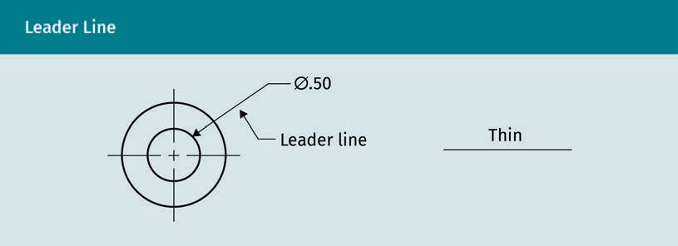

Both the leader line and the line attached to it are good examples of the correct use of a thin leader line. Note that the angled portion of the line that does the leading is lon- gest, with a short segment after the bend, horizontally aligned with the text.

Dimension Line Anatomy

Dimension lines and the lines leading to them (called extension lines), along with the tick marks or arrows noting the end of the dimension line, are characterized by stand- ardized line types from the primary and secondary groups. The placement of the numeral description, i.e., the dimension itself, is also standardized. An alternative to an arrow at the end of a leader line is a heavy dark circle. An example of this is shown in the image below in the top right corner adjacent to the 3 mm note, and on the bottom right with the 8 mm call out.

Dimensioning

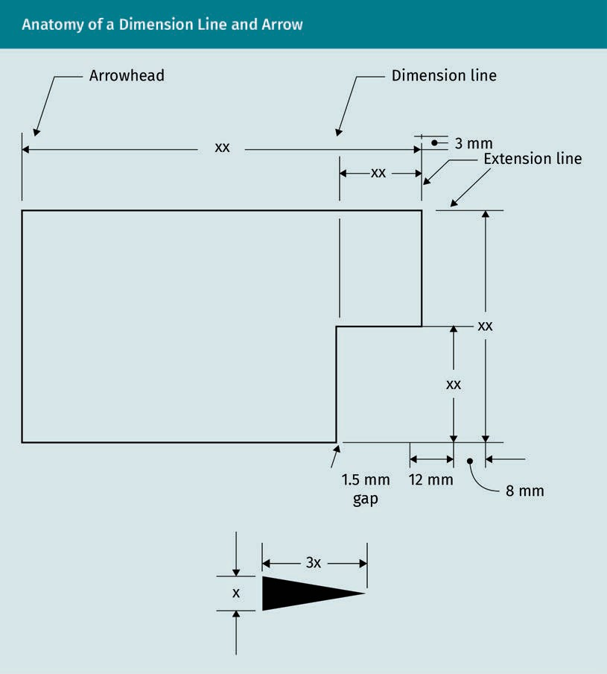

The example below shows extension lines crossing each other, as is standard. However, a space should normally be left between the object lines and the extension lines. It is, in fact, possible to ﬁnd examples of incorrect dimensioning. There is also no notation to indicate the meaning of the numbers; they could be either millimeters or miles. The overall dimensions could have been shown extended above the smaller dimensions.

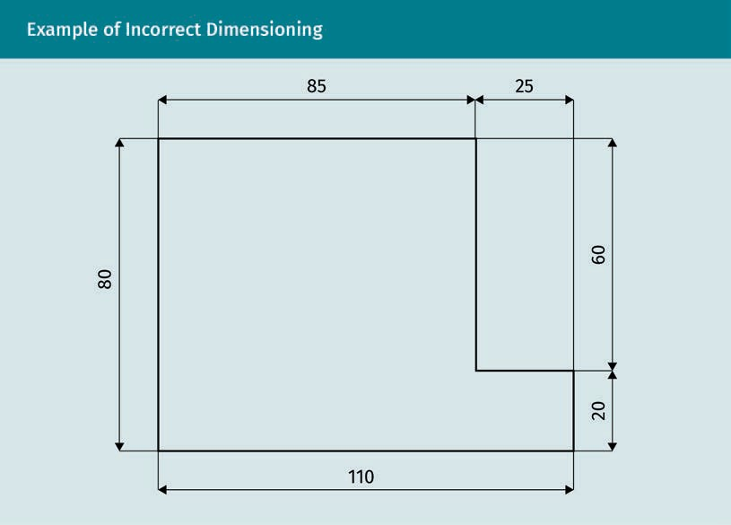

For mechanical engineering purposes, the drawing above errs by including “double dimensions” (20+60 and 80, 85+25 and 110). Avoid duplicating information as it leads to contradictions; it is possible to specify whether the measures are 80 and 60 or 80 and 20, but not all three. For this reason, deciding which one is deﬁned depends on the functions of the individual surface. The measures that are critical for a function, a ﬁt- ting, or the interaction with another workpiece are included. Therefore, the designer needs to decide to which lengths they assign a ﬁxed value, depending on all the availa- ble information and conventions in their discipline. Carefully review the examples that you ﬁnd online. Better examples are found in actual plans used in your design ﬁeld.

Dimensioning

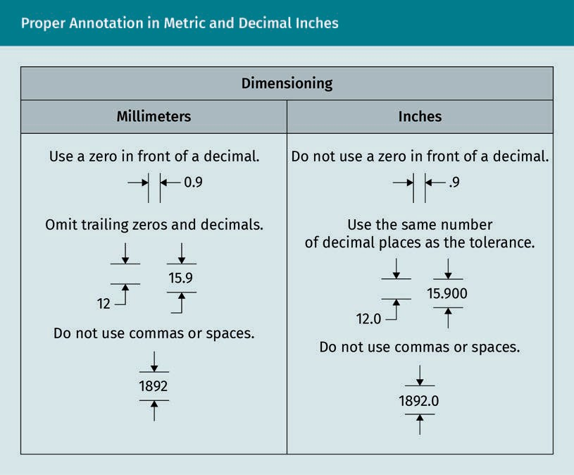

When using numerals, use the examples above as your guide. Make sure you use inch or millimeter notations, such as “in” or “mm,” if they are not speciﬁed elsewhere on the drawing sheet. When using fractional inches, the best practice is to use full size numer- als in a vertical format. Standard numeral height is 1/8” (0.125 in or 3 mm).

Angles are measured in degrees, minutes, and seconds. If the degree is ﬁnite, it is not necessary to include zeros for minutes and seconds. The location of the information should align with the type of dimensioning used, i.e., horizontal for unidirectional. If aligned dimensioning is used, follow the angle and place numbers either to the outside of the angle line or within it while keeping the same angle, if possible. Check the set- tings in your CAD program to see the options available.

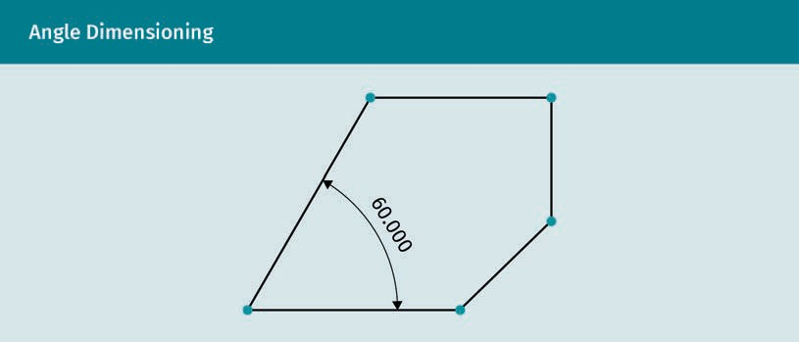

Practice lesson
Please complete the following tasks:

  - Manually add dimensions to a three-view orthographic layout without repeating any information.
  - Draw and sketch a cube and a cylinder using hidden lines. Add center lines and dimensions.
  - Sketch dimensions onto an isometric drawing of a machine part.

Dimensioning Rules
Madsen and Masden (2016) describe a dimension as “a numerical value (or values) or mathematical expression provided in appropriate units of measure and used to deﬁne form, size, orientation, or location of a feature or part” (p. 319). In technical drawing, the accurate notation of measurement is the responsibility of the draftsperson. In mechan- ical engineering, dimensioning determines the nominal geometry of the workpiece. The fulﬁllment of the function of a workpiece is based on its geometric properties (Leach, 2011).

Dimensions carry legal importance in drawing interpretation. Only written information supersedes the drawn and notated dimension line. If the drawn line varies from the numeration with it, the written numeration is considered correct. Plan sheets must include space for general notes, schedules, and legends. The written word within them takes priority over the numerals. When checking drawings, make sure that all agree. If there is a discrepancy, the written word will have legal priority. If there is no written ter- minology or numerical notation, the drawn line should be trusted.

Dimensioning

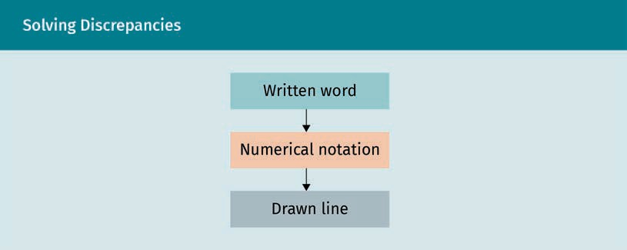

Dimension lines and the lines leading to them (called extension lines), along with the tick marks or arrows noting the end of the dimension line, are characterized by stand- ardized line types from the primary and secondary groups. Additionally, the placement of the numeral description is also standardized. Unidirectional placement is typical for manufacturing. All information is placed horizontally and read from the bottom of the page. Architectural and structural drawings use an aligned placement, which is read from the bottom and right side of the sheet. Numerals should be located within the dimension line, although in the past it was acceptable to locate them above the line, and that format may still be used in some situations.

Dimensions are always given in real world measurements, or on a 1:1 scale. You should know the smallest measurement to use. If your discipline uses mm as the smallest measure, there is no point in dimensioning to 0.001 mm. Some machining systems can read the line lengths, so dimensioning is not needed when the lines are accurate. If using such a system, make sure your lines are accurate to the smallest degree speci- ﬁed. CAD will measure to inﬁnitely minute amounts unless your software is set to a larger measure. Using automatic dimensions in CAD can lead to confusion and errors, so make sure you control the settings.

Practice lesson
Please make sure your CAD program is set up for dimensioning. Learn how to set and change line types, specify decimal, metric, or fractional inches, as well as font styles for dimensioning purposes.

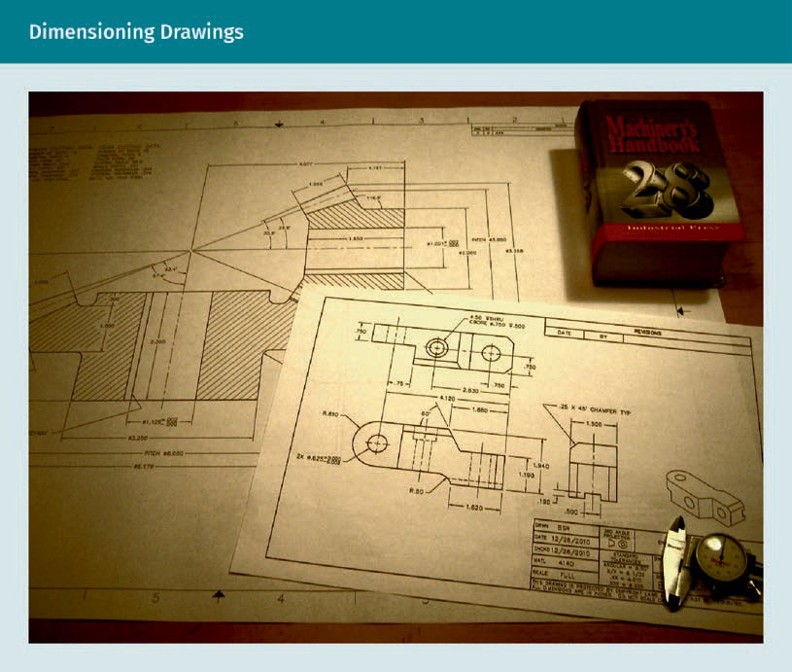

Best Practices for Placement of Dimensions

Drafters need to use the standardized line weights and best practices established for common understanding, readability, and clarity in drawings. These conventions have been developed for all the applied science ﬁelds of engineering technology. Each disci- pline includes additional accepted notations and symbols particular to their needs.

Basic rules of dimensioning
Be clear and concise, allowing for only one correct interpretation. Remember to include everything without being redundant, yet do not exclude anything required. Using the following checklist will help you with dimensioning:

  - For CAD, check dimension settings, line types, font sizes, and styles.
  - Choose unidirectional (manufacturing) lettering only readable from the bottom or aligned lettering (architectural or structural) readable from the bottom and right side.
  - Use a consistent method throughout the plan set.
  - Do not crowd dimensions; each view and associated dimensions need to remain separate.
  - Eliminate repetition, as this may cause contradictions when tolerancing different dimensions in mechanical drawings.

Dimensioning

- Avoid crossing lines, other than in the following cases:
- Extension and dimension lines must brieﬂy cross with a tick or stop with an arrow at extension lines.
- Extension lines may cross each other.
- Do not cross or break dimension lines.
- Do not dimension to hidden lines.
- Center dimension numerals within the line; however, offset numerals so they do not line up above each other as in the case of several centered measurements.
- Prioritize placement of dimensions above or to the right of the object when possi- ble. Be as consistent as possible so readers can easily ﬁnd the dimensions in the plans.
- Extension lines begin 1/32” (0.79 mm) away from the object line and extend 1/8” (0.125 in or 3 mm) past the dimension line.
- Dimension lines are placed 3/8” (0.375 in or 10 mm) above the object with subse- quent dimension lines placed 1/4” (0.25 in or 6 mm) above the previous dimension line. The smallest dimensions are closest to the object with the overall dimension the furthest out.
- Dimension numerals are 1/8” high (0.125 in or 3 mm).

Dimensioning arcs and circles
Arcs are dimensioned by the radius measurement indicated by the letter R and prefera- bly dimensioned within the radius; if they are too small, they may be dimensioned out- side the arc. Full circles are dimensioned with the diameter indicated by the symbol of a circle with a slash through it (Ø). The ﬁgure below shows some dimension circles and arcs on the face or view where the curve is visible.
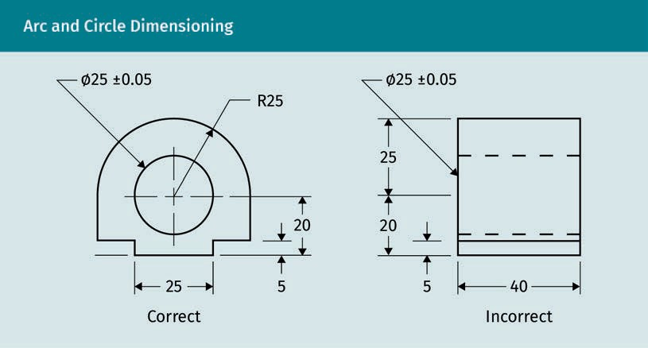

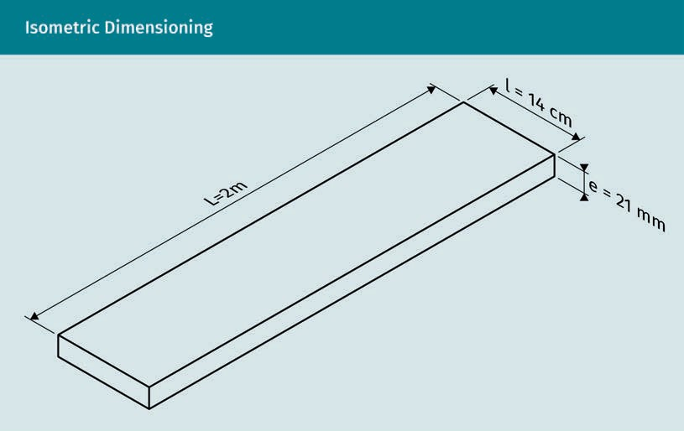

Consider whether using an axonometric drawing would be beneﬁcial. Isometric draw- ings can be accurately dimensioned in all axes. The example above shows the correct use of extension and dimension lines for an isometric drawing of a plank. The lines are on the same directional plane as the drawing, making the dimensions easy to refer- ence. Notice that the aligned numerals are above the dimension line instead of within it. An experienced architect or engineer may read orthogonal drawings easily, whereas others may ﬁnd it easier to understand dimensions provided on an isometric plan.

There are three basic types of dimensioning highlighted for use in engineering: base- line, direct, and chain dimensioning (Madsen & Masden, 2016). For all types of dimen- sioning, the drafting person needs to make sure there are no “breaks” or “busts.” A break (or bust) is when the overall dimension does not equal the addition of all the smaller dimensions within it. Check numerical values with a calculator to avoid such errors. For mechanical engineering, the dimensioning is most often associated with the function of the workpiece. Thus, the function that usually determines which measures are dimensioned is included in the drawing. Double indications should be avoided, e.g., by leaving one dimension open to be calculated from the remaining values.

Baseline dimensioning
Baseline dimensioning gives measures from a common datum line or reference point, which can be from a surface edge, axis alignment, or centerline. It is beneﬁcial to use this when parts are dependent upon their relationship to a common point, but each measurement of the different parts is independent (Madsen & Masden, 2016). Since each measure is independent, the possibility for tolerance build-up or stacking for mechanical drawings is reduced. Do not confuse the reference datum line with a dimension line that is a reference. A brief explanation of the importance of the base- line to the function of the workpiece is offered in the ﬁgure below.

Dimensioning

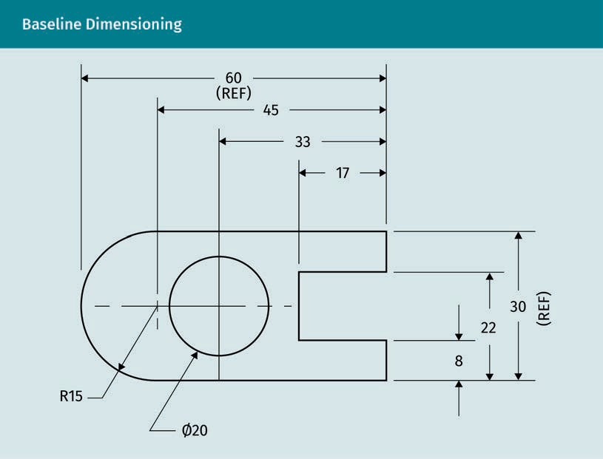

In the drawing above, REF means reference line. These dimensions are referenced to the overall measure of 60 and 30 and noted as (REF). The reference surface is critical for the function of the workpiece, so it is used as the initial point for dimensioning. If the numerals 60 and 30 were enclosed in parentheses, the notation of REF is not nee- ded. Standard best practices simply enclose the referenced line in parentheses, e.g., (60). When used, a REF measure would not be needed and is merely a reference. Notice that the arc and circle are correctly dimensioned. The arc is dimensioned with radius R15 and the circle is dimensioned with diameter measure Ø20.

Direct dimensioning
Direct dimensioning is common across all disciplines. It is “applied to control the size or location of one or more speciﬁc features” (Madsen & Masden, 2016, p. 332). Disci- plines use dimensions to locate a feature in relation to another feature or boundary line. They also use dimensions to specify the size of a feature. For mechanical drafting, it is valued as having the least tolerance build-up, which is desired. Having the least tolerance build-up is one of the beneﬁts of direct dimensioning and may be combined with baseline dimensioning.

Chain dimensioning
Chain dimensioning is sometimes called “point to point dimensioning” because meas- ures are based on a datum point and then are additive as the length progresses. Each new measurement begins at the end of the previous measurement, so they are linked like a chain and dependent upon the previous measurements (Madsen & Masden,

2016). All individual dimensions must add up to the overall dimension. This is why, sometimes, the last dimension is eliminated, allowing for the last dimension in the chain to be the value of all the preceding dimensions subtracted from the overall dimension. It is more commonly used in architectural or structural drawings.

When manufacturing tolerances are indicated, chain dimensioning results in the most tolerance build-up or tolerance stacking, which is not desired. This is also why chain dimensioning is not commonly used for machining purposes.

Running dimensions
Similar to chain dimensioning, in the case of documenting for historical preservation, dimensions of existing buildings and features are dimensioned from a beginning datum and are additive. This method for measured drawings allows a single measuring rod or tape to be placed and allows notations to be made easily in the ﬁeld. Since no busts are possible, this method reduces the probability of errors. The arrows on the drawing indicate the direction of measure. The Historic American Building Survey’s (HABS) prescribes speciﬁcs for measuring and ﬁeld notes. In the Historic American Buildings Survey (2008) General Requirements for Sketching and Measuring, they advise that “measurements are taken as long, continuous, running strings wherever possible. Avoid incremental measurements, since they tend to accumulate errors over long dis- tances” (p. 8). The sketch below shows running dimensions across the top area for a HABS project at the Baldpate Inn, Estes Park, Colorado, US.

Dimensioning

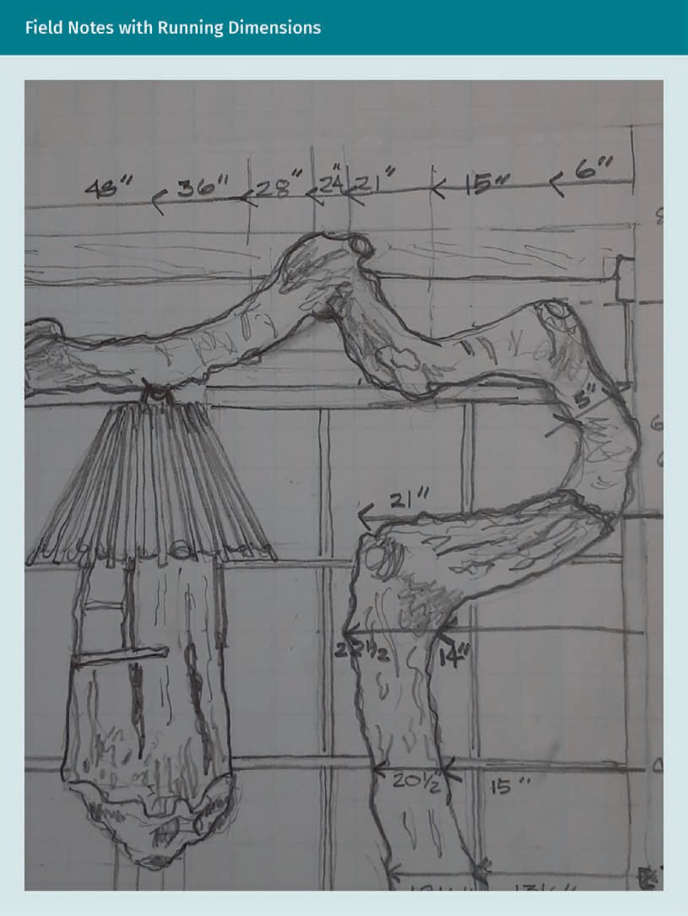

Final Review of Dimensioned Drawings

The following questions are helpful to the person responsible for dimensioning techni- cal drawings:

  - What information needs to be included?
  - Which type of drawing layout is the simplest and clearest?
  - Who will use the information, and where will they expect it to be located on the drawing?

When dimensioning, more information is added at the same time. Information about materials and references to details are often added simultaneously. Notes particular to a view or detail are added as well. The drafter needs to be judicious in the use of paper space and the organization of the views when determining the layout. For this reason, considering the aforementioned questions may provide space- and time-saving choices.

Consider the conventional layout and presentation used within your ﬁeld. Is the draw- ing used for descriptive purposes in a client presentation? Is the detail to be used by the production team? Is the main purpose for demonstrating connectivity and assem- bly? Make sure that drawings are not being cluttered with unnecessary information that can be found elsewhere in the plan set. Additionally, make a checklist of dimensioning rules and review your drawings before sharing them.

Practice lesson
Please complete the following tasks:

  - In CAD, add dimensioning to an isometric drawing.
  - Using best practices, draw and dimension the gear in the image below. Assume a center diameter of two inches. Convert to metric or use decimal inch measurements. Hint: Please do not duplicate information about dimensions.


Dimensioning

Summary
Line types and dimension rules have a critical role in technical drawing. Without them, the drawing is incomplete. An alphabet of line types provides the readers of the drawing with information understood through the applicable design discipline. The assurance that the project will be executed according to the designer’s intent is heavily dependent upon clear and concise presentation and relies upon accurate use of line types and correct dimensioning practices.

Notes and callouts are also added simultaneously to dimensioning. The written word takes precedence over numerical digits and drawn lines. The use of best prac- tices assists in eliminating discrepancies, and a ﬁnal review using a checklist is rec- ommended.

The analysis of why, when, and how to use dimensioning reaches beyond the rules given here. Drafters need to consider the placement of dimensions and associated information when they are selecting the view layout for a plan sheet. New chal- lenges arise for each project. Reviewing other drawings and repeated practice with dimensional drafting leads to expertise. Experience, although sometimes frustrat- ing, is the best teacher when it comes to improving one’s dimensioning skills.

Knowledge Check
Did you understand this unit?

You can check your understanding by completing the questions for this unit on the learning platform.

Good luck!



Unit 5

Surfaces

STUDY GOALS

On completion of this unit, you will be able to …

… explain why mechanical engineers specify surfaces.
… name the geometric properties of workpieces.
… understand which symbols are used to identify surface conditions.
… deﬁne roughness and waviness.

DL-E-DLBROTD01_E-U05

- Surfaces

Introduction
In mechanical engineering, surface deﬁnition and treatment are critical to the success- ful fabrication of the ﬁnal product. Due to the nature of the manufacturing processes, all surfaces will have differences from their drawn geometry. Therefore, technical draw- ings must address and specify how much difference is allowed for such surface varia- tions.

There are several causes of surface distortions, relating to chemical, mechanical, or geometric properties. This unit will concentrate on the geometric qualities and focus on their representation in technical drawings. Professionals in the ﬁeld of mechanical drawing need to familiarize themselves with terminology, surface ﬁnish symbols, and their correct use. Engineers and designers specify the surface requirements, and machinists read the drawings to ensure product quality.

Technical illustrators in the mechanical engineering and robotic engineering disciplines are required to be familiar with the machining processes. Technical illustrators or drafters greatly beneﬁt from visits to various machining or production facilities. There, they can learn to understand the processes and see the examination of post-produc- tion workpieces before and after ﬁnishing. Having this experience helps to reinforce learning, correctly reference surface ﬁnishes on the drawings, and add to an under- standing and appreciation of the industry and value of your specialized role.

Deﬁnition

Surface This is also known as surface texture or surface topography and refers to the nature of a surface (Taylor-Hobson Resource Center,
2020).
People often think of a surface as a ﬂat horizontal plane on which to eat or write, such as a table or desk. Specialized disciplines, such as engineering, have their own termi- nology and vocabulary; mechanical engineering is no different. In engineering, a sur- face may be any area, at any angle, of a solid object that is exposed. Think of a surface as the exposed plane that can be ﬂat or curved. A surface can be the interior of a recessed area, such as a hole, or the varied surface of a screw. For the purposes of mechanical engineering, including robotics, surface is “the part of a solid that repre- sents the boundaries between the solid body and its environment” (Stout & Blunt, 2000, p. 146).

Surface speciﬁcations enable the machinist to fabricate the part or workpiece accord- ing to the desired intent of the engineer. Engineers need to make sure pieces will ﬁt together, even if they are made in different locations. The interchangeability of parts relies on precision dimensioning and surface speciﬁcations that are carried out in pro- duction.

Surfaces

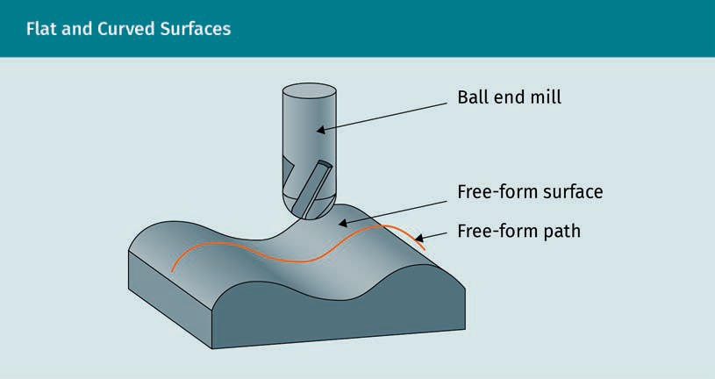

To obtain the desired product, certain characteristics of the ﬁnal object must meet the requirements speciﬁed in the drawings. Deﬁned characteristics or qualities of the ﬁn- ished product are compared to the drawing speciﬁcations. The success of the produced workpiece is determined according to the degree in which the production meets the requirements.

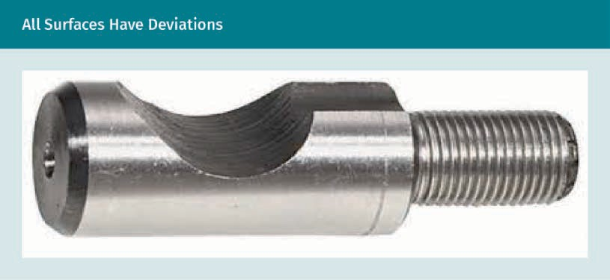
All surfaces will have irregularities (also called deviations) resulting from the machining and tooling processes. Surface textures will require honing, grinding, further machining, or lapping to ﬁnish the workpiece as speciﬁed. The successful outcome of the machined piece will affect performance criteria and life expectancy. Machining is an expensive process that can increase costs if brought to unnecessary levels. Therefore, engineers must carefully specify the type of surfaces and any associated tolerance with several considerations in mind. Speciﬁcations need to keep machining to a minimum and reduce costs while ensuring performance criteria, life expectancy, and interchange- ability of parts.

Tolerance
The full range of measure allowed beyond the designed geometry for a work- piece is called toler- ance.

The manufacturing of a workpiece, such as the camlock above, will result in surface deviations that require tolerance speciﬁcations to ensure the piece will perform as designed. If the piece, or portion of a piece, will receive a ﬁnal application of paint or other protective coating, some level of roughness may be desired as a ﬁnish texture to allow for adhesion of the ﬁnal coating. Another example where smoothness is not desired are surfaces that experience a lot of friction and require lubrication. They are intentionally manufactured with grooves to hold lubricant.

Geometric Properties of Materials Deﬁned as Deviations from the Ideal

Metrology is the science of measurement, embracing both experimental and theoretical determinations at any level of uncertainty in any ﬁeld of science and technology (Inter- national Bureau of Weights and Measures, n.d.). Simply, for the purposes of industrial or applied metrology, it is the science of measure. The terminology for measurements used in evaluating the machining of a workpiece refers to production phases from design to production. Surface metrology deals with three geometric measurements of three phases, i.e., nominal geometry, also known as target or ideal geometry; actual geometry; and measure geometry. Inherent within each measuring instrument is an uncertainty that results in the difference always present between the actual and the measured geometry. The measured and the nominal geometry are compared to assess the success of the manufacturing process.

Feature The physical shape of a part is called a feature. Examples of features are surfa- ces, edges, holes, or screw threads.
Nominal geometry
Nominal is the target or ideal geometry speciﬁed on the technical drawing, and the technical drawing consists of the geometry as designed. Adding dimensioning informa- tion to the drawing is critical for proper manufacturing; a dimension is the numerical value associated with the object, portion of an object, or feature. For the purpose of tolerancing, features also include axes, lines, and medians, which are dimensioned. Mechanical engineering dimensioning also includes notes, symbols, and information about the surface and tolerances. If information is missing from the drawing, the pro- duced part cannot be created according to its intended design or use, nor evaluated for accuracy.

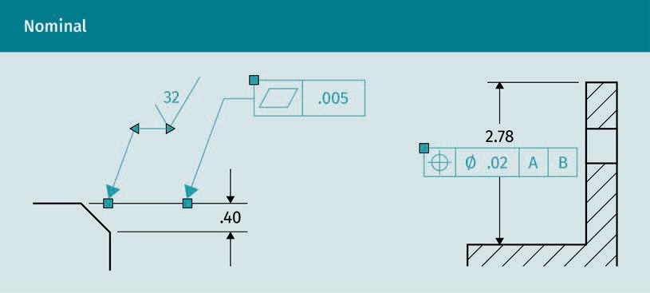

Surfaces

The feature control frame is the elongated rectangular area specifying the nominal geometry tolerances of a workpiece feature. Its name comes from its purpose, i.e., to control the features. In the ﬁgure above on the left, the parallelogram in the feature control frame indicates that a tolerance for ﬂatness is being speciﬁed. The next section speciﬁes .005, which means that the ﬂatness can be .005 (either positive or negative) for a total tolerance of .01. It is the responsibility of the technical drafter to understand the symbols and notations used.

Actual geometry
The actual geometry is that of the ﬁnal machined part. Actual is the real geometry in the physical workpiece after the piece is ﬁnished. Actual geometry can only be meas- ured on an actual manufactured workpiece. At this point in time, virtual pieces are not measurable as actual.
Feature control frame
The rectangular block of a technical drawing specifying nominal geometry and tolerances is the feature control frame.

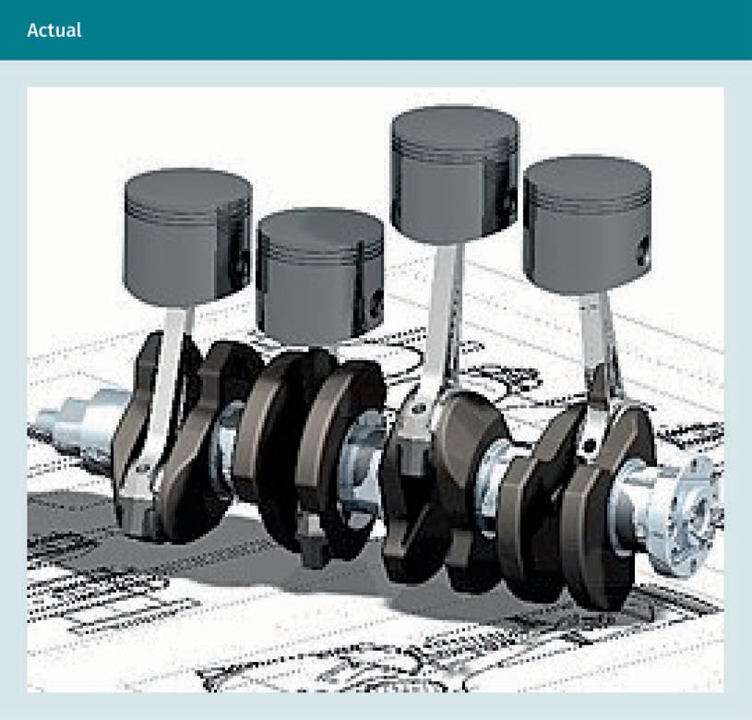

Measured geometry
Measuring the actual geometry leads to the measured geometry. Measured geometry is the geometry of the produced item, described with measurement data, which compares it to the ideal or nominal geometry. Specialized measuring instruments evaluate the surface ﬁnish. The ﬁgure below shows data of measured waviness and roughness, as well as a separation of the roughness by ﬁltering the original data with different ﬁlter- ing algorithms.
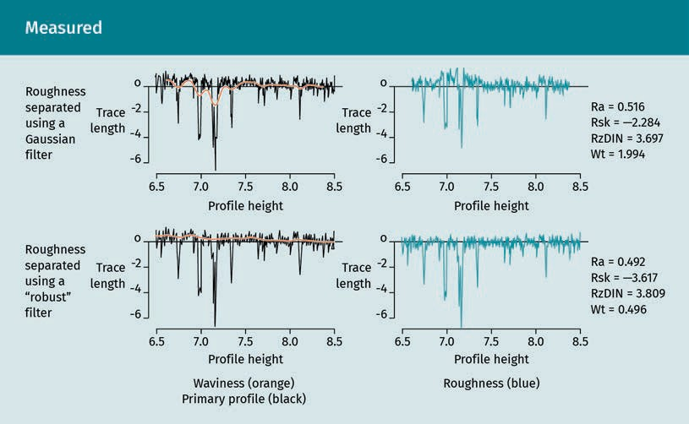

Embodiment In surface metrology, the ideal geometry is embodied into the reference element, thus becoming the embodiment.
It is not possible to manufacture ideal geometry in the manufacturing production proc- ess. The attempt to create the ideal geometry results in embodiment onto the surfaces of the workpiece. Henzold (2006) describes the geometrical deviation as “the deviation of a workpiece feature (axis, section line, edge, surface, or median face) from the (geo- metrical ideal) reference element (embodiment)” (p. 162). Instruments, such as a stylus proﬁlometer, or microscope, can determine the amount of deviation. The ﬁgure below shows the proﬁlometer with computer read outs and a close up of the measuring device.

Surfaces

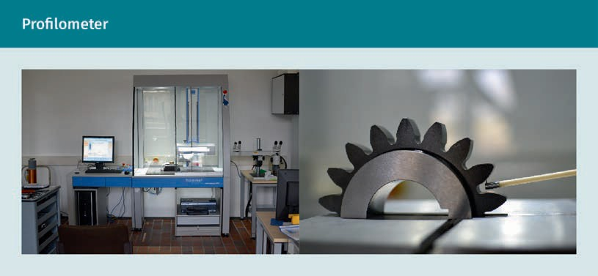

Material Properties and Surface Conditions

There are several categories of material properties relating to surface conditions and edge deviations. The three main categories are chemical, mechanical, and geometric. This unit will focus on geometric properties, although a brief explanation of each is given.

Chemical properties
Chemical properties are associated with the inherent properties within the raw material or with chemical exchanges or reactions due to the processes undertaken in manufac- turing. They may be on the level of physics and measured in atomic levels. Additionally, “many of the surfaces are chemically reactive. With the exception of noble metals, all metals and alloys and many nonmetals form surface oxide layers in air, and in other environments they are likely to form other layers” (Bhushan, 2000, p. 2).

Mechanical properties
Mechanical conditions refer to physical material characteristics that have an inﬂuence on the stability, strength, and structure of the material. Such physical properties include “chemical composition, grain, hardness, strength, and inhomogeneity” (Hen- zold, 2006, p. 2). They are inherent within the material selected for the project. Material and mechanical forces affect the operation of a workpiece, its interchangeability, and if applicable, its movability. The parameters are relevant for the workpiece to fulﬁll its intended functions. Mechanical properties are considered when the material is speci- ﬁed for the project, with speciﬁcations including any allowable variances. An example of a mechanical property would be to specify steel with a given hardness instead of plastic for a part that would receive repeated movement, so it would not wear down quickly with use. A zone is understood as the area in which the tolerance occurs. This can vary throughout a workpiece, and “the properties of the surface border zone may be different from those in the core zone” (Henzold, 2006, p. 2).

Geometric properties
Geometric material properties are those deviations of workpiece features that are eval- uated with measurement instruments. The technical drafter describes these most important properties nominally. In the metrology of geometric properties, nominal classiﬁcation depends upon the level of measurement, which can be either macro or micro. Macro measures from the micrometer to meter level, and micro measures from the nanometer to millimeter level.

Macro Geometry Functional Requirements

Macro geometry functional requirements are measured on a scale that ranges from the micrometer to the meter level. The macroscopic geometric features can be grouped into dimension, form, and location. Deviations from the nominal characteristics can be considered form deviations or displacements, such as location deviations. The devia- tions are brieﬂy summarized for basic introductory understanding.

Dimension or size deviations
The limits of a size vary between the maximum material condition (MMC) and the least material condition (LMC). In manufacturing, this allows deviation in the size within the speciﬁed limits. If MMC and LMC are not given, “regardless of feature size” (RFS) is implied. This is assumed for all geometric tolerances (Madsen & Masden, 2016).

Form deviations
Form deviations are found in a single feature or elements of a single feature that are generally straight or round. To ﬁnd them, the entire geometry of a single feature or ele- ment of an object is considered. When the full extent of a partial or whole surface is observed, any detectable surface deviations are considered form deviations. Form devi- ations are characterized by examining a surface to its full extent and include straight- ness (STR), ﬂatness (FLT), roundness (RON), and cylinder (CYL). Each deviation has a three letter identiﬁer as indicated.

Datum The perfectly ideal or nominal geometry from which meas- urement may be taken is a datum.
More short wavelength deviations that can already be observed when only a fraction of a geometrical element is considered, such as waviness or roughness, are assigned to the category of micro-geometry due to their smaller dimensions. Form deviations do not require a reference datum. They are independent from datum features in their characteristics. Each form deviation has deﬁned speciﬁcations. Straightness and ﬂat- ness control shape and features other than size, whereas circularity and cylindricity control shape. The feature control symbol identiﬁes each form deviation.

Straightness
Straightness is used to specify the straightness of lines, not planes, for ﬂat or curved surfaces. The variation of straightness allowed for the line of a surface element or axis indicates warpage tolerance. An example is specifying a tolerance for the axis of a cyl- inder. Normally, straightness tolerance is less than size tolerance. It can refer to the entire length of a piece or only a portion, and it can have directionality.

Surfaces

Flatness
Flatness speciﬁes the plane and describes the evenness of the surface. The smaller the tolerance allowed, the ﬂatter the surface must be. If a size tolerance is associated with the surface, the ﬂatness tolerance must be smaller. Flatness is always RFS. Costs can be minimized if only a portion of area is required to be ﬂat with speciﬁc area ﬂatness tol- erances. A unit ﬂatness can also be speciﬁed and combined with the total tolerance. In such a case, the unit tolerance would always be less than the total tolerance.

Roundness (or circularity)
Roundness (or circularity) is the speciﬁed deviation tolerance for circularity of a cross section, such as a shaft, bore hole, or cone. The cross-section must be taken perpen- dicular to the axis. Since roundness can refer to the interior or exterior element, it may also refer to the center of a sphere. It is always speciﬁed as RFS and must be less than size tolerance except with non-rigid materials subject to free state variation. An O-ring is an example of this type of piece.

Cylinder (or cylindricity)
Cylinder (or cylindricity) refers to the circularity and straightness of a cylinder and identiﬁes any distortion. It encompasses roundness, straightness, and angle or taper of a cylindrical feature. The combined tolerance covers the whole feature.

Proﬁle
Proﬁle refers to a deﬁned cross-section (proﬁle surface) or a deﬁned line (proﬁle line) on the surface that features a deﬁned geometry on the macro-level, but not a typical geometry like a circle or plane. Proﬁle is used for a deﬁned freeform surface that is speciﬁed with a proﬁle or a cross section. Such features cannot be described with the “form” property as it often includes straight and round geometries. The use of a datum is optional, but if used, the size, form, and orientation of surfaces can be controlled.

Line proﬁle
Line proﬁle refers to the line of the cross-section of a curved surface. The tolerance will be measured at an equidistance on either side. It will also follow the curvature of the nominal line proﬁle.

Surface proﬁle
Surface proﬁle refers to the entire speciﬁed curvature as a proﬁle of a plane. The toler- ance zone follows the curvature of the entire plane. It is also equidistant from the nominal geometry.

Other Non-Form Deviations

Displacement
Datum features are required for all displacements, both directional and orientational. Features, such as parallelism (PAR), perpendicularity (PER), and angularity (ANG), con- trol orientation, but never location. There is no relationship between features.

These tolerances “control ﬂatness in addition to their intended orientational control” (Madsen & Masden, 2016, p. 507). They are related to a datum feature, and imply RFS for the total feature, unless otherwise noted. Flatness does not use a datum, whereas par- allelism does. Parallelism may refer to a line or a plane. Perpendicularity is for 90° angles, and angularity is for all other angles speciﬁed by degree. Millimeters, rather than degrees, are used to specify these tolerances.

Location
The main location deviations are position (POS), concentricity or coaxiality (CAX), and symmetry (SYM). Position always refers to two pieces and their relationship to each other. When they deviate, it causes displacement. Position locates center points, axes, and median points for size features and can also control orientation. Coaxiality and symmetry control the location of derived median points.

Fillet Fillets are the inside rounded curves at corners where two planes intersect, and are integral to both.
Runout
When two planes of a workpiece meet, a special type of condition occurs. This may require a ﬁllet when both planes are of the same mold or casting, rather than another type of connection or joinery used when two separate pieces are combined. It is difﬁ- cult to manufacture sharp corners, and they can lead to unneeded stress. Fillets are “generally used to ease the machining of inside corners or to allow patterns to release more easily from castings and forgings. Fillets can also be designed into a part to allow additional material on inside corners for stress relief” (Madsen & Masden, 2016, p. 264). Some casting processes require ﬁllets on inside corners. Likewise, rounds connect outer corners, avoiding sharp edges that easily catch or break. A break corner is a slight round speciﬁed when a sharper corner is desired, reducing the potential for breakage. Both rounds and ﬁllets provide the intersection of two planes or features, and “the characteristics of the intersecting features are known as runouts” (Madsen & Masden, 2016, p. 264). The manner in which the runout is toleranced depends upon how it will be measured.

Runout tolerances
Runout tolerances control one or more features on a datum axis, and are a combina- tion of orientation tolerances and location tolerances, but “according to ISO 1101, they are considered as separate tolerances with separate symbols, because of their special measuring method” (Henzold, 2006, p. 33). Datum points are required for all runouts. Circular runouts only control a cross-section, are either radial or axial, and each use separate measuring methods. Radial runouts are measured by orientation, and axial runouts are measured by location, using an axis as a datum. Total runouts control the entire surface of cylinders or planes. They control straightness, circularity, coaxiality, tapers, angularity, and proﬁle.

Runouts are toleranced for a variety of possibilities depending on the properties and characteristics of the joining features. There may be multiple tolerances within the deﬁned zone. Other times, tolerances for one feature may control the runout. Sketching and using visualization skills helps us to understand which speciﬁc condition requires which tolerances. Rely on engineers for guidance to specify such complicated toleran- ces. Numerous examples are supplied in the text by Henzold (2006) with good illustra-

Surfaces

tions as a reference to the drafter. Additionally, a quick internet search for geometric dimensioning and tolerancing (GD&T) will provide many good resources and charts showcasing useful examples.

Micro-Geometry Functional Requirements

Short wavelength deviations measured from the scales nanometer to millimeter are considered micro-geometry. Line and surface proﬁles with surface deviations of rough- ness and waviness of the machined ﬁnish or texture are at the micro-geometry level. Properties that can be inﬂuenced by the micro-structure include tribological proper- ties, seals, surface feel (haptic), and ﬂow properties. Two types of surface deviations that are measured in the micro ranges are roughness and waviness. They are brieﬂy explained below.

Roughness
Roughness is ﬁne irregularity in surface condition. It is identiﬁed by its grooves and may also include cones. Material responses to the manufacturing method cause rough- ness as the cutting process removes material and produces the desired form. These can be due to vibrations of the manufacturing operation or deformation of the work- piece from cutting forces, form of the tool, or feed rate. Machine straightness and accu- racy also play a role, so it is important for the designer to understand the limits of cali- bration for the machines used. Depending on the manufacturing process, roughness can have either periodic or aperiodic characteristics. Manufacturing processes that use a deﬁned cutting edge geometry, such as turning or milling, lead to mostly periodic structures. Processes that do not apply a deﬁned cutting edge geometry, such as grind- ing or lapping, lead instead to a more stochastic and aperiodic characteristic of the microstructures.

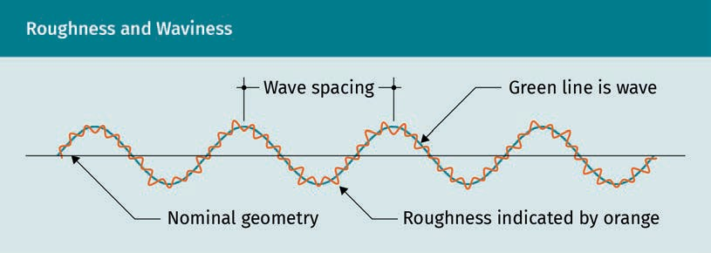
Waviness
Wavelengths are measured in the mm range with amplitude in the µm range (in the micrometer range in millimeters or inches). The height and width of the wavelengths are shown on technical drawings. Waviness is identiﬁed by periodic, long intervals of deviation from form and “includes all irregularities whose spacing is greater than the roughness sampling length and less than the waviness sampling length” (Bhushan, 2000, p. 3). Manufacturing problems, such as incorrect clamping, machine vibrations, heat, and warp, cause waviness.

Tribological proper- ties
In the science of sur- faces for moving parts, tribological properties relate to lubrication, friction, and wear.

Illustration
Understanding the terminology and using the vocabulary of mechanical engineering also includes recognizing symbols speciﬁc to the ﬁeld. We might think of the symbols as slang for the industry; however, the use of the symbols and knowing where and how to use them is a technicality that does not allow for much creativity or casual commu- nication. The symbols communicate very precise information, leaving no room for mis- interpretation. It falls upon the technical illustrator to make sure all the symbols and associated information are included for successful fabrication. The control feature frame includes a symbol for surface deviations in the furthest left box of the frame.
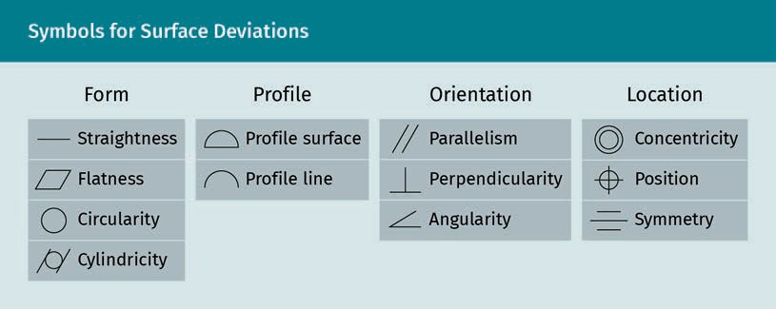

Fundamental Roughness Parameters

Fundamental roughness parameters are calculated for three values. Roughness param- eters are indicated with the letter R; for their determination, only the roughness is con- sidered. Roughness height is measured in wavelengths and amplitude is measured in the µm-range, which is micrometers or micro inches. The index of the R-parameter describes its information content. Parameters are Ra (the mean value of all heights), Rz (the amplitude of ﬁve segments from the maximum to the minimum, or average peak to valley height), and Rq (the root mean square of roughness). They are used to describe the extent of surface roughness and provide a quantitative measure to describe whether a surface is smooth or rough enough to fulﬁll a certain function. The remaining geometric deviations, form deviation and waviness, are removed from the dataset by ﬁltering. The noise from the measuring instrument that is characterized by the very short wavelengths is also removed.

Surfaces

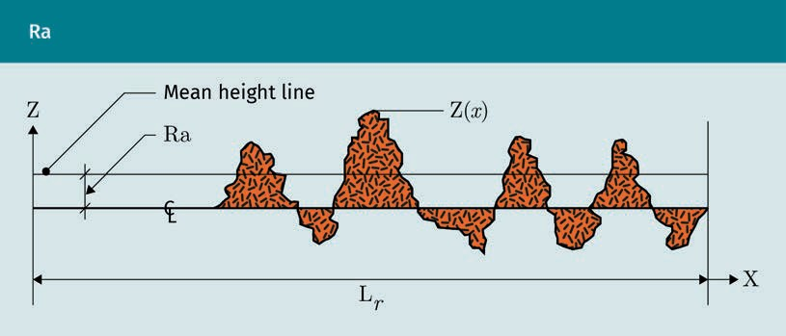

In the ﬁgure above, CL refers to the centerline. The mean value of all heights is set at 0 on the centerline. Lr is the length of segment for measuring Ra.
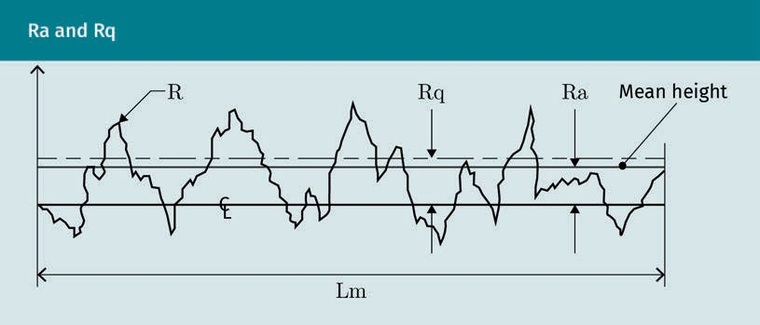

In the ﬁgure above, Lm is the measuring length showing the roughness measures from the centerline (CL). While Ra is measured from the centerline to the mean, Rq is meas- ured from the line representing the root mean to the centerline.

Roughness Parameters

= 1
lm
lm
=
1
l
∫
lm

2
m 0
∫
0

Rz uses the average of ﬁve segments of sampling lengths as depicted below. In the fol- lowing ﬁgure, Rt is the overall roughness proﬁle height from highest to lowest points. Lr indicates the width of the samples and Ln is the total evaluation length of all ﬁve sam- ples.

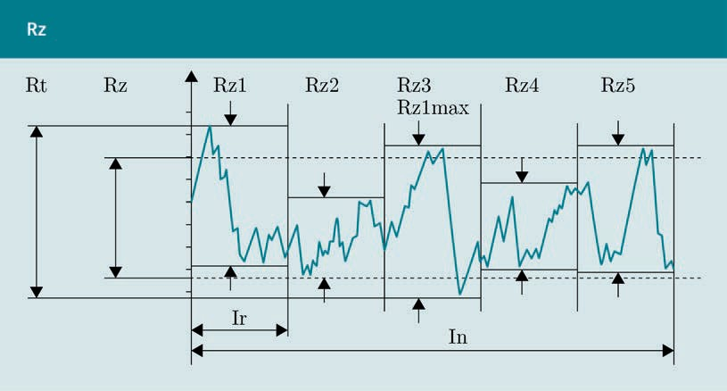

Surface ﬁnish symbols
Standardized conventions are required when specifying surfaces. Three basic types are presented here. The ﬁgure below shows the standard graphical symbol for surface tex- ture. When used in the drawing, place it on the surface where it is readable from the bottom or right if possible. If there is no room, it may be placed on a leader line shoul- der with an arrow on the surface. Alternatively, it may be placed on the dimension line. Be consistent and practical with placement of the symbol.
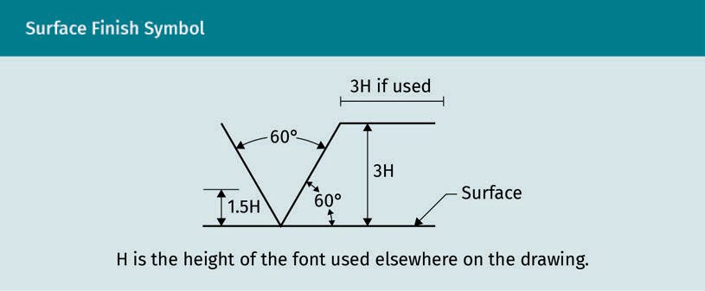

Examples of graphic surface ﬁnish symbols are shown below. The inadmissible symbol denotes a surface prohibiting material removal. The required symbol includes a numeral or speciﬁes material to be removed by machining. The optional symbol indi- cates a production method other than machining. The same surface texture required in all surfaces of a workpiece will have a circle drawing over the leader joint.

Surfaces

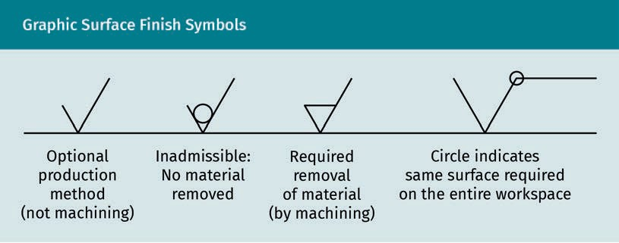

Additional notations as part of the speciﬁcation accompany the symbol. See the follow- ing examples of its use in technical drawings.
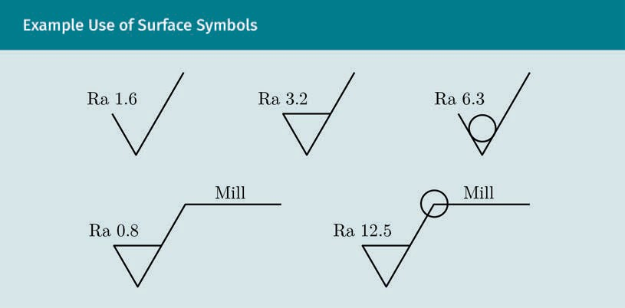

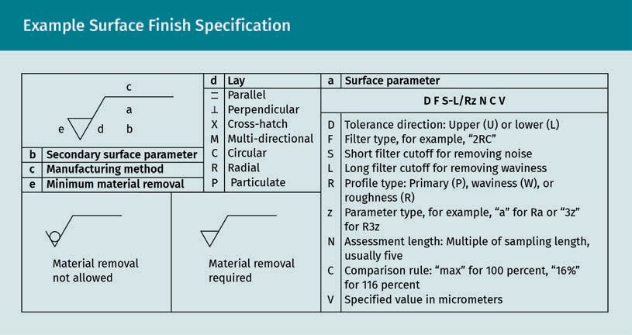

Surface ﬁnish symbols are used in the drawing. Additional information may be provi- ded in a speciﬁcation note and can be added with the title block. It is common for the maximum value of, for example, Rz or Ra to be provided in order to make sure that the surface is ﬁne enough.

Fundamentals of waviness
Waviness is deﬁned by long periodic intervals of surface deformation. A wavy surface can be smooth or have ﬁner roughness irregularities along the wave. The symbol is the same with waviness tolerances; it is speciﬁed with a horizontal extension bar, typically dimensioned in millimeters or inches.

Summary
Engineers have several reasons to specify surface ﬁnishes. Understanding the machining process and capabilities of the equipment is necessary for effective manufacturing. Correct speciﬁcation will serve to cut costs while resulting in the desired product quality. The precision of the ﬁnish surface ensures the function of the workpieces in the ﬁt of parts and interchangeability. Long-term beneﬁts include improved performance criteria and longer lifetime use.

Understanding the geometric properties of materials relating to surface ﬁnishes is helpful to drafters. All machined workpieces have deviations identiﬁed as chemical, mechanical, or geometric. Geometric properties are categorized as either macro- or micro-properties. Form, location, orientation, and proﬁle are types of surface devia- tions; all have reference symbols and three letter identiﬁers used in drafting.

Surfaces

Surfaces are speciﬁed using symbols with additional numerals and notations to describe allowable variances or tolerances. The correct placement of the surface speciﬁcations is critical to the manufacturing process. Waviness and roughness are form deviations, and it is important for a technical illustrator to be able to calculate fundamental roughness parameters.

Quality machine production relies on correctly placed and notated symbols, and knowing which symbols represent surface conditions is the responsibility of the technical illustrator. Visiting machine shops and talking with fabricators provide additional understanding of the importance of accurate surface speciﬁcation.

Knowledge Check
Did you understand this unit?

You can check your understanding by completing the questions for this unit on the learning platform.

Good luck!

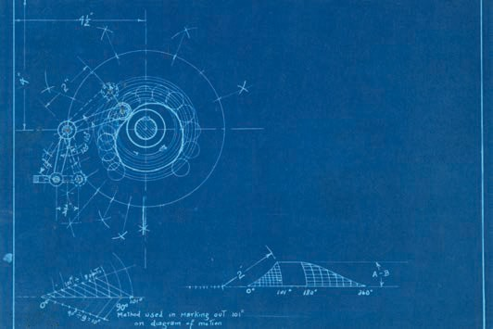

Unit 6

Tolerances

STUDY GOALS

On completion of this unit, you will be able to …

… read and create a feature control frame for dimensioning tolerances.
… explain the fundamental concepts and terminology for standard ﬁtting systems.
… dimension tolerances for basic shaft and basic hole.
… understand tolerance chain calculations.

DL-E-DLBROTD01_E-U06

- Tolerances

Introduction
Drawings with complete tolerances are necessary for accurate production and to ach- ieve competitive costs. Geometrical dimensioning and tolerancing (GD&T) follows cer- tain standards and norms understood in the industry. Surface ﬁnish symbols for geo- metric properties placed ﬁrst in the control feature frame designate the geometric property for the tolerance. Leaders indicate the surface or datum to which the toleran- ces apply. Additional symbols and tolerance values are provided in the feature control frame. This includes information about tolerance allowances, material conditions, and datum references; the placement of information regarding tolerances is the responsi- bility of the drafter. Determining tolerances is complex because tolerance choices depend upon materials, manufacturing processes, assemblies, and other constraints. Therefore, understanding the machining processes and their effect on the ﬁnal produc- tion accuracy and costs is beneﬁcial to the drafter or intern.

Standard ﬁtting systems assist the engineer when specifying tolerances for two parts that work together. Mechanical engineering uses terminology speciﬁc to dimensioning tolerances. Understanding the terminology assists the technical drafter in applying the concepts of ﬁtting systems. Three fundamental ﬁtting systems for tolerancing are clear- ance, transition, and interference. They are also used in tolerance zones for basic shaft and basic hole determinations. Engineering standards provide classiﬁcations and groups to categorize the most commonly used shaft and hole tolerances. There are many combinations possible among the twenty-eight classes established in the inter- national tolerancing (IT) system for basic shafts and basic holes.

Calculations of tolerance chains is important as it minimizes costs of mass production. Two calculations for chain tolerances are arithmetical and statistical (Henzold, 2006). Statistical calculations are simpliﬁed by computer-aided design (CAD) programs. CAD makes easy work of calculations, dimensioning, and creating feature control frames for tolerances. There is no substitute for understanding the concepts, methods, and means for drafting, engineering, and robotics. Without the basic fundamentals that are best learned manually, many errors are available to the CAD operator.

Dimensioning

Tolerance The full range of dif- ferent measures allowed beyond the designed geometry of a workpiece is called tolerance.
Because all geometries have deviations, each geometric property (size, form, proﬁle, orientation, location, runout) and relationship between features must receive a toler- ance to describe the product completely for the most accurate and efﬁcient method of production. However, to eliminate any opportunity for error and increase readability, it is advisable to apply general tolerances with a note near to or inside the title block whenever possible. General tolerances are equal to or larger than machine accuracy. The largest tolerance generally results in cost savings. Choosing the size of a tolerance is a tradeoff between function and costs. A deﬁned precision is required to ensure a part fulﬁlls its function; however, there is no sense in applying a smaller tolerance as

Tolerances

this increases the cost but is no longer useful for the function. Many manufacturers, and even smaller workshops, use standardized tolerances, which can vary within speci- alized industries. It can beneﬁt the drafter to check ahead with their company or the production company to ﬁnd out if general tolerances are employed. If so, the important general note will specify which standard(s) are included on the drawing, minimizing drafting time.

For the sake of emphasis and illustration, remember that a nanometer is one billionth of a meter, and that is much smaller than the diameter of a human hair measuring 80— 100 µm. Tolerancing is operating with dimensions in an even smaller magnitude. As you can see in the ﬁgure below, the width of a strand of DNA is only 2.5 nm (US Department of Energy, n.d.). Since the measures are so ﬁnitely precise and cannot be seen or felt, the numerical calculations of tolerances are a critical determination, and using the rec- ommended tables from standards or suppliers is a wise choice.



Each characteristic of a workpiece has a tolerance, and “the tolerance of a dimension is the total permissible variation in size or location. Tolerance is the difference of the lower limit from the upper limit” (Madsen & Madsen, 2016, p. 323). The tolerance value is not speciﬁed as positive or negative, but is rather the total value of the combined negative values below and the positive values above the ideal geometry. However, the speciﬁcation may include positive or negative values. For example, if a tolerance is

Tolerances

speciﬁed as 1 mm (without + or — signs), it could be shown as +/—.5 on the technical drawing. It could also be shown with unequal amounts, such as +.7/—.3, or any values that create a 1 mm difference. In mechanical engineering, tolerances are for dimen- sions and all the geometric properties for each feature. They deﬁne size and form, the surface quality of the item, and describe the relationships between features. The toler- ance, being the total permissible variation in the dimension, is calculated by subtract- ing the lower limit from the upper limit, as demonstrated in the following examples (Madsen & Madsen, 2016).

Examples

Example one:

Upper limit: 22.1

Lower limit: 21.9

22.1 — 21.9 = 0.2

Tolerance 0.2

Example two:

Upper limit: 31.85

Lower limit: 31.75

31.85 — 31.75 = 0.10

Tolerance 0.10

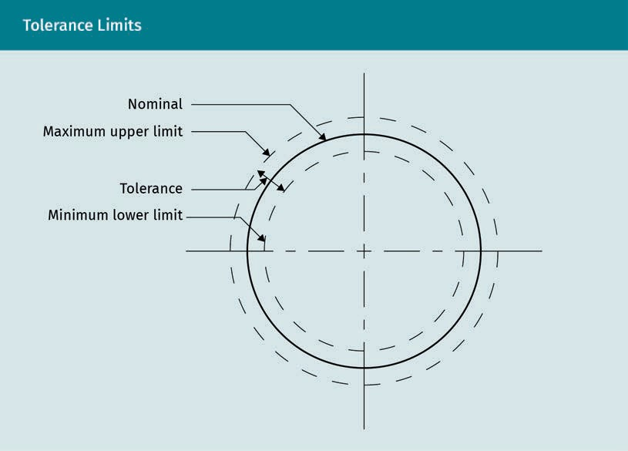

Geometrical Dimensioning and Tolerancing (GD&T)

Technical drawing is a means of communication throughout all design phases. These include identiﬁcation of need, idea conceptualization, schematic design, design devel- opment, prototype testing, and ﬁnal production. Geometrical dimensioning and toler- ancing (GD&T) is a universally accepted communication language understood interna- tionally between participants of the supply chain. In more detail, it is “the dimensioning and tolerancing of individual features of a part in which the permissible variations relate to characteristics of form, proﬁle, orientation, runout, or the relation- ship between features” (Madsen & Madsen, 2016, p. 276). The use of GD&T deﬁnes the design intent and provides information for the machinist and for the evaluation proc- ess, whether manual or computerized. Following GD&T ensures that the ﬁnal produc- tion meets the intended design in all ways, including economics of production, market- ing, and the satisfaction of the end user. Specifying the largest tolerance possible generally results in cost savings.

Requirements specify that tolerance should be provided in a general note within or separate from a title block, or directly with dimension information. When it is necessary to provide tolerancing information with the dimensions, a feature control frame is used. Typically, each feature requires a separate feature control frame, unless there is a note for general dimensioning.

Tolerances

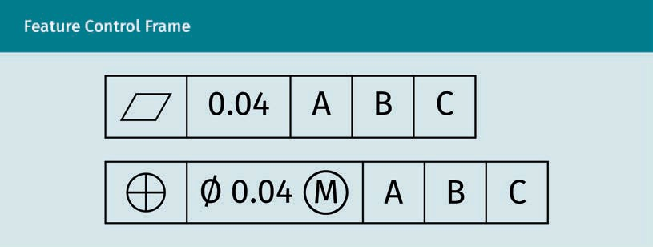

In the ﬁgure above, each part of the feature control frame has a symbol or number in a standard order. The letters and symbols within a feature control frame should be cen- tered within each square or rectangle, which are twice the height of the letter. The ﬁrst example shows the form symbol for ﬂatness and the second uses the symbol for posi- tion. In the feature control frame, the ﬁrst box to the left contains the symbol denoting the type of geometric tolerance or geometric characteristic.

The next box or rectangle includes the tolerance value, and if the feature is cylindrical, begins with a diameter symbol (Ø). The tolerance numeral or value is in the same rec- tangle, and if used, material condition modiﬁers or feature modiﬁers follow the symbol, as shown in the second frame. Modiﬁers and use of datum are explained later in this unit.

The next boxes are for letters referencing the datum, with the primary datum followed in order by the secondary and tertiary datum identiﬁers as applicable. Their order indi- cates the precedence of the datum control. All datum points are located on the drawing with the letter inside a square attached to a leader with a triangle base.

AutoCAD allows the user to add GD&T symbols to drawings using the “tolerance,” “mleader,” and “qleader” commands (Madsen & Madsen, 2016). Within the tolerance command is the editable feature control frame. “P” allows the user to enter tolerances. Gaining an understanding of tolerance basics makes learning the tolerance commands of whichever CAD program you use much easier.

Datum
The datum is the “theoretically perfect” ideal, or nominal geometry, to which the toler- ance is referenced on a drawing. It indicates the place from which the measurement is taken. A datum is the “theoretically exact” geometrical reference (such as an axis, plane, or straight line) to which tolerance features are related. The datum may be based on one or more datum features of a workpiece (Henzold, 2006).

Prioritize datum selection according to the function of the part, and order of prece- dence for the controlling feature. When deciding where to locate the datum, select actual physical surfaces of a part that will be accessible during manufacturing, if at all possible. While an axis could be used as a datum, centers of gravity or spheres are nei-

ther physical nor accessible, so do not use them. It is also advisable “to assign a little form, orientation, or runout control to the datum surface to ensure an accurate basis” (Madsen & Madsen, 2016, p. 553).

Datum feature The physical or actual datum on a workpiece, such as a plane surface, edge, hole, or axis, is the datum feature.
The datum feature is the actual physical surface, edge, or axis used when manufactur- ing or evaluating after production. Three datum points make up a datum reference frame (DRF) and are identiﬁed within the feature control frame. They are based on the three datum points perpendicular to each other and are placed in the feature control frame in order of importance for manufacturing and evaluating. They are referred to as primary, secondary, and tertiary datum; each datum is assigned a letter and placed at the end of the control feature frame.

The datum may also be indicated singularly on a drawing with a leader line and labeled with a letter within a triangle. It is placed in alignment with and above the dimension line. Depending on the function of the part and its complexity, it is possible to have multiple datum points. However, it is not necessary to complicate drawings with unnecessary datum references, and “any geometric tolerance applied to a datum should only be speciﬁed if the design requires the control” (Madsen & Madsen, 2016, p. 479). When using tolerance controls, form tolerances never use the datum; however, it is an option for proﬁle tolerances. For all other tolerances, datum points are required.

Basic dimension, nominal dimension, and TED
The ideal dimension is never perfect. The ideal or nominal geometry is a basic dimen- sion and, in AutoCad, it is a command for creating the correct symbol for tolerance dimensions. In GD&T, it may be referred to as the theoretical exact dimension (or TED). When dimensioning for machining, the nominal, basic, or “theoretical exact” dimension is encased in a rectangle if no tolerancing is needed. To indicate a cylinder, a diameter symbol Ø is placed before the numerical value instead of a square.

Tolerances

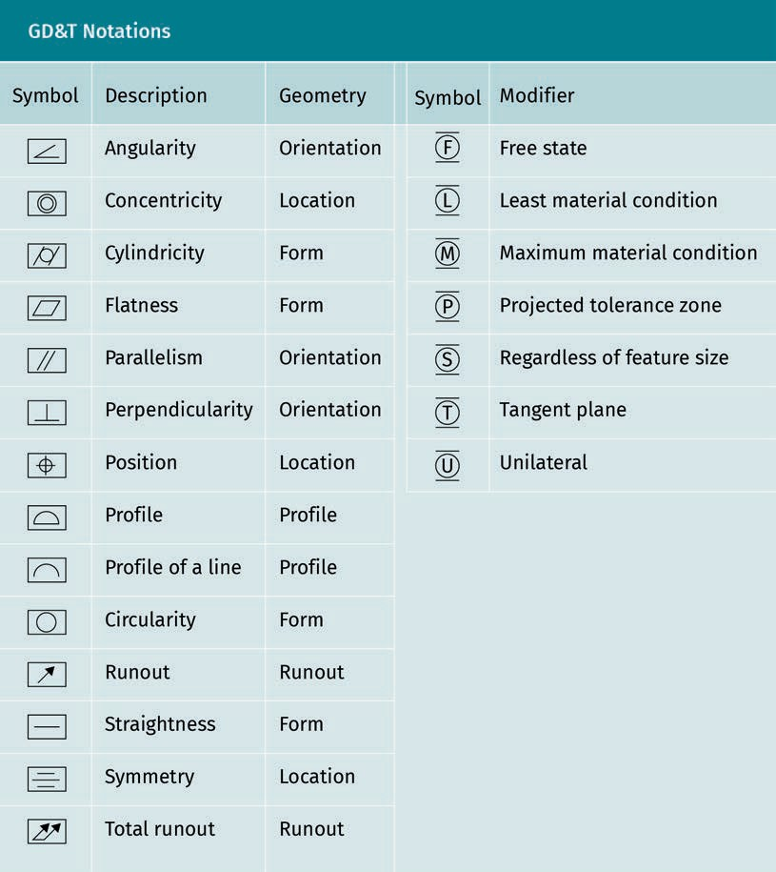

It is worth noting that the ISO now uses the term “roundness” instead of cylindricity. Either is still acceptable, as terminology changes are not quickly adapted. The GD&T modiﬁer symbols on the right column of the ﬁgure above are further explained below.

Modiﬁers for GD&T

It is often beneﬁcial to specify a maximum material condition (MMC) to allow for the largest tolerance, which could be the least expensive. Other times, tolerances also ben- eﬁt from specifying either maximum or minimum material condition. When used, the circle symbol with M or L (least material condition or LMC) illustrated in the ﬁgure above is placed within the feature control frame.

When M is used, gauging is necessary or should be simulated. The gauge should be cal- culated at the toleranced feature, for both shafts and holes, “from the maximum mate- rial size and the geometrical tolerance, which is followed by the symbol M” (Henzold, 2006, p. 102).

The MMC of an external feature is the upper limit tolerance, whereas the MMC of an internal feature is the lowest limit tolerance. Size (the shape of a part, such as a sur- face) is a feature with physical dimensions, e.g., a hole. “Regardless of feature size” (RFS) is assumed if no M or L are used, so it is no longer required to indicate it on the drawing.

Projected tolerance zone
In the practice of dimensioning tolerances, if the tolerance is not measured on the entire feature, its location must be identiﬁed. You must identify exactly where the toler- ance is measured on the datum feature. In such cases, a zone is identiﬁed within which the tolerance will occur—this is called interval zone or tolerance zone. The area in which a tolerance occurs between tolerance limits is the tolerance zone.

The latest update of ISO 286 now uses the word “interval” instead of “tolerance zone” because “an interval refers to a range on a scale whereas a tolerance zone in GPS refers to a space or an area, e.g., tolerancing according to ISO 1101” (International Organization for Standardization [ISO], n.d.-d, para. 3.2.8.4). This is always relevant to the x, y, z Carte- sian coordinate system. An example is two parallel planes or lines oriented perpendic- ularly to the datum feature or surface. A circular tolerance zone is the diameter in which the central axis of a feature lies. It may be helpful to differentiate the 2-D zones from the 3-D zones. It is recommended that new users “make a chart showing the toler- ance zones for each type of tolerance and a sampling of its various applications” (Mad- sen & Madsen, 2016, p. 553).

Free state
Free state refers to non-rigid bodies that are not subject to forces other than gravity. Other bodies are assumed to be rigid 3-D bodies.

Tangent plane
The tangent plane is a requirement of the American Society of Mechanical Engineers (ASME) Y14.5M—1994. The use of the symbol T after the orientation or the location of the tolerance value speciﬁes the tangent plane. The tolerance zone then only applies to the high points of the controlled feature, not to the irregularities of the entire surface (Henzold, 2006).

Unilateral
Tolerances are assumed to be equally bilateral unless two values show them as unequally bilateral. An example of unequal bilateral tolerance is +.02, —.01. A tolerance of .03 would be typically shown as ± .015, equally bilateral. If a tolerance is only positive or negative in one direction, it is denoted as unilateral.

Tolerances

Dimensioning Standards for Tolerances

Tolerancing is a complex task. It is typically prioritized by function, but manufacturing or inspection requirements may take precedence (Henzold, 2016). In this section, there are examples of tolerancing geometric properties, such as size, form, proﬁle, orienta- tion, location, and runout. The information that needs to be included and the informa- tion that can be extracted from the drawings is illustrated in the examples following the paragraph on general tolerances. Anytime general tolerances can be applied, the complex task of tolerancing is minimized.

General tolerances
General tolerances may be assigned to all measures with a note to reference the stand- ard in use, e.g., ISO 2768-m. The “m” indicates that the medium tolerance class is to be applied to the part unless otherwise stated in the drawing. Sometimes a table is added. A company standard is an alternative to the general tolerances in ISO 2768. As an exam- ple, a general tolerance on surface proﬁle (with or without a datum system) could be speciﬁed in a general note. Henzold (2006) explains that “for holes, a general positional tolerance (with a datum system and with the maximum material requirement) may be speciﬁed in addition. Usually, if not otherwise speciﬁed, the general positional toler- ance overrides the general surface proﬁle tolerance” (p. 149).
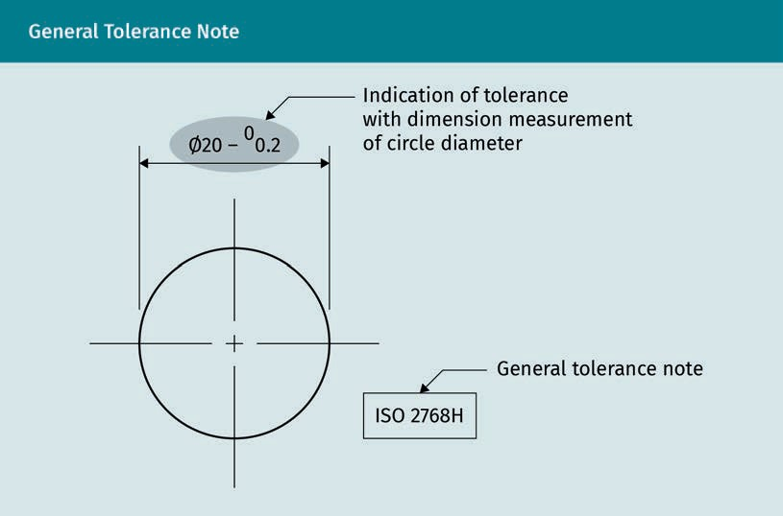

The ﬁgure above illustrates the use of the general tolerance note. The ISO 2768H refers to the ISO standard and the general tolerance class H. When using a general tolerance, if the desired tolerance is smaller than the general one, it needs to be provided on the drawing; otherwise, it does not need to be included. Make sure you include all dimen-

sions and geometrical tolerances to deﬁne the size and shape of a part. The use of general tolerances saves time and reduces clutter on the drawing, improving clarity and minimizing errors. It also makes it easier for the manufacturer to read and follow. Gen- eral tolerance cannot be used for proﬁle tolerances nor for plastic materials. Consider using a general tolerance when it can save money in manufacturing as the largest tol- erance possible, and retain the functionality of the part or assembly.

Geometric tolerances
The function of each feature limits allowable deviations of size, form, orientation, and location. If just one of these deviations is too large, it affects the functioning. Therefore, each geometric characteristic requires tolerancing. Technical drawings need to specify all dimensional and geometrical tolerances necessary to completely deﬁne the shape and size of the part (Henzold, 2006).

Size tolerances
Size tolerance speciﬁes the difference allowed between actual size and nominal size assessed over the entire geometrical feature. It can be drawn either inside a red circle with dimension values or as a basic dimension (42 in the rectangle). The large hole uses a leader line to indicate the hole, whereas the smaller hole is shown with a dimension line. Note that the feature control frames are not for size, but for positional tolerancing.
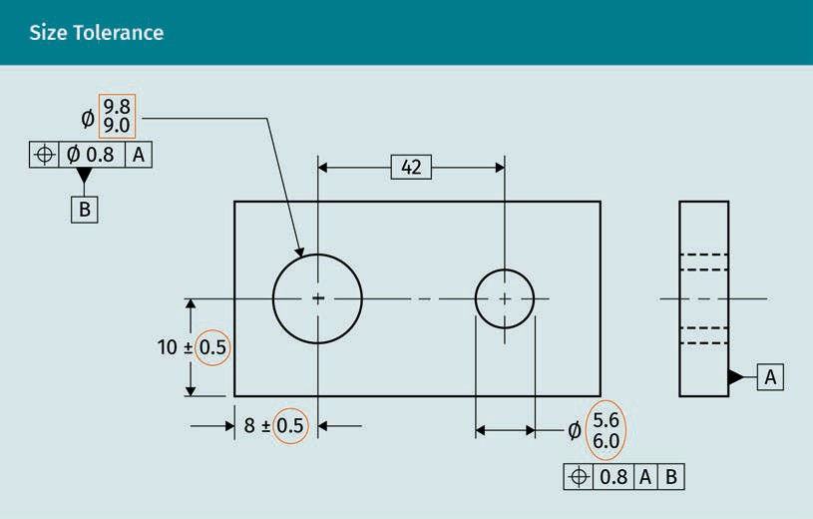

Form tolerances
The feature control frame can be located in either of the positions shown in the ﬁgure below, but not in both. Form tolerance speciﬁes the allowable deviation of a feature (geometrical element, surface, or line) from its nominal form. If not otherwise speciﬁed, form deviations are assessed over (or along) the entire feature (Henzold, 2006). Form

Tolerances

tolerances are only referenced to the form element that they are assigned to, whereas location tolerances describe the interaction between two form elements, e.g., their alignment to each other. Thus, one reference element is required. Four tolerances con- trolling the shape of form are straightness, ﬂatness, roundness, and cylindricity. Datum points are not used with form tolerances.
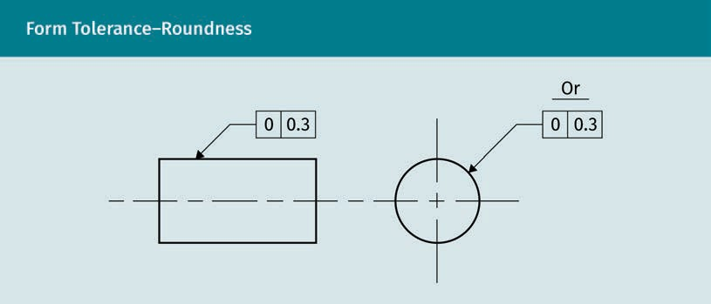

The ﬂatness tolerance describes the distance between two parallel planes for a surface with all elements in one plane. It must be shown in the view where the surface is drawn as a line. If it is associated with a size tolerance, the ﬂatness tolerance must be less than the size tolerance. The parallelogram graphic descriptor is the height of the letters and the width is 1/5 times the letter height.
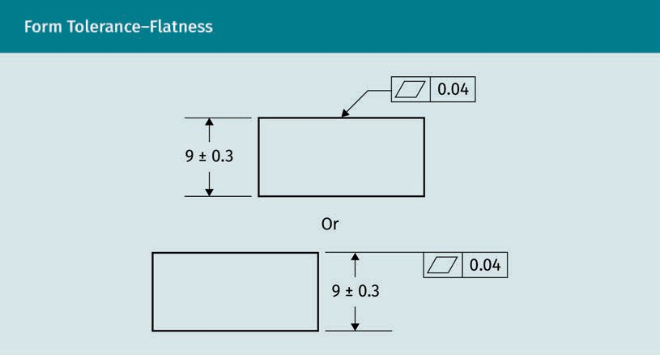

Proﬁle tolerances
In the simple line proﬁle example below, in order to emphasize the tolerance notations, the dimensions are not shown. Although they would be needed, they are not relevant to the proﬁle. If a unilateral tolerance were speciﬁed, a phantom line would be added with the tolerance to the side of the line.
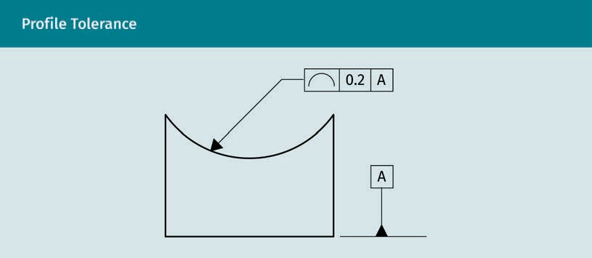

Orientation tolerances
Orientation tolerances control the allowable difference of a feature from its nominal form and orientation. The orientation is related to one or more (other) datum fea- ture(s). The orientational deviation includes the form deviation. If not otherwise speci- ﬁed, orientation tolerances are applied to the entire feature. Orientation tolerances include parallelism, perpendicularity, and angularity; they require a datum. They only control orientation, never location. The ﬁgure below illustrates a perpendicularity toler- ance required for a hole, which is controlled by datum A.
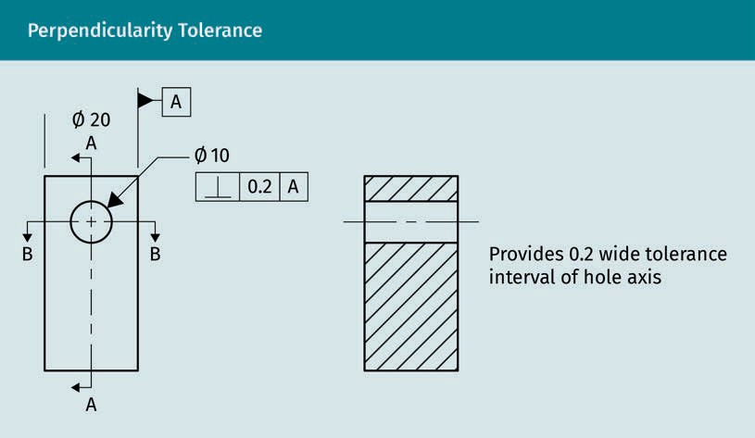

Tolerances

Location tolerances
Location tolerances control the allowable deviation of a feature (surface, line, or point) from its nominal location relating to one or more datum feature(s). The location toler- ance includes the form and orientation tolerances of the surface, axis, or median points. Unless otherwise speciﬁed, location tolerances include the entire feature and require a datum. There are three types of location tolerances: concentricity, position, and symmetry. Concentricity and symmetry control the location of derived median points, whereas position locates center points, axes, and median planes for size fea- tures and, optionally, orientation.
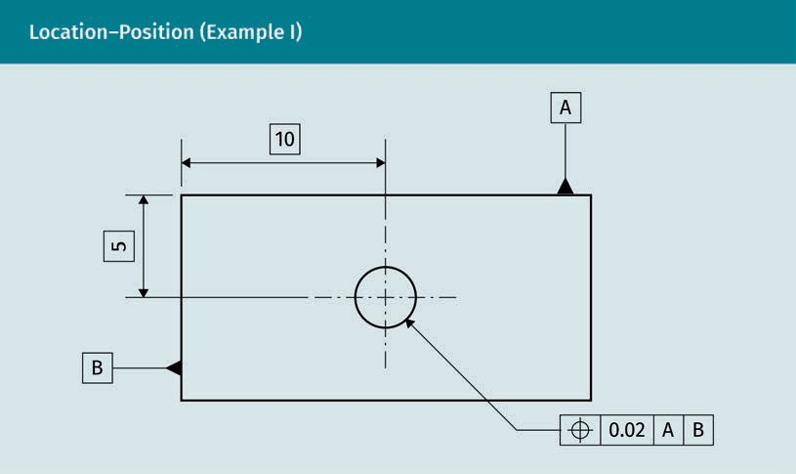

In the example above, the control frame feature is pointing to the hole, which means that the location is referencing the hole located from centerlines for datum A (10) and B (5). The tolerance value for the position is .02, meaning the location can vary by + or
—.02 from 10 and 5.

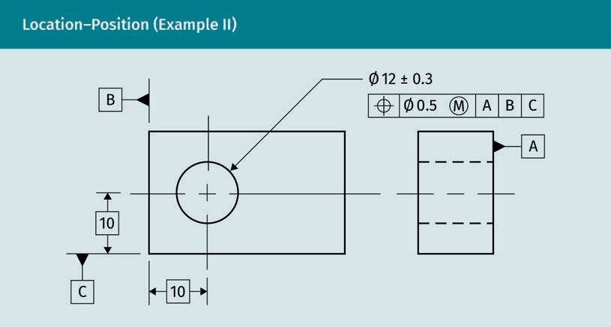

In the example above, the position is modiﬁed with the most material condition and controlled by three datum features.

Runout tolerances
Runout is a combination tolerance controlling one or more features to a datum axis, which is always RFS and RMB. Runout also controls circular elements of a surface, as well as perpendicularity and ﬂatness. There are two types of runout: circular and total. Circular runout is used for single circular elements and it can control circularity and coaxiality where two or more features share a common axis. Circularity or roundness is used to control wobbling motion. Total runout controls surface elements and their var- iations of roundness, straightness, coaxiality, angularity, taper, and proﬁle when applied to surfaces constructed around and at right angles to a datum axis (Madsen & Madsen, 2016).

It is important to fulﬁll a runout tolerance because doing so can override the need for additional tolerancing, since runouts control so many geometrical properties. Also, if a rotation is not performed around the center, or the workpiece is not round enough, the actual rotating parts can cause imbalance and compromise the function of the piece.

Tolerances

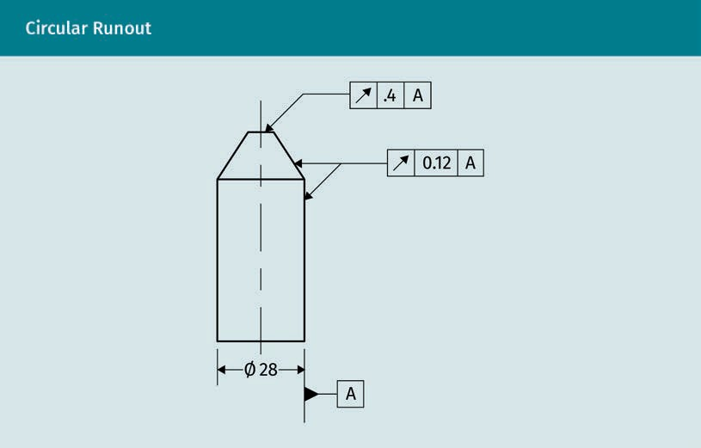

Circular runout in the example above is tied to datum A. Two features share a common axis although each are singular circular elements, which is a requirement for using cir- cular runout.

Standard Fitting System

The need for mass produced parts to be interchangeable combined with the inaccuracy of manufacturing methods resulted in limits and ﬁts becoming necessities (ISO, n.d.-e). To satisfy a ﬁt function, it was enough to “manufacture a given workpiece so that its size lay within two permissible limits, i.e., a tolerance, this being the variation in size acceptable in manufacture while ensuring the functional ﬁt requirements of the prod- uct” (ISO, n.d.-e, “Introduction” section). Fitting systems deal with the relationship of two joined features. They typically refer to shafts and holes, but can also refer to two planes, such as a key and a keyway. A ﬁt tolerance is needed in the design of any pieces that will be coupled.

The terms “limits and ﬁts” is also used for referencing the mating of parts. It is impor- tant to acquire a foundation of engineering terminology before tackling tolerances for ﬁts in the ﬁeld of technical drafting. The ISO deﬁnes the feature of size as “the geomet- rical shape deﬁned by a linear or angular dimension” (ISO, n.d.-d, para. 3.1.1). A ﬁt is the “relationship between an external feature of size and an internal feature of size (the hole and shaft of the same type) which are to be assembled” (ISO, n.d.-d, para. 3.3.3).

Fit
This is the relation- ship between an external and an internal feature of size, which are to be coupled.

ISO 286

ISO 286 establishes tolerances for linear sizes of features and assumes that nominal sizes for hole and shaft are identical. These ISO standards are under their geometrical product speciﬁcations (GPS). According to the ISO, only two types of linear size features are included: the cylinder and two parallel opposite surfaces, deﬁned by a linear dimension (ISO, n.d.-d). ISO 286 is split in to the following parts:

- ISO 286-1. This deﬁnes basic concepts for the basis of tolerances, deviations, and ﬁts (ISO, n.d.-e).
- ISO 286-2. This establishes tables of standard tolerance grades and limit deviations for holes and shafts (ISO, n.d.-d).

This course will introduce the basic concepts, but further research and experience will complete your understanding and capability to specify tolerances. In addition to ISO standard 286, “the use of geometrical form tolerances and surface texture requirements may improve the control of the intended function” (ISO, n.d.-e, “Introduction” section).

Fundamental Tolerances

Generally speaking, clearance and interference have the same meaning as in any regu- lar conversation. Staying clear refers to keeping a distance from something, whereas interference refers to something that is inhibiting our ability to do something. In the same manner, interference with ﬁts gets in the way of an easy ﬁt with lots of clearance (i.e., distance between parts). The ISO has also used the terms clearance and interfer- ence to refer to different types of ﬁts (ISO, n.d.-d). To clarify, in the course book, the type of ﬁt will begin with a capital letter and the use of the general term will be lower case, i.e., Clearance for the type of ﬁt and clearance for referencing space between parts. There are three different types of ﬁt based on the mutual tolerance zones of cou- pled parts, such as the difference between the size of a hole and the size of the shaft. These types are Clearance, Transition, and Interference; they are deﬁned as follows:

- Clearance provides a ﬁt with space between two parts (clearance), permitting ease in ﬁtting. With this ﬁt, there is always clearance between parts with all tolerances.
- Transition is a ﬁt with enough space or clearance between two parts to provide an easy yet snug ﬁt. It may have clearance or interference depending on the range of limits for the toleranced parts.
- Interference is a tight ﬁt with no space between parts that may even be so tight as to require pressure or force to ﬁt the two pieces together. This results in minimum or no clearance, creating interference with all tolerances.

Tolerances

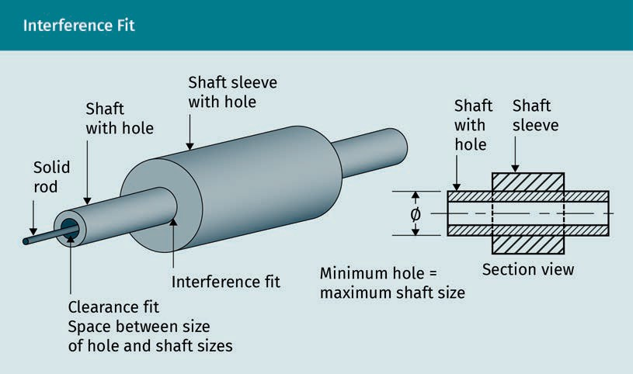

The ﬁt is determined by mutual tolerance zones between the size of the hole and the size of the shaft. The interference ﬁt is tight when the minimum hole equals the maxi- mum shaft size, as illustrated in the ﬁgure above. The clearance ﬁt provides an interval space between the sizes of hole and shaft.

Basic Shaft/Basic Hole
There are several fundamentals to consider when tolerancing shafts and holes. These relate to the manufacturing processes, machine capabilities, machine tolerances, eval- uation methods, tools, and procedures. A simple but important concept is that a hole cannot be measured until cut. In other words, the geometry cannot be evaluated prior to manufacturing. Manufacturing processes differ and machines have variances, devia- tions, and tolerances. As with all tolerances, shaft and hole tolerancing can be either Clearance, Transition, or Interference.

With all these considerations, and numerous possibilities of tolerance solutions, an emphasis is placed on the importance of understanding how best to avoid issues with ﬁts in regards to shafts and holes. Using standards minimizes the choices and many problems in calculations. ISO 286-1 “deﬁnes the basic terminology for ﬁts between two features of size without constraints of orientation and location and explains the princi- ples of ‘basic hole’ and ‘basic shaft’” (ISO, n.d.-d, para. 1). To aid in uniform speciﬁca- tions, eliminating some of the most common problems, ISO 286-2 provides tables of standard tolerance grades and limit deviations for hole and shaft standards (ISO, n.d.- e).

ISO 286-2

The ISO system for tolerances on linear sizes for the features forming a ﬁt requires the pre-condition that nominal sizes of the hole and the shaft are identical. ISO 286-2 uses letters and numbers to express international tolerance (IT) grades. IT is a standard measure of the maximum difference in size between the part and the basic size. Twenty different grades of accuracy for various specialty ﬁelds of engineering and manufactur- ing are determined. It considers the variations in methods of machining, each having their own set of tolerances. This assists with uniform tolerances, minimizing costs of mass production, and ensuring interchangeability of parts (ISO, n.d.-e).
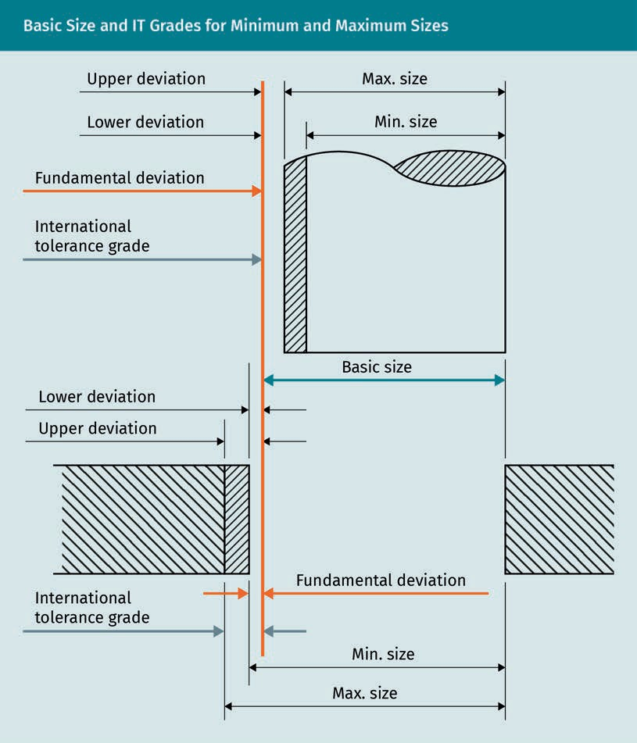

Tolerances

The image above depicts the basic size in blue, the fundamental deviation (mini- mum difference in size between a part and the basic size) in orange, and the IT grades compared to minimum and maximum sizes of the shaft and hole in gray. The funda- mental deviation is considered an allowance, rather than a Clearance tolerance. Allow- ance enables an amount of deviation from the nominal dimensions. For example, a Clearance ﬁt may or may not have an allowance added. An allowance may be intention- ally added when determining tolerances at maximum material condition. An example of allowance would be if the tolerances between a shaft and hole at MMC resulted in a measurable calculated difference. Consider that the shaft and hole have equal nominal dimensions, e.g., 8 mm. They could both have the same tolerances (i.e., ±.01), but this could become problematic. The hole may accommodate the shaft if the actual shaft diameter is 7.99 mm and the actual hole diameter is 8.01 mm, but this would not be possible if the actual shaft diameter is 8.01 mm and the actual hole diameter is
7.99 mm.

To ensure that the hole could accommodate the shaft with the given toler- ance, an allowance is added to the dimensions speciﬁed. The hole diameter might be speciﬁed as 8.03 mm with a manufacturing tolerance of ±0.01 mm. This means that the smallest acceptable hole diameter will be 8.02 mm, while the largest acceptable shaft diameter will be 8.01 mm, creating an “allowance” of 0.01 mm.

ISO 286-2 also classiﬁes 28 basic deviations for holes resulting in 28 classes (ISO, n.d.- e). Each class includes both a letter and numeral. For routine tolerances of holes, only grade numbers H7, H8, H9, and H11 are typically used. The lower case “h” refers to the shaft. As an example of some preferred tolerance zones for mechanical engineering, the following ISO table indicates the type of ﬁt based on American National Standards Institute (ANSI)/ASME nomenclature (Madsen & Madsen, 2016). ANSI B4.1 groups the external type of ﬁt and the ISO type has also been added (MITCalc, n.d.).

Allowance
An amount inten- tionally added to a dimension creating space between parts is an allowance.

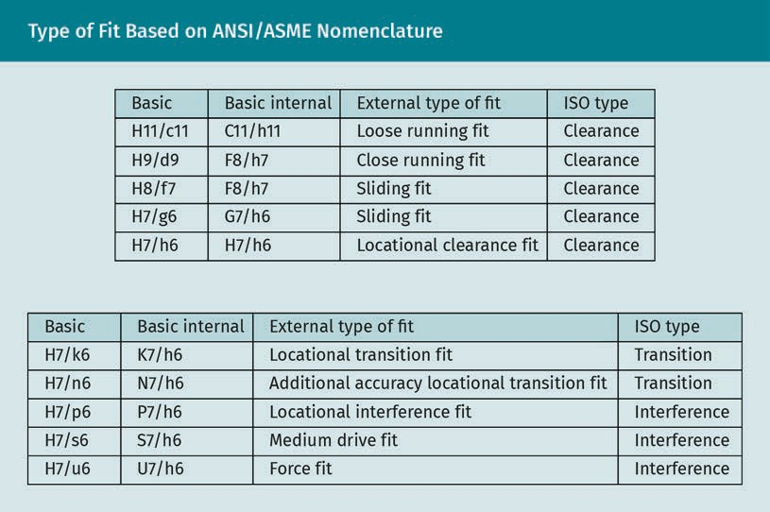

Looking at the chart below as an example, the two columns on the left provide the value of the nominal measure. The columns on the right give the tolerance values in µm. A hole with tolerance level of H7 (a clearance ﬁt) for a hole with the diameter of 55 mm would have a tolerance between 0 and 30 µm, as per the chart. The column under h6 indicates a shaft size that would ﬁt within the H7 hole around 55 mm, which would have a tolerance between 0 and 19 µm.

Tolerances

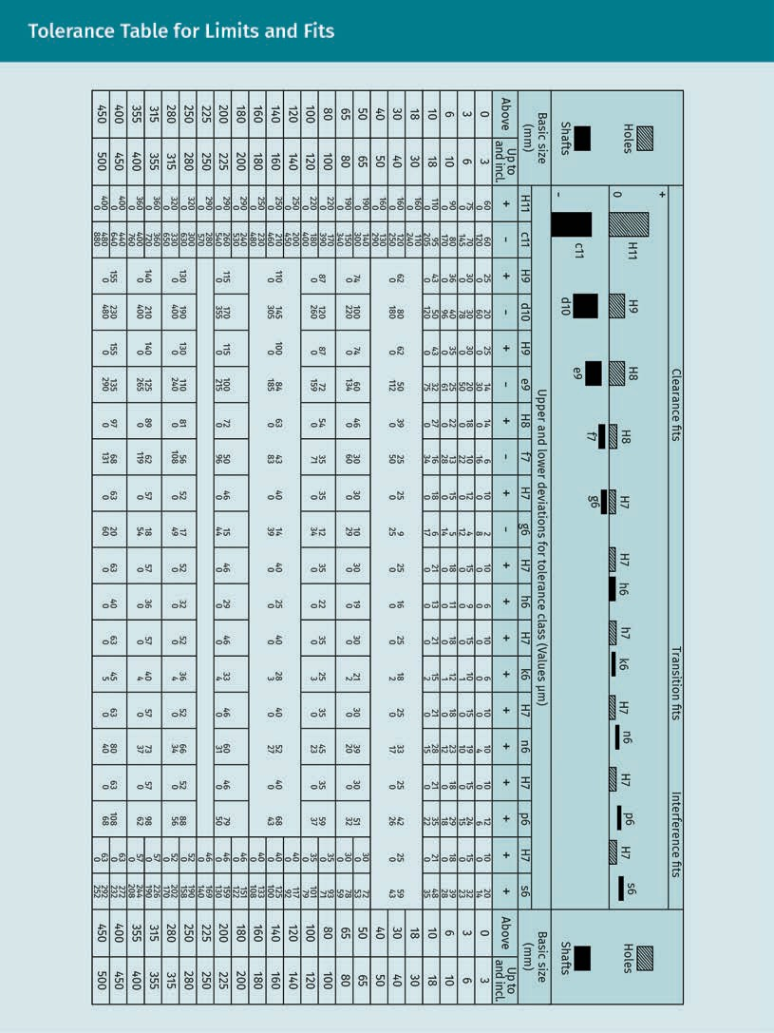

Practice lesson
Using what you know, choose tolerances for the clearance ﬁt of H7/h6 for a hole diam- eter of 55 mm. The options vary within the differences shown. Which would you choose? Why?

Running or sliding Clearance ﬁts are suitable for parts that run or slide against each other. These ﬁts are used with operational parts, such as gears, pistons, and shafts. The locational ﬁts (in all three zones) are for parts that need to be ﬁxed mechanically so that they do not move against each other during assembly. When ease of assembly and disassembly is priority, locational ﬁts are used. The Interference ﬁts of drive and force are used for the ﬁxed coupling of parts requiring the greatest precision of ﬁts. Such ﬁts are like locational ﬁts as they cannot be allowed to move during assembly. Interference ﬁts are speciﬁed when the smallest or no clearance is required. These are common for heavy steel or cast iron parts with high torsion or friction forces, such as in engines. The type of assembly and the temperature can also determine the type of ﬁt.

Determining Diameters of Holes and Shafts Based on the Tolerance Classes

The most common way of tolerancing shafts and holes is the hole base system. The hole should be speciﬁed before the shaft if both are being speciﬁed. The cost of gaug- ing the hole is lower than that of gauging a shaft, due to the cost of the tools.

Shaft basis ﬁt system
The tolerance is based on the shaft tolerance (h) ﬁrst, with options of the hole sizes (H). The upper deviation of the hole is always equal to zero. The shaft and hole tolerances are as follows:

- Clearance. The diameter of the shaft is smaller than the diameter of the hole (the largest shaft limit is smaller than the smallest hole limit).
- Transition. Tolerance zones partly or completely interfere and may also include clearance.
- Interference. The lower limit size of shaft is equal to or larger than the upper limit size of the hole.

DIN 7154, 7155, and 7157

German standards DIN 7154, 7155, and 7157 also apply to limits and ﬁts, the tolerancing of holes and shafts (Deutsches Institut für Normung [DIN], n.d.-g; n.d.-h; n.d.-i). The con- cept of these standards form the basis for ISO 286. The ISO includes members from the German organization DIN that established tables and charts to tolerance ﬁts for the hole basis system, which is most preferred. DIN 7155 provides a tolerance of ﬁts for the shaft basis system (DIN, n.d.-h). A recommended selection of ﬁts, tolerance zones, allowances, and ﬁt tolerances is available in DIN7157:1966 (DIN, n.d.-i). The DIN stand- ards are recommended for parts when no ISO standard exists.

Tolerances

6.4 Calculation of Tolerance Chains
With all of the possible tolerances on a single piece, it is possible to have several dif- ferent actual outcomes. When other parts are considered, the number of possibilities increases exponentially as more and more parts create a ﬁnal assembly. When the tol- erances of workpieces combine, the deviations add up. This is tolerance stacking. Cal- culation of the accumulation of tolerances is a tolerance chain. They are calculated in the following two ways:

- Arithmetical. This method is based on a worst-case scenario in which all sizes are at the most or least favorable limits. However, since this case is unlikely to occur, the statistical method is the norm.
- Statistical. This method considers the form of distribution of actual sizes (choosing single tolerances larger than the arithmetical tolerances). It gives the amount of clearance not to be exceeded with a particular statistical probability.

Henzold (2006) explains that if using arithmetical tolerance, the assembly could still function when all links of the chain have actual sizes equal to their limits of size. How- ever, the actual sizes are subject to variations, and are therefore statistically distrib- uted. It is therefore unlikely that an assembly would only contain parts with actual sizes equal to the limits of size. Furthermore, he states that “in contrast to the arith- metical tolerance line-up calculation, in the statistical tolerance line-up calculation it is assumed that this extreme case will not occur. The single tolerances are chosen larger than with arithmetical tolerancing” (p. 125).

There are several advantages to statistical tolerance chains beneﬁtting international mass production, increasing efﬁciency and thereby minimizing costs. According to Hen- zold (2006), “this results in a gain in manufacturing economy. Because of the current trend for greater miniaturization and more precise products, statistical tolerancing has become more important. Sometimes the smaller arithmetical tolerances are not even achievable” (p. 130).

There is no exact standard for statistical calculations of tolerance chains, but DIN 7186 does address it. When used, it is common practice to use the letters ST within an elon- gated hexagon for a symbol. According to Henzold (2006), “an international standard on drawing indications for statistical tolerances has not, thus far, been published. The planned standard will probably adopt the symbol ‘ST’” (p. 128).

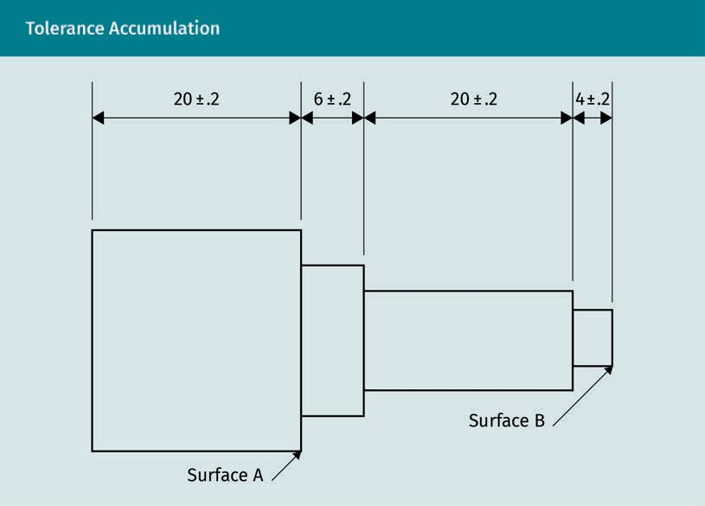

When all tolerances are added, it results in a tolerance chain. As the number of control- ling features increases, the tolerance accumulation increases, creating stacking. If the distance is controlled by several dimensions, all tolerances must be factored, as with chain dimensioning. However, if the distance is controlled by only one dimension, only one tolerance is required. Baseline and direct dimensioning are preferred to minimize build-up of tolerance or stacking.

Practice lesson
Using the dimensions and tolerances given, please calculate the tolerance for each of the sketches below.

Tolerances

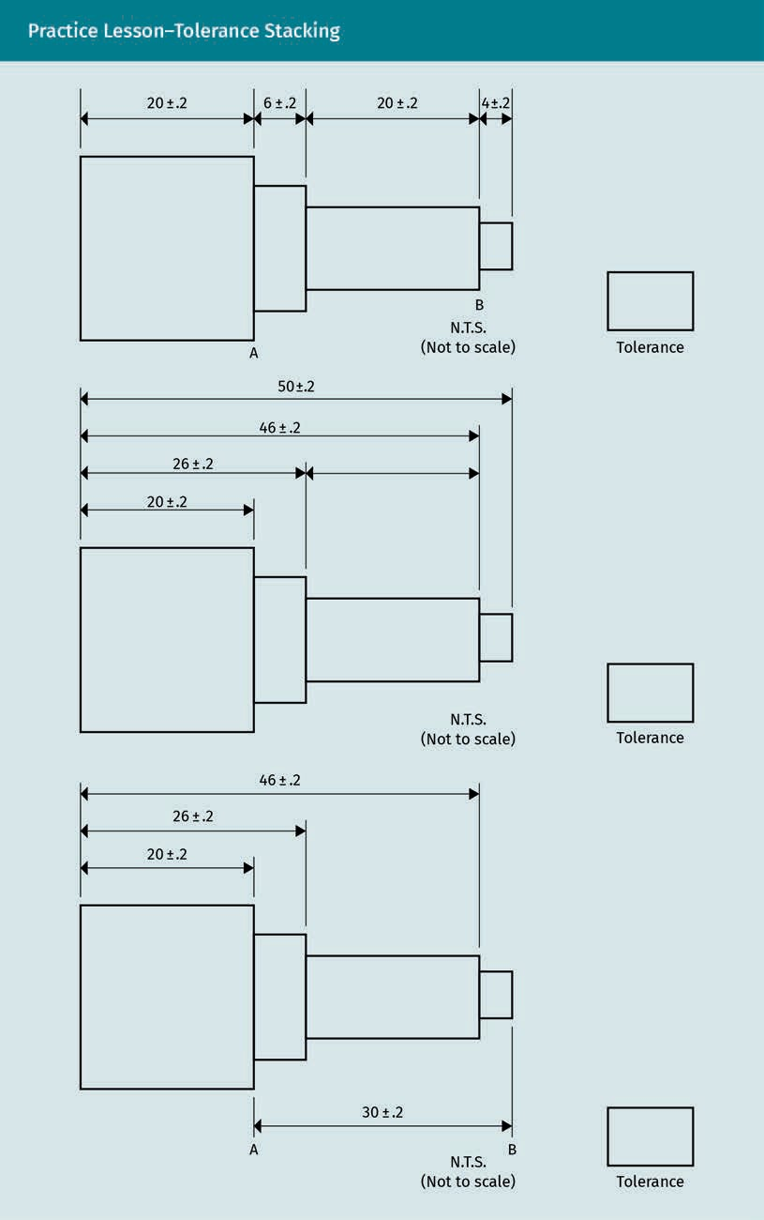

Fortunately, computer programs now solve tedious calculations. For example, CADD enables the accurate placement and editing of GD&T symbols (Madsen & Madsen, 2016). Keep in mind that it is still your responsibility to follow best drafting practices and comply with all applicable standards for tolerancing.

Summary

All actual geometries have deviations. Tolerances deﬁne upper and lower limits to control how much deviation can occur while retaining the intended function of a feature. The use of general tolerances located in a note or title block is recommen- ded whenever possible. Geometric dimensioning and tolerancing (GD&T) uses a feature control frame to specify individual tolerances on technical drawings. It includes the geometric characteristic symbol, the tolerance value, material condi- tion modiﬁers (if available), and datum references. The geometric properties of form do not use datum points in tolerancing. Datum points are optional for proﬁle tolerancing and required for all other geometric tolerance speciﬁcations of fea- tures.

Standard ﬁtting systems, developed to address international production, ensure the interchangeability of two adjoining parts. They also reduce costs and serve to sim- plify the process of tolerancing for limits and ﬁts. ISO 286 provides standard nomenclature for classiﬁcation of ﬁts for shafts and holes. Clearance, Transition, and Interference are three types of ﬁts based on the space between a shaft and hole (ISO, n.d.-d).

ISO 286-2 provides tables for standard ﬁts of shafts and holes. Two basic types of determining ﬁts are basic hole and basic shaft. While there are several considera- tions concerning choice, neither affect the function of a piece. Due to reduced costs of gauging a hole, a basic hole is typically recommended (ISO, n.d.-e). When no ISO standard exists, use German standards, e.g., DIN 7154 and 7155 (DIN, n.d.-g; n.d.-h).
Fits, tolerance zones, and allowances are addressed in DIN 7157 (DIN, n.d.-i).

Calculations of tolerance chains are needed to minimize problems of tolerance stacking, or accumulation of tolerances. Statistical tolerancing is the accepted method to use, rather than arithmetical. However, CAD programs now are relied upon to minimize stacking and calculate chains when necessary. Even with CAD, the technical drafter must be responsible for following standards and best practices in both drafting and tolerancing.



Unit 7

Standards

STUDY GOALS

On completion of this unit, you will be able to …

… name the various classiﬁcations of standards.
… understand what is important when choosing standards.
… name the organizations that provide technical drawing standards.
… identify the beneﬁts and considerations when using standard parts.

DL-E-DLBROTD01_E-U07

- Standards

Introduction
There are numerous organizations providing standards to the world of design and engi- neering. These include schools and work ﬁrms, which provide company standards for machining, manufacturing, and production. Industry and professional organizations also provide standards. There are also more formally accepted standards, i.e., national, multi-national, and worldwide standards, which may have their own set of classiﬁca- tions. Professionals are familiar with most of these standards and students of technical drawing proﬁt from the vast resources available.

The drawing standards within any major standard group are of primary importance to the technical illustrator. They are typically categorized as basic rules regarding drawing and documentation and imaging certain features or views. Each design discipline has particular standards relating to their ﬁeld. Speciﬁc to the mechanical engineering and closely associated disciplines are classiﬁcations of geometry, tolerancing, and ﬁts.

The use of standard parts is valuable to technical drafters because they may reduce costs and save much time that would have otherwise been spent designing or drawing parts. There are other pros and cons to the use of standard parts and these need to be weighed for each project. Advancements in technology and sustainability also factor heavily into the decision-making process.

Classiﬁcation of Standards

Standard This is an agreed upon best practice used in the industry.
A standard is a guide that an organization draws upon in order to facilitate clarity of communication, also deﬁned as “a repeatable, harmonized, agreed, and documented way of doing something. Standards contain technical speciﬁcations or other precise cri- teria designed to be used consistently as a rule, guideline, or deﬁnition” (International Renewable Energy Agency, 2013, para. 1). Standards are developed by many experts involving an industry or group of stakeholders with a common interest to create agreed upon terminology, symbology, and methods of working in their ﬁeld. According to the International Organization for Standardization (ISO, n.d.-n), standards are “a formula describing the best way of doing something. It could be about making a product, man- aging a process, delivering a service or supplying materials—standards cover a huge range of activities” (paras. 1—2).

There are many beneﬁts to using standards; they protect consumers, support and facil- itate international trade, and are accepted as best practice. Through the use of stand- ards, safe and reliable quality expectations are established and costs are reduced. These changes lead to an improvement in products and services, thereby protecting the consumers. Standards also enable trade between countries as they give common methods and measures of quality evaluation, as well as common terminology. These aspects of standards reduce the barriers to international trade, helping the global economy.

Standards

Due to the aforementioned reasons, standards are commonly accepted as best prac- tice. They have been proven to save time and costs by using prescribed means and methods, and they reduce liability risk by using prescribed best practices from other areas. Additionally, standards have some social beneﬁts when it comes to sustainability and global issues; standards are available to underdeveloped countries, which can help them to develop their own best practices.

Standards do not require compliance in their use unless adopted by a regulatory agency or are speciﬁed in a contract. This is signiﬁcant for technical drawing because it is important to consider which regulatory agent has authority for a project, which standards they may require, whether a standard is required by contract, and if using the correct standard can avoid rework. Furthermore, and perhaps most importantly, knowing whether standards are required may reduce liability risks. The project manager will also know if a standard is required per contract, or if there is a standard used by the ﬁrm. Some ﬁrms have actually developed their own set of standards to use. Many different standards are available. Knowing which one to use is critical to avoid having to redraw or even recalculate dimensions and tolerances. According to Bello (2012), “engineering drawing is a form of language in its own right with rules and signs. Just as it is applicable to any language, certain rules (or standards) must be followed in pro- ducing any drawing” (p. 16).

There are many levels of standards. Firms, companies, industries, and professional organizations all have standards, and there are also national, multi-national, and worldwide standards. With so much to consider, it is easier to break it down into vari- ous classiﬁcations of standards, which may have classiﬁcations themselves.

Firm and Company Standards

Typically, these standards are recommended for users within their industry. An example is that of a high-end car company. It should not be surprising that the car company would have their own exacting high standards. Such standards are not binding, but when they are speciﬁed in a contract, they may become binding. If required by your school, your grade may be affected depending on whether you are using the required standards. If so, realize that this level of scrutiny is to prepare students for real-life sce- narios when much more than a grade may be at stake. Your employer may use stand- ards speciﬁc to their needs and clientele. Whether within a company, profession, or industry, standards are developed upon agreement by experts.

Industry and Professional Associations

Nearly all professions and specialized industries have standards as guidelines of adherence for their members. The standards may range from ethics to certiﬁcation standards. Some include standards of care. In architecture and engineering, there are many organizations providing standards for different aspects of the profession. The fol- lowing organizations address or provide helpful support for technical drawing:

- Association for Computer Aided Design in Architecture (ACADIA) (ACADIA, n.d.)
- American Design Drafting Association (ADDA) (ADDA, n.d.)
- The AutoCAD User Group International (AUGI) (AUGI, n.d.)

The American Society of Automotive Engineers (ASME), Verein Deutscher Ingenieure (Association of German Engineers) (VDI), and Verband der Deutschen Automobilindus- trie (German Association of the Automotive Industry) (VDA) are examples of standards organizations for speciﬁc professions or industries that may be implemented in mechanical engineering. The ASME sets standards and deﬁnes best practices for the technical drawing of mechanical parts or assembly, and the VDI and VDA set standards for the German automobile industry (American Society of Mechanical Engineers [ASME], n.d.-a; Verein Deutscher Ingenieure, n.d.; German Association of the Automotive Indus- try, n.d.).

National and Multi-National Standards

Many of the following national standards have been incorporated into the international ISO system because their countries are members of the ISO:

- British Standards Institution (BSI). Technical product speciﬁcations for engineering standards provide routing to 150 ISO standards (British Standards Institution, n.d.).
- American National Standards Institute (ANSI). ANSI adopted many of ASME’s stand- ards. The ANSI system is commonly used in Canada, the US, and parts of northern Mexico. ANSI represents the US’s contribution to the ISO (American National Stand- ards Institute [ANSI], n.d.).
- Deutsches Institut für Normung (DIN). The German DIN is respected in many coun- tries for use in engineering professions (Deutsches Institut für Normung [DIN], n.d.- a).
- European Standards (EN). EN is a multi-national standard reference throughout Europe (European Committee for Standardization, n.d.).

Other national standards include the Bureau of Indian Standards, the Saudi Standards, Metrology and Quality Organization (SASO), and the Japanese Standard Association (JSA) (Bureau of Indian Standards, n.d; ISO, n.d.-m; n.d.-k).

Worldwide or Global Standards

Keep in mind that more than one standard may apply to your project. Organizations publish standards as a harmonized synthesis of agreed upon means and methods. However, a consensus may mean that standards “lack some of the clarity, detail or spe- ciﬁc criteria certain stakeholder groups or individuals would have preferred” (Interna- tional Renewable Energy Agency, 2013, para. 2). It is a reason for constant review and revisions of standards. As they are implemented, expert users re-evaluate and seek to improve standards. The following is a list of organizations that publish standards:

Standards

- The American Society of Heating, Refrigerating and Air-Conditioning Engineers (ASH- RAE), has many goals, including indoor air quality, refrigeration, more efﬁcient energy, building systems, and sustainability within the industry (American Society of Heating, Refrigerating and Air-Conditioning Engineers, n.d.).
- The American Society for Testing and Materials (ASTM) develops and publishes tech- nical standards for a wide range of materials, products, services, and systems, pro- viding over 12,500 voluntary consensus standards globally (American Society for Testing and Materials, n.d.).
- The International Electrotechnical Commission (IEC) provides standards for electrical and electronic goods. The IEC publishes international standards that help govern- ments build infrastructure. The standards also manage risk and quality and stand- ardize safety regulations, enabling reliable trade to most countries (International Electrotechnical Commission, n.d.).
- The International Standards Organization works closely with the International Elec- trotechnical Commission (IEC) and the International Telecommunication Union (ITU) in addition to having a strategic partnership with the World Trade Organization (WTO) promoting free and fair trade globally (International Telecommunication Union, n.d.; World Trade Organization, n.d.). ISO is the go-to standard for most mechanical engineering and architectural needs, especially relating to technical drawing, which is only one of many classes within ISO.

There are numerous technical drawing standards, and certainly too many to address in one course. The most important hint for any technical illustrator to know is to ask if you don’t know. Although you are never expected to know all the standards, you will eventually become quite familiar with many as you work, and some will become sec- ond nature to you.

Technical Drawing Standards
With standards for technical drawing that begin with paper size, title blocks, and line types, and progress through computer-aided design (CAD) standards, tolerancing standards, and standard parts, the technical drafter may feel confused and over- whelmed by all the rules. However, the standards are designed to make the work of the technical drafter easier; you should learn them as you go. Standards are simply a part of the communication tools available to you. Recognize that as you learn the language of technical drafting, you will become well-versed in the profession. Many standards have been introduced in this course, so you may already know some of them. For the purposes of mechanical engineering, they can be generally classiﬁed into a few groups: basic rules, imaging features and views, geometry, tolerancing, and ﬁts. This section can serve as a reference tool when you need to rely on a standard that is not yet second nature to you. It is also easy to go directly to the standard organization online and search for your particular needs. You should have the most used and updated stand- ards readily available either electronically or on your desk. Student versions are usually available and ISO also publishes a standards handbook.

ISO Standards Reference List

ISO standards The most critical standards to techni- cal drawing for robotics are ISO 128, 286, and 2768. These are extensive stand- ards covering many
topics for the mechanical and robotic engineering
professions.
This list of ISO standards is provided for initial reference, keeping in mind that it is crit- ical to research and use the most current standard available. Standards are reviewed every ﬁve years. A list is also available on the ISO online browsing platform (ISO, n.d.-n). The following is a short list of basic standards:

- ISO 128. This series of standards gives general rules for the execution of technical drawings (2-D and 3-D) and presents the structure of the other parts of the ISO 128 series. This document is applicable to technical drawing in the ﬁelds of mechanical engineering, construction, architecture, and shipbuilding. It is useful for both man- ual and computer-based technical drawings. For the purpose of this document, the term “technical drawing” shall be interpreted in the broadest possible sense, encompassing the total package of documentation specifying the product (work- piece, subassembly, and assembly). ISO 128-100 is the index for this group of stand- ards and was updated in 2020 (ISO, n.d.-u).
- ISO 286. This standard is also relevant in the ﬁeld of technical drawing. It deﬁnes the ISO code system for tolerances that should be used for linear sizes of cylinders and two parallel opposite surfaces (ISO, n.d.-d).
- ISO 2768. This standard provides simple versions of drawing indications and speci- ﬁes general tolerances for linear and angular dimensions (ISO, n.d.-a).

A table of further important ISO standards regarding imaging features and views is shown below.

Imaging Features and Views I
ISO number | ISO name
ISO 5261 | Technical drawings—Simpliﬁed representation of bars and proﬁle sections (ISO, n.d.-s)
ISO 5455 | Technical drawings—Scales (ISO, n.d.-p)
ISO 5456, Parts 1—4 | Technical drawings—Projection methods (ISO, n.d.- q)
ISO 6410 | Technical drawings—Screw threads and threaded parts (ISO, n.d.-r)
ISO 261 | ISO general purpose metric screw threads—Gen- eral plan (ISO, n.d.-i)

Standards

Further ISO standards regarding geometry, tolerancing, and ﬁts are shown in the table below.

Imaging Features and Views II
ISO number | ISO name
ISO 129-1:2018/AMD 1:2020 | Presentation of dimensions and tolerances part 1: General principles (ISO, n.d.-p)
ISO 1101 | GPS—Geometrical tolerancing—Tolerances of form, orientation, location, and run-out (ISO, n.d.-p)
ISO 1302 | Geometrical product speciﬁcations (GPS)—Indica- tion of surface texture in technical product docu- mentation (ISO, n.d.-p)
ISO 1660:1987 | Technical drawings—Dimensioning and tolerancing of proﬁles (ISO, n.d.-o)
ISO 2692 | Geometrical product speciﬁcation (GPS)—Geomet- rical tolerancing—Maximum material requirement (MMR) and least material requirement (LMR) (ISO, n.d.-p)
ISO 5458:1998 | Geometrical product speciﬁcations (GPS)—Geo- metrical tolerancing—Positional tolerancing (ISO, n.d.-p)
ISO 5459:1981 | Technical drawings—Geometrical tolerancing— Datums and datum-systems for geometrical toler- ances (ISO, n.d.-p)
ISO 8015:1985 | Technical drawings—Fundamental tolerancing principle (ISO, n.d.-p)
ISO 10578:1992 | Technical drawings—Tolerancing of orientation and location—Projected tolerance zone (ISO, n.d.-t)
ISO/TS 12180:2003 | Parts 1 and 2—Geometrical product speciﬁcations (GPS)—Cylindricity (ISO, n.d.-b)

ISO number | ISO name
ISO/TS 12181:2003 | Parts 1 and 2—Geometrical product speciﬁcations (GPS)—Roundness (ISO, n.d.-f)
ISO/TS 12780:2003 | Parts 1 and 2—Geometrical product speciﬁcations (GPS)—Straightness (ISO, n.d.-g)
ISO/TS 12781:2003 | Parts 1 and 2—Geometrical product speciﬁcations (GPS)—Flatness (ISO, n.d.-c)
ISO 25178:2012 | Parts 1 and 3—Geometrical product speciﬁcations (GPS)—Surface texture: Areal (ISO, n.d.-h)

ISO 17450 2016 is also of special interest to mechanical engineers; it consists of the general requirements for tolerancing under the title geometrical product speciﬁcation (GPS).

DIN Standards Reference List

ISO standards are valid worldwide and usually also adapted by most member coun- tries. However, in addition there are national standards, e.g., the following standards published by the DIN in Germany:

  - DIN 30: Technical drawings—Simpliﬁed drawing—Part 10: Simpliﬁed indications and collective indication, execution (DIN, n.d.-d)
  - DIN 103: ISO metric trapezoidal screw thread; proﬁles (DIN, n.d.-b)
  - DIN 199: Technical product documentation—CAD models, drawings, and items lists (DIN, n.d.-c)
  - DIN 323-1: Preferred numbers and series of preferred numbers: Basic values, calcula- ted values, rounded values (DIN, n.d.-e)
  - DIN 4760: Form deviations; concepts, classiﬁcation system (DIN, n.d.-f)
  - DIN 7154, 7155, 7157: ISO ﬁts for the hole basis system; tolerance zones, deviations (DIN, n.d.-g; n.d.-c; n.d.-i)

ASME Standards Reference List

ASME standards are usually accepted in the US and elsewhere when no ISO standard is available. The following is a list of important ASME standards:

  - ASME B46.1—2002 Surface texture (surface roughness, waviness, and lay) (ASME, n.d.- k)
  - ASME Y14.1—1995 Decimal inch drawing sheet size and format (ASME, n.d.-c)

Standards

- ASME Y—14.100 2017 Engineering drawing practices (ASME, n.d.-e)
- ASME Y14.2—2018 Line conventions and lettering (ASME, n.d.-f)
- ASME Y14.3—2012 Orthographic and pictorial views (ASME, n.d.-h)
- ASME Y14.5—2018 Geometric dimensioning and tolerancing (ASME, n.d.-d)
- ASME Y14.13M—1981 Mechanical spring representation (ASME, n.d.-g)
- ASME Y14.36—Surface texture symbols (ASME, n.d.-l)
- ASME Y14.6—2001 Screw thread representation (ASME, n.d.-j)

The ASME website states that “the Y14.5 standard is considered the authoritative guide- line for the design language of geometric dimensioning and tolerancing (GD&T)” (ASME, n.d.-d, “Description” section). Rules, deﬁnitions, and symbols are established in this standard; recommended practices are also given for stating and interpreting G&T (ASME, n.d.-d).

Choosing a Standard

Asking yourself the following questions may be helpful when deciding which standard to choose if you have not asked and received an answer:

- Does my school or employer require speciﬁc standards? If so, where can I locate them?
- If not, does the ISO have a standard that applies to my need?
- If the ISO does not have an applicable standard, is there an experienced colleague available as a good resource?
- If not, what country is the project owner in?
- Will the project be manufactured in my country or another country? If you can answer this question, try resourcing the standards used in that country.

If no answers are readily available, consider using the standards available locally, either in your jurisdiction or in your industry. As a last resort, search the standards websites for possible answers. These are to be used only if there is no one in a position of authority for you to contact. Another option would be to contact the jurisdictional agency for a recommendation. To avoid this situation altogether, always ask which standards to use when you are assigned a project.

Website Searches and Cataloging of Standards

Today’s professionals are quick to use the power of the internet to answer questions. However, prior to searching, be cautioned that your project may have parameters beyond your knowledge. As an example, the project engineer may have failed to tell you that this project will not follow the company standards you have used in the past. While they are away on vacation, you are tasked with setting up the project and of course, plan to use the company standards, not realizing this would be incorrect. A good draftsperson will not rely on the project manager to tell them, rather they would
ASME
Many standards of the American Society of Automotive Engi- neers (ASME) have been adopted by ANSI and ISO.

ask, and not assume. Once you know which technical drawing standards to use, they will hopefully already be incorporated into your CAD system. Then, it is a great time to rely on searches within CAD or on the website of the standards organization.

Website searches
Website searches for standards within the main organizations may have a listing availa- ble or a search engine to identify standards pertinent to your needs. However, the actual standards are costly. Hopefully, your school or ﬁrm has obtained access for you. If not, you may use the information found online to then access the actual standard in a reference book that should be available to you in the ﬁrm or school library.

Cataloging of standards
Each standards organization has their own cataloging system. After quickly looking over any of these standards, it is apparent that their organization is quite complex. Although it may seem daunting at ﬁrst, it may be helpful to review so that you may more easily search for and access the standards needed without wasting time. The ISO covers so many industries and has so many standards that they have a separate organization to catalog their standards. The ISO has developed over 23,638 international standards and all are included in the ISO standards catalogue (International Organization for Stand- ardization, n.d.-n). Thankfully, many of the ISO standards are for other industries, so there is no need to search through all of them for your particular need. The ISC is responsible for keeping the ISO standards updates and amendments available in their system. On the ISC website, browsing is available either by ICS or technical committee (TC). The online platform browser is also available.

Standard Parts
When the world was more isolated and people made things by hand, it was not neces- sary to standardize parts. However, the wise inventor or craftsperson soon realized that if they had a template or standard pattern for their prototype, they could more efﬁ- ciently create another similar item. Eventually, they realized that they could have others make parts for them according to their speciﬁcations. Steam power and mechanization allowed for increasing standardization. When advancements in industrialization allowed for mass production, the need for standard speciﬁcations became common. Now, with computerization, automation, global design, manufacturing, and distribution, the costs of all facets of the supply chain weigh heavily upon all participants and ulti- mately, the consumer. Processes that demand interchangeability result in time savings and lead to the reduction of costs. Standardization of drawing and design speciﬁca- tions of parts also result in cost savings.

Standards



Technological advances have shown that changes in industry, among other facets of life, is a continuing occurrence. There is a recognition of further computerization, 3-D printing, artiﬁcial intelligence, and growing machine capabilities. This is happening so quickly that it is challenging to keep up with capacities and potentials for ever-evolving systems. The rapidly changing technology makes technical drawing and design an excit- ing career. The evolution of computerization and resulting innovation has created what is now regarded as the fourth industrial revolution or era of cyber physical systems (CPS). Regarding design in CPS, of which robotics is a part, there are many exciting developments and challenges ahead. An example of a challenge is “the large differen- ces in the design practice between the various engineering disciplines involved, such as software and mechanical engineering” (“Cyber-physical system,” 2021, “Design” sec- tion). Hopefully, as we embrace new technologies, our values guide us to make the right ethical choices.

With globalization, sustainability has become a prominent concern in every aspect of life. The cost of continuing to live in unsustainable ways is perhaps even more of con- cern than saving money. The use of standardized parts provides even more value as a sustainable practice because “standardized parts, batteries, power adaptors, chassis, and similar components can be used in multiple generations of products as other ele- ments of the product evolve” (Madsen & Madsen, 2016, p. 115). The use of standardized parts as a sustainable practice proﬁts all of us beyond costs. Cost savings and sustain- ability are the primary purposes for parts standardization. As our technology grows, so will considerations regarding standard parts.

Professionals need to know when a project requires custom parts, or even innovative new parts, and when it is beneﬁcial to use standard parts that may include recycled parts. Whether handmade, mass produced, using traditional design methods, or employing innovative new technologies, all products beneﬁt from a cost-saving sus- tainable approach, including standardized parts when feasible.
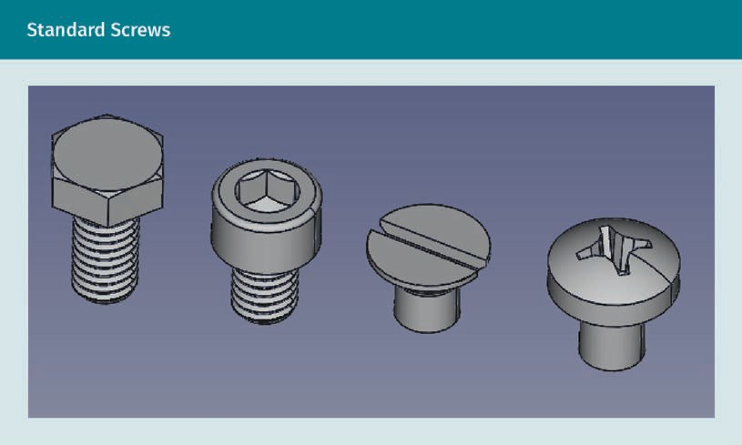

Common standard parts include screws, nuts, and bolts, as well as using the basic shaft or basic hole concept. Fasteners of many kinds are used for ﬁtting parts. DIN EN ISO 4753 standardizes fasteners and ends of parts with external ISO metric screw threads and CAD systems supply more options worth considering when designing the joining of workpieces (DIN, n.d.-j).
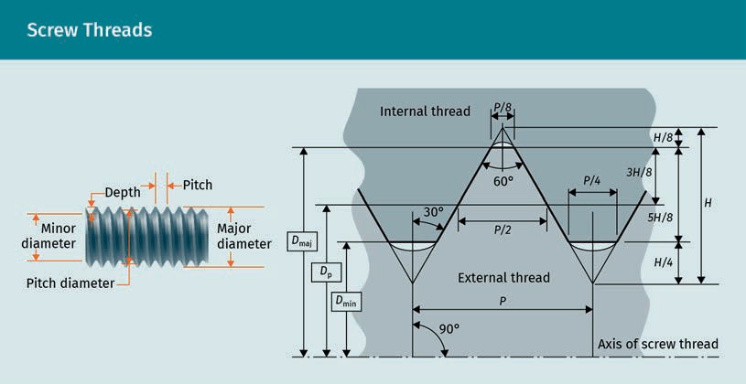

Standards

DIN EN ISO 4753 applies to standardized or non-standardized threaded parts. For each end type, a symbol is speciﬁed, and it is intended that these symbols be used when specifying one of the ends for threaded fasteners (DIN, n.d.-j).
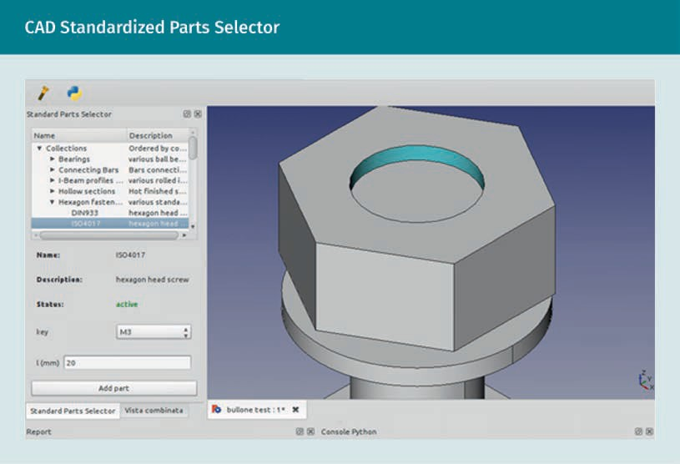
CAD programs, such as the one above, make the selection of standardized parts much quicker than referencing tables.

Beneﬁts of Standard Parts

The profession of technical drawing increasingly beneﬁts from the use of standard parts, which, in many ways, results in economic gains. The following is a list of beneﬁts of using standard parts:

Disadvantages of Using Standard Parts

The following is a list of disadvantages of using standard parts:

- design. More attention can be given to generating ideas for design and functionality, and using standard parts reduces drawing time.
- interchangeability. A huge advantage is knowing that standard parts will work with other standard parts for our global supply chain.
- reliability and cost reduction. Mass production reduces costs, parts are readily avail- able, and standard parts are more reliable due to industry speciﬁcations and proven use.

  - time saving. Built-in tolerancing is more efﬁcient due to the shorter production time.
  - life cycle costing and sustainability. Replacement parts are more readily available as needed, which reduces maintenance costs and time to repair and replace parts. Additionally, durability further maximizes beneﬁts of life cycle costing, and recycla- bility or reusability works towards sustainable living.

Not all of the advantages and disadvantages mentioned above will apply to any one project. It is important to ask questions of your company and manufacturing teams to ﬁnd out if they have experience with using standard parts. If standard parts are to be used, they must be catalogued into the computer-aided design (CAD) program. If they are not already input, this takes much longer than designing a part, so it may not be worth the effort; however, if it will be used again, the cost decreases.

Types of parts may be classiﬁed and managed in a ﬁle folder in your CAD software's computer. Parts management systems help you to ﬁnd and reuse approved standard parts. Like a web browser search tool, parts management systems parse and aggregate parts data so that the right part can be found quickly and efﬁciently. They are typically organized by standards and standard parts frequently used by your company. Addition- ally, they should be searchable by preferred standard parts and industry standards. Using a parts management system allows the designer, intern, or drafter to focus more on the design and drafting aspects with which they are tasked.

This is just one of the many possibilities to consider. Always check with your team to ﬁnd out what the most feasible solution is to optimize your project from design to pro- duction, marketing, and life cycle considerations. Communication is key both within your ﬁrm and with other companies if they are manufacturing and/or supplying parts. When deciding whether using a standard part is the best plan, keep the ultimate goal in mind: Technical drawing is a tool for communication and its purpose is to ensure that the designer’s intent is carried through.

  - cost. If the standard parts are of a high quality, they could be more expensive.
  - designing to make parts, rather than for innovation. This approach could result in an inferior product and possibly take more time.
  - availability. When using standard parts, you must rely on others to supply them. This could take a long time to order and a lot of storage space if you buy them in bulk or need to have them readily available.
  - quality. You must rely on other manufacturer’s quality control, which may not be of a similar standard to your own.

Summary
Standards can be classiﬁed in several ways, as there are many organizations creat- ing standards. For the purposes of this course, they are split in to four groups. The ﬁrst group is your school, ﬁrm, or company standards (including manufacturer’s standards).

Standards

Professions and industries also create their own standards speciﬁc to their needs; these form the second group of standards. The automotive industry as a whole has standards in both the US and Germany; the two organizations responsible for creat- ing these standards are the Verein Deutscher Ingenieure (Association of German Engineers) (VDI) and the American Society of Automotive Engineers (ASME) in the US. ASME standards are also used by mechanical engineers in the US and in other countries when international standards are not available.

The third group comprises national standards developed for some countries. Ger- many, the United Kingdom, and Japan, among other countries, have nationally rec- ognized and accepted standards. Countries in Europe use the EN as a multi- national standard.

The fourth group includes international standards with members from many coun- tries; these standards have many beneﬁts, including global sustainability and trade. The ISO international standard covers many different disciplines and countries. The ISO’s standards are used in architecture and engineering and the ISO is the go-to organization for technical drawing standards.

With the advancement of computerization into cyber physical systems, the profes- sion of technical drawing will experience changes and challenges. These changes and current option of standard parts demand the speciﬁer to carefully base choices on values and ethics, and not just obvious beneﬁts that may have unintended drawbacks. Standard parts have become readily available with many beneﬁts relat- ing to cost, but are not always the best solution. Speciﬁers need to carefully evalu- ate the pros and cons before choosing to use a standard part.

Knowledge Check
Did you understand this unit?

You can check your understanding by completing the questions for this unit on the learning platform.

Good luck!



Appendix 1

List of References

List of References

Abhishekmep2014. (2015). Free-form surface milling [Illustration]. Wikimedia Commons. https://en.wikipedia.org/wiki/Freeform_surface_machining#/media/File:FREE-FORM- SURFACE-MILLING.png

American Design Drafting Association. (n.d.). Homepage. https://www.adda.org/ American National Standards Institute. (n.d.). ANSI homepage. https://www.ansi.org/
American Society for Testing and Materials. (n.d.). About us. https://www.astm.org/ ABOUT/overview.html

American Society of Heating, Refrigerating and Air-Conditioning Engineers. (n.d.). About. https://www.ashrae.org/about

American Society of Mechanical Engineers. (n.d.-a). About ASME. https://www.asme.org/ about-asme

American Society of Mechanical Engineers. (n.d.-b). ANSI/ASME Y14.1-1995. https:// webstore.ansi.org/standards/asme/ansiasmey141995r2002
American Society of Mechanical Engineers. (n.d.-c). ASME homepage. www.asme.org American Society of Mechanical Engineers. (n.d.-d). Dimensioning and tolerancing: Y14.5
—2018. https://www.asme.org/codes-standards/ﬁnd-codes-standards/y14-5-dimen-
sioning-tolerancing

American Society of Mechanical Engineers. (n.d.-e). Engineering drawing practices: Y14.100—2013. https://www.asme.org/codes-standards/ﬁnd-codes-standards/y14-100- engineering-drawing-practices

American Society of Mechanical Engineers. (n.d.-f). Line conventions and lettering: Y14.2. https://www.asme.org/codes-standards/ﬁnd-codes-standards/y14-2-line-conven- tions-lettering

American Society of Mechanical Engineers. (n.d.-g). Mechanical spring representation: Y14.13M—1981. https://www.asme.org/codes-standards/ﬁnd-codes-standards/y14-13m- mechanical-spring-representation

American Society of Mechanical Engineers. (n.d.-h). Orthographic and pictorial views: Y14.3—2012. https://www.asme.org/codes-standards/ﬁnd-codes-standards/y14-3-ortho- graphic-pictorial-views

American Society of Mechanical Engineers. (n.d.-i). Orthographic and pictorial views: Y14.3—2012(R2018). https://www.asme.org/codes-standards/ﬁnd-codes-standards/ y14-3-orthographic-pictorial-views

List of References

American Society of Mechanical Engineers. (n.d.-j). Screw thread representation: Y14.6— 2001. https://www.asme.org/codes-standards/ﬁnd-codes-standards/y14-6-screw- thread-representation

American Society of Mechanical Engineers. (n.d.-k). Surface texture (surface roughness, waviness, and lay): B46.1—2019. https://www.asme.org/codes-standards/ﬁnd-codes- standards/b46-1-surface-texture

American Society of Mechanical Engineers. (n.d.-l). Surface texture symbols: Y14.36—2018. https://www.asme.org/codes-standards/ﬁnd-codes-standards/y14-36-surface-texture- symbols

Anderson, P. (1979). Floor plan, south, east, and west elevations—Lee Mangus cabin, Moose, Teton County, WY [Illustration]. Wikimedia Commons. https://commons.wikime- dia.org/wiki/File:Floor_Plan,_and_South,_East_and_West_Elevations_-_Lee_Man- gus_Cabin,_Moose,_Teton_County,_WY_HABS_WYO,20-MOOS.V,6-_(sheet_2_of_4).png

Anderson, W. (2019). Technical drawing and alphabet of line. SchoolWorkHelper. https:// schoolworkhelper.net/technical-drawing-alphabet-of-line/

AndrewBuck. (2010). Hubble exploded [Illustration]. Wikimedia Commons. https:// de.wikipedia.org/wiki/Datei:HubbleExploded_edit_1.svg

Andrewpmk. (2007). Gd&t [Infographic]. Wikimedia Commons. https://en.wikipedia.org/ wiki/File:Gd%26t.png

ANSI/ASME Y14.1. (2021, 24 January). In Wikipedia. https://en.wikipedia.org/wiki/ANSI/ ASME_Y14.1

Association for Computer-Aided Design in Architecture. (n.d.). Homepage. http:// acadia.org/

AutoCAD User Group International. (n.d.). Homepage. https://www.augi.com/ Autodesk. (n.d.-a). Autodesk homepage. https://www.autodesk.com/
Autodesk. (n.d.-b). Fusion 360. https://www.autodesk.com/products/fusion-360/over- view

Autodesk. (n.d.-c). Inventor. https://www.autodesk.com/products/inventor/overview? term=1-YEAR&support=null

BAxelrod. (2003). Mech draw 1 [Illustration]. Wikimedia Commons. https:// commons.wikimedia.org/wiki/File:Mech_draw_1.png

Bellis, M. (2020, August 26). Leonardo da Vinci quotes. ThoughtCo. https:// www.thoughtco.com/leonardo-da-vinci-quotes-1991581

Bello, E. S. R. (2012). Technical drawing presentation and practice. CreateSpace.

Benrobuck. (2011). Engineering drawings with machinery’s handbook [Illustration]. Wiki- media Commons. https://commons.wikimedia.org/wiki/File:Engineering_draw- ings_with_Machinery%27s_Handbook.jpg

Bhushan, B. (2000). Surface roughness analysis and measurement techniques. CRC Press.

Biezl. (2009a). First angle projecting [Illustration]. Wikimedia Commons. https:// commons.wikimedia.org/wiki/File:First_angle_projecting.svg

Biezl. (2009b). Third angle unfolding [Illustration]. Wikimedia Commons. https:// de.m.wikipedia.org/wiki/Datei:Third_angle_unfolding.svg

Blanco, E., Wilson, D. G., Tsutsumi, S., & Flowers, W. (2009). Design handbook: Engineer- ing drawing and sketching. MIT.

Boér, J., & Blaga, P. (2018). Reducing production costs by monitoring the roughness of raw product surfaces. Procedia Manufacturing, 22, 202—208. https://doi.org/10.1016/ j.promfg.2018.03.031

Bolognini, S. (2008). Heracles and Omphale [Illustration]. Wikimedia Commons. https:// en.wikipedia.org/wiki/File:Affresco_romano_-_eracle_ed_onfale_-_area_vesuviana.JPG

British Standards Institution (n.d.). British standards online (BSOL). https:// www.bsigroup.com/en-GB/standards/british-standards-online-database/?crea- tive=337707665987&keyword=bs%20standards&matchtype=b&net- work=g&device=c&gclid=EAIaIQobChMIsry_5IfY8AIVjbrtCh35WQI8EAAYASAAEgK- KUvD_BwE&gclsrc=aw.ds

Bromskloss. (2006a). ANSI size illustration2 [Illustration]. Wikimedia Commons. https:// en.wikipedia.org/wiki/File:ANSI_size_illustration2.svg

Bromskloss. (2006b). A size illustration2 [Illustration]. Wikimedia Commons. Brssareepun. (2009). Isometric [Illustration]. Thaigoodview.
BS 8888. (2020, 18 November). In Wikipedia. https://en.wikipedia.org/wiki/BS_8888

Bureau of Indian Standards. (n.d.). Bureau of Indian Standards homepage. https:// bis.gov.in/

CADFanatic. (2009). Annotation attachments [Illustration]. http://www.cadfanatic.com/ 2009/09/20-favorite-improvements-in-solidworks-2010/

Calkins, S. (n.d.). Assembly drawing: Spare parts [Illustration]. Pixy.org.

List of References

Cdang. (2006). Perspective isometrique cube ellipses [Isometric perspective cube ellip- ses] [Illustration]. Wikimedia Commons.

Cdang. (2011a). Ajustements fonctionnels assemblage visse [Functional adjustments screw assembly] [Illustration]. https://commons.wikimedia.org/w/index.php? curid=15565430

Cdang. (2011b). Dimensions planche exercice [Exercise board dimensions] [Illustration]. Wikimedia Commons. https://commons.wikimedia.org/wiki/File:Dimensions_plan- che_exercice.svg

Chickensaresocute. (2013). Brain lateralization [Illustration]. Wikimedia Com- mons. https://commons.wikimedia.org/wiki/File:Brain_Lateralization.svg

Chiesa, L. (2006). Gear pump exploded [Illustration]. Wikimedia Commons.

Clker-Free-Vector-Images. (2014a). Gear [Stock image]. Pixabay. https://pixabay.com/ vectors/gear-wheel-mechanical-mechanism-311996/

Clker-Free-Vector-Images. (2014b). Girl [Illustration]. Pixabay.

Cmglee. (2011). 3D shapes in isometric projection [Illustration]. Wikimedia Com- mons. https://commons.wikimedia.org/wiki/File:3D_shapes_in_isometric_projection.svg

Cmglee. (2019). Comparison of graphical projections [Illustration]. Wikimedia Commons.

Con-struct. (2013). Title block EN ISO 7200. Wikimedia Commons. https://en.wikipe- dia.org/wiki/File:ARCH_PAPER_SIZES_v3.svg

Costin, R. (2019). Basic blueprint reading. Open Oregon Education Resources.

Coyot. (2016). Sketching [Photograph]. Pixabay. https://pixabay.com/de/photos/kunst- zeichnung-papier-skizzieren-1714166/

Crick, F. H. C. (1953). Pencil sketch of the DNA double helix [Illustration]. The Well- come Library. https://wellcomecollection.org/works/kmebmktz

Cruzan, J. (n.d.). Circles [Illustration]. Xaktly. https://xaktly.com/GeometryDeﬁni- tions.html

Cyber-physical system. (2021, February 7). In Wikipedia. https://en.wikipedia.org/wiki/ Cyber-physical_system

da Vinci, L. (n.d.). Flywheels [Illustration]. Wikimedia Commons.

de Chiara, G. (2014). Dragon CRS isometric [Illustration]. Wikimedia Commons.

de Graaf, J. (2010). Sample rendering [Illustration]. De Graaf Design Associate’s Blog.

Delgadito. (2009). Catia V5 [Illustration]. Wikimedia Commons.

Deutsches Institut für Normung. (n.d.-a). Deutsches Institut für Normung homepage
[The German institute for standardization homepage]. https://www.din.de/de

Deutsches Institut für Normung. (n.d.-b). DIN 103-1. ISO metric trapezoidal screw threads; proﬁles. https://www.din.de/en/getting-involved/standards-committees/natg/ publications/wdc-beuth:din21:677778

Deutsches Institut für Normung. (n.d.-c). DIN 199-1:2002-03. Technical product documen- tation—CAD models, drawings and item lists—Part 1: Vocabulary. Beuth Verlag. https:// www.beuth.de/en/standard/din-199-1/46493205

Deutsches Institut für Normung. (n.d.-d). DIN 30-10. Technical drawings—Simpliﬁed drawing—Part 10: Simpliﬁed indications and collective indication, execution. https:// www.din.de/en/getting-involved/standards-committees/natg/publications/wdc- beuth:din21:84857498

Deutsches Institut für Normung. (n.d.-e). DIN 323-1. Preferred numbers and series of pre- ferred numbers; basic values, calculated values, rounded values. https:// www.din.de/en/getting-involved/standards-committees/natg/publications/wdc- beuth:din21:683378

Deutsches Institut für Normung. (n.d.-f). DIN 4760. Form deviations; concepts; classiﬁca- tion systems. https://www.din.de/en/getting-involved/standards-committees/natg/ publications/wdc-beuth:din21:962490

Deutsches Institut für Normung. (n.d.-g). DIN 7154-1:1966-08. ISO-ﬁts for the hole basis system; tolerance zones; deviations. Beuth Verlag. https://www.beuth.de/en/standard/ din-7154-1/25835463

Deutsches Institut für Normung. (n.d.-h). DIN 7155:1966-08. ISO ﬁts for the shaft basis system; tolerance zones, deviations. Beuth Verlag. https://www.beuth.de/en/standard/ din-7155-1/25834090

Deutsches Institut für Normung. (n.d.-i). DIN 7157:1966-01. Recommended selection of ﬁts; tolerance zones, allowances, ﬁt tolerances. Beuth Verlag. https://www.beuth.de/en/ standard/din-7157/506077

Deutsches Institut für Normung. (n.d.-j). DIN EN ISO 4753. https://www.din.de/en/ getting-involved/standards-committees/fmv/publications/wdc-beuth:din21:144411311? destinationLanguage=&sourceLanguage

Dmgerman. (2007). Pencils HB [Illustration]. Wikimedia Commons. DrJunge. (2006). Transmission diagram [Illustration]. Wikimedia Commons.

List of References

Ebber, N. (2014). Design thinking process in the chapters dialogue project [Illustration]. Wikimedia Commons.

Ecloud. (2014). Hex nut for bolts [Illustration]. Public Domain Files. Edwards, B. (1999). The new drawing on the right side of the brain. Penguin.
Emok. (2008). Surface ﬁnish waviness ﬁlter type [Illustration]. Wikimedia Commons. https://commons.wikimedia.org/wiki/File:Surface_ﬁnish_waviness_ﬁlter_type.svg

Engineering Essentials. (n.d.). Engineering drawing format and contents. http:// eon.sdsu.edu/~johnston/Eng_Graphics_Essentials_5th_Ed/ﬁles/ege/intro/ intro_page6.htm

European Committee for Standardization. (n.d.). European standards. https:// www.cen.eu/work/products/ens/pages/default.aspx

File Upload Bot (Magnus Manske). (2008). Cad crank [Illustration]. Wikimedia Commons. https://commons.wikimedia.org/wiki/File:Cad_crank.jpg

Fox Valley Technical College. (n.d.). Alphabet of lines. https://www.wisc-online.com/ GammaPlus/Apps/ViewFlashcardApp/170?randomAnswers=True

Frey, D., & Gossard, D. (2009). 2.007 design and manufacturing I. MIT OpenCourseWare.

German Association of the Automotive Industry. (n.d.). Safety and standards. https:// www.vda.de/en/topics/safety-and-standards.html

Gleich, S. (2006). Engineering drawing of a machine tool part [Illustration]. Wikimedia Commons.

Gupta. (2009). Full extrude cut [Illustration]. Boxer’s CAD CAM Blog.

Historic American Buildings Survey. (2008). Recording historic structures and sites with HABS measured drawings. https://www.nps.gov/hdp/standards/HABS/HABSDraw- ings.pdf

Hamiltonian of Design. (2014). Perspective projection [Illustration]. Hansen, C. D., & Johnson, C. R. (2004). The visualization handbook. Elsevier.
Hartmann, T. (2006). Engineering drawing (with BOM) of a worm gear [Illustration]. Wiki- media Commons.

Harvey, A. (2008). Trimetric [Illustration]. Andrew Harvey’s Blog. https://andrewhar- vey4.wordpress.com/2008/11/

HeatherPaque. (2016). Pencil holding [Illustration]. Pixabay.

Henzold, G. (2006). Geometrical dimensioning and tolerancing for design, manufactur- ing, and inspection. Elsevier.

Heupel, E. (n.d.). Desktop sketching [Illustration]. CUNY Academic Commons. Holley, M. (2012). Drafting board with T square [Illustration]. Wikimedia Commons.
Inductiveload. (2008). ISO and UTS thread dimensions (sk) [Illustration]. Wikimedia Commons. https://commons.wikimedia.org/wiki/File:ISO_and_UTS_Thread_Dimen- sions_(sk).svg

Inductiveload. (2009). Summary of basic size, fundamental deviation and IT grades compared to minimum and maximum sizes of the shaft and hole [Illustration]. Wikime- dia Commons. https://en.wikipedia.org/wiki/Engineering_tolerance#/media/ File:Mechanical_Tolerance_Deﬁnitions.svg

International Bureau of Weight and Measures. (n.d.). Worldwide metrology. https:// www.bipm.org/en/worldwide-metrology/

International Electrotechnical Commission. (n.d.). What we do. https://www.iec.ch/what- we-do

International Organization for Standardization. (n.d.-a). General tolerances—Part 1: Tol- erances for linear and angular dimensions without individual tolerance indications (ISO Standard No. 2768-1:1989). https://www.iso.org/standard/7748.html

International Organization for Standardization. (n.d.-b). Geometrical product speciﬁca- tions (GPS)—Cylindricity—Part 1: Vocabulary and parameters of cylindrical form (ISO Standard No. ISO/TS 12180-1:2003). https://www.iso.org/standard/38353.html

International Organization for Standardization. (n.d.-c). Geometrical product speciﬁca- tions (GPS)—Flatness—Part 1: Vocabulary and parameters of ﬂatness (ISO Standard No. ISO/TS 12781-1:2003). https://www.iso.org/standard/38731.html

International Organization for Standardization. (n.d.-d). Geometrical product speciﬁca- tions (GPS)—ISO code system for tolerances on linear sizes—Part 1: Basis of tolerances, deviations and ﬁts (ISO Standard No. 286-1:2010). https://www.iso.org/obp/ui/ #iso:std:iso:286:-1:ed-2:v1:en

International Organization for Standardization. (n.d.-e). Geometrical product speciﬁca- tions (GPS)—ISO code system for tolerances on linear sizes—Part 2: Tables of standard tolerance classes and limit deviations for holes and shafts (ISO Standard No. 286-2:2010). https://www.iso.org/obp/ui/fr/#iso:std:iso:286:-2:ed-2:v1:en

International Organization for Standardization. (n.d.-f). Geometrical product speciﬁca- tions (GPS)—Roundness—Part 1: Vocabulary and parameters of roundness (ISO Standard No. ISO/TS 12181-1:2003). https://www.iso.org/standard/38355.html

List of References

International Organization for Standardization. (n.d.-g). Geometrical product speciﬁca- tions (GPS)—Straightness—Part 1: Vocabulary and parameters of straightness (ISO Standard No. ISO/TS 12780-1:2003). https://www.iso.org/standard/38729.html

International Organization for Standardization. (n.d.-h). Geometrical product speciﬁca- tions (GPS)—Surface texture: Areal—Part 71: Software measurement standards (ISO Standard No. 25178-71:2012). https://www.iso.org/standard/56784.html

International Organization for Standardization. (n.d.-i). ISO general purpose metric screw threads—General plan (ISO Standard No. 261:1998). https://www.iso.org/standard/ 4165.html

International Organization for Standardization. (n.d.-j). ISO standards cata- logue. https://www.iso.org/standards-catalogue/browse-by-ics.html

International Organization for Standardization. (n.d.-k). Japan. https://www.iso.org/ member/1835.html

International Organization for Standardization. (n.d.-l). Quality management systems— Requirements (ISO Standard No. 9001:2015). https://www.iso.org/standard/62085.html

International Organization for Standardization. (n.d.-m). Saudi Arabia. https:// www.iso.org/member/1516.html

International Organization for Standardization. (n.d.-n). Standards. https://www.iso.org/ standards.html

International Organization for Standardization. (n.d.-o). Technical drawings—Dimension- ing and tolerancing of proﬁles (ISO Standard No. 1660:1987). https://www.iso.org/stand- ard/6280.html

International Organization for Standardization. (n.d.-p). Technical drawings—General principles of presentation—Part 1: Introduction and index (ISO Standard No. 128-1:2003). https://www.iso.org/obp/ui/#iso:std:iso:128:-1:ed-1:en

International Organization for Standardization. (n.d.-q). Technical drawings—Projection methods—Part 1: Synopsis (ISO Standard No. 5456-1:1996). https://www.iso.org/stand- ard/11501.html

International Organization for Standardization. (n.d.-r). Technical drawings—Screw threads and threaded parts—Part 1: General conventions (ISO Standard No. 6410-1:1993). https://www.iso.org/standard/12750.html

International Organization for Standardization. (n.d.-s). Technical drawings—Simpliﬁed representation of bars and proﬁle sections (ISO Standard No. 5261:1995). https:// www.iso.org/standard/21512.html

International Organization for Standardization. (n.d.-t). Technical drawings—Tolerancing of orientation and location—Projected tolerance zone (ISO Standard 10578:1992). https://www.iso.org/standard/18662.html

International Organization for Standardization. (n.d.-u). Technical product documenta- tion—General principles of representation—Part 100: Index (ISO Standard No. 128-100:2020). https://www.iso.org/standard/72950.html

International Organization for Standardization. (n.d.-v). Writing paper and certain classes of printed matter—Trimmed sizes—A and B series, and indication of machine direction (ISO Standard No. 216:2007). https://www.iso.org/standard/36631.html

International Organization for Standardization. (2014). Technical drawings—General principles of presentation—Part 24: Lines on mechanical engineering drawings (ISO Standard No. 128-24:2014-02). https://www.beuth.de/en/standard/iso-128-24/202035621

International Renewable Energy Agency. (2013). What are standards? https:// www.irena.org/inspire/Standards/What-are-Standards

International Telecommunication Union. (n.d.). About International Telecommunication Union (ITU). https://www.itu.int/en/about/Pages/default.aspx

K-code-g. (2016). Limits and ﬁts [Illustration]. Wikimedia Commons. https:// commons.wikimedia.org/wiki/File:Limits_and_Fits.jpg

Leach, R. (2011). Optical measurement of surface topography. Springer.

Lin, M. W. (1993). Drawing and designing with conﬁdence: A step-by-step guide. Wiley.

Madsen, D. A., & Madsen, D. P. (2016). Engineering drawing and design (6th ed.). Cengage Learning.

Maksim. (2006). First angle unfolded [Illustration]. Wikimedia Commons. ManufacturingET.org. (2011a). Auxiliary section [Illustration].
ManufacturingET.org. (2011b). Correct and incorrect procedures for drawing adjoining hidden lines [Illustration]. www.manufacturinget.org/2011/07/line-conventions/

ManufacturingET.org. (2011c). Foreshortening of a line in a multi-view projection [Illus- tration].

ManufacturingET.org. (2011d). Line types [Illustration]. http://www.manufacturinget.org/ 2011/07/line-conventions/

ManufacturingET.org. (2011e). Principle planes of projections [Illustration].

List of References

ManufacturingET.org. (2011f). Thread3 [Illustration]. http://www.manufacturinget.org/ 2011/10/screw-thread/

ManufacturingET.org. (n.d.-a). Camlock stud model [Photograph]. http://www.manufac- turinget.org/home/4472-computer-aided-design/4472-assigned-work/camlock-stud- modeling/

ManufacturingET.org. (n.d.-b). Geometric dimensioning and tolerancing [Illustration]. http://www.manufacturinget.org/home/4472-computer-aided-design/geometric- dimensioning-and-tolerancing/

Melton, D. W., & Stewardson, G. (2008). The American drafter: Why use ﬁrst angle projec- tion in a third angle world? Technology Interface Journal, 9(1), 1—11.

MITCalc (n.d.). Tolerances and ﬁts [Illustration]. https://www.mitcalc.com/doc/toleran- ces/help/en/tolerancestxt.htm

Moorepants. (2014a). Figure 5-122-64 [Illustration]. Moorepants. (2014b). Figure 5-122-70 [Illustration].
Moritz320. (2017). Sharp drop [Illustration]. Pixabay. https://pixabay.com/photos/sharp- drop-spitzer-sharpener-2086417/

M0rphzone. (2010). An electric eraser tool with replacement eraser heads [Illustration]. Wikimedia Commons. https://en.wikipedia.org/wiki/Eraser#/media/File:Elec- tric_eraser.jpg

Munford, P. (2010, February). Technical drawing standards: Leader lines. The CAD Setter Out. https://cadsetterout.com/drawing-standards/technical-drawing-standards-leader- lines/

Nandi, S. (2020, October 9). Specifying tolerance in engineering drawings. TechnoFAQ. https://technofaq.org/posts/2020/10/specifying-tolerance-in-engineering-drawings/

The New Student’s Reference Work. (1914). Nikola Tesla [Illustration]. Wikimedia Com- mons.

Obijuan. (2016). Obijuan [Illustration]. FreeCadWeb.

Oytun 73. (2009). Hex nut drawing [Illustration]. Wikimedia Commons. Phasmatisnox. (2007). Axonometric projections [Illustration]. Wikimedia Commons.
Pixy.org. (n.d.). IC/Microchip K157UD1 Analogue A759C [Illustration]. https://pixy.org/ 5585465/

Pwelleman. (2004). Prius [Illustration]. Wikimedia Commons.

Radomil. (2005). Olowk automat RB [Illustration]. Wikimedia Commons. RAEng Publications. (2020a). Engineer [Illustration]. Pixabay.
RAEng Publications. (2020b). Engineering [Illustration]. Pixabay.

Renatorivo. (2014). BOLTScomboview it. FreeCADweb. https://wiki.freecadweb.org/ File:BOLTScomboview_it.png

Richards, K. L. (2020). The engineering design process. CRC Press.

Roser, C. (2015). Industry 4.0 [Illustration]. Wikimedia Commons. https://commons.wiki- media.org/wiki/File:Industry_4.0.png

Rottonara. (2020). Pharaoh [Illustration]. Pixabay.

Schlumbom, A. (2008). Scot8000 Querschnitt [Scot8000 cross section] [Illustration]. Wikimedia Commons.

Schmidt455. (2009). Arch paper sized [Illustration]. Wikimedia Commons.

SharkD. (2009). Graphical projection comparison [Illustration]. Wikimedia Commons.

Simmons, C., Maguire, D. E., & Phelps, N. (2009). Manual of engineering drawing: Techni- cal product speciﬁcation and documentation to British and international stand- ards (3rd ed.). Butterworth-Heinemann.

SolidWorks. (n.d.). SolidWorks homepage. https://www.solidworks.com/ Stout, K., & Blunt, L. (2000). Three dimensional surface topography. Elsevier.
SuSmiKshya. (n.d.-a). First angle projection [Illustration]. Knowledge Zone. http:// 4.bp.blogspot.com/-XJSmr2BrIxI/T_lZvArq8II/AAAAAAAAGe8/SB-RX9rf_W8/s1600/First
+Angle+Projection+1.png

SuSmiKshya. (n.d.-b). Object in a transparent box [Illustration]. Knowledge Zone. http:// educare-zone.blogspot.com/2013/12/basic-engineering-drawing-projection.html

Target NID. (2012). Object drawing and exploded views [Illustration].

Taylor-Hobson Resource Center. (2020, February 10). Causes of surface roughness: Fac- tors affecting surface roughness. https://www.taylor-hobson.com/resource-center/ blog/2020/february/causes-of-surface-roughness

Teraﬂorin. (2015). Simbol de baza—rugozitate [Basic symbol—roughness] [Illustration]. Wikimedia Commons. https://commons.wikimedia.org/wiki/File:Simbol_de_baza_-
_rugozitate.png

List of References

Trumper, D., & Dubowsky, S. (2005). 2.003 Modeling dynamics and control I. MIT Open- CourseWare.

Untitledmind72. (2008). Pencil grading chart [Illustration]. Wikimedia Commons.

U.S. Department of Energy. (n.d.). Size of the nanoscale. Nano.gov. https:// www.nano.gov/nanotech-101/what/nano-size#:~:text=A%20strand%20of%20human
%20DNA,approximately%2080%2C000%2-D%20100%2C000%20nanometers%20wide

Va de ciencia. (2010). Acotació [Dimensioning] [Illustration]. Wikimedia Commons. https://commons.wikimedia.org/wiki/File:Acotaci%C3%B3.png

Verein Deutscher Ingenieure. (n.d.). VDI standards. Setting state-of-the-art benchmarks. https://www.vdi.de/en/home/vdi-standards

Vocx. (2018). TechDraw dimension angle example [Illustration]. Wikimedia Commons. https://wiki.freecadweb.org/File:TechDraw_Dimension_Angle_example.png

Vocx. (2020). T13 00 threads fasteners [Illustration]. Wikimedia Commons. https:// wiki.freecadweb.org/File:T13_00_Threads_fasteners.png

Wizard191. (2010). How to specify a surface ﬁnish on an engineering drawing [Illustra- tion]. Wikimedia Commons. https://en.wikipedia.org/wiki/Surface_ﬁnish#/media/ File:Surface_ﬁnish_speciﬁcation2.svg

Wizard191. (2011). Geometric dimensioning and tolerancing-hole [Illustration]. Wikime- dia Commons. https://commons.wikimedia.org/wiki/File:Geometric_dimenion- ing_and_tolerancing-hole.svg

World Trade Organization. (n.d.). About WTO. https://www.wto.org/ Xavier121. (2007). Holding a ruling pen [Illustration]. Wikimedia Commons. Yorikvanhavre. (2012). Arch. Section example 2 [Illustration]. FreeCADWeb.
Zielu20. (2020). Roughness symbols [Illustration]. Wikimedia Commons. https:// commons.wikimedia.org/wiki/File:Roughness_symbols.svg

