**Gartner Hype Cycle for Emerging Technologies**

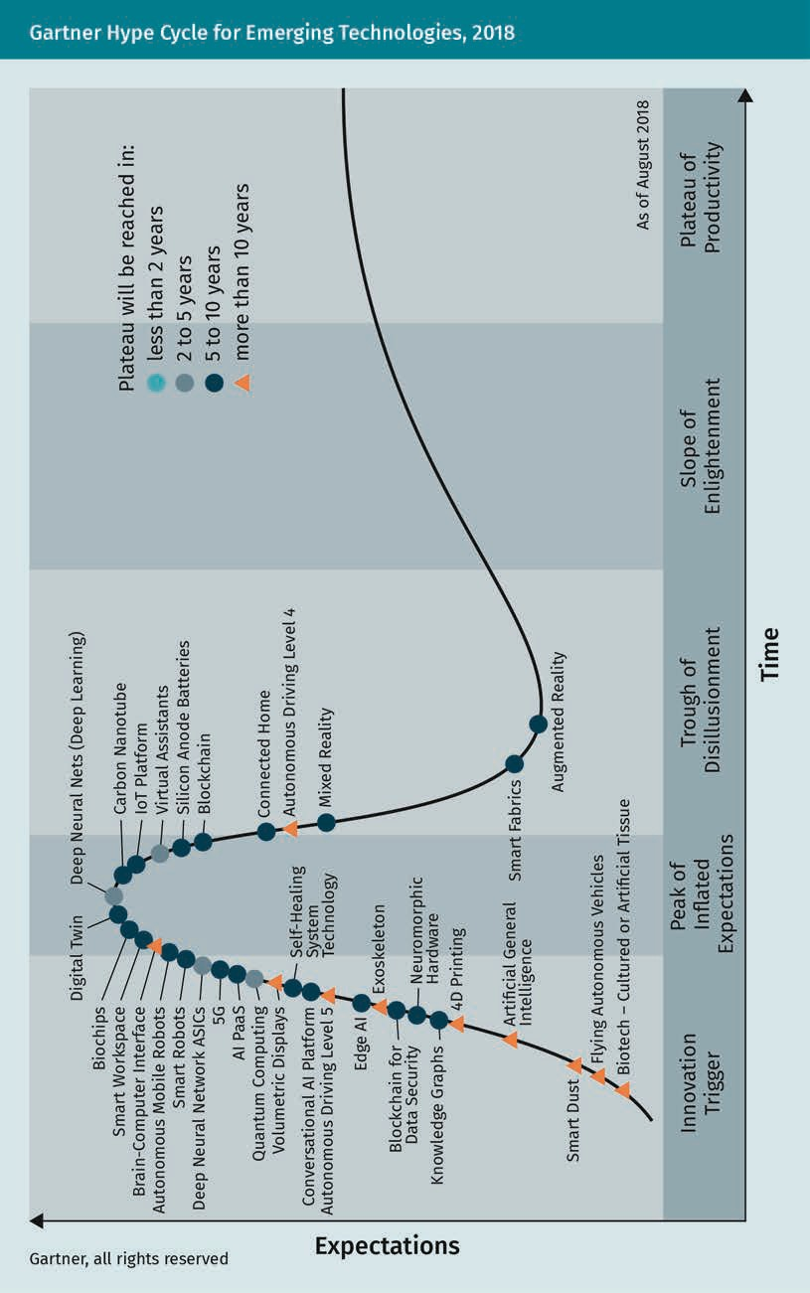**[Title]**

|  |  |
| --- | --- |
| Gartner, all rights reserved |  |
| Expectations |  |
| Biochips |  |
| Smart Workspace |  |
| Brain-Computer Interface |  |
| Autonomous Mobile Robots |  |
| Smart Robots |  |
| Deep Neural Network ASICs |  |
| 5G |  |
| AI PaaS |  |
| Quantum Computing |  |
| Volumetric Displays |  |
| Conversational AI Platform |  |
| Autonomous Driving Level5 |  |
| Edge AI |  |
| Blockchain for Data Security |  |
| Knowledge Graphs |  |
| Smart Dust |  |
| Digital Twin |  |
| Self-Healing System Technology |  |
| Exoskeleton |  |
| Neuromorphic Hardware |  |
| 4D Printing |  |
| Artificial General Intelligence |  |
| Flying Autonomous Vehicles |  |
| Biotech – Cultured or Artificial Tissue |  |
| Deep Neural Nets (Deep Learning) |  |
| Carbon Nanotube |  |
| IoT Platform |  |
| Virtual Assistants |  |
| Silicon Anode Batteries |  |
| Blockchain |  |
| Connected Home |  |
| Autonomous Driving Level 4 |  |
| Mixed Reality |  |
| Smart Fabrics |  |
| Augmented Reality |  |
| Plateau will be reached in: |  |
| Less than 2 years |  |
| 2 to 5 years |  |
| 5 to 10 years |  |
| More than 10 years |  |
| Innovation Trigger |  |
| Peak of Inflated Expectations |  |
| Trough of Disillusionment |  |
| Slope of Enlightenment |  |
| Plateau of Productivity |  |
| As of August 2018 |  |
| Time |  |

**The Frontal, Parietal, Occipital, and Temporal Lobes of the Brain**

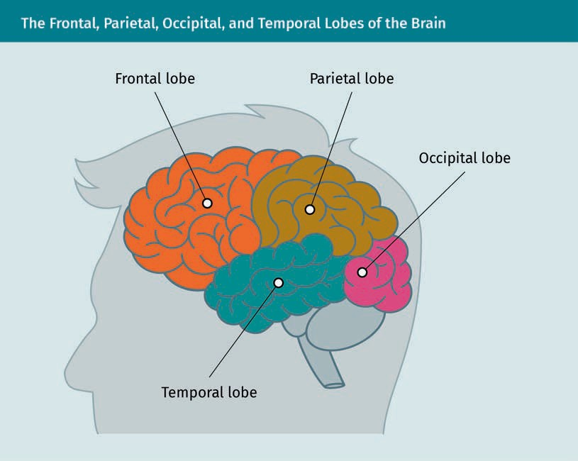

|  |  |
| --- | --- |
| Frontal lobe |  |
| Parietal lobe |  |
| Occipital lobe |  |
| Temporal lobe |  |

**A Neuron**

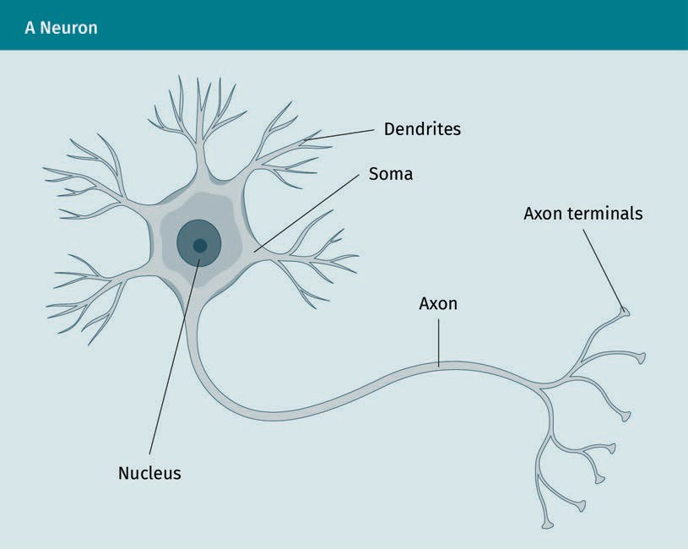

|  |  |
| --- | --- |
| Dendrites |  |
| Soma |  |
| Axon |  |
| Axon terminals |  |
| Nucleus |  |

**The perception of Inputs and the Cognition Process**

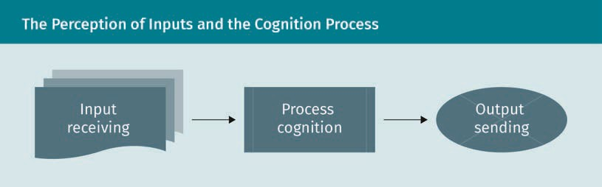

|  |  |
| --- | --- |
| Input receiving |  |
| Process cognition |  |
| Output sending |  |

**Schematic Depiction of an Artificial Neuron**

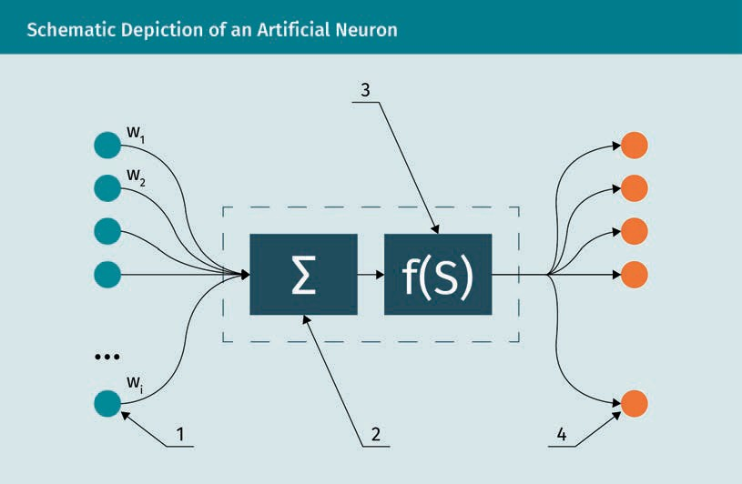

**Schematic Diagram of a 1-Layer Neural Network**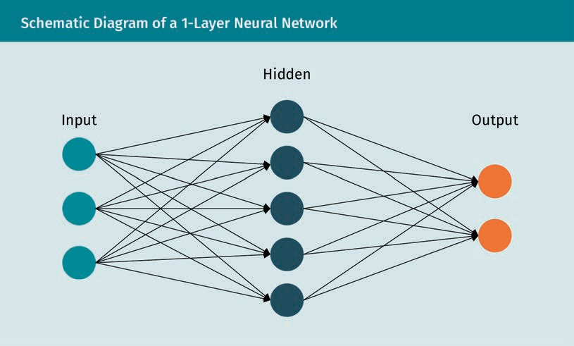

|  |  |
| --- | --- |
| Input |  |
| Hidden |  |
| Output |  |

**Generative Adversarial Network (GAN)**

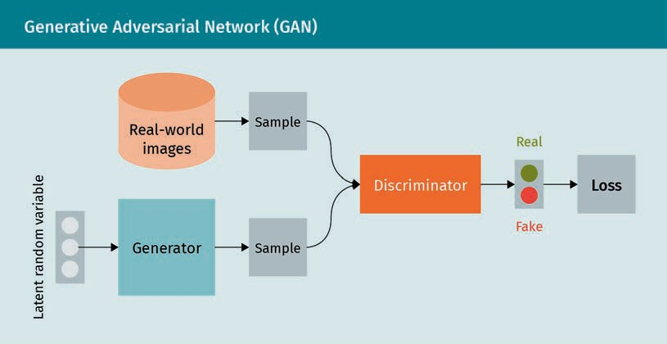

|  |  |
| --- | --- |
| Latent random variable |  |
| Real-world images |  |
| Generator |  |
| Sample |  |
| Sample |  |
| Discriminator |  |
| Real |  |
| Fake |  |
| Loss |  |

**Decision Tree Model**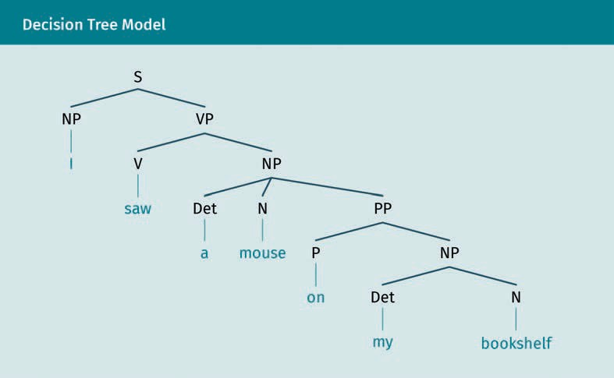

X

**Computer Vision and Artificial Intelligence**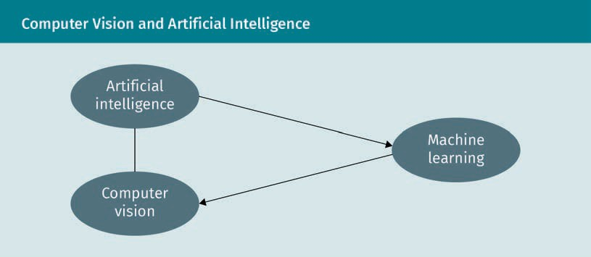

|  |  |
| --- | --- |
| Artificial intelligence |  |
| Machine learning |  |
| Computer vision |  |

**Approaches and Techniques of Computer Vision**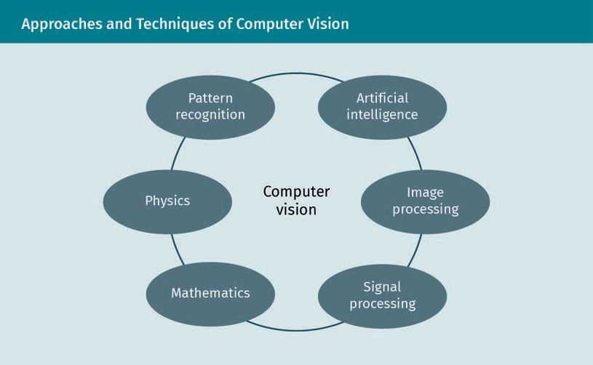

|  |  |
| --- | --- |
| Pattern recognition |  |
| Artificial intelligence |  |
| Image processing |  |
| Signal processing |  |
| Mathematics |  |
| Physics |  |
| Computer vision |  |