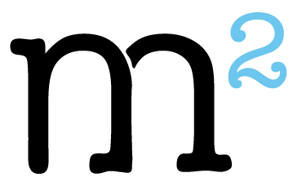

LIABILITY WAIVER  
  
In consideration for the participation of ___________________________ (hereinafter, the  
“Participant”), at the M²: The Institute for Experiential Jewish Education Senior Educators Cohort Israel (SEC), I, the undersigned participant, together with my heirs, executors, administrators, and assigns, hereby release, waive and forever discharge M²: The Institute for Experiential Jewish Education and/or their respective past and present employees, representatives, agents, officers, directors, affiliates, members, successors, assigns, and volunteers from and against any and all liability, claims, demands, actions, or causes of action of any and every kind and character which they had, have, or may have in the future, including but not limited to all injuries, damages, losses, or sicknesses, including contraction of Covid-19, which arise from or as a result of the Participant’s attendance in the program or participation in any associated activities. The undersigned herby further agrees to indemnify and to hold harmless the said Released Parties, of and from any and all liability, claims, demands, actions, rights of action, loss, damage, including attorney’s fees and costs, which arise from or as a result of the Participant’s attendance in the program or participation in any associated activities

Participant’s signature: ________________________

Date: ________________________