Dr. Abraham J. Berkovitz

Hebrew Union College

Dr. AJ Berkovitz received his Ph.D. in Religion from Princeton University for his dissertation, *The Life of Psalms in Late Antiquity*. He the co-editor of *Rethinking ‘Authority’ in Late Antiquity: Authorship, Law, and Transmission in Jewish and Christian Tradition*(Routledge, 2018), and the author of several articles. He currently serves as Assistant Professor of Liturgy, Worship and Ritual at HUC-JIR in New York.

Was Haman Hanged, Impaled or Crucified?

The manner in which Haman’s execution was depicted had real world consequences.

[Dr. Abraham J. Berkovitz](https://www.thetorah.com/author/abraham-j-berkovitz)

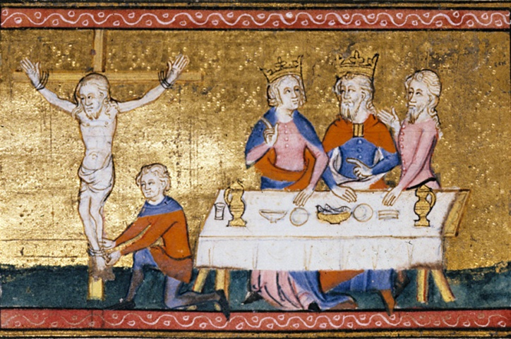

Haman being put to death, in Bible Historiale, 1357, BL Royal 19 D II, f. 237v. British Library

Hanging Haman

For most of us who learned the book of Esther growing up, Haman was killed by being hung on gallows. This seems to be what the Megillah describes in chapter 7. After Queen Esther accuses Haman of trying to have her and all her people killed, Harbona, one of the palace officials tells the king:

אסתר ז:ט ...גַּם הִנֵּה הָעֵץ אֲשֶׁר עָשָׂה הָמָן לְמָרְדֳּכַי אֲשֶׁר דִּבֶּר טוֹב עַל הַמֶּלֶךְ עֹמֵד בְּבֵית הָמָן גָּבֹהַּ חֲמִשִּׁים אַמָּה וַיֹּאמֶר הַמֶּלֶךְ תְּלֻהוּ עָלָיו. ז:י וַיִּתְלוּ אֶת הָמָן עַל הָעֵץ אֲשֶׁר הֵכִין לְמָרְדֳּכָי ….

Esth 7:9 … Look, the very gallows that Haman has prepared for Mordecai, whose word saved the king, stands at Haman’s house, fifty cubits (approx. 75 ft.) high.[1] And the king said, “Hang him on that.” 7:10 So they hanged Haman on the gallows that he had prepared for Mordechai. (NRSV)

The Hebrew word ת.ל.ה/י, means “to hang,” which is understood by many translations, such as the NRSV and the KJV as hanging by the neck on gallows. In fact, the *ArtScroll Youth Megillah*, the version of Esther that I cherished throughout my childhood, even includes a picture depicting Haman and his servants preparing the long wooden gallows pole upon which to hang Mordecai (Esth 5:14). The illustrated *megillah* of the famous artist Arthur Szyk (1894–1951) devoted an entire page to verse 7:10 and the gallows.

|  |  |
| --- | --- |
| https://firebasestorage.googleapis.com/v0/b/bageladmin.appspot.com/o/rtf%2Fartscroll-gallows.jpg?alt=media&token=26e1571e-abdb-46a3-994b-763a5e592002Gallows as illustrated in the *Artscroll Youth Megillah* | https://firebasestorage.googleapis.com/v0/b/bageladmin.appspot.com/o/rtf%2FHaman-szyk1.jpg?alt=media&token=b9a9bfdd-d71d-4003-aae7-86f458df0973The illustrated megillah of Arthur Szyk. 1950.[1] |

Centuries earlier, an illustrated *megillah* from Ferrara, Italy, published in 1617, depicts Haman dangling from the gallows.

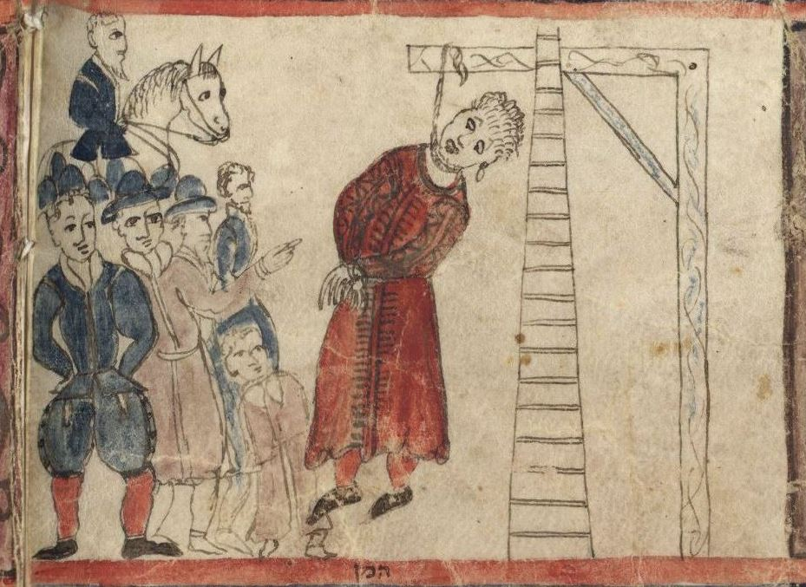

Detail from Megillat Esther, Moshe ben Avraham Pescarol, 1617. National Library of Israel

And yet, is Haman hanging on gallows what the author of the Megillah had in mind?

Hanging the Dead Sons of Haman?

On the 13th of Adar, the Jews prevailed over their enemies:

אסתר ט:ה וַיַּכּוּ הַיְּהוּדִים בְּכָל אֹיְבֵיהֶם מַכַּת חֶרֶב וְהֶרֶג וְאַבְדָן וַיַּעֲשׂוּ בְשֹׂנְאֵיהֶם כִּרְצוֹנָם. ט:ו וּבְשׁוּשַׁן הַבִּירָה הָרְגוּ הַיְּהוּדִים וְאַבֵּד חֲמֵשׁ מֵאוֹת אִישׁ. ט:ז וְאֵת... ט:י עֲשֶׂרֶת בְּנֵי הָמָן בֶּן הַמְּדָתָא צֹרֵר הַיְּהוּדִים הָרָגוּ...

Esth 9:5 So the Jews struck down all their enemies with the sword, slaughtering, and destroying them, and did as they pleased to those who hated them. 9:6 In the citadel of Susa the Jews killed and destroyed five hundred people. 9:7 including… 9:10 the ten sons of Haman son of Hammedatha, the enemy of the Jews…

The results of the battle are reported to the king, after which Ahasuerus asks Esther if there is anything else she requires:

אסתר ט:יג וַתֹּאמֶר אֶסְתֵּר אִם עַל הַמֶּלֶךְ טוֹב יִנָּתֵן גַּם מָחָר לַיְּהוּדִים אֲשֶׁר בְּשׁוּשָׁן לַעֲשׂוֹת כְּדָת הַיּוֹם וְאֵת עֲשֶׂרֶת בְּנֵי הָמָן יִתְלוּ עַל הָעֵץ. ט:יד וַיֹּאמֶר הַמֶּלֶךְ לְהֵעָשׂוֹת כֵּן וַתִּנָּתֵן דָּת בְּשׁוּשָׁן וְאֵת עֲשֶׂרֶת בְּנֵי הָמָן תָּלוּ.

Esth 9:13 Esther said, “If it pleases the king, let the Jews who are in Susa be allowed tomorrow also to do according to this day's edict, and let the ten sons of Haman be hanged on the gallows.” 9:14 So the king commanded this to be done; a decree was issued in Susa, and the ten sons of Haman were hanged. (NRSV)

Why do they hang the corpses of Haman’s sons?

Post-Mortem Hanging of Bodies

The hanging of a dead body post execution is described in the book of Deuteronomy:

דברים כא:כב וְכִי יִהְיֶה בְאִישׁ חֵטְא מִשְׁפַּט מָוֶת וְהוּמָת וְתָלִיתָ אֹתוֹ עַל עֵץ.

Deut 21:22 If a man is guilty of a capital offense and is put to death, and you hang him on wood.

Here the hanging is to shame a person after they have been executed. Joshua does this to the five kings he had just defeated:

יהושע י:כו וַיַּכֵּם יְהוֹשֻׁעַ אַחֲרֵי כֵן וַיְמִיתֵם וַיִּתְלֵם עַל חֲמִשָּׁה עֵצִים וַיִּהְיוּ תְּלוּיִם עַל הָעֵצִים עַד הָעָרֶב. י:כז וַיְהִי לְעֵת בּוֹא הַשֶּׁמֶשׁ צִוָּה יְהוֹשֻׁעַ וַיֹּרִידוּם מֵעַל הָעֵצִים וַיַּשְׁלִכֻם אֶל הַמְּעָרָה...

Josh 10:26 After that, Joshua had them put to death and [their bodies] hanged on five wood, and they remained hung on the wood until evening. 10:27 At sunset Joshua ordered them taken down from the wood and thrown into the cave…

The hanging of Haman’s sons fits with this practice. In these passages, however, the Bible is not picturing gallows or hanging people by their necks as a method of execution. Instead, the Bible is envisioning a different practice common in the ancient Near East.

Impaling Bodies

The Hebrew root ת.ל.ה/י can mean hang. But in the context of corpses, it most likely means “impale,” and thus עץ here means not “tree” or “gallows” but “stake.”

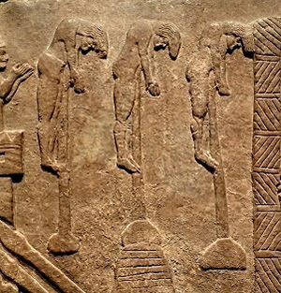Relief of an attack on an enemy town during the reign of Tiglath-Pileser III. Palace wall in Kalhu (Nimrud). Wikimedia

Assyrian reliefs depict the Assyrians impaling their enemies upon stakes. Consider the image to the right from the palace of the Assyrian monarch Tiglath-Pileser III (reg. 745-727) in Kalhu, which depicts the aftermath of an attack on an enemy town.

The defeated dead hang upon stakes. Perhaps they died there as well. Several Judeans themselves suffered this punishment at the hands of King Sennacherib of Assyria, as we can see from the reliefs in his palace at Nineveh depicting the conquest of Lachish.

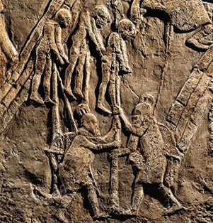

Judeans impaled by Sennacherib’s army, Lachish relief. Flickr

Such was a form of posthumous punishment and humiliation in the ancient world.[3]

Persian society, the very setting of Esther, continued to disgrace bodies of foes by impaling them. In the Behistun inscription, a multilingual text commissioned by the ruler Darius the Great (550-486 BCE), Darius claims to have hung up his enemies’ bodies.[4] The Greek historian, Herodotus (ca. 484–425), makes the same claim about Darius in his description of the capture of Babylon (*Histories* 3.159):

So was Babylon captured for the second time. When Darius became its master, he pulled down the walls and wrenched the gates from their hinges… Darius also impaled (ἀνεσκολόπισε) three thousand of the chief men but turned the town over to the rest of the Babylonians.[5]

Impaling Haman

Applying this to the book of Esther, it seems likely that לתלות על העץ should be translated “to impale on a stake.” For Haman, impalement also served as the method of execution while for his sons, it was a post-mortem rite of humiliating the corpses. The translation of “hang from the gallows” is an anachronistic retrojection of the common European form of execution on a book set in ancient Persia.[6]

The Crucifixion of Haman

Just as early modern translators imagined Haman being killed by a method with which they were familiar, ancient Greek translators also imagined something familiar to them, namely crucifixion, the standard Roman punishment which most resembles impaling.

The LXX (Septuagint) translates Ahasuerus’ command about Haman as “crucify him upon it,” from the Greek word “*stauro*-” (σταυρόω).[7] Similarly, the Latin Vulgate refers to the pole upon which Haman and then his sons are hung as *patibulum*, meaning “cross.”[8]

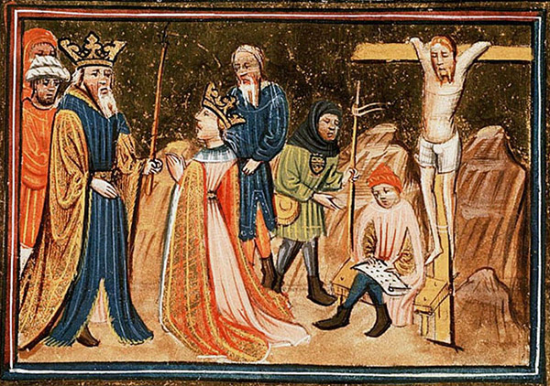

*Death of Haman*, Anonymous artist, 15th c. Museum Royal Library, The Hague

In his retelling of the story, Josephus Flavius (37–100) also writes about crucifixion (Ant. 11.266­–267, LCL trans.):

And then came the eunuch Sabuchadas (=Harbonah), and accused Haman, saying that he had found a cross (σταυρὸν) at his house prepared for Mordechai…. And the cross, he said, was sixty cubits in height. When the king heard this, he decided to inflict on Haman no other punishment that that which had been devised against Mordechai, and ordered him at once to be hanged (κρεμασθέντα) on the very same cross till he was dead.

While Josephus never uses the verb “to crucify” here, he consistently refers to the object as a cross.[9]

Haman and Jesus

The interpretation of Haman’s death as crucifixion had serious consequences in late antiquity, since the crucifixion of Haman suggested to Jewish minds a connection with Jesus.[10] In fact, Jews used this obvious parallel for polemical effect.

An Aramaic poem in honor of Purim,[11] composed towards the end of Late Antiquity (400-600 C.E.), imagines Haman conversing with all the great tyrants of Jewish history, such as Pharaoh and Nebuchadnezzar.[12]

After each villain complains about his failure, Haman retorts that his story contains more tragedy. Towards the end of the poem, Haman talks with Jesus, who chastises Haman and claims that his own lot was the worst of all. The poetry focuses on death by crucifixion, the feature of life that both Jesus and Haman share:[13]

סבר את בגרמך / דאת צלב בגרמך / ואנא שותף עימך

You think only of yourself,/ that you alone were crucified,[14] / but I participated alongside you

סמרי על קיס / ודמותי במרקוליס / מצייר על קיס

Nailed unto the cross (i.e. wood, AB) / I looked like a statue of Mercury (Roman god of commerce and luck, AB) / depicted on wood.

סמרי על קיס / ובשרי לטופח נקיס / ובר נגיד בקיס

They nailed me up on a cross /and a handbreadth-wide gash was flogged from my flesh / and a ‘Son’ was stretched out upon a cross.

סכיף באסקוטוס / מן אתא זיניטוס / וקרון יתי כריסטוס

Scourged with a whip / of woman born: / ‘Tis I who am called Christ.

סמר במסמרין / בגפיי מסמרין / טב מני אכל שעירין

Studded with nails / driven into my limbs / an “eater of barley” is better off than I.

סופיה די נקיבת / עבדין בהתה / בכל אתר ומדינתה

In the end, the pierced one / is worshipped in shame / in every town and city.

In this Jewish re-telling of the Passion narrative, Jesus identifies himself with Haman. Both men were put on a cross. But that is where the parallel ends. Jesus acknowledges Haman’s pain, but asserts that he suffered torment and ignominy that far eclipsed that of Haman.

Response to the Jewish Lampoon

For some ancient Jews, singing this poem likely functioned as a pressure-release valve. The daily hard and soft forms of Christian persecution for which they could not seek political, social or military redress were rectified in the performed space of fictive poetic drama. Instead of fomenting rebellion, Jews re-crucified Haman (= Jesus) every Purim.[15]

And some Christians noticed. On May 29th, 402 C.E., the Roman emperor sent out the following declaration:

The governors of the provinces shall prohibit the Jews from setting fire to (H)aman in memory of his past punishment during a certain ceremony of their festival, and from burning with sacrilegious intent a form cast in the shape of a holy cross in contempt of the Christian faith, lest they mingle the sign of our faith with their jests. They shall also restrain their rituals from ridiculing Christian law because if they do not abstain from matters that are forbidden they will promptly lose what had been thus far permitted to them (*Theodosian’s Code*16.8.18).[16]

Some Jews evidently burned a crucified Haman in effigy as a Purim practice. Christians—seeing a figure on a cross aflame—felt anxious. Who is on fire: Haman or Jesus? Setting the former alight might be acceptable. Doing so with the latter strikes at the heart of Christianity. The visual parallel between Jesus and Haman irked Roman authorities enough to demand that Jews cease this form of Purim revelry.[17] We see from here that, at least in some cases, reimagining the death of Haman had real-world consequences.

[View Footnotes](https://www.thetorah.com/article/was-haman-hanged-impaled-or-crucified)

1. Earlier in the story, Haman comes home furious that Mordechai the Jew still refuses to bow to him:

אסתר ה:יד וַתֹּאמֶר לוֹ זֶרֶשׁ אִשְׁתּוֹ וְכָל אֹהֲבָיו יַעֲשׂוּ עֵץ גָּבֹהַּ חֲמִשִּׁים אַמָּה וּבַבֹּקֶר אֱמֹר לַמֶּלֶךְ וְיִתְלוּ אֶת מָרְדֳּכַי עָלָיו וּבֹא עִם הַמֶּלֶךְ אֶל הַמִּשְׁתֶּה שָׂמֵחַ וַיִּיטַב הַדָּבָר לִפְנֵי הָמָן וַיַּעַשׂ הָעֵץ.

Esth 5:14 Then his wife Zeresh and all his friends said to him, “Let a gallows fifty cubits high be made, and in the morning tell the king to have Mordecai hanged on it; then go with the king to the banquet in good spirits.” This advice pleased Haman, and he had the gallows made. (NRSV)

This is what Harbona refers to here.

1. Szyk published a very different illustrated megillah in 1926. Note how, in this post-holocaust image, Haman’s outfit has two swastikas on his otherwise oriental-style garments. This illustrates Haman’s symbolic fluidity, his ability to stand in Judaism’s most recent foe. For a discussion Szyk’s two megillahs and the post-holocaust revisions, see Noam Zion, [“Arthur Szyk’s Style, Subjects, and Work Changed After Holocaust,”](https://www.hartman.org.il/artist-arthur-szyks-style-subjects-and-work-changed-after-holocaust/) *Hartman Blog* (April 4, 2017).
2. For a modern analogy, at least as depicted in TV shows and movies that set themselves in the distant past, think about the scenes in which city gates and public squares are decorated by the impaled heads of previously beheaded criminals, rebels and traitors.
3. In the Akkadian, the word is *zakipi*, and in the Aramaic version found on papyri, the word is צ.ל.ב. (See the edition in A. E. Cowley, *Aramaic Papyri from the 5th Century B.C.*, [Oxford: Clarenden Press, 1923] 248–271.) This led many early translators to suggest “crucify.” Nevertheless, in older Aramaic, צ.ל.ב has the same meaning as the Hebrew ת.ל.ה, “hanging or impaling.” See discussion in Aharon Shemesh, *עונשים וחטאים מן המקרא לספרות חז"ל*]Punishments and Sins: From Scripture to the Rabbis] (Jerusalem: Magnes Press, 2003), 27–34.
4. Translation from, Herodotus, *The History*, trans. David Grene (Chicago: University of Chicago Press, 1987), 278
5. This form of execution may have begun among the Germanic tribes in the 4th century C.E. or sometime after. See discussion in Jack Shuler, *The Thirteenth Turn: A History of the Noose* (New York: Public Affairs, 2014), 49.
6. Nevertheless, in the very next verse, the Greek reads “and they hung Haman upon the pole” (καὶ ἐκρεμάσθη Αμαν ἐπὶ τοῦ ξύλου), from the root “*kremannu*-” (κρεμάννυμι), “to hang.” This latter root is also what is used to describe the hanging of Haman’s sons, leaving exactly what the LXX is picturing here unclear. Note that neither of these terms is the classic word for impale used by Herodotus (as noted above).
7. Nevertheless, in v. 9 the Vulgate uses *lignum*, meaning “wood.” Also, the Latin Vulgate also uses two roots, *adpendite* in v. 9 and *suspensus* in v. 10—both of which mean “to hang”—but not *crucifigo*, which means “to crucify.” Thus, like the LXX, the matter is not entirely clear.
8. Josephus does this elsewhere as well. For example, the Pharaoh’s chief baker isn’t hung but crucified in Josephus’ retelling (Ant. 2:77).
9. The very Greek word used for Haman’s crucifixion in the LXX (σταυρόω) also appears in the various Gospel scenes that depict the death of Jesus (Mark 15:13; Matt 20:19; Luke 23:21; John 19:6).
10. It may have been sung in the synagogue before or after the reading of the scroll of Esther.
11. Joseph Yahalom and Michael Sokoloff, *Jewish Palestinian Aramaic Poetry from Late Antiquity: Critical Edition with Introduction and Commentary* (Jerusalem: Israel Academy of Sciences and Humanities, 1999), 216–17. Translation from Laura S. Lieber, *Jewish Aramaic Poetry from Late Antiquity: Translations and Commentaries*, Études Sur Le Judaïsme Médiéval 75 (Leiden: Brill, 2018).
12. For a reading Jewish reading of Jesus against another character in the Esther narrative – the queen herself, see my, [“‘My God, My God, Why Have You Forsaken Me?’ — Jesus or Esther?”](https://www.thetorah.com/article/my-god-my-god-why-have-you-forsaken-me-jesus-or-esther) *TheTorah* (2020).
13. As noted above צלב simply means “hang” in older Aramaic, and even in many early rabbinic sources. Nevertheless, here, considering the explicit polemical context, it is clear the author means “crucify,” which is the standard meaning in later Aramaic and even enters Hebrew with this meaning.
14. Similarly, medieval Jewish practice was to parody the story of Jesus on Christmas Eve, what is called Nittel Nacht. Note that in this liturgy, Jesus is referred to as התלוי, “the hung one.” For more on Nittel, see Shai Alleson-Gerberg, [“Nittel Nacht: An Inverted Christmas with Toledot Yeshu,”](https://www.thetorah.com/article/nittel-nacht-an-inverted-christmas-with-toledot-yeshu)TheTorah (2016).
15. Translating with Sivan, *Palestine in Late Antiquity*, 144.
16. Whether Jews discontinued this practice or not, we don’t know.