Author Questionnaire (Book Proposal)

- The main title should be less than 57 characters, which will show up as 19 characters / line x 3 lines. Make sure it specifically conveys the topic of your book. Avoid phrasing your title in the form of a question.

“Japanese Enterprise and German Enterprise: Comparison of Industrial Concentration and Business Management”

- Indicate whether your book is a single-authored volume, a co-authored volume or an edited volume.

■Single-Authored Volume
□Co-Authored Volume (maximum of three co-author names on the cover)
□Edited Volume (maximum of three the volume editor names on the cover) (edited volumes typically
include more than five chapters by chapter contributors

C. Indicate the Name(s) of the Author(s) or Editor(s) in the order that they should appear on the front cover of the book. Also indicate one main title(s), one main institution(s), e-mail and postal address (es). The name(s), title(s) and institution(s) will also appear inside the book.

Name of volume author/editor 1 (main corresponding author/editor): Toshio Yamazaki
Institution (One main institution): | Ritsumeikan University
Faculty/Department: | College of Business Administration
Title (Professor/Associate Professor/Etc.): | Professor
e-mail address: | tyt01363@ba.ritsumei.ac.jp
Complete postal address: | 567-8570
Building Name, Floor & Room Number | Building A, 9th floor, Room Number 9414
Telephone number: | +81-72-665-2440 (072^665-2440)
ORCID id (if you have one)*:

* If you do not have an ORCID id, register for free here: https://orcid.org/
* To ensure secure postal delivery, please indicate details of the building name, floor, room number, and telephone number.

- Please provide us a brief summary for marketing your book within 1,000 to 1,900 characters (including spaces and punctuation marks) (Approximately 150 - 200 words). Please see Appendix 1 of this document for details on how to write the description. Springer’s online SEO copy-editor will later copy-edit your summary.

This purpose of this book is to clarify characteristics of corporate expansion in postwar Japan and Germany. This is the first book to inclusively investigate many fields related to business administration, such as concentration of enterprise, management systems, production systems, management education, marketing, organizational structure, business strategy, and corporate governance from the perspective of author’s original framework “Re-framing.” It examines how Japanese or German business management style and their particular characteristics were created, conforming to exogenous factors and constraints in each country, while evolving because of endogenous determinants. By clarifying commonalities and differences of business management and how development of business management determined the direction of regionalization in each country, such as seen in Germany’s “Europeanization” and Japan’s “Asianization”, this book provids a unique understanding of business management and capitalism in both nations. These research results can contribute to deepening of study of mechanisms of corporate expansion. Demonstrating business management and the resulting logic of development of enterprise in Japan and Germany, this book is greatly recommended to readers who are interested in business management, business history, and economic history and international comparative study.

- Please write a short SEO Metadata description within 130-150 characters (characters, including spaces and punctuation marks – not words). Springer will later copy-edit your metadata description.

This book clarifies business management in postwar Japan and Germany and the direction of regionalization of each country determined by corporate expansion from comparative analysis.

- Please tell us three unique selling points (USPs) of your book (under 60 – 110 characters (including spaces and punctuation marks) each). USP’s should show why a customer wants to buy your book and they will show up front and center on springer.com. Springer will later edit these USPs.

1. | Comparing how industrial concentration determined competition structure and corporate expansion in postwar Japan and Germany
2. | Comparison of Americanization of business management in Japan and Germany from the author’s original framework of “Re-framing”
3. | Clarifying how business management in Japan and Germany after the war determined the movement toward regionalization

- Please provide more than 6 keywords that are applicable to your book. These key words will be used for Search Engine Optimization. Keywords should be single words or two-word phrases, not multi-word phrases, that potential readers are likely to use on search engines to find the content. They should be concrete and specific, yet concise. Each keyword should be no longer than 64 characters (including spaces and punctuation marks).

1. | Americanization
2. | Business management
3. | German enterprise
4. | Industrial concentration
5. | Japanese enterprise
6. | Regionalization

- Please provide us the table of contents. It does not matter if it is only a tentative one.

Preface

Chapter 1 Introduction: Research Topics and Analytical Framework
1.1 Awareness of the Issues of this Book
1.2 Research Topics
1.3 Prior Research and Issues Thereafter
1.4 Analytical Framework

Part 1 Total System of Business Management and Characteristics of Management in Japan and Germany
Chapter 2 Overview of the Total System of Business Management in Postwar Japan and Germany
2.1 Overview of the Total System of Business Management in Japan after World War II
2.2 Overview of the Total System of Business Management in Germany after World War II
Chapter 3 Characteristics of Business Management in Japan and Germany
3.1 Commonalities of Business Management among Major Countries
3.2 Characteristics of Japanese Business Management
3.3 Characteristics of German Business Management

Part 2 System of Postwar Industrial Concentration
Chapter 4 Structures and Functions of Large Corporate Groups
4.1 Influence of the US De-concentration Policy on Monopolies in Japan and Germany
4.2 New Developments in the System of Large Corporate Groups in Japan
4.3 New Developments in the System of Large Corporate Groups in Germany
4.4 Japanese and German Characteristics regarding the System of Large Corporate Groups
Chapter 5 New Developments of the Industrial System Based on Industry–Bank Relationships
5.1 New Development of Industrial Concentration Based on Industry–Bank Relationships in Japan
5.2 New Development of Industrial Concentration Based on Industry–Bank Relationships in Germany
5.3 Japanese and German Characteristics of Industrial System Based on Industry–Bank Relationships

Part 3 Americanization of Business Management and “Re-framing” in the Postwar Boom Years
Chapter 6 Deployment of American Management Education
6.1 Deployment of American Management Education in Japan
6.2 Deployment of American Management Education in Germany
6.3 The Characteristics of Japanese and German Deployment of American Management Education
6.4 Re-framing in the Deployment of American Management Education in Japan and Germany
Chapter 7 Deployment of Human Relations
7.1 Deployment of Human Relations in Japan
7.2 Deployment of Human Relations in Germany
7.3 The Characteristics of Japanese and German Deployment of Human Relations
7.4 Re-framing in the Deployment of Human Relations in Japan and Germany
Chapter 8 Deployment of Industrial Engineering
8.1 Deployment of Industrial Engineering in Japan
8.2 Deployment of Industrial Engineering in Germany
8.3 The Characteristics of Japanese and German Deployment of Industrial Engineering
8.4 Re-framing in the Deployment of Industrial Engineering in Japan and Germany
Chapter 9 Deployment of the Ford System
9.1 Deployment of the Ford system in Japan
9.2 Deployment of the Ford system in Germany
9.3 Re-framing in the Deployment of the Ford system in Japan and Germany
9.4 The Rollout of Mass-Production Systems and Japanese and German Manufacturing
Chapter 10 Deployment of Marketing Methods
10.1 Deployment of Marketing Methods in Japan
10.2 Deployment of Marketing Methods in Germany
10.3 The Characteristics of Japanese and German Deployment of American Marketing Methods
10.4 Re-framing in the Deployment of American Marketing Methods in Japan and Germany
Chapter 11 Deployment of a Divisional Structure
11.1 Transformation of Business Strategy and Deployment of Divisional Structure in Japan
11.2 Transformation of Business Strategy and Deployment of Divisional Structure in Germany
11.3 The Characteristics of Japanese and German Deployment of the Divisional Structure
11.4 Re-framing in the Deployment of Divisional Structure in Japan and Germany
Chapter 12 “Re-framing” in the Americanization Process and Japanese-Style Management and German-Style Management during the Postwar Boom Years
12.1 Japanese- and German-Style Adaptation in the “Americanization” of Business Management
12.2 “Re-framing” in the Americanization Process and Japanese-Style Management
12.3 “Re-framing” in the Americanization Process and German-Style Management

Part 4 Business Management in the Periods from the 1970s to the 1980s and after the 1990s
Chapter 13 Development of Mass Production Systems in Japan and Germany from the 1970s to the 1980s and Its Significance
13.1 Social and Economic Background Regarding the Reforms of the Mass Production System
13.2 Production System Reforms in Japan
13.3 Production System Reforms in Germany
13.4 Significances of the Reforms of the Mass Production System in Japan and Germany
Chapter 14 Transformation toward Shareholder Value-Oriented Management and Corporate Governance in Japan and Germany after the 1990s: Resurgence of the Americanization of Business Management
14.1 Influence of US-led Financialization in Japan and Germany
14.2 Transformation toward the Shareholder Value-Oriented Management Model in Japan
14.3 Transformation toward the Shareholder Value-Oriented Management Model in Germany
14.4 “Re-framing” in the “Americanization” of Business Management in Japan and Germany
14.5 Changes of Characteristic in the “Americanization” of Business Management after the 1990s and Their Significance

Chapter 15 Conclusion: Significance of Comparative Study of Business Management in Japan and Germany
15.1 Pursuit of Economic Rationality in Each Country: Comparison of the US, Japan, and Germany
15.2 The Postwar Reforms and Democratization of Economy and Their Influences on Business Management and Corporate Expansion in Japan and Germany
15.3 Industrial Development and Industrial Structure and Their Influences on Business Management and Corporate Expansion in Japan and Germany
15.4 Inter-firm Relationships and Their Influences on Business Management and Corporate Expansion in Japan and Germany
15.5 Regional Conditions and Their Influences on Business Management and Corporate Expansion: Different Paths toward the Global-Regionalization in Japan and Germany

- Is this book originally written in English, or translated from another language? If it is a translation, please provide its original title, publisher’s name and publishing year.

This book is translated from Japanese.
Original title:
Publisher:
Publishing year:

- Product category (Please select only one option from the list below.)

□ Handbook
■ Monograph (Edited Volume)
□ Proceedings
□ Textbook (for undergraduates)
□ Textbook (for graduates/advanced undergraduates)
□ Springer Briefs
□ / Other ( )

- Please select 3-6 sub-disciplines that cover your book’s topic from Column F Subject Name in the separately supplied spreadsheet.

Business and Management
Corporate History
Economic History
Management Education
Marketing
Modern History
(in alphabetical order)

- Please point out at least one title that is most similar to your title in terms of its purpose and its target readers that is offered by a publisher other than Springer.

Title: | German and Japanese Business in the Boom Years. Transforming American Management and Technology Models
Author(s)/Editor(s): | Akira Kudo, Matthias Kipping, Harm G. Schröter (eds.)
Publisher: | Routledge
Print ISBN (ISBN-13): | 9781138864023
Publication year: | 2015 (First publishing: 1st Edition 2004)
Hardback or Paperback: | Hardback
Pages: | pp.1-304
Price: | 42.39￡
How is your book different: | 1. By comparing Japan and Germany, rather than writing about Germany and Japan in separate chapters, my book attempts to compare and contrast, points out the unique Japanese and German factors and demonstrates the development of Business Management in both countries from unified comparative framework.  2. Based on the author’s original framework – “Re-framing”, my book analyzes business management in relation to important factors determining adaptation, modification, and adjustment of American management methods in order to make them compatible with the structural characteristics of Japanese or German capitalism. By applying the author’s original framework to this analysis, a unique understanding of business management and capitalism in Japan and Germany is possible.  3. My book gives emphasis on the development of Japan and German enterprises in a chronological manner during the 1950s and 1960s, while paying special attention to significant regional economic characteristics for Germany in Europe and those for Japan in Asia that were deeply connected with relationships with United States. It explores the significance of the German business management model that developed in the European environment by comparing Germany’s situation in Europe with that of Japan’s in Asia. Through this analysis, how corporate expansion in Japan and Germany after the war determined the path toward the regionalization in each country is clarified.

Title: | Americanization and Its Limits: Reworking US Technology and Management in Post-war Europe and Japan
Author(s)/Editor(s): | Jonathan Zeitlin, Gary Herrigel
Publisher: | Oxford University Press
Print ISBN (ISBN-13): | 9780199269044
Publication year: | 2004 (First publishing: 2000)
Hardback or Paperback: | Hardback
That | pp.1-410+xvi
Price: | ＄74
How is your book different: | 1. In the book edited by Zeitlin and Herrigel, direct comparison of common subject matter between Japan and Germany is not always performed. Therefore, characteristics of individual issues concerned in each country are not clarified. In my book, characteristics of business management and corporate expansion in both nations are clarified through analyzing important issues regarding business management and industrial concentration in each chapter.  2. In the edited book by Zeitlin and Herrigel, only specific issues of business management in each country are considered by different author in separate chapter. My book compares business management in various important fields that deeply concerned with corporate expansion in Japan and Germany after the war. Through such comparative analysis, overall view of industrial concentration and business management in Japan and Germany are clarified  3. Based on the author’s original framework – the “Total System of Business Management”, my book analyzes business management in relation to the structure of German capitalism and the cooperative interdependent structures that arose from concentration of industry. Overall, the book attempts to explain the transformation in business management.

Title: | Der produktive Blick. Wahrnehmung amerikanischer und japanischer Managment- und Produktionsmethoden durch deutscher Unternehmen
Author(s)/Editor(s): | Christian Kleinschmidt
Publisher: | Akademie Verlag
Print ISBN (ISBN-13): | 3-05-003657-5
Publication year: | 2002
Hardback or Paperback: | Hardback
Pages: | pp.1-453
Price: | €64.8
How is your book different: | - By comparing Germany in Europe and Japan in Asia, my book clarifies the significance of Japanese business management that developed depending on the US markets and German Business Management that developed under the regional characteristics in Europe.  2. Based on the author’s own framework ― the “Total System of Business Management”, my book considered business management with relation to the structure of German capitalism and the cooperative interdependent structures that arose from concentration of industry. The book attempts to explain the stages of transformation in business management.  3. In my book, the Implementation of American style management is considered from the author’s original framework―(1) “Re-framing” that management style, and (2) Germany’s and Japan’s contrasting regimes of implementing it.

- 本書に関係する本で，Springer社から出ている本を1冊以上教えてください．Springer社の本は，www.springer.comから選んでください．
Please point out at least one title which is related to your book and offered by Springer. You can search for our books on www.springer.com

Title: | Americanization of the European Economy
Author(s)/Editor(s): | Harm G. Schröter
Print ISBN (ISBN-13): | 978-1-4020-2884-7
Publication year: | 2005
Hardback or Paperback: | Hardback
Pages: | pp.1-268+xii
Price: | €117.69
How is your book different:  How is this title related: | 1. In my book, the Implementation of American style management is examined from the author’s original framework― (1) “Re-framing” that management style, and (2) Germany’s and Japan’s contrasting regimes of implementing it.  2. Based on the author’s original framework – the “Total System of Business Management”, my book explores management in regard to the structure of German capitalism and the cooperative interdependent structures that arose from concentration of industry. Overall, the book attempts to explain the transformation in business management.  3. My book gives emphasis on the development of Japan and German enterprises in a chronological manner during the 1950s and 1960s, while paying special attention to significant regional economic characteristics for Germany in Europe and those for Japan in Asia that were deeply connected with relationships with United States. It explores the significance of the German business management model that developed in the European environment by comparing Germany’s situation in Europe with that of Japan’s in Asia. Through this analysis, how corporate expansion in Japan and Germany after the war determined the path toward the regionalization in each country is clarified.

N. What kind of people do you think will read your book? (Please select only one option from the list below.)
(1) Popular/General
(2) Lower undergraduates
(3) Higher undergraduates
(4) Graduates
■(5) Researchers
(6) Other:

O. If you selected (2), (3) or (4) in quesiton N above, please inform us of the names of the courses and universities which will adopt your textbook.

P. Please provide, if any, the name of a book series in which you would like your book to be published.

Q. Expected number of pages after type-setting: pages(A type-set page includes 504 words on average.)

340 pages

R. Expected number of tables and figures: Color tables and figures: Black & white tables and figures: .

Tables: 12
Figures: 2

S. By when can you send your sample chapters or writing sample (30 - 50 pages). (Writing sample means a paper/article with a similar topic that you have published in the past.)

Month__March__ Date__3__ Year_2021__

T. By when can you send us your final manuscript (complete with all figures and after English copy-editing, conducted by a native speaker of English, and roughly formatted in Springer style)?

Month_ April___ Date__14__ Year 2021__

U. 略暦（最大4000文字）
Please provide details of your area of work, honors, etc. which underline the usefulness of your work to the reader. This information will be used in marketing materials. Note: Please repeat the above information for all authors and editors of the work. Short bio (max.4000 characters).

Toshio Yamazaki
University: Ritsumeikan University, Japan
Department: College of Business Administration
Title/Position: Professor

Other affiliations: Graduate School of Business Administration, Ritsumeikan University

Academic background: 1. Doctor of Business Administration (March 1999)
2. 1981-1985 Faculty of Commerce, Doshisha University, Japan
3. 1985-1987 Doctoral Program (1st Semester), Graduate School, Division of Commerce, Doshisha University (Master of Commerce)
4. 1987-1990 Doctoral Program (2nd Semester), Graduate School, Division of Commerce, Doshisha University, Japan

Research activities: 1. Japan Academy of Business Management
2. Japan Association for the Comparative Studies of Management
3. Japan Association of Business History

Subject of research: International comparative study of business administration

Research summary: Comparative Study on business management in Japan, Germany, and the United States
The target is to develop a corporate theory based on management studies, made through comparative studies on the process of development of corporate management and management systems in Japan, Germany, and the United States

Present specialized field: Management (keyword: Business administration)
Business History (Keyword: Comparative business history)

Receiving a prize: Academic Award of the Japanese association for the Comparative Study of Management, 2015 (Receiving a reward: Mai 2015)
“German Business Management: A Japanese Perspective on Regional Development Factors” Springer, 2013

V. Please submit the full English CVs of the volume author(s)/volume editor(s). The CV(s) should include a list of the author’s publications(journals/books), any experience as a journal editor, and awards/honors, in addition to professional/educational experiences. For multi-author volumes, please provide a short bio for chapter authors as well.

Curriculum vitae (CV)

Name: Toshio Yamazaki

Date of birth: 22. 3. 1962

University: Ritsumeikan University, Japan
Department/ Course: College of Business Administration (Department of Business Administration)
Title/Position: Professor

Academic degree: Doctor of Business Administration (March 1999)

Academic background
1981-1985 Commerce, Faculty of Commerce, Doshisha University
1985-1987 Doctoral program (1st Semester), Commerce, Graduate School, Division of Commerce, Doshisha University
1987-1990 Doctoral program (2nd Semester), Commerce, Graduate School, Division of Commerce, Doshisha University

Business career
1989-1990 Assistant professor, Faculty of Humanity, Koch University
1990-1992 Lecturer, Faculty of Humanity, Koch University
1992-1994 Associate professor, Faculty of Humanity, Koch University
1994-2001 Associate professor, College of Business Administration, Ritsumeikan University
2001- Professor, College of Business Administration, Ritsumeikan University

Research activities
Japan Academy of Business Management
Japan Association for the Comparative Studies of Management
Japan Association of Business History

Subject of research
International comparative study of Business Management

Research achievement
Books: 1. Inter-firm Relationships in Germany: Structures and Functions of Personnel Connection between Enterprises (Language: Japanese), Moriyama shoten, 2019, pp.1-544.
2.Comparison of Business Management in Japan and Germany (Language: Japanese), Moriyama
shoten, 2007 pp.1-612.
3. German Business Histrory before World War II (Language: Japanese), Moriyama shoten, 2015, pp.1-362.
4. German Business Management: A Japanese Perspective on Regional Development Factors
(Language: English), Springer, 2013, pp.1-247.
5. Contemporary German Enterprise (Language: Japanese), Moriyama shoten, 2013, pp.1-602.
6. German Capitalism after World War II and Business Administration (Language: Japanese), Moriyama shoten, 2009, pp.1-562.
7. Reconstruction of Modern Business Management Study (Language: Japanese), Mpriyama shoten, 2005, pp.1-502.
8. The Rationalization Movement in Germany during National Socialism (Language: Japanese), Moriyama shoten, 2001, pp.1-459.
9. The Rationalization Movement in Germany during the Weimar Republic (Language: Japanese), Moriyama shoten, 2001, pp.1-462.
10. History of Business Management System in Germany (Language: Japanese), Moriyama shoten, 1997, pp.1-378.

Receiving a prize: Academic Award of the Japanese association for the Comparative Study of Management, 2015 (Day of receiving a reward: 5.2015)
“German Business Management: A Japanese Perspective on Regional Development Factors” Springer, 2013

W. Please list up four to five names and e-mail address of professors (or researchers with equivalent expertise), if any, by whom you would like to have your manuscript reviewed. We will use this list as a guide to find referees for your manuscript. However, please note that the actual referee(s) may not be the ones in your list, and we will not be able to disclose their names to you.

Name 1: | Christian Kleinschmidt
Title: | Professor
Institution: | Philipps Universität Marburg, Germany
e-mail address: | Christian.kleinschmidt@staff.uni-marburg.de
Name 2: | Masaru Yoshimori
Title: | Emeritus Professor
Institution: | Yokohama National University, Japan
e-mail address: | Yoshimori-masaru-dj@ynu.ac.jp
Name 3:
Title:
Institution:
e-mail address:
Name 4:
Title:
Institution:
e-mail address:
Name 5:
Title:
Institution:
e-mail address:

X. If you are interested in publishing your book as an Open Access book, please let us know. For further details about our Open Access books, please see https://www.springer.com/gp/open-access/books

Y. If there is anything else you would like to mention about this book, please let us know.

Springer Japan
Editorial department: Economics, Business
Administration, Statistics, and Law

Appendix 1: Instructions for Writing a Book Description

The Description (Question D of this Author Questionnaire) will be printed on the back cover of the printed book as well as on the home page for your book on Springer.com and the product page on Amazon. Please follow the instructions below in writing the description.

- Length: 1,000 to 1,900 characters (including spaces and punctuation marks) (This is roughly 200 - 350 words.)

- Do not use the title of your book in the first two sentences.

- Begin with what is new about this book (compared to other similar books in the field).

- Articulate in the first or second sentence on what is specific to this book and how it is different from others.
(e.g. This is the first book to …..)

- Start your paragraph with one of the following openers:

- This (edited) book/volume/work/anthology/study/collection…
- The research and its outcomes presented here…
- is about…
- is devoted to….
- contains…
- focuses on…
- …. & …. form the cornerstone of this work (by international/world-renowned experts/authors).
- At the heart of this book is the matter of…

Other examples
- This is the second edition of a well-received book that reflects the state of the art in… This comprehensive reference text examines the current state of… which encompasses…
- A major objective of this monograph is to identify the key determinants of …
- This book covers many aspects of …
- The main focus of this monograph is …
- The idea of this monograph is to present the latest results related to…
- The purpose of this book is to thoroughly prepare the reader for research in string theory, at an intermediate level.
- This book shows how scientists, water managers, and policy makers approach drought and water scarcity in arid and semi-arid regions.
- How can anthropology and demography be used in conjunction in the field of population and development? This work addresses that question in 3 parts…

- Focus on the benefits of the book (how it solves problems in the field; latest insights and latest analyses), the scope of your project, the core themes, arguments, issues and/or topics of the work.

- Do not tell what your product IS but rather tell what your product DOES.

- Do not list up summaries of each chapter.

- Avoid describing the field your title is about or beginning your description with back-ground information or context. Expected readers are already familiar with the field. That's why they want your book. If you must provide context, please make sure to keep it to a minimum.

- Your description will be copy-edited by a native English speaker.

・ Example of a good book description:

Monetary Economics in Globalised Financial Markets
Belke, Ansgar, Polleit, Thorsten (Springer, 2011)
http://www.springer.com/978-3-540-71002-8

This book integrates the fundamentals of monetary theory, monetary policy theory and financial market theory, providing an accessible and comprehensive introduction to the many-sided interrelations between these fields of research. It provides the reader with the intellectual groundwork indispensable for understanding the workings and interactions of today’s globalised financial markets. The topics addressed in this book include, inter alia, alternative money supply regimes, money demand functions, monetary policy transmission, monetary policy effectiveness and the natural rate of unemployment, monetary political business cycles, and monetary policy strategies. Basic valuation models for stocks, and bonds and asset price linkages across currency areas are covered as well. Illustrated by carefully chosen examples and supported by extensive data analyses, this book is highly recommended to readers who seek an in-depth and up-to-date integrated overview about the ever-expanding theoretical and quantitative fields of monetary and financial economics. (1,062 Characters / 142 Words)

Description on Springer.com

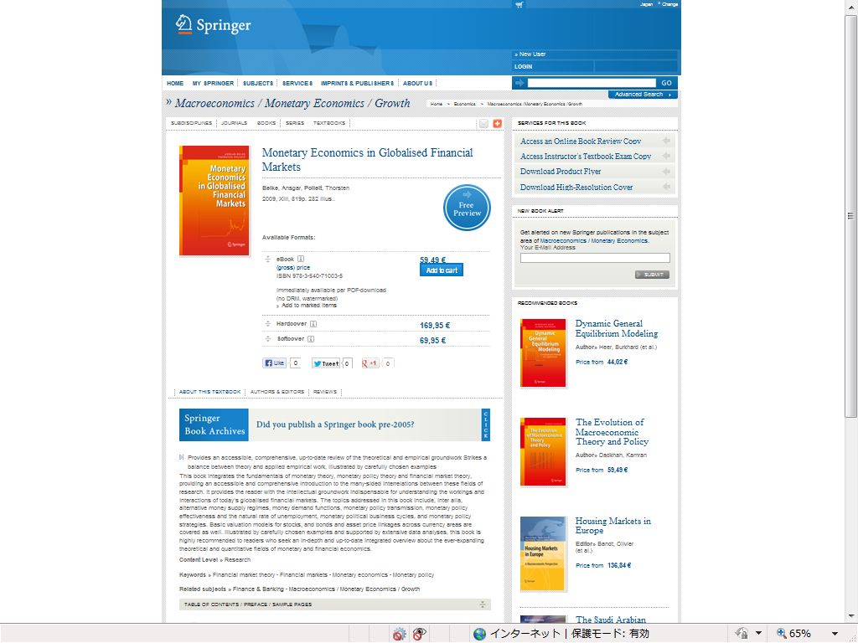

Description on Amazon

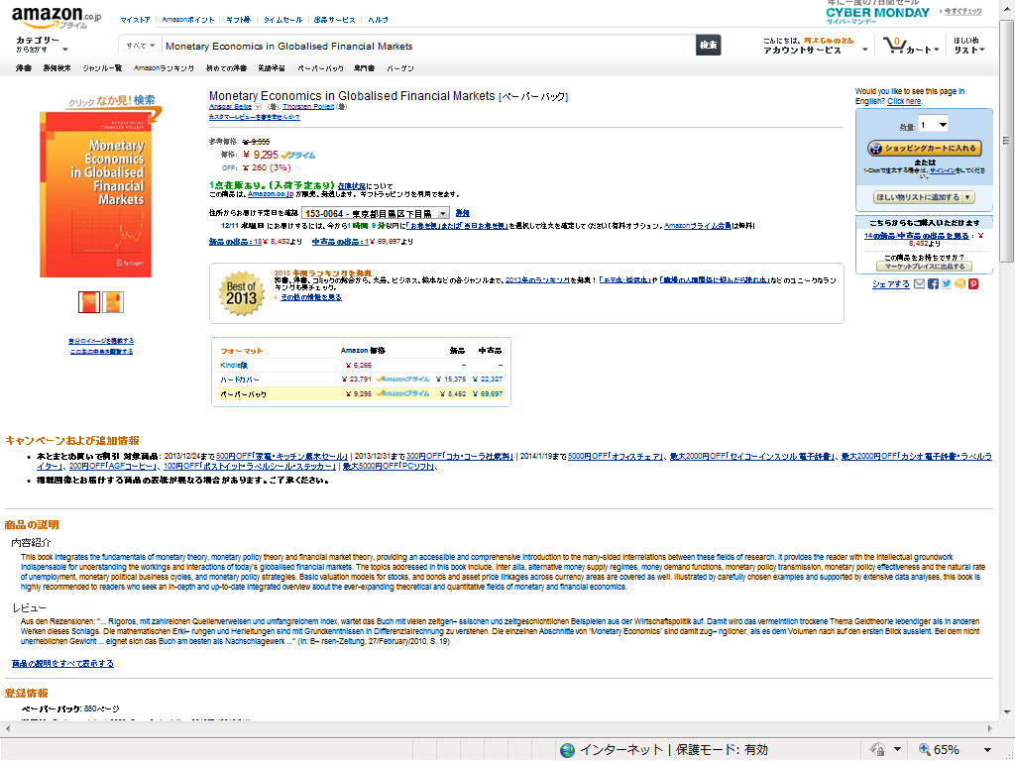

Back cover text



