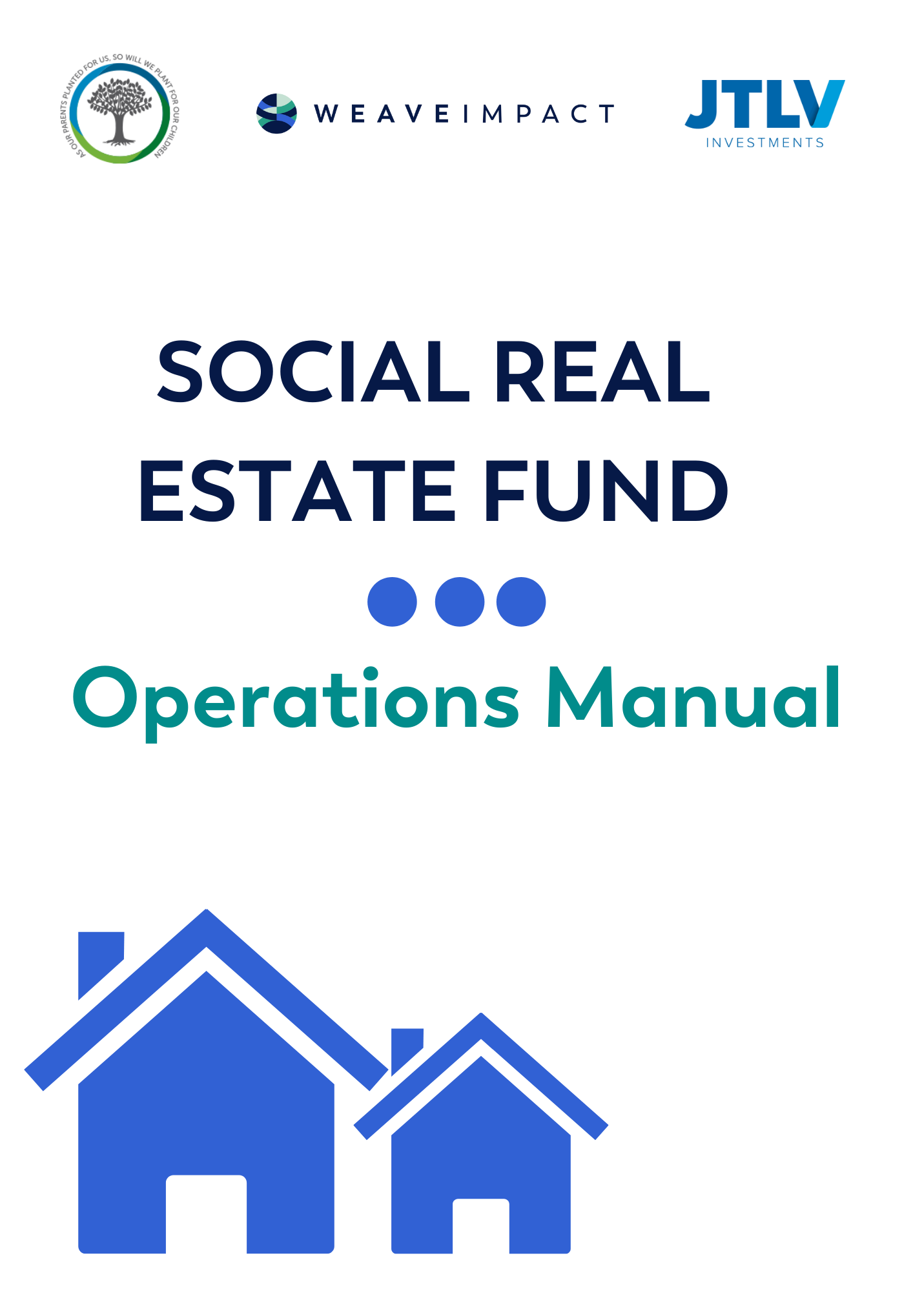

**Written By:**

**Dalia Black & Gabrielle Charnas**

**Weave Impact**

Contents

List of Terms and Abbreviations: 4

Gender Disclaimer 4

Principles of the Program 5

Overview of Social Real Estate Fund 5

Key Partnership Role Overview 6

Advisory Board 7

Operating Committee 7

Funding Requirements 8

The Fund: Overview, Roles and Responsibilities 8

Defining the Legal Structure and Tax Overview 8

Fund structure and Key Funders 8

Steps in Purchasing Properties 10

Steps in Preparing Properties for Tenants 10

Process of Rental Payment 10

Process of Transfer of Furniture Budget 11

Selecting Operating NGO 11

Potential NGO Partners 11

Role Distribution Fund 12

Real Estate Partner Responsibilities and Commitments 13

Real Estate Impact Manager Role Definition 14

Real Estate Operations Manager Role Definition 14

Investment Committee 14

NGO Responsibilities 14

Process of Transferring Capital Between Minisitries 14

Capacity Building Program for NGOs 15

Tenanting the Properties 15

Tenant Criteria 15

Process of Onboarding a Beneficiary 15

Terms of Beneficiary Contract 16

Terms of Eviction & Process 16

Transition Strategy 16

Transition Strategy Actions 17

Criteria for Evaluating Whether a Beneficiary is Ready to Move on to Independent Living 17

Wraparound Services 17

Wraparound Elements 18

Flexible Budget 18

Comparison to Currently Existing Services 19

Defining Program Success 19

Success of the Program for the Beneficiary (examples) 19

Success of the Model and Partnership 20

Success of the Financial Model (Cost Effective) 20

Impact Measurement Process 20

Appendix 1: Examples of Timing and Move on Solutions from Global Models 21

# List of Terms and Abbreviations:

|  |  |
| --- | --- |
| **Beneficiaries:** | People that are currently involved in prostitution that will become program participants |
| **The Program:** | The entirety of the intervention, including housing solution and wraparound social services |
| **The Fund/The Model:** | Used interchangeably, this refers to the investible fund model used to purchase the real estate for the housing element of the program |
| **MoLSA:** | Ministry of Labour and Social Affairs, the government ministry responsible for welfare in Israel |
| **MoCH:** | Ministry of Housing and Construction, the government ministry that is responsible for housing benefits in Israel. |
| **Wraparound Services/Wraparound Social Services:** | The welfare and support services offered as part of the program |
| **The NGO:** | The nongovernmental organization that will be responsible for the beneficiary, and also sign the lease with the fund |
| **Prostitution/**  **Prostitutes:** | This report will refer to prostitution and prostitutes as opposed to sex work/ers. The term “sex work” often connotes an active choice to engage in the sale of sex, which is not necessarily the case in these instances. The beneficiaries use the sale of their body as a survival mechanism. |
| **Normative Lifestyle:** | Ability to integrate into society, by maintaining sobriety and legal employment. Ability to responsibly take care of her own health and finances. Reduction in the dependency on the state welfare system. |

# Gender Disclaimer

While this program is open to all beneficiaries of all genders, the report will refer to beneficiaries in the female form using the pronouns she/her/hers. The use of gender specific language is not to be construed as sex-exclusion.

# Principles of the Program[1]

**Every human has the basic right to adequate housing, with no preconditions**

* The housing should be safe suitable, reflecting the needs of the beneficiary
* There are no preconditions determining if someone is “housing ready”, such as sobriety, abstinence from sex work, or ability to provide vocational income.
* As this is a pilot program there will be some basic criteria determining eligibility

**Separation of Housing and Treatment**

* Beneficiaries right to housing remains separate from their right to treatment.
* Beneficiary refusal of treatment will not lead to removal from housing, removal from housing will not result in inability to receive treatment when requested.

**Choice and Self-Determination**

* Beneficiaries have a right to choose furnishings and decorations
* Beneficiaries will have the right to choose social interventions
* Beneficiaries will not have a choice of apartment as it is dependent on availability.

**Individualized, Client Driven Support**

* Beneficiaries will have individualized wraparound social program, developed together with the NGO
* Beneficiaries will not be expected to reach certain milestones according to any timeline.
* Support will be flexible and adaptive.

**Social Inclusion and Integrations**

* Wraparound services will be developed to promote social inclusion and community involvement.
* Beneficiaries will be expected to keep good (normal) relationships with their neighbours and neighbourhood, as is expected of any rental tenant in a residential building
* Beneficiaries will have the opportunity and be encouraged to find employment, and vocational training services will be provided as part of the wraparound services in order to allow them to do.

# Overview of Social Real Estate Fund

The vision of the Social Real Estate Fund is to serve as a pilot project for an alternative solution to public housing, demonstrating that social real estate funds can become an accepted and desired housing solution for hundreds if not thousands of people in need in Israel.

The social goal of the pilot program is to use safe, secured housing as a central tool in the rehabilitation of prostitutes into a normative lifestyle.

The pilot will run for an initial 10 years, with the target beneficiary audience of people leaving prostitution.

This will be the first fund model in Israel offering leasing to NGOs specifically for the housing of vulnerable populations. The model enables the NGOs and government bodies the ability to deliver effective, targeted intervention[2].

The total rehabilitative program will include the following elements

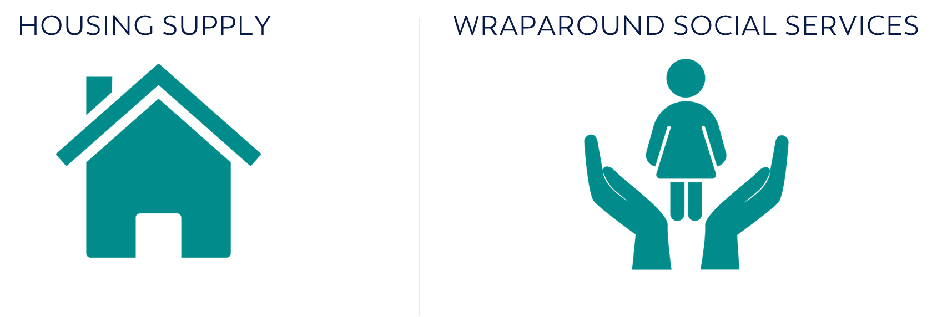

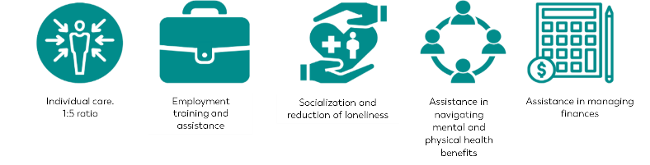

# Key Partnership Role Overview

The Social Real Estate Fund, and social program consists of a multi stakeholder partnership.

This partnership is important not only in securing funding, but the longevity and success of the program. The partners include:

* Real Estate Developer: JTLV
  + Oversees purchase and management of property portfolio
  + Brings the required real estate expertise to ensure success of the fund
* Schusterman Family Philanthropies
  + Provide catalytic capital for feasibility study, and initial set-up
  + Anchor investor
* Tza’ad Haba
  + Oversee the development of the wraparound services
  + Manage the infrastructure with the various Government partners
* Ministry of Labour and Social Affairs
  + Providing funding for housing element to close the rental gap. This funding ensures that the model remains financially viable
  + Matching funds for social wraparound services
* Ministry of Construction and Housing
  + Provide mechanism for which the MoLSA funding for housing is distributed to beneficiaries and reaches the NGOs
* Municipality of Tel Aviv
  + Provision of matching funds to government, that have element of flexibility
  + Provision of assistance in property purchasing
* NGO Partner (TBD)
  + Rental contract with JTLV
  + Tenanting of properties
  + Day-to-day management of properties and tenants
  + Overseeing wraparound services
* Weave Impact
  + Project research, development, implementation and oversight on behalf of Schusterman Family Philanthropies
  + Manager investor/donor relations
  + Project Oversight

## Advisory Board

* The Advisory Board will oversee the entirety of the project
* The Advisory Board will meet initially every 6 months, and then annually as required and decided by the Advisory Board
* The Advisory Board will be made up of representatives of all funding bodies and partners in the projects

## Operating Committee

* The operating committee, will be the professional staff of the project and meet weekly to oversee the project.

# Funding Requirements

The Social Real Estate Fund consists of two sections each requiring a different funding model.

Social Real Estate Fund: Housing

* Set up costs: philanthropy
* Housing purchases: philanthropy & impact investments
* Rental payments: Government funding, municipal funding, tenant contribution
  + Ministry of Construction and Housing (MoCH) is providing standard housing allowances dependant on beneficiary rights: NIS 770-1070/month
  + Ministry of Labour and Social Affairs is providing an additional NIS2000/month/tenant, for rental payments to be distributed through MoCH
  + Tel Aviv Municipality providing a matching NIS2000/month/tenant which can be used for rent, bills or utilities (flexible funding)
  + Beneficiaries will begin to contribute an initial NIS 500 from year 2.

Social Real Estate Fund: Wraparound Services

* First 3 years Schusterman Family Philanthropies through Tza’ad Haba for first two years, matching government funds for that period
* After year 3: MoLSA

# The Fund: Overview, Roles and Responsibilities

## Defining the Legal Structure and Tax Overview

(incl. tax structure)

## Fund structure and Key Funders

By focusing on creating an investable solution, the fund is bringing an international model to Israel, taking on the risk, and piloting a model that could change the way public housing is approached in Israel.

**Fund** **Model**

The fund will purchase, refurbish, and furnish the accommodation according the needs of those seeking to leave prostitution. The homes will be dispersed, but within geographical clusters.

**Leasing Model**

Properties will then be leased directly to the NGOs, properties are designed to meet the organization's needs:

* Safe affordable, single tenant accommodation.
* Long term leases, ensuring stability in the housing
* Rent levels according to level of available government aid

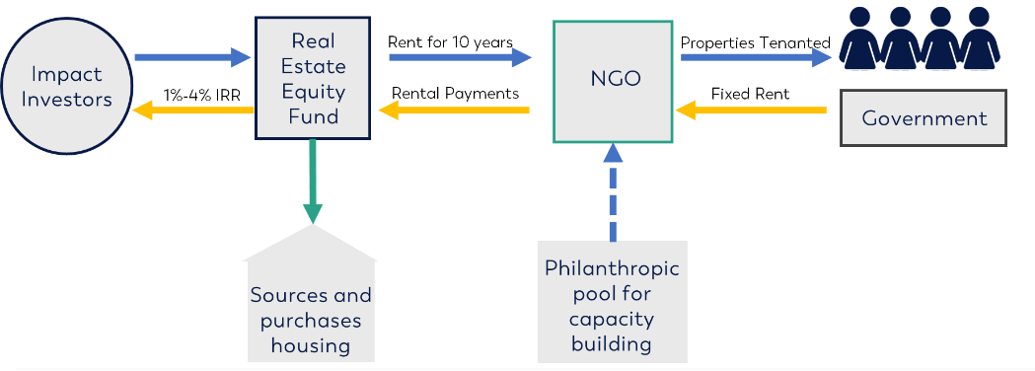

## Steps in Purchasing Properties

JTLV commits to: Sourcing the property, buying the property, providing funding for furnishing

NGO commits to: paying the bills, paying the rent, maintenance etc, purchasing the furniture

1. NGO identifies list of beneficiaries that meet criteria defined on page x
2. NGO provides JTLV with a request for number of apartments, location preferences and any specific requests (e.g.: physical disability)
3. JTLV sources properties, with the goal to find as close to NGO requirements as possible
4. Once property is sourced, JTLV shows NGO for approval
5. Investment committee to approve purchase

v

1. Purchase Property

v

1. Standard rental agreement signed between Fund and NGO

v

1. NGO signs agreement with beneficiary

## Steps in Preparing Properties for Tenants

1. Tenants to be informed of their participation in their program and undergo preparation, including selection of furniture

v

1. Apartment to undergoes necessary renovations (JTLV)

v

1. Apartments to be furnished based on furniture choices of tenant. (NGO to oversee the process, funds to be provided by the Model)

v

1. NGO to transfer all utility bills to be under the beneficiary name

v

1. NGO to settle in beneficiary and begin wraparound services

## Process of Rental Payment

1. Agreement with the Government that the capital is received up front for the complete year.
2. The capital is transferred to the NGO directly and is “designated”
3. XX ensures government transfer of rental subsidy to NGO
4. NGO pays monthly (end of month?) Delay?

## Process of Transfer of Furniture Budget

1. The fund has a budget of NIS 50,000 for furnishing per apartment.

v

1. JTLV will transfer an initial NIS 20,000 to the NGO per beneficiary

v

1. This process will be overseen by the fund manager and fund impact partner

v

1. NGO will not inform the beneficiary of the full amount in the furnishing budget

v

1. Beneficiary will go with NGO representative to select furniture for the apartment

v

1. NGO to ensure that basic furnishing needs are met (fridge, bed, stove/hotplates/oven/toaster oven/sofa), along with other furniture of beneficiary’s choice.

v

1. Unused capital will be held by the NGO for the next beneficiary, or returned to the fund should their be no additional beneficiaries.

v

1. Beneficiary may keep the furniture that she wants when she moves out

## Selecting Operating NGO

NGOs that will be partners to this organization must fulfil the following criteria;

1. Demonstration of ability to manage apartments
   1. Strong organizational structure and track record
   2. Staffing ability or willingness to recruit for the position
   3. Undergoing capacity building program if required
2. Proven success in working with the beneficiary population i.e. people in prostitution
   1. Wide outreach
   2. Trust from the beneficiaries
   3. Trust from the governmental authorities and funding bodies
   4. Successful partnership experience with governmental authorities
3. Their approach to intervention is in line with that of the program (a more holistic, individual, trauma informed approach)
4. Strong presence within Tel Aviv
5. “Buy-in” to the model
6. Willingness to be flexible to model parameters
7. The program requires for the pilot a relatively homogenic group (due to the small size of the pilot group) – the NGO needs to have the ability to find similar beneficiaries for the sake of a more accurate measurement of results.

## Potential NGO Partners

1. **Elem**
2. **Her Academy (Hamichlala)**
3. Salit
4. Lo’Omdot Mi;neged
5. Levinsky
6. Kite Pride

Based on the above criteria, Her Academy and Elem have been selected.

## Role Distribution Fund

|  |  |  |
| --- | --- | --- |
| Action Item | Responsibility |  |
|  | JTLV | Weave Impact/Schusterman/? |
| **Acquisition of Homes** | | |
| Sourcing | Sources the homes, according to brief from NGO |  |
| Property DD / viewings | Responsible for viewing and DD of properties | Confirms NGO has viewed the property |
| Investment Committee Management | The Fund will have an investment committee consisting of Amir Biram, Fund project manager, fund impact manager and representative from Weave Impact/Schusterman | |
| Agree price | Negotiate and agree on price |  |
| Conveyancing & completion | JTLV team to manage conveyance and completion process |  |
| Refurbishment | Refurbishment process managed by fund manager |  |
| Furnishing | Impact Manager Distribution of budget: Oversight of NGO furnishing process, funds for furnishing to come from fund budget |  |
| **Managing Current NGOs** | | |
| Acquiring the portfolio | Receive requests and specifications from NGO |  |
| Capacity Building |  | Oversight of capacity building program for NGOs |
| Impact data |  | Collection of Impact data from NGOs |
| Financial data | Tracking voids, arrears repair and maintenance. |  |
| Portfolio management | Impact manager to manage day to day portfolio such as reletting, renewals, property acquisition if necessary. |  |
| Asset management | Fund manager to manage brick and mortar of portfolio |  |
| Recruiting Additional NGOs |  | Oversight of Tza’ad Haba to recruit new NGOs if needed |
| Onboarding new NGOs |  | Work with Tza’ad haba to ensure correct onboarding and capacity development |
| Integrating new NGOs to work with JTLV | Impact manager to onboard the process | Oversight |
| **Oversight** | | |
| Impact reporting |  | Collection of data and production of impact report. In conjunction with Schusterman study |
| Fundraising |  | Lead on sourcing investors |
| Financial reporting | Provision of all necessary information for financial reporting | Dissemination of reports to funders |
| Meetings |  | Arrangement and facilitation of key investor meetings and Advisory Committee (annual) |
| **Financial Control / Compliance** | | |
| Compliance with the Regulator | Under JTLV responsibility |  |
| Fund Operator | Under JTLV responsibility |  |
| General Partner | JTLV is Fund general partner |  |
| Fund Administrator | Under JTLV responsibility |  |
| Financial Control | Under JTLV responsibility |  |
| Subject to Tax |  |  |
| Valuation | JTLV to arrange annual valuations |  |
| Debt Management | JTLV to manage bank debt |  |
| Annual / Quarterly accounts | Provision of all material and reporting | Dissemination of reports |
| **Communications / PR / Marketing** | | |
| Creation of marketing materials and investor decks |  | Weave Impact to prepare all external communication materials |
| **Fund Strategy and Other Key Areas** | | |
| Fund Investment Strategy Review; fund design for the scale up phase | Fund review to be undertaken by all parties involved in initial establishment to review opportunities for scale up. | |

## Real Estate Partner Responsibilities and Commitments

1. Raising and managing bank debt
2. Management of overall investor capital
3. Managing relations with the NGO (through specified Impact Manager, role defined below)
4. Acquiring 45 assets within first 6 months of year 1 (provided NGO partner allows for this timeline)

## Real Estate Impact Manager Role Definition

1. Point of contact with the NGOs
2. Report NGO needs and requirements to Fund Manager
3. Coordinate site visits with the NGO partner
4. Oversee contracts with NGO partners
5. Collect rental payments from NGO partners

## Real Estate Operations Manager Role Definition

1. Work with Impact Manager to source apartments
2. Oversee any refurbishments
3. Financial reporting
4. Xx
5. Xx

## Investment Committee

The investment committee will be made up of

* Amir Biram
* David Dover
* Fund Manager

## NGO Responsibilities

The NGO will be responsible for:

* Point person for the beneficiary
* Defining property requirements
* Viewing and approving of property before purchase
* Rental agreement and rental payments (based on the Government payments)
* Tenanting the properties
* Furnish the apartment together with the beneficiary. The funding for this will be provided from the fund financial model.
* Ensuring tenants are respecting the property, neighbours and neighbourhood.
* Ensure that the beneficiary is paying the necessary bills on time (electricity, gas etc.)
* Management of tenants and ensuring that they are receiving their social services and fulfilling their commitments to the program.
* Eviction of tenants if required.
* Deliver on the “transition strategy” as developed and funded by the Meyzam Hameshutaf

## Process of Transferring Capital Between Minisitries

MERAV

# Capacity Building Program for NGOs

The dedicated staff member and other representatives from the operating NGO will need to undergo capacity building training, in order to efficiently and effectively run the program.

Capacity building program includes and can be taught by an NGO in Israel currently managing properties: Alut, Or Shalom and can serve as income for these organizations :

* Property Management
  + Property upkeep and maintenance
  + Managing eviction
* Financial Management and Reporting
  + Ensure rental income received
  + Rental Payments paid
  + Payment and management of any bridge loans
  + Financing repairs
  + Management of flexible budget

# Tenanting the Properties

## Tenant Criteria

The pilot program will allow for an initial 45 people to be housed within the program. Determining who will be eligible for housing is the responsibility of the operating NGO. There will be no need for a committee or additional body to approve who moves into the apartments.

However, there are some clear criteria:

1. Potential beneficiary needs to have the motivation to change their lifestyles and therefore to join and complete the program
2. Potential beneficiaries must demonstrate that they are in prostitution or in the process of leaving prostitution, or at risk of returning to prostitution.
3. Potential beneficiaries must currently be residing in the Tel Aviv municipal region
4. Preference for beneficiaries with the ability to contribute or must be eligible for the defined rights (see section x) in order to receive additional rental subsidies
5. Potential beneficiaries must have had previous contact with the operating NGO
6. Potential tenants must be prepared to sign the contract agreement, and demonstrate commitment to abide by it.

REUT: Is there an amount of time that they have had to be homeless/working as a prostitute to qualify

## Process of Onboarding a Beneficiary

1. Beneficiary is required to share personal and financial information with the NGO to understand what is the current income that they are receiving (welfare benefits, salary).
2. Beneficiary signs contract with the NGO, in which she commits to abiding by the principles of the programs, defined above, and terms defined below.
3. Beneficiary will work with point person to decide what furniture is required and purchase the furniture as they prepare for moving in.
4. Beneficiary moves into temporary housing until the apartment is furnished and fit for living.

## Terms of Beneficiary Contract

* Tenant commits to at least one meeting with a point person from the project per week.
  + The location does not need to be at the apartment, they can meet in the park, at a coffee shop or in the office. The beneficiary can decide on the location as long as it reasonable for the project point person to reach.
  + The beneficiary does not need to demonstrate commitment to any welfare process, but must attend this meeting.
* The beneficiary will not be disruptive to the neighbours or neighbourhood
  + The beneficiary should behave in a way that is respectful to their neighbours, example: not host loud rowdy parties in the weekdays that will lead to noise complaints, not leave garbage in their doorway, not smoke in public stairwells etc.
  + The beneficiary will be respectful to the neighbourhood example: throw away trash, avoid vandalization.
* The beneficiary will maintain the upkeep of the apartment to a liveable standard
  + The beneficiary cannot vandalize the property.
  + The beneficiary should clean the apartment periodically and remove trash.
  + The beneficiary may paint the apartment, however cannot cause permanent damage to the infrastructure (can’t remove a wall etc.).
* The beneficiary may not sublet the apartment.
  + The beneficiary is allowed house guests, for a limited amount of time (do we want to define time?).
  + The beneficiary may not receive financial compensation for allowing smeone to stay in the apartment.

## Terms of Eviction & Process

1. Up to 3 warnings – if they do not succeed following the third warning they are evicted by the NGO (this will be detailed in the contract with the beneficiary)
2. Beneficiary stops meeting with the social worker once a week
3. Process: preference to move the beneficiary to an alternative framework if possible

# Transition Strategy

The program requires a transition strategy to accompany the beneficiary out of the program and into independent living.

The model is working on an assumption of a 4-year tenancy. Based on similar program results in the UK, the average time is 2-3 years for enabling the beneficiary to enter independent living (for UK housing Fund strategies see appendix 1):

1. No tenant will be removed from housing without a follow-on solution.
2. It is sufficient time to demonstrate initial proof of concept to government. This POC will be used as justification to change government policy on housing benefits.
3. Based on the Amari Research it allows for enough time to break the cycle of prostitution, with a one year cushion.
4. NGO partners will continue to provide support, once tenants have moved on to independent housing.

## Transition Strategy Actions

While no tenant will be removed from housing, and each can move at their own pace with no set time milestones, the assumption must be that beneficiaries are working towards independence and will eventually cycle out of the housing provided by the fund. In order to ensure a smooth transition, the following actions will be undertaken:

1. Beneficiary will begin to receive vocational training from the point that they are ready (estimate 12-18 months within the program).
2. Beneficiary will receive support in integrating into the workforce.
3. Beneficiary will receive social support to help them navigate their rights.
4. Beneficiary will receive financial management support.
5. Beneficiary will begin to contribute to their rent at year 3 or 4 of housing, thus already establishing a level of responsibility for housing.
6. Beneficiary will be assisted by NGO and case worker in securing suitable accommodation once ready to move on.
7. Beneficiary will continue to receive social support from NGO and case worker once they have moved into new accommodation. Social support could even become a bit more intense once they move into new housing
8. Tza’ad Haba, NGOs and the Social Real Estate Fund will continue to work with the Ministry of Housing and Ministry of Welfare from day 1, to ensure continued financial support for the beneficiary, even once moved on from housing.

## Criteria for Evaluating Whether a Beneficiary is Ready to Move on to Independent Living

Beneficiaries will only be moved on from the program, once they can demonstrate the following:

1. The beneficiary has expressed a desire to move on to independent housing.
2. The beneficiary can afford to move on, and has demonstrated financial responsibility.
3. The beneficiary has legal employment.
4. The beneficiary a strong working relationship with her case manager and demonstrated the willingness to maintain contact.

# Wraparound Services

The wraparound services for the beneficiaries of this program will be based on the existing ‘Ma’atefet’ program, that was created for youth at risk.

The program is based on the American “Wraparound Program” which is a strengths-based planning process. The program aims to move away from a traditional service driven approach to a more individually built needs drive approach[3].

Key features of the Ma’atefet program, which will be adapted for those leaving sex work, include five main focus areas:

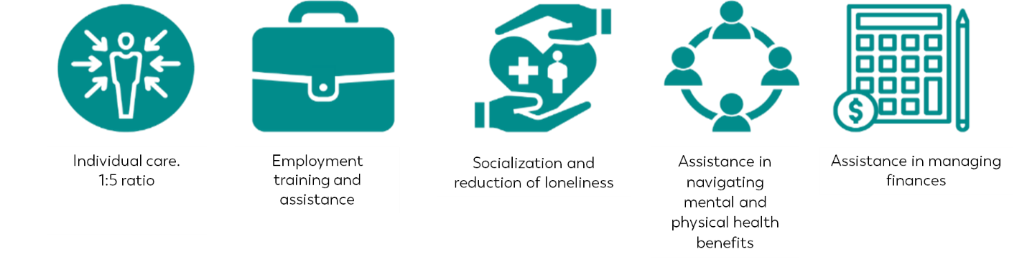

## Wraparound Elements

* A one to five ratio, of social worker to client, resulting in a much more intensive care program.
* A once-a-week meeting with a professional social worker
* Individually designed treatment plan, which will likely focus on
  + Exercising health, social and legal rights.
  + Vocational or employment training
  + Other life skills – social skills, hobbies, interests in life.
* Assistance in navigating benefits and application for the benefits for which she is eligible.
* Assistance in managing their finances and budgeting.

## Flexible Budget

Part of the budget for each participant remains discretionary and flexible, so that it can be used as seen fit by the participant and social worker, for their treatment plan. The budget can be used for a wide variety of uses:

* Cosmetic and clothing
* Groceries if needed
* Entertainment such as a movie or concerts
* A vocational or recreational course not otherwise offered by the program (pottery, creative writing etc.)
* Small decorative items for the apartment

The flexible budget does not include furniture, which will come out of a designated budget from the fund.

WHAT ABOUT DRUG REHAB? Do they leave the apartmet for that? Is it from felx budget?? Do they have to request it?

# Comparison to Currently Existing Services

Currently in Israel, there is no fully comprehensive program such as this for homeless people looking to leave the cycle of prostitution. Options that exist are the following:

Hostels:

There are 20 hostels for homelessness around Israel. Within Tel Aviv these include:

* Gagon for sober women
* Gagon for women with substance abuse
* Gagon for sober men
* Gagon for men with Substance abuse
* David Agayov Apartment (men only)
* Living on the street

These are open from 19:30 – 7:30 the next morning, and are available only to those that hold a permit from a social worker[4].

The cost per night in a shelter is NIS 450 (REUT MATZEGET)

There are 53 state registered hostels/homes for youth that were referred to by order of the state as a result of judgment, punishment and methods of treatment or treatment and supervision

This includes Shanti House, which also has youth that have not been referred there by the State.

Elem costs X/night

# Defining Program Success

Program Success will be defined on three fronts: success of the program for the beneficiary, success of the model and partnerships, success of the model financially (cost efficient.

## Success of the Program for the Beneficiary (examples)

**Maintenance of tenancy**

* Beneficiary is able to maintain their tenancy in her home
* Beneficiary is are able to maintain cordial relationships with her neighbours
* Beneficiary is able to keep her home to presentable standards

**Beneficiary Satisfaction with Program**

* Beneficiary demonstrates satisfaction with their living environment
* Beneficiary demonstrates satisfaction with their social point of contact, and services received

**Return to Normative Lifestyle**

* Beneficiary is able to maintain employment in a legal place of work
* Beneficiary is able to maintain sobriety
* Beneficiary is able to maintain friendships
* Beneficiary is able to resolve conflict in a respectable non-violent manner
* Beneficiary is no longer reliant on prostitution for income
* Beneficiary is able to think ahead and make future plans

## Success of the Model and Partnership

Xx

Xx

## Success of the Financial Model (Cost Effective)

xxx

# Impact Measurement Process

The impact measurement process will be managed internally by Schusterman Family Foundations and will be a five year process including a control group.

The process will be done via annual in-person surveys.

The control group will receive financial compensation in order for their participation in the survey[5].

Surveys will measure progress in the parameters of success as defined above.

# Appendix 1: Examples of Timing and Move on Solutions from Global Models

WISH

* Estimated time each woman will spend in housing: ~3 years
* “Day After Scenario”: While the estimated time in WISH housing is three years, no woman will be evicted after such time. However, it is expected that within three years, she will be leave the housing when she no longer requires the support provided by WISH. At this point she will either continue to receive local authority housing benefits, or have found employment to cover her rent.

SASH

* Estimated time each person will spend in housing: ~2.5 years
* “Day After Scenario”: While the estimated time in SASH housing is th2.5 years, no person will be evicted after such time. Depending on the scenario of each person, some people remain on housing benefits their whole lives and then are able to move on to other housing, paid by housing benefits. Others will have found employment to help with rent.

Commonweal, Amari

* Estimated time each woman will spend in housing: ~1.5 years
* “Day After Scenario”: The Commonweal Amari program is designed specifically for women leaving prostitution. Commonweal provides the housing, and Amari provides the support. The women that enter the Commonweal housing, are post drug rehabilitation. Amari research shows that without supported housing it takes 7 years to break the cycle of prostitution, however with the support of the Amari program it takes 2-3 years to break the cycle. Amari helps their clients find housing once they move out of the Commonweal Housing.

HSPG UK

* Estimated time each person will spend in housing: ~1-2 years (homeless/domestic abuse)
* “Day After Scenario”: Once the tenant is housed in social housing, they will begin to receive support towards independence. The next step is for them to live independently, which includes financial independence, such as working towards a job where they can earn money to get into rented accommodation.

Y Foundation Finland

* Estimated time each woman will spend in housing: Unlimited
* “Day After Scenario”: Y Foundation is based on a Housing First model of unlimited time in housing. Most of the rental income (80%) is covered by housing benefits. The remaining 20% is covered either by the tenant, or the state through other welfare benefits. There is no ‘day after scenario’, however the program is heavily dependent on continued benefits. Y Foundation also provides employment opportunities within the Foundation that can help with rental payments (maintenance, gardening, etc.)

1. Adapted from: *This is Housing First כor Youth, Operations Manual Part 2. Stephen Gaetz, Heidi Walter, Meryl Borato*
2. The fund model was developed through consultation with Keith Breslauer and Patron Capital, and the modelling of the WISH model, which is run by Patron Capital.
3. https://www.cdss.ca.gov/inforesources/cdss-programs/foster-care/wraparound
4. https://www.israelhayom.co.il/article/633051
5. This method was used by Pathways New York