Postpartum “Bloods of Purity”

Mesopotamian gynecological texts and what we know about women’s post-partum flow are helpful in parsing the unusual Hebrew idiom *demei tohorah*, literally, “bloods of purity,” used in Leviticus 12 to describe the second stage of postpartum bleeding.

[Prof. Tamar Kamionkowski](https://www.thetorah.com/author/tamar-kamionkowski)

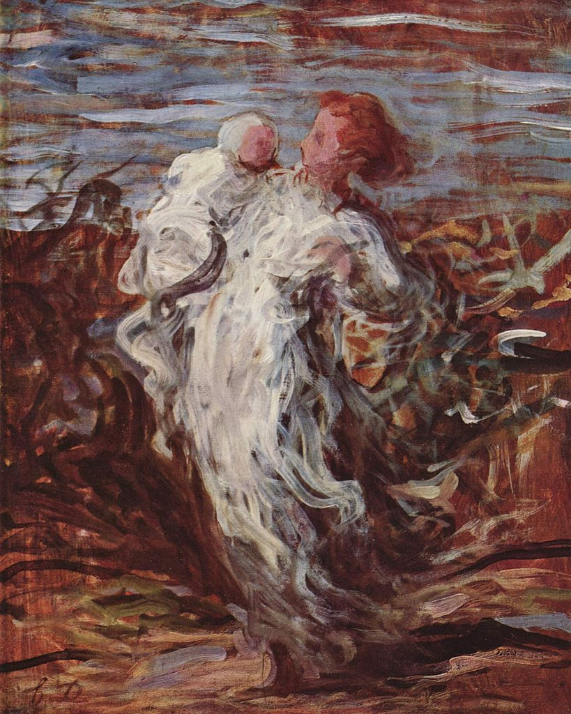

*Mother with child,*Honoré Daumier, circa 1865-1870. Wikimedia

The Second Stage after Childbirth

According to Leviticus 12, after a woman gives birth, she passes through two different stages. The first stage is compared to the seven-day impurity (ט.מ.א) of a menstruant, referring to the norms now found in Leviticus 15.

ויקרא יב:ב...אִשָּׁה כִּי תַזְרִיעַ וְיָלְדָה זָכָר וְטָמְאָה שִׁבְעַת יָמִים כִּימֵי נִדַּת דְּו‍ֹתָהּ תִּטְמָא...

Lev 12:2…When a woman at childbirth bears a male, she shall be unclean seven days; she shall be unclean as at the time of her menstrual infirmity….

In the second stage, the woman remains (literally “sits”) in her “bloods of *tohorah*,” from the root ט.ה.ר, meaning “pure”:

יב:ד וּשְׁלֹשִׁים יוֹם וּשְׁלֹשֶׁת יָמִים תֵּשֵׁב בִּדְמֵי טָהֳרָה בְּכָל קֹדֶשׁ לֹא תִגָּע וְאֶל הַמִּקְדָּשׁ לֹא תָבֹא עַד מְלֹאת יְמֵי טָהֳרָהּ.

12:4 And for thirty-three days she shall remain in her bloods of *tohorah*: she shall not touch any consecrated thing, nor enter the sanctuary until her days of *tohorah* are completed.

In the second stage, the woman is only restricted from entering the Tabernacle or touching anything that has been consecrated to God; otherwise, she may return to her regular activities.[1] We are then told that the two-stages apply to the birth of a daughter, but with the time for each stage doubled:

יב:ה וְאִם נְקֵבָה תֵלֵד וְטָמְאָה שְׁבֻעַיִם כְּנִדָּתָהּ וְשִׁשִּׁים יוֹם וְשֵׁשֶׁת יָמִים תֵּשֵׁב עַל דְּמֵי טָהֳרָה.

12:5 If she bears a female, she shall be unclean two weeks as during her menstruation, and she shall remain in bloods of *tohorah* for sixty-six days.[2]

Thus, the days of *tohorah* last 33 days for the birth of a son and 66 days for the birth of a daughter, but what does it mean to be in “her days of *tohorah*” and “sitting upon bloods of *tohorah*”?

Purification or Purity

The term “bloods of *tohorah”* is often understood as marking the period of time in which the woman gradually moves from ritual impurity to purity. According to this, *tohorah* here should be translated as “purification.”[3] This understanding of “bloods of *tohorah*” may be influenced by a similar passage regarding the laws of the *zav*, a man suffering from gonorrhea, who must have seven clean days in order to be purified:

ויקרא טו:יג וְכִי יִטְהַר הַזָּב מִזּוֹבוֹ וְסָפַר לוֹ שִׁבְעַת יָמִים לְ**טָהֳרָתוֹ** וְכִבֶּס בְּגָדָיו וְרָחַץ בְּשָׂרוֹ בְּמַיִם חַיִּים וְטָהֵר.

Lev 15:13 When one with a discharge becomes clean of his discharge, he shall count off seven days for his ***tohorah***, wash his clothes, and bathe his body in fresh water; then he shall be clean.

Here the term refers to the period of seven clean days as his *tohorah*, implying a process of moving closer to purity. A similar usage appears in the laws of the purification of someone from *tzaraʿat* (skin disease). The verse states that a poor person can use brings birds as offerings:

ויקרא יד:כג וְהֵבִיא אֹתָם בַּיּוֹם הַשְּׁמִינִי לְ**טָהֳרָתוֹ** אֶל הַכֹּהֵן...

Lev 14:23 On the eighth day of his ***tohorah***, he shall bring them to the priest…

Again the implication is that *tohorah* refers to the entire period of eight days in which the person was moving toward purity from impurity.[4]

Accordingly, Dorothea Erbele-Kürster of Johannes Gutenberg-Universität in Mainz, suggests that *demei tohorah* be translated as “blood purification,” and understood as a “transformation ritual,” an act or process during which a woman gradually moves from impurity to purity as her blood discharge decreases.[5]

Blood Purity

The cases of the *zav* and someone suffering from *tzaraʿat* do not explicitly describe the nature of the body’s transformation. These cases focus on the waiting time between the end of the illness and the next ritual step. In the case of the parturient, she waits a certain number of days, thus, the reference to *yemei tohorah* (days of her *tohorah*), but she also undergoes another physical transformation wherein her body is actually changing.

While “purification” may work for the phrase “days of *tohorah*,” it is harder to accept as a rendering for “bloods of *tohorah*.” Thus, in his JPS commentary on Leviticus, NYU Professor Emeritus of Bible, Baruch Levine, suggests that the translation “blood purity” is the more accurate translation.[6] The advantage of this translation is that it focuses on the nature of the blood itself as a purifying agent.

Can Blood be *Tahor*?

The concept of “blood of purity”—or even “blood of purification”—is difficult to understand. Nowhere else in the Bible is blood described as pure or purifying, not even the blood used to purify the altar (Lev 16:19) is referred to this way. Why would post-partum bleeding of all things be described as an agent of purity?

The Uniqueness of Postpartum Blood

Postpartum “blood” is a unique bodily discharge in that it gradually shifts from red to white. The discharge goes through three stages:

* ***Lochia rubra* (red discharge)**—Although containing pieces of membrane, this discharge has a lot of blood and thus appears as a deep red. It can last up to around day 10 after birth.
* ***Lochia serosa* (membranous discharge)**—This discharge is thinner, with much less blood, and thus appears more pink. This stage can last for a few weeks.
* ***Lochia alba* (white discharge)**—This white or yellowish-white discharge, which has very little blood (i.e., red blood cells), can last to about six weeks after the birth.

It may have been that the appearance of blood that seems to clear itself from red blood to a white or clear discharge may have led to the term “bloods of purity” – blood that transforms itself into another substance. No other blood changes its apparent composition.

Menstrual vs. Postpartum Flow

This interpretation gains support from a debate in rabbinic literature about whether post-partum discharge is even from the uterus (b. *San*. 87b; b. *Nid*. 11b, 35b-36a):

איתמר: רב אמר: ”מעין אחד הוא התורה טמאתו והתורה טהרתו. “

It was stated: Rav said: “There is one fountain (i.e., uterus or source of vaginal bleeding); the Torah made it impure and the Torah made it pure.”

ולוי אמר: ”שני מעינות הם נסתם הטמא נפתח הטהור נסתם הטהור נפתח הטמא. “

Levi said: “There are two fountains; when the impure one is closed the pure one opens, when the pure one is closed the impure one opens.”

Perhaps Levi’s point is that it is clear from merely looking at the discharge that this does not come from the same place as menstrual blood.[7] While he may have been wrong about the anatomy, his observation highlights a key difference between menstrual and post-partum flow that would have been clear to any ancient people with empirical medical knowledge, including the Priestly authors of the Bible, who note that the first stage is “like the days of her menstruation” while the second is not.

Fear of Infection

Noting the unique features of post-partum bleeding is not merely an academic exercise, but one of great importance for monitoring a woman’s health. As ancient societies knew and experienced, the post-partum period is especially dangerous. The Harvard University medical historian Edward Shorter notes the pervasiveness of post-partum infections in pre-modern societies, especially peritonitis. This condition can develop within a few days after delivery due to a spreading postpartum bacterial infection at the site of the uterus.

As Shorter writes, peritonitis articulates itself in a hard swollen belly, pain in “the lower part of the abdomen and stopping of the lochia... in the past, the lifetime risk for women to get puerperal infection was high (estimated 25% risk), and few women passed through their childbearing without ever getting a puerperal infection.”[8]

The high risk associated with the post-partum period explains the great interest taken in monitoring the health of a woman and her discharges in this period, which we know of from ancient Mesopotamian texts.

A Purifying Agent: The Mesopotamian Evidence

Mesopotamian medical texts indicate that postpartum discharges were carefully observed and monitored. Ulrike Steinert of Freie Universität Berlin, analyzes ancient Mesopotamian gynecological texts. She cites several texts that address postpartum complications in which there is blockage of the blood flow or excessive hemorrhaging.

One text reads:

If a woman [gives birth][9] and subsequently her womb [gives her a stinging pain…] concerning that woman, locked fluids are present.

Another text reads:

If a woman has given birth and subsequently she has intestinal fevers, vomits, […]: (it is) the blood of that woman in childbed, which has been blocked/detained in her womb...[10]

Additionally, there are incantations for gynecological hemorrhaging which describe the blood loss as a flowing river that needs to be damned up.[11] In short, the blockage or excessive flow of the discharge was a sign of illness and possible death, while the regular flow of blood, then lochia, was a sign of health and of life-renewed. Thus, monitoring discharges was likely connected to the danger inherent in this period of a woman’s life.

A Sign of Health

While no terminology from any of the Mesopotamian texts parallels the biblical idiom “bloods of purity,” it is likely that the two societies shared a similar concept: the proper progression of a woman’s flow after childbirth was a sign of her healing and health.[12] Thus, the term “bloods of purity” points to the idea that if the bleeding progresses the way it should, the body is healing itself. As healing and purity are intertwined in biblical literature, this discharge can reasonably be described as purity itself.

[View Footnotes](https://www.thetorah.com/article/postpartum-bloods-of-purity)

1. The exact legal status of this stage was a matter of fierce sectarian debate between Samaritans, Rabbinic Jews, and Karaite Jews. For a discussion of this debate, see Zev Farber, [“The Parturient's Days of Purity from Torah to Halacha,”](https://www.thetorah.com/article/the-parturients-days-of-purity-from-torah-to-halacha) *TheTorah* (2017).
2. The reason for the difference between the periods of time for male and female children have been debated for millennia. For some recent discussions of this, see Kristine Henriksen Garroway, [“Gendering a Child with Ritual,”](https://www.thetorah.com/article/gendering-a-child-with-ritual) *TheTorah* (2019); Tzvi Novick, [“Mother and Child Post-Partum Defilement and Circumcision,”](https://www.thetorah.com/article/mother-and-child-postpartum-defilement-and-circumcision) *TheTorah* (2014). See also the brief discussion of the Hittite Kunzigannaḫit ritual in, Yitzhaq Feder, [“A Sin Offering for Birth Anxiety,”](https://www.thetorah.com/article/a-sin-offering-for-birth-anxiety) *TheTorah* (2016).
3. See e.g., the renderings of the phrase in the New Revised Standard Version (NRSV) “Her time of blood purification…” and the New Jewish Publication Society (NJPS) Tanakh, “She shall remain in a state of blood purification.”
4. Notably, the other time the term “day of *tohorah*” appears in the Bible, describing a nazirite who became impure and needs to restart his count, the term refers only to the culmination of the process:

במדבר ו:ט וְכִי יָמוּת מֵת עָלָיו בְּפֶתַע פִּתְאֹם וְטִמֵּא רֹאשׁ נִזְרוֹ וְגִלַּח רֹאשׁוֹ בְּיוֹם טָהֳרָתוֹ בַּיּוֹם הַשְּׁבִיעִי יְגַלְּחֶנּוּ.

Num 6:9 If a person dies suddenly near him, defiling his consecrated hair, he shall shave his head on the day of his *tohorah*; he shall shave it on the seventh day.

The point here is that on the day that his purification takes place, he will shave his head.

1. Dorothea Erbele-Küster, *Body, Gender and Purity in Leviticus 12 and 15*, Library of Hebrew Bible/Old Testament Studies 539 (London: Bloomsbury T&T Clark, 2017), 38–39; trans. of, *Körper und Geschlecht: Studien zur Anthropologie von Leviticus 12 und 15*, WMANT 121 (Neukirchen-Vluyn: Neukirchener Verlag, 2008), 32.
2. Baruch Levine, *Leviticus: A JPS Commentary* (Philadelphia: Jewish Publication Society 1989), 74. A translation along these lines is offered in the NET (New English Translation), “Then she will remain thirty-three days in blood purity.”
3. For a discussion of this source focusing on a different explanation for Levi’s view, see part 3 in Zev Farber, [“The Parturient's Days of Purity from Torah to Halacha,”](https://www.thetorah.com/article/the-parturients-days-of-purity-from-torah-to-halacha) *TheTorah* (2017).
4. Edward Shorter, *Women's Bodies: A Social History of Women's Encounter with Health, Ill-Health and Medicine* (New Brunswick/London, 1997), cited in, Ulrike Steinert, “Fluids, Rivers and Vessels: Metaphors and Body Concepts in Mesopotamian Gynecological Texts,” *Journal of Med. Cuneiform* 22 (2013): 1–23 [8, n18].
5. Literally it says “ditto.”
6. Steinert, “Fluids, Rivers and Vessels,” 5-6.
7. Steinert, “Fluids, Rivers and Vessels,” 9.
8. For a discussion of the connection between health and purity, and between illness and impurity, see Yitzhaq Feder, [“Tumah: Ritual Impurity or Fear of Contagious Disease?”](https://www.thetorah.com/article/tumah-ritual-impurity-or-fear-of-contagious-disease) *TheTorah* (2019).