Tzaraat in Light of Its Mesopotamian Parallels

Notwithstanding its lengthy coverage of *tzaraat* (צרעת, biblical “leprosy”), why does the Torah omit discussion of its cause (sin?), its infectiousness, and its treatment? Comparison to the Mesopotamian rituals pertaining to a strikingly similar disease (*Saḫaršubbû*) shows that these omissions were far from accidental.

[Dr. Yitzhaq Feder](https://www.thetorah.com/author/yitzhaq-feder)

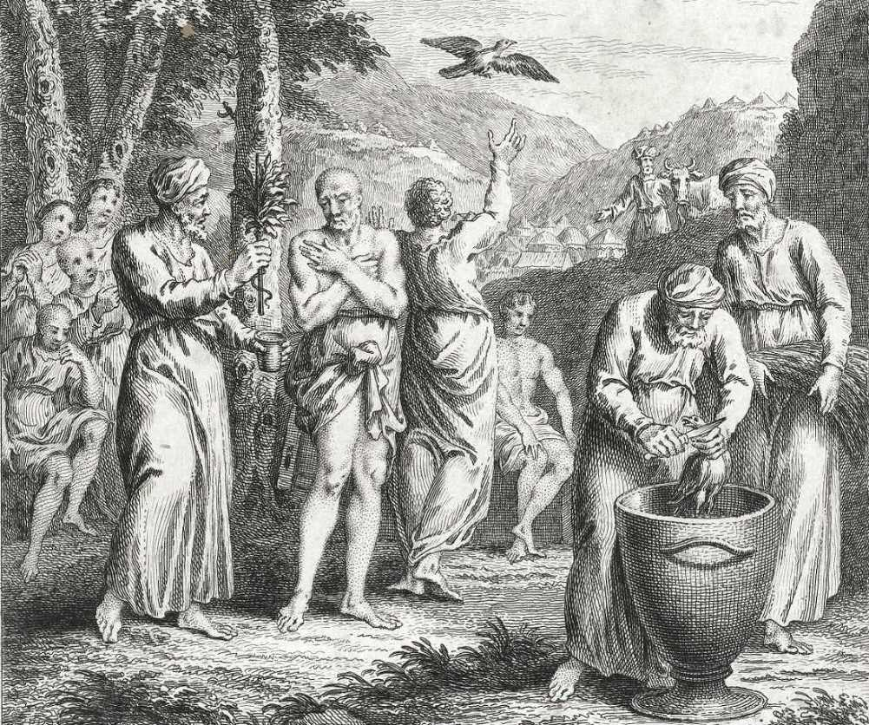

The Metzora being purified with the two birds. By Dutch engraver Simon Fokke, 1712-1784. Rijksmuseum

He is diagnosed as sick, but never treated. He is banished from the community, but not contagious. He offers a guilt offering (אשם), but his sin is left unstated. Who is this *meṣor‘a*, and what is this disease called *tzaraat?*

The question of the identity of this disease has been subject to hundreds of academic papers, a fact that may surprise the average reader who would be quite content to ignore this subject entirely. Yet the detailed discussion of skin disease in Leviticus 13–14 has implications that reach far beyond the discussion of this particular disease. These can only be appreciated when recognizing what is missing – perhaps even deliberately concealed – from these chapters.

An Imaginary Disease?

This disease cannot simply be identified with “leprosy” (Hansen’s Disease), which has a different set of symptoms, nor do its symptoms align with any single disease. For this reason, some scholars have suggested that it is a symbolic or imaginary disease,[1] but this is likely incorrect.

The existence of ancient Near Eastern parallels, and the ubiquitous discussion of this ailment in Second Temple writings, makes clear that the practical ramifications of these prescriptions were taken to be quite real. Without committing myself to a particular diagnosis, the translation “leprosy” will be adopted here for convenience.[2]

The Question of Contagiousness

The most perplexing aspect of this disease is the question of its contagiousness. The banishment of lepers is mentioned several times in the Hebrew Bible (Numbers 5:2–5; 12:14). Leviticus 13 depicts their ostracism in explicit terms (vv. 45–46):

וְהַצָּרוּעַ אֲשֶׁר בּוֹ הַנֶּגַע בְּגָדָיו יִהְיוּ פְרֻמִים וְרֹאשׁוֹ יִהְיֶה פָרוּעַ וְעַל שָׂפָם יַעְטֶה וְטָמֵא טָמֵא יִקְרָא… בָּדָד יֵשֵׁב מִחוּץ לַמַּחֲנֶה מוֹשָׁבוֹ.

The leper who has the affliction: his clothes shall be torn, his hair shall be disheveled, he shall cover his moustache and call out: ‘Impure, impure!’…He shall dwell alone. His dwelling shall be outside the camp.

This banishment is also reflected in the narrative describing the banishment of four lepers in 2 Kings 7:3–10. This account does not associate leprosy with concerns for sanctuary purity, and the numerous attestations to this practice in Second Temple sources (e.g. Temple Scroll 48:14–7; Josephus, *Against Apion* I 281), similarly suggest a general trepidation from any contact with these lepers, unrelated to the cultic sphere.[3]

This might suggest that the banishment was motivated by a concern for contagion, yet there is no hint in Priestly texts that this banishment was motivated by a fear of infection! In fact, the divine imperative mandating the banishment of lepers, gonorrheics and bearers of corpse impurity from the Israelite camp in Numbers 5:3 gives an entirely different rationale:

וְלֹא יְטַמְּאוּ אֶת מַחֲנֵיהֶם אֲשֶׁר אֲנִי שֹׁכֵן בְּתוֹכָם.

So that they do not defile the camp of those in whose midst I dwell.

Similarly, the corpus of purity laws in Leviticus 11–15 concludes with the rationale (15:31):

וְהִזַּרְתֶּם אֶת בְּנֵי יִשְׂרָאֵל מִטֻּמְאָתָם וְלֹא יָמֻתוּ בְּטֻמְאָתָם בְּטַמְּאָם אֶת מִשְׁכָּנִי אֲשֶׁר בְּתוֹכָם.

You shall put the Israelites on guard against their uncleanness, lest they die through their uncleanness by *defiling My Tabernacle* which is among them.

In other words, the motivation for these purity laws is a concern for maintaining the purity of the site of the divine presence, and not – as one might have supposed – an underlying fear of infection. Nevertheless, might this be a post-facto rationale that is covering up the more ancient motives underlying these purity practices?

A Mesopotamian Parallel: *Saḫaršubbû*

Before addressing this question, it is important to point out that biblical leprosy shares many characteristics with the Akkadian disease called *saḫaršubbû*(a loanword derived from Sumerian saḫar.šub.ba: “covered with dust”)*.*[4] This highly infectious skin disease is mentioned in numerous texts of various genres (lists of workers, incantations, oath-curses, rituals) from the early second millennium BCE and on.[5]

The Akkadian term referred to a condition that covered the body of its victim like a garment and led to his stigmatization and banishment from the community. Often the victim was forced to literally roam the steppe. Like *tzaraat*in non-Priestly biblical sources (Num 12:10; 2 Sam 3:29 2 Kgs 5:27; 2 Chr 26:19–20), it was often viewed as a divine punishment or curse.[6]

Treating the Patient

Of particular interest is the only known ritual for the treatment of *saḫaršubbû.*This ritual was found on a single tablet composed in Emar (located on the bend of the Euphrates River in Syria) in the 13th cent. BCE,[7] where several other important ritual comparisons were found.[8] This text contains three sections, consisting of an incantation, treatments, and a rite following recovery. The medical treatment section distinguishes between different types of the disease and offers specific instructions for each one, focusing on different skin discolorations (white, yellow, red, black and different combinations). Each one is followed by its appropriate treatment. For example, the text states that,

[If] the *saḫaršubbû* is yellow and red, it is the hand of (the moon god) Sîn. To remove it, you should anoin[t him] with human semen for seven days [and he will recover] (line 60).

These instructions are reminiscent of those of *ṣara‛at*in Leviticus 13, where discolorations serve as the primary diagnostic criteria. (Another illuminating parallel comes in the laws of wall *ṣara‛at*; see appendix for details.)

Ensuring a Permanent Healing – The Two Birds

An even more striking comparison involves the purification to be performed after the patient has healed. The bandages used in healing the patient are to be removed and thrown in a fire. An incense altar and table with offerings are presented to the sun god (Shamash). Then the following rite takes place:

This patient stands before Shamash. You shall burn one partridge and a crab before Shamash, [and] with (another) partridge you shall wipe his body and he will let (it) go.[9]

This rite aims to remove any residual impurity after the patient has healed. A crab and a partridge are burned, either as offerings or in order to destroy the impurity (which, according to this understanding, was absorbed into these creatures). Then a second partridge is wiped over the body of the patient and then released, serving to transfer this pollution to a distant location.

This rite invites a comparison with the purification of the leper in Leviticus 14. After he has been healed, the priest is instructed to perform upon him a rite involving two birds (vv. 4-7). The first of these is slaughtered, and its blood is sprinkled on the patient. The second bird is dipped in the blood and then released into an open field.

Both of these texts use two birds: one is killed and the other is used to carry the pollution away from the community. Since these rituals pertain to the same types of skin disease, this similarity is quite significant.

The Torah’s Treatment?

The most significant parallels and differences become clear when we compare the overall structure of these two texts:

|  |  |  |
| --- | --- | --- |
|  | ***saḫaršubbû -*Emar tablet, ll**(examples) | ***ṣara‛at -*Leviticus** (examples) |
| **Diagnostic procedures** | “If a person has *s.*and there is white color on his body…” (53) | “And the priest shall see, and look, there is a white lesion in the skin, and it has turned the hair white…” (10) |
|  | “Likewise if the *s.*is yellow and red…” (55) | “And if the flesh on his skin has a burn by fire and the healthy part of the burn on his skin becomes bright, shiny reddish–white or white…” (25) |
| **Treatment of Illness** | “…you should take *ašāgu*plant, salt, barley, flour…and anoint him and he will get well” (53–54) | - ? - |
|  | “…with human semen you should anoin[t him] for seven days”(60) |  |
| **Ritual After Recovery** | “You shall burn one partridge and a crab before Shamash, [and] with (another) partridge you shall wipe his body and he will let (it) go.” (87–9) | “The priest shall order two live clean birds, cedar wood, crimson stuff, and hyssop to be brought for him who is to be cleansed. The priest shall order one of the birds slaughtered over fresh water in an earthen vessel… and he shall set the live bird free in the open country.” (4–7) |

As noted, the elaborate diagnostic procedures outlined in Lev 13 parallels the detailed symptomology of *saḫaršubbû*as indicated in ll. 50–84 of the Emar tablet. In turn, Lev 14 parallels the section in lines 85–89 of the Emar tablet dealing with the patient “after he recovers” (*kīmê ibluṭ*[TI-*uṭ*]).

This comparison highlights what is missing in the Bible: the striking absence of any treatment for the leper. The absence of any healing rite in Lev 14 has been noted by scholars well before the Emar texts were published,[10] but the otherwise close parallel with the Emar ritual makes this omission all the more conspicuous.

That healing rites did exist among ancient Israelites is attested not only in the extra-biblical evidence from neighboring cultures, but from the abundant array of amulets and figurines found in Judean archaeological sites throughout the Iron Age. These probably served multiple functions, including healing and protection against dangerous forces.[11]

Sources of Impurity

The most convincing way to address the paradoxical treatment of the *meṣor‘a* is by assuming that this disease has been reconceptualized. Indeed, the Bible offers hints of a more ancient conception than the one represented in the Priestly texts. As I have suggested elsewhere, the notion of pollution (טומאה) serves in part as a premodern conceptualization of infection,[12]specifically regarding severe conditions such as leprosy and gonorrhea.[13] The severe pollution associated with corpses may stem from a fear associated with the spirits of the deceased.[14]

David’s curse of Joab (2 Samuel 3:28–29) suggests the general fear that was associated with these conditions:

שמואל ב ג:כט …וְאַל יִכָּרֵת מִבֵּית יוֹאָב זָב וּמְצֹרָע וּמַחֲזִיק בַּפֶּלֶךְ וְנֹפֵל בַּחֶרֶב וַחֲסַר לָחֶם.

2 Sam 3:29 …May there never cease to be in the house of Joab a gonorrheic (זב), leper (מצורע), a holder of the spindle,[15] a victim of the sword or a person lacking bread.

All of these curses involve social ostracism.[16] The presence of leprosy and gonorrhea (as well as corpses) in this list reinforces the impression that these situations were associated with a fear of contagion in ancient Israel, despite the fact that the Priestly source treats them as merely sources of impurity that needed to be distanced from the sanctuary. These types of pollution are exceptional in the Priestly instructions as regards their severity, involving banishment, seven day regimens of purification and expiatory offerings. Yet, Leviticus 13–15 lacks what is explicit in David’s curse, that these conditions are divine punishments.[17]

Though the Rabbis were quick to reassert this cause in their *aggadot,*[18] this omission in Leviticus was not accidental. Leviticus systematically distinguishes between sin offerings pertaining to accidental sins (Lev 4–5; Num 15), which involve forgiveness (ס.ל.ח), and sin offerings performed for bodily conditions (Lev 12; 15),[19] which only mention purification (ט.ה.ר). Apparently, the purity laws of leprosy here sought to depict pollution (caused by normal and abnormal bodily conditions) as a “natural” phenomenon, divorced from moral implications.

Controlling the (Psychological) Power of the Disease

Three main features characterize leprosy in Lev 13–14:

1. The non-threatening depiction of pollution.

2. The absence of an explicit causal link between sin and disease.

3. The absence of any healing ritual.

Is there any connection between these characteristics? They are somewhat connected, since the elimination of pollution (1) and sin (2) as causal factors to disease removes the metaphysical basis for ritual therapy (3).

These observations lend support to a more fundamental point made by Yehezkel Kaufmann nearly a century ago:

Now the distinctive feature of biblical purifications when compared with those of paganism is that they are not performed for the purpose of banishing harm or sickness. The pagan seeks to avert harm; his purgations are in effect a battle with baleful forces that menace men and gods. Biblical purifications lack this aspect entirely. Lustrations play no part in healing the sick. The woman who bears a child, the leper, the gonorrheic, the “leprous” house, are all purified after the crisis or disease has passed.[20]

Along these lines, it is likely that the ritual in Leviticus seeks to neutralize pollution so as to remove the impetus for various types of apotropaic rites aimed at exorcising malicious forces. In other words, to the extent that these diseases were considered to be dangerous, the sick party would be driven to seek some kind of ritual treatment. However, the existing options involved the banishment of malicious forces, involving an underlying worldview which was inimical to monotheism.[21] By reframing pollution (טמאה) from being viewed as a cause of disease to a secondary effect, bearing only on the sanctuary, the temptation to perform such rites was reduced significantly.

Tzaraat: Not What It is, But What It Isn’t

The ostensibly technical discussion of *ṣara‛at*in Lev 13–14 disguises the fact that the biblical discussion of this illness represents a radical departure from earlier conceptions of disease in the ancient Near East and, it may be assumed, in ancient Israel. The uniqueness of the Priestly treatment can only be fully appreciated by comparison with the extra-biblical evidence pertaining to *saḫaršubbû* disease.

The absence of any ritual prescription for healing *tzaraat*together with the comparatively benign implications of this disease suggest a deliberate attempt to distance the Israelites from apotropaic rituals that they knew. Rather than through programmatic theological statements, it is in the gentle silence ([22]קול דממה דקה) left by these deliberate omissions that the Priestly source’s revolutionary conception of God is manifested.

**Appendix**

Never Mind the Fungus on the Wall

An equally illuminating parallel to the one discussed in the main article can be found in the case of *ṣara‛at*in a house (Lev 14:33–53), which is comparable to the *katarru*fungus described in Mesopotamian omen and ritual texts. While today a home-owner suffering from this malady might prefer Lysol to an exorcist, this was no laughing matter for the Mesopotamians. For example, one text specifies:

[If] there is fungus on a man’s house on the outer northern side, the owner of the house will die and his [house] will be scattered.[23]

According to this text and others, the *katarru*fungus was viewed as an omen foretelling impending disaster. The text continues with other examples such as, if it is on the east, the victim will be his wife, and so on. Though the biblical instructions address a similar, if not identical, problem, there is no suggestion of any danger to the house’s occupants. In fact, they even limit the economic damage caused by the “impurity” by specifying that all of the belongings be removed from the house before the priest makes his diagnosis:

ויקרא יד:לו וְצִוָּה הַכֹּהֵן וּפִנּוּ אֶת הַבַּיִת בְּטֶרֶם יָבֹא הַכֹּהֵן לִרְאוֹת אֶת הַנֶּגַע וְלֹא יִטְמָא כָּל אֲשֶׁר בַּבָּיִת וְאַחַר כֵּן יָבֹא הַכֹּהֵן לִרְאוֹת אֶת הַבָּיִת.

Lev 14:36 The priest shall order the house cleared before the priest enters to examine the infection, so that nothing in the house may become impure, after that the priest shall enter to examine the house.[24]

The rationale for this dispensation, as is explicitly stated, is to enable the house-owner to save his possessions from needing to be discarded (or at least purified) as carriers of pollution.[25]

More significantly for our purposes, this rule represents a comprehensive downgrading of the seriousness of this fungus. Aside from the absence of any hint of mortal danger associated with this situation, even its ability to defile objects is under the control of the officiating priest. In this case, Jacob Milgrom’s conclusion concerning leprosy is indeed compelling: “we are dealing with an impurity that has been eviscerated of its principal potency.”[26]

[View Footnotes](https://www.thetorah.com/article/tzaraat-in-light-of-its-mesopotamian-parallels)

1. See especially Jacob Milgrom, *Leviticus 1 – 16*(New York: Doubleday, 1991), 816–20, 1002–3.
2. In a separate TABS article, Dr. Chaim Trachtman has raised a provocative new possibility that this disease should be identified as a type of cancer ([“Tzaraat as Cancer,”](http://thetorah.com/tzaraat-as-cancer/) *TheTorah.com*[2016]), though this is unlikely since the banishment of the patient indicated in numerous biblical sources suggests that this malady was contagious.
3. This disease was even the subject of an explicit dispute between the Qumran sectarians and the Rabbis. See my “The Polemic Regarding Skin Disease in 4QMMT,” *Dead Sea Discoveries* 19 (2012): 55–70. For discussion of relevant New Testament evidence, see T. Kazen, *Jesus and Purity Halakhah* (Stockholm: Almqvist & Wiksell, 2002), 116–8.
4. See Moshe Weinfeld, *Deuteronomy and the Deuteronomic School,*(Oxford: Clarendon, 1972), 117–8, n. 6, who calls attention to Ex 9:8–9: “Then the LORD said to Moses and Aaron, ‘Each of you take handfuls of soot from the kiln, and let Moses throw it toward the sky in the sight of Pharaoh. *It shall become a fine dust all over the land of Egypt, and cause an inflammation breaking out in boils* on man and beast throughout the land of Egypt” (NJPS).
5. See CAD S 36–37; M. Stol, “Leprosy: New Light from Greek and Babylonian Sources,”*Jaarbericht van het Vooraziatisch-Egyptisch Genootschap* (*Ex Oriente Lux*) 30 (1989), 22–31; J. Scurlock and B. Andersen, *Diagnoses in Assyrian and Babylonian Medicine*(Chicago: Indiana University Press, 2005)*,*70–73, 231–33, 723–24, nn. 139–40; “Disgust, Disease and Defilement: The Experiential Basis for Akkadian and Hittite Terms for Pollution,” *Journal of the American Oriental Society* 136 (2016): 99–116.
6. For a detailed analysis of these curse formulas, attested in documents from the 14th–7thcent. BCE, see K. Watanabe, “Die literarische Überlieferung eines babylonisch-assyrischen Fluchthemas mit Anrufung des Mondgottes Sîn,” *Acta Sumerologica*6 (1984), 99–119.
7. See A. Tsukimoto,“‘By the Hand of Madi-Dagan, the Scribe and *Apkallu-*Priest’ – A Medical Text from the Middle Euphrates Region,” in K. Watanabe (ed.),*Priests and Officials in the Ancient Near East*(Heidelberg: Winter, 1999), 187–200. The following abbreviated discussion is based on my article: “Behind the Scenes of a Priestly Polemic: Leviticus 14 and its Extra-Biblical Parallels,” *Journal of Hebrew Scriptures* 15.4 (2015): 1–26 http://www.jhsonline.org/Articles/article_207.pdf
8. See further Noga Ayali-Darshan, [“Sukkot’s Seventy Bulls,”](http://thetorah.com/sukkots-seventy-bulls/) *TheTorah.com* (2016).
9. Lines 87–89. My translation differs significantly from that Tsukimoto. For further discussion, see my “Behind the Scenes,” 6–8.
10. Specifically, see the remarks of Yehezkel Kaufmann and Jacob Milgrom cited below.
11. See J.D. Smoak, “May YHWH Bless You and Keep You from Evil: The Rhetorical Argument of Ketef Hinnom Amulet I and the Form of the Prayers for Deliverance in the Psalms,” *JANER*12 (2012), 202–36; idem, *The Priestly Blessing in Inscription and Scripture* (Oxford: Oxford University Press, 2016); B.B. Schmidt, “The Social Matrix of Early Judean Magic and Divination: From ‘Top Down’ or ‘Bottom Up,’” in B.J. Collins and P. Michalowski (eds.),*Beyond Hatti: A Tribute to Gary Beckman*(Atlanta: Lockwood Press, 2013), 279–94; E. Darby, *Interpreting Judean Pillar Figurines: Gender and Empire in Judean Apotropaic Ritual*(FAT2; Tübingen: Mohr Siebeck, 2014) .
12. “Contagion and Cognition: Bodily Experience and the Conceptualization of Pollution (*ṭum’ah*) in the Hebrew Bible,” *JNES*72 (2013), 159–64.
13. The medical anthropologist Edward Green came to a similar conclusion regarding African concepts of impurity: “Pollution…is not so mystical when examined closely. In the anthropological sense, pollution denotes a belief that people will become ill as a result of contact with, or contamination by, a substance or essence considered dangerous because it is unclean or impure.” (*Indigenous Theories of Infectious Disease*[Walnut Creek, CA: AltaMira, 1999] 13). Contrasted with beliefs in witchcraft, he notes that the notion of pollution supplies a preferred explanation for “illnesses whose cause-and-effect relationship between exposure or contact and illness is most apparent (e.g., syphilis, measles, leprosy, and cholera)” (248–49). Green’s mention of leprosy and genital diseases is striking, considering the sources of severe pollution described in Leviticus 13–14 and 15, respectively.
14. This topic will examined in a forthcoming article. For now, see “Contagion and Cognition,” 161–2.
15. The holder of a spindle, a symbol of the feminine role throughout the ancient Near East, suggests an effeminate man, probably including a homosexual orientation, For a detailed analysis of this expression and the curse in its entirety, see M. Malul, “David’s Curse of Joab and the Social Significance of *mḥzyq bplk,”Aula Orientalis*10 (1992), 49–67.
16. Malul summarizes (see previous note):

The basic and common theme in all the expressions in David’s curse seems clearly to be social – being chased across the border of civilized society and forced to stay in the lawless sphere. Whether the person is gonorrheal, leprous, poor or has fallen by the sword (and his corpse is assumed to have been left without burial), in all cases he or his spirit is relegated to the status of an outcast from society, having to roam the sphere of outlawry outside society (62).

1. J. S. Baden and C. R. Moss, “The Origins and Interpretation of *ṣaraʿat* in Leviticus 13–14,” *Journal of Biblical Literature*130 (2011): 643–53
2. E.g. *Bavli* *‛Arakhin* 15b; *Leviticus* *Rabbah* 16.
3. See R. Gane, *Cult and Character: Purification Offerings, Day of Atonement, and Theodicy* (Winona Lake: Eisenbrauns, 2005), 112–24.
4. *The Religion of Israel*(trans. M. Greenberg; Chicago: University of Chicago, 1960), 107.
5. Such rituals contained transfer rites (e.g. scape-goats) as well as the appeasement of demonic entities. This point brings to mind the scape-goat rite to Azazel in Lev 16, which has long been suspected of being based on an apotropaic ritual, Yet, as pointed out by David Wright in his thorough survey of related ancient Near Eastern evidence, the Priestly text depicts Azazel in a wholly passive role: “In contrast, Azazel does not act; he has no personality. The name refers more to a locale than to a supernatural figure” (*The Disposal of Impurity: Elimination Rites in the Bible and in Hittite and Mesopotamian Literature*[Atlanta: Scholars Press, 1987] 69. For further discussion, see Milgrom, *Leviticus 1–16,*1071–9.
6. 1 Kings 19:12.
7. See R. Caplice, “Namburbi Texts in the British Museum,” *OrNS* 40 (1971), 144, l. 23’; idem, *The Akkadian Namburbi Texts: An Introduction*(SANE 1/1; Los Angeles: Undena; 1974), 18. See also See S. Meier, “House Fungus: Mesopotamia and Israel (Lev 14: 33–53),”*RevBib*96 (1989), 184–92.
8. Milgrom’s translation: *Leviticus 1–16,*828–9.
9. The Rabbis cited this law as evidence that the Torah shows concern for Israel’s material possessions (m. *Negaim*12:5).
10. *Leviticus 1–16,*889.