Types of Production Automation

[Title]

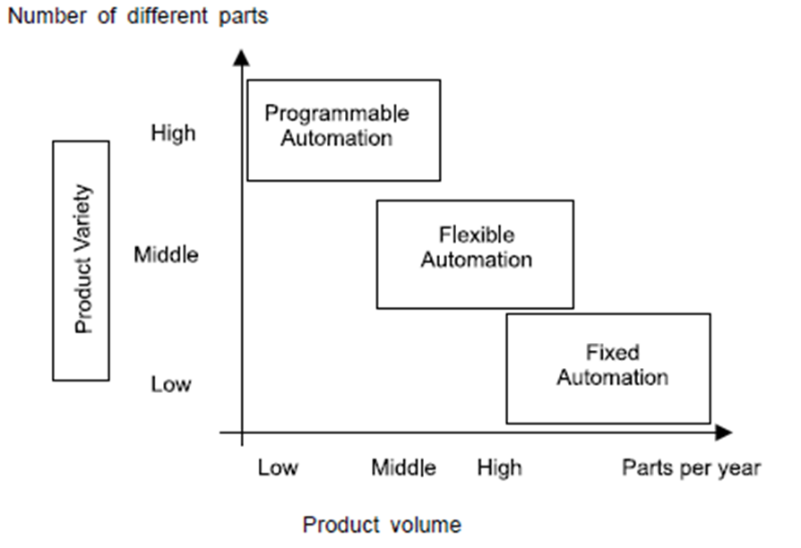

|  |  |
| --- | --- |
| Number of different parts |  |
| Product variety |  |
| Product volume |  |
| High |  |
| Middle |  |
| Low |  |
| Parts per year |  |
| Programmable automation |  |
| Flexible automation |  |
| Fixed automation |  |

Levels of an ISA-95 Functional Hierarchy Model

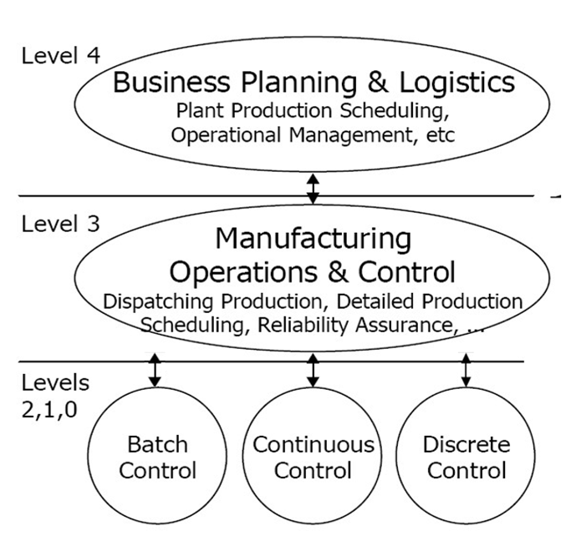

|  |  |
| --- | --- |
| Level 4 |  |
| Business planning and logistics |  |
| Plant production scheduling, operational management, etc. |  |
| Level 3 |  |
| Manufacturing operations and control |  |
| Dispatching production, detailed production scheduling, reliability assurance, etc. |  |
| Levels 2, 1, 0 |  |
| Batch control |  |
| Continuous control |  |
| Discrete control |  |

The Automation Pyramid

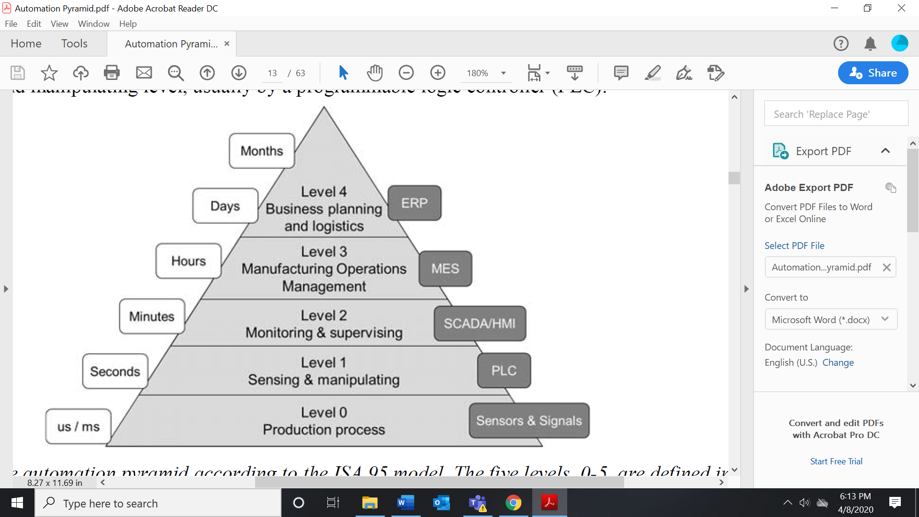

|  |  |
| --- | --- |
| Months |  |
| Days |  |
| Hours |  |
| Minutes |  |
| Seconds |  |
| us/ms |  |
| Level 4 |  |
| Business planning and logistics |  |
| Level 3 |  |
| Manufacturing operations management |  |
| Level 2 |  |
| Monitoring and supervising |  |
| Level 1 |  |
| Sensing and manipulating |  |
| Level 0 |  |
| Production process |  |
| ERP |  |
| MES |  |
| SCADA/HMI |  |
| PLC |  |
| Sensors and signals |  |

Technology Trends Expected to Have the Biggest Impact on Businesses in Total

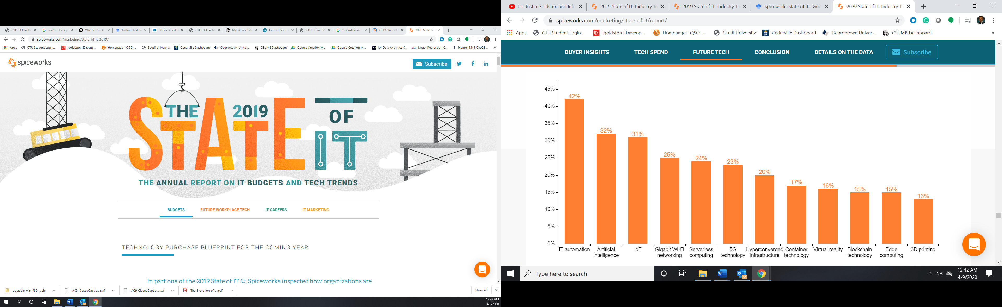

|  |  |
| --- | --- |
| IT automation |  |
| Artificial intelligence |  |
| IoT |  |
| Gigabit wi-fi networking |  |
| Serverless computing |  |
| 5G technology |  |
| Hyperconverged infrastructure |  |
| Container technology |  |
| Virtual reality |  |
| Blockchain technology |  |
| Edge computing |  |
| 3D printing |  |

Future-State Integrated Industrial Automation Systems

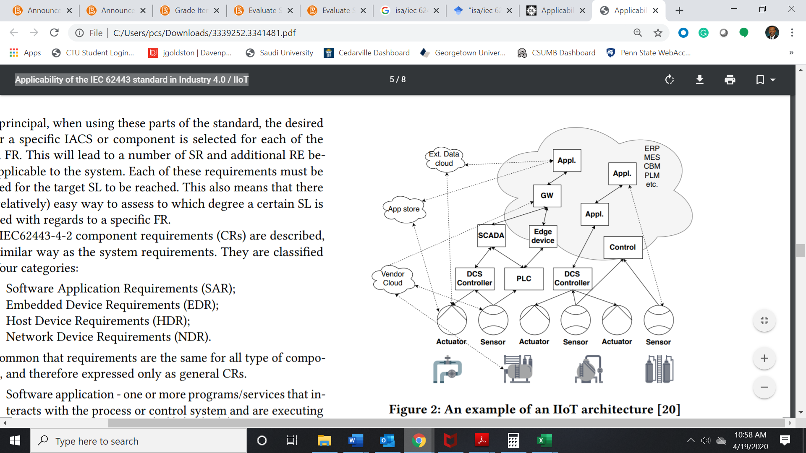

|  |  |
| --- | --- |
| Ext. data cloud |  |
| App store |  |
| Vendor cloud |  |
| Appl. |  |
| GW |  |
| SCADA |  |
| DCS controller |  |
| Edge device |  |
| PLC |  |
| Control |  |
| ERP |  |
| MES |  |
| CBM |  |
| PLM |  |
| Actuator |  |
| Sensor |  |

A Survey of Integration Challenges

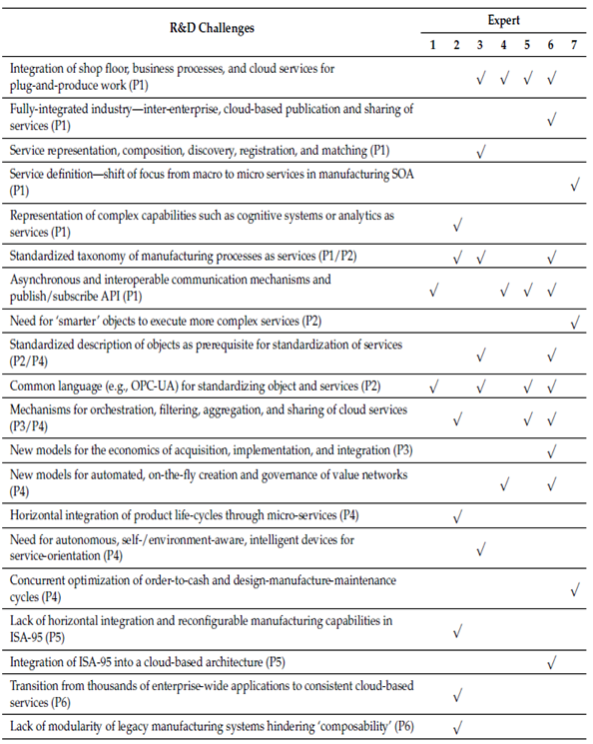

|  |  |
| --- | --- |
| R&D challenges |  |
| Expert |  |
| Integration of shop floor, business processes, and cloud services for plug-and-produce work (P1) |  |
| Fully integrated industry—inter-enterprise, cloud-based publication, and sharing of services (P1) |  |
| Service representation, composition, discovery, registration, and matching (P1) |  |
| Service definition—shift of focus from macro to micro services in manufacturing SOA (P1) |  |
| Representation of complex capabilities, such as cognitive systems or analytics as services (P1) |  |
| Standardized taxonomy of manufacturing processes as services (P1/P2) |  |
| Asynchronous and interoperable communication mechanisms and publish/subscribe API (P1) |  |
| Need for “smarter” objects to execute more complex services (P2) |  |
| Standardized description of objects as prerequisite for standardization of services (P2/P4) |  |
| Common language (e.g., OPC-UA) for standardizing objects and services (P2) |  |
| Mechanisms for orchestration, filtering, aggregation, and sharing of cloud services (P3/P4) New models for the economics of acquisition, implementation, and integration (P3) |  |
| New models for automated, on-the-fly creation, and governance of value networks (P4) |  |
| Horizontal integration of product life cycles through microservices (P4) |  |
| Need for autonomous, self-/environment-aware, intelligent devices for service orientation (P4) |  |
| Concurrent optimization for order-to-cash and design-manufacture-maintenance cycles (P4) |  |
| Lack of horizontal integration and reconfigurable manufacturing capabilities in ISA-95 (P5) |  |
| Integration of ISA-95 into a cloud-based architecture (P5) |  |
| Transition from thousands of enterprise-wide applications to consistent cloud-based services (P6) |  |
| Lack of modularity of legacy manufacturing systems hindering “composability” (P6) |  |

Notable Cyberattacks Impacting IACS

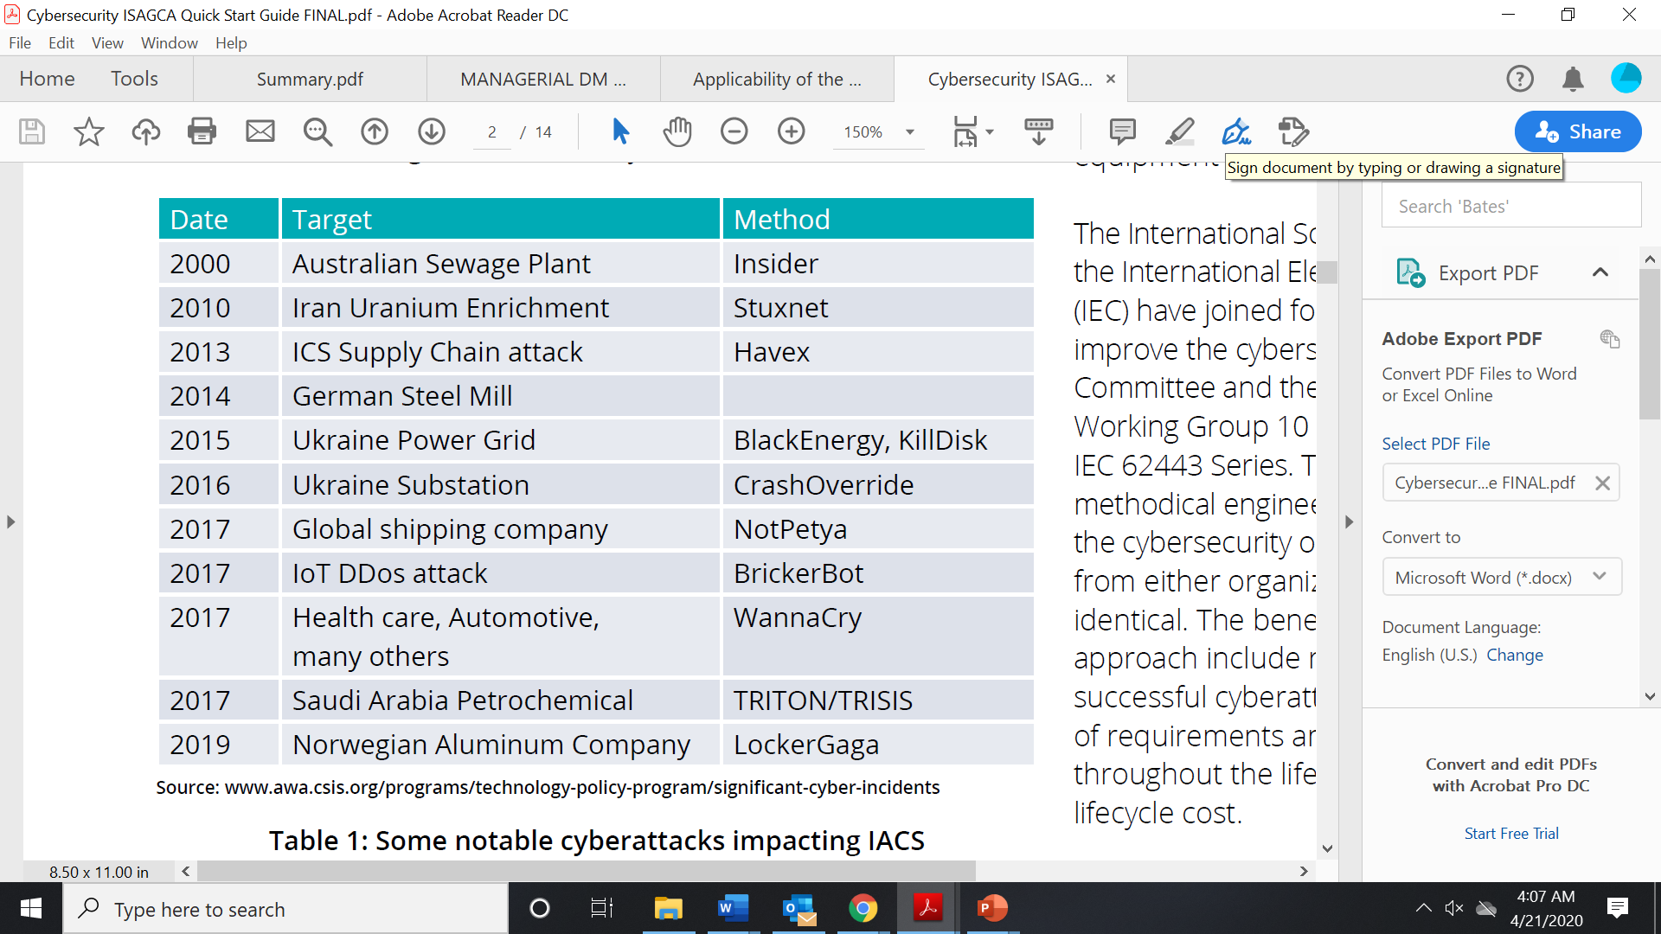

|  |  |
| --- | --- |
| Date |  |
| Target |  |
| Australian sewage plant |  |
| Iran uranium enrichment |  |
| ICS supply chain attack |  |
| German steel mill |  |
| Ukraine power grid |  |
| Ukraine substation |  |
| Global shipping company |  |
| IoT DDos attack |  |
| Health care, automotive, many others |  |
| Saudi Arabia petrochemical |  |
| Norwegian aluminum company |  |
| Method |  |
| Insider |  |
| Stuxnet |  |
| Havex |  |
| BlackEnergy, KillDisk |  |
| CrashOverride |  |
| NotPetya |  |
| BrickerBot |  |
| WannaCry |  |
| TRITON/TRISIS |  |
| LockerGaga |  |

The Structure of IEC 62443

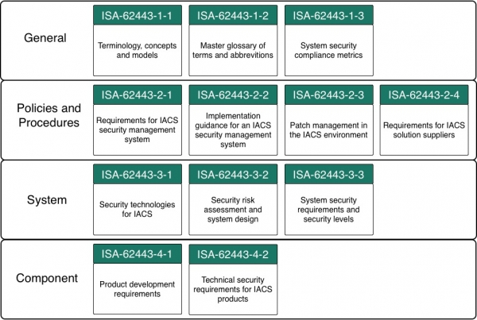

|  |  |
| --- | --- |
| General |  |
| ISA-62443-1-1  Terminology, concepts, and models |  |
| ISA-62443-1-2  Master glossary of terms and abbreviations |  |
| ISA-62443-1-3  System security compliance metrics |  |
| Policies and procedures |  |
| ISA-62443-2-1  Requirements for IACS security management system |  |
| ISA-62443-2-2  Implementation guidance for an IACS security management system |  |
| ISA-62443-2-3  Patch management in the IACS environment |  |
| ISA-62443-2-4  Requirements for IACS solution suppliers |  |
| System |  |
| ISA-62443-3-1  Security technologies for IACS |  |
| ISA-62443-3-2  Security risk assessment and system design |  |
| ISA-62443-3-3  System security requirements and security levels |  |
| Component |  |
| ISA-62443-4-1  Product development requirements |  |
| ISA-62443-4-2  Technical security for IACS products |  |

Dimensions of the Industry 4.0 Maturity Model

|  |  |
| --- | --- |
| Dimension | Definition |
| Strategy | Implementation of an Industry 4.0 roadmap, available resources for realization, adaptation of business models, … |
| Leadership | Leadership buy-in, management competences and methods, existence of central coordination for Industry 4.0, … |
| Customers | Utilization of customer data, digitalization of sales/services, customer’s digital media competence, … |
| Products | Individualization of products, digitalization of products, product integration into other systems, … |
| Operations | Decentralization of processes, modelling and simulation, interdisciplinary, interdepartmental collaboration, … |
| Culture | Knowledge sharing, open-innovation and cross company collaboration, value of Information and Communication Technology (ICT) in company, … |
| People | ICT competences of employees, openness of employees to new technology, autonomy of employees, … |
| Governance | Labor regulations for Industry 4.0, suitability of technological standards, protection of intellectual property, … |
| Technology | Existence of modern ICT, utilization of mobile devices, utilization of machine-to-machine communication, … |

|  |  |
| --- | --- |
|  |  |
|  |  |
|  |  |
|  |  |
|  |  |
|  |  |
|  |  |
|  |  |
|  |  |
|  |  |

Chomsky Hierarchy

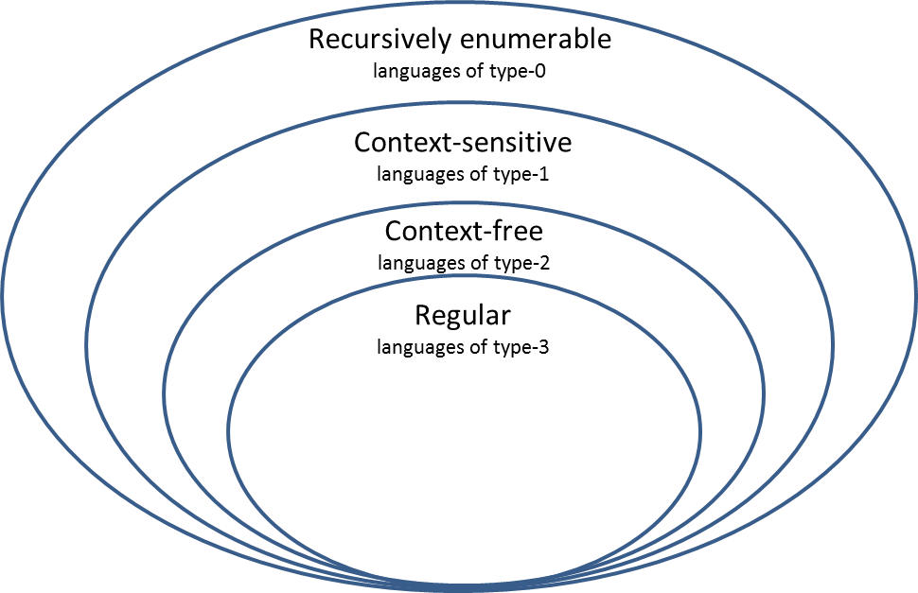

|  |  |
| --- | --- |
| Recursively enumerable |  |
| Languages of type-0 |  |
| Context-sensitive |  |
| Languages of type-1 |  |
| Context-free |  |
| Languages of type-2 |  |
| Regular |  |
| Languages of type-3 |  |

Deterministic Finite Automaton for a(b│c)*a

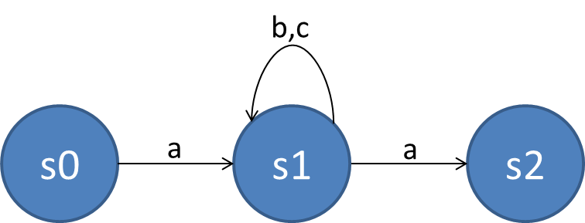

Acceptor for Variable Names in Python

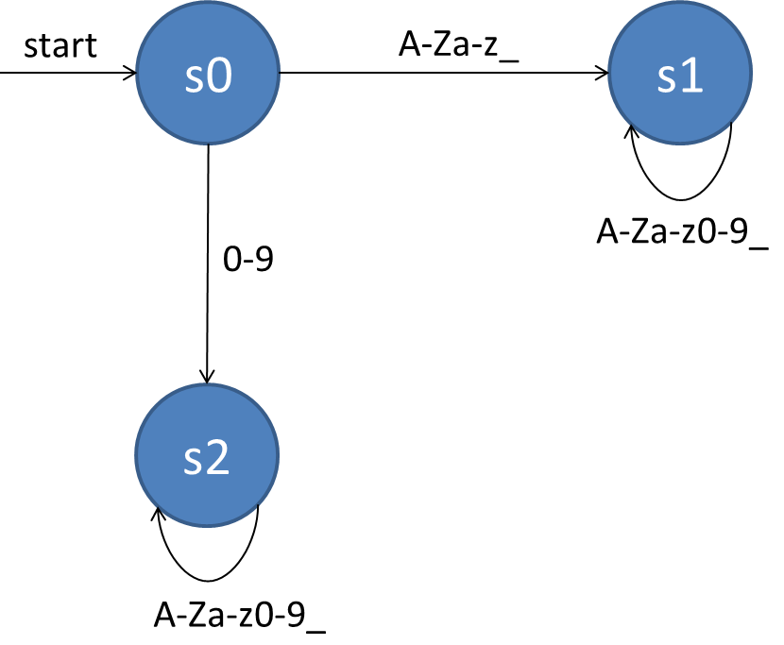

|  |  |
| --- | --- |
| Start |  |

Example of Deterministic Finite State Transducer

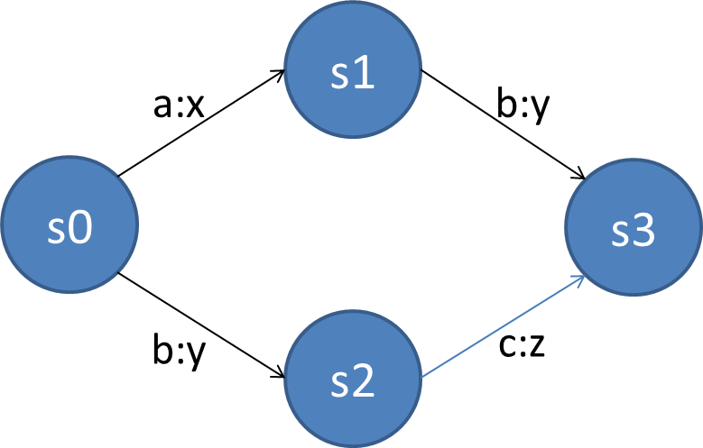

Nondeterministic Finite Automaton for a(b│c)*a

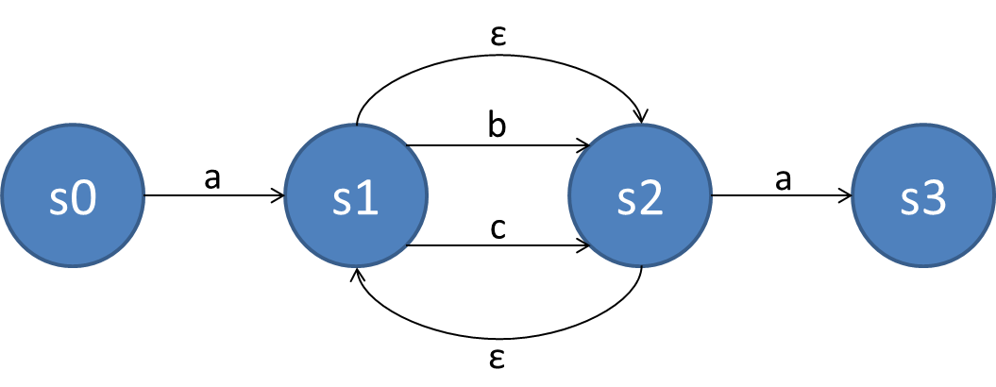

Nondeterministic Finite Automaton for a(b│c)*b

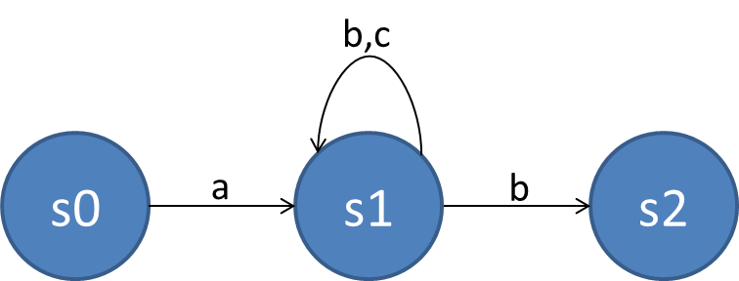

Deterministic Finite Automaton for a(b│c)*b

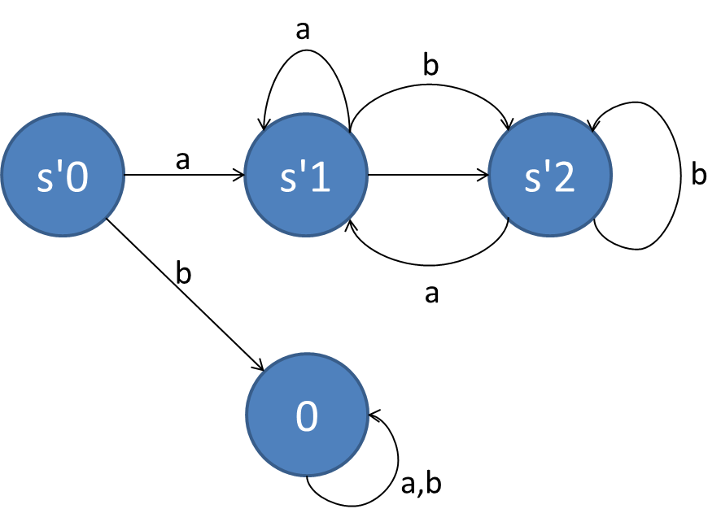

Automaton A1 (Left with Blue States) and A2 (Right with Red States)

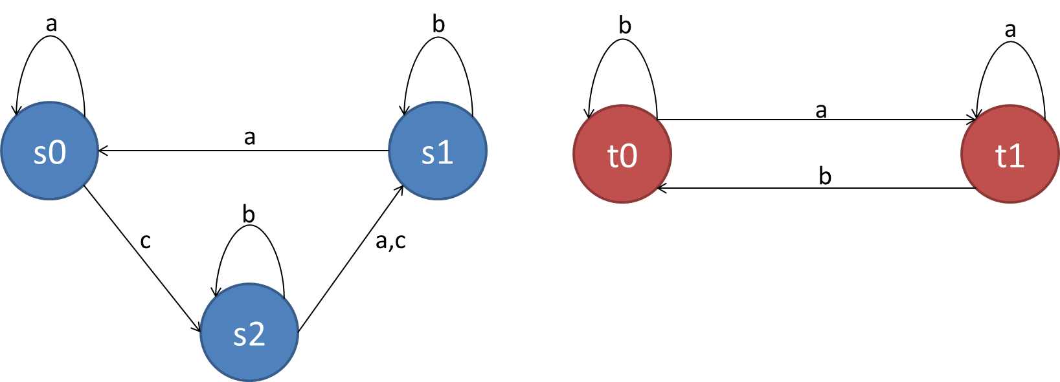

Product Composition of A1 and A2

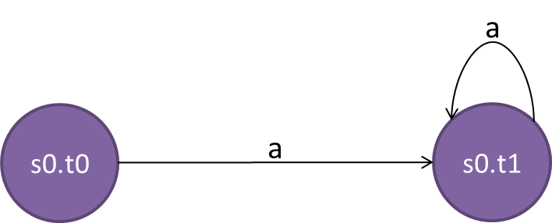

Parallel Composition of A1 and A2

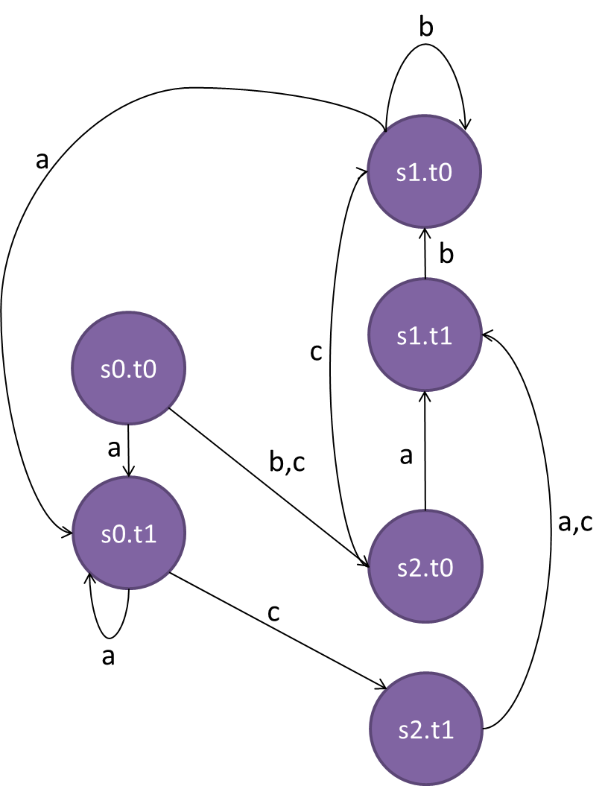

Complete Bipartite Graph

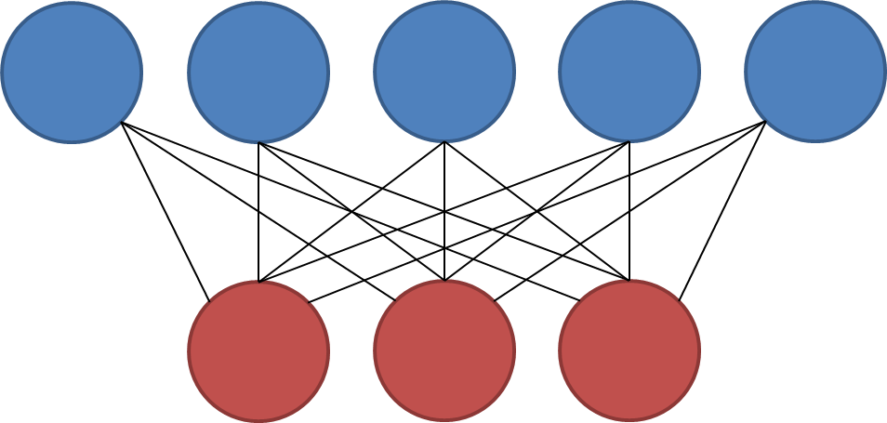

Petri Net for Cake Baking Process

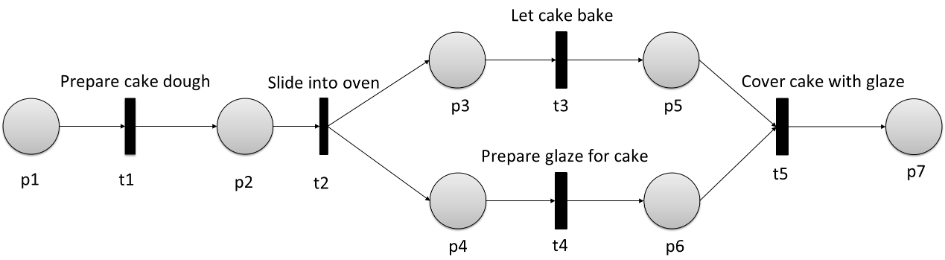

|  |  |
| --- | --- |
| Prepare cake dough |  |
| Slide into oven |  |
| Let cake bake |  |
| Prepare glaze for cake |  |
| Cover cake with glaze |  |

Marking of a Petri Net

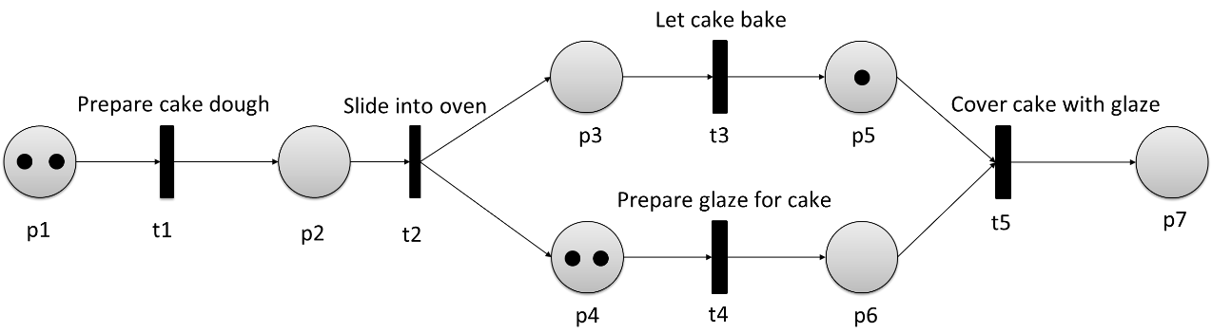

AND-Split and AND-Join

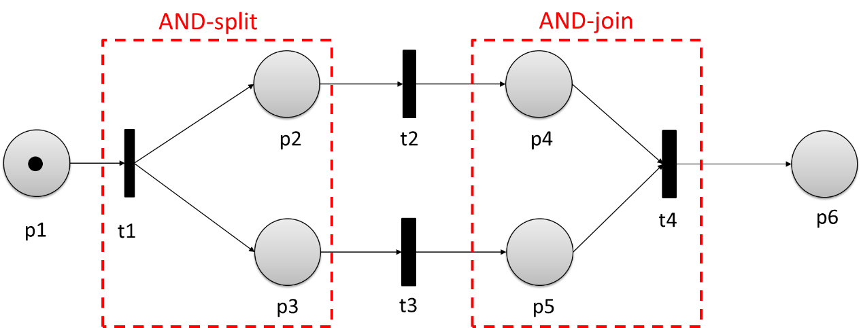

|  |  |
| --- | --- |
| AND-split |  |
| AND-join |  |

XOR-Split and XOR-Join

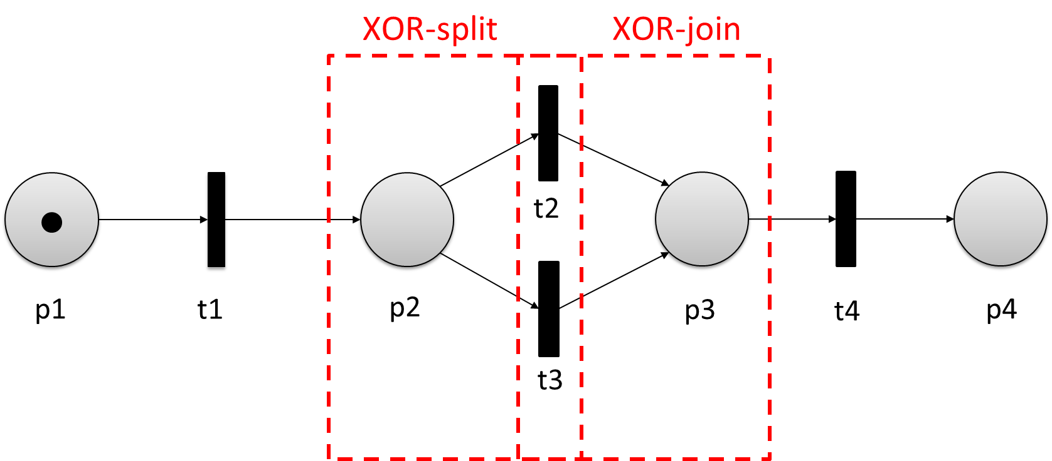

|  |  |
| --- | --- |
| XOR-split |  |
| XOR-join |  |

Petri Net for Drinks Machine with Initial Marking

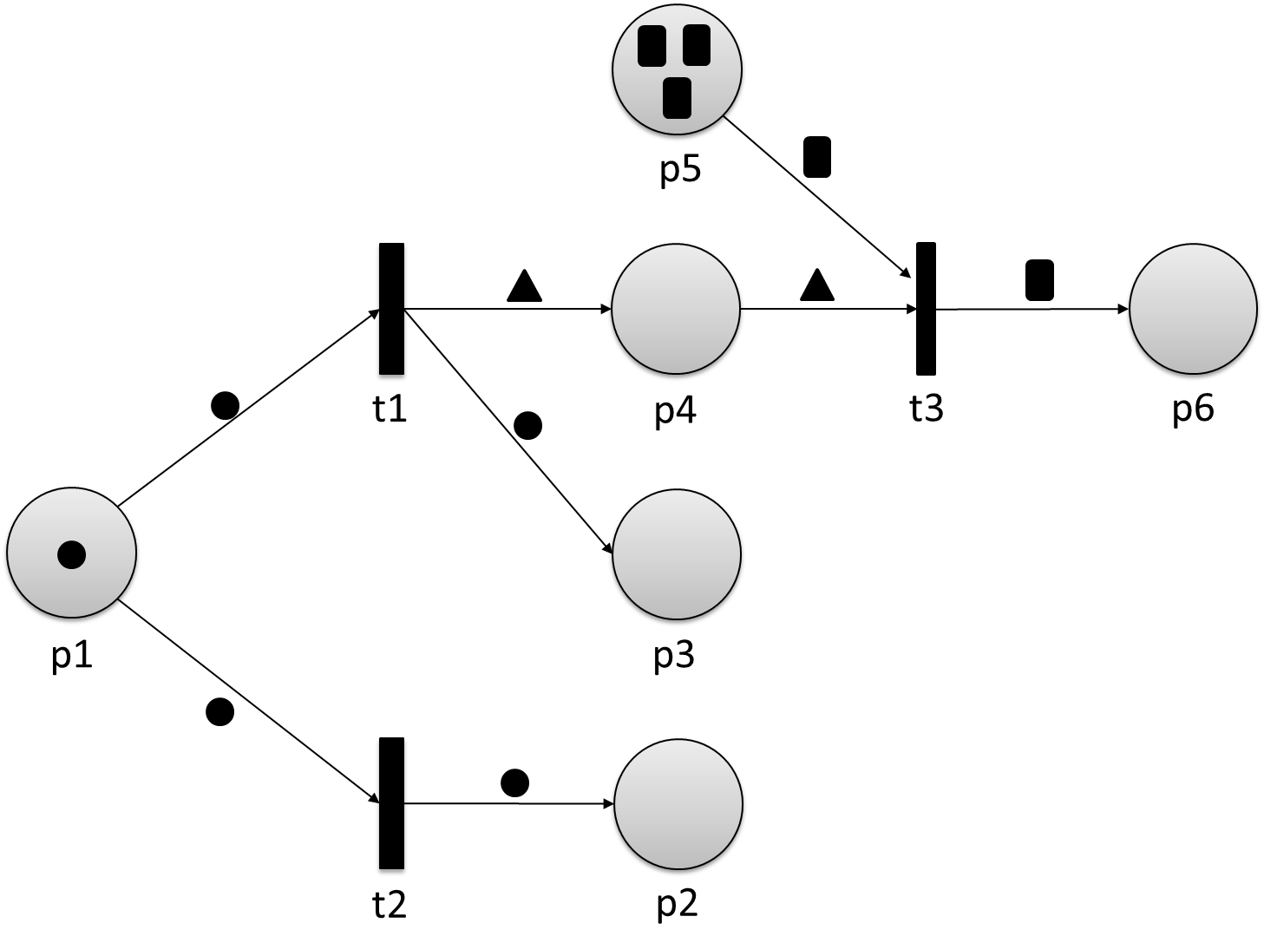

Properties of Concurrent Systems

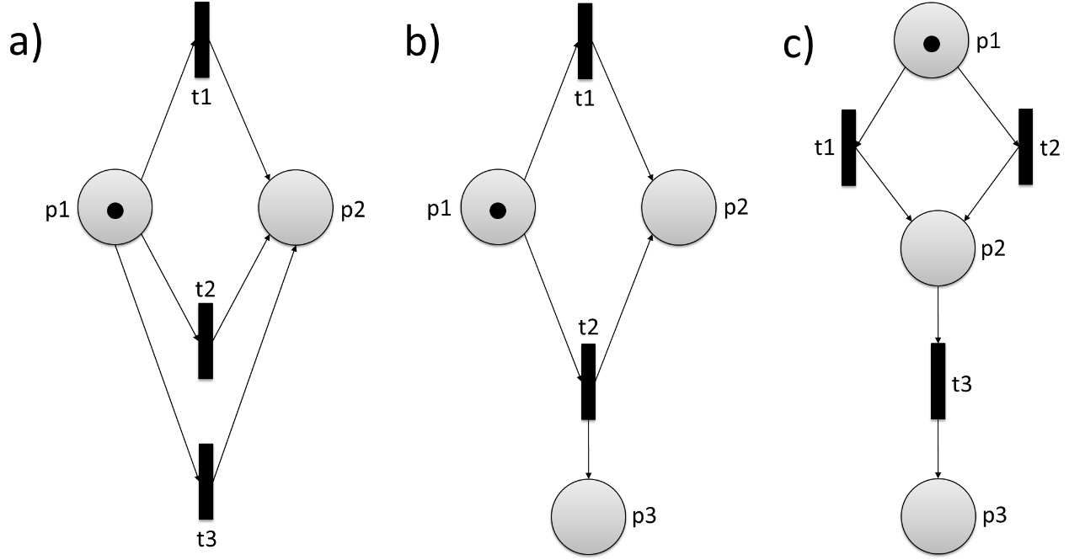

Petri Net (Right) for Single-Tracked Railway Line (Left) as Example for Mutual Exclusion

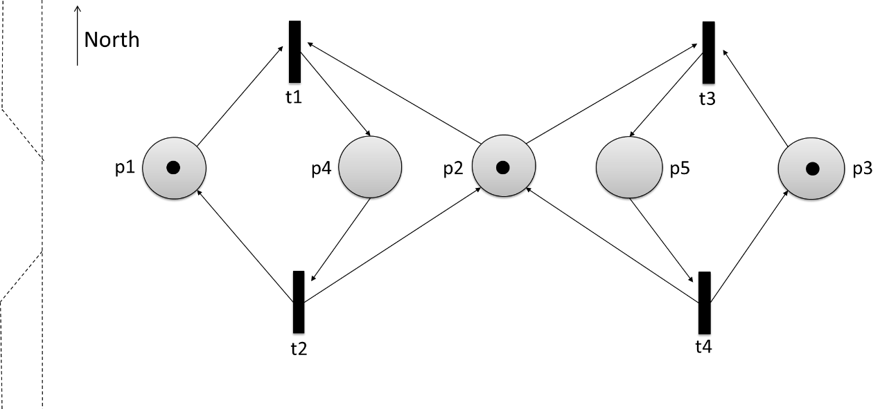

|  |  |
| --- | --- |
| North |  |

Reachability Graph for Petri Net

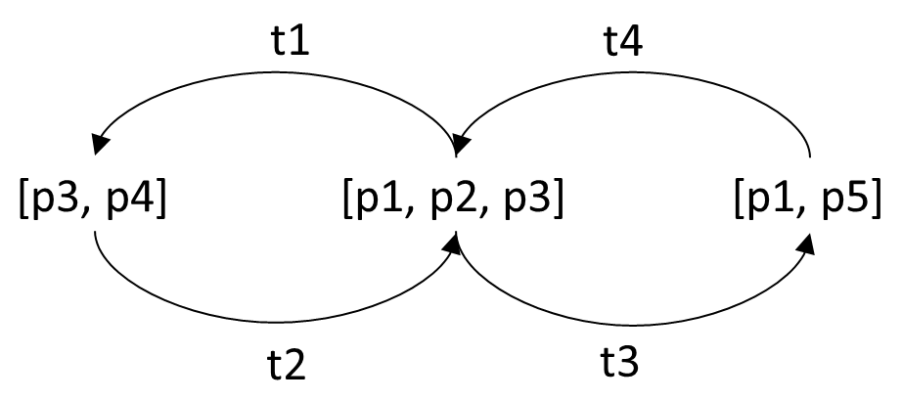

Acceptor for Timed Words w of L

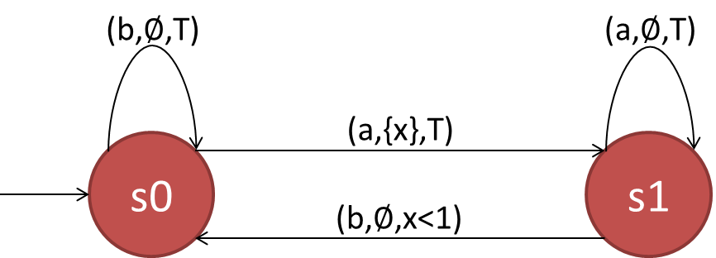

Transition Graph for Process of Weather

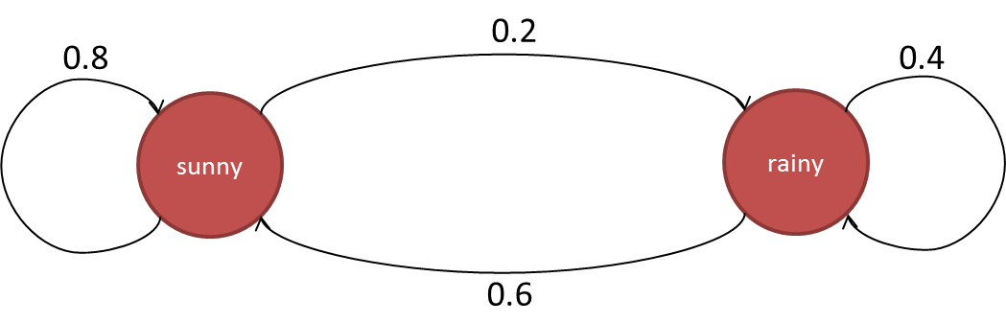

|  |  |
| --- | --- |
| Sunny |  |
| Rainy |  |

Transition Graph for Markov Process

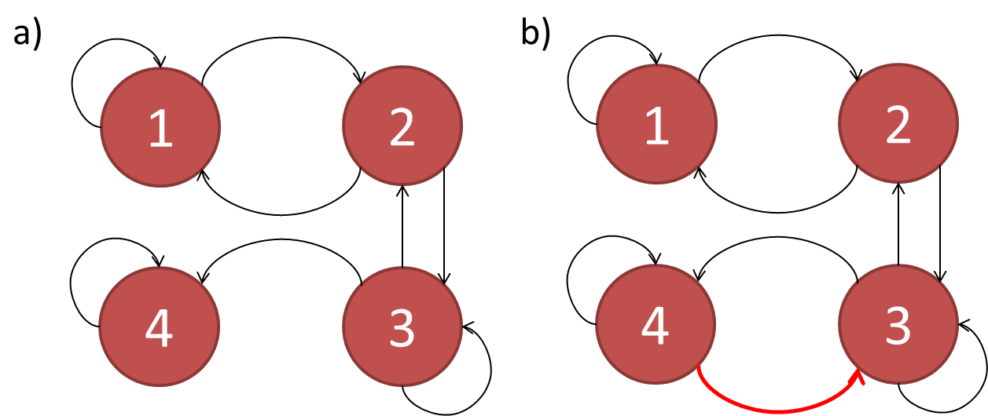

Queuing Node as Birth-Death-Process

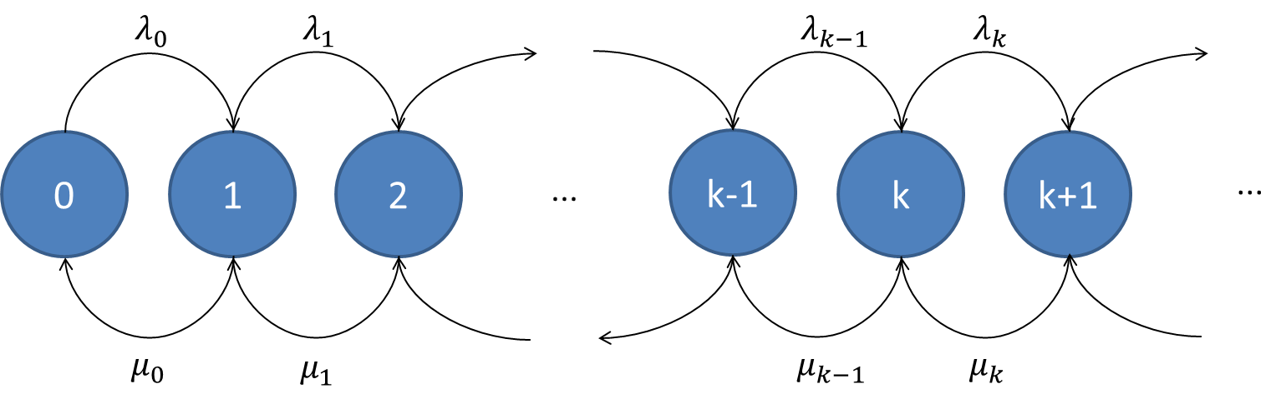

Example of Deterministic Timed Transitions Petri Net

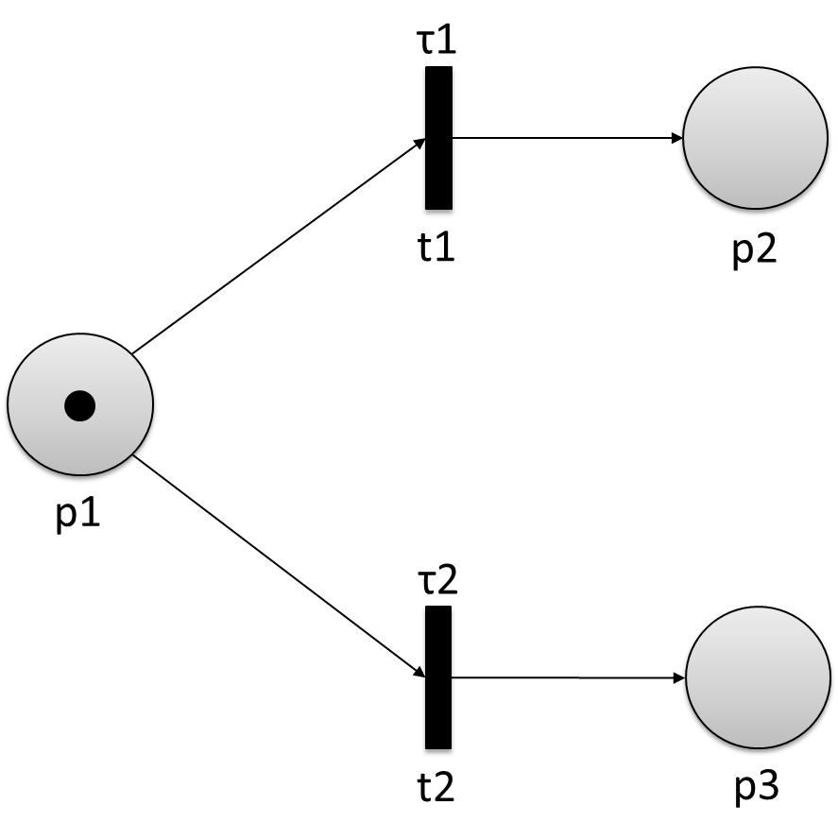

Relationship between Real-World System and Simulation Model

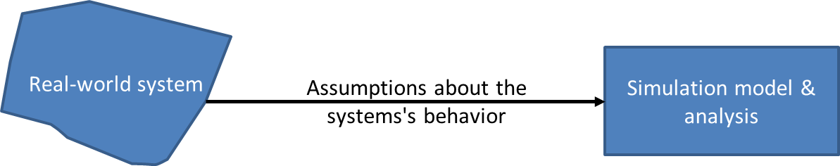

|  |  |
| --- | --- |
| Real-world system |  |
| Assumptions about the system’s behavior |  |
| Simulation model and analysis |  |

Fixed-Increment Time Progression (Top) and Next-Event Time Progression (Bottom)

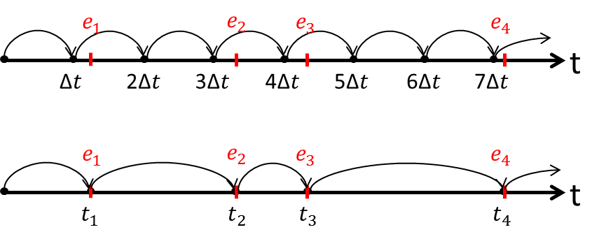

Steps in a Simulation Study

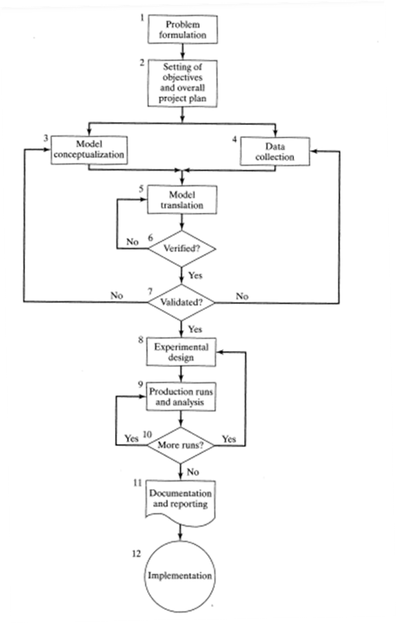

|  |  |
| --- | --- |
| Problem formulation |  |
| Setting of objectives and overall project plan |  |
| Model conceptualization |  |
| Data collection |  |
| Model translation |  |
| No |  |
| Verified? |  |
| Yes |  |
| Validated? |  |
| Experimental design |  |
| Production runs and analysis |  |
| More runs? |  |
| Documentation and reporting |  |
| Implementation |  |

Example of Snapshot of System for Simulation Time t

|  |  |  |  |  |  |  |  |
| --- | --- | --- | --- | --- | --- | --- | --- |
| **Clock** | **System state** | **Entities and attributes** | **Set 1** | **Set 2** | **…** | **Future event list** | **Cumulative statistics** |
| t | (x, y, z, …) |  |  |  |  | (3, t1)—Event type 3 occurs at t1  (1, t2)—Event type 1 occurs at t2 |  |

|  |  |  |  |  |  |  |  |
| --- | --- | --- | --- | --- | --- | --- | --- |
|  |  |  |  |  | **…** |  |  |
|  |  |  |  |  |  |  |  |

State Transitions for Example of Street with Pedestrian Crossing

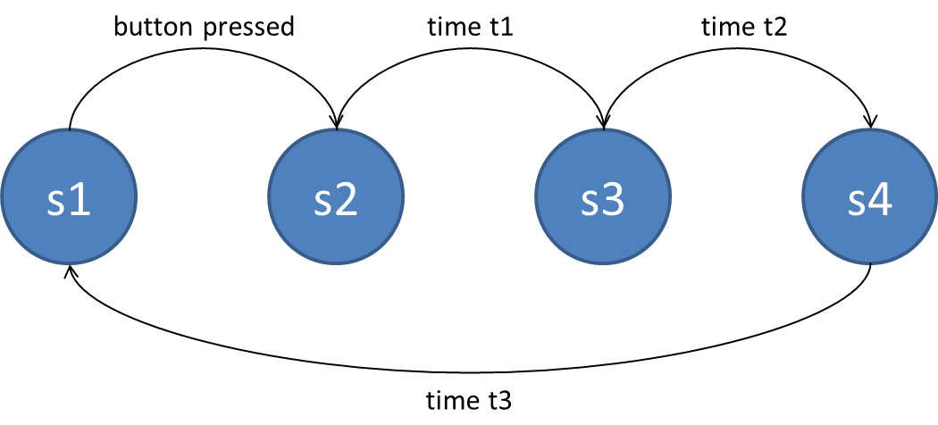

|  |  |
| --- | --- |
| Button pressed |  |
| Time t1 |  |
| Time t2 |  |
| Time t3 |  |

Snapshots of System for Simulation Steps

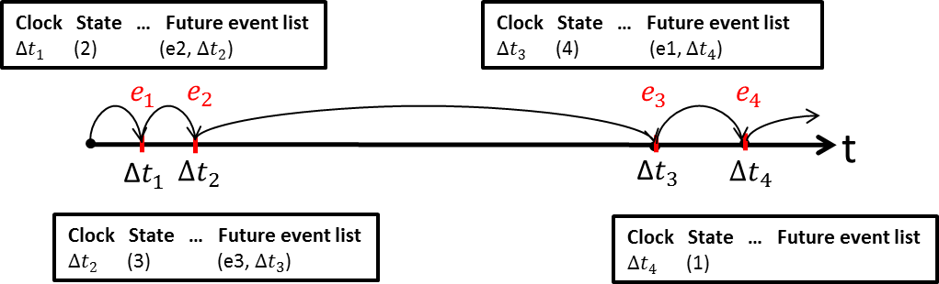

|  |  |
| --- | --- |
| Clock |  |
| State |  |
| Future event list |  |

Transient Simulation (Left) and Steady-State Simulation (Right)

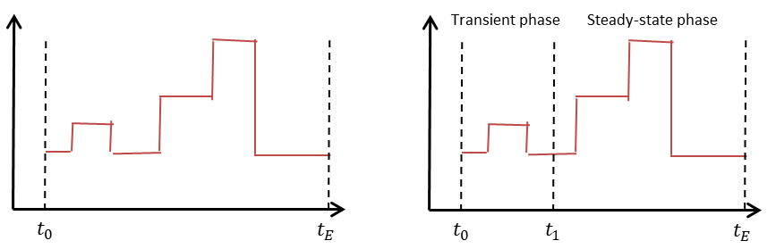

|  |  |
| --- | --- |
| Transient phase |  |
| Steady-state phase |  |

Confidence and Prediction Interval for Data

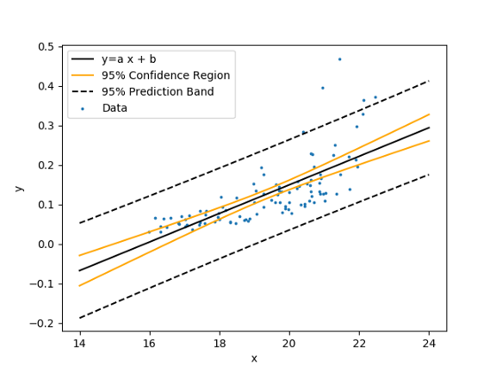

|  |  |
| --- | --- |
| 95% confidence region |  |
| 95% prediction band |  |
| Data |  |

Principles of Open Loop (Top) and Closed Loop (Bottom)

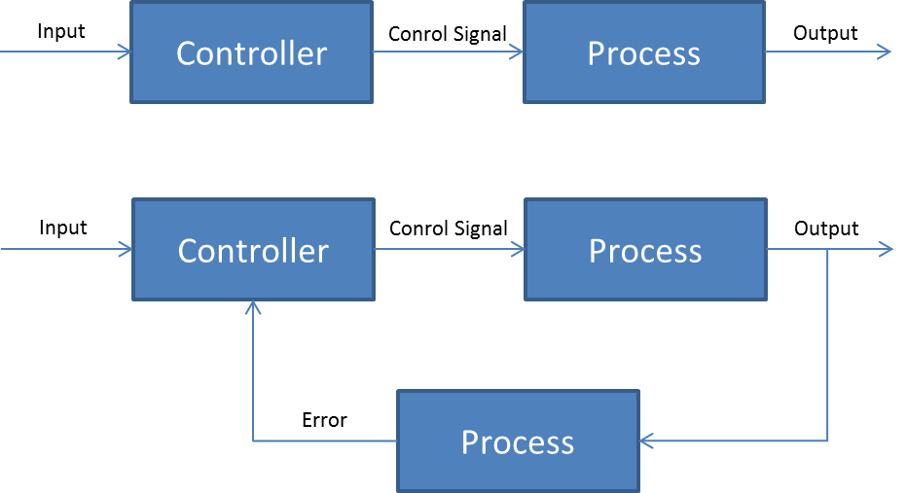

|  |  |
| --- | --- |
| Input |  |
| Controller |  |
| Control signal |  |
| Error |  |
| Process |  |
| Output |  |

Control System Consisting of Plant and Control Unit

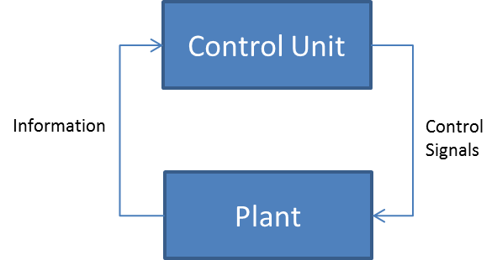

|  |  |
| --- | --- |
| Information |  |
| Control unit |  |
| Plant |  |
| Control signals |  |

Supervisory Control for Full (Left) and Partial Observation (Right)

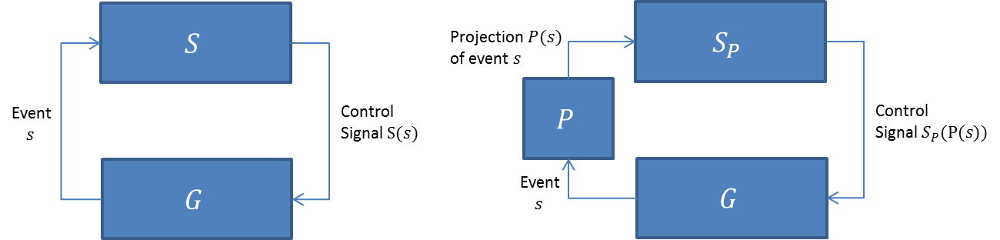

|  |  |
| --- | --- |
| Event *s* |  |
| Control signal S(*s*) |  |
| Projection *P(s)* of event *s* |  |
| Control signal *Sp*(P(*s*)) |  |

Automaton for Exemplary Process G. State s2 Marked

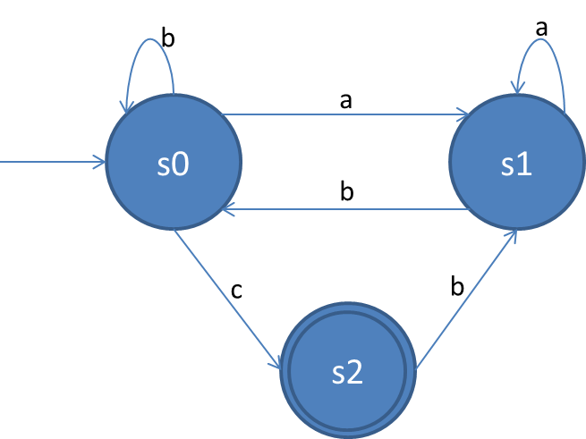

Resulting Automaton Specifying s1 to Be Illegal

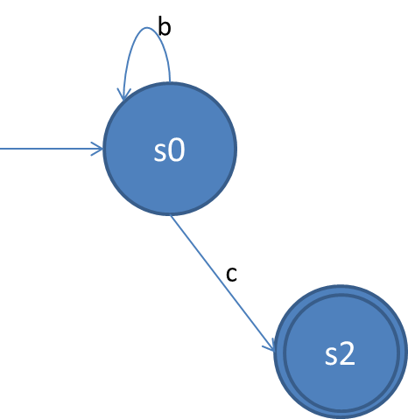

Automaton Modeling State Alternation

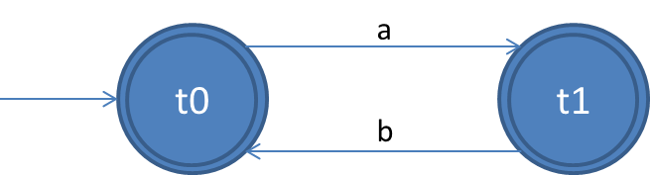

Automaton Representing State Alternation

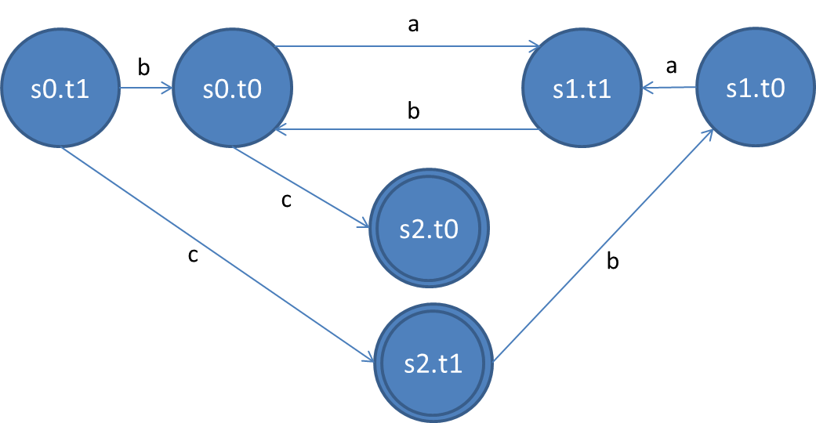

Uncontrolled Plant (Right), Desired Supervised Behavior (Center), Controller with Blocking Behavior (Right)

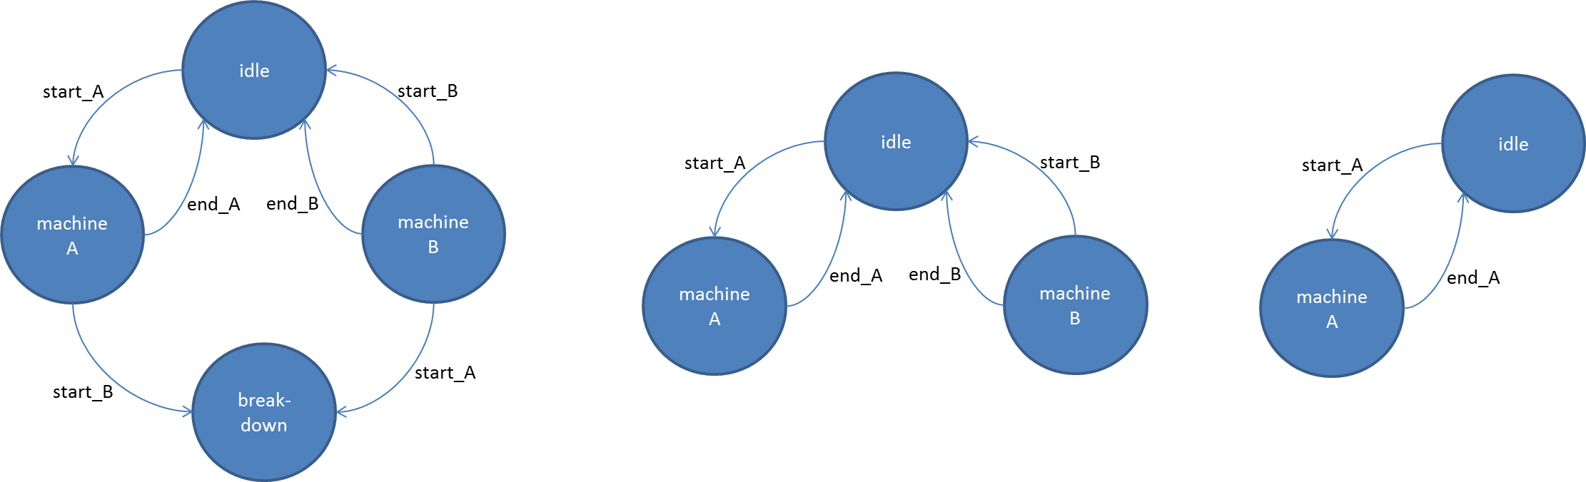

|  |  |
| --- | --- |
| Idle |  |
| Machine A |  |
| Machine B |  |
| Breakdown |  |
| Start_A |  |
| Start_B |  |
| End_A |  |
| End_B |  |

Implementation-Dependent Controlled Plant G

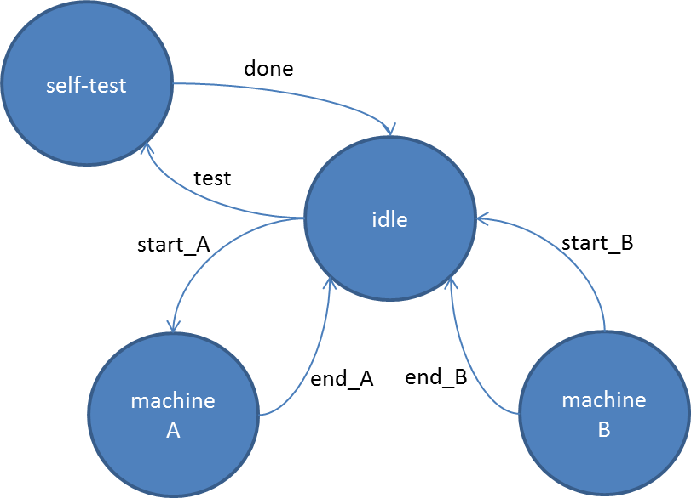

|  |  |
| --- | --- |
| Self-test |  |
| Done |  |
| Test |  |
| Idle |  |
| Machine A |  |
| Machine B |  |
| Start_A |  |
| Start_B |  |
| End_A |  |
| End_B |  |

Model of Hierarchical Supervision and Monitoring

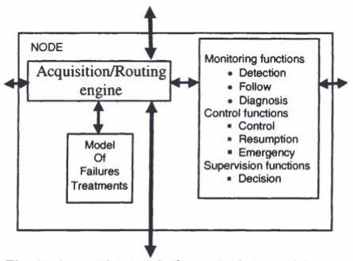

|  |  |
| --- | --- |
| Node |  |
| Acquisition/routing engine |  |
| Model of failures treatments |  |
| Monitoring functions |  |
| Detection |  |
| Follow |  |
| Diagnosis |  |
| Control functions |  |
| Control |  |
| Resumption |  |
| Emergency |  |
| Supervision functions |  |
| Decisions |  |

Architecture for Supervisory Control of Discrete Event Systems

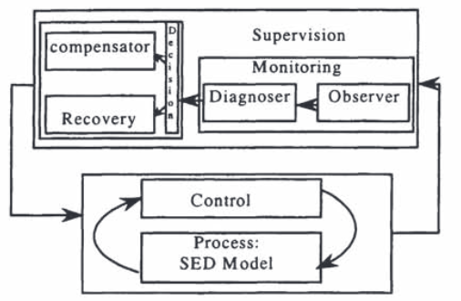

|  |  |
| --- | --- |
| Compensator |  |
| Recovery |  |
| Supervision |  |
| Monitoring |  |
| Diagnoser |  |
| Observer |  |
| Control |  |
| Process: SED model |  |

Architecture of Active Diagnosis

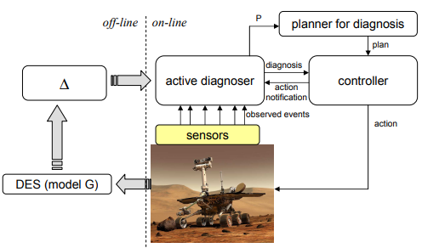

|  |  |
| --- | --- |
| Offline |  |
| Online |  |
| DES (model G) |  |
| Active diagnoser |  |
| Diagnosis |  |
| Action notification |  |
| Observed events |  |
| Sensors |  |
| Planner for diagnosis |  |
| Plan |  |
| Controller |  |
| Action |  |

Architecture of Decentralized Supervision

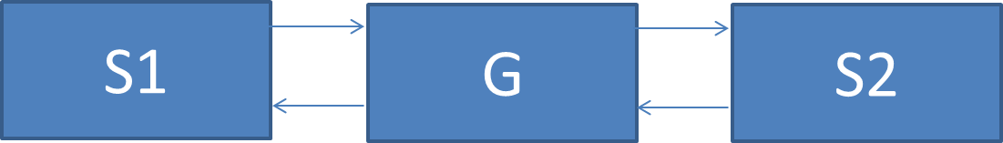

Decentralized Supervision: Architectural Design

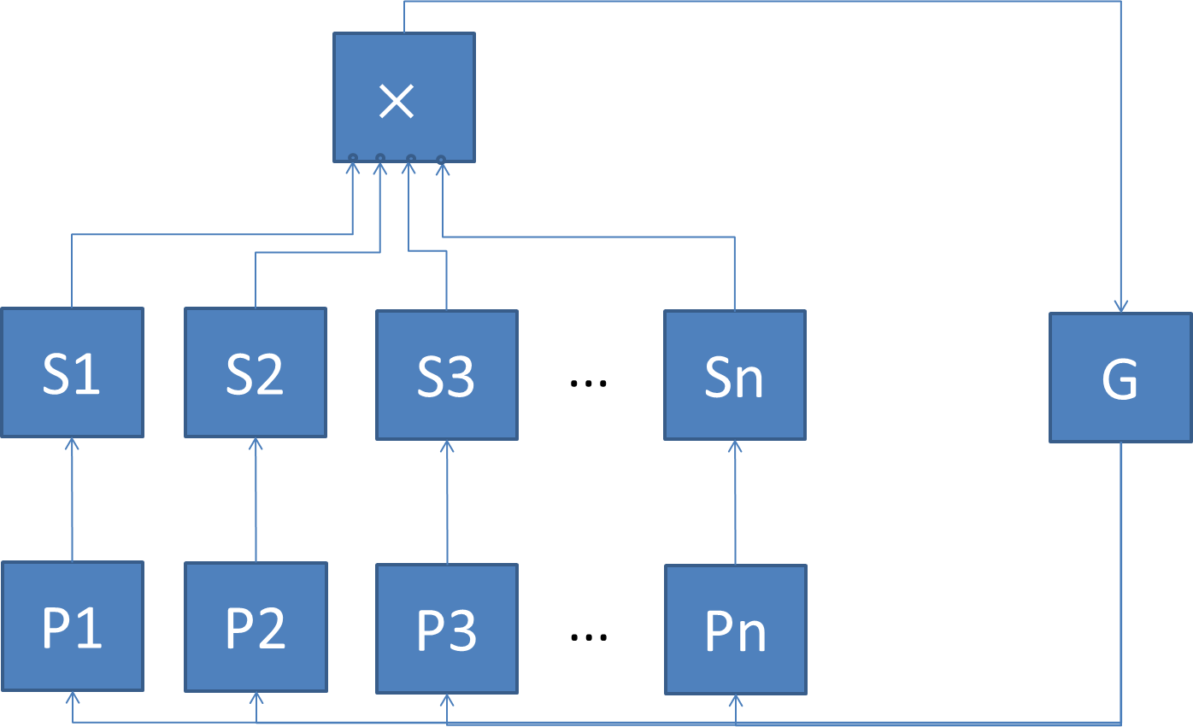

Supervisor Localization

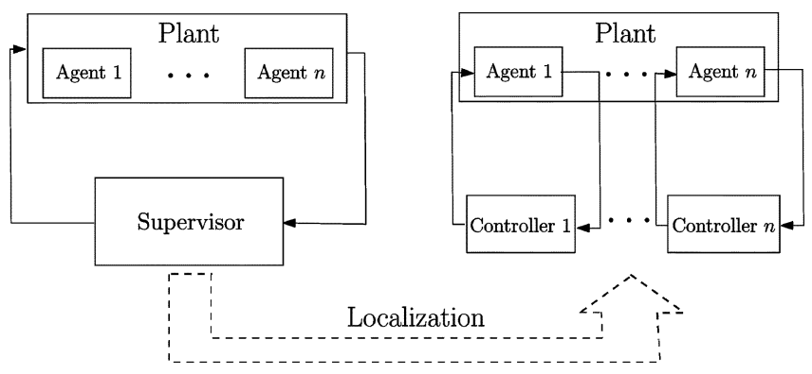

|  |  |
| --- | --- |
| Plant |  |
| Agent 1 |  |
| Agent *n* |  |
| Supervisor |  |
| Controller 1 |  |
| Controller *n* |  |
| Localization |  |

Adaptive Control Loop

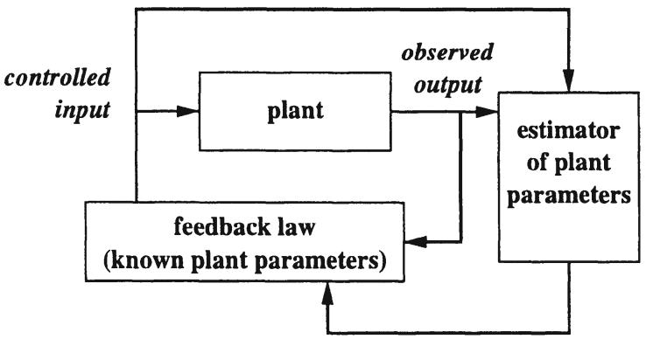

|  |  |
| --- | --- |
| Controlled input |  |
| Plant |  |
| Observed input |  |
| Estimator of plant parameters |  |
| Feedback law (known plant parameters) |  |

Control Loop of Adaptive Supervisory Control

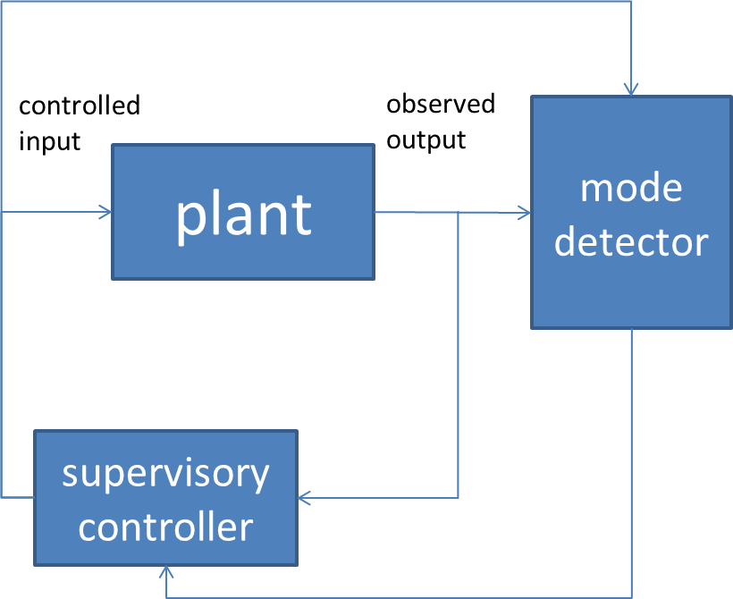

|  |  |
| --- | --- |
| Controlled input |  |
| Observed input |  |
| Plant |  |
| Mode detector |  |
| Supervisory controller |  |