African Masters

The Path to Discovery

The exhibition African masters in the MUZA museum Tel Aviv is the pinnacle of a journey, starting at my arrival to Conakry in early 2009. I found a dilapidated city just awakening from 50 years of totalitarian regimes, a city whose crumbling infrastructure lay witness to years of neglect and the devastating effects of the harsh sub-tropical Guinean climate.

Conakry’s lack of land reserves combined with no available modern office space appealed to my vision as a developer. Little did I know of the challenges involved in actual building in the sub-Sahara, such as the Ebola epidemic, military coups, complicated codes of conduct, and a different concept of time. But the long process had its advantages. Being an architect, appreciating art is part of one’s DNA. I was immediately smitten by my first glimpses of Baga art, then still available in the city markets. A decade ago, the only reference book on the subject was Lamp’s ‘Art of the Baga’ which I devoured immediately. Later, other scholars joined the ranks, such as Sarro, Berliner, and Curtis. But these books, as elaborate and comprehensive as they were, could not answer seemingly mundane questions, such as how a dancer could perform wearing a two-meter-long snake headdress attached to his scalp without breaking his neck.

It took years, long-term relationships and friendships with Guinean collectors and scholars till the richness and sophistication of the Baga culture became apparent to me.

The Baga

The Baga – in Susu “inhabitants of the sea”– or “those of the frontier land” are a small, deeply rural community of 35,000, as per the 1950s census.

A coastal indigenous society, documented as being in the Guinean Atlantic coastline since the 15th. Century, the Baga were dispersed over some 80 villages set among subtropical mangrove swamps and brackish lagoons, which even today can be accessed only by boats. They are virtually sealed off during the heavy rains. The scenery’s primal magic is composed of pristine beaches, oil palm trees, gigantic silk cotton trees, and lush red and white mangroves.

Each village usually housed three extended families. All public decisions were made after lengthy discussions between the elders of each of the households. Life was organized according to a cross-section of age and work groups.

Rites of passage, circumcisions and other religious ceremonies took place mainly late at night, conducted within the natural cathedrals created by the ravines of the sacred silk cotton trees’ gigantic roots.

Social and family public affairs, such as weddings, funerals, etc., were lavishly celebrated with dances, performances and ample palm wine, incorporating several villages, enabling the formation of larger political and social networks.

The Baga liturgy and paraphernalia united the entire congregation and enabled the community to act in cohesion and harmony, in which every individual was designated and committed to his age group, his secret society, and his extended family.

A Safe Haven During the Global Slave Trade

The Baga livelihood was based throughout the centuries on tidal rice cultivation supported by fishing, hunting and salt production (“we Baga salt & rice”). A comprehensive labor-intensive irrigation system based on tides and fresh water flow evolved, enabling the Baga to produce rice in commercial quantities, suppling friend and foe alike.

The Baga constantly needed working hands and were always ready to accept newcomers to their ranks. The endemic malaria and the virtual inaccessibility of the mangrove swamps created a marginal safe haven secured from the invading Muslim cavalry, who were constantly seeking men to supply the endless demand for captives for the global slave trade. therefore the Baga territory upstream the Nunez river was proclaimed as an asylum, attracting refugees fleeing the mainland.

Culture and Art in the Last Frontier

Two major migration waves formed the Baga culture as manifested in the 20th century.

The Mande invasion of the 16th century, into what is today’s Sierra Leone, forced the indigenous high Sapi culture to disperse. Those arriving to the Guinea coast brought with them a rich and cultivated formal vocabulary, traces of which can be easily traced in the Baga formal vocabulary. Other groups arrivied in the 18th century from the Guinean highland, escaping jihad and enslavement. These new groups, originating from the mainland, were from larger and less peripheral communities, and therefore triggered the formation of a complex liturgy.

Much of the Baga culture, in which the consumption of palm wine was a basic habit, and serving palm wine for the elders was part of the chores expected to be fulfilled by the youth, has evolved around the Baga standing conflict and opposition to Islam.

Colonial rule

The Baga did not put up a real resistance to the French. Other than in the capitol Conakry from which they were expelled, the Baga continued their lives largely undisturbed. The creation of cantons in the 1920s, governed by locals appointed by the colonial authority, enabled the Baga to maintain their autonomy practically unchanged.

Katako was chosen as the capital of the Baga canton, and Mr. Baki Camara, and later his descendants, were nominated as chiefs. In 1909, the first Catholic Missionary Church was established.

The Camara family served the French authorities well, especially in the mid-1940s, collecting vast quantities of rice for the Vichy regime. “Being Pagan was hard work for the youth.”

Baga Art and the West

Although western culture did arrive to the shores of West Africa in the 1930s, the rural mangrove community was not enriched by it. Instead, The Baga art exported to Paris ended up influencing Western culture.

Almost all of the avant-garde artists of the beginning of the 20th century acquired, and were influenced by African art, of which the oversized Baga sculptures with their unique colors and rich morphology were particularly appealing.

These artists, especially the Dada, turned their back on the Western cultural establishment. They saw the African works of art as an alternative and a new spiritual forbearer, a primary and purer father with whom they could identify. They became completely divorced from Western culture, a culture which ultimately led to the atrocities of World War One.

Picasso bought his Baga Nimba mask in 1928 and it had a great impact on his search for a new visual language for the 20th century.

“I experienced my greatest artistic emotions when the sublime beauty of the sculptures executed by the anonymous artists of Africa suddenly became apparent to me.

These religious, passionate, and rigorously logical works are the most powerful and beautiful things the human imagination has produced.”

Without any of their creators’ knowledge, the works of the “deep rural” Baga created worlds apart from Paris, became ‘objects of great desire’ for French high society. Their display, alongside modern art, was perceived as a mark of good taste, cosmopolitanism, and sophistication.

The great colonial exhibition of 1931, which attracted more than 9 million visitors, disseminated and reinforced the connection between modernity and African art, in general, and Baga art, in particular.

Revolution

World War II, the complete collapse of the old order, followed by the abolition of the canton mechanism, and the 1946 Brazerville conference, led to the end of colonial authority over the Baga, and with it the end of the gerontocracy of the first dynasties. The Marxist ideology and pan-African Islam appealed to young age societies. The generational tension, that was inherent in Baga culture, erupted into an open rebellion against the tradition, identified with reactionary pro-colonialism which finally culminated in the late 1950s in a Jihad against the Baga elders.

Iconoclasm

One of the reasons that Baga’s economy could not expand and meet the changing times was it’s chronic lack of land. On top of the extreme tropical weather conditions, each village was surrounded by a belt of sacred forest composed of gigantic cotton silk trees and natural flora, this belt was deemed as off limits to all apart from the initiated elders. Thus any future development necessitated the desecration of the forest.

In February, 1957, the Marabou Alseco Sayo was invited by the Baga youth organization to perform a Jihad and get rid of the old regime and its ways.

Sayo stayed in Katako for four months, felling the great cotton silk trees, laying the sacred forest bare. His Mob forced the elders to relinquish their masks, symbols of power and tools of sorcery. Sayo burned some of the art, but Being aware of it’s commercial value, sold most of the loot to French representatives and Parisian gallery owners such Hellen Leloupe who accompanied his mob.

Cultural Revolution & Demystification

The Guinean independence in 1958, and the Marxist regime of Sekou Toure, comprised the beginning of the end to the Baga’s religious art. In 1961, all of Guinea’s forest tribes were declared as the enemy within, their cults were restricted and a demystification program began, theater groups passed through the villages and presented the elders’ tradition and beliefs as degenerate and regressive. The cult and its production of religious paraphernalia were stopped almost entirely.

In 1968, coinciding with the Chinese Cultural Revolution – a violent campaign was declared. The elders of the community were beaten, the old cult and their masks were deemed unlawful, their operators were taken, stripped naked, and exposed as charlatans. The remaining Baga Liturgical paraphernalia was collected. Some was taken and exhibited in state “museums”, but most was burned.

While the Bags sculptures were viewed in the West as the spiritual fore-bearers of 20th century art, and every collector or museum tried to display “the source”, - the Baga Nimba placing her on a pedestal looking down at her surroundings as a proud foremother. In Guinea, they have almost completely disappeared.

The Katako Hoard

In the middle of 2017, Nkai Sadiki, a master sculptor, scholar and a long-term friend and teacher, informed me that he was approached by representatives of the Katako’s Baga elders wishing to depart from a group of pre-iconoclasm sacred statues which were kept in total secrecy. Nkai, being a master craftsman who regularly supplied the Baga Women’s Association with modern paraphernalia needed for their gatherings, knew of the group’s existence and helped in its day-to-day wood-maintenance, but was obliged according to society rules to keep their existence a secret.

A team was hastily organized and embarked on a trip to Katako, which during colonial times, used to serve as the Baga’s regional administrative capital. Today a dormant small village with a few hundred residents, nestled deep among the mangrove swamps of the Nunez river. It took a laborious year, until all parties involved: spirits, community members, women and men’s associations, were satisfied. The hoard, hidden from sight since the 1957 Muslim jihad, was ready to emerge from its underground hideout located deep in the women’s sacred groove, sheltered by the canopy of cotton silk trees, where it found refuge for more than sixty years.

A Time Capsule

The hoard was composed of 10 sculptures. All were immaculately detailed, revealing gestures and finery of a culture long gone.

The art is sculpted from extremely hard and heavy teak wood, weighing 20-30 kg each. All of the sculptures were dated using I.R.S. technology, with results ranging from 1890-1950.

The question as to whether or not all the Baga sacred paraphernalia was really totally destroyed was never answered. It was rumored that some was saved and hidden. Western scholars working in the area from the 1990s related stories and rumors of statues still in hiding, but none has surfaced.

Sekou Toure’s Marxist regime labeled all “Forestiers”, including the Baga, as the enemy within. And conducted a violent and structured 20-year long campaign against any manifestation of Pagan beliefs. All existing religious or semi-religious societies were strictly banned.

As early as 1957, the Katako Baga elders knew of the advancing jihad and the devastation of other Baga communities to which the Islamic preachers arrived. They urgently sent delegates to the French authorities asking them to prevent Sayo’s entrance to the village, but the delegation failed. The question wether Maurice Nicoud – who collaborated with the jihadists and was instrumental in their quest was in fact a government official could not be verified. The Baga elders, therefore, entrusted their most sacred objects for safe-keeping in the hands of local missionaries serving in the Katako’s church. Knowing that the church grounds were deemed off-limits to the jihad and its mob.

The abolishment of the chiefdoms at the end of 1957 followed by Guinea independence in 1958. changed the world from which the statues were seeking refuge, they were hidden during the twilight of colonial rule and returned to their owners in the heights of Guinea’s cultural revolution.

The French administration left the country in total disarray, destroying whatever meager infrastructure that it created during its fifty-year regime.

The Katako Catholic missionaries were regarded as colonial representatives and were ordered to close their schools. By 1967, they left Guinea completely. During the same year, the government directed a violent “cultural revolution” campaign emulating the Maoist model in China, and as a result of the campaign, the hoard was immediately buried deep in the off-limits, sacred wood from which it is now emerging.

The Katako’s Baga resumed their practice slowly in the late 1980s but secrecy is part of the culture.

Most of the artifacts were created for the ceremonies of the Women's Association, an organization which managed to hold its rank and power, even during Sekou Toure’s darkest hours.

Unlike other cultural groups in the Guinean rainforest who could have sent their youth to initiation camps in Liberia and maintain their traditions, the Baga people were completely surrounded by the Susu Muslim population. The Baga power, therefore, slowly diminished. Summarized in their saying “Once we were Baga, now we are Susu.”

The last Baga initiation camp was held in the early 1950s. Dances and rituals are still maintained in the village as a symbol and tradition and Baga’s unity, but communal practice in the sacred wood ended long ago. The congregation aged and the youth are seeking their future elsewhere.

The Nimba, once the Baga’s main symbol, was appropriated to serve as Guinea’s national symbol.

The Baga’s remaining elders, therefore, decided that the old spirits will preform on behalf of their community, a last act of generosity. Then, they will be set free, on a journey to seek different audiences elsewhere.

The Henriette Conte’s estate

In May 2019, Guinea’s former First Lady of twenty-four years (1984–2008) Henriette Conté, passed away.

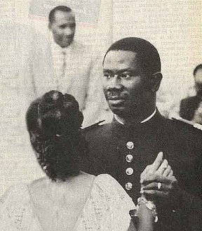Henriette had been Lancana Conté’s first love; the image of them waltzing together while Lancana was a young captain serving at the Guinean border still resonates today.

Although President Conté had three other wives, Henriette, who was known for her honesty, compassion, and integrity, remained at his side and continued to serve as Guinea’s First Lady throughout Lancana’s twenty-four years in office.

During this time, she was often called to mediate between her husband and her countrymen, employing her skills to ease tensions between Guinea’s unions and her husband’s military regime.

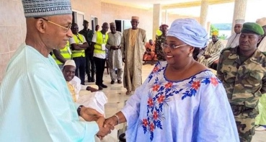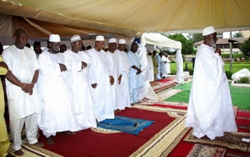Henriette Conté was Guinea’s moral beacon; as such, her death was grieved by all within the Guinean political sphere. Guinean President Alfa Condé attended the state funeral held in her honor, as did Cellou Diallo, head of the Guinean opposition. Lengthy obituaries were published in all the Guinean media.

Being a Baga from Boké, born to the Bangoura of Taigbe, Katako, she advocated for the Baga’s agenda in Conte’s centralist regime in Conakry.

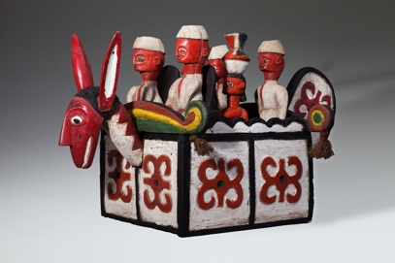Traces of the Guinean government’s close connections to the Baga community can be seen in the assortments of figures riding atop the Sibindel headrests from the 1960s and 1970s, which were used by dancers during receptions honoring government dignitaries visiting the Bagaland.

Henriette, like most of her female rural compatriots, was initiated into the the Baga women’s secret societies.

The various women’s associations of Guinea were the only traditional civil groups to survive Sekou Touré’s twenty-five years of Marxist dictatorship, a time in which the Baga village skyline , which was dominated for centuries by the silhouettes of the sacred cotton trees, gradually gave way to one of mosques and minarets.

These were years in which the male Baga population converted en masse to Islam, the old forest spirits and their advocates became branded as colonial collaborators, and foreign agents and village elders who adhered to the “ancient regime” were arrested and their sacred groves uprooted.

Unlike their male counterparts, 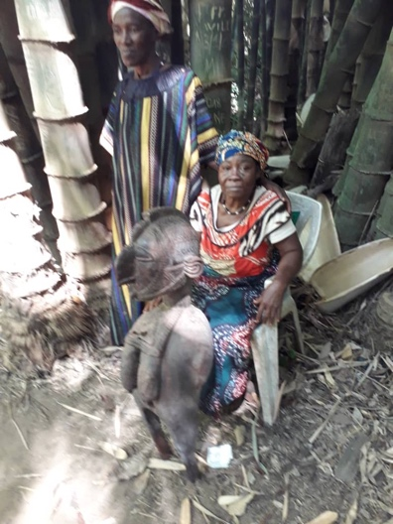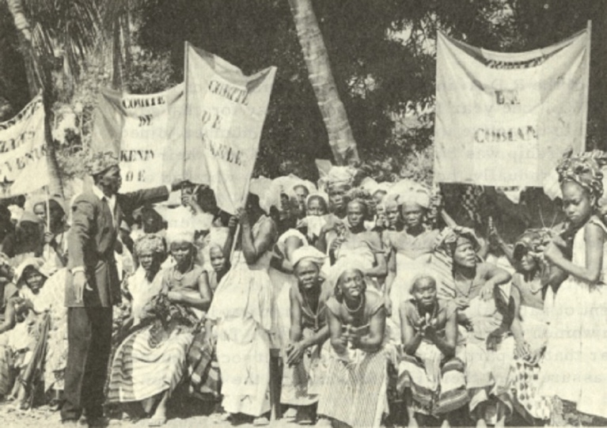the women’s secret associations challenged the revolutionary zeal of the central government. Advocating and maintaining their responsibilities for their community, they managed to retain their power, traditions, and morals. The women’s sacred groves and their domain thus remained virtually untouched.

Throughout her long career, Henriette was approached by delegations and representatives of the Baga women’s association who pressed their cases while bearing gifts., as customary at such meetings. Due to her position as a Baga elder, Henriette was entrusted with major artifacts from the Baga women’s sacred paraphernalia.

Upon her death, due to her status elaborate farewell celebrations were held. Traditionally, the cost of such week-long receptions was covered primarily by the sale of religious paraphernalia held by the deceased. The elder was merely the custodian of the objects entrusted by the community to his/her care, and thus upon his/her death the objects were regarded as communal property. As was customary, I was approached by the Baga elders to mediate the funeral costs and the receptions held in Henriette’s honor.

Slowly, a group of twelve pieces were uncovered, ten of which were masterpieces of the early twentieth century that had been hidden from sight since the iconoclasm of 1957. The final two were later versions of these from the eighties.

As some of the statues were in a progressive state of decay, a major painstaking restoration project led by master Nkai Sidime and Master Morri Curia, a renown Guinean restoration expert, was undertaken.

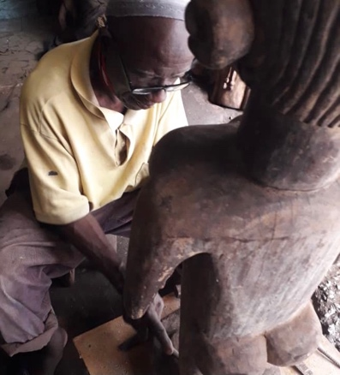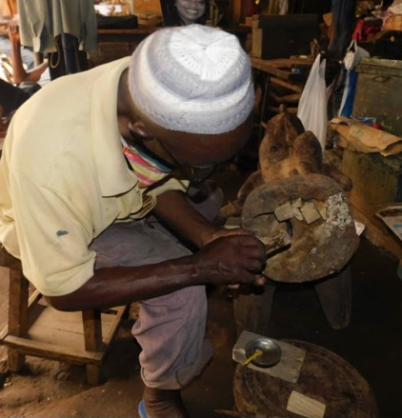

Henriette Conté’s collection, supplemented by the Katako hoard, that was exhibited at the Israel Museum in Jerusalem’s Nimba: Baga Art & the Great Mother exhibition, consists of most of the known oeuvre used by the Baga’s women’s association in the early twentieth century.

It is a cohesive group that represents Baga culture at its zenith.

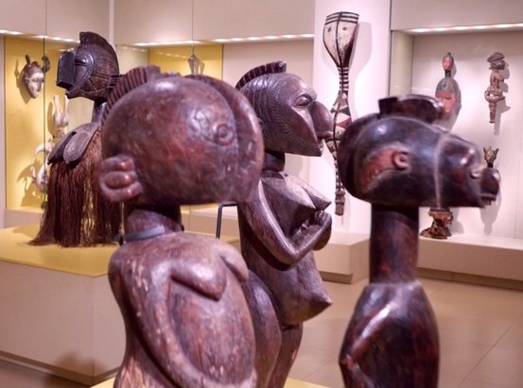

Close examination reveals three distinctive artists within the group, each with his own unmistakable approach, manner, and realm of interests. All operated within the liturgy and canon of Baga paraphernalia, but each employed his own unique and personal artistic vocabulary. The first embarked on a formalist journey toward the abstract. The second aimed at the metaphysical and the spiritual. Finally, the third indulged in his love of the figurative and delight in detail while moving towards realism and portraiture.

The still living Baga elders were approached with questions regarding the artists, their whereabouts, biographies, and other details. Contrary to former Western beliefs, all three artists were known figures, and respected members of their communities. Some were descendants of a long line of masters, whose craftsmanship had been loved, known, and appreciated for years.

Further research facilitated by the Boké governor revealed their years of birth, and more.

The three masters are :

Femori Camara, born in 1885 in Faraba.

Mangue Bangoura, born in 1895 in Camala.

Anadi fote’ Camara, born in 1890 in Taigbe

A comparative study of collections in other Western museums enabled additional attributions to the oeuvre of these three masters. For example, Famori Camara’s distinctive abstract vocabulary enabled the attribution of the following works:

Standing Male and Female Figures, Yale University Art Gallery, acquired 1954.

Nimba Headdress, Rierberg Museum, Zurich.

Janus Head , National Museum van Wereldculturen.

The Baga Artists

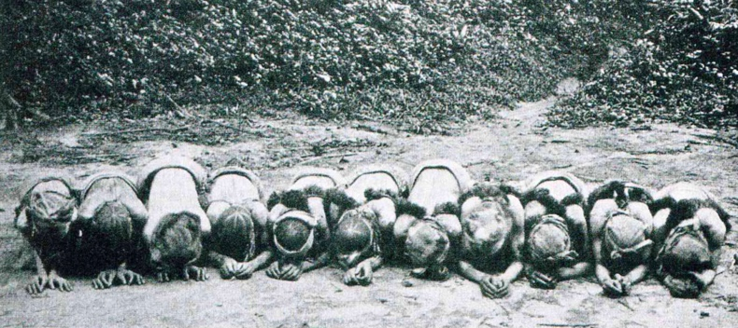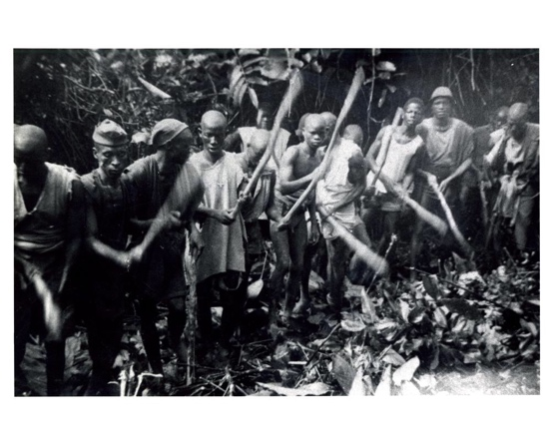Until the 1950s, all youth were sent to the “bush school,” attendance at which was a prerequisite for attaining adult status.

Male youth spent up to three years secluded in the bush, instructed by the elders on all the skills—social and professional—deemed necessary for leading an adult life. Upon returning to the village, they were expected to fulfill the traditional role established by their peers.

The bush school for girls lasted much less time and was held on the premises of the women’s society, an off-boundary secluded hut located at the village’s eastern perimeter. The girls spent several months in seclusion mastering their expected role as wives and mothers, and, most importantly, cultivating interdependence, secrecy, and loyalty to their fellow women. In this way, they came to serve as the backbone of Baga rural society as a unified, coherent labor force and a political group, responsible for the village commerce and social well-being.

The various women’s secret societies maintained their power and secrecy throughout the twentieth century, withstanding the onslaught of Sekou Touré’s Marxist regime. They ceased to operate only at the dawn of the twenty-first century, when the collapse of subsistence farming and the rise of mass Chinese rice imports opened Guinea to global international trade.

As in most acephalic West African societies, the Baga’s position in life was predetermined by birthright—offspring of first wife, second wife, etc.—as well as by the prominence of ancestors or family line. This highly deterministic social structure was balanced by a parallel structure based on age, membership in secret societies, and specific tutelage.

Such an elaborate double structure enabled each member to find his voice while

maintaining the equilibrium on which communal Baga society depended.

The Baga was a society with no concept of personal material accumulation;

wealth and status were measured in people (dependents), needed for political influence.

The society was a verbal one, in which language and conversation were held in high regard. Thoughts and ideas were implied rather than stated directly. Proverbs and elaborate stories were used to make a point. Decisions were reached by elders following lengthy meetings at which all adult members were expected to express their views, each in accordance with his position and rank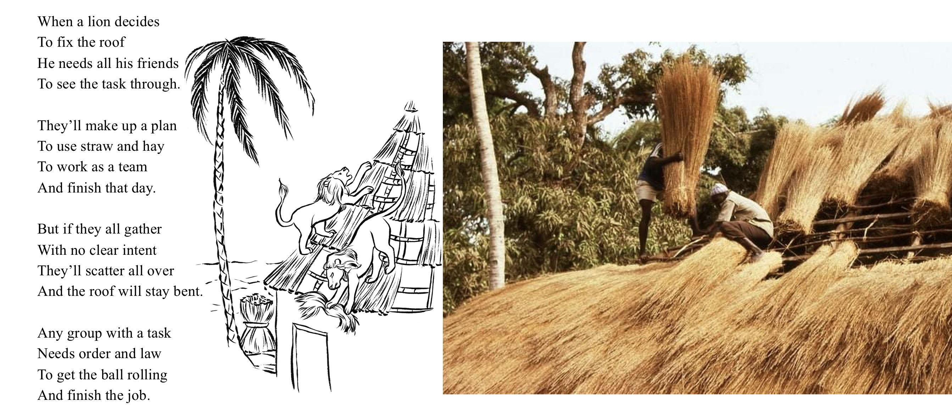.

For a verbal, non-materialistic society such as this, the need for a written text was less acute. This was a society in which ancestors were present, involved in everyday life, and treated with great respect, while people were merely transient. Bagas venerated the all-encompassing forest, nature, and forces of sub-Saharan equatorial Africa, and the only physical manifestations of culture, knowledge, and memory were the three-dimensional objects produced by members of the society with the skills taught primarily at the bush school: wood carvings in the case of boys, and pottery in that of girls. Further study under a known master was pursued only by those so inclined.

Nearly all material objects used in life were produced by members of the group.

Imported objects brought from afar, exchanged at crossroads markets set up by traveling Mandingo merchants, were of a mundane nature: jewelry, garments, medicines, or functional novelties. Everyday utilitarian objects and the customary religious paraphernalia, in contrast, were created by the Baga themselves with skills taught in the bush school,

For the Baga, life and art were totally interwoven. Religious objects accompanied all aspects of life and the celebrations conducted at everyday village gatherings: the setting of the bush school, graduation ceremonies, personal and extended family milestones, weddings and funerals, secret society gatherings, and religious conclaves deep in the woods.

To meet this demand, members produced an abundance of objects adhering to the conventional canon. Religious paraphernalia intended for the village masquerades were usually commissioned from local artisans, while important secret society commissions, such as power objects that proclaimed their members’ stature or the society’s power and were needed to impress new recruits, were commissioned from known masters whose fame as artists extended beyond their village.

At the heights of their powers, some of these artists even managed to replace farming altogether with full time carving . Only a few, however, elevated their practice to high art, and aspired to reach the profound while maintaining a dialogue with tradition and the canon.

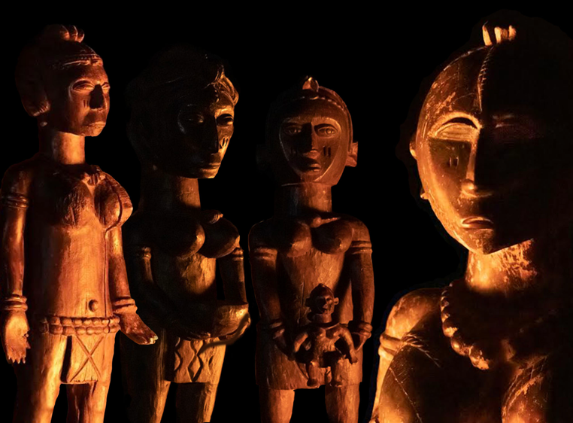The artists were known figures, recognized and appreciated by their peers. Like any artist, they were conscious of their vocation and not devoid of ego. As such, they were eager to leave their personal mark on posterity. Apart from their distinctive style and manner, they being all illiterate developed a characteristic mark, in order to express their authorship. Usually the rendering of an ear or eye,

they were also conscious of the fact that once their art was accepted, ordained by the clergy, and consecrated for ritual usage, it would be elevated to divine status. And as such, it would be disassociated from its worldly creator. For example in the Guinean hinterlands women’s associations such as The Sande - Sowei masks, were known to appear deep in the woods near a source of running water, proclaiming their presence to the association members in dreams never mentioning their male artists.

The wish to attain the divine ruled out the creation of representational portraits, therefore

emblematic portraiture that relied on symbolic devices to evoke images was desirable, but a more generalized anthropomorphic approach, was the norm.

One can only marvel at the eidetic capability demonstrated by these masters, who created highly complex compositions, knowing as they did, the importance and religious status of their art within their community, and the amount of love, respect, and care that would be bestowed on their works once they were completed.

These masters were able to transform a mentally constructed visual image directly to a block of wood, and to develop the final image with no preparatory stages while carving. (Sketches and paper were never been part of traditional West African art.)

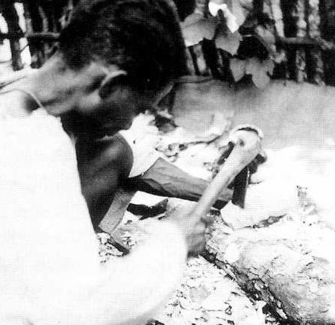Usually the artist would go and fell a tree only after having decided what he was looking for. The actual image materialized during the process of carving.

When commissioning a work from these masters, members of the society usually took into account

(in terms of reimbursement), expected delays and the time which were required to the artist to contemplate and find his vision before producing the piece

These monumental works of art were carved with a variety of sub-Saharan adzes.

Sitting or crouching on the ground, the artist carved with one hand while using his other hand, lap, thighs, and knees to hold the object in place. The production of such elaborate, precisely made sculptures with a simple adze required great concentration and technical skill. Although the Baga had a long history of trade with the West, they never resorted to industrial tools. (It takes two hands to manipulate Western carving tools.)

The artists worked within their tradition, all in close geographical proximity, each aware of the other’s accomplishments. All enjoyed full artistic license from their community. Their visual language developed from their memory of their masters’ works.

The moment a piece was delivered to the client (women’s association, etc.),

the artist never saw it again. A man could never venture into a women’s sacred grove, where these idols resided.

The Western concept of a studio that contained multiple works in process and enabled contemplation was totally alien to these artists. Each new commission had to be drawn from memory and made from scratch. Each work was unique. The artists respected the artistic heritage of their ancestors and considered it sacred.

The artists produced bodies of work that were organically bound to their community and faithful to their tradition, yet never marred by atavistic rigidity or soulless formalism.

Their creations, in fact, are wonderful examples of artistic license and tradition working in tandem to portray the divine.

It is a great privilege to make this small gesture and replace the customary museum plaques attributing these African masterpieces to an anonymous artist with one that bears an actual name.

Each of these artists worked in his community, within the canonical guidelines of his cult, and was attuned to the spirit of his time; each possessed his own artistic manner and a fully developed, personal voice.

**1.**

**El Hadje Ali Manigué Bangoura**

El Hadje Ali Manigué Bangoura, born in Tolkotch, Taigbe Kamala, 1895. 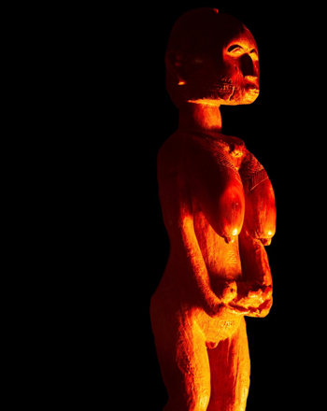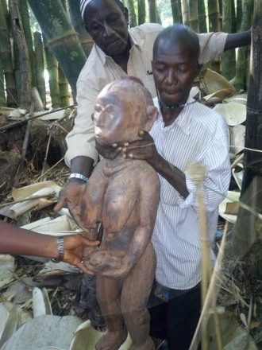

One of the most striking sculptures to emerge from the Katako hoard is that of an elderly female baga, 102 cm tall. The statue, whose face is a blend of human and Nimba, and whose exaggerated breasts and genitalia proclaim age and maturity, depicts the Baga ideal of the great mother; one who has given birth to many and is now an elder nourishing her community.

The figure’s face and breasts have been polished by countless caressing hands, whose ritual repetitive movements from top to bottom, from the cheeks down to the breasts, can be easily traced. When illuminated as intended by the flickering light of natural flames, the true nature and power of the statue becomes apparent: a mother solemnly holding a dead child’s body in her outstretched hands in a gesture of compliance, dignity, and grief.

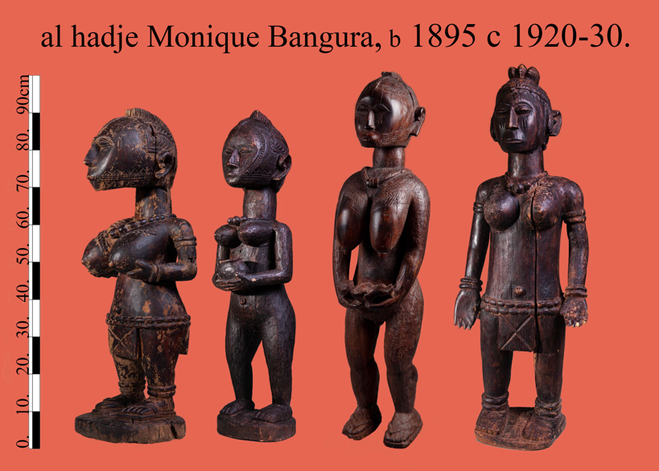This work was later joined by three additional pieces from the estate of Guinea’s First Lady Henriette Conté to form a group of four major works, all clearly crafted by the same hand.

As was common, the unique rendering of a human ear served as the artist’s personal mark, thereby expressing authorship without compromising the work’s liturgical powers. Among the other characteristics portrayed in the sculptures is the quest for human emotion, as evident in the powerful figure of the elder demanding total obedience, or the young disciple solemnly offering a tribute.

The community elders who were consulted identified the artist as Manigué Bangoura, a renowned artist from Faraba, (the River Nunez Delta) who later converted to Islam and made the pilgrimage to Mecca.

On a trip to El Hadje Bangoura’s birthplace, we were fortunate to meet his grandson, Abou Bachar Petro Bangoura, born in 1953, who continues with his grandfather’s profession and supplies local communities with the objects needed to maintain their community traditions.

Petro Bangoura is the son of George Bangoura (El Hadje Bangura’s son), also a known Baga sculptor. Petro Bangoura proudly sees himself as heir to his grandfather’s legacy and takes special pride in using his ancestor’s cherished handcrafted chair.

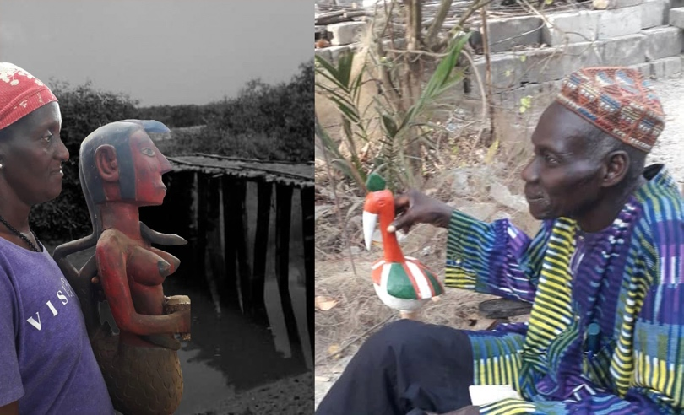

**2.**

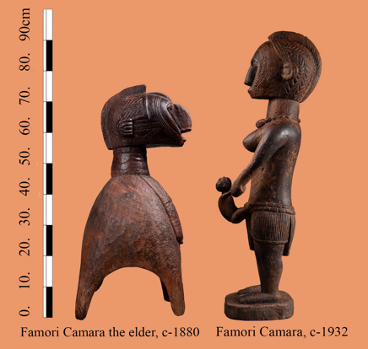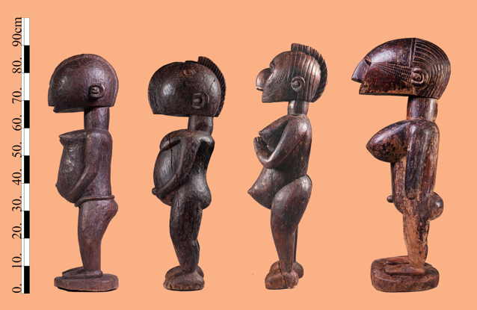**Amani Famori Camara**

Amadi Famori Camara, born in Faraba Guinea in 1890.

Four statues with outstanding abstract characteristics, once part of the Katako hoard were later joined by two additional exceptional pieces from Henriette Conté’s estate. Close examination reveals that all six display characteristics of a unique master hand, a mature artist with a personal vocabulary who commanded a technique to match. Five have been dated with infrared spectrography to circa 1930–1950, while an older small Nimba of extremely condensed wood has been dated to 1880.

All are carved out of dense and heavy African teak, all measure nearly the same height range of 80–90 cm. Theywere immediately recognized by the Baga elders and by master Bangoura as works of the master Famori Camara, a renowned Baga sculptor who was part of the creative hub in Faraba prior to Guinean independence. Master Bangoura proudly aligned himself and his work with that of Camara, and even claimed to be one of his descendants.

An analysis of Camara’s work clearly reveals his language. He possessed the ability to reinterpret and modernize the traditional Baga canon, while using semi-abstract shapes and myriad geometric patterns.

Camara developed a language in which the traditional ornate vocabulary was gradually reduced to a collage of primary shapes. He constructed the orthodox Nimba’s “Fulani” facial ornament from straight and rigorous geometric lines. Camara also reduced the ear to a circle surrounded by a concave half moon. the Baga elders described this feature as “Famori’s personal mark,” an observation further supported by a comparison of it to the ears of works similar to Camara’s that are currently in Western museums, such as those in the Rietberg Museum, the Yale African Art Gallery and the museum of Berg en dal Netherlands—all works that might therefore be claimed as belonging to Famori Camara’s oeuvre.

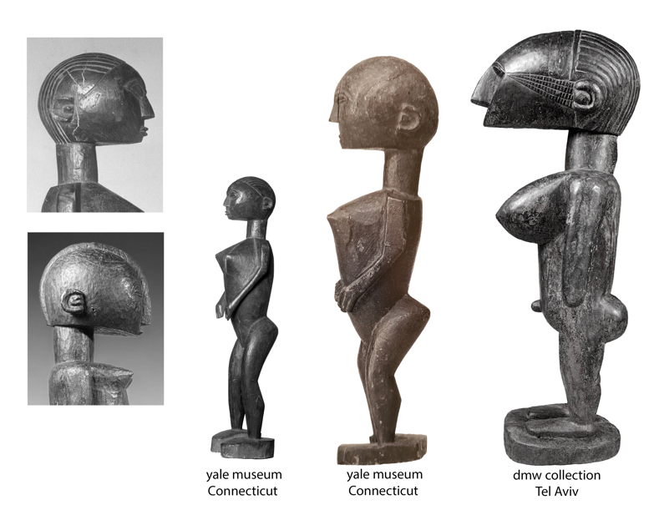

The wonderful small nineteenth-century Nimba, whose right face has been leveled by countless loving strokes of hands during its long years of service, is attributed to Camara’s father (an artist considered by everyone as a forebear of the Katako sculptors ) and has a slightly different ear mark.

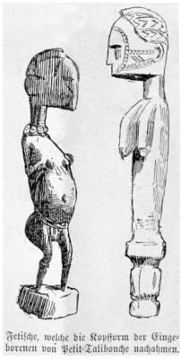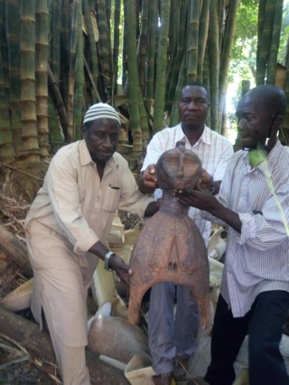A drawing of additional works resembling those made by this hand was published in 1886 by G. Caspar Felix in his account of his trip down the River Nunez, a trip embarked upon again only half a century later by Fred Bowald.

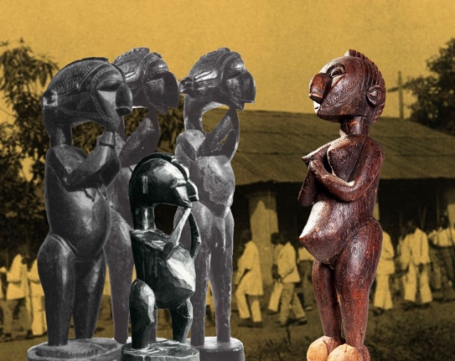Master Famori Camara worked in the the 1930s and 1940s, a time when the colonial regime and its representatives in Katako, the French catholic mission, were at the zenith of their power and Christianity was slowly being integrated into Baga life. A glimpse of how Camara’s art could have evolved had the jihad and the subsequent destruction of Baga culture not occurred can be gleaned by comparing this singular interpretation of a standing Nimba, her hands clasped in a classic Christian gesture of prayer, with eyes turned upwards and her lips smiling, to the traditional Nimba, whose hands are clasped beneath her chin in a vow of silence, her eyes downcast, and her mouth closed to signify secrecy. One is a figure denoting power to whom worship is due, while the other is a mediator between God and her community.

Camara’s work clearly shows that he was preoccupied with formalist and conceptual problems similar in nature to those of fellow Western European modern artists.

His oeuvre challenges the last century’s boundaries between and definitions of traditional versus modern art, White and Black, Western and African.

**3.**

**Foté Camara**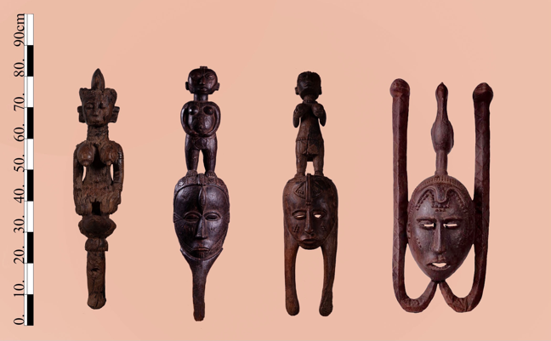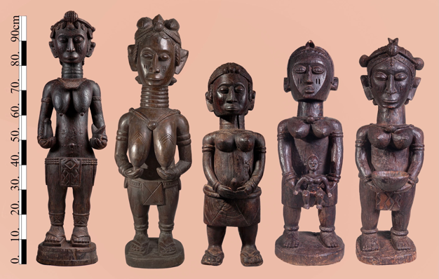

Barbady Foté Camara, born in Tolkotch-Taigbé Falaba 1890.

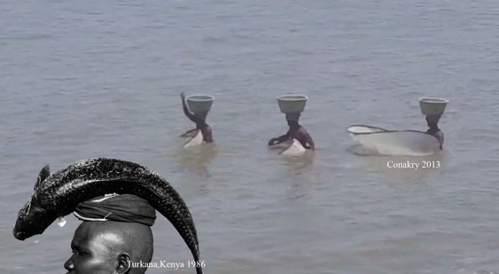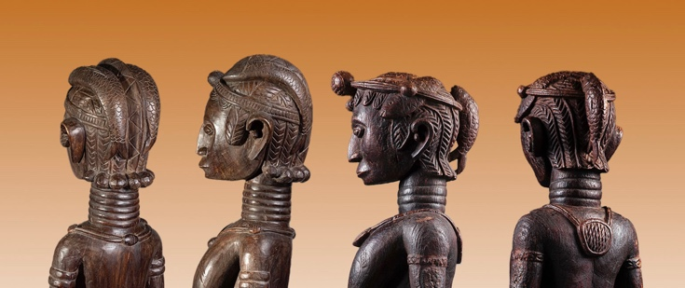Master Foté Camara was one of the most prolific and renowned Baga artists of the first half of the twentieth century. His fame spread widely throughout the Bagaland. Camara’s distinctive figurative style became extremely popular with the women’s secret associations, which, acting as the artist’s patrons, commissioned him to create numerous works for their ritual paraphernalia. Possession of a piece of such caliber and its presentation to new initiates during ceremonies was considered a sign of great status and a symbol of power for the entire secret society.

Many of Camara’s surviving works depict fish interlocked in elaborate female coiffeurs. Such figures have elongated ringed necks symbolizing beauty, downcast eyes, and a closed mouth denoting secrecy and unity. Their braided hair represent self-care and cultivation, and images of fish refer to an abundance of game and fertility (fishing was one of the women’s societies’ duties). Camara’s ability to combine all these symbols in a unified 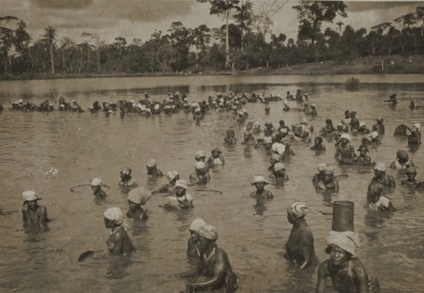sculptural figure is indeed unique.

George Labitte , Nezekore, Guinea, 1940

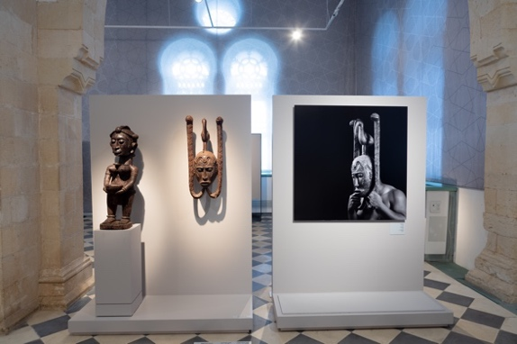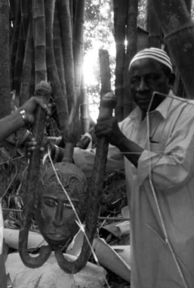Most of the masks of the men’s associations were destroyed in the 1957 jihad since they were regarded as armaments. Targeted by rebellious youth, their destruction was one of the first actions by the revolution. The importance of those that survive (Mask Museum, Scotland ) has never been realized. Three such masks by Camara were uncovered from the Katako hoard. Two of them are featured in the Israel Museum Jerusalem exhibit, Nimba, Baga Art and the Great Mother. A third one is now in the Be’er Sheva Islamic Art Museum’s Gold Road Encounters exhibit.

Camara’s hand and manner are easily recognizable. His compositions are static, frontal, and lavishly decorated, recalling classic European portraits. His beautifully rendered creations embody archaic monolithic omnipotent beings.

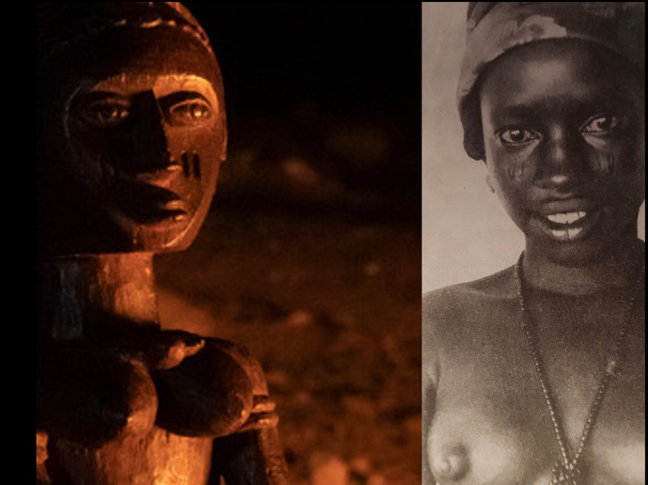Camara’s talent was so unique that his art was recognized by everyone without the help of any distinctive mark as signature. One is always drawn to his naturalistic all-consuming eyes, which, when illuminated by a red cascade of flickering flames (unlike the even, monochrome lighting in the museum), as they were in the women’s sacred forest, immediately spring to life.

Foté Camara’s greatness is evident in his archetypical portraits of Baga females, each representing a specific age group—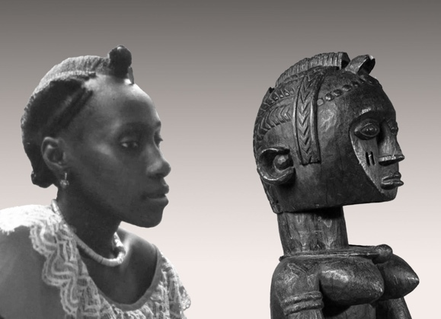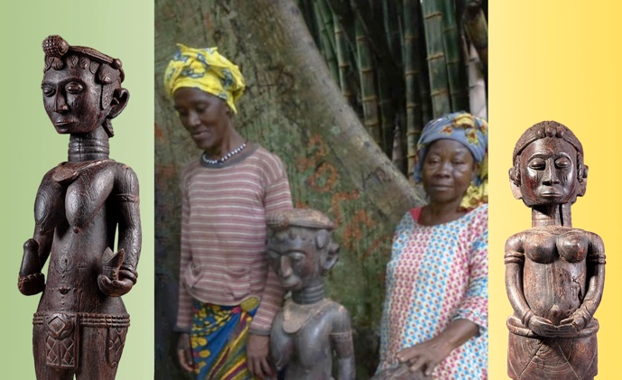young initiates, members, and elders—each typical of the group rather than a portrait of a specific individual.

When the idealized images are set alongside actual photos of Baga members taken years apart ( the statues were made in the 1930s, years before the older and younger members posing with them in Katako’s forest were ever born), Camara’s ability to capture the essence of his Baga patrons becomes apparent.

The works demonstrate incredible eidetic ability, especially bearing in mind that all the statues were carved from extremely hard wood with a single hand equipped with a traditional adze and no preparatory sketches. Camara’s figurative aspirations marked a clear break from tradition, which was usually strictly observed. So, for instance, the sound of the modern flute was banned from all festivities due to its similarly to the sound of a spirit. Nevertheless, Foté Comara’s art was praised by his peers and achieved immense popularity.

Post independence, his art was carefully guarded, kept away from the sight of the uninitiated for more then half a century, and made public only upon Henriette Conté’s death.

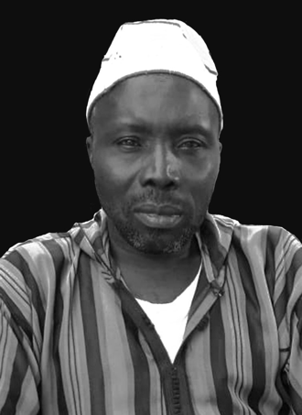Master Camara was succeeded by a son, born in 1930, with whom the practice ended. His grandson, Andre Foté Camara, was happy to recall his illustrious grandfather is a devout Muslim who is making his living by fishing in the River Nunez Delta.

Andre Foté Camara, Faraba, Guinea , 2020.