**A latent profile analysis: child sexual abuse and assault Teacher-pupils mediation**

Yaniv Efrati

Faculty of Education, Bar-Ilan University, Ramat Gan, Israel

___________________________________________________________________

Corresponding author: Yaniv Efrati, Bar-Ilan University, [Faculty of Education](https://www.researchgate.net/institution/Bar_Ilan_University/department/School_of_Education)

Ramat Gan, Israel. Email: [ypefrati@gmail.com](mailto:ypefrati@gmail.com) Phone: +972-545-800-094.

**ABSTRACT**

Although significant advances have been made in the field to date, mediation between teachers and their pupils on the subject of child sexual abuse and assault remain a neglected area in much of sex education research. In the current study I examined a Latent Profile Analysis (LPA) for estimating distinct profiles in teacher mediation of child sexual abuse and assault (CSAA). Next, profiles were compared in terms of pupils’ and teachers’ quality of communication, quality of communication on CSAA, general support, CSAA-related support, age, economic status, teachers’ perceived severity and susceptibility of CSAA among pupils, years of education, seniority, pupils’ sense of acceptance and rejection by teachers, teachers’ and pupils’ biological sex and religiosity. The study comprised of 756 pupils (341 boys and 415 girls), aged 11-18 years (M = 15.32, SD = 1.82), and 66 homeroom teachers (21 men and 45 women), between the ages of 25 and 64 (*M* = 41.88, *SD* = 8.93).Five distinct profiles were identified:The “moderate active mediation” (*n* = 256), the “high active mediation” (*n* = 222), the "High mediation" (*n* = 109), the "“minor active positive focused” (*n* = 86), and the “no mediation” (*n* = 41). The findings provide deeper insights into the ability of teacher to mediate on child sexual abuse and assault, and an opportunity for developing more effective program on sex education to pupils.

**Keywords:** child sexual abuse**,** mediation, Teacher- pupils communication, sexual-harassment

**A latent profile analysis: child sexual abuse and assault Teacher-pupils mediation**

**INTRODUCTION**

Child sexual abuse (CSA) is a worldwide health problem with long-term negative effects on survivors’ mental, psychological, physical, and sexual health. According to the World Health Organization (WHO, 1999), “Child sexual abuse is the involvement of a child in sexual activity that he or she does not fully comprehend, is unable to give informed consent to, or for which the child is not developmentally prepared and cannot give consent, or that violates the laws or social taboos of society. Child sexual abuse is evidenced by this activity between a child and an adult or another child who by age or development is in a relationship of responsibility, trust or power, the activity being intended to gratify or satisfy the needs of the other person.” For the purposes of this study, CSA includes offenses carried out by juvenile/peer offenders, and thus the word “assault” is added to the term: CSAA.

To date, researchers have focused extensively on estimating the prevalence of CSA (Barth et al., 2013; Singh et al., 2014; Stoltenborgh et al., 2011; Vogeltanz et al., 1999). Estimates of CSAA prevalence worldwide range from 8% to 31% for girls and from 3% to 17% for boys (Barth et al., 2013). Pereda et al.’s meta-analysis of the worldwide prevalence of CSAA (covering 22 countries) revealed that 7.9% of men and 19.7% of women had suffered sexual abuse before the age of eighteen (Pereda et al., 2009). In Israel, one out of four adults reports having been sexually abused as a child (Schein et al., 2000). In the Jewish population, no gender differences have been found in CSAA rates (17.6% for boys and 17.7% for girls), whereas among the Arab population, these rates are significantly higher among boys (28.4%) than among girls (18.7%) (Lev-Wiesel et al., 2018). In a recent national study on child maltreatment in Israel, 18.7% of Israeli children aged between 12 and 17 reported having been sexually abused (Lev-Wiesel et al., 2018). Prior research has indicated that CSAA has significant negative effects in both the short and long term, including post-traumatic stress disorder (PTSD), various psychiatric disorders, such as depression, anxiety, suicide and suicide attempts, substance use, neurobiological effects, poor physical health, eating disorders, and psychosomatic physical complaints and conditions (Briere & Runtz, 1993; Putnam, 2003).

Teachers play a key role in preventing and disclosing CSAA. In fact, in a recent study, Goldschmidt-Gjerløw highlights the importance of children’s rights and teachers’ responsibilities in addressing the topic of CSAA in schools (Goldschmidt-Gjerløw, 2019). As teachers spend several hours a day with their pupils, it is important that they discuss CSAA with them in appropriate and useful ways. Such discussions help to prevent this type of abuse, as pupils become informed about CSAA, what relationships are characteristic between the abuser and the victim, and what victims can do to break out of this pattern. Conversations about CSAA between teachers and pupils can equip pupils with greater protection and safety, and by openly discussing CSAA, teachers can become more alert to signs indicating that a pupil is being subjected to violence or abuse, and this helps to promote (and facilitate) victims’ disclosure of CSAA.

A timely disclosure of CSAA, combined with an appropriate response, can potentially reduce the risk of subsequent sexual exploitation/revictimization, and put an end to the suffering inflicted by offenders. It is therefore imperative that responsible and trusted adults in children’s lives learn how to encourage genuine disclosure of CSAA. Previous research shows that children do not often disclose their CSAA experience to teachers. In a national study conducted in the United States, it was found that 66.3% of youths aged between ten and 17 years did not report cases of sexual abuse to a parent or any other adult. However, of those who did disclose offenses, 31% disclosed to their parents, 19.1% to the police, and 21.8% to a teacher (Gewirtz-Meydan & Finkelhor, 2019). Similarly, in another study involving CSAA survivors, 75% of respondents did not disclose abuse during their childhood. Of the 25% of survivors who reported having told someone about the abuse, only 7% disclosed episodes to their teacher (Wager, 2015). Findings from Alaggia’s (2010) study on adult survivors suggest that there is an expectation that teachers should recognize distress in their pupils, along with the assumption directly asking students about the cause would help provoke a disclosure.

It is regrettable that children do not feel comfortable discussing CSAA with their teachers or disclosing cases of abuse to them (Schönbucher et al., 2012). Children and adolescents need adults from all spheres of their life – including parents, teachers, police, magistrates, and health-care providers – to openly discuss and sensitively respond to CSAA. The current study sought to examine the factors that facilitate this kind of mediation between teachers and pupils. While previous research in this area has focused mainly on the perspective of either pupils (Schönbucher et al., 2012) or teachers (Goldman & Bradley, 2011; Tener & Sigad, 2019), there is a growing need for studies that integrate the perceptions of both pupils and teachers to examine the gap between them. This research addresses this gap by examining the perceptions of both pupils and their homeroom teachers in the mediation on CSAA.

The study examines profiles of teachers’ mediation strategies regarding CSAA and how they correlate with pupils’ perceptions of teacher support and acceptance. It is based on three core strategies of mediation: restrictive, negative active, and positive active (Boniel-Nissim et al., 2020; Efrati & Boniel-Nissim, 2021; Nathanson, 2016). Restrictive mediation focuses on rules and boundaries and is not really a forum for open discussion, but rather, is intended to convey a clear message that sexual harassment is illegal and against the law. Discussions on CSAA from a negative active mediation approach focus on the negative aspects of CSAA (i.e., explaining why such behaviors are dangerous and harmful). Finally, a positive active approach emphasizes on healthy and beneficial sexual behaviors (e.g., discussing sex as something potentially wonderful and joyful, and advising children and young people to contact an adult if anybody ever touches them without their consent, or if sex ever feels unpleasant).

Research examining mediation strategies focuses mostly on parents (Chen & Chng, 2016; Shin & Li, 2017) and on media usage and risk behaviors online (Livingstone & Helsper, 2008). Findings on different mediation styles are mixed, with some studies suggesting that the positive active approach is associated with the most positive outcomes (Nathanson, 2001) and others indicating that a combination of different mediation strategies is most beneficial (Chen & Chng, 2016).

**The current study**

The importance and benefits of open discussion between teachers and their pupils on the subject of CSAA have been widely acknowledged (Goldschmidt-Gjerløw, 2019; Goldschmidt-Gjerløw & Trysnes, 2020), yet the available data indicate limited disclosure of CSAA to teachers (e.g., Gewirtz-Meydan and Finkelhor, 2019; Wager, 2015). Given this background, the current study sought to identify the profile of perceived CSAA mediation and what the most beneficial profile teacher uses to mediated on CSAA, I hypothesize that: (a) differences will be found between socio-demographic and latent profile of perceived CSAA mediation. (b) Differences will be found between latent profile of perceived CSAA mediation in teachers’ measures. (c) Differences will be found between latent profile of perceived CSAA mediation in pupils’ measures.

**METHOD**

**Participants**

**Pupils**

The study population comprised 756 pupils (341 boys and 415 girls), age 11-18 (M = 15.32, SD = 1.82), all enrolled in the sixth (n= 28), seventh (n= 32), eighth (n= 135), ninth (n= 148), tenth (n = 79), eleventh (n = 108), and twelfth (n = 226) grades. Most (94%) were native Israelis. Socioeconomically, 6.1% reported being lower than average, 58% average, and 36% above average. The sample comprised 299 (39%) self-defined religious individuals and 457 (70%) secular ones.

**Teachers**

Participants were recruited among teachers. Sample consist 66 individuals (21 male and 45 women), age 25-64 (*M* = 41.88, *SD* = 8.93). Each of the participants provided informed consent and study was approved by the ethical committee. Among the participants, 2 (3%) reported that they were single, 62 (94%) married, 2 (3%) divorced. Most of the participants (95%) were native Israelis. Financially, 17 (26%) reported to be in a very good state, 47 (72%) reported that their financial state is good, 2 (2%) – poor. The sample comprised 40 (60%) self-defined religious individuals and 26 (40%) secular ones. Participants’ years of education ranged from 12 to 26; the mean number of years of schooling was 17.09 (*SD =* 2.58). Finally, Participants’ years of teaching seniority ranged from 2 to 34; the mean number of years of teaching seniority was 15.34 (*SD =* 8.86).

**Measures**

*Teachers’ measures*

***Teacher Mediation of CSAA***(PMP; based on Boniel-Nissim, Efrati, & Dolev-Cohen, 2019). For this research we adapted the questionnaire to teachers. To assess teachers' mediation strategies of sexual protection (restrictive, negative, and positive active,) we administrated the PMP scale. *Restrictive Mediation* was measured using two items (α = 0.81) (e.g., " I set clear rules for my pupils regarding sexual harassment"); *Negative Active Mediation* was measured using three items (α = 0.79) (e.g., " I try to explain to my pupils why sexual harassment is a bad and dangerous thing"). *Positive Active Mediation* was measured using two items (α = 0.83) (e.g., " I try to explain to my pupils about the need to tell and not keep "secrets" with an emphasis on healthy and beneficial sexual behavior"). In this study we have omitted the Co Use Mediation because it makes no sense to the medium. Teachers were asked to report their agreement with each item on a 5-point scale ranging from 1 "not at all" to 5 "very much". For each teacher, we calculated three scores of mediation strategies of Sexual harassment by averaging the answers in the relevant items.

***Teacher Perceived Severity of CSAA*** (adapted from previous research: Hwang et al., 2017; Kim et al., 2012). To measure threat appraisal, perceived severity was measured using two items (α = 0.81). Adjustments were made to adapt the items to the subject matter of Sexual harassment. Sample items included “Sexual harassment is a serious problem” and “Sexual harassment can lead to severe consequences.” The items were rated on a 5-point Likert scale ranging from Strongly disagree to Strongly agree.

**Teacher Perceived Susceptibility of *CSAA*** (adapted from previous research: Hwang et al., 2017; Kim et al., 2012). Threat appraisal also includes perceived susceptibility. It was measured using two items (α = 0.83) adapted from previous research (Hwang et al., 2017; Kim et al., 2012). Adjustments were made to the items to adapt them to the subject matter of Sexual harassment. Sample items included “My pupils were susceptible to sexual harassment” and “My pupils were at risk of Sexual harassment and sexual assault” rated on a 5-point Likert scale ranging from Strongly disagree to Strongly agree.

***The Teacher-Pupil CSAA Communication Scale***(PCS; based on Jaccard, Dittus, & Gordon, 2000). To assess the quality of teacher-pupil communication about sexual harassment, we administrated the Hebrew version of the PCS scale. The scale comprises 16 items (e.g., “My pupils would not want to answer my questions about sexual harassment”) on which each pupil is asked to describe the extent that he or she agrees with the item on a 5-point Likert scale ranging from 1 – *strongly disagree*to5 – *strongly agree*. According to Jaccard and colleagues (Jaccard et al., 2000), the scale is highly reliable. The scale was translated to Hebrew by Efrati and Gola (2019). In the current study, we adapted the questionnaire to teachers and focus on sexual harassment. Accordingly, we will be calculated for each teacher a score of communication about sexual harassment by averaging his or her answers. Cronbach’s alpha of the PCS in this sample was 0.87.

**The Teacher-Pupil Communication Scale** (based on Barnes & Olson, 1982) is constructed of two 10-item subscales – the degree of openness in Teacher-Pupil communication, and the extent of problems in family communication. The Open Teacher Communication (OTC) subscale reflects feelings of free expression and understanding in teacher-pupil interactions (e.g., “When I ask questions, I get honest answers from my pupils”). The Problems in teacher Communication (PTC) subscale measures negative interaction patterns and hesitancy to disclose concerns (e.g., “My pupils are careful what they tell me”). Respondents rate their answers on a five-point Likert scale (1 – *Strongly disagree,*5 – *Strongly agree*) to indicate the degree of their agreement with the items. Scores can range from 10 to 50 for both subscales. For the OTC subscale, a higher score indicates a higher degree of openness in teacher-pupil communication. The scores for items on the PTC subscale are reversed, so that a high score is indicative of communication problems, and a low score indicative of a lack of perceived problems in teacher-pupil communication. For the present study, we adapted the questionnaire to teachers and focus on sexual harassment. Cronbach’s alpha of the scale in this sample was 0.83.

**The Teacher Support**. The questionnaire adapted from Multidimensional Scale of Perceived Social Support (MPSS; based on Zimet et al., 1988). The Scale of Perceived Teacher Support have 10-item self-report scale measuring perceived support from teachers (e.g., “My pupil trusts me when things go wrong”), (e.g., “My pupils receive the help and emotional support he/she needs from me”). Participants were asked to rate their answers on a 6-point Likert (1 – *strongly disagree,*6 – *very strongly agree*). We will be computed a total *Teacher```` support* score by averaging the 10 items (Cronbach's alpha =.96).

**The Teacher *CSAA* Support**. The questionnaire adapted from Multidimensional Scale of Perceived Social Support (MPSS; based on Zimet et al., 1988). The Scale of Perceived Teacher Sexual Assault Support have Ten item self-report scale measuring perceived sexual assault support from teachers (e.g., “I am always around when pupils need me about harassment and sexual assault”), (e.g., “My pupils talk about his/her problems with me when it comes to harassment and sexual assault”). Participants were asked to rate their answers on a 6-point Likert (1 – *strongly disagree,*6 – *very strongly agree*). We will be computed a total *Teacher* sexual assault *support* score by averaging the 10 items (Cronbach's alpha =.94).

*Pupils’ measures*

***Teacher Mediation of CSAA*** (PMP; based on Boniel-Nissim et al., 2020). The same questionnaire that was given to teachers but was adapted to the perspective of pupils. Cronbach’s alpha of the PMP in this sample was 0.78 for Restrictive Mediation, 0.81 for Negative Active Mediation and 0.80 for Positive Active Mediation.

*T****he Teacher-Pupil CSAA Communication Scale***( PCS; based on Jaccard, Dittus, & Gordon, 2000).The same questionnaire that was given to teachers but was adapted to the perspective of pupils. Cronbach’s alpha of the PCS in this sample was 0.90.

**The Teacher-Pupil Communication Scale** (based on Barnes & Olson, 1982). The same questionnaire that was given to teachers but was adapted to the perspective of pupils. Cronbach’s alpha of the DASS-T in this sample was 0.84.

**The Teacher Support** (MPTS; based on Zimet et al., 1988). The same questionnaire that was given to teachers but was adapted to the perspective of pupils. Cronbach’s alpha of the MPSS-T in this sample was 0.93.

**The Teacher *CSAA* Support** (MPTS; based on Zimet et al., 1988). The same questionnaire that was given to teachers but was adapted to the perspective of pupils. Cronbach’s alpha of the MPSS-T in this sample was 0.94.

**Children’s Appraisal of Teacher as a Secure Base (CATSB**; Al-Yagon & Mikulincer, 2006). This 25-item scale assessed adolescents’ perceptions of their homeroom teacher as an attachment figure along a 7-point scale ranging from does not apply at all (1) to applies very much (7). Previous findings demonstrated the validity and reliability of this scale (e.g., Al-Yagon & Mikulincer, 2006). The availability and acceptance subscale comprised 17 items assessing the teacher as caring and as available in times of need (e.g., “My teacher is always there to help me when I need her”). Reliability was high α = .95. The rejection subscale comprised 8 items assessing the extent to which the adolescent perceived the teacher as rejecting (e.g., “My teacher makes me feel unwanted”). Reliability for this scale was also good (α = .90).

**Procedure**

The study was presented as a research project on Teacher-Pupil Sexual harassment Communication and mediation among 11–18-year-old pupils and their teacher. The participants constituted a convenience sample. They were recruited from a variety of sources (postings on bulletin boards and in online forums). Questionnaires were uploaded to Qualtrics – an online platform for questionnaires – and distributed by several research assistants. The referral was made in the class WhatsApp and sent on a personal communication to the parents and the class teacher respectively by the research assistants. Parents of pupils and teachers who agreed to participate in the study were contacted via email and/or phone and were asked to review the questionnaires and sign an informed parental consent form, which was sent back to the research assistants by email. Upon agreement, a link for the online survey was sent to the pupils who was assured as to the anonymity of the survey. Participants were then asked to complete the survey in private, in a quiet room in their home (i.e., without the presence of others). Following an informed consent form, questionnaires were presented in random order. All questionnaires were in Hebrew – the native language in Israel. Lastly, an online debriefing was given, and participants were thanked for their participation. The procedure was approved by Institutional Review Board of [masked for review].

**Data Analysis**

Overall, the data comprised 756 pupils and their 66 teachers (number of pupils in each class ranged from 1 to 28, *M* = 11.45, *SD* = 7.38). ICC(1) coefficients (i.e. proportion of the total variance explained by the grouping structure) of the main outcome measures [i.e. pupils’ perceived mediation of sexual harassment (restrictive, active negative and active positive)] indicated that between 9.44% and 14.37% of the variance in the outcome measures was accounted for by teacher-level data. Accordingly, multilevel analyses were selected as the main analytical approach. First, we applied Latent Profile Analysis (LPA) for estimating distinct profiles in pupils’ perception of sexual-harassment mediating strategies – restrictive, active negative and active positive. To do so, we used *tidyLPA* R package (Rosenberg et al., 2019) with MPlus (Muthén & Muthén, 2019) integration. We examined 1 to 7 possible profiles. Optimal number of profiles were determined by Akogul and Erisoglu’s (2017) Analytic Hierarchy Process (AHP), bootstrapped likelihood ratio test (BLRT), sample size of each profile, and theoretical plausibility. The AHP uses the following information criteria in its decision tree: Akaike’s Information Criterion (AIC), Approximate Weight of Evidence (AWE), Bayesian Information Criterion (BIC), Classification Likelihood Criterion (CLC), and Kullback Information Criterion (KIC).

Next, we examine differences between perceived mediation profiles in the study’s continuous measures by a series of nested analysis of variance (ANOVA) using *lme4* (Bates et al., 2015) and *lmerTest* (Kuznetsova et al., 2017) R packages, and using the *glht* function of the *multcomp* package (Hothorn et al., 2008) for post-hoc analyses. In these post analyses, we used Tukey’s Honest Significant Differences (HSD) and Benjamini-Hochberg (BH) adjustment for multiple comparisons. The continuous measures were pupils’ and teachers’ quality of communication, quality of communication on sexual harassments, general support, sexual-harassment-related support, age, and economic status. In addition, we examined differences in teachers’ perceived severity of sexual harassments among pupils, susceptibility of pupils to sexual harassments, years of education and seniority. Finally, we examined differences in pupils’ sense of acceptance and rejection by teachers.

In the final section of the results, we examine differences between perceived mediation profiles in the study’s binary measures of teachers’ and pupils’ biological sex and religiosity (secular, religious) by a series of Bayesian logistic mixed-effects models using the *blme* R package (Chung et al., 2013) and the *glht* function of the *multcomp* package (Hothorn et al., 2008) for post-hoc analyses. Results are presented in Table 2, and significant results also in Figures 2 and 3.

**Results**

**Latent profile analysis**

Results are summarized in Table 1. The latent profile analysis indicated that the 6-profile solution had the lowest AIC, BIC, CLC, and KIC values, yet it did not have the highest entropy (classification efficiency) and had a group with only 21 participants (< 5% of the sample). In contrast, the 5-profile solution had the lowest AWE, the highest entropy and its smallest group comprised 41 participants (> 5%). Accordingly, we selected the 5-profile solution as the most optimal one (see Figure 1). The five profiles were: “High mediation” (*n* = 109), “high active mediation” (*n* = 222), “moderate active mediation” (*n* = 256), “minor active positive focused” (*n* = 86), and “no mediation” (*n* = 41). The “high mediation” group comprised adolescents who perceived all mediation strategies (restrictive and active negative and positive) as high; the “high” and “moderate active focused” groups comprised adolescents who perceived the active strategies (negative and positive) as higher than the restrictive strategy; the “minor positive focused” group comprised adolescents who perceived low levels of sexual-harassment mediation, with the active positive focused as higher than the rest of the strategies; finally, the “no mediation” group comprised adolescents who do not report on any type of sexual-harassment mediation.

**Socio-demographic differences between latent profile of perceived sexual-harassment mediation**

The models revealed that adolescents with different latent profile of perceived sexual-harassment mediation were significantly different in their economic status. Specifically, adolescents of the “no mediation” group were of lower economic status than adolescents of the “high mediation” (*p* = .002) and “high active mediation” (*p* = .004) and “moderate active focused” (*p* = .016) groups. Adolescents of the “high mediation” group were also of higher economic status than the “minor positive focused” group (*p* = .016).

The models also revealed differences in teachers’ age and biological sex. Specifically, teachers of the “high mediation” (*p* = .022) and “high active focused” (*p* = .022) groups were younger than teachers of the “minor positive focused” group. Regarding biological sex, the “high mediation” group comprised significantly more male teachers than the “high active focused” (*p* = .005) and “moderate active focused” (*p* = .006) groups and the “minor positive focused” group (*p* = .003). The “minor positive focused” group also had fewer male teachers than the “no mediation” group (*p* = .03). Other socio-demographic differences were not significant.

**Differences between latent profile of perceived sexual-harassment mediation in teachers’ measures**

The models revealed that teachers’ general support was higher for adolescents of the “high active focused” group than the “moderate active focused” group (*p* = .04). In addition, teachers’ support for sexual-harassment was higher for adolescents of the “high active focused” and/or “high mediation” groups than for those of the “no mediation (*p* = .003, *p* = .009, respectively) and the “minor positive focused” (*p* = .003, *p* = .03, respectively) groups. Adolescents of the “high active focused” also received more support for sexual harassment than those of the “moderate active focused” group (*p* = .003). Other differences in teachers’ reports were not significant.

**Differences between latent profile of perceived sexual-harassment mediation in pupils’ measures**

The models revealed significant and strong differences in all pupils’ measures. Specifically, groups with greater mediation (i.e. high mediation > high active focused > moderate active focused > minor positive focused > no mediation) reported on greater perceived general support, and perceived support for sexual harassment (all *ps* < 7.48-5 or lower). Regarding communication, the models indicated that whereas the “no mediation” and “minor positive focused” groups reported on the lowest quality of communication and sexual-harassment-related communication with their teachers (with no differences between the groups), the other groups had better communication and sexual-harassment-related communication with their teachers as a function of mediation profile: i.e. high mediation > high active focused > moderate active focused > minor positive focused = no mediation (all *ps* < .03 or lower).

Finally, regarding pupils’ sense of acceptance from teachers, the model indicated that groups with greater mediation (i.e. high mediation > high active focused > moderate active focused > minor positive focused > no mediation) reported on greater sense of acceptance (all *ps* < .03 or lower). Slightly different result emerged for rejection, such that “no mediation” and “minor positive focused” groups reported on greater rejection from all other groups (with no differences between each other; all *ps* < .012 or lower), and the “high mediation” and “high active focused” had the lowest rejection (with no differences between each other; all *ps* < .019 or lower). Other differences in pupils’ perceptions were not significant.

**DISSCUSSION**

The goals of this study were to identify distinct profiles of teacher mediation of CSAA, and to examine how these profiles differed in terms of pupils’ and teachers’ quality of communication, quality of communication on CSAA, general support, CSAA-related support, age, economic status, teachers’ perceived severity and susceptibility of CSAA among pupils, years of education, seniority, pupils’ sense of acceptance and rejection by teachers, teachers’ and pupils’ biological sex and religiosity. Five distinct profiles were identified. The largest group in the study was the “moderate active mediation” (*n* = 256) representing pupils' who perceived the active strategies (negative and positive) as higher than the restrictive strategy mediation of CSAA. The second largest group was the “high active mediation” (*n* = 222) representing pupils' who perceived the active strategies of CSAA (negative and positive) as high. The third largest group was the "High mediation" (*n* = 109), representing pupils' who perceived the all three-mediation strategy of CSAA (restrictive and active negative and positive) as high. The fourth largest group was the "“minor active positive focused” (*n* = 86), representing pupils' who perceived the low levels of CSAA mediation, with the active positive focused as higher than the rest of the strategies. The smallest group was “no mediation” (*n* = 41), representing pupils' who do not report on any type of CSAA mediation.

These profiles are encouraging and optimistic as they indicate the importance

of teachers mediate CSAA. While most of the recent research has attempted to understand the mechanisms of parental mediation (Boniel-Nissim, Efrati, and Dolev-Cohen, 2020; Efrati and Boniel-Nissim, 2021; Hwang, Choi, Yum, & Jeong, 2017), the present study is an attempt to investigate the profile of teacher mediation. The main question we raise is what the most beneficial profile teacher uses to mediated on CSAA. The “high active focused” profile seemed to have the highest beneficial mediation use. The high active focused group was significantly younger by age, higher teachers’ general support, higher teachers’ support for CSAA, and adolescents also received more support for CSAA. This finding is in line with research showing that parents (not teachers) seem to use active mediation more frequently than restrictive mediation (Bybee et al., 1982; Valkenburg et al., 1999; Beyens, Valkenburg, & Piotrowski, 2019). Also, younger teachers use active mediation just as younger parents open communication with their children about sex (Jerman, & Constantine, 2010).

The findings of the current study also raise several “high mediation” profile advantages. Similarly, as high active focused profile I found the teacher were younger the other profiles. By pupils’ measures the high mediation found to be greater perceived general support, and perceived support for sexual harassment, better communication and CSAA-related communication with their teachers, greater sense of acceptance and lowest rejection. I found that as long as teachers discuss and mediate CSAA related issues, regardless of the way they do so, these discussions and mediation have a positive effect on pupils. This finding corresponds with earlier studies indicating both active and restrictive mediation are found to be positively predictive of youths' online self-regulation and emotion regulation, and negatively predictive of impulsivity levels in a longitudinal study (Chen & Chng, 2016). Moreover, I found more male teachers in this group. Across a variety of situations, men are less verbally expressive, open to self-disclosure, and attuned to emotional and relational cues compared with women (Brizendine, 2011). This difficulty in sharing emotional experiences or discussing potentially embarrassing and sensitive relational topics may inhibit some teachers' abilities to have open and active mediation about CSAA and use restrictive mediation strategy.

Finally, the “minor positive focused” group and “no mediation” group found with lower economic status, lowest general support, and perceived support for sexual harassment, lowest quality of communication and sexual-harassment-related communication with their teachers, lowest acceptance from teachers and greater rejection. This finding is important for prevention and intervention strategies of CSAA, as it suggests that the strategies could benefit from the increasing level of teacher mediation that pupils perceive. If teachers do not care about his pupils, not talk to them about their problems, not help them with school problems, and not believe that they can do well, the harm that will cause is that pupils will be more exposure to CSAA (Topping, & Barron, 2009).

This study offers strong support for mediation about CSAA. The findings provide evidence for the effectiveness of mediation strategy that address a comprehensive tool to prevent CSAA and promote sexual health and well-being and take positive, affirming, and inclusive approaches to human sexuality, across multiple grade levels. The implications of this work for teachers and school communities are important. In other word, attention to the high active focused group and high mediation group profiles teachers has the potential to improve sexual, social, and emotional health, and prevent CSAA outcomes for pupils.

**Limitations and future studies**

The results of the current study should be considered in light of its limitations. The study was based on self-report measures, which may have been subject to response bias. This is especially relevant for items that address intimate subjects such as sexual-related discussions and CSAA. The design was cross-sectional. Hence, causal relations between the study variables could not be inferred. Longitudinal studies are necessary to determine the directionality of the associations between teacher mediation of CSAA, teacher’s perceived susceptibility of CSAA, quality of teacher-pupil communication in general and specifically about CSAA, teacher’s support in general and specifically about CSAA, and acceptance or rejection (attachment) by teachers during adolescence. Finally, the research population was comprised Jewish Israeli schools. Future studies should examine other schools and diverse ethnic and cultural populations to ascertain the replicability and generalizability of the findings.

Table 1

Results of latent profile analysis

|  |  |  |  |  |  |  |  |  |
| --- | --- | --- | --- | --- | --- | --- | --- | --- |
| Smallest profile  [*n*(%)] | Entropy | BLRT | KIC | CLC | BIC | AWE | AIC |  |
|  | 1.00 |  | 6294.72 | 6275.72 | 6313.14 | 6368.58 | 6285.72 | 1 profile |
| 334 (46.78%) | 0.73 | 603.95*** | 5702.77 | 5671.23 | 5735.48 | 5829.73 | 5689.77 | 2 profile |
| 92 (12.89%) | 0.83 | 355.62*** | 5359.15 | 5315.81 | 5406.15 | 5538.49 | 5342.15 | 3 profile |
| 82 (11.48%) | 0.79 | 101.81*** | 5269.35 | 5213.93 | 5330.62 | 5501.32 | 5248.35 | 4 profile |
| 41 (5.74%) | **0.88** | 115.72*** | 5165.63 | 5098.40 | 5241.19 | **5449.99** | 5140.63 | 5 profile |
| 21 (2.94%) | 0.87 | 99.56*** | **5129.12** | **5049.88** | **5218.98** | 5466.05 | **5100.12** | 6 profile |
|  |  |  |  |  |  | Model did not compile | | 7 profile |

Note. *** *p* < .001. AIC = Akaike’s Information Criterion; AWE = Approximate Weight of Evidence; BIC = Bayesian Information Criterion; CLC = Classification Likelihood Criterion; KIC = Kullback Information Criterion; BLRT = bootstrapped likelihood ratio test.

Table 2

Mixed-effects models for studying differences between adolescents with different perceived mediation profiles followed by means and standard deviations

| Measure | No mediation | Minor positive  focused | Moderate  active focused | High active  focused | High mediation | *F* (*R2conditional*) |
| --- | --- | --- | --- | --- | --- | --- |
| Support | 3.21 (1.64) | 3.78 (1.52) | 4.44 (1.22) | 5.05 (1.02) | 5.63 (1.15) | 47.43*** (.26) |
| Support for sexual harassment | 2.08 (1.28) | 3.20 (1.36) | 3.80 (1.19) | 4.77 (1.10) | 5.78 (1.15) | 108.18*** (.41) |
| Communication | 2.93 (0.58) | 2.98 (0.54) | 3.31 (0.52) | 3.45 (0.47) | 3.64 (0.59) | 24.71*** (.22) |
| Communication on sexual harassment | 3.33 (0.98) | 3.29 (0.68) | 3.57 (0.62) | 3.77 (0.53) | 4.08 (0.69) | 20.89*** (.20) |
| Acceptance | 4.09 (1.67) | 4.46 (1.29) | 5.03 (1.08) | 5.65 (0.83) | 6.03 (1.06) | 42.87*** (.29) |
| Rejection | 2.61 (1.82) | 2.51 (1.14) | 2.14 (1.16) | 1.78 (0.90) | 1.79 (1.23) | 8.89*** (.20) |
| Age | 15.28 (1.62) | 15.10 (1.80) | 15.36 (1.90) | 15.36 (1.80) | 15.46 (1.90) | 0.17 (.01) |
| Economic Status | 1.98 (0.61) | 1.81 (0.66) | 1.72 (0.56) | 1.66 (0.58) | 1.60 (0.58) | 4.67** (.11) |
| Teacher’s support | 5.53 (1.18) | 5.51 (0.86) | 5.53 (0.96) | 5.76 (0.76) | 5.57 (0.89) | 2.55* (.01) |
| Teacher’s support for sexual harassment | 4.46 (1.35) | 4.66 (1.12) | 4.80 (1.12) | 5.13 (0.87) | 5.04 (0.99) | 6.34* (.04) |
| Teacher’s communication | 3.79 (0.37) | 3.75 (0.38) | 3.76 (0.36) | 3.83 (0.32) | 3.80 (0.35) | 1.43 (.01) |
| Teacher’s communication on sexual harassment | 3.79 (0.56) | 3.70 (0.57) | 3.76 (0.55) | 3.82 (0.47) | 3.86 (0.40) | 1.60 (.01) |
| Severity of sexual harassments | 3.89 (0.69) | 3.89 (0.48) | 3.98 (0.56) | 4.04 (0.52) | 4.01 (0.46) | 1.45 (.01) |
| Susceptibility to sexual harassments | 3.54 (0.80) | 3.82 (0.76) | 3.80 (0.84) | 3.70 (0.79) | 3.73 (0.75) | 1.27 (.01) |
| Teacher’s age | 43.22 (9.25) | 43.93 (8.89) | 42.08 (9.17) | 40.43 (8.88) | 40.19 (9.27) | 3.51** (.02) |
| Teacher’s Economic Status | 1.78 (0.47) | 1.90 (0.61) | 1.80 (0.51) | 1.72 (0.48) | 1.75 (0.44) | 2.09 (.01) |
| Years of Education | 16.85 (2.80) | 17.03 (2.33) | 16.85 (2.45) | 16.86 (2.28) | 17.32 (3.20) | 0.76 (.00) |
| Seniority | 16.83 (9.52) | 17.09 (9.37) | 15.74 (9.10) | 15.87 (9.08) | 15.07 (8.76) | 0.72 (.00) |
|  |  |  |  |  |  |  |
| Sex |  |  |  |  |  | *χ2* (*R2*model) |
| Boys | 17 (41%) | 27 (31%) | 123 (48%) | 91 (41%) | 62 (57%) | 4.20 (.01) |
| Girls | 24 (59%) | 59 (69%) | 133 (52%) | 131 (59%) | 47 (43%) |  |
| Religiosity |  |  |  |  |  |  |
| Religious | 19 (46%) | 36 (42%) | 103 (40%) | 82 (37%) | 38 (35%) | 7.48 (.01) |
| Secular | 22 (54%) | 50 (58%) | 153 (60%) | 140 (63%) | 71 (65%) |  |
| Teacher’s Sex |  |  |  |  |  |  |
| Female | 24 (59%) | 69 (80%) | 184 (72%) | 163 (73%) | 60 (55%) | 19.56*** (.12) |
| Male | 17 (41%) | 17 (20%) | 72 (28%) | 59 (27%) | 49 (45%) |  |
| Teacher’s Religiosity |  |  |  |  |  |  |
| Religious | 34 (83%) | 59 (69%) | 173 (68%) | 143 (64%) | 77 (71%) | 6.38 (.06) |
| Secular | 7 (17%) | 27 (31%) | 83 (32%) | 79 (36%) | 32 (29%) |  |
| 1Mean (SD); n (%) | | | | | |  |

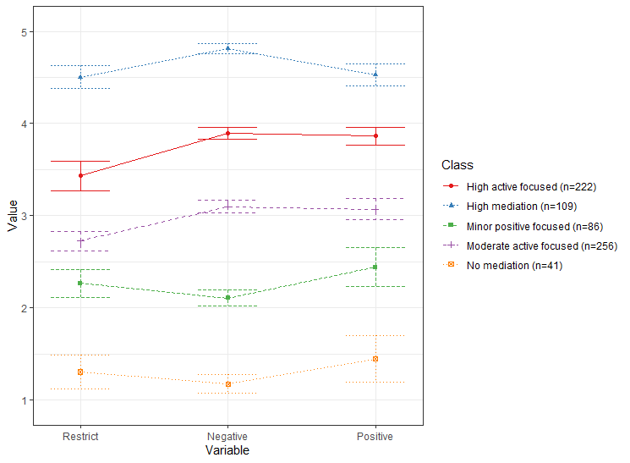

Figure 1. the 5-profile solution of the latent profile analysis.

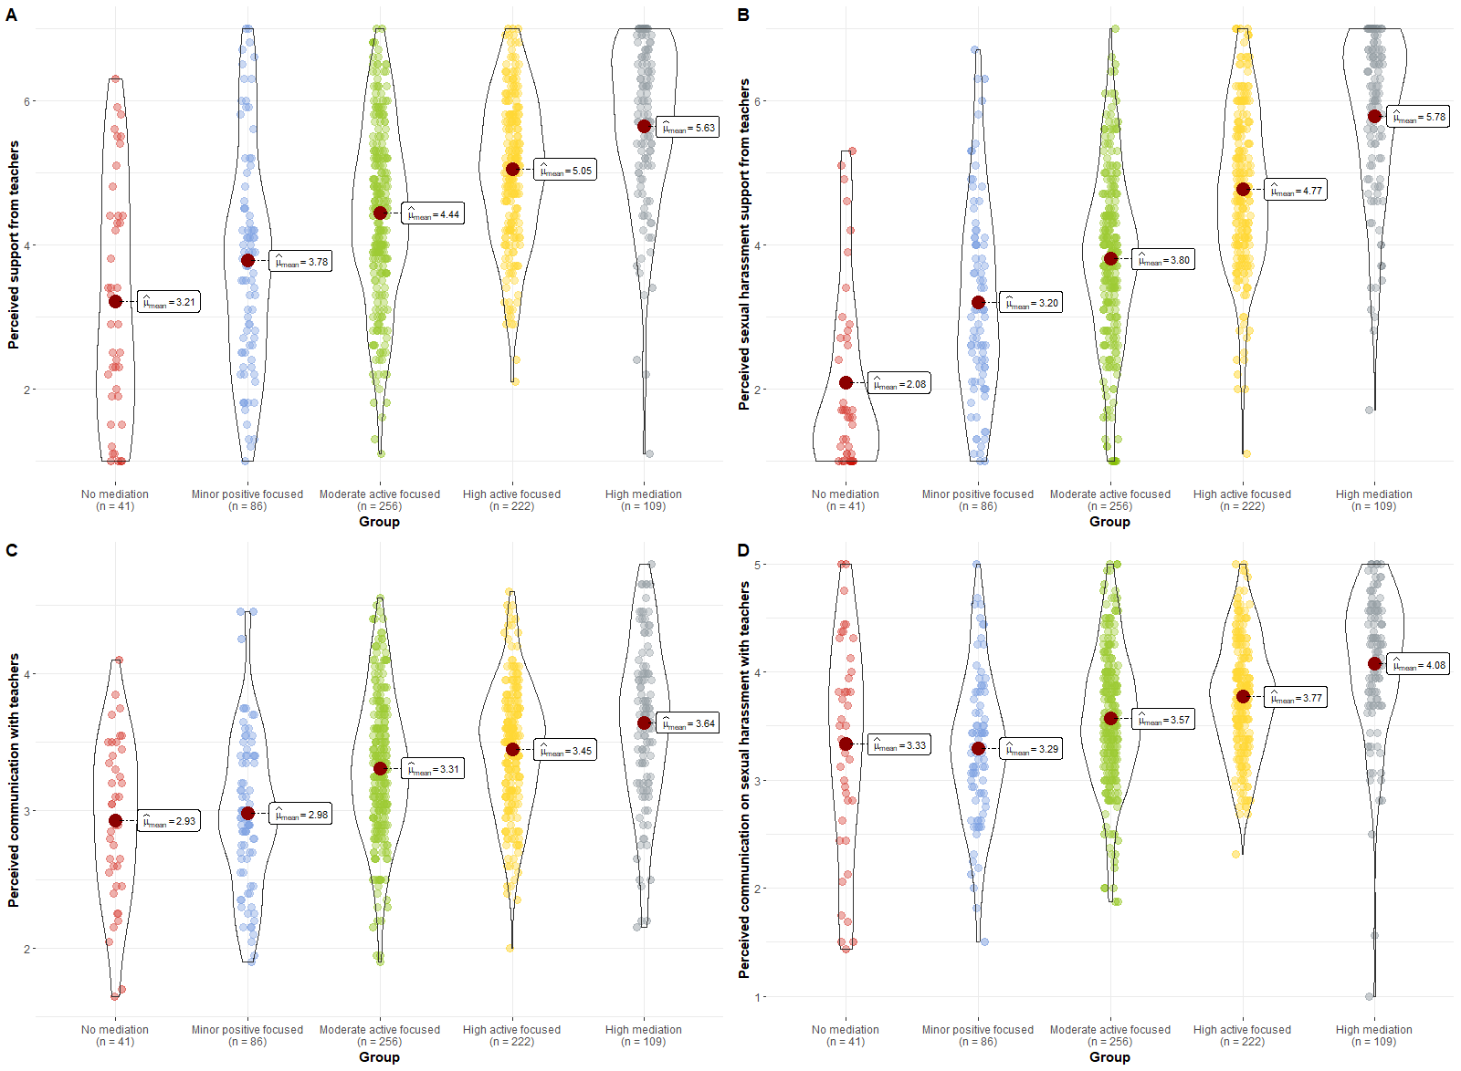

Figure 2. Differences between latent mediation profiles in pupils’ perceived support, sexual-harassment support, communication and sexual-harassment-related communication.

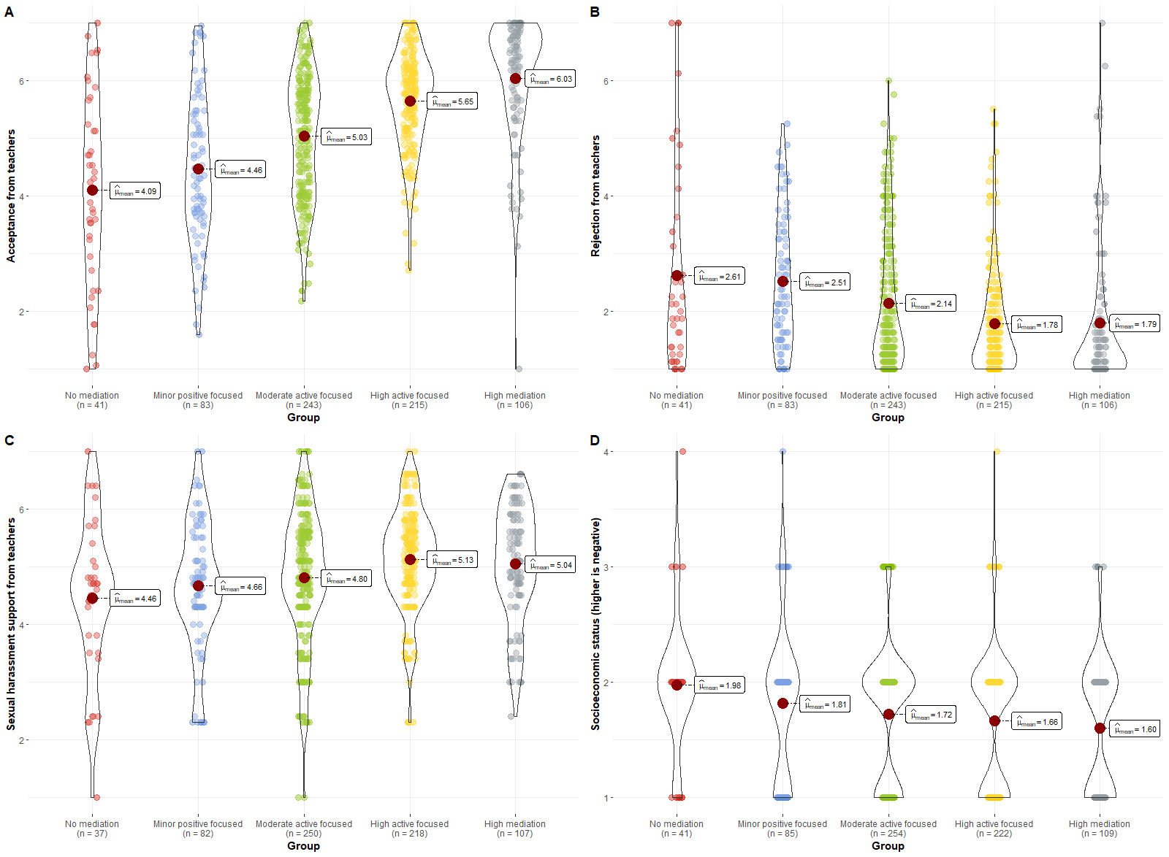

Figure 3. Differences between latent mediation profiles in pupils’ acceptance and rejection from teachers, economic status and teachers’ sexual-harassment-related support.

**References**

Akogul, S., & Erisoglu, M. (2017). An approach for determining the number of clusters in a model-based cluster analysis. *Entropy*, *19*(9), 452.

Al-yagon, M., & Mikulincer, M. (2006). Adjustment in middle childhood. *Research in Education*, *75*, 1–18.

Alaggia, R. (2010). An ecological analysis of child sexual abuse disclosure: Considerations for child and adolescent mental health. *Journal of the Canadian Academy of Child and Adolescent Psychiatry*, *19*(1), 32–39. https://www.ncbi.nlm.nih.gov/pmc/articles/PMC2809444/pdf/ccap19_1p0032.pdf

Barnes, H., & Olson, D. H. (1982). *Parent-adolescent communication, family inventories. ‏*. Family social science, University of Minnesota.

Barth, J., Bermetz, L., Heim, E., Trelle, S., & Tonia, T. (2013). The current prevalence of child sexual abuse worldwide: A systematic review and meta-analysis. *International Journal of Public Health*, *58*(3), 469–483. https://doi.org/10.1007/s00038-012-0426-1

Bates, D., Maechler, M., Bolker, B., Walker, S., Christensen, R. H. B., Singmann, H., & Dai, B. (2015). Fitting Linear Mixed-Effects Models Using lme4. *Journal of Statistical Software*, *67*(1), 1–48. https://doi.org/https://doi.org/10.18637/jss.v067.i01

Berger, P. (2020). Teachers’ mediation practice: Opportunities and risks for youth media behavior. *Comunicar*, 47–56. www.revistacomunicar.com%7Cwww.comunicarjournal.com

Boniel-Nissim, M., Efrati, Y., & Dolev-Cohen, M. (2020). Parental Mediation Regarding Children’s Pornography Exposure: The Role of Parenting Style, Protection Motivation and Gender. *Journal of Sex Research*, *57*(1), 42–51. https://doi.org/10.1080/00224499.2019.1590795

Briere, J., & Runtz, M. (1993). Childhood sexual abuse: Long-term sequelae and implications for psychological assessment. *Journal of Interpersonal Violence*, *8*(3), 312–330.

Chen, V. H. H., & Chng, G. S. (2016). Active and restrictive parental mediation over time: Effects on youths’ self-regulatory competencies and impulsivity. *Computers and Education*, *98*, 206–212. https://doi.org/10.1016/j.compedu.2016.03.012

Chung, Y., Rabe-Hesketh, S., Dorie, V., Gelman, A., & Liu, J. (2013). A nondegenerate penalized likelihood estimator for variance parameters in multilevel models. *Psychometrika*, *78*(4), 685-709.

Efrati, Y., & Boniel-Nissim, M. (2021). Parents’ Psychopathology Promotes the Adoption of Ineffective Pornography-Related Parenting Mediation Strategies. *Journal of Sex and Marital Therapy*, *47*(2), 117–129. https://doi.org/10.1080/0092623X.2020.1835759

Efrati, Y., & Gola, M. (2019). Adolescents’ compulsive sexual behavior: The role of parental competence, parents’ psychopathology, and quality of parent–child communication about sex. *Journal of Behavioral Addictions*, *8*(3), 420–431. https://doi.org/10.1556/2006.8.2019.33

Gewirtz-Meydan, A., & Finkelhor, D. (2019). Sexal abuse and assault in a large national sample of children and adolescents. *Child Maltreatment*. https://doi.org/10.1177/1077559519873975

Goldman, J. D. G., & Bradley, G. L. (2011). Assessing primary school student-teachers’ pedagogic implementations in child sexual abuse protection education. *European Journal of Psychology of Education*, *26*(4), 479–493. https://doi.org/10.1007/s10212-011-0059-4

Goldschmidt-Gjerløw, B. (2019). Children’s rights and teachers’ responsibilities: reproducing or transforming the cultural taboo on child sexual abuse? *Human Rights Education Review*, *2*(1), 25–46. https://doi.org/10.7577/hrer.3079

Goldschmidt-Gjerløw, B., & Trysnes, I. (2020). #MeToo in school: teachers’ and young learners’ lived experience of verbal sexual harassment as a pedagogical opportunity. *Human Rights Education Review*, *3*(2), 27–48. https://doi.org/10.7577/hrer.3720

Hothorn, T., Bretz, F., & Westfall, P. (2008). Simultaneous inference in general parametric models. *Biometrical Journal: Journal of Mathematical Methods in Biosciences*, *50*(3), 346-363.

Hwang, Y., Choi, I., Yum, J. Y., & Jeong, S. H. (2017). Parental Mediation Regarding Children’s Smartphone Use: Role of Protection Motivation and Parenting Style. *Cyberpsychology, Behavior, and Social Networking*, *20*(6), 362–368. https://doi.org/10.1089/cyber.2016.0555

Jaccard, J., Dittus, P. J., & Gordon, V. V. (2000). Parent-teen communication about premarital sex: Factors associated with the extent of communication. *Journal of Adolescent Research*, *15*(2), 187–208. https://doi.org/10.1177/0743558400152001

Jerman, P., & Constantine, N. A. (2010). Demographic and psychological predictors of parent–adolescent communication about sex: A representative statewide analysis. *Journal of youth and adolescence*, *39*(10), 1164-1174.‏

Kim, S., Jeong, S. H., & Hwang, Y. (2013). Predictors of Pro-Environmental Behaviors of American and Korean Students: The Application of the Theory of Reasoned Action and Protection Motivation Theory. *Science Communication*, *35*(2), 168–188. https://doi.org/10.1177/1075547012441692

Kuznetsova, A., Brockhoff, P. B., & Christensen, R. H. (2017). lmerTest package: tests in linear mixed effects models. *Journal of Statistical Software*, *82*(1), 1–26.

Lev-Wiesel, R., Eisikovits, Z., First, M., Gottfried, R., & Mehlhausen, D. (2018). Prevalence of Child Maltreatment in Israel: A National Epidemiological Study. *Journal of Child and Adolescent Trauma*, *11*(2), 141–150. https://doi.org/10.1007/s40653-016-0118-8

Livingstone, S., & Helsper, E. J. (2008). Parental mediation of children’s internet use. *Journal of Broadcasting and Electronic Media*, *52*(4), 581–599. https://doi.org/10.1080/08838150802437396

Muthén, L. K., & Muthén, B. O. (2019). *Mplus user’s guide* (8th ed.). Muthén & Muthén.

Nathanson, A. I. (2001). Parent and child perspectives on the presence and meaning of parental television mediation. *Journal of Broadcasting and Electronic Media*, *45*(2), 201–220. https://doi.org/10.1207/s15506878jobem4502_1

Nathanson, A. I. (2016). Identifying and Explaining the Relationship Between Parental Mediation and Children’s Aggression: *Http://Dx.Doi.Org/10.1177/009365099026002002*, *26*(2), 124–143. https://doi.org/10.1177/009365099026002002

Pereda, N., Guilera, G., Forns, M., & Gómez-Benito, J. (2009). The international epidemiology of child sexual abuse: A continuation of Finkelhor (1994). *Child Abuse & Neglect*, *33*(6), 331–342. https://doi.org/10.1016/J.CHIABU.2008.07.007

Putnam, F. W. (2003). Ten-year research update review: Child sexual abuse. *Journal of the American Academy of Child and Adolescent Psychiatry*, *42*(3), 269–278. https://doi.org/10.1097/01.CHI.0000037029.04952.72

Rosenberg, J. M., Beymer, P. N., Anderson, D. J., van Lissa, C., & Schmidt, J. A. (2019). tidyLPA: An R package to easily carry out Latent Profile Analysis (LPA) using open-source or commercial software. *Journal of Open Source Software*, *4*(44), 978.

Schein, M., Biderman, A., Baras, M., Bennett, L., Bisharat, B., Borkan, J., Fogelman, Y., Gordon, L., Steinmetz, D., & Kitai, E. (2000). The prevalence of a history of child sexual abuse among adults visiting family practitioners in Israel. *Child Abuse & Neglect*, *24*(5), 667–675. https://doi.org/10.1016/S0145-2134(00)00128-9

Scholes, L., Jones, C., Stieler-Hunt, C., Rolfe, B., & Pozzebon, K. (2012). The teachers’ role in child sexual abuse prevention programs: Implications for teacher education. *Australian Journal of Teacher Education*, *37*(11), 104–131. https://doi.org/10.14221/ajte.2012v37n11.5

Schönbucher, V., Maier, T., Mohler-Kuo, M., Schnyder, U., & Landolt, M. A. (2012). Disclosure of child sexual abuse by adolescents: A qualitative in-depth study. *Journal of Interpersonal Violence*, *27*(17), 3486–3513. https://doi.org/10.1177/0886260512445380

Shin, W., & Li, B. (2017). Parental mediation of children’s digital technology use in Singapore. *Journal of Children and Media*, *11*(1), 1–19. https://doi.org/10.1080/17482798.2016.1203807

Singh, M. M., Parsekar, S. S., & Nair, S. N. (2014). An epidemiological overview of child sexual abuse. *Journal of Family Medicine and Primary Care*, *3*(4), 430–435. https://doi.org/10.4103/2249-4863.148139

Stoltenborgh, M., Van Ijzendoorn, M. H., Euser, E. M., & Bakermans-Kranenburg, M. J. (2011). A global perspective on child sexual abuse: Meta-analysis of prevalence around the world. *Child Maltreatment*, *16*(2), 79–101. https://doi.org/10.1177/1077559511403920

Tener, D., & Sigad, L. (2019). “I felt like I was thrown into a deep well”: Educators coping with child sexual abuse disclosure. *Children and Youth Services Review*, *106*(April), 104465. https://doi.org/10.1016/j.childyouth.2019.104465

Topping, K. J., & Barron, I. G. (2009). School-based child sexual abuse prevention programs: A review of effectiveness. *Review of educational research, 79*(1), 431-463.‏

Vogeltanz, N. D., Wilsnack, S. C., Harris, T. R., Wilsnack, R. W., Wonderlich, S. A., & Kristjanson, A. F. (1999). Prevalence and risk factors for childhood sexual abuse in women: National survey findings. *Child Abuse and Neglect*, *23*(6), 579–592. https://doi.org/10.1016/S0145-2134(99)00026-5

Wager, N. M. (2015). Understanding children’s non-disclosure of child sexual assault: Implications for assisting parents and teachers to become effective guardians. *Safer Communities*, *14*(1), 16–26. https://doi.org/10.1108/SC-03-2015-0009

Zimet, G. D., Dahlem, N. W., Zimet, S. G., & Farley, G. K. (1988). The Multidimensional Scale of Perceived Social Support. *Journal of Personality Assessment*, *52*(1), 30–41. https://doi.org/10.1207/s15327752jpa5201_2