**Circuits and computations for state-dependent multisensory integration during social behavior**

**1. Background and preliminary results**

Nearly all behaviors are multimodal. When we decide whether a fruit is ripe, we combine visual, tactile, and olfactory cues - the perfect tomato should be deep red, not too soft and not too firm, and have an aromatic smell. Social behaviors also often rely on the combination of multiple cues: during conversation, we evaluate facial expression in addition to speech and can detect dishonesty from a mismatch between the cues. Similarly, birds, frogs, and insects combine visual and acoustic displays during courtship [1–3](https://paperpile.com/c/yL3yeU/Rctt+nayS+Vy7n). Multimodal cues may carry redundant information (e.g., on the species, quality or location of a potential mate) and enhance animal responses [4](https://paperpile.com/c/yL3yeU/3f0m). Alternatively, multimodal cues may provide complementary pieces of information: olfactory cues may signal the species of a potential mate [5](https://paperpile.com/c/yL3yeU/YKjH), while acoustic cues may signal mate quality [6](https://paperpile.com/c/yL3yeU/JxHr) or location [7](https://paperpile.com/c/yL3yeU/SF5M).

Much insight into multimodal decision making comes from animals trained to perform simple multimodal tasks. These studies have shown, for instance, that cue integration tends to follow optimality principles [8,9](https://paperpile.com/c/yL3yeU/xLQ9+29fj), or that multimodal integration can happen early (Andrew King) or late [8](https://paperpile.com/c/yL3yeU/xLQ9) in the brain. Accordingly, a wide range of models of decision making exist, ranging from drift-diffusion and rise-to-threshold models [10,11](https://paperpile.com/c/yL3yeU/VlOps+oh7N3) to attractor-type models.

However, how these experimental results and models translate to ethologically relevant settings is not well studied [12](https://paperpile.com/c/yL3yeU/D1KG).Studying multisensory integration in the context of naturalistic, and specifically - social behaviors - is critical for multiple reasons: First, social stimuli are often complex and dynamically modified by feedback from the partner [13,14](https://paperpile.com/c/yL3yeU/DhCt+taGJ). Natural stimulus statistics and feedback-driven dynamics are missing in artificial tasks but likely affect multimodal integration of sensory stimuli, since neural circuits are adapted to process natural stimuli. Second, multisensory integration affects social behavior on multiple timescales. From moment-to-moment decisions on the timescale of seconds, including non-binary (change in speed or angle) and binary (to court or to be aggressive), to onetime decisions that result from the accumulation of information over many minutes (to mate or not to mate). Lastly, responses to social cues depend on the animal’s internal state [15,16](https://paperpile.com/c/yL3yeU/f03K+jJtn). For example, the female response to fly courtship depends on mating state in flies [17,18](https://paperpile.com/c/yL3yeU/1Yzx+l6oI), and olfactory-auditory integration in female mice is modulated by maternal experience [19](https://paperpile.com/c/yL3yeU/t2rC). State-dependent and dynamic decisions across timescales are typically not captured in simplified tasks. Studying multisensory integration during social behaviors allows us to study how the brain solves a complex task it has evolved to solve. However, the complexity of social behavior complicates linking multimodal cues with behavior via circuit computations. To overcome this challenge, we combine our experimental (Deutsch) and computational (Clemens) expertise to study multimodal courtship in the genetic model organism *Drosophila melanogaster* (Fig. 1A). Combining a powerful experimental system (Figs 2-3) with computational tools (Figs 4-5) enables us to 1) detect multimodal and state-dependent effects in natural behavior on short and long timescales, 2) identify how brain-wide dynamics are affected by naturalistic multimodal cues and internal state during behavior, 3) causally link social cues with behavior through functional and connectomics data, network models, and optogenetic manipulations.

Fly courtship is state-dependent and multimodal (Fig. 1A): The male courts the female using a multimodal display that includes acoustic (song) and olfactory cues (pheromones). The song consists of two major modes: Sine song which corresponds to a constant sinusoidal oscillation with a frequency of 150Hz. And pulse song - brief pulses produced at a regular interval of 40ms. Cuticular hydrocarbons act as pheromones and play important roles in courtship and aggregation behaviors (Table 1). The major male-specific pheromones are (*Z*)-7-tricosene (7-T) and cis-vaccenyl acetate (cVA) [20,21](https://paperpile.com/c/yL3yeU/SZzJ+LyI7). In addition, several cuticular odorants, like methyl laurate (ML), methyl myristate (MM), and methyl palmitate (MP), are present approximately equally in males and females.

Females respond to the males’ multimodal courtship display with a wide range of behaviors based on their sexual maturation and mating history [17](https://paperpile.com/c/yL3yeU/1Yzx). Mature virgin females respond to pulse song with acceptance (slowing, vaginal plate opening) or rejection (wing flicking, shoving, ovipositor extrusion) behaviors [17](https://paperpile.com/c/yL3yeU/1Yzx), and ultimately by accepting or rejecting the male’s copulation attempts. Mated females remate, but they display more rejection behaviors and take longer until they accept the male [17](https://paperpile.com/c/yL3yeU/1Yzx). The male-specific pheromones 7-T and cVA have been shown to promote copulation [22,23](https://paperpile.com/c/yL3yeU/DjO5+xTUY) and many pheromones elicit short-range attraction behavior in both sexes [24](https://paperpile.com/c/yL3yeU/SOuq). However, a detailed analysis of the specific behaviors affected by most pheromones during courtship is still missing. This is probably because pheromones do not elicit behavioral responses by themselves, but modulate responses to other cues such as male touch or song - they act in a multimodal context.

The work of others as well as our own published and preliminary data suggest a tight integration of song and pheromones during courtship in females. However, how song and pheromones are combined at the neuronal and behavioral level is poorly understood. First, connectomics data suggest that many neurons that control social behaviors in flies are multimodal. Male and female courtship behavior in *Drosophila melanogaster* is regulated by two transcription factors, *fruitless* (*fru*)and *doublesex* (*dsx*). We have shown that many *dsx* neurons respond to song in the female [25](https://paperpile.com/c/yL3yeU/fY4k), and our preliminary results show that auditory responses are also widespread in *fru* neurons (Fig. 3). Additional preliminary evidence from connectomic data shows that many *dsx* and *dru* neurons are at most two synapses away from song and pheromone sensing areas (see also [26,27](https://paperpile.com/c/yL3yeU/6uGS+9qU2)). This implies that multimodal processing during courtship is pervasive in flies, but the functional significance of multimodal progressing in most of these neurons is not tested. Second, the multimodality of courtship is further supported by neuronal data showing that responses to song are facilitated by pheromones. We recently showed that pC2l and pC1 neurons detect pulse song and drive behavioral responses to song [15,25](https://paperpile.com/c/yL3yeU/f03K+fY4k)). The vpoDNs are postsynaptic to both cell types and directly control female receptivity to courtship [28,29](https://paperpile.com/c/yL3yeU/iySG+I4Ek). Interestingly, responses to song in the vpoDNs are facilitated by additional inputs from non-auditory pC1 or pC2 neurons, that encode mating state [29](https://paperpile.com/c/yL3yeU/I4Ek) and possibly also olfactory cues [30](https://paperpile.com/c/yL3yeU/hHZx). This is consistent with our own preliminary data showing facilitated responses to song in pC1/2 in the presence of male pheromones. Again, the specific effect and source of this olfactory information is unknown. Lastly, pheromones likely increase memory for social cues in flies. The pC1 neurons respond to social cues in both sexes and drive persistent social behaviors by activating a recurrent neural network (Hoopfer, [15](https://paperpile.com/c/yL3yeU/f03K). In the male, the integration time of this network is increased by the pheromone detecting pCd neurons [31](https://paperpile.com/c/yL3yeU/79bC). In the female, pC1 neurons respond to song, and the pCd neurons to the male pheromone cVA [30](https://paperpile.com/c/yL3yeU/hHZx) (Fig. 3C). We therefore hypothesize that they play a similar role as in males: To increase the “memory” for song in the presence of pheromones from a nearby male. This is consistent with our own published results: Females integrate song over minutes in the presence of the male but not when alone [25,32](https://paperpile.com/c/yL3yeU/Cp0Z+fY4k), and brief optogenetic pC1 activation in females drives persistent social behaviors and brain activity for minutes [15](https://paperpile.com/c/yL3yeU/f03K).

Thus, there is ample evidence that male acoustic and olfactory cues interact at the neuronal and behavioral level during courtship in females (Fig. 1A). However, the specific behavioral effects of acousto-olfactory stimuli as well as the circuits that combine and accumulate acoustic and olfactory cues are not understood.

**2. Objectives and merits of the proposed research**

In this project, we aim to reveal the circuits and computations that link acousto-olfactory integration to female mating behavior, and to determine how the female’s mating state modulates these computations. Our working hypothesis is that pheromones modulate the transformation from male song to female behavior at multiple levels along the sensorimotor pathway (Fig. 1A). We will test this hypothesis through a combination of experimental and theoretical approaches via a collaboration between the Deutsch and Clemens labs. We will systematically map how pheromones and auditory signals are combined to drive neural activity and behavioral responses over the multiple timescales that are relevant for mating behavior in flies: from hundreds of milliseconds to minutes [25,32](https://paperpile.com/c/yL3yeU/Cp0Z+fY4k). Experiments will inform and constrain models, and theory will be used to interpret data and refine hypotheses (Fig. 1B). The Deutsch lab will employ the experimental accessibility of *Drosophila* (e.g., optogenetics, volumetric two-photon imaging, connectomics), while the Clemens lab will develop computational methods for analyzing and modeling behavioral and neuronal data (e.g., behavioral classification, analysis of volumetric imaging data, models of decision making). **This approach will identify principles for state-dependent multimodal integration in ethologically relevant contexts – from behavioral strategies down to their circuit implementation.**

Our specific aims are:

**Aim 1:** Identify circuits that integrate acoustic and olfactory cues in the female brain

**Aim 2:** Determine computations and mechanisms linking acousto-olfactory integration and behavior

**Aim 3:** Characterize how multimodal integration is affected by social experience

**3. Detailed description of the joint research (including methods and plan of operation)**

**Aim 1:** Identify circuits that integrate acoustic and olfactory cues in the female brain

To identify neurons that integrate courtship song and sex pheromones we will take two complementary approaches: (1) A behavioral screen of the effect of different pheromones on female mating behaviors. Given that our behavioral assays are high-throughput and that the analysis pipeline is automated, 13 pheromones (see Table 1) can be easily tested and analyzed in less than six months. We will initially focus on virgin females, but in case behavioral effects are small, we will switch to recently mated females, since they are known to be more choosy and display a richer repertoire of rejection behaviors (see Aim 3). Behavioral experiments will be performed in the Deutsch lab in circular behavioral chambers with a diameter of 10 cm. Song will be recorded using 16 microphones tiling the chamber floor. Male and female behavior will be recorded with USB video cameras at 100 fps and a spatial resolution of 35 mm/pixel for pose tracking. (2) A screen of neural responses in sexually dimorphic cells (cells that express the sex-determination genes doublesex (dsx) or fruitless (fru)) using two-photon (2P) imaging (Fig. 2, 3). The Deutsch lab is currently equipped with two 2P systems, one resonant system for fast volumetric imaging (2Hz volume rate) and one galvo-based system for scanning more specific populations/drivers at a higher SNR. We will focus on a small set of auditory stimuli (pulse and sine song with conspecific parameters and white noise [15](https://paperpile.com/c/yL3yeU/f03K)), and on a small subset of pheromones with demonstrated effects on female behaviore ( *cis*-vaccenyl acetate [33](https://paperpile.com/c/yL3yeU/xvKQ), 7-tricosene [34](https://paperpile.com/c/yL3yeU/3GTB) and methyl palmitate [35](https://paperpile.com/c/yL3yeU/08G8)), and on virgin females. Based on the behavioral screen we will extend the set of stimuli in the imaging setup, or extend the imaging to mated females. While auditory stimuli will be presented using a sound delivery system in all experiments, there are a number of ways to deliver pheromonal stimuli: (1) coating the behavioral chamber or presenting a soaked filter paper to a female under a 2P [30](https://paperpile.com/c/yL3yeU/hHZx), (2) using an air-stream with the odorant (for volatile odors). Dr. Parnas (Tel-Aviv University) [36](https://paperpile.com/c/yL3yeU/GPDq) will advise Dr. Deutsch in setting up the olfactory delivery system. (3) Using optogenetic activation of odor-specific olfactory receptor neurons or glomeruli.

Computational pipelines for analyzing the behavioral and imaging data will be developed in the Clemens lab, based on existing tools [37–39](https://paperpile.com/c/yL3yeU/Hk0g+fpyh+aToq). For the behavioral data from the pheromone screen, we will detect changes in female behaviors during courtship with the presentation of pheromones, with a focus on behaviors triggered by song. We will score moment-by-moment female behaviors, like ovipositor extrusion, wing flicking, slowing [17](https://paperpile.com/c/yL3yeU/1Yzx), as well as copulation times. Song will be detected using DeepAudioSegmenter, developed in the Clemens lab (Steinfath 2021). Fly poses will be tracked with SLEAP ([37](https://paperpile.com/c/yL3yeU/Hk0g), Fig 1) and supervised classifiers will identify specific female behaviors based on the female’s pose dynamics. This dataset will also form the basis for behavioral modeling in aim 2.

In the volumetric calcium data, multimodal neurons will be identified by comparing response magnitudes between unisensory (song or pheromone alone) to multisensory stimulation. We will also compare response dynamics, by fitting linear-nonlinear models to the calcium imaging data [32,40](https://paperpile.com/c/yL3yeU/Cp0Z+gJO0) (Fig. 4). For instance, if pheromones increase neural integration times for song response, then the filters for acoustic inputs are expected to become wider in the presence of pheromones [13](https://paperpile.com/c/yL3yeU/DhCt). For the thus identified multimodal neurons, we will more finely probe how pheromones affect the neural coding of behaviorally-relevant features of the song, by presenting a wide range of artificial song patterns with varying features (Deutsch 2019) in combination with pheromone of different concentrations. Finally, we will identify the cell types of multi-modal neurons for more detailed characterization in aims 2 and 3, for instance, to determine the behavioral relevance of these neurons through activation or inhibition during behavior or to identify the circuit computations by which they combine song and pheromones. The auditory responses of dsx neurons were already mapped [25](https://paperpile.com/c/yL3yeU/fY4k) (Fig. 3C). Since the number of dsx neurons is relatively small, we are able to assign neural responses to specific cell types, including pC1 which responds to courtship song and controls female receptivity [25,30,41](https://paperpile.com/c/yL3yeU/hHZx+fY4k+87hs), pC2, which is tuned to pulse song [25](https://paperpile.com/c/yL3yeU/fY4k) and vpoDN (pMN2), which responds to pulse song [25](https://paperpile.com/c/yL3yeU/fY4k) and controls vaginal plate opening in female flies [41](https://paperpile.com/c/yL3yeU/87hs). In the case of fru neurons, we have preliminary evidence for widespread auditory responses (Fig 3A), but a systematic mapping of auditory and pheromonal responses in fru neurons is missing. As the fru population is more dense compared to the dsx population, it will be hard to identify cell types using a fru driver (fru-Gal4 or fru-LexA). However, in collaboration with Dr. Mala Murthy, Dr. Barry Dickson and Dr. Kaiyu Wang and based on previous mappings of dsx/fru neurons using light microscopy [25–27](https://paperpile.com/c/yL3yeU/6uGS+9qU2+fY4k), we identified candidates for all the dsx and fru cells in the two available EM datasets (Hemibrain [42](https://paperpile.com/c/yL3yeU/QbDO), FlyWire [43](https://paperpile.com/c/yL3yeU/XpD0); Fig 3C), which will guide the cell identification. Once we identify acousto-olfactory responses in a given region of interest (ROI), we will image responses to song and pheromones in sparser lines to confirm the identified the specific cell types. Dr. Deutsch is collaborating with Dr. Barry Dickson and Dr. Kaiyu Wang who built a library of driver lines for specific fru-subsets.  
The Deutsch lab will perform the imaging experiments, while the Clemens lab will develop tools to detect and characterize multimodal neurons in the volumetric imaging of sexually dimorphic cells and to combine functional and connectomics data.

**Overall, this aim will provide 1) the first systematic characterization of the effects of sex pheromones on specific female courtship behaviors and 2) the first brain-wide map of multimodal integration of social cues in sexually dimorphic neurons.**

**Aim 2:** Determine computations and mechanisms linking multimodal integration and behavior

We will link multimodal integration in the female brain and female mating behavior. First, we will determine how female courtship behaviors, in particular her responses to male song, are modulated by pheromones. Females respond to courtship and singing with a variety of rejection [17,18,29,44](https://paperpile.com/c/yL3yeU/EJ6r+I4Ek+l6oI+1Yzx) or acceptance behaviors [13,28,32,41](https://paperpile.com/c/yL3yeU/Cp0Z+iySG+DhCt+87hs). Pheromones can modify song responses through a range of mechanisms: they can modulate the response gain in auditory neurons, change integration times, or the excitability of the neurons that drive behavior. We will combine behavioral experiments with model-based analyses to disentangle these mechanisms.

In **step 1**, we will use behavioral modeling based on the data collected in aim 1 to determine how song and pheromones are integrated to modulate female mating behavior

In **step 2**, we will focus on one or two multimodal circuit nodes, and will use the fly connectome, functional imaging and network modeling to reveal how the auditory-olfactory computations that drive mating behaviors are implemented at the circuit level.

Step 1 - Behavioral computations for multimodal integration

Our behavioral screen in aim 1 will reveal which pheromones affect which types of females behaviors during courtship. To determine how these effects arise, we will use behavioral modeling in this aim, to identify the computations by which song and pheromones are integrated. Two classes of behavioral models - generalized linear models (GLMs, Fig. 4) and drift-diffusion models (DDMs, Fig. 5) - will be used to characterize the effects of pheromones on specific behaviors.

For continuous behavioral responses, like slowing, we will compare the parameters of Generalized Linear Models fitted to behavioral data recorded in the presence and absence of the pheromones (Coen 2014, Clemens 2018) (Fig. 4). GLMs consist of filters that detect behaviorally relevant temporal patterns in social cues followed by a nonlinearity, which transforms the filtered social cues into a behavioral output. Increases in the gain of auditory neurons will change the magnitude of the filter, longer integration times will lead to longer filters, and changes in the overall excitability of the neurons that drive the behavior will change the shape of the nonlinearity.

For discrete behavioral events - like the vaginal plate opening, ovipositor extrusion or the onset of mating - we will use extensions of drift-diffusion models (DDM, Fig. 5). In a classical drift-diffusion model, sensory inputs are integrated with an integration time constant which corresponds to the memory of the integrator. If the integrated information reaches a threshold, a behavioral response (vaginal plate opening, mating) is elicited. We will extend this framework to also include multi-dimensional drift-diffusion and attractor-type models of decision making[45](https://paperpile.com/c/yL3yeU/IaCWw). A multi-dimensional DDM allows for multiple inputs to the integrator, therefore allowing us to determine whether olfactory responses act as independent inputs. Attractor-type dynamics have been shown to shape decision making in vertebrates [46](https://paperpile.com/c/yL3yeU/Z33U) and flies [47](https://paperpile.com/c/yL3yeU/ql3S) and can be produced by adding a positive feedback term to the DDM. In the past, Dr. Clemens has used DDMs to show how different features of song are integrated to drive female responses [48](https://paperpile.com/c/yL3yeU/j2I5). In the context of this project, the DDMs will reveal whether male pheromones control integration timescales, decision thresholds, or act as independent evidence.

The models will be experimentally validated and if necessary refined by testing specific predictions during behavior. We will do so by manipulating the female’s acoustic and pheromonal inputs using stimulus playback or optogenetic manipulations of olfactory inputs (see aim1). Sound will be introduced via playback. As described above, pheromones can be induced in different ways (coating the behavioral arena or optogenetic activation of receptor neurons). This first step will identify multimodal computations that combine olfactory and auditory inputs to drive female mating behavior. This will guide, in step 2, the investigation of the neural basis of these computations.

Step 2 - Circuit computations driving acousto-olfactory female mating behaviors

Based on the behavioral computations identified in step 1 of this aim, and guided by the brain-wide functional map and connectomics data (aim 1), we will focus on a few circuit nodes (cell types) that integrate song and pheromones. We will confirm the behavioral relevance of the multimodal nodes using optogenetic activation and inactivation during behavior. Then, we will characterize the circuit and molecular mechanisms by which the multimodal nodes integrate multimodal cues.

We will first identify the most significant inputs of the selected multimodal cells based on the connectome, and use computational ([https://neuronbridge.janelia.org/](https://neuronbridge.janelia.org/about)) and genetic [49](https://paperpile.com/c/yL3yeU/knWr) tools to experimentally access these inputs with specific drivers. This will allow us to characterize these inputs (are they already multimodal) and walk upstream to identify loci of multimodal convergence. Optogenetic activation during imaging (as previously done in Deutsch et al. (2020)) will confirm functional connectivity and characterize the specific effects of individual inputs on the multimodal neurons of interest.

We will then manipulate and image neurotransmitter or neuromodulator systems in a cell-type specific manner, to determine the circuit and biophysical implementation of the behavioral models. For example, an increase of integration time constants for song by pheromones can be achieved via neuromodulators that affect cell-intrinsic properties or the synaptic gain of recurrent connections [50](https://paperpile.com/c/yL3yeU/t6J1). Interfering with the relevant neuromodulators that extend integration times during behavior will shorten the corresponding parameters in our behavioral models (Figs 4, 5) and should also reduce the persistence of song-evoked activity in the brain. The behavioral and neuronal data will be integrated using circuit models to confirm the sufficiency of the changes in neuronal responses for explaining the behavioral effects and for generating testable hypotheses..

We will also test already existing hypotheses: Based on existing (Zhou 2014) and our own preliminary data, we know that the song response of the pC1 and pC2l neurons is modulated by male pheromones like cVA. We will further characterize this identification using a wide range of artificial song stimuli and pheromone concentrations. This will reveal whether the modulation affects all sound stimuli similarly or whether it is song feature specific. We will also confirm the putative olfactory inputs to pC1/2l based on the connectome. In males, song-responsive pC1 and pheromone-responsive pCd neurons are functionally connected [31](https://paperpile.com/c/yL3yeU/79bC), and dopamine controls the intrinsic excitability as well as the sensitivity to chemical inputs in a subset of the pC1 neurons [50](https://paperpile.com/c/yL3yeU/t6J1). We will test whether dopamine has similar effects on pC1 in the female, if the pheromone-responding pCd neurons and song-responding pC1 or pC2l cells are connected, and whether and by which mechanisms they promote longer temporal integration of male song in the female brain. As above, the effect of circuit manipulations will be test in behavior and imaging, and circuit models will link both levels of description.

Step 1 of this aim focuses on modeling and will mainly executed in the Clemens lab. Step 2 relies on a close interact between experiment (Deutsch) and modeling (Clemens).

**The outcome of aim2 will be circuit models constrained by the behavioral, imaging and connectomics data, that reveal how multimodal social cues are integrated to inform social behavior.**

**Aim 3:** Characterize how multimodal integration is affected by social experience

In the last aim we will reveal how acousto-olfactory integration depends on the female mating state. Mated females do remate [51,52](https://paperpile.com/c/yL3yeU/qzp2+Gk1O), though with a lower probability than virgins [53](https://paperpile.com/c/yL3yeU/7gtB), possibly reflecting a difference in the cost-benefit balance between the two conditions [54,55](https://paperpile.com/c/yL3yeU/7JH7+4xvt). Accordingly, mated females show more rejection behaviors towards a courting male [17,18,29,56](https://paperpile.com/c/yL3yeU/I4Ek+l6oI+Tt72+1Yzx). We hypothesize that the mating status modifies the female choosiness by modifying the way multisensory cues are integrated in the female brain, to suppress the upregulated rejection and promote the downregulated acceptance behaviors in the mated female.

Mating affects neural processing at multiple stages of processing: Sensitivity to the male sex-phermone cVA in females in second-order olfactory neurons is reduced after mating [57](https://paperpile.com/c/yL3yeU/t4Zm). Whether or not mating also reduces sensitivity to acoustic cues in early auditory neurons is unknown, though there is evidence for behavioral and neural plasticity in the response to courtship song following a previous exposure [25,58](https://paperpile.com/c/yL3yeU/fY4k+cDPL). Mating also reduces computations in neurons at the sensorimotor interface: the vpoDNs elicit vaginal plate opening, which signals her readiness to mate. vpoDNs require coincident input from the song-responsive pC2 neurons and from pC1 to reliably produce the receptivity signal [41](https://paperpile.com/c/yL3yeU/87hs). Interestingly, seminal fluid proteins transferred to the female during copulation suppress pC1 activity in mated females, which in turn reduces responses to song in the vpoDNs [41](https://paperpile.com/c/yL3yeU/87hs). Given that unimodal cues lose their potency in mated females, we hypothesize that multimodal processing becomes crucial to elicit acceptance behaviors in mated females. However, behavioral effects of mating go beyond changes in response magnitude to song and pheromones, and also include changes in cue valence. For instance, song slows virgins but induces escape responses in mated females [13](https://paperpile.com/c/yL3yeU/DhCt). We will test how the female mating state modulates specific nodes and computations for acousto-olfactory integration. Does the female mating state modulate responses to song and olfactory cues differently? Does mating state affect the temporal integration of multisensory evidence? Do recently mated females have a higher threshold for mating acceptance? We will target these questions on the behavioral and circuit level using the experimental and computational frameworks established in aims 1 and 2. We will first compare brainwide functional maps for song and pheromones in virgin and mated females (see aim1). This will reveal how and where responses to song and pheromones are modulated by the female mating state. Then, we will compare behavioral responses in virgin and mated females using our model-based analysis and produce testable hypotheses as to how mating state affects cue integration in the brain - via a reduction of strength of sensory inputs, a reversal in the sign of sensory inputs, shorter integration times, or higher response thresholds. These results will then be linked to the functional maps and to the circuits identified in aim 2, to reveal how changes in circuit computation change multisensory processing and ultimately female mating behavior.

**Overall, by combining experimental and theoretical approaches, we will reveal the circuits and computations that link multimodal cues with social decisions, and their modulation by social experience.**

**4. Qualifications of the investigators and the facilities at their disposal**

The Deutsch lab is currently equipped with two setups of two-photon microscopes, including one equipped with resonant mirrors for fast volumetric imaging. The setup will allow auditory and optogenetic stimulation as previously done by Dr. Deutsch and Dr. Clemens [15,25](https://paperpile.com/c/yL3yeU/fY4k+f03K), as well as olfactory stimulation. The Deutsch lab will also have, starting February 2023, six setups for high-throughput behavioral screening of courtship behavior, using SLEAP [59](https://paperpile.com/c/yL3yeU/7AcG) for pose-tracking and DAS [38](https://paperpile.com/c/yL3yeU/fpyh) for song segmentation. Dr. Deutsch was also involved in establishing the FlyWire tool for neural segmentation in the FAFB dataset [43](https://paperpile.com/c/yL3yeU/XpD0), and is currently involved in two projects, aiming to characterize neuron types, information flow and circuit motifs in FlyWire (manuscripts in preparation) that will also inform this proposed work.

The lab of Dr. Clemens has experience with all data analysis and modeling that will be used in this project. A pipeline for analyzing volumetric calcium data (automatic segmentation and ROI detection, detection of stimulus evoked activity) is established and will be used in the collaborative project. Several methods for modeling the behavioral and neural data that will be used in the project exist: linear-nonlinear models [32](https://paperpile.com/c/yL3yeU/Cp0Z), generalized linear models [13,60](https://paperpile.com/c/yL3yeU/DhCt+JFmG), drift-diffusion models [48](https://paperpile.com/c/yL3yeU/j2I5), and circuit models to link computation with mechanism (Clemens 2021). A pose tracking pipeline and methods for nonlinear dimensionality reduction and behavioral classification will be adapted to detect specific female behavioral responses during courtship (Clemens 2018).

**5. Mode of cooperation**

Dr. Clemens and Dr. Deutsch have previously collaborated on two projects [15,25](https://paperpile.com/c/yL3yeU/f03K+fY4k), and share overlapping interest in deciphering the neural basis of social communication, using *Drosophila* as a model system. The two labs have complementary expertise, which will form the basis for this collaboration, with the Deutsch lab being focused on conducting behavioral and imaging experiments, and the Clemens lab focusing on analyzing and modeling data (Fig. 1B). Close interactions between both labs will be fostered through yearly visits, monthly joint lab meetings, and a common data and code base shared via dataverse (https://data.goettingen-research-online.de) and github (https://github.com/janclemenslab). Results will be disseminated through joint publications and co-organized workshops. The two PIs will co-organize a scientific workshop/symposium in Europe (e.g. FENS 2024 in Vienna), focusing on multimodal integration in ethologically-relevant settings.

**Supplementary material**

Table 1 ( [21,61–63](https://paperpile.com/c/yL3yeU/LyI7+zKYM+Kzo1+1v3Z))

| **Compound** | **Male** | **Female** | **Known receptor?** | **PN** | **Effects on female receptivity** | **Comments** |
| --- | --- | --- | --- | --- | --- | --- |
| cVA | + | -* | Or67d  /Or65a | DA1 /DL3 | + | *transferred to female during copulation |
| CH503 | + | -* | Gr68a |  | ? | *transferred to female during copulation |
| Methyl laurate (ML), methyl myristate (MM), methyl palmitate (MP) | + | + | Or88a/Or47b (for ML) | VA1d/  VA1v (for ML) | ?* | Drives aggregation in both sexes and triggers courtship song in activated females [35](https://paperpile.com/c/yL3yeU/08G8) |
| 7-T | + | Low | Gr32a | n/a | + | [34](https://paperpile.com/c/yL3yeU/3GTB) |
| 9-P, 7-P | + | Low | Contact  ? | n/a | ? | Role in courtship conditioning |
| 5-T | + | + | Gr32a | n/a | ? |  |
| 9-T, 11-P | + | - | Gr32a/Gr33a | n/a | ?* | *drives male and female aggregation and female oviposition site-selection |
| 7,11-HD; (7,11-ND) | - | + | Contact | n/a | ? | Detected by ppk23/25/29 |
| (z)-4-undecenal | - | + | Or69aB | ? | ? | a volatile degradation Oxidation product of 7,11-HD  Elicits flight attraction in both sexes |

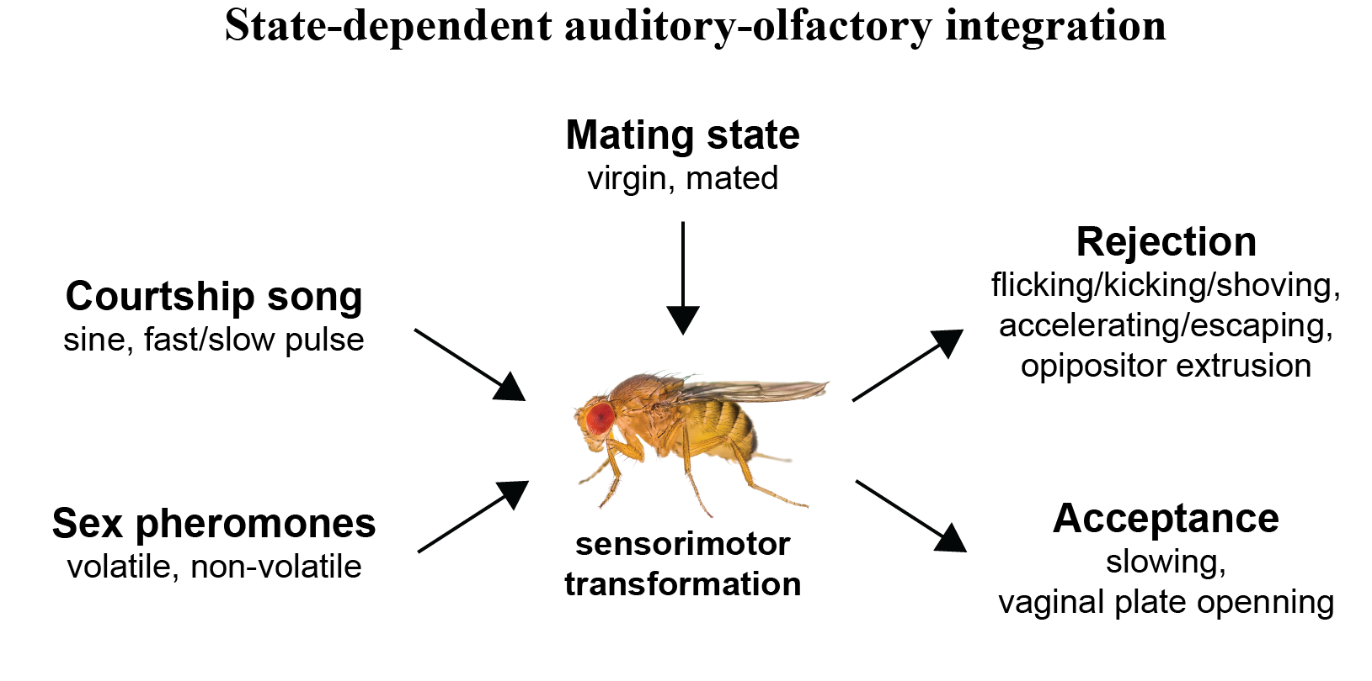

**Figure 1** - state-dependent audio-olfactory integration

Female mating response depends both on sensory cues (e.g., auditory and olfactory), and on her mating state.

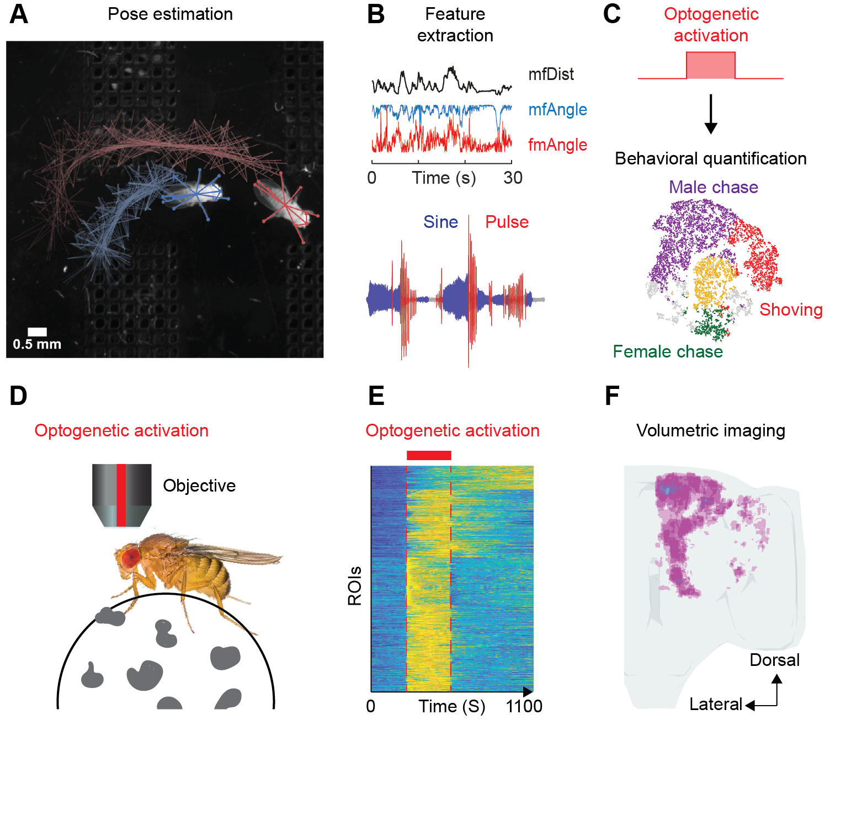

**Figure 2** - Experimental setups and analysis pipelines.

**A**. Pose estimation in socially interacting flies using SLEAP., **B**. Feature extraction and song segmentation., **C**. Optogenetic activation of specific neuronal subsets during behavior, and automatic (supervised or unsupervised) behavioral clustering., **D**. Two-photon imaging and optogenetic activation in a behaving female fly., **E**. Automatic ROI extraction based on temporal correlations, **F**. Extracting spatio-temporal neural activity: spontaneous and in response to sensory stimuli or optogenetic activation of specific cell populations.

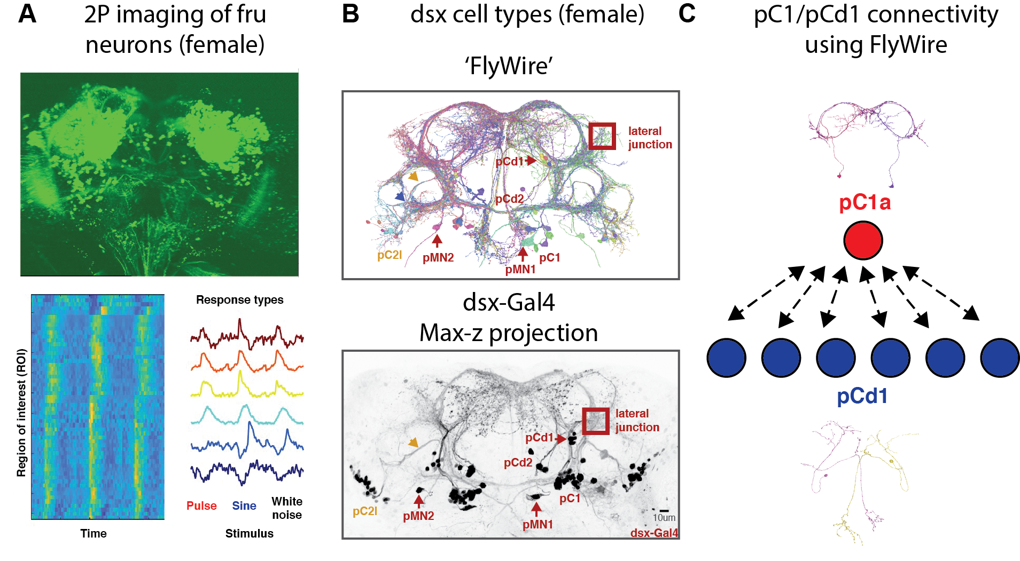

**Figure 3** - Functional imaging and connectivity of sexually dimorphic cells.

**A**. Two-photon imaging of fruitless expressing neurons. Three stimuli (Pulse,sine,White noise) were repeated 6 times per fly. Responding ROIs were detected and sorted as in [39](https://paperpile.com/c/yL3yeU/aToq)., **B**. Dsx neurons in the female brain in FlyWire (top) and using light microscopy (dsx-Gal4; adapted from [25](https://paperpile.com/c/yL3yeU/fY4k))., **C**. The doublesex pC1 and pCd1 neurons are indirectly, reciprocally connected. pC1 neurons control female receptivity [30,41](https://paperpile.com/c/yL3yeU/87hs+hHZx), and some pC1 cells respond so male pulse song. pCd1 neurons respond to the sex pheromone cVA [30](https://paperpile.com/c/yL3yeU/hHZx). Individual pC1a and pCd1 from FlyWire are shown (1 per hemisphere).

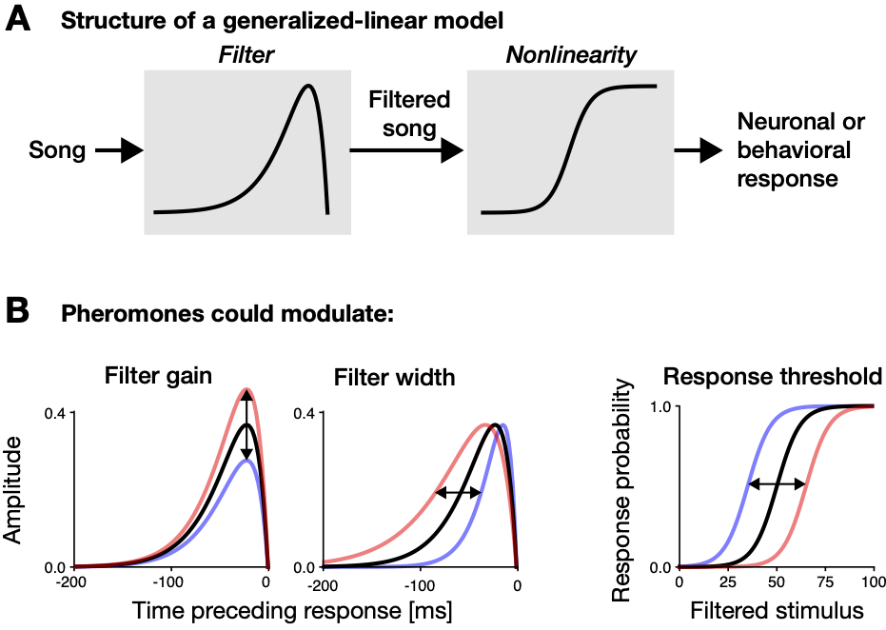

**Figure 4 -** Generalized-linear models (GLMs) for modeling continuous responses like neuronal calcium signals, or behavioral locomotor responses. **A** A GLM consists of a filter, which captures the temporal pattern in the input (song) that drives the response. The filtered stimulus signals the match between stimulus and filter and is transformed into a response via the nonlinearity. **B** Changes in neuronal and behavioral computations through pheromones can result in changes in the filter gain (left), filter width (middle) and the response threshold (right) (black arrows). Pheromones can decrease (blue) or increase (red) the respective parameter relative to the unisensory baseline (black).

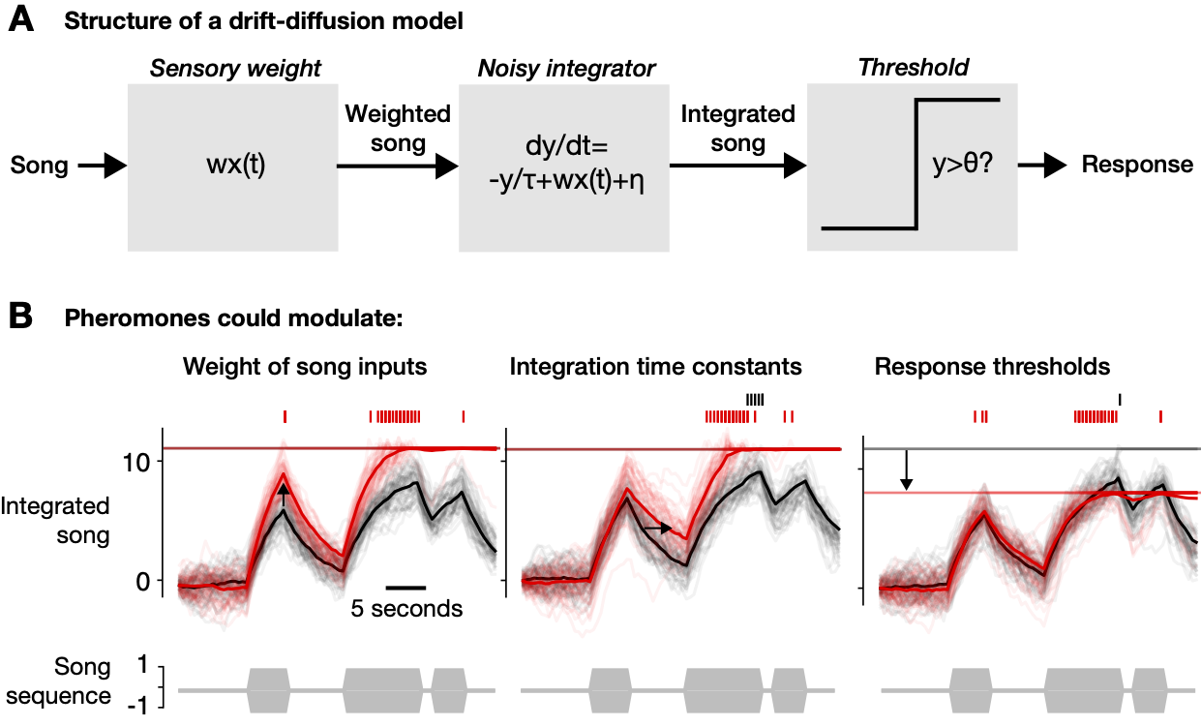

**Figure 5 -** Drift-diffusion models (DDMs) for modeling the timing of onetime responses or events like mating or vaginal plate opening. **A** A DDM consists of three steps: First, the sensory input (song) x(t) is weighted (left). The weighted song, wx(t), is then integrated with a time constant τ and additive Gaussian noise η (middle). If the integrated song exceeds a threshold θ, the response is triggered. **B** Changes in neural computations through pheromones can result in changes in weights of song inputs (left) integration time constants (middle), or response thresholds (right). Black arrows point to then changes. Black traces show the DDM for song alone, red traces show the DDM modulated by pheromones. Thin and thick traces correspond to integrated song for individual trials with independent noise (thin) and the trial-averaged integrated song (thick). The horizontal lines depict the decision threshold. Vertical ticks on top mark response events triggered by the integrated song crossing the threshold. Gray boxes below show the song sequence as input x(t) to the DDM.

1. [Thiagarajan, D. & Sachse, S. Multimodal information processing and associative learning in the insect brain. *Insects* **13**, 332 (2022).](http://paperpile.com/b/yL3yeU/Rctt)

2. [Dickson, B. J. Wired for sex: the neurobiology of Drosophila mating decisions. *Science* **322**, 904–909 (2008).](http://paperpile.com/b/yL3yeU/nayS)

3. [Zhu, B. *et al.* Multisensory modalities increase working memory for mating signals in a treefrog. *J. Anim. Ecol.* **90**, 1455–1465 (2021).](http://paperpile.com/b/yL3yeU/Vy7n)

4. [Bailey, W. J., Ager, E. I., O’Brien, E. K. & Watson, D. L. Searching by visual and acoustic cues among bushcrickets (Orthoptera: Tettigoniidae): will females remain faithful to a male who stops calling? *Physiol. Entomol.* **28**, 209–214 (2003).](http://paperpile.com/b/yL3yeU/3f0m)

5. [Fan, P. *et al.* Genetic and neural mechanisms that inhibit Drosophila from mating with other species. *Cell* **154**, 89–102 (2013).](http://paperpile.com/b/yL3yeU/YKjH)

6. [Vijendravarma, R. K., Narasimha, S., Steinfath, E., Clemens, J. & Leopold, P. Drosophila females have an acoustic preference for symmetric males. *Proc. Natl. Acad. Sci. U. S. A.* **119**, e2116136119 (2022).](http://paperpile.com/b/yL3yeU/JxHr)

7. [Wohlgemuth, M. J., Luo, J. & Moss, C. F. Three-dimensional auditory localization in the echolocating bat. *Curr. Opin. Neurobiol.* **41**, 78–86 (2016).](http://paperpile.com/b/yL3yeU/SF5M)

8. [Coen, P., Sit, T. P. H., Wells, M. J., Carandini, M. & Harris, K. D. Mouse frontal cortex mediates additive multisensory decisions. *bioRxiv* 2021.04.26.441250 (2021) doi:](http://paperpile.com/b/yL3yeU/xLQ9)[10.1101/2021.04.26.441250](http://dx.doi.org/10.1101/2021.04.26.441250)[.](http://paperpile.com/b/yL3yeU/xLQ9)

9. [Fetsch, C. R., Pouget, A., DeAngelis, G. C. & Angelaki, D. E. Neural correlates of reliability-based cue weighting during multisensory integration. *Nat. Neurosci.* **15**, 146–154 (2011).](http://paperpile.com/b/yL3yeU/29fj)

10. [Vijayan, V., Wang, F., Wang, K., Chakravorty, A. & Adachi, A. A rise-to-threshold signal for a relative value deliberation. *bioRxiv* (2021).](http://paperpile.com/b/yL3yeU/VlOps)

11. [Vrontou, E. *et al.* Response competition between neurons and antineurons in the mushroom body. *Curr. Biol.* **31**, 4911–4922.e4 (2021).](http://paperpile.com/b/yL3yeU/oh7N3)

12. [Hady, A. E., El Hady, A., Davidson, J. D. & Gordon, D. M. Editorial: An Ecological Perspective on Decision-Making: Empirical and Theoretical Studies in Natural and Natural-Like Environments. *Frontiers in Ecology and Evolution* vol. 7 (2019).](http://paperpile.com/b/yL3yeU/D1KG)

13. [Coen, P. *et al.* Dynamic sensory cues shape song structure in Drosophila. *Nature* **507**, 233–237 (2014).](http://paperpile.com/b/yL3yeU/DhCt)

14. [Coen, P., Xie, M., Clemens, J. & Murthy, M. Sensorimotor Transformations Underlying Variability in Song Intensity during Drosophila Courtship. *Neuron* **89**, 629–644 (2016).](http://paperpile.com/b/yL3yeU/taGJ)

15. [Deutsch, D. *et al.* The neural basis for a persistent internal state in Drosophila females. *eLife* vol. 9 (2020).](http://paperpile.com/b/yL3yeU/f03K)

16. [Liu, M., Kim, D.-W., Zeng, H. & Anderson, D. J. Make war not love: The neural substrate underlying a state-dependent switch in female social behavior. *Neuron* **110**, 841–856.e6 (2022).](http://paperpile.com/b/yL3yeU/jJtn)

17. [Aranha, M. M. & Vasconcelos, M. L. Deciphering Drosophila female innate behaviors. *Curr. Opin. Neurobiol.* **52**, 139–148 (2018).](http://paperpile.com/b/yL3yeU/1Yzx)

18. [Connolly, K. & Cook, R. Rejection Responses by Female Drosophila melanogaster: Their Ontogeny, Causality and Effects upon the Behaviour of the Courting Male. *Behaviour* **44**, 142–166 (1973).](http://paperpile.com/b/yL3yeU/l6oI)

19. [Nowlan, A. C., Kelahan, C. & Shea, S. D. Multisensory integration of social signals by a pathway from the basal amygdala to the auditory cortex in maternal mice. *BioRxiv* (2022) doi:](http://paperpile.com/b/yL3yeU/t2rC)[10.1101/2022.02.17.480854](http://dx.doi.org/10.1101/2022.02.17.480854)[.](http://paperpile.com/b/yL3yeU/t2rC)

20. [Ferveur, J.-F. Cuticular hydrocarbons: their evolution and roles in Drosophila pheromonal communication. *Behav. Genet.* **35**, 279–295 (2005).](http://paperpile.com/b/yL3yeU/SZzJ)

21. [Kohl, J., Huoviala, P. & Jefferis, G. S. Pheromone processing in Drosophila. *Curr. Opin. Neurobiol.* **34**, 149–157 (2015).](http://paperpile.com/b/yL3yeU/LyI7)

22. [Greenspan, R. J. & Ferveur, J. F. Courtship in Drosophila. *Annu. Rev. Genet.* **34**, 205–232 (2000).](http://paperpile.com/b/yL3yeU/DjO5)

23. [Grillet, M., Dartevelle, L. & Ferveur, J.-F. A Drosophila male pheromone affects female sexual receptivity. *Proc. Biol. Sci.* **273**, 315–323 (2006).](http://paperpile.com/b/yL3yeU/xTUY)

24. [Dweck, H. K. M. *et al.* Pheromones mediating copulation and attraction in Drosophila. *Proc. Natl. Acad. Sci. U. S. A.* **112**, E2829–35 (2015).](http://paperpile.com/b/yL3yeU/SOuq)

25. [Deutsch, D., Clemens, J., Thiberge, S. Y., Guan, G. & Murthy, M. Shared Song Detector Neurons in Drosophila Male and Female Brains Drive Sex-Specific Behaviors. *Curr. Biol.* **29**, 3200–3215.e5 (2019).](http://paperpile.com/b/yL3yeU/fY4k)

26. [Cachero, S., Ostrovsky, A. D., Yu, J. Y., Dickson, B. J. & Jefferis, G. S. X. E. Sexual dimorphism in the fly brain. *Curr. Biol.* **20**, 1589–1601 (2010).](http://paperpile.com/b/yL3yeU/6uGS)

27. [Yu, J. Y., Kanai, M. I., Demir, E., Jefferis, G. S. X. E. & Dickson, B. J. Cellular Organization of the Neural Circuit that Drives Drosophila Courtship Behavior. *Curr. Biol.* **20**, 1602–1614 (2010).](http://paperpile.com/b/yL3yeU/9qU2)

28. [Mezzera, C. *et al.* Ovipositor Extrusion Promotes the Transition from Courtship to Copulation and Signals Female Acceptance in Drosophila melanogaster. *Curr. Biol.* **30**, 3736–3748.e5 (2020).](http://paperpile.com/b/yL3yeU/iySG)

29. [Wang, F., Wang, K., Forknall, N., Parekh, R. & Dickson, B. J. Circuit and Behavioral Mechanisms of Sexual Rejection by Drosophila Females. *Curr. Biol.* **30**, 3749–3760.e3 (2020).](http://paperpile.com/b/yL3yeU/I4Ek)

30. [Zhou, C., Pan, Y., Robinett, C. C., Meissner, G. W. & Baker, B. S. Central brain neurons expressing doublesex regulate female receptivity in Drosophila. *Neuron* **83**, 149–163 (2014).](http://paperpile.com/b/yL3yeU/hHZx)

31. [Jung, Y. *et al.* Neurons that Function within an Integrator to Promote a Persistent Behavioral State in Drosophila. *Neuron* **105**, 322–333.e5 (2020).](http://paperpile.com/b/yL3yeU/79bC)

32. [Clemens, J. *et al.* Connecting Neural Codes with Behavior in the Auditory System of Drosophila. *Neuron* **87**, 1332–1343 (2015).](http://paperpile.com/b/yL3yeU/Cp0Z)

33. [Datta, S. R. *et al.* The Drosophila pheromone cVA activates a sexually dimorphic neural circuit. *Nature* **452**, 473–477 (2008).](http://paperpile.com/b/yL3yeU/xvKQ)

34. [Ferveur, J. F. & Jallon, J. M. Genetic control of male cuticular hydrocarbons in Drosophila melanogaster. *Genet. Res.* **67**, 211–218 (1996).](http://paperpile.com/b/yL3yeU/3GTB)

35. [Rezával, C. *et al.* Activation of Latent Courtship Circuitry in the Brain of Drosophila Females Induces Male-like Behaviors. *Curr. Biol.* **26**, 2508–2515 (2016).](http://paperpile.com/b/yL3yeU/08G8)

36. [Israel, S., Rozenfeld, E., Weber, D., Huetteroth, W. & Parnas, M. Olfactory stimuli and moonwalker SEZ neurons can drive backward locomotion in Drosophila. *Curr. Biol.* **32**, 1131–1149.e7 (2022).](http://paperpile.com/b/yL3yeU/GPDq)

37. [Pereira, T. D. *et al.* SLEAP: A deep learning system for multi-animal pose tracking. *Nat. Methods* **19**, 486–495 (2022).](http://paperpile.com/b/yL3yeU/Hk0g)

38. [Steinfath, E., Palacios-Muñoz, A., Rottschäfer, J. R., Yuezak, D. & Clemens, J. Fast and accurate annotation of acoustic signals with deep neural networks. *Elife* **10**, (2021).](http://paperpile.com/b/yL3yeU/fpyh)

39. [Pacheco, D. A., Thiberge, S. Y., Pnevmatikakis, E. & Murthy, M. Auditory activity is diverse and widespread throughout the central brain of Drosophila. *Nat. Neurosci.* **24**, 93–104 (2021).](http://paperpile.com/b/yL3yeU/aToq)

40. [Clemens, J. & Murthy, M. The Use of Computational Modeling to Link Sensory Processing with Behavior in Drosophila. in *Decoding Neural Circuit Structure and Function: Cellular Dissection Using Genetic Model Organisms* (eds. Çelik, A. & Wernet, M. F.) 241–260 (Springer International Publishing, 2017).](http://paperpile.com/b/yL3yeU/gJO0)

41. [Wang, K. *et al.* Neural circuit mechanisms of sexual receptivity in Drosophila females. *Nature* **589**, 577–581 (2021).](http://paperpile.com/b/yL3yeU/87hs)

42. [Scheffer, L. K. *et al.* A connectome and analysis of the adult Drosophila central brain. *Elife* **9**, (2020).](http://paperpile.com/b/yL3yeU/QbDO)

43. [Dorkenwald, S. *et al.* FlyWire: online community for whole-brain connectomics. *Nat. Methods* **19**, 119–128 (2022).](http://paperpile.com/b/yL3yeU/XpD0)

44. [Arez, E. *et al.* Male courtship song drives escape responses that are suppressed for successful mating. *Sci. Rep.* **11**, 9227 (2021).](http://paperpile.com/b/yL3yeU/EJ6r)

45. [Zoltowski, D., Pillow, J. & Linderman, S. A general recurrent state space framework for modeling neural dynamics during decision-making. in *Proceedings of the 37th International Conference on Machine Learning* (eds. Iii, H. D. & Singh, A.) vol. 119 11680–11691 (PMLR, 2020).](http://paperpile.com/b/yL3yeU/IaCWw)

46. [Inagaki, H. K., Fontolan, L., Romani, S. & Svoboda, K. Discrete attractor dynamics underlies persistent activity in the frontal cortex. *Nature* **566**, 212–217 (2019).](http://paperpile.com/b/yL3yeU/Z33U)

47. [Kim, S. S., Rouault, H., Druckmann, S. & Jayaraman, V. Ring attractor dynamics in the Drosophila central brain. *Science* **356**, 849–853 (2017).](http://paperpile.com/b/yL3yeU/ql3S)

48. [Clemens, J., Krämer, S. & Ronacher, B. Asymmetrical integration of sensory information during mating decisions in grasshoppers. *Proc. Natl. Acad. Sci. U. S. A.* **111**, 16562–16567 (2014).](http://paperpile.com/b/yL3yeU/j2I5)

49. [Dionne, H., Hibbard, K. L., Cavallaro, A., Kao, J.-C. & Rubin, G. M. Genetic Reagents for Making Split-GAL4 Lines in Drosophila. *Genetics* **209**, 31–35 (2018).](http://paperpile.com/b/yL3yeU/knWr)

50. [Zhang, S. X., Miner, L. E., Boutros, C. L., Rogulja, D. & Crickmore, M. A. Motivation, Perception, and Chance Converge to Make a Binary Decision. *Neuron* **99**, 376–388.e6 (2018).](http://paperpile.com/b/yL3yeU/t6J1)

51. [Gromko, M. H. & Markow, T. A. Courtship and remating in field populations of Drosophila. *Anim. Behav.* **45**, 253–262 (1993).](http://paperpile.com/b/yL3yeU/qzp2)

52. [Markow, T. A., Beall, S. & Castrezana, S. The wild side of life: Drosophila reproduction in nature. *Fly*  **6**, 98–101 (2012).](http://paperpile.com/b/yL3yeU/Gk1O)

53. [Liu, H. & Kubli, E. Sex-peptide is the molecular basis of the sperm effect in Drosophila melanogaster. *Proc. Natl. Acad. Sci. U. S. A.* **100**, 9929–9933 (2003).](http://paperpile.com/b/yL3yeU/7gtB)

54. [Manier, M. K. *et al.* Resolving mechanisms of competitive fertilization success in Drosophila melanogaster. *Science* **328**, 354–357 (2010).](http://paperpile.com/b/yL3yeU/7JH7)

55. [Laturney, M., van Eijk, R. & Billeter, J.-C. Last male sperm precedence is modulated by female remating rate in Drosophila melanogaster. *Evol Lett* **2**, 180–189 (2018).](http://paperpile.com/b/yL3yeU/4xvt)

56. [Lasbleiz, C., Ferveur, J.-F. & Everaerts, C. Courtship behaviour of Drosophila melanogaster revisited. *Anim. Behav.* **72**, 1001–1012 (2006).](http://paperpile.com/b/yL3yeU/Tt72)

57. [Das, S. *et al.* Electrical synapses mediate synergism between pheromone and food odors in Drosophila melanogaster. *Proc. Natl. Acad. Sci. U. S. A.* **114**, E9962–E9971 (2017).](http://paperpile.com/b/yL3yeU/t4Zm)

58. [Li, X., Ishimoto, H. & Kamikouchi, A. Auditory experience controls the maturation of song discrimination and sexual response in Drosophila. *Elife* **7**, (2018).](http://paperpile.com/b/yL3yeU/cDPL)

59. [Pereira, T. D., Tabris, N., Li, J. & Ravindranath, S. SLEAP: Multi-animal pose tracking. *bioRxiv* (2020).](http://paperpile.com/b/yL3yeU/7AcG)

60. [Clemens, J., Ozeri-Engelhard, N. & Murthy, M. Fast intensity adaptation enhances the encoding of sound in Drosophila. *Nature Communications* vol. 9 (2018).](http://paperpile.com/b/yL3yeU/JFmG)

61. [Billeter, J.-C. & Wolfner, M. F. Chemical Cues that Guide Female Reproduction in Drosophila melanogaster. *J. Chem. Ecol.* **44**, 750–769 (2018).](http://paperpile.com/b/yL3yeU/zKYM)

62. [Everaerts, C., Farine, J.-P., Cobb, M. & Ferveur, J.-F. Drosophila cuticular hydrocarbons revisited: mating status alters cuticular profiles. *PLoS One* **5**, e9607 (2010).](http://paperpile.com/b/yL3yeU/Kzo1)

63. [Auer, T. O. & Benton, R. Sexual circuitry in Drosophila. *Curr. Opin. Neurobiol.* **38**, 18–26 (2016).](http://paperpile.com/b/yL3yeU/1v3Z)