Dr. Norma Franklin

Zinman Institute of Archaeology, Haifa University

Dr. Norma Franklin is a Research Fellow at the Zinman Institute of Archaeology of the University of Haifa and an Associate Fellow of the W.F. Albright Institute for Archaeological Research. She received her Ph.D. from Tel Aviv University. She is the co-directer of the Jezreel Expedition with Dr. Jennie Ebeling. Among her articles are: “Dispelling the fog (אפל) around the Ophel ( עֹפֶל),” “Correlation and Chronology: Samaria and Megiddo Redux,” and “Samaria: From the Bedrock to the Omride Palace.”

Jezreel: A Military City and the Location of Jehu’s Coup

Biblical, geographical, and archaeological data coalesce to clarify the military importance of this city to Iron Age Israel and the possible meaning of the term “Ahab’s *hêḵal.*”

[Dr. Norma Franklin](https://www.thetorah.com/author/norma-franklin)

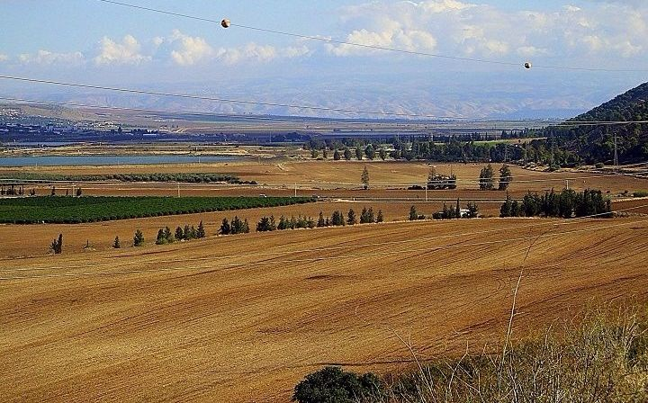

The picture looks east from Tel Jezreel down the Jezreel Valley and across the Jordan. Visible in the back are the mountains of Ramat Gilead, whence Jehu rode furiously towards Jezreel along this route. The field next to the winery, a good candidate for *helkat*Naboth, is in the foreground. © Norma Franklin

The Bible mentions Jezreel more than 30 times, including in the books of Joshua, Judges, Samuel, Kings, Chronicles and Hosea, where it is part of the haftarah for *Parashat Bemidbar*that refers obliquely to Jehu’s coup against the Omride dynasty,[1] which, despite its great power,[2] collapsed relatively quickly. As the biblical text tells the story, this collapse begins and ends at Jezreel! Thus, although the site was likely inhabited almost continuously from late prehistory to the modern era, we will focus in this piece, on the reality on the ground during the Iron Age II.

Jehu’s Assassination of Joram in Jezreel

According to 2 Kings 9, the prophet Elisha sends a young prophet to the military encampment at Ramot Gilead, where troops are protecting the border against the army of Hazael king of Aram, with a message to appoint Jehu, an army general (שר), as the new king (vv. 1-10), telling him to lead a coup against King Joram, son of Ahab:

מלכים ב ט:ז וְהִכִּיתָה אֶת בֵּית אַחְאָב אֲדֹנֶיךָ וְנִקַּמְתִּי דְּמֵי עֲבָדַי הַנְּבִיאִים וּדְמֵי כָּל עַבְדֵי יְ-הוָה מִיַּד אִיזָבֶל.ט:ח וְאָבַד כָּל בֵּית אַחְאָב וְהִכְרַתִּי לְאַחְאָב מַשְׁתִּין בְּקִיר וְעָצוּר וְעָזוּב בְּיִשְׂרָאֵל.

2 Kings 9:7 You shall strike down the House of Ahab your master; thus will I avenge on Jezebel the blood of My servants the prophets, and the blood of the other servants of YHWH. 9:8 The whole House of Ahab shall perish, and I will cut off every male belonging to Ahab, bond and free in Israel.

Jehu accepts the charge, and immediately rides towards Jezreel where, we are told, King Joram is convalescing from a battle wound (vv. 11-16).

After repeated failed attempts to get Jehu to state his business, Joram, together with Ahaziah king of Judah who happened to be visiting, go out to meet Jehu:

מלכים ב ט:כא …וַיֵּצְאוּ לִקְרַאת יֵהוּא וַיִּמְצָאֻהוּ בְּחֶלְקַת נָבוֹת הַיִּזְרְעֵאלִי. ט:כבוַיְהִי כִּרְאוֹת יְהוֹרָם אֶת יֵהוּא וַיֹּאמֶר הֲשָׁלוֹם יֵהוּא וַיֹּאמֶר מָה הַשָּׁלוֹם עַד זְנוּנֵי אִיזֶבֶל אִמְּךָ וּכְשָׁפֶיהָ הָרַבִּים. ט:כגוַיַּהֲפֹךְ יְהוֹרָם יָדָיו וַיָּנֹס וַיֹּאמֶר אֶל אֲחַזְיָהוּ מִרְמָה אֲחַזְיָה.

2 Kings 9:21 …They met him at the field of Naboth the Jezreelite. 9:22 When Joram saw Jehu, he asked, “Is all well, Jehu?” But Jehu replied, “How can all be well as long as your mother Jezebel carries on her countless harlotries and sorceries?” 9:23 Thereupon Joram reined about and fled, crying out to Ahaziah, “Treason, Ahaziah!”

ט:כד וְיֵהוּא מִלֵּא יָדוֹ בַקֶּשֶׁת וַיַּךְ אֶת יְהוֹרָם בֵּין זְרֹעָיו וַיֵּצֵא הַחֵצִי מִלִּבּוֹ וַיִּכְרַע בְּרִכְבּוֹ. ט:כה וַיֹּאמֶר אֶל בִּדְקַר [שָׁלִשׁוֹ] שָׂא הַשְׁלִכֵהוּ בְּחֶלְקַת שְׂדֵה נָבוֹת הַיִּזְרְעֵאלִי…

9:24 But Jehu drew his bow and hit Joram between the shoulders, so that the arrow pierced his heart; and he collapsed in his chariot. 9:25 Jehu thereupon ordered his officer Bidkar, “Pick him up and throw him into the field of Naboth the Jezreelite…”

Jehu also has King Ahaziah of Judah killed, as he attempts to flee, and then enters the city where he soon encounters the queen mother:

מלכים ב ט:ל וַיָּבוֹא יֵהוּא יִזְרְעֶאלָה וְאִיזֶבֶל שָׁמְעָה וַתָּשֶׂם בַּפּוּךְ עֵינֶיהָ וַתֵּיטֶב אֶת רֹאשָׁהּ וַתַּשְׁקֵף בְּעַד הַחַלּוֹן׃ט:לא וְיֵהוּא בָּא בַשָּׁעַר… ט:לג וַיֹּאמֶר [שִׁמְטוּהָ] וַיִּשְׁמְטוּהָ וַיִּז מִדָּמָהּ אֶל הַקִּיר וְאֶל הַסּוּסִים וַיִּרְמְסֶנָּה׃

2 Kings 9:30Jehu went on to Jezreel. When Jezebel heard of it, she painted her eyes with kohl and dressed her hair, and she looked out of the window. 9:31 Jehu entered the gate…9:33 “Throw her down,” he said. They threw her down; and her blood spattered on the wall and on the horses, and they trampled her.

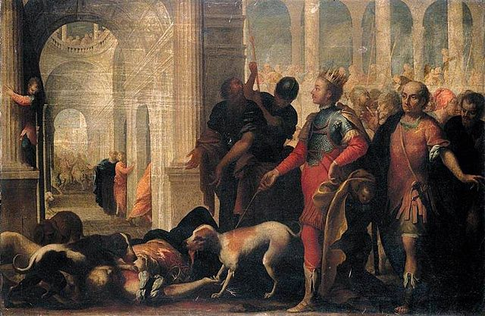

Queen Jezebel Being Punished by Jehu by Andrea Celesti (1637–1712)

What do we know about the city of Jezreel? Why would a king and his entourage be there instead of in the capital city, Samaria?

The Location of Jezreel

Perched on a rocky spur in the foothills of Mount Gilboa, ca. 100 meters above sea level, the ancient site of Jezreel is located in the Jezreel Valley, over which it commanded an unparalleled view. It was located opposite the city of Shunem at the valley’s narrowest point, while the ancient cities of Megiddo and Beth Shean lie some 10 miles (16 kilometers) away to the west and east, respectively.

Military Considerations – On the Crossroads

The city of Jezreel was of military importance for the Iron Age kingdom of Israel. The Jezreel valley sits between the Galilean Highlands to its north and the Samarian Highlands (biblical Ephraimite Hills) to its south. Control of this valley by an outside party effectively isolates these regions from each other. Moreover, Jezreel sat on the intersection between two ancient highways:

* The Via Maris—biblical “Way of the Sea”—that linked Egypt with Assyria.[3]
* The Ridge Route—popularly referred to as “Way of the Patriarchs”—which branched off south, connecting Jezreel with the central sites of Dothan, Shechem, Samaria (the capital city!), Bethel, and Jerusalem.

It comes as no surprise, therefore, that Jezreel is the scene of many important battles in the Bible and later, such as the final encounter between Saul and the Philistines (1 Samuel 29–31) Saladin’s defeat of the crusaders in 1187 C.E., the Mamluk defeat of the Mongols in 1260, and Napoleon’s successful battle against the Ottomans in 1799.

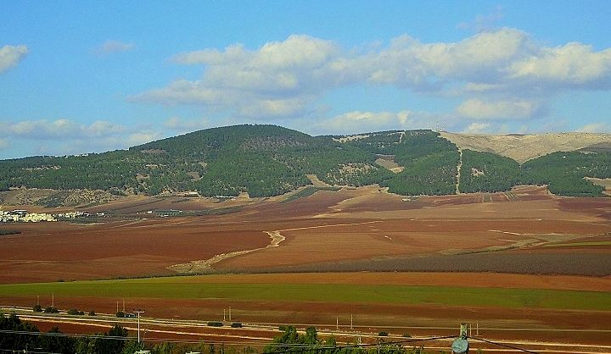

Taken from the north of Tel Jezreel, this photo shows the narrowness of the Jezreel Valley at the strategic point between Jezreel and Shunem (where the Arab village of Shullam sits today [far-left of the pic]). This area, where the Ridge Route to Samaria branches off from the Via Maris, is the place of many famous battles. © Norma Franklin

A Military City Protecting Samaria

The capital of Israel was Samaria, but Jezreel is often presented as the Israelite king’s second or winter capital.[4] But no historical or archaeological evidence exists for this fanciful scenario. Instead, Samaria was the *only* capital of the Northern kingdom from the time it was established by King Omri (1 Kings 16:24).

Nevertheless, Jezreel’s importance in Iron Age Israel can hardly be overstated. As noted above, its position on the Ridge Route at the entrance to the Samarian hill country was strategic, guarding the way to the capital city, Samaria. Israel’s enemies during the 9th and 8th centuries BCE were the Arameans and the Assyrians whose lands lay to the north and east. Any invasion by them would first have to conquer Jezreel, and any military action taken against them would be launched from Jezreel. Thus, Jezreel was likely not built as a town, but as the army’s mustering station possibly even headquarters.

The Archaeology of Jezreel

The first large-scale excavations at Tel Jezreel were conducted in the 1990s by David Ussishkin of Tel Aviv University and John Woodhead of the British School of Archaeology in Jerusalem.[5] They revealed the remains of a 9th-(or possibly 8th) century-BCE military enclosure. Two towers were exposed in the southeast and northeast corners, and two more towers are presumed to have stood at the other two corners. A six- or possibly four-chambered gate was constructed on the southern side, and a surrounding casemate (double) wall and a rock-cut dry moat protected the enclosure on at least three sides.

Limited excavations conducted below the level of the enclosure revealed evidence of a slightly earlier phase. Due to the very poor preservation of the remains, neither phase could be accurately dated. Ussishkin and Woodhouse dated the later complex to the Omride dynasty (9th century), mainly on the “basis of biblical evidence,”[6] making the earlier phase pre-Omride. In my view, however, the later complex is more likely 8th century (Nimshide, i.e. from the dynasty of Jehu ben Nimshi), with the earlier phase being Omride.[7]

What was this enclosure?

The *Hêḵal* at Jezreel – Ahab’s Edifice

In the story of Naboth’s vineyard[8]—the biblical story which makes reference to Ahab’s residence—Ahab calls it a “house” (בית) and the narrator calls it a *hêḵal*:

מלכים א כא:א כֶּרֶם הָיָה לְנָבוֹת הַיִּזְרְעֵאלִי אֲשֶׁר בְּיִזְרְעֶאל **אֵצֶל** **הֵיכַל אַחְאָב מֶלֶךְ שֹׁמְרוֹן**: כא:ב וַיְדַבֵּר אַחְאָב אֶל נָבוֹת לֵאמֹר תְּנָה לִּי אֶֽת־כַּרְמְךָ וִיהִי לִי לְגַן יָרָק כִּי הוּא **קָרוֹב אֵצֶל בֵּיתִי**…

1 Kings 21:1 Naboth the Jezreelite owned a vineyard in Jezreel, **near the *hêḵal*** of King Ahab of Samaria. 21:2Ahab said to Naboth, “Give me your vineyard, so that I may have it as a vegetable garden, since it is **right next to my house**…

Ahab refers to the היכל as his house, but what is a היכל? The Hebrew word היכל is a loan word from the Akkadian *ekallu*, itself derived from the Sumerian É.GAL meaning “great house.” The Akkadian term is generally used to describe a large building such as a palace or a temple. It can also refer to a military headquarters (*ekal mašārti*, literally “review palace.”) In the Bible, it is most often used as a reference to the Temple and only in a handful of verses does it refer to a palace.[9]

To what does the term *hêḵal* in the Ahab story refer? It is certainly not a temple. The popular translation “palace” is a possible meaning, especially since Ahab does refer to it as his “house” and בית המלך (“house of the king”) is the most common term for palace in the narrative sections of the Bible.[10]

Nevertheless, archaeologically speaking, Jezreel does not look like a town and the structure does not look like a palace. In fact, no evidence of a town with domestic dwellings in the 9th-8th century BCE has been uncovered on the upper tel thus far. People must have lived there but so far it does not give the impression of a town. In addition, there would be little need of another real palace so close to the capital city, Samaria.

Therefore, I offer the tentative suggestion that *hêḵal* may refer to an army headquarters, like the Akkadian *ekal mašārti*. This would be particularly fitting for Jezreel, considering its placement guarding the road to Samaria. The existence of a “review palace” not far from the capital city would parallel what is found in Assyria. For example, an *ekal mašārti* stood not far from the Assyrian capital of Nineveh, in Tell Nebi Yunus, and was used as a strategic military center and a mustering station.[11]

Even if it were not a “palace,” Ahab’s *hêḵal* was certainly a large building. This is clear both archaeologically as well as biblically: Ahab calls it his house in the Naboth account and the account of the defenestration of Jezebel assumes a two-story building.[12] Thus, I suggest we should be envisioning a large constructed area, serving as a military headquarters, with accommodations for the king and his entourage.[13]

The Blood of Jezreel and the Day of Jezreel

The account of Jehu’s assassination of King Joram in 2 Kings 9, cited above, pictures Jehu traveling from Ramot-Gilead west toward Jezreel (vv. 14-16), where the king is convalescing. As the story is set during a war between Aram and Israel, during with King Joram was injured, it is not surprising that the king wished to stay at his military headquarters as opposed to his capital city, or that he would have ridden out to meet his main general rushing towards him, to find out what news he may be bringing from the front.

Although the book of Kings views Jehu’s actions at Jezreel positively, they appear to have inspired horror among at least some Israelites. Toward the beginning of Hosea, God tells the prophet to name their first son Jezreel:

הושע א:ד וַיֹּאמֶר יְ-הֹוָה אֵלָיו קְרָא שְׁמוֹ יִזְרְעֶאל כִּי עוֹד מְעַט וּפָקַדְתִּי אֶת דְּמֵי יִזְרְעֶאל עַל בֵּית יֵהוּא וְהִשְׁבַּתִּי מַמְלְכוּת בֵּית יִשְׂרָאֵל: א:ה וְהָיָה בַּיּוֹם הַהוּא וְשָֽׁבַרְתִּי אֶת קֶשֶׁת יִשְׂרָאֵל בְּעֵמֶק יִזְרְעֶאל:

Hosea 1:4 YHWH instructed him, “Name him Jezreel; for, I will soon punish the House of Jehu for the bloody deeds at Jezreel and put an end to the monarchy of the House of Israel. 1:5 In that day, I will break the bow of Israel in the Valley of Jezreel.”

The text never mentions Joram or describes the assassination, but commentators have long understood this to be the referent.[14] Thus, in Hosea’s interpretation of history, Jehu’s bloody revolt was offensive to YHWH and his dynasty will suffer a defeat or punishment at the same place he committed his offense, Jezreel. Nevertheless, the prophecy ends on a positive note, with the imagery of Jezreel transformed from a place of blood to a place of hope; it is this part of the prophecy that comprises the haftarah for *Parashat Bemidbar* (Hos 2:1-22):

הושע ב:ב וְנִקְבְּצוּ בְּנֵי יְהוּדָה וּבְנֵי יִשְׂרָאֵל יַחְדָּו וְשָׂמוּ לָהֶם רֹאשׁ אֶחָד וְעָלוּ מִן הָאָרֶץ כִּי גָדוֹל יוֹם יִזְרְעֶאל:… ב:כגוְהָיָה בַּיּוֹם הַהוּא אֶֽעֱנֶה נְאֻם יְ-הֹוָה אֶעֱנֶה אֶת הַשָּׁמָיִם וְהֵם יַעֲנוּ אֶת הָאָרֶץ: ב:כדוְהָאָרֶץ תַּעֲנֶה אֶת הַדָּגָן וְאֶת הַתִּירוֹשׁ וְאֶת הַיִּצְהָר וְהֵ֖ם יַעֲנוּ אֶֽת יִזְרְעֶאל: ב:כהוּזְרַעְתִּיהָ לִּי בָּאָרֶץ…

Hoshea 2:2 The people of Judah and the people of Israel shall assemble together and appoint one head over them; and they shall rise from the ground—for marvelous shall be the day of Jezreel!…  2:23 In that day, I will respond—declares YHWH—I will respond to the sky, And it shall respond to the earth; 2:24 And the earth shall respond With new grain and wine and oil, And they shall respond to Jezreel. 2:25 I will sow her in the land as My own…

[View Footnotes](https://www.thetorah.com/article/jezreel-a-military-city-and-the-location-of-jehus-coup)

1. That Jezreel was a prominent site well before the Omrides came to power is also hinted at in 1 Kings 4:12.
2. In Assyrian King Shalmeneser III monolith, Omri’s son, Ahab, is pictured as having one of the strongest armies in the Levantine league fighting against Assyria at the battle of Karkur (853 BCE), with the most chariots (2000). Similarly, in the Mesha inscription, Omri is described as having conquered territory from Moab in the Transjordan. The name for Samaria in a number of Akkadian sources is Bet Omri (the house of Omri).
3. A small part of this road, from Pelusium in the Delta to Gaza (Pa-Ca’anan) on the Levantine coast, was called the “Way of Horus” by the Egyptians. The identification of the דרך הים with the Via Maris has been disputed. See David Dorsey, *The Roads and Highways of Ancient Israel* (ASOR Library of Biblical and Near Eastern Archaeology; Baltimore: Johns Hopkins University Press, 1991), 49.
4. The idea was floated by scholars looking to explain the existence of a “palace” (היכל) in Jezreel with the royal family being located there in some accounts (see later discussion). Those scholars did not understand the military aspect of Jezreel hence the summer/winter palace theory. The earliest appearance of this idea is in Julian Morgenstern, *Amos Studies*, I (Cincinnati: HUC, 1941), 286, 288, 303 and Albrecht Alt, *Der Stadt Samaria* (Berlin, 1954); reproduced in: Albrecht Alt, *Kleine Schriften zur Geschite des Volkes Israel*, III (Munich, 1959): 258-302. Examples of contemporary scholars who assume the winter palace concept are Baruch Halpern, *The First Historians: The Hebrew Bible and History* (Pennsylvania State University Press, 1996), xxix; Hillel I. Millgram, *The Elijah Enigma: The Prophet, King Ahab, and the Rebirth of Monotheism* (McFarland, 2014), 141.
5. David Ussishkin and John Woodhead “Excavations at Tel Jezreel 1990–1991: Preliminary Report,”*Tel Aviv*19 (1992): 3–56; David Ussishkin and John Woodhead, “Excavations at Tel Jezreel 1992–1993: Second Preliminary Report,”*Levant*26 (1994): 1–71; David Ussishkin and John Woodhead, “Excavations at Tel Jezreel 1994–1996: Third Preliminary Report,”*Tel Aviv*24 (1997): 6–72.
6. David Ussishkin, “Samaria, Jezreel and Megiddo: Royal Centers of Omri and Ahab,” in*Ahab Agonistes: The Rise and Fall of the Omri Dynasty*(edited by Lester L. Grabbe; Old Testament Studies 421; London: T & T Clark, 2007), 293–309 [301].
7. Norma Franklin, “Jezreel: Before and After Jezebel,” in *Israel in Transition: From Late Bronze II to Iron IIAs (c. 1250–850 BCE)* 1.*The Archaeology: An Arts and Humanities Research Council Conference*(edited by Lester L. Grabbe; London and New York, 2008), 45–53.
8. See my “[The Story of Naboth’s Vineyard and the Ancient Winery in Jezreel](http://thetorah.com/the-story-of-naboths-vineyard-and-the-ancient-winery-in-jezreel/),”*TheTorah.com* (2017).
9. Out of 65 appearances of the term in the Bible, only 6 or 7 times does it likely mean palace: 2 Kings 20:18 (=Isa 39:7); Nah 2:7; Dan 1:4, 4:26; Ezra 4:14; maybe Psa 144:12 (LXX translates “temple”).
10. In poetry, the usual word for palace is ארמון and appears 32 times in the Bible. That said it is worth noting that this term, which is unambiguously “palace,” is not exclusively used in poetic contexts, since it appears twice in Kings to denote the king of Israel’s residence in Samaria (2 Kings 15:25) and in the previous capital, Tirza (1 Kings 16:18).
11. See Geoffrey Turner, “Tell Nebi Yunus: The *Ekal Māšarti* of Nineveh,” *Iraq* 32.1 (1970): 68-85 (70).
12. As mentioned above, I date the later enclosure to the Nimshide period, and the earlier one to the Omride period. Nevertheless, if the stories about Ahab and Jezebel in Jezreel were written down or edited after the fall of the Omrides, as seems likely, then the author would have been picturing the later enclosure.
13. This idea builds on Ussishkin and Woodhead’s earlier work. See Ussishkin, “Samaria, Jezreel, and Megiddo.”
14. Rashi, for instance, interprets the phrase “the blood of Jezreel” as:

…את דמי בית אחאב שהרג יהוא ביזרעאל…

 …The blood of the house of Ahab which Jehu struck down in Jezreel…