The Story of Naboth’s Vineyard and the Ancient Winery in Jezreel

What light can archaeology shed on the significance and location of the vineyard?

[Dr. Norma Franklin](https://www.thetorah.com/author/norma-franklin)

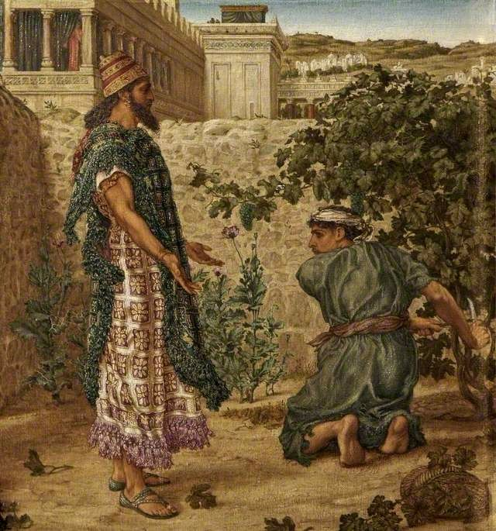

Naboth refuses King Ahab his vineyard. Thomas Matthews Rooke (1842–1942), Russell-Cotes Art Gallery & Museum

The Story of Naboth’s Vineyard in Jezreel

The well-known story of Naboth’s vineyard begins:

מלכים א כא:א כֶּרֶם הָיָה לְנָבוֹת הַיִּזְרְעֵאלִי אֲשֶׁר בְּיִזְרְעֶאל אֵצֶל הֵיכַל אַחְאָב מֶלֶךְ שֹׁמְרוֹן: כא:ב וַיְדַבֵּר אַחְאָב אֶל נָבוֹת לֵאמֹר תְּנָה לִּי אֶֽת כַּרְמְךָ וִיהִי לִי לְגַן יָרָק כִּי הוּא קָרוֹב אֵצֶל בֵּיתִי וְאֶתְּנָה לְךָ תַּחְתָּיו כֶּרֶם טוֹב מִמֶּנּוּ אִם טוֹב בְּעֵינֶיךָ אֶתְּנָה לְךָ כֶסֶף מְחִיר זֶה: כא:ג וַיֹּאמֶר נָבוֹת אֶל אַחְאָב חָלִילָה לִּי מֵֽי-הֹוָה מִתִּתִּי אֶת נַחֲלַת אֲבֹתַי לָךְ:

1 Kings 21:1 Naboth the Jezreelite owned a vineyard in Jezreel, near the *hêḵal*of King Ahab of Samaria. 21:2Ahab said to Naboth, “Give me your vineyard, so that I may have it as a vegetable garden, since it is right next to my house, I will give you a better vineyard in exchange; or, if you prefer, I will pay you the price in money.” 21:3 But Naboth replied, “YHWH forbid that I should give up to you what I have inherited from my fathers!”

It continues with Ahab expressing his bitterness about Naboth’s response, and his wife, Queen Jezebel, arranging false witnesses to charge Naboth with blasphemy, a capital offense. Upon Naboth’s execution, she presents the vineyard to Ahab, spurring the prophet Elijah to make his famous declaration (v. 19), “Have you murdered and then inherited?!” (הֲרָצַחְתָּ וְגַם יָרָשְׁתָּ) and to inform Ahab that he, his wife, and his dynasty have been condemned by God.

The fulfilment of this prophecy is narrated in 2 Kings 9, which describes Jehu’s assassination of Joram son of Ahab near Naboth’s plot in Jezreel. After Joram is killed, Jehu explains his actions to his men:

ט:כה וַיֹּ֗אמֶר אֶל בִּדְקַר [שָׁלִשׁוֹ] שָׂא הַשְׁלִכֵהוּ בְּחֶלְקַת שְׂדֵה נָבוֹת הַיִּזְרְעֵאלִי כִּֽי זְכֹר אֲנִי וָאַתָּה אֵת רֹכְבִים צְמָדִים אַֽחֲרֵי אַחְאָב אָבִיו וַֽי-הֹוָה נָשָׂא עָלָיו אֶת הַמַּשָּׂא הַזֶּה: ט:כו אִם לֹא אֶת דְּמֵי נָבוֹת וְאֶת דְּמֵי בָנָיו רָאִיתִי אֶמֶשׁ נְאֻם יְ-הֹוָה וְשִׁלַּמְתִּי לְךָ בַּחֶלְקָה הַזֹּאת נְאֻם יְ-הֹוָה וְעַתָּה שָׂא הַשְׁלִכֵהוּ בַּחֶלְקָה כִּדְבַר יְ-הֹוָה:

9:25 He ordered his officer Bidkar, “Pick him (Joram) up and throw him into the field of Naboth the Jezreelite. Remember how you and I were riding side by side behind his father Ahab, when YHWH made this pronouncement about him: 9:26 ‘I swear, I have taken note of the blood of Naboth and the blood of his sons yesterday—declares YHWH. And I will requite you in this plot—declares YHWH.’ So pick him up and throw him unto the plot in accordance with the word of YHWH.”

A key feature of both parts of the story is Naboth’s plot or vineyard. What light can archaeology shed on this vineyard and its place in Jezreel?

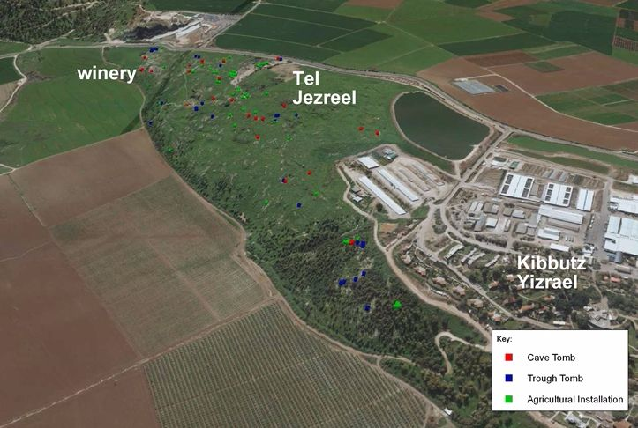

The Fertile City of Jezreel

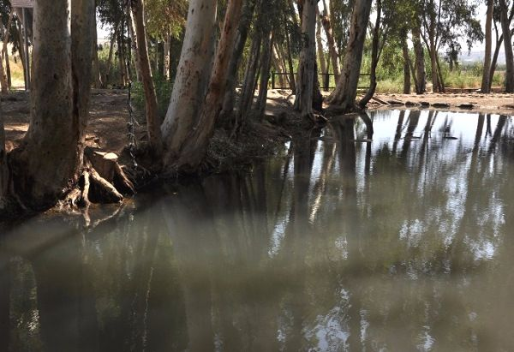

Jezreel Spring 2015

The ancient site of Jezreel was built on a rocky spur in the foothills of Mount Gilboa, overlooking the fertile Jezreel Valley, which was named after it.[1] The city sits opposite Shunem, with its rich, agricultural fields,[2] and by a nearby a perennial spring, mentioned in 1 Samuel 29:1 (the story of Saul’s final battle):

וְיִשְׂרָאֵל חֹנִים בַּעַיִן אֲשֶׁר בְּיִזְרְעֶאל.

Israel was encamping at the spring in Jezreel.

The spring, which still exists today, provided water for both city dwellers and travellers, and was guarded by the recently discovered lower city of Jezreel (Tel ‘Ein Yizre’el). The rich land surrounding Jezreel provided ideal conditions for agriculture and grazing.

Excavations and Findings of the LiDAR Scan

The present [Jezreel expedition](http://jezreel-expedition.com/" \t "_blank), which I (Norma Franklin, University of Haifa) am co-directing with Jennie Ebeling (University of Evansville, Indiana), was founded in 2012 with the aim of surveying, excavating[3] and documenting the site of greater Jezreel over a long period of time [4]

A LiDAR (Light Detection and Ranging) scan was commissioned and a large selection of maps, aerial photographs and archival material was utilized prior to a traditional landscape survey conducted in June of 2012. A three-to-four square kilometer area to the west, north, and east of the upper tel of Jezreel was divided into survey areas based on the LiDAR model. More than 360 features were documented, among them 57 agricultural installations such as wine and olive oil presses.[5]

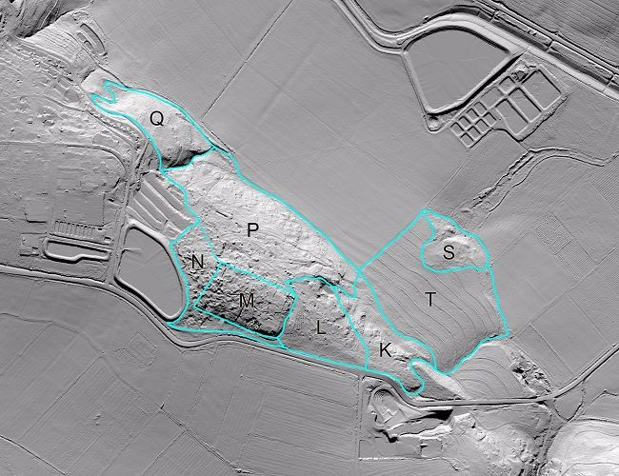

**LiDAR map of Jezreel area** (Winery in Area K). Airborne LiDAR works by scanning the ground with a laser from an aircraft; data obtained are then used to create to an accurate 3D model of the land surface. This model was examined to identify historic and natural features and geo-referenced with aerial photographs (the earliest of which dates to 1918) and provided information about the landscape before mechanized farming and other modern surface-changing events took place.

Also, over 100 rock-cut bottle-shaped pits, scattered over the summit of the hill, were found. Some were hewn for use as cisterns, and others as temperate underground storage pits.[6] Likely some of these were used to store wine; at ancient Gibeon, 63 rock-cut, bottle-shaped storage pits or cellars, one with in-situ wine jars, served just this purpose.[7]

Evidence of a Vineyard?

Vineyards do not leave archaeological remains, but circumstantial evidence suggests that Jezreel likely had one. Kibbutz Yizre’el alerted us to the fact that they had independently conducted a soil analysis and found a plot of land with proper quality for growing grapes, whereas the soils in the fields further west were found to be better suited to growing olives.[8]This plot is immediately north of an ancient winery, and during the biblical period wine processing areas were generally located next to vineyards.[9]

The Winery Complex

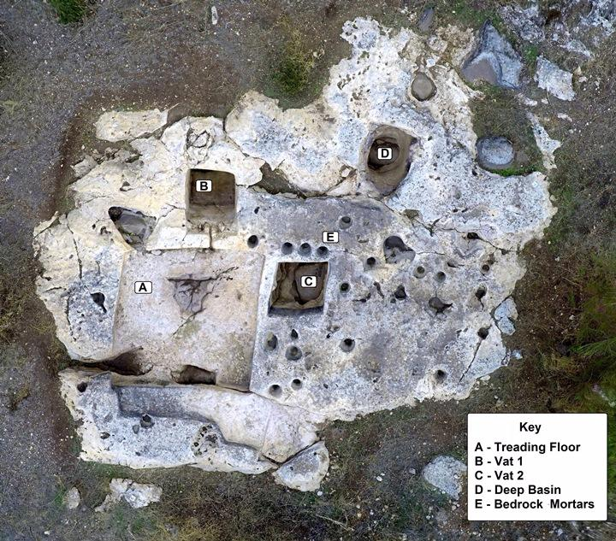

Jezreel Winery – Area K

In Area K, a particularly impressive installation was carved into the limestone bedrock at the foot of the hill of Jezreel, north-east of the area excavated in the 1990s, and directly south of a large fertile terrace that sloped towards the spring of Jezreel. The complex covers an area of approximately 12 square meters, and its characteristics indicate that it was a winery:

* A square rock-cut treading floor measuring 3.2 meters on each side
* Two adjacent rock-cut vats each ca. 1.3 meters square and over one meter deep.
* The treading floor, which slopes down toward a vat, Vat 1, and is connected to it by a 15 centimeter long, 5 centimeter wide, rock-cut channel.
* A sump for collecting liquids in the northwest corner of Vat 1.
* Another vat, Vat 2, located to the east of the treading floor but not connected to it.
* A deep circular basin, northeast of the treading floor, ca. 1 meter in diameter, that possibly functioned as another vat.

How the Winery Worked

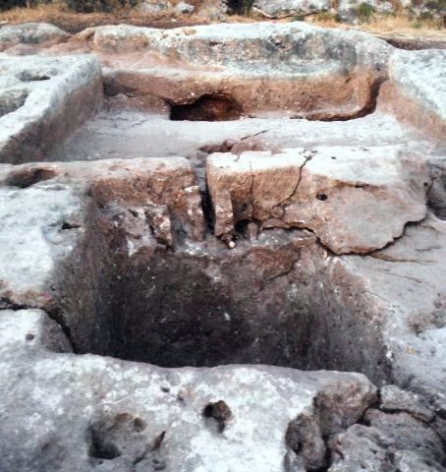

Treading floor draining to into vat 1

The wine in Jezreel was made by traditional grape-stomping. The benefit of treading grapes by feet as opposed to using a wine press is that it prevents the pips (little grape seeds) from being smashed and changing the taste of the wine. A roughly triangular depression in the center of the treading floor was probably used to collect the grape skins, pips and stalks that formed a block around which the juice flowed toward the primary fermentation vat (Vat 1).

The young, unfiltered grape juice, called “must,” would have started to ferment as soon as it came into contact with the yeast that occurs naturally on the grape skins. Primary fermentation would have continued in Vat 1 for a number of days; a number of ancient sources specify that this first stage took place for three days in open jars or in the collection vat.[10] The wine was then strained into jars that were stored in a cool place for secondary fermentation. The bottle-shaped pits found at Jezreel are identical with those at Gibeon, and were ideal temperate storage places for secondary fermentation.

The Jezreel winery was typical for this area and general period. An extensive survey of 117 wine treading areas southwest of Jezreel was conducted in the 1960s. The majority consisted of a rectangular treading floor with a rectangular vat, similar to the Jezreel winery, and were usually located outside of a village and cut into the edge of the bedrock outcrop next to the fields.[11]

The Date of the Jezreel Winery

It is difficult to date ancient rock-cut agricultural installations,[12] and the winery in Area K is no exception. During the time it was in use, any pottery or other artifacts that could help date the complex would have been cleared away on a regular basis because they would have interfered with wine production.[13] The one thing we can say about the dating is that it is pre-Hellenistic, since from the Hellenistic period onwards wineries used a beam or screw press, and the Jezreel winery does not.[14]

Comparison with Samaria

As Jezreel was an important city in ancient Israel, it is likely that winery dates from this period. This would also fit with the current assumptions about the winery in the capital, Samaria, where a 5 by 10 meter treading floor and some smaller treading areas were excavated by the Harvard Excavations in the early 1900s. Their dating has been recently reevaluated and attributed to the earliest phase of building (called “Building Period 0” since it is the earliest layer), 10th or 9th century BCE.[15]

A Valuable Commodity for a King

Evidence from Assyrian texts show that at the same time that Naboth is pictured as tending his grapes (Omride period), Ashurnasirpal II of Assyria is described as having provided 10,000 wineskins at an inaugural party at his new palace in Calah, where he wined and dined 70,000 guests.[16] Although we don’t have textual evidence of quite such lavish entertaining in ancient Israel, wine also flowed freely at the Israelite capital, Samaria. Archaeologists have recovered over one hundred wine dockets (receipts for taxes paid in wine), in the form of *ostraca* (inscribed pottery sherds), that testify to wine having been brought in to the capital.

Furthermore, between the ninth and sixth centuries B.C.E., wine was also listed among basic military supplies.[17] Jezreel in the Iron Age was a military center, probably the main mustering station for Ahab’s chariot force, and he would have used his own vineyard to provision the army.

Strangely, the biblical narrative relates that Ahab wished to purchase the vineyard in order to turn it into a vegetable garden but this makes no sense when we know the importance of viticulture at that time and likely points to it having been a later addition to the narrative.

Naboth the Jezreelite

The Bible names the owner of the vineyard as Naboth the Jezreelite. The use of this gentilic implies that he resided somewhere else as well, otherwise he would not have required a qualifier. A person with a residence in one place and a vineyard in another is a wealthy person, and one might imagine that such a person lived in the capital city, Samaria. Whether or not the “Naboth the Jezreelite” is a historical character, whoever owned that plot of land and its vineyard was certainly well off and not a simple, poor farmer.

We cannot know if any part of the account of Naboth’s vineyard is historical, but its author knew at least that ancient Jezreel had a vineyard (and a winery), and this area was near the large instillation that probably served to house the king (among others) when he was in Jezreel. Moreover, the editor of Kings is clearly picturing a vineyard located east of Jezreel and close to the main highway, the Via Maris. The location of the winery, east of the Jezreel enclosure and near the junction of the Via Maris with the Ridge Route to Jezreel and on to Samaria, correlates well with the story.

[View Footnotes](https://www.thetorah.com/article/the-story-of-naboths-vineyard-and-the-ancient-winery-in-jezreel)

1. Nadav Na’aman, “Pharonic Lands in the Jezreel Valley in the Late Bronze Age. Appendix: The Ancient Name of the Jezreel Valley,” in *Canaan in the Second Millennium B.C.E.: Collected Essays* Volume 2 (Winona Lake: Eisenbrauns, 2005) 233–241 (239).
2. For a description of Shunem as having agricultural fields, see 2 Kings 4:1–44, 8:1–6.
3. Excavations commenced in June 2013 in four very different areas—K, M, P and S..
4. The first large-scale excavations at Tel Jezreel were conducted in the 1990s by David Ussishkin of Tel Aviv University and John Woodhead of the British School of Archaeology in Jerusalem, and it focused on excavating the remains of a 9th-(more likely 8th) century-BCE military enclosure. David Ussishkin and John Woodhead “Excavations at Tel Jezreel 1990–1991: Preliminary Report,”*Tel Aviv*19 (1992): 3–56; David Ussishkin and John Woodhead, “Excavations at Tel Jezreel 1992–1993: Second Preliminary Report,”*Levant*26 (1994): 1–71; David Ussishkin and John Woodhead, “Excavations at Tel Jezreel 1994–1996: Third Preliminary Report,”*Tel Aviv*24 (1997): 6–72. See my discussion of this complex in my “[Jezreel: A Military City and the Location of Jehu’s Coup](http://thetorah.com/jezreel-a-military-city-and-the-location-of-jehus-coup/" \t "_blank),” *TheTorah.com* (2017).
5. Jennie Ebeling, Norma Franklin, and Ian Cipin, “Jezreel Revealed in Laser Scans: A Preliminary Report of the 2012 Survey Season,” *Near Eastern Archaeology* 75.4 (2012): 232–39.
6. Most, if not all of these pits were originally hewn ca. 10 – 9th cent. BCE and approximately 100 other examples can be found at Samaria and other hill-top sites from that period. Franklin, “Samaria,” 190–195; Franklin, “Jezreel,” 46.
7. James B. Pritchard, *Winery, Defences, and Soundings at Gibeon*(Philadelphia: The University Museum, University of Pennsylvania, 1964). I discuss the function of these bottle-shaped pits in detail in my forthcoming, “Exploring the Function of Bell-Shaped Pits: With a View to Iron Age Jezreel.”
8. The kibbutz told us this in response to inquiry about whether they had taken in any soil to analyze. They did not know about the discovery of the winery and their information about soil conditions was totally unexpected. The kibbutz planted a large olive growth in the western fields but did not attempt a vineyard in the area to the north—sadly the rich vineyard-friendly soil north of the ancient winery was not large enough for the economics of a modern-day vineyard.
9. Rafael Frankel, *Wine and Oil Production in Antiquity in Israel and Other Mediterranean Countries*(Sheffield: Sheffield Academic Press, 1999), 54.
10. Michal Dayagi-Mendels, *Drink and Be Merry: Wine and Beer in Ancient Times*(Jerusalem: The Israel Museum, 1999), 30.
11. Rafael Frankel, *Wine and Oil Production,* 27, 52, 56.
12. Ahlström “Wine Presses,” 19–21.
13. Gösta W. Ahlström, “Wine Presses and Cup Marks of the Jenin–Megiddo Survey,”*Bulletin of the American Schools of Oriental Research* 231 (1978): 19–49 (48).
14. Though not the case for Jezreel, some early wineries were undoubtedly altered in later periods and continued to function. See, Carey E. Walsh, *The Fruit of the Vine: Viticulture in Ancient Israel* (Harvard: Harvard Semitic Museum Publications, 2000), 149-150.
15. Norma Franklin, “Samaria: From the Bedrock to the Omride Palace,” *Levant*36 (2004): 189–202 [190–94].
16. See discussion in Marvin A. Powell, “Wine and the Vine in Ancient Mesopotamia: the Cuneiform Evidence,” in *The Origins and Ancient History of Wine*(eds., Patrick E. McGovern, Stuart J. Fleming, and Solomon H. Katz; Amsterdam: Overseas Publishers Association, 1996), 97–122 [118-119]; David Stronach, in *The Origins and Ancient History of Wine*(eds., Patrick E. McGovern, Stuart J. Fleming, and Solomon H. Katz; Amsterdam: Overseas Publishers Association, 1996), 175-195 [175]; Albert Kirk Grayson, *Assyrian Rulers of the Early First Millennium B. C. (1114–859 BC)*(Toronto: University of Toronto Press, 1991), 292–298. This is in stark contrast with festivities that took place during the vernal equinox when palace employees also received wine, but just a modest 1 *kāsu,* 0.2 litres or one ordinary glass. See, Frederico Mario Fales, “A Fresh Look at the Nimrud Wine Lists,” in *Drinking in Ancient Societies*(ed. Lucio Milano; Padova: Sargon Srl, 1994) 361–380 (369).
17. The fermentation process enhances the nutritional content and preservation of food, including wine. However it was probably the antimicrobial and anti-oxidant properties present in the alcohol and polyhydroxy aromatic compounds, the latter stronger than even carbolic acid, properties essential to preserve health. (McGovern et al 1997:17). Patrick E. McGovern, *Ancient Wine: The Search for the Origins of Viticulture* (Princeton: Princeton University Press, 2007), 17.