**Supplementary materials.**

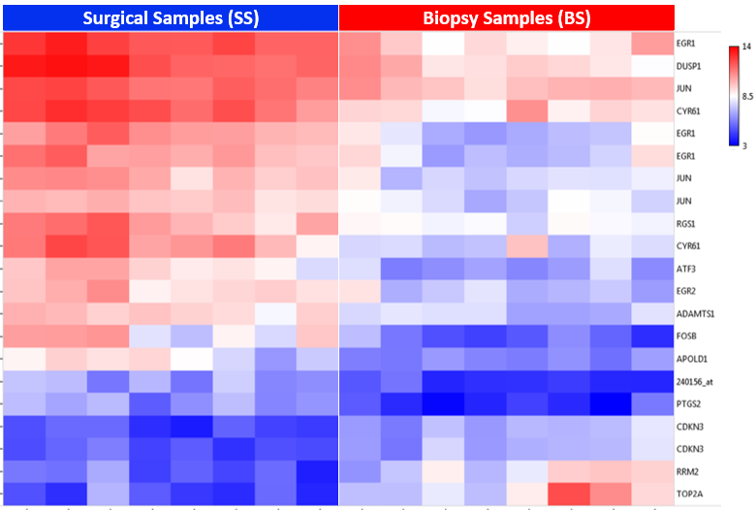

**Supplementary Figure 1.** Heatmap of pCR patients (BS vs SS). Blue areas: low gene expression, red areas: high gene expression. Top row: Blue is for SS and red for BS tissues Each column represents a patient sample and each row, a single probe. Official symbols for gene or probe identification are displayed in the right side.

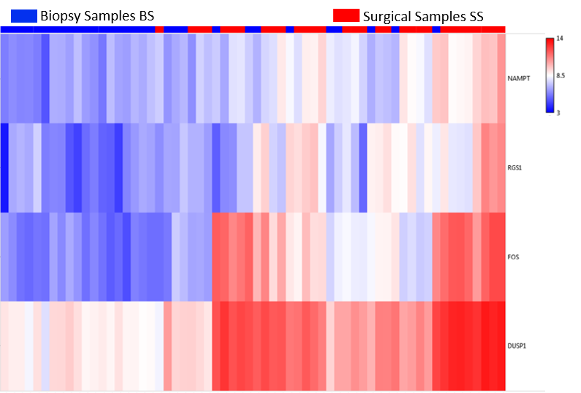

**Supplementary Figure 2.** Heatmap of non-pCR patients (BS vs SS). Blue areas: low gene ex-pression and red areas, high gene expression. Top row: BS (blue) and SS (red). Each column represents a different sample, and each row is for a single probe. Official symbols for gene or probe identification are displayed in the right side.

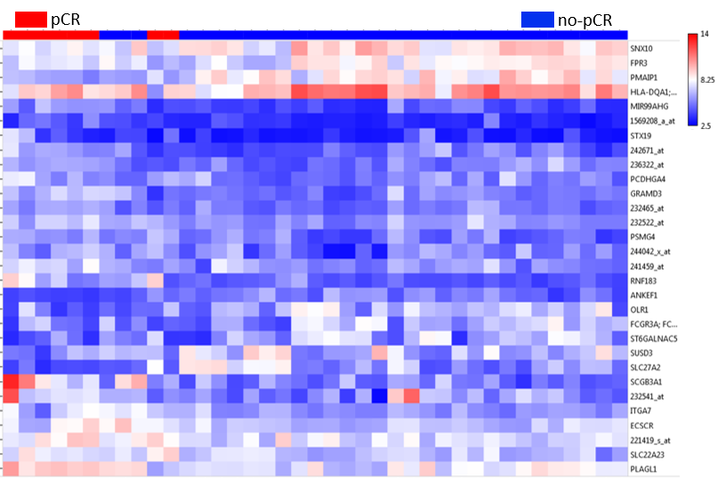

**Supplementary Figure 3**. BS tissue comparisons between non-pCR (n = 31) and pCR (n = 8). Profile of 30 probes representing 21 genes (11 over and 10 subexpressed in pCR, Fold Change: +2, *p*-value: ≤ 0.01). Blue areas: low gene expression, red areas: high gene expression. Top row. Blue: non-pCR patients and red: pCR patients. Each column represents a different patient sample and each row, a single probe. Official symbols for gene or probe identification are displayed in the right margin.

|  |  |
| --- | --- |
| A | B |
| C | D |

|  |  |
| --- | --- |
| E | F |
| G | H |

**Supplementary Figure 4.** Validation by qPCR (*NUSAP1*, *KIAA0101*, *DST*, and *MME*). **A and B** represent expression of *NUSAP1* and *KIAA0101* analyzed by qPCR, respectively. **C and D** represent expression levels of *NUSAP1* and *KIAA0101*, respectively, according to the expression signal after normalization with RMA from the microarray data. **E and F** represent expression of *DST* and *MME* analyzed by qPCR, respectively. **G and H** represent expression levels of *DST* and *MME*, respectively, according to the expression signal after normalization with RMA from the microarray data. The red lines represent the non-pCR patient group and the blue lines, the pCR group. The unpaired *t* test with Welch's correction was used for comparisons.



**Supplementary Figure 5.** Expression levels of *NUSAP1* according to the molecular subtype after the NCT (SS). LA = Luminal A, LB = Luminal B, TN = Triple Negative. One-way ANOVA and Holm-Sidak's multiple comparisons test were used for comparisons.

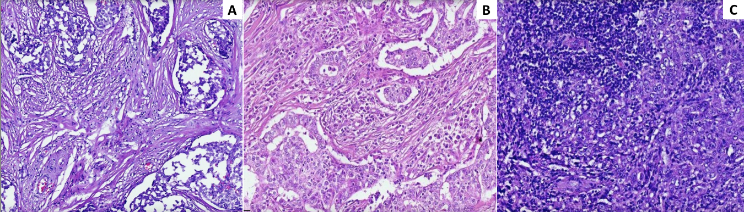

**Supplementary Figure 6.** Microscopic evaluation of TILs (A) Low TILs 10X. Fibrous stroma is observed between the tumor cells, with little lymphoplasmacytic infiltrate in a percentage of 5%. (B) Moderate TILs 10X. Moderate lymphoplasmacytic infiltrate is seen in the tumoral stroma in a percentage of 30%. (C) High TILs 10X. Dense lymphoplasmacytic infiltrate observed in the stroma between the neoplastic cells in the upper left area in a percentage of 80%.

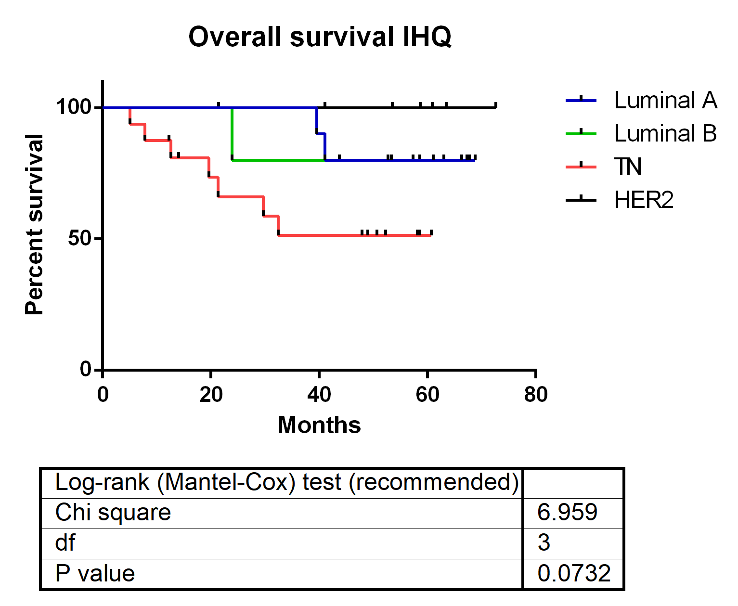**Supplementary Figure 7.** Overall survival according to the molecular subtype after the NCT (SS). LA = Luminal A, LB = Luminal B, TN = Triple Negative. Log-rank (Mantel-Cox) test were used for comparisons.

**Supplementary Table 1.** Probes differentially expressed in pCR and non-pCR surgical samples.

|  |  |  |  |  |  |  |  |
| --- | --- | --- | --- | --- | --- | --- | --- |
| **ID** | **Cx: NR Avg (log2)** | **Cx: pCR Avg (log2)** | **Fold Change** | ***p*-val** | **FDR P-val** | **Gene Symbol** | **Description** |
| 206825_at | 5.61 | 9.57 | -15.5 | 0.0002 | 0.0243 | *OXTR* | oxytocin receptor |
| 206742_at | 4.39 | 8.18 | -13.86 | 3.92E-06 | 0.0049 | *FIGF; PIR-FIGF* | c-fos induced growth factor (vascular endothelial growth factor D); PIR-FIGF readthrough |
| 230867_at | 4.8 | 8.1 | -9.84 | 0.0002 | 0.0274 | *COL6A6* | collagen, type VI, alpha 6 |
| 214023_x_at | 4.74 | 7.45 | -6.54 | 7.30E-05 | 0.0186 | *TUBB2B* | tubulin, beta 2B class IIb |
| 222717_at | 5.7 | 8.39 | -6.48 | 0.0002 | 0.0279 | *SDPR* | serum deprivation response |
| 235236_at | 3.21 | 5.86 | -6.29 | 2.50E-05 | 0.0124 | *FAM196B* | family with sequence similarity 196, member B |
| 1552509_a_at | 4.21 | 6.77 | -5.93 | 0.0002 | 0.029 | *CD300LG* | CD300 molecule-like family member g |
| 223541_at | 4.98 | 7.49 | -5.7 | 6.60E-06 | 0.0067 | *HAS3* | hyaluronan synthase 3 |
| 240717_at | 3.11 | 5.61 | -5.68 | 7.51E-10 | 2.05E-05 | *ABCB5* | ATP binding cassette subfamily B member 5 |
| 1556427_s_at | 5.89 | 8.2 | -4.95 | 0.0001 | 0.021 | *LRRN4CL* | LRRN4 C-terminal like |
| 1553243_at | 5.33 | 7.56 | -4.72 | 0.0002 | 0.0255 | *ITIH5* | inter-alpha-trypsin inhibitor heavy chain family, member 5 |
| 210432_s_at | 3.77 | 5.94 | -4.51 | 0.0001 | 0.0213 | *SCN3A* | sodium channel, voltage gated, type III alpha subunit |
| 1558820_a_at | 5.1 | 7.2 | -4.3 | 0.0002 | 0.025 | *CCDC178* | coiled-coil domain containing 178 |
| 229118_at | 4.13 | 6.18 | -4.12 | 0.0001 | 0.0214 | *PRRG3* | proline rich Gla (G-carboxyglutamic acid) 3 (transmembrane) |
| 203435_s_at | 6.16 | 8.17 | -4.02 | 6.74E-06 | 0.0067 | *MME* | membrane metallo-endopeptidase |
| 230644_at | 4.48 | 6.47 | -3.97 | 7.98E-05 | 0.0193 | *LRFN5* | leucine rich repeat and fibronectin type III domain containing 5 |
| 228368_at | 5.33 | 7.31 | -3.96 | 1.43E-06 | 0.0028 | *ARHGAP20* | Rho GTPase activating protein 20 |
| 203951_at | 6.91 | 8.86 | -3.86 | 0.0001 | 0.0241 | *CNN1* | calponin 1, basic, smooth muscle |
| 229308_at | 5.2 | 7.14 | -3.85 | 9.59E-05 | 0.0204 | *ANKRD29* | ankyrin repeat domain 29 |
| 229357_at | 7.65 | 9.54 | -3.71 | 0.0002 | 0.0276 | *ADAMTS5* | ADAM metallopeptidase with thrombospondin type 1 motif 5 |
| 216918_s_at | 4.46 | 6.34 | -3.69 | 0.0001 | 0.0213 | *DST* | Dystonin |
| 203434_s_at | 5.96 | 7.82 | -3.62 | 0.0002 | 0.0279 | *MME* | membrane metallo-endopeptidase |
| 235335_at | 3.32 | 5.16 | -3.57 | 1.57E-08 | 0.0002 | *ABCA9* | ATP binding cassette subfamily A member 9 |
| 1556936_at | 3.39 | 5.2 | -3.5 | 7.34E-06 | 0.0068 | *GAS1RR* | GAS1 adjacent regulatory RNA |
| 204482_at | 7.2 | 8.94 | -3.35 | 7.82E-05 | 0.0192 | *CLDN5* | claudin 5 |
| 204793_at | 6.56 | 8.29 | -3.31 | 0.0002 | 0.0244 | *GPRASP1* | G protein-coupled receptor associated sorting protein 1 |
| 206030_at | 4.26 | 5.98 | -3.3 | 0.0001 | 0.0235 | *ASPA* | Aspartoacylase |
| 214505_s_at | 5.64 | 7.36 | -3.29 | 0.0002 | 0.0292 | *FHL1* | four and a half LIM domains 1 |
| 223496_s_at | 4.75 | 6.43 | -3.21 | 0.0002 | 0.0257 | *CCDC8* | coiled-coil domain containing 8 |
| 226303_at | 5.2 | 6.82 | -3.08 | 8.80E-05 | 0.0199 | *PGM5* | phosphoglucomutase 5 |
| 236359_at | 5.54 | 7.13 | -3.03 | 0.0001 | 0.0231 | *SCN4B* | sodium channel, voltage gated, type IV beta subunit |
| 201563_at | 8.23 | 6.54 | 3.23 | 0.0002 | 0.0244 | *SORD* | sorbitol dehydrogenase |
| 222067_x_at | 7.06 | 5.31 | 3.38 | 0.0002 | 0.0287 | *HIST1H2BD* | histone cluster 1, H2bd |
| 217755_at | 7.74 | 5.97 | 3.42 | 9.34E-05 | 0.0204 | *HN1* | hematological and neurological expressed 1 |
| 201690_s_at | 11.17 | 9.39 | 3.43 | 3.72E-05 | 0.0145 | *TPD52* | tumor protein D52 |
| 218782_s_at | 6.82 | 4.99 | 3.56 | 0.0001 | 0.0227 | *ATAD2* | ATPase family, AAA domain containing 2 |
| 204092_s_at | 6.76 | 4.73 | 4.06 | 0.0003 | 0.0297 | *AURKA* | aurora kinase A |
| 201689_s_at | 9.54 | 7.42 | 4.32 | 1.47E-05 | 0.01 | *TPD52* | tumor protein D52 |
| 222740_at | 6.97 | 4.84 | 4.39 | 0.0002 | 0.0257 | *ATAD2* | ATPase family, AAA domain containing 2 |
| 204285_s_at | 7.69 | 5.55 | 4.4 | 0.0001 | 0.021 | *PMAIP1* | phorbol-12-myristate-13-acetate-induced protein 1 |
| 214710_s_at | 7.35 | 4.99 | 5.11 | 8.16E-05 | 0.0194 | *CCNB1* | cyclin B1 |
| 202503_s_at | 9.08 | 6.55 | 5.75 | 9.19E-05 | 0.0204 | *KIAA0101-* | KIAA0101/PCLAF |
| 201688_s_at | 7.75 | 5.2 | 5.85 | 3.47E-06 | 0.0047 | *TPD52* | tumor protein D52 |
| 223229_at | 7.2 | 4.63 | 5.91 | 6.98E-05 | 0.0183 | *UBE2T* | ubiquitin conjugating enzyme E2T |
| 202954_at | 7.91 | 5.33 | 5.96 | 0.0002 | 0.0264 | *UBE2C* | ubiquitin-conjugating enzyme E2C |
| 219978_s_at | 6.79 | 4.2 | 6.01 | 0.0003 | 0.0298 | *NUSAP1* | nucleolar and spindle associated protein 1 |
| 209773_s_at | 7.75 | 5.11 | 6.25 | 0.0001 | 0.0218 | *RRM2* | ribonucleotide reductase M2 |
| 201890_at | 8.37 | 5.46 | 7.52 | 0.0001 | 0.0226 | *RRM2* | ribonucleotide reductase M2 |