**Squeezing Water Clusters within Anthracene Dimers**

Estefania Rossich Molina,[a] Bo Xu,[b] Oleg Kostko,[b] Musahid Ahmed,*[b]

Tamar Stein*[a]

[a] Dr. E.R. Molina, Dr. T. SteinTitle(s), Initial(s), Surname(s) of Author(s) including Corresponding Author(s)  
Fritz Haber Research Center for Molecular Dynamics, Department of Chemistry  
InstitutionThe Hebrew University of Jerusalem  
Givaat Ram 9190401, Israel  
E-mail: [tamar.stein@mail.huji.ac.il](mailto:tamar.stein@mail.huji.ac.il), mahmed@lbl.gov

[b] B.Xu, O. Kostko, Dr. M. Ahmed  
Chemical Sciences, Berkeley   
Division Lawrence Berkeley National Laboratory  
California 94720, USA

Supporting information for this article is given via a link at the end of the document.((Please delete this text if not appropriate))

**Abstract:**. The interactions of water clusters with polycyclic aromatic hydrocarbon (PAH) are of paramount interest in many chemical and biological processes. We study anthracene monomer and dimer with water (up to four) cluster systems using a molecular beam vacuum-UV photoionization mass spectrometry experiments and density functional calculations. Loss of structure in the photoionization efficiency curves when adding water indicates that various isomers are generated in the experiment, while theory shows that photoionization states of different isomers demonstrate only a slight shift in energy. Calculations reveal that the energetic tendency of water is to stay clustered with itself and not to disperse around the PAH. We observe water confinement exclusively in the case of four water clusters and only when the anthracenes are in a cross configuration due to optimal OH $⋯π$ interactions, indicating it depends on the size and structure of the PAH. Structural changes in the water occur upon ionization of the anthracene, guided by the optimal interaction of the resulting hole and the water hydrogens.

Introduction

The non-covalent interactions of polyaromatic hydrocarbons (PAHs) with water have drawn much attention due to their importance in chemical, environmental, astrochemical, and biological processes.1 Small PAHs can act as a model for understanding water graphite and graphene interactions,2 driven by the huge societal interest in water purification and hydrogen production in the confinement of carbon nanotubes.3 This is thanks to the nature of water interactions in nanometer-scale pores and capillaries. There are suggestions that water takes on an increased structural order in nanoconfined geometries, resulting in a technological application of acene type molecules;4 embedding them within synthetic nanostructures allows for fast transport of water through membranes.5, 6 There is as well interest in how aromatic systems with $π$ clouds7 can be used for molecular recognition8, what is relevant both in sensing and medical applications. In cold interstellar regions, PAHs can freeze on icy mantles formed on dust grains,9 where UV and VUV processing can occur on these ices. The subsequent photochemistry can be ion or radical-mediated, giving rise to possibly complex new molecules due to dehydrogenation, charge or proton transfer that occur after the initial ionization event.10 There is much discussion on how PAHs embedded in water ice can lead to a lowering of ionization energies during UV processing.11

In the last few years, increasingly sophisticated experimental and theoretical tools have been brought to bear on understanding PAH and water cluster interactions. Rotational and IR spectroscopy on a series of PAHs solvated by water cluster showed subtle non-covalent intermolecular interactions.12-15 Ion mobility coupled with density functional theory (DFT) was used to study naphthalene water and methanol clusters thermodynamics.16 It was postulated that in the case of water, there is external solvation, and upon clustering, chains mediated by CH $⋯$ O interactions are formed. Vibrational and electronic spectroscopy revealed that in protonated naphthalene water monomer, the proton is located on the naphthalene, and that the process is dramatically reversed with the addition of a second water.17 In related work, the electronic spectroscopy of anthracene water clusters was mapped out almost three decades ago with resonant photoionization.18 Using ion thermochemistry, it was shown19 that there was no reaction between the naphthalene cation and water. However, the reaction with the naphthyl radical was facile. Infrared spectroscopic studies20 of naphthalene-water monomer and dimer have been extended to larger water clusters of up to five to reveal the differences between benzene and the effects of adding a ring to solvation.21 Anion two-dimensional photoelectron spectroscopy revealed that incremental solvation of anionic anthracene by up to five water molecules led to enhanced formation mediated by a bound excited state of the anion.22

Due to the great importance of a molecular-level understanding of PAH water interactions, many theoretical studies have focused on important bonding patterns governing those interactions. The electronically excited states, binding energies (BE) and hydrogen bonding interactions have been studied using wave-function and DFT methods on the naphthalene water hexamer system. The interaction of the water cluster with the aromatic rings is via OH $⋯π$ and CH $⋯$ O type interactions. OH $⋯π$ interactions were found to dominate, and the $π-π^{*}$ transition in naphthalene was redshifted upon solvation by the water cluster. An empirical potential was used to model the interactions of 20 water clusters around C60, coronene and corannulene cations.23 The salient finding was that a water cluster was formed next to the ion and that the (H2O)4X+ species, where X is the relevant PAH, was often the most stable. An analysis of the binding energies and the dynamics indicated that water-water interactions dominated over the water seed interactions suggesting that water does not wet the hydrocarbon. Hirunsit and Balbuena24 used benzene and naphthalene complexed with water clusters (1- 4) to study the optimal interactions. They claim that water tends to maximize the number of hydrogen bonds above the surface and form a cyclic network. A recent high-level theoretical calculation of the water dimer on naphthalene confirms the suggestion that OH···O interactions dominate, leading to a dimer sitting on the surface, with the hydrogen of the waters interacting with the $π$ cloud and one of the oxygen interacting with the hydrogens of the naphthalene.25 Hirunsit and Balbuena24 also probed the effects of confinement of water clusters on the properties of water and proton transfer. Interestingly, confining the water cluster between two naphthalene molecules was only obtained by imposing constraints on the systems. Lifting the constraints resulted in a rearrangement of the confined structure to a non-confined structure. Directly relevant to the present study are a series of theoretical papers which discuss the energetics and structures of PAHs' clusters,26 particularly the dimerization of anthracene.27, 28

In a recently published study of naphthalene-water clusters using a combined experimental and theoretical approach, we demonstrated that different channels of ionization of the naphthalene-water clusters depend on the energy of the ionizing photon. When the photon energy is below the water ionization value threshold, the naphthalene moiety of the cluster is ionized, and no protonated naphthalene water clusters are observed.29 The study showed that rearrangements of the water sub-cluster upon ionization enhance their charge dipole interactions and other induced interactions with cationic naphthalene while maintaining the hydrogen bonding network. There is proton transfer within the water-sub-cluster and hydroxyl radical emission when ionization occurs above the water ionization threshold. In addition, the generated hydroxyl radical can also react with naphthalene to form an adduct, and the remaining waters solvate the proton.

Here, we study the structural motifs and photoionization dynamics of anthracene water clusters with synchrotron-based VUV photoionization mass spectrometry measurements coupled to a supersonic molecular beam expansion. The experimental results are coupled with electronic structure calculations to elucidate the effect of water on the photoionization dynamics of anthracene and its dimer. We analyze the possible isomers formed in the molecular beam (before and after ionization) containing monomer and dimer anthracene with up to four water molecules. We study different possible isomers corresponding to the different orientations of the water clusters with respect to the anthracene monomers and dimers. The photoionization efficiency (PIE) curve suggest that various isomers are formed in the experiment. Our results demonstrate that the energetic tendency of the water clusters is to stay clustered together. In addition to the hydrogen bonds between the water molecules, hydrogen bonds also form with the aromatic ring, which dictates the stability of the different isomers. Ionization of the anthracene leads to structural changes in the water clusters. Water confinement inside two anthracenes is not energetically preferred in the case of one to three water molecules, similar to previous results on water confinement within two naphthalene units. However, unlike the naphthalene case, four water clusters can be confined between two anthracenes when they are in cross configuration due to an additional stabilizing OH $⋯π$ interaction.

Results and Discussion

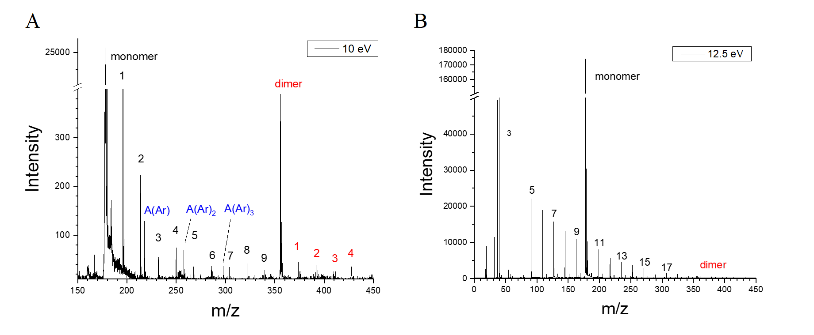

**Figure 1** Mass spectra of anthracene water clusters recorded at (A) 10 eV and (B) 12 eV photon energy, with Ar backing pressure of 820 Torr, and heater temperature of 381 K.

Experimental mass spectra are presented in Figure 1. As one can see in Figure 1A, we detected an anthracene monomer structure with 1 to 9 water molecules and a dimer structure with 1 to 4 water molecules at a photon energy of 10 eV. Our supersonic expansion is cold enough to also generate anthracene clustered with one, two and three argon atoms. In contrast to naphthalene water clusters, the mass spectra show that is relatively difficult to form clusters of anthracene with water, however the signal intensity is sufficient for us to generate PIE curves for these clusters. Figure 1B shows the distribution of water clusters that are also formed in the molecular beam upon photoionization at 12.5 eV, where all water clusters will have ionized. The mass spectra alone reveal that the binding of water to anthracene is minor compared to anthracene and water distributions. However, it does provide a template for the theoretical results presented later.

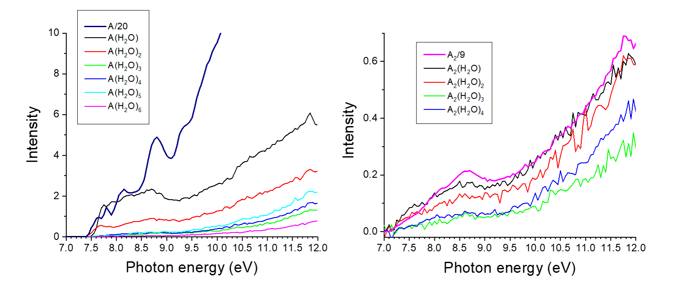

**Figure 2** Photoionization efficiency curves and appearance energy determinations of anthracene water clusters. The intensity of anthracene monomer and dimer are divided by 20 and 9 respectively to be displayed on the same scale as that of the anthracene water clusters.

Figure 2 A and B show the PIEs for anthracene and anthracene dimer respectively clustered with water. While the anthracene monomer exhibits a structured curve, a less structured curve is observed for the dimer case. The anthracene monomer curve fits earlier experimental determination extremely well (see SI Figure S1). The addition of one water molecule to anthracene leads to a dramatic change in the shape, the peaks tend to shift and broaden out and this trend continues with the addition of a second water molecule. Adding additional water molecules makes the curves resemble each other, with no discernable structure. In Figure 2B, we see that upon dimerization, the structure also tends to smoothen out, compared to the monomer, and that the addition of water leads to almost similar shaped PIE’s. The ionization energies extracted from these PIE curves, and the general change in shape upon dimerization of anthracene and clustering of water are described together with the theoretical calculations later in the text.

**Theoretical Results:**

To computationally model the experimental results, we start by studying the structures of neutral clusters containing anthracene and water formed prior to photoionization. We then re-optimize the structures on the cationic surface to model structural changes following ionization. To study the mutual effect of the aromatic ring and the water cluster, we focus on the water clusters containing one to four water molecules complexed with the anthracene monomer and dimer.

**Neutral Anthracene Water Clusters**

It was previously demonstrated that the naphthalene water sub-clusters could be in different orientations with respect to the aromatic ring; specifically, two orientations were reported, an "on-top" orientation and a "side" orientation, with a general preference for the "on-top" orientation (only with two water molecules is the side orientation more stable).29

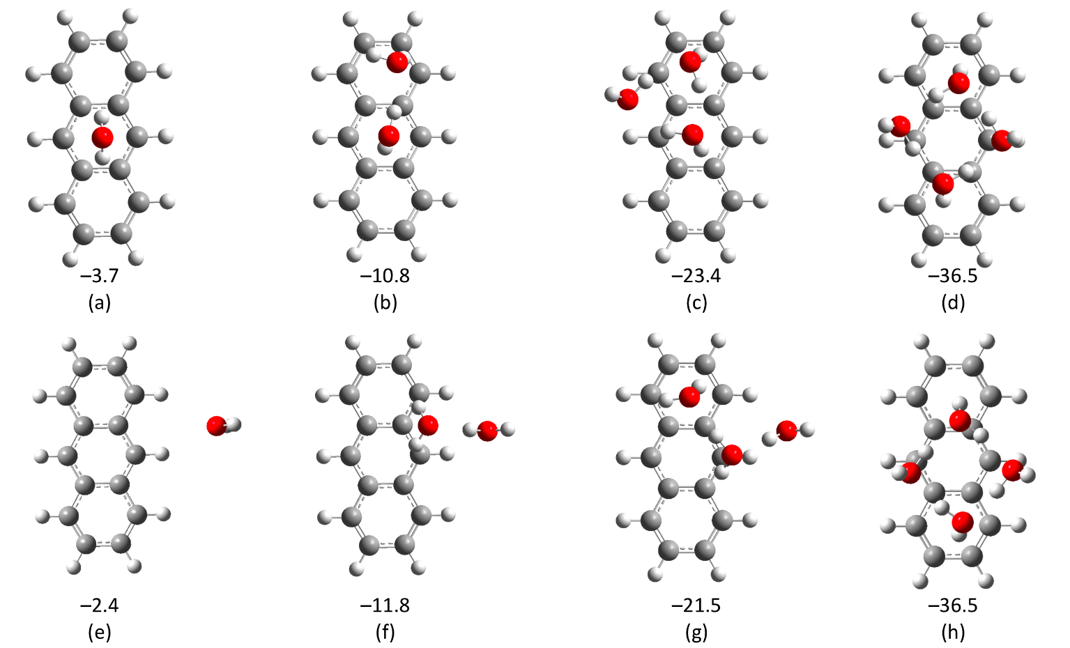

Figure 3 Top: Anthracene with water sub-cluster in the "on-top" orientation. Bottom: Anthracene with water sub-cluster in the "side" orientation. BEs are given in kcal/mol.

Figure 3 presents anthracene water clusters in the two discussed orientations. Here, we observe that the preference of the water cluster is to form sub-clusters similar to those found in isolated water clusters30, 31 on top of the anthracene ring. This orientation is more stable in all cases except in the case of two water molecules where the "side" orientation is more stable, similar to the trends reported for the naphthalene case.29 In the case of four water molecules, the two initial structures ("side" and "on-top") converged to the same minima, where the water forms an optimal sub-cluster on top of the aromatic ring.

The structures of the anthracene dimer were calculated to explore possible orientations of the water sub-clusters on it. Results of different isomers of anthracene dimer are presented in Figure 4. For each isomer, we report the BE, which is calculated according to $BE=E_{dimer}-2{×E}_{anthracene}$.

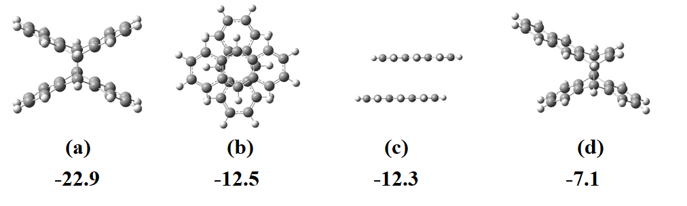

Figure 4 Structure of neutral anthracene dimers. Structure (a) is a bonded structure in which a bond is formed via a bridge between the central rings, and structure(d) is a bonded structure where the bond is formed via a terminal ring of one anthracene and the central ring of the second anthracene. Structures (b) and (c) are stacked configurations with different orientations of the anthracene units.

The most stable dimer structure is (a), where the two units of anthracene are bonded via a bridge between the central rings, with BE of -22.9 kcal/mol. Structures (b) and (c) are stacked configurations with a slight difference of 0.2 kcal/mol in their BEs. Structure (d) is also a bridge structure, albeit here, the bridge is formed between the central ring of one unit and a terminal ring of the second unit. In this case, the isomer is the least stable and has the lowest BE of the set of the studied isomers.   
Structure (a) is the result of [4+4]-cycloaddition on anthracene which can form upon exposure to radiation and is thus unlikely to form under the neutral expansion conditions reported here.

We now turn to calculate structures of the anthracene dimer with water clusters, Wn, (n=1-4) as observed in the experiment. When interacting with the dimer, the water cluster can hinder the interaction between the two anthracene molecules resulting in the following configurations:

* All the waters molecules located between the two anthracene molecules (A-W-A)
* Interspersed configuration, where the anthracene and waters are in layers (W-A-W-A)

Alternatively, the anthracene dimers can remain intact. Two kinds of configurations are possible in this case:

* All water molecules are on top of the anthracene dimer (W-A-A)
* The water molecules are divided such that part of the water molecules are on top of the dimer, and the rest are below it. (W-A-A-W)

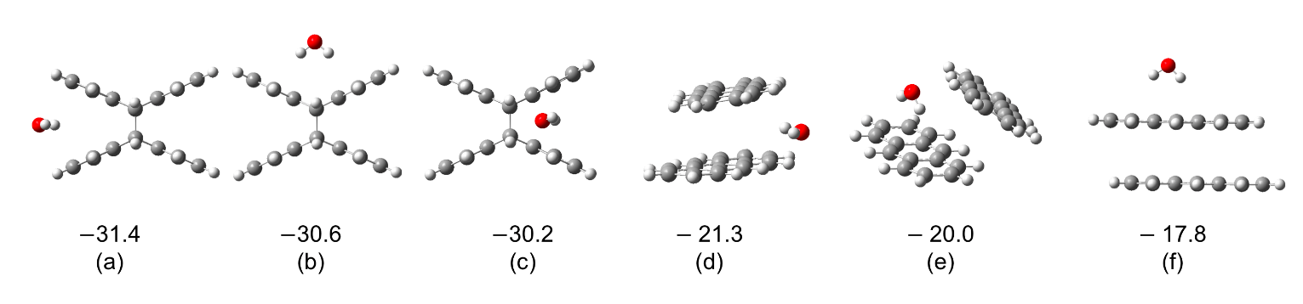

**Figure 5**: Structures and BEs of two anthracene + one water molecules complexes. All energies are given in kcal/mol.

Figure 5 presents the results for a neutral complex of two anthracene molecules with one water molecule, and their BE is calculated via: $E_{BE}=E_{complex}-E_{water}-{2×E}_{anthracene}$. The most stable structures with the largest BEs are structures 5(a), 5(b) and 5(c) with BEs of -31.4, -30.6 and -30.2 kcal/mol, respectively. The considerable stability follows the trend of the isolated dimer, with the bonded structure being the most stable. Here we can see that there is a slight preference for the structure with oxygen pointing toward the carbon-carbon bond between the two anthracenes. Structures 5(d) and 5(e) follows with BEs of -21.3 and -20.0 kcal/mol, respectively. In structure (d), the calculation starts in an orientation in which the water lies between the two anthracenes in the dimer structure; however, we observe that this situation is not favorable, and during the optimization, the water does not stay within the anthracenes and moves to the side. The hydrogens of the water points into the dimer, and the distances between the oxygen of the water and the four closest hydrogens of the anthracene are between 2.5Å to 3.0Å. In structure (e), the starting point of the calculation had the water inside the dimer structure, and again we observe a movement in the structure so that the water is not confined. The hydrogens of the water molecule point toward the $π$ electrons of the bottom anthracene, and the distance between the two closest hydrogens of the top anthracene and the oxygen of the water is 2.5Å and 2.4Å. Clusters (d) and (e) are more stable than structure (f) as a result of the water interacting with two anthracene units, unlike structure (f), in which the water molecule is located above the dimer and only interacts with one anthracene. Structure (f) is the least stable structure.

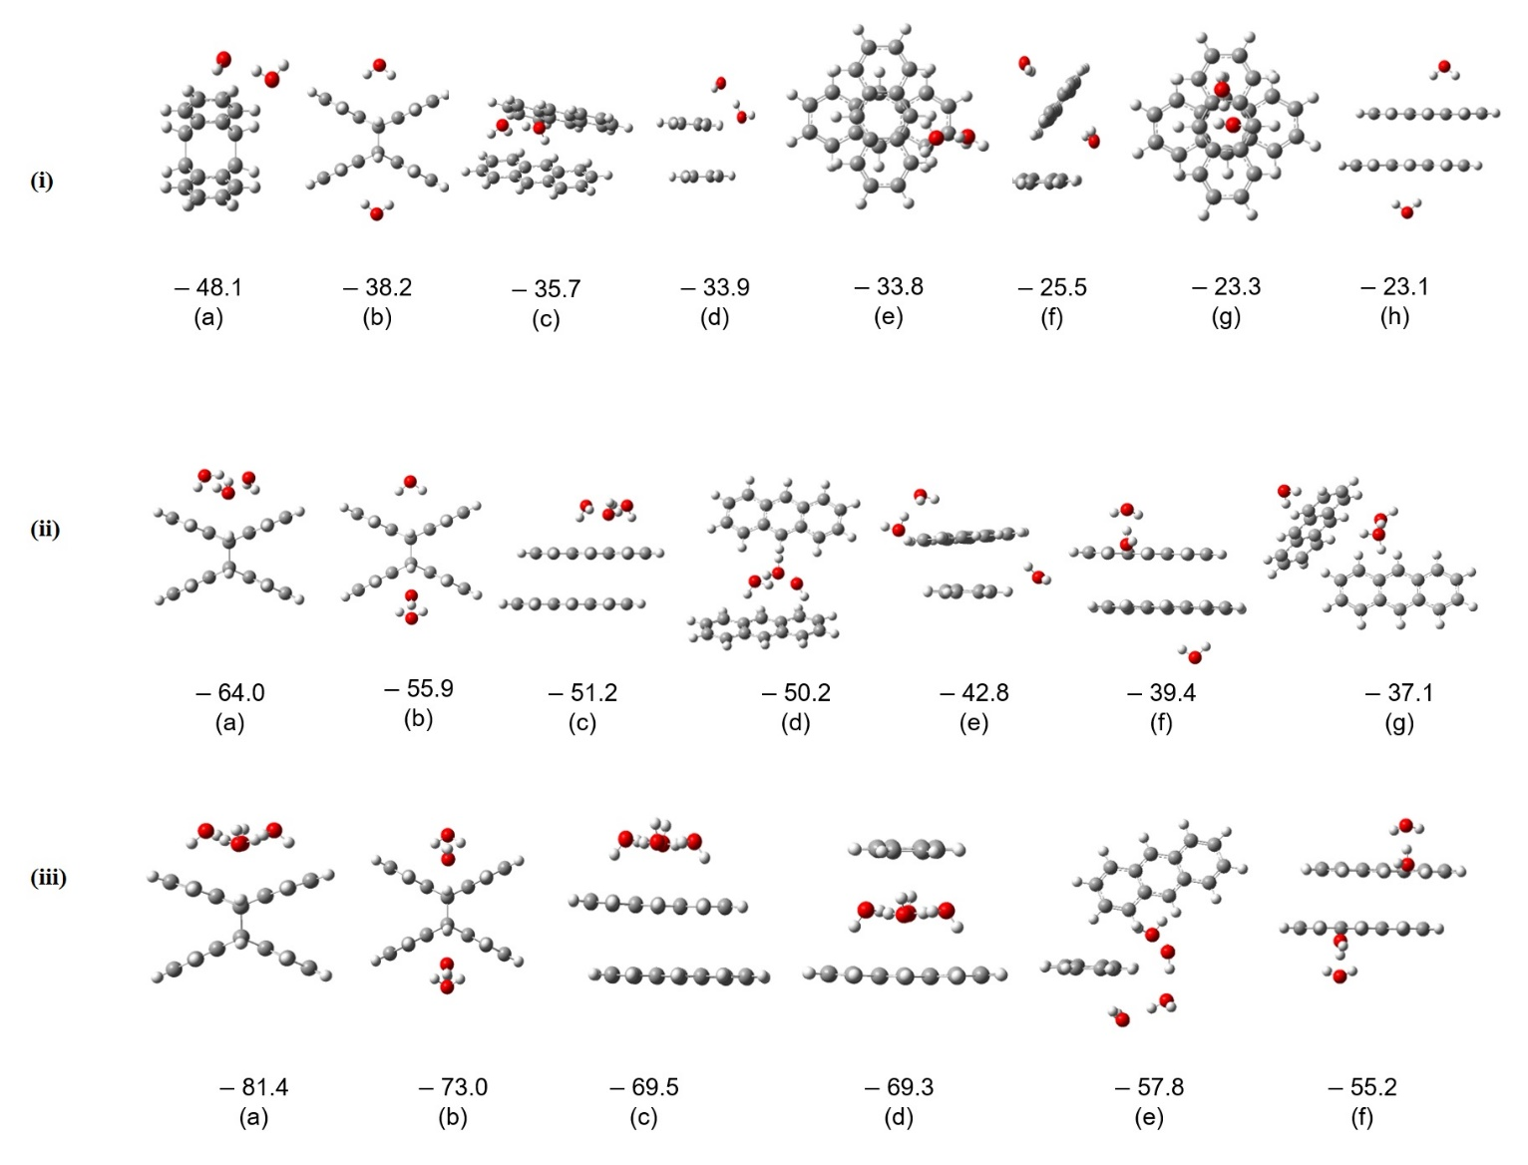

**Figure 6:** Panel (i): Anthracene dimer cluster with two water molecules, panel (ii): Anthracene dimer cluster with three water molecules, and panel (iii): anthracene dimer cluster with four water molecules. BEs are in kcal/mol.

Similar trends can be seen in the case of the two, three and four water sub-clusters. The corresponding structures and their BEs are presented in Figure 6. The stability trends follow those observed for the isolated anthracene dimers; bonded structures are more stable than the non-bonded structures. In all cases, the structures with the largest BE correspond to the bonded anthracene dimer complexed with water sub-clusters on top of them. The following stable structure is again bonded anthracene, but with the water cluster divided below and on top of the dimers. This trend in the BEs reveals the tendency of the water clusters to stay clustered together and is consistent with the cases of three and four water molecules. There is a significant difference between the BEs when the water stays clustered and the water cluster being divided for the case of two (panel (i)), three (panel (ii)) and four (panel (iii)) water molecules in the cluster, respectively. These results indicate that the water molecules tend to cluster and not solvate the PAHs. In all cases, the following stable structure is the non-bonded anthracene dimer in which the water molecules stay clustered to one another. For the two water cases (Figure 6 panel (i)), structure (i-c) is the following stable structure. As observed in the case of one water molecule, the water sub-cluster (which starts between the anthracene units) moves to the side so that both anthracenes interact with each other and with the water sub-cluster. Next are the structures (i-d) and (i-e), which are very close in energy. In these structures, the water sub-cluster mainly interacts with one of the anthracene units, which leads to a decrease in the BE. The least stable structure, (i-h), has the water sub-clusters divided; structure (i-f) is slightly more stable as one of the water molecules interacts with both anthracenes. Similar trends are seen in the case of three and four water molecules in the sub-cluster.

**Ionized Clusters**

We next turn to the study of photoionized anthracene water clusters since these are the ones observed in the experiments. Figure 7 presents the structures of one anthracene complexed with different number of water clusters. As in the neutral case, two possible orientations are possible. In the top orientation the water stays as a cluster on top of the anthracenes, as shown in Figure 7(i). As the system is now charged (specifically, the anthracene bears a +1 charge), the water rotates so that the oxygen atoms point toward the anthracene. In addition, we observe structures in which the water clusters are on the side of the anthracene and form a chain of hydrogen bonds wherein one oxygen from water forms a hydrogen bond with the hydrogens of the anthracene, and then forms a chain of water as shown in Figure 7(ii). In the case of four water molecules, the system starting from a side-chain orientation converges to a cyclic water cluster on the side of the anthracene. As can be seen in Figure 7, the side orientation is more stable than the top orientation for the cases of one and two water molecules, while for the cases of three and four molecules, the top orientation is the most stable, in line with a previous study performed on naphthalene.29

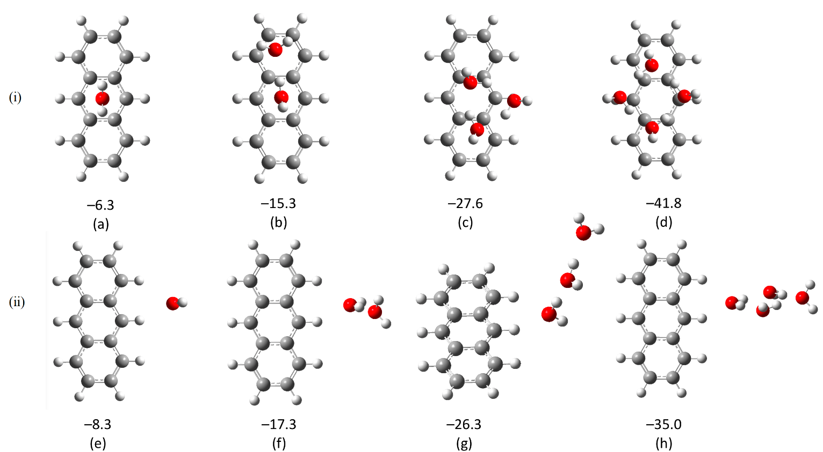To study the effect of the ionization on the structure of the anthracene dimer water system (A2Wn) we first studied ionized anthracene dimers separately, as we observed that for the neutral cluster, trends in the stability of the anthracene dimers are preserved when water clusters are present. Re-optimization of the neutral dimers on the cationic surface leads to the structures shown in Figure 8.

**Figure 7:** Anthracene dimer complexed to water clusters of various sizes. Top panel: "on-top" orientation. Bottom panel: "side" orientation. BEs are given in kcal/mol.

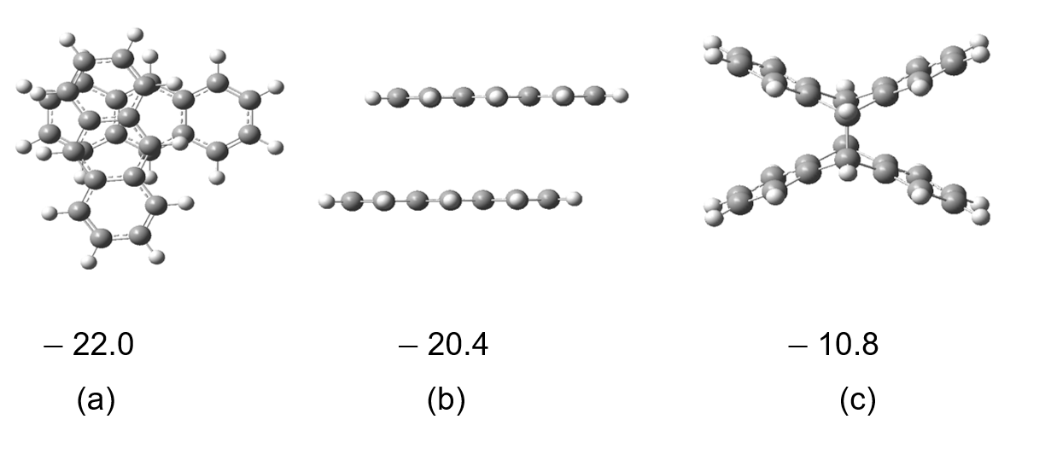Interestingly, upon ionization, the trends in the dimer are reversed, and the energetic preference for the cationic dimer is not to be covalently bonded; in fact, here, the BE of the covalently bonded structure, (c), is about 10 kcal/mol less than the other two structures. Thus, we expect the most stable anthracene water complexes to be with water complexed to structures (a) and (b).

**Figure 8** :Optimized charged anthracene dimers. BEs are given in kcal/mol.

Figure 9 presents ionized anthracene water complexes. In Figure 9(i), anthracene dimers are complexed to a single water molecule. As expected, the most stable structures are of water complexed to the non-bonded structure, where the side orientation of the water with respect to the anthracene is preferred, in agreement with the ionized monomer case. The bonded complexes follow the non-bonded complexes, with a significant difference in the BEs between the most optimal non-bonded structure (a) and the most optimal bonded one (d).

Figure 9(ii) show the dimers with two water molecules. The trends are as follows: water molecules tend to stay together, largest BEs are for the non-bonded anthracene dimer with side orientation to the water sub-clusters (structures (a), (b) and (c)). Structure (d) is the covalently bonded structure with a two water sub-cluster on top of it. Even though the covalently bonded structure is the least preferred among the anthracene dimers, this structure is still slightly more stable than structure (e), where there is no interaction between the water molecules. The least stable structures, (f) and (g), are those with the water on separate sides of the anthracene dimer, with the non-covalent structure being more stable by 1.5 kcal/mol.

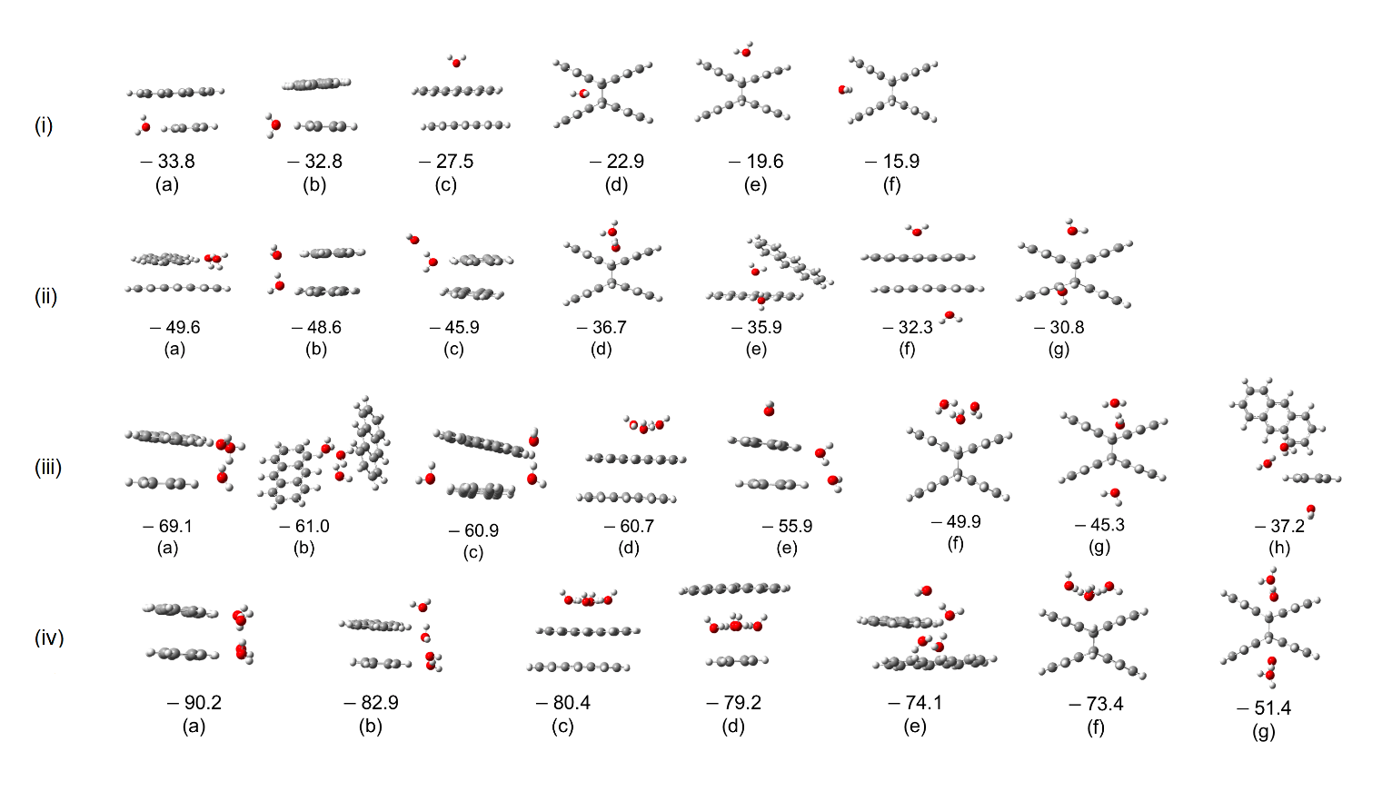Figures 9 panels (iii) and (iv) present the ionized structures with 3 and 4 water molecules, respectively. Once again, we observe that the order of stability follows the ionized anthracene dimers. The most stable structures are those with non-bonded anthracene dimers, and water tends to stay in clusters.

**Figure 9**: Ionized anthracene dimer complexed to one (i), two (ii) , three (iii) and four (iv) water molecules.

**Electronic States of Photoionized PAHs.**

Insight into the ionized electronic states can be obtained from PIE curves presented in Figure 2. Additionally, from the PIEs, we can extract the IE of the structures, which are shown in Table 1.

**Table 1** Experimental and calculated ionization energies (IE) of anthracene water (AnWn) clusters in eV. Values in grey correspond to clusters where the two anthracenes are bonded by their central ring. A2Wn clusters’ nomenclature (a to h) follows the indexing utilized in Figures 4, 5 and 6.

|  |  |  |  |  |  |  |  |  |  |
| --- | --- | --- | --- | --- | --- | --- | --- | --- | --- |
| **species** | **experimental** | **calculated** | |  |  |  |  |  |  |
| **monomer** | IE (eV) | A |  |  |  |  |  |  |  |
| A | 7.4 | 7.4 |  |  |  |  |  |  |  |
|  |  |  |  |  |  |  |  |  |  |
|  |  | W top | W side |  |  |  |  |  |  |
| AW | 7.5 | 7.6 | 7.1 |  |  |  |  |  |  |
| AW2 | 7.4 | 7.7 | 7.4 |  |  |  |  |  |  |
| AW3 | 7.5 | 7.6 | 7.5 |  |  |  |  |  |  |
| AW4 | 7.5 | 7.4 | 7.4 |  |  |  |  |  |  |
| AW5 | 7.5 | - | - |  |  |  |  |  |  |
| AW6 | 7.5 | - | - |  |  |  |  |  |  |
|  |  |  |  |  |  |  |  |  |  |
| **dimer** | IE (eV) | a | b | c | d |  |  |  |  |
| A2 | 7.1 | 7.8 | 7.2 | 7.0 | 7.2 |  |  |  |  |
|  |  |  |  |  |  |  |  |  |  |
|  |  | a | b | c | d | e | f | g | h |
| A2W | 7.2 | 7.7 | 8.0 | 7.9 | 7.1 | 7.2 | 7.2 | - | - |
| A2W2 | 7.2 | 7.9 | 8.2 | 7.1 | 7.0 | 7.0 | 7.3 | 7.5 | 7.3 |
| A2W3 | 7.3 | 7.9 | 8.0 | 7.2 | 7.0 | 6.9 | 7.2 | 7.4 | - |
| A2W4 | 7.3 | 7.8 | 7.9 | 7.0 | 7.2 | 7.1 | 7.0 | - | - |

The experimental IE of anthracene is measured to be 7.4 eV, (figure S1) in excellent agreement with the calculated value of 7.4 eV. The IE of the dimer is measured to be 7.1 eV, and this value is in agreement with the calculated values for the non-bonded dimers, which are calculated to be 7.2 eV (Figure 3 structure b) and 7.0 eV (Figure 3 structure c). Those structures are indeed the structures we anticipate will form under the experimental conditions. The bonded systems, Figure 3 (a) and (b), exhibit more significant values of IEs calculated at 7.8 eV and 7.6 eV, respectively, and indeed were not expected to form under the experimental conditions. We observe a decrease in the IE from the monomer to the dimer, in agreement with previous observations of a reduction in the appearance energy of naphthalene with additions of monomer units.29

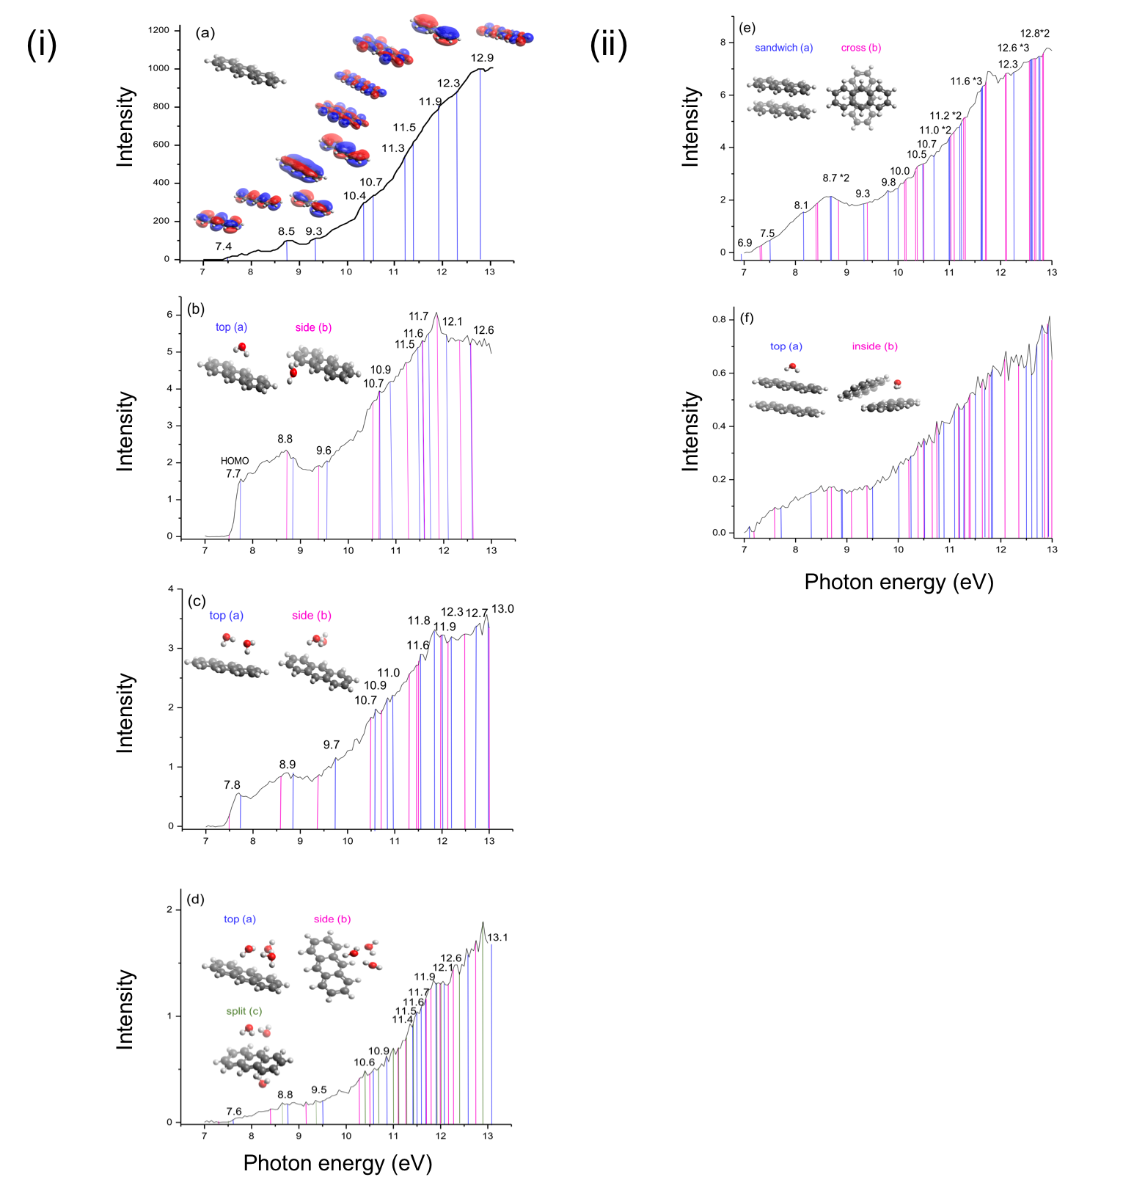To understand the trends observed in the spectra, we calculated the possible ionized states of anthracene from different electronic levels – depending on the available energy. Figure 10(i-a) presents the molecular orbitals of anthracene from which electrons can be removed, with the energy corresponding to each state. Ionization is possible from states HOMO to HOMO -9 in the experimental energy range—adding one water molecule to anthracene results in a slight shift of the energies of the ionized states, as demonstrated in Figure 10(i-b). Additionally, because more than one orientation of the water with respect to the anthracene is possible (specifically: side and on-top orientations), from each orientation we get different contributions with similar energies (in the Figure blue for the on-top orientation and pink for the side orientation). We also observe an ionized state from the water molecule (at 11.6 eV for the on-top orientation and 12.6 eV for the side orientation). The exact ionization energies are given in the SI, Table TS1. For the AW2 system (Figure 10(i-c)), again, both the on-top and the side orientation are calculated (blue and pink lines in the Figure), and both exhibit similar, slightly shifted energies to the ionized states. In this case, several more isomers are possible, likely resulting in similar energies for each ionized state of anthracene. Moreover, more ionized states are possible for each isomer (ionization can take place from up to HOMO -11). In the case of AW3 system (Figure 10(i-d)), we have calculated three different orientations (note that more are possible): top (blue), side (pink) and split (green). The energies of the ionized state of the different orientations are again similar. The abundance of lines along with an increased number of isomers results in the loss of structure in the PIE.

**Figure 10:** Ionized states calculated for different isomers corresponding to monomer with water (i) and dimer with water (ii): (i-a) A, $(i-b)AW$, ${\left(i-c\right) AW}_{2}$, (i-d) ${ AW}_{3}$, (ii-e) $A_{2}$ and ${\left(ii-f\right) A}_{2}W_{2}$. Theoretical intensities are superimposed to experimental photoionization efficiency curve and do not represent calculated intensities.

The spectrum of anthracene dimer is presented in Figure 10(ii-e). For the dimer state, there are many more possible states than for the monomer in the energy range of the experiment. Besides, more than one isomer is possible, which gives rise to a slightly different line and thus, a less structured spectrum is expected. The abundance of lines also increases when adding water molecules due to the numerous possible orientations, each contributing to the spectra, and resulting in a complete loss of structure, as observed in the experiments.

**Water confinement and the influence of ionized anthracene on the structure of 4 water cluster.**

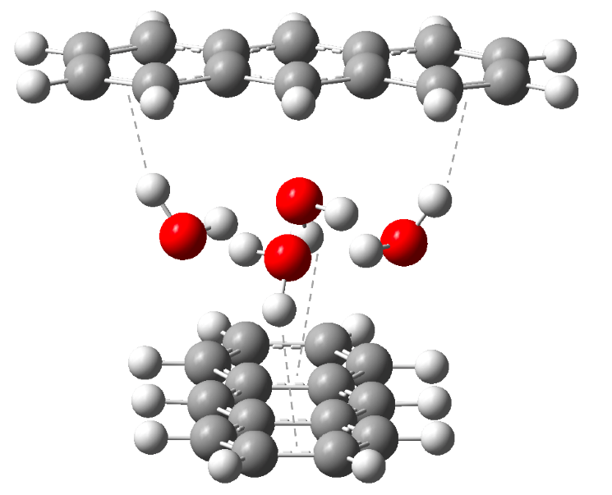In the case of neutral A2W4 we observe a stable isomer in which the water cluster is confined between the two anthracene units. In a stable isolated water cluster containing four waters, two non-contiguous hydrogens point up, and the other two point down. The confinement becomes possible only in a cross configuration of the anthracene dimer. In this configuration, the hydrogens pointing up interact via OH⋯𝜋 with the anthracene above them, and the two hydrogens pointing down interact via OH $⋯π$ with the anthracene below them as demonstrated in Figure 11.

In the case of three water cluster, two hydrogens point up, and one hydrogen points down; thus, one of the rings contain only one OH $⋯π$. The lack of the additional OH⋯𝜋 interaction with one of the anthracenes results in its rotation to maximize CH $⋯$ O interaction, and the water cluster is no longer confined. These reasons explain why confinement was not observed in the case of naphthalene with four water cluster24; due to the size of the acene, the OH $⋯π$ interactions are not optimal.

We have demonstrated that upon ionization, the water tends to stay clustered. However, structural changes in the water are observed; the calculation of the water dimer started with the optimal structure of isolated four water cluster; thus, the observed structural changes at the end of the calculations are due to the presence of the ionized dimer. To study the effect of the ionized anthracene dimer on the water sub-cluster, we calculated the root mean square deviation (RMSD) between the different structures (namely between isolated (neutral) water cluster and the water sub-cluster in structures (iv-c), (iv-d) and (iv-f) of Figure 9). The RMSD compares the coordinates of the two clusters and thus gives us a measure of the structural changes that occurred. If the structures are completely identical the RMSD would be zero. The larger the RMSD, the larger the differences between the structures.

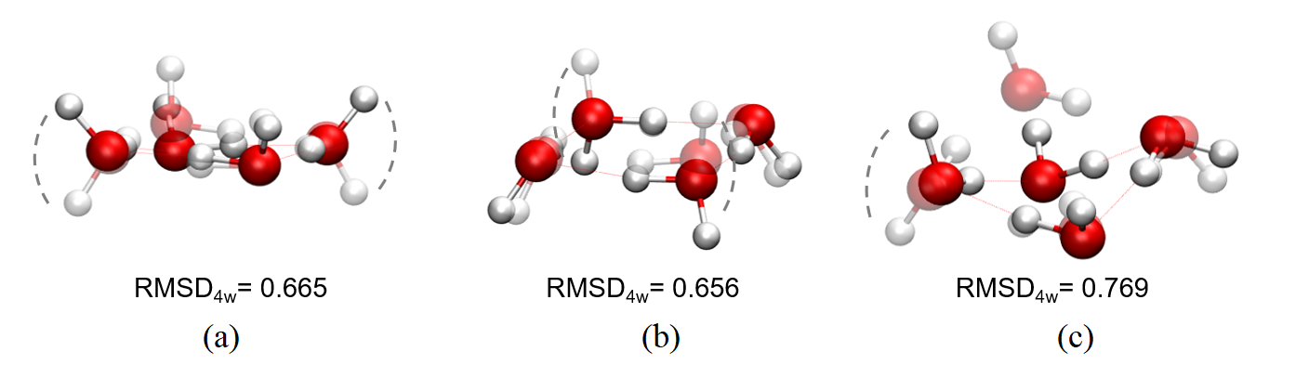Figure 12 presents visually the difference between the isolated water clusters and the water clusters in the presence of anthracene dimer taken from structures (iv-c), (iv-d) and (iv-f) of Figure 9. The RMSD values and Figure 12 (a-c) demonstrate that there is indeed structural change in the water sub-cluster. Instead of having interleaved hydrogens (one up, one down), the water cluster changes into configurations where two or more adjacent protons are pointing in the same direction (up-up or down-down). To get better insight into these changes, we calculated the hole due to ionization by comparing the electron density of the neutral structureand the cation with the neutral geometry (i.e. before structural relaxation). Results are presented in Figure 13.

**Figure 11:** Four water cluster confined in anthracene dimer in a cross configuration.

**Figure 12**: Difference of the water sub-clusters in structures (iv-c), (iv-d) and (iv-f) of Figure 9 with respect to isolated water clusters. Plain atoms: configuration of the water cluster in the presence of anthracene dimer. Transparent atoms: configuration of the isolated water cluster. For each case, the RMSD between the clusters is reported.

Observing the hole in the different structures explains the structural changes in the water clusters. For example, in the unbonded anthracene structures (a) and (b) of Figure 13, extra stabilization of the system is possible by the oxygen atoms getting closer to the hole of the molecule and the hydrogens pointing away from it. The isolated water cluster with four hydrogens pointing to the same side is 3.3 kcal/mol less stable than the water cluster where adjacent water molecules have their protons pointing in opposite directions. In the case of Figure 13 structure (c), the hole is not in the anthracene right next to the water cluster. This results in the lack of extra stabilization by the oxygen-hole interaction, and we observe the "flipping" of only one of the protons. Thus, the water sub-cluster is in a configuration that is energetically more favorable.

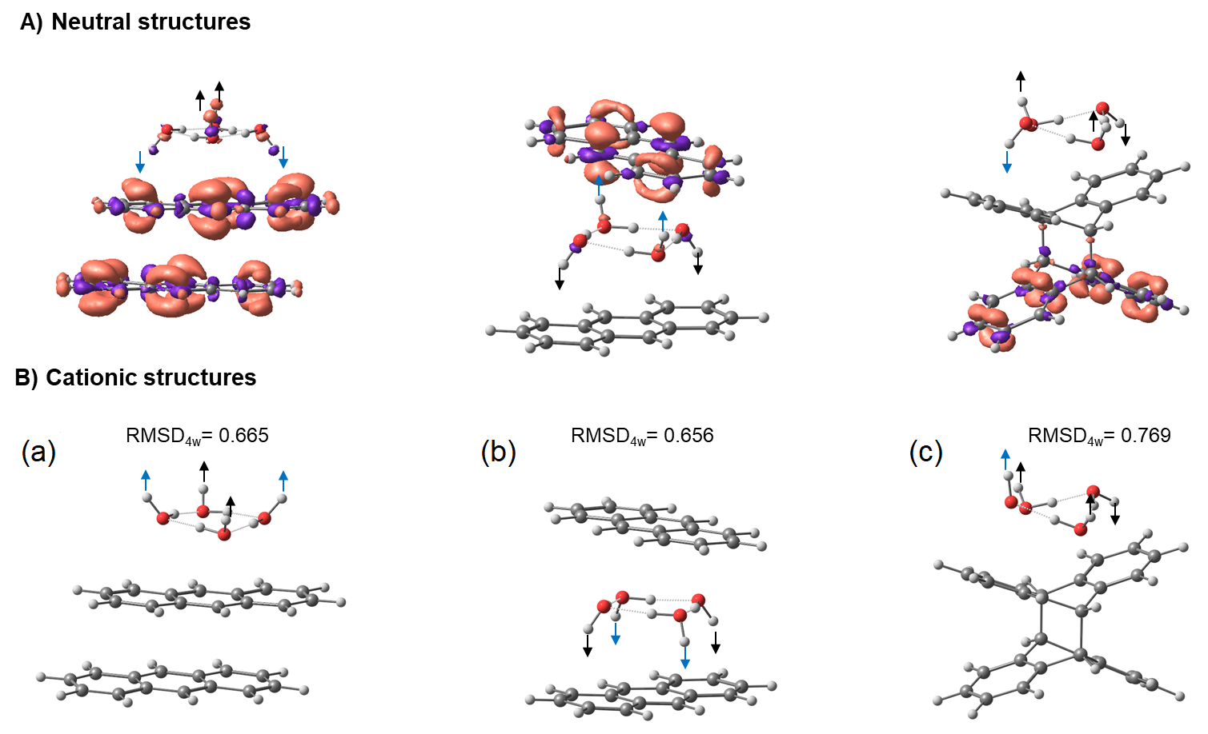

**Figure 13**: Electron hole due to ionization of the neutral structures (top panel) and relaxed cationic structures (bottom panel) (a): Figure 9 (iv-c), (b): Figure 9 (iv-d), and c: Figure 9 (iv-f). Hydrogen atoms on the waters that preserve their orientation (up or down) with respect to the oxygen in the neutral clusters are marked with a black arrow. In contrast, a blue arrow represents a "flipped" hydrogen when compared to the neutral structure.

Conclusion

Photoionization mass spectrometry coupled to tunable VUV radiation from a synchrotron allowed for studying the anthracene monomer and dimer and their hydration by water clusters. Experimental photoionization efficiency spectra reveal a loss of structure going from the monomer to the dimer and when adding water units. This loss of structure, or smoothing, indicates the presence of several isomers in the beam. We have studied the structure of these clusters using density functional theory both as neutrals and upon subsequent photoionization. For the case of anthracene monomer with different number of water molecules, the most stable isomers are those where there are OH $⋯π$ and CH $⋯$ O interactions between the water cluster and the aromatic ring. In the case of A2Wn, the stability trends follow that of the anthracene dimers. When comparing structures of the same dimer isomer with different distribution of the water clusters, it is clear that the energetic tendency of the waters is to remain clustered. In all cases, except in the case of four water molecules, water clusters are not confined inside the anthracene dimers, and structures with an OH $⋯π$ interaction with one ring and a CH $⋯$ O interaction with the second ring are preferred. When the anthracene unit is ionized, we see that hydrogen bond chain formation in the case of AW*n*where *n* = 1,2. When *n*=3,4, the preference is to form a cyclic water cluster above the aromatic ring. Here the clusters are flipped so that the oxygen is pointing toward the ionized ring. In ionized A2Wn the structures again follow the stability of the dimer; however, we observe a reversal in the stability trends in dimer structure: the bonded system is the least stable on the cationic surface. As one of the anthracenes is ionized, we observe in some cases more CH $⋯$ O interaction and the tendency of the waters to be in a side orientation to the aromatic rings. Here as well, the preference of the water is to stay clustered together and not to spread around the anthracenes. As a result of the ionization, the water cluster goes through structural changes so that the oxygen points toward the hole and the hydrogen atoms point away from it. Confinement of a water cluster was observed only in the case of A2W4.

Experimental Section

**Experimental Methods**

The experiments are performed with a reflectron time-of-flight mass spectrometer incorporating a continuous supersonic expansion molecular beam source. The apparatus is coupled to a 3-meter vacuum monochromator on the Chemical Dynamics Beamline (9.0.2) located at the Advanced Light Source and has been described in our previous studies.29 Anthracene was placed at the front end of a stainless-steel nozzle, which has a 50 μm diameter center hole and is heated to 381 K using a cartridge heater. Anthracene vapor is diffused into 820 Torr argon carrier gas seeded with water vapor. The gas mixture passes through the 50 μm hole and expands supersonically in a vacuum to produce a molecular beam at the interaction region of a reflectron time-of-flight mass spectrometer, where the neutral clusters are ionized by the VUV light and subsequently detected. Mass spectra are recorded for the photon energy range between 7 and 12.5 eV in a photon energy step size of 50 meV. The PIE curves of the water clusters are obtained by integrating over the peaks in the mass spectrum at each photon energy and are normalized by the photon flux.

**Computational Methods**

All the calculations in this manuscript were performed using the Q-Chem software.32 Optimal structures were obtained using the wB97X-V functional.33 Optimization calculations on the monomer were performed using the aug-cc-pVTZ basis set. For all dimer calculations we used cc-pVDZ basis set.34 Frequency calculations followed optimization of the structures to verify that they are indeed minima on the potential energy surface (PES). To model the experimental results, we started by building neutral clusters containing anthracene monomer and dimer with water clusters of one to four molecules, as observed experimentally. The neutral clusters were then optimized on the cationic surface to account for the structural changes upon ionization. The ionized states were calculated using the ionization-potential variant of the equation of motion coupled cluster with singles and doubles corrections (EOM-IP-CCSD) using the cc-pVDZ basis set.35-37 EOM-CCSD includes dynamic and non-dynamic correlation effects and provides accurate ionization and excitation energies.

Acknowledgements

The Israel Science Foundation funded work at the Hebrew University under Grant No. 1941/20. Work at the Advanced Light Source is supported by the Director, Office of Science, Office of Basic Energy Sciences, of the US Department of Energy under Contract No. DE-AC02-05CH11231, through the Gas Phase Chemical Physics Program, Chemical Sciences Division. This research used resources of the Advanced Light Source, a Department of Energy (DOE) Office of Science User Facility under the same contract.

**Keywords:** keyword 1 • keyword 2 • keyword 3 • keyword 4 • keyword 5

1. Meyer, E. A., et al., Interactions with Aromatic Rings in Chemical and Biological Recognition. *Angewandte Chemie International Edition* **2003,** *42* (11), 1210-1250.

2. McKenzie, S.; Kang, H. C., Squeezing water clusters between graphene sheets: energetics, structure, and intermolecular interactions. *Physical Chemistry Chemical Physics* **2014,** *16* (47), 26004-26015.

3. Holt, J. K., et al., Fast Mass Transport Through Sub-2-Nanometer Carbon Nanotubes. *Science* **2006,** *312* (5776), 1034-1037.

4. Radha, B., et al., Molecular transport through capillaries made with atomic-scale precision. *Nature* **2016,** *538* (7624), 222-225.

5. Song, W., et al., Artificial water channels enable fast and selective water permeation through water-wire networks. *Nature Nanotechnology* **2020,** *15* (1), 73-79.

6. Majumder, M., et al., Enhanced flow in carbon nanotubes. *Nature* **2005,** *438* (7064), 44-44.

7. Dopfer, O.; Fujii, M., Probing Solvation Dynamics around Aromatic and Biological Molecules at the Single-Molecular Level. *Chemical Reviews* **2016,** *116* (9), 5432-5463.

8. Salonen, L. M., et al., Aromatic Rings in Chemical and Biological Recognition: Energetics and Structures. *Angewandte Chemie International Edition* **2011,** *50* (21), 4808-4842.

9. Öberg, K. I., Photochemistry and Astrochemistry: Photochemical Pathways to Interstellar Complex Organic Molecules. *Chemical Reviews* **2016,** *116* (17), 9631-9663.

10. Cuylle, S. H., et al., Photochemistry of PAHs in cosmic water ice. *A&A* **2014,** *562*, A22.

11. Michoulier, E., et al., Theoretical determination of adsorption and ionisation energies of polycyclic aromatic hydrocarbons on water ice. *Physical Chemistry Chemical Physics* **2018,** *20* (17), 11941-11953.

12. Pérez, C., et al., Corannulene and its complex with water: a tiny cup of water. *Physical Chemistry Chemical Physics* **2017,** *19* (22), 14214-14223.

13. Domingos, S. R., et al., Water Docking Bias in [4]Helicene. *Angewandte Chemie International Edition* **2019,** *58* (33), 11257-11261.

14. Loru, D., et al., How does the composition of a PAH influence its microsolvation? A rotational spectroscopy study of the phenanthrene–water and phenanthridine–water clusters. *Physical Chemistry Chemical Physics* **2021,** *23* (16), 9721-9732.

15. Chatterjee, K., et al., Unravelling the microhydration frameworks of prototype PAH by infrared spectroscopy: naphthalene–(water)1–3. *Physical Chemistry Chemical Physics* **2021,** *23* (25), 14016-14026.

16. Attah, I. K., et al., Hydrogen bonding of the naphthalene radical cation to water and methanol and attachment of the naphthalene ion to extended hydrogen bonding chains. *Chemical Physics Letters* **2014,** *613*, 45-53.

17. Alata, I., et al., Microhydration effects on the electronic spectra of protonated polycyclic aromatic hydrocarbons: [naphthalene-(H2O)n = 1,2]H+. *The Journal of Chemical Physics* **2011,** *134* (7), 074307.

18. Palmer, P. M.; Topp, M. R., Electronic spectroscopy of jet-cooled anthracene/(H2O)n clusters (n=1–16): comparisons of inhomogeneous structure. *Chemical Physics* **1998,** *239* (1), 65-81.

19. Le Page, V., et al., Reactions of Cations Derived from Naphthalene with Molecules and Atoms of Interstellar Interest. *Journal of the American Chemical Society* **1999,** *121* (40), 9435-9446.

20. Chatterjee, K.; Dopfer, O., Microhydration of PAH+ cations: evolution of hydration network in naphthalene+-(H2O)n clusters (n ≤ 5). *Chemical Science* **2018,** *9* (8), 2301-2318.

21. Lietard, A., et al., The effect of solvation on electron capture revealed using anion two-dimensional photoelectron spectroscopy. *Nature Chemistry* **2021,** *13* (8), 737-742.

22. Sharma, D.; Paterson, M. J., Ground and excited states of naphthalene–water (naphtha–W6) clusters: a computational study. *RSC Advances* **2015,** *5* (36), 28281-28291.

23. Hernández-Rojas, J., et al., Modeling Water Clusters on Cationic Carbonaceous Seeds. *The Journal of Physical Chemistry A* **2010,** *114* (27), 7267-7274.

24. Hirunsit, P.; Balbuena, P. B., Effects of Confinement on Small Water Clusters Structure and Proton Transport. *The Journal of Physical Chemistry A* **2007,** *111* (42), 10722-10731.

25. Cabaleiro-Lago, E. M., et al., Computational Study on the Characteristics of the Interaction in Naphthalene···(H2X)n=1,2 (X = O, S) Clusters. *The Journal of Physical Chemistry A* **2008,** *112* (28), 6344-6350.

26. Takeuchi, H., Structures, stability, and growth sequence patterns of small homoclusters of naphthalene, anthracene, phenanthrene, phenalene, naphthacene, and pyrene. *Computational and Theoretical Chemistry* **2013,** *1021*, 84-90.

27. Grimme, S., et al., The Importance of Inter- and Intramolecular van der Waals Interactions in Organic Reactions: the Dimerization of Anthracene Revisited. *Angewandte Chemie International Edition* **2006,** *45* (4), 625-629.

28. Zade, S. S., et al., Products and Mechanism of Acene Dimerization. A Computational Study. *Journal of the American Chemical Society* **2011,** *133* (28), 10803-10816.

29. Xu, B., et al., Probing solvation and reactivity in ionized polycyclic aromatic hydrocarbon–water clusters with photoionization mass spectrometry and electronic structure calculations. *Faraday Discussions* **2019,** *217* (0), 414-433.

30. Gregory, J. K., et al., The Water Dipole Moment in Water Clusters. *Science* **1997,** *275* (5301), 814-817.

31. Steber, A. L., et al., Capturing the Elusive Water Trimer from the Stepwise Growth of Water on the Surface of the Polycyclic Aromatic Hydrocarbon Acenaphthene. *The Journal of Physical Chemistry Letters* **2017,** *8* (23), 5744-5750.

32. Shao, Y., et al., Advances in molecular quantum chemistry contained in the Q-Chem 4 program package. *Molecular Physics* **2015,** *113* (2), 184-215.

33. Mardirossian, N.; Head-Gordon, M., [small omega]B97X-V: A 10-parameter, range-separated hybrid, generalized gradient approximation density functional with nonlocal correlation, designed by a survival-of-the-fittest strategy. *Physical Chemistry Chemical Physics* **2014,** *16* (21), 9904-9924.

34. Dunning , T. H., Jr, Gaussian basis sets for use in correlated molecular calculations. I. The atoms boron through neon and hydrogen. *The Journal of Chemical Physics* **1989,** *90* (2), 1007-1023.

35. Krylov, A. I., Equation-of-Motion Coupled-Cluster Methods for Open-Shell and Electronically Excited Species: The Hitchhiker's Guide to Fock Space. *Annual Review of Physical Chemistry* **2008,** *59* (1), 433-462.

36. Pieniazek, P. A., et al., Benchmark full configuration interaction and equation-of-motion coupled-cluster model with single and double substitutions for ionized systems results for prototypical charge transfer systems: Noncovalent ionized dimers. *The Journal of Chemical Physics* **2007,** *127* (16), 164110.

37. Khistyaev, K., et al., Proton Transfer in Nucleobases is Mediated by Water. *The Journal of Physical Chemistry A* **2013,** *117* (31), 6789-6797.