Dispersal removes legacy of substrate history on microbial functioning

Elsa Abs1, Michaeline B. N. Albright2, Steven D. Allison1,3

1. Department of Ecology and Evolutionary Biology, University of California, Irvine, California 92697 USA
2. BioScience Division, Los Alamos National Laboratory, Los Alamos, New Mexico
3. Department of Earth System Science, University of California, Irvine, California 92697 USA

## Abstract

Microbial community responses to environmental change are mainly studied with regard to climate although we know that substrate quality, also associated with global change, might be a stronger selective force on soil microbes. Here we conducted substrate transplant simulations with a mathematical trait-based model of microbial litter decomposition (DEMENTpy) to assess the legacy effects of past substrate quality and the effects of selection by a new substrate quality on community decay performance. Simulations were run with different treatments of dispersal, from no dispersal to dispersal from communities long adapted to the new substrate. We found that legacy effects are found with substrate change with native communities differ in composition; and we found that protein content is the only strong enough selective force to affect community composition. Legacy effects disappeared with dispersal when dispersers came from substrates similar to the transplanted one. Together, our simulations demonstrate that we can expect substrate quality change associated with global change to lead to legacy effects on substrate degradation when it involves increase in protein content and limited or functionally redundant microbial dispersal.

## Introduction

Global change may cause important shifts in plant composition [(Franklin et al. 2016)](https://paperpile.com/c/jyKzcy/AsKn), and we know that aboveground vegetation diversity strongly influences underground microbial community composition and decay function, largely through litter quality [(Zak et al. 2003)](https://paperpile.com/c/jyKzcy/zObKF). However, it is still elusive how microbial communities will respond to change in litter quality induced by global change, and how that will affect soil carbon and nutrient cycling. Local and regional dispersal of microbes might play a role in the resilience and adaptation of microbial communities to litter change [(Shade et al. 2012)](https://paperpile.com/c/jyKzcy/ItZ2O).

Dispersal has been studied in ecology mostly for its role in microbiome assembly [(Evans, Martiny, and Allison 2017; Walters and Martiny 2020)](https://paperpile.com/c/jyKzcy/WVKjS+E5hIE). Dispersers can represent up to 60% of the biomass of a community and mix individuals from nearby to thousands of kilometers away [(Van der Gucht et al. 2007)](https://paperpile.com/c/jyKzcy/jKvh2). What is less studied is its effect on microbiome function. Albright et al. [(Albright et al. 2020)](https://paperpile.com/c/jyKzcy/jSz3) found that the identity of the resident community and the identity of the distant dispersers was a higher determinant of community function (respiration, degradation) than intensity of dispersal (amount of dispersers, frequency). Regional dispersal is a potential flux of new taxa bringing in functions that are absent in the resident community and that enhance carbon and nutrient cycling.

What is even less studied is the role of dispersal on microbiome function in the context of environmental change. Empirical studies forcing climate change with transplants found that microbial communities and functions have both characteristics of the past climate (legacy effect) and of the new climate (contemporary selection by the environment) [(Glassman et al. 2018)](https://paperpile.com/c/J9vMGS/d8iv). Wang et al. were able to reproduce the climate-driven legacy effects on community composition and SOC decomposition [(Wang and Allison 2021)](https://paperpile.com/c/J9vMGS/RphV). They found that dispersal removed legacy effects of drought on soil organic decay even in case of severe drought. Local dispersal allowed in their experiment for extinct data to never be fully extinct, and therefore to recolonize after drought. Both of these studies were performed on a unique substrate. We need to study substrate legacies.

Many studies have shown how substrate quality determines its decomposition [(Schnecker et al. 2019; ChapinIII, Matson, and Vitousek 2011)](https://paperpile.com/c/jyKzcy/jR7pl+pM9eX). More recent studies have shown that past substrate also has a strong influence on decomposition of present substrate. Using a common garden experiment with communities taken from sites with different aboveground vegetation and tested on decomposing same substrates, Strickland et al showed that past substrate determines microbial community composition, which in turns determine microbial functioning on a same substrate [(Strickland et al. 2009)](https://paperpile.com/c/jyKzcy/sU96C). As global models already integrate dynamical aboveground vegetation functions, we propose here to increase our understanding of microbial functions dynamics with litter substrate chemistry in preparation for connecting both in Earth system models.

To investigate the effect of microbial dispersal of different substrate origin on transplanted communities, we used a mechanistic numerical model of litter decomposition by microbes called DEMENT (Decomposition Model of Enzymatic Traits). We wanted a tool that represents our current understanding of the driving processes at play in microbial decomposition of organic matter in order to reveal their limitations. Since we now know that microbial community composition has an important role on its function, DEMENT represents a diversity of taxa (distinct by their traits), of enzymes (distinct by their production cost and activity kinetics) and of substrate components (12 such as hemicellulose, lignin or nucleic acids that differ by their C,N,P ratios).

Although not much is known on the effect of dispersal on microbial functioning in the context of litter quality change, we made a few hypotheses based on transplant and drought experiments [(Wang and Allison 2021; Albright et al. 2020)](https://paperpile.com/c/jyKzcy/lnWM+jSz3). We hypothesized that substrate chemistry will select for distinct community assemblies that have distinct functioning. We hypothesized that those differences in community composition in the different litters will be responsible for legacy effects on substrate degradation in transplanted communities. We hypothesized that those legacy effects can disappear in presence of dispersers coming from substrates of similar chemistry to the new one (Figure 1).

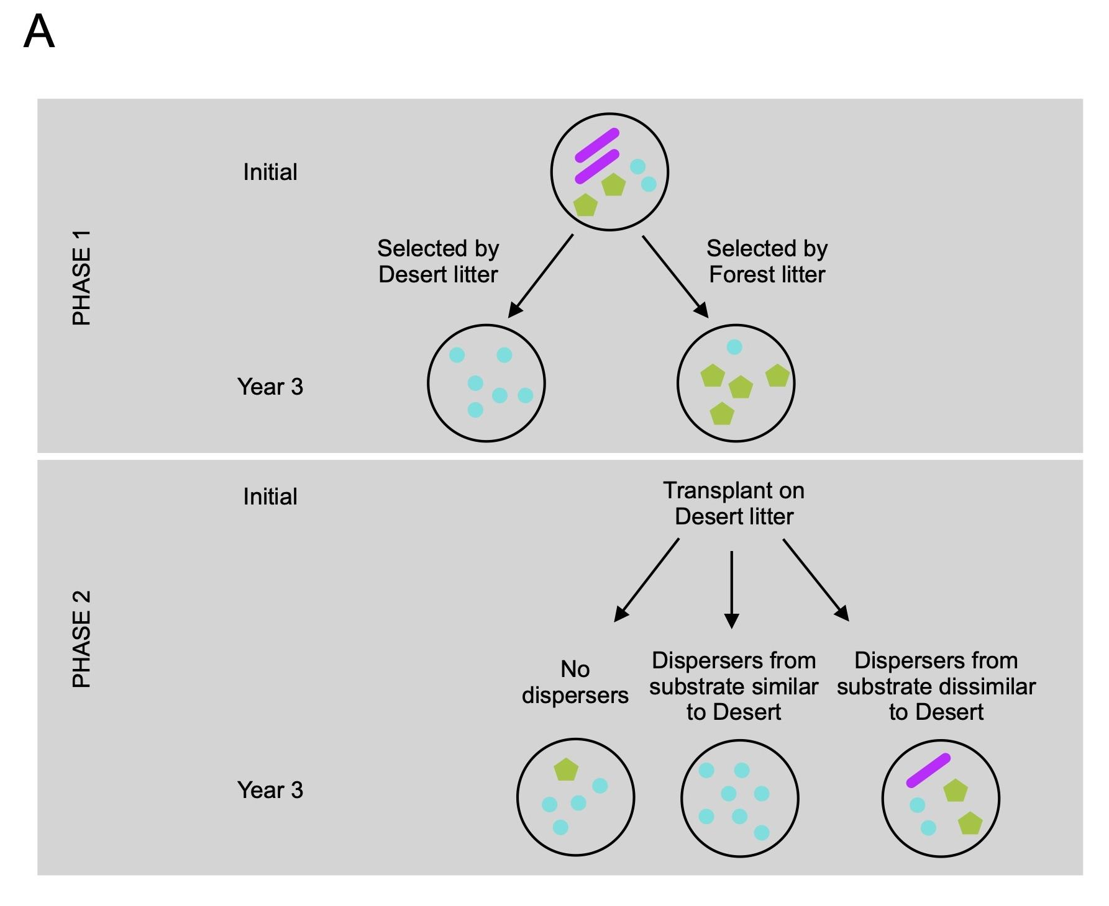

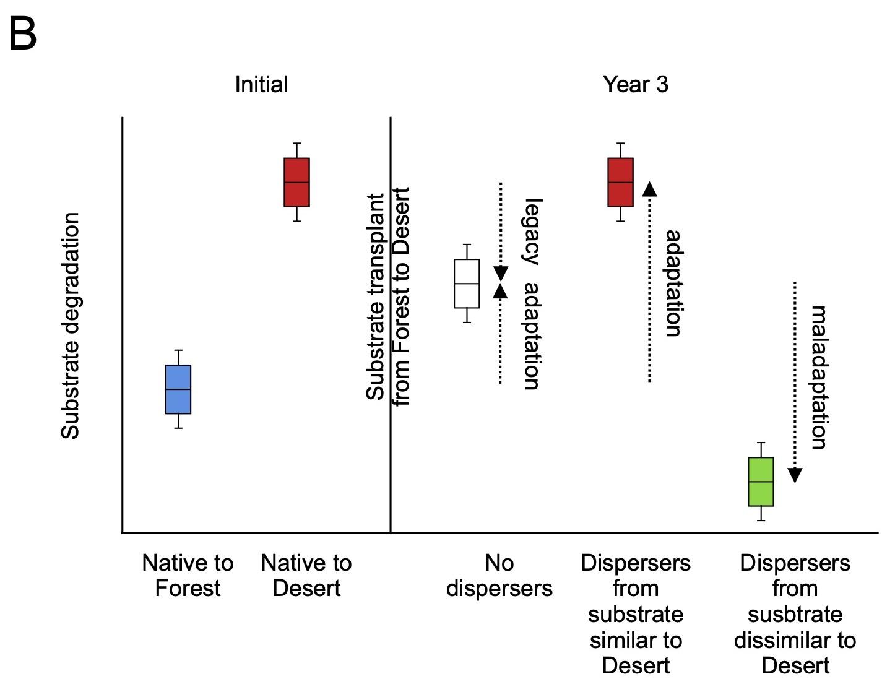

**FIGURE 1.** **Conceptual illustration of our hypotheses** on the effect of substrate change and dispersal treatment on microbial (A) community composition (phases 1 and 2), and (B) substrate degradation (phase 2), illustrated with a community native to forest litter transplanted on desert litter. We hypothesized that forest litter will select for different taxa than desert litter. When transplanting forest native communities on desert litter, the change in substrate will change the community composition leading to its substrate degradation to be closer to the one of communities native to desert litter (contemporary selection by the environment). However, the loss or lack of taxa adapted to desert litter during the first phase on forest litter won’t allow a full contemporary selection (legacy effect), unless we add dispersers coming from a substrate close to desert litter. Reversely adding dispersers from a more dissimilar substrate chemistry will take substrate degradation in the opposite direction (maladaptation).

## Material and Methods

#### Model description

DEMENT is a spatially explicit individual- and trait-based microbial model that simulates leaf litter decomposition emerging from both cell-level physiology and community-level interactions [(Allison 2012)](https://paperpile.com/c/jyKzcy/o8fYp). We used the python more recent version of the code, DEMENTpy, with explicit drought tolerance genes [(Wang and Allison 2021)](https://paperpile.com/c/jyKzcy/lnWM). We initialized the simulation on a spatial grid of 100 x 100 grid boxes, each 1-10 μm on a side, that represents the surface of a litter substrate. The 14 compounds that compose the leaf, such as cellulose or lignin, were initially homogeneously distributed on the grid. In our study, we randomly placed on the grid 100 taxa that differed by their trait values, such as monomer maximal uptake rate or number and type of enzymes produced. Bacterial taxa had an initial biomass of 1 mg.cm-3 and a 1% chance to be in each grid box. Fungal taxa had an initial biomass of 25 mg.cm-3 and a 0.04% probability of occupying each grid box. So there was initially on average 0.52 taxa and 1 mg.cm-3 biomass (bacteria or fungi) in a grid box.

Every day microbes produced enzymes, substrate compounds were decomposed into monomers, monomers diffused on the grid, microbes took up monomers, grew, produced metabolites, reproduced, and/or died. One taxon was assigned the production of one or more enzyme types. One enzyme was assigned zero, one or several substrate compounds to degrade. Each substrate compound was decomposed into one type of monomer. Taxa membrane transporters were monomer specific. A taxon was assumed to possess the transporter type(s) of the enzyme(s) it produces. Reproduction occurred every time the initial biomass of a taxon was doubled, with one daughter cell staying in the same grid box, and the other randomly sent on one of the four adjacent grid boxes. Taxa also produced osmolytes that determined their probability of death depending on soil moisture.

Temperature and moisture were held constant for this study. Enzyme kinetics depended on temperature according to an Arrhenius relation. Every year, the assembled microbial community was placed on fresh litter substrate, with reinitialized substrate distribution, no monomers and no enzymes. There was no additional substrate input between day 0 and day 365. DEMENT simulates 6 years of an individual based complex community on a grid of 1 mm2 in 20 hours. A more detailed description of the model is available in Wang and Allison [(Wang and Allison 2021)](https://paperpile.com/c/jyKzcy/lnWM).

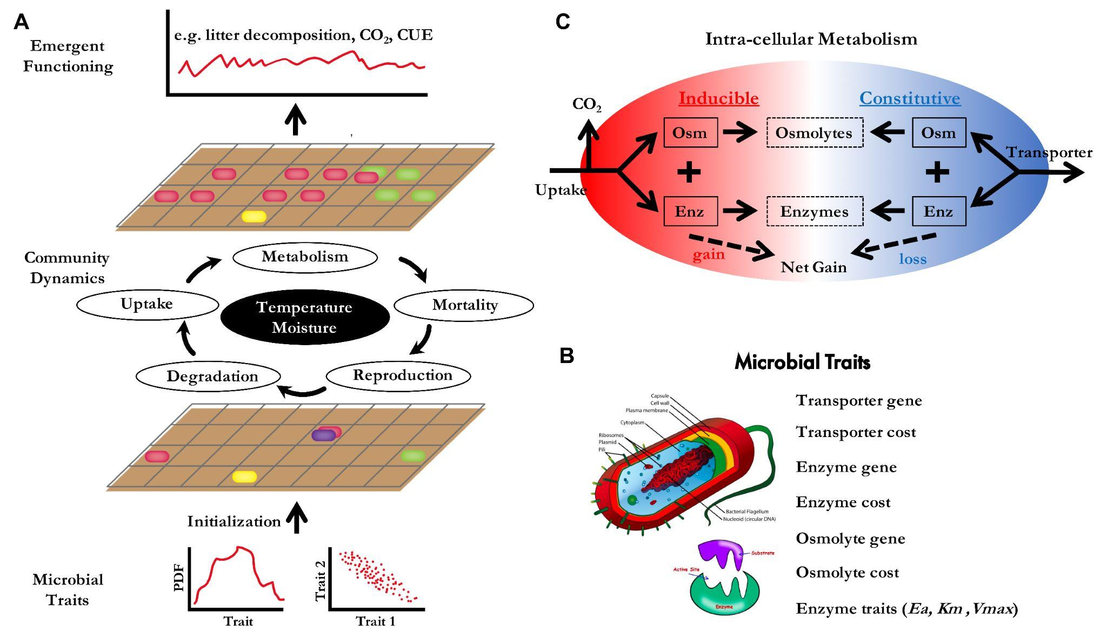

**SUPPLEMENTAL FIGURE 1.** **Conceptual structure of DEMENT**. The model represents microbial growth implicitly as the difference between uptake and loss processes (respiration, metabolite production, stoichiometric rebalancing). (Reproduced from Wang and Allison 2021)

#### Litter substrate chemistry

To test whether litter substrate chemistry affects microbial community composition and functioning, we let 10 communities assemble randomly on each of 5 different substrates (phase I in Figure 2). The chemistry is taken from Baker et al [(Baker and Allison 2017)](https://paperpile.com/c/jyKzcy/ypcik) and corresponds to the leaf litter chemistry of 5 sites along a Californian elevation gradient (desert, scrubland, grassland, pine oak, subalpine) (Figure S2). These are the same sites as the ones used for Glassman et al.’s climate transplant experiment. We calculated yearly averaged substrate decay rates and taxa relative abundances. Preliminary runs showed that both outputs stop varying by year 3 of the simulation so we compared community composition and decay rate averaged over year 3.

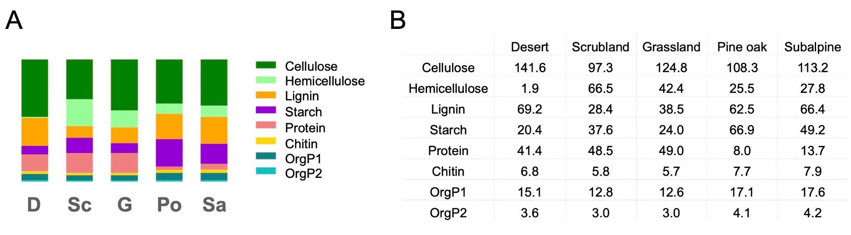

**SUPPLEMENTAL FIGURE 2.** **Leaf litter substrate chemistry**. Both represent the sum of C, N and P density (mg.cm-3) (A) bar plots, (B) values. The 5 bars correspond to 5 sites of an elevation gradient of California. Colors correspond to the different substrate components. Data come from Baker et al 2017 and have been normalized for the sum of C, N, P to be equal between sites to 300 mg.cm-3.

#### Dispersal

To test the effect of dispersal following a change in litter substrate chemistry, we initialized a new set of simulations with each of the 50 microbial communities assembled in phase I (phase II in Figure 2). To simulate change in leaf substrate chemistry, we transplanted each community to 1 of the other 4 substrates. To simulate dispersal, we merged the community with a pool of dispersers equivalent to 40% the size of one of the final communities from phase I. Dispersers could come from the same community (local dispersal), or from a different one (regional dispersal). We also ran transplanted communities with no dispersers as a control experiment. As in phase I, assembly stabilized around years 2-3, so we stopped the simulations at the end of year 3. We compared substrate decay rates and taxa relative abundances averaged over year 3 between substrate chemistry and dispersal treatments.

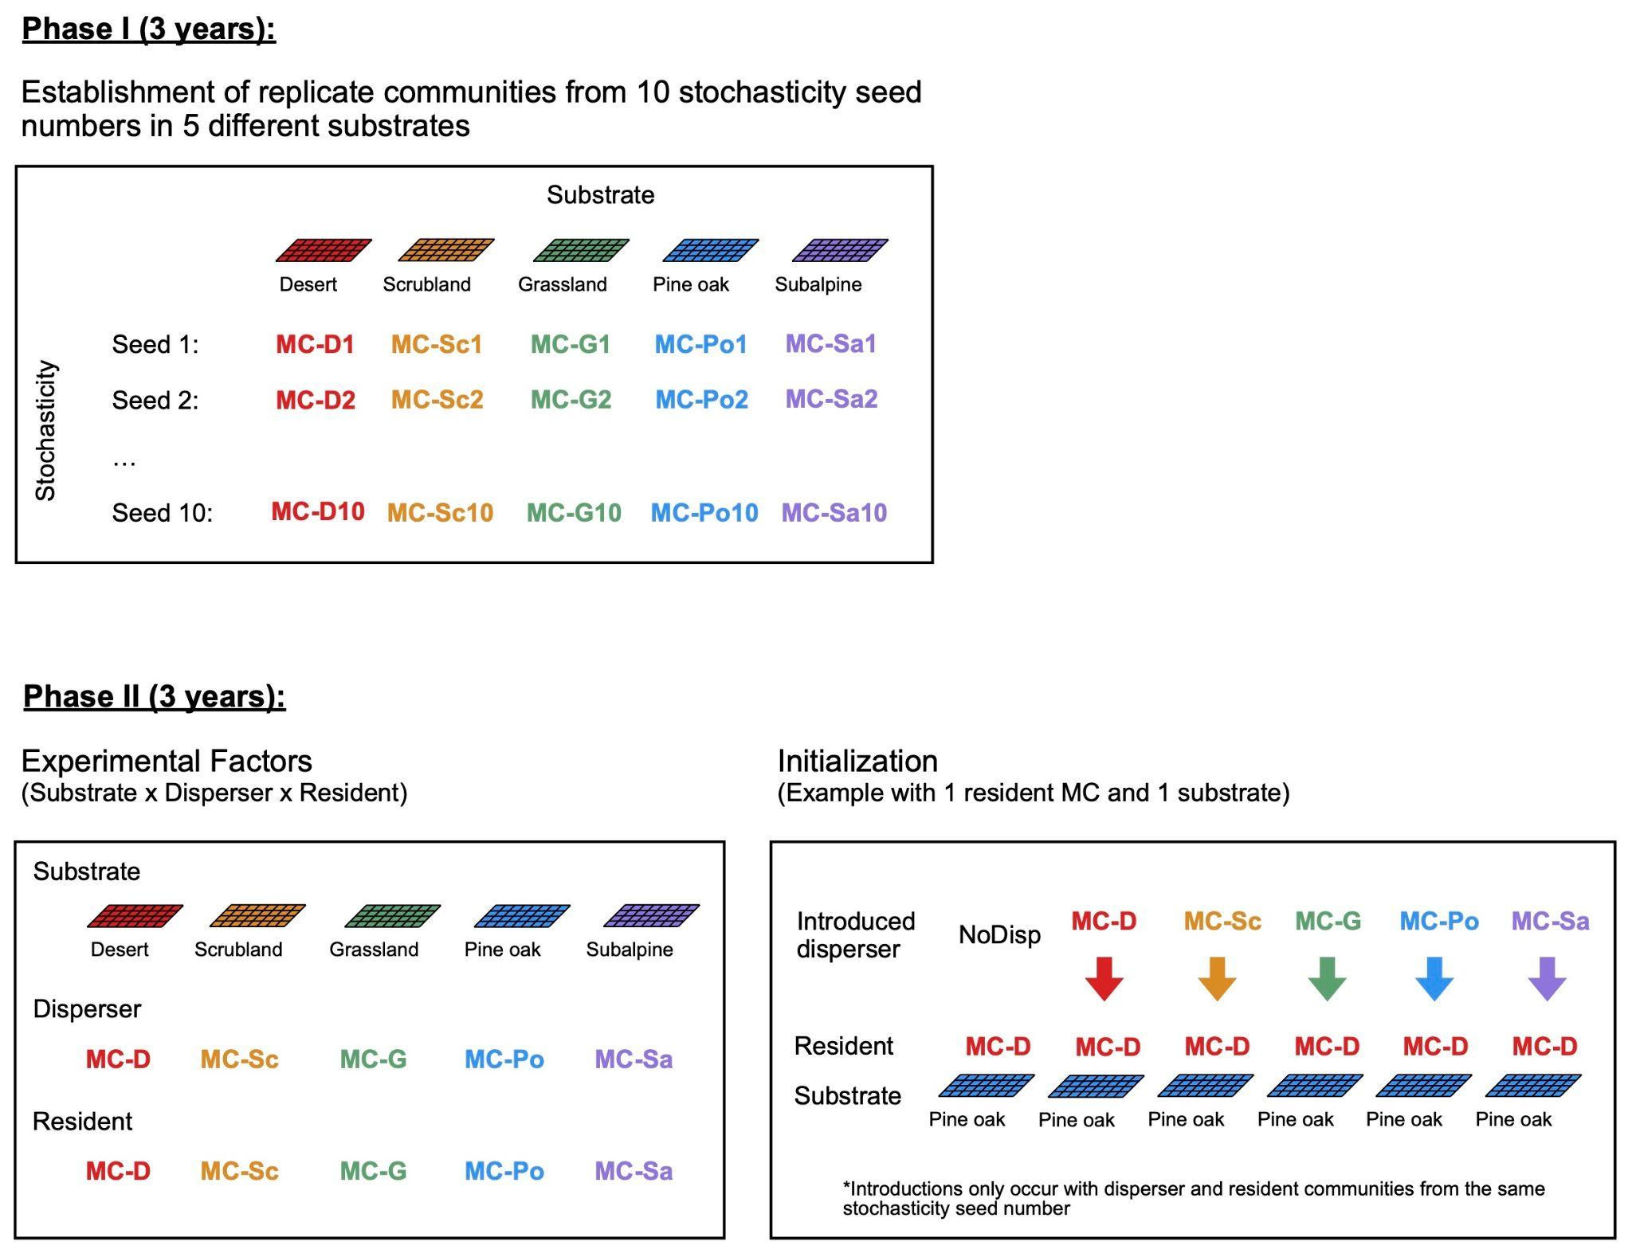

**FIGURE 2.** **Conceptual framework of the simulation experiment.** Experimental setup to test factors driving composition and functional outcomes of dispersal in the context of substrate change. In phase I, 50 microbial communities were created from 10 random assembled communities run on 5 different substrates for 3 years (by when community composition stops varying) in a common climate (soil temperature = 15.7°C, soil moisture = -0.1 MPa). In phase II, we conducted disperser introductions at t0 in each of the 50 communities of phase I, and we ran them for 3 years on a different substrate as the one they were run on in phase I (n = 5 residents x 4 substrates x (5 dispersers + 1 control) x 10 seeds = 1200 simulations).

## Results

#### Dispersal removes legacy effect of substrate change on protein decay

Substrate quality has no significant effect on overall decay or total biomass (Figure S3), but it does on two substrate component decay: hemicellulose and protein. Hemicellulose decay is lower in desert litter, where hemicellulose content is lower than in other substrates. The biomass of hemicellulose degraders in desert communities is not significantly different from the other substrate communities (Figure 3a-b). On the other hand, protein decay is lower in pine oak and subalpine litters that have lower protein content, and this is accompanied by lower biomass of protein degraders in pine oak and subalpine communities than in other substrate communities (Figure 3c-d).

When we proceeded to substrate transplants between substrates that differ in hemicellulose and/or protein decay, we observed two different patterns. In the case of a shift in hemicellulose content, hemicellulose decay after 3 years is the same as the one of communities native to the final litter (Figure 3a, example with transplant between desert and scrubland substrates). The biomass of hemicellulose degraders is the same in native and transplanted communities (Figure 3b). When substrate shifts from low to high protein content, for example from pine oak to desert substrate, protein decay after 3 years remains the same as before substrate change despite higher protein availability (Figure 3c).

The biomass of protein degraders has the same response: protein degraders biomass in pine oak communities transplanted on desert substrate remains the same as in pine oak communities despite higher protein availability (Figure 3d). This substrate legacy effect on community composition and function can disappear when we added dispersers from protein-rich communities (desert, scrubland, grassland) but is unchanged when we added dispersers from protein-poor communities (pine oak, subalpine) (Figure 3e). Disperser communities from protein-rich substrates contain significantly higher biomass of protein degraders than disperser communities from protein-poor substrates (Figure 3f).

#### 

**SUPPLEMENTAL FIGURE 3.** **Effect of substrate on litter average decay rate (A) and total microbial biomass (B).** Average litter decay rate is calculated as the average decay rate of the 12 chemical substrates weighted by their average total (C+N+P) mass over the grid for year 3.

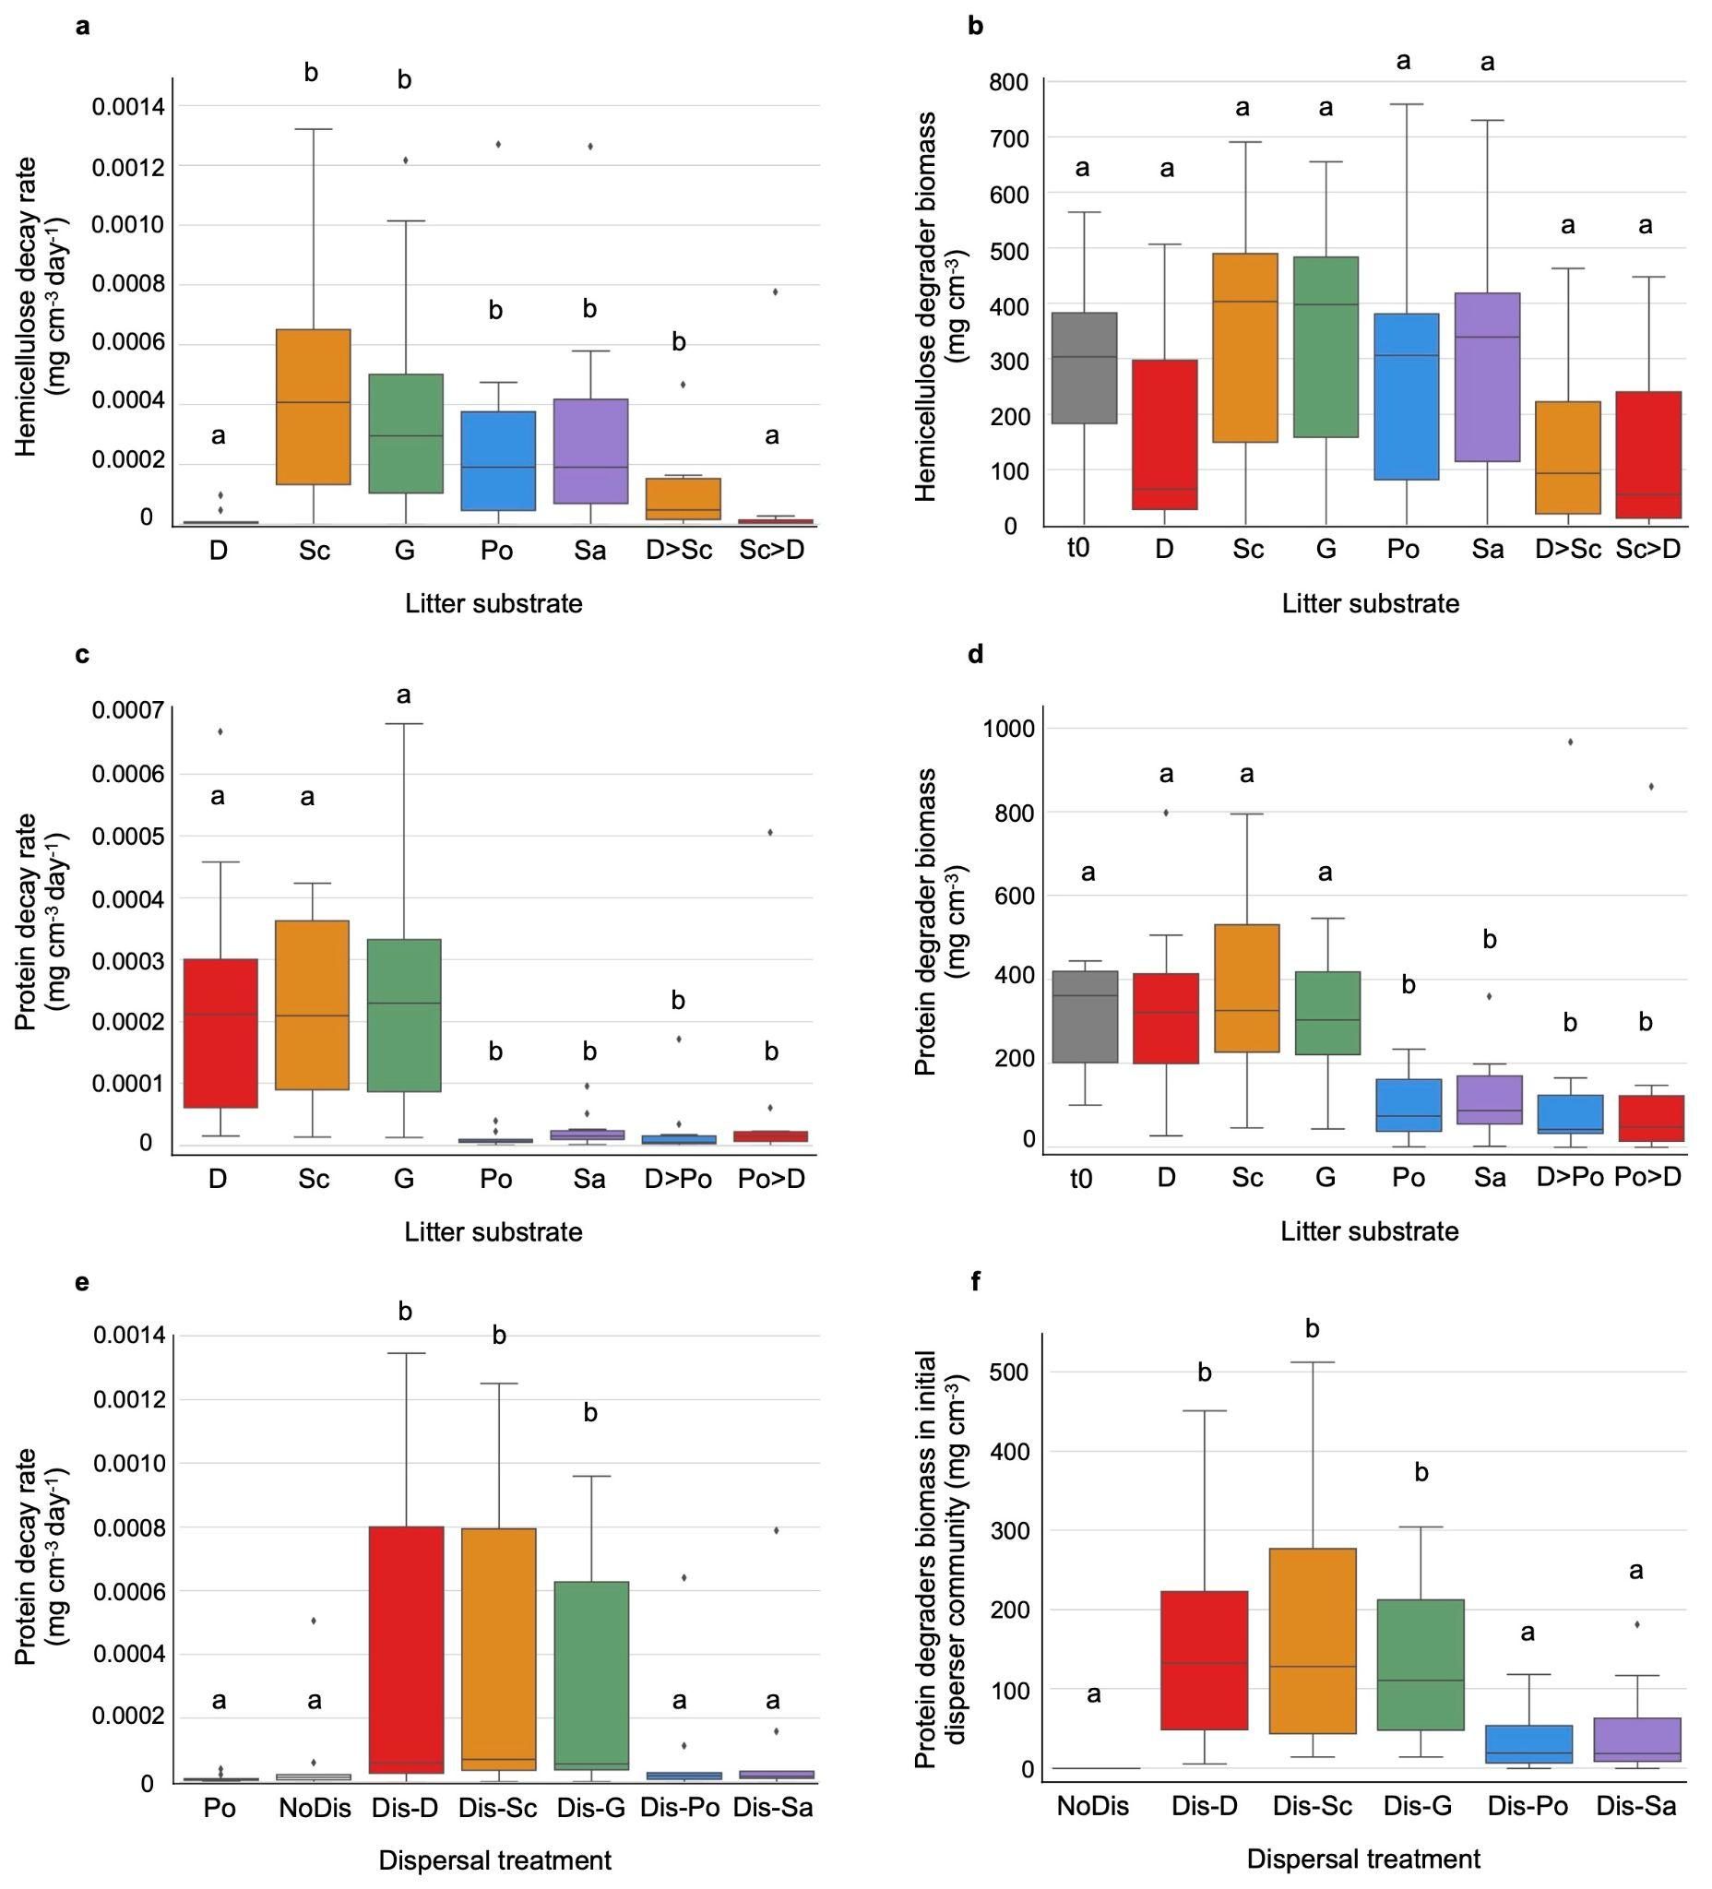

**FIGURE 3.** **Effect of substrate, substrate change and dispersal on decay and biomass. (a)** Hemicellulose decay averaged over the grid and year 3 on the 5 substrates - desert (D), scrubland (Sc), grassland (G), pine oak (Po) and subalpine (Sa) - and on 2 substrate transplants - desert to scrubland (D>Sc: hemicellulose-poor to hemicellulose-rich) and scrubland to desert (Sc>D: hemicellulose-rich to hemicellulose-poor). **(b)** Biomass of hemicellulose degraders initially (day 0 of phase I), and averaged over the grid and year 3 of phase I on each substrate, and on year 3 of phase II of the 2 substrate transplants desert to scrubland and reverse. **(c)** Protein decay averaged over the grid and year 3 on the 5 substrates, and on 2 substrate transplants, desert to pine oak (D>Po: protein-rich to protein-poor) and pine oak to desert (Po>D: protein-poor to protein-rich). **(d)** Biomass of protein degraders initially (day 0 of phase I), and averaged over the grid and year 3 of phase I on each substrate, and on year 3 of phase II of the 2 substrate transplants desert to pine oak and reverse. **(e)** Protein decay averaged over grid and year 3 of phase I on pine oak (Po), and on year 3 of phase II with all disperser treatments - no disperser (NoDis), dispersers from desert communities (Dis-D), dispersers from scrubland communities (Dis-Sc), dispersers from grassland communities (Dis-G), dispersers from pine oak communities (Dis-Po), dispersers from subalpine communities (Dis-Sa). **(f)** Biomass of protein degraders in initial disperser communities in all disperser treatments.

#### Strong facilitation between protein degraders

We found that the growth rate of protein degraders increases exponentially with their initial biomass (Figure 4a). We calculated that the threshold is at 140 mg.cm-3: if their initial biomass is under 140 mg.cm-3, their growth is negative or zero; above 140 mg.cm-3, their growth is positive. This explains why we observed a legacy effect with communities native to protein poor substrates, but not if dispersers arrive from protein rich substrates that contain more protein degraders. We found no significant relationship between total initial microbial biomass of non protein degraders and the growth rate of protein degraders (Figure 4b). These results suggest that the interaction between protein degraders is positive, and that the effect of non protein degraders on protein degraders at the community level is neutral.

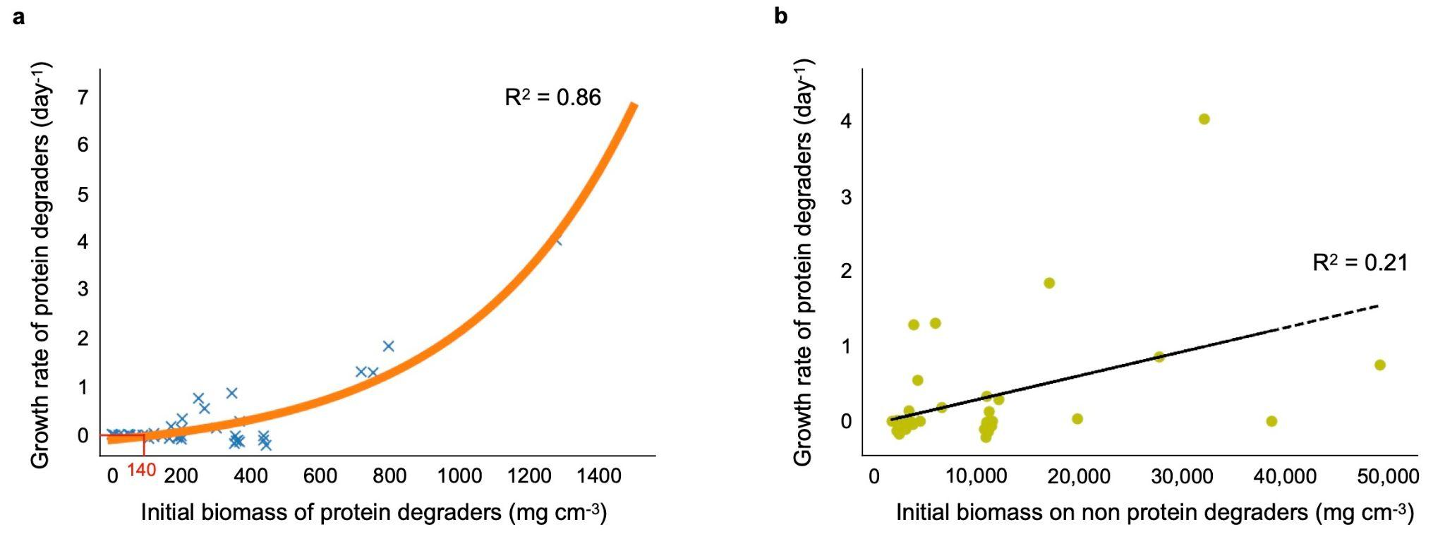

**FIGURE 4.** **Effect of initial biomass of (a) protein degraders, and (b) non protein degraders on protein degraders growth rate.** Growth rate is calculated as log(final biomass/initial biomass)*1/T, where T is the time of simulations (1095 days). Protein degraders’ growth rate is an exponential function of their initial biomass (R2 = 0.86 versus R2 of a linear fit = 0.63) (a), and that there is no significant relationship with the total initial microbial biomass of non protein degraders (b).

## Discussion

While we often focus on temperature and moisture in the attempt to predict future soil microbial decay with global change and dispersal [(Wang and Allison 2021)](https://paperpile.com/c/jyKzcy/lnWM), increasing evidence indicates that change in plant composition will happen on ecological timescales and will influence soil microbe-mediated carbon and nutrient cycling. Transplant experiments are great to quantify the effects of both legacy and contemporary selection by the environment [(Chase, Weihe, and Martiny 2021; Albright and Martiny 2018)](https://paperpile.com/c/jyKzcy/hMYCX+EeVrl). Here, we reproduced this approach with an individual trait-based model to quantify the effects of past and present selection by substrate chemistry on litter decay, and how it interacted with dispersal. We found that there are legacy effects only when changes in community composition are involved. Hemicellulose content and decay differ between the 5 litters but the composition in hemicellulose degraders does not, and there are no legacy effects after transplant. Reversely, protein content affects both protein decay and composition in protein degrading taxa, and there are legacy effects after transplant. Additionally and as we hypothesized, legacy effects disappear when dispersal helps the shift in community composition. Unlike what we hypothesized, we did not find instances of dispersal causing maladaptation.

We found that the amount of proteins is not sufficient to predict the growth of protein degraders. Protein degraders’ growth also depends on their initial biomass and on the total microbial initial biomass. All taxa are able to take up NH4, but that is the only source of nitrogen for taxa that do not degrade nitrogen containing substrate components that are common in this system where microbes are specialists (can degrade at most 3 of the 12 substrate components). This makes mineralized nitrogen a public good, taxa that degrade nitrogen organic compounds cooperators, and taxa that do not cheaters (with regard to inorganic nitrogen). This explains why we found growth of protein degraders decreasing with higher initial total microbial biomass.

Our results also showed positive frequency-dependent selection (PFDS): the fitness of protein degraders increases when their initial abundance is higher. Frequency-dependent selection is expected in microbial communities because strong selection, structuring, and cooperation-dependent growth are common in microbial populations [(Ross-Gillespie et al. 2007)](https://paperpile.com/c/jyKzcy/jOIN). Both negative and positive frequency-dependent selection have been found in cooperative microbial communities with potential cheating [(Rendueles, Amherd, and Velicer 2015; Healey, Axelrod, and Gore 2016)](https://paperpile.com/c/jyKzcy/PP6I+wLhD). Note that our tests were only spamming an initial frequency of protein degraders between 0 and 0.1. It is not impossible that we would observe negative frequency-dependent selection at higher frequencies. Still, our results demonstrate that, where Healey et al. simplified fitness to be flat at low frequencies, we found that it is instead exponential, meaning that cooperators’ growth will accelerate with high initial abundance when rare.

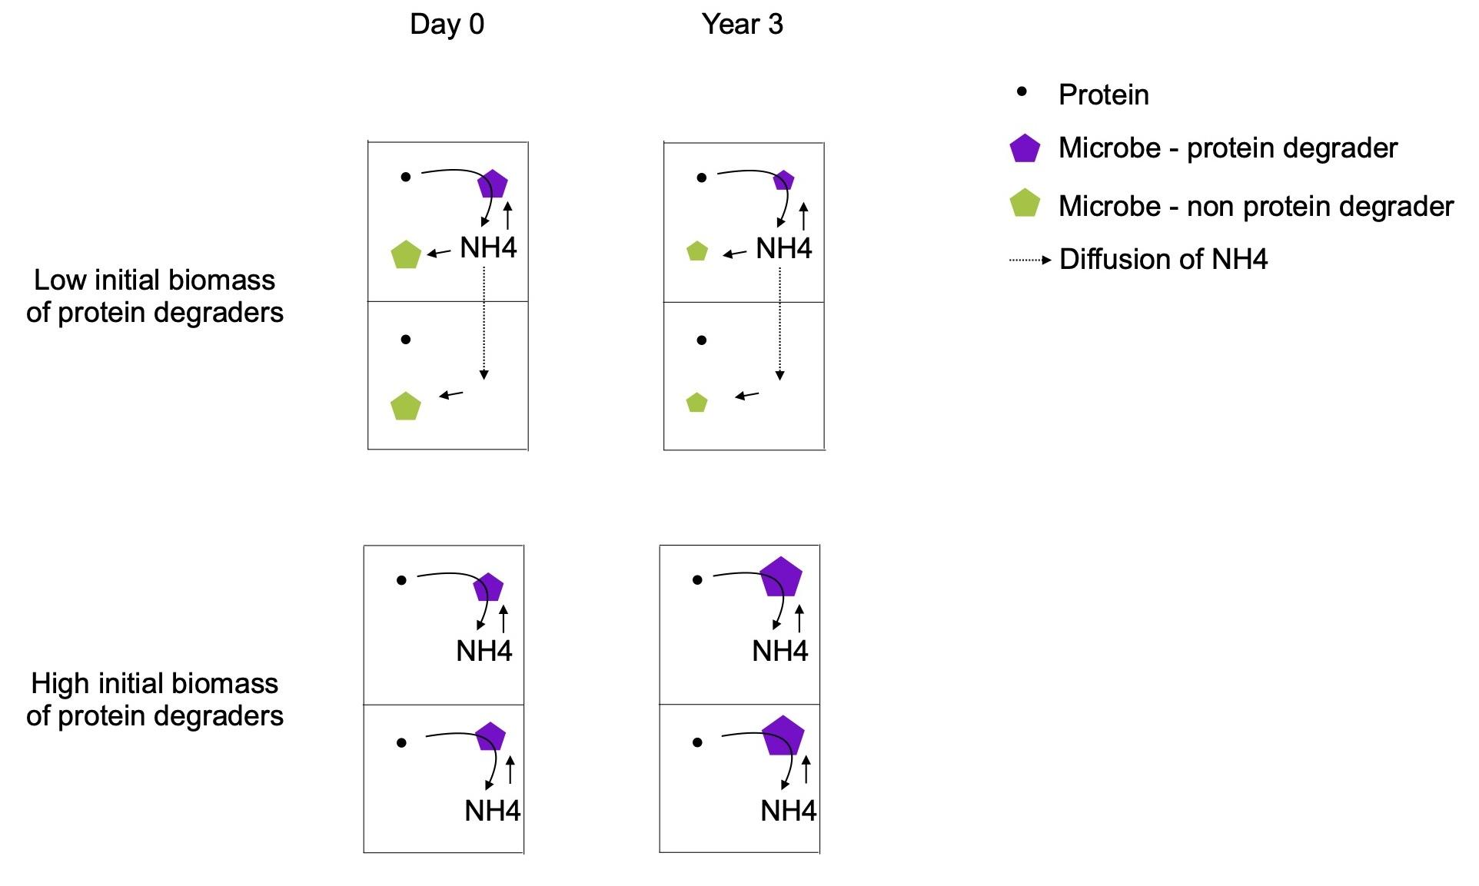

**FIGURE 5.** **Conceptual illustration of our results** on the effect of initial biomass of protein degraders (purple) on their growth rate. Here are represented 2 grid boxes. There is a spatial structure between grid boxes but not within a grid box, meaning substrate components and monomers are equally accessible for all taxa within a box. Exchanges between boxes are only of taxa (only between adjacent grid boxes and when biomass exceeds twice its initial size, not represented here) and monomers (excess are divided evenly on the whole grid) and occur at the end of each day. The NH4 that protein degraders release is shared between taxa proportionally to their biomass, and excess will diffuse in the whole grid. When the frequency of protein degraders (purple, cooperators) is low and relative abundance of non protein degraders (green, cheaters) is high (top), NH4 will mostly benefit non protein degraders, therefore the benefit to cost ratio of nitrogen mineralization for protein degraders is low leading to zero or negative growth rate. On the other hand, when the frequency of protein degraders is high and relative abundance of non protein degraders is low (bottom), diffusing NH4 will mostly benefit protein degraders, therefore the benefit to cost ratio of nitrogen mineralization is high and the growth rate of protein degraders is strongly positive.

Previous work on soil carbon models already showed that microbial community trait eco-evolution in response to environmental change modified carbon decay [(Abs, Leman, and Ferrière 2020)](https://paperpile.com/c/jyKzcy/3ZJM). However they did not find the dependence on the initial trait value, i.e. the legacy effect that we found here. This is because they worked at a higher organization level. The microbial trait was the allocation to enzyme production and the function was the decay rate of the one pool of soil organic pool. Our and other studies working at a finer scale [(Wang and Allison 2021)](https://paperpile.com/c/jyKzcy/lnWM) shows that with explicit representation of microbial taxa and soil organic compounds, we can reveal the legacy effect of community initial structure on decay responses to environmental change that has been observed empirically [(Martiny et al. 2017)](https://paperpile.com/c/jyKzcy/EJlv).

For this study, we made some assumptions that should be explored more in future studies. For example, we made microbial functional groups specialists by allowing them to degrade at most 3 substrate components out of 14. If we parameterized the opposite, i.e. microbes producing all types of enzymes and having access to all substrate components, we would expect no discriminatory selection of specific taxa, and therefore no more difference in community compositions between substrates than within one substrate. We would expect no more effect of substrate change and dispersal on community composition, and specific substrate decay would only be determined by its content. We could investigate if we can find the degree of specialism under which substrate protein content no longer selects for different community compositions.

Understanding the effect of substrate and dispersal on soil microbial community functions has numerous potential implications. Because microbial activity releases nutrients, such as mineralized nitrogen, which plants need to grow, there has been interest in performing microbial inoculation to increase crop yield, but it is still unclear which microbes to add [(O’Callaghan 2016)](https://paperpile.com/c/jyKzcy/KhSD). Our study shows that adding N-rich organic matter might not be sufficient to stimulate the growth of already present N mineralizers without inoculating additional N mineralizers. Another application of microbial inoculation could be stakeholders and land managers looking to increase soil carbon sequestration [(Metting et al. 2001; Trivedi, Anderson, and Singh 2013)](https://paperpile.com/c/jyKzcy/pul1B+MXFPf). This field of research looks for most cost efficient ways to modify microbiome cycling into storing more carbon in soil and releasing less CO2 or CH4 in the atmosphere. Our study suggests that management of abiotic conditions (water, temperature, nutrients) might need to be coupled with inoculation of specific functional groups of microbes to achieve this goal. Finally another application is the use of probiotics for improving human health such as facilitating digestion or protecting against pathogens [(Zhou et al. 2020)](https://paperpile.com/c/jyKzcy/ooYQ). For those working on determining the criteria that make probiotics most efficient, our study shows that high quantities of the specific functional group of interest will improve colonization success, coupled with controlled diet and a knowledge of the historical diet of the patient.

## References

[Abs, Elsa, Hélène Leman, and Régis Ferrière. 2020. “A Multi-Scale Eco-Evolutionary Model of Cooperation Reveals How Microbial Adaptation Influences Soil Decomposition.” *Communications Biology* 3 (1): 520.](http://paperpile.com/b/jyKzcy/3ZJM)

[Albright, Michaeline B. N., and Jennifer B. H. Martiny. 2018. “Dispersal Alters Bacterial Diversity and Composition in a Natural Community.” *The ISME Journal* 12 (1): 296–99.](http://paperpile.com/b/jyKzcy/EeVrl)

[Albright, Michaeline B. N., Sanna Sevanto, La Verne Gallegos-Graves, and John Dunbar. 2020. “Biotic Interactions Are More Important than Propagule Pressure in Microbial Community Invasions.” *mBio* 11 (5). https://doi.org/](http://paperpile.com/b/jyKzcy/jSz3)[10.1128/mBio.02089-20](http://dx.doi.org/10.1128/mBio.02089-20)[.](http://paperpile.com/b/jyKzcy/jSz3)

[Allison, S. D. 2012. “A Trait-Based Approach for Modelling Microbial Litter Decomposition.” *Ecology Letters* 15 (9): 1058–70.](http://paperpile.com/b/jyKzcy/o8fYp)

[Baker, Nameer R., and Steven D. Allison. 2017. “Extracellular Enzyme Kinetics and Thermodynamics along a Climate Gradient in Southern California.” *Soil Biology & Biochemistry* 114 (November): 82–92.](http://paperpile.com/b/jyKzcy/ypcik)

[ChapinIII, F. Stuart, Pamela A. Matson, and Peter M. Vitousek. 2011. *Principles of Terrestrial Ecosystem Ecology*. Springer, New York, NY.](http://paperpile.com/b/jyKzcy/pM9eX)

[Chase, Alexander B., Claudia Weihe, and Jennifer B. H. Martiny. 2021. “Adaptive Differentiation and Rapid Evolution of a Soil Bacterium along a Climate Gradient.” *Proceedings of the National Academy of Sciences of the United States of America* 118 (18). https://doi.org/](http://paperpile.com/b/jyKzcy/hMYCX)[10.1073/pnas.2101254118](http://dx.doi.org/10.1073/pnas.2101254118)[.](http://paperpile.com/b/jyKzcy/hMYCX)

[Evans, Sarah, Jennifer B. H. Martiny, and Steven D. Allison. 2017. “Effects of Dispersal and Selection on Stochastic Assembly in Microbial Communities.” *The ISME Journal* 11 (1): 176–85.](http://paperpile.com/b/jyKzcy/WVKjS)

[Franklin, Janet, Josep M. Serra-Diaz, Alexandra D. Syphard, and Helen M. Regan. 2016. “Global Change and Terrestrial Plant Community Dynamics.” *Proceedings of the National Academy of Sciences of the United States of America* 113 (14): 3725–34.](http://paperpile.com/b/jyKzcy/AsKn)

[Healey, David, Kevin Axelrod, and Jeff Gore. 2016. “Negative Frequency-Dependent Interactions Can Underlie Phenotypic Heterogeneity in a Clonal Microbial Population.” *Molecular Systems Biology* 12 (8): 877.](http://paperpile.com/b/jyKzcy/wLhD)

[Martiny, Jennifer Bh, Adam C. Martiny, Claudia Weihe, Ying Lu, Renaud Berlemont, Eoin L. Brodie, Michael L. Goulden, Kathleen K. Treseder, and Steven D. Allison. 2017. “Microbial Legacies Alter Decomposition in Response to Simulated Global Change.” *The ISME Journal* 11 (2): 490–99.](http://paperpile.com/b/jyKzcy/EJlv)

[Metting, F. Blaine, Jeffrey L. Smith, Jeffrey S. Amthor, and R. Cesar Izaurralde. 2001. “Science Needs and New Technology for Increasing Soil Carbon Sequestration.” In *Storing Carbon in Agricultural Soils: A Multi-Purpose Environmental Strategy*, edited by Norman J. Rosenberg and Roberto C. Izaurralde, 11–34. Dordrecht: Springer Netherlands.](http://paperpile.com/b/jyKzcy/pul1B)

[O’Callaghan, Maureen. 2016. “Microbial Inoculation of Seed for Improved Crop Performance: Issues and Opportunities.” *Applied Microbiology and Biotechnology* 100 (13): 5729–46.](http://paperpile.com/b/jyKzcy/KhSD)

[Rendueles, Olaya, Michaela Amherd, and Gregory J. Velicer. 2015. “Positively Frequency-Dependent Interference Competition Maintains Diversity and Pervades a Natural Population of Cooperative Microbes.” *Current Biology: CB* 25 (13): 1673–81.](http://paperpile.com/b/jyKzcy/PP6I)

[Ross-Gillespie, Adin, Andy Gardner, Stuart A. West, and Ashleigh S. Griffin. 2007. “Frequency Dependence and Cooperation: Theory and a Test with Bacteria.” *The American Naturalist* 170 (3): 331–42.](http://paperpile.com/b/jyKzcy/jOIN)

[Schnecker, Jörg, Timothy Bowles, Erik A. Hobbie, Richard G. Smith, and A. Stuart Grandy. 2019. “Substrate Quality and Concentration Control Decomposition and Microbial Strategies in a Model Soil System.” *Biogeochemistry* 144 (1): 47–59.](http://paperpile.com/b/jyKzcy/jR7pl)

[Shade, Ashley, Hannes Peter, Steven D. Allison, Didier L. Baho, Mercè Berga, Helmut Bürgmann, David H. Huber, et al. 2012. “Fundamentals of Microbial Community Resistance and Resilience.” *Frontiers in Microbiology* 3 (December): 417.](http://paperpile.com/b/jyKzcy/ItZ2O)

[Strickland, Michael S., Ernest Osburn, Christian Lauber, Noah Fierer, and Mark A. Bradford. 2009. “Litter Quality Is in the Eye of the Beholder: Initial Decomposition Rates as a Function of Inoculum Characteristics.” *Functional Ecology* 23 (3): 627–36.](http://paperpile.com/b/jyKzcy/sU96C)

[Trivedi, Pankaj, Ian C. Anderson, and Brajesh K. Singh. 2013. “Microbial Modulators of Soil Carbon Storage: Integrating Genomic and Metabolic Knowledge for Global Prediction.” *Trends in Microbiology* 21 (12): 641–51.](http://paperpile.com/b/jyKzcy/MXFPf)

[Van der Gucht, Katleen, Karl Cottenie, Koenraad Muylaert, Nele Vloemans, Sylvie Cousin, Steven Declerck, Erik Jeppesen, et al. 2007. “The Power of Species Sorting: Local Factors Drive Bacterial Community Composition over a Wide Range of Spatial Scales.” *Proceedings of the National Academy of Sciences of the United States of America* 104 (51): 20404–9.](http://paperpile.com/b/jyKzcy/jKvh2)

[Walters, Kendra E., and Jennifer B. H. Martiny. 2020. “Alpha-, Beta-, and Gamma-Diversity of Bacteria Varies across Habitats.” *PloS One* 15 (9): e0233872.](http://paperpile.com/b/jyKzcy/E5hIE)

[Wang, Bin, and Steven D. Allison. 2021. “Drought Legacies Mediated by Trait Trade‐offs in Soil Microbiomes.” *Ecosphere*  12 (6). https://doi.org/](http://paperpile.com/b/jyKzcy/lnWM)[10.1002/ecs2.3562](http://dx.doi.org/10.1002/ecs2.3562)[.](http://paperpile.com/b/jyKzcy/lnWM)

[Zak, Donald R., William E. Holmes, David C. White, Aaron D. Peacock, and David Tilman. 2003. “Plant Diversity, Soil Microbial Communities, and Ecosystem Function: Are There Any Links?” *Ecology* 84 (8): 2042–50.](http://paperpile.com/b/jyKzcy/zObKF)

[Zhou, Zhao, Xin Chen, Huakang Sheng, Xiaolin Shen, Xinxiao Sun, Yajun Yan, Jia Wang, and Qipeng Yuan. 2020. “Engineering Probiotics as Living Diagnostics and Therapeutics for Improving Human Health.” *Microbial Cell Factories* 19 (1): 56.](http://paperpile.com/b/jyKzcy/ooYQ)