# Setup phone authentication with Flutter

## Introduction

Among various authentication methods, phone authentication is one of the most reliable for mobile applications. And with the recent release, Appwrite has introduced phone authentication. In this article, we will learn how to implement Appwrite’s phone authentication in our Flutter applications.

**New to Appwrite?**

[Appwrite](http://appwrite.io/) is an open-source back-end-as-a-service that abstracts all the complexity of building a modern application by providing a set of REST and Realtime APIs for your core back-end needs. Appwrite takes the heavy lifting for developers and handles user authentication and authorization, databases, file storage, cloud functions, webhooks, and much more!

## Prerequisites

* Access to the Appwrite project or permission to create one. If you don’t already have an Appwrite server running, follow the official [installation tutorial](https://appwrite.io/docs/installation) to set up one.
* [Flutter](https://flutter.dev) configured development machine.

## Twilio Account Setup

To set up phone authentication, we need to set up a phone service provider. One of the popular ones is Twillo. We first need to set up our Twilio account and get API access keys to allow Appwrite access to send codes to mobile phones. If you don’t already have a Twilio account, you can visit <https://www.twilio.com/try-twilio> and create one using your email and password for free. You will receive a verification link in your email after you create an account. Use the link to verify your Twilio account. Click on the link will also ask you to verify your phone number.

Enter your phone number and click on the **Verify** button. You will then receive a code in the text on your phone, Enter the received code in Twillio and click **submit** to verify your phone number.

On the next screen, enter your choices. It doesn’t matter which coding language you choose, as we will integrate Twilio with Appwrite, so we don’t have to interface with Twillio directly. Next, click on **Get started with the Twillio** button.

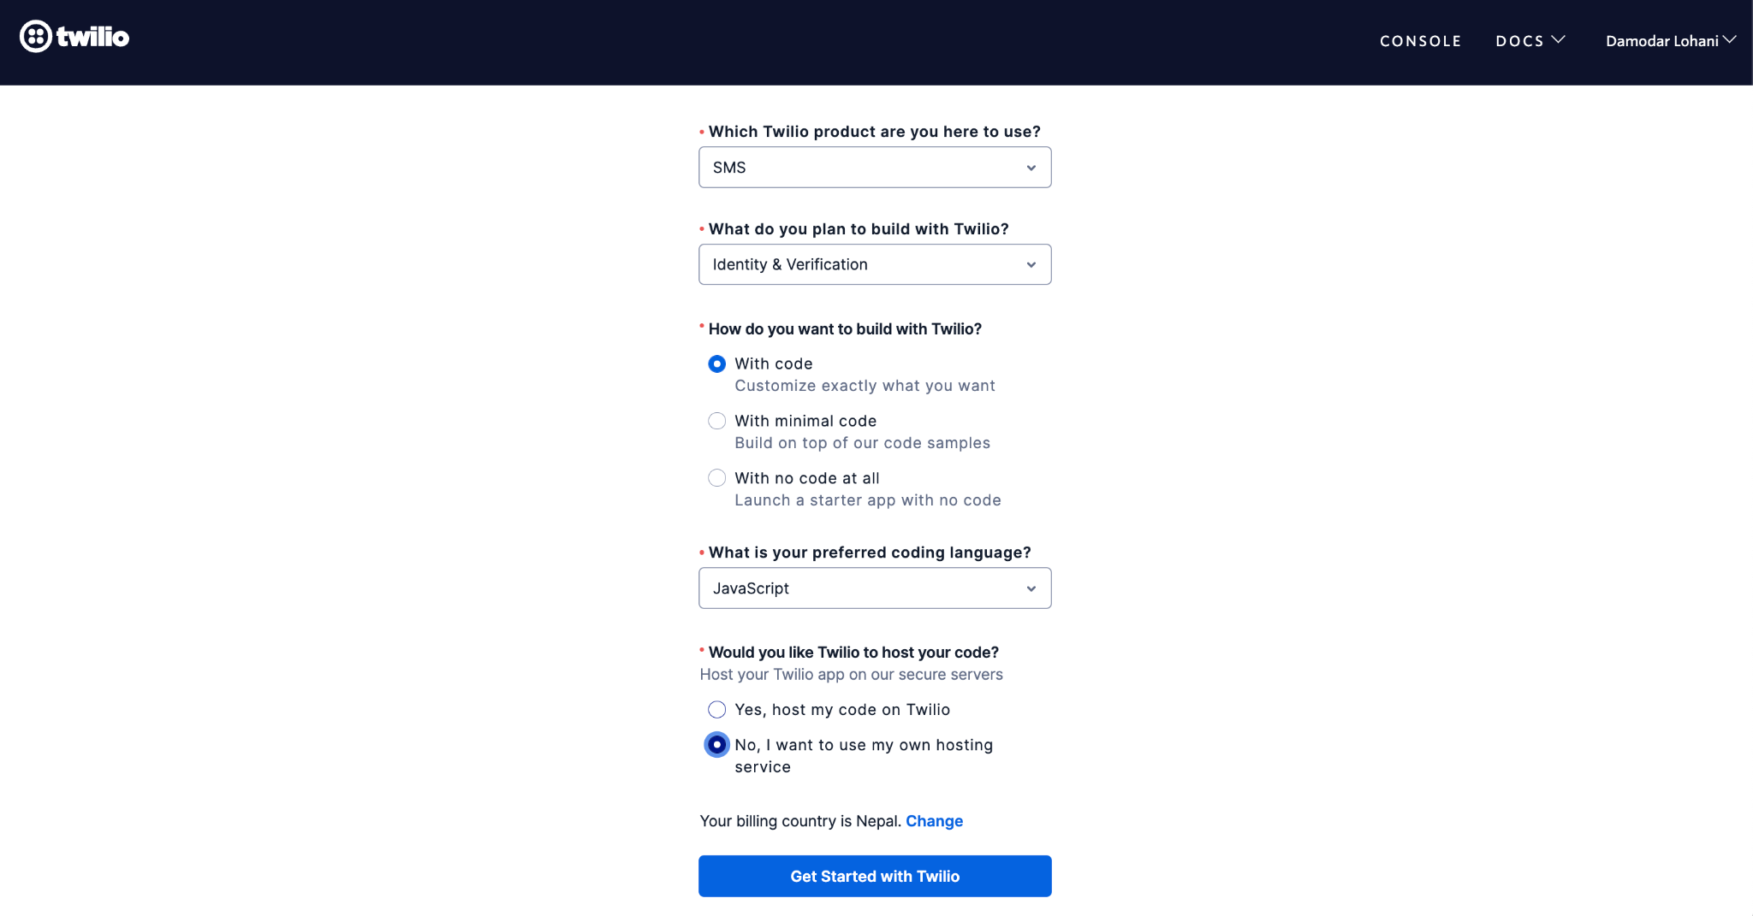

You should then be redirected to the Twilio console, where you can get your first Twilio number by clicking on the **Getting your Twillio number** button. Initially, you will be on a trial account and can only send texts and calls to your verified numbers. That’s perfect for us for testing. However, for production use, you must upgrade your Twilio account.

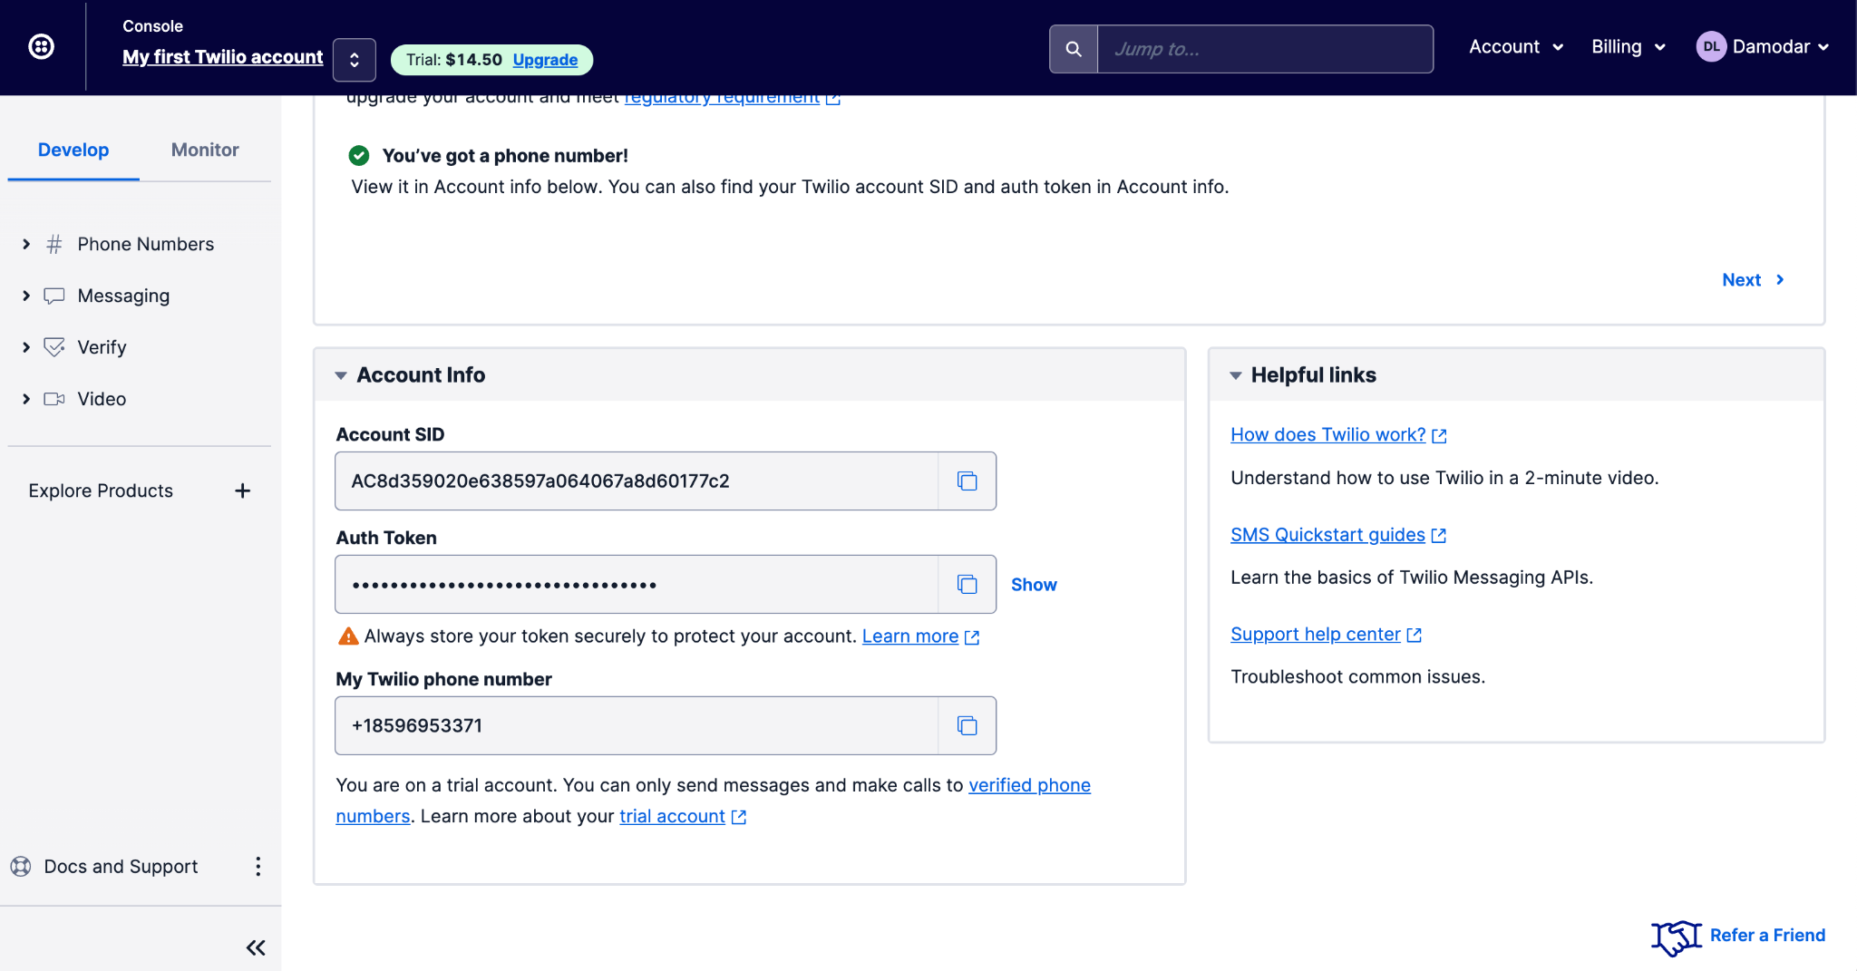

You can see the Account SID, Auth Token, and Phone number in the console. You will need these in the next session to set up Appwrite to use Twillio as an SMS provider. Your Twilio account should now be ready to integrate with Appwrite, which is what we will do next.

## Appwrite Setup

Follow the [official guide](https://appwrite.io/docs/installation) to set up and run Appwrite. For Appwrite to know about Appwrite, we need to open the `.env` file from the appwrite directory where you installed Appwrite and update the following environment variables.

_APP_PHONE_PROVIDER=twilio

_APP_PHONE_USER=<ACCOUNT_SID_FROM_TWILIO_CONSOLE>

_APP_PHONE_SECRET=<AUTH_TOKEN_FROM_TWILIO_CONSOLE>

_APP_PHONE_FROM=<TWILIO_PHONE_NUMBER>

Once the environment variables are updated, you need to run the following command from the command line in the installation directory that contains the `.env` and `docker-compose.yml` files.

docker-compose up -d

This will restart the containers providing new values for the environment variables so Appwrite can connect to Twilio. We are now ready to implement phone authentication in our application. Let’s do that in the next section.

**Install and Configure Appwrite’s Flutter SDK**

Clone the project we created for this tutorial so we can skip the setup and UI part and focus on the main topic. Clone <https://github.com/lohanidamodar/appwrite_phone_auth.git>. Once cloned, open it in your favorite IDE.

We will start by adding Appwrite’s SDK as a dependency. Open pubspec.yaml file and add Appwrite’s SDK under dependencies.

dependencies:

appwrite: ^6.0.0

If the IDE doesn’t get dependencies automatically, run the following command from the terminal.

flutter pub get

Next, open lib/providers/app_state.dart file. This is where we will configure our Appwrite SDK. First, import the appwrite package.

import ‘package:appwrite/appwrite.dart’;

import ‘package:appwrite/models.dart’; // Response type definitions

In the AuthState class, add new properties.

class AuthState extends ChangeNotifier {

final _client = Client();

late final Account _account;

}

Then in the constructor, let’s configure the client and instantiate the account.

AuthState() {

_client.setEndpoint(‘YOUR_ENDPOINT’)

.setProject(‘YOUR_PROJECT_ID’);

_account = Account(client);  
 }

Once the SDK is installed and configured, one final thing we need to do is add the platform to our Appwrite project. Open the Appwrite console and choose the project you created for this project. You can find the **Add Platform** button on the project home page. Click on the **Add Platform** button and select **New Flutter App**. In the dialog box that appears, choose the appropriate Flutter platform, give your platform a recognizable name, and add the application ID or package name based on the platform. You must follow this step for each Flutter platform you will build your application.

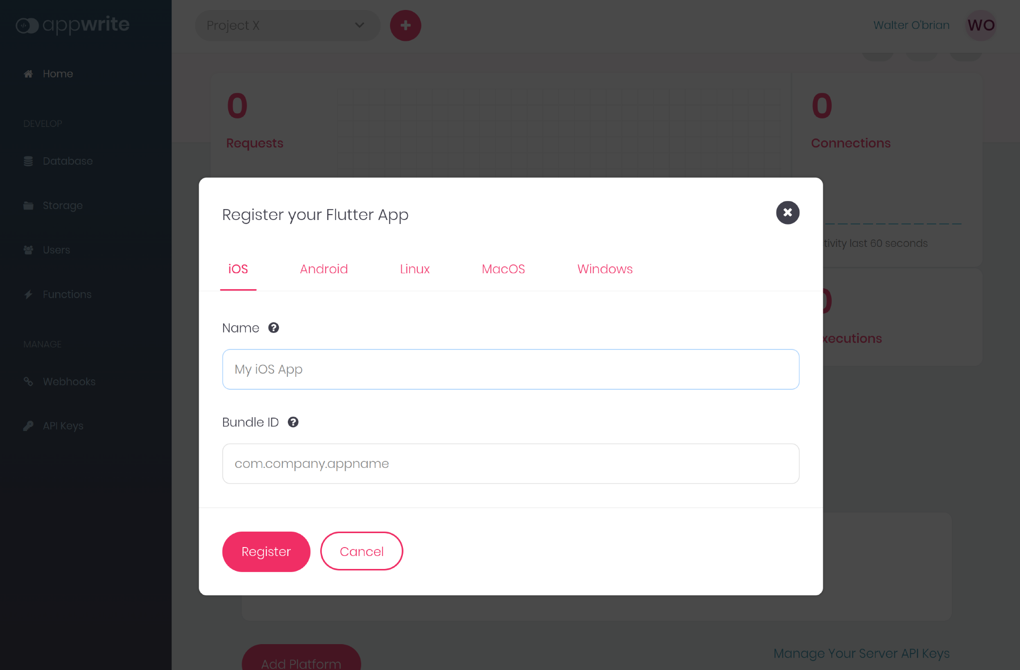

For more detailed instructions on getting started with Appwrite for Flutter developers, follow our official [Getting Started for Flutter](https://appwrite.io/docs/getting-started-for-flutter) guide.

Now that our SDK is installed and configured, we are ready to implement phone authentication in our application. We will do that in the next section.

## Creating Session with Phone

We must implement two methods to create a valid session for users with phone numbers. First, to initiate the session creation process, we will use the setup provider to send a verification code to the provided phone number. Next, use the verification code to confirm and create a valid session for the user. So let us implement those two methods in our AuthState class like the following.

To initiate the session, we call createPhoneSession from the account service and pass the userId and phone numbers. Passing ‘unique()’ as userId allows Appwrite to generate a unique userId.

Future<bool> createSession(String phone) async {

try {

final token =

await _account.createPhoneSession(userId: 'unique()', number: phone);

userId = token.userId;

return true;

} on AppwriteException catch (e) {

_error = e.message ?? e.toString();

isLoggedIn = false;

notifyListeners();

return false;

}

}

Calling createPhoneSession returns a token object with userId. We save userId we need it to confirm authentication and create a valid session. To do that, we need to call updatePhoneSession from the account service. Let’s create confirmSession method as the following.

Future<bool> confirmSession(String secret) async {

if (userId.isEmpty) {

_error = 'userId not known, call `createSession` first to get userId';

notifyListeners();

return false;

}

try {

await _account.updatePhoneSession(userId: userId, secret: secret);

isLoggedIn = true;

notifyListeners();

return true;

} on AppwriteException catch (e) {

_error = e.message ?? e.toString();

isLoggedIn = false;

return false;

}

}

Let’s call these methods in the appropriate UI. Open lib/login.dart and find the Login button. In the onPressed action of the button, add the following code after the check.

final success = await ref

.read(AuthState.provider.notifier)

.createSession(_phoneController.text);

if (!mounted) return;

if (success) {

Navigator.pushNamed(context, '/verify');

}

Open lib/verify_phone.dart and find the Verify button. In the onPressed action of the button, add the following code after the check.

final loggedIn = await ref

.read(AuthState.provider.notifier)

.confirmSession(currentText);

if (!mounted) return;

if (loggedIn) {

Navigator.pushReplacementNamed(context, '/');

} else {

ScaffoldMessenger.of(context).showSnackBar(SnackBar(

content: Text(ref.read(AuthState.provider).error),

));

}

Here we are calling Appwrite with the code received in the SMS. There’s one last thing we need to do. We need to make a call to get an account. Open lib/providers/app_state.dart and add the following function.

Future<bool> getAccount() async {

try {

user = await _account.get();

isLoggedIn = true;

notifyListeners();

return true;

} on AppwriteException catch (e) {

_error = e.message ?? e.toString();

isLoggedIn = false;

user = null;

notifyListeners();

return false;

}

}

Call this function in the constructor of the AuthState, so when the application starts, it checks if we already have a valid session. You can now run the application and see the phone authentication in action.

// gif

## Conclusion

That’s how easy it is to set up phone authentication with Appwrite. You can choose between different providers. For now, [Twilio](https://twilio.com/), [Telesign](https://www.telesign.com/), and [TextMagic](https://www.textmagic.com/) now. You are also welcome to contribute by adding more providers. To learn more about Appwrite and to integrate it with Flutter, here are a few more resources that might help you.

* [Getting Started for Flutter](https://appwrite.io/docs/getting-started-for-flutter)
* [Appwrite Docs](https://appwrite.io/docs)
* [Appwrite Discord](https://appwrite.io/discord)
* [Appwrite Github](https://github.com/appwrite/appwrite)