Simple Network Architecture
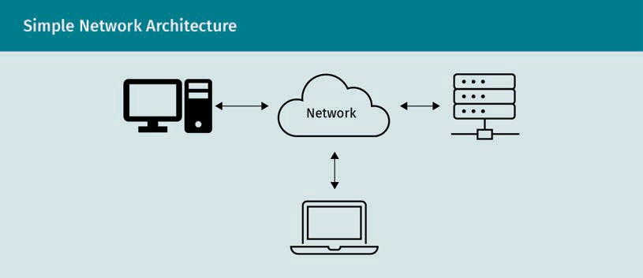
[Titel]

Network

The Professor-Translator-Transmission Architecture
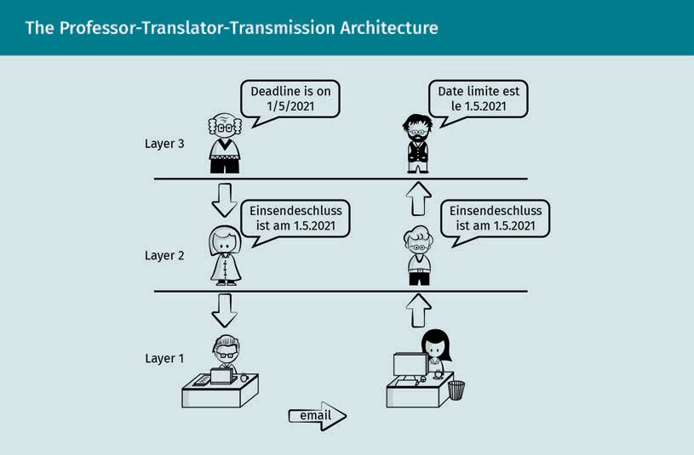
Email

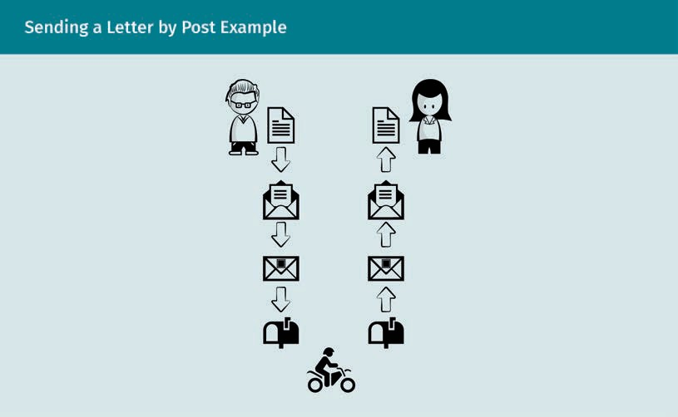
Sending a Letter by Post Example

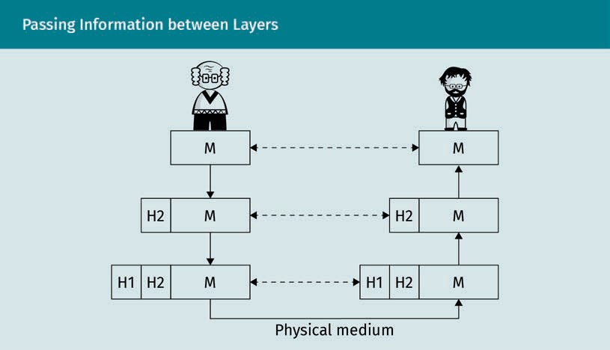
Passing Information between Layers

M
H2
H1
Physical medium

TCP/IP Reference Model
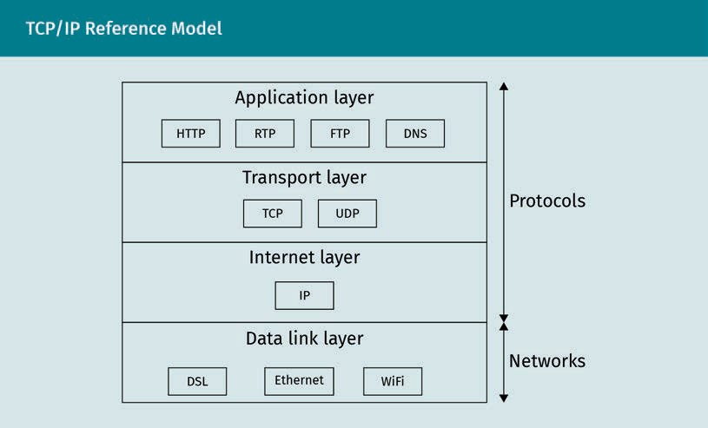
Application layer
HTTP
RTP
FTP
DNS
Transport layer
TCP
UDP
Internet layer
IP
Data link layer
DSL
Ethernet
WiFi
Networks
Protocols

Client and Server Communication over an Unsecured Channel
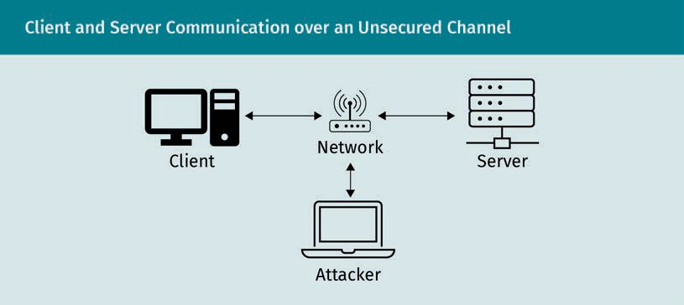
Client
Network
Server
Attacker

The Default Wireshark View
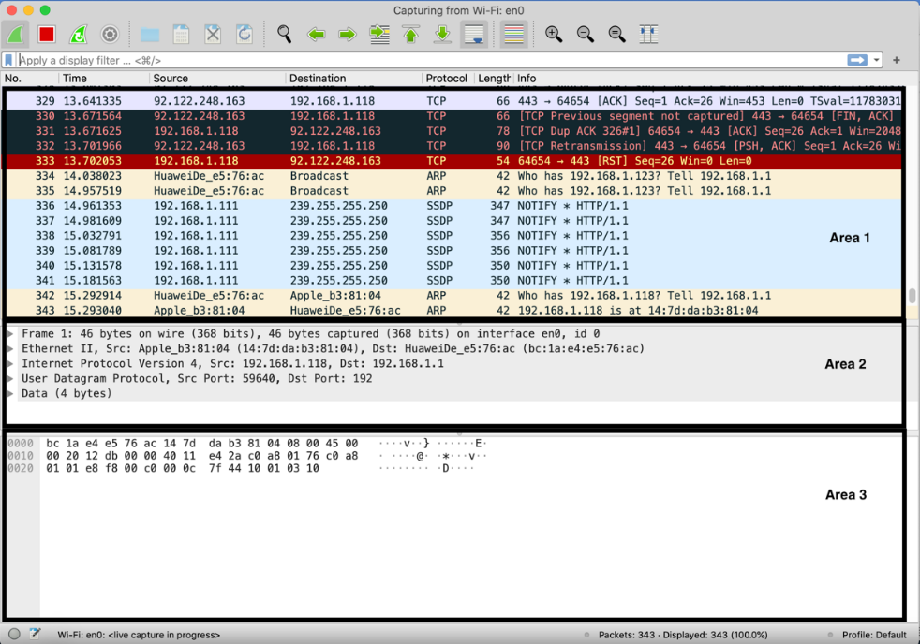
Capturing TCP Connection
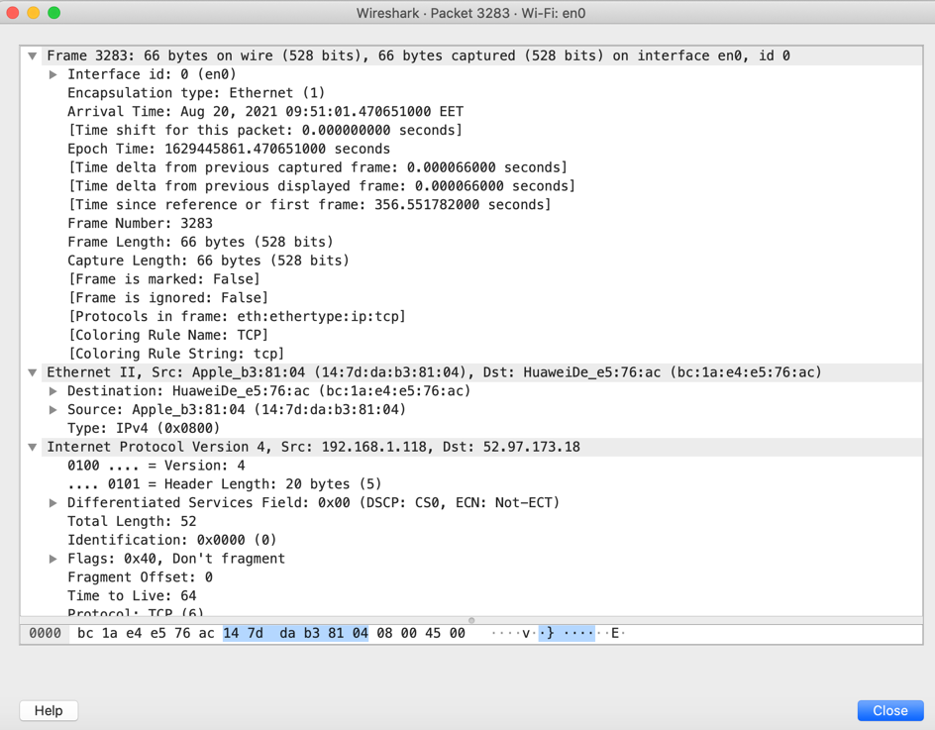

Man-in-the-Middle Scenario
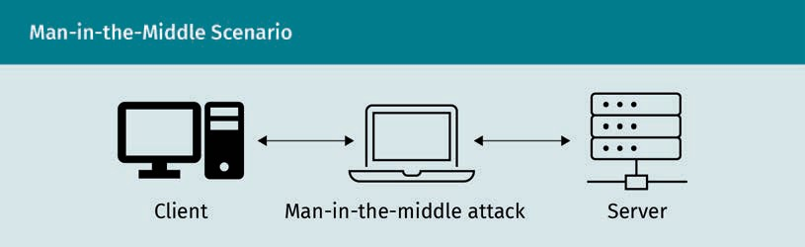
Client
Man-in-the-middle attack
Server

Connected Network Infrastructure Devices
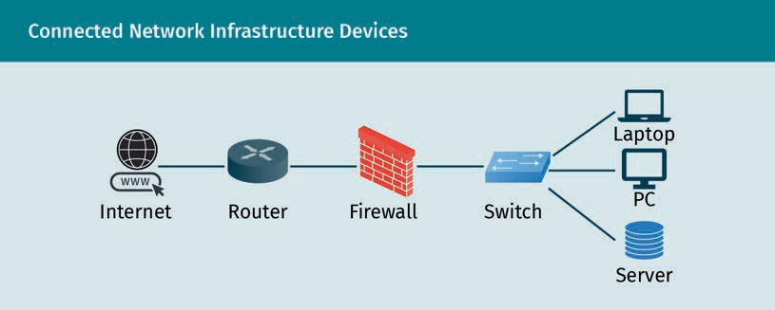
Internet
Router
Firewall
Switch
Laptop
PC
Server

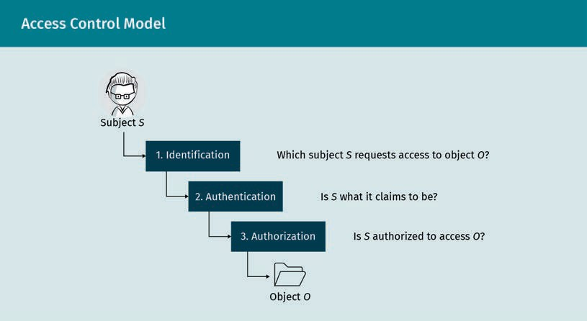
Access Control Model

1. Identification
Which subject S requests access to object O?
2. Authentication
Is S what it claims to be?
3. Authorization
Is S authorized to access O?
Object O

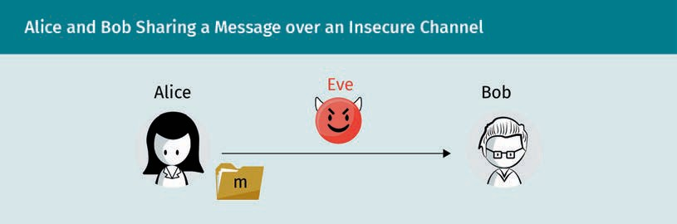
Alice and Bob Sharing a Message over an Insecure Channel

Alice
Eve
Bob

Alice and Bob Sharing an Encrypted Message over an Insecure Channel
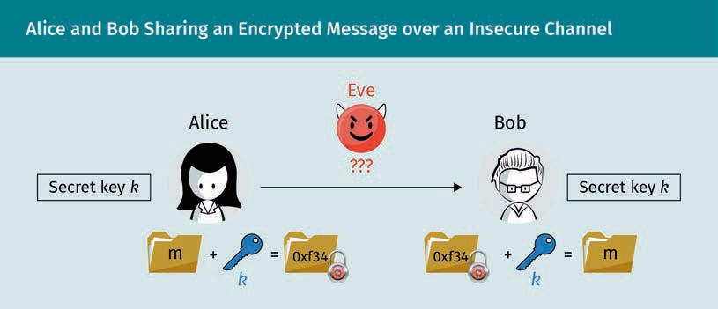
Secret key k
Alice
Eve
???
Bob
0xf34

Symmetric Key Cryptography Model
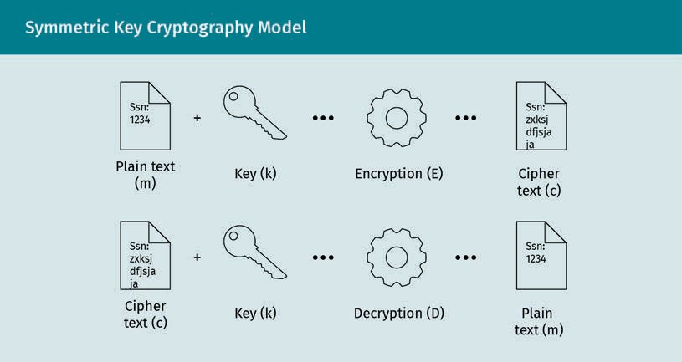
Plain text (m)
Key (k)
Encryption (E)
Cipher text (c)
Decryption (D)

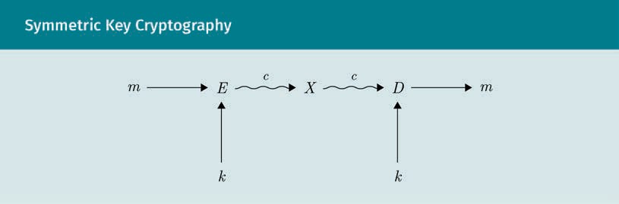
Symmetric Key Cryptography

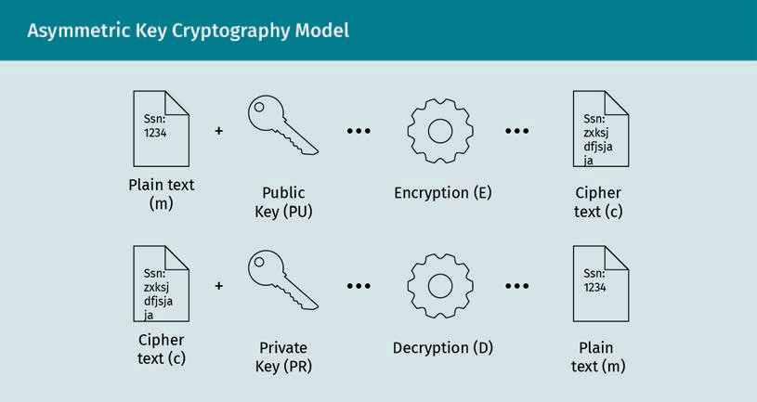
Asymmetric Key Cryptography Model

Ssn: 1234
Plain text (m)
Key (k)
Encryption (E)
Ssn: zxksjdfjsjaja
Cipher text (c)
Decryption (D)

Alice and Bob Using Asymmetric Cryptography for Sending Messages over Insecure Public Channel
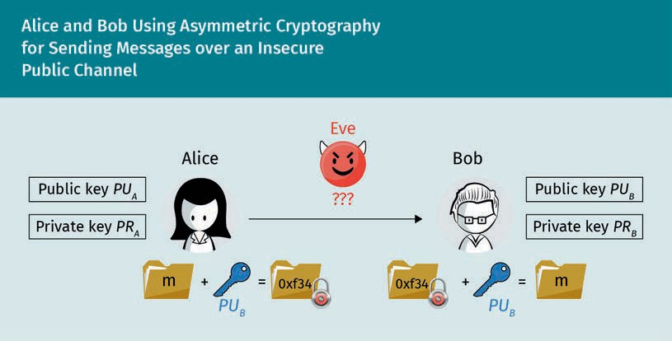
Public key
Private key
Alice
Eve
???
Bob
0xf34

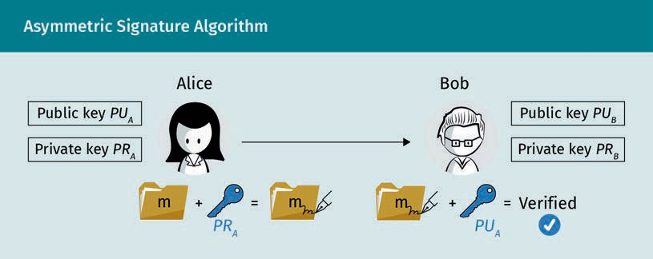
Asymmetric Signature Algorithm

Public key
Private key
Alice
Bob
Verified

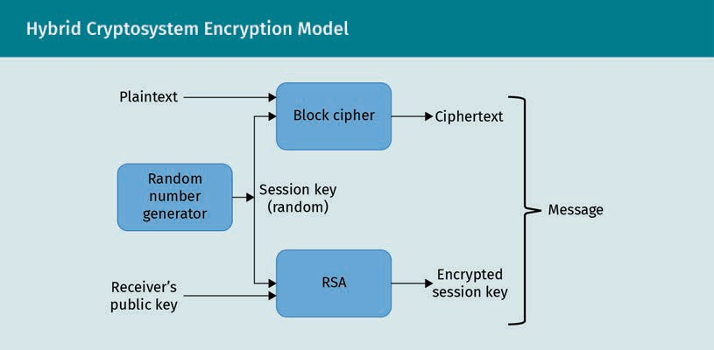
Hybrid Cryptosystem Encryption Model

Plaintext
Block cipher
Ciphertext
Random number generator
Session key (random)
Message
Receiver’s public key
RSA
Encrypted session key

MikTex Source Hash
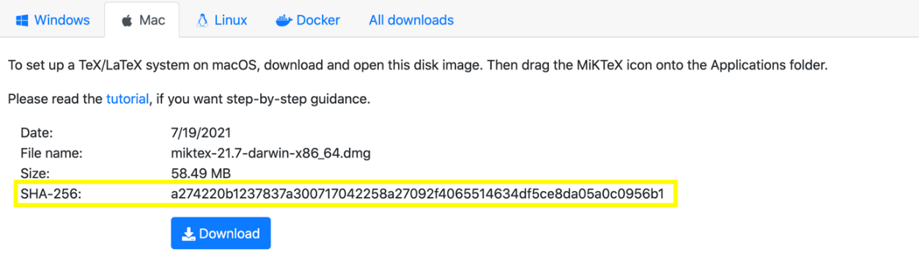

Checking MikTex Source File Integrity Using Hash Function via the Terminal
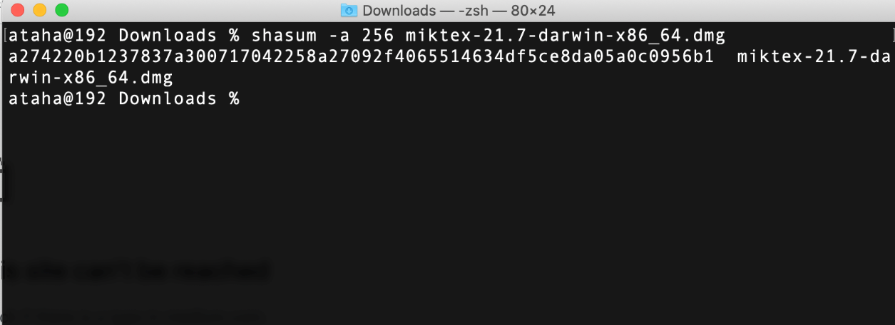

PGP Keys Creation

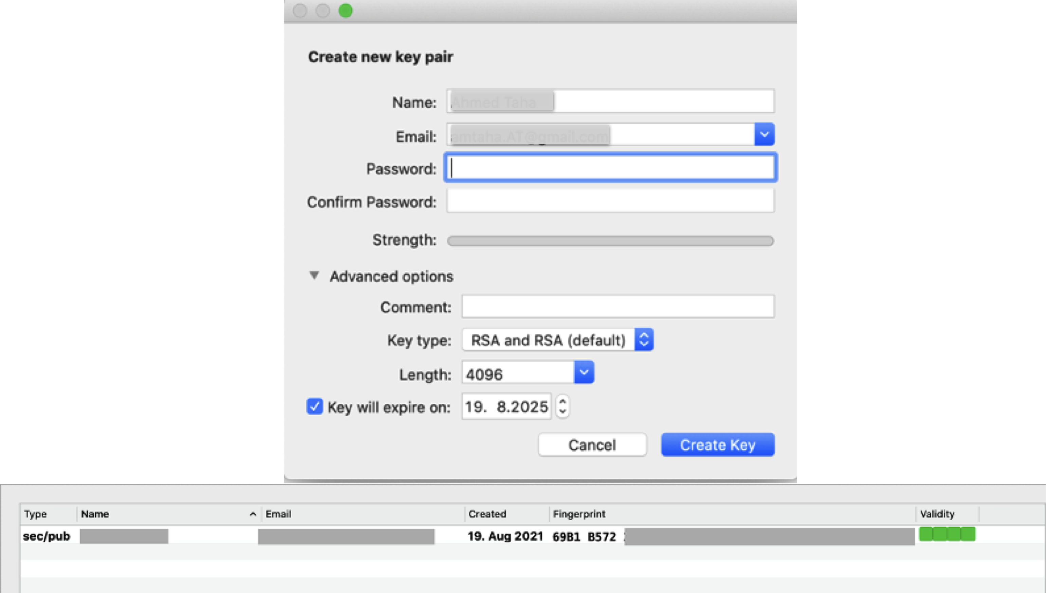

Encrypting the Plaintext Using the Public PGP Key
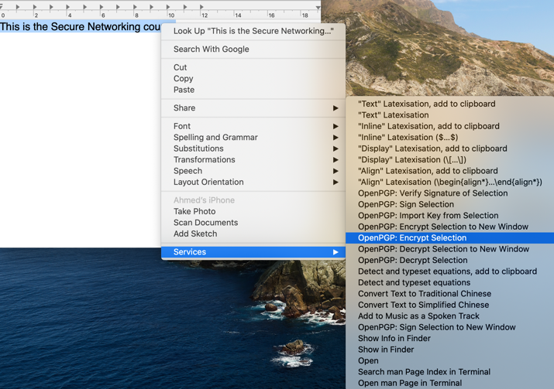

Cipher Text of the Encrypted Plaintext
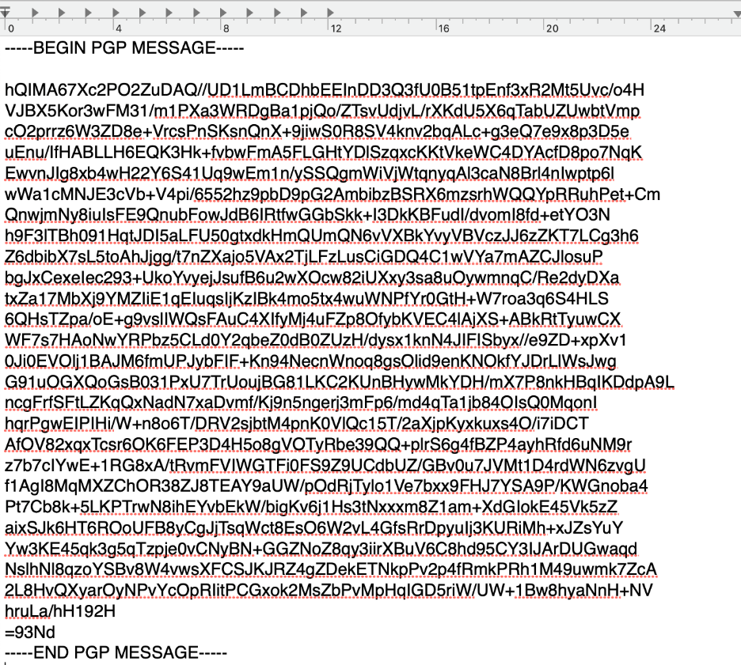

Restoring the Plaintext by Decrypting the Cipher Text Using the PGP Private Key
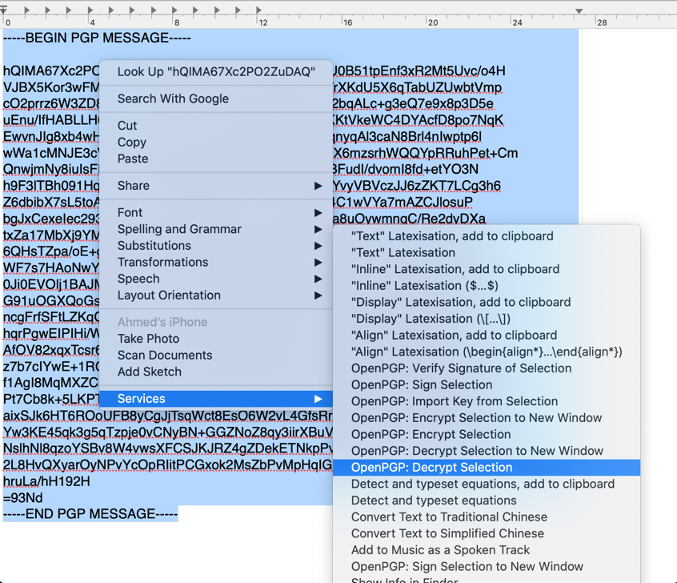

Decryption Failed if We Modified the Cipher Text
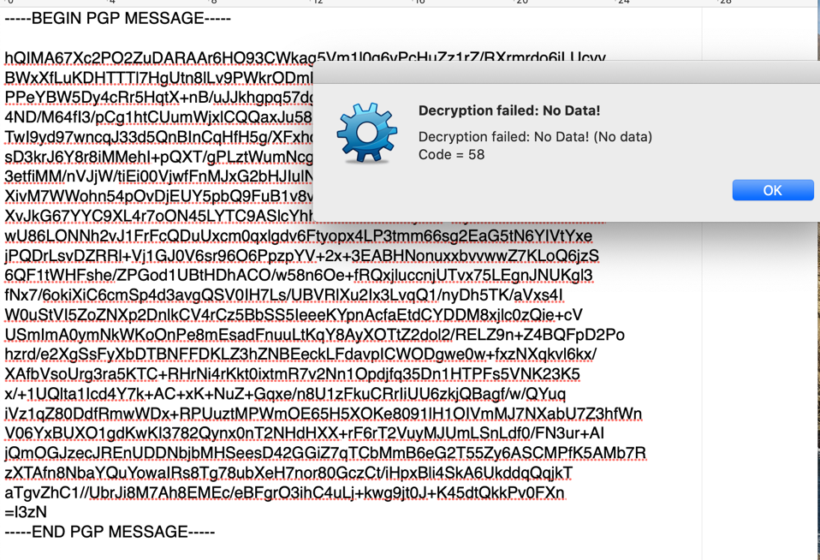\

Using PGP to Sign a Message Using PGP’s Private Key
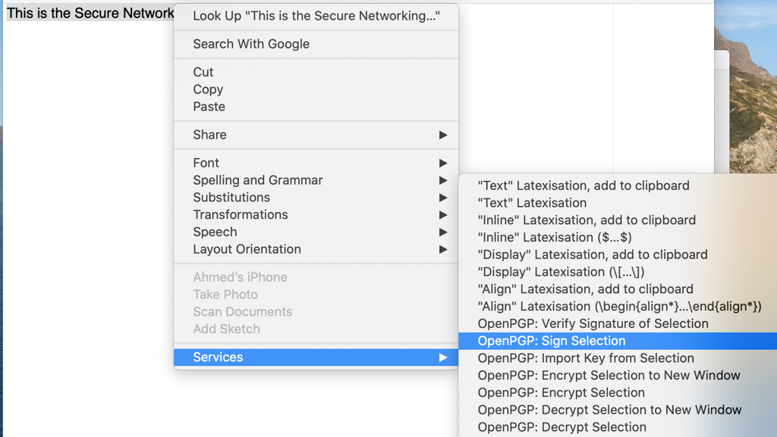

Generated Signed Message
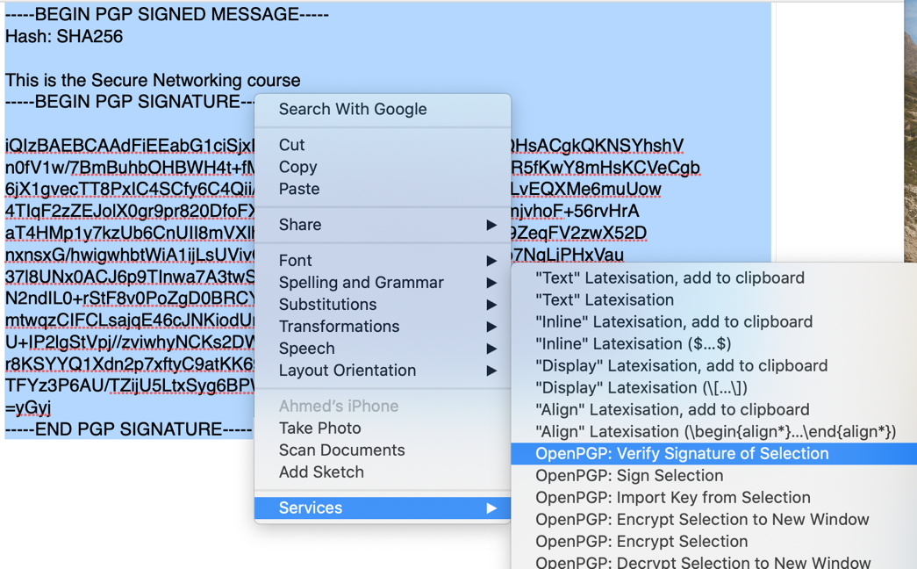

Successfully Verified Signature
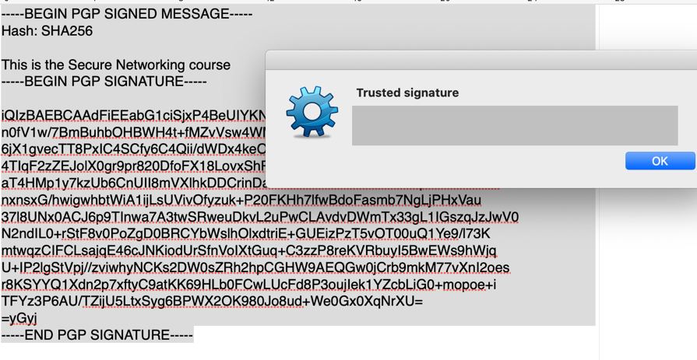

Verification Failed if the Signed Message Was Modified
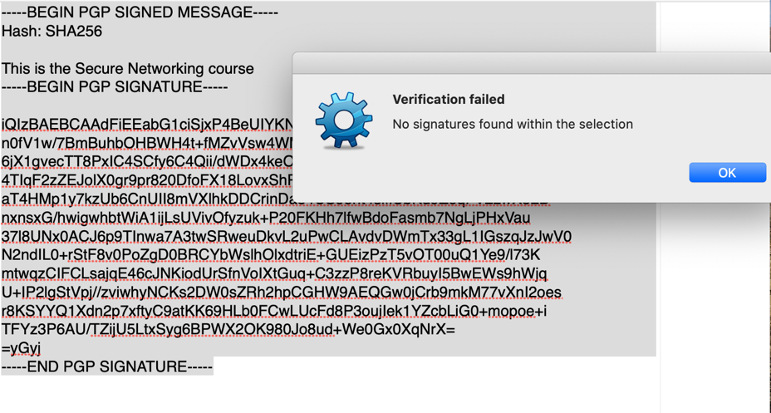

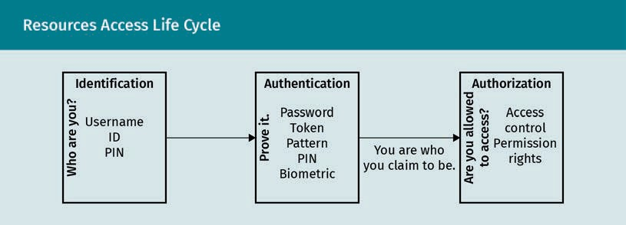
Resources Access Life Cycle

Identification
Who are you?
Username
ID
PIN
Authentication
Prove it
Password
Token
Pattern
PIN
Biometric
You are who you claim to be
Authorization
Are you allowed to access
Access control
Permission rights

Google Chrome Digital Certificate
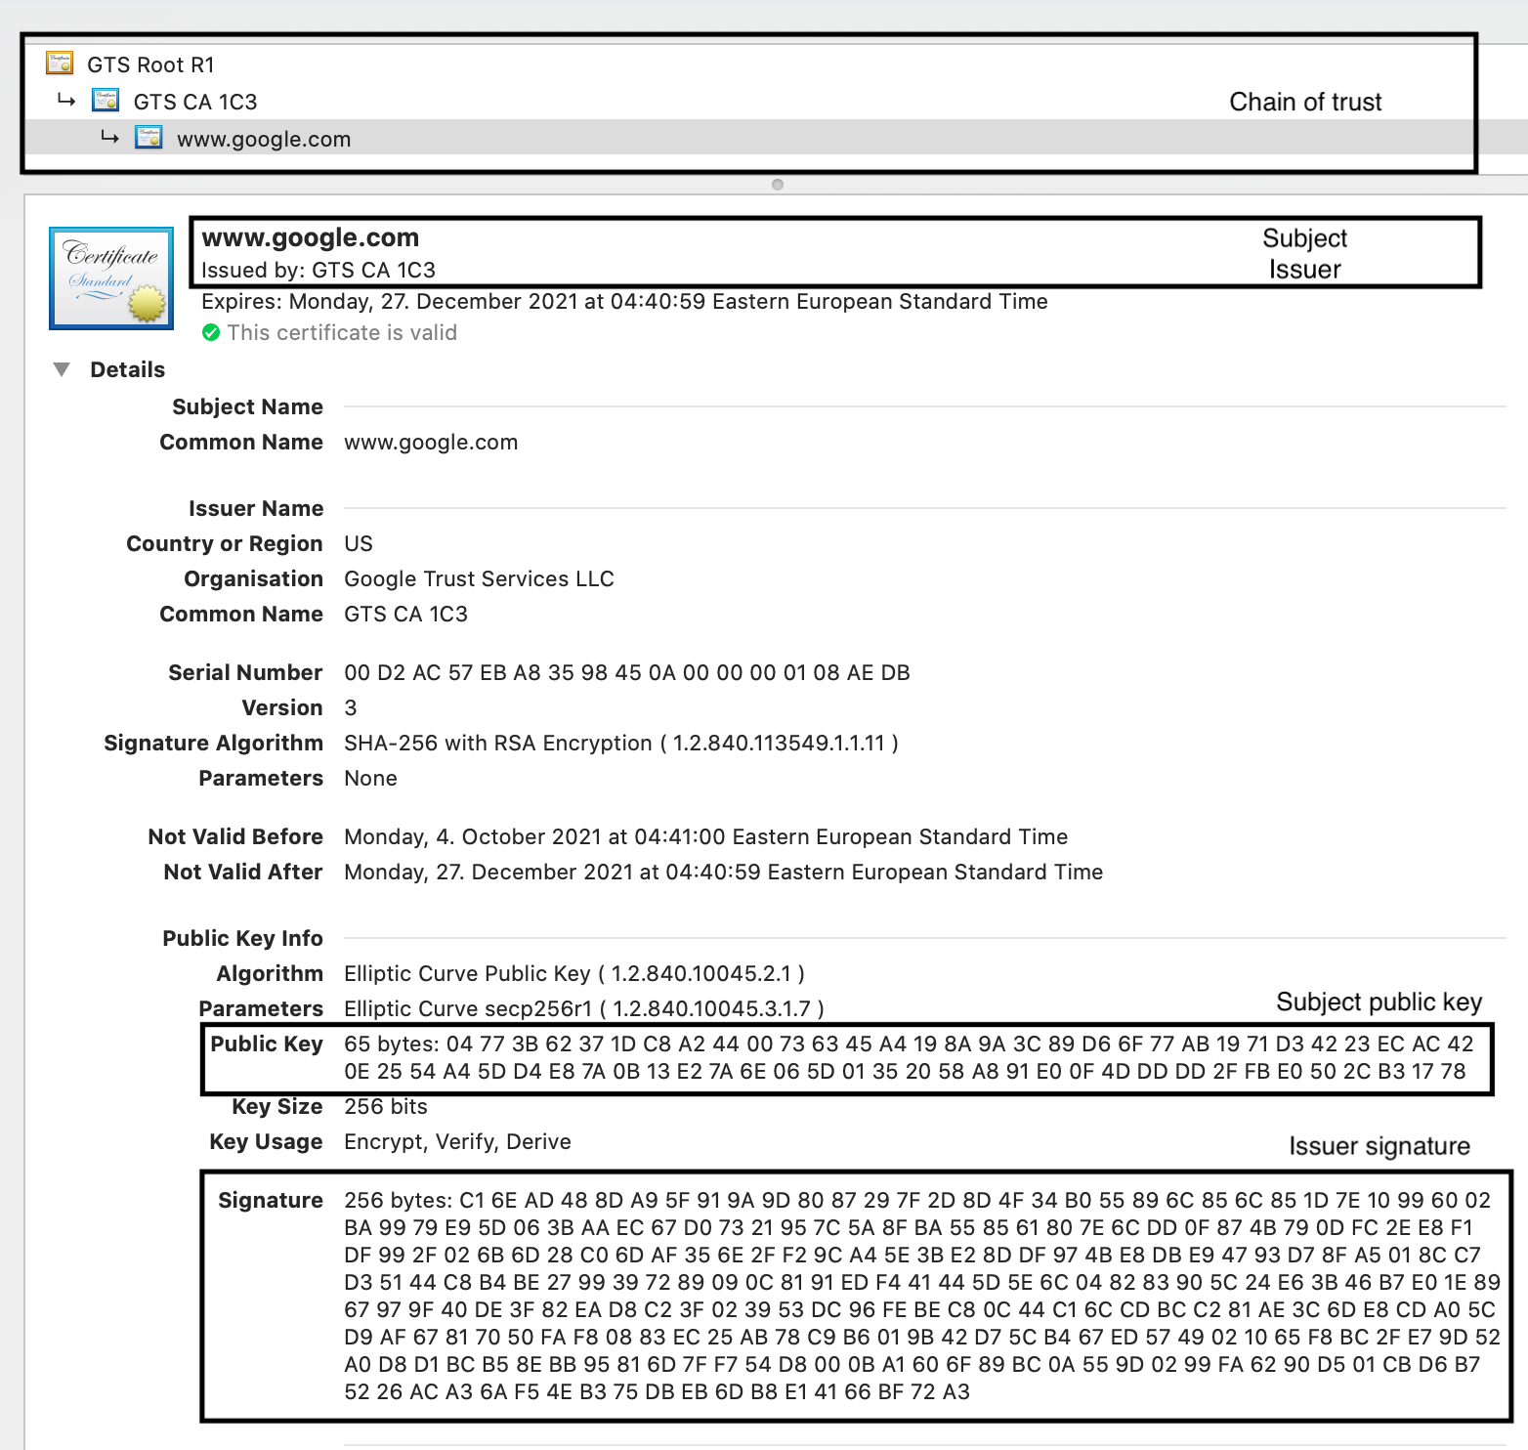

Authentication Implementation
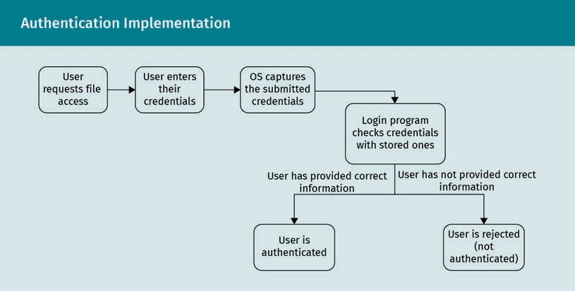

User requests file access
User enters his/her credentials
OS captures the submitted credentials
Login program checks credentials with stored ones
User has provided correct information
User has not provided correct information
User is authenticated
User is rejected (not authenticated)

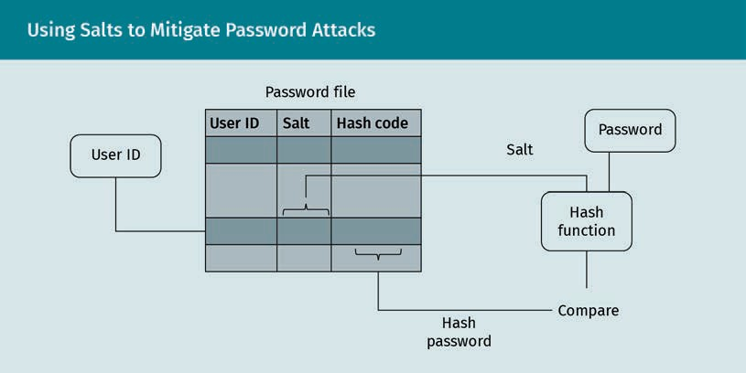
Using Salts to Mitigate Password Attacks

User ID
Password file
Salt
Hash code
Hashed password
Hash function
Compare
Password

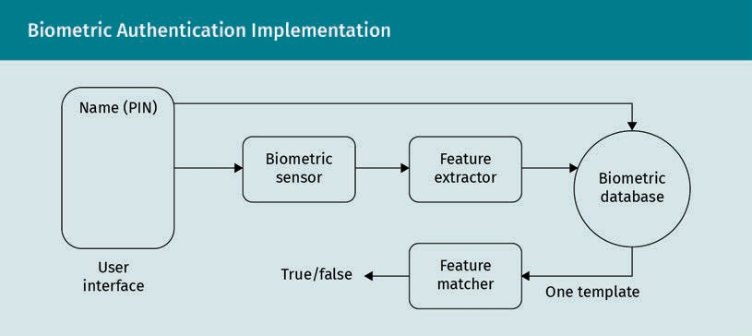
Biometric Authentication Implementation

Name (PIN)
User interface
Biometric sensor
True/false
Feature extractor
Feature matcher
One template
Biometric database

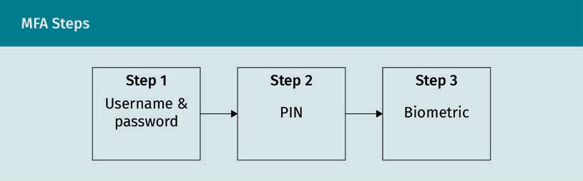
MFA Steps

Step 1
Username & password
Step 2
PIN
Step 3
Biometric

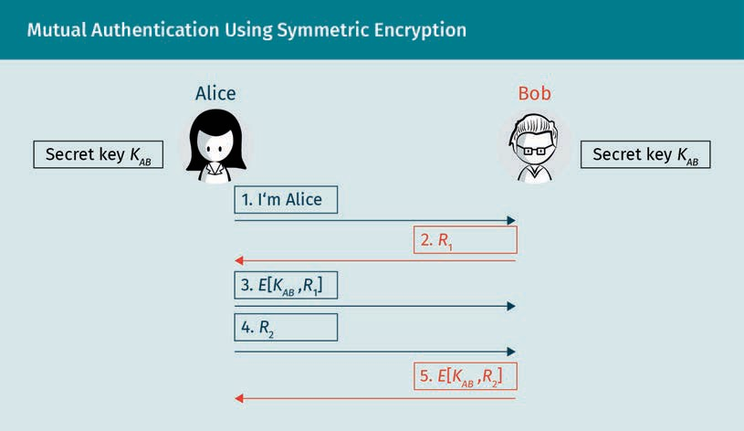
Mutual Authentication Using Symmetric Encryption

Secret key
Alice
Bob
I’m Alice

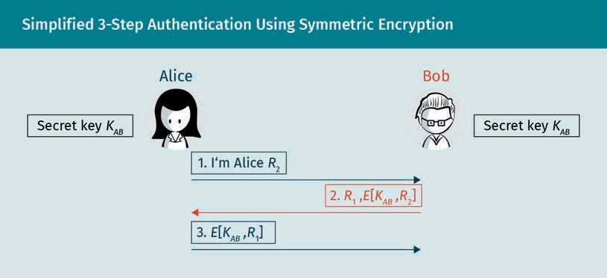
Simplified 3-Step Authentication Using Symmetric Encryption

Secret key
Alice
Bob
I’m Alice

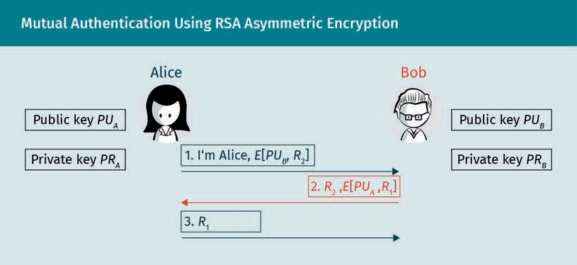
Mutual Authentication Using RSA Asymmetric Encryption

Public key
Private key
Alice
Bob
I’m Alice

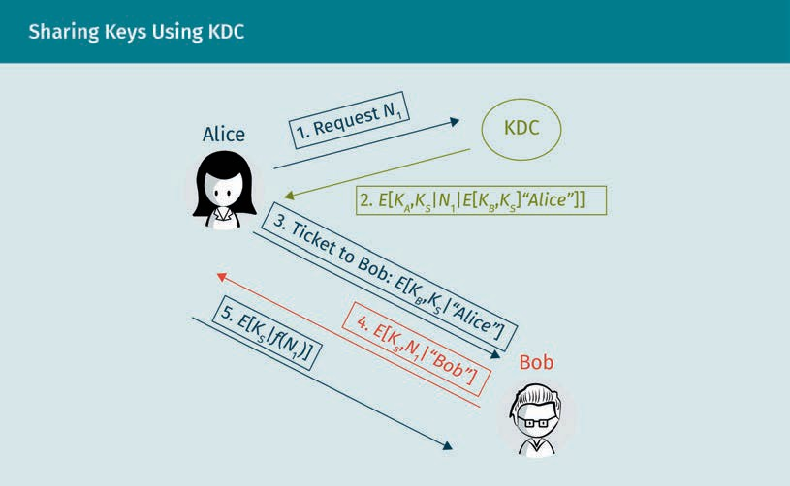
Sharing Keys Using KDC

Alice
Request
KDC
Ticket to Bob
Bob

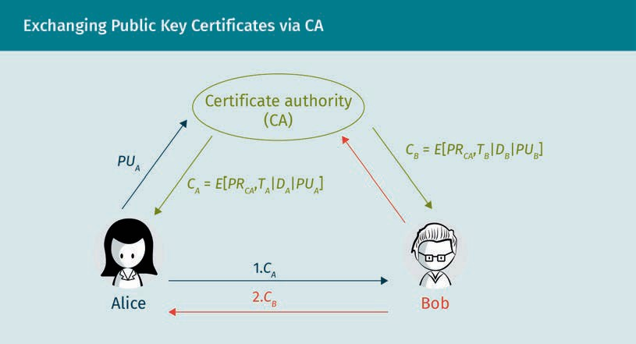
Exchanging Public Key Certificates via CA

Alice
Bob
Certificate authority (CA)

IPsec Architecture

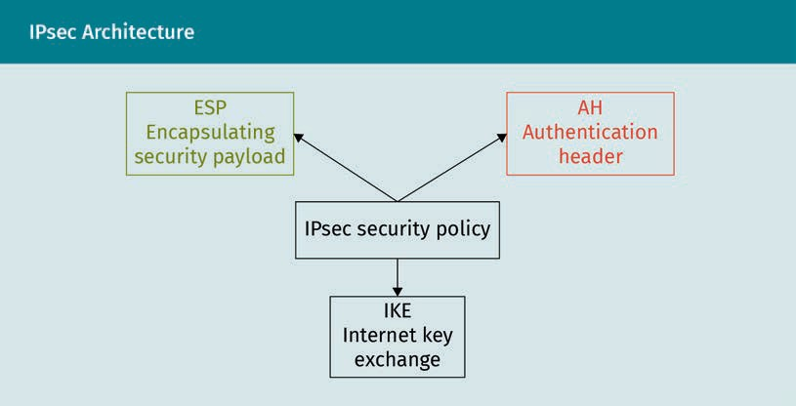
ESP
Encapsulating security payload
AH
Authentication header
IPsec security policy
IKE
Internet key exchange

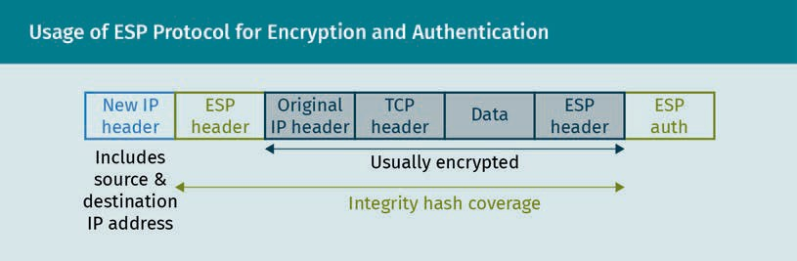
Usage of ESP Protocol for Encryption and Authentication

New IP header
Includes source & destination IP address
ESP header
Original IP header
TCP header
Data
ESP auth
Usually encrypted
Integrity hash coverage

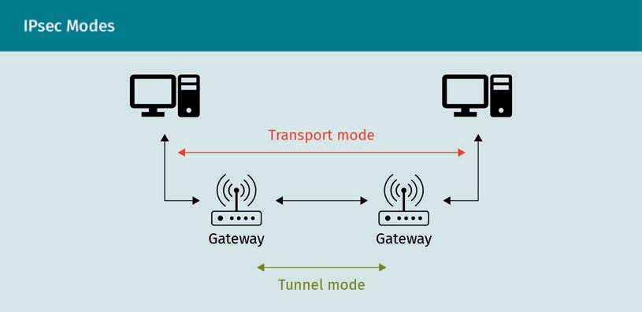
IPsec Modes

Transport mode
Gateway
Tunnel mode

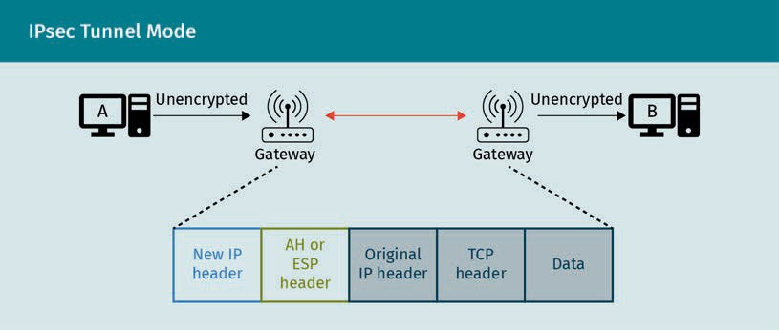
IPsec Tunnel Mode

Unencrypted
Gateway
Encrypted
New IP header
AH or ESP header
Origin IP header
TCP header
Data

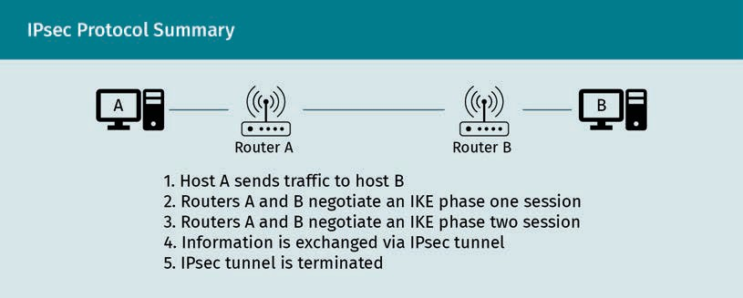
IPsec Protocol Summary

Router A
Router B
1. Host A sends traffic to host B
2. Routers A and B negotiate an IKE phase one session
3. Routers A and B negotiate an IKE phase two session
4. Information is exchanged via IPsec tunnel
5. IPsec tunnel is terminated

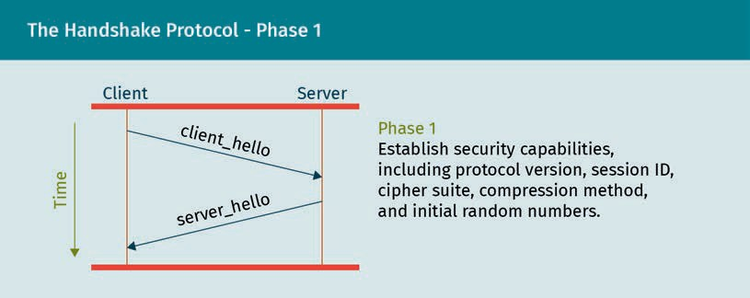
The Handshake Protocol—Phase 1

Time
Client
Server
client_hello
server_hello
Phase 1
Establish security capabilities, including protocol version, session ID, cipher suite, compression method, and initial random numbers

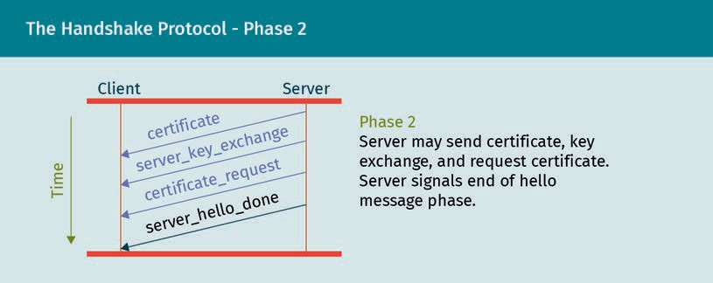
The Handshake Protocol—Phase 2

Time
Client
Server
certificate
server_key_exchange
certificate_request
server_hello_done
Phase 2
Server may send certificate, key exchange, and request certificate. Server signals end of hello message phase

The Handshake Protocol—Phase 3
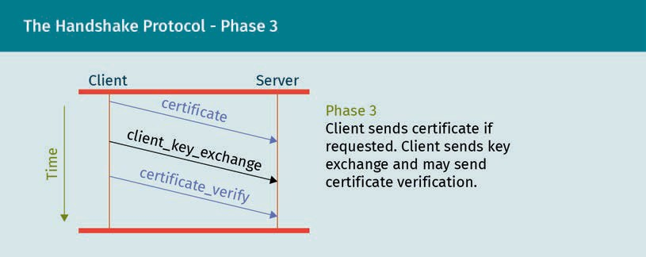

Time
Client
Server
certificate
client_key_exchange
certificate_verify
Phase 3
Client sends certificate if requested. Client sends key exchange and may send certificate verification

The Handshake Protocol—Phase 4
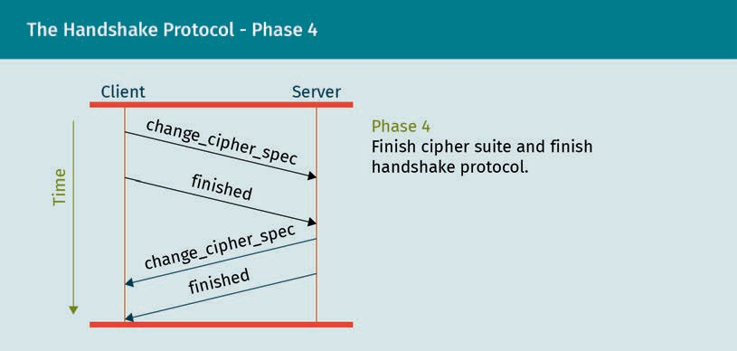
Time
Client
Server
change_cipher_spec
finished
Phase 4
Finish cipher suit and finish handshake protocol

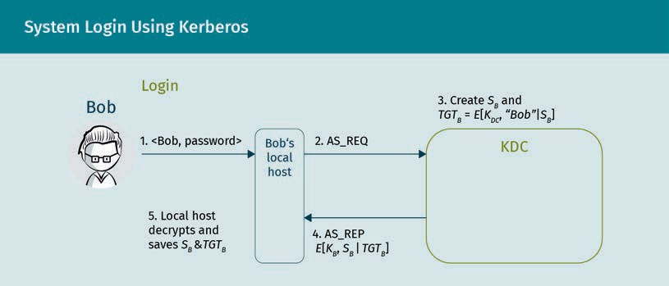
System Login Using Kerberos

Bob
Login
1. <Bob, password>
Bob’s local host
2. AS_REQ
3. create
KDC
4. AS_REP
5. Local host decrypts and saves

Accessing the Printer Using Kerberos (1/2)
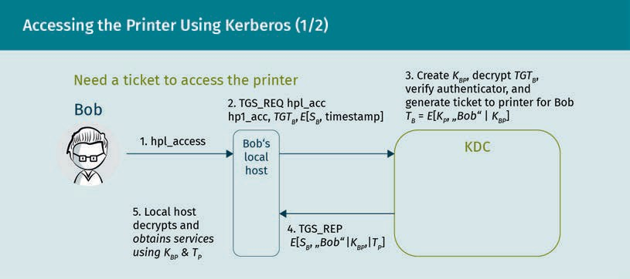
Need a ticket to access the printer
Bob
1. hpl_access
2. TGS_REQ hpl_acc
Bob’s local host
3. create, decrypt, verify authenticator, and generate ticket to printer for Bob
KDC
4. TGC_REP
5. Local host decrypts and obtains services using

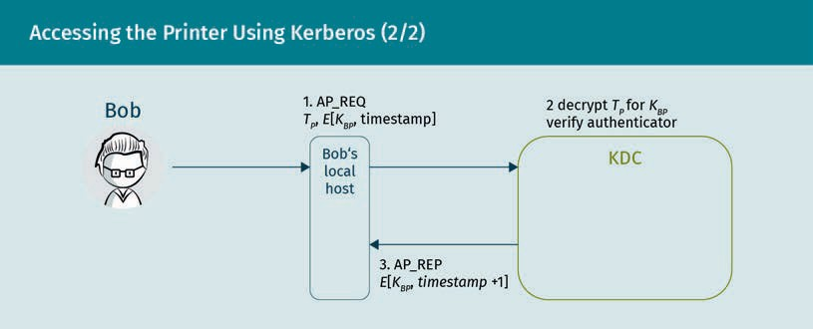
Accessing the Printer Using Kerberos (2/2)

Bob
Bob’s local host
1. AP_REQ
2. decrypt for verify authenticator
Printer server
3. AP_REP

Bluetooth Networks
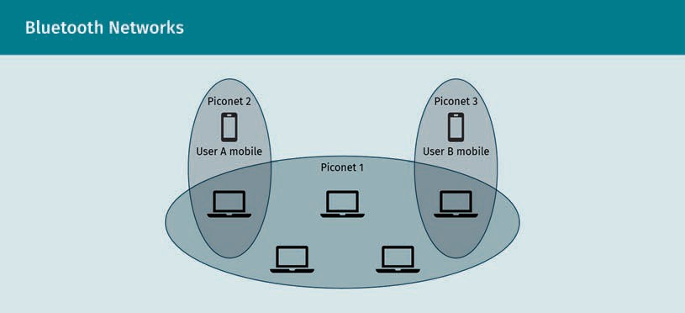
Piconet 2
User A mobile
Piconet 1
Piconet 3
User B mobile

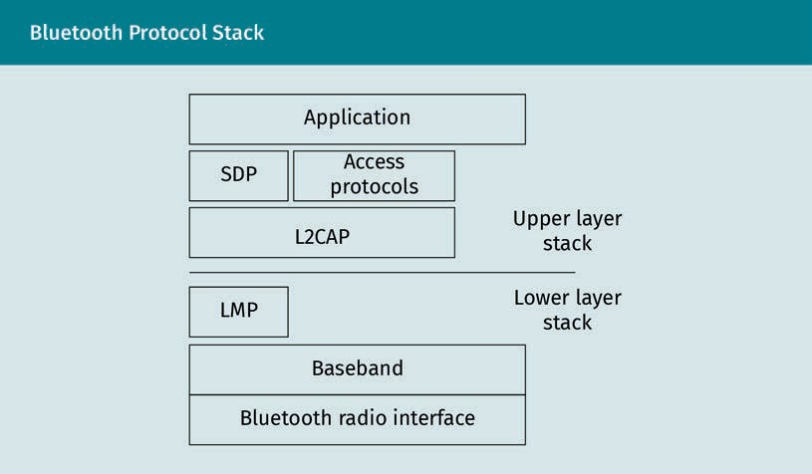
Bluetooth Protocol Stack

Application
SDP
Access protocols
L2CAP
Upper layer stack
LMP
Lower layer stack
Baseband
Bluetooth radio interface

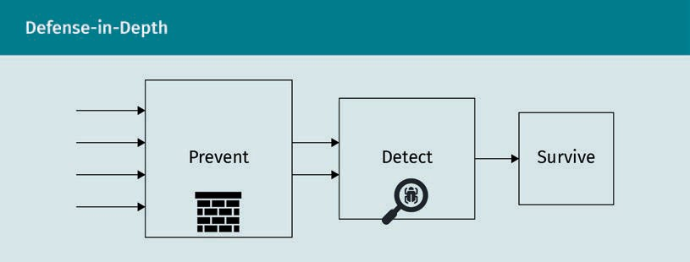
Defense-in-Depth

Prevent
Detect
Survive

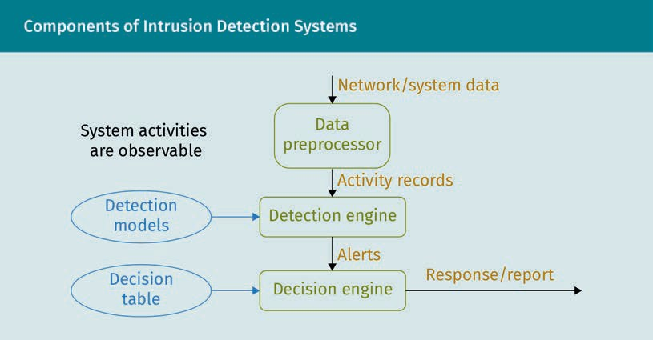
Components of Intrusion Detection Systems

System activities are observable
Detection models
Decision table
Network/system data
Data preprocessor
Activity records
Detection engine
Alerts
Decision engine
Response/report

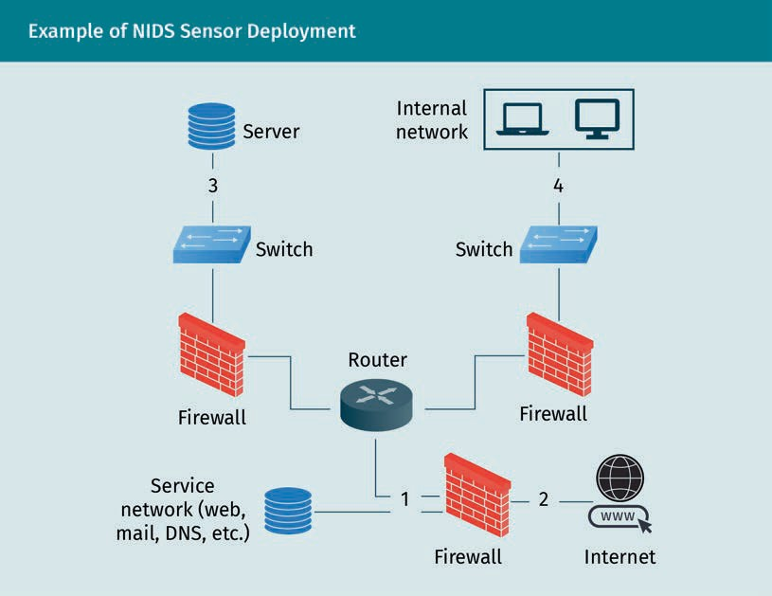
Example of NIDS Sensor Deployment

Server
Switch
Firewall
Service network (web, mail, DNS, etc.)
Router
Internal network
Internet

DLMSEESN01_D_MC_010
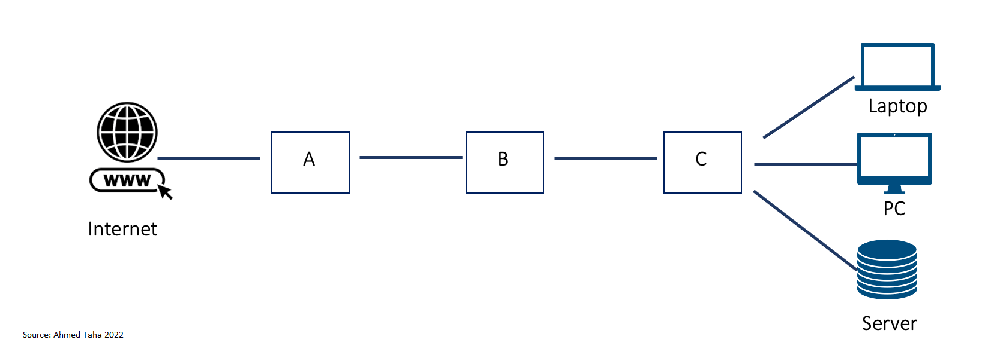
Laptop
PC
Server

DLMSEESN01_D_offen_010
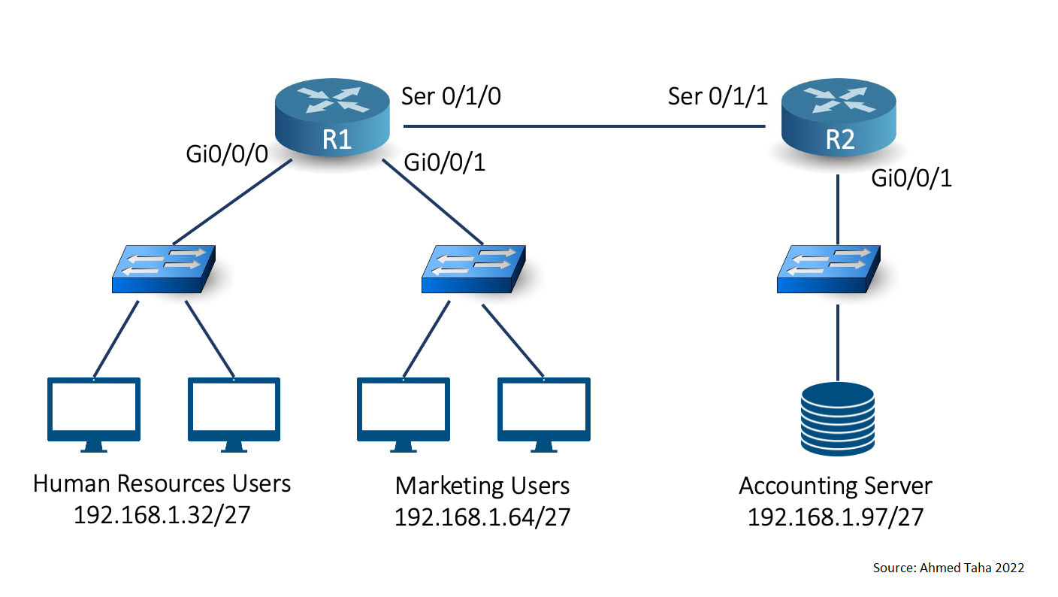
Human Resources Users
Marketing Users
Accounting Server

DLMSEESN01_D_offen_018
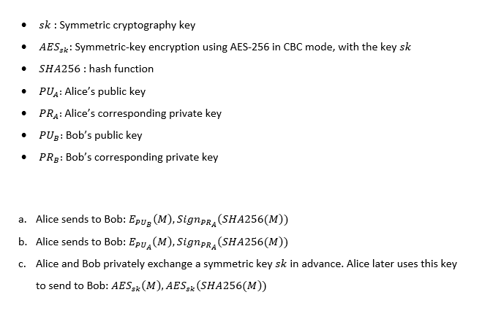
Sk: Symmetric cryptography key
AES_{sk}: Symmetric-key encryption using AES-256 in CBC mode, with the key sk
SHA256: hash function
PU_{A}: Alice’s public key
PR_{A}: Alice’s corresponding private key
PU_{B}: Bob’s public key
PR_{B}: Bob’s corresponding private key
a. Alice sends to Bob: $E_{{PU}_{B}}\left(M\right), {Sign}_{{PR}_{A}}(SHA256\left(MM\right))$
b. Alice sends to Bob: $E_{{PU}_{A}}\left(M\right), {Sign}_{{PR}_{A}}(SHA256\left(MM\right))$
Alice and Bob privately exchange a symmetric key sk in advance. Alice later uses this key to send to Bob: ${AES}_{sk}(M), {AES}_{sk}(SHA256\left(MM\right))$

DLMSEESN01_D_offen_029
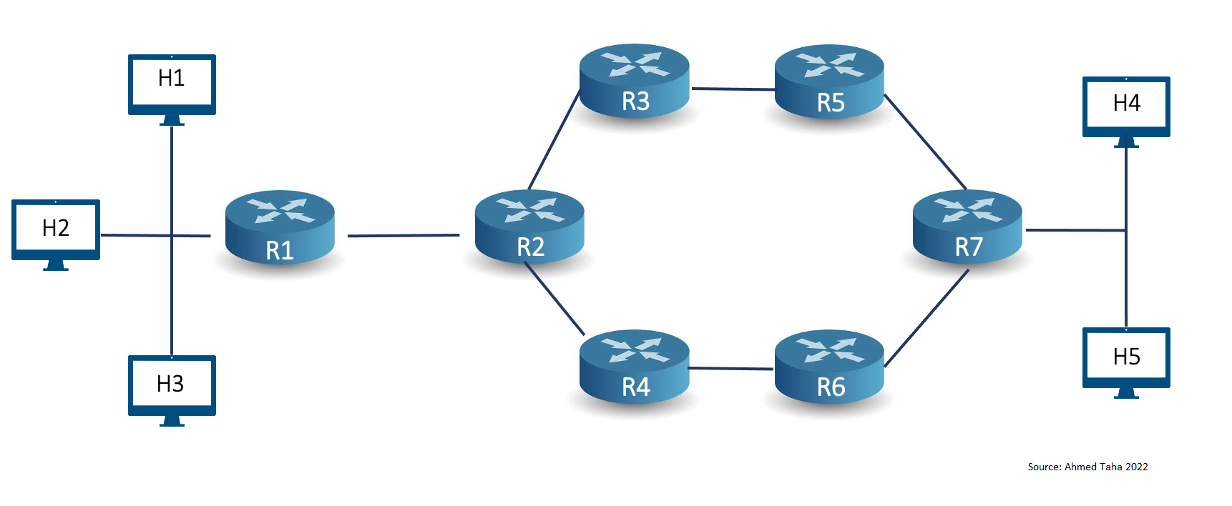

DLMSEESN01_D_offen_046
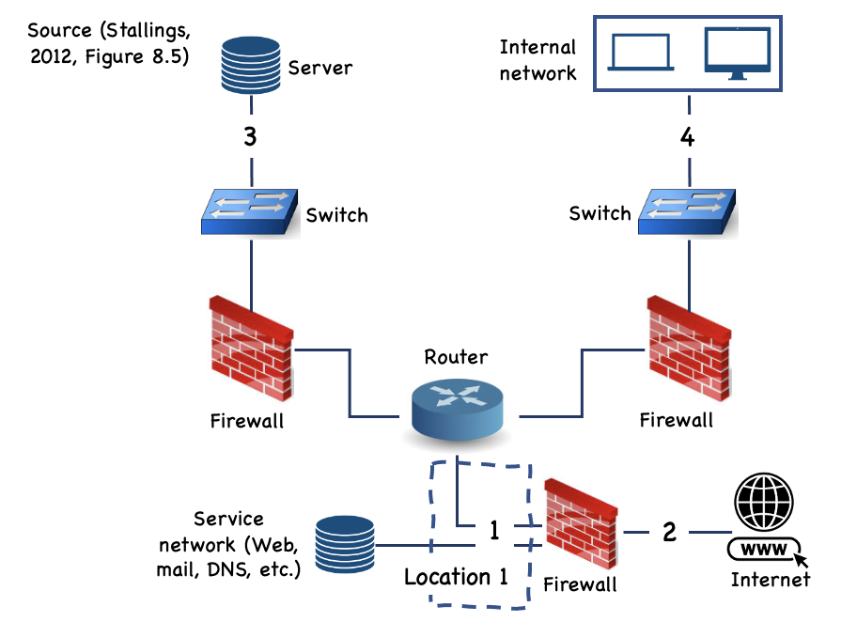
Server
Switch
Firewall
Router
Internal network
Service network (Web, mail, DNS, etc.)
Location 1
Internet

