**Centre and periphery—The ‘in-site’ story: Tracking intra-site culinary variability at Tel Tsaf (ca. 5,200–4,700 cal BC)**

**I. Scientific Background**

1. *The reconstruction of late prehistoric socio-culinary diversity*

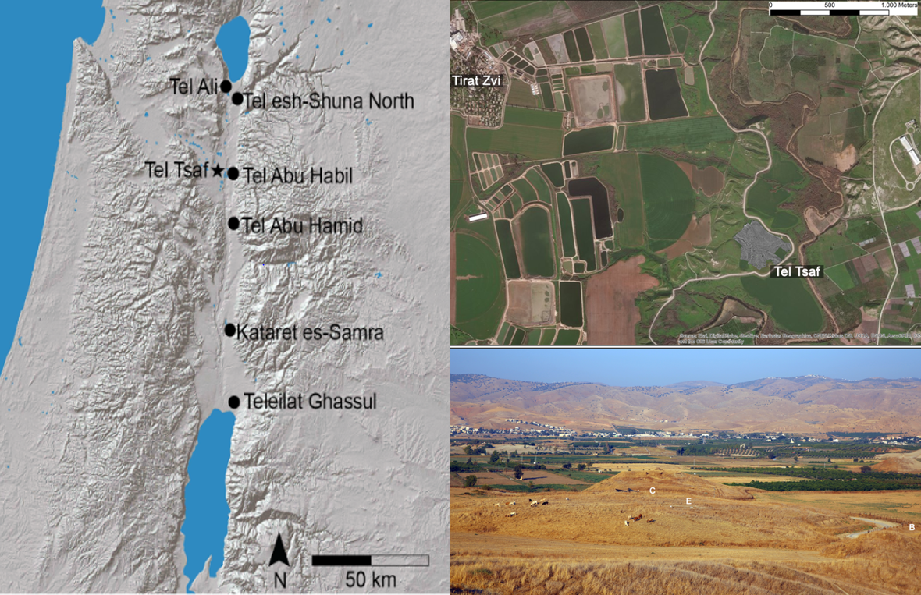The proposed project will trace and investigate how food-related practices varied across the Middle Chalcolithic community of Tel Tsaf (ca. 5,200–4,700 cal. BC; Fig. 1) as it negotiated the emerging culinary regime of the Mediterranean diet and related food processing technologies and a rapidly transforming social order. Specifically, it will strive to discern the various choices concerning food production, processing, and consumption, determine how they transformed over time, and how they varied across socio-economic units. While pursuing these goals, the project will (a) produce substantial and detailed databases of food remains from different parts and phases of the occupation at Tel Tsaf, (b) trace hitherto poorly understood dietary practices and related technologies, (c) evaluate the impact of long-distance contacts, and (d) document the environmental background for these dietary preferences.

Figure 1. Tel Tsaf in the Jordan Valley. A map showing the location of Tel Tsaf and other Chalcolithic sites in the Jordan Valley (left), an aerial view of the site and its environs (upper right), and the site (in the summer), a view from the east (the green areas are in Jordan).

We expect the project to divulge numerous gains for various disciplines (archaeology, biology, environment), and our multidisciplinary approach to be uniquely suitable for the task. The project builds on the well-established observation that food, dietary preferences, and the various practices tied in with them constitute a uniquely sensitive and deeply rooted cultural feature (*e.g.* Appaduri 1981; Curt and Pestle 2010; Graff and Rodríguez-Alegría 2012), marking the nexus where aesthetics and tastes intersect with the environment, biology, economy, and identity. Thus, the project presupposes that culinary practices provide a sensitive device for monitoring social, economic, technological and environmental circumstances (*e.g.* Bently *et al*. 2011; Goody 1982; Reed 2021). It also means that when transformations in food regimes are noted, large-scale cultural and technological shifts of considerable lateral breadth are likely to be involved. While evidence for dietary changes during the south Levantine Chalcolithic period of the southern Levant were noted in recent years (*e.g.* Chasan *et al*. 2022; Galili *et al*. 2021; Langgut and Garfinkel 2022; Namdar *et al*. 2014) it seems that we still lag behind, in understanding the mechanisms that tied Chalcolithic social, environmental and technological changes with variation their culinary and dietary traditions.

The Chalcolithic period in general, and the Middle Chalcolithic period, in particular, reflect an exciting time marked by considerable technological developments (*e.g.* metallurgy), craft specialisation, intensive long-distance trade, and explicit and elaborate symbolic expression (*e.g.* Goren 2008, Kerner 2010; Levy 1986, 1998; Rosenberg *et al.* 2016; Rosenberg and Shimelmitz 2017; Roux and Courty 2005). Most notably, these included the secondary product revolution that introduced dairy products to the menu (Sherratt 1983) and the beginning of systematic olive cultivation and consumption (*e.g.* Galili *et al*. 2021; Rosenberg and Klimscha 2021; Rosenberg *et al.* 2021 and references therein). Thus, this period saw major transformations in food production and consumption, marking the incipience of the Mediterranean diet (*e.g.* Rosenberg and Klimscha 2018, 2021; Rosenberg *et al.* 2016; Roux and Courty 2005; Rowan and Golden 2009; see also Chasan *et al*. 2022a, 2022b).

Thus, the Chalcolithic period was a time of radical reorganisation, and food-related matters of production, processing, and consumption were intertwined throughout. However, while many studies dwelt on the intersection of food with other cultural aspects (*e.g.* Bray 2003; Craig *et al*. 2011; Evershed *et al*. 2008; Grigson 2006; Lemonnier 1996; Pauketat *et al*. 2002; Service 1975; Stein 2012; Zeder 1991), we are still unable to say how and under what social and environmental circumstances the south Levantine Mediterranean diet crystallised during this time span. Nor can we say what position it occupied in the broader scheme of Chalcolithic cultural transformations. For example, it is indeterminate whether novel Mediterranean dietary features were rapidly adopted by entire communities or whether some segments of these communities responded with suspicion and resistance. Further, if various parts of a community responded differently, what was the nature of the unfolding social negotiation and what precisely was at stake for the different parties? Were these negotiations responsive to external factors, and if so, which and how?

Notably, much of the inadequacies in our knowledge are attributable to our poor grasp of the Chalcolithic period’s botanical record. Partly, this is due to a lack of interest and inadequate excavation methods (but see Bourke 2001; Chasan *et al*. 2022b and references therein): While issues of architecture and typology have been extensively discussed, relatively little has been done about matters of diet and food consumption. Another part of the problem pertains to circumstantial and objective obstacles: the discontinuity of the prehistoric record (*e.g.* Bourke 1997, 2002; Lovell 2001: table 5.3) and the relative paucity of well-excavated sites of this period and region, specifically of the Middle Chalcolithic period (ca. 5,200–4,700 cal BC). The result is a fragmentary record often biased toward the latest phases of the cultural sequence (*e.g.* Baird and Philip 1994; de Contenson 1960; Gilead 1990, 2007; Gustavson-Gaube 1986; Leonard 1989, 1992; Lovell *et al*. 1997; Philip and Baird 1993). Additionally, organic materials are poorly preserved in many regions of the southern Levant, a condition that discourages research of many sites’ food-related botanical components.

The case of Tel Tsaf constitutes an excellent response to this predicament, boasting exceptionally robust and diverse botanical assemblages. It is also notable for its deep stratigraphic sequence and numerous indications of a sizeable, vibrant, and socially complex community (see below). Thus, the research programme proposed here seeks to capitalise on these advantages to better understand the social processes and dialogues underlying the emergence of the Mediterranean diet during the Chalcolithic period and their role in the redefinition of Levantine society and culture more broadly.

1. *The site*

Tel Tsaf is ca. 5 ha in size, built on laminated Pleistocene Lake Lisan deposits (Garfinkel *et al*. 2020) and covering three low hills and the area around them (Horn *et al.* 2016). Since its discovery in the late 1940s (Tzori 1958), three expeditions have excavated the site (Garfinkel *et al*. 2020; Gophna and Sadeh 1988–1989; Rosenberg and Klimscha 2021), progressively underscoring the site’s uniqueness.

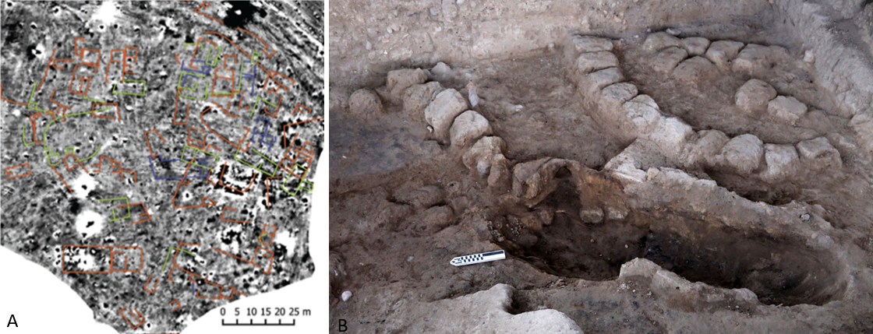It is one of the best examples of a site continuously occupied throughout the Middle Chalcolithic period (with no earlier phases and only scarce later remains, scanty Byzantine/Early Islamic finds), featuring ca. 3 m of occupational deposits. It also represents a community larger than most of its contemporaries (Fig. 2) and comprises numerous well-preserved features, including sizeable multi-room courtyard structures, silos and cooking facilities, and burials (Ben-Shlomo *et al.* 2009; Garfinkel *et al*. 2009, 2020; Rosenberg *et al*. 2020).

Fig. 2. A. Results of the geomagnetic survey on the tel, showing the possible remains of multiple structural remains 10–120 cm below the surface; B. Remains of an earth oven and segments of a mudbricks structure found during the renewed project in Area C.

Concerning its portable material culture, Tel Tsaf produced the earliest evidence for metallurgy in the region (Garfinkel *et al*. 2014) and numerous items indicating long-distance trade or exchange (Fig. 3, and see Rosenberg and Klimscha 2018, 2021; Rosenberg *et al*. in press a, in press b, and see references therein). Among others, these artefacts point towards Anatolia (obsidian items), northern Syria/Mesopotamia (pottery sherds of the ‘Ubaid style; clay tokens), and Egypt (Nilotic shells and olivine beads). Additionally, rocks from southern Jordan, shells from the Mediterranean Sea, and cotton fibres, 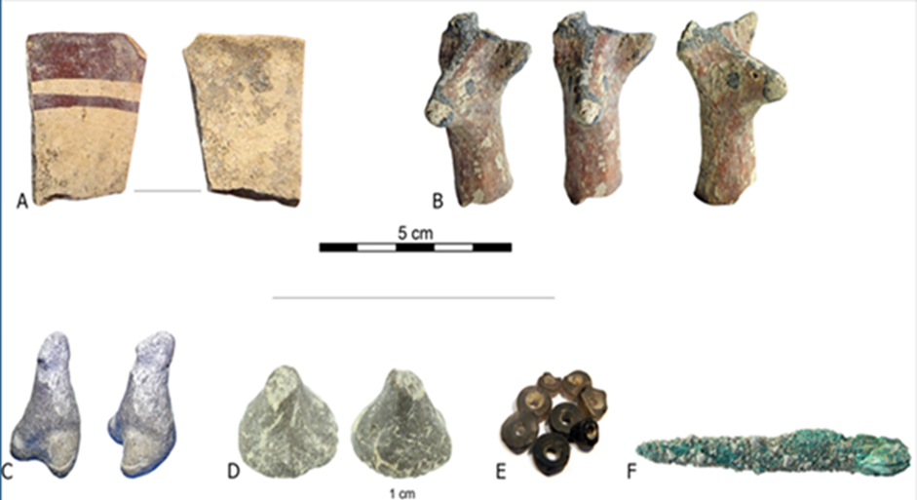presumably from the Indus Valley, were also found.

Figure 3. Selected finds from Tel Tsaf that reflect long-distance contacts.

Significantly, the renewed excavations at Tel Tsaf have produced substantial and diverse collections of organic materials, underscoring the outstanding preservation of botanical remains at the site (Rosenberg and Klimscha 2021). These remains mainly include seeds and wood retrieved from all layers and various contexts (rooms, houses, courtyards, and installations). Furthermore, preliminary efforts to extract micro-organic remains from stone tools and pottery vessels proved highly successful, underscoring a promising venue for producing multiple new lines of evidence for foodways and culinary diversity (Fig. 4). Notably, these finds and samples derive from precise and carefully executed excavations that applied state-of-the-art documentation technologies and protocols. Thus, all samples are securely integrated into a high-resolution GIS-based record, documenting their spatial and stratigraphic contexts and chrono-spatial circumstances.

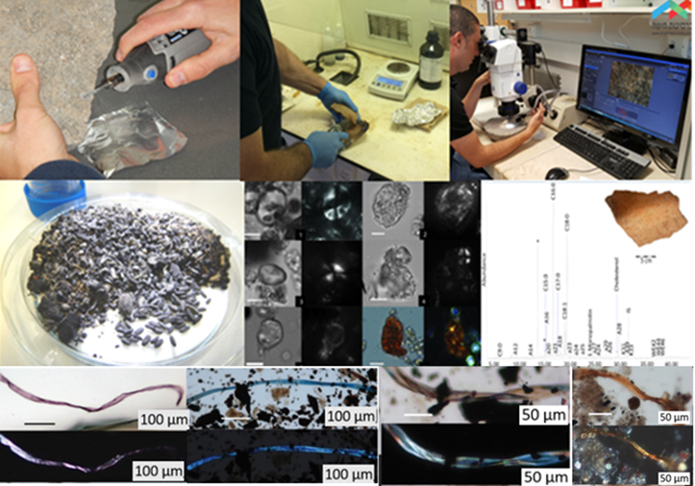

Figure 4. Sampling pottery and stone vessels from Tel Tsaf and preliminary results thereof (seeds and wood, starch granules, a chromatograph showing acids content extracted from a bowl fragment and fibres extracted from pottery vessels and sediments)*.*

**II. Research objectives expected significance***A. State-of-the-art and research objectives*

The Mediterranean diet (Keys *et al*. 1986 and references therein) is a diet low in saturated fat and is well known today as the main factor for high adult life expectancy and low rates of coronary heart disease, certain cancer types and other diet-related chronic diseases (e.g. Belahsen and Rguibi 2006; Choi 2003; Hu 2003; Obeid et al. 2022; Vasto et al. 2014; Willett et al. 1995). While holding great dietary advantages, today the Mediterranean diet is no longer studied just as a reflection of food choices, but, rather, also as a combination of integrated subsistence activities, culinary practices and cultural identities (e.g. Bellizzi 1993; Romaguera et al. 2009; Trichopoulou and Lagiou 2001 and see Zeghichi-Hamri and Kallithraka 2007).

The archaeological research of food-related practices and culinary traditions in the southern Levant is skewed. The dietary features of some episodes are much better understood than others: notably, the transition to sedentism, the emergence of agriculture (Pre-Pottery Neolithic period; *e.g.* Abbo *et al. 2*006; Zohary *et al.* 2012 and references therein), and early urbanism (Early Bronze Age; *e.g.* Berger 2018 and references therein). Comparatively, archaeologists have dedicated little attention to the culinary practices of the Chalcolithic period. This is surprising, given the period’s enormous cultural significance: It is the episode in cultural evolution that embodies the aftermath of the Neolithic Revolution and builds up towards the crystallisation of socially stratified urban societies. Consequently, the Chalcolithic period emerges as a chasm that has no substance of its own and needs to be bridged, leaving many questions unanswered: What and how were certain foodstuffs selected? What were the means of their production? How were they managed, processed, and redistributed within the community? What impact did they have on communities’ sustainability and development? What role did they play in the ongoing processes of increasing social and economic complexity?

Past expeditions at Tel Tsaf focused mainly on Area C (on the central hill), while the rest of the site, *e.g.* the Eastern hill that slopes into the Jordan River, other parts of the Central hill, The Western hill, where a well was found by the Garfinkel expedition (Garfinkel *et al*. 2020) and the area immediately surrounding the tel, were hardly explored and probed. Our project principally focused on Area C, centred around excavating a small area of ca. 20 m2 under Garfinkel’s main trench (the ‘Deep Cut’) and exploring the earliest levels of the site, which were only limitedly probed by Gophna (2 m2) in the Late 70’s while probing additional area on the main Tel and field to its northeast. Our high-resolution excavation in the ‘Deep Cut’ in Area C produced multiple lines of evidence for culinary preferences and economic choices (*e.g.* Chasan et al. 2021, 2022a, 2022b; Rosenberg and Klimscha 2021; Rosenberg *et al.* 2021), and trade (*e.g.* Rosenberg *et al.* in press a, in press b), originated from different phases (starting the earliest, basal levels of the village) and different architectural features.

The preliminary results we have acquired from the ‘Deep Cut’ in Area C, indicate that the preservation conditions are highly favourable and show that contemporary and non-contemporary structures (due to the limited exposure, only partly excavated) show differential food preferences and various combinations of domestic animal and plant products and that these food products were supplemented by local wild plants (and meagre amounts of wild game that appears only in some of the buildings). These reflect culinary traditions incorporated recipes where these food products were cooked and consumed together in various combinations. Our results tend to support some continuity of dietary traditions from the preceding Neolithic period; however, there were some developments within the suite of domesticated resources, e.g. the earliest direct evidence for milk exploitation in the southern Levant, the use of honey and the increasing role of olives in the diet through time. Hand in hand with this evidence that is tied to the establishment of the Mediterranean diet in the region, our preliminary results also showed that different architectural units also reflect sometimes different preferences geared toward food processing and handling (vessels and tools), mirroring various traditions of food preparation techniques and related technologies. Variation between different structures was also noted with regard to the presence of goods that reflects long-distance (e.g. obsidian, beads, specific pottery and figurines, shells).

While we managed to extract multiple sets of data pertinent to the emergence of the Mediterranean diet and the environmental and cultural circumstances involved, as well as discerning various aspects pertaining to food processing and handling technologies and variability in exotic goods, now we need to determine whether these patterns repeat themselves in other parts of Tel Tsaf or whether different parts of the settlement experienced a somewhat different trajectory. This will allow for a better understanding of the processes that were involved in dietary and technological changes during the Chalcolithic period. Moreover, it will allow analysing, in an elaborate, detailed manner, whether different segments of the community (as reflected in separate households) were similarly adopting the Mediterranean diet and the related food processing technologies or had equal access to its components (resources).

Ultimately, the various problems, open questions, and inconsistencies that permeate our understanding of Chalcolithic food-related practices can be boiled down to three principal gaps:

1. A rudimentary, simplistic, and impoverished body of data concerning Chalcolithic dietary and culinary behaviour due to a combination of unfavourable empirical circumstances and epistemic biases;
2. A persistent failure to indicate if and how Chalcolithic food preferences and technologies varied across residential units and societal segments, which in turn implies a failure to consider social mechanisms that may have been at work;
3. A nearly complete failure to distinguish internal (*e.g.* political, availability and access to food sources) from external factors (*e.g*. contacts with foreign communities; environmental background, short and long-distance trade, inter-regional cultural contacts, geopolitics, and large-scale economic developments) that may have influenced dietary practices and related technologies.

In order to overcome these gaps, the project’s main objectives are to *construct* a detailed and comprehensive databases of culinary and dietary practices and to *identify, document, and analyse* evidence for intra-site variability in food-related practices. The study will draw on Tel Tsaf’s rich and excellently preserved organic, archaeological, and environmental records to discern specifiable dietary preferences and their distributions in space and time. In doing so, the study will gain access to intricate socio-economic mechanisms that drove and negotiated these developments, presumably casting light on the community’s increasing social complexity. Ultimately, the project will work its way through three main research questions (**RQ 1–3**):

**RQ1.** What did Tel Tsaf’s diet consist of, and how was it processed?

**RQ2.** Did different households consume the same foods and wield the same technologies, or did they vary, and if so, how?

**RQ3.** What were the principal mechanisms and deciding factors, both internal and external, that shaped these culinary preferences and food-related technologies?

We aim to construct large, detailed, and contextually exacting databases of botanical remains, organic residues, and food-related technologies (**RQ1**). Once collected, the distribution of these features across architectural units and strata will allow us to determine if and how households drew on different resources and means of production (**RQ2**). These patterns, we expect, will allow us to establish (a) if and how food-related practices changed over time and (b) if and how they varied across households and social units. As empirical embodiments of spatio-temporal processes, these patterns are presumed to manifest the operations of deeper intra-communal mechanisms and dynamics. In turn, these mechanisms and dynamics will be correlated with lines of evidence indicative of the community’s broader cultural and economic settings (**RQ3**), including beads, figurines, tokens, pottery, obsidian, copper, and ground stone tools. Emerging patterns are expected to allow a distinction between internal and external contributing factors.

1. *Expected significance of the proposed research*

The proposed research project is the first to systematically address the social, economic, and ideological mechanisms that underlay the formation and negotiation of Chalcolithic food-related practices, in general, and the emerging Mediterranean diet, in particular. The proposed project is also unprecedented in terms of scale, quality, and detail of its data acquisition and analysis. As such, it will provide the first comprehensive yet nuanced account of post-Neolithic­/pre-urban culinary practices in the southern Levant and achieve a broad appreciation of quotidian food production, preparation, and consumption procedures. Furthermore, it will offer a detailed and multifaceted account of the Mediterranean diet’s crystallisation and its eventual institutionalisation. More concretely, this original research programme will bridge significant gaps in our knowledge of the social, economic, and environmental circumstances that may have encouraged or hindered the adoption of the Mediterranean diet. It will do so by producing new, high-quality empirical data within a well-defined and carefully-dated stratigraphic sequence.

**III. Detailed description of the proposed research**

1. *Working hypothesis*

The project’s working hypothesis stipulates that the Mediterranean diet consolidated in the Near East during the 6th and early 5th millennia cal BC as a complex set of *food resources, culinary practices, and related technologies* and that, given adequate circumstances and procedures, we can detect and identify these resources, preferences, and technologies. We also presume that the acquisition and manipulation of these resources followed specifiable temporal trajectories, manifesting how culinary practices changed over time. Finally, it is presupposed that dietary behaviours and food processing technologies are responsive to a wide range of agencies and influences, both internal and external to a community. Accordingly, these behaviours are expected to provide access to the *dynamics of cultural, political, and economic relations among social units of various scales: household, societal segments, sites, and regions*.

1. Research design and methods

The proposed research builds on the results of an ongoing ISF‐funded excavation at the site of Tel Tsaf. Crucial for the present purposes, these results include detailed stratigraphic sequences spanning ca. 3 m of occupational deposits, a wealth of seeds and wood, sediment samples, and sizeable assemblages of food processing paraphernalia. The project will assemble a multidisciplinary, international team of researchers and students that cut across the humanities and natural sciences and its design builds on three primary stages: (1) *Excavation and sampling*, (2) *data production*, and (3) *Database construction, analysis and interpretations*.

1. *Excavation and sampling*. Four seasons of excavations will be conducted at Tel Tsaf. The PI and his team will implement a high-resolution excavation and sampling strategy to uncover and collect remains pertinent to culinary and environmental reconstructions. Specifically, these excavation seasons will focus on sampling new, hitherto unexplored areas, both on the central mound (between Areas C and E), and immediately around it (mainly to the north and northwest), where our geomagnetic survey indicated the presence of substantial architectural remains, and on the yet unexplored eastern part of the site, attempting to locate undisturbed layers and contexts in this part of the site, that today lays above the Jordan River creek.

The excavation will be implemented through a 1×1 m grid, and 3D models of the excavated areas will be produced in photogrammetry with the goal of accurately recording the different features. Sampling will follow a two-pronged programme: a sediment-oriented one and a vessels/tools-oriented one. Concerning the first, all excavated sediments will be sieved through 2 mm mesh, and 200 cc of soil will be collected from every excavated unit (basket) for further micro-scale analyses (*e.g.* starches, phytoliths, parasitology, ADNA). Additionally, ten litres of sediments will be collected from all secure contexts for floatation (in a 200-400 microns’ mash) to recover small-scale remains: charred botanical remains, micro-faunal remains, and artefacts smaller than 2 mm. Vessel-oriented sampling, on the other hand, will focus on a sample of vessels/tools from secure contexts, presumably used for cooking, processing, storing, and serving foods. Once exposed, these vessels will be collected and enclosed in a sterilised package (*e.g.* oil-free aluminium foil, zip-lock plastic bags, and glass vials) along with control soil samples extracted from the same context. When delicate substances are expected (*e.g.* DNA, fibres), sample extracting will be conducted while wearing a disposable coverall lab coat to prevent contamination.

To further augment spatial control, the position of every sample and feature encountered in the field will be documented with a high-precision GIS software (ArcGIS/ArcView) and uploaded to a modular site database. By the same token, to maximise temporal control, we will apply an intensive 14C sampling and dating programme that will focus on short-lived charred plant remains. Ultimately, these sampling measures are geared to provide the ground necessary for a detailed and precise dataset.

1. *Analyses and data production*. The next step is to produce the data needed for tracking the dietary and culinary patterns at Tel Tsaf. For this purpose, a wide range of analyses will be applied, oriented towards three major specimen categories, reflecting how dietary and culinary behaviours manifest themselves in the archaeological record: floral, faunal, and artefactual. Analyses concerned with Tel Tsaf’s floral components engage with seeds, wood, starch and phytoliths, and organic residues (fatty acids). The seeds will be studied by Prof. E. Weiss and a joint PhD student (Bar-Ilan University), who will classify them with as much precision as possible, speaking directly for specifiable foodstuffs consumed at the site. Wood remains that speak for the site’s natural and cultivated vegetal environment will be studied and identified by Dr.???????? (University of ????). Starch granules and phytoliths lodged inside the walls of tools and vessels are expected to provide a link between particular implements and specifiable foodstuffs, making way for a discussion of food processing technologies. This analysis will be implemented by postdoctoral researcher Dr. H. Ahituv with the PI in the Laboratory for Ancient Food Processing Technologies (LAFPT), Zinman Institute of Archaeology, University of Haifa. In a similar vein, biochemical elements inside vessel walls and tools are suggestive of the organic substances cooked, processed, served, or stored in or by them. This analysis will be carried out on selected tools and vessels by Prof. C. Spiteri, University of Torino.

Analyses of Tel Tsaf’s faunal component will focus on five categories of evidence: macro-faunal remains (*e.g.* domestic and wild game) and micro-faunal remains (*e.g.* rodents, avifauna, fish) animal bones and teeth, shells, parasites, DNA, and proteomes. Archaeozoological assemblages constitute evidence for the animal-oriented economy (husbandry/hunting), processing (butchering), and consumption; and will assist in paleoenvironmental and palaeoecological reconstructions (particularly micro-vertebrate), these assemblages will be studied by Prof. J. Meier, University of North Florida. Shells are implicated in a host of environmental and economic systems; particularly interesting for the present project is the evidence they might offer for shellfish consumption and the Jordan River’s ecology more broadly. They will be identified and studied by Dr. N. Hausmann, Römisch Germanisches Zentralmuseum (RGZM), Leibniz Forschungsinstitut für Archäologie. Parasite eggs and other remains in a site’s sediments are suggestive of health issues for humans and non-humans alike. They are presumed to be sensitive to changes in diet and, therefore, provide indications for food-related variations. The parasitological study will be conducted by Prof. A. Perri, University of Nevada, Las Vegas. Ancient animal DNA will allow a better understanding of the genetic-level composition of herds and their variations in time. Prof. G. Kahila Bar-Gal, The Hebrew University of Jerusalem, will conduct this analysis. Finally, Proteomes are proteins produced in an organism or other biological context and thus indicate this system’s operations. For the purposes of the present project, proteomes will be extracted from dental calculus, providing direct evidence for the food consumed. These operations will be carried out by ????, University of ?

Finally, analyses concerned with the project’s artefactual components are primarily typological and functional. They will include (1) the classification of ceramic vessels with particular emphasis on cooking, serving, and storing to be conducted by PhD. student T. Shooval, (2) the research of ground stone tools, most of which were presumably used for processing foodstuffs to be implemented by postdoctoral researcher Dr. K. Hruby, (3) lithics (flint and obsidian) and vessels use-wear analyses to distinguish specifiable food-processing operations, and (4) the scrutiny of fibers extracted from sediments, ground stone tools, and pottery vessels in order to identify textiles and containers that may have been used in the course of food processing or storing (*e.g.* baskets, bags and sacks). These analyses will be conducted in the Laboratory for Ancient Food Processing Technologies (LAFPT), Zinman Institute of Archaeology, the University of Haifa.

Additional complementary analyses include stable-isotope and ancient human DNA analyses. Stable oxygen and carbon isotope analyses of botanical, human, shell, and faunal remains will be conducted by Dr. C. Pickard and Dr. R. Bendery, University of Edinburgh. These analyses are expected to gauge the intensity of various economic and environmental parameters, including yields, water availability, manuring, herding distances and elevations, and consumed varying ratios of C3/C4 plant biomass in their diet. Skeletons and isolated human bones will be studied by Prof. I. Hershkovitz, Tel Aviv University, and ancient human DNA extracted from human bones and sediments will be extracted and analyzed by Dr. V. Slone, Tel Aviv University, providing access to the genetic makeup of the Tel Tsaf community and its links with others, both close and far.

Establishing the correlations between, on the one hand, food remains and residues and, on the other hand, finds indicative of long-distance contact and trade (*e.g.* beads, figurines, tokens, pottery, obsidian, copper, and ground stone tools) will be tested (Dr. Y. Weiss, The Hebrew University of Jerusalem; Prof. T. Carter, McMaster University). Insofar as such correlations are found, they will serve to explore the impact trade relations and cultural contacts with distant communities may have had on the crystallisation and transformation of culinary practices at Tel Tsaf.

1. *Database construction, analysis and interpretations.* The comprehensive database will be assembled with the use of GIS software (ArcGIS/ArcView) that will combine all lines of information (architectural, artefactual and biological, with emphasis on culinary and food-related finds, as well as stratigraphic and spatial, environmental and ecological data). The combined results of the different analyses will be integrated to trace the full range of dietary preferences (food) and culinary practices (food handling and processing technologies) at Tel Tsaf as well as the possible factors that influenced the adoption of the Mediterranean diet in the Jordan Valley during the 6th and early 5th millennia cal BC, and its local characteristics. This will provide the much-needed infrastructure for interpreting the what were the principal mechanisms and deciding factors, both internal and external, that shaped these culinary preferences and food-related technologies and what were their social and cultural backgrounds.

Applying state-of-the-art scientific equipment and techniques, are imperative to achieve a breakthrough in the field of palaeo-diet. The present long-term collaboration of experts and expertise is expected to advance the topic further, as some of our preliminary results already demonstrate. The synergetic study of environmental data, botanical and zoological remains, together with archaeological features and food-related tools and vessels as well as artefacts that convey information concerning short- and long-distance trade and mobility will enable us to create a higher‐resolution picture of the different nuances, affinities and dynamics entangled with the Mediterranean diet at Tel Tsaf.

**Bibliography** [to be checked and formatted]

1. Abbo, S., Gopher, A., Peleg, Z., Saranga, Y., Fahima, T., Salamini, F. and Lev-Yadun, S. 2006. The ripples of ‘‘The Big (agricultural) Bang’’: the spread of early wheat cultivation. *Genome* 49: 861–863
2. Ambrose, S. H. 2000. Controlled diet and climate experiments on nitrogen isotope ratios of rats. In S. H. Ambrose and M. A. Katzenberg (Eds.), *Biogeochemical Approaches to Paleodietary Analysis*. Advances in Archaeological and Museum Science, pp. 243–263. Volume 5. New York: Kluwer Academic/Plenum Publishers.
3. Appaduri, A. 1981. Gastro-politics in Hindu South-Asia. *American Ethnologist* 8(3): 494–511.
4. Araújo, A., Ferreira, L. F., Confalonieri, U and Nuñez, L. 1985. The finding of *Enterobius vermicularis* eggs in Pre-Columbian human coprolites. *Mem Inst Oswaldo Cruz* *80*: 141–143.
5. Araus, J. L. Slafer, G. A., Romagosa, I. and Molist, M. 2001. FOCUS: Estimated wheat yields during the emergence of agriculture based on the Carbon Isotope discrimination of grains: Evidence from a 10th Millennium BP site on the Euphrates. *Journal of Archaeological* Science 28: 341–350.

Bagordo, F., Grassi, T., Serio, F., Idolo, A., & De Donno, A. (2013). Dietary habits and health among university students living at or away from home in southern Italy. *Journal of Food & Nutrition Research*, *52*(3).‏

1. Baird, D. and Philip, G. 1994. Preliminary report on the third (1993) season of excavations at Tell esh-Shuna North. *Levant* 26: 111–133.
2. Belahsen, R., & Rguibi, M. 2006. Population health and Mediterranean diet in southern Mediterranean countries. Public health nutrition, 9(8A), 1130-1135.‏
3. Bellizzi, M. (1993). Changing eating habits of the Maltese. *Malta: Food, Agriculture, Fisheries and the Environment. Options Méditerranéennes: Série B. Etudes et Recherches* (7): 55-70.‏
4. Ben-Shlomo, D., Hill, A. C. and Garfinkel, Y. 2009. Feasting between the revolutions: Evidence from the Chalcolithic Tel Tsaf, Israel. *Journal of Mediterranean Archaeology* 22(2): 129–150.
5. Bently, A., Earls, M. and O’Brian, M. J. 2011. *I’ll Have What She’s Having: Mapping Social Behavior*. Cambridge: MIT Press.
6. Berger, A. 2018. ‘Feeding cities’?—Preliminary notes on the provisioning of animal products at Tel Bet Yerah, Israel. In C. Çakırlar, J. Chahoud, R. Berthon, and S. Pilaar Birch (eds.), *Archaeozoology of the Near East XII: Proceedings of the 12th International Symposium of the ICAZ Archaeozoology of Southwest Asia and Adjacent Areas Working Group*, Groningen Institute of Archaeology, June 14–15, 2015, University of Groningen, Netherlands, pp. 13–26.
7. Bourke, S. J. 1997. The ‘Pre-Ghassulian’ sequence at Teleilat Ghassul. In H. G. K. Gebel, Z. Kafafi and G. Rollefson (Eds.), *The Prehistory of Jordan II: Perspectives from 1997, Studies in Early Near Eastern Production, Subsistence, and Environment 4*, pp. 395–417. Berlin: Ex-oriente.
8. Bourke, S. J. 2001. The Chalcolithic period. In: B. Macdonald, R. Adams and P. Bienkowski (Eds.), *The Archaeology of Jordan*, pp. 107–163. Sheffield: Sheffield Academic Press.
9. Bourke, S. J. 2002. The origins of social complexity in the south Jordan Valley: New evidence from Teleilat Ghassul, Jordan. *Palestine Exploration Quarterly* 134: 2–27.
10. Bray, T. 2003. *The Archaeology and Politics of Food and Feasting in Early States and Empires.* New York: Springer Verlag.
11. Brumfiel, E. M., and Earle, T. K. 1987. *Specialisation, Exchange, and Complex Societies*. Cambridge: Cambridge University Press.
12. Chasan, R., Rosenberg, D.,Klimscha, F., Beeri, R. Golan, D., Dayan, A., Galili, E., andSpiteri, C. 2021. Bee products in the prehistoric southern Levant: evidence from the lipid organic record. *Royal Society Open Science* 8. 210950. <https://doi.org/10.1098/rsos.210950>
13. Chasan, R., Klimscha, F., Spiteri, C. and Rosenberg, D. 2022. Foodways of an agro-pastoral community: organic residue analysis of pottery and stone vessels at the Middle Chalcolithic Tel Tsaf. *Journal of Archaeological Science – Reports* 43. <https://doi.org/10.1016/j.jasrep.2022.103491>
14. Chasan, R., Spiteri, C. and Rosenberg, D. 2022. Dietary continuation in the southern Levant: A Neolithic-Chalcolithic perspective through organic residue analysis. *Journal of Archaeological and Anthropological Sciences* 14: 49. <https://doi.org/10.1007/s12520-022-01519-0>
15. Choi, S. B. 2003. Benefits of Mediterranean diet affirmed, again. *Canadian Medical Association Journal* 169: 316–316.
16. de Contenson, H. 1960. Three soundings in the Jordan Valley. *Annual of the Department of Antiquities of Jordan* 4–5: 12–56.
17. Costin, C. L. and Earle, T. 1989. Status distinction and legitimation of power as reflected in changing patterns of consumption in Late Prehispanic Peru. *American Antiquity* 54: 691–714.
18. Craig, O. E., Steele, V., Fischer, A., Sönke, H., Søren, H. A., Donohoe, P., Glykou, A., Saul, H., Jones, D. M., Koch, E. and Heron, C. 2011. Ancient lipids reveal continuity in culinary practices across the transition to agriculture in northern Europe. *Proceedings of the National Academy of Sciences* 108: 17910–17915.
19. Curt, L. A. and Pestle, W. J. 2010. Identifying high status foods in the archaeological record. *Journal of Anthropological Archaeology* 29(4): 413–431.
20. Evershed, R. P. 2008. Organic residue analysis in archaeology: The archaeological biomarker revolution. *Archaeometry* 50: 895–924.
21. Galili, E., Langgut, D., Terral, J. F., Barazani, O., Dag, A., Kolska Horwitz, L., Ramirez, I.O., Rosen, B, Weinstein-Evron, M., Chaim, S., Kremember, E., Lev-Yadun, S., Boaretto, E., Ben-Barak-Zelas, Z., Fishman, A., 2021. Early production of table olives at a mid-7th millennium BP submerged site off the Carmel coast (Israel). *Scientific Reports* 11: 2218. <https://www.nature.com/articles/s41598-020-80772>
22. Garfinkel, Y., Ben-Shlomo, D. and Freikman M. 2020. Excavations at Tel Tsaf 2004–2007: Final Report, Volume 1. Ariel: Ariel University Press.Garfinkel, Y., Ben-Shlomo, D. and Kuperman, T. 2009. Large-scale storage of grain surplus in the sixth millennium BC: the silos of Tel Tsaf. *Antiquity* 83: 309–325.
23. Garfinkel, Y., Klimscha, F., Shalev, S. and Rosenberg, D. 2014. The beginning of metallurgy in the southern Levant: a Late 6th Millennium CalBC copper awl from Tel Tsaf, Israel. *PLoS ONE* 9(3): e92591. doi:10.1371/journal.pone.0092591.
24. Gilead, I. 1990. The Neolithic–Chalcolithic transition and the Qatifian of the northern Negev and Sinai. *Levant* 22: 47–63.
25. Gilead, I. 2007. The Besorian: a Pre-Ghassulian cultural entity. *Paléorient* 33(1): 33–49.
26. Goody, J. 1982. *Cooking, Cuisine, and Class:* *A Study in Comparative Sociology.* Cambridge: Cambridge University.
27. Gophna, R. and Sadeh, S. 1988–1989. Excavation at Tel Tsaf: An Early Chalcolithic site in the Jordan Valley. *Tel Aviv* 15–16: 3–36.
28. Goren, Y. 2008 The location of specialised copper production by the Lost Wax technique in the Chalcolithic southern Levant. Geoarchaeology 23: 374–97.
29. Graff, S. R. and Rodríguez-Alegría, E. 2012. *The Menial Art of Cooking: Archaeological Studies of Cooking and Food Preparation*. Boulder: University Press of Colorado.
30. Grigson, C. 2006. Farming? Feasting? Herding? Large mammals from the Chalcolithic sanctuary of Gilat. In T.E. Levy (Ed.), *Archaeology, Anthropology and Cult. The Sanctuary at Gilat, Israel*, pp. 215–318. London: Equinox.
31. Gustavson-Gaube, C. 1986. Tell Esh-Shuna North 1985: a preliminary report. *Annual of the Department of Antiquities of Jordan* 30: 69–113.
32. Hu, F. 2003. The Mediterranean diet and mortality — Olive oil and beyond. *The New England Journal of Medicine* 348(26): 2595–2596.
33. Kerner, S. 2010. Craft specialisation and its relation with social organisation in the late 6th to early 4th millennium BC of the southern Levant. *Paléorient* 36(1): 179–198.
34. Keys, A., Menotti, A., Karvonen, M.J., Aravanis, C., Blackburn, H., Buzina, R., Djordjevic, B.S., Dontas, A.S., Fidanza, F., Keys, M.H., Kromhout, D., Nedeljkovic, S., Punsar, S., Seccareccia, F., Toshima, H. 1986. The diet and 15 year death rate in the Seven Countries Study. *American Journal of Epidemiology* 124:903 915.
35. Langgut, D. and Garfinkel, Y. 2022. 7000‑year‑old evidence of fruit tree cultivation in the Jordan Valley, Israel. *Scientific Reports* 12:7463. https://doi.org/10.1038/s41598-022-10743-6.
36. Lemonnier, P. 1996. Food, competition, and the status of food in New Guinea. In P. Wiessner and W. Schiefenhovel (Eds.), *Food and the Status Quest, an Interdisciplinary Perspective*, pp. 126–147. Providence: Berghahn.
37. Leonard, A. jr. 1989. A Chalcolithic “Fine Ware” from Kataret es-Samra in the Jordan Valley. *Bulletin of the American Schools of Oriental Research* 276: 3–14.
38. Leonard, A. jr. 1992. *The Jordan Valley Survey, 1953: Some Unpublished Soundings Conducted by James Mellaart. Annual of the American Schools of Oriental Research* (Volume 50). Winona Lake: Eisenbrauns.
39. Lev, L. 2008. *Melanopsis Shells as Chronometers and Paleo-environmental Tracers of Lake Kinneret and its Vicinity, Israel.* Report GSI/32/08.
40. Levy, T. E. 1986. Social archaeology and the Chalcolithic period: Explaining social organisational change during the 4th millennium in Israel. *Michmanim* 3: 5–20.
41. Levy, T. E. 1998. Cult, metallurgy and rank societies – The Chalcolithic period (ca. 4500–3500 BCE). In T. E. Levy (Ed.), *The Archaeology of Society in the Holy Land,* pp. 226–244. London: Leicester University Press.
42. Lovell, J. L. 2001. *The Late Neolithic and Chalcolithic Periods in the Southern Levant. New Data from the Site of Teleilat Ghassul, Jordan*. Monographs of the Sydney University Teleilat Ghassul Project I. BAR International Series 974. Oxford: Archaeopress.
43. Lovell, J. L., Dollfus, G. and Kafafi, Z. 1997. A preliminary note on the ceramics from the basal levels at Abu Hamid. In H. G. K Gebel, Z. Kafafi and G. O Rollefson (Eds.), *The Prehistory of Jordan* II: *Perspectives from 1997, Studies in Early Near Eastern Production, Subsistence, and Environment 4*, pp. 361–370. Berlin: Ex oriente.
44. Marangoni, F., Martiello, A., & Galli, C. 2007. Dietary fat intake of European countries in the Mediterranean area: An update. *World Review of Nutrition and Dietetics*, *97*, 67-84.
45. Namdar, D., Amrania, A., Getzov, N. and Milevski, Y. 2014. Olive oil storage during the fifth and sixth millennia BC at Ein Zippori, Northern Israel. *Israel Journal of Plant Sciences* 62(1-2): 1–10. <http://www.tandfonline.com/doi/full/10.1080/07929978.2014.960733>.
46. Obeid, C. A., Gubbels, J. S., Jaalouk, D., Kremers, S. P. and Oenema, A. 2022. Adherence to the Mediterranean diet among adults in Mediterranean countries: a systematic literature review. *European journal of nutrition*, 1-18.‏
47. Pauketat, T. R., Kelley, L. S., Fritz, G. J., Lopinot, N. H., Elias, S. and Hargrave, E. 2002. The residues of feasting and public ritual at early Cahokia’. *American Antiquity* 67: 257–279.
48. Pearson , J. A.; Buitenhuis, H.; Hedges, R. E. M.; Martin , L.; Russell, N. and Twiss, K. C. 2007. New light on early caprine herding strategies from isotope analysis: a case study from Neolithic Anatolia. *Journal of Archaeological Science* 34: 2170–2179.
49. Philip, G. and Baird, D. 1993. Preliminary report on the second (1992) season of excavations at Tell esh-Shuna North. *Levant* 25: 13–36.
50. Reed, K. 2021. Food systems in archaeology: Examining production and consumption in the past. *Archaeological Dialogues* 28: 51–75.
51. Renna, M., Rinaldi, V. A. and Gonnella, M. 2015. The Mediterranean Diet between traditional foods and human health: The culinary example of Puglia (Southern Italy). *International Journal of Gastronomy and Food Science*, *2*(2), 63-71.‏
52. Romaguera, D., Bamia, C., Pons, A., Tur, J. A., & Trichopoulou, A. 2009. Food patterns and Mediterranean diet in western and eastern Mediterranean islands. *Public health nutrition*, *12*(8), 1174-1181.‏
53. Rosenberg, D., Garfinkel, Y. and Klimscha, F. 2016. Large-scale storage and storage symbolism in the protohistoric Near East—a unique clay silo model from Middle Chalcolithic Tel Tsaf, Israel.*Antiquity* (In press).
54. Rosenberg D. and Klimscha F. 2018. Prehistoric dining at Tel Tsaf. *Biblical Archaeology Review* 44(4): 54–56.
55. Rosenberg, D. and Klimscha, F. 2021. Social complexity and ancient diet – The renewed research project at Tel Tsaf, Jordan Valley. *Qadmoniyot* 161:12–17 (Hebrew).
56. Rosenberg, D., Levine, M., Klimscha, F., Shalem, D. and Liu, L. 2021. From hangovers to hierarchies: Beer production and use during the Chalcolithic period of the southern Levant—New evidence from Tel Tsaf and Peqi‘in Cave. *Journal of Anthropological Archaeology* 64: 1­–17.
57. Rosenberg, D., Love, S., Hubbard, E., and Klimscha, F. 2020. 7,200 years old constructions and mudbrick technology: The evidence from Tel Tsaf, Jordan Valley, Israel. *PLoS ONE* 15(1): e0227288. <https://doi.org/10.1371/journal.pone.0227288>.
58. Rosenberg, D., Rizzuto, B., Klimscha, F.and Carter, T. in press a. Obsidian beads and long-distance trade during the Middle Chalcolithic period: Evidence from Tel Tsaf (ca. 5,200–4,700 cal BC), Jordan Valley, Israel. *Archaeological and Anthropological Sciences.*
59. Rosenberg, D. and Shimelmitz, R. 2017. Perforated stars: Networks of prestige item exchange and the role of perforated flint objects in the Late Chalcolithic of the southern Levant. *Current Anthropology* 58: 295–306.
60. Rosenberg, D., Elkayam, Y., Garfinkel, Y., Klimscha, F., Vučković, V. and Weiss, Y. in press b. Long-distance trade in the Middle Chalcolithic of the southern Levant: the case of the olivine beads from Tel Tsaf, Jordan Valley, Israel. PLOS1.
61. Roux, V. and Courty, M-A. 2005. Identifying social entities at the macro-regional level: Chalcolithic ceramics of south Levant as a case study. In A. Livingstone Smith, D. Bosquet and R. Martin (eds.), Pottery Manufacturing Processes: Reconstruction and Interpretation. Acts of the XIV UISPP Congress, University of Liège, Belgium, 2–8 September 2001, Symposium 2.1. BAR International Series 1349. Oxford: B.A.R, pp. 201–214.
62. Rowan, Y. M. and Golden, J. 2009. The Chalcolithic period of the southern Levant: a synthetic review. *Journal of World Prehistory* 22(1): 1–92.
63. Service, E. R. 1975. *Origins of the State and Civilization*. New York: Norton.
64. Sherratt, A. 1983. The secondary exploitation of animals in the Old World. *World Archaeology* 15(1): 90–104.
65. Stein, G. J. 2012. Food preparation, social context, and ethnicity in prehistoric Mesopotamian colony. In S. R. Graff and E. Rodríguez-Alegría (Eds.), *The Menial Art of Cooking: Archaeological Studies of Cooking and Food Preparation*, pp. 47–63. Boulder: University Press of Colorado.
66. Trichopoulou, A., & Lagiou, P. 2001. The Mediterranean diet: Definition, epidemiological aspects and current patterns. The Mediterranean diet: Constituents and health promotion, 53-73.
67. Tzori, N. 1958. Neolithic and Chalcolithic sites in the Valley of Beth-Shan. *Palestine Exploration Quarterly* 90: 44–51.
68. Vasto, S., Buscemi, S., Barera, A., Di Carlo, M., Accardi, G. and Caruso, C. 2014. Mediterranean diet and healthy ageing: A Sicilian perspective. *Gerontology*, *60*(6), 508-518.‏
69. Willett, W. C.; Sacks, F.; Trichopoulou, A.; Drescher, G.; Ferro-Luzzi, A.; Helsing, E and Trichopoulos, D. 1995. Mediterranean diet pyramid: a cultural model for healthy eating. A*merican Journal of Clinical Nutrition* 61(6):14025–14065.
70. Zeder, M. A. 1991. *Feeding Cities: Specialized Animal Economy in the Ancient Near East*. Washington DC: Smithsonian Institution Press.
71. Zeghichi-Hamri, S. and Kallithraka, S. 2007. Mediterranean diet in the Maghreb: an update. *World Review of Nutrition and Dietetics*, *97*, 139-161.‏
72. Zohary, D., Hopf, M. and Weiss, E. 2012. *Domestication of Plants in the Old World* (4th edition). Oxford: Oxford University Press.