**New potential marine food source – Light induced pigment synthesis and antioxidant activity in endosymbiotic jellyfish (*Cassiopea andromeda*)**

**Holger Kühnhold1, 4, Monika Schreiner2, 4, Andreas Kunzmann1,4, Karin Springer3**

*1Leibniz Centre for Tropical Marine Research (ZMT), Fahrenheitstraße 6, 28359 Bremen, Germany*

*2Leibniz Institute of Vegetables and Ornamental Crops (IGZ), Theodor-Echtermeyer-Weg 1, 14979 Großbeeren, Germany*

*3University Bremen, Marine Botany*

*4Food4Future (F4F), c/o Leibniz Institute of Vegetables and Ornamental Crops (IGZ), Theodor-Echtermeyer-Weg 1, 14979 Großbeeren, Germany*

Given efficient biomass production and high nutritional value, the microalgae carrying upside-down jellyfish *Cassiopea andromeda* is a promising marine species for food innovation farming. In this study, effects of various light intensities and narrow-banded UVB application on light harvesting pigments and antioxidant activity (AOA) were investigated. The results show a prevalence of peridinin and chlorophyll *a* pigments, indicating that valuable peridinin-chlorophyll *a*-proteins (PCP) dominate the *C. andromeda* light harvesting complex. Over two and four weeks treatment time, pigment synthesis and ratio correlated significantly with intensity changes of photosynthetically active radiation (PAR) ranging from 50 to 800 µmol photons m-2 s-1, while AOA was not affected. Increases over the same time periods in both, pigment synthesis and AOA, were only reached with daily exposure to narrow-banded UVB (λ = 285 ± 10 nm) radiation (1.3 KJ m-2 day-1) in combination with 200 µmol photons m-2 s-1 PAR. This study contributes to the development of an environmentally controlled *C. andromeda* indoor aquaculture system, suitable to supply functional new marine food ingredients also in urban and semi-urban surroundings.

**Introduction**

To ensure global food security and healthy nutrition within the planetary boundaries, the utilization of aquatic food sources must play a more pronounced role to prevent malnutrition, particularly in the Global South, and to enhance health through dietary intake (Ahern at al., 2021). Foremost, marine resources have the potential to provide health-promoting nutrients without eliciting depletions of key resources (e.g. arable land and fresh water) (Duarte et al., 2009; Béné et al., 2015; Hilborn et al., 2018; Troell et al., 2019) and to ameliorate global food systems resilience (Troell et al., 2014; Béné et al., 2019).

Jellyfish may provide a biomass that can be sustainably exploited as new food source (Edelist et al., 2021). The nutritional and pharmacological value of several jellyfish species has been extensively studied (Leone et al., 2013, 2015; De Rinaldis et al., 2021), whereby jellyfish that host symbiotic microalgae showed particularly rich nutritional profiles, as the proteinaceous animal tissue is enriched with nutritive algae components (Leone et al., 2015). In this regard, the jellyfish *Cassiopea andromeda* seems to be a particularly promising candidate species, since it is densely packed with microalgae symbionts belonging to the dinoflagellate family Symbiodiniaceae (*Symbiodinium spp.*) (Lambert et al., 2012). Dinoflagellates are known as potential source of peridinin carotenoids, which occur in form of peridinin-chlorophyll *a*-proteins (PCP) (Carbonera et al., 2014). In dinoflagellates PCP is the predominant light harvesting complex (LHC), with structural properties very similar to that of fucoxanthin (Supasri et al., 2021). PCP extracted and purified from dinoflagellates (*Symbiodinium tridacnidorum* CS-73) exhibited significant antioxidant, antitumor and anti-inflammatory activities (Supasri et al., 2021). Thus, PCP might be a novel bioactive compound with strong utilization potential, also as ingredient in functional foods and nutraceuticals. Next to the antioxidants synthesized by the dinoflagellates e.g. through PCP, jellyfish possess other components such as proteins, phenols and enzymatic antioxidants that can lead to high antioxidant activity (AOA) (e.g. Leone et al., 2013, 2019; De Domenico et al., 2019). Hence, the food supplementation of jellyfish such as *C. andromed*a could contribute to a diet with enhanced endogenous antioxidant capacity, which is linked to many health benefits (e.g. Zampelas and Micha, 2015).

In *C. andromeda*, dinoflagellates become endosymbionts that reside in the jellyfish mantle tissue, mainly in the appendages. The strongly interdependent organism-unit is referred to as ‘holobiont’. As the *C. andromeda* ‘holobiont’ (from now on referred as *C. andromeda*) is specialized to provide optimal growing conditions and protection for the dinoflagellates, the microalgae can proliferate in this habitat. Thus, *C. andromeda* could be targeted as a promising new PCP resource for various food innovations e.g. new supplement for functional foods and nutraceuticals. In order to fully exploit the potential of *C. andromeda* for PCP and antioxidant supply, enhancing the concentrations of these target compounds is the key refinement strategy to substantially valorisethis largely untapped marine biomass. Like all photoactive organisms, *Symbiodinium spp.* species alter the number and ratio of photosynthetic pigments to adjust their capacity for light harvesting (Hennige et al., 2011). Given that peridinin and Chlorophyll *a* pigments dominate the LHC in endosymbiotic dinoflagellates, various facets of the ambient light might be applicable to trigger the synthesis of these PCP forming pigments in *C. andromeda*. Moreover, antioxidants functions as endogenous mechanism for reactive oxygen species (ROS) removal and to avoid photoinhibition (Hennige et al., 2011). Hence, light stress such as high PAR intensities can be used to enhance AOA in algae (e.g. Magnusson et al. 2015; Sommer et al. 2021). In microalgae aquaculture, different light treatments including PAR intensity, spectral composition, light flashing and UVB exposure are utilized to enhance the production of targeted photosynthetic active compounds (Begum et al., 2015; Ljubic et al., 2020). Several studies suggested that low light intensities lead to increased synthesis of accessory pigments (e.g. Wyman and Fay, 1987; Grossmann et al., 1993; Chauhan and Pathak, 2010). On the other hand, higher light intensities led to enhanced expressions of phycocyanin, phycoerythrin (Madhyastha and Vatsala, 2007), astaxanthin (Imamoglu et al., 2009) and β-carotene (Pisal and Lele, 2005) in microalgae and cyanobacteria. Varying light spectra and UVB irradiation have also been applied to enhance the synthesis of phycobiliproteins (Fatma, 2009) and vitamin D3 production (Ljubic et al., 2020) in cyanobacteria and microalgae. In addition, recent UVB studies on various terrestrial plant species have highlighted the regulatory properties of ecologically-relevant UVB irradiation, that triggers distinct changes in secondary plant metabolites (carotenoids, chlorophylls, flavonoids) leading to a desired accumulation of these protective compounds in respect to human diet (Schreiner et al. 2009, 2012). Thus, the question arises whether targeted low UVB dosage radiation can be used as emerging technology to generate pigment-enriched food sources not only in terrestrial organisms but also in marine organisms.

There are considerable knowledge gaps concerning how various light applications affect *C. andromeda*, especially in view of health-promoting properties such as pigment synthesis and AOA levels. Therefore, the aims of this study were to assess the effects of a broad range of PAR intensities (50 – 800 photons µmol m-2 s-1) and low dosing of narrow-banded UVB (λ = 285 ± 10 nm) irradiation (1.3 KJ m-2 day-1) in combination with a mild PAR intensity (200 photons µmol m-2 s-1) on (1) the content and ratio of the PCP forming pigments chlorophyll *a* and peridinin and on (2) the overall AOA in adult *C. andromeda* medusa cultured indoor in recirculating aquaculture systems (RAS).

**Materials and Methods**

**Jellyfish culture**

Adult *Cassiopea* *andromeda* medusae were sourced from an established jellyfish culture bred from polyps within the aquaria facilities of the Leibniz Centre of Tropical Marine Research (ZMT), Bremen, Germany. Incubation experiments were conducted in experimental tanks (ETs) in the Marine Experimental Ecology unit (MAREE) of the ZMT. The individual ETs function as recirculating aquaculture systems with a water volume of ~120 L, with an upper culture unit and a sump tank equipped with a biofilter system and a protein skimmer below. The temperature and salinity were set at 26°C and 35 SA, respectively, these conditions were controlled and regulated automatically through submersed sensors. The ETs were each illuminated by an Aquaillumination Hydra FiftyTwo HD (AI Hydra 52 HyperDrive, USA) lamp with seven types of LEDs, emitting the full spectrum of photoactive radiation (380 – 680 nm).

A number of 52 visually healthy (i.e. no signs of pitched bells or lost oral arms, etc.) *Cassiopea andromeda* specimens with initial body weights of 111.4 ± 35.7 g and diameters of 10.3 ± 1.3 cm were randomly allocated over 6 ETs. Within the ETs the animals were individually kept in plastic containers (length 16 cm, width 12 cm, height 12 cm). The containers were fixed just below the water surface, to maintain the same horizontal position and vertical distance under the lamps. This setup allowed the recognition of individual jellyfish and precise control of PAR emission per animal. Slits at the sides of the plastic containers allowed the exchange of water within the container and the surrounding tank. Over the acclimation and experimental phase, the ETs were cleaned once per week. This included the scratching off of biofilm and siphoning of feed residues and other particles. During cleaning, approximately one third of the water volume was exchanged with filtered seawater. In addition, the bacterial film that accumulated at the surface of the water was removed daily with a fine mesh, to prevent the refraction of light through this layer. *C.* *andromeda* individuals were target fed daily with 1 mL dense freshly hatched brine shrimp *Artemia* nauplii solution, using a plastic pipette. One hour after feeding, left-over food residues as well as faecal matter were removed from the plastic containers via siphoning with a small plastic pipette. The small plastic boxes were regularly rotated in order to exclude the effects of different positioning within the tanks. For acclimation purposes, the jellyfish were kept for three weeks in the ETs at a constant PAR intensity of 100 µmol photons m-2 s-1 with 12:12 h light/dark cycle. Light intensities (Li-250A, LI-COR, USA) and spectra (RAMSES ACC-VIS spectroradiometer, TriOS, Germany) were determined at the bottom of the plastic containers.

**Experimental phase - light treatments**

After the acclimation phase, four animals were collected for the initial sampling. Subsequently, the PAR intensities in five ETs were changed in steps of maximal 100 µmol photons m-2 s-1 per day, until the desired light treatment conditions of 50, 200, 400 800 µmol photons m-2 s-1 were reached. Above one of the ETs that reached a PAR intensity of 200 µmol photons m-2 s-1, UVB-LEDs (λ=285 ± 10 nm) emitting a dose of 1.3 KJ m-2 day-1 were installed. Once treatment conditions were reached, the six different light manipulations were kept constant over a period of four weeks. The sixth ET served as control at the two measurement times (after two and four weeks treatment time), with a constant PAR intensity of 100 µmol photons m-2 s-1 throughout the acclimation and experimental phase (see spectral composition for all treatments in the Appendix).

**Physiological parameters - photosynthetic response, growth and pulsation**

The umbrella pulsation rate, photosynthetic efficiency (maximum quantum yield) and wet weight was quantified for each *C. andromeda* individual, at the beginning and end of the experiment. The pulsation of the umbrella was counted over a period of 15 s, the number was then extrapolated to receive the amount of umbrella pulses per minute. To exclude stress reactions, the umbrella pulsations were counted initially, before taking the organisms out of the tanks for further analyses. After the determination of umbrella pulsation, *C. andromeda* were removed by hand from the ETs and placed into small glass containers filled with seawater from their tanks. In these containers the animals were kept in darkness for 5 min, to dark adapt the endosymbiotic dinoflagellates before the variable Chl *a* fluorescence measurements (Schreiber et al., 1995; Maxwell and Johnson, 2000). In this way, photosynthetic performance of the endosymbiotic dinoflagellates was determined by measuring the maximum quantum yield of photosystem II (photosynthetic efficiency; Fv/Fm), using a portable pulse amplitude modulation (PAM) chlorophyll fluorometer (Diving-PAM, Walz, Effeltrich, Germany). Subsequently, the organisms were placed on absorbent tissues for 5 s to remove excess water, before determining the wet weight of the jellyfish on a digital scale (Sartorius, Germany). The relative growth rate (RGR) was calculated from the weighing of wet biomass using the formula:

$$RGR = \frac{\ln{W2-\ln{W1}}}{ΔT}$$

Where W1 is starting mass, W2 is increase in mass over the course of the entire experiment and ΔT is the length of the experiment.

**Sampling and preparation for analyses**

For the analyses of pigments and antioxidant activity a number of four *C. andromeda* specimens (n = 4) were sampled initially after the acclimation phase, after two weeks and at the end of the experiments after four weeks. The whole animals where snap frozen in liquid N2 and stored at -80°C. Prior to the lab analyses, the sampled organisms were lyophilized for 72 h at 1 mbar (ALPHA 1-4 LD plus; Christ GmbH, Osterode, Germany) and then ground to powder for 20 s using a benchtop homogenizer (FastPrep-24, MP Biomedicals, Germany). For the counting of endosymbiotic algae cells ~20 mg of homogenized sample was resuspended in 50 µl distilled water. To prevent the clogging of cells, the solution with resuspended sample material was treated with ultrasound prior to cell counting.

**Pigment analysis**

For pigment analyses 140 mg lyophilized sample material was weighted into Eppendorf cups and pigments were extracted in 1 mL of cold 90% acetone for 24 h at 4°C in the dark. After centrifugation (2500g, 4°C, 5 min) and filtration (0.45 µm nylon syringe filters, Nalgene, USA), pigment analyses were performed using reversed-phase high-performance liquid chromatography (HPLC). Pigments (chlorophyll *a*, peridinin, chlorophyll *c*2, diadinoxanthin and β-carotene) were separated on a LaChromElite system equipped with a chilled autosampler L-2200 and a DAD detector L-2450; VWR-Hitachi, Germany) with a LiChropher 100-RP-18 guard cartridge, applying a gradient according to Wright et al. (1991). Peaks were detected at 440 nm and identified as well as quantified by co-chromatography with standards (obtained from DHI Lab Products, Denmark). Pigment concentrations were expressed as µg g-1 *C. andromeda* dry weight and as pg cell-1 of endosymbiotic microalgae.

**Analysis of antioxidant activity (AOA)**

For AOA measurements an amount of 200 mg lyophilized sample material was dissolved in 1 mL ethanol (70%) and extracted in a water bath (47°C) for 4 h, being vortexed hourly. Prior to the analysis, samples were centrifuged (2500 g, 20°C) for 5 min. The AOA was determined after a modified ABTS•+ assay of Re et al. (1999), also known as Trolox Equivalent Antioxidant Capacity (TEAC) assay, where Trolox (6-hydroxy-2,5,7,8-tetramethylchroman-2-carboxylic acid) was used as standard. A 2.45 mM ABTS+ stock solution was obtained by oxidising 7.0 mM ABTS+ with potassium disulfate (K2S2O8) for 16 h. By dilution with ethanol (absolute) a working solution with a consistent photometrically measured absorption of 0.7 ± 0.02 at a wavelength of 734 nm was obtained (UV/VIS-spectrophotometer, Thermo Scientific Genesys 140/150, Fisher Scientific GmbH, Schwerte, Germany). For analysis, 1 mL ABTS+ working solution was added to 10 μL sample extract and the deradicalization was measured after 6 min. AOA of the samples was expressed as Trolox Equivalents (mmol TE 100 g-1 DW), considering the dilution factor. All chemicals were purchased from Sigma (Aldrich/Merck KGaA, Darmstadt, Germany).

**Data Analyses**

To compare potential changes of the measured parameters over time, the *C. andromeda* specimens (n = 4) that were analysed and sampled initially (after the acclimation phase) served as reference. In order to determine the effects of the different light irradiances, the different treatments (50 – 800 µmol photons m-2 s-1 and 200 µmol photons m-2 s-1 + UVB) were compared with each other (n = 4 per treatment), whereby one treatment (100 µmol photons m-2 s-1) was the continuation of acclimation condition and thus, served as control. Statistical analyses were conducted using R (version 3.4.3; R Core Team 2019). After testing the normal distribution of data, ANOVAs were used to analyse differences over time and between treatments for the measured parameters. Significant differences were assumed at p < 0.05. *Post-hoc* Tukey tests were used for pairwise comparison of treatment groups.

**Results**

**Relative growth rate (RGR), umbrella pulsation and photosynthetic performance**

The data for RGR, umbrella pulsation and photosynthetic efficiency (Fv/Fm) are summarized in Tab. 1. Under various light intensities (50 – 800 µmol photons m-2 s-1) *C. andromeda* showed no difference in RGR over the four weeks treatment time. In contrast, additional UVB exposure at 200 µmol photons m-2 s-1 PAR reduced the RGR significantly (n < 0.01; n = 4). The umbrella pulsation rate of *C. andromeda* revealed a clear positive correlation with light intensities. Compared to the initial values the pulsation rates increased significantly (n < 0.05; n = 4) for all specimens that were exposed over four weeks under elevated light intensities (200 – 800 µmol photons m-2 s-1). After four weeks exposure, the pulsation rates of *C. andromeda* adapted to 800 µmol photons m-2 s-1 almost doubled (n < 0.01; n = 4) compared to *C. andromeda* under the lowest light intensity (50 µmol photons m-2 s-1). The UVB treatment did not affect the umbrella pulsation rate of *C. andromeda*. After four weeks, the photosynthetic performance measured as Fv/Fm remained in a very narrow range (mean values of 0.66 – 0.67) for *C. andromeda* treated with relative low light intensities from 50 – 200 µmol photons m-2 s-1 and additional UVB exposure. Compared to the mean initial Fv/Fm value (0.68 ± 0.02), no distinct changes in photosynthetic performance were detected under the PAR range 50 – 200 µmol photons m-2 s-1 also including the additional UVB treatment. In contrast, at relative high light intensities of 400 – 800 µmol photons m-2 s-1 Fv/Fm showed the tendency to decrease after four weeks exposure. At 400 µmol photons m-2 s-1 mean Fv/Fm dropped to 0.62 ± 0.02, the lowest mean value (0.58 ± 0.02) was reached at the highest light intensity of 800 µmol photons m-2 s-1. The latter Fv/Fm value was significantly lower (n < 0.05; n = 4) compared to the initial mean and all other treatments after four weeks exposure time, except for 400 µmol photons m-2 s-1.

Table 1: Relative growth rate (RGR), umbrella pulsation rate and photosynthetic efficiency (Fv/Fm) of *C. andromeda* specimens treated with different doses of light irradiation intensity (50 – 800 µmol photons m-2 s-1) and UVB (1.3 KJ m-2 day-1). Values are given for the initial sampling and for the different treatments after four weeks exposure time. Values are expressed as mean ± SD of n = 4. The star (*) indicates significant differences based on one-way ANOVA (n = 4; p < 0.05) followed by Tukey´s HSD.

Table 2: Concentration of chlorophyll *a*, peridinin, chlorophyll *c2* and diadinoxanthin found in initially sampled *C. andromeda* specimens. Values are expressed as mean **±** SD of n = 4.

**Detected light harvesting pigments**

The analyses of light harvesting pigments (LHP) in *C. andromeda* revealed the presence of chlorophyll *a* and *c2* and the two carotenoids peridinin and diadinoxanthin (Tab. 2). β-carotene and diatoxanthin were also detected, but only in negligible amounts. Pigment quantification revealed chlorophyll *a* and peridinin as dominant LHPs in *C. andromeda*, both per jellyfish dry weight and per microalgae cell.

**Light intensity and UVB effects on chlorophyll *a*, peridinin and AOA**

In comparison to the initial chlorophyll *a* concentrations per jellyfish dry weight, the levels increased only at 50 and UVB in addition to 200 µmol photons m-2 s-1, after two weeks exposure time (Fig.1). The chlorophyll *a* levels in the other treatments decreased below initial values with decreasing chlorophyll *a* concentrations alongside increasing light intensity. After two weeks, the control (100 µmol photons m-2 s-1) and elevated light treatments (200 – 800 µmol photons m-2 s-1) exhibited significantly lower chlorophyll *a* levels compared to the 50 µmol photons m-2 s-1 and UVB in addition to 200 µmol photons m-2 s-1 (p < 0.01). After four weeks the mean chlorophyll *a* concentration more than doubled at the lowest light intensity compared to initial levels, exhibiting the significantly highest chlorophyll *a* content (p < 0.01) compared to all other treatments except UVB in addition to 200 µmol photons m-2 s-1. The chlorophyll *a* concentration in all elevated light treatments (200 – 800 µmol photons m-2 s-1) dropped significantly (p < 0.01) below initial and control levels after four weeks, reaching lowest concentrations at the highest light intensity (800 µmol photons m-2 s-1). Throughout the experiment, the jellyfish that were exposed to UVB in addition to 200 µmol photons m-2 s-1 showed significantly higher (p < 0.01) chlorophyll *a* concentrations compared to the 200 µmol photons m-2 s-1 treatment. The comparison of chlorophyll *a* concentrations per cell of endosymbiotic microalgae revealed a very similar pattern compared to the changes of chlorophyll *a* per jellyfish dry weight. However, the increase of chlorophyll *a* was less pronounced per microalgae cell and only visible after four weeks exposure time. Yet the overall decrease (p < 0.01 – 0.05) in chlorophyll *a* concentrations above control light intensity and a significant (p < 0.01) chlorophyll *a* increase due to 200 µmol photons m-2 s-1 + UVB was also visible per microalgae cell.

Overall the changes in peridinin concentrations per jellyfish dry weight and per microalgae cell (Fig. 2) showed strong parallels to chlorophyll *a*. Both peridinin concentrations, per jellyfish dry weight and per microalgae cell, dropped after two weeks (p < 0.01) in those jellyfish that were treated with elevated light intensities (200 – 800 µmol photons m-2 s-1), compared to all other treatments. After four weeks, peridinin concentrations at elevated light intensities remained significantly lowest (p < 0.01), continuously decreasing with rising light intensity, while peridinin levels increased (p < 0.01) at lowest light intensity (50 µmol photons m-2 s-1), reaching significantly higher levels compared to the control treatment.

Fig. 1. Chlorophyll *a* concentrations in *C. andromeda* specimens treated with different light intensities (50 – 800 µmol photons m-2 s-1) and 200 µmol photons m-2 s-1 + UVB (1.3 KJ m-2 day-1). White boxes show the values of the initial sampling, colored boxes display the values of the different light treatments after two weeks (left) and four weeks (right) exposure time. Chlorophyll *a* concentrations are presented jellyfish dry weight (A) and per endosymbiotic microalgae cell(B). Boxes represent interquartile range with lowest and highest percentiles (lines), dots indicate outliers. Small letters indicate significant differences between treatments and stars denote significant differences over time (between 2 and 4 weeks) within treatments. Significant differences are based on one-way ANOVA (n = 4; p < 0.05) followed by Tukey´s HSD.

Throughout the experiment (after 2 and 4 weeks), the peridinin concentrations (per jellyfish dry weight and per microalgae cell) were significantly higher (p < 0.01) in *C. andromeda* treated with 200 µmol photons m-2 s-1 + UVB compared to 200 µmol photons m-2 s-1 without UVB.

The chlorophyll *a* and peridinin ratio (CPR) showed an increasing trend when light intensities exceeded the control level of 100 µmol photons m-2 s-1 (Fig. 3A). After two weeks CPR was significantly higher in the endosymbiotic microalgae receiving 400 and 800 µmol photons m-2 s-1 compared to 50 µmol photons m-2 s-1. After four weeks CPR exhibited the significantly (p < 0.01) highest levels throughout the experiment, compared to the initial, control and lowest light treatment. UVB irradiation did not affect CPR.

Fig. 2. Peridinin concentrations in *C. andromeda* specimens treated with different light intensities (50 – 800 µmol photons m-2 s-1) and 200 µmol photons m-2 s-1 + UVB (1.3 KJ m-2 day-1). White boxes show the values of the initial sampling, colored boxes display the values of the different light treatments after two weeks (left) and four weeks (right) exposure time. Peridinin concentrations are presented jellyfish dry weight (A) and per endosymbiotic microalgae cell(B). Boxes represent interquartile range with lowest and highest percentiles (lines), dots indicate outliers. Small letters indicate significant differences between treatments and stars denote significant differences over time (between 2 and 4 weeks) within treatments. Significant differences are based on one-way ANOVA (n = 4; p < 0.05) followed by Tukey´s HSD.

The overall antioxidant activity (AOA) measured as Trolox Equivalents (TE) mmol per 100 g dried *C. andromeda* showed no significant changes, neither between various light intensities (50 – 800 µmol photons m-2 s-1) nor over time (Fig. 3B). Only those jellyfish that were exposed to 200 µmol photons m-2 s-1 + UVB (λ=285 ± 10 nm) irradiation (1.3 KJ m-2 day-1) exhibited significantly elevated AOA after two and after four weeks.

Fig. 3. (A) Ratio of chlorophyll *a*/peridinin based on the concentrations per microalgae cells (pg cell-1) and (B) antioxidant activity expressed as Trolox Equivalents (TE mmol g-1 dry weight) in *C. andromeda* treated with different light intensities (50 – 800 µmol photons m-2 s-1) and 200 µmol photons m-2 s-1 + UVB (1.3 KJ m-2 day-1). White boxes show the values of the initial sampling, colored boxes display the values of the different light treatments after two weeks (left) and four weeks (right) exposure time. Boxes represent interquartile range with lowest and highest percentiles (lines), dots indicate outliers. Small letters indicate significant differences between treatments. Significant differences are based on one-way ANOVA (n = 4; p < 0.05) followed by Tukey´s HSD.

**Discussion**

Light effects on *C. andromeda* performance

In the present results, the photosynthetic efficiency of *C. andromeda* confirmed the functionality of its LHC despite light intensity manipulations ranging from 50 – 800 µmol photons m-2 s-1 and narrow UVB (λ=285 ± 10 nm) irradiation (1.3 KJ m-2 day-1). Although the Fv/Fm values dropped clearly at elevated light intensities of 400 and 800 µmol photons m-2 s-1, the maximum quantum yield of photosystem II was always within a photosynthetic active range (Fv/Fm = 0.58 – 0.68). Hence, it can be inferred that the indoor-cultured *C. andromeda* had a strong ability to cope with changing light conditions. Similarly, wild *C. andromeda* individuals exhibited a high photosynthetic plasticity, where photosynthetic saturation was reached at 800 and 400 µmol photons m-2 s-1 and photosynthetic compensation occurred around 200 and 50 µmol photons m-2 s-1 PAR in studies by Mammone et al. (2021) and Welsh et al. (2009), respectively. In terms of umbrella pulsation *C. andromeda* showed a clear trend of increasing activity with increasing light intensity. Through umbrella pulsation, *C. andromeda* creates a jet stream, which can be linked to feeding, nutrient and gas exchange and removal of excreta (Battista et al., 2022). Hence, increased umbrella pulsation may indicate increased metabolic activity at higher PAR intensities. The consequential change in energy turnover should be reflected by differences in relative growth rate (RGR). However, the RGR of the jellyfish exposed to 50 – 800 µmol photons m-2 s-1 did not differ. In fact, the mean RGRs exhibited within the range of light intensity manipulations were rather low and revealed huge standard deviations. It can be assumed that the poor growth performance of the medusa during this experiment was a repercussion of spatial containment in the culture system. Without space restrictions, the lab cultured *C. andromeda* shows RGRs that are at least one magnitude higher compared to the present results (unpublished data). This indicates that the measured RGRs were not representative for changes in PAR intensity. However, compared to all other treatments, the jellyfish that were exposed to narrow-banded UVB irradiation in addition to 200 µmol photons m-2 s-1 shrank significantly over the experimental time. It was observed that the UVB treated jellyfish produced markedly more mucus than the jellyfish that were only exposed to PAR intensity changes. Apparently, the protective response of *C. andromeda* against UVB irradiation led to a disintegration of jellyfish mantle tissue.

Quantification of protective pigments and antioxidants in *C. andromeda*

This study shows that the primary photosynthetic pigments in *C. andromeda* were chlorophyll *a* and *c2* next to the carotenoids peridinin and diadinoxanthin. This finding is consistent with the pigment profile found in other endosymbiotic dinoflagellates (Hennige et al., 2009; Roth, 2014) and was also identified in other jellyfish holobionts e.g. *Cotylorhiza tuberculata* (Enrique-Navarro et al., 2022). Overall, the PCP forming pigments chlorophyll *a* and peridinin dominated the LHC of *C. andromeda*. At control conditions (100 µmol photons m-2 s-1) the mean concentration of chlorophyll *a* and peridinin in the microalgae ranged from 2 – 2.7 pg cell-1 and 1 – 1.5 pg cell-1, respectively. Chlorophyll *a* levels measured in other jellyfish holobionts, such as 1.33 pg cell-1 in *C. tuberculata* (Enrique-Navarro et al., 2022), 1 – 2.21 pg cell-1 in *Cassiopea xamachana* (Vodenichar, 1995; Verde and McCloskey, 1998; Estes et al., 2003), 2 – 2.1 pg cell-1 in *Linuche unguiculata* (Kremer et al., 1990; Wilkerson and Kremer, 1990), 2 pg cell-1 in *Mastigias sp.* (McCloskey et al., 1994) were slightly lower compared to the results of this study. Calculated as pigment concentration per *C. andromeda* dry weight, mean chlorophyll *a* and peridinin contents ranged from 71 – 127 µg g-1 dry weight (DW) and from 38 – 78 µg g-1 DW, respectively, at control conditions of this study. Leone et al. (2013) measured much higher peridinin levels of 385 ± 49.6 µg g-1 DW in the *C. tuberculata* holobiont. However, it should be considered that comparisons of total pigment concentrations are difficult, because differences in sample processing and handling can lead to strong variabilities in the final data. Recent trial assays, optimized for *C. andromeda*, revealed mean chlorophyll *a* and peridinin concentrations ranging from 380 – 450 µg g-1 dry DW and 320 – 420 µg g-1 DW, respectively (unpublished data). Overall, *C. andromeda* possesses viable amounts of health-promoting pigments, implying strong protective potential. The uptake of pigments is crucial for the human diet, as these health-promoting components are exclusively synthesized by plants and algae. This means that pigments such as carotenoids need to be sufficiently obtained exogenously, for conversion into functional metabolites which are indispensable for human cells (e.g. Chuyen and Eun, 2017). In terms of AOA, *C. andromeda* exhibited considerable mean levels, between 92 to 94 TE mmol 100 g-1 DW at control conditions. The AOA levels measured in this study are substantially higher than mean AOA levels of 1.63 ± 0.125 and 2.94 ± 0.28 TE mmol 100 g-1 measured recently by De Rinaldis et al. (2021) in dried *C. andromeda* umbrella and oral arms, respectively. However, the AOA levels of *C. andromeda* found in the current study are in a similar range as the AOA levels of different microalgae e.g. *Haematococcus pluvialis* (activity up to 197.4 TE mmol 100 g-1 dried supercritical H2O extract) (Rodríguez-Meizoso et al. 2010), *Dunaliella salina* (activity up to 111.8 TE mmol 100 g-1 dried hexane extract) (Herrero et al. 2006) and *Chaetoceros* sp. (102.9 TE mmol 100 g-1 dried dichloromethane extract), in terms of superoxide radical neutralization capacities (Guzman et al. 2001). The present data indicate great potential of *C. andromeda* as new source of antioxidants for biofunctional purposes. As antioxidants are crucial components of endogenous mechanisms to remove ROS, a diet rich in antioxidants has been linked with many health benefits (e.g. Halliwell, 2000; Zampelas and Micha, 2015).

Triggering pigment synthesis und AOA with different irradiances of PAR and UVB exposure

The guiding questions of this study were, whether the synthesis of the PCP forming pigments chlorophyll *a* and peridinin can be specifically triggered through ambient light manipulations, including PAR intensity changes and UVB exposure. And whether these controlled LHC adjustments not only induced pigment changes but also infer changes in overall AOA. The results show that adult *C. andromeda* medusa exhibited significantly elevated concentrations of the PCP forming light harvesting pigments chlorophyll *a* and peridinin, when PAR intensities decreased. This finding provides first evidence that the total yield of PCP from *C. andromeda* biomass can be considerably enhanced through the exposure to lower PAR intensities. Similar results were found in a study by Supasri et al. (2021), where an extracted *Symbiodinium* strain (*S. tridacnidorum* CS-73) exhibited highest PCP synthesis rates at the lowest PAR levels (30 µmol photons m-2 s-1). Next to the clear effect of PAR intensity on overall pigment concentration, also low-dosed UVB exposure (1.3 KJ m-2 day-1) in combination with 200 µmol photons m-2 s-1 led to significantly increased pigment levels in *C. andromeda*. This discovery contradicts the generally accepted assumption that UV radiation lead to photoinhibition in endosymbiotic cnidaria, due to damages on the photosynthetic apparatus (e.g. Weis, 2008; Enrique-Navarro et al., 2022). Similarly, in the microalgae *Nannochloropsis oceanica* the concentrations of chlorophylls and carotenoids decreased significantly with increasing UVB (312 nm) dose, ranging from 3 – 22 KJ m-2 day-1 (Ljubic et al., 2020). To clarify whether the measured changes in µg pigment per *C. andromeda* dry weight were triggered via PAR intensity- and UVB-induced pigment synthesis, within individual endosymbiont cells, and not by variations in microalgae cell density in the *C. andromeda* tissue, the measured concentration of chlorophyll *a* and peridinin were also quantified in pg microalgae cell-1. Although less pronounced, the effects of PAR intensity and UVB on the amounts of chlorophyll *a* and peridinin per microalgae cell, followed the same significant trend of increasing pigment concentration with decreasing light intensity and UVB exposure, which was also detectable in total pigment quantities per jellyfish dry weight. Thus, it can be concluded that the measured differences in pigment quantities resulted from LHC adjustments in the endosymbiotic microalgae within the *C. andromeda* mantle tissue, due to the environmental light manipulations. Moreover, a significant shift in the ratio of chlorophyll *a* and peridinin in the endosymbiotic microalgae due to PAR intensity changes was observed, which indicated that targeted PAR intensity changed not only total pigment concentrations, but also relative pigment composition. These results shed new light on the debate, to which extent ambient light changes can affect Symbiodiniaceae in Cnidaria holobionts, despite protection through the host tissue. During pre-experimentation, ambient light spectral changes did not show strong effects on the light harvesting pigments in *C. andromeda* endosymbionts (unpublished data), which indicated the validity of the assumption that optical properties of Cnidaria tissue, in terms of scattering and absorption of the ambient light, shelter the endosymbionts from sub-optimal light conditions (Kühl et al., 1995; Roth, 2014). However, in this study it is demonstrated for the first time that the pigment synthesis in *C. andromeda* endosymbionts can be significantly manipulated through PAR intensity changes and UVB exposure. The increased pigment synthesis at low PAR intensities can be explained as response of the microalgae to increase light-energy yield. In contrast to that, the enhanced pigment synthesis due to UVB exposure is very surprising. Given that the UVB treated *C. andromeda* endosymbionts exhibited no photoinhibition in form of decreased Fv/Fm values, the increased pigment synthesis was not a stress response of the microalgae but rather a triggered UVB protection as it was already already demonstrated in terrestrial plants (Schreiner et al. 2017). In contrast, the UVB exposed jellyfish-host revealed a dramatic stress response in form of mucus production and shrinking. Apparently, most of the severe UVB stress was absorbed through the jellyfish tissue, raising the question what UVB intensity and spectral composition actually reached the endosymbionts. It is known that the tissue of Cnidaria holobionts possess UV-absorbing properties, to protect the endosymbionts (Enrique-Navarro et al., 2022; Higuchi et al., 2010). Next to that, mycosporine-like amino acids (MAA), which are known as functional UV sunscreen were found in Cnidaria holobionts (Banaszak and Lesser, 2009). In the endosymbiotic jellyfish *Cassiopea xamachana*, MAAs were synthesized by its own symbionts under UV (280 – 400 nm) exposition (Banaszak and Trench, 1995). Accounting for the different UV-protection strategies of Cnidaria holobionts, it can be assumed that only a fraction of the actual 1.3 KJ m-2 day-1 UVB dose were reaching the endosymbionts in this experiment. Hence, this underlines that a UVB shielding response created pigment promoting conditions within the host mantle tissue, which may explains the increased pigment levels under UVB exposure. Since only the jellyfish host showed significant stress symptoms in response to UVB, while Fv/Fm values indicated no sign of photoinhibition in the endosymbionts, it can be assumed that the significantly enhanced AOA levels in UVB treated *C. andromeda* represented just host tissue damage. Interestingly, the AOA levels did not correlate positively with changes in pigment concentrations. From this it can be inferred that PCP forming pigments are not the dominant driver of AOA levels in *C. andromeda*. Recent analyses revealed the presence of vitamin E (Alpha- and Gamma- Tocopherol) and vitamin K1 (Phyllochinon) in *C. andromeda* (unpublished data), which might be the more prevalent AOA factors.

Conclusions

Radical food innovations will be a pivotal premise to nourish a growing world population, without transgressing planetary boundaries. The exploration of underutilized marine resources such as endosymbiotic jellyfish might be a promising pathway to develop novel, sustainable and risk resilient future foods. In this study, we demonstrate the feasibility of indoor RAS culture of *C. andromeda*, as potential strategy to provide new health promoting food ingredients. Moreover, we show for the first time that state of the art LED technology can be utilized to manipulate the synthesis of light harvesting pigments and AOA in *C. andromeda*, in order to systematically valorize this biomass for dietary purposes. The implementation of modular, light-optimized RAS for *C. andromeda* cultivation might also be a new opportunity for alternative nutrient provisioning in urban and sub-urban surroundings. Given that the inclusion of antioxidants, chlorophyll and carotenoid-based formulations in human diets is emerging as new field to promote a healthy lifestyle, *C. andromeda* enriched in chlorophyll *a*, peridinin and AOA can be considered as a promising antioxidant and anti-lipoperoxidant with utilization potential as a supplement for functional foods, nutraceuticals or as effective biological probe for therapeutic purposes.

**References**

Ahern, M., Thilsted, S. H. and Oenema, S. with inputs from Inputs from, Barange, M., Vannuccini, S., Zhou, X., Ward, A., Penarubia, O., Garrido-Gamarro, E., Kühnhold, H., Mohammed, E. and Cartmill, M. K. (2021). The Role of Aquatic Foods in Sustainable Healthy Diets. UNSCN Discussion paper.

Banaszak, A. T., and Trench, R. K. (1995). Effects of ultraviolet (UV) radiation on marine microalgal-invertebrate symbioses. II. The synthesis of mycosporine-like amino acids in response to exposure to UV in *Anthopleura elegantissima* and *Cassiopeia xamachana*. J. Exp. Mar. Bio. Ecol. 194, 233–250.

Banaszak, A. T., and Lesser, M. P. (2009). Effects of solar ultraviolet radiation on coral reef organisms. Photochem. Photobiol. Sci. 8, 1276–1294.

Battista, N., Gaddam, M.G., Hamlet, C.L., Hoover, A.P., Miller, L.A., Santhanakrishnan, A. (2022). The Presence of a Substrate Strengthens the Jet Generated by Upside-Down Jellyfish. Front. Mar. Sci., 9, 847061.

Begum, H., Yusoff, F. M., Banerjee, S., Khatoon, H., and Shariff, M. (2016). Availability and utilization of pigments from microalgae. Critical reviews in food science and nutrition, 56(13), 2209-2222.

Béné, C., Barange, M., Subasinghe, R., Pinstrup-Andersen, P., Merino, G., Hemre, G., Williams, M. (2015). Feeding 9 billion by 2050 – Putting fish back on the menu. Food Security, 7, 261–274.

Béné, C., Oosterverr, P., Lamotte, L., Brower, I.D., de Haan, S., Prager, S.D., Talsma, E.F., Khoury, C.K. (2019). When Food Systems Meet Sustainability: Current Narratives and Implications for Actions. World Development, 113, 116–130.

Carbonera, D.; Di Valentin, M.; Spezia, R.; Mezzetti, A. (2014). The unique photophysical properties of the Peridinin-Chlorophyll-a-Protein. Curr. Protein Peptide Science, 15, 332–350.

Chauhan, U. K., and Pathak, N. (2010). Effect of different conditions on the production of chlorophyll by *Spirulina platensis*. J Algal Biomass Utln, 1(4), 89-99.

Chuyen, H. V. and Eun, J. B. (2017). Marine carotenoids: Bioactivities and potential benefits to human health. Critical reviews in food science and nutrition, 57(12), 2600-2610.

Coulombier, N., Jauffrais, T., and Lebouvier, N. (2021). Antioxidant compounds from microalgae: A review. Marine drugs, 19(10), 549.

De Domenico, S., De Rinaldis, G., Paulmery, M., Piraino, S., Leone, A. (2019). Barrel Jellyfish (*Rhizostoma pulmo*) as Source of Antioxidant Peptides. Mar. Drugs 17, 134.

De Rinaldis, G., Leone, A., De Domenico, S., Bosch-Belmar, M., Slizyte, R., Milisenda, G., Santucci, A., Albano, C., Piraino, S. (2021). Biochemical Characterization of *Cassiopea andromeda* (Forsskål, 1775), Another Red Sea Jellyfish in the Western Mediterranean Sea. Marine Drugs, 19(9), 498

Duarte, C.M., Holmer, M. & Olsen, Y. 2009. Will the oceans help feed humanity? BioScience, 59(11), 967–976.

Edelist, D., Angel, D. L., Canning-Clode, J., Gueroun, S. K., Aberle, N., Javidpour, J., Andrade, C. (2021). Jellyfishing in Europe: Current Status, Knowledge Gaps, and Future Directions towards a Sustainable Practice. Sustainability, 13(22), 12445.

Enrique-Navarro, A., Huertas, E., Flander-Putrle, V., Bartual, A., Navarro, G., Ruiz, J., Malej, A., Prieto, L. (2022). Living Inside a Jellyfish: The Symbiosis Case Study of Host-Specialized Dinoflagellates, “Zooxanthellae”, and the Scyphozoan *Cotylorhiza tuberculata*. Front. Mar. Sci. 9:817312.

Estes, A. M., Kempf, S. C., and Henry, R. P. (2003). Localization and quantification of carbonic anhydrase activity in the symbiotic scyphozoan *Cassiopea xamachana*. Biol. Bull. 204, 278–289. doi: 10.2307/1543599

Fatma, T. (2009). Screening of cyanobacteria for phycobiliproteins and effect of different environmental stress on its yield. Bulletin of environmental contamination and toxicology, 83(4), 509-515.

Grossman, A. R., Schaefer, M. R., Chiang, G. G., Collier, J. L. (1993). Environmental effects on the light-harvesting complex of cyanobacteria. Journal of bacteriology, 175(3), 575-582.

Guzman, S., Gato, A., & Calleja, J. M. (2001). Antiinflammatory, analgesic and free radical scavenging activities of the marine microalgae *Chlorella stigmatophora* and *Phaeodactylum tricornutum*. Phytotherapy Research: An International Journal Devoted to Pharmacological and Toxicological Evaluation of Natural Product Derivatives, 15(3), 224-230.

Halliwell, B. (2000). The antioxidant paradox. The Lancet, *355*(9210), 1179-1180

Hennige, S. J., Suggett, D. J., Warner, M. E., McDougall, K. E., and Smith, D. J. (2009). Photobiology of Symbiodinium revisited: Bio-physical and bio-optical signatures. Coral Reefs 28, 179–195.

Hennige, S. J., McGinley, M. P., Grottoli, A. G., & Warner, M. E. (2011). Photoinhibition of *Symbiodinium spp.* within the reef corals *Montastraea faveolata* and *Porites astreoides*: implications for coral bleaching. Marine Biology, 158(11), 2515-2526.

Herrero, M., Jaime, L., Martín-Álvarez, P. J., Cifuentes, A., and Ibáñez, E. (2006). Optimization of the extraction of antioxidants from *Dunaliella salina* microalga by pressurized liquids. Journal of agricultural and food chemistry, 54(15), 5597-5603.

Higuchi, T., Fujimura, H., Hitomi, Y., Arakaki, T., Oomori, T., and Suzuki, Y. (2010). Photochemical formation of hydroxyl radicals in tissue extracts of the coral *Galaxea fascicularis*. Photochem. Photobiol. 86, 1421–1426.

Hilborn, R., Banobi, J., Hall, S.J., Pucylowski, T., Walsworth, T.E. (2018). The environmental cost of animal source foods. Frontiers in Ecology and the Environment, 16(6), 329–335.

Imamoglu, E., Dalay, M. C., Sukan, F. V. (2009). Influences of different stress media and high light intensities on accumulation of astaxanthin in the green alga *Haematococcus pluvialis*. New biotechnology, 26(3-4), 199-204.

Kremer, P., Costello, J., Kremer, J., Canino, M. (1990). Significance of photosynthetic endosymbionts to the carbon budget of the scyphomedusa *Linuche unguiculata*. Limnol. Oceanogr. 35, 609–624.

Kühl, M., Cohen, Y., Dalsgaard, T., Jørgensen, B. B., and Revsbech, N. P. (1995). Microenvironment and photosynthesis of zooxanthellae in scleractinian corals studied with microsensors for O2, pH and light. Mar. Ecol. Ser. 117, 159–172.

Lampert, K.P., Bürger, P., Striewski, S., Tollrian, R. (2012). Lack of association between color morphs of the Jellyfish *Cassiopea andromeda* and zooxanthella clade. Marine Ecologiy, 33, 364–369.

Leone, A., Lecci, R.M., Durante, M., Piraino, S. (2013). Extract from the zooxanthellatae jellyfish *Cotylorhiza tuberculata* modulates gap junction intercellular communication in human cell cultures. Mar. Drugs 2013, 11, 1728–1762.

Leone, A., Lecci, R., Durante, M., Meli, F., Piraino, S. (2015). The bright side of gelatinous blooms: Nutraceutical value and antioxidant properties of three mediterranean jellyfish (Scyphozoa). Mar. Drugs 13, 4654–4681.

Leone, A., Lecci, R.M., Milisenda, G., Piraino, S. (2019). Mediterranean jellyfish as novel food: Effects of thermal processing on antioxidant, phenolic, and protein contents. Eur. Food Res. Technol. 245, 1611–1627.

Ljubic, A., Jacobsen, C., Holdt, S. L., Jakobsen, J. (2020). Microalgae *Nannochloropsis oceanica* as a future new natural source of vitamin D3. Food Chemistry, 320, 126627.

Madhyastha, H. K., and Vatsala, T. M. (2007). Pigment production in *Spirulina fusiformis* in different photophysical conditions. Biomolecular engineering, 24(3), 301-305.

Magnusson, M., Mata, L., Wang, N., Zhao, J., de Nys, R., Paul, N. A. (2015). Manipulating antioxidant content in macroalgae in intensive land-based cultivation systems for functional food applications. Algal research, 8, 153-160.

Mammone, M., Ferrier-Page´s, C., Lavorano, S., Rizzo, L., Piraino, S., Rossi, S. (2021). High photosynthetic plasticity may reinforce invasiveness of upside-down zooxanthellate jellyfish in Mediterranean coastal waters. PLoS ONE, 16(3), e0248814.

Maxwell, K., and Johnson, G. N. (2000). Chlorophyll fluorescence—a practical guide. Journal of experimental botany, 51(345), 659-668.

McCloskey, L. R., Muscatine, L., Wilkerson, F. P. (1994). Daily photosynthesis, respiration, and carbon budgets in a tropical marine jellyfish (*Mastigias sp.*). Mar. Biol. 119, 13–22.

Pisal, D. S., and Lele, S. S. (2005). Carotenoid production from microalga, *Dunaliella salina*.

R Core Team (2019) R: A language and environment for statistical computing. R Foundation for Statistical Computing, Vienna, Austria. Retrieved from <http://www.r-project.org/>).

Re, R., Pellegrini, N., Proteggente, A., Pannala, A., Yang, M., Rice-Evans, C. (1999). Antioxidant activity applying an improved ABTS radical cation decolorization assay. Free radical biology and medicine, 26(9-10), 1231-1237.

Rodríguez-Meizoso, I., Jaime, L., Santoyo, S., Señoráns, F. J., Cifuentes, A., and Ibáñez, E. (2010). Subcritical water extraction and characterization of bioactive compounds from *Haematococcus pluvialis* microalga. Journal of pharmaceutical and biomedical analysis, 5*1*(2), 456-463.

Roth, M. S. (2014). The engine of the reef: Photobiology of the coral-algal symbiosis. Front. Microbiol. 5:422.

Roth, M. S., Latz, M. I., Goericke, R., and Deheyn, D. D. (2010). Green fluorescent protein regulation in the coral Acropora yongei during photoacclimation. J. Exp. Biol. 213, 3644–3655.

Schreiber, U. B. W. N., Bilger, W., Neubauer, C. (1995). Chlorophyll fluorescence as a nonintrusive indicator for rapid assessment of in vivo photosynthesis. In Ecophysiology of photosynthesis (pp. 49-70). Springer, Berlin, Heidelberg.

Schreiner, M. A., Krumbein, I. Mewis, C. Ulrichs, S. Huyskens-Keil. 2009. Short-term UV-B radiation effects on secondary metabolism in different organs of *Tropaeolum majus* L. Innovative Food Emerging Technol. 10, 93–96.

Schreiner, M. A., Mewis, I. Huyskens-Keil, S, Jansen, M.A.K., Zrenner, R., Winkler, J. B., O’Brien, N., Krumbein, A. 2012. UV-B induced secondary plant metabolites - potential benefits for plant and human health. Crit. Rev. Plant Sci. 31, 229-240.

Schreiner, M. A., Wiesner, M., Baldermann, S., Hanschen, F. S., Neugart, S. 2017. UV-B induced changes in secondary plant metabolites. In: The role of UV-B radiation in plant growth and development. CABI press, Oxford, UK (Ed. B. R. Jordan). 39-57. ISBN 978 1 78064 859 0.

Sommer, J., Kunzmann, A., Stuthmann, L. E., Springer, K. (2022). The antioxidative potential of sea grapes (*Caulerpa lentillifera*, Chlorophyta) can be triggered by light to reach comparable values of pomegranate and other highly nutritious fruits. Plant Physiology Reports, 1-6.

Supasri, K. M., Kumar, M., Segečová, A., McCauley, J. I., Herdean, A., Padula, M. P., O´Meara, T., Ralph, P. J. (2021). Characterisation and Bioactivity Analysis of Peridinin-Chlorophyll *a*-Protein (PCP) Isolated from *Symbiodinium tridacnidorum* CS-73. Journal of Marine Science and Engineering, 9(12), 1387.

Troell, M., Naylor, R. L., Metian, M., Beveridge, M., Tyedmers, P. H., Folke, C., Arrow, K. J., Barret, S., Crépin, A., Ehrlich, P. R., Gren, Å. Kautsky, N., Levin, S. A., Nyborg, K., Österblom, H., Polasky, S., Scheffer, M., Walker, B. H., Xepapadeas, T., de Zeeuw, A. (2014). Does aquaculture add resilience to the global food system? Proceedings of the National Academy of Sciences of the United States of America, 111(37), 13257–13263.

Troell, M., Jonell, M., Crona, B. 2019. Scoping report: The role of seafood in sustainable and healthy diets: The EAT-Lancet Commission report through a blue lens. Stockholm: https://eatforum.org/content/uploads/2019/11/Seafood_Scoping_Report_EAT-Lancet.pdf).

Verde, E. A., and McCloskey, L. R. (1998). Production, respiration, and photophysiology of the mangrove jellyfish *Cassiopea xamachana* symbiotic with zooxanthellae: Effect of jellyfish size and season. Mar. Ecol. Prog. Ser. 168, 147–162.

Vodenichar, J. S. (1995). Ecological Physiology of the Scyphozoan *Cassiopea Xamachana*. Ph.D thesis, Athens, USA: University of Georgia.

Weis, V. M. (2008). Cellular mechanisms of Cnidarian bleaching: stress causes the collapse of symbiosis. J. Exp. Biol. 211, 3059–3066.

Welsh, D.T., Dunn, R.J.K., Meziane, T. (2009). Oxygen and nutrient dynamics of the upside- down jellyfish (*Cassiopea sp.*) and its influence on benthic nutrient exchanges and primary production. Hydrobiologia, 635, 351–362.

Wilkerson, F. P., and Kremer, P. (1992). DIN, DON and PO4 flux by a medusa with algal symbionts. Mar. Ecol. Prog. Ser. 90, 237–250.

Wright, S. W., Jeffrey, S. W., Mantoura, R. F. C., Llewellyn, C. A., Bjørnland, T., Repeta, D., & Welschmeyer, N. (1991). Improved HPLC method for the analysis of chlorophylls and carotenoids from marine phytoplankton. Marine ecology progress series, 183-196.

Wyman, M., and Fay, P. (1987). Acclimation to the natural light climate. Cyanobacteria/editors, P. Fay and C. Van Baalen.

Zampelas, A. and Micha, R. (2015). Antioxidants in health and disease (p. 341). Taylor & Francis.

**Tables and Figures**

Tab. 1

|  |  |  |  |  |  |  |  |  |
| --- | --- | --- | --- | --- | --- | --- | --- | --- |
| **Light Treatment** | 100 (initial) | 50 | 100  (control) | | 200 | 200  + UVB | 400 | 800 |
| **Parameter** |  | | | | | | | |
| RGR (x10-3) |  | **2.3**  **± 2.8** | **0.8**  **± 5** | **0.65**  **± 0.9** | | **- 33.9\***  **± 15.2** | **-0.07**  **± 6.7** | **0.8**  **± 3.5** |
| Umbrella pulsation (min-1) | **25.5**  **± 3** | **23**  **± 3.5** | **27**  **± 4** | **34.5**  **± 4.5** | | **34.5**  **± 4.2** | **35.5**  **± 8.7** | **43\***  **± 6.7** |
| Fv/Fm | **0.68**  **± 0.02** | **0.67**  **± 0.009** | **0.67**  **± 0.01** | **0,66**  **± 0.01** | | **0.67**  **± 0.02** | **0.62**  **± 0.02** | **0.58\***  **± 0.02** |

Tab. 2

|  |  |  |  |  |
| --- | --- | --- | --- | --- |
| **Pigment** | **Chlorophyll a** | **Peridinin** | **Chlorophyll c2** | **Diadinoxanthin** |
| µg g-1 dw  pg cell-1algae | **104 ± 18.3**  **2.7 ± 0.1** | **70.3 ± 43.5**  **1.5 ± 0.3** | **53.2 ± 3.1**  **1.2 ± 0.2** | **16 ± 17.3**  **0.27 ± 0.25** |

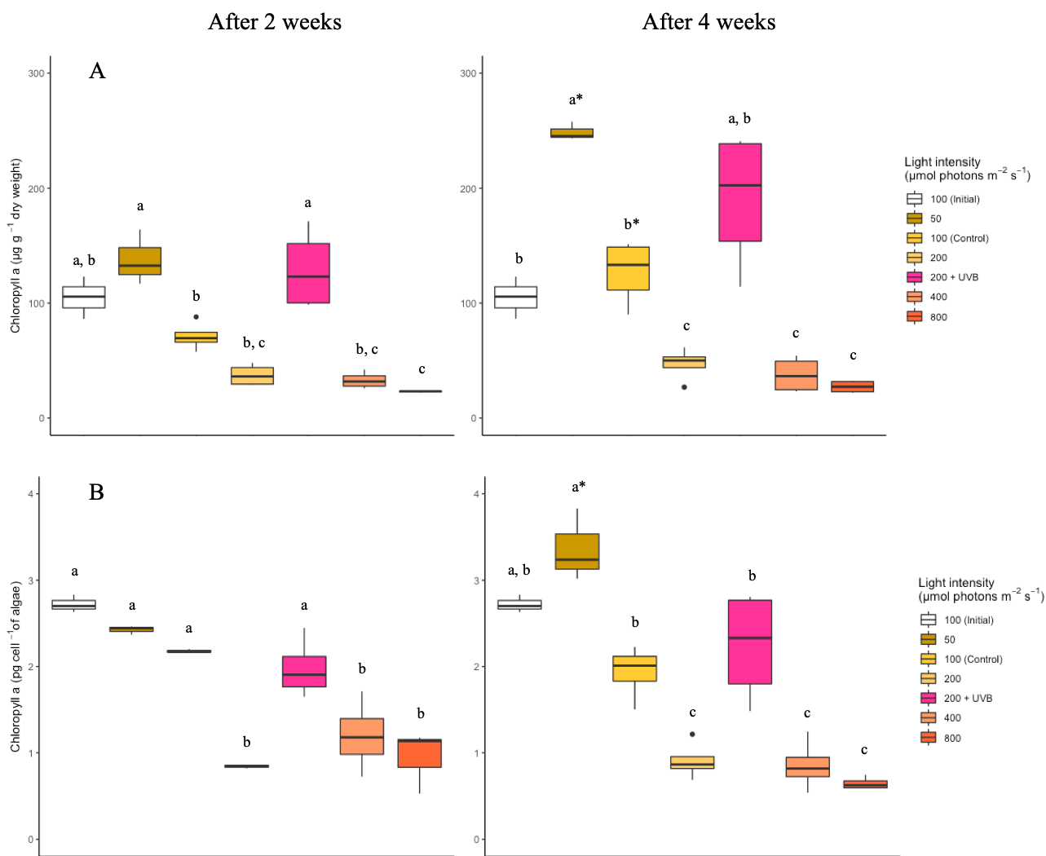

Fig. 1

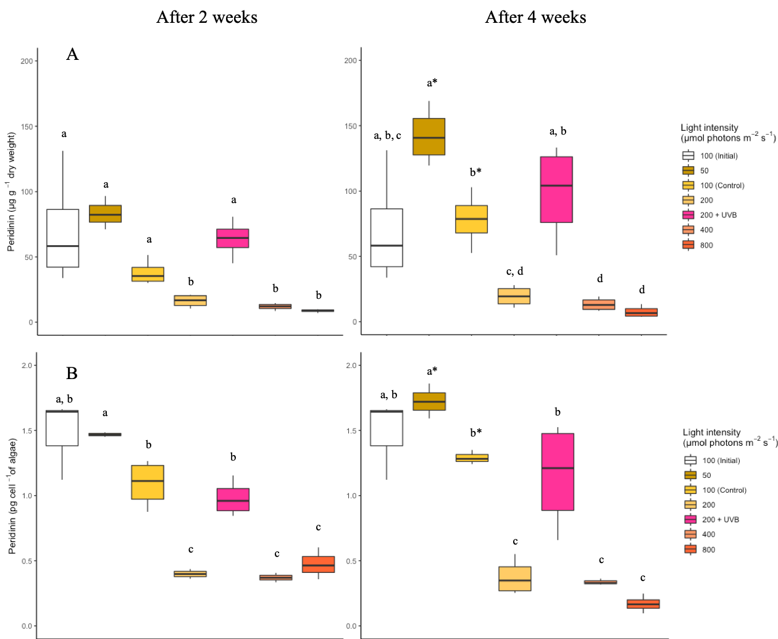

Fig. 2

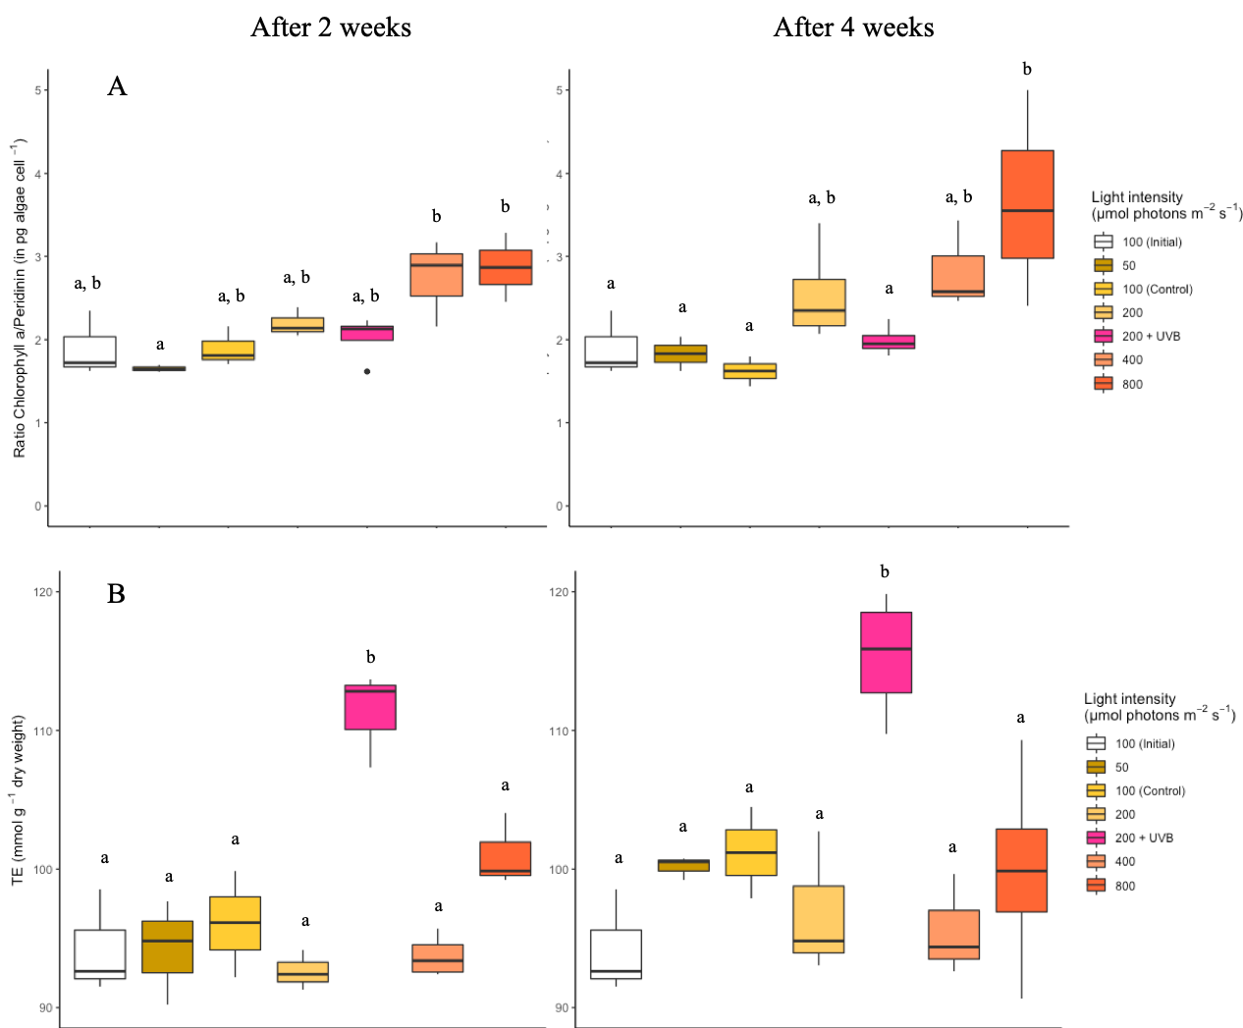

Fig. 3