**Study design, proof of feasibility and preliminary findings**

**Study design**

**Figure 1. Study design – Aims 1,2.** Totest for real-time biological differences between different mindsets while performing the same physical action (food consumption, Aim 1; exercising, Aim 2), we will employ a within-subject crossover design, counterbalanced for order of conditions. Participants will visit the lab three times, at least four days apart, to allow sufficient rest and recovery. Each aim will include 30 healthy men and women with normal BMI (18.5-25), ages 21-45y.

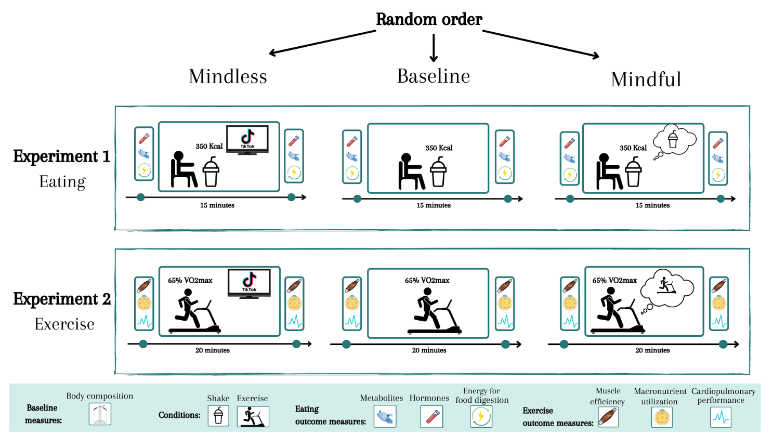

**Figure 2. Study design – Aim 3.** To elucidate longer-term effects of mindset-induced biological changes, we will probe structural and functional changes in the hypothalamus, a brain region responsible for homeostasis regulation including appetite and energy expenditure. We will also compare changes in body composition and microbiome.

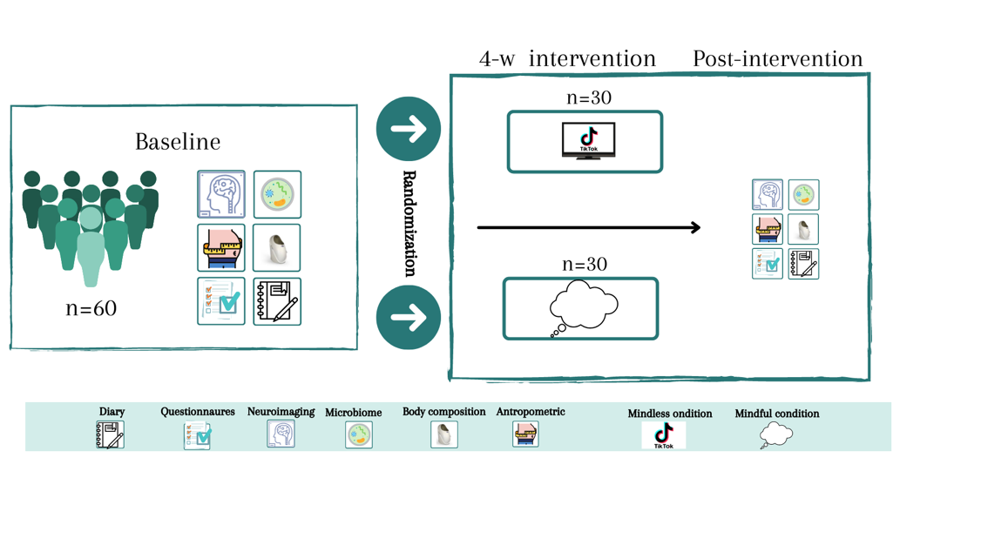

**Preliminary results**

1. **Attention during a meal (mindful/mindless) is linked to sensations of satiety and hunger following the meal.** We collected data from 60 participants (ages 18-64, 21 men and 39 women) about their eating habits, including levels of hunger and satiety, time of last meal consumption, and activity during eating (in this order, with additional questions in between to prevent identification of the study question). We find that sensations of hunger and satiety were significantly influenced by whether participants were mindful or mindless while eating, even after considering how long has passed since their last meal (F1,41=10, *p*=0.003). In fact, being mindful (vs mindless) during a meal was the strongest predictor for feeling satiated (β=0.4, *p*=0.003); the second predictor was time since last meal (β=-0.31, *p*=0.02). These behavioral findings strongly suggest that physiological factors such as levels of appetite-regulating hormones may differ when people eat mindfully versus mindlessly. Critically, these differences were observed as fast as 0-30 minutes after consuming the meal, indicating real-time regulation of satiation. Of note, most mindless eating was while participants watched TV or were on their phones, which strengthens our operationalization of screen viewing for the mindless condition.

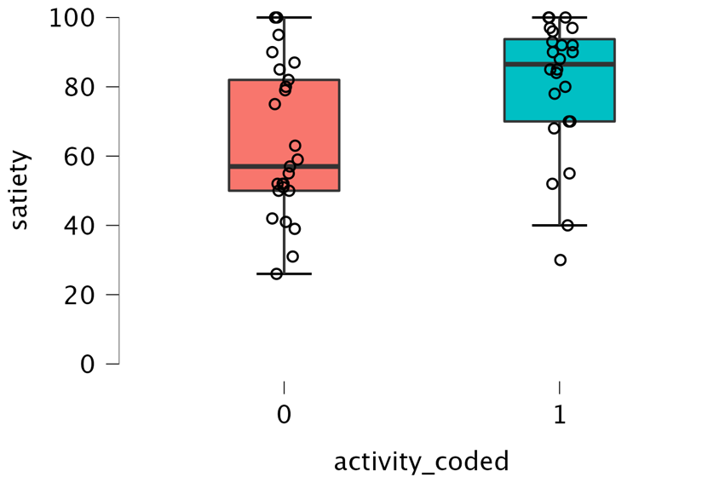

Mindless Mindful

Satiety (higher 🡪)

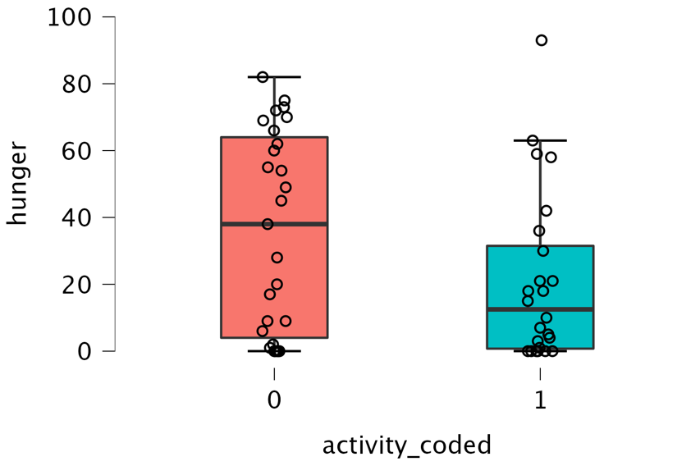

Mindless Mindful

Hunger (higher 🡪)

Figure 3. **Mindless eating is associated with higher hunger and reduced satiety.** Differences in satiety (left) and hunger (right) levels following a meal between group who reported being mindful during their meal versus mindless (on their phone/ watching TV).

[A second graph indicating satiety for each group at each timepoint post meal (0-30 minutes, 30-60 minutes, 60-120 minutes, >120 minutes) is in preparation]

1. 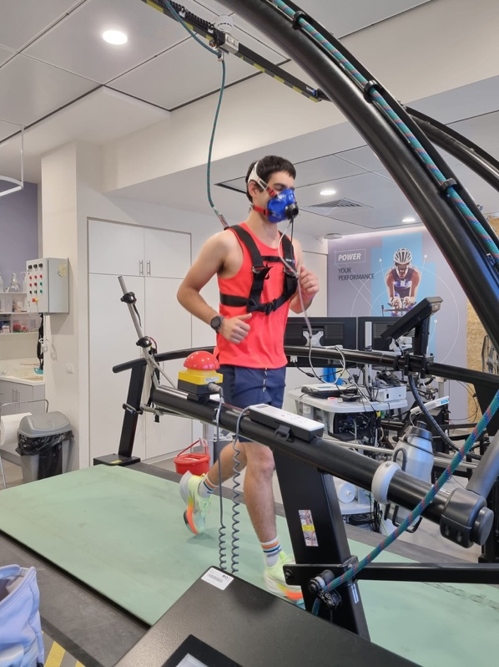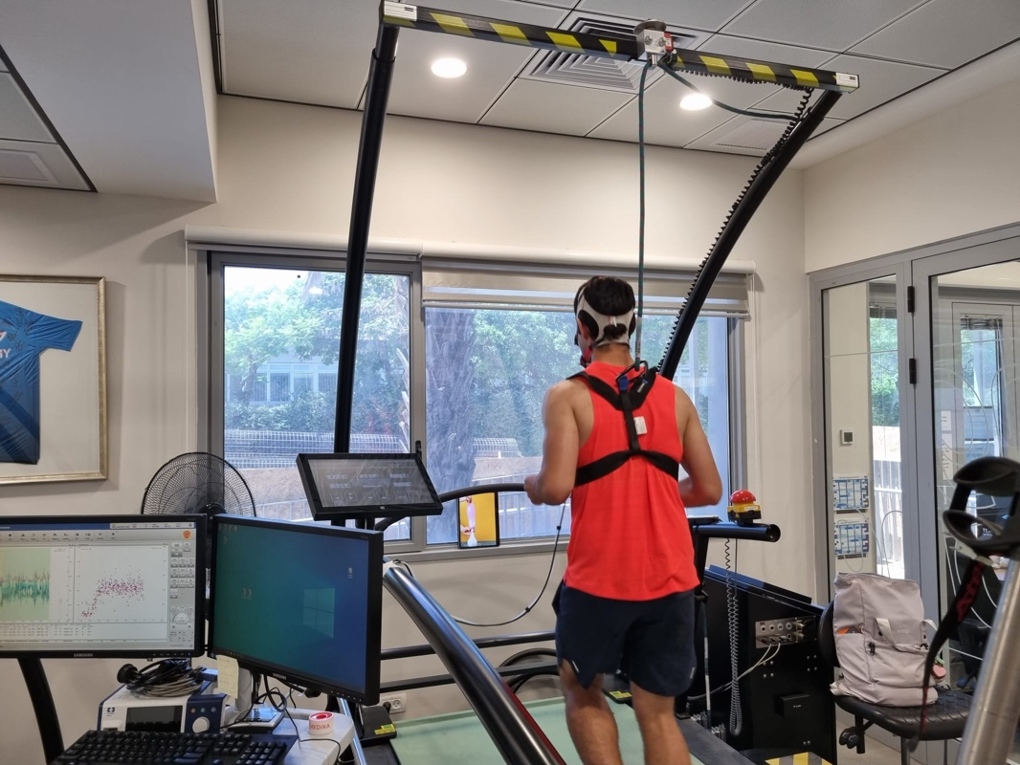**Proof of concept: Performing an exercise while mindful versus mindless triggers better oxygen utilization, carbon dioxide release and higher muscle efficiency.** We collected data from two participants; each completed both mindful and mindless exercise (20 minutes running at 75% of their maximal predicted heart rate) in a counterbalanced order, while collecting their physiological-metabolic measurements using a respiration mask (figure 7). We show proof of concept for the metabolic and physiological benefits of exercising mindfully versus mindlessly.

Figure 5. Study settings. Participants run for 20 minutes on a custom designed treadmill while wearing a respiratory mask (see middle panel) which measures O2 consumption and CO2 production for every breath. In the left-most panel is participant 1 under the mindless condition (the blue arrow points to the screen presenting short, captivating videoclips). In the right-most panel is participant 2 under the mindful condition, directed to focus on the actions of her body (no screen). Critically, both participants completed both conditions, a week apart, in a counter-balanced order, to allow us to gain a within-participants comparison of the differences between conditions.

During the exercise, both participants showed higher respiratory efficiency in the mindful condition: they had higher breathing volume, lower respiration rate and higher ventilation (more air entering the lungs per minutes). They also had more efficient O2 consumption and better rate of CO2 release. In addition, both participants showed higher muscle efficiency during exercise: their muscles utilized more O2 than in the mindless condition, and they exploited more calories during the exercise and less calories during the recovery phase. Finally, during the mindful exercise, both participants exhibited more efficient macronutrient utilization, indicated by more balanced use of energy from fat and carbohydrates. To conclude, this is a proof of concept, both for the feasibility of the study, and for our hypothesis of more efficient metabolism when mindful.

**Proof of feasibility: Metabolic indicators following food consumption**

1. Energy devoted to digestion: Using similar respiratory measures as shown in Figure 5, we can measure the thermic effect of food, the amount of energy devoted to digestion of food over and above the basal metabolic rate. Figure 8 depicts the intra-individual variation in the amount of energy devoted to digestion, even when all participants consumed the same test meal (425 Kcal). This variability, which is largely unexplained, could be partially resolved by considering attention paid during the meal, namely was the person mindful or mindless of their actions.

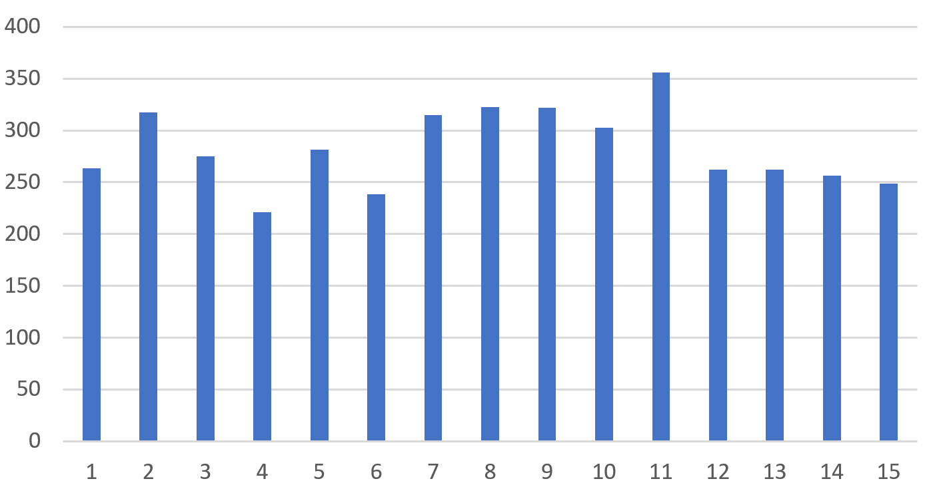

Thermic effect of food

(Kcal)

Subject #

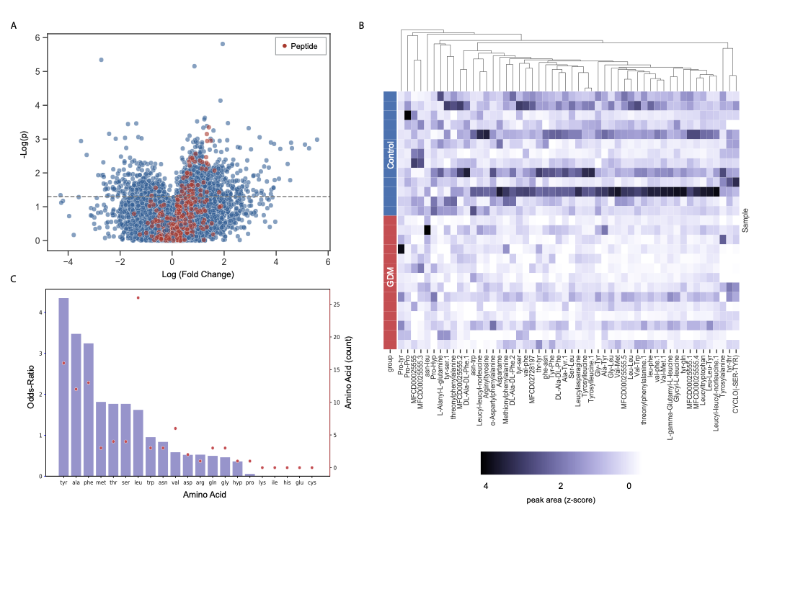

1. Analysis of human serum metabolomics (Koren’s lab). In Figure 7, we can see a heatmap of the expressions of 52 metabolites and their differential expression between two populations, healthy (Control) pregnant women and a group of diabetic pregnant women. Each row denotes a sample collected from a participant (grouped by disease state) and each column denotes a peptide. While these samples are not taken from the same participant, the figure depicts the ability to isolate and analyze different metabolites in serum.