Health Capital Investment

[Titel]

|  |  |
| --- | --- |
| Inputs (e.g., diet and exercise) |  |
| Health capital |  |
| Outputs (e.g., number of days) |  |

Relationship between Health Capital Stock and Health Output

|  |  |
| --- | --- |
| Health capital stock |  |
| Health output |  |

Cost of Capital versus Health Stock

|  |  |
| --- | --- |
| Cost of capital |  |
| Health stock |  |

Production of Health

|  |  |
| --- | --- |
| Health status |  |
| Healthcare inputs |  |

Global Health Expenditure

|  |  |
| --- | --- |
| Health spending (% of GDP) |  |
| High income |  |
| Upper-middle income |  |
| Low income |  |
| Lower-middle income |  |

Life Expectancy versus Health Expenditure 2015

|  |  |
| --- | --- |
| Mexico |  |
| Hungary |  |
| Poland |  |
| Czechia |  |
| Chile |  |
| Greece |  |
| Israel |  |
| Italy |  |
| New Zealand |  |
| Japan |  |
| France |  |
| Belgium |  |
| Sweden |  |
| The Netherlands |  |
| Germany |  |
| Switzerland |  |
| Norway |  |
| Luxembourg |  |
| The United States |  |
| Life expectancy (years) |  |
| Health expenditure (2010 in $) |  |
| Asia |  |
| Europe |  |
| North America |  |
| Oceania |  |
| South America |  |

Health System Inputs

|  |  |
| --- | --- |
| Financial resources |  |
| Expenditure categories |  |
| Capital |  |
| Training of people |  |
| Investment in building and equipment |  |
| Recurrent |  |
| Labor cost |  |
| Maintenance |  |
| Other |  |
| Health system inputs |  |
| Human resources |  |
| Retirement, obsolescence |  |
| Physical capital |  |
| Deprecation, obsolescence |  |
| Consumables |  |
| Expiry, loss |  |
| Production of health interventions |  |

Isoquant Curve

|  |  |
| --- | --- |
| Human resources (H) |  |
| Isoquant curve |  |
| Physical capital (P) |  |

Economic Efficiency: Intersection between Isoquant Curve and Isocost Line

|  |  |
| --- | --- |
| Human resources (H) |  |
| Isoquant curve |  |
| Physical capital (P) |  |

Short-Term Total Cost Curves

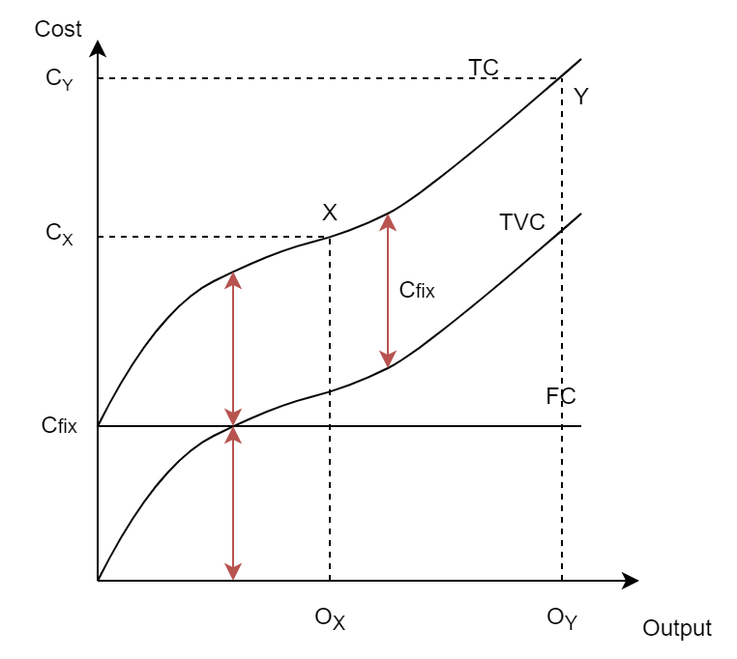

|  |  |
| --- | --- |
| Cost |  |
| Output |  |

Marginal and Average Cost Curves

|  |  |
| --- | --- |
| Total cost |  |
| Output |  |

Externalities among Two Individuals

|  |  |
| --- | --- |
| H: Health |  |
| HC: Healthcare |  |
| SR: Social relation |  |
| C: Consumption |  |
| U: Utility |  |
| T: Tax |  |
| G: Government spending |  |

Efficiency in Society with the Presence of a Beneficial Externality

|  |  |
| --- | --- |
| Price |  |
| Quantity |  |
| Psocial |  |
| Psub |  |
| Qsocial |  |
| Subsidy |  |

The Edgeworth Box for a Two-Good and Two-Individual Economy

|  |  |
| --- | --- |
| Water |  |
| Food |  |

Equality and Equity

The Commission on Social Determinants of Health Conceptual Framework

|  |  |
| --- | --- |
| Socioeconomic and political content |  |
| Governance |  |
| Macroeconomics policies |  |
| Social policies (e.g., labor market, housing, land) |  |
| Public policies (e.g., education, health, social protection) |  |
| Culture and societal values |  |
| Structural determinants |  |
| Social determinants of health inequalities |  |
| Socioeconomic position |  |
| Social class |  |
| Gender |  |
| Ethnicity (racism) |  |
| Education |  |
| Occupation |  |
| Income |  |
| Social cohesion and social capital |  |
| Material circumstances (e.g., living and working conditions, food availability) |  |
| Behaviors and biological factors |  |
| Psychosocial factors |  |
| Health system |  |
| Intermediary determinants |  |
| Social determinants of health |  |
| Impact on equity in health and well-being |  |

Framework for Tackling Inequities by Addressing Social Determinants of Health

|  |  |
| --- | --- |
| Context-specific strategies tackling both structural and intermediary determinants |  |
| Globalization environment |  |
| Macro level: Public policies |  |
| Mesa level: Community |  |
| Micro level: Individual interaction |  |
| Key dimensions and directions for policy |  |
| Intersectoral action |  |
| Social participation and empowerment |  |
| Policies on stratification to reduce inequalities and mitigate the effects of stratification |  |
| Policies to reduce exposures of disadvantaged people to health-damaging factors |  |
| Policies to reduce vulnerabilities of disadvantaged people |  |
| Policies to reduce unequal consequences of illness in social, economic, and health terms |  |
| Monitoring and follow-up of health equity and SDH |  |
| Evidence on interventions to tackle social determinants of health across government |  |
| Include health equity as a goal in health policy and other social policies |  |

Fee Test of Inducement

|  |  |
| --- | --- |
| Fee per visit |  |
| Number of visits |  |

QALY of a Patient with and without Treatment

|  |  |
| --- | --- |
| Perfect health |  |
| Death |  |
| Death (no treatment) |  |
| Death (with treatment) |  |
| Years of follow-up |  |
| QALY gains |  |
| QALY loss |  |
| QALY without treatment |  |

Recommended Cost Categories in Two Perspectives

|  |  |
| --- | --- |
| Total costs |  |
| Formal healthcare sector |  |
| Informal healthcare sector |  |
| Non-healthcare sector |  |
| Drug costs, medical devices, physician times and services, out- and inpatient care, etc. (paid by third-party payers or patient out-of-pocket expenditures) |  |
| Patient time, unpaid caregiver time, transportation costs, etc. |  |
| Productivity, consumption, social services, education, housing, environment, etc. |  |
| Healthcare sector perspective |  |
| Societal perspective |  |

Causal Relationship in Econometric Analysis

|  |  |
| --- | --- |
| Independent variable (explanatory variable) |  |
| Dependent variable (outcome variable) |  |