**Cooling of CO2-rich geothermal fluids – A mechanism for cave systems formation**

Roi Roded1*, Einat Aharonov2*, Amos Frumkin2, Nurit Weber3, Boaz Lazar2 and Piotr Szymczak4

1Hydrology and Water Resources, The Hebrew University, Jerusalem, Israel.

2Institute of Earth Sciences, The Hebrew University, Jerusalem, Israel.

3Department of Earth and Planetary Sciences, The Weizmann Institute of Science, Rehovot, Israel.

4Institute of Theoretical Physics, Faculty of Physics, University of Warsaw, Warsaw, Poland.

**Corresponding authors:** E.A. ([einatah@mail.huji.ac.il](mailto:einatah@mail.huji.ac.il)), R.R. ([roi.roded@mail.huji.ac.il](mailto:roi.roded@mail.huji.ac.il)).

**Abstract** (<250 words)

Rock-groundwater interactions may substantially alter the shape and size of voids within the rocks comprising the Earth’s upper crust. In carbonate aquifers, these interactions may often lead to intense dissolution and the formation of extensive karstic cave systems. Recent studies show that a large portion of the known karst systems were formed by groundwaters ascending from depth(“*hypogenic karst*”), rather than by CO2-loaded meteoric water which infiltrated from the surface (“*epigenic karst*”). The hypogenic karstic cave systems often make up giant and complex mazes of caves with passages reaching lengths of hundreds of kilometers, having a great environmental, economic and cultural importance since the dawn of humanity. Despite the importance of the hypogene karstic cave systems, the mechanisms of their formation remained elusive and ill-constrained. In this study, we provide geological, geochemical and theoretical evidence that many hypogene karst systems were most likely formed by the interaction of carbonate country rocks with CO2-rich, geothermal groundwater that rapidly ascended from depth. As the water cools, carbonate solubility increases (due to its retrograde solubility nature), inducing rock dissolution and cave formation at relatively short geological timescales. A theoretical simulation model based on this scenario produced maze-like hypogenic karst cave systems very similar to those observed in field studies; and constrained the feasibility range of the possible hydrological/geological/geochemical conditions. These conditions are very common in the Earth’s crust, suggesting that the scenario presented here for the formation of extensive hypogene karstic caves may be ubiquitous worldwide.

**Significance Statement** (<120 words)

Studies reveal that many of the known karst and giant and intricate cave systems in the Earth’s upper crust were formed by deep-origin ascending groundwater, rather than by percolating rainwater. Nevertheless, the processes responsible for the formation of such systems remained largely obscure. This study provides geological observations and modeling simulations showing for the first time that many such cave systems may have formed by the dissolution of carbonate country rocks during cooling of CO2-rich geothermal groundwater on timescales of ~104 yr. Such a process may reduce CO2 outgassing from the continental crust into the atmosphere on a timescale shorter (or similar to) the glacial-interglacial period, which we suggest investigating as a possibly overlooked pathway in the global CO2 cycle.

**Introduction**

Earth’s upper crust is a dynamic geo-environment that is constantly shaped by strong temperature, pressure, and chemical gradients (1, 2). These forces induce groundwater motion that transports various elements which interact with the country rocks, leading to a suite of geological processes, such as replacement of the original rocks’ minerals, and precipitation or dissolution that modify the rocks. Particularly, dissolution can lead to the development of large voids and caves (“*speleogenesis*”) (3, 4). The best-known cave formation process involves the dissolution of carbonate rocks by downward infiltration of CO2-rich meteoric waters (“*epigenic karst*”) (5–7). However, in recent decades it became apparent that many of the known caves, and some of the most voluminous and complex cave systems worldwide (with cumulative passages length of up to hundreds of kilometers and hundreds of meters deep shafts), are not linked to surface characteristics such as topography, drainage system and downward flow (5, 8, 9). Observations showed that this type of caves is formed as isolated cavities by the interaction of water, rising from a depth > 1 km, with the country rocks (“*hypogenic karst*”) (2, 8). At a later stage, these systems were exposed by erosion which removed the rock masses above the caves (10, 11).

Beyond the phenomena of speleogenesis, the hypogenic fluid-rock interactions may lead to an extensive enhancement of the porosity (11, 12). The increasing volume of the porosity space enhances the flow of pore fluids in which various gases are dissolved (e.g., the “corrosive gas”, CO2). This positive feedback between flow and reaction provides an important mechanism that controls the geophysical properties of shallow and deep carbonate aquifers and reservoirs (6, 13–15). These processes are relevant to a range of geo‑engineering applications including sustainable management of water resources (5, 11), geothermal energy use (16, 17), CO2 geological storage (18), and mitigation of induced-seismicity (19, 20) and sinkhole hazards (2, 8).

The evidence for the abundancy of the “*hypogenic karst”* phenomenon, raises the question: *What are the hydrogeological and geochemical mechanisms responsible for its formation*? In this study, we provide a quantitative answer to this question, comprising a feasible *dynamic hydro*-*thermo-geochemical scenario*. This scenario involves (I) an aggressive (undersaturated with respect to the major country-rock’s mineral) solution that causes *a large-scale dissolution of the country rocks*, (II) a hydrodynamic groundwater transport setup that leads to *speleogenesis by localized dissolution* and (III) accounts for the observed *natural cave morphologies*, including intricate patterns of the network of passages. The formation details of these patterns and the underlying physics, which are often markedly different from that of their epigenic counterparts (9, 11), remained a matter of debate, and their resolution may provide a key to understanding hypogenic karst formation (9, 21–24).

Previous studies commonly attributed the aggressiveness of groundwater forming hypogenic karst in carbonates to “*mixing corrosion*“, i.e., mixing of CaCO3 saturated solutions of different compositions to produce an undersaturated solution; and to condensation of undersaturated water on rock walls above the groundwater table (“*condensation corrosion*”), commonly involving corrosive sulfuric vapors (25–29). Here, we suggest a largely overlooked source of aggressiveness, the so-called “*retrograde solubility*”. This mechanism for the dissolution of carbonate minerals like calcite and dolomite arises due to the cooling of geothermal fluids of deep-origin, in which the solubility increases as the temperature decreases. The cooling of the deep-origin fluids turns them into *undersaturated* solutions with respect to carbonate minerals, triggering dissolution of the rocks. This mechanism was discussed in earlier studies (e.g., *31*), but was considered negligible, only capable of producing diffuse and dispersed karst, and hence not likely to be responsible for well-developed hypogenic karst and cave systems (9, 11, 31). In contrast to these earlier estimates, this study shows that the cooling mechanism, in particular in CO2-enriched fluids, produces highly aggressive solutions which drive continuous dissolution. This dissolution may form large hypogene cave systems on geologically short timescales and also produce the observed natural cave morphologies.

In what follows, first, a conceptual model is laid out, based on a case study of a large group of hypogene caves in a confined carbonate aquifer (10). The model assumes two main ingredients: incoming hot and CO2-rich water, and a soluble layer that is confined and permeable. Next, thermodynamic calculations show that the cooling of these groundwaters and the retrograde solubility of the calcite minerals can produce aggressive solutions that are capable of rapidly dissolving a substantial portion of the country rocks. Subsequently, numerical model simulations are used to evaluate the conditions for localized dissolution during the cooling of geothermal waters and examine the feasibility of the conceptual model. Last, the results of these calculations are used to construct a numerical network model which enables simulating the formation of maze-like cave structures that are similar to those of our case study and characteristic to hypogene caves.

The different components of the suggested mechanism, namely, elevated temperature and CO2 concentration at depth, ascending flow through fractures and faults, and a certain degree of a soluble layer confinement, are ubiquitous and globally widespread. Hence, it is likely that this mechanism played a major role in forming cave systems worldwide, including very extensive hypogene karst systems like those of the Black Hills of South Dakota (30, 32), the Buda thermal karst cave systems in Hungary (33), cave systems throughout Europe (34–37), Brazil (38, 39), Southern Africa (40) and in many other locations worldwide (41).

**Conceptual Model and Analyses**

**Conceptual Model.** The conceptual model describes a scenario in which groundwater originates from a deep aquifer (>1 km), where it became heated and considerably enriched with CO2 (9, 28, 42). This hot groundwater ascends in a pipe-like manner through permeable sub-vertical faults and fractures, driven by artesian or tectonic pressures and buoyancy forces (2, 43). Such pipe-like water flow arises either at fault or fracture plane intersections (44–46) or at flow conduits that naturally occur on the rough surfaces of fractures (17, 47). The rapidly ascending fluids maintain their heat and temperature until they approach a flow barrier (e.g., an aquiclude layer), which diverts their flow sideways radially (~2-D around the conduit) within the permeable bedding horizon of the soluble rock layer (48, 49). During their radial flow, the fluids cool rapidly by transferring heat to the rock below and above. Given the retrograde solubility of carbonate minerals, the rapidly cooling groundwater becomes undersaturated, significantly increasing the solubility of the aquifer’s rocks. After a geologically short time, the localized dissolution forms a large cave surrounding the conduit’s inlet (cave feeder; Fig. 1*A*).

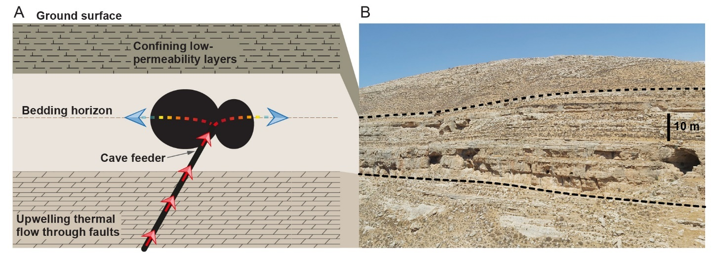

**Fig. 1.** The formation of hypogene caves depicting the conceptual model (*A*) and a field appearance (*B*). (*A*) Thermal, CO2-enriched groundwater upwells rapidly through a conduit pathway in a fault and/or fractures (red arrows) and, upon approaching a confining low-permeability layer, the flow is diverted sideways to the permeable bedding horizons in a soluble layer (dashed brown line), where it flows slowly. The temperature of the water remains high during the fast flow through the narrow fault conduit (red arrows) and drops quickly when the water slows down during its radial flow and heat transfer to the rock below and above (gradient color arrows). The rapid cooling of the water leads to a high degree of undersaturation with respect to calcite, inducing localized dissolution of the rock and cave formation (black ellipses). (*B*) Field appearance of hypogene caves in carbonate rocks located near Jerusalem, Israel (photograph by R.R.). A confining low-permeability layer overlaying the main karstic layer (bordered by dashed lines).

The conceptual model described above is consistent with the configuration and morphological features of many known hypogenic cave systems (e.g., *31*, *33*–*42*). In particular, this setting also applies to the group of caves in our case study (Fig. 1*B*; *10*). This group comprises dozens of extended caves located along the fold system adjacent to the Dead Sea Transform in Israel. Large, rooted faults at the base of the folds are assumed to facilitate the upwelling of thermal flow. The caves are commonly developed along prominent bedding horizons in limestone formations overlaying massive limestone and dolostone layers (>400 m). The cave-forming rock layer is overlaid by low-permeability layers comprising mainly soft chalk and marl horizons-rich limestone. The cave systems usually present a maze-like pattern, or occasionally are chamber caves. The maze caves developed via relatively uniform dissolution of the network of conduits formed by the intersection of the horizon and subvertical fracture network (10, 50).

The groundwater that formed this karst probably originated from a deep (1 to 2 km) and large sandstone aquifer, as suggested by mineral assemblages and the temperature and composition of present spring systems, although a shallower origin from a carbonate aquifer cannot be excluded (<1 km depth; *10*). Tectonic and hydrological events constrain the karst formation period to be within a several millions of years window (Oligocene–early Miocene). Karst formation was terminated by the Neogene uplifting and deepening of the Dead Sea Transform, which resulted in disconnection of the far-field groundwater flow, water-level drop, and cave dewatering. A detailed description of the caves and their geological setting is provided by Frumkin et al. (10) and references therein.

**Model Analyses.** Geochemical calculations were used to estimate the dissolution capacities of cooling thermal waters. These results were incorporated into the numerical models for: (I) heat transport and dissolution in a confined bedding horizon (Axisymmetric Horizon Dissolution model, AHD model, described in *Materials and Methods*); and (II) channelized dissolution and cave-pattern formation using a network model (described in S5, Supporting Information (SI)).

The numerical AHD model depicts a simple physical system (Fig. 2): fluid is discharged through a central inlet of a radius *r*0, representing the channelized upwelling. The fluid enters radially into a permeable bedding horizon at a constant temperature, *T*in, and volumetric flow rate, *Q* (Fig. 2*A*). In the horizon, we assume a uniform flow, dissolution, and axisymmetry (channelized flow and dissolution are considered in a subsequent section). Furthermore, assuming orders-of-magnitude contrasts in permeability (5, 51), flow in the rock matrix is neglected.

Basal heat flow and the initial background geothermal gradient are assumed negligible compared with the heat input of the ascending fluid. The thickness of the low-permeability caprock is large enough to act as a thermal insulator and no substantial heat is transferred to the surface. When this is not the case, the cooling rate increases, and dissolution and speleogenesis may localize even closer to the inlet.

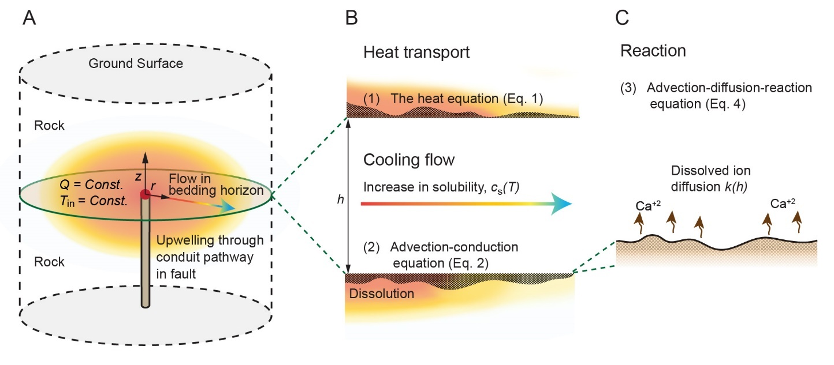

**Fig. 2.** A cartoon of the AHD model geometry and the settings: (*A*) the fluid discharges from a pipe through an inlet of radius *r*0 (red point) with total flow rate *Q* and temperature *T*in. The flow is distributed radially, where it cools by transferring heat to the rock below and above (color gradient arrow); (*B*) heat transport in the bedding horizon and the rock and its effect on calcite solubility (magnified). Heat transport is governed by conduction in the rock and by the advection-conduction equation in the fluid, with heat exchange term (*Θ*) accounting for conduction between the rock and fluid. As the fluid cools, the concentration at saturation (solubility), *c*s(*T*), increases, inducing carbonate dissolution, which alters the horizon aperture, *h*; (*C*) the calcite dissolution reaction at the horizon surface. An advection-diffusion-reaction equation is calculated assuming a fully-transport-limited dissolution of the Ca2+ ions that depends on the surface to fluid mass-transfer coefficient, *k*(*h*).

The model further assumes closed-system conditions and the following: fluid pressure, *p*, in the aquifer is larger than the CO2 partial pressure, PCO2, in the thermal water (*p*> PCO2), so no gas phase (bubbles) forms. This is facilitated by the confinement above the cave forming layer, otherwise degassing of CO2 near the water table can lead to calcite supersaturation and precipitation (27, 52); the volumetric flow rate from the cave feeder (i.e., fluid inlet) remains constant, this is since the cavities are formed as isolated voids, and the overall permeability of the system remains constant (9, 47). This last assumption breaks down if speleogenesis occurs near the surface (15, 47), our case study however deals with dissolution under a thick impermeable rock section; for reactive transport calculations, we use a stationary reactive transport equation, neglecting the transient term, is justified given the large differences of the characteristic timescales between solute transport and mineral dissolution (see section S2, SI).

Section S3 (SI) presents a theoretical analysis of dissolution in a uniform horizon as a result of heat exchange with the rock and fluid cooling. The results are then used to validate the numerical model presented here and implemented in a finite-difference code (see sections S4 and S2.3, SI). Tables S1 and S4 give the notation for the physical parameters and their values, respectively.

**Results and Discussion**

**Geochemical Calculations.** The PCO2 of porewater in confined aquifers is observed to increase with both temperature and pressure (i.e., with depth), and generally in sedimentary aquifers to be much higher than in crystalline aquifers (42). Elevated PCO2 of groundwater in deep-seated aquifers is maintained over time by large CO2 fluxes originating, for example, from deep magmatic bodies and decomposition of sedimentary organic matter (42, 53, 54). In this study, we calculated the PCO2 and saturation conditions in groundwaters from sandstone and carbonate aquifers for different temperatures and pressure and different PCO2, using a PHREEQC (v.3.7.0) software package (55) assuming closed system conditions, under which no degassing occurs (section S1, SI).

The results reveal that the saturation concentration of calcium ions, *c*s, depends strongly on the initial PCO2 and temperature (Fig S1*B*). In particular, if the initial PCO2 is high, *c*s strongly increases as the geothermal water cools down and thus, leads to a highly aggressive dissolution process. The calculations suggest that it takes less than 300 yr to form a hypothetical hemisphere-shaped cave with a diameter of 6 m within a limestone rock, which is in contact with slowly flowing water (*Q* = 1 m3/day), when it is cooled by ∆*T* = 65 °C (dotted line in Fig. 3*A*). This can be shown using a simple equation that estimates the volume of dissolved solid to be *V = Q·t·*∆*c*s*·*(*m*CaCO3*/ρ*r), where *t* is the time, ∆*c*sis the difference between the solubilities at cold and warm conditions, *m*CaCO3 is the molar mass of calcite and *ρ*r is the rock’s density, here *ρ*r = 2200 kg/m3. The calculation assumes that groundwater came from a sandstone aquifer with PCO2 of 0.5 MPa, which corresponds to temperature of ≳ 85 °C and a depth of ~3 km. At such conditions, the solubility, *c*s, increases by over 12 mmol/kg H2O as the water is cooled to 20 °C (see dotted lines in Figs. S1). For comparison, under atmospheric pressure and epigenic karst conditions, a typical value of *c*s is much smaller, ~2 mmol/kg H2O (7).

The calculations demonstrate that even at a small temperature difference of ∆*T* = 5 °C and with PCO2 as low as 0.001 MPa, the hypothetical cave can form within several tens of thousands of years (dashed line in Fig. 3*A*). Here, in agreement with our case study, we shall consider upwelling from a sandstone aquifer of ~2 km depth (with *T* = 60°C) and of PCO2 ≈ 0.03 MPa (point (i) on dashed lines in Fig. S1) that discharges into a shallow limestone aquifer and cools to 20 °C (see *Conceptual Model* section). At these conditions, the saturation concentration of calcium can change by ∆*c*s ≈ 3 mmol/kg H2O, twice the ∆*c*s of groundwater originating from a carbonate aquifer (point (ii) on dashed lines in Fig. S1).

Overall, the thermodynamic calculations demonstrate that groundwater cooling and retrograde solubility of carbonate minerals can lead to extensive hypogene karst formation within very short geological periods. Furthermore, if the time interval for the formation of hypogenic karst is several millions of years as suggested in the literature (2, 10), then the hydrogeological conditions to form extensive cave systems, which are observed worldwide in the geological section, are rather mild: requiring only a small drop in the temperature and a small PCO2 of the ascending hydrothermal water.

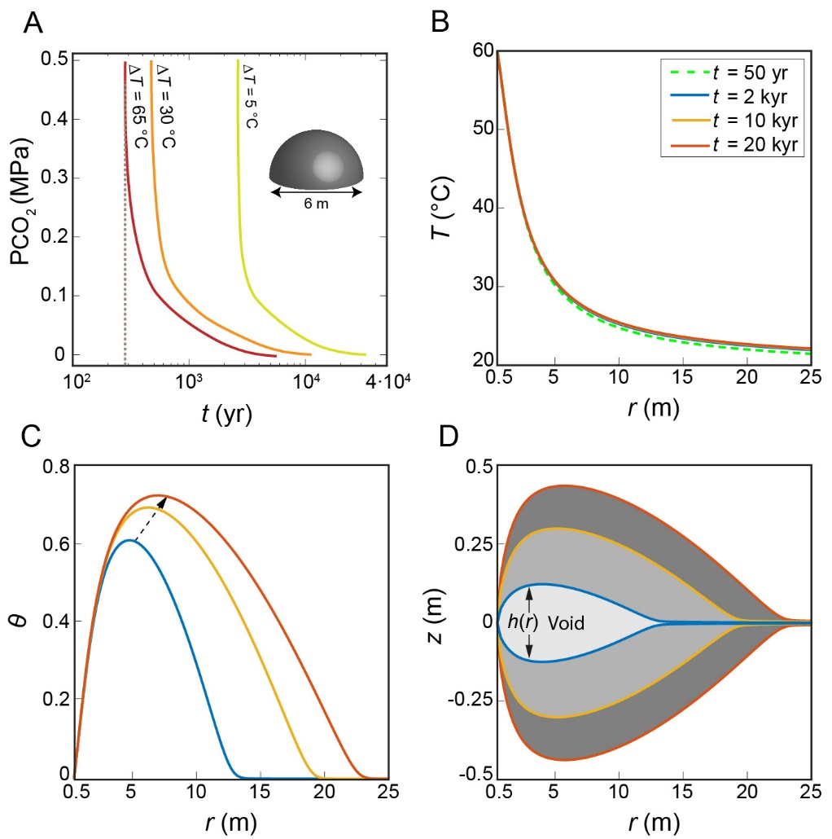

**Fig. 3.** (*A*) Calculated plots of PCO2 versus time, *t*, for dissolving a 6 m diameter hemisphere-shaped hypothetical cave in a limestone rock. The cave is fed by slowly flowing groundwater (1 m3/day) of different cooling ranges: ∆*T* of 65, 30 and 5 °C (see text). The plots show that a cave can be formed within 300 yr (dotted line) under favorable conditions, or in several tens of thousands of years for very mild conditions (dashed line). (*B-D*) Results from the AHD model for temperature, *T*, degree of undersaturation, *θ*, (see text for definition) and cave profile and aperture, *h* (the vertical distance in-between the curves) versus the radial distance from the inlet, *r*, at different times during cave development: (*B*) *T* shows a rapid cooling of the water, approaching a quasi-steady thermal state after a very short time of ~50 yr (see text); (*C*) *θ* increases sharply with distance (due to high cooling and advective rates), reaches a maximum and then decreases downstream because of the dissolution reaction; (*D*) the cave aperture (*h*) develops substantially with time and lateral extent, *r* (grayscale). In accordance with *θ*, a pronounced maximum appears in *h* a few meters from the inlet.

**Cave Formation by Cooling and Localized Dissolution.** The results obtained by solving Eqs. **1**–**7** (*Materials and Methods*) in the setting described in Fig. 2 show that during the radial flow within the horizon the geothermal groundwater cools relatively quickly (from 60 °C at the inlet to 25 °C at a distance *r* ≈ 10 m; Fig. 3*B*). The rapid cooling is promoted by the radial discharge from a localized low-discharge source, which allows the fluid to reach a quasi-steady thermal state after about 50 yr[1]*. The fluid is hot and saturated with respect to calcite at the inlet, *c* = *c*s(*T*in), but as it moves away from the inlet, the undersaturation, *θ*, first increases with *r* and then – after several meters reaches a maximum and decreases (Fig. 3*C*; here, *θ* = [*c*s(*T*(*r*))− *c*(*r*)]*/*∆*c*s0where ∆*c*s0= *c*s(*T*0)− *c*s(*T*in), and *T*0 is the initial temperature). Undersaturation along the flow path is controlled by the interplay between 3 variables: (I) dissolution that reduces undersaturation; (II) progressive cooling that increases undersaturation; and (III) advection that transports reaction products (i.e., calcium ions) outward and helps in maintaining undersaturation. Here, the effect of fluid velocity and advection decays with distance, as 1/*r*.

The high advection and cooling rates near the inlet cause a buildup of undersaturation. Further downstream, cooling and advection rates are much lower, and undersaturation decreases due to the dissolution reaction. Accordingly, the cave profile develops a pronounced maximum several meters from the inlet point (Fig. 3*D*). Over time, the widening cave aperture, *h* (the vertical distance in-between the lines, gray regions in Fig 3*D*) cause a reduced diffusion rate. Since the reaction is transport limited (Eq. **5**) this reduces the dissolution rate, which in turn, leads to the increase in undersaturation.

The flow rate (*Q*) has a significant effect on karst formation, particularly on the aspect ratio of the dissolution cavity, as demonstrated by the plots of dissolution focusing, *η*, versus total fluid volume, *V*f, discharged over time *t* (*V*f = *Q·t*) (see cave shapes for 3 different *Q* values in Fig. 4). The degree of dissolution focusing, *η* is defined here as, *η = h*p*/l*v, which is the ratio between the maximum cave’s height (*h*p) and its length (*l*v) for *h* > 1.01·*h*0, where *h*0 is the size of the initial aperture of the bedding horizon (see Fig. 4). The plots show that *η* decreases (caves become more elongated) with increasing volumetric flow rates. This is because: (I) higher *Q* transports heat further downstream, leading to more gradual cooling and undersaturation profile development; and (II) higher *Q* advects undersaturated fluid faster, promoting dissolution farther from the inlet.

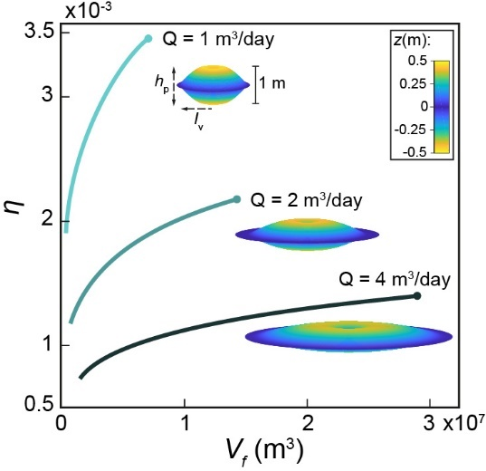

**Fig. 4.** Degree of dissolution focusing, *η* (see text) versus the integrated fluid discharge volume, *V*f, over a time interval, *t* (*V*f = *Q·t*). The plot depicts 3 different cases with volumetric flow rate, *Q,* of 1, 2 and 4 m3/day shown for *t* between 1 to 20 kyr. The curves show that lowering *Q* increases *η*, indicating increasingly localized dissolution, as demonstrated by the three-dimensional visualizations of the caves after 20 kyr (the vertical cave’s dimension, *h*p, is exaggerated by a factor of 30 relative to the cave’s length, *l*v).

Consequently, a void gets a shape of a cave (high *η*) at relatively low flow rates, while at high flow rates dissolution is diffused (low *η*) resulting in only porosity change in the aquifer (9, 56). Such low flow rates are typical for geothermal fluids sourced from depth (>1 km) that discharge as thermal seepages and springs (21, 43, 57), corroborating the idea that cooling of such fluids is responsible for cave formation. Note, however, that in contrast to the slowness of fluid flow as it enters the horizon and radially diverges (Fig. 2*A*), the vertical velocity of the ascending geothermal fluids is high due to channelized ascent through the narrow conduit.

**Time scales for Speleogenesis and Thermal Water Origin.** The results indicate that the timescale of speleogenesis and the formation of human-size passages due to cooling of CO2-rich geothermal flow is several tens of thousands of years (Fig. 3*D*), comparable to the typical timescales of epigenic speleogenesis (7, 11) and even shorter. This mechanism, within reasonable timescales, can lead to the formation of extensive caves systems known worldwide for cumulative passages length of hundreds of kilometers, e.g., the Jewel and Wind caves in South Dakota (30). This is in contrast to the general dogma rooted by earlier works which estimated the timescale for hypogene cave formation to be much longer, ~106 yr (9, 11, 21). Specifically, early calculations of dissolution by rising thermal waters conducted by Palmer (Ref. *11*, p. 18) assumed rather low cooling rates and thermal gradients (5 °C/100 m). He concluded that “only under the most favorable conditions can dissolution by cooling of thermal water produce caves of traversable size. Even then, times on the order of 105 to 106 yr are required.”

The geological setting of our case study area suggests that the geothermal fluids that formed the caves ascended from a deep sandstone aquifer (10, 58). The sandstone aquifer is hotter and its groundwaters contain substantially higher PCO2 than the overlying carbonate aquifer (see *Conceptual Model* and section S1, SI). The caves in our case study were estimated to form within a time window of several million years (10). According to our calculations, this time interval is much longer than the time required to form similar-sized caves in the case study area, by the high PCO2 and temperature groundwaters ascending from the deep sandstone aquifer. The several million years’ time window is even longer than the time required for forming these caves by the rather low PCO2 and temperature groundwaters originating from the shallower carbonate aquifer. In fact, our calculations show that these caves could have formed within several million years even by groundwaters which are only several degrees warmer than the country rocks.

**Fundamental Conditions for the Formation of the Caves.** Localized dissolution and hypogene cave formation require both (I) a substantial physico-geochemical driving force (cooling and high PCO2) and (II) an appropriate confined hydrogeological setup, as described above (e.g., Fig. 1*A*). Under these conditions, the upwelling pipe-like flow radially spreads within the confined layer and quickly cools, inducing the speleogenesis observed along bedding horizons.

Previous models of hypogene karst assumed unconfined conditions, at which thermal flow upwells through a fault and discharges to the surface as springs. These studies found diffuse dissolution (31, 56) or localized dissolution only near the surface (17). We argue that the confined hydrological conditions, which our conceptual model requires, are ubiquitous: ascending hydrothermal flow will very often encounter a confining layer on its way upward through a thick heterogeneous sedimentary sequence (9, 41). Indeed, hypogene cave systems formed immediately under, or in close proximity to confinement are very prevalent worldwide (32–40). Furthermore, although unconfined flow near the Earth’s surface may also cool rapidly (due to proximity to the cooled surface), and may be expected to promote localized dissolution (17), CO2 outgassing at shallow depths, close to the surface, should drive supersaturation with respect to calcite and hence precipitation instead of dissolution (e.g., speleothems), as observed in many caves (2, 27).

**Cave Morphology and Pattern Formation.** Previous sections showed the formation of caves under confining layers along bedding horizons, by cooling geothermal flows and reproduced the fundamental field observations in our case study. In this section we show that the characteristics of cave shape, as predicted by the AHD model, fit well with some field observations and provide a brief analysis of the pattern formation of cave passages. Small-scale morphologic features that are characteristic of hypogene processes (e.g., smooth walls, cupolas, and solution pockets) are usually inconclusive indicators (21, 59) and hence are not discussed here.

In most cave locations it is impossible to identify cave feeders because they are covered by debris and sediments. Such caves feeders have been identified and carefully mapped in two hypogene karst systems in Israel, the Ashalim and Berenike, which are located within the setting of our case study (Fig. 5; *59*, *61*). This allows us to compare these caves' morphology with the results of the numerical model (Fig. 3*D*). The Ashalim cave includes feeders and dissolution features along a prominent oblique fracture or fault (dashed-dotted red line in Fig. 5*A*), comprising the backbone of the three-dimensional maze cave (58). While feeders and dissolution along the fracture appear clearly in many parts of the cave, the largest chambers and their ceiling peaks (A.1–A.5) are located away (up to 20 m) from the fracture and feeders. Similarly, Berenike cave reveals a characteristic convex profile with the most spacious region (B.1) appearing approximately 10 m from the inlet, with diminishing passage sizes further downstream (Fig. 5*B*; *61*). These previously enigmatic findings are in accordance with the results of our numerical model that calculates the maximum cave’s height to be several meters away from the feeder (Fig. 3*D*).

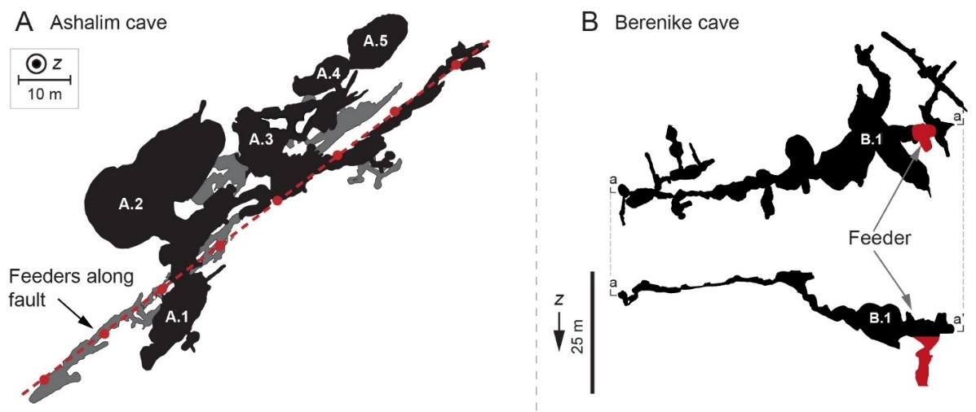

**Fig. 5.** Morphology of two hypogenic caves with identified feeders. (*A*) Plan-view (normal to the *z*-direction, z) of Ashalim cave where feeders are visible at the lower level along a fracture (dashed-dotted red line). Note that the largest chambers (marked by A.1–A.5) and their maximum ceiling height (not shown) are located several meters to 20 m away from the fracture and feeders; the gray zones mark overlapping lower levels (58); (*B*) plan-view of the upper level of the Berenike cave (top) and its vertical profile a-a’ (bottom). Note that the largest hall (marked by B.1) is located approximately 10 m from the feeder (red region), with the passage size gradually decreasing downstream (60).

Finally, we present results from an extended AHD numerical network model, which simulates the formation of a maze-cave system with multiple closed loops (Fig. 6*A*). This numerical model simulates a point injection of geothermal fluid (red dot in the center of Fig. 6*A*) into a dissolving network of conduits in a fractured bedding horizon and considers cooling and retrograde solubility as the source of aggressiveness of the solution (see section S5 (SI) for details). The model uses the fact that the temperature distribution becomes almost time-invariant after a short time (Fig. 3*B*). The maze pattern of the passages in the simulation results (Fig. 6*A*) has indeed a typical morphological characteristic of hypogene karst caves observed worldwide (9, 21), as also demonstrated by the Chariton cave map (Fig. 6*B*; *10*).

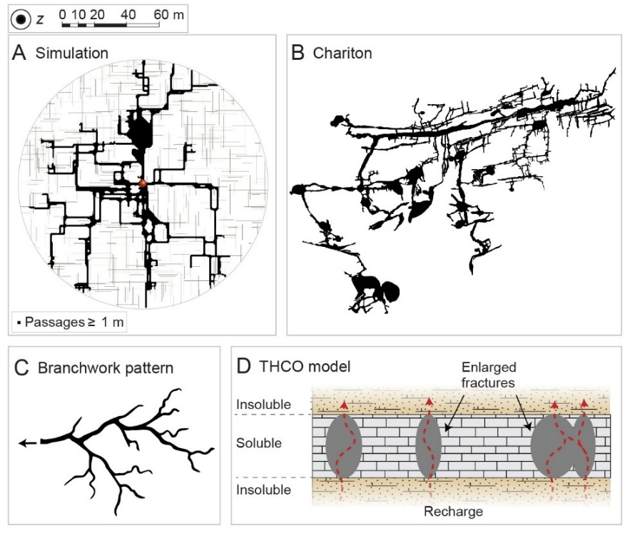

**Fig. 6.** (*A*) Plan-view (normal to the *z*-direction, z) of simulation results. The simulated maze was obtained after 43 kyr using a network model for dissolution by cooling fluids within a fractured bedding horizon (the thin gray lines represent initial model fractures, red point marks the inlet and black represents passages with width ≥1 m). Note that the simulation produces a typical maze-like pattern characterized by numerous closed loops. Figs. S4 and S5 (SI) show schematics of the network model and the progression of speleogenesis up to the final state shown in (*A*), respectively. (*B*) A map of Chariton cave showing a typical maze-like pattern (feeders were not identified; *10*). (*C*) Schematic presentation of a branched network pattern, typical of epigenic caves. These branched network caves develop from many source points (recharge zones) on the surface that interact with the carbonate country rocks forming a drainage-basin-like pattern that resembles a river and its tributaries (6, 7, 61). (*D*) schematics of the THCO model (see text).

Maze pattern caves are notably different from other speleological patterns and especially from the characteristic ramified branched network patterns of epigenic karst, which are not evident in hypogenic karsts (see Fig. 6*C*; *6*, *9*, *11*). Several alternative mechanisms were suggested for the formation of maze caves, and these have long been under debate (summarized in Refs. *8*, *22*). If the cave is hydrologically linked to the surface (i.e., epigenic origin), then the mazes may form as a result of intense flooding events, leading to the uniform dissolution of a fracture network (51, 62). Other mechanisms involve diffuse and distributed recharge to the cave-forming layer (9, 11, 21, 63, 64), such as the commonly invoked concept of *transverse hypogenic cave origin* (THCO; *64*, *66*, *67*).

According to the THCO model, an ascending fluid forms a hypogene maze within a “soluble” rock layer which is sandwiched between permeable but insoluble rock layers (Fig. 6*D*). This setting sustains an upward distributed flow within the soluble strata and precludes the channelized flow that can develop due to preferential dissolution (6, 67). The vertical and distributed flow discharges via multiple feeders, enlarging all major fractures in the soluble layer at comparable rates. The best-known example of THCO model is the formation of the giant gypsum caves in Ukraine (65). This mechanism however cannot explain hypogene maze caves formation in many cases, such as in aquifers confined by impermeable caprock layer, or the formation of caves in soluble carbonate rock successions (see e.g., *33*–*41*). Furthermore, in many cases, THCO model is not supported by field observations, since in many cases multiple ceiling and floor feeders are not observed (10, 41, 50). Thus, the geological setting of the mechanism suggested here for the formation of maze caves, namely, by cooling of CO2-rich hydrothermal fluids discharging from a feeder within a confined aquifer, is apparently more general and ubiquitous and hence are likely to form many of the hypogenic karst systems worldwide.

In accordance with Fig. 4 results, the maze pattern in Fig 6*A* was obtained using a low volumetric flow rate (2 m3/day), typical to geothermal fluids sourced from depth (43, 57, 68). In case of higher flow rates, a more uniform maze structure surrounding the inlet develops, while lower flow rates and diffusion dominance chamber caves develop. Here, the formation of large halls in the simulation (bulky black regions, Fig. 6*A*) results from the merging of adjacent passages and resembles some of the halls observed within natural maze caves (e.g., Fig. 6*B*; *10*). Last, it is noted that the formation of a maze pattern in the model simulations only requires that the initial fractures be hydraulically connected. The spatial distribution of these initial fractures mainly controls the pattern properties (e.g., number of loops) and their statistics.

**Summary and Conclusions**

The study shows that large karst caves may form in carbonate rocks at the Earth’s upper crust, under fairly common conditions – when channelized CO2-rich geothermal flow discharges into a confined aquifer. In contrast to previous estimates, it is demonstrated that this process stemming from cooling and the retrograde solubility of carbonates, may be a common mechanism by which caves form at a very short geological time (tens of thousands of years). Theoretical simulations of this process reproduced very well major characteristics of cave morphology, including the typical maze pattern of hypogene karst caves. Particularly, it is shown here that such a cave pattern forms as a result of discharge of CO2-rich hydrothermal fluids into a bedding horizon that flow laterally and hence, explain the formation of maze caves in confined conditions and soluble rock successions. Such conditions are ubiquitous and this scenario is likely to be applicable to many and large maze cave systems around the world, e.g., the Black Hills of South Dakota (30), Buda thermal karst in Hungary (33) and many others (41).

In a wider view, the results suggest that Earth’s geothermal heat loss by upper-crust advective circulations (68, 69), in conjunction with the large deep-seated CO2 fluxes, induces dissolution within the upper-crust carbonate strata to form extensive karstic cave systems. In turn, this process may reduce CO2 outgassing from the continental crust into the atmosphere (70) and point on a link to the mid-term carbon cycle (longer than the fast biogenic pathway but presumably shorter than the glacial-interglacial time scale), which remains for future upscaling.

**Materials and Methods**

**Heat Transport.** Heat transport in the rock, confining the horizon above and below (Fig. 2), is governed by the heat equation, which in polar coordinates takes the form

$$\frac{∂T}{∂t}=\frac{α_{r}}{r}\frac{∂}{∂r}\left(r\frac{∂T}{∂r}\right)+α_{r}\frac{∂^{2}T}{∂z^{2}}, [1]$$

where *T* is the temperature, *t* is time, and *r* and *z* are the radial and vertical coordinates, respectively, both of which have their origin at the inlet. The quantity *α*r= *K*r*/ρ*r*C*pr is the thermal diffusivity, where the subscript r denotes rock, *K* is the thermal conductivity, *ρ* is the density, and *C*p is the heat capacity (16).

Assuming that heat transport in the fluid, along the horizon, is governed by advection and conduction and that complete mixing occurs along the horizon aperture, the “depth-averaged” heat transport equation can be written as

$$\frac{∂\left(hT\right)}{∂t}=-\frac{1}{r}\frac{∂\left(rqT\right)}{∂r}+\frac{α_{f}}{r}\frac{∂}{∂r}\left(hr\frac{∂T}{∂r}\right)-Θ\left(r,t\right), [2]$$

where *q* is the fluid velocity integrated over the horizon aperture *h* [L2/T] and calculated from the total volumetric flow rate *Q* using *q* = *Q*/(2*πr*), and *α*f is the fluid thermal diffusivity (17, 31). *Θ* accounts for the heat exchange of the flow within the horizon with the rock below and above and is calculated using Fourier’s law assuming temperature continuity at the fluid-solid interface,

$$Θ=-\frac{2Κ_{r}}{ρ_{f}C_{p_{f}}}\frac{∂T}{∂|z|}. [3]$$

The absolute value accounts for both conduction to the rock above and below the horizon. The complete mixing approximation can be validated *a posteriori* and is justified because the transverse temperature gradients in the horizon remain relatively small throughout speleogenesis.

**Reactive Transport.** The depth-averaged solute transport advection-diffusion-reaction equation in the horizon is

$$0=-q\frac{∂c}{∂r}+\frac{D}{r}\frac{∂}{∂r}\left(hr\frac{∂c}{∂r}\right)+Ω\left(r,t\right), [4]$$

where *c* is the depth-averaged dissolved-calcite-ion concentration [M/L3], *D* is the molecular diffusion coefficient, and *Ω* is the reaction term (17, 71). The transient term in Eq. **4** is neglected, and the quasistatic approach is justified by the separation of timescales between mineral dissolution and the relaxation of solute concentration (see section S2, SI).

Here, the initial CO2 partial pressure, PCO2, is relatively high and the kinetics are rapid, hence the rate-limiting step for the reaction is the diffusion of reaction products away from the mineral surface so that undersaturation is sustained. Consequently, the reaction rate can be calculated from the transport rate alone regardless of kinetics (31, 72). The reaction term *Ω* is proportional to the difference between *c*s (*c* at calcite saturation or equilibrium at the given conditions) and *c*:

$$Ω=2k\left(h\right)ε\left[c_{s}\left(T\right)-c\right], [5]$$

where *k*(*h*) is the mass-transfer coefficient [L/T], which is inversely proportional to the aperture *h*, *ε* is a geometrical correction term that accounts for the aperture inclination that develops following dissolution, and the factor of two accounts for the upper and lower surfaces. Section S2 (SI) provides the explicit expression for *k*(*h*) and the complete derivation of Eq. **5** and its justification.

The saturation concentration *c*s depends on the temperature and is expressed as a Taylor expansion to account for retrograde solubility:

$$c_{s}\left(T\right)=c_{s}\left(T_{0}\right)-β\left(T-T_{0}\right), [6]$$

where the constant *β* is evaluated from the data presented in section S1 (SI) and *T*0 is the reference (ambient) temperature. Finally, the change in the horizon aperture is calculated by using

$$\frac{∂h}{∂t}=\frac{Ω}{υc_{sol}}, [7]$$

where *ν* is a stoichiometric constant and *c*sol is the soluble-solid concentration within the solid rock (73).

**Initial and Boundary Conditions.** The initial conditions are uniform temperature, *T*0 = 20 °C. The boundary conditions at the horizon inlet (*r* = *r*0) are constant volumetric flow rate (*Q*) of fluid with a temperature *T*in = 60 °C and initially no undersaturation, *θ* = 0, where *θ* = [*c*s(*T*(*r*))− *c*(*r*)]*/*∆*c*s0where ∆*c*s0= *c*s(*T*0)− *c*s(*T*in). Here, we model conditions of a large domain, so that no substantial heat transport occurs near the boundaries (*r* → *∞* and|*z*| → *∞*). In practice, *z* and *r* are limited to 1 km. A constant temperature *T*0 is set at the upper surface. At the horizon outlet (*r* = 1 km), the temperature and concentration are calculated using the thermal and solute conservation Eq. **2** and Eq. **4** for a free-flow boundary. The remaining boundaries are assumed to be thermally insulating with zero conductive heat flux.

**Acknowledgments:** We thank P. Lu for sharing the field data used in Fig. S1*A* and *B*. Langford for fruitful discussions and field assistance.

**Funding:** National Science Centre (Poland) Grant 2016/21/B/ST3/01373 (P.S.). ISF Grant #910/17 (E.A.). The carbonate system software used in this manuscript was based on a PHREEQC code developed for the "Salt Ages" project funded by the ISF grant #695/19 (B.L.). Israel Water Authority student's scholarship (R.R.).

**Author contributions:** Conceptualization: R.R., E.A., P.S. Numerical analysis: R.R. Theoretical analysis: E.A., R.R., P.S. Field aspects and trips guiding: A.F. Geochemical analysis: N.W., B.L. Writing—original draft: R.R. Writing—review & editing: R.R., E.A., P.S., A.F., N.W., B.L.

**Competing interests:** Authors declare that they have no competing interests.

**Data and materials availability:** All data is available from the corresponding author upon request.

References

1. M. Dentz, T. Le Borgne, D. R. Lester, F. P. de Barros, “Mixing in groundwater” in *The Handbook of Groundwater Engineering*, (CRC Press, 2016), pp. 401–430.

2. A. Klimchouk, “Types and settings of hypogene karst” in *Hypogene Karst Regions and Caves of the World*, (Springer, 2017), pp. 1–39.

3. B. Jamtveit, Ø. Hammer, Sculpting of rocks by reactive fluids. *Geochemical Perspectives* **1**, 341–342 (2012).

4. J. De Waele, F. Gutierrez, *Karst Hydrogeology, Geomorphology and Caves* (John Wiley & Sons, 2022).

5. D. Ford, P. D. Williams, *Karst hydrogeology and geomorphology* (John Wiley & Sons, 2013).

6. P. Szymczak, A. J. C. Ladd, The initial stages of cave formation: Beyond the one-dimensional paradigm. *Earth and Planetary Science Letters* **301**, 424–432 (2011).

7. W. Dreybrodt, F. Gabrovšek, D. Romanov, *Processes of a Speleogenessis [sic]: A Modeling Approach* (Založba ZRC, 2005).

8. P. Audra, A. N. Palmer, Research frontiers in speleogenesis. Dominant processes, hydrogeological conditions and resulting cave patterns. *Acta Carsologica* **44** (2015).

9. A. Klimchouk, “Speleogenesis—Hypogenе” in *Encyclopedia of Caves*, (Elsevier, 2019), pp. 974–988.

10. A. Frumkin, B. Langford, S. Lisker, A. Amrani, Hypogenic karst at the Arabian platform margins: Implications for far-field groundwater systems. *GSA Bulletin* **129**, 1636–1659 (2017).

11. A. N. Palmer, Origin and morphology of limestone caves. *Geological Society of America Bulletin* **103**, 1–21 (1991).

12. L. Luquot, P. Gouze, Experimental determination of porosity and permeability changes induced by injection of CO2 into carbonate rocks. *Chemical Geology* **265**, 148–159 (2009).

13. E. Aharonov, M. Spiegelman, P. Kelemen, Three-dimensional flow and reaction in porous media: Implications for the Earth’s mantle and sedimentary basins. *Journal of Geophysical Research: Solid Earth* **102**, 14821–14833 (1997).

14. E. Aharonov, E. Tenthorey, C. H. Scholz, Precipitation sealing and diagenesis: 2. Theoretical analysis. *J. Geophys. Res. Solid Earth* **103**, 23969 (1998).

15. R. Roded, P. Szymczak, R. Holtzman, Wormholing in anisotropic media: Pore‐scale effect on large‐scale patterns. *Geophysical Research Letters*, e2021GL093659 (2021).

16. F. Stauffer, P. Bayer, P. Blum, N. M. Giraldo, W. Kinzelbach, *Thermal use of shallow groundwater* (CRC Press, 2019).

17. A. Chaudhuri, H. Rajaram, H. Viswanathan, Early‐stage hypogene karstification in a mountain hydrologic system: A coupled thermohydrochemical model incorporating buoyant convection. *Water Resources Research* **49**, 5880–5899 (2013).

18. G. Dávila, L. Luquot, J. M. Soler, J. Cama, Interaction between a fractured marl caprock and CO2-rich sulfate solution under supercritical CO2 conditions. *International Journal of Greenhouse Gas Control* **48**, 105–119 (2016).

19. H. Rattez, M. Veveakis, Weak phases production and heat generation control fault friction during seismic slip. *Nature communications* **11**, 1–8 (2020).

20. G. Zhai, M. Shirzaei, M. Manga, X. Chen, Pore-pressure diffusion, enhanced by poroelastic stresses, controls induced seismicity in Oklahoma. *Proceedings of the National Academy of Sciences* **116**, 16228–16233 (2019).

21. A. N. Palmer, Distinction between epigenic and hypogenic maze caves. *Geomorphology* **134**, 9–22 (2011).

22. P. Audra, L. Mocochain, J.-Y. Bigot, J.-C. Nobécourt, Morphological indicators of speleogenesis: hypogenic speleogens. *Hypogene speleogenesis and karst hydrogeology of artesian basins (pp. 17À22). Simferopol: Ukrainian Institute of Speleology and Karstology (Special Paper 1)* (2009).

23. M. D. Covington, M. Perne, Consider a cylindrical cave: A physicist’s view of cave and karst science. *Acta Carsologica* **44** (2016).

24. G. Kaufmann, F. Gabrovšek, D. Romanov, Deep conduit flow in karst aquifers revisited. *Water Resources Research* **50**, 4821–4836 (2014).

25. K. De Vriendt, M. Pool, M. Dentz, Heterogeneity‐Induced Mixing and Reaction Hot Spots Facilitate Karst Propagation in Coastal Aquifers. *Geophysical Research Letters* **47**, e2020GL087529 (2020).

26. J. De Waele, *et al.*, Sulfuric acid speleogenesis (SAS) close to the water table: examples from southern France, Austria, and Sicily. *Geomorphology* **253**, 452–467 (2016).

27. Y. Dublyansky, “Hydrothermal caves” in *Encyclopedia of Caves*, (Elsevier, 2019), pp. 546–552.

28. F. Gabrovšek, W. Dreybrodt, Early hypogenic carbonic acid speleogenesis in unconfined limestone aquifers by upwelling deep-seated waters with high CO 2 concentration: a modelling approach. *Hydrology and Earth System Sciences* **25**, 2895–2913 (2021).

29. J. E. Mylroie, “Coastal caves” in *Encyclopedia of Caves*, (Elsevier, 2019), pp. 301–307.

30. M. J. Bakalowicz, D. Ford, T. Miller, A. Palmer, M. Palmer, Thermal genesis of dissolution caves in the Black Hills, South Dakota. *Geological Society of America Bulletin* **99**, 729–738 (1987).

31. B. J. Andre, H. Rajaram, Dissolution of limestone fractures by cooling waters: Early development of hypogene karst systems. *Water Resources Research* **41** (2005).

32. A. N. Palmer, “Hypogenic versus epigenic aspects of the Black Hills caves, South Dakota” in *Hypogene Karst Regions and Caves of the World*, (Springer, 2017), pp. 601–615.

33. S. Leél-Őssy, “Caves of the buda thermal karst” in *Hypogene Karst Regions and Caves of the World*, (Springer, 2017), pp. 279–297.

34. S. Galdenzi, “The thermal hypogenic caves of Acquasanta Terme (Central Italy)” in *Hypogene Karst Regions and Caves of the World*, (Springer, 2017), pp. 169–182.

35. S. Galdenzi, M. Menichetti, “Hypogenic Caves in the Apennine Mountains (Italy)” in *Hypogene Karst Regions and Caves of the World*, (Springer, 2017), pp. 127–142.

36. B. P. Onac, V. Drăgușin, “Hypogene caves of Romania” in *Hypogene Karst Regions and Caves of the World*, (Springer, 2017), pp. 257–265.

37. P. Audra, “Hypogene caves in France” in *Hypogene Karst Regions and Caves of the World*, (Springer, 2017), pp. 61–83.

38. A. S. Auler, T. A. Souza, “Hypogene Speleogenesis in the Vazante Group, Minas Gerais, Brazil” in *Hypogene Karst Regions and Caves of the World*, (Springer, 2017), pp. 841–852.

39. A. S. Auler, *et al.*, “Origin and evolution of Toca da Boa Vista and Toca Da Barriguda cave system in north-eastern Brazil” in *Hypogene Karst Regions and Caves of the World*, (Springer, 2017), pp. 827–840.

40. J. Martini, “Hypogene Karst in Southern Africa” in *Hypogene Karst Regions and Caves of the World*, (Springer, 2017), pp. 865–878.

41. A. Klimchouk, A. N. Palmer, J. De Waele, A. S. Auler, P. Audra, *Hypogene karst regions and caves of the world* (Springer, 2017).

42. A. Coudrain-Ribstein, P. Gouze, G. de Marsily, Temperature-carbon dioxide partial pressure trends in confined aquifers. *Chemical Geology* **145**, 73–89 (1998).

43. R. Roded, E. Shalev, D. Katoshevski, Basal heat-flow and hydrothermal regime at the Golan-Ajloun hydrological basins. *Journal of Hydrology* **476**, 200–211 (2013).

44. D. Craw, Fluid flow at fault intersections in an active oblique collision zone, Southern Alps, New Zealand. *Journal of Geochemical Exploration* **69**, 523–526 (2000).

45. S. Micklethwaite, S. F. Cox, Progressive fault triggering and fluid flow in aftershock domains: Examples from mineralized Archaean fault systems. *Earth and Planetary Science Letters* **250**, 318–330 (2006).

46. G. I. Tripp, J. R. Vearncombe, Fault/fracture density and mineralization: a contouring method for targeting in gold exploration. *Journal of Structural Geology* **26**, 1087–1108 (2004).

47. P. Szymczak, A. J. C. Ladd, Wormhole formation in dissolving fractures. *J. Geophys. Res. Solid Earth* **114**, 1–22 (2009).

48. W. Dreybrodt, Processes in karst systems, physics, chemistry, and geology (1988).

49. M. Filipponi, P.-Y. Jeannin, L. Tacher, Evidence of inception horizons in karst conduit networks. *Geomorphology* **106**, 86–99 (2009).

50. A. Frumkin, I. Fischhendler, Morphometry and distribution of isolated caves as a guide for phreatic and confined paleohydrological conditions. *Geomorphology* **67**, 457–471 (2005).

51. G. Kaufmann, J. Braun, Karst aquifer evolution in fractured rocks. *Water resources research* **35**, 3223–3238 (1999).

52. P. Meakin, B. Jamtveit, Geological pattern formation by growth and dissolution in aqueous systems. *Proceedings of the Royal Society A: Mathematical, Physical and Engineering Sciences* **466**, 659–694 (2010).

53. G. Ceriotti, C. Geloni, M. Dalla Rosa, A. Guadagnini, G. Porta, Probabilistic modeling of field-scale CO 2 generation by carbonate–clay reactions in sedimentary basins. *Hydrology and Earth System Sciences* **25**, 3539–3553 (2021).

54. P. Lu, P. Luo, G. Zhang, S. Zhang, C. Zhu, A mineral-water-gas interaction model of pCO2 as a function of temperature in sedimentary basins. *Chemical Geology* **558**, 119868 (2020).

55. D. L. Parkhurst, C. Appelo, “Description of input and examples for PHREEQC version 3: a computer program for speciation, batch-reaction, one-dimensional transport, and inverse geochemical calculations” (US Geological Survey, 2013).

56. G. D. Jones, Y. Xiao, Geothermal convection in South Atlantic subsalt lacustrine carbonates: Developing diagenesis and reservoir quality predictive concepts with reactive transport models. *AAPG bulletin* **97**, 1249–1271 (2013).

57. N. Weber, *et al.*, The circulation of the Dead Sea brine in the regional aquifer. *Earth and Planetary Science Letters* **493**, 242–261 (2018).

58. A. Frumkin, B. Langford, Arid hypogene karst in a multi-aquifer system: hydrogeology and speleogenesis of Ashalim Cave, Negev Desert, Israel. *Geological Society, London, Special Publications* **466**, 187–200 (2018).

59. J. E. Mylroie, J. R. Mylroie, Diagnostic features of hypogenic karst: is confined flow necessary in *NCKRI Symposium*, (2009), pp. 12–26.

60. M. Ullman, “Human selection and exploitation patterns of complex karstic caves during the later prehistory of the southern Levant. PhD in progress.,” The Hebrew University. (2020).

61. S. Worthington, D. Ford, Self‐organized permeability in carbonate aquifers. *Groundwater* **47**, 326–336 (2009).

62. A. D. Howard, C. G. Groves, Early development of karst systems: 2. Turbulent flow. *Water Resources Research* **31**, 19–26 (1995).

63. C. Rehrl, S. Birk, A. Klimchouk, Conduit evolution in deep-seated settings: Conceptual and numerical models based on field observations. *Water Resources Research* **44** (2008).

64. T. Clemens, D. Hückinghaus, M. Sauter, R. Liedl, G. Teutsch, Simulation of the evolution of maze caves in *Proceedings, 12th International Congress of Speleology*, (1997), pp. 65–68.

65. A. Klimchouk, “Ukraine giant gypsum caves” in *Encyclopedia of Caves*, (Elsevier, 2019), pp. 1082–1088.

66. A. Klimchouk, Speleogenesis in gysum. *International Journal of Speleology* **25**, 5 (1996).

67. E. Aharonov, J. A. Whitehead, P. B. Kelemen, M. Spiegelman, Channeling instability of upwelling melt in the mantle. *J. Geophys. Res. Solid Earth* **100**, 20433 (1995).

68. G. Garven, Continental-scale groundwater flow and geologic processes. *Annual Review of Earth and Planetary Sciences* **23**, 89–117 (1995).

69. J. H. Davies, Global map of solid Earth surface heat flow. *Geochemistry, Geophysics, Geosystems* **14**, 4608–4622 (2013).

70. J. B. Martin, Carbonate minerals in the global carbon cycle. *Chemical Geology* **449**, 58–72 (2017).

71. P. Szymczak, A. J. C. Ladd, Reactive-infiltration instabilities in rocks. Fracture dissolution. *Journal of Fluid Mechanics* **702**, 239–264 (2012).

72. F. Golfier, *et al.*, On the ability of a Darcy-scale model to capture wormhole formation during the dissolution of a porous medium. *J. Fluid Mech.* **457**, 213–254 (2002).

73. R. Roded, E. Aharonov, R. Holtzman, P. Szymczak, Reactive flow and homogenization in anisotropic media. *Water resources research*, p.e2020WR027518. (2020).

1. * **See e.g., the solution for a continuous point source in infinite space which is given in Ref.** (16) **(Eq. 3.24, pg. 114).**