Water Confinement in Small Acenes

Alon Zamir,1 Estefania R. Molina, 1 Musahid Ahmed, 2 Tamar Stein*1

1 Fritz Haber Research Center for Molecular Dynamics, Hebrew University of Jerusalem, Jerusalem 9190401, Israel

2 Chemical Sciences Division, Lawrence Berkeley National Laboratory, Berkeley, California 94720, USA

*Corresponding author: tamar.stein@mail.huji.ac.il

Abstract

The ability to confine water molecules is important in many fields, from biology to nanotechnology. We report a computational study of the confinement of water clusters inside polyaromatic hydrocarbon (PAHs) dimers, that can serve as model systems for larger carbon allotropes and are important for understanding the molecular level interactions in confined systems. The conditions allowing confinement in small finite PAHs are not clear and are crucial for understanding confinement in larger systems. Here, we shed light on the size and structural motif allowing confinement and demonstrate it in various acene systems. We show that optimal OH···π interactions between the water clusters and the PAH dimer allow for confinement, and the lack of it leads to the formation of CH···O interactions, and less ideal confinement. Confinement of layered clusters is also possible as long as the optimal OH···π are conserved.

The ability of water to be confined in nonpolar pores is interesting in various fields such as biology, nanotechnology, and nanofluids, to name a few.[1, 2] Nonpolar cavities can often be found in the vicinity of a protein’s active site, and its occupation with water is critical to many biological processes.[3] Water flows through hydrophobic pores at the nanoscale with low wall friction and a higher flow rate than expected macroscopically; thus, the confinement of water within carbon nanotubes (CNT) has great potential for applications in many areas.[4-11] CNTs raise interest as gas storage containers,[12] water purification and hydrogen production.[7] The confined water displays unusual properties which differ significantly from bulk water due to a modified hydrogen bond network.[13, 14]

The interaction between graphene allotropes such as graphite, CNT and fullerene with water is widely studied. Specifically, the adsorption of water molecules to the surface modelled computationally using *ab-initio* methods and density functional theory (DFT) calculations.[15-19] Water confinement in carbon nanotubes has been studied using DFT, demonstrating that waters tend to be near the CNT wall due to OH···π interaction between the water and the π cloud of the CNT. [20] The unique hydrogen bonds in waters confined in CNT were also demonstrated via vibrational spectroscopy, showing intra-ring and inter-ring hydrogen bonds.[21] Effect of confinement on hydrogen bonds and other properties such as diffusion and charge migration was studied extensively as well.[22] Molecular dynamic simulations revealed the importance of the orientation of the water molecules; an orientation that enables OH···π interactions is dominant for both adsorption upon a surface and for confinement.[19, 21, 23-25] Furthermore, both experimental[26] and theoretical[27] works have shown that for small confinement up to 1nm, the water cluster can arrange into either a monolayer or bilayer.[28, 29]

*Ab-initio* calculations allowed the molecular level study of the interactions of small carbon surfaces with water molecules. This emphasized the importance of the relative orientations between the surfaces and the water molecules as exhibited by the binding energies (BE).[20, 30, 31] Previous work have used polyaromatic hydrocarbons (PAHs), which can serve as model systems to graphene and CNT, and attempted to determine their interaction with water.[23, 32, 33] Hirunsit *et al*. have modelled the confinement of two to four water molecules within benzene and naphthalene dimer.[34] It has been observed that water clusters with up to four water molecules in the cluster cannot be confined within the naphthalene dimer, as in this case the naphthalene dimers served as model systems for graphite sheets, constrains were impose the enable the confinement. When optimizing the structures without constraints, water molecules move to the side of the naphthalene and form CH···O interactions. In recent work, Molina *et al.* have studied anthracene dimer complexed to water clusters with up to four water molecules.[33] In the case of one to three water molecules, confinement of the water within the dimer was not observed, and the optimal structures are those with the water in a side orientation with respect to the anthracene. In the case of four water molecules, confinement was observed when the anthracene dimers were in a cross configuration. Confinement was attributed to optimal OH···π interactions. As anthracene and naphthalene are made up of three/two linearly fused benzene rings, respectively, the apparent additional ring plays an important role, in addition to the number of confined water molecules.

In the work of Molina et al, various complexes of water and anthracene dimers have been compared thoroughly demonstrating that the tendency of the water molecules is to remain clustered with themselves. Among the different possible isomers, only one was found where the water is confined in the anthracene dimer; the case of four water molecules inside the anthracene dimer in a cross configuration.

In this study, we wish to explore the conditions that enable water confinement inside small PAH systems. Consequently, we only focus on the isomers that show confinement of water molecules within the PAHs, without any artificial constraints.

We begin by comparing different PAH dimers confining four-water clusters, as optimal OH···π interactions in the four water case have been demonstrated to achieve confinement in the anthracene dimer case. We next study the effect of reducing the number of waters on the confinement as the infrastructure of optimal OH···π interactions is not attainable on lower amount of water molecules. We additionally report the interaction between water clusters containing five and six water molecules and layered water clusters containing 8 and 12 water molecules with various acenes of different sizes and structures. We reveal the size and structural motifs enabling confinement at the molecular level, which is crucial for obtaining an understanding of the confinement of water in larger systems such as a CNT.

To quantify the confinement, we measure the BEs of the system to determine if the confinement is favorable. Additionally, we check whether there is a tilting angle between the confining dimers. As the interaction within the dimer varies on the displacement, the water molecules could potentially escape the confinement more freely due to the tilting angle.

Calculations have been performed using density functional calculations using the $ωB97X-V$ functional, which can account for van der Waals interactions and is thus suitable to study cluster systems.[35] Structures were optimized using the cc-pVTZ basis set[36] followed by frequency calculations to verify that they are minima on the PES. To calculate BEs, we performed single-point calculations using $ωB97X-V$ with the aug-cc-PVTZ[37] basis set. All reported structures exhibit negative BEs, and as we increase the water cluster size, the BE increase significantly. For comparison purposes, we normalized the BEs by dividing by the number of water molecules and report the absolute values of the normalized BE (*n*BE). All calculations were performed with the Q-Chem 5.4 software package.[38] To study the possibility of confinement, we started with different dimer structures with water confined inside them and performed optimization. When confinement is possible, the water indeed stays within the dimer.

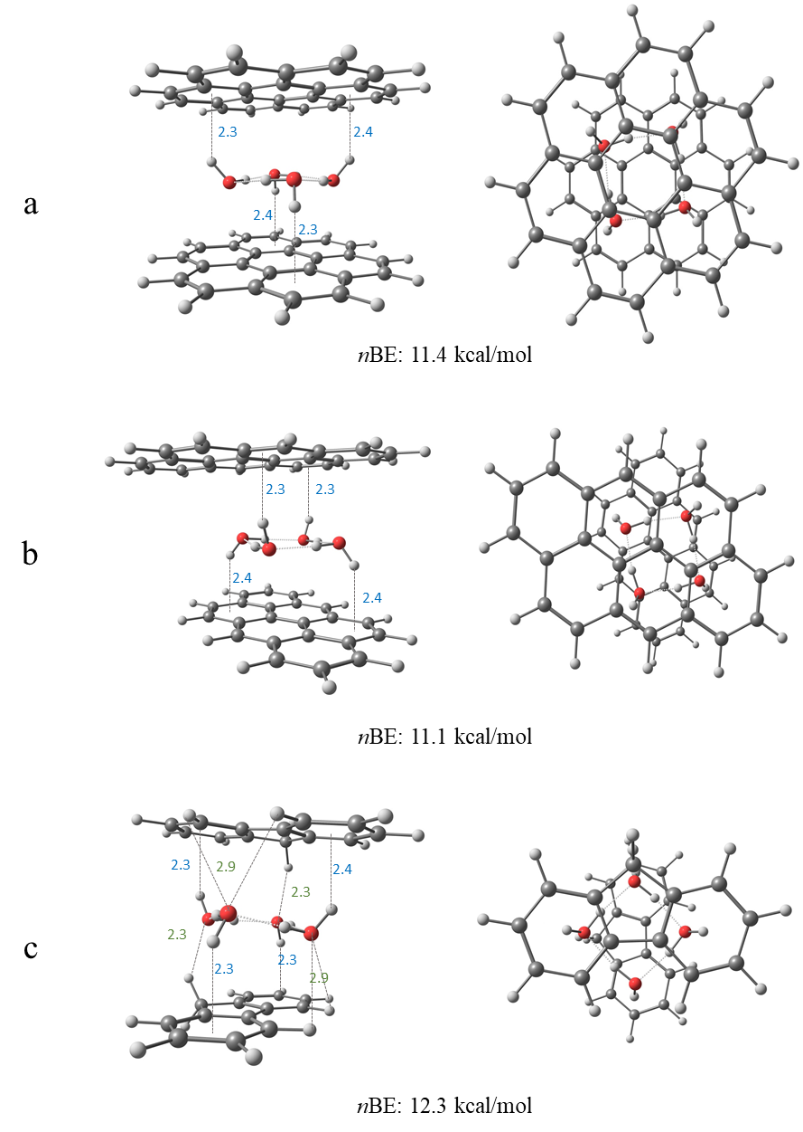

Figure 1: Side (left panel) and top view (right panel) of four-water clusters confined within two coronenes (a), anthanthrenes (b) and fluorenes (c). All reported bond lengths are in Å. The blue numbers mark the OH···π bond lengths, and the green numbers mark the CH···O bond lengths.

We have optimized dimer structures of coronene, anthanthrene and phenanthrene with four water molecules, as shown in Figure 1. Similar to the case of anthracene reported by Molina et al.,[33] coronene (Figure 1a) and anthanthrene (Figure 1b), having a large surface, can ideally confine the clusters within the dimer. The confinement is achieved due to the formation of optimal OH···π interactions between the non-contiguous hydrogens and the π clouds of the acenes. Interestingly, both cross (Figure 1b) and parallel (Figure S1a) configurations enable confinement in anthanthrene, as an stabilizing interaction is possible in both cases. Both coronene and anthanthrene exhibit similar *n*BEs of 11.4 kcal/mol and 11.1 kcal/mol, respectively. Ideal confinement was also observed in the case of pyrene, as shown in the SI Figure S1c.

Likewise, confinement was possible in the case of fluorene (Figure 1c), albeit here, a slight tilting angle was observed. Due to the nonlinearity of the structure and its non-planar hydrogens, additional CH···O interactions between the oxygen of the two of the water molecules and hydrogens in the bay region of the acenes are also possible; this results in a tilting angle of 10.3˚. Despite the non-optimal confinement, additional stabilization is obtained via the CH···O interactions. In this case the close CH···O interactions (distances of 2.3Å between H and O) result in a *n*BE of 12.3 kcal/mol, the highest value among all molecules presented in the manuscript. In the case of phenanthrene (Figure S1b), the additional CH···O interactions also led to a tilting angle of 11.2° and a *n*BE of 11.3 kcal/mol.

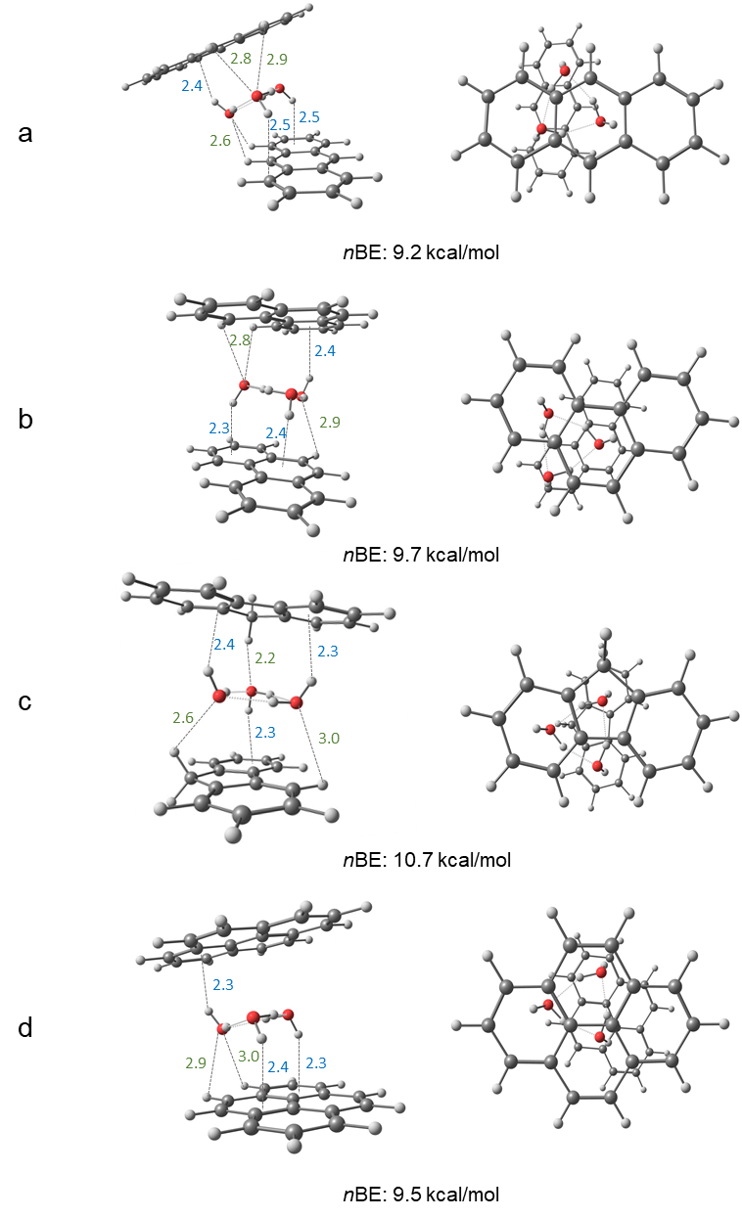

Figure 2: Side (left panel) and top view (right panel) of three-water clusters confined within anthracenes (a), phenanthrenes (b), fluorenes (c) and pyrenes (d) from the side view (left panel) and top view (right panel). All reported bond lengths are in Å. The blue numbers mark the OH···π bond lengths, and the green numbers mark the CH···O bond lengths.

We proceed to the comparison of the confinement of three water molecules within anthracene, phenanthrene, fluorene, and pyrene, as shown in Figure 2. We do not expect confinement to be ideal since here, two contiguous hydrogens point upward and one points downward, thus leading to a preference in one of the directions. This is well demonstrated in the case of anthracene dimer shown in Figure 2a. Upon optimization, the water cluster moves to form CH···O interactions, leading to a movement of the top anthracene, and a large tilting angle of 18.5˚ is observed. In this case, confinement is weakened severely. The *n*BE is 9.2 kcal/mol, demonstrating the non-ideal interactions. `

Figures 2b and 2c show the confinement of the water cluster inside phenanthrene and fluorene, respectively. The PAHs are similar in length and shape; however, fluorene is not aromatic. As seen in Figure 2, both molecules show tilting angles of 6.7˚(phenanthrene) and 9.1˚(fluorene). In the case of phenanthrene (Figure 2b), two hydrogens of the water point downward and interact with the bottom PAH via OH··· π. Interaction with the top PAH occurs via one OH···π interaction and additional CH···O bonds in the bay region (of length 2.8Å). Due to the position of the oxygen forming the CH···O bond, confinement is possible. In the case of fluorene, (Figure 2c) confinement is enabled by strong CH···O interactions form due to the small distances between the hydrogen in the middle rings and the oxygens in the water clusters. The strong CH···O interactions lead to a large *n*BE of 10.7 kcal/mol, in comparison to 9.7 kcal/mol in the case of phenanthrene. The difference between phenanthrene and fluorene validates the importance of the PAHs geometry in addition to the water clusters’ size and geometry.

As shown in Figure 2d, pyrene, although similar to phenanthrene in length, does not form additional CH···O interactions due to the lack of the bay region, and the resulting *n*BE is 9.5 kcal/mol. Overall, the structures confining three water molecules have lower nBEs than those confining four water molecules, due to the lack of additional OH···π interaction, which could lead to further stabilization.

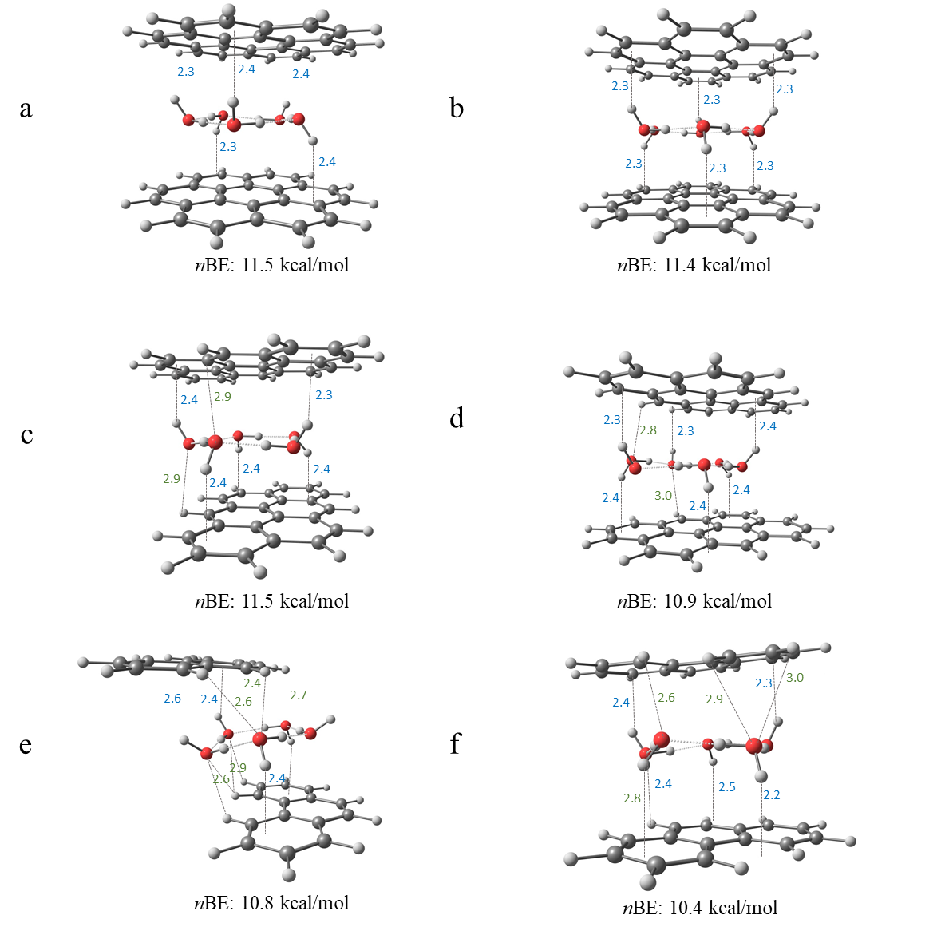

Figure 3: Side views of five-water and six-water clusters confined within coronenes (a,b), anthanthrenes (c,d), and five water molecules with two conformers of phenanthrenes (e,f). All reported bond lengths are in Å. The blue numbers mark the OH···π bond lengths and the green numbers mark the CH···O bond lengths. Top views are included in Figure S2.

Next, we demonstrate the confinement of five and six water molecules, as shown in Figure 3. Coronene (Figures 3a, 3b) is large enough so that the confinement of five and six water clusters is optimal. They do not exhibit tilting angles, and the optimal confinement is evidenced via their large *n*BEs of 11.5 kcal/mol and 11.4 kcal/mol for the five and six water clusters, respectively. Similarly, anthanthrene is large enough to contain a five-ringed water cluster (Figure 3c) with optimal confinement. Once again, no tilting angle was observed, and the *n*BE is 11.5 kcal/mol. In the case of confinement of six waters in the cluster (Figure 3d), due to the relative sizes of the water clusters and the dimer, some of the water molecules are partially sticking outside the dimer, resulting in less optimal OH··· π interactions and a lower *n*BE of 10.9 kcal/mol.

Five water within phenanthrene dimer is shown in Figure 3e. Formation of optimal OH··· π interactions is prohibited due to the small size of the PAH, resulting in a shift of one of the rings to enable those interactions together with CH···O. The resulting structure does not confine the water and the *n*BE is 10.8 kcal/mol. A second minimum was found (Figure 3f), in which the cluster is partially confined although, due to the size of the PAH some of the waters are sticking out, forming CH···O interaction. This structure results in a tilting angle of 11.2˚ and *n*BE of 10.4 kcal/mol which is smaller than previous cases. Similar trends are observed for the case of six waters confined within phenanthrenes dimer and presented in Figure S3b.

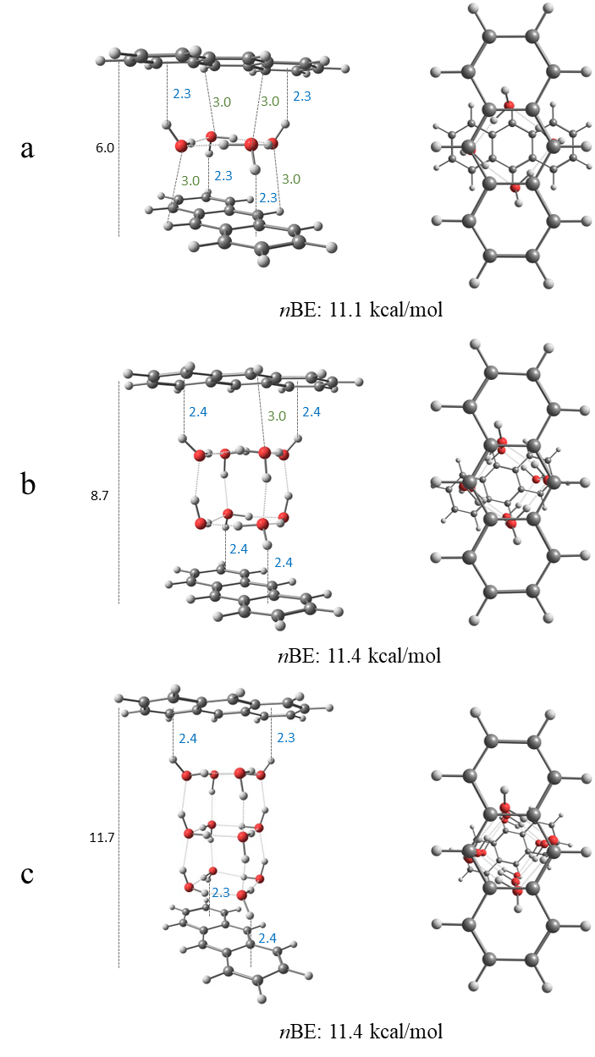

Figure 4: Side (left panel) and top view (right panel) of four (a), eight (b) and twelve (c) water clusters confined within anthracene dimers from the side view (left panel) and top view (right panel). All reported bond lengths are in Å. The blue numbers mark the OH···π bond lengths, the green numbers mark the CH···O bond lengths and the black number shows the overall distance between the anthracenes.

As previously mentioned, confined water molecules between graphene sheets may arrange in a monolayer and up to a bilayer with a distance of 1nm between the sheets. We demonstrate the confinement of eight and twelve water molecules within anthracene, resulting in two and three layers of four water molecules, as seen in Figures 4b and 4c, respectively. We observe that the bilayer is optimal at a distance of 0.87nm, while three water layers are optimal at a distance of 1.14nm. Similar to graphene, it is feasible to confine additional water molecules by allowing the arrangement of several layers, preserving the ideal OH···π interactions. In terms of *n*BE, the four-water cluster confined within the dimer shows 11.1 kcal/mol, while the *n*BEs of eight water cluster and twelve water clusters are 11.4 kcal/mol.

In conclusion, there are key similarities between the confinement of water within PAHs and low- dimensional carbon surfaces which results from the underlying molecular interactions. We demonstrate the key role of the OH···π orientations which enables stabilization. Unlike in low dimensional carbon surfaces such as graphene, PAHs benefit from CH···O interactions, whereas in graphene-like materials, these interactions are negligible as the majority of the interactions rely on OH···π. Even though a tilting angle reduces the optimal OH···π interactions between the water and the dimers, these interactions may be compensated by additional CH···O interactions, as demonstrated in the BEs. While the BE increases with the addition of water molecules, the *n*BE value shows consistency along the series of studied systems with values ranging mostly between 9-12 kcal/mol. It could be generalized that ideal confinement due to OH···π interactions results in *n*BE of about 11.5 kcal/mol, with the distance of 2.3-2.4 Å for said interactions. The water cluster size, and its relative size to the dimers has a direct effect upon the interactions mentioned above and dictated whether confinement will occur. It is also possible to confine two or three layers given the optimal OH···π interactions are preserved as demonstrated for the anthracene case. These results will guide future experiments using vibrational spectroscopy as recently demonstrated for pure water clusters [39-41] to probe the stability and structure of PAH water clusters shedding insight into the confinement of water. Furthermore, ideas of confinement developed in this work could potentially benefit an understanding of anthracene cluster interactions with water ice [42] and in anthracene dimer exciplex formation in solution.[43]

Acknowledgments:

TS, AZ and ERM are supported by The Israel Science Foundation under Grant No. 1941/20.MA is supported by the Director, Office of Science, Office of Basic Energy Sciences, of the US Department of Energy under Contract No. DE-AC02-05CH11231 through the Gas Phase Chemical Physics Program, Chemical Sciences Division.

1. Rasaiah, J.C., S. Garde, and G. Hummer, *Water in Nonpolar Confinement: From Nanotubes to Proteins and Beyond.* Annual Review of Physical Chemistry, 2008. **59**(1): p. 713-740.

2. Giovambattista, N., P.J. Rossky, and P.G. Debenedetti, *Computational Studies of Pressure, Temperature, and Surface Effects on the Structure and Thermodynamics of Confined Water.* Annual Review of Physical Chemistry, 2012. **63**(1): p. 179-200.

3. Bellissent-Funel, M.-C., et al., *Water Determines the Structure and Dynamics of Proteins.* Chemical Reviews, 2016. **116**(13): p. 7673-7697.

4. Hummer, G., J.C. Rasaiah, and J.P. Noworyta, *Water conduction through the hydrophobic channel of a carbon nanotube.* Nature, 2001. **414**(6860): p. 188-190.

5. Kalra, A., S. Garde, and G. Hummer, *Osmotic water transport through carbon nanotube membranes.* Proceedings of the National Academy of Sciences, 2003. **100**(18): p. 10175-10180.

6. Majumder, M., et al., *Enhanced flow in carbon nanotubes.* Nature, 2005. **438**(7064): p. 44-44.

7. Holt, J.K., et al., *Fast Mass Transport Through Sub-2-Nanometer Carbon Nanotubes.* Science, 2006. **312**(5776): p. 1034-1037.

8. Miller, S.A., V.Y. Young, and C.R. Martin, *Electroosmotic Flow in Template-Prepared Carbon Nanotube Membranes.* Journal of the American Chemical Society, 2001. **123**(49): p. 12335-12342.

9. Guo, Y., et al., *Co2P–CoN Double Active Centers Confined in N-Doped Carbon Nanotube: Heterostructural Engineering for Trifunctional Catalysis toward HER, ORR, OER, and Zn–Air Batteries Driven Water Splitting.* Advanced Functional Materials, 2018. **28**(51): p. 1805641.

10. Marbach, S. and L. Bocquet, *Osmosis, from molecular insights to large-scale applications.* Chemical Society Reviews, 2019. **48**(11): p. 3102-3144.

11. Chin, H.-T., et al., *Ferroelectric 2D ice under graphene confinement.* Nature Communications, 2021. **12**(1): p. 6291.

12. Dillon, A.C., et al., *Storage of hydrogen in single-walled carbon nanotubes.* Nature, 1997. **386**(6623): p. 377-379.

13. Li, Q., et al., *Two-Dimensional Material Confined Water.* Accounts of Chemical Research, 2015. **48**(1): p. 119-127.

14. Park, H.G. and Y. Jung, *Carbon nanofluidics of rapid water transport for energy applications.* Chemical Society Reviews, 2014. **43**(2): p. 565-576.

15. Kysilka, J., et al., *Accurate Description of Argon and Water Adsorption on Surfaces of Graphene-Based Carbon Allotropes.* The Journal of Physical Chemistry A, 2011. **115**(41): p. 11387-11393.

16. Freitas, R.R.Q., et al., *DFT Studies of the Interactions of a Graphene Layer with Small Water Aggregates.* The Journal of Physical Chemistry A, 2011. **115**(44): p. 12348-12356.

17. Feller, D. and K.D. Jordan, *Estimating the Strength of the Water/Single-Layer Graphite Interaction.* The Journal of Physical Chemistry A, 2000. **104**(44): p. 9971-9975.

18. Feller, D., *Strength of the Benzene−Water Hydrogen Bond.* The Journal of Physical Chemistry A, 1999. **103**(38): p. 7558-7561.

19. Pertsin, A. and M. Grunze, *Water−Graphite Interaction and Behavior of Water Near the Graphite Surface.* The Journal of Physical Chemistry B, 2004. **108**(4): p. 1357-1364.

20. Tripathy, M.K., D.K. Mahawar, and K.R.S. Chandrakumar, *Effect of nano-confinement on the structure and properties of water clusters: An ab initio study.* Journal of Chemical Sciences, 2019. **132**(1): p. 7.

21. Byl, O., et al., *Unusual Hydrogen Bonding in Water-Filled Carbon Nanotubes.* Journal of the American Chemical Society, 2006. **128**(37): p. 12090-12097.

22. Muñoz-Santiburcio, D. and D. Marx, *Confinement-Controlled Aqueous Chemistry within Nanometric Slit Pores.* Chemical Reviews, 2021. **121**(11): p. 6293-6320.

23. Wu, Y. and N.R. Aluru, *Graphitic Carbon–Water Nonbonded Interaction Parameters.* The Journal of Physical Chemistry B, 2013. **117**(29): p. 8802-8813.

24. M, R. and K.G. Ayappa, *Enhancing the Dynamics of Water Confined between Graphene Oxide Surfaces with Janus Interfaces: A Molecular Dynamics Study.* The Journal of Physical Chemistry B, 2019. **123**(13): p. 2978-2993.

25. Laage, D. and W.H. Thompson, *Reorientation dynamics of nanoconfined water: Power-law decay, hydrogen-bond jumps, and test of a two-state model.* The Journal of Chemical Physics, 2012. **136**(4): p. 044513.

26. Bampoulis, P., et al., *Hydrophobic Ice Confined between Graphene and MoS2.* The Journal of Physical Chemistry C, 2016. **120**(47): p. 27079-27084.

27. Koga, K., X.C. Zeng, and H. Tanaka, *Freezing of Confined Water: A Bilayer Ice Phase in Hydrophobic Nanopores.* Physical Review Letters, 1997. **79**(26): p. 5262-5265.

28. Cicero, G., et al., *Water Confined in Nanotubes and between Graphene Sheets:  A First Principle Study.* Journal of the American Chemical Society, 2008. **130**(6): p. 1871-1878.

29. Eslami, H. and N. Heydari, *Hydrogen bonding in water nanoconfined between graphene surfaces: a molecular dynamics simulation study.* Journal of Nanoparticle Research, 2013. **16**(1): p. 2154.

30. McKenzie, S. and H.C. Kang, *Squeezing water clusters between graphene sheets: energetics, structure, and intermolecular interactions.* Physical Chemistry Chemical Physics, 2014. **16**(47): p. 26004-26015.

31. Rubeš, M., et al., *Structure and Stability of the Water−Graphite Complexes.* The Journal of Physical Chemistry C, 2009. **113**(19): p. 8412-8419.

32. Xu, B., et al., *Probing solvation and reactivity in ionized polycyclic aromatic hydrocarbon–water clusters with photoionization mass spectrometry and electronic structure calculations.* Faraday Discussions, 2019. **217**(0): p. 414-433.

33. Rossich Molina, E., et al., *A combined theoretical and experimental study of small anthracene–water clusters.* Physical Chemistry Chemical Physics, 2022.

34. Hirunsit, P. and P.B. Balbuena, *Effects of Confinement on Small Water Clusters Structure and Proton Transport.* The Journal of Physical Chemistry A, 2007. **111**(42): p. 10722-10731.

35. Mardirossian, N. and M. Head-Gordon, *[small omega]B97X-V: A 10-parameter, range-separated hybrid, generalized gradient approximation density functional with nonlocal correlation, designed by a survival-of-the-fittest strategy.* Physical Chemistry Chemical Physics, 2014. **16**(21): p. 9904-9924.

36. Dunning , T.H., Jr, *Gaussian basis sets for use in correlated molecular calculations. I. The atoms boron through neon and hydrogen.* The Journal of Chemical Physics, 1989. **90**(2): p. 1007-1023.

37. Kendall, R.A., T.H.D. Jr., and R.J. Harrison, *Electron affinities of the first‐row atoms revisited. Systematic basis sets and wave functions.* The Journal of Chemical Physics, 1992. **96**(9): p. 6796-6806.

38. Shao, Y., et al., *Advances in molecular quantum chemistry contained in the Q-Chem 4 program package.* Molecular Physics, 2015. **113**(2): p. 184-215.

39. Zhang, B., et al., *Infrared Spectroscopy of Neutral Water Dimer Based on a Tunable Vacuum Ultraviolet Free Electron Laser.* The Journal of Physical Chemistry Letters, 2020. **11**(3): p. 851-855.

40. Zhang, B., et al., *Infrared spectroscopy of neutral water clusters at finite temperature: Evidence for a noncyclic pentamer.* Proceedings of the National Academy of Sciences, 2020. **117**(27): p. 15423-15428.

41. Li, G., et al., *Infrared spectroscopic study of hydrogen bonding topologies in the smallest ice cube.* Nature Communications, 2020. **11**(1): p. 5449.

42. Chakraborty, S., A.D. Stubbs, and T.F. Kahan, *Direct Observation of Anthracene Clusters at Ice Surfaces.* Journal of the American Chemical Society, 2022. **144**(2): p. 751-756.

43. Das, A., et al., *Dynamics of Anthracene Excimer Formation within a Water-Soluble Nanocavity at Room Temperature.* Journal of the American Chemical Society, 2021. **143**(4): p. 2025-2036.