Emendation, Editing, Elucidation: Towards a Historical Edition of Zoharic Texts

Textual dynamism and the profound questions it raises are at the heart of my lecture today, which concerns the lively debate about the appropriate methodology to adopt in producing a critical edition of that somewhat important kabbalistic work called the Zohar.
I have divided my talk into three parts. I begin by very briefly surveying the problematic state of the Zohar’s earliest textual witnesses and emphasizing the dynamic aspects of the initial manuscript transmission. Then, in the bulk of my talk, I exemplify this dynamism through the prism of language, namely, the textual variation and use of Zoharic Aramaic across the witnesses. With these findings in mind, I conclude with a few words about what I am convinced is the optimal approach to producing a critical edition of the Zohar from manuscript.
These remarks are only a sliver of a broader, ongoing study, which is heavily indebted to the work of great scholars who have preceded me. In this regard, I would like to specifically mention the enormous contribution of the keynote speaker, Professor Daniel Abrams, who has devoted many studies to the various aspects of the reception of the Zohar in manuscript and in print.

***
So far as we can tell, it was during the last two decades of the thirteenth century in Castile that texts later identified as part of the Zoharic corpus first appeared, and from that point forward they had a very complicated history of transmission and reception. Although it is impossible to do any justice to this history in the time allotted, I would like to make some general observations on the rather poor textual witnesses of the Zohar in the first few decades after its appearance.
The main documentary evidence in question is indirect in nature. By this I mean not only quotations of the Zohar in other works, but Hebrew translations (or attempts thereof) and paraphrases of Zoharic homilies, and sporadic references to Zoharic texts. But direct documentary evidence, independent copies of long tracts from the Zohar, is vanishingly small in this period. Not only that, but the earliest extant direct witnesses date from nearly a century after the initial appearance of Zoharic texts, and are from Byzantium of all places. From the tail end of the fourteenth century until the first print runs of the Zohar in sixteenth-century northern Italy, the manuscript witnesses tend to separate out into groups, each with common characteristics based on the location and period of transcription. We can therefore speak confidently of discrete documentary regions across the entire Mediterranean basin.
Returning to the early, critical decades of dissemination, the point is that direct attestations of what we call the Zohar are few and far between. This fragmentary documentation makes it very difficult for a historian to answer the most pressing questions about the text of the Zohar: How large was the corpus of so-called Zoharic texts? How delineated were its textual boundaries? Of what texts was it composed? What were its major textual branches? And, on an even more basic level, what was this corpus of texts called? How did readers and copyists refer to it?
This work from the beginning of the Late Middle Ages left us very little from its first century of public existence, while other works produced in the exact same milieu fared much better—full copies of them survive. While I can’t get too much into why the Zohar’s fate was singularly unfortunate, I would like to mention two undeniably contributing factors. First, simply put, the corpus in question was massive. Second, as others have observed, certain, complicated its acceptance and veneration.
From the period that would have been so critical to the Zohar’s particular routes and methods of dissemination, the period in which pioneering attempts were made to treat parts of the Zohar as if they were complete units with discrete beginnings and endings, the manuscript tradition has precious little to tell us indeed.

Nevertheless, we can and must still work with what we have. The surviving partial witnesses amply bear out the considerable textual dynamism of the Zohar’s homilies on the Torah. [SLIDE] In a few moments, we’ll look at a few early manuscripts of the Zohar from all over the Mediterranean basin that were copied at various points over the fourteenth century. Of note are MS Vatican 202, copied around 1300, which has a few dozen folios of the Zohar’s homilies (described by Abrams); MS Vatican 226, copied in 1311, which contains a Hebrew translation of many Zoharic texts (recently described by Benarroch); a few manuscripts copied in Jerusalem in the second half of the fourteenth century that preserve unknown fragments from the Zohar (I have worked on these); and a number of Byzantine manuscripts from the end of the fourteenth century (referred to by several scholars in the past). [NEXT SLIDE]
Now, when one compares these witnesses to one another and to other “Zoharic collections” from later periods up to and including the age of print, the exceptional degree of textual dynamism stands out. This dynamism, or if you wish “fluidity”, is expressed in every one of the following three important parameters:
- Higher criticism, that is, the classification, organization, and editing of textual units. When placed side by side, the same units appear to have been transmitted in or adapted to different textual frameworks. There is great disparity in the texts’ order, boundaries, context, given titles, language (Aramaic or Hebrew), and more.
- Lower criticism, which concerns the wording of the text itself. Again, comparison of parallel textual units reveals great fluctuations in the textual transmission across decades and geographical expanses. Often, the textual tradition of these units was apparently so weak that attempts were made to standardize it.
- Language reception, by which I mean the Semitic language used in transmission, elucidation, and translation. Early witnesses indicate quite clearly that tradents and transcribers encountered many difficulties in deciphering the meaning of unfamiliar Aramaic forms and terms. This occurred even during transcription, let alone explication and translation.
This third and final aspect of the Zohar’s transmission history has barely been studied, and because I believe it is so important, the examples I will show you today center around it. Certainly, the examples also touch on higher and lower criticism, since the text is sometimes printed in a particular parashah while various manuscripts incorporate them into other frameworks.
Through three select case studies I will identify a number of significant phenomena that marked or marred the Zohar’s language in the formative stages of its early dissemination. Taken together, these phenomena seriously challenge the speculative theories bandied about in recent decades about the Zohar’s Aramaic, especially the romantic notion that it was not some artificial construct but a living, spoken language, perhaps even the argot of mystics.
In my own scholarship I work with as many manuscripts of the Zohar as I can locate. For today’s discussion, however, I must limit the number of texts. The basis for comparison will be, on one side, the early manuscripts mentioned above, all of which date to what I am calling the Zohar’s “dynamic period,” and, on the other side, later Spanish and Italian manuscripts alongside the first printings from Mantua and Cremona, in which the text had been more or less fixed.

[1] Lilith and the Books of Old
The first example is taken from a passage that appears in the earliest witnesses, and later in print, in the homilies on parashat Vayikra. There is nothing substantive, however, that ties it to this specific parashah. In the homily that immediately precedes the section in question, there is a mythological description (relying on earlier sources) of Lilith and other impure spirits who attempted to attach themselves to, and even enter, Adam when he was still the only human being in the world. Later, after Eve was formed from his rib, Lilith took note and fled overseas. Let us read MS Toronto, Friedberg Collection 5-015, copied in a Byzantine hand circa 1400:
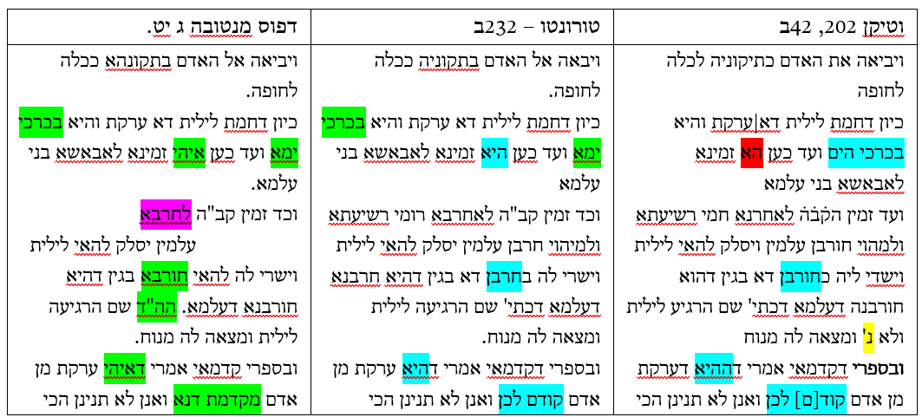
This synoptic comparison makes the discrepancy between the texts glaring. In the Mantua edition, there is no trace of the expression לאחרבא רומי רשיעתא ולמהוי חורבן עלמין, “to destroy wicked Rome and bring destruction to the world,” almost certainly due to censorship.
Beyond deletions due to censorship, attested in spades by careful comparisons, I would like to turn your attention to another phenomenon: the multiplicity of Hebrew forms in the earliest textual witnesses and of the Aramaic forms found in later ones [HIGHLIGHT EXAMPLES VISUALLY]. We find the same thing in the interesting continuation, which contains a passage from the Book of Ashmedai, followed by a complete spell in Aramaic for the banishment of Lilith during marital relations.
Careful examination of other early manuscripts reveals scores of such examples, where Hebrew elements are replaced by Aramaic equivalents. The clear trend towards eliminating Hebrew forms attested in later manuscripts, and then in print, makes it almost certain that these texts underwent systematic Aramaization. This would have been part of the more extensive process of standardizing the Aramaic text, which adjusted the text’s nominal and verbal forms to those of more familiar Aramaic dialects, particularly the Jewish Babylonian Aramaic of the Babylonian Talmud. I can’t say more about this kind of standardization here, which I have dealt with in depth in a published study, other than to note that Aramaization and all the other expressions of textual standardization must factor into any critical edition of Zoharic texts.

[2] The Book of Enoch and the Book of King Solomon
The second example concerns one of the many mysterious apocryphal books invented by the Zohar. It appears among the homilies on parashat Vayikra, which like the previous example it bears no specific connection to, and it also appears as a separate text.
As opposed to the previous example, in this case none of the manuscript versions read smoothly. If we choose any one of the manuscripts, let alone one of the late printings, we end up with a reading that produces a unique meaning not shared by any of the others, and one that is nearly inscrutable. A synoptic comparison reveals probable instances of corruption, although it proves difficult to reconstruct the original reading and the subsequent process of corruption with a high degree of confidence.
What I think we can say is that the Aramaic fragment from “the Book of King Solomon” includes a theosophical exposition of the alphabet, a kind of “alphabetical mysticism.” The barrier to understanding is met at the get-go, though, when the reader encounters bizarre hapax legomena commonly referred to as ha-millim ha-zarot, which can only be understood on the strength of context, if at all.
Allow me to read just the first three lines in Aramaic, from MS Vatican 202:
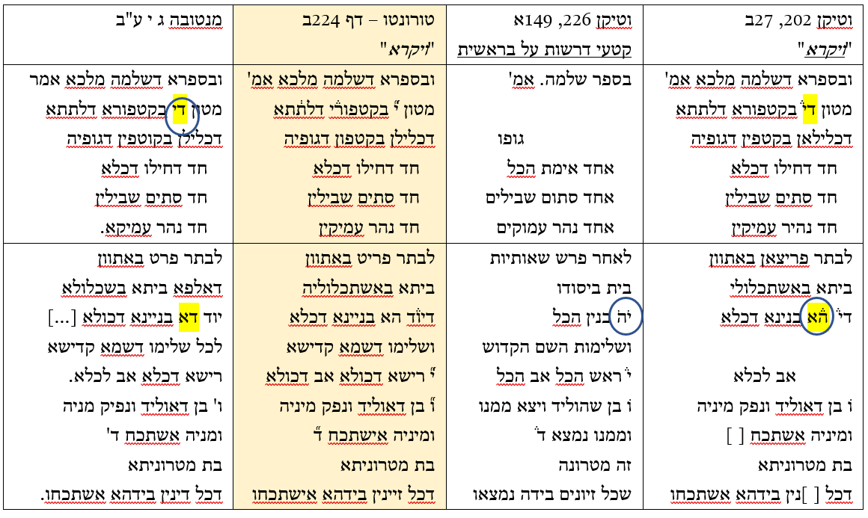
One does not even know where to begin, because the opening words are mystifying. Granted that commentators throughout the ages have proposed very creative interpretations, but we still have no lexicon that satisfactorily clarifies the terminology, and probably never will. Even the early translator of MS Vatican ebr. 226 (from 1311) threw up his hands when he reached this passage. He took the easy way out by simply leaving it out.
The next three short clauses (חד דחילו דכלא / חד סתים שבילין / חד נהיר עמיקין) perhaps help us make sense of things, by gesturing to a potential exposition of some kind on the threefold nature of the Hebrew letter yod. In other words, in the “Book of King Solomon” three parts were isolated in the yod, perhaps three letter strokes.
This speculative reading fits nicely with the next passage, which I will read now from MS Toronto (from which we read earlier). The focus here is on the three letters yod, vav, and dalet, which together spell the name of the letter yod. These letters respectively correspond to the father, the son, and the daughter-matron, a theosophical scheme in which there is a descending hierarchy of the masculine potency, its lower masculine offshoot, and its lower feminine offshoot. So far so good. But now consider the fact that in the earlier Vatican manuscript witnesses, the homily also includes the letter he from the Tetragrammaton, meaning, both yod and he are treated. Should we assume that this was part of the original text, or was it perhaps a later intervention to fill out the theosophic genealogy, by providing a he that corresponds to the supernal mother?
Whatever the case may be, note the dramatically divergent readings of the word הא. It can be vocalized with a tzere and read as the letter he, or it can be vocalized with a kamatz and read as Aramaic ha, meaning “hence” or “therefore.” A similar divergence occurred with the word די at the very beginning. The dalet can be vocalized with a mobile schwa and the yod stands for the letter yod itself, or the word can be reanalyzed as Aramaic di, meaning “that” or “which.” The Mantua edition read it the second way, such that the very subject of the homily, the letter yod, is confusingly not mentioned in this line. By reading the text this way, the Mantua edition (and the many others based on it) closes off all other interpretive possibilities, so that one comes away with an understanding that could not be more different from those of the other versions.
With a difficult text like this, it’s very tempting to deploy logic, based on context, syntax, or semantics, on a word-by-word or sentence-by-sentence basis to eclectically produce the “correct reading” of the entire passage. As a matter of fact, Over the centuries, learned copyists undoubtedly could not withstand the temptation and did precisely this. The important takeaway is that every single one of the witnesses in our possession takes the reader in a completely different direction, and this is again something that editors of Zoharic texts must take note of and make note of in their editions.

[3] Parallel Hebrew and Aramaic Homilies
The previous examples essentially touched on early translations of the Zohar into Hebrew and their underexplored importance for many aspects of studying its text. I would like to dedicate the third and last example to a different language problem: the so-called Hebrew parallels to the Zohar. I am referring of course to those texts originally written in Hebrew that contain long parallels of complete textual units in the Zohar, and can be considered to some extent their earlier Hebrew versions.
The topic of the following Hebrew and Aramaic homilies is the theosophical elucidation of the mitzvah of yibbum (levirate marriage), and the sentences we will read specifically concern the spiritual fate of a man who dies childless. According to the kabbalistic idea presented in the Zohar, if his wife does not undergo yibbum, his soul cannot return to its source and enter the divine “storehouse of souls” in the World to Come, identified theosophically with the upper sefirah of Binah.
The first Aramaic text appears in the homilies on the Judah and Tamar story cycle in parashat Vayeshev, and the Hebrew parallel is from a passage titled סוד הייבום in a Hebrew work by Moses de León. Note that these are but a few lines from a much larger text. De León wrote the latter around 1290, and we will read the text from a copy made in Mamluk Jerusalem in 1382, when a small conventicle of scholars copied kabbalistic writings owned by one another:
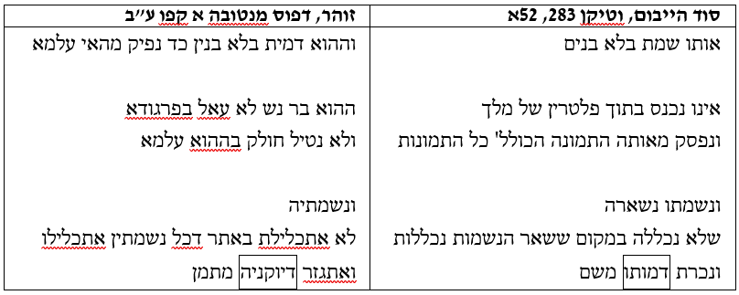
The same idea is repeated in the two texts: since the deceased did not father children, his soul is denied entry into the place of all other souls. The figurative language that expresses this idea is partly equivalent in the two languages: לא עאל בפרגודא is very close to אינו נכנס בתוך פלטרין של מלך; and אתגזר דיוקניה מתמן is the equivalent of נכרת דמותו משם (his figure was severed from there). Still, the texts do display some variety: נפסק מאותה התמונה הכוללת כל התמונות (his image loses its connection to the ideal image) appears only in de León’s Hebrew text.
But this final image too, which originated with the earlier Geronese kabbalists, made its way into the Aramaic homilies of the Zohar. The text in which it is found, and with which we will conclude, was not included in the first printings of the Zohar, but it was published about fifty years later in Salonika in what is conventionally called the Zohar Ḥadash. On the right, one can see a sentence from this passage as it appears in a Byzantine collection in MS Toronto, which we are already quite familiar with. On the left is the same passage from the very early MS Vatican 283, copied in Jerusalem, which preserves a Hebrew version:
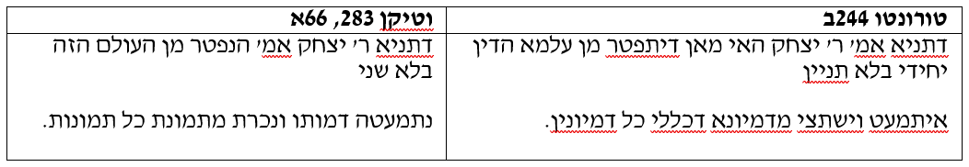
Earlier in the lecture I mentioned the Aramaization of Zoharic passages. I then showed you an early example of translation attempts and their importance for clarifying issues in the text’s transmission and reception. But these last two texts highlight a different but no less interesting textual phenomenon: the preservation of Hebrew and Aramaic versions of the same homiletical material. In such instances, it is not at all easy to say which is the original and which the translation. Sometimes, there are grounds for assuming that both versions circulated from the outset. These data can inform us about the formation of the text and language of the Zohar itself, and not only about its transmission and reception. Moreover, the importance of a finding like this goes well beyond questions of phraseology to the more fundamental questions of the chronology of the Zohar’s composition. Here, it has a major bearing on the original language in which the text was composed. Such findings open up new vistas for resolving thorny problems.

***
My time is almost up, so allow me to wrap up with some thoughts on how to edit Zoharic texts based on what we have seen.
The state and extent of the earliest witnesses can cause the scholar to despair of getting anywhere using the traditional tools of philology. There is a strong tendency to instead focus on each particular witness on its own, describing its unique character and every last detail. While I greatly sympathize with this approach, it is not enough to merely treat each text as a discrete, disconnected unit, as if one cannot find a way to connect the dots between the various data points.
I also do not think that the other methodological extreme is bound to be productive. I’m talking about the rather fusty approach of using printed editions as the control and labeling all other versions “variants,” an approach that has been surprisingly and somewhat disconcertingly enjoying a resurgence of late.
In light of the findings I’ve presented today, I think the optimal approach lies somewhere in the middle. I have tried to demonstrate that the best way to probe these texts and their textual dynamism is through a synoptic analysis of the relevant textual evidence while also respecting the integrity of each fragment. To this end, I am convinced that digitally-enhanced synopses are the way forward. The printed synopses are too rigid. Digital databases allow for making specific queries and retrieving particular cross-sections of the material. Furthermore, the results can be visually rearranged to great effect. This type of synopsis can serve scholars as a dynamic, developing tool that, with all due caution, can be of great value in historical or textual inquiry, by creating a basis for comparison between the various discrete witnesses.

