**The Metacognitions about Sex Scale: Development and psychometric properties**

Yaniv Efrati**a\***, and Marcantonio M. Spadab

a Bar-Ilan University, Faculty of Education, Ramat Gan, Israel.

b Division of Psychology, School of Applied Sciences, London South Bank University, London, UK.

**Abstract**

Metacognitions about sex are theorized to guide cognitive appraisal, and coping styles and (dis)regulate behaviors during the pre- and post-engagement phases toward external triggers (e.g., exposure to sex). In our study, we evaluate psychometric properties of the metacognitions about sex, including its factor structure, reliability, and predictive validity among Israeli adolescents. We also, examined by theoretical model, as a mediate the associations between emotional status, dysregulated thoughts, and impulsivity and compulsive sexual behavior (CSB). The study population include 662 Israeli adolescents (252 males and 410 females, M = 16.70, SD = 1.32) with an age range of 13–18 years. The participants completed the metacognitions about sex, external and internal shame, anxiety, suppression of sexual thoughts, moral disapproval of sexual thoughts, impulsive behavior scales – negative urgency, positive urgency, sensation seeking, and lack of premeditation and perseverance – and CSB. The analyses indicated that the factorial structure of the metacognitions about sex comprised the expected two factors. We also found that positive and negative metacognitions significantly mediated the effect of negative emotions, dysregulated thoughts and impulsivity on CSB. The findings provide evidence that metacognitions about sex among Israeli adolescents appears psychometrically appropriate to be used by researchers and practitioners dealing with the prevention and treatment of CSB.

**The Metacognitions about Sex Scale: Development and psychometric properties**

**1. Introduction**

Metacognition refers to “thinking about one’s own thinking”. It can be defined as any stable knowledge about one’s own cognitive system and strategies that may affect the regulation of cognition, the awareness of the current state of cognition, and the appraisal of the meaning of cognitive-affective states (Wells & Matthews, 1996). According to Wells and Matthews’ (1994; 1996) metacognitive model of psychological distress, metacognitions (beliefs about one’s cognitive-affective experiences and how they should be controlled) are involved in the activation and maintenance of maladaptive coping strategies that exacerbate negative affect. This, in turn, increases the likelihood of engaging in addictive behaviors as a form of escapism and as a last resort for achieving cognitive-affective self-regulation (Spada, Caselli, Nikcevic, & Wells, 2015). As metacognitions may vary across disorders (Casale et al., 2021), Spada and Caselli (2017) drew researchers’ attention away from generic metacognitions (i.e., generic beliefs about cognitive-affective experiences such as “I need to control my mind at all times”) to specific metacognitions concerning online gaming, I this study we adapt this scale to sex. Metacognitions about sex are theorized to guide cognitive appraisal, and coping styles and (dis)regulate behaviors during the pre- and post-engagement phases toward external triggers (e.g., exposure to sex).

Two types of metacognitions have been identified in the literature: positive and negative. Positive metacognitions relate to the benefits of engaging in coping strategies for controlling cognitive-affective experiences (e.g., “Engaging in sex will help me to control my negative thoughts”) and are linked to activating such coping strategies. Negative metacognitions are judgments about perceived control over adopted coping strategies and the resulting cognitive-affective states (e.g., “I have no control over my sexual behaviour”). These types of metacognitions may hamper attempts at self-regulation and contribute to an escalation of psychological distress. The ubiquitous role of positive and negative metacognitions in addictive behaviors has been widely evidenced across numerous studies over the last 20 years (e.g., Spada et al., 2015; Hamonniere & Varescon, 2018). In this study, we evaluate psychometric properties of the metacognitions about sex and the ubiquitous role to CSB. Although there is no sufficient scientific evidence yet to conclusively determine whether CSB should be classified as an impulse control, compulsivity-related, or addictive disorder (Reed et al., 2022) we found metacognitions about sex a very importance mechanism.

**Compulsive sexual behavior**

The World Health Organization (WHO) classified compulsive sexual behavior as a disorder in the 11th edition of the International Classification of Diseases (ICD-11). CSBD is characterized by excessive pornography use and masturbation, uncontrolled use of paid sexual services, and risky sexual behaviors and/or an intense preoccupation with sex. These behaviors often lead to impaired social or occupational functioning, distress, and negative affect (Chen, Jiang, Luo, Kraus, & Bőthe, 2021; Koos et al., 2021). Despite this relatively recent addition, it should be noted that there has been tremendous debate about the inclusion of compulsive, impulsive, and addictive sexual behavior in nosologies of mental disorders (Reed et al., 2022). In the present study, we did not examine a clinical population, therefore we use a non-clinical definition -CSB. To date, CSB has been mostly studied among adults (for review see Grubbs et al., 2020) with only a few studies addressing a predisposition toward CSB among adolescents (e.g., Adelson et al., 2012; De Crisce, 2013; Efrati, 2020). However, these studies have indeed recognized CSB in children and adolescents (Adelson et al., 2012; De Crisce, 2013), identified clinical CSB among adolescents (Efrati & Dannon, 2018), and explored the profile of adolescents with CSB (e.g., Efrati, 2018; Efrati & Gola, 2018a). CSB among adolescents may be related to personality (Efrati, 2018; Efrati & Gola, 2018a), religiosity (Efrati, 2019), family atmosphere and/or relationship with parents (Efrati & Gola, 2019a), generic metacognition (Efrati et al., 2021), desire thinking (Efrati et al., 2020) and psychopathology (Efrati & Dannon, 2018) but to date, no study has considered how metacognitions about sex may associate with CSB. In the present research, we evaluate psychometric properties of the metacognitions about sex, including its factor structure, reliability, and predictive validity among Israeli adolescents. We also, examined by theoretical model, as a mediate the associations between emotional status, dysregulated thoughts, and impulsivity and compulsive sexual behavior (CSB).

**Emotional status**

Shame is a universal human emotion, existing at individual, interpersonal, social and cultural levels (Matos et al., 2021). Theorists regard shame as vital to our sense of self as a social agent, and to our social interactions and moral behaviour (Dearing & Tangney, 2011; Gilbert, 2007; Gilbert & Andrews, 1998; Tracy & Robins, 2004). In spite of its adaptive value in human psychosocial development and functioning, shame can be an overpowering, painful and incapacitating emotion. Recent research has ascertained that shame can be an incapacitating and pathogenic emotion associated with CSB (Efrati, 2018; Sassover et al., 2021). Efrati (2018) found on 274 Israeli adolescents that who experienced a high degree of shame with their CSB reported greater willingness to receive help; those who reported less, or no shame did not express a desire to seek help, despite their level of CSB. Sassover et al (2021) found on 121 Israeli adults that CSB is characterized by feeling of shame and self-criticism like other addictive or compulsive behaviors (Adams and Robinson, 2001).

In the current study we use Gilbert’s model who defined shame as experiences involve a social and externally focused component, related to the experience of the self as seen and judged by others; and an internal self-evaluative component focused on the ‘experience of the self as seen and judged by the self’ (Gilbert, 1998, 2003). External shame pertains to the experience of the self as existing negatively in the minds of others, as having deficits or flaws exposed (Gilbert, 1998, 2002). Internal shame is linked to how one judges oneself and refers to the global negative self-evaluations of oneself as inferior, defective, bad, inadequate, different, unwanted, empty, weak, or alone (Gilbert, 2003; Tracy & Robins, 2007).

CSB included a focus on potential comorbidities, risk factors, or symptoms resulting from such behaviors, including anxiety (Efrati and Gola, 2019b; Grant Weinandy et al., 2022). For example, research has indicated that maladaptive emotional regulation processes that are commonly associated with anxiety such as escaping disturbing thoughts and emotions and/or lacking control of evoked emotions may be a source of addictive or compulsive behaviors such as CSB (Rooney et al., 2018; Dickenson et al., 2018). Therefore, we hypothesize that shame and anxiety will be found to be related to metacognitions about sex and CSB.

**Suppression and Moral disapproval of sexual thoughts**

Thought suppression is a mental control strategy, characterized by attempts to manage emotional distress by keeping unwanted thoughts out of awareness (Wenzlaff & Wegner, 2000). A common strategy to handle unwanted thoughts is to try to suppress them (e.g., Brockman, Ciarrochi, Parker, & Kashdan, 2017), particularly if a person cannot openly share these thoughts with others (Gross & John, 2003). The engagement in thought suppression, however, can paradoxically lead to an increase in the suppressed thought – i.e., a rebound effect (Abramowitz, Tolin, & Street, 2001; Wenzlaff & Luxton, 2003). This effect has been observed in various addictive and addictive-like behaviors among adolescents and adults such as CSB (Efrati, 2019; Efrati, Kolubinski, Caselli, & Spada, 2020; Efrati, Kolubinski, Marino, & Spada, 2021), which suggests that there is a transdiagnostic role for thought suppression in addictive or compulsive behaviors (Spada, Caselli, Nikcevic, & Wells, 2015).

When people experience a discrepancy between their sexual values and their sexual behaviors, they often report profound distress and greater experiences of feeling out of control or compulsive (Griffin et al., 2016; Walton, 2019) which represented at The Pornography Problems due to Moral Incongruence model (PPMI; Grubbs, Perry, Wilt, & Reid, 2019). This model was developed to explain the contribution of both moral conflict and behavioral dysregulation to the development of problematic pornography use (PPU). In the present paper, PPU is conceptualized as a manifestation of CSB involving use of pornography that leads to distress and impairment (Antons & Brand, 2021). Recently, the ICD-11 diagnostic guidelines for CSBD note that distress related to moral disapproval of one’s own sexual behaviors is not sufficient to receive the diagnosis. This distinction is only made for CSB and not present for any other recognized diagnosis (Gola et al., 2022), which suggests that moral beliefs about sexuality might play a unique role in understanding this disorder.

Therefore, we hypothesize that suppression and moral disapproval of sexual thoughts will be found to be related to metacognitions about sex and CSB.

**Impulsivity**

Impulsivity is broadly defined as the tendency toward rapid, poorly considered, and disinhibited decisions and actions, while disregarding the possible negative consequences of these decisions and actions [42,43]. Impulsivity may be considered

as a risk factor of addictive behaviors and pronounced at the early stages of development addictions ((Brand et al., 2016, 2019; Fineberg et al., 2014). Moreover

research directions that may contribute to key insights on the roles of impulsivity and compulsivity in CSBD, advancing the classification of CSBD (Bőthe, Koós, & Demetrovics, 2022). Therefore, we hypothesize that adolescence who may in an early stage of development CSB will correlated to impulsivity.

**In the current study**

Given the limited research that focuses on adolescents and the metacognitions about sex and CSB, the current research has two aims: 1) to evaluate the psychometric properties of the metacognitions about sex, including its factor structure, reliability, and predictive validity among Israeli adolescents; and 2) to examine the metacognitions about sex as a theoretical model that mediates the effect emotional status, dysregulated thoughts, and impulsivity on CSB. Specifically, the study examines two questions: First, is the factorial structure of the metacognitions about sex comprised of two factors? Second, do metacognitions mediate the effect of emotional status, dysregulated thoughts, and impulsivity on CSB?

**Method**

**Participants**

The study population comprised 662 Jewish Israeli adolescents from the general community (252 males and 410 females), aged 13–18 (M = 16.70, SD = 1.32), all enrolled in the ninth (n= 78; 12%), tenth (n = 101; 16%), eleventh (n = 150; 24%), and twelfth (n = 308; 48%) grades and Unknown (n=25). Most (96%) were native Israelis and 92% report Hebrew native language. Socioeconomically, 0.5% of participants described their level as being very bad, 2.9% bad, 63% good, and 33% very good. In terms of religious affiliation, the sample consisted of 123 (19%) self-reported religious individuals, of which 201 (31%) traditional, 314 (48%) secular, and 20 (3%) ultra-Orthodox.

**Measures**

**Sociodemographic variables**. Adolescents reported their age (13-18), biological sex (male, female), religiosity (secular, traditional, religious, ultra-Orthodox), immigration status (Israeli, immigrant), and socioeconomic status (or SES, divided into the categories of very good, good, bad, and very bad).

**The Metacognitions about sex.** Based on the metacognitions about online gaming (MOGS; Spada and Caselli 2017) we used to assess positive and negative metacognitions about sex. The scale has two factors, each of which is assessed by serval items: “positive metacognitions about sex” referring to the usefulness of sex as cognitive-affective self-regulatory strategy (e.g., “Engaging in sex will help me to control my negative thoughts”); and “negative metacognitions about sex” referring to the uncontrollability and dangers of sex and sex related thoughts (e.g., “I have no control over my thoughts about sex”). Participants were asked to rate the extent of their agreement to each item on a 4-point scale (from (1) “do not agree” to (4) “agree very much”). Items were summed to obtain a score for both positive and negative metacognitions. Higher scores represent higher levels of metacognitions. The Cronbach’s alpha for the positive and negative subscales in the present study were .89 for positive metacognitions and .84 for negative metacognitions.

**Shame.** The External and Internal Shame Scale (EISS; Ferreira et al., 2020) is an 8-item self-report instrument aimed to assess two factors, each of which is assessed by 4 items: 'External Shame' strategy (e.g., “People around me see me as not being up to their standards”); and 'Internal Shame' strategy (e.g., “I am unworthy as a person”). Participants are asked to rate each item using a 5-point scale (0 = “Never” to 4 = “Always”) with higher scores representing higher levels of shame. The Cronbach’s alpha for external and internal shame subscales in the present study were .72 for external shame and .79 for internal shame.

**Sexual Suppression Scale**. The Suppression Scale (Efrati, 2019) is based on the white beer questionnaire (Wegner et al., 1987) and expressive suppression scale from The Emotion Regulation Questionnaire for Children and Adolescents (ERQ–CA), developed by Gullone and Taffe (2012). Participants were asked to rate, on a 5-point Likert scale (1 – *not at all,*5 – *very much*), the degree to which each statement characterized their feelings (e.g., Item 1: "Very often I find myself trying to suppress my sexual thoughts"; Item 11: "Sometimes I try to get involved with work or studies just to avoid all sorts of sexual thoughts"). The Cronbach’s alpha in the present study was .84. Accordingly, we calculated for each participant a score of suppression of sexual-related thoughts and fantasies by averaging the items.

**Moral disapproval**. To measure participant’s level of moral or ethical objection to sexual thoughts, we used a scale developed by Grubbs et al (2018). The scale consists of four statements and respondents rated their level of agreement with each statement using a seven-point Likert scale. We adapted this scale to sexual thoughts. For example, “I believe that thoughts about sex is morally wrong". The Cronbach’s alpha in the present study was .90

**Anxiety Symptoms** were measured using the Hospital Anxiety and Depression Scale (HADS) (Zigmond and Snaith, 1983) which asks about symptoms in the past week. It measures anxiety symptoms (7 items, e.g. ‘I feel tense or ’wound up’’) and depressive symptoms (7 items, e.g. ‘I still enjoy the things I used to enjoy’) using 4-point Likert scales; higher scores indicate higher levels of symptoms. The HADS has been extensively used in Hebrew (e.g., Buria et al., 2015) and was found valid and reliable. In this study, we used only Anxiety scale, Depression scale has not been found reliable, the Cronbach’s alpha in the present study was .79.

**Impulsivity**. Impulsive personality traits were assessed using the Short UPPS-P

Impulsivity Scale (Cyders et al., 2014). The Short UPPS-P is a 20-item self- report measure assessing positive urgency (i.e., rash action in a positive mood state; a = .78), negative urgency (i.e., rash action in a negative mood state, a = .75), lack of perseverance (i.e., lack of focus; a = .73), lack of premeditation (i.e., lack of planning, a = .73), and sensation seeking (thrill- seeking, adventurousness; a = .74). All responses were measured on a scale of 1 (Agree Strongly) to 4 (Disagree Strongly) and were reverse-scored so that higher values indicated higher impulsivity.

**The Individual-based Compulsive Sexual Behavior scale** (I-CSB; Efrati & Mikulincer, 2018): The I-CSB was developed to assess distinct aspects of CSB, such as sexual fantasies, obsessive sexual thoughts, and considerable time spent on watching pornography. The I-CSB is a self-report questionnaire with 24 items measuring the following factors: unwanted consequences (e.g., “I feel that my sexual fantasies hurt those around me”); lack of control (e.g., “I waste lots of time on my sexual fantasies”); negative affect (e.g., “I feel bad when I’m unable to control my sexual urges”); and affect regulation (e.g., “I turn to sexual fantasies as a way to cope with my problems”). Using a 7-point Likert scale, participants were asked to rate the degree to which each statement accurately describes their feelings (1 – not at all, 7 – very much). The questionnaire was successfully used in previous research on non-clinical populations of adolescents (Efrati et al., 2020;2021). We computed a total I-CSB score by averaging the 24 I-CSB items (Cronbach’s alpha = 0.93).

**Procedure**

The study was presented to participants as a research project on sexual behavior in Jewish adolescents from various regions of Israel (males and females, secular and religious, from the eastern, central, southern, or northern parts of Israel). The participants constituted a convenience sample recruited from a variety of sources (postings on bulletin boards and in online forums). Questionnaires were uploaded to Qualtrics, an online platform for questionnaires, and distributed by several research assistants. Parents of adolescents who agreed to participate in the study were contacted via email and/or phone and were asked to review the questionnaires and sign an informed parental consent form, which was sent back to the research assistants by email. Upon agreement, a link to the online survey was sent to the participant who was assured anonymity. Participants were then asked to complete the survey in private, in a quiet room in their home (without the presence of others). Following receipt of a signed informed consent form, questionnaires were presented in random order. All questionnaires were in Hebrew, Israel’s the native language. Lastly, there was an online debriefing and participants were thanked for their participation. The procedure was approved by the Institutional Review Board (IRB).

**Data Analysis**

In the first part of the results, we examine the construct structure and validity of the metacognitions about sex questionnaire. To do so, we employed Exploratory Graph Analysis (EGA; Golino et al., 2020) using *EGAnet* R package – a novel network psychometrics method that uses undirected network models for the assessment of psychometric properties of questionnaires. EGA was used to appraise the number of or factors using graphical lasso (Friedman et al., 2008) and the items that are associated with each factor. Network loadings, which are roughly equivalent to factor loadings, are reported using *net.loads*, with suggested general effect size guidelines for network loadings of 0.15 for small, 0.25 for moderate, and 0.35 for large (Christensen & Golino, 2021). The number of factors were corroborated with other traditional methods – parallel analysis (PA), Velicer’s minimum average partial (MAP) test, and the comparison data approach (Ruscio & Roche, 2012). After establishing the number of factors, we dropped items with network loading < .15, and/or loading > .15 on more than one factor. Next, to examine the structure stability of the final version of the questionnaire, we followed the analysis with Bootstrap Exploratory Graph Analysis with 5,000 resampling cycles and with the *itemStability* function to detect unstable items (i.e. items that switch factors in different bootstrap analyses). To end the first part of the results, we estimated the quality of the construct structure by a Confirmatory Factor Analysis (CFA) using the *CFA* function in *EGAnet* R package and the maximum likelihood estimation with robust standard errors and a mean- and variance adjusted test statistic (MLMVS). Goodness of fit was appraised by Comparative Fit Index (CFI), Tucker Lewis Index (TLI), and Root Mean Square Error of Approximation (RMSEA), with values > .95 in CFI and TLI, and upper bout of RMSEA’s confidence interval < .08 would indicate excellent fit.

In the second part of the results, we estimated the convergence validity of the metacognitions about sex questionnaire by associating its factors with the following measures: external and internal shame, anxiety, suppression of sexual thoughts, moral disapproval of sexual thoughts, impulsive behavior scales – negative urgency, positive urgency, sensation seeking, and lack of premeditation and perseverance – and CSB. Associations were based on Spearman rho correlations. We also examined differences in metacognitions about sex clusters between genders (men, women), and religiosity status (secular, religious) because of the documented differences between these groups in other sex-related factors. To do so, we conducted Welch’s independent samples t-test alongside Hedges’s *g* effect sizes.

In the third and final part of the results, we conducted a Structural Equations Model in which we examined the possibility that metacognitions about sex mediate the association between negative emotions (external and internal shame, anxiety), dysregulated thoughts (suppression of sexual thoughts, moral disapproval of sexual thoughts), and impulsivity on the one hand, and CSB on the other hand. To do so, we estimated the suggested model using the *lavaan* R package*.* In the model, negative emotions, dysregulated thoughts, and impulsivity were latent factors that serves as predictors, metacognitions were exogenous factors that served as mediators, and CSB was exogenous factor that served as the outcome measure. Significance of all effects (direct and indirect) were estimated using bias-corrected and accelerated bootstrap analysis with 1,000 resampling cycles; missing data pattern was assessed with the *finalfit* R package (specifically the *missing_pattern* and *missing_compare* functions) and handled by full information maximum likelihood (FIML). Goodness of fit was appraised by CFI, TLI, and RMSEA.

**Results**

**Part I: Construct structure and validity of the metacognitions about sex questionnaire**

The Exploratory Graph Analysis suggested a factor solution of 2-factors, which was corroborated by parallel analysis (Eigenvalues of 5.42 and 1.69 for first two factors, respectively), Velicer’s minimum average partial (MAP) test (smallest average squared correlation is 0.023, and smallest average 4rth power correlation is 0.0018 for 2 factors), and the comparison data approach (best solution as compared with 1 to 7 possible factors). Network loadings are presented in Table 1. The two factors were negative metacognitions about sex (items 1-8) and positive metacognitions about sex (items 9-13). We also found, however, that item 1 “I continue to think on sex despite thinking it would be better to stop” had inadequate loading, and item 9 “Engaging in sex will make my worries more bearable” had high loading on both negative and positive metacognitions about sex clusters. Accordingly, these items were dropped. The final EGA is presented in Figure 1, upper left panel.

To appraise the stability of the structure, we conducted a Bootstrap Exploratory Graph Analysis, which showed excellent stability (*SE* = 0.02, *95%* confidence interval [CI] for the number of dimensions: 1.96, 2.04) such that 99.996% of the 5,000 models produced a 2-factor solution (0.0004% produced a 3-factor solution). In keeping with these results, all items had 100% stability – i.e. none switch factors in all 5,000 models (see Figure 1, bottom left panel). Finally, the CFA corroborated the results (see Figure 1, upper right panel) and had adequate fit to the observed data, *χ2*(27.84) = 81.34, *p* < .05, *CFI* = .95, *TLI* = .95, *RMSEA* = .06, 95% CI .05, .07.

**Part II: convergence validity of the metacognitions about sex questionnaire.** Associations are presented in Figure 2; the series of Spearman correlations indicated adequate convergence validity for the metacognitions about sex, such that both positive and negative metacognitions were strongly linked with CSB symptom severity, and moderately with external and internal shame, anxiety, negative and positive urgency, and lack of premeditation. In addition, negative but not positive metacognitions about sex was associated with suppression of sexual thoughts and moral disapproval of sexual thoughts; positive but not negative metacognitions about sex was related to sensation seeking.

Regarding differences between genders and religiosity status (secular, religious), the analyses, Welch’s independent samples t-test indicated that men had higher positive and negative metacognitions about sex than women, and religious people had higher negative metacognitions about sex than seculars (see Figure 3).

**Part III: do metacognitions about sex mediate the associations between emotional status, dysregulated thoughts, and impulsivity and CSB.** The model is presented in Table 4 and summarized in Table 2. The model had adequate fit to the observed data, *χ2*(42) = 193.28, *p* < .05, *CFI* = .95, *TLI* = .93, *RMSEA* = .07, 95% CI .06, .08. We found four significant mediated paths via metacognitions about sex: (i) Negative emotions were associated with more positive metacognitions about sex, which was, in turn, linked with greater CSB symptom severity; (ii) dysregulated thoughts were associated with more negative metacognitions about sex, which was, in turn, linked with greater CSB symptom severity; and (iii, vi) Impulsivity was associated with more positive and negative metacognitions about sex, which were, in turn, linked with greater CSB symptom severity. In sum, metacognitions about sex might be potent factors in predicting sex- and sexual-related constructs.

**Discussion**

The current study highlights metacognitions about sex as a key factor that could explain development of CSB among adolescents. In the current study, we focused on critical factors that might account for the psychometric properties of the metacognitions about sex, including its factor structure, reliability, and predictive validity. To do so, we conducted a study involving 662 Israeli Jewish adolescents from the general population. We were able to examine the contribution of the metacognitions about sex as a mediator of the effects of emotional status, dysregulated thoughts, and impulsivity on CSB.

Overall, we corroborated the results of the EGA with a CFA of the metacognitions about sex, suggesting that the metacognitions about sex can optimally measure within a two-factor latent construct: “negative metacognitions” and “positive metacognitions.” These results align with the study in Spada and Caselli’s (2017) work on the development of the metacognitions about online gaming. Cronbach’s alpha coefficients for all factors and the total score were good (0.84 and 0.89).

In keeping with convergence validity predictions, adolescents reported both positive and negative metacognitions were strongly linked with CSB symptom severity, and moderately with external and internal shame, anxiety, negative and positive urgency, and lack of premeditation. These findings correspond with previous study on

generic metacognition that was directly and positively associated with CSB (Efrati et al., 2021). Metacognition is key in the activation of forms of coping (rumination, worry, thought suppression) in the presence of distressing triggers (e.g. upsetting thoughts, shame, anxiety, sensations) that may ‘backfire’ leading to an escalation of negative affect (Wells, 2000). This, in turn, may increase the probability of engaging in CSB as a means of cognitive-affective regulation. For example, Paunovic and Hallberg (2014) suggested that CSB may be related to a cluster of negative and distorted beliefs and interpretations about one’s sexual fantasies, urges, and behavior such that an adolescence with CSB might conclude that “I can’t control my sexual behavior” and therefore “I am a bad person”. People with CSB are also known to hold maladaptive sexual cognitions regarding their capacity for controlling their sexual behavior and their inability to change their sexual behavior (Kraus et al., 2015; Pachankis et al., 2014; Reid, Temko, Moghaddam, & Fong, 2014).

In addition, as we expected negative metacognitions about sex was associated with suppression of sexual thoughts and moral disapproval of sexual thoughts. Negative metacognitions reflect adolescents’ beliefs regarding their lack of control (Marino et al., 2020; Akbari et al., 2021). These beliefs, possibly activated during or after sexual thoughts, may lead to continue these thoughts to reduce negative affect with the paradoxical effect of increasing it. Finally, positive metacognitions about sex were related to sensation seeking. An explanation for this is that sensation seeking is the search for varied experiences and feelings, and the readiness to take risks for the sake of such experiences, therefore engaging in sex can be a coping strategy that has a certain aspect of risk.

In general, males reported a higher prevalence of sexual thoughts and behavior than females based on studies on adolescent populations (Efrati & Amichai-Hamburger, 2021). As we hypothesized, in this research, we found that men had higher positive and negative metacognitions about sex than women. This finding is in line with research findings that men show higher levels of metacognitions (Dang et al., 2022). Unsurprisingly, and in keeping with the hypothesis, religious people had higher negative metacognitions about sex than seculars. One possible reason for these differences is that religion imposes explicit moral standards for thinking and behaving that are inculcated by influential authority figures (e.g., rabbi) and includes the possibility of severe punishment (e.g., banishment and death). One example is the Jewish commandment that forbids masturbation (Genesis 38:9–10).

Consistent with previous research (Casale, Caplan, & Fioravanti, 2016; Casale, Musicò, & Spada, 2021; Marino et al., 2019), metacognitions were found to mediate the relationship between potential risk factors and problematic technological behavior in general. Our findings indicate that positive and negative metacognitions significantly mediated the effect of emotional status, dysregulated thoughts, and impulsivity on CSB. Specifically, we found that negative emotions were associated with more positive metacognitions about sex, which was, in turn, linked with greater CSB symptom severity. These results corroborate with previous research who found that CSB is performed partly to momentarily alleviate distress, difficult emotions (e.g., External shame, Internal shame or anxiety), and/or painful experiences (Efrati & Mikulincer, 2018; Gola et al., 2020; Lew-Starowicz, Lewczuk, Nowakowska, Kraus, & Gola, 2020; Sassover et al., 2021), we may speculate that adolescence could turn to CSB in the hope to manage their negative emotions by positive metacognitions. This process could also fuel a vicious cycle because CSB is also ineffective ways of coping with emotions.

Our results also indicated that dysregulated thoughts were associated with more negative metacognitions about sex, which was, in turn, linked with greater CSB symptom severity. These findings support views in the field that suppression and moral disapproval of sexual thoughts was more constantly linked with CSBD among adult general community (Grubbs et al., 2022) and adolescence (Efrati et al., 2021). A possible explanation for thought suppression is that adolescence attempts to manage emotional distress by attempting to keep certain unwanted thoughts out of awareness (Wenzlaff & Wegner, 2000). For example, adolescence who report difficulties dealing with repetitive sexual thoughts may develop CSB. These thoughts make them feel that “something might be wrong” with them (negative metacognitions), and they believe that such thoughts may harm their daily functioning and even increase their need for sex as a means of relaxation.

Finally, we found that Impulsivity was associated with more positive and negative metacognitions about sex, which were, in turn, linked with greater CSB symptom severity. These findings support views in the field that Impulsivity was more constantly linked with CSB among adult general community (Antons & Brand, 2018; Miner et al., 2009; Reid et al., 2011; Voon et al., 2014; Walton et al., 2017, 2018; Efrati & Gola, 2019) and adolescence (Efrati et al., 2020; 2021). This result highlight that Impulsivity may be a key factor for advancing the classification of CSBD (Bőthe, Koós, & Demetrovics, 2022).

Although our main premises were supported, the study has several limitations. The study is correlational, and so precludes conclusions regarding causal processes, caution is warranted when implementing the current findings into interventions. In addition, the research population was comprised of Israeli Jewish adolescents. Future studies should examine other diverse ethnic and cultural adolescent populations to ascertain the replicability and generalization of the findings.

Despite the limitations of this study, we view its findings as an important step towards understanding the dynamics of metacognitions about sex in the development of CSB in adolescents. Based on our findings, therapy has the potential to deliver more focused help to adolescents with a disposition toward CSB. It is crucial to increase therapists’ awareness of the benefits of considering the role of metacognitions about sex when dealing with CSB symptoms and adding a cognitive approach to individual therapy for adolescents experiencing CSB.

Table 1

Network loadings based on

|  |  |  |
| --- | --- | --- |
|  | Negative metacognitions | Positive metacognitions |
| 5. Thoughts about sex interfere with my functioning | 0.40 |  |
| 6. Thoughts about sex are becoming an obsession | 0.34 |  |
| 4. Sexual thoughts make me lose control | 0.32 |  |
| 3. Once I start thinking of sex, I cannot stop | 0.31 |  |
| 8. I have no control over my sexual behaviour | 0.28 |  |
| 7. Having thoughts about sex means I will act on them | 0.19 |  |
| 2. I have no control over my thoughts about sex | 0.17 |  |
| 1. I continue to think on sex despite thinking it would be better to stop | 0.12 |  |
| 12. Engaging in sex distracts my mind from problems |  | 0.42 |
| 13. Engaging in sex reduces my feelings of tension |  | 0.40 |
| 11. Engaging in sex reduces my anxious feelings |  | 0.40 |
| 10. Engaging in sex will help me to control my negative thoughts |  | 0.34 |
| 9. Engaging in sex will make my worries more bearable | 0.15 | 0.20 |

Note. Network loadings of 0.15 are small, 0.25 are moderate, and 0.35 are large (Christensen & Golino, 2021). Items 1 and 9 (in red) were dropped because of low loading and dual loading, respectively.

Table 2

Significance of model’s path by 95% bias-corrected and accelerated bootstrap analysis and standardized coefficients

| **Effect** | | | **95% LL** | **95% UB** | **β** |
| --- | --- | --- | --- | --- | --- |
| Emotional | ⇒ | CSB | 0.07 | 0.40 | 0.15 |
| Impulsivity | ⇒ | CSB | 0.05 | 0.39 | 0.12 |
| Dysregulated thoughts | ⇒ | CSB | 0.78 | 1.34 | 0.42 |
| Emotional | ⇒ | Negative metacognitions | -0.00 | 0.19 | 0.12 |
| Impulsivity | ⇒ | Negative metacognitions | 0.25 | 0.43 | 0.36 |
| Dysregulated thoughts | ⇒ | Negative metacognitions | 0.21 | 0.44 | 0.26 |
| Emotional | ⇒ | Positive metacognitions | 0.14 | 0.42 | 0.24 |
| Impulsivity | ⇒ | Positive metacognitions | 0.17 | 0.47 | 0.22 |
| Dysregulated thoughts | ⇒ | Positive metacognitions | -0.18 | 0.20 | 0.00 |
| Negative metacognitions | ⇒ | CSB | 0.17 | 0.58 | 0.19 |
| Positive metacognitions | ⇒ | CSB | 0.22 | 0.22 | 0.22 |
| Emotional ⇒ Negative metacognitions | ⇒ | CSB | 0.00 | 0.09 | 0.02 |
| Impulsivity ⇒ Negative metacognitions | ⇒ | CSB | 0.06 | 0.22 | 0.07 |
| Dysregulated thoughts ⇒ Negative metacognitions | ⇒ | CSB | 0.06 | 0.21 | 0.05 |
| Emotional ⇒ Positive metacognitions | ⇒ | CSB | 0.04 | 0.15 | 0.06 |
| Impulsivity ⇒ Positive metacognitions | ⇒ | CSB | 0.05 | 0.17 | 0.05 |
| Dysregulated thoughts ⇒ Positive metacognitions | ⇒ | CSB | -0.06 | -0.06 | -0.06 |

Note. Paths with 95% confidence interval that do not include 0 are significant; 95% LL = lower bound of confidence interval, UB = upper bound of confidence interval. β =standardized coefficient.

Figure 1. EGA results (upper left), item stability (lower left) and CFA results (upper right) of the final version of the metacognitions about sex questionnaire.

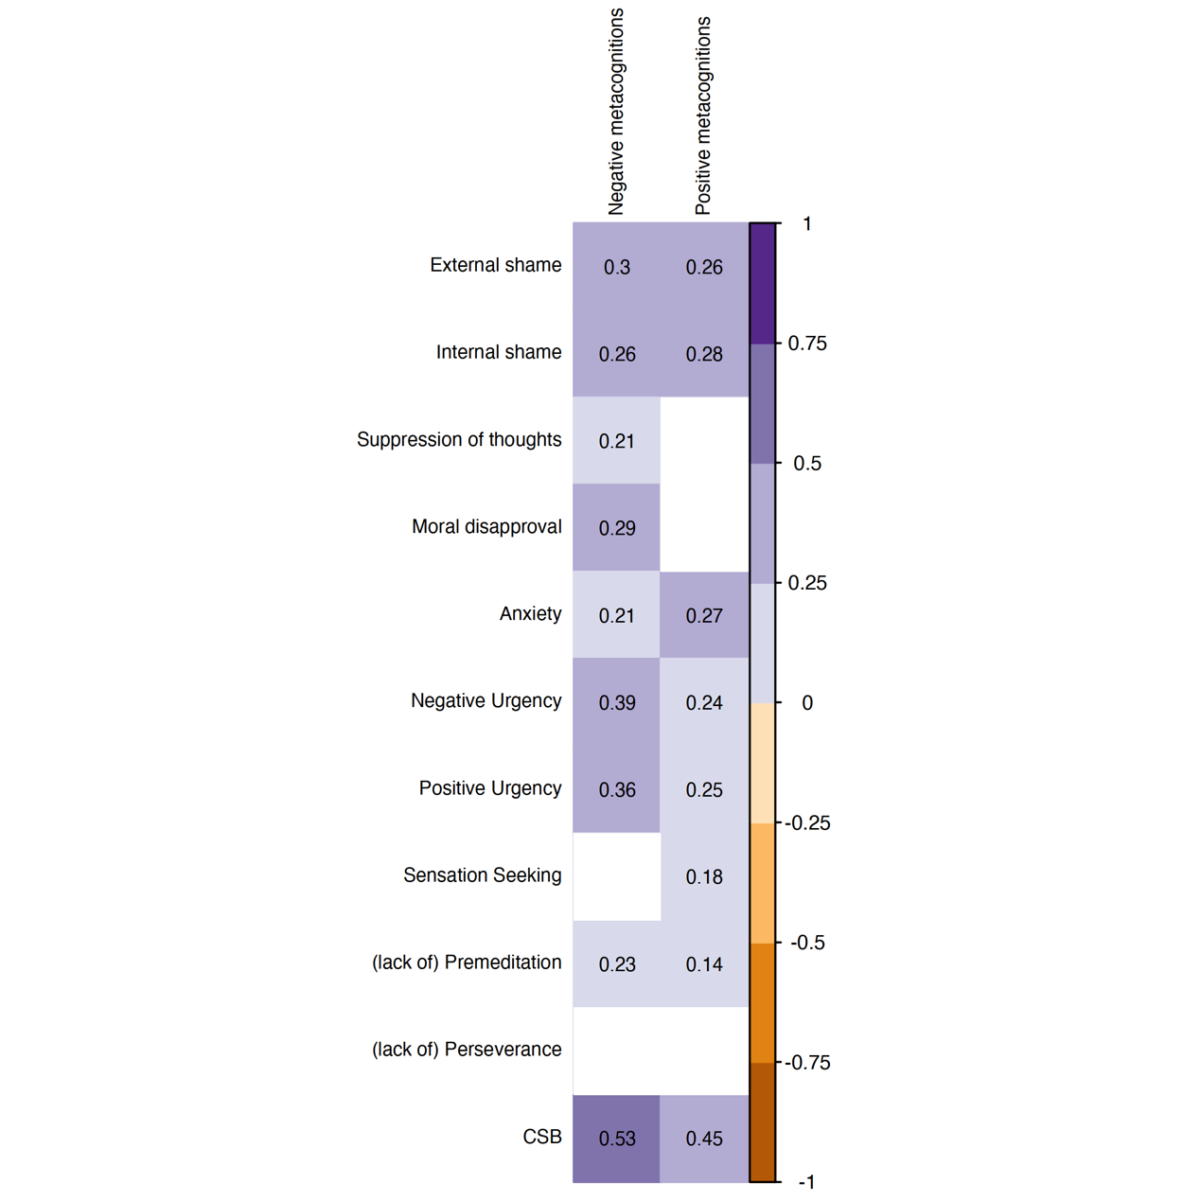

Figure 2. Convergent validity between metacognitions about CSB clusters and related measures. For simplicity, nonsignificant correlations were omitted.

Figure 3. Differences in negative and positive metacognitions between genders (left column) and religiosity status (right column).

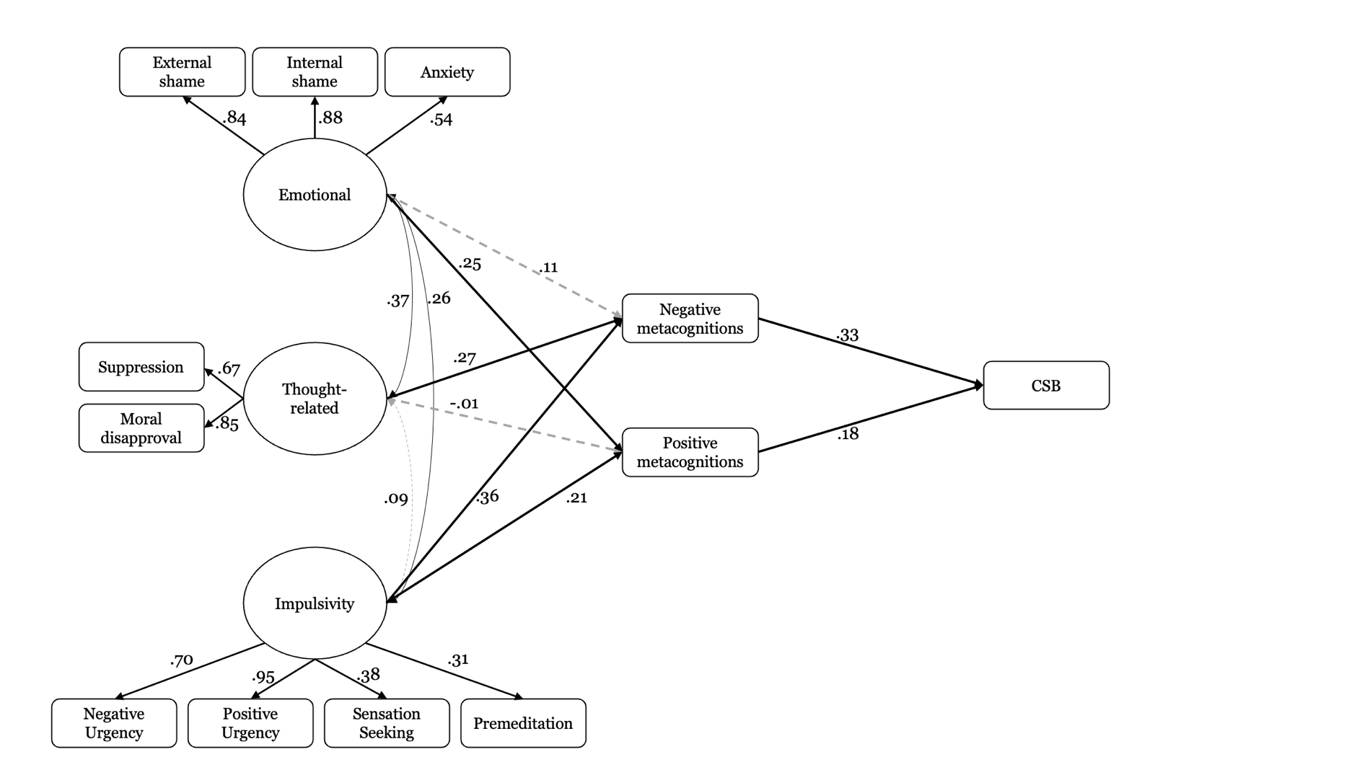

Figure 4. Possible model associating CSB with emotional status, dysregulation thoughts and impulsivity via metacognitions about sex. Solid black lines represent significant paths (*p* < .05 or better); grey dashed lines are nonsignificant.

**Appendix A**

**Metacognitions about Sex Scale (MSS) – structured version (Final version)**

|  |  |  |  |  |  |
| --- | --- | --- | --- | --- | --- |
| **Factor** | **Item** |  |  |  |  |
| Negative metacognitions | 1. I have no control over my thoughts about sex | 1 | 2 | 3 | 4 |
|  | 2. Once I start thinking of sex, I cannot stop | 1 | 2 | 3 | 4 |
|  | 3. Sexual thoughts make me lose control | 1 | 2 | 3 | 4 |
|  | 4. Thoughts about sex interfere with my functioning | 1 | 2 | 3 | 4 |
|  | 5. Thoughts about sex are becoming an obsession | 1 | 2 | 3 | 4 |
|  | 6. Having thoughts about sex means I will act on them | 1 | 2 | 3 | 4 |
|  | 7. I have no control over my sexual behaviour | 1 | 2 | 3 | 4 |
|  | 8. I have no control over my thoughts about sex | 1 | 2 | 3 | 4 |
| Positive metacognitions | 9. Engaging in sex will help me to control my negative thoughts | 1 | 2 | 3 | 4 |
|  | 10. Engaging in sex reduces my anxious feelings | 1 | 2 | 3 | 4 |
|  | 11. Engaging in sex distracts my mind from problems | 1 | 2 | 3 | 4 |
|  | 12. Engaging in sex reduces my feelings of tension | 1 | 2 | 3 | 4 |

**References**

Buria, L., Drori, Y., Geulayov, G., Schwammenthal, E., Kobaliov, A., & Dankner, R. (2015). The psychometric properties of the Hebrew version of the Hospital Anxiety and Depression Scale (HADS) in cardiac patients. *Gerontol Geriatr*, *42*, 41-58.‏

Christensen, A. P., & Golino, H. (2021). On the equivalency of factor and network loadings. *Behavior Research Methods*, *53*(4), 1563-1580.

Friedman, J., Hastie, T., & Tibshirani, R. (2008). Sparse inverse covariance estimation with the graphical lasso. *Biostatistics*, *9*(3), 432-441.

Golino, H., Shi, D., Christensen, A. P., Garrido, L. E., Nieto, M. D., Sadana, R., Thiyagarajan, J. A., & Martinez-Molina, A. (2020). Investigating the performance of exploratory graph analysis and traditional techniques to identify the number of latent factors: A simulation and tutorial. *Psychological Methods*, *25*(3), 292.

Ruscio, J., & Roche, B. (2012). Determining the number of factors to retain in an exploratory factor analysis using comparison data of known factorial structure. *Psychological Assessment*, *24*(2), 282.