Detailed description of the research program

Making Learning Durable:
Long-term pathways of modeling-based learning about complex systems in science

Scientific Background
The project investigates the long-term processes of learning through an approach that integrates modeling activities into science learning experiences in middle school, while increasing conceptual integration among concepts in science. Complexity and computational similarity among systems in chemistry and physics underlies the design of the computational modeling toolkit. The scientific background presents long-term and long-term study of learning in science, learning about complex systems, and learning by modeling (LbM).
Long-term Studies of Model-based Learning and of Learning in Science
No research was found regarding long-term model-based learning, in any form of interaction, exploring prebuilt models or constructing new ones. Long-term studies in science education in general, and specifically, regarding student’s understanding of systems are presented.
Long-term projects of up to a year include the following. Elementary students’ science learning during five months was compared for constructivist and traditional teaching approaches, finding that the first teaching approach resulted in better learning outcomes, increased metacognitive engagement and use of information processing strategies (Wu & Tsai, 2005). Eilam and Reiter (2014) explored ninth-grade students learning of genetics over a year and compared two teaching methods, self-regulated learning and teacher-controlled learning, finding that the first group outperformed the second, and that these students gradually became aware of their learning processes and were able to apply appropriate strategies to regulate the learning.
Longer-term research projects in science education include the following. Young preschool children’s science learning was examined over 1.5 years and related to their interactions with their teachers (van der Steen et al., 2019). It was found that the higher-scoring children in science learning had more variable and adaptable interactions with their teachers. Novak and Musonda (1991) investigated students’ concepts in science over twelve years, after they had participated in audio-tutorial science lessons in first or second grade and compared them with students who did not participate in this type of learning. They found that the experimental group had more valid concepts and less misconceptions than the comparison group. Lofgren & Hellden (2009) researched students during a period of ten years, starting with second grade, when they were instructed regarding the particulate nature of matter, finding that few of these students continued to use such concepts as they grew older. Bamberger and Tal (2008) investigated the long-term effects of a single science museum visit by interviewing students right after a visit and 16 months later, finding that they had retained details of the experience, appreciated the contribution of the visit to their understanding and highlighted the social interactions that took place.
The only previous longitudinal research into students’ understanding of complex systems is the work of Snapir et al., (2017), which explored students’ concepts of the human body along four time-points in their high-school education, focusing on its systemic character. Using a systems framework named Components-Mechanisms-Phenomena (Hmelo-Silver et al., 2016) they found that for the three categories, students gradually increased their understanding, especially for the micro-level in the system and for mechanisms.
To summarize, long-term studies in science education are far and few between; there is only one research that focuses on students’ long-term understanding of complex systems, and none on students’ modeling.
Learning about Complex Systems
This project seeks to explore and advance systems thinking, due to the systemic nature of many of the world’s central problems, a form of reasoning that is today viewed as vital to learning (Wilensky & Papert, 2010; Chen & Stroup, 1993; Jacobson & Wilensky, 2006; Assaraf & Orion, 2005). Complex systems are made up of many elements, which interact, self-organizing in coherent global patterns (Forrester, 1968, Epstein & Axtell,1996; Holland, 1998; Wolfram, 2002; Strogatz, 2003; Bar-Yam, 2003). The field of complex systems has developed enormously in the past three decades, contributing to our understanding of a wide range of systemic phenomena across the disciplines (Barabasi & Bonabeau, 2003; Nicholis & Prigogine, 1989; Turchin, 2003). It has also provided a framework for representing and comprehending the structure and dynamics of systems, which generates global patterns from local behaviors and interactions. This framework’s wide applicability presents a powerful paradigm for interpreting systems and is used in the current project.
Complex systems challenge our understanding, as several biases sway people’s reasoning: assuming central control (Resnick, 1994), confusion among levels (Wilensky & Resnick, 1999), a fixing in on the system’s structure at the expense of function and mechanism (Hmelo-Silver & Pfeffer, 2004) and a tendency to view causal relations as a consecutive chain of causes and effects rather than parallel concurrent interactions (Chi, 2005). Moreover, when the micro- and macro-levels are dissimilar, concepts are difficult to grasp and comprehend (Samon & Levy, 2017). These difficulties point to the importance of educational support in making sense of systems.
Several innovative learning environments have been designed to help people overcome these biases and understand complex systems, such as constructing and exploring computer models (Blikstein & Wilensky, 2009; Guo et al., 2016; Hashem & Mioduser, 2011, 2013; Levy & Mioduser, 2010; Levy & Wilensky, 2009ab; Louca, Zacharia, Michael & Constantinou, 2011; Sengupta & Wilensky, 2009; Wilensky & Reisman, 2006; Wilensky & Resnick, 1999; Wilkerson-Jerde, Gravel & Macrander, 2015) and participating in role-playing simulations (Colella, 2000; Klopfer et al., 2005; Levy, 2017). The project supports students learning of complexity by constructing and exploring computer models of systems and studies their reasoning through a complexity perspective.
Learning by Modeling in Science
Computational modeling is one of the categories of computational thinking (Weintrop et al., 2016). Computational thinking has recently become established as central to people’s understanding of the world regarding a wide range of practices and domains (Wing, 2006). The meaning of computational thinking is evolving since its start as thinking processes related to computational problem solving, abstraction, pattern finding, algorithm construction and decomposition and has taken a broader view in recent years. From the perspective of science education, the STEM education standards, the Next Generation Science Standards (NGSS Lead States, 2013), highlights eights core practices, one of which is “mathematics and computational thinking”. There is a growing consensus among some researchers in the field that CT includes important computation-related competences that are used in a variety of professional and academic settings, such as data science and simulation (Weintrop et al., 2016). As a result, several studies in educational STEM address the impact of integrating CT into learning within the STEM domains. This broader definition becomes more relevant when the learning process focuses on enhancing both CT and conceptual understanding through computational modeling of complex systems, the focus of the present study (Basu et al., 2014; Zhang & Biswas, 2019; Guzdial, 2008; Hambrusch et al. 2009; Blikstein and Wilensky 2009; diSessa 2000; Kaput 1994; Pei, Weintrop, & Wilensky, 2018).
Constructing models is a core activity in this project. Central researchers into modeling in science education have defined models as "… a representation of a phenomenon initially produced for specific purpose" (Gilbert, Boulter & Elmer, 2000). Model construction simplifies the phenomenon of interest based on the future use or the goal of the model; and can serve as an explanatory tool (Gobert & Buckley, 2000). Several approaches for modeling complex systems in science education have been introduced (Wilensky & Resnick, 1999; Mandinach & Cline, 1994; Assaraf, Dodick, & Tripto, 2013; Eilam & Poyas, 2010; Liu & Hmelo-Silver, 2009). In this study we adopt the agent-based modeling approach (ABM) for modeling complex systems which relies on complexity theory (Bar-Yam, 2003). The ABM approach represents systems through their participating entities, assigning them behaviors and interactions. Running the simulation has these entities act and interact. As a result, an emergent collective pattern can arise bottom-up. We selected this viewpoint in the present research because of its generativity both in science and in helping students relate micro and macro levels (Wilensky & Resnick, 1999; Levy & Wilensky, 2009).
The act of constructing rather than exploring models, is a less common practice in schools, as it requires much support at early stages. One might be warded off for several reasons, such as the difficulty in learning and teaching programming, the added time needed for this learning and the question of whether students could represent complex phenomena and reason about them. Constructionist research (Constructionism, 1991; Papert, 1980; Sherin, diSessa & Hammer, 1993; Ackermann, 1996; Kafai, Ching & Marshall, 1997; Kafai, 2006) has demonstrated richly expressive forms for constructing models with computation.
The proposed project uses a visual block-based programming interface. The advent of block-based programming has circumvented the problem of learning text-based programming and making it more accessible to younger students in more conventional settings (Weintrop & Wilensky, 2017). Block-based programming has provided access to younger students due to its visual features. The program resembles a puzzle in the way the blocks fit and “lock” together. However, different from a puzzle that has a single complete picture, this is a free-form assembly. The visual nature of the blocks, the graphic symbols and the immediate scaffolds that the platform provides help students quickly understand how to use these blocks.
An Introduction to the project via the Preliminary Results
Preliminary results are moved earlier in the research program, as they provide a good setting and introduction to the present research proposal. Moreover, the design of the learning environment in the proposal and the related technology are the same, so that the description here will suffice and will not repeat.
This proposal follows in the footsteps of an ongoing research project now in its last year, “Much.Matter.in.Motion: Learning science through building models of complex systems” (ISF grant #1205/18). The project investigated the conceptual framework for learning, Much.Matter.in.Motion (MMM). The goal of the framework is to integrate CT and modeling practices into learning experiences in middle school science courses, while increasing conceptual integration. During this project, the framework which was theoretical at the start, was gradually developed into applications that were needed to explore its feasibility and contribution to science learning. The MMM framework focuses on learning by modeling (LbM) complex systems. This form of learning is viewed as powerful as it engages with students’ personal representations, their processes of translating them into computational objects and externalizing these into visual and dynamic representations, which present feedback. This feedback is potent due to its being dynamic, visual, and immediate. As such, it spurs evaluation, debugging and revision processes. An important component is the social setting of the classroom, where students present their work informally and formally, sharing the products of their thought processes, comparing, discussing, and possibly revising their models further. LbM in the project is based on constructionist theory which promotes learning by building and sharing personally meaningful objects (Papert, 1980). LbM complex systems has been implemented and researched over the years (e.g. Wilensky & Resnick, 1999; Louca, Zacharia, Michael & Constantinou, 2011; Wilkerson-Jerde, Gravel & Macrander, 2015). What makes the MMM framework unique with respect to previous work is a combination of two factors. First, it generalizes computation of several systems in chemistry and physics by using a small set of elements and principles to construct a wide range of phenomena. Second, it allows students to engage with modeling through a combination of drawing and construction, simplifying the modeling process, enabling the creation of many more models, and making it more accessible to teachers and students in science classrooms.
The MMM framework presents a condensed view of systems that is based on a complexity perspective but goes beyond this in condensing scientific concepts. It focuses on the micro-level in chemical and physical systems and makes the similarity of the interactions in different systems apparent. One example for such similarity is how diffusion and heat conduction take place through random motion and collisions, resulting in structurally similar equations. Another example from one of our learning units, is how the code for modeling electrons in electric circuits is the same as that for gas molecules in a container, and all you need to add is a field (Drude’s model of electricity).
A central component needed to research the conceptual structure was the development of a programming platform. The Much.Matter.in.Motion (MMM) modeling platform enables constructing computational models of complex systems in the domains of chemistry and physics (Levy, Saba & Hel-Or, 2018; Saba, Hel-Or & Levy, 2021; Figure 1). This platform allows students to create computational models by drawing the macro-level elements, such as wires and electric fields in an electric system, and coding the micro-level entities, such as electrons and atoms. Programming is done by dragging blocks (on the right side of the screen in Figure 1) that encapsulate underlying code onto a programming board. This block-based type of coding is a common practice in a variety of well-known programming environments, such as Scratch (Resnick, et al., 2009) and Alice (Cooper et al., 2000) and is meant to circumvent the need for debugging textual code, which requires much more support. Students’ and teachers’ familiarity with this kind of programming is an additional consideration.
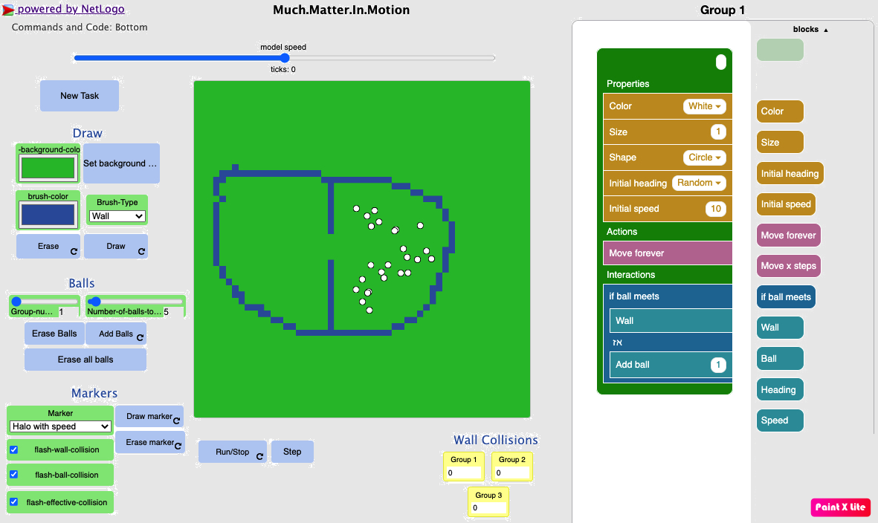
Figure 1: Much.Matter.in.Motion platform with a built model of a gas, exploring gas diffusion. On the left side is the world (green square), drawing (draw, balls) and visualization (marker) tools, as well as monitors providing numerical information. On the right side is the programming board, where the green structure is filled by dragging blocks with by color into one of the three cavities.
The platform was designed to highlight both (a) a complex systems way of thinking about systems, agent-based modeling, from the micro-level object up to the group, and (b) the specific condensed view of physical and chemical systems. The basic entity in the models is a circle, named “ball, which represents one of the micro-level entities. The ball can be an electron, atom, particle, marble, or a planet. The code students create operates on these balls independently, guiding them to move and interact in particular ways. Each kind of ball, or population in complex systems terms, has its own set of instructions. To guide students’ modeling, the coding board is prepared with a pre-existing object that represents a population, a green shape with three cavities, one for the population’s properties (e.g., color, size, initial speed), one for its actions (moving in a straight line) and one for its interactions, typical of agent-based modeling type of reasoning (Wilensky & Rand, 2015). Interactions can take place between members of the population (electron-electron), with members of another population (electron-atom), with the macro-level objects (electron-conductor wall) or with fields (electrons accelerating along the field vectors). This visual and enactive structure makes the epistemology of modeling complex systems explicit, an important consideration in helping students generalize from the specific model they are making. It also makes the coding choices simpler, as each kind of code block can go into only one of those cavities. Each population, such as electrons versus atoms, has its own green programming object. We have used MMM all the way up to four populations, for chemical reactions that include several reactants and products, such as methane combustion CH4 + 2O2 CO2 + 2H2O. The similarity among chemistry and physics systems, beyond their complex structure, is seen in the coding blocks themselves. Code blocks for the balls’ properties are those one would use in developing many models, such as size (representing mass), initial speed and heading. Code blocks for actions are straight-line motion forever or for a limited time, in accord with Newton’s laws of motion. Code blocks for interactions are “if-then” statements regarding interactions with other balls (same or different kind), with macro-level walls or with fields. The action part of the statement is a menu that opens up with a limited set of choices: nothing, collide, stop, accelerate, decelerate, attract, repel, and attract-repel (Lennard-Jones interactions).
The MMM platform is based on a model we programmed with NetLogo (Wilensky, 1999), which includes the variety of code that could go into the students’ model; and the NetTango toolkit (Horn, Baker & Wilensky, 2020) that supports forming a block-based coding interface for models. As the NetTango toolkit is relatively new, we were supported in the process by researchers and programmers at the Center for Connected Learning and Computer-based Modeling at Northwestern, who will continue to support the proposed project as well (see Wilensky letter of collaboration).
Three online digital learning units were formed on topics learned in middle school science in chemistry – structure of matter and gases, and chemical reactions; and in physics – electricity. Each online learning unit includes presentations and explanations, guides, prompts, challenges, and questions. Content experts advised on the concepts presented and programmed in the learning units. Each unit’s duration is about ten lessons long and was co-taught by the teachers and the researchers. The general scheme of each learning unit includes: (1) Introduction through an interesting demonstration or experiment for which students are invited to predict and explain their ideas (one lesson); (2) Physical laboratories and demonstrations (two lessons) to provide a wide array of topics the students could model; (3) Modeling in pairs and class-wide discussions of students’ models (six lessons); and (4) Class-wide consolidation of the learning unit (one lesson). Including physical experiences is crucial, as they encourage the back-and-forth between the richness of experience and the parsimonious model representations, making sure they align, and encouraging further explorations (Samon & Levy, 2021). Modeling takes place in pairs to encourage communication and deliberation of ideas and explanations.
The main results are the following: (1) Learning with the MMM framework resulted in greater conceptual understanding of the science topics with respect to normative curriculum comparisons; (2) This greater understanding corresponded with a deeper understanding of each system’s micro-level; (3) Learning transfer was observed, with far transfer independently impacted by CT and understanding complexity (Saba et al., under review, b); (4) During modeling, conceptual understanding gradually included more concepts with higher degrees of integration; (5) Increased experience in modeling was related to larger differences between successive models created in a single session, as they explored different aspects of the represented phenomenon. Several conference papers were presented (seven) and submitted (five). One published journal paper describes the theoretical structure of the design and initial experimental results (Saba, Hel-Or & Levy, 2021). Two additional journal papers are under review. In one of these papers (Saba et al., under review after revision, a), the focus was on our discovery of a sequence of mental models in electricity that shifts from an engineering view to a combined complexity and engineering view of the system, the two approaches merging for the concept of current. Comparison of the pretest and posttest results shows a strong shift in the experimental group towards this combined view, which is unique in its integration of functional and causal aspects of system.
Research objectives and expected significance
The project explores how students may develop a more sophisticated understanding of scientific systems, modeling and computational thinking (CT); and how this more sophisticated understanding could impact subsequent learning about new systems in science, by engaging them in the construction of computational models over a long period of time. This endeavor combines two cross-cutting concepts called for in US science education standards (NGSS, 2013): (1) a complexity perspective for representing diverse chemistry and physics systems; and (2) the practices related to scientific computational modeling.
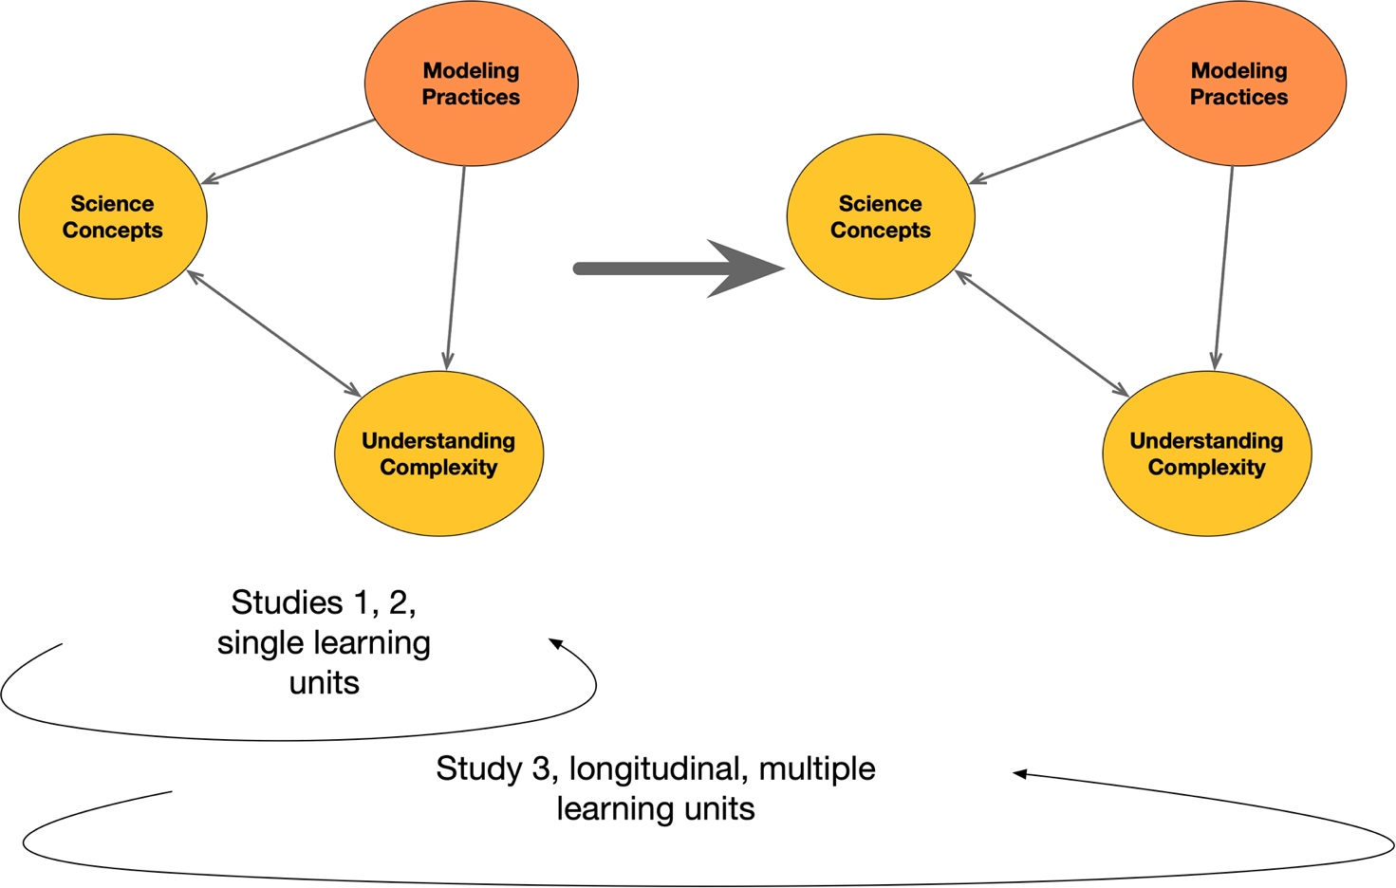
Figure 2: Conceptual framework of the proposed research
The proposal’s conceptual framework is described in Figure 2, bringing together the key variables and constructs in the proposed research. The main activity students engage in is modeling. The students’ modeling practices are explored and typified for each learning unit and compared across learning units to see how they might change through extended engagement. Related to modeling, two variables related to the students’ knowledge are explored: science concepts – both within the studied topic and across to other systemic topics and understanding complex systems. The relationships between these variables are explored within each learning unit. Across six learning units studied across three years, the changes to each of these variables is investigated; moreover, the degree to which changes to these variables predicts changes in variables in a following unit are explored, so that the interrelations can be laid out.
The research addresses two gaps.
The first gap is the relative lack of knowledge regarding characteristics of long-term learning about complex systems across science topics. Knowing how such long-term learning takes place enables developing appropriate supports for learning, generalization, and consolidation over longer periods of time, or “making learning durable”. Understanding how long-term modeling of complex systems interacts with science learning would significantly advance the domain of learning about complex systems in science. Research into long-term science learning is scarce in science education, and only one research investigated systems thinking (Snapir et al., 2017), and none were found regarding model-based learning. Building upon this research, the project looks into not only students’ systems thinking, but also their science concepts and modeling practices. The ISF’s recent change of policy, which enables five years of research, presents a tremendous opportunity to ameliorate this state of affairs and has been a significant motivation to forming this research program. The specific topic of learning – learning about systems and modeling – presents another unique opportunity, as the two constructs are content-general, thus enabling repeated testing and comparison of the same knowledge over extended time periods and contributing to the study of learning over longer time-periods in general. In Israel, learning through a complex systems approach is not yet part of normative learning materials, presenting another excellent reason for conducting the research in Israel: the starting point of most of the students will be similar and independent of previous learning. Understanding such long-term effects on the very process of learning could support designing for learning across the years and decisions regarding appropriate frameworks to employ in helping students develop more sophisticated views. More specifically, to the best of our knowledge, classroom learning of complex systems has not been studied for a variety of topics and extended durations; nor has modeling-based learning; so that these more specific topics would be advanced as well.
The second gap is fragmentation problems in science learning when each topic is taught separately with relatively few connections across concepts related to different phenomena or systems. This issue of fragmentation has been related to lower transfer of learning across science topics (Bybee, 2014). The proposal continues the development of the Much.Matter.in.Motion conceptual framework, meant to unify the learning of systems in science in ways that help see the common principles between them, as described in the preliminary results and that has shown promising results. The proposed research advances a unified conceptual framework for learning about systems in chemistry and physics that was described above. It goes beyond the ongoing project in two ways. On one hand, the focus shifts from individual learning units to a more comprehensive approach to by using this framework across topics and years. The significance of this research is in advancing science education by offering simpler and more powerful representations that are easier to comprehend and which engage students in deeper mechanistic reasoning. The research will further extend the framework to additional science topics: liquids and solids, phase change, and the solar system, to test its theoretical applicability as a framework to the full range of chemistry and physics systems learned in middle school science. The proposed research advances the design of new platforms for advancing CT in the context of science education, which can be easily incorporated into science classes, mutually enhancing the learning of science and computation.
The research project has two main objectives:
- Understanding long-term classroom-based science learning by modeling complex systems: Exploring how students’ - learning processes, modeling practices, conceptual learning, understanding of systems and computational thinking, as well as the non-cognitive factors of interest in science and self-efficacy as science learnings - change and interact during extended learning of science by constructing computational models with a complexity-based perspective.
- Creating a unified conceptual framework for model-based learning about systems in science: Understanding how to design for extended modeling-based learning of science with a complexity perspective, which considers previous and future learning across science topics and age-groups.

Detailed description of the proposed research

Working hypothesis
With respect to single-unit learning with the MMM approach, learning several learning units with this approach will result in
- higher pretest scores in the later units through learning transfer
- higher posttest scores for the later units, as more cognitive resources can be allotted to understanding the science concepts.
- shorter times until the upward shift in mental models during the learning unit
Research Design and Methods
The project proceeds through four studies, two that use qualitative methods with a small number of students (1 & 4) and two that use quantitative methods with comparisons (2 & 3).
Study 1: Lab setting learning process of LbM - Characterizing the short-term processes by which middle school students represent and construct models, interact with the programming platform and learn about science phenomena and complex systems, testing of research tools.
Study 2 – Classroom-based learning gains for individual LbM units - Comparing the learning gains in learning through modeling with learning with standard learning materials, test scaling up to classrooms.
Study 3 – Classroom-based long-term learning gains with multiple LbM units – Trajectories of learning the science and systems concepts, modeling practices and their interactions across a range of systems in science.
Study 4: Classroom-based long-term learning process with multiple LbM units – Characterizing the long-term changes in how middle school students use modeling practices, learn the science and systems concepts.
Research Variables
Independent Variable:
- Learning Environment: Learning by modeling versus standard learning materials, number of LbM units experienced.
Dependent Variables
- Science conceptual understanding – science conceptual understanding of the systems and phenomena modelled in the activities.
- Understanding complex systems – structure of reasoning about systems in terms of levels, interactions, decentralization, probabilistic behaviors, equilibration processes and emergence.
- Modeling practices –ways of representing complex phenomena, creating them computationally, debugging, revising and evaluating models.
- Learning process – time to upward shift in mental model while engaging with a learning unit.
Research Sample
The project plans to work with a school in the north of Israel. Long-term research is challenging to organize and deploy, and a good relationship with the school is crucial. The intended school is one we have worked with in the past. We are currently discussing whether and how this research could be implemented. Based on our earlier work with the school, they had decided to adopt complexity as a cross-cutting concept to connect curricula in different courses, making this a more accepting context for conducting the research.
Table 1: Experimental Groups
Exp. Group | Sample Size | Topics of Learning | Learning Environment | Single / Long-term | Participate in Study
1 | 6 | Structure of Matter & Gases | MMM1¹ | Single | 1
2 | 6 | Phases & Transitions | MMM1 | Single | 1
3 | 6 | Electricity | MMM1 | Single | 1
4 | 6 | Energy transfer | MMM1 | Single | 1
5 | 6 | Chemical reactions | MMM1 | Single | 1
6 | 6 | Astronomy | MMM1 | Single | 1
7 | 200 | All topics | MMM2 | Long-term | 3, 4
8 | 60 | Phases & Transitions | MMM2 | Single | 2, 3
9 | 60 | Electricity | MMM2 | Single | 2, 3
10 | 60 | Energy transfer | MMM2 | Single | 2, 3
11 | 60 | Chemical reactions | MMM2 | Single | 2, 3
12 | 60 | Astronomy | MMM2 | Single | 2, 3
13 | 60 | Structure of Matter & Gases | Standard | Single | 2, 3
14 | 60 | Phases & Transitions | Standard | Single | 2, 3
15 | 60 | Electricity | Standard | Single | 2, 3
16 | 60 | Energy transfer | Standard | Single | 2, 3
17 | 60 | Chemical reactions | Standard | Single | 2, 3
¹ MMM1 and MMM2 are initial and improved versions of the experimental learning environment
Total sample size is about 770 students sub-divided by the independent variable, whether the learning environment includes modeling, and prior experience with modeling (Table 1). 15 students will be selected from the long-term experimental by random stratified sampling, based on gender and academic ability, for interviews and microgentic research. Expected attrition is high, so that the final sample size will probably be about 20% smaller. IRB and Education Ministry Head Scientist approval will be obtained, as will the schools’ principal and teachers. Parents’ and students’ consent will be gained before the studies begin.
Research Design
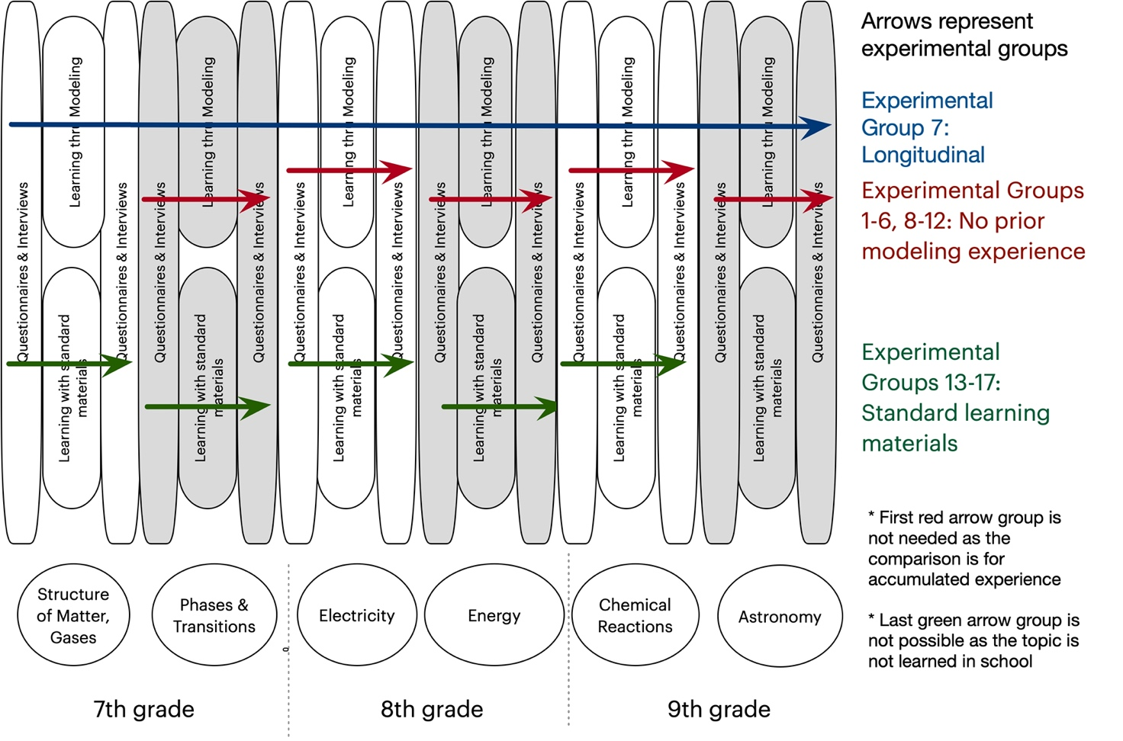
Figure 3: Experimental design of proposed research, which includes the learning units, their pre- and post-tests, and participation of each of the experimental groups.
Research instruments
1. Pre- and post-test questionnaires. Each test includes two questionnaires. The demographic information questionnaire consists of a set of standard questions. For experience in programming and simulations, the students will be asked to write out examples. The conceptual understanding and systems thinking questionnaire will include questionnaires already developed and tested for three of the six topics. The questionnaires will include approximately 18 closed items, and two open-ended items. Existing questionnaires will be improved to include more challenging items to prevent a ceiling effect. For three topics, questionnaires will be designed by conducting a two-dimensional analysis of the learning unit challenges posed to the students. A content dimension describes the main content addressed in the learning unit. A process dimension involves Shavelson, Ruiz-Primo & Ayala’s (2002; Ayala, Shavelson, & Yin, 2002) categories of knowledge: declarative, procedural, schematic and strategic. The proportion of different challenge types in the two-dimensional array will be used to plan the questionnaire. Items from published research and international tests will be used, and others will be developed in-house, and reviewed by content experts and the lab members. Teachers will then review them to ensure clarity and coverage of the concepts and principles taught with standard learning materials.
2. Interview protocols: Semi-structured interview protocols will include two open-ended items, with scenarios, which present a problem the student needs to solve, while describing and explaining their thinking in words, moving objects and drawings. Protocols will be designed as clinical interviews (Ginsburg, 1997) and will be reviewed by members of the lab, piloted, and improved.
3. Logs of students’ activity with the learning units and modeling platform. Students work with the online units will be logged, specifically the texts that they enter as answers to questions, tables, graphs, and drawings that they create during the unit and screenshots of their models.
4. Observations. Computer screens and the students will be video-recorded during learning sessions and interviews using screen capture and video software. Interviews will be videotaped.
Procedure
Study 1: Lab setting learning process of LbM
Study 1 characterizes the processes by which middle school students represent and construct models, interact with the programming platform and learn about science phenomena and systems. It is also used to try out the new and improved learning units, the modeling platform, and the data collection instruments, so these can be improved before the next studies. More specifically, the study explores students’ modeling practices; science and systems conceptual learning, students’ mental models and the shifts between them; and how these variables interact. Participants are from Experimental Groups 1-6. For each learning unit, three pairs of students will work with the researcher in a lab setting. Modeling will be in pairs, so the students’ conversations can provide insight into their understanding and strategizing. They will work for four one-hour sessions, fill out pre- and post-test questionnaires and participate in individual semi-structured interviews. Each pair’s work will be logged and screen-captured. The questionnaires will be coded for science and systems concepts. Qualitative analysis of the interviews will provide an in-depth view of students’ understanding. The modeling sessions will be analyzed for the modeling practices that include how students design a model, explore, and evaluate it, revise and debug it, and the actual programs they create, and the science and systems concepts expressed in writing and in words.
Study 2 – Classroom-based learning gains for individual LbM units
This study compares LbM using the MMM approach with learning with standard materials and tests scaling up to classrooms. In this study, Experimental Groups 8-12 learn one of the science topics through modeling. They are compared with Experimental Groups 13-17 who learn the same topics with standard learning materials for the same duration. The study is structured as a quasi-experimental comparison group pre-test-post-test design. Students will fill out questionnaires before and after the learning unit. The questionnaires will be coded, followed by statistical analyses. Students’ modeling practices will be hand-coded from the data logged from students’ activities with the learning units: screenshots of their models will enable analysis of their programs, structured sections of the activities will ask students to plan and draw the models before programming them, revise and explain their revisions, use the models to explore the science topics and record their observations in data tables and graphs, and reflect and explain their understanding of phenomena. Categories for coding these activities will be created top-down based on existing research literature and based on the data itself and the distinctive differences that are observed.
To detect students’ learning process chara. cteristics, namely the shifts in their mental models during the activity, the texts the students write in learning unit will be analyzed. In my lab, we have been doing the preliminary work needed to prepare for automatic analysis of students’ articulated ideas for several years now (Samon & Levy, 2019; Zohar & Levy, 2019; Saba et al., under review, a). The analysis we have developed involves noting and analyzing students’ knowledge elements from their texts. Knowledge elements are a term that describes basic concepts or ideas upon which students build their answers, such as p-prims in diSessa’s (1993) work. In these studies, we hand-coded for knowledge elements and formed a vector describing each student’s mental model. We then used automated and visual clustering methods to detect the mental models. Using these coding tables, we can now automate detecting the knowledge elements. The analysis is based on Sherin’s (2013) work that explores conceptual dynamics in clinical interviews with vector space models and cluster analysis. Once the right granularity to capture students’ explanations is determined, we will be able to compute the time it takes for students to move between mental models. Comparison with hand coded analysis will be used for verification.
Study 3 – Classroom-based long-term learning gains with multiple LbM units
The heart of the research is the long-term study that relates the various aspects of understanding and learning as they impact each other following learning of different STEM topics. Experimental group 7 are the students who participate in the project for three years. They are compared with Experimental groups 8-12 who studied only one learning unit without prior experience with the MMM approach. This comparison will allow testing the cumulative effects. Several analyses will be made based on trajectories for each of the variables, learning transfer by comparing the pretest scores, added value to learning by comparing the posttest scores and time to upward shift of mental models, using data analytics described above and their Interactions. Their relationships will be explored within and across learning units. The statistical modeling and methods for analyzing long-term data with several variables being measured at successive time points will be conducted with the help of a statistician. Linear mixed-effects models will be used as they allow characterization and comparison of changes over time, accommodate incomplete data, and can handle unbalanced data. This flexibility will be necessary as students miss classes and tests. Given the limited sample size, interactions will be grouped and tested within this limitation.
Study 4: Classroom-based long-term learning process with multiple LbM units
The proposed research begins and ends with detailed studies which are qualitative in nature, intending to characterize the processes of learning different students go through over a three-year period of LbM. 15 students out of the classes who are learning the extended program will be interviewed before and after each learning unit and will be observed during learning using screen-captures of their computer screens and video. Analyses will attend to each of the research variables, as well as the contexts, processes and non-cognitive factors that can form a more in-depth understanding of long-term LbM of complex systems.
Institutional Resources
The Faculty of Education at the University of Haifa is one of the primary educational research institutions of its kind, the largest in Israel. The faculty includes 58 senior faculty members and 100 additional staff members, 25 research centers and laboratories that conduct diverse research that incorporates many graduate students. The faculty includes two national centers for mathematics education that provide continuous training and assistance to mathematics teachers across the country. Finally, the faculty includes an IT center that supports several faculty members in their research and teaching with technologies. The author’s research group currently includes nine students, two postdocs, a lab director and a computer science professor. Some of the group members are experienced in designing novel computational learning environments and provide assistance to each other on a regular basis, such as data collection tools appraisal and reliability testing. The lab also has most of the needed equipment for data-collection.
Expected Results and Pitfalls
Study 1: Lab setting learning process of LbM: (1) A richly textured multi-faceted analysis of students’ learning process that includes an understanding of results regarding the four dependent variables; (2) Recommendations for improvement of the MMM learning environment and learning units; (3) Recommendations for the improving the research tools.
Study 2 – Classroom-based learning gains for individual LbM units: (1) Learning gains for each of the four dependent variables; (2) Comparison between LbM and learning with standard learning materials; (3) Comparison of LbM for different topics of learning.
Study 3 – Classroom-based long-term learning gains with multiple LbM units: (1) Trajectories of the dependent variables and their comparison; (2) Transfer rates of learning from earlier units to later units; (3) Depth of understanding in science, systems and modeling practices; (4) Interactions among variables.
Study 4: Classroom-based long-term learning process with multiple LbM units: (1)A richly textured multi-faceted analysis of students’ learning process across six learning units that includes an understanding of the four dependent variables as well as the situated and non-cognitive aspects of learning.
Addressing possible pitfalls: (1) Attrition: To address attrition, sample size is larger than what is needed for analysis by about 25%; (2) Technical problems: software, hardware – prior testing of the equipment and software will be extensive – both within the laboratory and piloted prior to the actual research; (3) Technological development problems: to this goal, Uri Wilensky is consulting us; (4) Loss of data: given the fact that information is stored online and the instability of school’s digital infrastructure, analysis was planned for six learning units, a relatively large number that could be reduced in case of such loss.

Bibliography
- Ackermann, E. (1996). Perspective-taking and object construction: Two keys to learning. In Y. Kafai & M. Resnick (Eds.), Constructionism in practice: Designing, thinking, and learning in a digital world (pp. 25 – 37). Mahwah, NJ: Erlbaum.
- Assaraf Ben-Zvi, O. & Orion, N. (2005) Development of system thinking skills in the context of earth system education. Journal of Research in Science Teaching, 42(5), 518–560.
- Assaraf, O. B. Z., Dodick, J., & Tripto, J. (2013). High school students’ understanding of the human body system. Research in Science Education, 43(1), 33–56.‏
- Bamberger, Y., & Tal, T. (2008). An experience for the lifelong journey: The long-term effect of a class visit to a science center. Visitor Studies, 11(2), 198-212.
- Bar-Yam Y (2003). Dynamics of complex systems. Perseus Publishing, New York.
- Barabasi, A.L., and Bonabeau, E. (2003). Scale-free networks. Scientific American, 50-59.
- Basu, S., Kinnebrew, J. S., & Biswas, G. (2014). Assessing student performance in a computational-thinking based science learning environment. In International conference on intelligent tutoring systems (pp. 476-481). Springer, Cham.‏
- Blikstein, P., & Wilensky, U. (2009). An atom is known by the company it keeps: A constructionist learning environment for materials science using multi-agent simulation. International Journal of Computers for Mathematical Learning, 14(1), 81 – 119.
- Chen, D., & Stroup, W. (1993). General system theory: Towards a conceptual framework for science and technology education for all. Journal of Science Education and Technology, 2(3), 447-459.
- Chi, M. T. H. (2005). Commonsense conceptions of emergent processes: why some misconceptions are robust. Journal of the Learning Sciences, 14, 161–199.
- Cooper S., Dann W., & Pausch R. (2000) Alice: a 3-D tool for introductory programming concepts. Journal of Computing Sciences in Colleges 15(5), 107–116.
- Colella, V. (2000). Participatory simulations: Building collaborative understanding through immersive dynamic modeling. The Journal of the Learning Sciences, 9(4), 471-500
- diSessa, A.A. (2000). Changing minds: Computers, learning, and literacy. Cambridge: MIT Press.
- DiSessa, A. A. (1993). Toward an epistemology of physics. Cognition and instruction, 10(2-3), 105-225.
- Eilam, B., & Poyas, Y. (2010). External visual representations in science learning: The case of relations among system components. International Journal of Science Education, 32(17), 2335–2366.‏
- Eilam, B., & Reiter, S. (2014). Long‐term self‐regulation of biology learning using standard junior high school science curriculum. Science Education, 98(4), 705-737.
- Epstein J., & Axtell R. (1996). Growing artificial societies: social science from the bottom up. Brookings Institution Press, Washington.
- Forrester, J.W. (1968). Principles of systems. Pegasus Communications, Waltham, MA
- Gilbert, J. K., Boulter, C. J., & Elmer, R. (2000). Positioning Models in Science Education and in Design and Technology Education. In Gilbert, J. K. & Boulter, C. J.(eds.), Developing Models in Science Education (pp. 3-17). Kluwer Academic Publishers, Netherlands.
- Gobert, J. D., & Buckley, B. C. (2000). Introduction to model-based teaching and learning in science education. International Journal of Science Education, 22(9), 891-894.‏
- Guo, Y., Wagh, A., Brady, C., Levy, S. T., Horn, M. S., & Wilensky, U. (2016). Frogs to Think with: Improving Students' Computational Thinking and Understanding of Evolution in A Code-First Learning Environment. In Proceedings of the 15th International Conference on Interaction Design and Children (pp. 246-254). ACM.‏
- Guzdial, M. (2008). Paving the way for computational thinking. Communications of the ACM, 51(8), 25–27.
- Hambrusch, S., Hoffmann, C., Korb, J. T., Haugan, M., & Hosking, A. L. (2009). A multidisciplinary approach towards computational thinking for science majors. ACM SIGCSE Bulletin, 41(1), 183-187.‏
- Hashem, K., & Mioduser, D. (2011). Promoting Complex Systems Learning through the use of Computer Modeling. International Journal of Social, Behavioral, Educational, Economic, Business and Industrial Engineering, 5(11).
- Hashem, K., & Mioduser, D. (2013). Learning by modeling (LbM): understanding complex systems by articulating structures, behaviors, and functions. Learning, 4(4).
- Hmelo-Silver, C. E., Jordan, R., Eberbach, C., & Sinha, S. (2016). Systems learning with a conceptual representation: A quasi-experimental study. Instructional Science, 1–20.
- Hmelo‐Silver, C. E., & Pfeffer, M. G. (2004). Comparing expert and novice understanding of a complex system from the perspective of structures, behaviors, and functions. Cognitive science, 28(1), 127-138.
- Holland, J. (1998). Emergence: From chaos to order. New York: Addison-Wesley Longman.
- Jacobson, M., & Wilensky, U. (2006). Complex systems in education: Scientific and educational importance and implications for the learning sciences. Journal of the Learning Sciences, 15(1), 11-34.
- Kafai, Y. B., Ching, C. C., & Marshall, S. (1997). Children as designers of educational multimedia software. Computers & Education, 29, 117–126.
- Kaput, J. (1994). Democratizing access to calculus: New routes using old routes. In A. Schoenfeld (Ed.), Mathematical thinking and problem solving (pp. 77–156). Hillsdale, NJ: Lawrence Erlbaum.
- Klopfer, E., Yoon, S., & Um, T. (2005). Teaching complex dynamic systems to young students with StarLogo. Journal of Computers in Mathematics and Science Teaching, 24(2), 157 – 178.
- Levy, S. T., Saba, J., Hel-Or, H. (2019). Much.Matter.in.Motion (MMM) platform: Block-based platform for constructing computational models in science. Systems Learning & Development Lab, University of Haifa, Israel.
- Levy, S.T. (2017). Learning about Complex Systems from the Bottom Up: Role-playing together in a participatory simulation. I. Levin & D. Tsybulsky (Eds.), Digital Tools and Solutions for Inquiry Based STEM Learning. A volume in the Advances in Educational Technologies and Instructional Design (AETID) Book Series. Hershey, Pennsylvania: IGI Global.
- Levy, S.T. & Mioduser, D. (2010). Approaching complexity through planful play: Kindergarten children’s strategies in programming an autonomous robot. International Journal of Computers in Mathematical Learning, 15(1), 21-43.
- Levy, S.T., & Wilensky, U. (2009a). Crossing levels and representations: The Connected Chemistry (CC1) curriculum. Journal of Science Education and Technology, 18(3), 224-242.
- Levy, S.T., & Wilensky, U. (2009b). Students’ Learning with the Connected Chemistry (CC1) Curriculum: Navigating the Complexities of the Particulate World. Journal of Science Education and Technology, 18(3), 243-254.
- Liu, L., & Hmelo‐Silver, C. E. (2009). Promoting complex systems learning through the use of conceptual representations in hypermedia. Journal of Research in Science Teaching, 46(9), 1023-1040.‏
- Löfgren, L., & Helldén, G. (2009). A longitudinal study showing how students use a molecule concept when explaining everyday situations. International Journal of Science Education, 31(12), 1631-1655.
- Louca, L. T., Zacharia, Z. C., Michael, M., & Constantinou, C. P. (2011). Objects, entities, behaviors, and interactions: A typology of student-constructed computer-based models of physical phenomena. Journal of Educational Computing Research, 44(2), 173 – 201.
- Mandinach, E. B. & Cline, H. F. (1994). Project Components: Systems Thinking, Graphical User Interface, and Modeling. In CLASSROOM DYNAMICS: Implementation a Technology-Baesd Learning Environment (pp. 45-72). Lawrence Erlbaum associates. Hillsdale, New Jersey Hove and London.
- Nicolis, G., & Prigogine, I. (1989). Exploring complexity an introduction. St. Martin's Press.
- Novak, J. D., & Musonda, D. (1991). A twelve-year longitudinal study of science concept learning. American educational research journal, 28(1), 117-153.
- Papert, S. (1980). Mindstorms: Children, computers, and powerful ideas. New York, NY: Basic
- Pei, C., Weintrop, D., & Wilensky, U. (2018). Cultivating computational thinking practices and mathematical habits of mind in Lattice Land. Mathematical Thinking and Learning, 20(1), 75–89. Peteranetz, M. S., Flanigan,
- Resnick, M. (1994). Turtles, termites and traffic jams: Explorations in massively parallel microworlds. Cambridge: MIT Press.
- Resnick, M., Maloney, J., Monroy-Hernández, A., Rusk, N., Eastmond, E., Brennan, K., Millner, A., Rosenbaum, E., Silver, J., Silverman, B., & Kafai, Y. (2009). Scratch: Programming for all. Communications of the ACM, 52(11), 60–67.
- Saba, J., Hel-Or, H., & Levy, S. T. (2021). Much. Matter. in. Motion: learning by modeling systems in chemistry and physics with a universal programing platform. Interactive Learning Environments, 1-20.‏
- Samon, S., & Levy, S. T. (2017). Micro–macro compatibility: When does a complex systems approach strongly benefit science learning?. Science Education.‏
- Samon, S., & Levy, S.T. (2021). Not without Labs: The role of physical and computer-based experiences in learning science using a complex systems approach. Science & Education, 30, 717-753.
- Sengupta, P., & Wilensky, U. (2009). Learning electricity with NIELS: thinking with electrons and thinking in levels. International Journal of Computers for Mathematical Learning, 14(1), 21–50.
- Sherin, B. (2013). A computational study of commonsense science: An exploration in the automated analysis of clinical interview data. Journal of the Learning Sciences, 22(4), 600-638.
- Sherin, B., diSessa, A., & Hammer, D. (1993). Dynaturtle revisited: Learning physics through collaborative design of a computer model. Interactive Learning Environments, 3(2), 91–118.
- Snapir, Z., Eberbach, C., Ben-Zvi-Assaraf, O., Hmelo-Silver, C., & Tripto, J. (2017). Characterising the development of the understanding of human body systems in high-school biology students–a longitudinal study. International Journal of Science Education, 39(15), 2092-2127.
- Strogatz, S. (2003). Sync: The emerging science of spontaneous order. New York: Hyperion
- Turchin, P. (2003). Historical Dynamics: Why States Rise and Fall. Princeton Studies in
- van der Steen, S., Steenbeek, H. W., Den Hartigh, R. J., & van Geert, P. L. (2019). The link between microdevelopment and long-term learning trajectories in science learning. Human development, 63(1), 4-32.
- Weintrop, D., & Wilensky, U. (2017). Comparing block-based and text-based programming in high school computer science classrooms. ACM Transactions on Computing Education (TOCE), 18(1), 1-25.
- Weintrop, D., Beheshti, E., Horn, M., Orton, K., Jona, K., Trouille, L., & Wilensky, U. (2016). Defining Computational Thinking for Mathematics and Science Classrooms. Journal of Science Education and Technology, 25(1), 127–147.
- Wilensky U, & Rand, W. (2015) An introduction to agent-based modeling: modeling natural, social and engineered complex systems with NetLogo. MIT Press, Cambridge
- Wilensky U. (1999). NetLogo. Center for Connected Learning and Computer-Based Modeling, Northwestern University, Evanston. http://ccl.northwestern.edu/netlogo.
- Wilensky U., & Papert S. (2010). Restructurations: reformulations of knowledge disciplines through new representational forms. In: Clayson J, Kalas I (Eds.) Proceedings of the Constructionism 2010 conference (pp. 97). Paris. 10–14 August, 2010.
- Wilensky, U., & Reisman, K. (2006). Thinking like a wolf, a sheep, or a firefly: Learning biology through constructing and testing computational theories—an embodied modeling approach. Cognition and Instruction, 24(2), 171-209.
- Wilensky, U., & Resnick, M. (1999). Thinking in levels: A dynamic systems perspective to making sense of the world. Journal of Science Education and Technology, 8(1), 3-19.
- Wilkerson-Jerde, M.H., Gravel, B.E., & Macrander, C.A. (2015). Exploring shifts in middle school learners’ modeling activity while generating drawings, animations, and computational simulations of molecular diffusion. Journal of Science Education and Technology, 24(2–3):396–415.
- Wing, J. M. (2006). Computational thinking. Communications of the ACM, 49(3), 33.
- Wolfram, S. (2002). A new kind of science. Wolfram Media, Tokyo
- Wu, Y. T., & Tsai, C. C. (2005). Development of elementary school students' cognitive structures and information processing strategies under long‐term constructivist‐oriented science instruction. Science Education, 89(5), 822-846.
- Zhang, N., & Biswas, G. (2019). Defining and Assessing Students’ Computational Thinking in a Learning by Modeling Environment. In Computational Thinking Education (pp. 203-221). Springer, Singapore.‏
- Zohar, A. R., & Levy, S. T. (2019). Students’ reasoning about chemical bonding: The lacuna of repulsion. Journal of Research in Science Teaching, 56(7), 881-904.

It’s important to note that MMM was not designed or programmed at Northwestern, but in my laboratory. Support involved was the generous enabling of the early use of NetTango, teaching us how to use this toolkit, advice about various functionalities, and debugging and design fixes due to the early stage of the toolkit.
Using the terms p-prims and mental models in the same work seems contradictory, based on the conflicting use of these terms in different conceptual change theories. However, knowledge-in-pieces theory does not have a good term of describing the ecology of concepts that are elicited in explaining phenomena. My view, which has been accepted by several journals in science education, is that if we don’t view mental models as complete and stable theories, but as ad hoc constructions on the fly, this would work. In fact, original work of mental models (Norman, 1983) highlights the transitory character of mental models.

