**Research Program**

**1. Scientific Background**

Rodents use their whiskers to detect and distinguish various tactile features in their environment[1, 2], including object position [3-5], shape [6],[2, 7], aperture and gap width [8], and textures [9-15]. The active and receptive interactions between the whiskers [16-19] and the environment lead to frictional movement and induce whisker bends, vibrations, and brief, discrete, high-velocity, high-acceleration micro motions. This deformation is mechanically transformed into stresses in the follicle, where sensory mechanoreceptors reside [10, 20, 21] Mechanoreceptors convert touch and whisker movement signals to action potentials in the trigeminal ganglion neurons (TG) [22-28]. This neural activity propagates to the sensory cortices and several lower-level nested loops, which evokes tactile sensation and perception. Thus, the force and moment at the vibrissal base implicitly contain information about whisker location and the location and the nature of an object. The role of the nervous system is to decode this information in a manner that allows determination object location, contour and shape.

The follicle is a heterogeneous structure composed of distinct cell layers, differing in density and viscoelastic properties. (Fig. 1[29]). The follicle is populated by receptors with various morphologies and which are located in different cell layers and/or at different depths within the follicle[30] [29, 31],[21, 32]. Each is densely innervated by the peripheral axons of 100~200 trigeminal ganglion (TG) sensory neurons [26, 32, 33]. Different TG neurons form distinct specialized sensory endings inside each vibrissa follicle. The functional heterogeneity of the various nerve endings may be a consequence of the different locations within the follicle [34, 35] and their biophysical differences [31, 34, 36, 37]. The relations between the morphology and location of a receptor and detailed neuronal response properties are emerging.

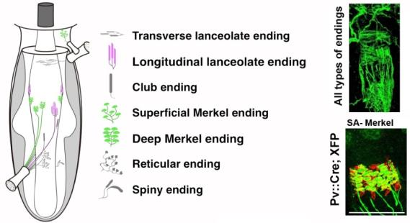

**Figure 1.** **Multiple types of mechanosensory neurons innervate the whisker follicle[29].**

The discovery of genetic markers for different mechanoreceptors, along with the development of intra-axonal recordings and optogenetic tagging methods, has enabled the dissection of the anatomical basis of this diversity[31, 36, 38], and the relations between the morphology, location of a receptor, and detailed neuronal response properties. The close relationship between sensor mechanics and neural coding leads directly to the question of how whisker movement is represented in the spiking activity of individual TG neurons. Severson et. al.[36] addressed this question significantly and found that most recorded TG neurons, including a large majority of identified Merkel afferents, which are mostly slowly adapting (SA), code for both self-motion and active touch.

Delineating how the different mechanoreceptors influence the activity of cortical neurons is critical since it provides a baseline for understanding how downstream circuits transform the ascending drive and use it as the basis for behaviorally oriented coding. Previous attempts at addressing these issues compared how mechanical signals are encoded in the periphery to how they are encoded in the cortex. It was originally suggested in primates that rapidly adapting (RA) and SA inputs are segregated into labeled lines [39]. However, recent studies have shown that most neurons in primates' somatosensory cortex receive convergent RA and SA inputs [40, 41].

Previous attempts at addressing these issues in the whisker somatosensory system, compared how mechanical signals are encoded in the periphery to how they are encoded in the cortex[42]. These studies have shown in one respect that encoding in the cortex and periphery are similar. Information about bending moment and its rate of change is preserved across the ascending pathway, suggesting that these are essential mechanical variables underlying touch-based behavior [19, 43-49]. In contrast, it has been shown in many occasions that the barrel cortex has distinct functions beyond the simple transmission of peripheral whiskers' self-motion and touch information: *First*, whisking elicits robust ‘self-motion’ activity in mechanoreceptors [23, 36, 47, 50, 51]. These signals are markedly attenuated in extragranular layers in the barrel cortex [46, 52]. *Second*, the activity of cortical neurons is strongly influenced by non-sensory inputs[46] which is likely stem of motor origin[53] and S2 contribution[54]. *Third*, Compared to mechanoreceptors and thalamic neurons, cortical neurons display sensitivity to multiple spatiotemporal tactile features rather than a single one [42],[55]. *Fourth*, barrel cortical neurons in rodents exhibit non-sensory driven spiking, which correlates with animal choice[6, 56-58]; *Fifth,* barrel cortical neuronal responses depend on their location [59] and to where these neurons send their projections [60] [61, 62]. *Finally*, Stüttgen et al. [63] devised an alternative approach to study the functional role of mechanoreceptors that suggested that psychophysical channels mediating the detection of whisker deflection are based on the response properties of different mechanoreceptors.

***The proposed research aims to characterize the mechanoelectrical transformation of tactile inputs and whisker motion of two types of mechanoreceptors and their relative contributions to sensorimotor tasks.*** Despite notable progress in understanding mechanoelectrical transformations [36], the specific roles of the various mechanoreceptors that innervate the whisker follicle are poorly understood. **We posit that distributed coding of tactile information is mediated through the different types of mechanosensory neurons. The tactile aspects transmitted through each receptor will be revealed while whisking against objects with complex shapes/texture.**

Some of these channels converge upon arrival at the cortex since numerous barrel cortical neurons are sensitive to multiple kinetic and kinematic features [48, 64]. However, some studies support the notion of interspersed separate processing streams for various characteristics of the tactile environment in the somatosensory cortex of rodents [63, 65, 66]. Our preliminary data presents new experimental data showing that ***specific types of mechanoreceptors activate a subset of cortical neurons. These findings support the concept of separate tactile channels reaching the cortex,*** *the feasibility of the proposed experiments, and our argument that they will yield new insights into the functional circuitry of the somatosensory system.*

**2. Research Objectives and Expected Significance**

The collective activity of mechanosensory neurons within the whisker follicle is essential for processing tactile information. It is well established that different mechanoreceptors carry diverse kinetic and kinematic aspects of whisker motion; however, their role in tactile information processing remains largely unknown.

This project aims to study the role of the different mechanoreceptors on several functional levels in awake-behaving mice. We will use optogenetic tagging that will allow us to record spikes from single genetically identified TG neurons during behavior. This method will allow us to examine the mechanoelectrical transformation in various mechanoreceptors in the whisker follicle. By concurrently recording cortical activity, we will be able to examine how the transmission of tactile information through the different mechanoreceptors affects cortical neuronal response properties and their role in sensorimotor processing in awake-behaving mice. Using molecular, electrophysiological, and imaging techniques *in vivo*, we will seek to achieve the following specific aims:

**Specific Aim Set 1: *The Mechanoelectrical Transformation in the Different Mechanoreceptors.***

We created two mice lines (in collaboration with Prof. Fan Wang) to implement optogenetic tagging that will allow us to record spikes from single genetically identified afferents during behavior: Merkel-cell-associated SA tagged and Club-like and lanceolate receptors RA tagged afferents (*see preliminary results*). We will obtain electrophysiological recordings from these afferents in awake mice while they whisk freely in the air and against various complex surfaces as they run on a treadmill, generating mechanical signals at the whisker base. This characterization will go beyond a description of responses to passively applied stimuli or whisking against simple objects but rather involves multiple dynamic representations that are context and behaviorally dependent. *The results of these experiments will provide a quantitative description of the mechanoelectrical transformation in different tactile channels originating from the whisker follicle.*

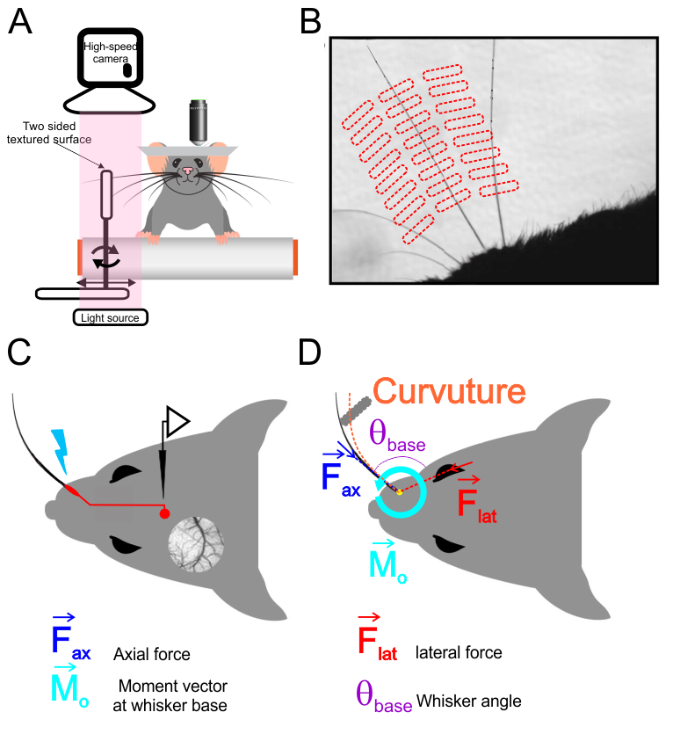

**Figure 2.** **Schematic of experimental setup**. (A) A mouse whisked against a small vertical surface while head-fixed and running on a treadmill. High-speed video of whiskers was obtained at the same time as electrophysiological recordings from TG neurons or cortical two photon Ca2+ imaging. (B) Image from high-speed video overlaid with example grid showing the set of surface locations used during one afferent recording. (C) Schematic of in vivo identification of Merkel-associated afferents by optogenetic tagging. (D) Schematic view showing a whisker in contact with the surface. Whisker-pole contact force can be decomposed into several components. The magnitudes of these forces and of the bending moment induced by were estimated for each video frame

**Specific Aim Set 2: *The Influence of the Different Mechanoreceptors on Cortical Neuronal Function.***

Cortical neurons integrate information from multiple sources. Nevertheless, using two-photon Ca2+ imaging and electrophysiological recording from layers 2/3 and 4 cortical neurons, we found that the optical stimulation of the different tagged mechanoreceptors leads to an activation of distinct neuronal pools in the barrel cortex (*see preliminary results*). Once we identify the cortical neurons activated by afferent stimulation, we will be able to examine the dissemination of this information throughout the cortex and the spatiotemporal patterns of cortical activation resulting from it in awake mice as they whisk freely in the air and against various complex surfaces. Finally, we will use trans-synaptic anterograde tracers to map these mechanosensory channels. *These characterizations will enable us to decipher the dynamic role of the different mechanoreceptors in transforming tactile information into spatiotemporal cortical neuron activation patterns.*

**Specific Aim Set 3: *The Role of the Different Mechanoreceptors Signaling in Sensorimotor Behavior.***

To examine the degree to which the different mechanoreceptors have any functional role in sensorimotor behavior, we will use awake, head-fixed animals trained in a rough-smooth surface discrimination task. To determine the mechanoreceptors' functional role in sensory perception and decision, we will transiently inactivate them during active touch. Moreover, using optical activation, we can create patterns of illusory surfaces and determine whether their activation is sufficient or necessary for perceptual decisions.

Together, these experiments will provide direct information on how the somatosensory system copes with multifaceted and complex tactile signals. Such information is essential to understanding the functional circuitry that underlies critical components of sensory information processing. The study may facilitate an understanding how sensory systems encode and store information during natural behavior.

**3. Detailed Description of proposed research**

**Specific Aim Set 1:** ***The Mechanoelectrical Transformation in the Different Mechanoreceptors.*** As mentioned above, TG touch neurons form specialized sensory endings arranged in a stereotyped pattern along each vibrissa follicle (Fig. 1); functionally, they primarily belong to two main categories: SA and RA touch sensory neurons. In collaboration with Prof. Fan Wang (*see preliminary results and methods sections*), we developed two mice lines expressing optogenetic tools in two largely non-overlapping populations of touch receptors innervating whisker follicles: The first is a **PVCre** line, which are Merkel-cell-associated SA afferents[29]. The second is the NetrinG-1 (Ntng1) gene (**Ntng1Cre** mouse) which are Club-like and Lanceolate receptors RA afferents (figure 3). We crossed these lines with RosaAi32/Ai32 (mice expressing channelrhodopsin-2/EYFP fusion protein (Chr2) fusion protein).

**Experiment set 1:** ***Record from Mechanosensory Afferents during Whisking and Active Touch and Characterize their Mechanoelectrical Transformations.***We will obtain electrophysiological recordings from Merkel, and Club-like/Lanceolate afferents that innervate the whisker follicle. The optogenetic tagging approach will allow us to record spikes from single genetically identified afferents in awake mice (Figure 2). Mice will whisk freely in the air and against a textured surface presented at multiple locations and distances as they run on a treadmill, generating mechanical signals at the whisker base (Figure 2D). We will use this experimental configuration since locomotion significantly enhances barrel cortex activity across layers[67]. Whisker movements will be measured in response to a smooth surface and sandpaper of two different grades (from coarse-grained to fine-grained; grain sizes in parentheses in microns): P220 (68), P800 (21). High-speed (1000 fps) video of the whisker combined with electromyogram (EMG) data from two major muscle groups that control whisking [28, 68], the intrinsic protractor and m. nasolabialis muscles.

Post hoc measurements of whisker shape [19, 20] will allow us to estimate mechanical variables expected to cause spiking. We will align spike times from single afferents with mechanical time series of the following *kinematic characteristics of whisker movements*: angular position, velocity, acceleration, and jerk (the rate of change of acceleration) of the whisker. In addition, we will measure the following *kinetic characteristics*: axial and lateral force pushing the whisker into the follicle and along the face, respectively. Finally, we will measure the bending moment resulting from whisker-surface interactions in the plane of video imaging. We will use the Generalized Additive Models (GAMs; see methods section) to quantify the “instantaneous” relationship between spike probability and various mechanical and kinematic variables.

***Possible Outcomes:*** We believe a sizeable tactile stimulus space will give us a more accurate description of tactile transformation. The previous study[36] used whisking and pole touching to characterize these Mechanoelectrical transformations. However, whisking against surfaces with more complex shapes/textures and different locations and distances involves dynamic effects such as slip-sticks[69].

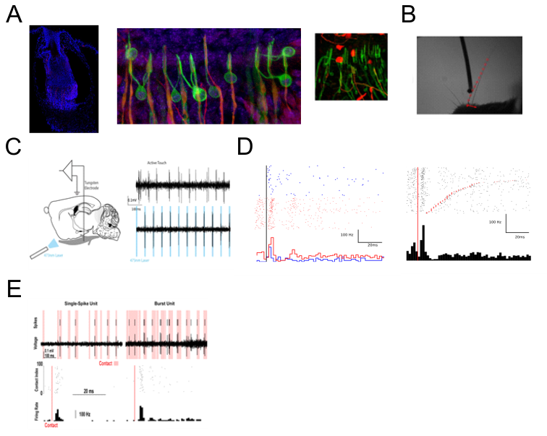

C

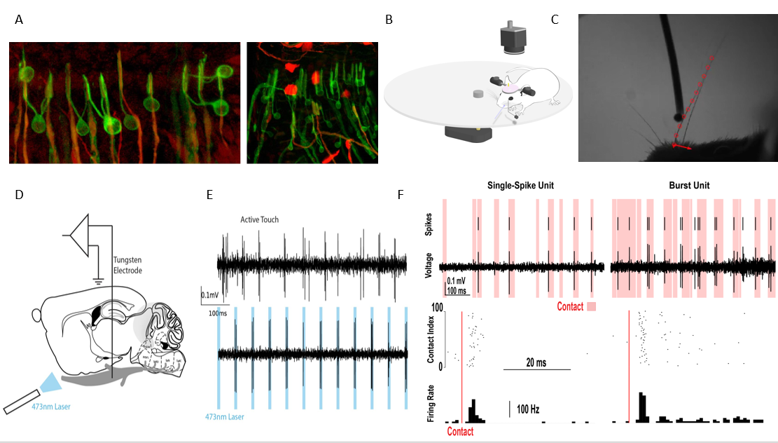

D E

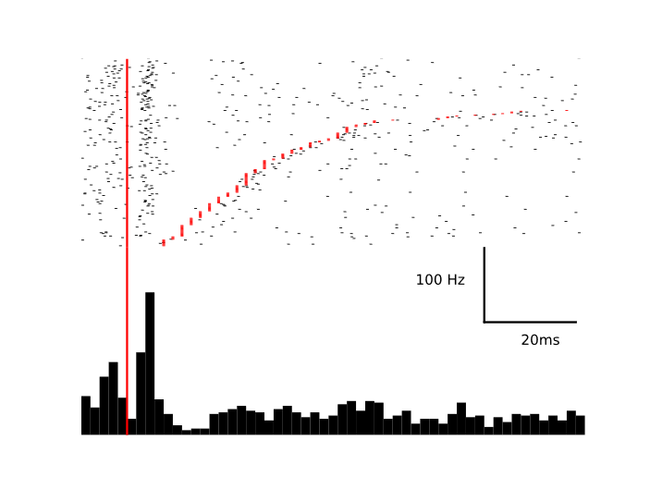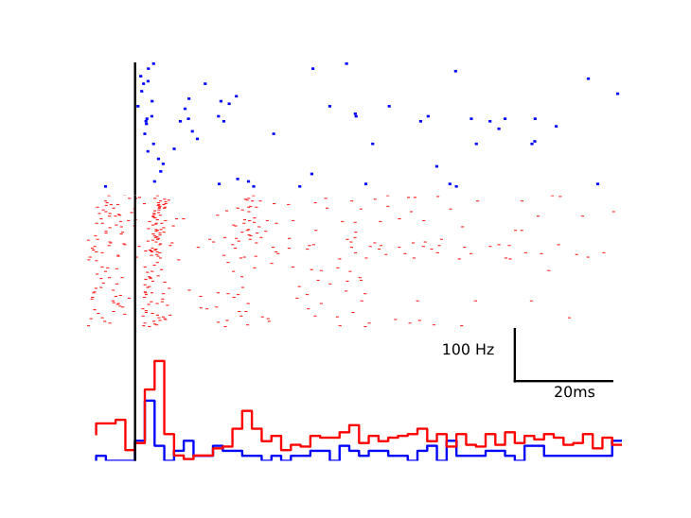

F



**Figure 3.** (**A**) **Ntng1Cre labels rapidly adapting mechanoreceptors (**left panel**)**. We crossed ntng1Cre mice with a tdTomato reporter line to quantify whisker pad expression for different receptors. Most of labeled endings were Club-like (middle) and lanceolate (right) endings shown in red alongside cells that express S100 (green). (**B**) High speed camera image with tracked mouse whisker (red circles), and force vectors calculated from whisker positions (red arrows). (**C**) Recording scheme showing electrode in trigeminal ganglion and laser directed to whisker follicle. A “phototagged” neuron that responds to active touch (top) and pulses of laser (bottom). (**D**) Photo identified ntng1 neurons show contact induced firing and rapid adaptation. Single trial spike raster (top) and trial average peri-event time histogram (bottom) aligned to pole contact (red line). (**E**) NTG1+ neurons show direction selectivity to contact. Single trial spike rasters (top) for protraction (blue) and retraction (red) for the same pole location. Trial average responses (bottom) show that while both directions cause an increased firing rate, this neuron fires more frequently with retractive touch. (**F**) Example neuron that responds only during some contacts (left) with a single spike and another example unit that responds with bursts of spikes more frequently (right). Both are rapidly adapting to touch

A mouse whisked against a small vertical surface while head-fixed and running on a treadmill. High-speed video of whiskers was obtained at the same time as electrophysiological recordings from TG neurons or cortical two photon Ca2+ imaging. (B) Image from high-speed video overlaid with example grid showing the set of surface locations used during one afferent recording. (C) Schematic of in vivo identification of Merkel-associated afferents by optogenetic tagging. (D) Schematic view showing a whisker in contact with the surface. Whisker-pole contact force can be decomposed into several components. The magnitudes of these forces and of the bending moment induced by were estimated for each video frame

***Potential Pitfalls:*** From our experience in the last six months with this type of recording, we found that the yield of these recordings is meager. To increase our yield, since all specific afferents are tagged, we will keep all whiskers in row C intact, thereby increasing our chances for a recording. Recording from head-fixed is inherently problematic since the whisking strategy may differ from free-running mice. Thus, we may not capture the whole whisker behavior and, as a result, their full Mechanoelectrical transformation.

***Preliminary Results:***

We created two mice lines (in collaboration with Prof. Fan Wang) to implement optogenetic tagging that will allow us to record spikes from single genetically identified afferents during behavior. We expressed optogenetic tools in two largely non-overlapping populations of touch receptors innervating whisker follicles: Parvalbumin (PV) positive versus netrin-G1 (ntng1) positive receptors. It was shown by our collaborator that PV is primarily expressed in SA Merkel-ending neurons innervating the large whiskers[29]. Whereas Netrin G1 (Ntng1) gene is expressed in A-fiber touch receptors primarily club endings, with occasional labeling of lanceolate and reticular endings in the whisker follicle (Fig. 3A) that are likely RA receptors and are largely non-overlapping with PV-expressing neurons[70].

*Club Endings RA neurons*

To examine the mechanoelectrical transformation of club and lanceolate endings we crossed the Ntng1Cre line with RosaAi32/Ai32 line. We then made single unit recordings from photo-identified neurons in awake, behaving mice. Head-fixed mice were trained to run on a circular treadmill and whisk against a pole. A tungsten electrode was lowered into the trigeminal ganglion until a whisker-responsive neuron was well-isolated. After recording neuronal activity and whisker positions during active touch with a high-speed camera, a blue laser was directed at the whisker follicle to photo-identify the unit (Figure 3C). RA units were found to be light responsive. ***We recorded from 23 units during active touch that were found to be ntng1 by photo-identification.***

All units showed heightened activity during touch. Most units displayed the greatest increase in firing rate immediately after contact (Figure 3D). However, some units responded most after periods of prolonged contact, or with the initial increase in activity, suppression, and increased activity again before the end of touch. All units displayed sparse firing, consistent with rapid adaptation. Generally, units showed strong direction selectivity (Figure 3E).

We next examined the kinematic or mechanical variables that could best explain these afferents' firing properties. This analysis is still ongoing (data not shown). Shortly, we quantified the contact-induced mechanical changes in the follicle during active touch. An active touch against a pole causes a normal force against the contact point of the whisker, which can be decomposed into lateral and axial components at the whisker follicle, and produces a bending moment. These variables have been shown to provide explanatory power for the firing of slowly adapting afferents. During contact, the moment at the follicle greatly influenced the spiking probability. However, the probability of spiking of the photo-identified was not always monotonically increasing with the moment. There was often a local maximum at small values that would be seen at the onset of touch. Touch induces not only such quasi-static forces but also dynamical forces that are proportional to the velocity of the contact. Such velocity tuning could better explain some firing of the photo-identified units. In these cases, the spiking probability was often monotonically related to the speed of the whisker at contact, indicating that these neurons were more selective for larger dynamical forces. To further extend this analysis, we are now in the process of recording the responses of these neurons to textures (Figure 2).

*Merkel Ending SA neurons*

To examine the mechanoelectrical transformation of Merkel endings we crossed the PVCre line with RosaAi32/Ai32 line. We use the same approach as in the RA neurons (see above). ***We recorded from 5 units during active touch that were found to be PV by photo-identification.*** These experiments are ongoing. However, we observed that in some sessions, the neurons respond to self-motion and surface touch (Figure 4).

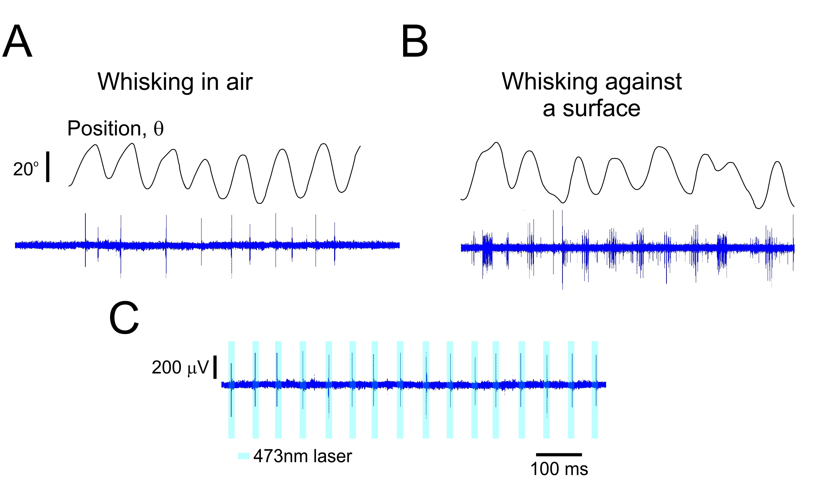

**Figure 4.** **Merkel and Unidentified Afferents Respond to Both Active Touch and Self Motion.** (**A**) Example time series for a Merkel afferent during whisking in air and against a textured surface (**B**). The upper panels show the whisker angular position (θ). The lower panels show the responses of PV-tagged TG neurons. (**C**). the response of the neuron to laser stimuli.

**Specific Aim Set 2:** ***The Influence of the Different Mechanoreceptors on Cortical Neuronal Function.*** Intracortical processing integrates, elaborates, and distributes elemental sensory signals to construct perception. We posit that diverse subsets of neurons receive a predominant portion of their inputs from specific mechanosensory channels (see preliminary results). We will use the two mechanosensory tagged mice lines (see above) and cross these lines with RosaAi32/Ai32 and RosaAi39/Ai39 (mice expressing Halorhodopsin/EYFP (HR) fusion protein). We will initially determine the specific cortical neurons activated directly by stimulating the tagged afferent and the spatiotemporal patterns of cortical activation resulting from it. We will then monitor the activity of these neuronal pools in awake mice while they whisk freely in the air and against various complex surfaces as they run on a treadmill and determine the tactile properties conveyed by these neurons and the information they disseminate to nearby neurons. We will employ several recording techniques. Each one examines different spatial and temporal scales, from recording calcium transients from multiple neurons using two-photon Ca2+ imaging and electrophysiological recording from layers 2/3 and 4 cortical neurons. Finally, we will use trans-synaptic anterograde tracers to map these mechanosensory channels.

**Experiment set 1:** ***Identify and Record from Cortical Neuron Responding to Mechanoreceptor Stimulation using Two-Photon Ca2+ Imaging.*** We will initially determine the specific cortical neurons activated directly by stimulating the tagged afferent and the spatiotemporal patterns of cortical activation resulting from it in awake, non-whisking mice having a *single whisker*. We will determine the "***primary***" neurons activated by the optogenetic stimulus to the follicle. Two main criteria will be used to select these neurons in response to stimulation: response latency and response probability (see preliminary results and methods section). *Once this is established, we will determine the spatiotemporal relations between the primary neurons and all activated neurons*. The treadmill will start moving at that point, resulting in whisker movement in the air and across the different textures. Post hoc measurements of whisker movement kinematic and kinetic characteristics will allow us to estimate the transformation of mechanical variables into cortical *primary* and other neuronal activity in natural conditions. (Figure 2).

***Possible Outcomes:*** Our preliminary results show the existence of primary neurons and the fundamental interactions between these neurons and other cortical neurons (Figure. XX). We believe that when it comes to object touch, cortical neurons faithfully transmit the mechanoreceptors' signals. However, whisker movement and texture responses depend on various dynamic influences such as stick-slip magnitude.

***Potential Pitfalls:*** *Same as Specific Aim Set 2.* While we can record from multiple neurons within the barrel, which will enable us to determine the spatial interaction, we are limited in the temporal domain due to the low temporal resolution of the calcium signal (*see experiment set 2*). Moreover, due to the nature of the calcium recording that reflects mostly suprathreshold responses, neurons that respond with robust post-synaptic potentials (PSP) but do not spike will be missed (*see experiment set 3*). Finally, optogenetic stimuli to the follicle may cause a synchronized afferent volley that may result in an inaccurate estimation of the functional connectivity (*see experiment set 3*).

**Experiment set 2:** ***Identify and Record from Cortical Neuron Responding to Mechanoreceptor Stimulation using extracellular recording.***The experimental paradigm is similar to experiment set 1, except that we will record chronically with a multi-electrodes extracellular recording (see methods section). This technique will enable us to quantify the neuronal responses and interactions at higher temporal resolution.

**Experiment set 3:*****Examine the Synaptic and Cellular Mechanisms that Mediate Cortical Responses.*** The experimental paradigm is similar to experiment set 1, except that we will use whole-cell patch recording in layers 2/3 and 4 of the barrel cortex (see methods section) and, in some instances, employ "shadow patching" with the two-photon Ca2+ imaging to identify ***primary*** neurons. Using this technique, we will be able to examine the relative synaptic inputs coming from the specific receptors as well as the synaptic and intrinsic mechanisms underlying the responses to natural stimuli. These experiments will add important new information regarding the mechanisms of synaptic integration in cortical neurons in vivo. Such information is essential to understanding the organization and function of cortical microcircuits thought to be the building blocks of higher cortical function.

**Experiment set 4:*****Determine the Anatomical Pathway from the Different Mechanoreceptors to the Cortex.*** To map the output pathways of genetically marked mechanoreceptors, we will use a cre-dependent, anterograde transsynaptic viral tracer based on the h129 strain of the herpes simplex virus. Application of this virus to transgenic or knockin mice expressing cre in peripheral neurons will reveal the spread, polysynaptic labeling of higher-order neurons in the somatosensory system[71].

***Preliminary Results:***

***Two-Photon Ca2+ Imaging***

***Extracellular recording.***

**Specific Aim Set 3:** ***Examine the Role of the Different Mechanoreceptors Signaling in Sensorimotor Behavior.***

To examine the degree to which the different mechanoreceptors have any functional role in sensory perception and discrimination.

**Experiment set 1:** ***The Influence of the Different Mechanoreceptors on Gratings Discrimination.*** The experimental paradigm is similar to Specific Aim Set 2, except we will examine neural coding in single-unit recordings from S1 or two-photon Ca2+ imaging while mice perform a rough-smooth surface discrimination task with active whisking [48, 72]. Surfaces included raised gratings (0.5, 1, 2, and 4 mm spatial period). 0.5 mm is termed "Smooth", and the other surfaces are collectively called "Rough". *These stimuli were chosen since they will enable us to compare similar stimuli differencing only in one aspect (spatial frequency).* One randomly chosen surface will be presented per trial. Mice will be trained operantly to lick to Smooth stimuli (**Go** stimuli) and withhold licking to any of the Rough stimuli (**NoGo** stimulus). In about 10% of trials, the stimulus will be kept just out of reach, allowing mice to whisk in air. Once the mouse reaches high performance (approximately 75% correct; see preliminary data), we will modify surface location and distance to modify the forces acting on the follicle. For each neuron in general and primary neurons in particular, we will analyze the relationship between spiking and the kinetic and kinematic variable for the whisker and the relation between these variables and the decision of the mice [6].

**Experiment set 2:** ***Inactivation of the*** ***Different Mechanoreceptors.*** The experimental paradigm is similar to Specific Aim Set 2, except we will have the two mice lines mate with RosaAi39/Ai39 line to enable the inactivation of the specific mechanoreceptors. Once the mice reach high performance (see above), we will examine whether transient inactivation of the different mechanoreceptors alters animals’ acuity in object gratings, location and distance and whether behavioral strategies and whisker kinematics are modified by the separate channels and their temporal constraints.

**Experiment set 3:** ***Illusory Surfaces.*** The experimental paradigm is similar to Specific Aim Set 2, except we will have the two mice lines mate with RosaAi32/Ai32 line to enable the activation of the specific mechanoreceptors. Using optical activation, we can create patterns of illusory surfaces (*taken from whisker movements across the different gratings in experiment set 1*) that corresponds to Smooth and Rough gratings at different locations and distances and determine whether their activation is sufficient or necessary for grating discrimination and whether the whisking phase and stimulus intensity influence it. Alternatively, during smooth-rough discrimination experiments, we will introduce laser pulses, which will activate the receptors and interfere with the patterns sensed by the animal.

***Preliminary Results:***

**General Experimental Methods**

However, if we use PVCre Ntng1Cre to drive ChR2 or HR expressions, the opsins will be expressed in both primary afferents and second-order neurons. To overcome this problem, we used the Advillin gene, which is largely restricted to primary sensory neurons [73, 74]. We used an intersectional strategy by generating Advillin-Flipase (Advillin-Flp) line. In mice carrying the PvCre or Ntng1Cre allele, an Advillin-Flipase allele, and an Flp/Cre double-dependent allele (triple transgenic mice), the desired gene was specifically expressed in Pv-expressing (or Ntng1-expressing) mechanosensory neurons.

***Surgery.*** Adult mice (6-8 weeks old; 20-30 gr.) will be implanted with headposts. Briefly, mice will be anesthetized (1–2% isoflurane in O2) and mounted in a stereotaxic apparatus. Body temperature will be maintained with a thermal blanket. For TG recordings, a craniotomy of 0.5 mm×2 mm (medial-lateral, anterior-posterior) will be made over the left hemisphere, centered at 1.0 mm anterior and 1.5 mm lateral to Bregma. Dura will be left intact. Craniotomy will be covered acutely with a gelatin sponge under a layer of dental acrylic. For the TPLM recordings, a circular craniotomy will be made over the left barrel cortex (2.5 mm diameter; center relative to Bregma: lateral, 3.5 mm; posterior, 1.3 mm) of mice. The dura will be left intact. After the virus injection, the craniotomy will be covered with an imaging window by gluing together two pieces of microscope cover glass. Intrinsic signal imaging will be performed through the window during the surgery to localize a barrel column within the cranial window. For chronic electrophysiological recordings, a multielectrode holder will be implanted after the localization of the specific barrel.

***Intrinsic Optical Imaging.*** The principle whisker will be identified using intrinsic optical imaging[75]. Functional imaging was performed using a Qcam CCD camera (Q-imaging, Canada) equipped with a tandem lens system. The surface blood vessel pattern was imaged for reference. Image acquisition of the reflectance changes in the hemodynamic signal and analysis were made using a frame grabber and custom software written in our lab in the Matlab software. Images were acquired at 10 Hz frame rate with a 2X2 binning (~300X300 pixels, 7.4 μm pixel size).

**AAV-synapsin1-GCaMP6 injection.** Adult mice (P42–56) will be anesthetized and injected with AAV-synapsin1-GCaMP6s (AAV-6s) or AAV-synapsin1-GCaMP6f (AAV-6f) into the barrel cortex (4 injections, 30 nl each; [76]). Mice will be implanted with a cranial window. The injected mice will be used after 3–4 weeks post-injection.

***Two Photon Laser Microscopy.*** Two-photon imaging will be performed using a Prairie two photon laser scanning microscope (TPLSM) platform (Prairie Technologies, Wisconsin, USA) equipped with a Ti: Saphire laser excitation (Spectra Physics) and a 40X water immersion objective lens (0.8 NA, Olympus). The combination of this method with high resolution patch clamp recording from single cells is a powerful tool for the correlation of the single cell activity and the network activity.

***Whole cell recording and staining methods.*** Intracellular voltage and current clamp recordings will be obtained with patch pipettes electrodes (5-12 MΏ) using an Axoclamp 2B amplifier (Axon). Patch electrodes will be filled with intracellular solution consisting of (in mM) 115 K+-gluconate, 20 KCl, 2 Mg-ATP, 2 Na2-ATP, 10 Na2-phosphocreatine, 0.3 GTP, 10 HEPES, pH 7.2. By including Biocytin in the intracellular recording electrode, we will be able to recover the morphology and laminar location of the recorded neurons. In all experiments, the brains will be fixed with paraformaldehyde, sectioned (60-100µm), and stained with standard methods for reconstruction of the neurons and to determine their location in respect to the barrels (cytochrome oxidase).

***Extracellular Recording.*** Neuronexus multielectrode silicone probes will be used. The recorded signals will be amplified (1k), band-pass filtered (LFP: 1Hz-150Hz; Single unit: 500Hz-10kHz), digitized (25 kHz/channel)and stored for off-line spike sorting and analysis.

***Electromyogram***. To record the vibrissal electromyogram (EMGs), a pair of bipolar EMG electrodes (76 μm Teflon-coated stainless steel wire) were tunneled subcutaneously into the deep intrinsic muscles through a small incision in the face as previously described [77, 78]. Microwires were also placed subcutaneously in the fibers of the extrinsic musculature [28, 79]. EMG recordings were sampled at 25 kHz and filtered (0.1 Hz to 10 kHz).

***Anterograde Transsynaptic staining.***

***Behavioral Training and Apparatus.*** Mice received 1 mL/day of water for ≥ 7 days prior to training. Mice were head-fixed and placed on a custom linear treadmill in order to promote whisking, because mice whisk as they run. Running was encouraged by providing water reward following voluntary bouts of running. Water was delivered via a custom “lickport” under control of homemade software. A textured surface or gratings covered surface were oriented vertically and placed in range of the whiskers (Figure 2). The top of the surface was elevated above the remaining whiskers but remained within the depth of high-speed video focus. The X-Y position of the surface was controlled via translation stages.

We will employ a modified version of the Go/NoGo task used by O'Connor et al. (2010), in which the mice are required to perform a rough-smooth surface discrimination task with active whisking [48, 72]. Surfaces included raised gratings (0.5, 1, 2, and 4 mm spatial period). 0.5 mm is termed "Smooth", and the other surfaces are collectively called "Rough". One randomly chosen surface will be presented per trial. Mice will be trained operantly to lick to Smooth stimuli (**Go** stimuli) and withhold licking to any of the Rough stimuli (**NoGo** stimulus). In about 10% of trials, the stimulus will be kept just out of reach, allowing mice to whisk in air. Once the mouse reaches high performance (approximately 75% correct; see preliminary data), we will modify surface location and distance to modify the forces acting on the follicle.

***Data Analysis***

***Spike extraction and sorting:*** We separate the recorded signal to local field potentials (LFP; 1-150Hz), and isolated single-unit activity(SUA; 0.5-10Khz). Spike extraction and sorting of multiple units in tetrode data are accomplished with the use a modified version of MClust based spike-sorting software (**Fig. 16**).

***Quantification of the forces and moments exerted by whiskers:*** Whisker shape will be extracted from each video. The kinematic and mechanical variables of contact will be computed from the whisker shape[20, 80].

***Comparison of neurometric and psychometric sensitivity:*** We will employ the approach used by Stuttgen et al., [81] in which psychophysical data will be assessed as response-probabilities. This will be converted into sensitivity *d′* To compare psychometric with neurometric sensitivities *d′* values will be converted to area under the receiver operating curve [82].

***Information theoretic analysis***: To quantify the information extracted by neuronal response function about the different features sensory stimulation as well as the rat about textures features and the way these features interact on a trial by trial basis, we will perform mutual information analysis[83].

#### **Generalized Additive Models:** We used statistical models to quantify the “instantaneous” (in 1ms time bins) relationship between spike probability and various mechanical and kinematic variables. We fitted GAMs using the “mgcv” package in R language [84]

***Available Resources:*** The laboratory has two fully equipped sets for acute *in vivo* extracellular and whole-cell recording and staining. Each set includes stereotactic apparatus used with dissecting microscope. Multiple amplifiers for extracellular and intracellular recordings. Additionally, the lab has a patch-clamp slice physiology system, based on an Olympus fluorescence microscope, Sutter micromanipulators, Axon amplifiers and Axopatch software. It is also integrated with an optogenetic setup. A vibratome unit is also available for production of live brain slices for patch clamp experiments. For the awake mice studies, we have two separate rooms, which include home-build head-fixed setups. The setups are equipped with multiple fast-speed cameras and amplifiers for extracellular and whole-cell recordings. One of the setup is equipped with a two-photon imaging system (Bruker) that will enable us to image Ca2+ in the cortex. Finally, we have another setup equipped with Intrinsic Optical Imaging camera to determine the exact location of virus injection in the cortex.A room for histology work includes a sliding microtome, a microscope equipped with epifluorescence and camera lucida. The laboratory includes the equipment and expertise necessary for preparing and testing constructs and viruses for optogenetic experiments. The lab employs a full-time technician trained in a wide range of anatomical techniques and genotyping procedures.

**BIBLIOGRAPHY**

1. Kleinfeld, D., Ahissar, E., and Diamond, M.E. (2006). Active sensation: insights from the rodent vibrissa sensorimotor system. Curr Opin Neurobiol *16*, 435-444.

2. Brecht, M., Preilowski, B., and Merzenich, M.M. (1997). Functional architecture of the mystacial vibrissae. Behav Brain Res *84*, 81-97.

3. Knutsen, P.M., and Ahissar, E. (2009). Orthogonal coding of object location. Trends Neurosci *32*, 101-109.

4. Mehta, S.B., Whitmer, D., Figueroa, R., Williams, B.A., and Kleinfeld, D. (2007). Active spatial perception in the vibrissa scanning sensorimotor system. PLoS Biol *5*, e15.

5. Kleinfeld, D., and Deschenes, M. (2011). Neuronal basis for object location in the vibrissa scanning sensorimotor system. Neuron *72*, 455-468.

6. Rodgers, C.C., Nogueira, R., Pil, B.C., Greeman, E.A., Park, J.M., Hong, Y.K., Fusi, S., and Bruno, R.M. (2021). Sensorimotor strategies and neuronal representations for shape discrimination. Neuron *109*, 2308-2325.e2310.

7. Harvey, M.A., Bermejo, R., and Zeigler, H.P. (2001). Discriminative whisking in the head-fixed rat: optoelectronic monitoring during tactile detection and discrimination tasks. Somatosens Mot Res *18*, 211-222.

8. Krupa, D.J., Matell, M.S., Brisben, A.J., Oliveira, L.M., and Nicolelis, M.A. (2001). Behavioral properties of the trigeminal somatosensory system in rats performing whisker-dependent tactile discriminations. J Neurosci *21*, 5752-5763.

9. Carvell, G.E., and Simons, D.J. (1990). Biometric analyses of vibrissal tactile discrimination in the rat. J Neurosci *10*, 2638-2648.

10. Diamond, M.E. (2010). Texture sensation through the fingertips and the whiskers. Current Opinion in Neurobiology *20*, 319-327.

11. Jadhav, S.P., and Feldman, D.E. (2010). Texture coding in the whisker system. Curr Opin Neurobiol *20*, 313-318.

12. Morita, T., Kang, H., Wolfe, J., Jadhav, S.P., and Feldman, D.E. (2011). Psychometric curve and behavioral strategies for whisker-based texture discrimination in rats. PLoS One *6*, e20437.

13. Diamond, M.E., von Heimendahl, M., Knutsen, P.M., Kleinfeld, D., and Ahissar, E. (2008). 'Where' and 'what' in the whisker sensorimotor system. Nat Rev Neurosci *9*, 601-612.

14. Lottem, E., and Azouz, R. (2009). Mechanisms of tactile information transmission through whisker vibrations. J Neurosci *29*, 11686-11697.

15. Kuruppath, P., Gugig, E., and Azouz, R. (2014). Microvibrissae-based texture discrimination. J Neurosci *34*, 5115-5120.

16. Towal, R.B., Quist, B.W., Gopal, V., Solomon, J.H., and Hartmann, M.J. (2011). The morphology of the rat vibrissal array: a model for quantifying spatiotemporal patterns of whisker-object contact. PLoS Comput Biol *7*, e1001120.

17. Hires, S.A., Pammer, L., Svoboda, K., and Golomb, D. (2013). Tapered whiskers are required for active tactile sensation. Elife *2*, e01350.

18. Hartmann, M.J., Johnson, N.J., Towal, R.B., and Assad, C. (2003). Mechanical characteristics of rat vibrissae: resonant frequencies and damping in isolated whiskers and in the awake behaving animal. J Neurosci *23*, 6510-6519.

19. Pammer, L., O'Connor, D.H., Hires, S.A., Clack, N.G., Huber, D., Myers, E.W., and Svoboda, K. (2013). The mechanical variables underlying object localization along the axis of the whisker. J Neurosci *33*, 6726-6741.

20. Birdwell, J.A., Solomon, J.H., Thajchayapong, M., Taylor, M.A., Cheely, M., Towal, R.B., Conradt, J., and Hartmann, M.J. (2007). Biomechanical models for radial distance determination by the rat vibrissal system. J Neurophysiol *98*, 2439-2455.

21. Ebara, S., Kumamoto, K., Matsuura, T., Mazurkiewicz, J.E., and Rice, F.L. (2002). Similarities and differences in the innervation of mystacial vibrissal follicle-sinus complexes in the rat and cat: a confocal microscopic study. J Comp Neurol *449*, 103-119.

22. Stuttgen, M.C., Kullmann, S., and Schwarz, C. (2008). Responses of rat trigeminal ganglion neurons to longitudinal whisker stimulation. J Neurophysiol *100*, 1879-1884.

23. Szwed, M., Bagdasarian, K., and Ahissar, E. (2003). Encoding of vibrissal active touch. Neuron *40*, 621-630.

24. Szwed, M., Bagdasarian, K., Blumenfeld, B., Barak, O., Derdikman, D., and Ahissar, E. (2006). Responses of trigeminal ganglion neurons to the radial distance of contact during active vibrissal touch. J Neurophysiol *95*, 791-802.

25. Solomon, J.H., and Hartmann, M.J. (2011). Radial distance determination in the rat vibrissal system and the effects of Weber's law. Philos Trans R Soc Lond B Biol Sci *366*, 3049-3057.

26. Zucker, E., and Welker, W.I. (1969). Coding of somatic sensory input by vibrissae neurons in the rat's trigeminal ganglion. Brain Res *12*, 138-156.

27. Gibson, J.M., and Welker, W.I. (1983). Quantitative studies of stimulus coding in first-order vibrissa afferents of rats. 1. Receptive field properties and threshold distributions. Somatosens Res *1*, 51-67.

28. Dorfl, J. (1982). The musculature of the mystacial vibrissae of the white mouse. J Anat *135*, 147-154.

29. Sakurai, K., Akiyama, M., Cai, B., Scott, A., Han, B.X., Takatoh, J., Sigrist, M., Arber, S., and Wang, F. (2013). The organization of submodality-specific touch afferent inputs in the vibrissa column. Cell Rep *5*, 87-98.

30. Rice, F.L. (1993). Structure, vascularization, and innervation of the mystacial pad of the rat as revealed by the lectin griffonia simplicifolia. Journal of Comparative Neurology *337*, 386-399.

31. Tonomura, S., Ebara, S., Bagdasarian, K., Uta, D., Ahissar, E., Meir, I., Lampl, I., Kuroda, D., Furuta, T., Furue, H., et al. (2015). Structure-function correlations of rat trigeminal primary neurons: Emphasis on club-like endings, a vibrissal mechanoreceptor. Proceedings of the Japan Academy Series B: Physical and Biological Sciences *91*, 560-576.

32. Rice, F.L., Mance, A., and Munger, B.L. (1986). A comparative light microscopic analysis of the sensory innervation of the mystacial pad. I. Innervation of vibrissal follicle-sinus complexes. The Journal of Comparative Neurology *252*, 154-174.

33. Welker, E., and Van der Loos, H. (1986). Quantitative correlation between barrel-field size and the sensory innervation of the whiskerpad: a comparative study in six strains of mice bred for different patterns of mystacial vibrissae. J Neurosci *6*, 3355-3373.

34. Mitchinson, B., Gurney, K.N., Redgrave, P., Melhuish, C., Pipe, A.G., Pearson, M., Gilhespy, I., and Prescott, T.J. (2004). Empirically inspired simulated electro-mechanical model of the rat mystacial follicle-sinus complex. Proceedings of the Royal Society B: Biological Sciences *271*, 2509-2516.

35. Whiteley, S.J., Knutsen, P.M., Matthews, D.W., and Kleinfeld, D. (2015). Deflection of a vibrissa leads to a gradient of strain across mechanoreceptors in a mystacial follicle. J Neurophysiol *114*, 138-145.

36. Severson, K.S., Xu, D., Van de Loo, M., Bai, L., Ginty, D.D., and O’Connor, D.H. (2017). Active Touch and Self-Motion Encoding by Merkel Cell-Associated Afferents. Neuron *94*, 666-676.e669.

37. Furuta, T., Bush, N.E., Yang, A.E.-T., Ebara, S., Miyazaki, N., Murata, K., Hirai, D., Shibata, K.-i., and Hartmann, M.J.Z. (2020). The Cellular and Mechanical Basis for Response Characteristics of Identified Primary Afferents in the Rat Vibrissal System. Current Biology *30*, 815-826.e815.

38. Takatoh, J., Prevosto, V., and Wang, F. (2018). Vibrissa Sensory Neurons: Linking Distinct Morphology to Specific Physiology and Function. Neuroscience *368*, 109-114.

39. Sur, M., Wall, J.T., and Kaas, J.H. (1984). Modular distribution of neurons with slowly adapting and rapidly adapting responses in area 3b of somatosensory cortex in monkeys. J Neurophysiol *51*, 724-744.

40. Pei, Y.C., Denchev, P.V., Hsiao, S.S., Craig, J.C., and Bensmaia, S.J. (2009). Convergence of submodality-specific input onto neurons in primary somatosensory cortex. J Neurophysiol *102*, 1843-1853.

41. Friedman, R.M., Chen, L.M., and Roe, A.W. (2004). Modality maps within primate somatosensory cortex. Proc Natl Acad Sci U S A *101*, 12724-12729.

42. Bale, M.R., and Maravall, M. (2018). Organization of Sensory Feature Selectivity in the Whisker System. Neuroscience *368*, 70-80.

43. O'Connor, D.H., Peron, S.P., Huber, D., and Svoboda, K. (2010). Neural activity in barrel cortex underlying vibrissa-based object localization in mice. Neuron *67*, 1048-1061.

44. Huber, D., Gutnisky, D.A., Peron, S., O'Connor, D.H., Wiegert, J.S., Tian, L., Oertner, T.G., Looger, L.L., and Svoboda, K. (2012). Multiple dynamic representations in the motor cortex during sensorimotor learning. Nature *484*, 473-478.

45. Petreanu, L., Gutnisky, D.A., Huber, D., Xu, N.L., O'Connor, D.H., Tian, L., Looger, L., and Svoboda, K. (2012). Activity in motor-sensory projections reveals distributed coding in somatosensation. Nature *489*, 299-303.

46. Andrew Hires, S., Gutnisky, D.A., Yu, J., O'Connor, D.H., and Svoboda, K. (2015). Low-noise encoding of active touch by layer 4 in the somatosensory cortex. Elife *4*.

47. Campagner, D., Evans, M.H., Bale, M.R., Erskine, A., and Petersen, R.S. (2016). Prediction of primary somatosensory neuron activity during active tactile exploration. Elife *5*.

48. Sharma, H., and Azouz, R. (2022). Coexisting Neuronal Coding Strategies in the Barrel Cortex. Cereb Cortex.

49. Moore, J.D., Mercer Lindsay, N., Deschênes, M., and Kleinfeld, D. (2015). Vibrissa Self-Motion and Touch Are Reliably Encoded along the Same Somatosensory Pathway from Brainstem through Thalamus. PLOS Biology *13*, e1002253.

50. Leiser, S.C., and Moxon, K.A. (2007). Responses of trigeminal ganglion neurons during natural whisking behaviors in the awake rat. Neuron *53*, 117-133.

51. Khatri, V., Bermejo, R., Brumberg, J.C., Keller, A., and Zeigler, H.P. (2009). Whisking in air: encoding of kinematics by trigeminal ganglion neurons in awake rats. J Neurophysiol *101*, 1836-1846.

52. Yu, J., Gutnisky, D.A., Hires, S.A., and Svoboda, K. (2016). Layer 4 fast-spiking interneurons filter thalamocortical signals during active somatosensation. Nat Neurosci *19*, 1647-1657.

53. Xu, N.L., Harnett, M.T., Williams, S.R., Huber, D., O'Connor, D.H., Svoboda, K., and Magee, J.C. (2012). Nonlinear dendritic integration of sensory and motor input during an active sensing task. Nature *492*, 247-251.

54. Crochet, S., Lee, S.H., and Petersen, C.C.H. (2019). Neural Circuits for Goal-Directed Sensorimotor Transformations. Trends Neurosci *42*, 66-77.

55. Estebanez, L., Férézou, I., Ego-Stengel, V., and Shulz, D.E. (2018). Representation of Tactile Scenes in the Rodent Barrel Cortex. Neuroscience *368*, 81-94.

56. Yang, H., Kwon, S.E., Severson, K.S., and O'Connor, D.H. (2016). Origins of choice-related activity in mouse somatosensory cortex. Nature Neuroscience *19*, 127-134.

57. Zuo, Y., Safaai, H., Notaro, G., Mazzoni, A., Panzeri, S., and Diamond, M.E. (2015). Complementary contributions of spike timing and spike rate to perceptual decisions in rat S1 and S2 cortex. Curr Biol *25*, 357-363.

58. Sachidhanandam, S., Sreenivasan, V., Kyriakatos, A., Kremer, Y., and Petersen, C.C.H. (2013). Membrane potential correlates of sensory perception in mouse barrel cortex. Nature Neuroscience *16*, 1671-1677.

59. Garion, L., Dubin, U., Rubin, Y., Khateb, M., Schiller, Y., Azouz, R., and Schiller, J. (2014). Texture coarseness responsive neurons and their mapping in layer 2-3 of the rat barrel cortex in vivo. Elife *3*, e03405.

60. Chen, J.L., Margolis, D.J., Stankov, A., Sumanovski, L.T., Schneider, B.L., and Helmchen, F. (2015). Pathway-specific reorganization of projection neurons in somatosensory cortex during learning. Nat Neurosci *18*, 1101-1108.

61. Chen, J.L., Carta, S., Soldado-Magraner, J., Schneider, B.L., and Helmchen, F. (2013). Behaviour-dependent recruitment of long-range projection neurons in somatosensory cortex. Nature *499*, 336-340.

62. Yamashita, T., Pala, A., Pedrido, L., Kremer, Y., Welker, E., and Petersen, Carl C.H. (2013). Membrane Potential Dynamics of Neocortical Projection Neurons Driving Target-Specific Signals. Neuron *80*, 1477-1490.

63. Stuttgen, M.C., Ruter, J., and Schwarz, C. (2006). Two psychophysical channels of whisker deflection in rats align with two neuronal classes of primary afferents. J Neurosci *26*, 7933-7941.

64. Maravall, M., Petersen, R.S., Fairhall, A.L., Arabzadeh, E., and Diamond, M.E. (2007). Shifts in coding properties and maintenance of information transmission during adaptation in barrel cortex. PLoS Biol *5*, e19.

65. Estebanez, L., El Boustani, S., Destexhe, A., and Shulz, D.E. (2012). Correlated input reveals coexisting coding schemes in a sensory cortex. Nat Neurosci *15*, 1691-1699.

66. Martini, F.J., Molano-Mazon, M., and Maravall, M. (2017). Interspersed Distribution of Selectivity to Kinematic Stimulus Features in Supragranular Layers of Mouse Barrel Cortex. Cereb Cortex *27*, 3782-3789.

67. Ayaz, A., Stäuble, A., Hamada, M., Wulf, M.-A., Saleem, A.B., and Helmchen, F. (2019). Layer-specific integration of locomotion and sensory information in mouse barrel cortex. Nature Communications *10*, 2585.

68. Haidarliu, S., Simony, E., Golomb, D., and Ahissar, E. (2010). Muscle architecture in the mystacial pad of the rat. Anat Rec (Hoboken) *293*, 1192-1206.

69. Gugig, E., Sharma, H., and Azouz, R. (2020). Gradient of tactile properties in the rat whisker pad. PLOS Biology *18*, e3000699.

70. Usoskin, D., Furlan, A., Islam, S., Abdo, H., Lonnerberg, P., Lou, D., Hjerling-Leffler, J., Haeggstrom, J., Kharchenko, O., Kharchenko, P.V., et al. (2015). Unbiased classification of sensory neuron types by large-scale single-cell RNA sequencing. Nat Neurosci *18*, 145-153.

71. Lo, L., and Anderson, David J. (2011). A Cre-Dependent, Anterograde Transsynaptic Viral Tracer for Mapping Output Pathways of Genetically Marked Neurons. Neuron *72*, 938-950.

72. Isett, B.R., Feasel, S.H., Lane, M.A., and Feldman, D.E. (2018). Slip-Based Coding of Local Shape and Texture in Mouse S1. Neuron *97*, 418-433 e415.

73. Hasegawa, H., Abbott, S., Han, B.X., Qi, Y., and Wang, F. (2007). Analyzing somatosensory axon projections with the sensory neuron-specific Advillin gene. J Neurosci *27*, 14404-14414.

74. da Silva, S., Hasegawa, H., Scott, A., Zhou, X., Wagner, A.K., Han, B.X., and Wang, F. (2011). Proper formation of whisker barrelettes requires periphery-derived Smad4-dependent TGF-beta signaling. Proc Natl Acad Sci U S A *108*, 3395-3400.

75. Grinvald, A., Lieke, E., Frostig, R.D., Gilbert, C.D., and Wiesel, T.N. (1986). Functional architecture of cortex revealed by optical imaging of intrinsic signals. Nature *324*, 361-364.

76. Chen, T.W., Wardill, T.J., Sun, Y., Pulver, S.R., Renninger, S.L., Baohan, A., Schreiter, E.R., Kerr, R.A., Orger, M.B., Jayaraman, V., et al. (2013). Ultrasensitive fluorescent proteins for imaging neuronal activity. Nature *499*, 295-300.

77. Carvell, G.E., Simons, D.J., Lichtenstein, S.H., and Bryant, P. (1991). Electromyographic activity of mystacial pad musculature during whisking behavior in the rat. Somatosens Mot Res *8*, 159-164.

78. Fee, M.S., Mitra, P.P., and Kleinfeld, D. (1997). Central versus peripheral determinants of patterned spike activity in rat vibrissa cortex during whisking. J Neurophysiol *78*, 1144-1149.

79. Wineski, L.E. (1985). Facial morphology and vibrissal movement in the golden hamster. J Morphol *183*, 199-217.

80. Quist, B.W., and Hartmann, M.J. (2012). Mechanical signals at the base of a rat vibrissa: the effect of intrinsic vibrissa curvature and implications for tactile exploration. J Neurophysiol *107*, 2298-2312.

81. Stuttgen, M.C., and Schwarz, C. (2008). Psychophysical and neurometric detection performance under stimulus uncertainty. Nat Neurosci *11*, 1091-1099.

82. Green, D.M., and Swets, J.A. (1966). Signal detection theory and psychophysics. 1966. New York *888*, 889.

83. Ince, R.A., Mazzoni, A., Petersen, R.S., and Panzeri, S. (2010). Open source tools for the information theoretic analysis of neural data. Front Neurosci *4*.

84. Wood, S.N. (2006). Generalized additive models : an introduction with R, (Boca Raton, FL: Chapman & Hall/CRC).