**Analyzing therapy logs: Physical clinical manifestations among children with anxiety disorders during dance movement therapy**

**Abstract**

Attachment theory refers to non-verbal elements that characterize an insecure attachment pattern, such as dependence and attachment, and physical aspects that are associated with symptoms of anxiety. While various studies have also examined physical aspects that shed light on attachment patterns, there is a lack of research identifying and mapping physical manifestations of symptoms of anxiety as they appear. Addressing this lacuna in the context of emotional therapy can assist in building therapeutic plans.

**Characteristics of Childhood Anxiety Disorders in relationships**

According to attachment theory, humans are equipped with an attachment behavioral system that has evolved to ensure proximity to a caregiver who provides protection and assistance in times of distress (Shaver et al., 2000), and “a secure base from which to explore the world” (Ainsworth, 1964, p. 54). In cases where parental care is not continuous, sensitive, and available, the primary strategy of the attachment system, which is a search for closeness, does not achieve its goal, and thus two secondary defensive attachment strategies develop: hyperactivation and deactivation of the attachment system (Cassidy & Kobak, 1988; Main, 1990). Hyperactivation strategies are expressed in increasing closeness-seeking behaviors such as dependence and separation protest, when the feelings of anxiety are the basic feelings that activate the individual. That is, an anxiety disorder may develop under conditions of object relations characterized by inconsistency of parental presence and reactivity, and in addition also by the parent's low mentalization ability, or in other words parental reflective ability, which is the ability to explain behaviors to the child in mental terms (reference). Studies show that low parental reflectivity is linked to difficulties in emotional regulation of the child (reference) Moreover, stress and anxiety patterns are transferred via verbal and non-verbal communication through identification and internalization processes (Sossin & Birklein, 2006

**Dance movement therapy for anxiety symptoms**

The therapeutic methods that have been found most effective address both emotional and physical patterns in order to reduce symptoms of anxiety disorder (Alkozei et al., 2015, Hoffman, 2019).

Dance movement therapy (DMT) does just this. While an independent discipline, integrating movement experiences with listening to the body's feelings for dynamic thinking (Chaiklin & Wengrower, 2015.

Essentially, it is possible that the somatic complaints are a way of searching for closeness to the parent, When physical symptoms are addressed while the child's emotional feelings are ignored, or when a biased interpretation is given to the child's physical senses, there are increased displays of anxiety symptoms.

Following this, attachment classification is correlated to non- verbal expression like comfort with distance, and the action of pushing and pulling (Schore, 2011; Porges, 2011; Damasio and Carvalho, 2013; Ogden and Fisher, 2015). Additional studies refer to physical expressions in different attachment classification. A study that examined attachment patterns in adults (n=48) during somatic mirroring revealed that participants with secure attachment classification made richer use of body parts and movement, compared to participants with insecure attachment classification. Participant movement with safe attachment classification was characterized by playfulness and exploration with the other. The study verifies the concept that observing physical gestures in communication can help both assessment and therapeutic processes (Feniger-Schaal et al., 2018). Another study was based on observation movement patterns to assess a mother - child relationship, The early diagnosis and detection of emotional and behavioral difficulties in preschool children are critical to the well-being and health of children and their families. Without a satisfactory response, emotional and behavioral difficulties may become exacerbated during the kindergarten period and later on in adolescence (Federman & Feinberg, 2017). Folowing this, the goal of this research is, therefore, to identify the physical clinical manifestations of children coping with anxiety symptoms within the therapeutic setting in order to improve clinical understanding of such children and assist in building an effective therapy plan utilizing various therapeutic methods.

The current study is a hypothesis-generating study, with participant observation study (Aronson, 1995)‏ in which the therapist is also one of the researchers. It is a hypothesis-generating study. It is also possible to think of actions of initiative, which arise naturally in early development as expressions of separateness (Mahler, 1968). On the other hand, difficulties in separateness will also be expressed in the lack of initiative of a separate movement, or the initiative of a creative movement.

. These findings can help improve the development of more effective treatment plans informed by greater insights into children’s experience with anxiety from the therapy setting. since children don't keep sensory or phenomenological journals, therapists have to work in parallel play and countertransference to construct an inner landscape that can then be mentalized with less distortion than that provided by the anxious parent, etc

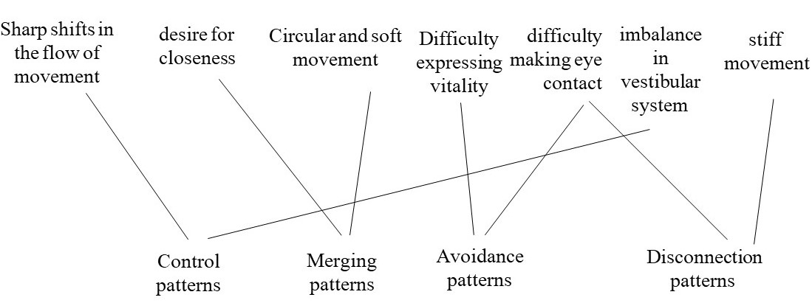

.

Second, The children were referred to treatment based on anxiety symptoms that were identified by the school's psychologist, without being formally diagnosed by diagnostic tool. To address this limitation, the therapeutic process