**Research Title**

**PON1's central role in a new paradigm of atherosclerosis etiology**

**Keywords:**

Cholesterol, Transmural cholesterol flux, Atherosclerosis, Reverse cholesterol transport, CVD, PON1, HDL, SR‑B1, eNOS, Endothelium, Caveolae, Palmitoylation.

**Scientific abstract**

According to the consensus paradigm, atherosclerosis is caused by the entry of cholesterol, mostly as low-density lipoproteins (LDL), from the lumen into the arterial intima layer, where it slowly accumulates. Presumably, the lipoproteins enter by passive filtration through endothelial lesions caused mainly by oxidative stress and inflammation ("endothelial dysfunction"). However, developing plaques first appear deep in the intima-media boundary under intact, uninjured endothelium with no signs of inflammation. Likewise, no passive LDL filtration through injured endothelium has ever been conclusively demonstrated. A more recent hypothesis claims that blood lipoproteins enter from the lumen by active apical-to-basolateral endothelial transcytosis. However, this hypothetical process serves no clear physiological purpose and could potentially create an energy-wasting futile cycle whose sole product is ATP hydrolysis.

Contrarily, in our recently published alternative hypothesis, most lipoproteins enter the arterial wall not from the lumen but through the artery's vascular system – the adventitial vasa vasorum. With no lymphatic system to drain it, excess cholesterol diffuses from the adventitia through the avascular media and intima toward the endothelium, creating a directional transmural cholesterol flux (TCF). It is eventually cleared through the apical endothelial membrane mainly by high-density lipoprotein (HDL)-mediated efflux in the initial step of the reverse cholesterol transport (RCT) back to the liver and the digestive tract. A plaque is formed when this cholesterol clearance rate lags behind its rate of arrival by TCF.

HDL and its associated small hydrolytic enzyme Paraoxonase 1 (PON1) are responsible for the rapid endothelial efflux and are a keystone of our TCF hypothesis. PON1 has unusually broad in-vitro substrate specificity, but its true function and substrate are still unknown. We hypothesize that PON1 is a palmitoyl-protein thioesterase (PPT) that sets the RCT rate by controlling the timely release of cholesterol-loaded HDL from its endothelial receptor - scavenger receptor class B, type 1 (SR-B1). PON1 does so by entering the apical endothelial membrane and hydrolyzing the palmitoyl anchors of SR-B1 or caveolae proteins. This hydrolysis destabilizes the receptor facilitating the release of HDL. So far, our preliminary results corroborate this scenario. We have demonstrated that PON1 can hydrolyze palmitoyl-cysteine thioester bonds in-vitro, has direct or indirect PPT activity in-vivo, and can significantly reduce, as expected, the presence of SR-B1 in the endothelial membrane.

Our specific aims in this grant proposal are **1)** to demonstrate PON1's ability to hydrolyze SR-B1's palmitoyl moieties directly; **2)** to further elucidate PON1 internalization process; **3)** to measure PON1's effect on the receptor-bound HDL's dwell time during active efflux and under flow conditions; **4)** to measure PON1 and SR-B1 contributions to the endothelial cholesterol efflux rate under static and flow conditions; **5)** to measure the endothelial basolateral-to-apical LDL transcytosis. By achieving these goals, we will prove the major predictions of a new hypothesis with far-reaching implications for atherosclerosis and cardiovascular disease (CVD) research, prevention, and treatment and solve the old riddle of PON1's physiological function.

**The research program:**

1. **Scientific background**
   1. **Atherogenesis and the new transmural cholesterol flux hypothesis**

Atherosclerotic cardiovascular disease (CVD) is the most lethal disease globally, claiming millions of lives annually1. However, its etiology has remained debatable and is still poorly understood. The prevailing account asserts that plaque formation is initiated by a lesion in the large arteries' endothelium, caused mainly by oxidative stress and inflammation. This results in increased permeability to LDL cholesterol (LDL-C) that enters from the lumen by passive filtration and accumulates in the subendothelial intima forming a growing plaque1,2. However, passive LDL filtration through injured endothelium has not been convincingly demonstrated3, and cholesterol accumulates first under an intact, uninjured endothelium, deep in the intima-media boundary, away from the lumen and with no signs of inflammation or the presence of macrophages4.

Another newer version of the "entry from the lumen" paradigm claims that LDL-C enters from the lumen by active receptor-mediated, apical-to-basolateral endothelial transcytosis3. However, this process serves no clear physiological purpose; it also transports HDL in the opposite basolateral-to-apical direction, and its central components are shared by the counter process of reverse cholesterol transport (RCT). Therefore, the proposed LDL transcytosis mechanism could create an energy-wasting futile cycle and paradoxically be pro- and anti-atherogenic simultaneously5.

A handful of researchers believe that the overt incompatibility of the "entry from the lumen" paradigm with the scientific evidence can no longer be ignored and point to the adventitial vv as the more likely site of lipoproteins entry into the arterial wall4,6. Our recently published hypothesis addresses these paradoxes and incoherent accounts by providing a complete, self-consistent description of atherogenesis5. We also assert that lipoproteins enter the wall of large arteries mainly through their adventitial vv and diffuse into the media. With very few adventitial lymph vessels and their complete absence in the avascular media7,8, excess cholesterol can only leave by diffusion down its concentration gradient through the media and intima toward the endothelium, creating a unidirectional transmural cholesterol flux (TCF). It crosses the endothelium assisted by receptor-mediated endocytosis and basolateral-to-apical transcytosis of LDL and HDL. It is then cleared through the endothelium's apical membranes by several efflux mechanisms, including the HDL-mediated efflux that is specifically adapted to this unique environment (Fig. 1, a.). This TCF is maintained by the constant influx of cholesterol through the vv on the one hand and its continuous efflux back to the bloodstream through the apical endothelial membrane on the other. The intima's capacity to sequester cholesterol by binding to intimal extracellular matrix proteins also helps maintain this transmural gradient by creating an effective cholesterol sink and a high-capacity buffer against fluctuating TCF and RCT rates5.

The endothelial surface area-to-wall thickness ratio determines the endothelial membrane's capacity to sustain the inward cholesterol flux from the media. This capacity becomes relatively smaller in large arteries, with thick media and intima layers and rapid cholesterol influx through the vv. The reliance on cholesterol diffusion and removal through the "bottleneck" of the apical endothelial surface makes these large arteries exceptionally vulnerable to cholesterol homeostasis disorders while thin-walled veins and small vv-less arteries remain atherosclerosis free. Atherogenesis is initiated when the cholesterol flux from the media becomes faster than its clearance through the apical endothelial membrane (Fig. 1, b.). Since the accumulating cholesterol is effectively sequestered and immobilized by extracellular matrix proteins secreted by intimal cells, the concentration gradient of freely diffusing cholesterol and lipoproteins is maintained, and the TCF can continue. Once plaque formation begins, it will proceed (Fig. 1, c., d.) through the well-documented stages of atherogenesis, such as proinflammatory lipid oxidation and enzymatic eLDL generation, inflammation, and immune cells infiltration2.

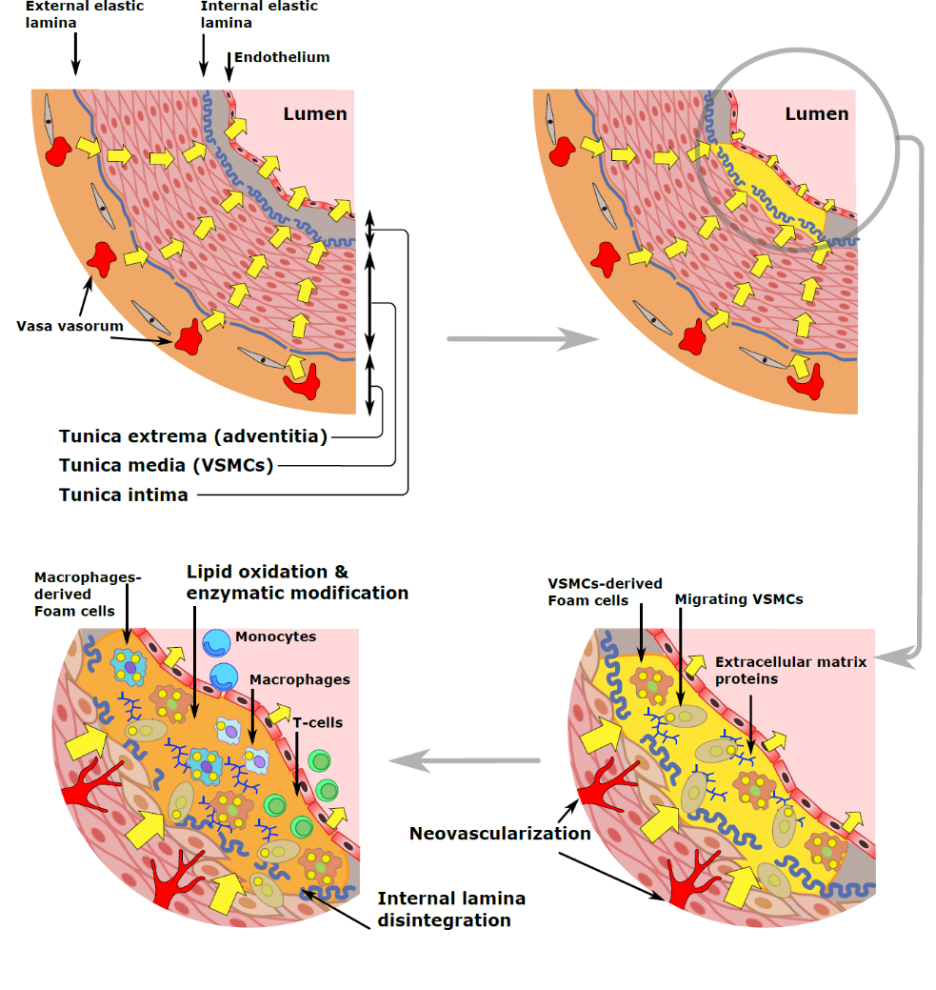

**a.**

**b.**

**d.**

**c.**

**Fig. 1: TCF-driven plaque formation**

**a.** TCF in a healthy artery. The yellow arrows represent the transmural flux of lipoproteins and cholesterol from the adventitial vasa vasorum to the endothelium through the media layer of vascular smooth muscle cells (VSMCs) and the intima.

**b.** The result of impaired endothelial RCT: excess cholesterol slowly accumulates by binding to intimal extracellular matrix proteins and initiates plaque formation.

**c.** A magnified cutaway of the initial plaque shows smooth muscle cells (VSMCs) migrating from the media into the intima and transdifferentiating into cholesterol-loaded foam cells. The resulting cholesterol-induced hypoxia stimulates neovascularization and vv expansion.

**d.** A full-fledged atherosclerotic plaque: lipids oxidation and enzymatic modifications trigger inflammation and migration of monocytes and T-cells from the lumen. The monocytes differentiate into cholesterol scavenging macrophages which eventually also become foam cells.

* 1. **HDL and its SR-B1 receptor**

HDL and its high-affinity receptor scavenger receptor class B, type 1 (SR-B1)9,10 play a central role in our TCF hypothesis. HDL is the smallest and densest lipoprotein class responsible for collecting excess cholesterol from the peripheral tissues in the initial step of the RCT. The HDL particle is formed in the liver and the small intestine around a scaffold of its main protein component - apolipoprotein A1 (ApoA1). It comprises a heterogeneous group of lipoproteins with a dynamic structure and complex lipidome and proteome, which change considerably as the lipoproteins make their way through the different stages of the RCT process11. HDL particles can be divided into four main subgroups: small lipid-poor nascent HDL (also designated as discoid or pre-beta HDL), small spherical HDL3, large spherical HDL2, and large spherical ApoE containing HDL112,13.

The HDL receptor SR-B1 binds its ligand with a high affinity of ~2.5e-8 M through interaction with ApoA114. SR-B1 is a homodimer or homomultimer receptor localized in the caveolae of the plasma membrane15. In the liver and steroidogenic tissues, SR-B1 mediates the selective uptake of HDL cholesterol – primarily as cholesteryl ester (CE). In the rest of the peripheral tissues, the receptor mediates the efflux of free cholesterol (FC) and phospholipids by passive diffusion into the bound HDL particle, causing it to grow in size14,16.

* 1. **PON1**

PON1 is a 354-amino-acid, 43-kDa HDL-bound enzyme belonging to a three-membered family of paraoxonases (reviewed in17). Paraoxonases derive their name from the exclusive ability of PON1, discovered soon after WWII, to hydrolyze paraoxon - the toxic organophosphate ingredient of the insecticide parathion18. PON1 gained prominence only half a century later when Mackness and Walker first described its association with HDL19. Mackness *et al.* then went on to demonstrate, in 1991, that the enzyme was responsible for the ability of HDL to prevent the accumulation of oxidized lipids in LDL and thus could be directly linked to atherosclerosis and cardiovascular disease (CVD)20. Since then, this direct link has been established by several epidemiological studies that have found an inverse relationship between PON1 serum activity and atherosclerosis and CVD (extensively reviewed in21-23).

Most circulating PON1 is attached to the HDL3 fraction of small spherical lipid-poor particles24. The atheroprotective capability of PON1 has been conclusively demonstrated by using PON1 knockout (PON1-/‑) and transgenic (PON1-Tg) mice. PON1-/- mice are more prone to develop atherosclerotic lesions and plaques than controls when fed a high-fat diet25. Conversely, mice overexpressing human PON1 are more resistant to atherosclerotic lesion development in a dose-dependent manner26. However, despite decades of intensive research, the exact physiological function of PON1 and the identity of its endogenous substrate have remained known22.

PON1 has a six-bladed beta-propeller architecture, with a catalytic site inside its central tunnel27. The catalytic site holds two calcium ions essential for its activity27. The access to the catalytic site is limited by a lid ("canopy") formed by two (out of three) alpha-helices (H2 and H3, Fig. 2)27. The N-terminal alpha-helix (H1, Fig. 2) protrudes above the catalytic site. It is probably used to anchor PON1 to the HDL particle by penetrating its lipid envelope like a tack27. Both H1 and H2 helices create a very high affinity (*K*d <<10-9 M) bond with HDL, with the catalytic site facing the lipoprotein's core (Fig. 2)27,28.

The spatial position of the HDL-bound PON1 (Fig. 2) implies that it can hydrolyze only lipid-soluble substrates able to reach the active site by dissolving into the HDL's core28. Since HDL-bound PON1 is essentially inaccessible to external substrates, it is unclear how it can hydrolyze oxidized LDL lipids in the blood. Despite PON1 high affinity towards HDL, it is not a fixed component of the lipoprotein29. Its lipophilic nature allows it to be easily 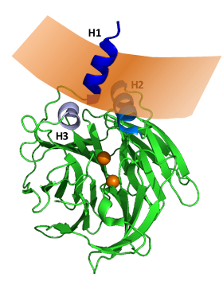exchanged between VLDL and HDL and between HDL and cell membranes of culture cells (in-vitro) or cells of the arterial endothelium and other peripheral tissues (in-vivo)29,30.

**Fig. 2: PON1's structure and interaction with HDL**

The three blue-shaded helices - H1, H2, and H3 sit above the catalytic site with its two calcium ions (orange spheres). The protein's hydrophobic regions of H1 and H2 are in contact with the HDL's envelope (the light orange concave polygon). H1 is protruding into the lipoprotein's lipid core27. This spatial arrangement blocks the catalytic site to external substrates.

PON1 can shuttle between the endothelial cell membrane and HDL and that this shuttling is quantitatively dependent on the presence of SR-B129. It is probably the reason why the protein has been detected in all murine tissues tested while it is expressed almost exclusively by the liver30. PON1 binding to the endothelial membrane leads to its internalization by caveolae-mediated endocytosis followed by lysosomal degradation31,32.

The binding of PON1 to HDL - especially to ApoA1-HDL - dramatically increases its structural stability and catalytic efficiency towards lipophilic lactones28. Delipidation of PON1 results in a complete loss of activity. Therefore, when HDL is not present in the reaction mixture in vitro, it must be replaced by detergents28. This absolute requirement of PON1 for a lipid environment is probably why it is always associated with phospholipids - of either the plasma membrane or the lipoprotein's envelope33.

PON1 can hydrolyze, with varying efficiency, a remarkably long list of potential substrates – the outcome of a decades-long quest to find its "true" endogenous substrate. The list includes numerous organophosphates, lactones, esters, and thioesters34. This unique quality of PON1 has been termed "promiscuity"35. It reflects the remarkable versatility of residues of the enzyme's catalytic group to perform multiple tasks depending on the substrate34. It is believed that PON1's promiscuity enhances its evolvability and adaptation to new substrates35. As elaborated below, we believe it reflects advanced adaptation to an essential aspect of its function in the RCT through the apical membrane of the arterial endothelium.

When Mackness et al. discovered the ability of PON1 to protect LDL against lipid peroxidation by metal ions in-vitro, they suggested that the hydrolysis of LDL's lipid peroxides by PON1 is the basis of HDL's anti-atherogenic activity20. Although this notion is now supported by many publications36, the exact mechanism of PON1's protection against lipid peroxidation has not been adequately elucidated. It is unclear whether the main catalytic site of PON1 is involved in its antioxidant activity or whether LDL protection represents an independent second activity, which relies on a free thiol group on cysteine 28437,38. At least two publications seem to refute the peroxidase activity of PON1 altogether. Connelly et al. and Teiber et al. have shown that purified PON1 was incapable of preventing LDL and HDL oxidation by either metal ions or peroxynitrite 33,39.

* 1. **PON1's hypothetical role in endothelial HDL-meditated RCT**

The RCT from the apical endothelial membrane faces a considerable challenge. It must securely anchor the HDL3 particle to the surface of the endothelium in the face of the force exerted by the flowing blood (Fig. 2, a.). In places near the endothelial membrane, where the flow is laminar and its velocity is virtually zero, this force is minimal. However, in areas of arterial curvature or branching, the flow becomes turbulent40, and the anchored HDL may have to resist its full force, which increases rapidly as the diameter of the particle grows. Therefore, the small size and high density give the HDL particle an advantage by reducing drag, and we believe that they reflect a specific adaptation to this dynamic and unstable environment.

In order to keep the HDL particle anchored until its loading by cholesterol molecules is complete, the endothelial RCT apparatus deploys two additional effective countermeasures against the destabilizing force of blood flow. The first is lowering blood pressure, which occurs by eNOS activation by SR-B1 upon HDL binding (Fig. 2, b.)9. The sconed countermeasure is the gradual increase of HDL binding affinity to its SR-B1 receptor as the particle grows41. We think that both mechanisms also represent a specific adaptation of the HDL-mediated RCT to the harsh environment of the apical endothelial membrane of blood vessels. Interestingly, caveolae number and Cav1 and SR-B1 expression are higher in atheroprone sections of the murine aorta where blood flow is turbulent42,43 in an apparent effort to compensate for the harsher HDL-binding conditions. Therefore, according to our hypothesis, atherosclerosis is site-specific and more frequent in areas of low endothelial shear stress and turbulent blood flow44, not because the turbulent flow "injures" the endothelium but because it exerts a greater force on the HDL particle and may disrupt cholesterol efflux by dislodging it from its receptor5. Indeed, *apoE*-/- eNOS‑/- mice exhibit exacerbated formation of atherosclerotic vascular lesions compared with *apoE*-/- mice45, while the exclusively endothelial overexpression of SR-B1 in *apoE*-/- mice can reduce diet-induced atherosclerosis46.

We hypothesize that when the loading process ends, the increased binding affinity of HDL turns from an asset to liability since it prevents the release of the loaded particle. This moment is when PON1 becomes active. The larger diameter of the cholesterol-loaded HDL particle now allows it to contact the cell membrane (Fig. 2, c.). Using its ability to shuttle between membranes29,47, PON1 moves into the endothelial cell membrane and makes its way directly toward its inner leaflet. We believe that PON1 uses its N-terminal H1 helix to pierce through the membrane, much like some known cell-penetration-peptides (CPPs)48.

It is here, inside the cell membrane, where PON1 enzymatic activity counts. Although PON1 bears no sequence or structural similarity to human palmitoyl-protein thioesterase (PPT1), we now have preliminary evidence (see below) that the enzyme is also a palmitoyl-protein thioesterase (PPT) whose natural substrate could be the palmitoyl moieties used to anchor proteins to the inner leaflet of the plasma membrane. By hydrolyzing the palmitoyl moieties on SR-B1, or critical components of the caveolae such as Cav1, PON1 can destabilize the receptor, or even the entire caveolae structure, causing SR-B1 to release its bound lipoprotein and probably inactivates eNOS (Fig. 2., d.). In doing so, PON1 can ensure the timely release of the CE-loaded HDL2 and, to a large extent, sets the pace of the entire endothelial RCT process. Indeed, our preliminary results clearly show that PON1 can hydrolyze palmitoyl-thioester bonds in-vitro, has direct or indirect PPT activity in-vivo, and can significantly reduce the presence of SR-B1 in the endothelial membrane.

Instead of being an evolutionary oddity, The exceptional promiscuity of PON135 can now be viewed as a perfect adaptation to a large and virtually immobile substrate situated in the restrictive environment of the inner membrane. Under such conditions, the enzyme must maneuver around the substrate to correctly position the thioester bond of the palmitoyl moiety with respect to the catalytic group. The versatility of residues of the catalytic group to perform multiple tasks35 now relaxes the restrictions on the correct relative spatial positions of the enzyme and its substrate and increases the ability of PON1 to carry out the hydrolysis.

Once PON1 completes its task in the membrane, it becomes fully internalized in the cytoplasm by caveolae-mediated endocytosis and is then directed for lysosomal destruction31. The mechanism of PON1's internalization and its dependence on the enzyme's catalytic activity is not yet clear, and it might be possible that under active cholesterol efflux, internalized PON1 can be recycled back to the cell membrane and then to HDL.

Any failure on the part of PON1 to release the HDL particle on time will slow the RCT and the turnover of cholesterol, resulting in longer retention of LDL in the blood, with the inevitable consequence of increased LDL lipids peroxidation, as observed in PON1-/- mice49. Therefore, there is no need to invoke a direct peroxidase activity of PON1 to account for its observed effect on LDL peroxidation in-vivo. In the long run, RCT malfunction due to diminished PON1 activity can lead to cholesterol accumulation in the intima and the formation of an atherosclerotic plaque, as has also been found in PON1-/- mice and epidemiological studies22,49.

This hypothetical PON1's role as palmitoyl-protein thioesterase controlling the release of HDL from its SR-B1 receptor and, hence, the endothelial RCT rate is now backed by substantial evidence. So far, we have been able to demonstrate the following:

1. PON1 bound to HDL can hydrolyze palmitoyl-cysteine thioester bonds of an artificial substrate in-vitro.
2. PON1 has direct or indirect PPT activity in-vivo manifested by an increased number of free protein thiol groups after incubating endothelial cells with the enzyme.
3. PON1 can significantly reduce the presence of SR-B1 in the endothelial membrane.

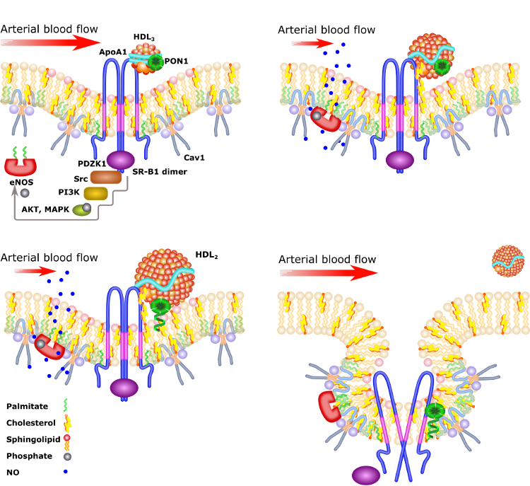

**a.**

**b.**

**c.**

**d.**

**Fig. 3:** **The hypothetical release of HDL from SR-B1 by PON1's palmitoyl thioesterase activity**

**a.** The ApoA1-dependent binding of HDL3 to SR-B1 in the cholesterol-rich caveolae causes the activation of eNOS by the Src-Akt signal transduction pathway. SR-B1 can activate Src directly through the SR-B1 bound PDZK1 adaptor protein. The Src pathway can also be activated indirectly through the interaction of HDL lipids with the lysophospholipid receptor S1P3 (not shown).

**b.** SR-B1 facilitates the passive diffusion of additional FC into the bound HDL3 particle causing it to grow further and become the larger HDL2. The activation of eNOS reduces the force acting on the growing HDL particle and facilitates its loading. HDL's progressively increasing binding affinity also helps anchor it to the receptor.

**c.** When the loading process ends, the HDL particle's larger diameter allows PON1 to enter the cell membrane using its N-terminal helix and move towards the inner membrane leaflet.

**d.** When PON1 reaches the cell membrane's inner leaflet, it hydrolyzes the palmitoyl moieties on SR-B1 or critical components of the caveolae, such as Cav1. The hydrolysis of the palmitoyl anchors destabilizes the receptor, or even the entire caveolae structure, causing SR-B1 to release its bound lipoprotein. By ensuring the timely release of the CE-loaded HDL2, PON1 sets the pace of the RCT process. PON1 itself is internalized by endocytosis and eventually degraded.

In summary, we present here a far-reaching hypothesis capable of coherently integrating a large corpus of scientific literature and creating, for the first time, a self-consistent account of atherogenesis and PON1's essential role in it. It replaces the complex, general term "endothelial dysfunction" with simple mechanistic causality and points the way for future research and better prevention and treatment of atherosclerosis.

1. **Research objectives and expected significance**

The proposed research aims to provide evidence for a new, comprehensive hypothesis of atherogenesis in which PON1 is a palmitoyl-protein thioesterase whose role is to control the release of the cholesterol-loaded HDL from its endothelial SR-B1 receptor and, consequently, to set the rate of the arterial wall TCF and RCT.

* 1. **The specific aims of the present study:**

1. **To** **demonstrate PON1's ability to hydrolyze SR-B1's palmitoyl moieties in-vitro and in-vivo:** We will measure the hydrolysis of SR-B1's palmitoyl moieties by recombinant PON1 (rePON1) and its variants, both in-vivo in-vitro. Achieving this aim will prove the central prediction of our model - PON1's capability to remove SR-B1's palmitoyl groups. It will also clarify whether it does so by direct hydrolysis or indirectly by, for example, activating endogenous Ppts.
2. **To further elucidate PON1's internalization process:** We will investigate whether endocytosis is required for PON1's observed palmitoyl hydrolysis activity or whether this activity is required for the enzyme's endocytosis. We will also investigate the possible PON1 recycling during active efflux. Achieving this aim will shed more light on this unique process, which is central to our model.
3. **To measure PON1's effect on HDL3's dwell time on SR-B1 during active efflux:** We will measure the time it takes cholesterol-effluxing HDL3 from the moment of binding to its receptor till its release back to the medium. Our model predicts that in the absence of PON1, HDL dwell time will be longer. Achieving this goal will enable us to assess the validity of our model better.
4. **To measure the effect of PON1 and SR-B1 on the HDL3-mediated cholesterol efflux rate in cultured arterial endothelial cells:** We will investigate whether PON1 presence and activity and SR-B1 expression affect the rate of the HDL3-dependent cholesterol efflux from cultured arterial endothelial cells. Our model predicts an enhancement of the cholesterol efflux rate in the presence of PON1 and its dependence on SR‑B1 expression. Therefore, achieving this aim will either help us validate the model in case of positive results or force us to reconsider it in case of negative results (no PON1 or SR-B1-dependent rate increase).
5. **To measure the endothelial basolateral-to-apical LDL transcytosis:** We will measure the basolateral-to-apical LDL transcytosis in cultured arterial endothelial cells. Achieving this aim will prove a critical prediction of our TCF hypothesis.
   1. **The expected significance:**

Achieving all five specified aims will provide enough evidence to validate our hypothesis and allow us to present it as a solid foundation for a new atherogenesis paradigm with far-reaching consequences for atherosclerosis research, diagnosis, and treatment. It suggests that we should focus our efforts on the endothelium and its cholesterol efflux capacity instead of on macrophages and inflammation - both only late symptoms of advanced and already irreversible disease. One alternative course of action could be the specific enhancement of various endothelial efflux mechanisms. For example, the selective enhancement of lipid-poor, efflux-promoting pre-beta HDL or HDL3 fractions50,51 or increasing the expression of cholesterol transporters in the atheroprone regions of the aorta and coronary arteries by the targeted transfection of their mRNAs52 We should also discard the absurd distinction between "good cholesterol (i.e., HDL) and "bed cholesterol" (i.e., LDL) while both lipoproteins constitute a continuum in the same cholesterol cycle and RCT. Instead of measuring the cholesterol ratio as a predictor of impending atherosclerosis, we might be better off if we could measure the rate of aortal TCF using 18F-labeled cholesterol and the cholesterol version of PET-CT.

1. **A Detailed description of the proposed research**
   1. **The working hypothesis**

The endothelial RCT, and PON1's role in this process, are key elements in our new TCF-centered atherogenesis hypothesis (Fig. 1 above). It claims that excess cholesterol rapidly enters the wall of large blood vessels through the adventitial vasa vasorum and not from the lumen. With no or very few lymphatic vessels available in the arterial wall7,8, the only possible route for an equally rapid cholesterol clearance is through the apical endothelial membrane by HDL-mediated RCT and other mechanisms. Therefore, therapid cholesterol efflux through the apical endothelial membrane is essential for maintaining cholesterol homeostasis in the mostly avascular arterial wall. Even a tiny imbalance in the TCF can result in the slow intimal accumulation of cholesterol and plaque formation. In large arteries, with extensive vasa vasorum and rapid - sometimes turbulent - blood flow that can dislodge the lipoprotein from its receptor, this delicate balance can be more easily disturbed. Therefore, such arteries are exceptionally vulnerable to cholesterol homeostasis disorders manifested by atherosclerotic plaques.

Nature's remedy comes in the form of a unique adaptation of the RCT apparatus to the demanding environment of the apical endothelial membrane. The HDL particle is dense and small, creating minimal resistance to the blood flow; its binding to its SR-B1 receptor activates eNOS, thereby reducing blood pressure and flow velocity9, and this binding gets progressively stronger as the particle's diameter grows by loading cholesterol molecules 14,16.

However, a strongly bound HDL particle must have a release mechanism to set it free once it becomes fully loaded. Our working hypothesis is that PON1 is this unknown release mechanism. By moving from its carrier HDL into the cell membrane (Fig. 3, c.), it can hydrolyze the palmitoyl moieties of SR-B1, destabilizing the receptor and forcing it to leave the cell membrane and release the lipoprotein. This destabilizing effect may also initiate the eventual endocytosis of PON1 – probably together with its SR-B1 receptor – which ends in its lysosomal destruction31.

Several already known characteristics of PON1 strongly support this hypothetical scenario:

1. PON1's lipophilic nature allows it to be easily exchanged between the lipoprotein and the cell membrane29.
2. PON1 is expressed almost exclusively by the liver but becomes disseminated by HDL to all tested murine peripheral tissues30.
3. PON1 is a "promiscuous" enzyme having a versatile catalytic group capable of performing various tasks with many different substrates35.
4. The delipidation of PON1 results in a complete loss of activity28.
5. Once PON1 is fully internalized, it is directed to the lysosome for degradation31.
6. HDL-bound PON1 has its active site facing the lipoprotein's core (see Fig. 2) and is, therefore, inaccessible to external substrates27.

It turns out that the HDL-bound PON1 is inactive toward substrates outside the particle's lipid core, and it becomes inactive and is rapidly degraded upon internalization. Therefore, the only place and time the enzyme is active are in the cell membrane during its transition from HDL to the cytoplasm. Using its versatile, flexible catalytic site, the "promiscuous" PON1 can maneuver in the restrictive lipid environment of the cell membrane and correctly position its catalytic group around its immobile substrate and catalyze the hydrolysis of palmitoyl moieties. This hydrolysis releases the loaded HDL and affects the pace of excess cholesterol clearance by the endothelial RCT.

The HDL-PON1 duo forms an elaborate mechanism whose very existence strongly indicates that the endothelial RCT serves not only the modest needs of the monolayered endothelium but is responsible for the cholesterol clearance from the entire vascular wall. Only when viewed in our TCF hypothesis context, can this mechanism become physiologically intelligible. Hence, PON1's PPT activity and the endothelial RCT can be the determining factors between balanced TCF and a healthy functioning artery and imbalanced TCF and a diseased artery clogged by an atherosclerotic plaque. This research proposal is intended to provide convincing evidence for PON1's pivotal role in controlling the RCT rate and, hence plaque development within the framework of a larger, comprehensive TCF-based atherosclerosis etiology hypothesis.

* 1. **Research design and methods**
     + 1. **Aim 1 – to demonstrate PON1's ability to hydrolyze SR-B1's palmitoyl moieties in-vitro and in-vivo**

We will measure the hydrolysis of SR-B1's palmitoyl moieties by commercially available recombinant PON1 (rePON1) in-vitro and in-vivo. The in-vitro measurement will be done by first immunoprecipitating SR-B1 from cultured human arterial endothelial cells and reconstituting the immunoprecipitated receptors into the double-layered membrane of nanodisc particles. The reconstituted receptors will then be incubated for several hours with rePON1 or HDL-bound rePON1, and the degree of palmitoyl residues hydrolysis will be assayed by the fatty acyl biotinyl exchange (ABE) method53 in which all free thiols are first blocked by N-ethylmaleimide (NEM). Next, existing palmitoyl residues are cleaved by hydroxylamine, leaving the freed cysteine thiols to react with thiol-specific labeling reagents. The number of thiol-specific labels is then measured by an ELISA reader.

The in-vivo PPT activity will be measured by incubating cultured human arterial endothelial cells with HDL-bound PON1 for four hours. The presence of HDL is required to guide the added enzyme to the receptor and provide it with a protective lipid envelope (our unpublished results). At the end of the incubation, the cells will be collected and lysed, and SR-B1 will be immunoprecipitated as before. The number of free thiol groups on the immunopurified SR-B1 will be assayed by the ABE method. The in-vivo experiment will be repeated using a catalytically impaired rePON1 variant54 and the human PPT1 inhibitor GNS561 (Ezurpimtrostat)55. The expectation is that there will be no or little SR-B1 depalmitoylation with the impaired rePON1, while the PPT1 inhibitor will not affect the receptor's degree of depalmitoylation.

**Expected results:** proof that PON1 can hydrolyze the palmitoyl moieties of membrane-bound SR-B1 directly and not by somehow activating an endogenous membrane-bound PPT156.

**Possible pitfalls:**

* It is possible that PON1 only triggers the hydrolysis of SR-B1's palmitoyl residues by activating a membrane PPT1 which is itself controlled by reversible cysteine acylation57. In this case, we will repeat the SR-B1 experiments but this time using anti-PPT1 specific antibodies to see if PPT1 is the real PON1 target.
* The amount of immunoprecipitated protein is too small to give reliable and reproducible ELISA detection. In this case, the immunoprecipitated proteins will be analyzed by mass spectroscopy following trypsin digestion.
  + - 1. **Aim 2 – To further elucidate PON1's internalization process**

We will use HDL3-bound, fluorescently labeled rePON1 and rePON1-DM54 (a catalytically impaired double mutant), fluorescence confocal microscopy, endocytosis inhibitors, and a lysosome-specific fluorescent dye to track rePON1 during its internalization into cultured human arterial endothelial cells as previously described31. This tracking will allow us to determine whether PON1 PPT activity is required for its internalization by endocytosis and whether PON1 is recycled back to HDL during active efflux. We will use unlabeled HDL3-bound rePON1 variants and endocytosis inhibitors to determine whether the observed PON1-dependent depalmitoylation (our preliminary results) requires and coincides with PON1's endocytosis.

**Expected results:** PON1's PPT activity is independent of its endocytosis but not vice versa.

**Possible pitfalls:** The bulky fluorescent label interferes with PON1 PPT activity. In this case, we will label PON1 in-situ using fluorescently labeled anti-PON1 antibodies after fixation and permeabilization of the cells31.

* + - 1. **Aim 3 – to measure PON1's effect on the average HDL3's dwell time on SR-B1 during active efflux**

We will measure HDL's dwell time on SR-B1 using fluorescently labeled HDL3, with or without PON1, and a custom microfluidic cell culture system (produced by rapid prototyping) of confluent monolayered human aortic endothelial cells under constant medium flow with both straight and branched (turbulent flow) geometry as previously described58. The receptor-bound HDL particle will be tracked by a time series of confocal microscope images, and its dwell time will be inferred by MATLAB-based image processing.

**Expected results:** a PON1-dependent shorter HDL3 dwell time.

**Possible pitfalls:** The phenomenon is hard to observe and is cell type-dependent. In this case, we will try to follow as many HDL particles as possible for robust statistical analysis. To prevent cell type-related artifacts, we will repeat the experiment using at least three different commercially available arterial endothelial primary cultures or cell lines.

* + - 1. **Aim 4 – to measure PON1's effect on the HDL3-mediated endothelial cholesterol efflux rate**

The endothelial HDL3-mediated efflux rate will be measured by loading confluent endothelial culture cells with fluorescently labeled cholesterol (using a commercial kit and protocol) and then measuring the cholesterol efflux percent by HDL3 with or without PON1. The measurements, at certain time intervals for 4 h, will be done by an enzyme-linked immunosorbent assay (ELISA) reader. We will manipulate the SR-B1 expression level by the transient transfection of either its mRNA or a specific commercial siRNA. The receptor's expression will be measured by direct cell-based ELISA and western blotting. In order to distinguish between cell-type specific and a more general phenomenon, we will repeat the experiment in three different relevant human arterial endothelial cell types.

**Expected results:** faster HDL3-mediated efflux in the presence of PON1.

**Possible pitfalls:** We may find that the endothelial efflux is independent of SR-B1 expression59. In this case, we will determine whether other cholesterol transporters, such as those belonging to the ATP binding cassette (ABC) transporters 49-membered family60 (excluding ABCA1 and ABCG159), are involved.

* + - 1. **Aim 5 – to measure the endothelial basolateral-to-apical LDL transcytosis**

We will measure this transcytosis using a custom microfluidic transwell assay system, confluent arterial endothelial cells culture, and fluorescently labeled LDL, as previously described61 but with the labeled LDL in the basolateral compartment. The straight geometry microfluidic transwell system will be produced by custom rapid prototyping. The essay will be carried out under static and flow conditions using physiological HDL3 and LDL concentrations. The process will be monitored by measuring the fluorescent lipoprotein appearing on the opposite transwell compartment through the endothelial cells. Achieving this aim will prove a critical element of our TCF hypothesis and fill a glaring gap in our understanding of the endothelial transcytosis phenomenon.

**Expected results:** a demonstration of basolateral-to-apical LDL transcytosis.

**Possible pitfalls:** No basolateral-to-apical LDL transcytosis can be measured. In this case, we will test alternative explanations to the observed apical-to-basolateral LDL transcytosis and try to measure it in the presence of competing physiological HDL3 concentration under flow conditions.

* 1. **Preliminary results**
     1. **Substrate synthesis and PON1 PPT activity in-vitro**

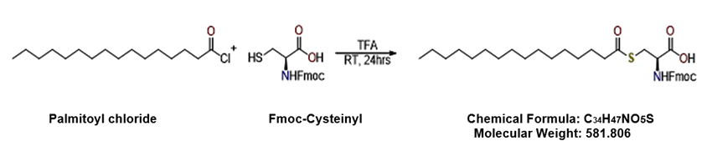The palmitoyl thioesterase activity of rePON1 was measured in-vitro using the synthesized substrate, cysteinyl palmitate thioester, in which the cysteine's amine is protected by the Fmoc (Fluorenylmethoxycarbonyl) protection group. The substrate was synthesized, purified, and identified using LC-MS/MS and 1H-NMR (Fig. 4).

**Fig. 4: The synthesis process of rePON1 PPT activity substrate**

The ability of rePON1, with and without HDL, to cleave the thioester bond of the substrate was measured spectrophotometrically using Ellman's assay. Incubating the substrate with either rePON1 or HDL alone did not result in substrate cleavage. However, the addition of rePON1 after overnight incubation of HDL with the substrate to allow its diffusion into the lipoprotein resulted in a statistically significant increase in substrate degradation, probably due to increased stability and activity of PON1 in HDL's phospholipid envelope28 (Fig. 5).

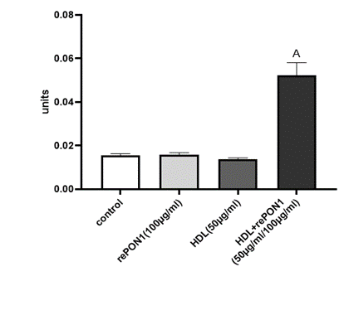

Arbitrary units

**Figure 5: rePON1 hydrolysis of a synthetic substrate.**

The PPT activity rePON1 (100 µg/ml) with palmitoyl-Fmoc-cysteinyl thioester at 1 mM concentration. rePON1 was added separately or after incubating the substrate with HDL overnight at 37°C. Results are presented as mean ± standard error (n = 3). (A) represents significance between substrate incubated with rePON1 and HDL versus substrate incubated with rePON1 or HDL separately p<0.0001.

* + 1. **PON1 PPT activity in-vivo**

Human umbilical vein endothelial cells (HUVEC) were incubated with rePON1 (10 µg/ml), HDL (50 µg/ml), or both for 4 h. The cells were then washed, and a protein lysate was prepared. The quantity of protein thioester bonds was measured spectrophotometrically using the acyl biotin exchange (ABE) – ELISA method53. Incubating the cells with rePON1 alone significantly reduced the number of protein thioester bonds. Incubating the cells with HDL alone significantly increased the number of protein thioester bonds. Contrarily, adding rePON1 with HDL significantly decreased the number of protein thioester bonds compared to incubation with HDL alone (Fig. 6). The results suggest that rePON1 triggered protein thioester bonds breakdown in vivo or somehow inhibited their increase by HDL.

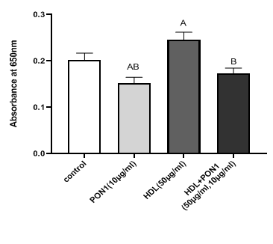**Fig. 6: rePON1 hydrolysis of acyl protein thioester bonds in-vivo**

HUVEC endothelial cells were incubated with PON1, HDL, or both for 4 hours, then collected and lysed, and the quantity of the thioester bonds in the cell lysates was measured spectrophotometrically at 650 nm in the ABE ELISA assay. Results are presented as mean ± standard error (n = 3). (A) represents significance relative to the control group p<0.0001, (B) represents significance relative to cells treated with HDL alone p<0.0001.

* + 1. **PON1 effect on the endothelial SR-B1 expression**

The effect of rePON1, HDL, or both on SR-B1 expression in HUVEC endothelial cells was measured by western blot using either anti-SR-B1 or anti-GAPDH (as the normalizing protein) primary antibodies and goat anti-rabbit HRP secondary antibodies. Incubating the cells with HDL significantly increased SR-B1 expression compared to the control. However, the addition of rePON1 together with HDL significantly decreased SR-B1 expression compared to cells treated with HDL alone (Fig. 7, a, b and c),

**a**

**b**

**c**

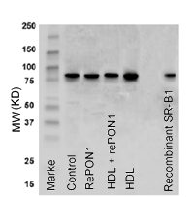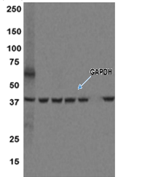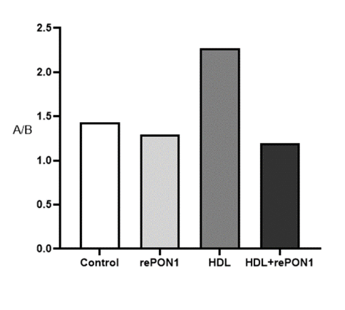

**Fig. 7: PON1 effect on SR-B1 expression**

Proteins were extracted from cells treated with rePON1 (10µg/ml), HDL (50µg/ml), or both. The SR-B1 expression was quantified by ECL-based western blot. (**a**) Anti-SR-B1 antibodies. (**b**) Anti-GAPDH antibodies. (**c**) Band quantification by the ImageJ software is shown as SR-B1 quantity normalized by GAPDH.

* + 1. **PON1 effect on SR-B1t membrane presence**

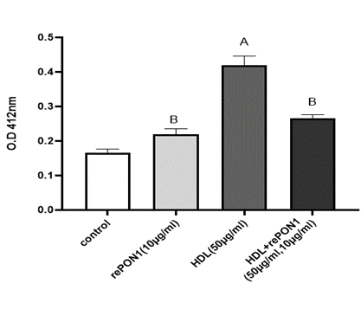The effect of rePON1, HDL, or both on SR-B1 presence on the endothelial cells' membrane was measured using a direct ELISA. HUVEC cells grown in an ELISA plate were incubated with rePON1, HDL, or both and, after washing and fixation, reacted with anti-SR-B1 rabbit antibodies, and the specific binding was measured calorimetrically at 412 nm. As before, incubation with HDL significantly increased SR-B1 presence on the cell membrane compared to control - cells without treatment. The addition of rePON1 together with HDL significantly decreased SR-B1 membrane presence (Fig. 8).

**Fig. 8: HDL and PON1 effect on SR-B1 cell membrane presence**

The effect of rePON1, HDL, or both on SR-B1 receptor on endothelial cells' membranes using the direct ELISA method. The endothelial cells were incubated with HDL (50µg/ml), rePON1 (10µg/ml), and both for 6 h. The cells were then fixed, blocked, and reacted with anti-SR-B1 primary and goat anti-rabbit-HRP secondary antibodies. The specific binding was measured calorimetrically at 412 nm. Results are presented as mean ± standard error (n = 3). A represents significance relative to the control group, p<0.0001. B represents significance relative to cells treated with HDL alone

* 1. **Facilities available to the researchers**

The proposed research will be carried out at the Laboratory of Natural Compounds and Analytical Chemistry at MIGAL Galilee Research Institute under the supervision of Prof. Soliman Khatib. The laboratory specializes in medicinal chemistry, the characterization of proteins, and small molecule interactions using experimental and molecular modeling methods. In addition, the laboratory specializes in synthesizing, isolating, identifying, and quantifying bioactive natural compounds with biological activities - especially compounds that increase PON1 activities and improve HDL quality. The laboratory also specializes in in-vitro assays related to atherosclerosis using endothelial and macrophage cells. The laboratory is fully equipped with all of the facilities and instrumentation required for the proposed experiments: Infinite M200 multimode microplate readers, centrifuges, chemical, and biological hoods, cell culture rooms, cell incubators, cell culture equipment, refrigerators, freezers, computers, FACS, and confocal microscope fluorescence microscope. Analytical instruments such as HPLC, HR-LCMS, and GC-MS-MS. The laboratory consists of one Ph.D. research fellow, two Ph.D. students, one post-doctor, three M.Sc. students, and a technician. A microfluidic flow system required for the proposed research will be purchased.

**Bibligraphy**

.1 Libby, P., Buring, J.E., Badimon, L., Hansson, G.K., Deanfield, J., Bittencourt, M.S., Tokgozoglu, L., and Lewis, E.F., (2019). Atherosclerosis*.* *Nature Reviews Disease Primers*. **5** (1): 56.

.2 Milutinovic, A., Suput, D., and Zorc-Pleskovic, R., (2020). Pathogenesis of atherosclerosis in the tunica intima, media, and adventitia of coronary arteries: An updated review*.* *Bosnian Journal of Basic Medical Sciences*. **20** (1): 21-30.

.3 Jang, E., Robert, J., Rohrer, L., von Eckardstein, A., and Lee, W.L., (2020). Transendothelial transport of lipoproteins*.* *Atherosclerosis*. **315**: 111-125.

.4 Subbotin, V.M., (2016). Excessive intimal hyperplasia in human coronary arteries before intimal lipid depositions is the initiation of coronary atherosclerosis and constitutes a therapeutic target*.* *Drug Discov Today*. **21** (10): 1578-1595.

.5 Goldberg, D. and Khatib, S., (2022). Atherogenesis, Transcytosis, and the Transmural Cholesterol Flux: A Critical Review*.* *Oxidative Medicine and Cellular Longevity*. **2022**: 2253478.

.6 Boyle, E.C., Sedding, D.G., and Haverich, A., (2017). Targeting vasa vasorum dysfunction to prevent atherosclerosis*.* *Vascular Pharmacology*. **96-98**: 5-10.

.7 Sano, M., Unno, N., Sasaki, T., Baba, S., Sugisawa, R.*, et al.*, (2016). Topologic distributions of vasa vasorum and lymphatic vasa vasorum in the aortic adventitia--Implications for the prevalence of aortic diseases*.* *Atherosclerosis*. **247**: 127-134.

.8 Eliska, O., Eliskova, M., and Miller, A.J., (2006). The absence of lymphatics in normal and atherosclerotic coronary arteries in man: a morphologic study*.* *Lymphology*. **39** (2): 76-83.

.9 Saddar, S., Mineo, C., and Shaul, P.W., (2010). Signaling by the high-affinity HDL receptor scavenger receptor B type I*.* *Arteriosclerosis, Thrombosis, and Vascular Biology*. **30** (2): 144-150.

.10 Shen, W.J., Asthana, S., Kraemer, F.B., and Azhar, S., (2018). Scavenger receptor B type 1: expression, molecular regulation, and cholesterol transport function*.* *Journal of Lipid Research*. **59** (7): 1114-1131.

.11 Kontush, A., Lindahl, M., Lhomme, M., Calabresi, L., Chapman, M.J., and Davidson, W.S., (2015). *Structure of HDL: Particle Subclasses and Molecular Components*, In: *High Density Lipoproteins: From Biological Understanding to Clinical Exploitation*, von Eckardstein, A. and Kardassis, D., Editors., Springer International Publishing, New York. p. 3-51.

.12 Jomard, A. and Osto, E., (2020). High Density Lipoproteins: Metabolism, Function, and Therapeutic Potential*.* *Frontiers in Cardiovascular Medicine*. **7**: 39.

.13 Semenkovich, C.F., Goldberg, A.C., and Goldberg, I.J., (2012). *Disorders of lipid metabolism*, In: *Williams Textbook of Endocrinology*, Melmed, S., Polonsky, K.S., and Kronenberg, H.M., Editors., Elsevier Inc. p. 1660-1700.

.14 Rodrigueza, W.V., Thuahnai, S.T., Temel, R.E., Lund-Katz, S., Phillips, M.C., and Williams, D.L., (1999). Mechanism of scavenger receptor class B type I-mediated selective uptake of cholesteryl esters from high density lipoprotein to adrenal cells*.* *Journal of Biological Chemistry*. **274** (29): 20344-20350.

.15 Babitt, J., Trigatti, B., Rigotti, A., Smart, E.J., Anderson, R.G., Xu, S., and Krieger, M., (1997). Murine SR-BI, a high density lipoprotein receptor that mediates selective lipid uptake, is N-glycosylated and fatty acylated and colocalizes with plasma membrane caveolae*.* *Journal of Biological Chemistry*. **272** (20): 13242-13249.

.16 Shen, W.J., Azhar, S., and Kraemer, F.B., (2018). SR-B1: A Unique Multifunctional Receptor for Cholesterol Influx and Efflux*.* *Annual Review of Physiology*. **80**: 95-116.

.17 Furlong, C.E., (2008). *Paraoxonases: An Historical Perspective*, In: *The Paraoxonases: Their Role in Disease Development and Xenobiotic Metabolism*, Mackness, B., Mackness, M., Aviram, M., and Paragh, G., Editors., Springer Netherlands, Dordrecht. p. 3-31.

.18 Mazur, A., (1946). An enzyme in animal tissues capable of hydrolyzing the phosphorus-fluorine bond of alkyl fluorophosphates*.* *Journal of Biological Chemistry*. **164** (1): 271-289.

.19 Mackness, M.I. and Walker, C.H., (1983). Partial purification and properties of sheep serum "A'-esterases*.* *Biochemical Pharmacology*. **32** (15): 2291-2296.

.20 Mackness, M.I., Arrol, S., and Durrington, P.N., (1991). Paraoxonase prevents accumulation of lipoperoxides in low-density lipoprotein*.* *FEBS Letters*. **286** (1-2): 152-154.

.21 Aviram, M. and Vaya, J., (2013). Paraoxonase 1 activities, regulation, and interactions with atherosclerotic lesion*.* *Current Opinion in Lipidology*. **24** (4): 339-344.

.22 Khalil, A., Fulop, T., and Berrougui, H., (2020). Role of Paraoxonase1 in the Regulation of High-Density Lipoprotein Functionality and in Cardiovascular Protection*.* *Antioxidands and Redox Signaling*.

.23 Gugliucci, A., (2017). *Chapter 9 - Paraoxonase 1 and Its Clinical Relevance*, In: *The HDL Handbook (Third Edition)*, Komoda, T., Editor., Academic Press. p. 187-208.

.24 Bergmeier, C., Siekmeier, R., and Gross, W., (2004). Distribution spectrum of paraoxonase activity in HDL fractions*.* *Clinical Chemistry*. **50** (12): 2309-2315.

.25 Shih, D.M., Gu, L., Xia, Y.R., Navab, M., Li, W.F.*, et al.*, (1998). Mice lacking serum paraoxonase are susceptible to organophosphate toxicity and atherosclerosis*.* *Nature*. **394** (6690): 284-287.

.26 Tward, A., Xia, Y.R., Wang, X.P., Shi, Y.S., Park, C., Castellani, L.W., Lusis, A.J., and Shih, D.M., (2002). Decreased atherosclerotic lesion formation in human serum paraoxonase transgenic mice*.* *Circulation*. **106** (4): 484-490.

.27 Harel, M., Aharoni, A., Gaidukov, L., Brumshtein, B., Khersonsky, O.*, et al.*, (2004). Structure and evolution of the serum paraoxonase family of detoxifying and anti-atherosclerotic enzymes*.* *Nature Structural & Molecular Biology*. **11** (5): 412-419.

.28 Gaidukov, L. and Tawfik, D.S., (2005). High affinity, stability, and lactonase activity of serum paraoxonase PON1 anchored on HDL with ApoA-I*.* *Biochemistry*. **44** (35): 11843-11854.

.29 Deakin, S.P., Bioletto, S., Bochaton-Piallat, M.L., and James, R.W., (2011). HDL-associated paraoxonase-1 can redistribute to cell membranes and influence sensitivity to oxidative stress*.* *Free Radical Biology and Medicine*. **50** (1): 102-109.

.30 Marsillach, J., Mackness, B., Mackness, M., Riu, F., Beltrán, R., Joven, J., and Camps, J., (2008). Immunohistochemical analysis of paraoxonases-1, 2, and 3 expression in normal mouse tissues*.* *Free Radical Biology and Medicine*. **45** (2): 146-157.

.31 Ben-David, R., Chuyun, D., and Szuchman-Sapir, A., (2020). The uptake mechanism and intracellular fate of Paraoxonase-1 in endothelial cells*.* *Free Radical Biology and Medicine*. **153**: 26-33.

.32 Gilad, D., Atiya, S., Mozes-Autmazgin, Z., Ben-Shushan, R.S., Ben-David, R., Amram, E., Tamir, S., Chuyun, D., and Szuchman-Sapir, A., (2019). Paraoxonase 1 in endothelial cells impairs vasodilation induced by arachidonic acid lactone metabolite*.* *Biochimoca et Biophysica Acta - Molecular and Cell Biology of Lipids*. **1864** (3): 386-393.

.33 Connelly, P.W., Draganov, D., and Maguire, G.F., (2005). Paraoxonase-1 does not reduce or modify oxidation of phospholipids by peroxynitrite*.* *Free Radical Biology and Medicine*. **38** (2): 164-174.

.34 Khersonsky, O. and Tawfik, D.S., (2005). Structure-reactivity studies of serum paraoxonase PON1 suggest that its native activity is lactonase*.* *Biochemistry*. **44** (16): 6371-6382.

.35 Ben-David, M., Elias, M., Filippi, J.J., Dunach, E., Silman, I., Sussman, J.L., and Tawfik, D.S., (2012). Catalytic versatility and backups in enzyme active sites: the case of serum paraoxonase 1*.* *Journal of Molecular Biology*. **418** (3-4): 181-196.

.36 Sozmen, E.Y., Sagin, F.G., Kayikcioglu, M., and Sozmen, B., (2008). *Oxidative Stress & Antioxidants and PON1 in Health and Disease*, In: *The Paraoxonases: Their Role in Disease Development and Xenobiotic Metabolism*, Mackness, B., Mackness, M., Aviram, M., and Paragh, G., Editors., Springer Netherlands, Dordrecht. p. 61-73.

.37 Aviram, M., Billecke, S., Sorenson, R., Bisgaier, C., Newton, R.*, et al.*, (1998). Paraoxonase active site required for protection against LDL oxidation involves its free sulfhydryl group and is different from that required for its arylesterase/paraoxonase activities: selective action of human paraoxonase allozymes Q and R*.* *Arteriosclerosis, Thrombosis, and Vascular Biology*. **18** (10): 1617-1624.

.38 Tavori, H., Aviram, M., Khatib, S., Musa, R., Mannheim, D., Karmeli, R., and Vaya, J., (2011). Human carotid lesion linoleic acid hydroperoxide inhibits paraoxonase 1 (PON1) activity via reaction with PON1 free sulfhydryl cysteine 284*.* *Free Radical Biology and Medicine*. **50** (1): 148-156.

.39 Teiber, J.F., Draganov, D.I., and La Du, B.N., (2004). Purified human serum PON1 does not protect LDL against oxidation in the in vitro assays initiated with copper or AAPH*.* *Journal of Lipid Research*. **45** (12): 2260-2268.

.40 VanderLaan, P.A., Reardon, C.A., and Getz, G.S., (2004). Site specificity of atherosclerosis: site-selective responses to atherosclerotic modulators*.* *Arteriosclerosis, Thrombosis, and Vascular Biology*. **24** (1): 12-22.

.41 Phillips, M.C., (2014). Molecular mechanisms of cellular cholesterol efflux*.* *Journal of Biological Chemistry*. **289** (35): 24020-24029.

.42 Huang, L., Chambliss, K.L., Gao, X., Yuhanna, I.S., Behling-Kelly, E.*, et al.*, (2019). SR-B1 drives endothelial cell LDL transcytosis via DOCK4 to promote atherosclerosis*.* *Nature*. **569** (7757): 565-569.

.43 Ramírez, C.M., Zhang, X., Bandyopadhyay, C., Rotllan, N., Sugiyama, M.G.*, et al.*, (2019). Caveolin-1 regulates atherogenesis by attenuating low-density lipoprotein transcytosis and vascular inflammation independently of endothelial nitric oxide synthase activation*.* *Circulation*. **140** (3): 225-239.

.44 Heo, K.S., Fujiwara, K., and Abe, J., (2014). Shear stress and atherosclerosis*.* *Molecules and Cells*. **37** (6): 435-440.

.45 Rudic, R.D., Shesely, E.G., Maeda, N., Smithies, O., Segal, S.S., and Sessa, W.C., (1998). Direct evidence for the importance of endothelium-derived nitric oxide in vascular remodeling*.* *Journal of Clinical Investigation*. **101** (4): 731-736.

.46 Vaisman, B.L., Vishnyakova, T.G., Freeman, L.A., Amar, M.J., Demosky, S.J.*, et al.*, (2015). Endothelial expression of scavenger receptor class B, type I protects against development of atherosclerosis in mice*.* *BioMed Research International*. **2015**: 607120.

.47 Deakin, S., Leviev, I., Gomaraschi, M., Calabresi, L., Franceschini, G., and James, R.W., (2002). Enzymatically active paraoxonase-1 is located at the external membrane of producing cells and released by a high affinity, saturable, desorption mechanism*.* *Journal of Biological Chemistry*. **277** (6): 4301-4308.

.48 Ruseska, I. and Zimmer, A., (2020). Internalization mechanisms of cell-penetrating peptides*.* *Beilstein Journal of Nanotechnology*. **11**: 101-123.

.49 Shih, D.M., Xia, Y.R., Wang, X.P., Miller, E., Castellani, L.W.*, et al.*, (2000). Combined serum paraoxonase knockout/apolipoprotein E knockout mice exhibit increased lipoprotein oxidation and atherosclerosis*.* *Journal of Biological Chemistry*. **275** (23): 17527-17535.

.50 Du, X.M., Kim, M.J., Hou, L., Le Goff, W., Chapman, M.J.*, et al.*, (2015). HDL particle size is a critical determinant of ABCA1-mediated macrophage cellular cholesterol export*.* *Circulation Research*. **116** (7): 1133-1142.

.51 Favari, E., Calabresi, L., Adorni, M.P., Jessup, W., Simonelli, S., Franceschini, G., and Bernini, F., (2009). Small discoidal pre-beta1 HDL particles are efficient acceptors of cell cholesterol via ABCA1 and ABCG1*.* *Biochemistry*. **48** (46): 11067-11074.

.52 Mocanu, C.A., Fuior, E.V., Voicu, G., Rebleanu, D., Safciuc, F.*, et al.*, (2021). P-selectin targeted RAGE-shRNA lipoplexes alleviate atherosclerosis-associated inflammation*.* *Journal of Controlled Release*. **338**: 754-772.

.53 Drisdel, R.C., Alexander, J.K., Sayeed, A., and Green, W.N., (2006). Assays of protein palmitoylation*.* *Methods*. **40** (2): 127-134.

.54 Khersonsky, O. and Tawfik, D.S., (2006). The histidine 115-histidine 134 dyad mediates the lactonase activity of mammalian serum paraoxonases*.* *Journal of Biological Chemistry*. **281** (11): 7649-7656.

.55 Bestion, E., Jilkova, Z.M., Mège, J.L., Novello, M., Kurma, K.*, et al.*, (2020). GNS561 acts as a potent anti-fibrotic and pro-fibrolytic agent in liver fibrosis through TGF-β1 inhibition*.* *Therapeutic Advances in Chronic Disease*. **11**: 2040622320942042.

.56 Sapir, T., Segal, M., Grigoryan, G., Hansson, K.M., James, P., Segal, M., and Reiner, O., (2019). The Interactome of Palmitoyl-Protein Thioesterase 1 (PPT1) Affects Neuronal Morphology and Function*.* *Frontiers in Cellular Neuroscience*. **13**.

.57 Segal-Salto, M., Sapir, T., and Reiner, O., (2016). Reversible Cysteine Acylation Regulates the Activity of Human Palmitoyl-Protein Thioesterase 1 (PPT1)*.* *PloS One*. **11** (1): e0146466.

.58 Myers, D.R., Sakurai, Y., Tran, R., Ahn, B., Hardy, E.T., Mannino, R., Kita, A., Tsai, M., and Lam, W.A., (2012). Endothelialized microfluidics for studying microvascular interactions in hematologic diseases*.* *Journal of Visualized Experiments*, (64).

.59 O’Connell, B.J., Denis, M., and Genest, J., (2004). Cellular Physiology of Cholesterol Efflux in Vascular Endothelial Cells*.* *Circulation*. **110** (18): 2881-2888.

.60 Vasiliou, V., Vasiliou, K., and Nebert, D.W., (2009). Human ATP-binding cassette (ABC) transporter family*.* *Human Genomics*. **3** (3): 281-290.

.61 Armstrong, S.M., Sugiyama, M.G., Fung, K.Y., Gao, Y., Wang, C.*, et al.*, (2015). A novel assay uncovers an unexpected role for SR-BI in LDL transcytosis*.* *Cardiovascular Research*. **108** (2): 268-277.