**Can Gender Pay-gap Disclosures Make a Difference?**

*Menachem (Meni) Abudy*¥*\**, *David Y. Aharon*₰*, Efrat Shust£*

**Abstract**

In 2017, the United Kingdom launched the UK Equality Act 2010. The law mandates public and private firms to disclose their gender pay gap (GPG) each year. We examine whether the effect of this disclosure rule led to any change in male and female wage differences, thus, attempting to evaluate the effectiveness of such regulation. Our analysis reveals that the GPG disclosure decreased the wage gap across time since UK Equality Act 2010 was introduced. The results hold for different regression specifications and after controlling for industry- fixed effects. However, the bonus gap remained similar. We also document high and positive correlation between wage gap and bonus gap. The findings may suggest a possible channel through which policy makers can reduce gender disparities, as well as improving corporates social responsibility habits.

*Keywords*: Gender Wage Gap; UK Equality Act; Female Wage; Disclosure; Labour Participation

*JEL classifications*: G01, G12

* Corresponding author.

¥Menachem (Meni) Abudy, Graduate School of Business Administration, Bar-Ilan University, Ramat Gan, Israel, menachem.abudy@biu.ac.il.

₰David Y. Aharon, Faculty of Business Administration, Ono Academic College, Tzahal St 104, Kiryat Ono, Israel, [dudi.ah@ono.ac.il](mailto:dudi.ah@ono.ac.il).

*£ Efrat Shust*, The Department of Management and Economics, The Open University of Israel, Raanana, Israel, phone: +972-9-7781891, efratshu@openu.ac.il.

1. **Introduction**

In recent years, many developed and developing countries have begun embracing different reforms and regulations aiming to reduce wage differences between males and females. Recently, the International Monetary Fund has officially published its strategy towards reducing gender pay disparities, placing it as a top priority issue, with the premise that gender equality increases economic growth, stability, and resilience, and decreases income inequality.[1]

In this study, we focus on the United Kingdom, who passed the UK Equality Act 2010-Specific Duties and Public Authorities- Regulations 2017 (hereafter, Equality Act). This law obligates all employers with 250 or more employees to calculate and disclose several gender-pay[2] gap measures, aiming to increase transparency of female wage versus their male counterparts. The law mandated both public and private firms to disclose the hourly pay gap and bonus gap, as well as the percentage of males and females in each quartile of the wage distribution. Moreover, the law provides specific guidance for the calculation of these measures. We take the advantage of the Equality Act as an exogenous shock to gender wage gap in UK firms and examine the extent to which such disclosure indeed alleviates the labour compensation differences between males and females, thereby, try to assess the effectiveness of mandatory disclosure on the gender pay gap (Hereafter, GPG).

There are several reasons that shape both the motivation and importance of this study. First, while female participation in the labour force is evident worldwide, their contribution of females to the economy is undervalued, at least through the lenses of their wage. In most developed and developing countries females possess a substantial portion of the labour force[3] (see Figure 1a & Figure 1b), whereas in several ones they even constitute most of the labour force.[4] . Abudy et al. (2021), for example, show that female participation in labour force can contribute to market liquidity, which is a key factor in allowing and promoting economic growth via capital markets. Tsani et al. (2013) show that higher female labour force participation rates have a positive impact on growth.

**[Figure 1a & 1b]**

Second, from a social point of view, as women are overrepresented in the low-income occupation areas, they are also highly susceptible to economic, financial and sustainability shocks. Crises such as the ongoing Russia-Ukraine conflict, leading to commodities shortage, food insecurity and increasing inflation are major sources for even exacerbating the gender disparity. Therefore, the GPG has become a global challenge, and our paper aims to reveal whether the transparency of the wage gap and the percentage of males and females in the wage distribution can make a change.

Third, GPG has a clear social aspect. Former studies demonstrate that non-financial information, and more particularly corporate social responsibility (CSR) activities, may have the potential of not only explaining the firm’s cost of capital, but also other important aspects such as stock price crash risk, and information asymmetry (e.g., Anderson and Frankel 1980; Richardson and Welker 2001; El Ghoul et al, 2011; Dhaliwal et al 2011; Kim, Li, & Li, 2014; Cui, Jo & Na 2018; Lev et al., 2010).

The analysis of the UK GPG disclosure show that the hourly pay gap decreased across the entire wage quartiles. That is, the GPG decreased both in the quartile of the lowest-paid employees and the highest-paid employees. In addition, the GPG also decreased over time, indicating that the disclosure rule affected firms’ behavior. However, the bonus pay gap demonstrated different pattern: both the bonus pay gap and the percentage gap in bonus recipients did not significantly change over time. An additional analysis across industries reveals high positive correlation (0.81) between hourly wages gap and bonus pay gap. Moreover, in most all industries bonus pay gaps are higher than hourly rate gaps. It seems that on average, UK firms diminished wage gap following the initiation of the GPG disclosure requirement yet fail to reduce bonus gap. A plausible explanation for the dissimilarity between these two pay components is the relatively standard and transparent nature of hourly pay, compared to the more arbitrary and obscure nature of bonuses.

Our paper contributes to the growing field of studies of GPG disclosure rules and their potential impact on pay disparities. Böheim & Gust (2021) and Gulyas et al. (2021) explore impact of the Austrian gender pay transparency law launched in 2011. They conclude that the Austrian GPG law effectiveness is poor, as the disclosure did not change the gender wage gap. However, Baker et al. (2019) find that the disclosure of salaries (exceeding specified threshold) in Canadian universities have led to a decrease in by nearly 20 to 40 percent. Similarly, Gamage et al. (2020) explored the effect of allowing public access to mean salaries of males and females in UK universities, showing that the disclosure requirement led to a decrease of at least 4.37% in the gender wage gap. Bennedsen et al. (2019) employ the Denmark 2006 legislation which required companies the disclosure of gender wage gap and find that the legal intervention decreased GPG by 2%, or 13% compared with the pre-legislation period.

To summarize, the existing literature shows no unanimous conclusion about the impact of GPG disclosure. In contribution to the literature, we suggest an attempt of examining the effectiveness of UK’s GPG disclosure legislation. Namely, we test the legislation impact on both the wage and bonuses. Moreover, the UK disclosure provides a more accurate estimate on the gender gap, since it also requires reporting on the percentage of males and females in each pay quartile. The empirical evidence showed here may be useful for policy makers in their attempt to shape the social habits of firms.

The remainder of the paper is structured as follows. In Section 2, we describe our data, the sample, and the descriptive statistics. In Section 3, we outline our empirical approach and discuss the results for our analysis., while in Section 4, we summarize and conclude the paper.

1. **The Sample, Data and Descriptive Statistics**

We obtain data on all firms reporting gender pay gaps for the years 2017-2021 from GOV.UK, the official website of the British government. Each firm reports pay gap for both hourly pay and bonus pay. Data on hourly pay gaps include the mean percentage gap in hourly pay and the percentage of men and women in each hourly pay quarter.[5] Data on bonus pay gaps includes the percentage gap between average bonus granted to men and average bonus granted to women, and the percentage of men and women receiving bonuses.[6] In addition, the firm reports its employer size classification – to which of the six defined categories it belongs.[7] The sample consists of 45,001 firm-years observations. Out of these, only 37,049 pay bonuses, so the analysis of bonus pay gaps uses this sub-sample.

Panel A of Table 1 describes the sample, Panel B presents the pay gap by industry and Table C reports the evolution of the pay gap measures across time. As Panel A shows, the mean (median) hourly rate gap between male and female employees in the sample period 13.99% (13.00%). In addition, the percentage of men in the top hourly pay quarter exceeds the percentage of women in this quarter (*TopDif*) by 21.52%, suggesting that men are much more likely to be in the firm's top pay grades. The bottom pay quarter is a mirror image, where the percentage of men less the percentage of women (*BottomDif*) is -6.98%, showing than women are more dominant among low pay employees. As for bonuses, Panel A shows that bonuses granted to men are higher than bonuses granted to women, where the mean (median) gap for the entire sample is 25.23% (31.80%). However, the percentage of men and women receiving bonuses (*BonusDif*) is about 1.741%. Hence, Panel A of Table 1 reveals substantial pay gaps between men and women, for both hourly pay and bonuses.

Panel B reports the gender pay gap by industry. As the panel demonstrates, in all cases except one, mean gap in hourly rate (*MeanHourlyPayDif*) and in bonus (*MeanBonusDif*) are positive, reflecting higher pay for men. The highest hourly pay gap was recorded in the financial and insurance services, which also recoreded the highest bonus pay gap. Notably, though not reported here, there is a high and positive correlation (0.81) between hourly rate and bonus pay gaps, so industries exhibiting high hourly pay gaps are likely to exhibit high bonus pay gaps. Another insight stemming from this table is that in almost all industries (19 out of 21) the mean bonus pay gaps are higher than the mean hourly rate gaps. This is reasonable since bonuses are more arbitrary and less transparent than hourly rate, therefore more likely to be biased against women. Additional interesting finding is that in almost all industries, there is a male dominance in the top par quartile. In some industries, such as Construction, Transportation and storage and Manufacturing, the percentage of men in the top quartile exceeds the percentage of women by more than 60%. The only two exceptions are Education and Human health and social work activities, two industries characterized by dominant female participation.

Panel C shows the time trend of the pay gap variables. The findings indicate a trend of decrease in the mean hourly pay gap between 2017 and 2021.[8] This finding indicates that following the introduction of the pay gap reporting requirement, the gap in hourly rate (*MeanHourlyPayDif*) declined. Admittedly, the decrease is moderate, but this is expected since making voluntary pay adjustments to a large number of employees is a long-term process. The gap between the percentage of men and women in the top pay quarter (*TopDif*) shows a similar trend, and narrows during this period, suggesting that the fraction of women in the top paid employees increased. Conversely, the gap in the bottom quarter does not show a clear pattern (*BottomDif*). Likewise, the two bonus gap measures, the mean percentage gap between bonuses granted to men and women (*MeanBonusDif*) and the percentage gap between men and women receiving bonuses (*BonusDif*) do not suggest a time trend. Taken together, the descriptive statistics suggests that the pay gap disclosure affected hourly pay but did not affect bonuses.

**[Table 1]**

1. **Empirical Approach and Results**

We perform a multivariate analysis of the evolvement of pay gaps over time using the following regression:

$PayGap_{i,t}=α+β_{1}Time_{t}+Size_{i,t}+ε_{i,t}, (1)$

Where *PayGap* is a pay gap variable (each one of the following: *MeanHourlyPayDif*, *TopDif*, *BottomDif*, *MeanBonusDif* and *BonusRecDif*), *Time* reflects the period since the introduction of mandatory gender pay gap disclosure, equal to the calendar year minus 2017 (Cohen, Dey and Lys, 2008), and *Size* is an ordinal variable denoting the firm's number of employees category, ranging between 1 and 6.[9] The regressions incorporate fixed industry effect and clusters standard errors by firm.

Table 2 reports regressions on the three hourly pay gap variables: mean hourly pay gap, percentage gap in the top pay quartile and percentage gap in the bottom pay quartile. As Column (1) reports, the is a negative and significant coefficient on *Time*, suggesting that mean hourly pay gap declined over time. This result is consistent with the evidence reported in Panel B of Table 1. Notably, the coefficient on *Size* is insignificant, indicating that the pay gap is independent from the firm's number of employees. Column (2) analyses the percentage gap in the top quartile and presents a negative and significant coefficient on *Time*, suggesting that this gap has been reduced over time. Lastly, Column (3) that examines percentage gap in the bottom quartile shows a different pattern. The coefficient on *Time* is also negative and significant here, but this time it reflects a widening of the gap. Women, who were already the majority of this pay quarter, account now for even greater proportion of the low-paid employees. Nevertheless, the magnitude of this effect is much smaller than the effect recorded for the top quartile. Therefore, overall, it seems that following the introduction of the mandatory gender pay gap disclosure, the gap in hourly pay diminished.

**[Table 2]**

Next, we turn to examine what happened to bonus pay gap using the same regression, estimated for both mean bonus gap and percentage of bonus recipients’ gap. Table 3 reports the main results. Column (1) suggests no support for possible decline in bonus gap. Moreover, the coefficient on *Time* is positive and marginally significant. This finding indicates that while firms decreased gender gap in the relatively standard and visible hourly pay, they maintained the gap in the more arbitrary and obscure component of bonuses, and some firms may even have raised it. Such behaviour would undermine the achievement recorded for the hourly pay gap following the disclosure requirement. Column (2) reports the results for the percentage gap in bonus recipients. Here, the coefficient is negative, albeit insignificant, indicating no change in the gap between the percentage of men and the percentage of women receiving bonuses.

**[Table 3]**

**4. Summary and Conclusions**

In this paper we analyze the effect of the UK Equality Act, which mandates all employers with 250 or more employees to disclose data about the gender pay gap in the UK. We analyze the effect of this disclosure rule on the gender wage gap and find that while the hourly pay gap decreased across the entire wage distribution, both the bonus pay gap and the percentage gap in bonus recipients did not change. These finding indicates that in response to the gender gap disclosure, firms focused on specific parts of compensation rather than in eliminating the entire wage gap. In addition, the confounding results of GPG disclosure across countries call for future research regarding the proper disclosure mechanism that will bring to higher pay equality.

**References**

Abudy, M. M., Mugerman, Y., & Wiener, Z. (2021). Stock markets and female participation in the labor force. *Journal of International Financial Markets, Institutions and Money*, *74*, 101297.

Anderson, J. C., and A. W. Frankel. 1980. Voluntary social reporting: An ISO-beta portfolio analysis. *The Accounting Review* 15: 467–479.

Baker, M., Halberstam, Y., Kroft, K., Mas, A., & Messacar, D. (2019). *Pay transparency and the gender gap* (No. w25834). National Bureau of Economic Research.

Bennedsen, M., Simintzi, E., Tsoutsoura, M., & Wolfenzon, D. (2022). Do firms respond to gender pay gap transparency?. *Journal of Finance*, *77*(4), 2051-2091.

Böheim, R., & Gust, S. (2021). The Austrian pay transparency law and the gender wage gap. <https://papers.ssrn.com/sol3/papers.cfm?abstract_id=3812077>

Richardson, A., and M. Welker. 2001. Social disclosure, financial disclosure and the cost of equity capital. *Accounting, Organizations and Society* 26: 597–616

Chen, J., Leung, W. S., Song, W., & Goergen, M. (2019). Why female board representation matters: The role of female directors in reducing male CEO overconfidence. *Journal of Empirical Finance*, *53*, 70-90.

Cohen, D. A., Dey, A., & Lys, T. Z. (2008). Real and accrual‐based earnings management in the pre‐and post‐Sarbanes‐Oxley periods. *The accounting review*, *83*(3), 757-787.

Cui, Jinhua, Hoje Jo, and Haejung Na. "Does corporate social responsibility affect information asymmetry?." *Journal of Business Ethics* 148, no. 3 (2018): 549-572.

Dhaliwal, D. S., Li, O. Z., Tsang, A., & Yang, Y. G. (2011). Voluntary nonfinancial disclosure and the cost of equity capital: The initiation of corporate social responsibility reporting. *The Accounting Review*, *86*(1), 59-100.

Dutta, S., & Nezlobin, A. (2017). Information disclosure, firm growth, and the cost of capital. *Journal of Financial Economics*, *123*(2), 415-431.

El Ghoul, S., Guedhami, O., Kwok, C. C., & Mishra, D. R. (2011). Does corporate social responsibility affect the cost of capital?. *Journal of Banking & Finance*, *35*(9), 2388-2406.

Francis, J. R., & Wang, D. (2005). Impact of the SEC's public fee disclosure requirement on subsequent period fees and implications for market efficiency. *Auditing: A Journal of Practice & Theory*, 24(s-1), 145-160.

Gamage, D. D. K., Kavetsos, G., Mallick, S., & Sevilla, A. (2020). Pay transparency initiative and gender pay gap: Evidence from research-intensive universities in the UK. <https://papers.ssrn.com/sol3/papers.cfm?abstract_id=3682949>

Gulyas, A., Seitz, S., & Sinha, S. (2021). Does pay transparency affect the gender wage gap? Evidence from Austria. *Centre for European Economic Research Discussion Paper No. 21-076*.

Kim, Y., Li, H., & Li, S. (2014). Corporate social responsibility and stock price crash risk. *Journal of Banking & Finance*, *43*, 1-13.

Lev, B., C. Petrovits, and S. Radhakrishnan. 2010. Is doing good good for you? How corporate charitable contributions enhance revenue growth. *Strategic Management Journal* 31 2: 182–200

Mas, Alexandre (2017), Does transparency lead to pay compression?, *Journal of Political Economy* 125(5), 1683–1721.

Tsani, S., Paroussos, L., Fragiadakis, C., Charalambidis, I., & Capros, P. (2013). Female labour force participation and economic growth in the South Mediterranean countries. *Economics Letters*, *120*(2), 323-328.

**Figure 1a: Labor force, female (% of total labor force)**

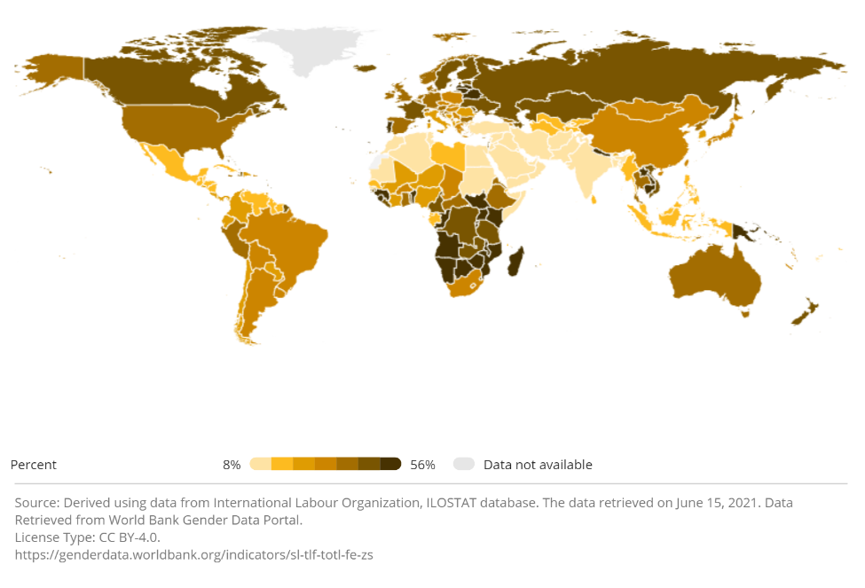

**Figure 1b: Ratio of female to male labor force participation rate (%)**

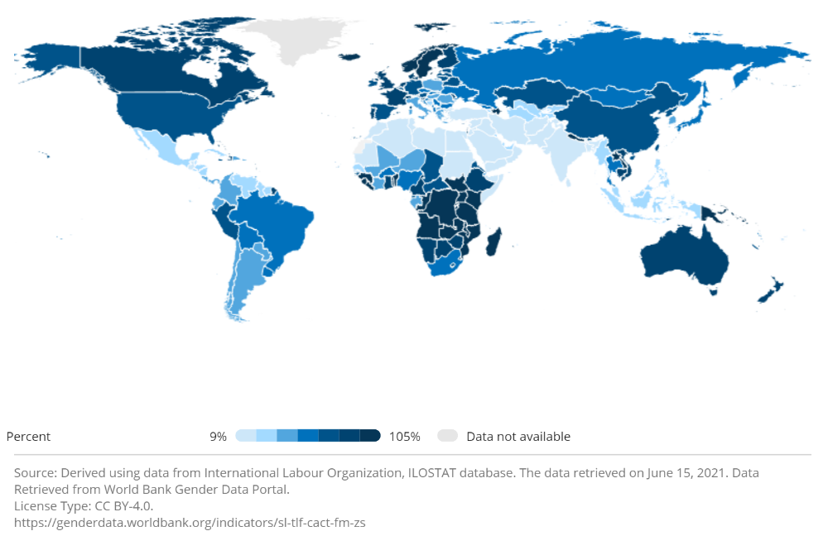

Note: The above graphs depict two variables representing the participation of females in the labor force. The top figure presents the percentage of women out of the total labor force, while the bottom figure depicts the ratio of female to male Data and Figures on female labor force participation, obtained from the World Bank. Both graphs demonstrate that the role of women in the labor force is substantial.

**Table 1: Descriptive Statistics**

|  |  |  |  |  |  |  |
| --- | --- | --- | --- | --- | --- | --- |
| **Panel A - Descriptive statistics** | |  |  |  |  |  |
|  | **N** | **Mean** | **Q1** | **Median** | **Q3** | **Std Dev** |
| *MeanHourlyPayDif* | 45,001 | 13.990 | 4.700 | 13.000 | 22.400 | 13.326 |
| **TopDif** | 44,631 | 21.522 | -18.000 | 26.200 | 64.800 | 48.774 |
| **BottomDif** | 44,631 | -6.978 | -46.000 | -10.000 | 30.200 | 48.535 |
| *MeanBonusDif* | 37,049 | 25.234 | 0.200 | 31.800 | 56.000 | 49.065 |
| **BonusDif** | 37,049 | 1.741 | -1.900 | 0.400 | 4.800 | 11.236 |

Note: The table reports descriptive statistics on the gender pay gap in the UK following the UK Equality Act. The sample period is 2017-2021. The sample includes all UK employers with 250 or more employees. *MeanHourlyPayDif* the gap in hourly rate betweenmen and women. *TopDif* is difference betweenthe percentage of men and women in the top hourly pay quarter. *BottomDif* is difference betweenthe percentage of men and women in the lowest hourly pay quarter. *MeanBonusDif* isthe mean percentage gap between bonuses granted to men and women. *BonusDif* is difference betweenthe percentage of men and women receiving bonuses.

**Table 1: Descriptive Statistics - *Continued***

**Panel B – Industry Descriptive Statistics**

|  |  |  |  |  |  |  |
| --- | --- | --- | --- | --- | --- | --- |
| **Industry** | **N** | *MeanHourlyPayDif* | **TopDif** | **BottomDif** | *MeanBonusDif* | **BonusDif** |
| **Agriculture, Forestry and Fishing** | 846 | 13.56 | 0.16 | -30.34 | 15.52 | 0.70 |
| **Mining and Quarrying** | 199 | 20.41 | 76.77 | 39.47 | 32.51 | -0.14 |
| **Manufacturing** | 5,265 | 12.21 | 61.12 | 32.41 | 25.11 | 1.97 |
| **Electricity, gas, steam, and** | 244 | 14.28 | 63.40 | 28.09 | 24.84 | 0.63 |
| **Water supply, sewerage** | 253 | 6.03 | 58.73 | 41.28 | -2.18 | 4.23 |
| **Construction** | 1,259 | 21.56 | 79.00 | 37.57 | 31.39 | 1.05 |
| **Wholesale and retail trade** | 4,346 | 14.56 | 30.78 | 6.68 | 32.96 | 3.77 |
| **Transportation and storage** | 1,733 | 9.91 | 68.24 | 42.62 | 15.61 | 3.39 |
| **Accommodation and food service activities** | 2,187 | 8.04 | 12.29 | -6.69 | 19.74 | 0.63 |
| **Information and communication** | 2,002 | 18.94 | 52.93 | 13.28 | 35.33 | 2.04 |
| **Financial and insurance activities** | 1,904 | 25.61 | 39.87 | -13.86 | 45.76 | 1.59 |
| **Real estate activities** | 582 | 17.03 | 29.85 | -9.30 | 32.76 | 2.39 |
| **Professional, scientific, and technical activities** | 3,471 | 19.19 | 36.42 | -2.62 | 36.42 | 1.57 |
| **Administrative and support service activities** | 5,816 | 11.77 | 27.32 | 0.34 | 22.67 | 0.55 |
| **Public administration and defense** | 2,331 | 7.53 | 5.03 | -15.72 | 8.56 | 0.81 |
| **Education** | 5,360 | 16.26 | -22.94 | -56.36 | 12.70 | -0.13 |
| **Human health and social work activities** | 4,455 | 10.07 | -43.84 | -54.72 | 12.82 | 0.42 |
| **Arts, entertainment, and recreation** | 1,352 | 15.74 | 20.70 | -0.30 | 37.67 | 2.81 |
| **Other service activities** | 1,330 | 12.36 | 12.20 | -17.07 | 20.08 | 0.97 |
| **Activities of households as employers;** | 30 | 8.84 | 16.07 | -0.55 | 21.62 | 3.37 |
| **Activities of extraterritorial organizations** | 36 | 8.59 | 25.47 | 5.21 | 22.58 | -0.47 |

Note: The table reports descriptive statistics on the gender pay gap in the UK following the UK Equality Act. The sample period is 2017-2021. The sample includes all UK employers with 250 or more employees. *MeanHourlyPayDif* the gap in hourly rate betweenmen and women. *TopDif* is difference betweenthe percentage of men and women in the top hourly pay quarter. *BottomDif* is difference betweenthe percentage of men and women in the lowest hourly pay quarter. *MeanBonusDif* isthe mean percentage gap between bonuses granted to men and women. *BonusDif* is difference betweenthe percentage of men and women receiving bonuses.

|  |  |  |  |  |  |  |
| --- | --- | --- | --- | --- | --- | --- |
| **Table 1: Descriptive Statistics - *Continued***  **Panel C - Mean pay gaps by year** | |  |  |  |  |  |
| **Year** | **N** | *MeanHourlyPayDif* | **TopDif** | **BottomDif** | *MeanBonusDif* | **BonusDif** |
| **2017** | 9,477 | 14.303 | 22.791 | -5.945 | 21.157 | 1.575 |
| **2018** | 9,969 | 14.112 | 21.527 | -6.645 | 25.504 | 1.413 |
| **2019** | 6,435 | 14.316 | 20.971 | -8.301 | 29.748 | 1.463 |
| **2020** | 9,622 | 13.839 | 21.256 | -7.271 | 27.151 | 1.197 |
| **2021** | 9,498 | 13.482 | 20.878 | -7.177 | 25.295 | 1.332 |

Note: The table reports descriptive statistics on the gender pay gap in the UK following the UK Equality Act. The sample period is 2017-2021. The sample includes all UK employers with 250 or more employees. *MeanHourlyPayDif* the gap in hourly rate betweenmen and women. *TopDif* is difference betweenthe percentage of men and women in the top hourly pay quarter. *BottomDif* is difference betweenthe percentage of men and women in the lowest hourly pay quarter. *MeanBonusDif* isthe mean percentage gap between bonuses granted to men and women. *BonusDif* is difference betweenthe percentage of men and women receiving bonuses.

|  |  |  |  |  |  |  |
| --- | --- | --- | --- | --- | --- | --- |
| **Table 2: Gap in hourly rate** | | |  |  |  |  |
|  |  |  |  |  |  |  |
|  | *MeanHourlyPayDif* | | *TopDif* | | *BottomDif* | |
|  | **Coef** | **P-value** | **Coef** | **P-value** | **Coef** | **P-value** |
| Intercept | 9.329 | <.0001 | 26.394 | 0.027 | 5.348 | 0.612 |
| **TIME** | **-0.197** | **<.0001** | **-0.320** | **<.0001** | **-0.186** | **0.036** |
| SIZE | -0.140 | 0.222 | -0.127 | 0.682 | 0.071 | 0.832 |
|  |  |  |  |  |  |  |
| R2 | 0.164 |  | 0.577 |  | 0.491 |  |
| N | 45,001 |  | 44,631 |  | 44,631 |  |

Notes: The table reports results of a regression analysis of pay gap in the UK. The sample period is 2017-2021. The sample includes all UK employers with 250 or more employees. The dependent variables are defined in Table 1. *Time* equals to the calendar year minus 2017. *Size* is an ordinal variable denoting the firm's number of employees category, ranging between 1 and 6. The regressions incorporate fixed industry effect and clusters standard errors by firm.

|  |  |  |  |  |  |
| --- | --- | --- | --- | --- | --- |
| **Table 3: Gap in bonus** | | |  |  |  |
|  |  |  |  |  |  |
|  | *MeanBonusDif* | | *BonusDif* | |  |
|  | **Coef** | **P-value** | **Coef** | **P-value** |  |
| Intercept | 20.581 | 0.130 | -0.511 | 0.735 |  |
| **TIME** | **0.298** | **0.093** | **-0.054** | **0.153** |  |
| SIZE | 0.521 | 0.175 | 0.035 | 0.702 |  |
|  |  |  |  |  |  |
| R2 | 0.164 |  | 0.051 |  |  |
| N | 37,049 |  | 37,049 |  |  |

Notes: The table reports results of a regression analysis of pay gap in the UK. The sample period is 2017-2021. The sample includes all UK employers with 250 or more employees. The dependent variables are defined in Table 1. *Time* and *Size* are defined in Table 2. The regressions incorporate fixed industry effect and clusters standard errors by firm.

**CRediT Author Statement**

**All authors contribute equally to the research**

**Menachem (Meni) Abudy:** Conceptualization; Investigation; Data curation; Methodology; Resources; Formal analysis; Writing – original draft; Writing – review & editing.

**David Y. Aharon:** Conceptualization; Investigation; Data curation; Methodology; Resources; Formal analysis; Writing – original draft; Writing – review & editing.

**Efrat Shust:** Conceptualization; Investigation; Data curation; Methodology; Resources; Formal analysis; Writing – original draft; Writing – review & editing.

**Declaration of Interests**

The authors declare that they have no known competing financial interests or personal relationships that could have appeared to influence the work reported in this paper.

The authors declare the following financial interests/personal relationships which may be considered as potential competing interests:

1. <https://www.imf.org/en/Publications/Policy-Papers/Issues/2022/07/28/IMF-Strategy-Toward-Mainstreaming-Gender-521344>
2. The term pay relates to the total compensation, including wage, bonuses, etc.
3. <https://genderdata.worldbank.org/indicators/sl-tlf-totl-fe-zs/>
4. <https://genderdata.worldbank.org/indicators/sl-tlf-cact-fm-zs>
5. Each firm has to sort its employees based on their hourly rate, in descending order, and then divide them into four equal sized groups of employees based on their hourly pay. Each group is referred to as a 'pay quarter', where the highest-paid employees belong to the top quarter and the lowest-paid employees belong to the bottom quarter.
6. Detailed information on the calculation of all pay variables is available at: <https://www.gov.uk/guidance/making-your-gender-pay-gap-calculations#calculating-the-mean-average-gender-pay-gap-using-bonus-pay>
7. The categories are: less than 250, 250-499, 500-999, 1,000-4,999, 5,000-19,999 and 20,000 or more.
8. There is a slight exception in 2019. However, this year has relatively small number of observations, which is approx.2/3 of the average number of observations in other sample years. The reason for this discrepancy is that in March 2020, before the publication deadline for the 2019 reports, the disclosure requirement was temporarily suspended due to the Covid-19 pandemic.
9. We use this measure to control for firm size since the database does not provide financial data. For robustness, we repeat the analysis using number of employees equal to the middle of each category's range, as well as the natural logarithm of these mid-range numbers of employees. The results are similar.