Application No. 838/23

PI Name: Victor Yashunsky

*Control of Multicellular Turbulence with Regulated Topological Defects Unbinding*

Abstract

Flocks of birds, schools of fish, groups of bacteria, living tissues and cytoskeleton are all made of “active” entities that use external energy to generate their own motion and forces. Study of living active systems motivate and test the theories of non-equilibrium statistical physics. The physics of active matter illuminates natural processes of life, such as intracellular dynamics, biofilm formation, cancer metastasis, morphogenesis and up to the herds behavior of animals. Compared to rapid theoretical progress, experimental research advances at a slower pace and requires a truly interdisciplinary effort.

The multicellular organization exhibits the properties of nematics liquid crystals and provides a wide range of dynamics among available active systems, ranging from jammed state to turbulent chaos. Most attempts to control multicellular nematics focused on passive-like regime, where organization relaxes to the ordered state. So far, cell organization controlled with confinement of cell ensembles or by direct application of substrate topography to each cell. Highly active, turbulent systems continuously reorganize their orientation and flows by spontaneous unbinding of new defects. Programing of defect unbinding events would make it possible to control the organization of chaotic active turbulent systems. However, so far, control of defect unbinding was not shown. Multicellular migration underlies physiological and pathological processes. Thus, understanding the physical principles of multicellular dynamics and the ability to control them is of great importance.

The goal of this proposal is to be able to determine the macroscale dynamics of turbulent multicellular systems using pre-programed defect unbinding configurations. Three aims will be addressed: Aim#1: To determine location and orientation of single unbinding event; Aim#2: Enable coupling between flow fields from different unbinding regions; Aim#3: To demonstrate macroscopic multicellular flows governed by pre-designed arrays of topological defect.

The proposed study will be an interdisciplinary effort at the interface of physics, biology, chemistry, and engineering. Microfabricated cell substrates will be designed to control defect unbinding in cell monolayers. High content analysis of multicellular mechanics will rely on automated time-lapse microscopy and include development of new methods. The experimental results will be compared with theoretical predictions. The impact of this work will lead to new possibilities for the control of chaotic active systems, while the control of multicellular dynamics will also enable the control of tissue organization and function with potential applications in tissue engineering.

Application No. 838/23

PI Name: Victor Yashunsky

*Control of Multicellular Turbulence with Regulated Topological Defects Unbinding*

* 1. Scientific background

**Multiple studies in the last decade demonstrated that organization of many multicellular systems could be described as active liquid crystal [1-9]. My recent works have shown that certain tissue cell types are in highly active state knows as *active turbulence* or *chaos* [8, 9]. However, there are no experimental implementations yet that allow controlling active turbulent systems in general and turbulent multicellular systems in particular. This proposal describes the conceptual strategy and experimental implementation of the manipulation of turbulent multicellular cultures and the design multicellular dynamics.**

Collective cell dynamics and shaping of completely different multicellular systems could be explained within unified physical framework of active liquid crystals hydrodynamics or *active nematics* [1-9]. Active nematics provides coarse-grained description of the velocity and the orientation fields and characterizing the mesoscopic variables, such as active stress, Frank elastic modulus, viscosity, friction, and chiral stress [10]. Prominent examples where active nematics prediction were observed in cell monolayers include spontaneous emergence of shear flows under confinement [2, 5], appearance of counterrotating vortex pairs at comet-shaped, nematic +1/2 defects [7-9], and exponential distribution of vortex areas [9].

The dynamic modes of multicellular systems span from jammed, solid-like phase, where cells hardly move beyond their own sizes [11-13], to intermediate regimes, where cells exhibit long-range collective flows [2, 14], and up highly active chaotic phase, where cell flows form transient pattern of vortices [8, 9, 15, 16] (Figure 1, left panel). A hallmark of liquid crystalline organization is an existence of singular points of the nematic order, where the director field is discontinuous, these called topological defects [17, 18] (Figure 1, right panel). In active nematics defects are the hotspots of flow generation and suggested as potential organizing centers for shape evolution [19, 20]. Importance of topological defects has recently been highlighted in developmental processes in eukaryotic organisms, such as the large-scale cell rearrangements in the Drosophila embryo [21] and the growth of tentacles in Hydra [6], cell apoptosis and extrusion in epithelia[7] and crisscross multilayering of myoblasts [22]. Evolution of defect population is an indicator of activity level. Passive-like behaving cell systems, where relaxation forces are dominating over the active stress, annihilate defect pairs of opposite charge, but not able of unbinding new pairs of defects [23]. Highly active systems are able to compete with the nematic elasticity and spontaneously unbind defect pairs of opposite signs [8, 9].

***Figure 1 |*****Multicellular dynamics modes and flow-structure correlations.**

*Left panel:* Schematic diagram of dynamic states in multicellular systems shows different dynamic modes as a function of energy inflow (driving force) and microscopic interaction strength (interaction force).

*Right panel:* Examples of transport modes in active-nematic fluids corresponding to topological defects. From left to right: translation at +1/2 defect; rotation at +1 defect; and divergence at -1/2 defect. Grey lines show the orientational nematic field and black arrows show fluid velocity.

Control of multicellular orientation demonstrated in passive-like behaving cells dominated by a large friction of cell with the substrate [24]. For example, orientation of fibroblast cells was controlled with a substrate pattern made of liquid crystal elastomer [25]; mesoscale micron-sized ridges pattern exploited to generate ±1 and ±1/2 defects in 3T6 fibroblasts and EpH-4 epithelial cells [26]; NIH-3T3 fibroblasts, C2C12 muscles cell or RPE1 retina cells in circular confinements organized with two facing  +1/2 defects positioned on a diameter [3]; C2C12 confined in smaller disks developed +1 defect and evolved into dome shape [27]. In all above-mentioned examples cells organized like passive liquid crystals with only difference that collective flows cells are not static and keep flowing, these flows are attributed to the gradients of active stress.  and since cells proliferate the ensemble shape can evolve.

Oppositely to passive-like behaving cells, highly active, turbulent systems continuously reorganize their orientation and flow field by unbinding of new defects. In non-cellular active turbulent systems, a few experimental attempts showed that electric fields and confinements allow to manipulate the organization of tubulin-kinesin active gels [28, 29]. Confinements were also used to generate edge flows in bacterial groups [30-32]. In my recent work, we showed that defects alignment and net flows can be achieved in cancerous human fibrosarcoma using physical boundaries [8].

Here we propose a concept and experimental realization of controlled unbinding of defects as a strategy to manipulate dynamics of active turbulent multicellular systems.

The ability to control defect nucleation would enable manipulate macroscale organization using local cues. Such approach, naturally, could be applied for manipulation of unbounded cells culture with minimal intervention, without controlling each cell like it is done in contact guiding methods.

Overall, spatial control of defects nucleation would allow rational design of multicellular organization and determine the velocity field. Such ability would make possible the predesign of cell mass transfer and programing transformation of multicellular shapes, and in the long run to determine biological functionality, which is often tightly linked to multicellular architecture.

* 1. Research objectives and expected significance

The ultimate goal of this proposal is to demonstrate that organization of chaotically moving cell ensembles could be guided using topological mechanism.

The specific aims listed below will tackle existing knowledge gaps and enable the proposed goal:

**Aim#1:** To develop ability to determine the position and orientation of defect pair unbinding. Patterned and curved substrates will be developed to generate highly stressed regions in cell monolayers and result in hot spots for nucleation of defect pairs.

**Significance of aim#1:** Defects serve as organizing centers for the flows and for shape evolution. Unbinding of defects occurs spontaneously and does not allow control of cell dynamics. Determination of defect unbinding region will be the first step towards controlling multicellular transport and will open a new avenue for the manipulation of the active matter.

**Aim#2:** To determine spacing, relative orientation and critical distances for various unbinding site configurations. Different configurations of unbinding region will be tested to quantify associated flow patterns across different cell types in order to find optimal conditions for coupling between flow fields associated with different defect unbinding regions.

**Significance of aim#2:** Since defects interact with each other through elastic forces, mapping of interaction between defects is essential for programming integrated performance of defect arrays.

**Aim#3:** To develop ability to design multicellular flows using predesign arrays of nucleated defects. Defect arrays, which will be predesigned to translate and rotate cells according to the knowledge from the aim #2, will be used to demonstrate a proof of concept that chaotic motion in active systems can be controlled via topological defects.

**Significance of aim#3:** Harnessing the mobility of individual particles to achieve macroscale organization is one of the gold mines in active matter research. The ability to control and manipulate active materials essential for their practical use application. Personally, I am mostly excited about the possibility of programing the assembly of multicellular shapes, which would open a path to mimic the self-shaping (morphogenesis) of living tissues.

Along with physical motivation and significance, the multicellular migration underlies physiological and pathological situations like embryonic morphogenesis, intestinal epithelial regeneration, wound repair, and cancer invasion. Therefore, understanding of the physical principles governing multicellular dynamics and ability to control cell organization is of great importance.

* 1. Detailed description of the proposed research
     1. Working Hypothesis

**Turbulent active nematic in multicellular systems**

Cells in bidimensional cultures often acquire elongated shapes and tend to align together forming domains of co-aligned cells [4, 33]. These domains are separated by nematic defects of charge  ±1/2 that prevent them to fuse [3, 5, 7-9, 22]. When the activity, which drives deformation in cells is high enough to compete with the nematic elasticity it results in unbinding of defect pairs [34]. Because of their large activity and elongated shape, these cells give rise to a collective state known as ``active nematic turbulence'' [23, 35, 36], where cells are locally aligned, and yet chaotically moving and topological defects persistently unbind and annihilate [9]. Defects leave a distinct signature on the flow itself, via backflow mechanism [37, 38]. In particular, +1/2 defects drive a Stokeslet-like flow consisting of two vortices symmetrically counter-rotating about the defect longitudinal direction (Figure 2). Recent experiments in passive-like cellular systems, where defects annihilate without unbinding, indicate that topological defects serve as organizing centers in multicellular shape evolution [5, 6, 22, 27]. In my last work we found that in highly active HT1080 cultures, which continuously unbinding ±1/2 defect pairs, edge flows arise via co-alignment of +1/2 defects near culture boundaries [8]. Therefore we expect that programing of defect unbinding location will allow to harness the motility of chaotically moving cells to desired global flow pattern.

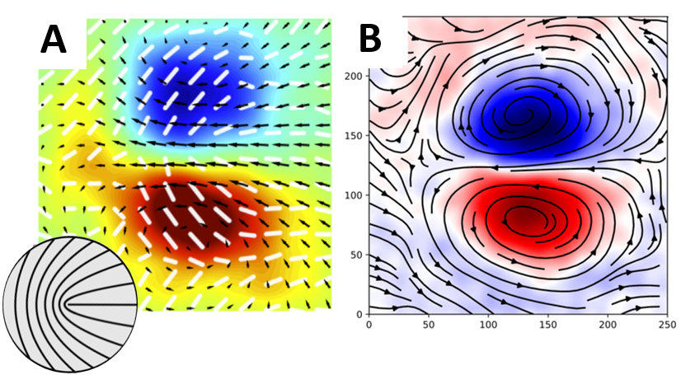

***Figure 2 |*****TBD**

Defect unbinding spontaneously occur in turbulent active nematics, and specifically in HBEC and HT1080 cell monolayers. Pearce et al [39] investigated the effect of curvature on turbulent active nematics using hydrodynamic, particle-based simulations, and found that defect unbinding rates increase on surfaces with negative Gaussian curvature. Negative curvature increases the shear force (Figure 3C), since the streamlines inevitably converge, and therefore increases the rate of defect unbinding (Figure 3B) and rises defect population (Figure 3A). This result was supported by experimental findings in microtubules-kinesin suspensions in toroidal droplet [39].

The hypothesis behind this proposal that increment of the shear force can be applied locally in highly active multicellular monolayers and in such way to determine “hot spots” for defect unbinding. We assume that cell flows could be converged trough substrate geometry (i.e., cell-repelling patterns and substrate curvature) without using confinement. If true, it would allow (1) to define defect unbinding positions and orientation, (2) to design multi-defect patterns, and (3) to control multicellular transport.

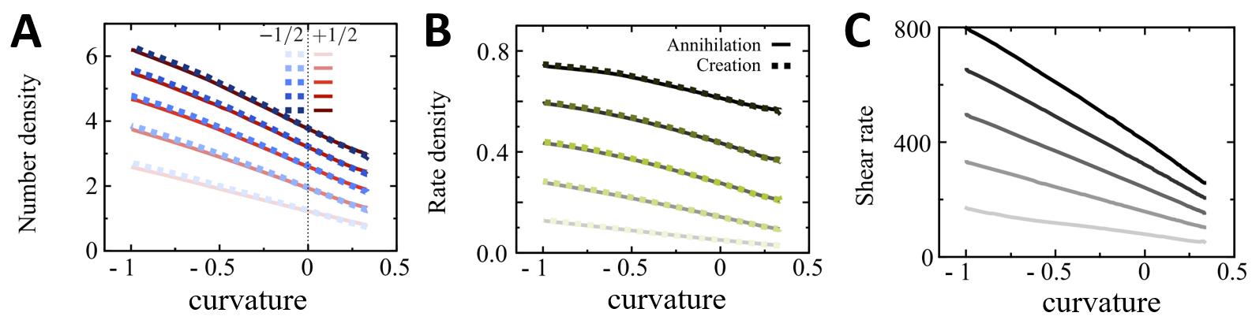

***Figure 3 |*****TBD**

* + 1. Experimental design

**Aim I:**

To control the position of defect nucleation we will use highly active cell cultures of human bronchial cells (HBEC), human fibrosarcoma cells (HT1080). Both cells have already been identified as turbulent nematics, where spontaneous nucleation of defects occurs [8, 9]. Additional potential cell lines where defect nucleation or swirling flow patterns were observed include Madin-Darby Canine Kidney (MDCK), and human skin keratinocyte (HaCaT) cells. Cell lines will be purchased from American Type Culture Collection (ATCC) and cultured in humidity-controlled CO2 incubator. Cell organization will be studied on customized 6 and 9 well plates, where plastic bottoms will be replaced with round glass coverslips (diameter 2-3 cm, thickness 175 µm). Coverslips will be patterned cell-repelling microstructures, either coated with structured thin layer of elastomer (PDMS). The fabrication will take place inside the laboratory cleanroom or in the Nanofabrication center of BGU.

**PEG-acrylamide cell-repelling microstructures** will be prepared by a method, which was developed in my earlier works [2, 8, 40]. Glass coverslips fist will be cleaned with piranha solution (3:1 mixture of sulfuric acid and hydrogen peroxide), incubated in ATC-silane solution (80:1 mixture of toluene with allyltrichlorosilane 95%), and coated with acrylamide and PEG using 365nm UV transilluminator (25W-UVP-TFL 40V, Analytik Jena, Germany). PEG-acrylamide layer will be coated with positive photoresist (S1813, Shipley, USA) and exposed to UV radiation in mask aligner (UV-KUB 2, KHLOÉ, France) trough mask containing the desirable microstructure. Alternative method of cell-repellent micropatterning will rely on PRIMO system (Alvéole, France) - maskless digital micromirror system designed for UV-photopatterning. PRIMO module attached directly to inverted epifluorescence microscope and does not require clean room conditions. To force formation of +1/2 and -1/2 defect pairs, shape, and dimensions of will be tuned for each cell type (see examples in Figure 4A).

**PDMS microstructures** will be prepared by embossing method. The embossing stamp will be ordered from laser engraving workshop (Digital-Cut, Israel) and will be made of PMMA.

The stamp will be used to make negatively curved relief on PDMS film (Figure 4B). PDMS film will be spin-coated coverslip, cured at 60 °C for 1 h with PMMA stamp on top, after the stamp will be peeled off and PDMS film will be incubated in Fibronectin 10 µg/mL solution for 1 hour. The glass coverslip with structured PDMS film will be glued with PDMS to a bottom of multiwall plate, cured for 3 hours at room temperature and serve as a substrate for cell culture.

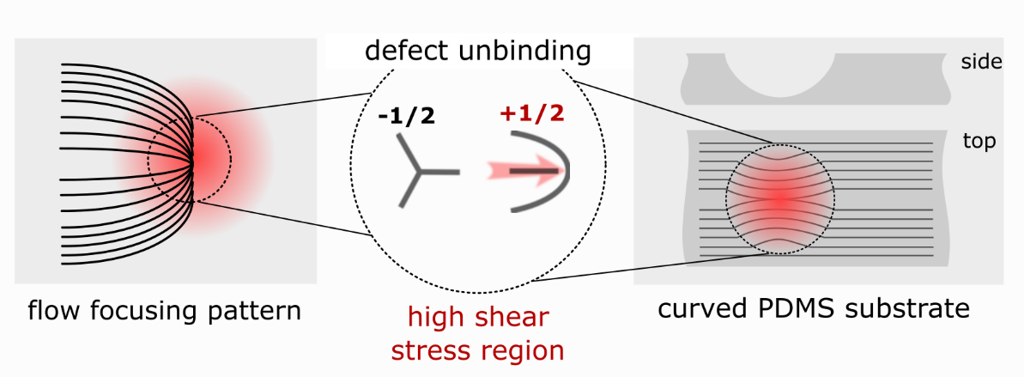

***Figure 4 |*****TBD**

Cells will be seeded on cell-repelling or PDMS substrates, and incubated until they rich full confluence, usually 12-24 hours in CO2 incubator.

Time-lapse (5-30 frames per hour) multi-field (100-300 position) imaging of cell cultures in multi-well plates will be performed in phase contrast and fluorescent channels using 4X or 10X objectives on fully motorized inverted microscope (Zeiss AxioObserver7) equipped with thermal, humidity and CO2 regulated chamber (CUBE&BOX, LIS, Switzerland).In case of curved cultures each position will be imaged with 10X objective at multiple depth (z-stack) spaced by 5 µm. The microscopic experiments will last from 2 to 5 days, depending on the proliferation rate of the cell type, and acquire images in automatic manner imaging the positions defined in the beginning of experiment. Initially focus will be checked every 12 hours and drifts will corrected by manual adjustment of z-position using remote control connection. Later autofocus algorithm that was developed as a part of another project will be integrated into image acquisition routine. The record of position x-y-z position of each field of view will be stored together with the image to allow detection of cell-repellent features, which otherwise are invisible. MATLAB and Python algorithms developed in my recent works [8, 9] and afterwards will be employed to detect and classify population of +1/2 and -1/2 defects together with their flow fields from phase contrast images. Live probes of nuclei (Hoechst 33342, Thermo Scientific), actin cytoskeleton (CellLight Actin-GFP, Thermo Scientific) will be used for fluorescent imaging. Prior to orientation and velocity analysis z-stacks of curved cultures will be preprocessed to produce single image using maximum intensity projection.

**Aim II:**

Different defect configuration will be tested using cell-repelling and curved microstructures. The spacing and relative position between defect nucleation sites will be tested to define relevant configurations of defect nucleation regions in different cell types (e.g., HBEC, HT1080). New patterns will be fabricated according to the obtained results. Typical distance between defect nucleation regions expected to range between 100 µm and 500 µm. PEG-acrylamide cell-repelling microstructures patterns will be prepared using lithography method as described in my previous works [2, 8, 40]. Plastic film masks with desired pattern design will be ordered from SELBA, Switzerland or produced in Nanofabrication center of BGU. PDMS patterns with curved regions will be produced by stamping method as explained in aim#1. Microengraved stamps made of PMMA with custom designs will be ordered from (Digital-Cut, Israel). Cell culture and time-lapse imaging will be performed according to same procedure as described in aim#1. To observe interaction between nucleation regions imaging will be performed using 4X objective to result in field of view of approximately 3x3 cm2 for each position. Structure and dynamics will be extracted from microscopic images using algorithms for image analysis developed in my previous works [8, 9, 22]. Multicellular structures and dynamics will be compared to theoretical prediction with an assistance of Luca Giomi group (University of Leiden, Netherlands) to determine mechanical properties values (e.g., Frank elastic constant, active stress, rotational viscosity).

**Aim III:**

The results of two previous aims will make possible rational design of defect nucleating arrays that will enable to guide multicellular dynamics at the long range. For example, to enable linear translation of cells +1/2 defects will be organized as unidimensional array, while the alignment of defects tilted by several degrees relatively to array direction (Figure 5A). To produce collective rotation of cells achieved nucleation regions will be distributed on arc of circular and aligned tangentially to it (Figure 5B). Actual spacing and relative orientation between nucleation regions will be designed according to results measured in aim#2 and adjusted according to experimental results.

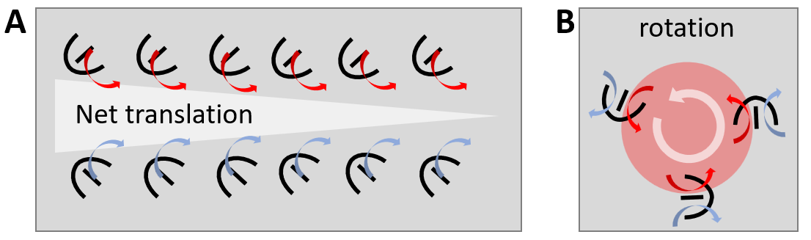

***Figure 5 |*****TBD**

* + 1. Preliminary results

**Imaging conditions:** From already acquired experiments with unbounded HBEC and HT1080 cell cultures we measured the conditions required for reconstruction of orientation and velocity fields. Phase contrast imaging with 10X objective enables orientation reconstruction and segmentation of individual cells (Figure 6). Imaging with 4X is sufficient for cell orientation reconstruction of HBEC cells. HBEC maximal velocities were approximately 70 µm/hr, which requires 5 min delay between frames with 10X objective to measure velocity field with PIV algorithm. The velocity of HT1080 did not exceed 20 µm/hr, which required time resolution of 15 min using 10X objective.

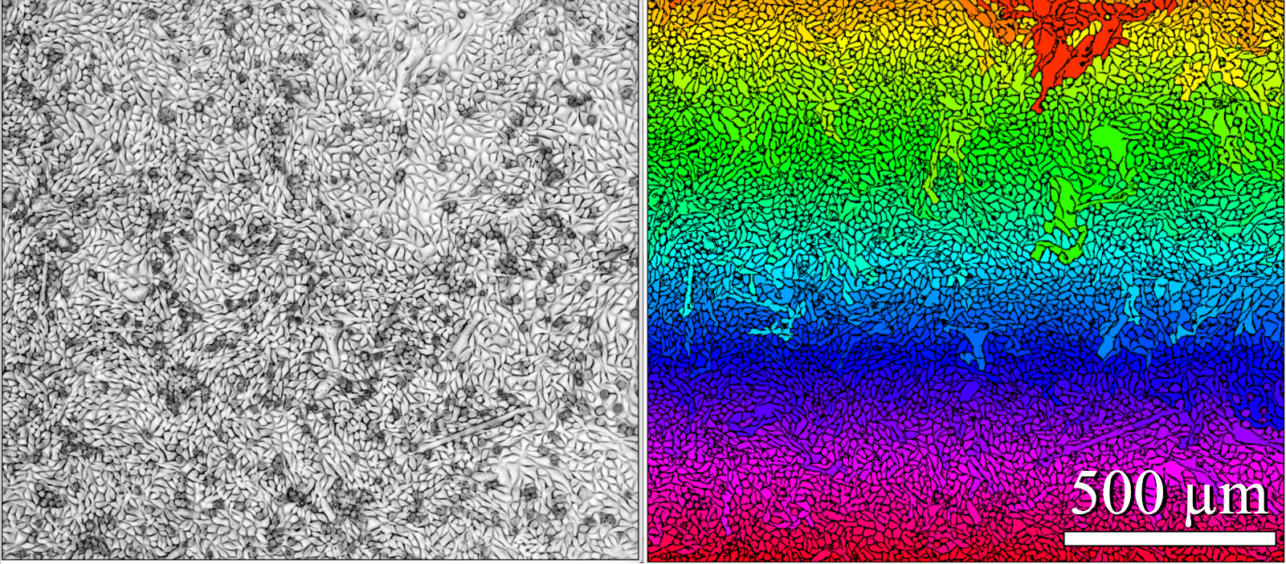

***Figure 6 |*****TBD**

**Spontaneous defect unbinding:** Important result was obtained for HBEC cells, showing that even without enforcing unbinding sites for defects, probability of defect unbinding is not equally distributed in space, but mostly happens around same regions (Figure 7). During another project we found that collective flows of HBEC cells could be aligned by cell-repelling line pattern (line width of 4 µm). These two findings straighten the assumption that cell flow could by guided and result in stable regions of defect unbinding.

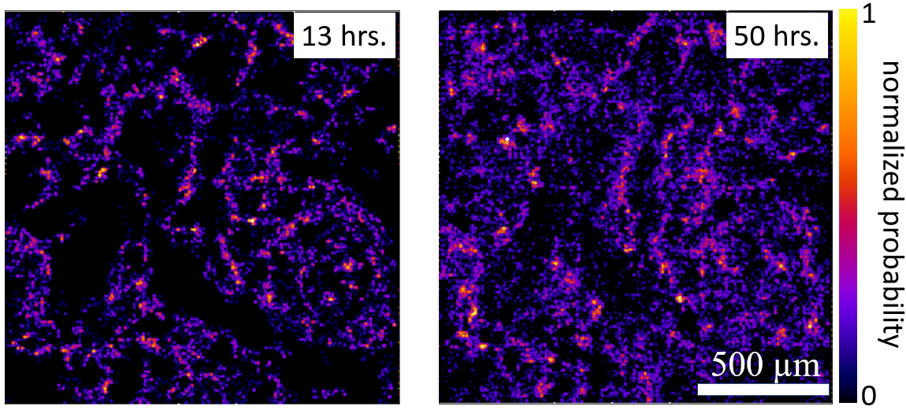

***Figure 7 |*****TBD**

**Analysis:** ImageJ plugins and MATLAB codes previously used codes for measurement of cell orientation and analysis of director field [8, 9], now replaced with Python codes. Defect detection and classification, which was previously time-consuming task, changed with faster method directly measuring the topological charge of whole director field. The classification of the defects now based on measurement of their charge, which calculated by integration along the path surrounding the core of the defect (Figure 8).

For velocity field analysis we found that dense *optical flow*, Gunnar Farneback's algorithm [41] outperforms the previously used us PIV algorithm [42], and now allowing to achieve higher spatial resolution of velocity field.

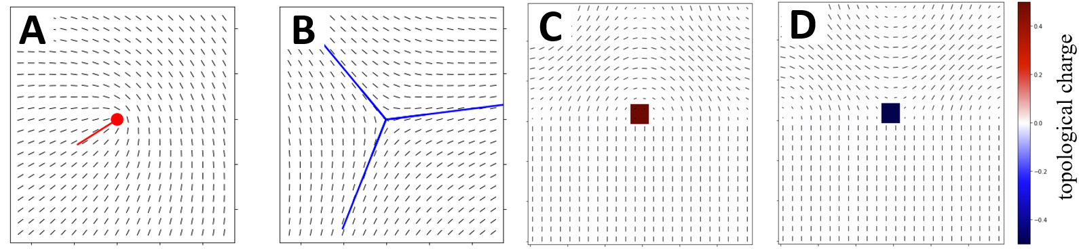

***Figure 8 |*****TBD**

* + 1. Conditions available for conducting research

My laboratory consists of a cleanroom, a cell culture room, and a microscopy space. The laboratory equipped with all the basic equipment for the proposed research. ISO8 level dust-free space in the laboratory allows to execute major part of the fabrication processes. The cleanroom equipped with chemical hood, spin coater, plasma vacuum chamber, UV transilluminator. Processes requiring high end equipment, such as printing of chromium masks, superfine feature lithography and micromachining available at Nanofabrication center of BGU. All essential equipment for cell culturing (e.g., CO2 incubator, liquid nitrogen storage, biosafety cabinet) available inside the laboratory. Large refrigerators and freezers (−20 oC and −80 oC) for reagent storage, autoclaves, water purification system are available as shared equipment nearby in the building next by. Our microscopy space equipped with fully automated inverted fluorescence microscope with environment regulated chamber suited for prolonged imaging of multicellular organization. For image processing and storage, the laboratory purchased GPU station and network attached storage.

Additional equipment for this research, such as PRIMO microscope based photopatterning system, and TILT light-sheet microscopy (Mizar Imaging, US) or Clarity (Aurox, UK) spinning disc confocal module for 3D live imaging will be purchased from a different funding source.

* + 1. Expected results

**Aim#1:** Predefined regions with cell-repellent structures negatively curved features expected to guide and converge the multicellular flows. Flow convergence is expected to increase the probability of defect unbinding due to increased shear stresses in these regions.

**Aim#2:** Controlled defect unbinding should directly allow testing of critical distances for various unbinding site configurations. Here we expect to find optimal configuration to unbound more than one defect pair. Optimal configurations expected to couple between flow fields. This result will be a preliminary step for generation of net flows with defect arrays.

**Aim#3:** Defect arrays that designed according to results from two previous aims, will employ the optimal defect unbinding method. Using defect arrays, we expect to demonstrate the possibility to generate translational and rotational net flows. Such proof of concept will allow to design complex flow pattern in controlled manner.

The study proposed herein relays on my research experience in wet biology, microscopy, microfabrication, and computer vision. More specifically my recent works with highly active cells directly linked to defect unbinding in HBEC monolayers [9] and defect generated flow at the edge of their HT1080 colonies [8]. However, this proposal has several challenging milestones. Control of defect unbinding relies as suggested here relays on increment of shear stress by flow focusing. This theoretical concept has never been tested on cells, which may react in unexpected ways, for example due to compressibility not accounted for by theory. Alternative approach will be direct generation of stress with pneumatic microvalves vastly used in microfluidic devices [43]. Another challenge related to imaging and extraction of structure and velocity in non-planar geometries (curved substrates). In case that image distortion will not allow z-stacks projection and extraction of relevant information. The straightforward solution is confocal imaging (spinning disk). This will require the purchase of additional equipment for the laboratory's controlled environment microscope. However, other imaging modalities, such as reflection bright-field, or epi-fluorescent imaging with deconvolution postprocessing could provide a solution based on the existing equipment.

Bibliography

1. Balasubramaniam L, Doostmohammadi A, Saw TB, Narayana GHNS, Mueller R, Dang T, et al. Investigating the nature of active forces in tissues reveals how contractile cells can form extensile monolayers. Nature Materials. 2021;20(8):1156-66.

2. Duclos G, Blanch-Mercader C, **Yashunsky V**, Salbreux G, Joanny JF, Prost J, et al. Spontaneous shear flow in confined cellular nematics. Nature physics. 2018;14(7):728-32.

3. Duclos G, Erlenkämper C, Joanny J-F, Silberzan P. Topological defects in confined populations of spindle-shaped cells. Nature Physics. 2017;13(1):58-62.

4. Duclos G, Garcia S, Yevick H, Silberzan P. Perfect nematic order in confined monolayers of spindle-shaped cells. Soft Matter. 2014;10(14):2346-53.

5. Kawaguchi K, Kageyama R, Sano M. Topological defects control collective dynamics in neural progenitor cell cultures. Nature. 2017;545(7654):327-31.

6. Maroudas-Sacks Y, Garion L, Shani-Zerbib L, Livshits A, Braun E, Keren K. Topological defects in the nematic order of actin fibres as organization centres of Hydra morphogenesis. Nature Physics. 2021;17(2):251-9.

7. Saw TB, Doostmohammadi A, Nier V, Kocgozlu L, Thampi S, Toyama Y, et al. Topological defects in epithelia govern cell death and extrusion. Nature. 2017;544(7649):212-6.

8. **Yashunsky V**, Pearce D, Blanch-Mercader C, Ascione F, Giomi L, Silberzan P. Chiral edge currents in confined fibrosarcoma cells. arXiv preprint arXiv:201015555. 2020. (accepted for publication in Physical Review X)

9. Blanch-Mercader C, **Yashunsky V**, Garcia S, Duclos G, Giomi L, Silberzan P. Turbulent Dynamics of Epithelial Cell Cultures. Physical Review Letters. 2018;120(20):208101.

10. Shankar S, Souslov A, Bowick MJ, Marchetti MC, Vitelli V. Topological active matter. Nature Reviews Physics. 2022;4(6):380-98.

11. Palamidessi A, Malinverno C, Frittoli E, Corallino S, Barbieri E, Sigismund S, et al. Unjamming overcomes kinetic and proliferation arrest in terminally differentiated cells and promotes collective motility of carcinoma. Nature Materials. 2019;18(11):1252-63.

12. Atia L, Bi D, Sharma Y, Mitchel JA, Gweon B, A Koehler S, et al. Geometric constraints during epithelial jamming. Nature physics. 2018;14(6):613-20.

13. Park J-A, Kim JH, Bi D, Mitchel JA, Qazvini NT, Tantisira K, et al. Unjamming and cell shape in the asthmatic airway epithelium. Nature Materials. 2015;14(10):1040-8.

14. Leclech C, Gonzalez-Rodriguez D, Villedieu A, Lok T, Déplanche A-M, Barakat AI. Topography-induced large-scale antiparallel collective migration in vascular endothelium. Nature Communications. 2022;13(1):1-11.

15. Vedula SRK, Leong MC, Lai TL, Hersen P, Kabla AJ, Lim CT, et al. Emerging modes of collective cell migration induced by geometrical constraints. Proceedings of the National Academy of Sciences. 2012;109(32):12974-9.

16. Lin S-Z, Zhang W-Y, Bi D, Li B, Feng X-Q. Energetics of mesoscale cell turbulence in two-dimensional monolayers. Communications Physics. 2021;4(1):1-9.

17. De Gennes P-G, Prost J. The physics of liquid crystals: Oxford university press; 1993.

18. Ardaševa A, Doostmohammadi A. Topological defects in biological matter. Nature Reviews Physics. 2022;4(6):354-6.

19. Hoffmann LA, Carenza LN, Eckert J, Giomi L. Theory of defect-mediated morphogenesis. Science Advances. 2022;8(15):eabk2712.

20. Copenhagen K, Alert R, Wingreen NS, Shaevitz JW. Topological defects promote layer formation in Myxococcus xanthus colonies. Nature physics. 2021;17(2):211-5.

21. Streichan SJ, Lefebvre MF, Noll N, Wieschaus EF, Shraiman BI. Global morphogenetic flow is accurately predicted by the spatial distribution of myosin motors. Elife. 2018;7:e27454.

22. Sarkar T, **Yashunsky V**, Brézin L, Mercader CB, Aryaksama T, Lacroix M, et al. Crisscross multilayering of cell sheets. bioRxiv. 2021.

23. Doostmohammadi A, Ignés-Mullol J, Yeomans JM, Sagués F. Active nematics. Nature communications. 2018;9(1):1-13.

24. Doostmohammadi A, Adamer MF, Thampi SP, Yeomans JM. Stabilization of active matter by flow-vortex lattices and defect ordering. Nature Communications. 2016;7(1):1-9.

25. Turiv T, Krieger J, Babakhanova G, Yu H, Shiyanovskii SV, Wei Q-H, et al. Topology control of human fibroblast cells monolayer by liquid crystal elastomer. Science advances. 2020;6(20):eaaz6485.

26. Endresen KD, Kim M, Pittman M, Chen Y, Serra F. Topological defects of integer charge in cell monolayers. Soft matter. 2021;17(24):5878-87.

27. Guillamat P, Blanch-Mercader C, Pernollet G, Kruse K, Roux A. Integer topological defects organize stresses driving tissue morphogenesis. Nature materials. 2022;21(5):588-97.

28. Guillamat P, Ignés-Mullol J, Sagués F. Control of active liquid crystals with a magnetic field. Proceedings of the National Academy of Sciences. 2016;113(20):5498-502.

29. Opathalage A, Norton MM, Juniper MP, Langeslay B, Aghvami SA, Fraden S, et al. Self-organized dynamics and the transition to turbulence of confined active nematics. Proceedings of the National Academy of Sciences. 2019;116(11):4788-97.

30. Lushi E, Wioland H, Goldstein RE. Fluid flows created by swimming bacteria drive self-organization in confined suspensions. Proceedings of the National Academy of Sciences. 2014;111(27):9733-8.

31. Wioland H, Lushi E, Goldstein RE. Directed collective motion of bacteria under channel confinement. New Journal of Physics. 2016;18(7):075002.

32. Beppu K, Izri Z, Sato T, Yamanishi Y, Sumino Y, Maeda YT. Edge current and pairing order transition in chiral bacterial vortices. Proceedings of the National Academy of Sciences. 2021;118(39):e2107461118.

33. Kemkemer R, Kling D, Kaufmann D, Gruler H. Elastic properties of nematoid arrangements formed by amoeboid cells. The European Physical Journal E. 2000;1(2):215-25.

34. Shankar S, Ramaswamy S, Marchetti MC, Bowick MJ. Defect unbinding in active nematics. Physical review letters. 2018;121(10):108002.

35. Bratanov V, Jenko F, Frey E. New class of turbulence in active fluids. Proceedings of the National Academy of Sciences. 2015;112(49):15048-53.

36. Wensink HH, Dunkel J, Heidenreich S, Drescher K, Goldstein RE, Löwen H, et al. Meso-scale turbulence in living fluids. Proceedings of the national academy of sciences. 2012;109(36):14308-13.

37. Giomi L, Bowick MJ, Mishra P, Sknepnek R, Cristina Marchetti M. Defect dynamics in active nematics. Philosophical Transactions of the Royal Society A: Mathematical, Physical and Engineering Sciences. 2014;372(2029):20130365.

38. Pismen L. Dynamics of defects in an active nematic layer. Physical Review E. 2013;88(5):050502.

39. Pearce D, Ellis PW, Fernandez-Nieves A, Giomi L. Geometrical control of active turbulence in curved topographies. Physical Review Letters. 2019;122(16):168002.

40. Duclos G, Deforet M, Yevick HG, Cochet-Escartin O, Ascione F, Moitrier S, **Yashunsky V**, et al. Controlling Confinement and Topology to Study Collective Cell Behaviors. Methods in molecular biology. 2018;1749:387-99.

41. Farnebäck G, editor Two-frame motion estimation based on polynomial expansion. Scandinavian conference on Image analysis; 2003: Springer.

42. Sveen JK. An introduction to MatPIV v. 1.6. 1. Preprint series Mechanics and Applied Mathematics <http://urn> nb no/URN: NBN: no-23418. 2004.

43. Unger MA, Chou H-P, Thorsen T, Scherer A, Quake SR. Monolithic microfabricated valves and pumps by multilayer soft lithography. Science. 2000;288(5463):113-6.