Prof. Albert I. Baumgarten

Bar Ilan University

Prof. Albert I. Baumgarten is Professor (Emeritus) at the Department of Jewish History in Bar Ilan University. He holds a B.H.L. in Talmud from JTS and a Ph.D. in History from Columbia University. He was a Fulbright Fellow at the University of Strasbourg and a Principal Investigator at The McMaster Project: Judaism and Christianity in the Graeco-Roman Era. Baumgarten is the author of *The Flourishing of Jewish Sects in the Maccabean Era: An Interpretation*and *Second Temple Sectarianism – A Social and Religious Historical Essay* (2000), and more recently “The Preface to the Hebrew Edition of *Purity and Danger*” (2020), part of his larger effort to present the work of Dame Mary Douglas (1921-2007) to a wider audience.

Why Is Esau’s Kiss Dotted?

Esau’s kiss to Jacob is written with scribal dots over the word וַׄיִּׄשָּׁׄקֵ֑ׄהׄוּׄ, “and he kissed him.” Traditional commentators suggest this hints to Esau’s feelings or state of mind. Critical scholarship, however, points to something much more prosaic, a question of syntax.

[Prof. Albert I. Baumgarten](https://www.thetorah.com/author/albert-l-baumgarten)

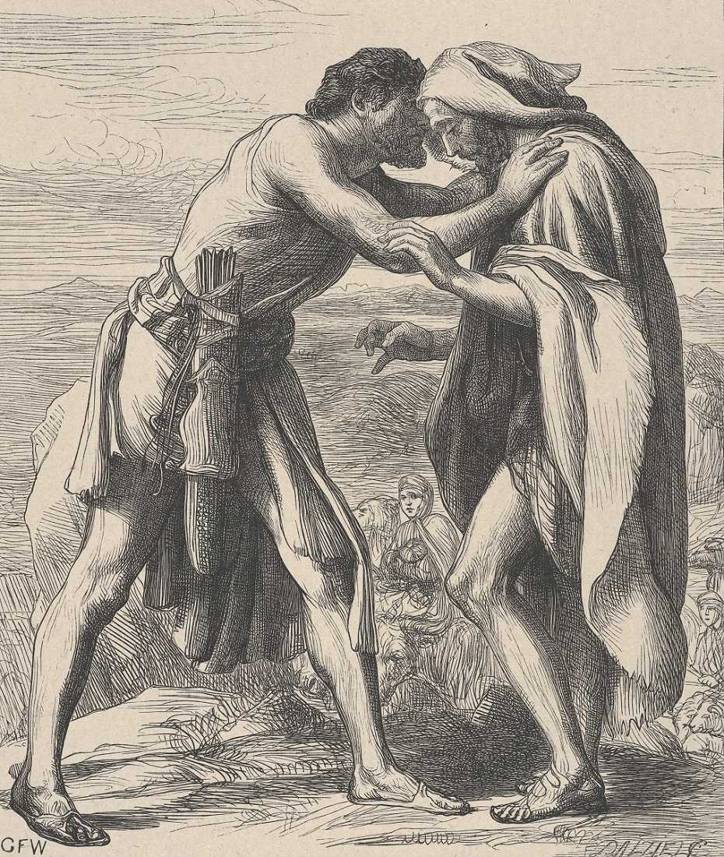

Esau Meeting Jacob, 1881, Dalziel Brothers Metmuseum.org

**W**hen Esau saw his brother Jacob for the first time in twenty years, the text states:

בראשית לג:ד וַיָּ֨רָץ עֵשָׂ֤ו לִקְרָאתֹו֙ וַֽיְחַבְּקֵ֔הוּ וַיִּפֹּ֥ל עַל־צַוָּארָ֖ו וַׄיִּׄשָּׁׄקֵ֑ׄהׄוּׄ וַיִּבְכּֽוּ.

Why is וַׄיִּׄשָּׁׄקֵ֑ׄהׄוּׄ, “he kissed him” dotted?[1] Before answering this question, we must probe a broader one: what do scribal dots in ancient scrolls from this period mean?

*Nota Bene*: Attracting the Reader’s Attention

Shemaryahu Talmon, the late J. L. Magnes Professor of Bible at Jerusalem’s Hebrew University, argued that the “special dots” (*puncta extraordinaria*) found in MT and in certain Qumran texts had multiple uses. They were, in his view, an ancient form of *nota bene* (Latin for “note well”),[2] calling special attention to a word or phrase. For Talmon, the dots were a way for later scribes to call attention to something in the Torah, but for traditional interpreters, the dots were an integral part of the Torah itself.

A Fake Kiss?

Understanding the dots as the Torah’s own *nota bene*, the ancient rabbis attempted to ascertain what exactly the Torah was attempting to call to our attention. Thus, *Sifre Numbers*65 offered the following:

שלא נשקו בכל לבו. ר’ שמעון בן יוחיי אומר **והלא**[3]**בידוע**שעשו שונא ליעקב אלא נהפכו רחמיו באותה שעה ונשקו בכל לבו.-

The first, anonymous position, suggested that the dots imply that the kiss was not reflective of Esau’s inner feelings, while R. Shimon bar Yohai suggested that they were meant to convey that the kiss was authentic, despite the suspicion the reader might have to the contrary.

A Treacherous Kiss: R. Yannai and Origen

A somewhat different understanding appears in *Genesis Rabbah* (927):

אמר ר’ יניי…מלמד שביקש לנשכו, ו י ב כ ו זה בכה על צווארו וזה בכה על שיניו.

Playing on the similarity between the words נשק (kiss) and נשך (bite), and emphasizing the plural ויבכו, “and they both cried,” R. Yannai claimed that the dots explained why both Jacob and Esau were crying.[7]

A similar understanding appears in the work of the Church Father, Origen (184/185 – 253/254 C.E.), a contemporary of R. Yannai. Origen was one of the greatest biblical scholars of the time, and the author of the *Hexapla*, a complex and massive work named thus for its six columns of Biblical text,[8] which, unfortunately, only survives in very fragmentary form.-

Two manuscripts of the Hexapla contain an anonymous remark on our verse with the following note in Greek:

[The word] *Vayyishakehu*is dotted in every (Greek: *enpanti*) Hebrew Bible, not [to indicate] that it should not be read, but the wickedness of Esau is hereby hinted by the Bible: he treacherously kissed Jacob.

Fridericus Field, a 19th century scholar who produced the critical edition of the fragments, believed the note to be Origen’s (*sed videturOrigenisesse*).[11] Assuming Field is correct, and this comment is Origen’s, we see that וישקהו was dotted in all the Hebrew Bibles Origen knew, ca 240 C.E., which fits with the evidence from Rabbinic sources quoted above.

Moreover, although Origen did not specify just what Esau did to make his kiss “treacherous,” this notion fits well with interpretation offered by R. Yannai in *Genesis Rabbah*. This may not be accidental, since we know that Origen and his Jewish contemporaries sometimes shared midrashic traditions, and R. Yannai was roughly contemporary with Origen, even if R. Yannai was based in Sepphoris and Origen in Caesarea.

Cancellation of Letters

Origen rejected an alternative interpretation, that the dotted letters “should not be read,” i.e., that dots were an indication of a spurious or doubtful reading. But many contemporary scholars, such as Hebrew University’s Emanuel Tov, suggest that this is, in fact, what the dots meant.

For ancient scribes, dots above letters were a sign indicating problematic letters to be omitted. They originated in the conviction of a given scribe that a letter, letters, word or words were inappropriate, superfluous, or incorrect. Alternately, a scribe may have dotted a piece of text when collating one MSS against another, considered more authoritative, in which the dotted portion was lacking.[13]

Dots had the role of cancellation marks not only in the Torah, but also in classical texts, as we can see from a comment in the Scholion to the *Iliad* (10.397):

They say that Aristarchus marked (certain verses) with dots, but afterwards removed them entirely.[14]

Tov notes that of the fifteen places in the Bible in which the Masoretic text is dotted, an alternative text without the dotted word is attested in ancient sources in seven or eight instances.[15] The cancellation dots in the Bible are therefore undeniably ancient and reflect well attested ancient textual traditions for how scribes marked problematic words and letters.

Thus, against Talmon, I am convinced by Tov’s conclusion concerning the Qumran evidence: “The Qumran parallels leave no doubt that the original intention of these dots was the cancellation of letters.”[16] Accordingly, elimination, and not emphasis, should be the default choice and the first possibility pursued in all cases of dotted letters.[17]

Rabbinic Knowledge of this Practice

Although rabbinic interpretation assumed that dotted words in the Bible should be treated as an integral part of a verse, the rabbis were aware that scribes used dots to suggest erasure. For example, *Avot of Rabbi Nathan* (version A, 101, column a)[18] makes a general observation:

כך אמר עזרא: אם יבוא אליהו ויאמר לי מפני מה כתבת כך? אומר אני לו כבר נקדתי עליהן ואם אומר לי יפה כתבת אעבור נקודה מעליהן

According to this source, Ezra the scribe put the dots in the biblical books to express ambivalence, and whether the words should remain or be erased was to be answered by Elijah the prophet in messianic times. Indeed, *Sifre Numbers* seems to suggest in one instance that the dots imply that a word was dubious.[19]

But what is the problem with Esau kissing Jacob in this verse such that the word וַׄיִּׄשָּׁׄקֵ֑ׄהׄוּׄ, “he kissed him,” was marked for erasure? I suggest that the scribes were not bothered by the content of the verse, that “Esau wouldn’t have kissed his brother,” but by something much more prosaic: syntax.

Suggestion 1: Hugging and Kissing Should Be Consecutive

In other verses in Genesis, the way of expressing that someone hugs and kisses his fellow is to place the verbs consecutively:

בראשית כט:יגוַיְהִי כִשְׁמֹעַ לָבָן אֶת שֵׁמַע יַעֲקֹב בֶּן אֲחֹתוֹ וַיָּרָץ לִקְרָאתוֹ וַיְחַבֶּק לוֹ וַיְנַשֶּׁק לוֹ…

בראשית מח:י …וַיַּגֵּשׁ אֹתָם אֵלָיו וַיִּשַּׁק לָהֶם וַיְחַבֵּק לָהֶם

If that were the idiom governing our verse, it should have had the verbs adjacent to each other. Thus, it is possible that וַׄיִּׄשָּׁׄקֵ֑ׄהׄוּׄ was dotted because it was in the wrong place in the verse and the dots were meant to convey “delete here and move to the proper spot”:[21]

וַיָּרָץ עֵשָׂו לִקְרָאתֹו וַֽיְחַבְּקֵהוּ [וַיִּשָּׁקֵהוּ] וַיִּפֹּל עַל־צַוָּארָו וַׄיִּׄשָּׁׄקֵ֑ׄהׄוּׄ וַיִּבְכּוּ.

The problem with this interpretation is that dots indicate that a word should be considered/designated for elimination, not that it should be moved. The difficulty is therefore not the place of וַׄיִּׄשָּׁׄקֵ֑ׄהׄוּׄ in the verse but whether it belongs there at all.

Suggestion 2: Conflating the Idioms for Hugging/Kissing and Crying

I suggest that the problem the scribe had was connected to the way the kiss cuts into the description of the crying, as already suggested in 1906 by Romain Butin.[22] Genesis uses two idioms for crying:

Idiom 1 – *Falling on someone’s neck and crying:*

בראשית מה:יד וַיִּפֹּל עַל צַוְּארֵי בִנְיָמִן אָחִיו וַיֵּבְךְּ וּבִנְיָמִן בָּכָה עַל צַוָּארָיו.

בראשית מו:כט … וַיִּפֹּל עַל צַוָּארָיו וַיֵּבְךְּ עַל צַוָּארָיו עוֹד.

Idiom 2 – *Kissing and crying*

בראשית כט:יא וַיִּשַּׁק יַעֲקֹב לְרָחֵל וַיִּשָּׂא אֶת קֹלוֹ וַיֵּבְךְּ.

בראשית מה:טו וַיְנַשֵּׁק לְכָל אֶחָיו וַיֵּבְךְּ עֲלֵיהֶם…

The problem in our verse as it stands is then that it conflates these two idioms for crying. As the text now reads, Esau *fell* *on Jacob’s neck, crying,*and *kissed* him at the same time. Butin suggests that this is why וַׄיִּׄשָּׁׄקֵ֑ׄהׄוּׄ was marked with dots as dubious. When וַׄיִּׄשָּׁׄקֵ֑ׄהׄוּׄ is omitted only one idiom for crying, falling on someone’s neck and crying remains controlling the description of the event.

If the word is deleted, the verse would then read, following one of the expected patterns:

וַיָּרָץ עֵשָׂו לִקְרָאתֹו וַֽיְחַבְּקֵהוּ וַיִּפֹּל עַל־צַוָּארָו וַיִּבְכּוּ.

Not Correcting Gen 50:1

If this explanation is correct, why are there no dots over Joseph’s kissing (וַיִּשַּׁק) his deceased father in Gen 50:1, which also comes together with crying:

בראשית נ:א וַיִּפֹּל יוֹסֵף עַל פְּנֵי אָבִיו וַיֵּבְךְּ עָלָיו וַיִּשַּׁק לוֹ.

I suggest that it is because the text reads על פני, “on his face,” rather than על צוארו, “on his neck,” which is a different idiom. Also, the kissing does not interrupt the idiom, but follows afterwards as a separate action.[25]

Postscript: Scribal Error as a Religious Problem

Many readers of TheTorah.com, like any number of its writers, live on the seams between the worlds of tradition and the university. These offer two different ways of approaching the same set of texts, based on different assumptions, asking and answering very different sorts of questions. Sometimes these seams are rough, sharp, and very uncomfortable to sit on. The dissonance can be great.[26]

The case of the dotted letters, however, is one in which the tradition itself invites university-style analysis, employing philological tools to identify problem readings deserving elimination, which is not a usually accepted procedure in traditional analysis. The dotted letters open the door to asking what might be wrong with a specific word and why it might be appropriate to strike it from the text.

If, as *Avot of Rabbi Nathan* (referenced above) states, Ezra could explain to Elijah that the dots meant that certain letters were incorrectly found in the Torah and should be taken out, then we are free to understand what might be wrong with those letters that Ezra conceded were candidates for omission by means of text critical and philological analysis.

The dotted letters are thus an issue where the two different approaches to the sacred text can agree on the assumptions underlying the questions to be asked and the sorts of answers to be offered. To return to the metaphor of the seams, if those seams are sometimes uncomfortable to sit on, in this case they are flat and smooth. They cause little discomfort, if any.

1. Genesis 33:4 is one of the ten places dotted in the Torah. The basic presentation of the topic of the significance of dotted letters in the Torah remains Saul Lieberman, “The Ten Dotted Places in the Torah,” *Hellenism in Jewish Palestine*(New York, 1962), 43-46. Manuscripts from Qumran have added further evidence, but not changed the basic picture. See further Emanuel Tov, *Scribal Practices and Approaches Reflected in the Texts Found in the Judean Desert*(Leiden, 2009), 175-186; *ibid*., [“(Proto-)Masoretic Text: Scribal Marks,”](http://thetorah.com/proto-masoretic-text/scribal-marks/)*TheTorah.com* (2017).
2. Shemaryahu Talmon, “Prolegomenon,” in Romain F. Butin, *The Ten Nequdoth of the Torah* (Baltimore: J.H Furst, 1906; New York: Ktav, 1969 Reprint), xxi-xxviii.
3. An alternative text, והלכה בידוע “it is a known rule,” which was known to Rashi and thus became the dominant reading, led to much speculation about why this is a “rule.” See discussion in Martin Lockshin, [“Esau Hates Jacob But Is Antisemitism a Halakha?”](http://thetorah.com/esau-hates-jacob-but-is-antisemitism-a-halakha/)*TheTorah.com* (2016).
4. He was of the first generation of *amoraim* in the Land of Israel, roughly the first half of the third century CE.
5. According to the version of the event as told in the first printed edition of *Genesis Rabbah,*as recorded in the critical apparatus of Theodor-Albeck (927), Jacob’s neck became like marble and Esau broke his teeth on Jacob’s neck. Jacob then cried over his neck while Esau cried over his broken teeth. From the first printed edition this account of the consequences of Esau’s kiss was then repeated in popular (vulgate) versions of *Genesis Rabbah*such as the Vilna edition, as Albeck commented *ad loc.*:וכן הדפיסו אחריו .
6. Despite the authority of the Rabbis, Ibn Ezra rejected the midrashic interpretation of the verse:

הדרש על נקודות וישקהו טוב הוא לעתיקי משדים כי על דרך הפשט לא חשב עשו לעשות רע לאחיו והעד, ויבכו, כאשר עשה יוסף עם אחיו.

Ibn Ezra, however, did not offer his own explanation of why וישקהו was dotted. Compare Nahum Sarna, *The JPS Torah Commentary Genesis בראשית* (Philadelphia, 1989), 366, n. 3, who adopted the midrashic explanation of the verse known from Origen and the Rabbis.

1. The columns were:
   1. Hebrew;
   2. Transliteration of the Hebrew into Greek letters;
   3. LXX;
   4. Aquila;
   5. Symmachus;
   6. Theodotion.

In addition to simply putting the various versions in columns, Origen also marked what was in Hebrew but not in the LXX as well as marking what was in the LXX but not in the Hebrew.

1. Field, in his edition of Origen’s Hexapla, 49, n. 6. Field cited five MSS. Codd. Regii in his work, 4-5, all in the “royal” library of Paris. He did not specify which of the five were the two that had this anonymous comment.
2. This explanation of the origin of dotted letters suggests that there was not one organized body, practicing one consistent textual policy, behind the dotted letters. This presumption may explain the fact that the reasons for some dotted letters in the Torah are hard to determine. See for example the dots in Deut 29:28 on לנו ולבנינו ע which Tov, *Scribal Practices*, 204, considered cryptic and Talmon, “Prolegomenon,” xviii, deemed “extremely enigmatic.”
3. As quoted by Lieberman, *Hellenism,*44, n. 52. For the use of dots as marks for omission in Classical texts, see Tov, *Scribal Practices,*184.
4. For some examples, see his, [“(Proto-)Masoretic Text: Scribal Marks,”](http://thetorah.com/proto-masoretic-text/scribal-marks/) *TheTorah.com*(2017).
5. Tov, *Scribal Practices*, 202.
6. I follow Tov because he wrote some forty years after Talmon and his conclusion was based on knowledge of a far wider corpus of texts.
7. In *Avot of Rabbi Nathan* B, 98, col. b, Ezra’s explanation to Elijah was introduced with the question: ולמה נקוד על כל האותיות האלה?
8. In Num 3:5 Moses was commanded to “bring forward the Levites” (הקרב את בני לוי), and the rest of chapter continues with the account of how this was done. However, at the end, summarizing the counting of the Levites, in Num 3:39 we find:

במדבר ג:לט כָּל פְּקוּדֵ֙י הַלְוִיִּ֜ם אֲשֶׁר֩ פָּקַ֙ד מֹשֶׁ֧ה וְ֗אַ֗הֲ֗רֹ֛֗ן֗ עַל פִּ֥י יְ-הוָ֖ה לְמִשְׁפְּחֹתָ֑ם

Not surprisingly, ואהרן (“”) is dotted. What was he doing there, as the original command was given to Moses alone!? This difficulty was recognized in *Sifre Numbers* 69, where the dots were explained as indicating a problem word שלא היה במיניין “.” The standard printing reads differently, שלא היה אהרן מן המנין “.” Menachem Kahana suggested that this might have been a deliberate attempt to adjust the more controversial claim to something less problematic. See Menachem Kahana, *Sifre on Numbers: An Annotated Edition*, volume 4 (Jerusalem: Magnes, 2011), 475-476.

1. Butin, *Ten Nequdoth*, 74, suggested that this was the reading behind the Hebrew source of the major archetype of the verse in the LXX. The connection with the LXX version was a principal reason Talmon also preferred this explanation of the dotted letters, “Prolegomenon,” xii-xiii. For Tov’s comments on the LXX version of this verse see Tov, *Scribal Practices*, 203, n. 268.
2. Butin, *Ten Nequdoth*, 74.
3. Perhaps, as suggested to me by the editors, this act of kissing and crying was seen differently because Joseph was kissing his dead father. It was a kiss of goodbye, closure after crying. Cf. the idiom in Gen 46:29, above, where Joseph fell on Jacob’s neck and wept on his neck some more.
4. For some reflections on this dissonance, see, [“Not a Naive Reading: An Interview with Professor James Kugel,”](https://thetorah.com/not-a-naive-reading-an-interview-with-prof-james-kugel/) *TheTorah.com* (2018).

‍