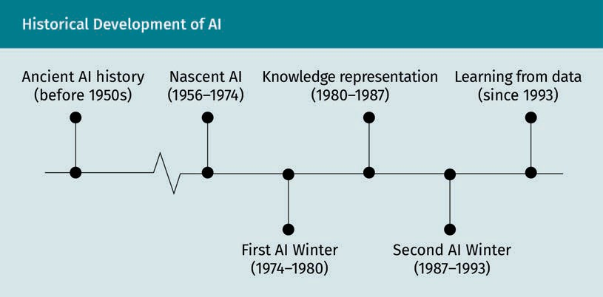
Historical Development of AI
Ancient AI history (before 1950s)
Nascent AI (1956–1974)
First AI Winter (1974–1980)
Knowledge representation (1980–1987)
Second AI Winter (1987–1993)
Learning from data (since 1993)

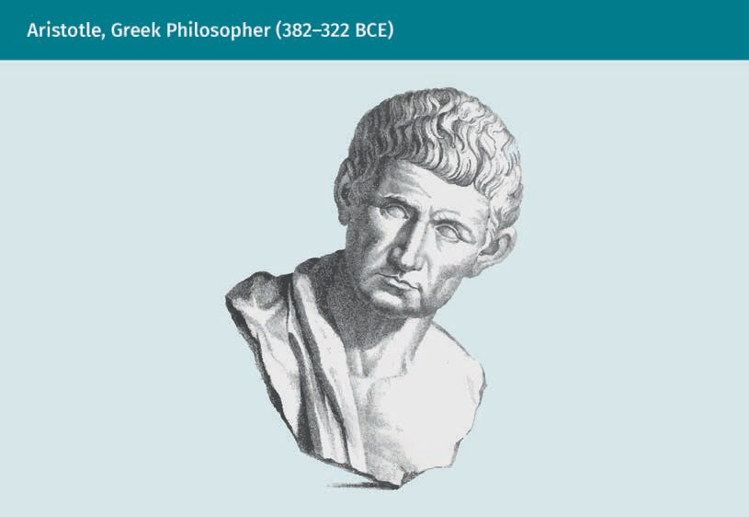
Aristotle, Greek Philosopher (382–322 BCE)

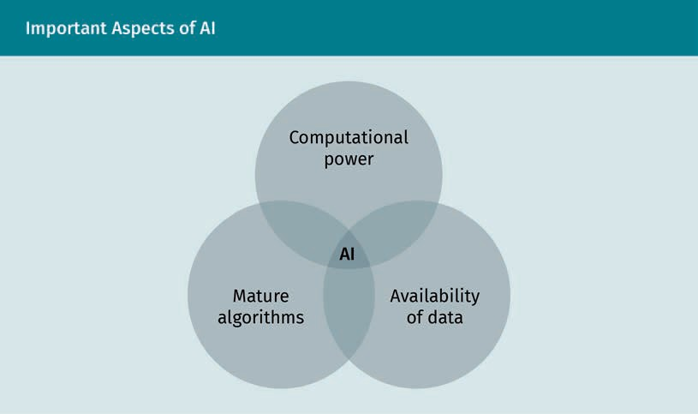
Important Aspects of AI
Computational power
Mature algorithms
Availability of data
AI

Components of an Expert System
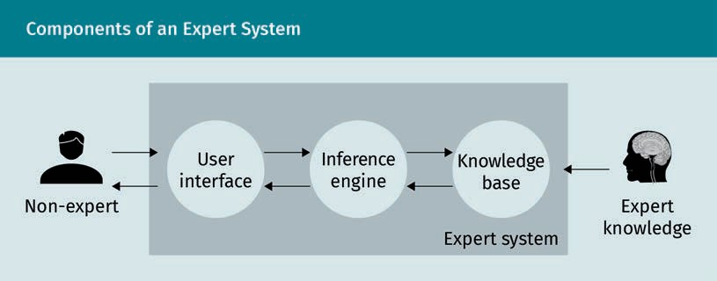

Non-expert
User interface
Inference engine
Knowledge base
Expert system
Expert knowledge

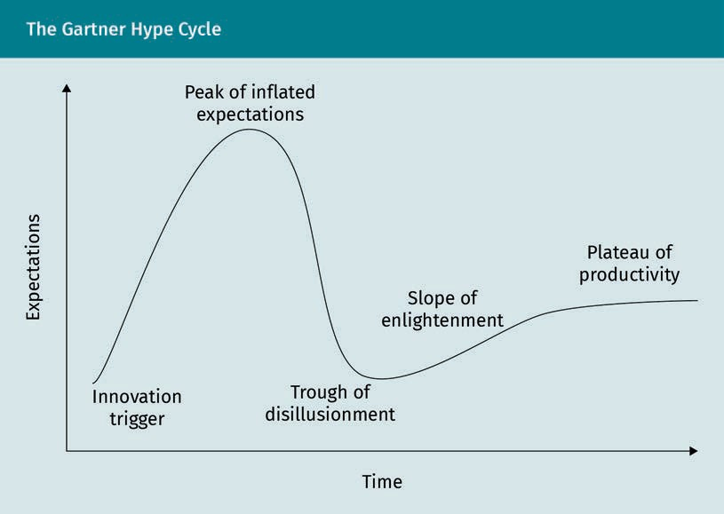
The Gartner Hype Cycle

Expectations
Time
Innovation trigger
Peak of inflated expectations
Trough of disillusionment
Slope of enlightenment
Plateau of productivity

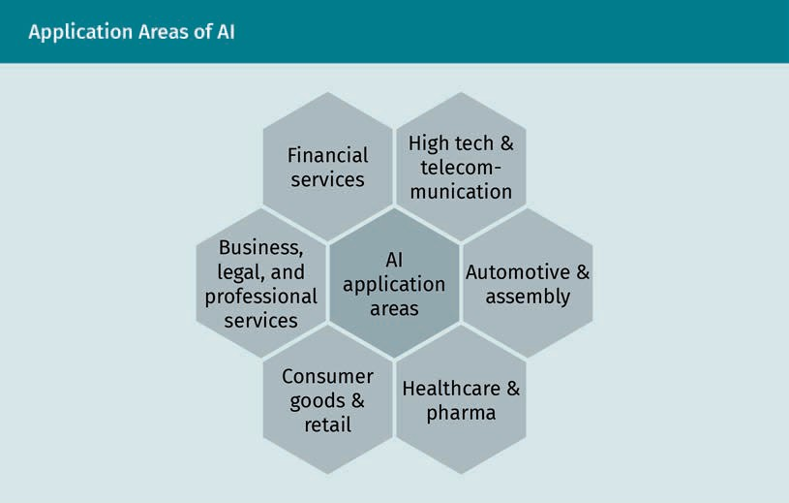
Application Areas of AI

AI application areas
High tech & telecommunication
Automotive & assembly
Healthcare & pharma
Consumer goods & retail
Business, legal, and professional services
Financial services

The Confusion Matrix
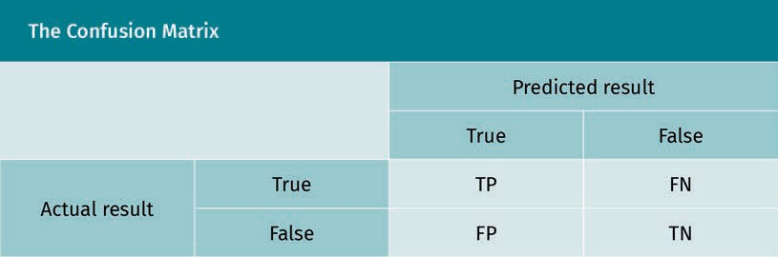
Predicted result
Actual result
True
False

Initial Situation in the Labyrinth
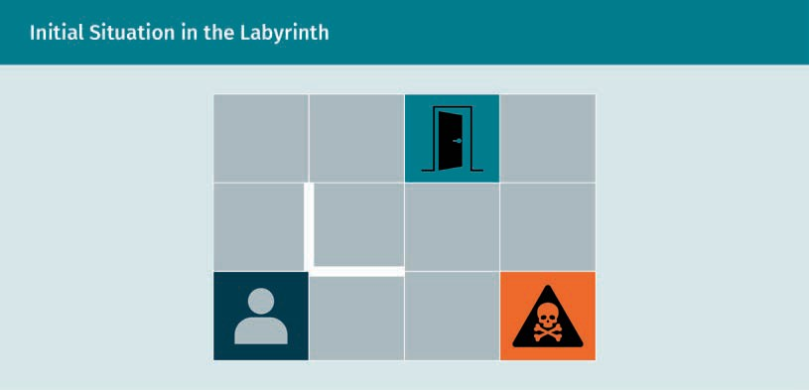

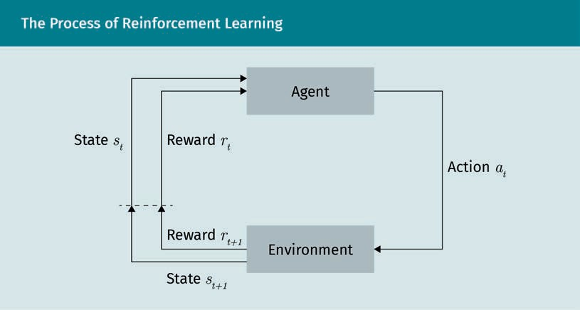
The Process of Reinforcement Learning

Agent
Environment
State
Reward
Action

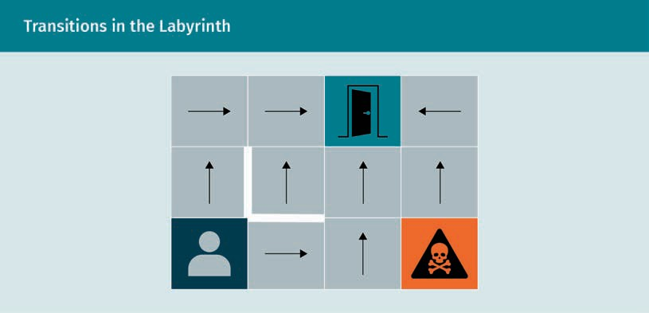
Transitions in the Labyrinth

Example for Named Entity Recognition


On Monday afternoon I will meet Paul at the library
Date
Time
Person
Location

Text-to-Text Translation as a Part of Speech-to-Speech Translation
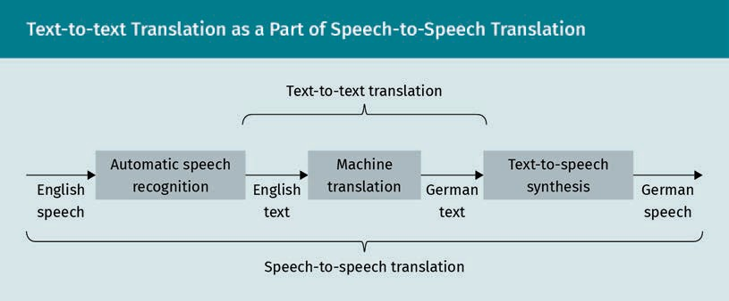

English speech
Automatic speech recognition
English text
Machine translation
German text
Text-to-text synthesis
Text-to-text translation
Speech-to-speech translation

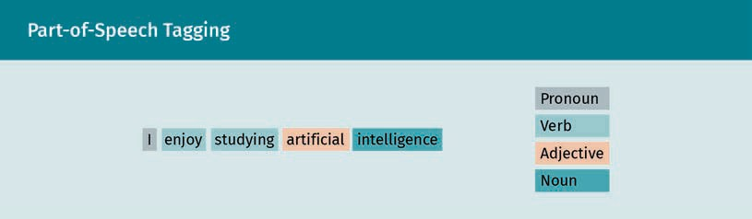
Part-of-Speech Tagging

I enjoy studying artificial intelligence
Pronoun
Verb
Adjective
Noun


The Importance of Semantics in NLP

He is blue

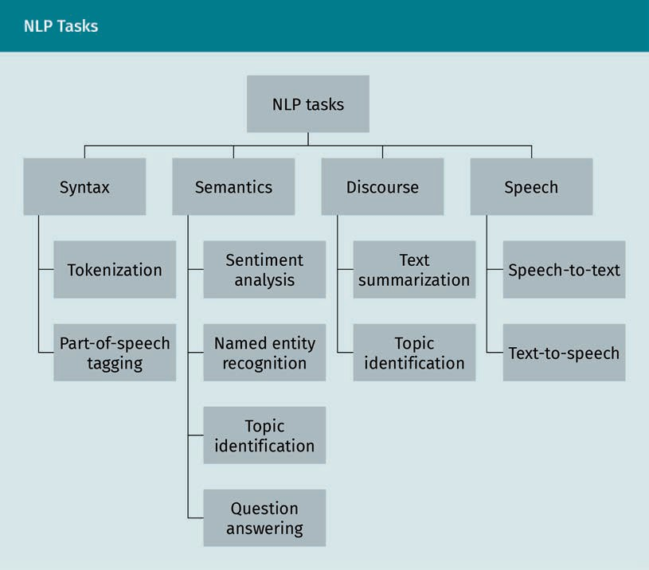
NLP Tasks

Syntax
Semantics
Discourse
Speech
Tokenization
Sentiment analysis
Text summarization
Speech-to-text
Part-of-speech tagging
Named entity recognition
Topic identification
Text-to-speech
Topic identification
Question answering

Comparison of CBOW and Skip-Gram
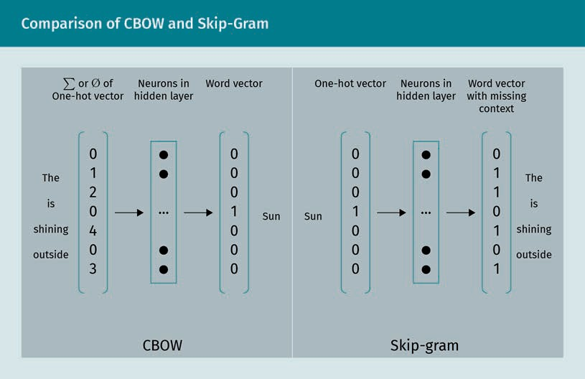

∑ or ø of one-hot vector
Neurons in hidden layer
Word vector
The (sun) is shining outside
Sun
CBOW
Skip-gram
One-hot vector
Word vector with missing context

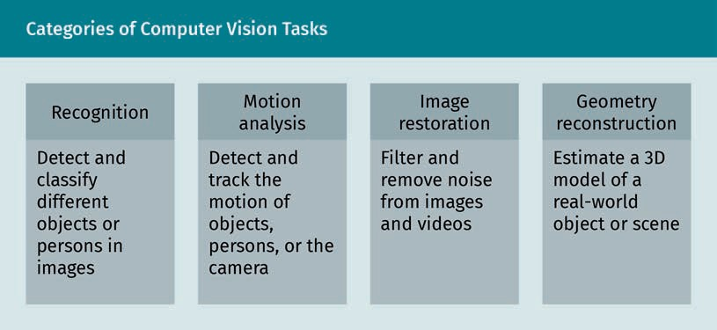
Categories of Computer Vision Tasks

Recognition
Detect and classify different objects or persons in images
Motion analysis
Detect and track the motion of objects, persons, or the camera
Image restoration
Filter and remove noise from images and videos
Geometry reconstruction
Estimate a 3D model of a real-world object or scene

Pixels of a Digital Image
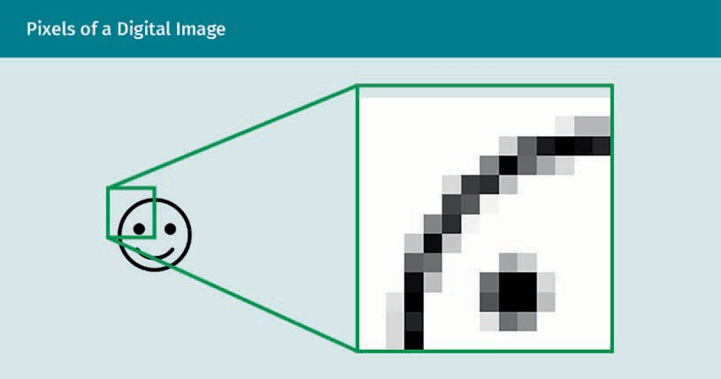

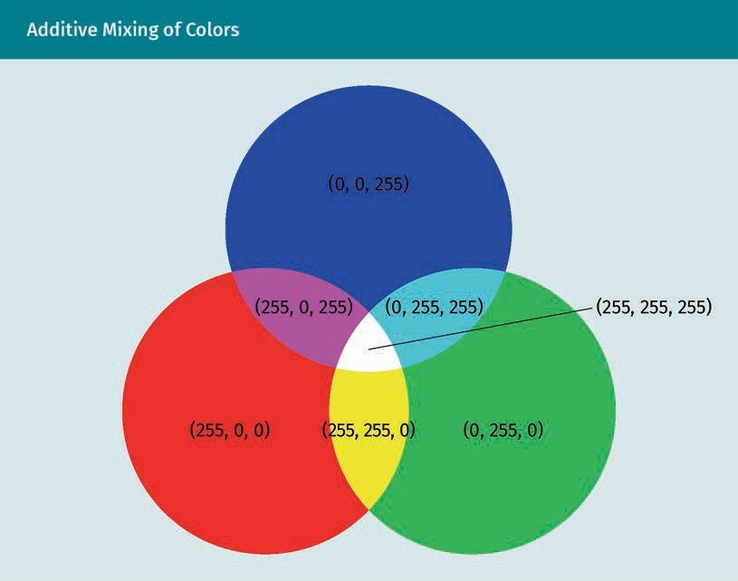
Additive Mixing of Colors

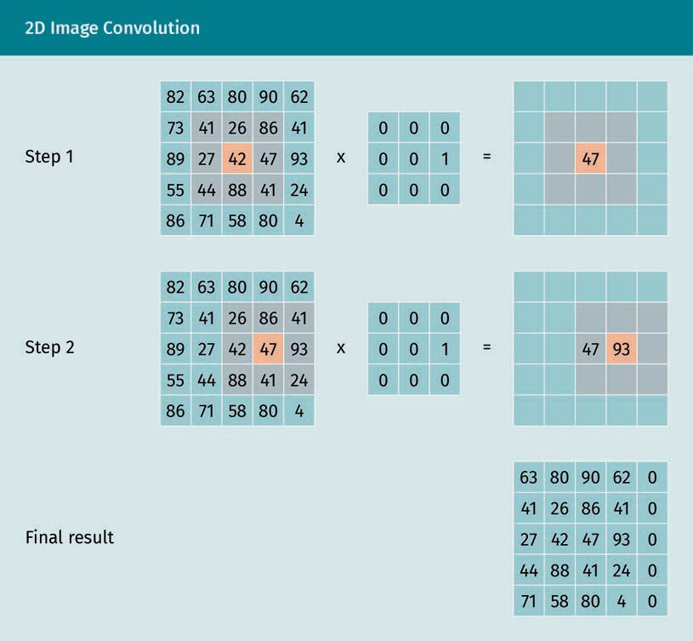
2D Image Convolution

Step 1
Step 2
Final result

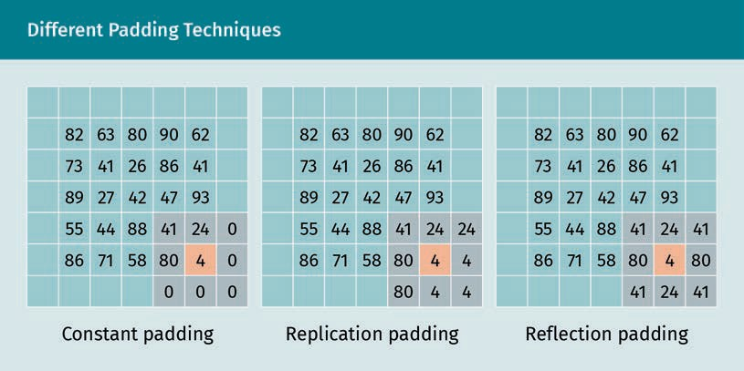
Different Padding Techniques

Constant padding
Replication padding
Reflection padding

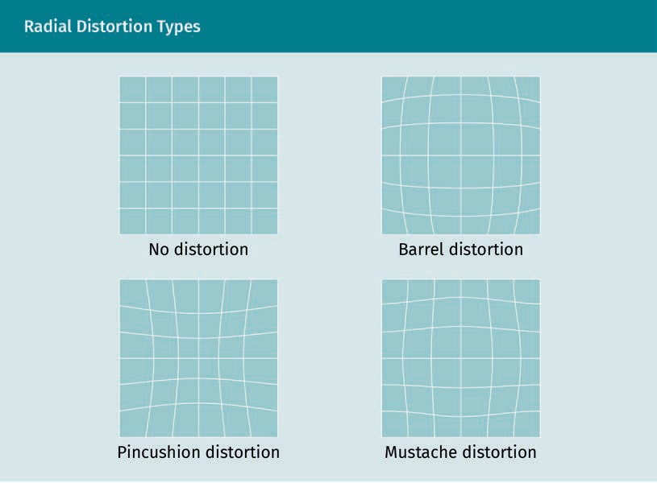
Radial Distortion Types
No distortion
Barrel distortion
Pincushion distortion
Mustache distortion

Tangential Distortion
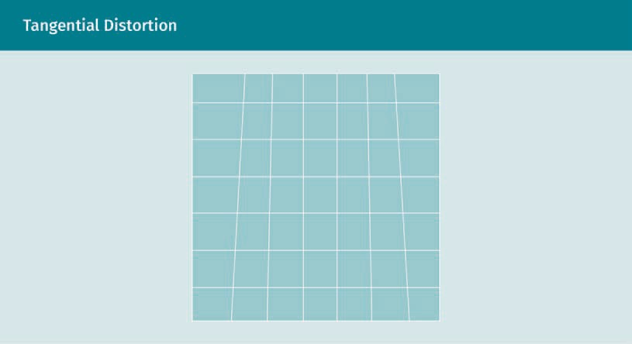

Principle of the Pinhole Camera
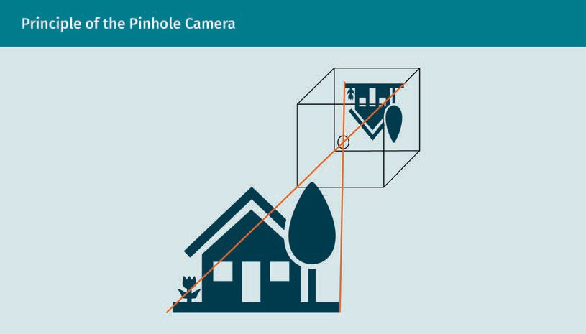

Projection of 3D World Coordinates onto 2D Image Coordinates
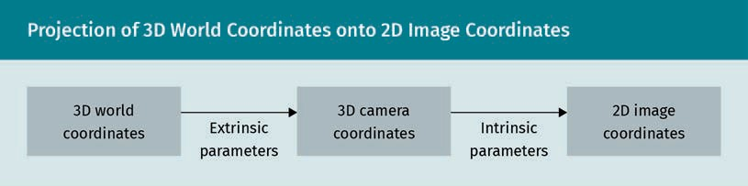
3D world coordinates
Extrinsic parameters
3D camera coordinates
Intrinsic parameters
2D image coordinates

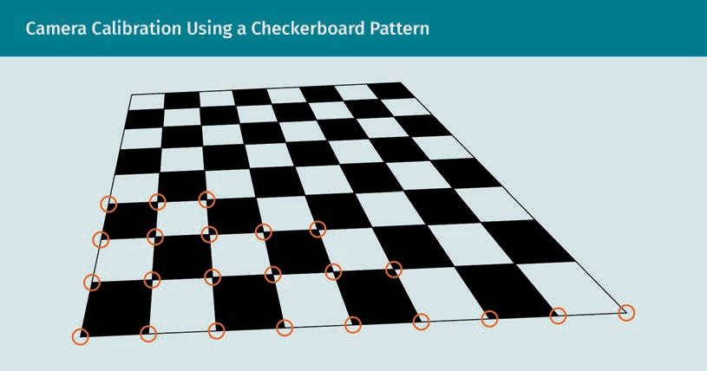
Camera Calibration Using a Checkerboard Pattern

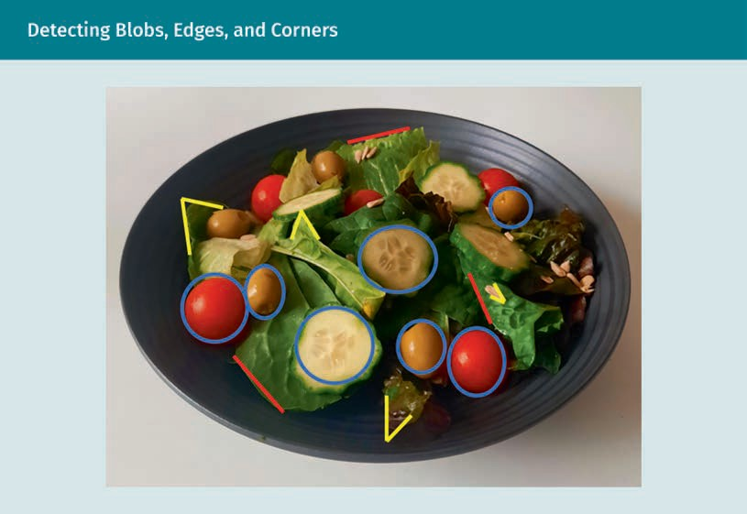
Detecting Blobs, Edges, and Corners

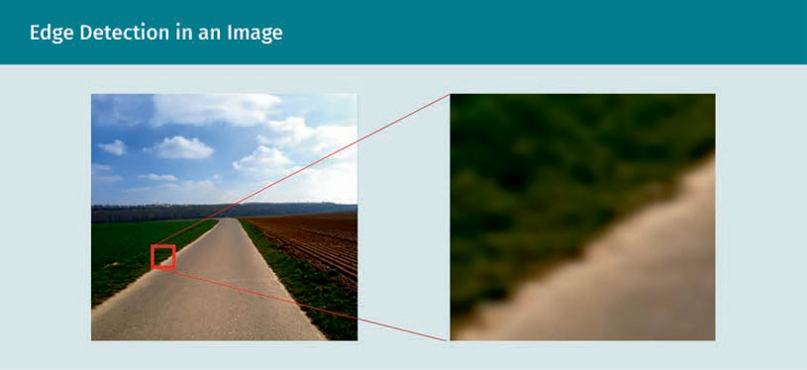
Edge Detection in an Image

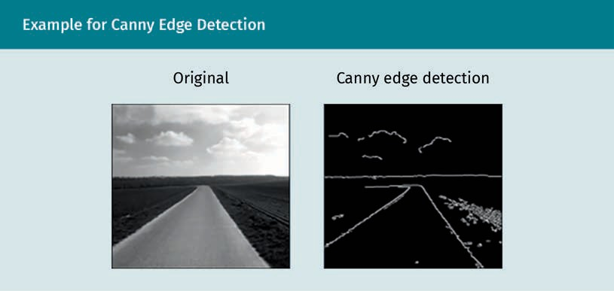
Example for Canny Edge Detection

Original
Canny edge detection

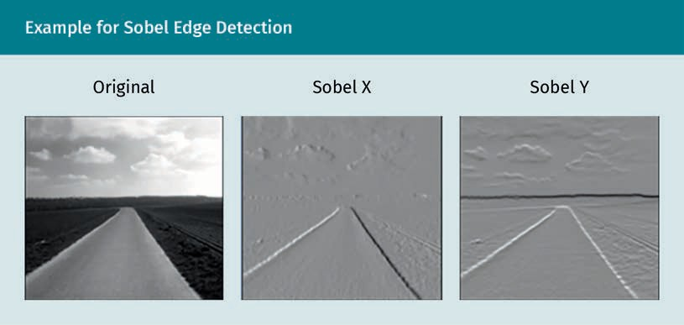
Example for Sobel Edge Detection

Original
Sobel X
Sobel Y

Harris Corner Detection
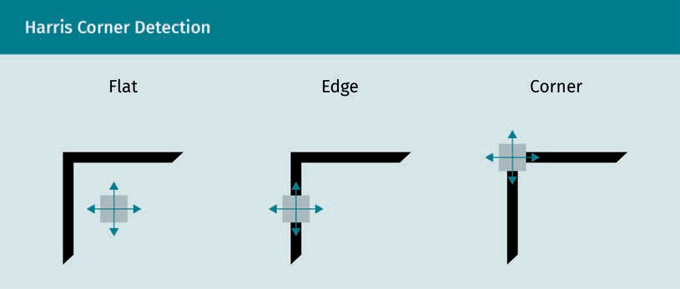

Flat
Edge
Corner

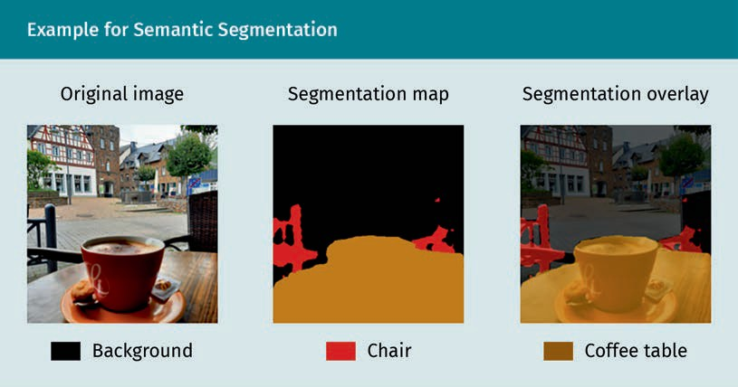
Example for Semantic Segmentation

Original image
Segmentation map
Segmentation overlay
Background
Chair
Coffee table

Network Architecture for Semantic Segmentation
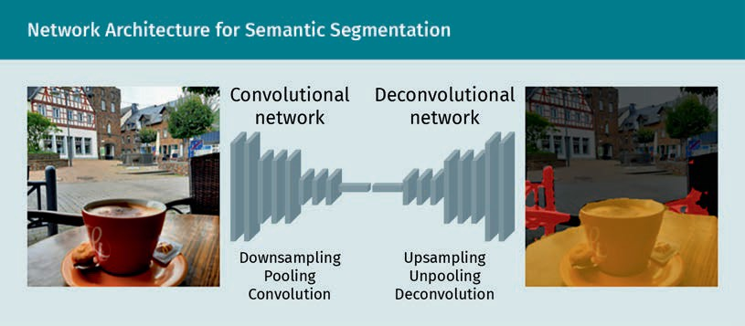

Convolutional network
Downsampling
Pooling
Convolution
Deconvolutional network
Unsampling
Unpooling
Deconvolution

