**7 Faces of the Menorah**

Debra Spero Applebaum holds an M.S in Library Science from Case Western Reserve University and a M.A in Biblical Exegesis from Haifa University in conjunction with the Matan Bellows Bible Program. Debra works as a docent at the Israel Museum, Bible Lands and Rockefeller Museums.

In honor of HaKohen Baruch Baer, upon reaching בן שמונים לגבורות. With many fond memories of family events, vacations and other adventures, wishing you many years of health and nachat from your family, who במהרה בימינו, will merit to light *The* Menorah!

למה נסמכה פרשת מנורה לחנכת הנשיאים, לפי שכשראה אהרן חנוכת הנשיאים חלשה דעתו שלא היה עמהם בחנוכה לא הוא ולא שבטו, אמר לו הקדוש ברוך הוא חייך שלך גדולה משלהם, שאתה מדליק ומטיב את הנרות בקר וערב, לשון רש"י ממדרש אגדה (רמב"ן במדבר ח, ב)

1. **Menorah as Tree of Life**

When we read the description of the Menorah (Shmot 37) with its central trunk, six branches and its ornaments of almond blossoms and flowers, what we visualize is actually a stylized tree. The Tree of Life is associated with that fundamental and universal human quest for life and immortality and with Man’s dependence and interaction with nature. These themes are common in many cultures, as exemplified by an Assyrian relief from the 9th century BCE which features a palm tree in the middle, surrounded by two genies that are pollinating the tree. Unlike this Assyrian pagan myth, Judaism teaches that eternal life is not to be sought in nature, but rather by some special light or illumination associated with the knowledge of G-d, and by His presence in the life forms. The Tree of Life, then, is transmuted into a Tree of Light. It is this fusion of life and light that is Judaism’s answer as to how the expelled Adam and Eve can return to the Garden of Eden. It is the Teachings of Torah that becomes the Tree of Life. It becomes the source of immortality and knowledge and symbolically, takes the form of the Menorah, whose fruit is light, as it says, 'כי נר מצוה ותורה אור' (משלי ו, כג)and.'עץ חיים היא למחזיקים בה' (משלי ג, יח)

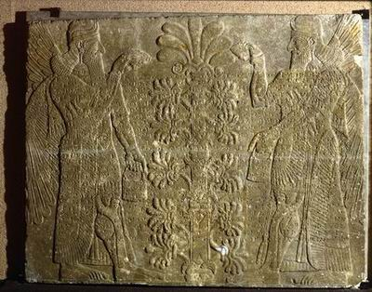

Figure Assyrian Relief, 9th century BCE (Israel Museum)

Interestingly, the aromatic weed *Salvia Palaestina* which is indigenous to Israel, bears an uncanny resemblance to the Menorah. Although this plant doesn’t always have 7 branches, it always has an even number of branches growing from a central branch. Botanists, Ephraim and Chana Hareuveni suggested that this plant was the inspiration for the shape of the Menorah. From an etymological perspective, they suggested that the Hebrew word *marva* (Hebrew for *salvia*), originated from the word *Moriah-*reflecting that connection between this plant and the Temple vessel. Some species have small apples-plant galls- that look like a knob, the כפתור - one of the decorative elements on the Menorah.[1] According to the story, the Hareuveni couple found his plant growing wild on Mt. Moriah.

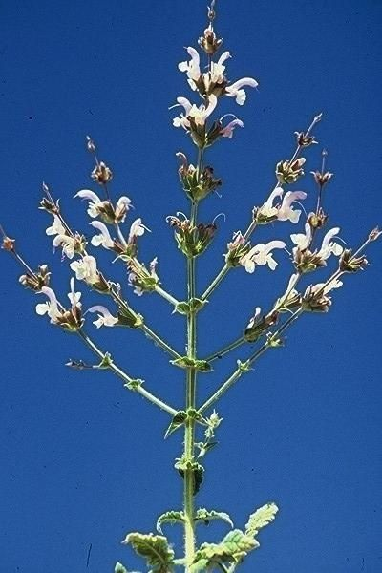

Figure Salvia Palaestina

**2. Menorah as a Priestly Symbol**

Images in the shape of the Menorah have been uncovered from the end of the 2nd Temple period. The earliest example appears on a small, bronze prutah coin struck by the last Hasmonean King, Antigonus Matityahu in 37 BCE, of which only 32 have been published so far. Among the other images, 4 were etched /incised in private spaces: in a tomb, a refuge cave, a mikveh and a house. The schematic graffiti of the Menorah on plaster uncovered in a house not far from the Temple itself, was probably made by a priest for instructive purposes. The other 5 images were etched on private, moveable objects, such as ossuaries, a sun dial, and a cup . According to archaeologists, Roni Reich and Yuval Baruch, the motif of the Menorah at this time, is not meant to be decorative, nor a national symbol, rather, its association is limited to the Temple service and the priests, specifically to the Hasmoneans and was adopted by them as their emblem. Hence, Antigonus Matityahu, High Priest and the last Hasmonean king, puts the Temple Menorah on his coin. The weight and the mold of this *prutah* coin is not consistent with any of the other *prutahs* struck by him, which strengthened numismatist, Yaakov Meshorer’s opinion that this coin had no commercial value, but rather its purpose was to rally those Jews in a besieged Jerusalem 37 BCE, calling on them to protect the Temple –the soul of the nation. With Herod’s rise to power, and the Hasmoneans fall from power, the priests will continue to use the Menorah as their private emblem, while keeping it out of the public eye.

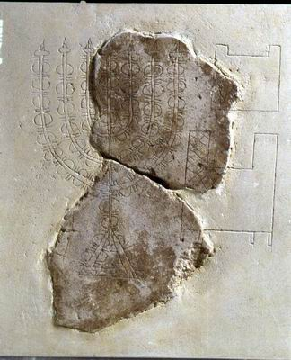

Figure Graffito with Temple vessels, Jewish Quarter, 1st century BCE (Israel Museum)

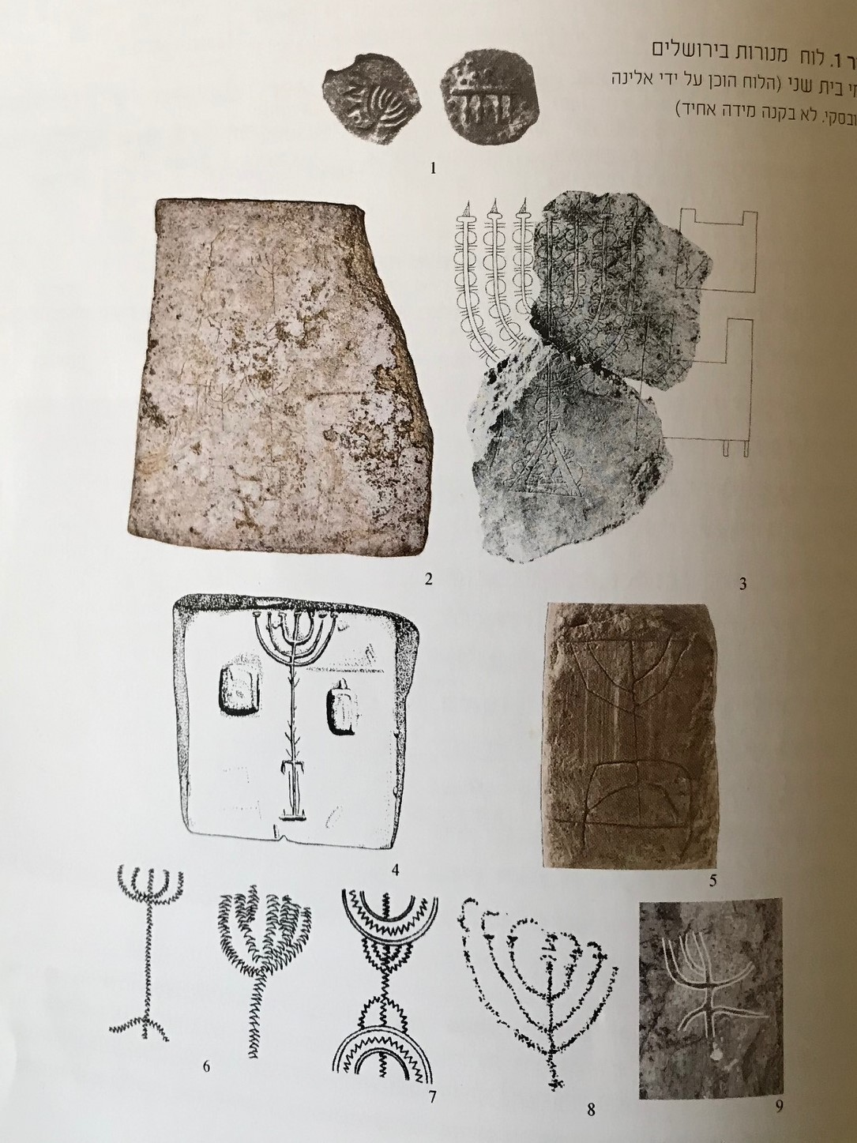

Figure Bronze prutah, 37 BCE (Israel Museum)

**3. Menorah as a National Symbol**

Situated on the highest point of the Sacra Via, the Arch of Titus, depicting the Menorah and other spoils of Jerusalem triumphantly paraded in Rome, created a powerful visual for generations. With the defeat of the Great War against Rome in 70CE, it is the Menorah that will become the most important Jewish symbol for the next two millennia, culminating as the symbol of the State of Israel. Ironically, it was precisely the model of the Menorah that went into *Exile*, that will make its *Return*, as the winning entry of the design competition for the symbol of the new state of Israel.

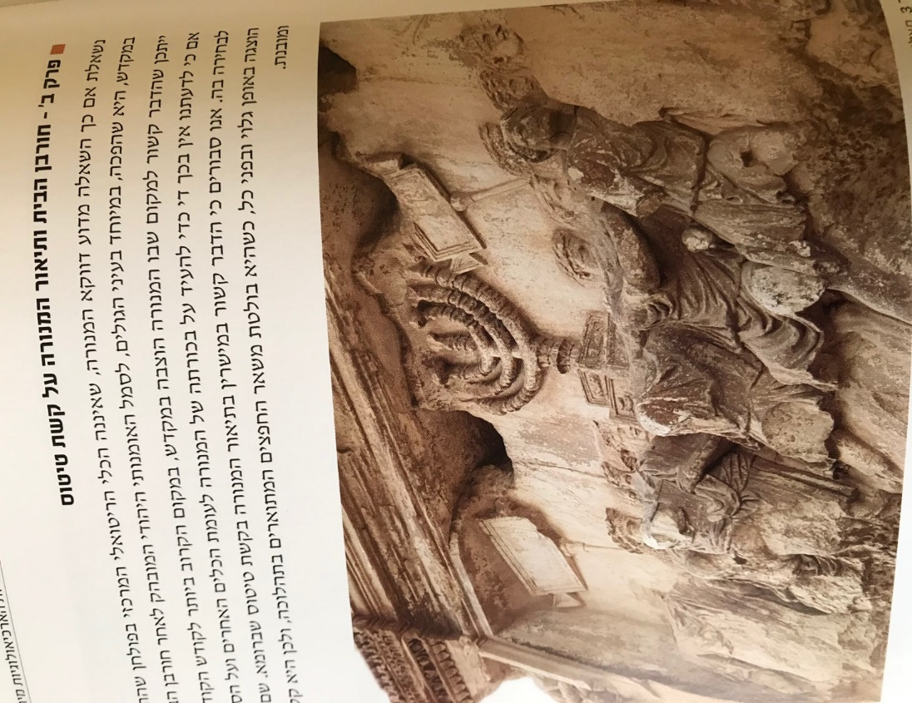

**Arch of Titus, Rome, 1st century CE**

Because Judaism is both a religion and a nationality-the significance of the Menorah will take on different combinations of religious, political and nationalistic values, as it embodies Jewish collective memories and dreams.

I’d like to focus, however, on one specific visual manifestation of the Menorah that appears during the Talmudic (Late Roman and Byzantine) period, when the Menorah appears as a composite icon, combined (in different variations) with the lulav, shofar, incense shovels and the sacred portal-that architectural motif that symbolizes either the Tabernacle, the Temple, the synagogue, or- all the above. And so, for the first time, Jewish art has created in pictorial language a series of objects inspired by the Temple and forming a conceptual whole. For the congregants of the synagogues at Beit Alpha, Tsippori, Beit Shean or Dura Europas, this motif, whether depicted on a fresco, mosaic, or engraved on capitals, was a reminder of what was once when the Temple stood, and a dream of what will be, when according to tradition- a third Temple will be built. In addition, I would like to suggest that this composite icon conveyed a message of adjustment to the new, post-Temple reality. And so, although there is no more Temple, these same rituals that were once used in the Temple as part of the worship/service, will continue to be used in the worship of G-d, without the Temple! (albeit with differences). We are all familiar with the ritual of the four species, shofar and the role of the synagogue as מקדש מעט in post-Temple Judaism, where does the Menorah and incense shovel fit in?

Based on references in the Zohar and the Talmud (Zohar Vayekhel 218, Ber. 42a, Ker. 6a, Bec. 43a) it seems that both the Menorah and incense shovels continued to be used in religious rituals even after the Temple was destroyed –but was frowned upon by the rabbis, and ultimately discontinued. The 3-dimensional Menorahs uncovered in synagogues, such as, the carved stone Menorah from Chammat Tiveria with soot in the lamps, is evidence of their continued use during the Talmudic period כזכר לחורבן. Support for this post-churban practice might be found in the commentary found in the Tanchuma and Bamidbar Rabbah on Bamidbar 8:2:

דַּבֵּר אֶל אַהֲרֹן וְאָמַרְתָּ אֵלָיו בְּהַעֲלוֹתְךָ את הנרת הַקָּרְבָּנוֹת, כָּל זְמַן שֶׁבֵּית הַמִּקְדָּשׁ קַיָּם הֵן נוֹהֲגִים, אֲבָל הַנֵּרוֹת, לְעוֹלָם

This source may have been interpreted as referring to the continuous ritual lighting of a 7 branched Menorah, rather than referring to the future lighting of the Chanukah lights.

The Rabbis’ prohibition to make exact copies of the Temple implements, might explain the added features to these Menorahs, such as, a horizontal bar/block under the 7 lamps, which while useful for placing the wicks or tweezers when cleaning the Menorah , may also have been a way to circumvent the Rabbis’ ban.

This composite motif appears on diverse objects uncovered in the Land of Israel and in the Diaspora, such as, on lead coffins in Beth Shearim, on painted tomb stones from Zoar, and on the gold-glass bases from Rome. The gold and glass bases were uncovered, embedded in the walls of Jewish catacombs and sarcophagi in ancient Rome, as a way to identity with the Jewish people and its mission, and to symbolize the eternity of the soul and the resurrection of the dead.

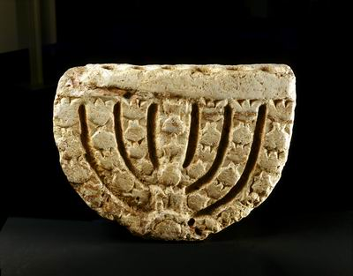

Synagogue Menorah, Chammat Tiveria, 4-5th century CE (Israel Museum)

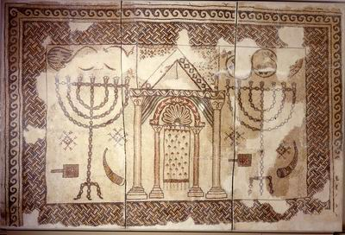

Synagogue floor, Bet Shean, 5-7th century CE (Israel Museum)

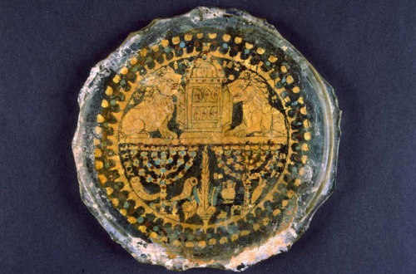

Gold glass base, Rome, 4rth century CE (Israel Museum)

**4. The Menorah as a Kabbalistic Symbol**

The Menorah is also an important symbol in Kabbalistic literature. In the 14th century, we begin to see the drawing of the Menorah by means of the words of Psalm 67 referred to as the Menorah Psalm. How do we explain this connection of the Menorah with Psalm 67 and what makes this combination so potent? Firstly, if we do not include the superscription, Psalm 67 consists of 7 verses, corresponding to the 7 branches of the Menorah and furthermore, the total number of Hebrew words in these verses add up to 49, corresponding to the total number of decorative elements ,42 + 7 branches=49, which in addition, relates to G-d’s 49 letter name. Secondly, there is the structural similarity between the layout of the psalm and the shape of the Menorah. If we count the number of words in each verse in their given sequence, we get the following symmetrical arrangement 7,6,6,11,6,6,7 and if we were to plot them out along a Menorah design- the proportion is an almost perfect match! More than just structural similarities and numerical equivalents, what we have here is the conflation of two traditions. Noting that this psalm is anonymous, the Zohar explains in the name of Reb Eliezer, that Psalm 67 was divinely revealed to David in the form of the Menorah, to which Hasidic sources add that this image was emblazed on David’s original shield. Regarding the Menorah, Rashi comments how Moshe had difficulty in visualizing it until G-d showed him a Menorah of fire, וזה מעשה המנורה – as if God was pointing this image to Moshe. The combination, then, of these two divinely inspired ideas and images, creates a symbol whose power is greater than the mere sum of its parts! Psalm 67 written in the shape of a Menorah appears in siddurim, on amulets and in synagogues, such as, on the doors of the Ark from the Ramah synagogue in Cracow, Poland. Many *segulot* are attributed to reciting Psalm 67, especially when read off the image of the Menorah.

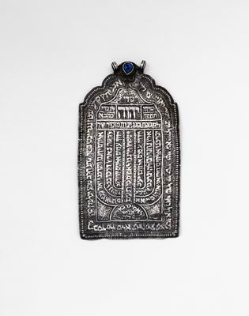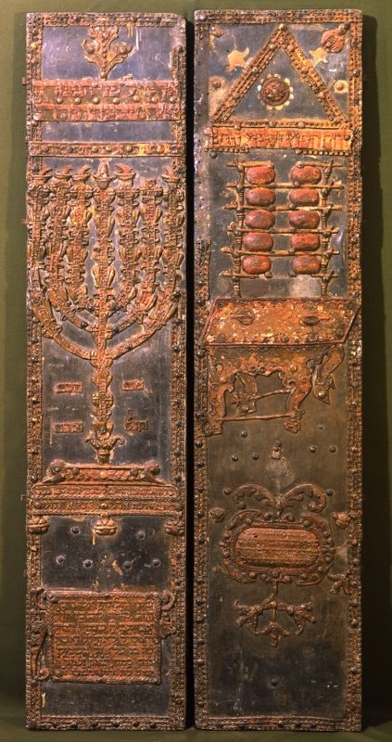

Ramah Synagogue Ark, Cracow, Poland, 17th (Israel Museum) Shiviti amulet, Persia, 18th century

**5. The Menorah as Prophecy**

The Bible of Cervera and the upper part of the Ark from Parur, India features the 7 branched Menorah, as described in Zecharyah 4. The prophet’ s vision is of a golden Menorah, whose 7 lamps are fed with olive oil by way of seven pipes and a bowl, from two olive trees that are positioned on either side of the Menorah. There are many aspects to this vision. This prophecy is about Redemption, it’s about the balance of power during the period of *Shivat Zion*, between the High Priest Yehoshua and the governor, Zerubavel . This prophecy is also about optimism and perseverance in times of challenge. Remember, Zecharyah’s audience are those Jews who had just returned to Jerusalem after 70 years of exile in Babylon, and the reality is a sad one- the city and its walls are destroyed, the economic conditions are dire and although the Jews received permission from Cyrus to rebuilt the Temple, it had been stopped because of hostility from local populations, and so the prophet affirms, לא בחיל ולא בכח כי אם ברוחי אמר ה' צבאות. In addition, the prophet seems to focus on the Menorah’s maintenance. The Menorah in the Temple could have been lit miraculously as were other rites carried out in the Temple according to tradition, yet the Halacha prescribes how the wicks are to be trimmed and cleaned, the olives harvested and squeezed, daily, thereby, emphasizing the human element - the active participation of the person, the input of the worshipper. As a symbol of peace, the two olive trees on either side of the Menorah- was, of course, the inspiration for the design of the emblem of the state of Israel.

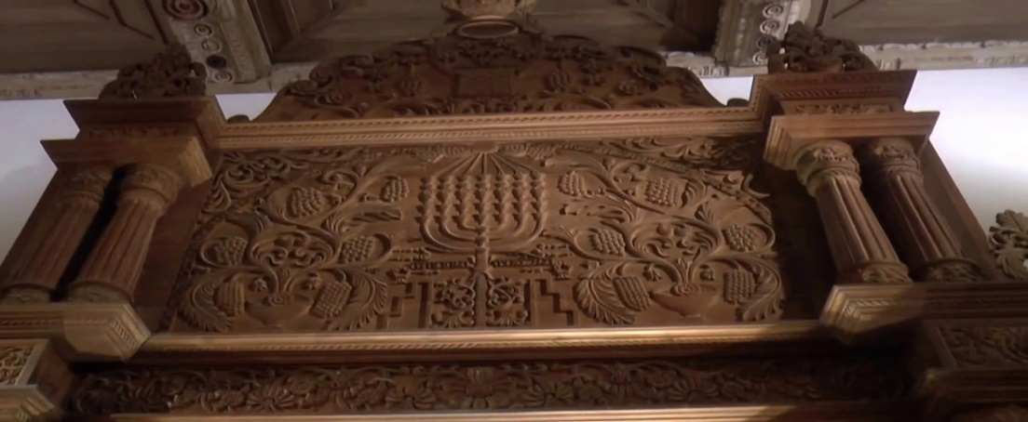

**Synagogue Ark, Parur, India, 1892, (Israel Museum)**

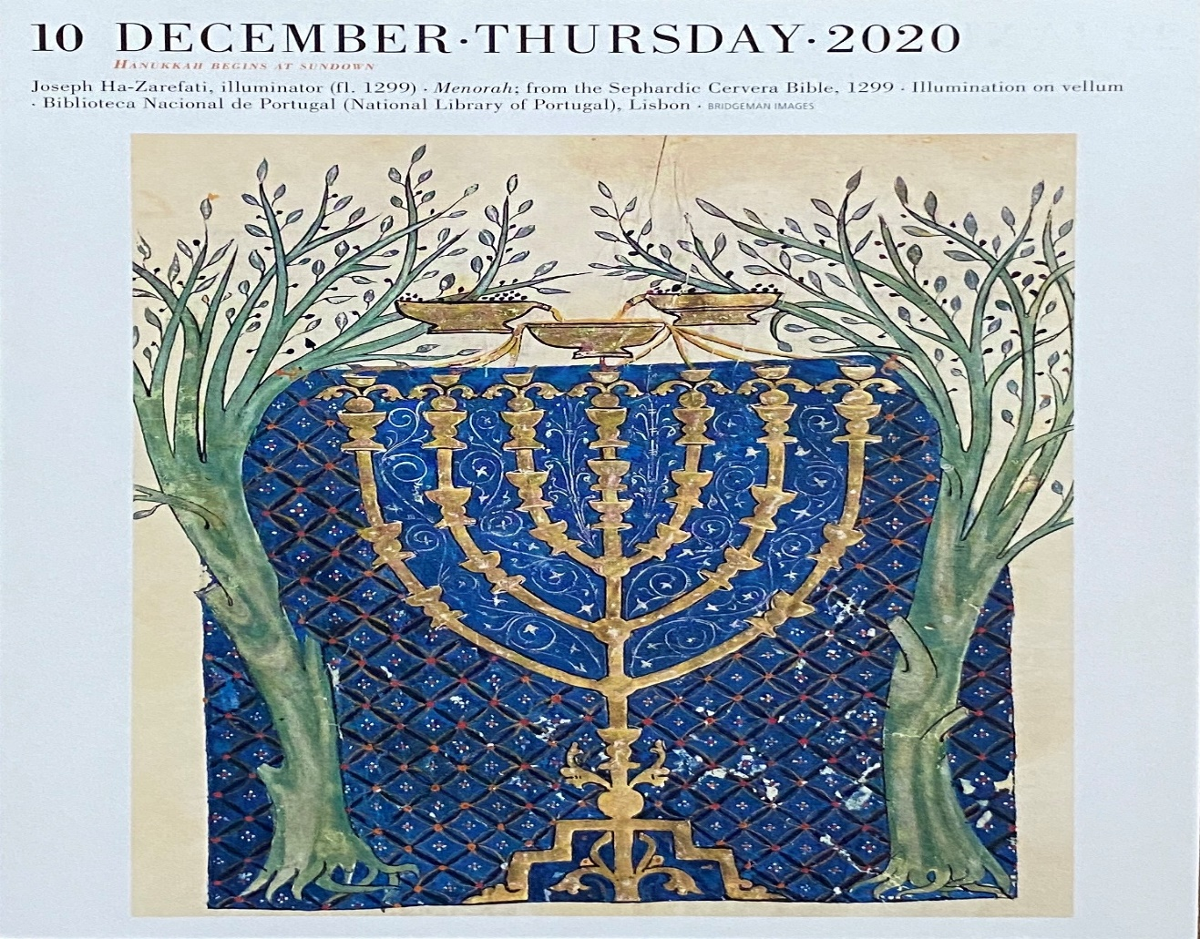

**Bible of Crevera ,1299-1300 (National Library of Portugal, Lisbon)**

**6. Menorah as Chanukiya**

It is not until the end of the Middle Ages that we begin to see chanukiyot in the shape of a candelabra, with its basic shape and even its decorative elements –inspired by the Temple Menorah. The chanukiya in the shape of the Menorah was first introduced in the synagogue and eventually, on a smaller scale for the domestic market. Although the connection between the Chanuka story and the Menorah is obvious! It was probably the Rabbis’ disfavor of replicating Temple vessels that kept back the appearance of a chanukiya in the shape of the Menorah. An example is the 17th century silver chanukiya from Frankfurt am Main, crafted by the silversmith Schuler, that features alternating knobs and flowers, and is crowned with the figure of Judith, holding the head of Holoferenes in her left hand ,and a sword in her right hand .

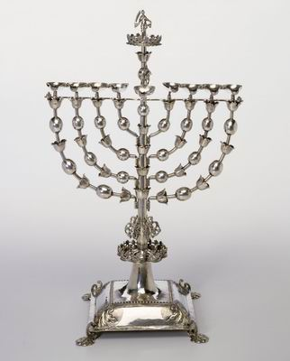

Chanukiya, Frankfurt, German, 17th century (Israel Museum)

**7. Menorah as Heroism.**

This visual combination of the Temple Menorah with the chanukiya now becomes a symbol of Jewish heroism. It is for this reason that Ze`ev Jabotinsky, founder of the Revisionist Zionist movement Beitar, chose the Menorah as the emblem of his movement. Large brass standing chanukiyot in the shape of the Menorah were popular in East European synagogues. Usually positioned next to the Ark, these chanukiyot were lit for the sake of those who were not able to light, and in order to publicize the miracle of Chanukah in a public place, modeled after the Temple. Ironically, these chanukiyot that celebrate the Jews overthrowing the yolk of one nation, are often crowned with the yolk of a different nation -typically, with the eagle -in one form or another -whether representing Poland , Austria-Hungary, Germany, or Russia, as a gesture of thanks or loyalty to the sovereign . Agnon writes in his *Tale* *of a Menorah*, that the congregation kept handy a collection of small cast eagles, ready to be exchanged to fit the new ruler at short notice, given the constant shifting of borders among those warring political entities. The single or double eagles were attached to the Menorah with a threaded base for easy installation and removal. Few of these standing Menorah- shaped chanukiyot that once stood proudly in Polish synagogues, have been retrieved from the Nazis, and now stand in museums and synagogues as a memorial to the many hundreds of synagogues and communities destroyed during the Holocaust and as a testimony to Jewish heroism-evoking the heroism of the Maccabbes and of all those Jews who suffered and fought tyranny בימים ההם בזמן הזה .

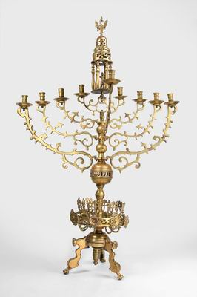

Synagogue Chanukiya, Poland, 17th century (Israel Museum)

1. Nogah HaReuveni, `Teva VeNof BeMoreshet Yisrael,` Neot Kedumim, 1980, pp. 125-130.