It's going to get cloudy! 🌩 ☂️ The Appwrite Cloud is coming soon! You can learn more about our upcoming hosted solution and signup for free credits at: <https://appwrite.io/cloud>

Appwrite Logo

A complete backend solution for your [Flutter / Vue / Angular / React / iOS / Android / *ANY OTHER*] app

Hacktoberfest Discord Build Status Twitter Account

English | [简体中文](https://github.com/appwrite/appwrite/blob/master/README-CN.md)

[Appwrite Console 2.0 has been released! Learn what's new!](https://medium.com/appwrite-io/announcing-console-2-0-2e0e96891cb0?source=friends_link&sk=7a82b4069778e3adc165dc026e960fe1)

Appwrite is an end-to-end backend server for Web, Mobile, Native, or Backend apps packaged as a set of Docker microservices. Appwrite abstracts the complexity and repetitiveness required to build a modern backend API from scratch and allows you to build secure apps faster.

Using Appwrite, you can easily integrate your app with user authentication & multiple sign-in methods, a database for storing and querying users and team data, storage and file management, image manipulation, Cloud Functions, and [more services](https://appwrite.io/docs).

Appwrite - 100% open source alternative for Firebase | Product Hunt

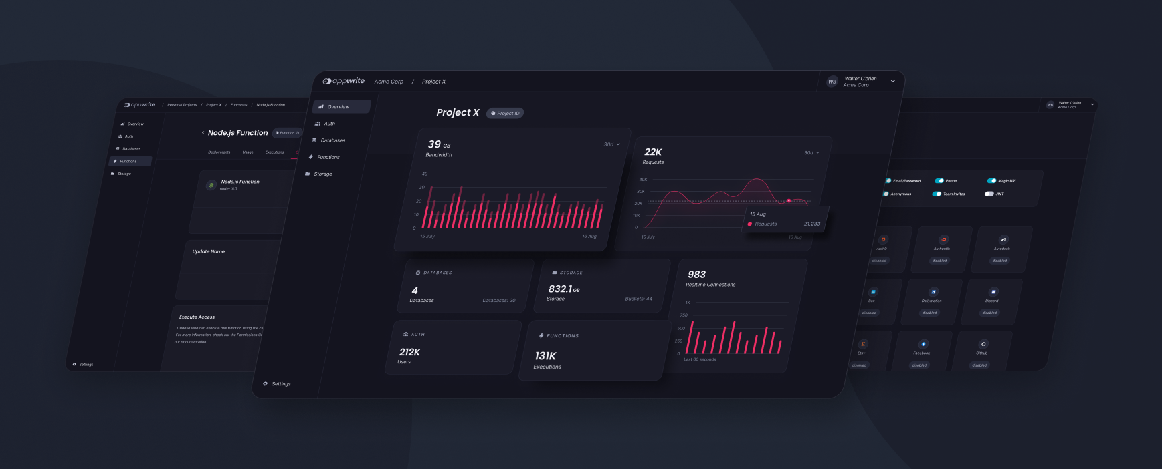

Find out more at: [https://appwrite.io](https://appwrite.io/)

Table of Contents:

* [Installation](https://github.com/appwrite/appwrite/blob/master/README.md#installation)
  + [Unix](https://github.com/appwrite/appwrite/blob/master/README.md#unix)
  + [Windows](https://github.com/appwrite/appwrite/blob/master/README.md#windows)
    - [CMD](https://github.com/appwrite/appwrite/blob/master/README.md#cmd)
    - [PowerShell](https://github.com/appwrite/appwrite/blob/master/README.md#powershell)
  + [Upgrade from an Older Version](https://github.com/appwrite/appwrite/blob/master/README.md#upgrade-from-an-older-version)
* [Getting Started](https://github.com/appwrite/appwrite/blob/master/README.md#getting-started)
  + [Services](https://github.com/appwrite/appwrite/blob/master/README.md#services)
  + [SDKs](https://github.com/appwrite/appwrite/blob/master/README.md#sdks)
    - [Client](https://github.com/appwrite/appwrite/blob/master/README.md#client)
    - [Server](https://github.com/appwrite/appwrite/blob/master/README.md#server)
    - [Community](https://github.com/appwrite/appwrite/blob/master/README.md#community)
* [Architecture](https://github.com/appwrite/appwrite/blob/master/README.md#architecture)
* [Contributing](https://github.com/appwrite/appwrite/blob/master/README.md#contributing)
* [Security](https://github.com/appwrite/appwrite/blob/master/README.md#security)
* [Follow Us](https://github.com/appwrite/appwrite/blob/master/README.md#follow-us)
* [License](https://github.com/appwrite/appwrite/blob/master/README.md#license)

## **Installation**

Appwrite backend server is designed to run in a container environment. Running your server is as easy as running one command from your terminal. You can either run Appwrite on your localhost using docker-compose or on any other container orchestration tool like Kubernetes, Docker Swarm, or Rancher.

The easiest way to start running your Appwrite server is by running our docker-compose file. Before running the installation command, make sure you have [Docker](https://www.docker.com/products/docker-desktop) installed on your machine:

### **Unix**

docker run -it --rm \

--volume /var/run/docker.sock:/var/run/docker.sock \

--volume "$(pwd)"/appwrite:/usr/src/code/appwrite:rw \

--entrypoint="install" \

appwrite/appwrite:1.1.2

### **Windows**

#### **CMD**

docker run -it --rm ^

--volume //var/run/docker.sock:/var/run/docker.sock ^

--volume "%cd%"/appwrite:/usr/src/code/appwrite:rw ^

--entrypoint="install" ^

appwrite/appwrite:1.1.2

#### **PowerShell**

docker run -it --rm `

--volume /var/run/docker.sock:/var/run/docker.sock `

--volume ${pwd}/appwrite:/usr/src/code/appwrite:rw `

--entrypoint="install" `

appwrite/appwrite:1.1.2

Once the Docker installation completes, go to [http://localhost](http://localhost/) to access the Appwrite console from your browser. Please note that on non-Linux native hosts, the server might take a few minutes to start after installation completes.

For advanced production and custom installation, check out our Docker [environment variables](https://appwrite.io/docs/environment-variables) docs. You can also use our public [docker-compose.yml](https://appwrite.io/install/compose) and [.env](https://appwrite.io/install/env) files to manually set up an environment.

### **Upgrade from an Older Version**

If you are upgrading your Appwrite server from an older version, you should use the Appwrite migration tool once your setup is completed. For more information regarding this, check out the [Installation Docs](https://appwrite.io/docs/installation).

## **One-Click Setups**

In addition to running Appwrite locally, you can also launch Appwrite using a pre-configured setup. This allows you to get up and running with Appwrite quickly without installing Docker on your local machine.

Choose from one of the providers below:

| DigitalOcean Logo  [DigitalOcean](https://marketplace.digitalocean.com/apps/appwrite) | Gitpod Logo  [Gitpod](https://gitpod.io/#https://github.com/appwrite/integration-for-gitpod) |
| --- | --- |

## **Getting Started**

Getting started with Appwrite is as easy as creating a new project, choosing your platform, and integrating its SDK into your code. You can easily get started with your platform of choice by reading one of our Getting Started tutorials.

* [Getting Started for Web](https://appwrite.io/docs/getting-started-for-web)
* [Getting Started for Flutter](https://appwrite.io/docs/getting-started-for-flutter)
* [Getting Started for Apple](https://appwrite.io/docs/getting-started-for-apple)
* [Getting Started for Android](https://appwrite.io/docs/getting-started-for-android)
* [Getting Started for Server](https://appwrite.io/docs/getting-started-for-server)
* [Getting Started for CLI](https://appwrite.io/docs/command-line)

### **Services**

* [Account](https://appwrite.io/docs/client/account) - Manage current user authentication and account. Track and manage the user sessions, devices, sign-in methods, and security logs.
* [Users](https://appwrite.io/docs/server/users) - Manage and list all project users when building backend integrations with Server SDKs.
* [Teams](https://appwrite.io/docs/client/teams) - Manage and group users in teams. Manage memberships, invites, and user roles within a team.
* [Databases](https://appwrite.io/docs/client/databases) - Manage databases, collections and documents. Read, create, update, and delete documents and filter lists of document collections using advanced filters.
* [Storage](https://appwrite.io/docs/client/storage) - Manage storage files. Read, create, delete, and preview files. Manipulate the preview of your files to fit your app perfectly. All files are scanned by ClamAV and stored in a secure and encrypted way.
* [Functions](https://appwrite.io/docs/server/functions) - Customize your Appwrite server by executing your custom code in a secure, isolated environment. You can trigger your code on any Appwrite system event, manually or using a CRON schedule.
* [Realtime](https://appwrite.io/docs/realtime) - Listen to real-time events for any of your Appwrite services including users, storage, functions, databases and more.
* [Locale](https://appwrite.io/docs/client/locale) - Track your user's location, and manage your app locale-based data.
* [Avatars](https://appwrite.io/docs/client/avatars) - Manage your users' avatars, countries' flags, browser icons, credit card symbols, and generate QR codes.

For the complete API documentation, visit <https://appwrite.io/docs>. For more tutorials, news and announcements check out our [blog](https://medium.com/appwrite-io) and [Discord Server](https://discord.gg/GSeTUeA).

### **SDKs**

Below is a list of currently supported platforms and languages. If you wish to help us add support to your platform of choice, you can go over to our [SDK Generator](https://github.com/appwrite/sdk-generator) project and view our [contribution guide](https://github.com/appwrite/sdk-generator/blob/master/CONTRIBUTING.md).

#### **Client**

* ✅ [Web](https://github.com/appwrite/sdk-for-web) (Maintained by the Appwrite Team)
* ✅ [Flutter](https://github.com/appwrite/sdk-for-flutter) (Maintained by the Appwrite Team)
* ✅ [Apple](https://github.com/appwrite/sdk-for-apple) - Beta (Maintained by the Appwrite Team)
* ✅ [Android](https://github.com/appwrite/sdk-for-android) (Maintained by the Appwrite Team)

#### **Server**

* ✅ [NodeJS](https://github.com/appwrite/sdk-for-node) (Maintained by the Appwrite Team)
* ✅ [PHP](https://github.com/appwrite/sdk-for-php) (Maintained by the Appwrite Team)
* ✅ [Dart](https://github.com/appwrite/sdk-for-dart) - (Maintained by the Appwrite Team)
* ✅ [Deno](https://github.com/appwrite/sdk-for-deno) - Beta (Maintained by the Appwrite Team)
* ✅ [Ruby](https://github.com/appwrite/sdk-for-ruby) (Maintained by the Appwrite Team)
* ✅ [Python](https://github.com/appwrite/sdk-for-python) (Maintained by the Appwrite Team)
* ✅ [Kotlin](https://github.com/appwrite/sdk-for-kotlin) - Beta (Maintained by the Appwrite Team)
* ✅ [Apple](https://github.com/appwrite/sdk-for-apple) - Beta (Maintained by the Appwrite Team)
* ✅ [.NET](https://github.com/appwrite/sdk-for-dotnet) - Experimental (Maintained by the Appwrite Team)

#### **Community**

* ✅ [Appcelerator Titanium](https://github.com/m1ga/ti.appwrite) (Maintained by [Michael Gangolf](https://github.com/m1ga/))
* ✅ [Godot Engine](https://github.com/GodotNuts/appwrite-sdk) (Maintained by [fenix-hub @GodotNuts](https://github.com/fenix-hub))

Looking for more SDKs? - Help us by contributing a pull request to our [SDK Generator](https://github.com/appwrite/sdk-generator)!

## **Architecture**

**Appwrite Architecture**

Appwrite uses a microservices architecture that was designed for easy scaling and delegation of responsibilities. In addition, Appwrite supports multiple APIs (REST, WebSocket, and GraphQL-soon) to allow you to interact with your resources by leveraging your existing knowledge and protocols of choice.

The Appwrite API layer was designed to be extremely fast by leveraging in-memory caching and delegating any heavy-lifting tasks to the Appwrite background workers. The background workers also allow you to precisely control your compute capacity and costs using a message queue to handle the load. You can learn more about our architecture in the [contribution guide](https://github.com/appwrite/appwrite/blob/master/CONTRIBUTING.md#architecture-1).

## **Contributing**

All code contributions - including those of people having commit access - must go through a pull request and be approved by a core developer before being merged. This is to ensure a proper review of all the code.

We truly ❤️ pull requests! If you wish to help, you can learn more about how you can contribute to this project in the [contribution guide](https://github.com/appwrite/appwrite/blob/master/CONTRIBUTING.md).

## **Security**

For security issues, kindly email us at security@appwrite.io instead of posting a public issue on GitHub.

## **Follow Us**

Join our growing community around the world! See our official [Blog](https://medium.com/appwrite-io). Follow us on [Twitter](https://twitter.com/appwrite), [Facebook Page](https://www.facebook.com/appwrite.io), [Facebook Group](https://www.facebook.com/groups/appwrite.developers/), [Dev Community](https://dev.to/appwrite) or join our live [Discord server](https://discord.gg/GSeTUeA) for more help, ideas, and discussions.

## **License**

This repository is available under the [BSD 3-Clause License](https://github.com/appwrite/appwrite/blob/master/LICENSE).