**Using robotic technology for Parkinson’s disease: needs and concerns from the perspective of individuals with Parkinson’s disease and their family members**

**Abstract**

1. **Introduction**

Parkinson's disease (PD) is a progressive neurodegenerative disorder that is expressed in individuals with several detrimental motor and non-motor symptoms affecting millions of people around the world (Aarsland et al., 2021; H. M. Lee & Koh, 2015). The pathological course of the disease is caused by the degeneration of dopaminergic neurons in the Substantia Nigra Pars Compacta (SNc), resulting in loss of the neurotransmitter dopamine in the Basal Ganglia, and leading to pathologies in the cortico-striatal circuits (Dexter & Jenner, 2013; Fahn, 2003; Raza et al., 2019).

There are currently more than 6 million individuals living with PD worldwide (Tolosa et al., 2021). The most significant risk factor is age and with the world population aging, the number of individuals with the disorder is expected to increase in the coming years (Dorsey et al., 2007; Elbaz et al., 2016). The incidence of PD is higher among men than among women with a ratio of 1.5: 1 when they are from a European country of origin (Blauwendraat et al., 2021; Dorsey et al., 2018; Moisan et al., 2016). Factors such as head trauma, smoking and the exposure to chemicals such as pesticides and metals make individuals more prone to developing PD (Pezzoli & Cereda, 2013; Rocca, 2018).

The disease is manifested in a variety of motor and non-motor symptoms such as tremors, bradykinesia (slowness in movement), sleep disorders (Bloem et al., 2021; Jankovic, 2008), olfactory deficits, and visual changes (Postuma et al., 2012). These and other symptoms become more detrimental with the progression of the disease (Elbaz et al., 2016). Likewise, the symptoms triggered by PD can lead to impairment in performing activities of daily living (ADL), such as walking, transitioning (e.g., changing one’s position from sitting to standing, or from lying to sitting), eating, and dressing (Elbaz et al., 2016; Koerts et al., 2011). The ability to maintain their position in the workforce is also impaired, with 23-92 percentage of people who developed PD before retirement retiring early because of their disease (Koerts et al., 2016). The symptoms experienced in individuals with PD often cause embarrassment and the execution of common actions requires more time and effort than for healthy individuals (Elliott & Velde, 2006). As a result, people with PD are reported to participate less in leisure and social activities (Foster & Hershey, 2011).

With the progression of the disease, people with PD require more assistance in ADL and in order to be able to participate in social events. In Canada, this crucial assistance is often delivered by informal caregivers that tend to be spouses (64%); However, other relatives, friends and neighbors (36%) also provide assistance to individuals who live with PD (Wong et al., 2014). Having effective caregivers is associated with benefits in health-related conditions for people with PD (Mosley et al., 2017). However, caregiver burden increases with the progressive stages of the disease affecting their wellbeing, quality of life and the relationship they have with those living with PD (Grün et al., 2016; Karlstedt et al., 2020; Krol et al., 2015; Mosley et al., 2017).

The combination of motor and non-motor symptoms such as falls, speech impairments, depression, diminished attention, impaired executive functions and dementia affect individuals with PD and may amplify the caregiver burden (Martinez‐Martin et al., 2019; Yarnall et al., 2011).

In recent years, advances in medical research have led to treatments such as new drugs or advanced deep-brain stimulators (DBS) (Dhivya & Balachandar, 2017; Espay et al., 2016; Krauss et al., 2021) Nevertheless, these solutions, while helpful for some aspects of the disease, do not eliminate the burden on people with PD and their caregivers, since assistance is still needed. For example, Mosley et al. (2017) showed that while DBS reduces motor symptoms, non-motor symptoms increase, and therefore, the caregivers’ burden may not change and may even worsen.

To date, various technologies have been developed for people with PD, such as wearable sensors that measure symptoms (Espay et al., 2016; Maetzler et al., 2016; Ramdhani et al., 2018) or help tailor users’ medication regimen (Watts et al., 2021). An underexplored technological tool for use by individuals with PD is the socially assistive robot (SAR). SARs are robots that offer assistance through social interactions. SARs have been investigated with other specific populations, such as individuals with stroke, individuals with dementia (including Alzheimer’s disease, individuals who have suffered a heart attack, and healthy young individuals (Céspedes et al., 2021; Cohavi & Levy-Tzedek, 2022; Eizicovits et al., n.d.; Feingold-Polak et al., 2021; Geva et al., 2020a; Kashi & Levy-Tzedek, 2018; Koutentakis et al., 2020; Langer et al., 2019); To the best of our knowledge, less than a handful of studies explored the potential benefits of SARs for individuals with PD (Briggs et al., 2015; Eizicovits et al., n.d.; Feingold-Polak et al., 2021; Geva et al., 2020a; Kashi & Levy-Tzedek, 2018; Miyake, 2009; Wilson et al., 2020). SARs can assist in various ways, such as providing company, assisting with ADL, and guiding exercises (Céspedes et al., 2021; Zuschnegg et al., 2021). Studies on people with dementia (Koutentakis et al., 2020) and Alzheimer's (Koutentakis et al., 2020; Zuschnegg et al., 2021) have shown that social robots have improved the quality of life of patients and informal caregivers, reducing the burden on them.

Given the potential benefits of assistive robots, as demonstrated with other population groups, we aimed to explore how they can be of assistance to individuals with PD, by using the **participatory-design** approach (Gill et al., 2008; H. R. Lee & Riek, 2018; Wilson et al., 2018).

When designing technology for specific populations is it important to consider the particular context and the desired interaction between robot and humans, in order to improve the relationship between the robot and the end-user (Liberman-Pincu et al., 2021). The personalization of the technology to the person's needs and level of impairment can enhance the interaction between the technology and the users, and contribute to the success of the rehabilitation process (Feingold-Polak & Levy-Tzedek, 2021), while maintaining patient safety (Kubota et al., 2021). In order to develop technologies that can address the specific needs of individuals with PD in their rehabilitation cycle, we aimed to use focus groups (Rogers et al., 2021; Winkle et al., 2020) to understand what are the needs, concerns and expectations of the main stakeholders. Focus groups are a qualitative research method for holding group interviews (Gill et al., 2008; Halliday et al., 2021; Morgan, 1997). In this group setting, a variety of opinions may be expressed and discussed within the group (Morgan, 1997). These discussion may offer insights into the subject being researched (Kingry et al., 1990; Morgan, 1997; Tausch & Menold, 2016)

In a previous study (Bar-On et al., 2022) we conducted focus groups with clinicians who treat individuals with PD. In the current study, we conducted two sets of focus groups: one set of meetings was held with individuals with PD, and one set of meetings was held with family members of individuals with PD. We were interested in these groups’ perspective on how they can benefit from technology, their thoughts towards a potential interaction with a SAR, what they identify as pressing needs, their expectations from the use of assistive robotic technology, and what would encourage them to use or discourage them from using a SAR. The combination of the perspectives of people with PD and their caregivers will provide a holistic perspective from those who are expected to use the assistive technology, or be affected by its use (Dembovski et al., 2022).

The main contributions of this paper are: (1) The collection and analysis of the perspectives of individuals with PD and by family members of individuals with PD regarding: (a) The major needs of people living with PD; (b) The advantages, disadvantages and concerns with regards to using SARs with individuals with PD; (2) The compilation of a set of specific potential applications for SARs for PD, as identified by these groups; and (3) The identification of points of agreement and disagreement between the individuals with PD and the family members of individuals with PD.

1. **Methods**

**Participants**

A total of **46** participants participated in this focus-group study, which is comprised of two experiments. Groups were held separately for the individuals with PD (experiment 1) and for the family members (experiment 2), as detailed below. We recruited a convenience sample using information sheets distributed by branch leaders of the Parkinson's Association. Those interested contacted one of the researchers via email, phone, or social media.

**Participants – Experiment 1: Individuals with PD**

**24** individuals with PD (**9** women, **15** men; age range **59-83** years, mean **71 ± 6.8**; **1-25** years from PD onset, mean **10.3 ± 6.6**) participated in this study. Participants who met the following inclusion criteria were recruited to the study: (1) Diagnosis of PD; (2) Age 18-85 years; (3) Fluency in the Hebrew language. Exclusion criteria for the study group were as follows: (1) Diagnosis of additional non-PD-related neurological disease; (2) Significant uncorrected visual impairment.

**Participants – Experiment 2: Family members of individuals with PD**

22 family members of individuals with PD (17 women, 5 men; age range 43-82 years ,mean 68.5± 9.7; age range of their family member with PD 61-81 years, mean 72.6± 6.1; 1-25 years from family member PD onset, mean 12 ± 7.8) participated in this study. Participants who met the following inclusion criteria were recruited to the study: (1) Family members of people diagnosed with PD (2) Age 18-85 years; (3) Their family member with PD is 18-85 years old; (4) Fluency in the Hebrew language. Exclusion criteria for the study group were as follows: (1) Their family member was diagnosed with another non-PD-related neurological disease; (2) Significant uncorrected visual impairment. **Procedure**

We conducted a total of X focus groups, with X-X participants in each group. The number of participants in each group is based on previous studies in which focus groups were conducted (Dembovski et al., 2022; Feingold-Polak et al., 2021; Gill et al., 2008b; Hollis et al., 2002; Louie et al., 2014; van Teijlingen & Pitchforth, 2006; Wu et al., 2012) Each focus group meeting lasted approximately 60 minutes. Two of the sessions held with individuals with PD and one family-member session were held as face-to-face meetings; they were held where the local Parkinson's Association branch holds its regular meetings. Due to COVID-19-related limitations, X sessions with individuals with PD and X family-member sessions were held as online sessions using the Zoom software. This gave us the opportunity to hold focus-group discussions which included individuals from various geographical locations in the same meeting. All sessions were recorded for future analysis.

We based the methodology in this study on the list of Consolidated Criteria for Reporting Qualitative Research (the COREQ list), designed to create transparency in the data reporting of qualitative research and focus groups in particular (Tong et al., 2007).

All sessions included a moderator and an observer, with the exception of group 3, which included two observers. The group moderator for the focus groups held with individuals with PD was author AK, a male undergraduate student in the department of Physical Therapy. A female observer was present in each focus group; In Group 1 it was author SL, a university professor, director of the Cognition, Aging & Rehabilitation Laboratory, and in groups XX-XX, it was author SBS, a graduate student in the department of Brain Science and Cognition. The group moderator for the focus groups held with family members of individuals with PD was author SBS. In group X, the observer was a female undergraduate student from the department of Mechanical Engineering. In groups XX-XX the observer was author AK; in group X there was a second male observer, a graduate student from the department of Physical Therapy. There was no prior acquaintance between the participants and the moderators or observers.

Prior to holding the first focus group, the research team conducted a pilot focus-group discussion, attended by members of the research lab, who gave feedback on the questions and how to moderate the group.

At the beginning of each session, the moderator presented the goal of the session; SARs were not mentioned at that time, to reduce bias in participants’ responses to the first two questions. Tables 1 and 2 list the questions used to guide the discussions for the groups of individuals with PD and for the groups of family members, respectively. Before each question was presented by the moderator, participants received the question in writing: in the face-to-face meetings they each received a handout with the question printed in large (60-pt) font (a single question at a time); in the online meetings the question appeared on the screen both on a presentation slide, and as text sent through the chat forum of the online meeting. After participants responded to questions 1 and 2, they watched a short video, about 3-minutes long, showing different SARs and their functions (see Table 3 for the list of robots presented in the video (Bar-On et al., 2022).We used the short video, featuring different social robots, to showcase the various tasks that social robots are designed to perform. Participants watched the video several times, as needed.After watching the video, participants were asked questions 3-6.

At the beginning of each meeting, the meeting’s moderator emphasized that there is no obligation to respond to the questions if they are not interested in answering. To ensure that everyone interested in answering the question does so, the moderator turned to participants who did not participate in the discussion and asked them if they were interested in providing their view on the topic.

The study was approved by the ethics committee of the Ben-Gurion University; Additional approval for the patient study was obtained from the Helsinki Committee of the Soroka Medical Center (SOR-0185-21). All participants gave their informed consent to participate in the study.

**Data analysis**

The recordings from the focus groups were transcribed and coded, using the thematic-analysis approach (Kiger & Varpio, 2020). Two research-team members (SBS and AK) read the transcripts separately and coded them using a combined deductive and inductive approach for coding (Gale et al., 2013). This method selects predefined codes and adds codes during the process (Gale et al., 2013). Whenever codes were assigned differently by the two team members, they were discussed until an agreement was reached. Then, a discussion was held within the research team to identify the main categories that emerged from the codes. We used the ATLAS.ti software (version 22) for coding. Within each experimental group (individuals with PD / family members), data saturation was assessed after analyzing the data from the first two groups. Hence, a third and final group session was held for each experimental group due to the repetition of ideas and information.

**Table 1: Questions that were presented at the focus-group discussions of individuals with PD**

|  |
| --- |
| 1. Name three main restrictions\limitations you experience, living with PD |
| 2. How can technology aid with those limitations or other limitations you have not mentioned? |
| / Participants watched a video showing a variety of functions performed by SARs / |
| 3. How do you think you can benefit from SARs? |
| 4. Would you use SARs? for what needs? |
| 5. Do you have any concerns regarding the use of SARs? What are they? |
| 6. For which needs would you rather not use SARs? Why? |

**Table 2: Questions that were presented at the family members’ focus-group discussions**

|  |
| --- |
| 1. Name three main restrictions/limitations that your family member face in their everyday lives. |
| 2. How can technology aid with those limitations or other limitations you have not mentioned? |
| / Participants watched a video showing a variety of functions performed by SARs / |
| 3. How do you think your PD family member can benefit from SARs? |
| 4. Do you think your family member would use SARs? For what needs? |
| 5. Do you have any concerns regarding the use of SARs? What are they? |
| 6. For which needs do you prefer your family member would not use SARs? Why? |

**Table 3: Description of the short video clips, demonstrating various functions performed by SARs, which were used in the video shown to participants in the study**

|  |
| --- |
| 1. "ELLIQ": A SAR that acts as a personal assistant and notifies the user about a new text message (*Elliq.Com*, n.d.) |
| 2. "HARI": A SAR brings the user his medications and reminds him to take them (*The Associate Laboratory of Robotics and Engineering System, Tecnic Lisboa*, n.d.) |
| 3. "JESSIE": A SAR that interacts with the user using a touch screen, asks the user mathematical questions, and the user types the answer on the screen (Kubota et al., 2020) |
| 4. "PARO": A SAR designed as a baby seal that interacts with the user through movements and sounds to decrease pain and anxiety. The video shows the user cuddling the SAR (Geva et al., 2020b) |
| 5. "NAO": A SAR that demonstrates a physical exercise and encourages the user during practice (Assad-Uz-Zaman et al., 2019) |
| 6. "MICO": A SAR that plays Tic-Tac-Toe with the user (Eizicovits et al., 2018) |
| 7. "PEPPER": A SAR instructs the user to perform an action that requires cognitive and motor skills and gives feedback on the performance. In the video, the user is requested to organize cups and keys by color and receives feedback from the robot (Feingold Polak & Tzedek, 2020) |

1. **Results**

**3.1 Experiment 1 - Individuals with PD**

A total of 24 individuals with PD (15 males, 9 females; ages 59-84 years; 71± 6.8 years [mean ± SD]) 1-25 years since the diagnosis (10.3 ± 6.6 years) participated in Experiment 1. Each took part in one of three focus-group meetings. The first (N = 10) and the second (N = 8) focus-group meetings were held in person, while the third (N = 6) was held online using the Zoom software due to the Omicron wave of COVID-19. As a result, participants from across the country were able to take part in the study.

The demographic information of the participants appears in Table 4. Each participant is listed using a code name, composed of the location where the meeting took place, their group affiliation (PD – for family members), and two numbers (the first number is the group number, and the second is the participant number). The first two meetings were held in the city of Sderot, and are therefore marked with the letters “S” (Sderot group) and the number of the meeting (1/2), and the third meeting is marked with “O” to denote that the meeting was held online.

|  |  |  |  |  |
| --- | --- | --- | --- | --- |
| Women/men | Years since diagnosis | Age | Participant | G1- Sderot |
| M | 6 | 74 | SPD1 – 1 |  |
| M | 16 | 75 | SPD1 – 2 |  |
| M | 5 | 70 | SPD1 – 3 |  |
| M | 6 | 67 | SPD1 – 4 |  |
| W | 10 | 83 | SPD1 – 5 |  |
| M | 17 | 71 | SPD1 – 6 |  |
| M | 6 | 65 | SPD1 – 7 |  |
| M | 12 | 78 | SPD1 – 8 |  |
|  |  |  |  | G2- Sderot |
| W | 6 | 64 | SPD2- 1 |  |
| W | 25 | 75 | SPD2- 2 |  |
| M | 20 | 59 | SPD2- 3 |  |
| M | 16 | 84 | SPD2- 4 |  |
| M | 6 | 65 | SPD2- 5 |  |
| M | 4 | 72 | SPD2- 6 |  |
| M | 4 | 69 | SPD2- 7 |  |
| M | 5 | 67 | SPD2- 8 |  |
|  |  |  |  | G3-Online |
| W | 17 | 63 | OPD-1 |  |
| W | 16 | 70 | OPD-2 |  |
| W | 20 | 80 | OPD-3 |  |
| W | 4 | 66 | OPD-4 |  |
| W | 11 | 71 | OPD-5 |  |
| W | 13 | 75 | OPD-6 |  |
|  | 10.3 | 71 |  | Average |

**Table X4. Demographic information of Individuals with PD.**

Six key themes emerged from the thematic analysis we performed: (1) Key difficulties of people living with PD; (2) Ideas for assistive technologies for individuals with PD; (3) Perceived advantages of SARs; (4) Suggestions regarding SAR design, operation and interactive functionality; (5) Concerns regarding the use of SARs, and (6) Attitudes towards SARs.

We further divided each of the six main themes into sub-categories, as detailed below. In the detailed description below, ‘N’ denotes the number of items within each category, and ‘n’ denotes the number of participants who mentioned the item.

**3.1.1 Key difficulties of people living with PD**

The responses of individuals with PD to the question “Name three main restrictions/limitations you experience, living with PD” fell into one of five categories: motor (N = 52), autonomic system (N = 19), communication (N = 18), emotional (N = 8), and cognitive (N = 1). The division into these categories is consistent with other studies that discussed the difficulties of people with PD (Bar-On et al., 2022; Rajiah et al., 2017).

The specific difficulties that came up within each category are listed in figure 1,. 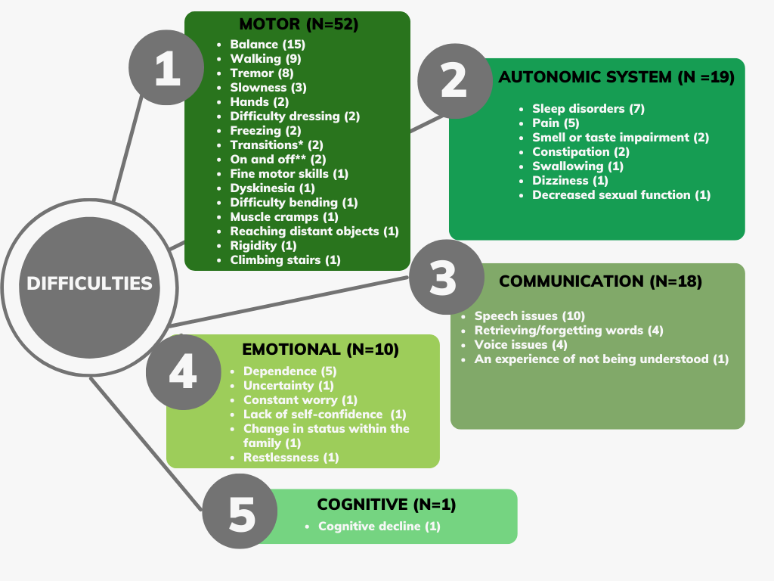

* For example, changing one's position from sitting to standing or from lying to sitting

** Changes between mobility and immobility in patients treated with levodopa

**Figure 1.** The key difficulties of people living with PD, as identified by individuals with PD; We divided the difficulties into five main categories; The order in which they are listed corresponds to the number of times items from each category were brought up.

**3.1.2 Ideas for assistive technologies**

The responses of individuals with PD to the question “How can technology aid with those limitations or other limitations you have not mentioned?” fell into one of five categories(see Figure 2): mobility (N=14), reminders and organizers (N=12), help with ADL (N=10), others (N=7) and fine motor skills (N=6).

The specific ideas that came up within each category are listed in Figure 2. Within the *mobility* category, the most frequently mentioned ideas centered on assistance with bed mobility (n=5) and assistance walking outdoors (n=5).

“As the disease progresses, one avoids being outside. It is a great loss and if there were anything that could prolong the duration of the stay outside, in an environment that is not flat* [it would be helpful]” (SPD1-3)

(*the topic of walking in an environment that is not flat came up by several participants, and it appears to refer both to hilly areas as well as to uneven surfaces).

Within the *reminders and organizers* category, ideas that came up a relatively large number of times either focused on technology to keep the users organized in terms of activities in their daily routine, including their medication schedule, or on devices to help maintain good posture and avoid tremor.

*“When I’m tired at home, I ... drag my feet so as not to fall, and then I remember I can walk [properly] ... I would like something to help me with that – perhaps a device which will remind me to straighten my back [while I walk]” (SPD2-3)*

Within the *help with ADL* category, ideas that came up most frequently were technology that could help them with housework (n=3) and technology that would help users put on their socks and shoes (n=3).

Within the *communication* category, the most frequently noted idea was technology for speech practice (n=2), and within the *fine motor skills* category, the most frequently noted idea was opening a bottle with one hand (n=2).

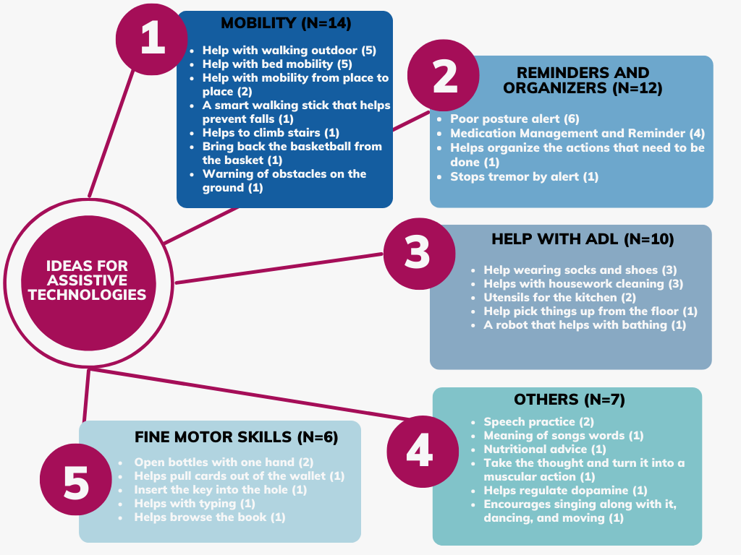

**Figure 2.** The ideas for assistive technologies for individuals with PD, as identified by individuals with PD; We divided the ideas into five main categories; The order in which they are listed corresponds to the number of times items from each category were brought up.

**3.1.3 SARs Perceived Advantages**

The responses of individuals with PD to the question “How do you think you can benefit from SARs?” fell into one of two categories: physical (N = 6) and social and cognitive assistance (N = 6).

Under the *physical assistance* category, participants noted several perceived advantages, such as the SAR’s ability to motivate exercise training (n=2): “[A] robot that does exercises for Parkinson’s... it is essential for us” (SPD2-3), for helping with cooking and cleaning (n=2), making multitasking easier (n=1) and reducing the load on the main caregivers (n=1).

Under the *social and cognitive* *assistance* category, participants noted the following perceived advantages: such as a robot’s potential ability to improve mood (n=2): “It can be incredible if such a thing can help improve my mood, [make me] laugh, rejoice, dance, and sing” (SPD2-5)

Another perceived advantage is that interactivity with the robot can encourage practice (n=1), the robot can serve as a companion (n=1), the robot can help to calm down (n=1), and practicing alone can be embarrassing; a robot solves the problem (n=1):

“I’m ashamed to practice voice exercises ... I practice sports well; if it’s physically related, I have no problem. Interacting with a robot-like a voice teacher can solve the problem.” (SPD1-8)

**3.1.4 Suggestions regarding SAR design, operation, and interactive functionality**

Individuals with PD noted the important features that technology for PD should include. We divided the suggestions into two categories : design and operation (N = 8) and trust and interaction (N = 7).

Suggestions with the *design and operation* category included ensuring that the device is simple to operate (n=3), has small dimensions (n=1), makes use of music and dance (n=1), encourages sport exercise (n=1), uses sound and/or voice prompts (e.g., to help with walking; n=1), and uses adaptation for people with PD, such as large fonts (n=1):

*"The fonts you used today [for the discussion questions which were handed to participants in printed form] – you used huge letters, and I find that… very considerate; especially considering that we are loaded with medicine, I cannot read many things, even with my glasses on, I can hardly read very small letters... I think the robot [should] also [help with this aspect]" (SPD2-3)*

In the *trust and interaction* category, the importance of adapting the robot’s actions, instructions and levels of assistance to the patient's condition - including adaptation to the specific cultural context – was mentioned by five participants: *"In my opinion, robots should constantly be [adapting]… to … the patient's condition" (SPD2-4).* In addition, the interaction with the robot should provide the user with an experience of success (rather than create frustration by frequent alerts on failure to maintain good posture, for example) (n=1) and promote physical exercise by requiring users to perform exercises to use the device (e.g., doing a squat to open the fridge; n=1).

**3.1.5 Concerns Regarding the use of SARs**

We divided the concerns raised by individuals with PD into two sub-categories: design and operation (N = 12) and trust and Interaction (N = 11; see Figure 3).

Concerns that came up a relatively large number of times within the *design and operation* category were the cost of the robot (n=3), that the robot would be too large (n=3), and difficulties operating the technology (n=3): “I’m just too old, it is much easier for my grandchildren, and I do not know how easily I can use such robots at my age.” (SG1-5)

Concerns that came up a relatively large number of times within the *trust and interaction* category were the ability to trust the robot (n=3) - including trusting that it would bring the right medicine and that the battery would not run out suddenly. In addition, the concern that the robot will replace human-human communication was brought up twice: “Those robots are social, and I will lose my social skills as a result of contact only with robots and not with humans” (SPD2-1).

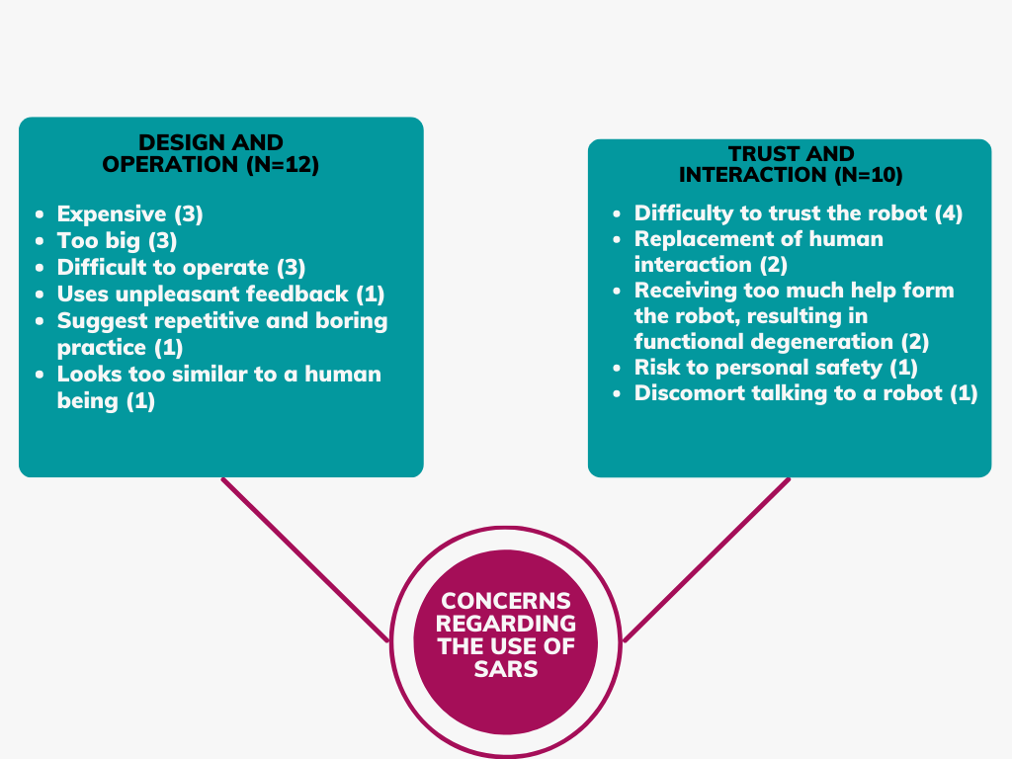

**Figure 3. Concerns regarding the use of SARs for individuals with PD, as identified by individuals with PD**. We divided the concerns into two main categories: Design and operation and Trust and interaction.

**3.1.6 Attitudes towards SARs**

Anecdotally, the group moderators noted their impression that some participants demonstrated a positive attitude toward SARs throughout the focus groups, while others showed a negative attitude throughout the session.

There was a total of 10 mentions by eight participants with a positive attitude towards SARs. This attitude is reflected in the positive reactions to the robots they saw in the video, the possible capabilities of the robots, and in reducing of dependence on others:

"I am able to do a lot of things [independently], but if indeed … technology will enable [more] independence and we would not have to be dependent on a[nother] person, then it's perfect, what can I tell you" (O1)

There were a total of nine statements by six participants that expressed a negative attitude towards SARs. This attitude was reflected in statements that suggested that resources used to develop assistive technology are wasted resources, which should instead be used to find a cure for the disease; that the robotic approach is not adapted to the local culture (specifically noted with regards to the robot Paro, shown in the short video); and the superiority of a pet over an animal-like robot.

"Will it stop the disease? I think about it, well, it's going to help me drink soup; Big deal, I will not drink soup, (that's not what) really worries me." (SPD1- 1)

Eight of the nine negative statements were made by five participants in one group (G1-S); Four of those were made by a specific participant (SPD1-3).

**3.2 Experiment 2 – Family members of individuals with PD**

A total of 22 family members (17 women, 5 men; ages 43-82 years; 68.5 ± 9.7 years [mean ± SD]) participated in Experiment 2. Twenty were spouses of individuals with PD, one was a daughter, and one was a son of individuals with PD. Their family members had been diagnosed with PD up to 25 years earlier (13.6 ± 7.0 years; range 5-18 years). Each participant took part in one of three focus-group meetings. The first (n = 8) focus-group meeting was held in person, while the second (n = 8) and third (n = 6) meetings were held online using the Zoom software due to the Omicron wave of COVID-19. As a result, participants from across the country were able to take part in the study.

The demographic information of the participants appears in Table 5. Each participant is listed using a code name, composed of the location where the meeting took place, their group affiliation (F – for family members), and two numbers (the first number is the group number, and the second is the participant number). The first meeting were held in the city of Sderot, therefore it is marked with the letters “S” (Sderot group) and the number of the meeting (1), and the second and third meetings (2/3) are marked with an “O” to denote that the meetings were held online.

|  |  |  |  |  |  |
| --- | --- | --- | --- | --- | --- |
| Age of family member with PD | Women/men | Years since the diagnosis of their family member | Age of participant | Participant | Group1- Sderot |
| 75 | W | 6 | 66 | SF1 – 1 |  |
| 70 | W | 16 | 43 | SF1 – 2 |  |
| 84 | W | 5 | 82 | SF1 – 3 |  |
| 65 | W | 6 | 52 | SF1 – 4 |  |
| 71 | W | 10 | 69 | SF1 – 5 |  |
| 70 | W | 17 | 65 | SF1 – 6 |  |
| 81 | W | 6 | 80 | SF1 – 7 |  |
| 61 | W | 12 | 65 | SF1 – 8 |  |
|  |  |  |  |  | Group2- Online |
| 72 | W | 9 | 74 | OF1- 1 |  |
| 81 | W | 12 | 77 | OF1- 2 |  |
| 75 | M | 25 | 75 | OF1- 3 |  |
| 62 | M | 22 | 69 | OF1- 4 |  |
| 67 | M | 17 | 70 | OF1- 5 |  |
| 72 | M | 25 | 69 | OF1- 6 |  |
| 81 | M | 12 | 48 | OF1- 7 |  |
| 73 | M | 5 | 70 | OF1- 8 |  |
|  |  |  |  |  | Group3-Online |
| 76 | W | 12 | 73 | OF2-1 |  |
| 70 | W | 10 | 72 | OF2-2 |  |
| 72 | W | 4 | 70 | OF2-3 |  |
| 79 | M | 4 | 73 | OF2-4 |  |
| 68 | M | 14 | 67 | OF2-5 |  |
| 74 | W | 18 | 78 | OF2-6 |  |
| 72.7 |  | 13.6 | 68.5 |  | Average |

**Table 5.** **Demographic information of Family Members**

We performed a thematic analysis of the data we collected in these three meetings; Six key themes emerged from the analysis: (1) Key difficulties of people living with PD; (2) Ideas for assistive technologies for individuals with PD; (3) Perceived advantages of SARs; (4) Suggestions regarding SAR design, operation, and interactive functionality; (5) Concerns regarding the use of SARs, and (6) Attitudes towards SARs.

We further divided each of the six main themes into sub-categories, as detailed below. In the detailed description below, ‘N’ denotes the number of items within each category, and ‘n’ denotes the number of participants who mentioned the item.

**3.2.1 Key difficulties of people living with PD**

Family members' responses to the question “Name three main restrictions/limitations that your family member with PD experiences” fell into one of five categories (see Figure 4): motor (N = 37), autonomic system (N = 14), communication (N = 11), cognitive (N = 8), and emotional (N = 7).

The specific difficulties that came up within each category are listed in Figure 4.

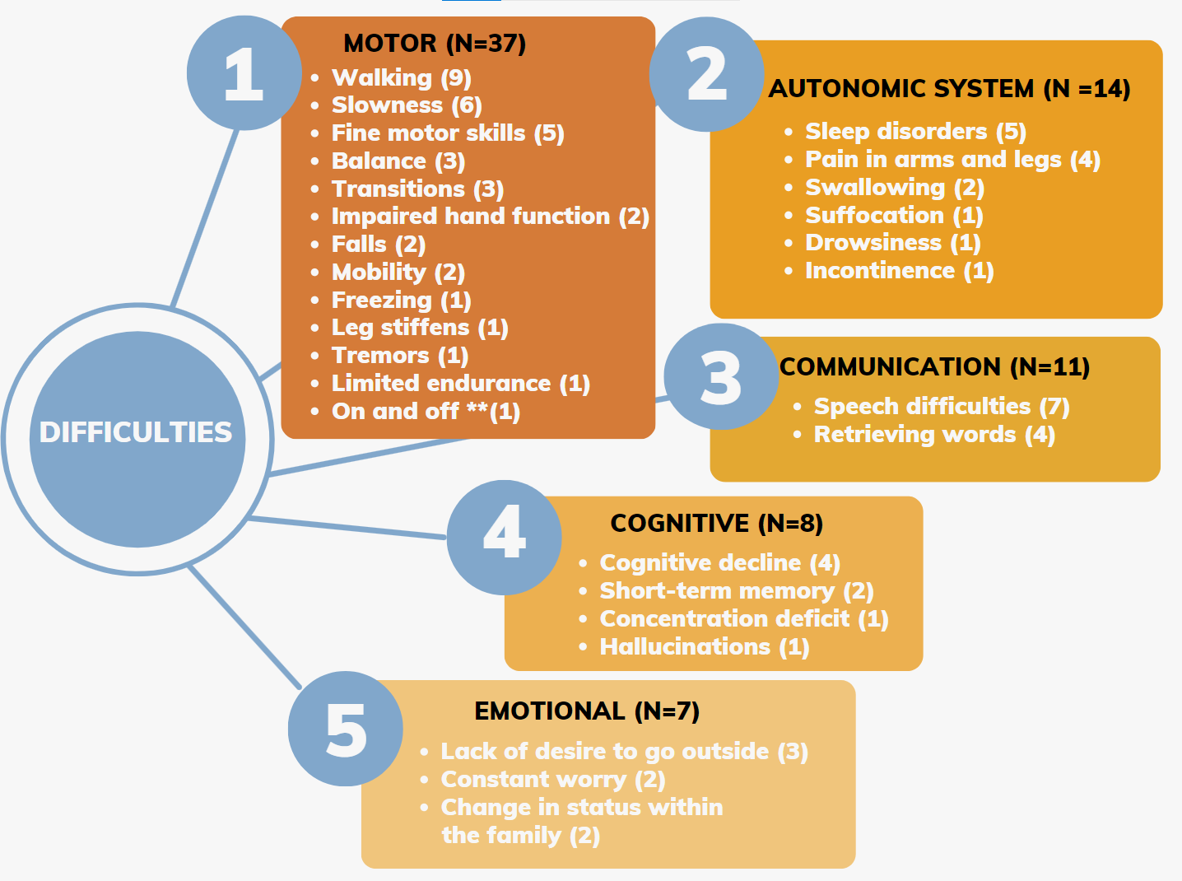

** Changes between mobility and immobility in patients treated with levodopa

**Figure 4.** The key difficulties of people living with PD, as identified by family members of individuals with PD; We divided the difficulties into five main categories; The order in which they are listed corresponds to the number of times items from each category were brought up.

**3.2.2 Ideas for assistive technologies**

Family members' responses to the question “How can technology aid with those limitations or other limitations you have not mentioned?” fell into one of five categories(see Figure 5): mobility (N=12), reminders and organizers (N=10), others (N=10), help with ADL (N=5) and fine motor skills (N=1).

The specific ideas that came up within each category are listed in Figure 5.   
Within the *mobility* category, the most frequently mentioned ideas centered on assistance with bed mobility (n=4), and help to reach distant objects (n=3).

“I think something that would be very helpful, would be a robot that would help him get in and out of bed, sit down or stand up ... That is really hard for us, even for the [paid] caregiver who tries to help him stand” (SF1-3)

Within the *reminders and organizers* category, ideas that were mentioned several times focused on technology to help with medication management and reminders (n=5), help finding objects and prompts for where things are, such as one’s keys (n=3), and technology that will collect medical data and transmits them to doctors (n=2).

*“When everything started, I opened an Excel sheet and wrote … [symptoms] with [specific] dates. I said we need to collect data… Now the Doctor says ‘do this’ [e.g., walk in a straight line] and says ‘nothing changed from the last time [I saw you]’. Can… [the doctor] really remember what … [the patient] did four months ago?" (SF1-8)*

Regarding the *others* category, ideas that were mentioned most often were a technology that could help with speech practice (n=3), a technology that would decrease the pain that individuals with PD experience (n=2) and an adaptable pacemaker for DBS (n=2).

*"Of course, if there was something like a sock that will relieve my wife's pain in her foot, that would be very helpful and would resolve a big part of the problem that she is experiencing" (OF1-4).*

*"We need something that will help [my spouse] go out of the ‘off’ state, something related to music with some sort of lights as cues, or voice instructions that would spur him out [of the ‘off’ state]” (OF2-5)*

Regarding *the help with ADL category,* ideas that came up were regarding help with dressing (n=2), help serving food and liquids (n=1), and help with bathing (n=1).

Within the *help with fine motor skills* category, there was only one mention of assistance with holding objects, to overcome hand weakness and tremor.

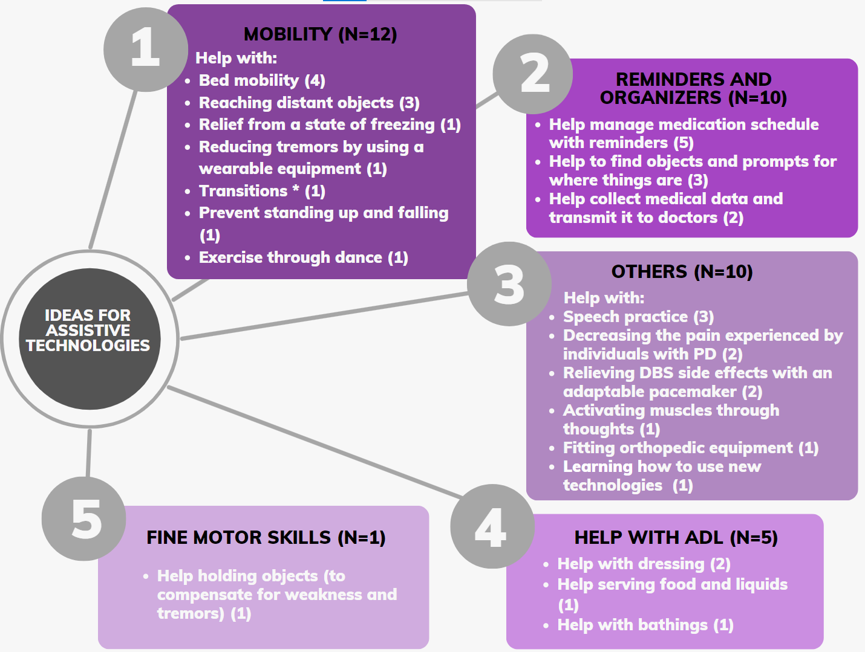

* For example, changing one's position from sitting to standing or from lying to sitting.

**Figure 5.** The ideas for assistive technologies for individuals with PD, as identified by family members; We divided the ideas into five main categories; The order in which they are listed corresponds to the number of times items from each category were brought up.

**3.2.3 SARs Perceived Advantages**

Family members' responses to the question “How do you think your family member can benefit from SARs?” fell into one of two categories: social and cognitive assistance (N=7) and physical assistance (N=6).

Under the *social and cognitive assistance* category, family members noted several perceived advantages, such as the SAR’s potential ability to: (1) train cognition in an enjoyable way (n=3); (2) assist in practicing meditation (n=2); (3) help the patient be less dependent on family members (n=1); (4) serve as a companion (n=1); and (5) serve as a point of attraction to grandchildren (who will thus visit more frequently) (n=1). After watching the video with the robots, (SF1-2) said: "*That cognitive training could be very helpful. The Tic Tac Toe [game], and matching the cups*" (Eizicovits et al, 2018; Feingold-Polak, 2021).

 Under the *physical* *assistance* category, family members noted the SAR’s potential ability to coach exercises (n=5), and to help with holding objects (n=1) as potential advantages.

**3.2.4 Suggestions regarding SAR design, operation and interactive functionality**

Family members suggested important features that technology for individuals with PD should include. We divided the suggestions into two categories: design and operation (N=8) and trust and interaction (N=3).

Suggestions for *design and operation* of the SARs included: (1) small dimensions and ease of operation (n=2) ; (2) voice activation of the robot (n=1); (3) features that encourage the user to dance with music (n=1); (4) integration of phone functionalities into the robot (n=1); (5) the robot should have added benefits compared to existing methods of telerehabilitation \ (n=1); (6) a humanoid appearance, to better engage the users (n=1); and conversely, (7) a non-humanoid appearance, as a human-like appearance would be disagreeable (n=1).

"*I don’t have space in my house for big robots” )OF2-3(  
" I'm not sure that a sedentary robot, [just] because it's a robot, has an advantage over something like … remote rehabilitation. Except for the fact that it's very nice to pet this dog and it's cute [referring to PARO]. But I’m not sure that this [referring to embodiment]is the part that makes the important difference”* *(OF2-1)*

In the *trust and interaction* category, family members mentioned that a robot should adapt itself to each patient (n=2) and that it should motivate movement through interaction with the patient (n=1).

**3.2.5 Concerns Regarding the use of SARs**

We divided the concerns raised by family members into two sub-categories: Trust and Interaction (N = 14) and design and operation (N = 12) (see Figure 6).

Concerns in the *trust and interaction* sub-category were: (1) Degeneration of abilities due to the robot's over-assistance (n=7). (2) Difficulty to trust the robot (n=4). (3) Replacement of human-human relations due to the intervention of the robot (n=2). (4). Misunderstanding of speech due to the inability of the robot to comprehend individuals with PD (n=1)

Concerns in the *design and operation* sub-category were (1) Inability to contact technical support (n=3). (2) Unpleasant similarity of the robot to a human being (n=2). (3) Unpleasant ("metallic") voice of the robots (4) Inability to operate the robot (n=1).

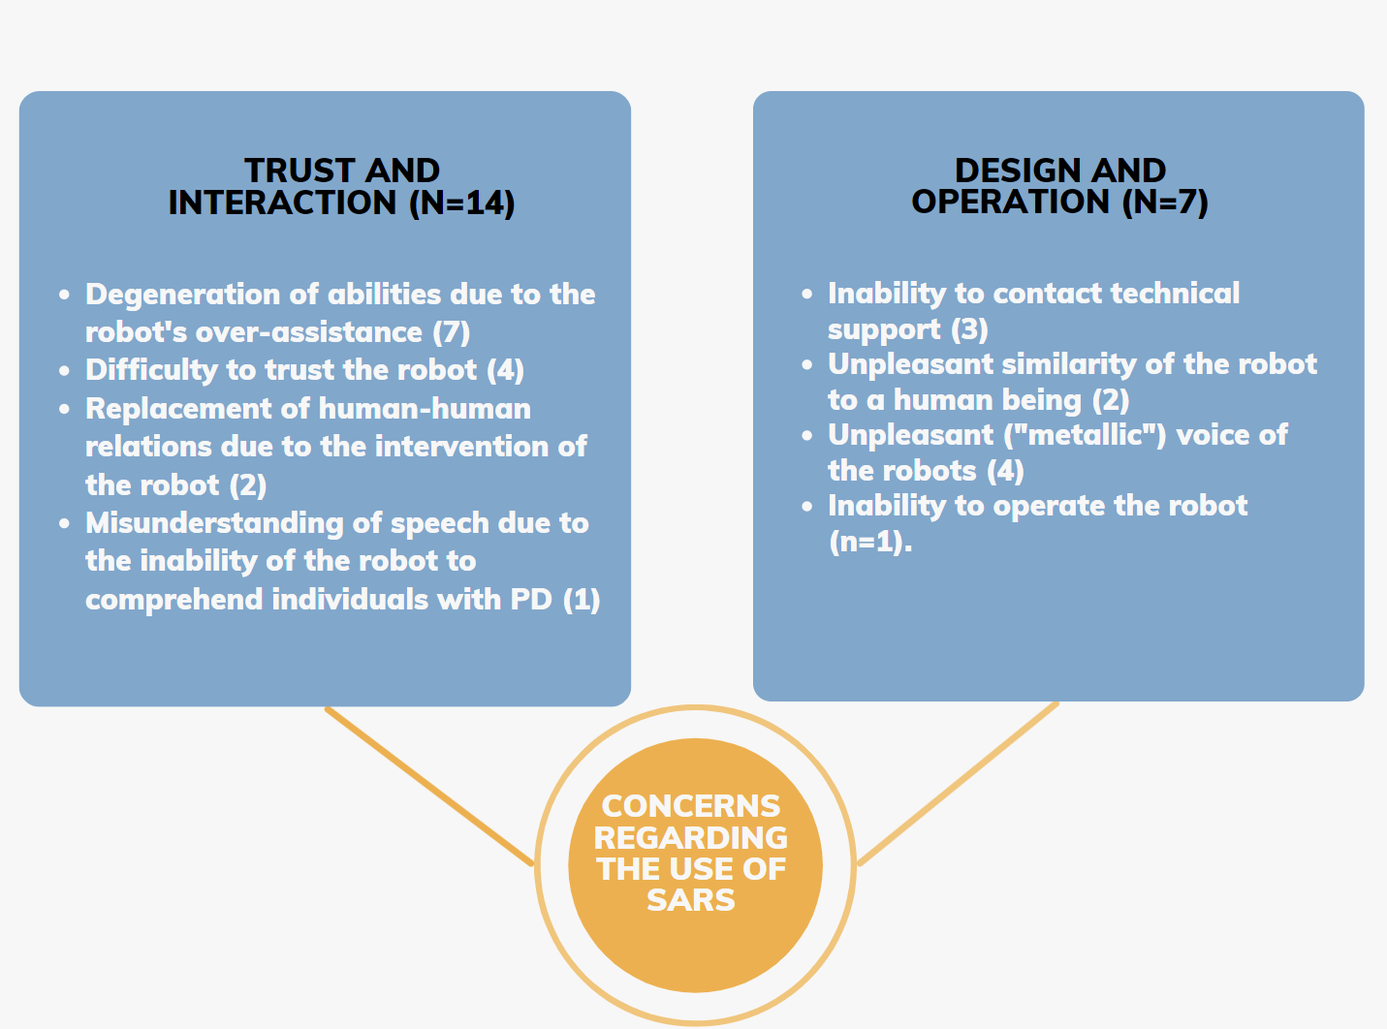

**Figure 6**. Concerns regarding the use of SARs for individuals with PD, as identified by family members. We divided the concerns into two main categories: Design and operation and Trust and interaction.

**3.2.6 Attitudes towards SARs**

There was a total of five utterances by five participants which expressed a positive attitude towards SARs.

"This total dependence that makes you ask for everything, including the newspaper, or things like that, is simply dispiriting, I think. If one can reach the objects that they want [with the assistance of the robot] – if it is the TV remote, or the newspaper, it doesn’t matter what – that would really improve [their situation]" (OF1-7)

There was a total of five statements by five participants that expressed a negative attitude toward SARs. This attitude was reflected, for example, by stating that real pets are better than the PARO baby-seal robot (shown in the video participants saw) (n=3), and that robots will never be able to replace humans and the unique interaction between them (n=2).

Table 6 summarizes the main similarities and differences that came up in the two population groups of Experiments 1 and 2.

**Similarities and differences between the points of view of individuals with PD and family members**

|  |  |  |  |
| --- | --- | --- | --- |
| Individuals with PD | | Family members | |
| **Medication-management technology (reminding and dispensing) would be helpful** | | |
| A robot that can improve mood and help to calm down would be helpful | A robot that can help improve cognitive skills would be helpful | |
| **The robot should be easy to operate, have small dimensions, and keep adapting its function to the disease stage of the individual, and their specific needs** | | |
| Technology could be beneficial to alleviate difficulties with ADL and fine motor skills | Technology could be beneficial to decrease pain or as adaptable pacemaker for the DBS | |
| **A robot that over-assists may compromise the user’s autonomy, potentially leading to functional degeneration; Interaction with a robot may replace human-human interaction** | | |
| Aspects of *Design and Operation* (e.g., cost and dimensions of the robot) are a primary concern | Aspects of *Trust and Interaction* (e.g., the inability of the robot to recognize the speech of individuals with PD) are a primary concern | |
| **Real pet animals are more beneficial as companions than a pet-like robot (e.g., PARO)** | | |

**Table 6. Similarities and differences between the points of view of individuals with PD and family members.** Bolded sentences reflect findings that were similar between the two population groups; unbolded sentences reflect findings that differed between the groups.

1. **Discussion**

We collected information from a total of 46 participants: 24 individuals with PD and 22 family members of individuals with PD, to better understand their needs, their perspective on technology and SARs, and specifically the use of SARs by individuals with PD. Additionally, to identify points of similarity and differences between individuals with PD and family members.

To the best of our knowledge, this is the first study that explored the potential interaction between SARs and the PD population through focus groups with individuals with PD and family members of individuals with PD.

The present research is a complementary study to a previous investigation done with PD clinicians (Bar-On et al., 2022).

**Similarities and differences across the two population groups**

When examining the results across the two population groups, it is apparent that there were serval of overlap agreement and disagreement between them. Broadly speaking, concerns about technology, including technical and operational issues, as well as the concern that robots will replace human interaction, were shared by both groups. There were specific needs from technology which differed across groups (e.g., the wish for mobility aids outside the home, expressed almost exclusively by PD), as well as specific difficulties (e.g., cognitive decline mentioned almost exclusively by family members).

*Similarities*

*Difficulties & Ideas for assistive technology*

In both population groups, when the participants were asked to raise difficulties of individuals living with PD, difficulties related to the motor aspect were most frequently mentioned. Motor difficulties accounted for 52% of all difficulties that were raised by individuals with PD and 44% in family members. The motor difficulties in Parkinson's are a significant component of the disease (Aarsland et al., 2021; Lee & Koh, 2015), and this is indeed reflected in the reported subjective experience of our research participants as they emphasize motor difficulties above all other difficulties.  
Among the motor difficulties, difficulty in walking was raised as significantly important and was mentioned by 18 participants from both population groups (combined). Walking is an essential aspect of independence in everyday activities (Jones et al. 2008), which likely explains why walking-related issues were frequently brought up in group discussions by both individuals with PD and by family members.

After asking the participants to indicate the difficulties, we asked them to suggest ideas for assistive technology that could assist them with those difficulties or with other difficulties. As in the *difficulties* theme, in the *ideas for assistive technology* theme, the category of ideas intended to help with *mobility* was the most prominent among both populations. An interesting point that was repeated among both population groups was the fact that some participants mentioned some difficulties, but almost no technological solutions were offered to overcome them. For example, a total of 11 participants from both populations mentioned sleep disorders, but no technological solution has been suggested. In another example, nine participants from both population groups raised pain-related issues, corresponding to existing literature on PD (Buhmann et al., 2020; Mostofi et al., 2021), while only two participants (both from the family members group) proposed a technological solution to this issue. Participants possibly did not believe that technology could solve these difficulties and therefore did not propose technological solutions for these problems.

*Concerns*

Over 50% of the concerns raised by individuals with PD and their family members overlapped between the two groups. Several concerns raised in this study were also mentioned by clinicians treating individuals with PD (Bar-On et al., 2022).

Specifically, there were three main concerns that were most frequently raised by both populations; They concerned the preservation of patient autonomy, the smooth operation of the technology, and the impact of technology on human-human interactions. We detail these below.

1. **Autonomy**. The concern that the robot will "help too much" causing functional deterioration (n=9). This result is consistent with a previous study which found that PD clinicians expressed concern that robot assistance may lead to degeneration by providing over-assistance (Bar-On et al., 2022). It has been demonstrated by several studies that a lack of use of muscles results in a loss of motor units and a loss of function (Coletti et al., 2022; Mosole et al., 2016) and that a lack of use of cognitive abilities results in cognitive decline (Mistridis et al., 2017). These studies may explain why this concern has been widely raised across different populations.
2. **Operation**. The operational concern regarding technology and technical support (n=7). This concern was also mentioned in other studies, in which clinicians indicated that a robot for rehabilitation should be easy to operate (Feingold Polak et al., 2022).
3. **Effect on human-human interactions**. The concern that robots will replace human interaction (n=4). Other studies have raised similar concerns as to the potential effects of robots in roles previously performed by humans (Randall et al, 2019).

The significant overlap of the concerns between the two population groups in this study, along with the overlap with the group of clinicians treating individuals with PD, emphasizes the prevalence of these concerns among the various relevant stakeholders, and the importance of taking them into account in the development of assistive technologies in general, and SARs in particular.

*Attitudes towards SARs & SARs for companionship*Interspersed within the group discussions, participants made comments that exposed their general attitudes toward SARs. Overall, among both populations, there was a positive attitude towards the robots, as was demonstrated, inter alia, by comments made when the robots were viewed via video, such as "cute" or "cool”.

Nonetheless, a negative attitude was observed in both population groups regarding the use of SARs for companionship, which was demonstrated by the seal-like robot PARO (Geva et al., 2022) in the 2-min video shown to participants, which covered a variety of social robots. The overall perception of PARO as a companion robot was negative, with two participants in each population group expressing the sentiment that a real house pet is better than a robotic one (and others agreeing). According to Shibata et al., (2012), there are cultural differences associated with the acceptance of PARO as a pet; There are thus at least two potential explanations for why participants in our study rejected the use of a robot as a pet/companion: (1) most participants in our study were members in a PD support network; and (2) a cultural-based approach to the use of a robot as a pet/companion may have played a role in their expressed preferences. These specific considerations per population group (including the type of condition they live with, their social network and their cultural context) highlight the importance of understanding who the specific end users are, and personalizing the technology to them when developing assistive technology (Feingold Polak & Levy-Tzedek, 2021).

Consistent with participants' attitudes toward PARO vs. pets, when asked to indicate the expected benefits of SARs, the use of social robots for companionship has been suggested by only one participant from each population group (i.e., by two participants in total). This relatively low level of interest differs from that found in a study by Bradwell., (2021), where SARs were accepted by stakeholders (older adults, family members and staff members) as companions for older adults living in long-term facilities. This difference may stem from the fact that older adults living in long-term facilities are more prone to be lonely than individuals living in the community (Prieto-Flores et al, 2011). Most of the participants in our study live at home with their spouses, and thus a robotic companion is not needed. We previously reported that clinicians treating individuals with PD thought that SARs could be helpful as companions for individuals with PD, but individuals with PD and their family members disagreed (Bar-On et al., 2022); It may reflect the fact that the clinicians see a wider population sample, which may better represent the overall PD population, and may also include people who experience loneliness, whereas the other two groups (individuals with PD and family members) are part of the Parkinson's Association (a national support network), so they may not experience a lack in social connections. It should also be noted that some of the clinicians in (Bar-On et al., 2022) expressed their concern that using a robot as a companion may eventually lead to increased loneliness and reclusion. Initial investigations into this realm of using robots as companions with older adults with depression produced surprising results: In some cases, having a companion robot increased the frequency of human-human interactions (which started around the robot; Randall et al., 2019). We posit that the question of the utility of a robot as a companion should be explored per context, together with its effect on the users’ human-human interactions (Langer & Levy-Tzedek, 2021).

Alongside with the similarities noted above, several differences also came up between the groups.

*Differences*

*difficulties & ideas for assistive technology*

When the participants were asked about the difficulties of individuals living with PD, difficulties related to the cognitive aspect differed between the two population groups. While only one participant with PD mentioned a cognitive difficulty, eight family members mentioned cognitive difficulties such as cognitive decline and short-term memory problems. This phenomenon could be explained by the fact that individuals living with PD may not be aware of the cognitive impairment as the disorder advances (Orfei et al, 2018).

After asking participants to indicate their difficulties, we asked them to outline ideas for assistive technology that could help them overcome these difficulties or other difficulties. While there were many similarities between the two population groups, we identified two key differences, relating to posture and fine-motor skills:

1. **Posture-alert technology** was only mentioned by individuals with PD (n=6). It could be expected that this issue would also arise among family members, since they are the ones who can see this as observers from the side. It thus appears that for individuals with PD, poor posture is perceived as affecting their self-image. A similar relationship has been reported between poor posture and self-perception in previous research (Briñol et al., 2009).
2. Six individuals with PD suggested devices that would help with **fine-motor actions**, such as opening bottles and pulling out cards from a wallet; this was mentioned by only one person in the family-members groups. Several solutions are, in fact, available on the commercial market that address issues related to fine motor skills (e.g., “GYENNO SPOON®” designed to help eat, despite the tremors). Even so, it is possible that these solutions are not widely available or not fully address the needs of individuals with PD, which may explain why such technology is still in demand by individuals with PD.

It is instructive to examine the relationship between the difficulties and the technological solutions that participants brought up: Mobility was the largest category under the *difficulties* and the *ideas for assistive technology* themes, brought up by both population groups; However, the proposed solutions for this category differed between the groups: while family members focused on assistance with home-based mobility, individuals with PD also proposed solutions for outdoor mobility. A potential explanation for this difference is that the individuals with PD focus more on what they *lost* or *miss* in their everyday life, and search for solutions to address these issues – such as engaging in outdoor activities, while the family members focus more on where individuals with PD *need* their assistance as caregivers, which may occur primarily within the home environment.

The significant overlap between the perspectives of the two population groups emphasizes the importance of understanding any differences when they arise. One way to explain the differences that emerged between the groups is to identify the prisms through which the two population groups seem to have identified difficulties and potential solutions.

***Prism***

It appears that the individuals with PD used the prism of independence (lost and desired), while the family members used the prism of burden (physical and emotional) in their everyday dealings with the effects of the disease. These two prisms are closely related, but not identical.

Independence

Indeed, when asked to indicate difficulties, five participants with PD listed lack of independence as one of their difficulties, while none of the family members did. There are also some indirect examples: the PD individuals (n=6) discussed several technological solutions for everyday tasks, such as an assistive device for pulling the credit card from their wallet or for inserting a key in the door, whereas such solutions were only mentioned once by a family member. It is possible that individuals with PD focus more on small, day-to-day needs, which can help them be more independent. It may even be embarrassing to ask for assistance with such small things, so they are interested in assistive technology for these things.

This difference between the two prisms is also demonstrated in the fact that family members offered technological solutions primarily for mobility inside the home, while individuals with PD provided many additional solutions for mobility outside the home as well. Individuals with PD may experience the loss of the ability to independently spend time outside, and thus emphasized mobility outside more than family members did. There are also anecdotes that illustrate similar concept, such as a suggestion provided by one of the individuals with PD for a device that would help returning basketball from the basket, while playing basketball. This proposal may imply that he focuses on his independence, and on what he lacks. The examples above illustrate that individuals with PD tend the focus on their independence and the abilities they have lost or missed.

Burden

It is interesting to note that while the family members did not directly address their burden (with one exception), they did address it indirectly in several different instances. For example, there were 37 mentions of motor difficulties, and 12 mentions of the need for assistive technology for motor difficulties, which may be an indirect expression of burden. Another indirect indication of the burden can be seen in the fact that the family members mentioned cognitive difficulties eight times, compared to only one person with PD. Cognitive decline causes an increase in the burden of the caregiver (Gonzalez-Latapi et al., 2021), which may explain why the family members mentioned it more frequently. Only one family member mentioned assistance with fine motor skills for people with PD, compared to six mentions by individuals with PD; it is possible that these actions are simple, and therefore do not significantly increase the burden of the family member, compared to other tasks, thus explaining why family members did not mention them more frequently.

In a previous focus-group study, clinicians treating individuals with PD stressed that the burden experienced by the main caregiver is vast (Bar-On et al., 2022). And yet, burden was expressed in the current study only indirectly. There may be several reasons as to why the family members did not raise the burden issue directly: it may be because (1) the family members felt uncomfortable expressing their need for assistance in reducing their burden; (2) they did not believe that technology can help reduce their burden; (3) we did not explicitly ask them about their difficulties vis-à-vis the disease, but rather focused on the difficulties experienced by the individuals with PD. Indeed, when asked about it directly in the Bar-On et al., (2022) study, most family members agreed with a statement that robots would help reduce the burden on informal caregivers. Importantly, it was the researchers' uniform impression that the family members were deeply empathetic to the situation of the individuals with PD, and any mention of burden – be it direct or indirect – does not reflect a focus on themselves rather than on their family members.

Together, these two lenses – of independence vs. burden – provide an explanation for the differences that were observed between the groups, as well as a better understanding of what is fundamentally important to each of the groups. In this way, we will be able to develop a more complete picture of the needs, which will include all stakeholders. For this reason, we believe that it is essential to consider both perspectives when developing technology to assist individuals with PD.

**Study limitations**

The use of qualitative methods such as focus groups and open-ended questions allowed participants to share their views and personal thoughts; This approach provided us with insights into the potential benefits of interactions between SARs and the PD population.

At the same time, the current study has several limitations. All our participants were members of the Parkinson's Association, which acts as a support network for individuals with PD and their family members; This may have affected the results in several ways: the familiarity among participants may have helped people share their thoughts freely, or conversely, it may have made it uncomfortable to disagree with each other. Furthermore, the specific views expressed in this study (e.g., rejecting the use of robots as companions) may be related to the fact that the participants are part of a support network.

Additionally, there were cases where an individual brought up a point that was generally agreed upon by all (or most) members of the group, but as they expressed their agreement using – for example – head nodding, this was not captured in the transcriptions, which were used to count the number of occurrences of each topic. The level of agreement among group members may therefore be higher than captured in the transcripts.

1. **References**

Aarsland, D., Batzu, L., Halliday, G. M., Geurtsen, G. J., Ballard, C., Ray Chaudhuri, K., & Weintraub, D. (2021). Parkinson disease-associated cognitive impairment. *Nature Reviews Disease Primers*, *7*(1), 47. https://doi.org/10.1038/s41572-021-00280-3

Assad-Uz-Zaman, M., Rasedul Islam, M., Miah, S., & Rahman, M. H. (2019). NAO robot for cooperative rehabilitation training. *Journal of Rehabilitation and Assistive Technologies Engineering*, *6*, 205566831986215. https://doi.org/10.1177/2055668319862151

Bar-On, I., Mayo, G., & Levy-Tzedek, S. (2022). Socially Assistive Robots for Parkinson’s Disease: Needs, Attitudes and Specific Applications as Identified by Healthcare Professionals. *ACM Transactions on Human-Robot Interaction*. https://doi.org/10.1145/3570168

Blauwendraat, C., Iwaki, H., Makarious, M. B., Bandres‐Ciga, S., Leonard, H. L., Grenn, F. P., Lake, J., Krohn, L., Tan, M., Kim, J. J., Gibbs, J. R., Hernandez, D. G., Ruskey, J. A., Pihlstrøm, L., Toft, M., van Hilten, J. J., Marinus, J., Schulte, C., Brockmann, K., … Singleton, A. B. (2021). Investigation of Autosomal Genetic Sex Differences in Parkinson’s Disease. *Annals of Neurology*, *90*(1), 35–42. https://doi.org/10.1002/ana.26090

Bloem, B. R., Okun, M. S., & Klein, C. (2021). Parkinson’s disease. *The Lancet*, *397*(10291), 2284–2303. https://doi.org/10.1016/S0140-6736(21)00218-X

Briggs, P., Scheutz, M., & Tickle-Degnen, L. (2015). Are Robots Ready for Administering Health Status Surveys’: First Results from an HRI Study with Subjects with Parkinson’s Disease. *Proceedings of the Tenth Annual ACM/IEEE International Conference on Human-Robot Interaction*, 327–334. https://doi.org/10.1145/2696454.2696476

Briñol, P., Petty, R. E., & Wagner, B. (2009). Body posture effects on self-evaluation: A self-validation approach. *European Journal of Social Psychology*, *39*(6), 1053–1064. https://doi.org/10.1002/ejsp.607

Buhmann, C., Kassubek, J., & Jost, W. H. (2020). Management of Pain in Parkinson’s Disease. *Journal of Parkinson’s Disease*, *10*(s1), S37–S48. https://doi.org/10.3233/JPD-202069

Céspedes, N., Irfan, B., Senft, E., Cifuentes, C. A., Gutierrez, L. F., Rincon-Roncancio, M., Belpaeme, T., & Múnera, M. (2021). A Socially Assistive Robot for Long-Term Cardiac Rehabilitation in the Real World. *Frontiers in Neurorobotics*, *15*, 633248. https://doi.org/10.3389/fnbot.2021.633248

Cohavi, O., & Levy-Tzedek, S. (2022). Young and old users prefer immersive virtual reality over a social robot for short-term cognitive training. *International Journal of Human-Computer Studies*, *161*, 102775. https://doi.org/10.1016/j.ijhcs.2022.102775

Coletti, C., Acosta, G. F., Keslacy, S., & Coletti, D. (2022). Exercise-mediated reinnervation of skeletal muscle in elderly people: An update. *European Journal of Translational Myology*, *32*(1). https://doi.org/10.4081/ejtm.2022.10416

Dembovski, A., Amitai, Y., & Levy-Tzedek, S. (2022). A Socially Assistive Robot for Stroke Patients: Acceptance, Needs, and Concerns of Patients and Informal Caregivers. *Frontiers in Rehabilitation Sciences*, *2*, 793233. https://doi.org/10.3389/fresc.2021.793233

Dexter, D. T., & Jenner, P. (2013). Parkinson disease: From pathology to molecular disease mechanisms. *Free Radical Biology and Medicine*, *62*, 132–144. https://doi.org/10.1016/j.freeradbiomed.2013.01.018

Dhivya, V., & Balachandar, V. (2017). Cell replacement therapy is the remedial solution for treating Parkinson’s disease. *Stem Cell Investigation*, *4*, 59. https://doi.org/10.21037/sci.2017.06.08

Dorsey, E. R., Constantinescu, R., Thompson, J. P., Biglan, K. M., Holloway, R. G., Kieburtz, K., Marshall, F. J., Ravina, B. M., Schifitto, G., Siderowf, A., & Tanner, C. M. (2007). Projected number of people with Parkinson disease in the most populous nations, 2005 through 2030. *Neurology*, *68*(5), 384–386. https://doi.org/10.1212/01.wnl.0000247740.47667.03

Dorsey, E. R., Elbaz, A., Nichols, E., Abbasi, N., Abd-Allah, F., Abdelalim, A., Adsuar, J. C., Ansha, M. G., Brayne, C., Choi, J.-Y. J., Collado-Mateo, D., Dahodwala, N., Do, H. P., Edessa, D., Endres, M., Fereshtehnejad, S.-M., Foreman, K. J., Gankpe, F. G., Gupta, R., … Murray, C. J. L. (2018). Global, regional, and national burden of Parkinson’s disease, 1990–2016: A systematic analysis for the Global Burden of Disease Study 2016. *The Lancet Neurology*, *17*(11), 939–953. https://doi.org/10.1016/S1474-4422(18)30295-3

Eizicovits, D., Edan, Y., Tabak, I., & Levy-Tzedek, S. (n.d.). Robotic gaming prototype for upper limb exercise: Effects of age and embodiment on user preferences and movement. *Restorative Neurology and Neuroscience*, *36*(2), 261–274. https://doi.org/10.3233/RNN-170802

Eizicovits, D., Edan, Y., Tabak, I., & Levy-Tzedek, S. (2018). Robotic gaming prototype for upper limb exercise: Effects of age and embodiment on user preferences and movement. *Restorative Neurology and Neuroscience*, *36*(2), 261–274. https://doi.org/10.3233/RNN-170802

Elbaz, A., Carcaillon, L., Kab, S., & Moisan, F. (2016). Epidemiology of Parkinson’s disease. *Revue Neurologique*, *172*(1), 14–26. https://doi.org/10.1016/j.neurol.2015.09.012

Elliott, S. J., & Velde, B. P. (2006). Integration of Occupation for Individuals Affected by Parkinson’s Disease. *Physical & Occupational Therapy In Geriatrics*, *24*(1), 61–80. https://doi.org/10.1080/J148v24n01_04

*Elliq.com*. (n.d.). https://elliq.com/

Espay, A. J., Bonato, P., Nahab, F. B., Maetzler, W., Dean, J. M., Klucken, J., Eskofier, B. M., Merola, A., Horak, F., Lang, A. E., Reilmann, R., Giuffrida, J., Nieuwboer, A., Horne, M., Little, M. A., Litvan, I., Simuni, T., Dorsey, E. R., Burack, M. A., … Technology, on behalf of the M. D. S. T. F. on. (2016). Technology in Parkinson’s disease: Challenges and opportunities. *Movement Disorders*, *31*(9), 1272–1282. https://doi.org/10.1002/mds.26642

Fahn, S. (2003). Description of Parkinson’s Disease as a Clinical Syndrome. *Annals of the New York Academy of Sciences*, *991*(1), 1–14. https://doi.org/10.1111/j.1749-6632.2003.tb07458.x

Feingold-Polak, R., Barzel, O., & Levy-Tzedek, S. (2021). A robot goes to rehab: A novel gamified system for long-term stroke rehabilitation using a socially assistive robot—methodology and usability testing. *Journal of NeuroEngineering and Rehabilitation*, *18*(1), 122. https://doi.org/10.1186/s12984-021-00915-2

Feingold-Polak, R., & Levy-Tzedek, S. (2021). Personalized Human Robot Interaction in the Unique Context of Rehabilitation. *Adjunct Proceedings of the 29th ACM Conference on User Modeling, Adaptation and Personalization*, 126–127. https://doi.org/10.1145/3450614.3463415

Foster, E. R., & Hershey, T. (2011). Everyday Executive Function is Associated with Activity Participation in Parkinson Disease without Dementia. *OTJR: Occupation, Participation and Health*, *31*(1_suppl), S16–S22. https://doi.org/10.3928/15394492-20101108-04

Gale, N. K., Heath, G., Cameron, E., Rashid, S., & Redwood, S. (2013). Using the framework method for the analysis of qualitative data in multi-disciplinary health research. *BMC Medical Research Methodology*, *13*, 117. https://doi.org/10.1186/1471-2288-13-117

Geva, N., Uzefovsky, F., & Levy-Tzedek, S. (2020a). Touching the social robot PARO reduces pain perception and salivary oxytocin levels. *Scientific Reports*, *10*(1), 9814. https://doi.org/10.1038/s41598-020-66982-y

Geva, N., Uzefovsky, F., & Levy-Tzedek, S. (2020b). Touching the social robot PARO reduces pain perception and salivary oxytocin levels. *Scientific Reports*, *10*(1), 9814. https://doi.org/10.1038/s41598-020-66982-y

Gill, P., Stewart, K., Treasure, E., & Chadwick, B. (2008a). Methods of data collection in qualitative research: Interviews and focus groups. *British Dental Journal*, *204*(6), 291–295. https://doi.org/10.1038/bdj.2008.192

Gill, P., Stewart, K., Treasure, E., & Chadwick, B. (2008b). Methods of data collection in qualitative research: Interviews and focus groups. *British Dental Journal*, *204*(6), Article 6. https://doi.org/10.1038/bdj.2008.192

Gonzalez-Latapi, P., Bayram, E., Litvan, I., & Marras, C. (2021). Cognitive Impairment in Parkinson’s Disease: Epidemiology, Clinical Profile, Protective and Risk Factors. *Behavioral Sciences (Basel, Switzerland)*, *11*(5), 74. https://doi.org/10.3390/bs11050074

Grün, D., Pieri, V., Vaillant, M., & Diederich, N. J. (2016). Contributory Factors to Caregiver Burden in Parkinson Disease. *Journal of the American Medical Directors Association*, *17*(7), 626–632. https://doi.org/10.1016/j.jamda.2016.03.004

Halliday, M., Mill, D., Johnson, J., & Lee, K. (2021). Let’s talk virtual! Online focus group facilitation for the modern researcher. *Research in Social and Administrative Pharmacy*, *17*(12), 2145–2150. https://doi.org/10.1016/j.sapharm.2021.02.003

Hollis, V., Openshaw, S., & Goble, R. (2002). Conducting Focus Groups: Purpose and Practicalities. *British Journal of Occupational Therapy*, *65*(1), 2–8. https://doi.org/10.1177/030802260206500102

Jankovic, J. (2008). Parkinson’s disease: Clinical features and diagnosis. *Journal of Neurology, Neurosurgery & Psychiatry*, *79*(4), 368–376. https://doi.org/10.1136/jnnp.2007.131045

Karlstedt, M., Fereshtehnejad, S.-M., Aarsland, D., & Lökk, J. (2020). Mediating effect of mutuality on caregiver burden in Parkinson’s disease partners. *Aging & Mental Health*, *24*(9), 1421–1428. https://doi.org/10.1080/13607863.2019.1619165

Kashi, S., & Levy-Tzedek, S. (2018). Smooth leader or sharp follower? Playing the mirror game with a robot. *Restorative Neurology and Neuroscience*, *36*(2), 147–159. https://doi.org/10.3233/RNN-170756

Kiger, M. E., & Varpio, L. (2020). Thematic analysis of qualitative data: AMEE Guide No. 131. *Medical Teacher*, *42*(8), 846–854. https://doi.org/10.1080/0142159X.2020.1755030

Kingry, M. J., Tiedje, L. B., & Friedman, L. L. (1990). Focus groups: A research technique for nursing. *Nursing Research*, *39*(2), 124–125.

Koerts, J., König, M., Tucha, L., & Tucha, O. (2016). Working capacity of patients with Parkinson’s disease – A systematic review. *Parkinsonism & Related Disorders*, *27*, 9–24. https://doi.org/10.1016/j.parkreldis.2016.03.017

Koerts, J., Van Beilen, M., Tucha, O., Leenders, K. L., & Brouwer, W. H. (2011). Executive Functioning in Daily Life in Parkinson’s Disease: Initiative, Planning and Multi-Task Performance. *PLoS ONE*, *6*(12), e29254. https://doi.org/10.1371/journal.pone.0029254

Koutentakis, D., Pilozzi, A., & Huang, X. (2020). Designing Socially Assistive Robots for Alzheimer’s Disease and Related Dementia Patients and Their Caregivers: Where We Are and Where We Are Headed. *Healthcare*, *8*(2), Article 2. https://doi.org/10.3390/healthcare8020073

Krauss, J. K., Lipsman, N., Aziz, T., Boutet, A., Brown, P., Chang, J. W., Davidson, B., Grill, W. M., Hariz, M. I., Horn, A., Schulder, M., Mammis, A., Tass, P. A., Volkmann, J., & Lozano, A. M. (2021). Technology of deep brain stimulation: Current status and future directions. *Nature Reviews. Neurology*, *17*(2), 75–87. https://doi.org/10.1038/s41582-020-00426-z

Krol, M., Papenburg, J., & van Exel, J. (2015). Does Including Informal Care in Economic Evaluations Matter? A Systematic Review of Inclusion and Impact of Informal Care in Cost-Effectiveness Studies. *PharmacoEconomics*, *33*(2), 123–135. https://doi.org/10.1007/s40273-014-0218-y

Kubota, A., Peterson, E. I. C., Rajendren, V., Kress-Gazit, H., & Riek, L. D. (2020). JESSIE: Synthesizing Social Robot Behaviors for Personalized Neurorehabilitation and Beyond. *Proceedings of the 2020 ACM/IEEE International Conference on Human-Robot Interaction*, 121–130. https://doi.org/10.1145/3319502.3374836

Kubota, A., Pourebadi, M., Banh, S., Kim, S., & Riek, L. (2021). *Somebody That I Used to Know: The Risks of Personalizing Robots for Dementia Care* (SSRN Scholarly Paper No. 3910089). https://papers.ssrn.com/abstract=3910089

Langer, A., Feingold-Polak, R., Mueller, O., Kellmeyer, P., & Levy-Tzedek, S. (2019). Trust in socially assistive robots: Considerations for use in rehabilitation. *Neuroscience & Biobehavioral Reviews*, *104*, 231–239. https://doi.org/10.1016/j.neubiorev.2019.07.014

Lee, H. M., & Koh, S.-B. (2015). Many Faces of Parkinson’s Disease: Non-Motor Symptoms of Parkinson’s Disease. *Journal of Movement Disorders*, *8*(2), 92–97. https://doi.org/10.14802/jmd.15003

Lee, H. R., & Riek, L. D. (2018). Reframing Assistive Robots to Promote Successful Aging. *ACM Transactions on Human-Robot Interaction*, *7*(1), 1–23. https://doi.org/10.1145/3203303

Liberman-Pincu, E., van Grondelle, E. D., & Oron-Gilad, T. (2021). Designing Robots with Relationships in Mind: Suggesting Two Models of Human-socially Assistive Robot (SAR) Relationship. *Companion of the 2021 ACM/IEEE International Conference on Human-Robot Interaction*, 555–558. https://doi.org/10.1145/3434074.3447125

Louie, W.-Y. G., McColl, D., & Nejat, G. (2014). Acceptance and Attitudes Toward a Human-like Socially Assistive Robot by Older Adults. *Assistive Technology*, *26*(3), 140–150. https://doi.org/10.1080/10400435.2013.869703

Maetzler, W., Klucken, J., & Horne, M. (2016). A clinical view on the development of technology-based tools in managing Parkinson’s disease. *Movement Disorders*, *31*(9), 1263–1271. https://doi.org/10.1002/mds.26673

Martinez‐Martin, P., Macaulay, D., Jalundhwala, Y. J., Mu, F., Ohashi, E., Marshall, T., & Sail, K. (2019). The long‐term direct and indirect economic burden among Parkinson’s disease caregivers in the United States. *Movement Disorders*, *34*(2), 236–245. https://doi.org/10.1002/mds.27579

Mistridis, P., Mata, J., Neuner-Jehle, S., Annoni, J.-M., Biedermann, A., Bopp-Kistler, I., Brand, D., Brioschi Guevara, A., Decrey-Wick, H., Démonet, J.-F., Hemmeter, U., Kressig, R. W., Martin, B., Rampa, L., Savaskan, E., Stuck, A., Tschopp, P., Zekry, D., & Monsch, A. (2017). Use it or lose it! Cognitive activity as a protec-tive factor for cognitive decline associated with Alzheimer’s disease. *Swiss Medical Weekly*, *147*, w14407. https://doi.org/10.4414/smw.2017.14407

Miyake, Y. (2009). Interpersonal synchronization of body motion and the walk-mate walking support robot. *IEEE Transactions on Robotics*, *25*(3), 638–644. https://doi.org/10.1109/TRO.2009.2020350

Moisan, F., Kab, S., Mohamed, F., Canonico, M., Le Guern, M., Quintin, C., Carcaillon, L., Nicolau, J., Duport, N., Singh-Manoux, A., Boussac-Zarebska, M., & Elbaz, A. (2016). Parkinson disease male-to-female ratios increase with age: French nationwide study and meta-analysis. *Journal of Neurology, Neurosurgery & Psychiatry*, *87*(9), 952–957. https://doi.org/10.1136/jnnp-2015-312283

Morgan, D. L. (1997). *The Focus Group Guidebook*. SAGE Publications. http://ebookcentral.proquest.com/lib/bgu-ebooks/detail.action?docID=997152

Mosley, P. E., Moodie, R., & Dissanayaka, N. (2017). Caregiver Burden in Parkinson Disease: A Critical Review of Recent Literature. *Journal of Geriatric Psychiatry and Neurology*, *30*(5), 235–252. https://doi.org/10.1177/0891988717720302

Mosole, S., Carraro, U., Kern, H., Loefler, S., & Zampieri, S. (2016). Use it or Lose It: Tonic Activity of Slow Motoneurons Promotes Their Survival and Preferentially Increases Slow Fiber-Type Groupings in Muscles of Old Lifelong Recreational Sportsmen. *European Journal of Translational Myology*, *26*(4), 5972. https://doi.org/10.4081/ejtm.2016.5972

Mostofi, A., Morgante, F., Edwards, M. J., Brown, P., & Pereira, E. A. C. (2021). Pain in Parkinson’s disease and the role of the subthalamic nucleus. *Brain: A Journal of Neurology*, *144*(5), 1342–1350. https://doi.org/10.1093/brain/awab001

Pezzoli, G., & Cereda, E. (2013). Exposure to pesticides or solvents and risk of Parkinson disease. *Neurology*, *80*(22), 2035–2041. https://doi.org/10.1212/WNL.0b013e318294b3c8

Postuma, R. B., Aarsland, D., Barone, P., Burn, D. J., Hawkes, C. H., Oertel, W., & Ziemssen, T. (2012). Identifying prodromal Parkinson’s disease: Pre-Motor disorders in Parkinson’s disease. *Movement Disorders*, *27*(5), 617–626. https://doi.org/10.1002/mds.24996

Rajiah, K., Maharajan, M. K., Yeen, S. J., & Lew, S. (2017). Quality of Life and Caregivers’ Burden of Parkinson’s Disease. *Neuroepidemiology*, *48*(3–4), 131–137. https://doi.org/10.1159/000479031

Ramdhani, R. A., Khojandi, A., Shylo, O., & Kopell, B. H. (2018). Optimizing Clinical Assessments in Parkinson’s Disease Through the Use of Wearable Sensors and Data Driven Modeling. *Frontiers in Computational Neuroscience*, *12*. https://www.frontiersin.org/article/10.3389/fncom.2018.00072

Raza, C., Anjum, R., & Shakeel, N. U. A. (2019). Parkinson’s disease: Mechanisms, translational models and management strategies. *Life Sciences*, *226*, 77–90. https://doi.org/10.1016/j.lfs.2019.03.057

Rocca, W. A. (2018). The burden of Parkinson’s disease: A worldwide perspective. *The Lancet Neurology*, *17*(11), 928–929. https://doi.org/10.1016/S1474-4422(18)30355-7

Rogers, W. A., Kadylak, T., & Bayles, M. A. (2021). Maximizing the Benefits of Participatory Design for Human–Robot Interaction Research With Older Adults. *Human Factors: The Journal of the Human Factors and Ergonomics Society*, 001872082110374. https://doi.org/10.1177/00187208211037465

Tausch, A. P., & Menold, N. (2016). Methodological Aspects of Focus Groups in Health Research: Results of Qualitative Interviews With Focus Group Moderators. *Global Qualitative Nursing Research*, *3*, 2333393616630466. https://doi.org/10.1177/2333393616630466

*The Associate Laboratory of Robotics and Engineering System, Tecnic Lisboa*. (n.d.).

Tolosa, E., Garrido, A., Scholz, S. W., & Poewe, W. (2021). Challenges in the diagnosis of Parkinson’s disease. *The Lancet Neurology*, *20*(5), 385–397. https://doi.org/10.1016/S1474-4422(21)00030-2

Tong, A., Sainsbury, P., & Craig, J. (2007). Consolidated criteria for reporting qualitative research (COREQ): A 32-item checklist for interviews and focus groups. *International Journal for Quality in Health Care*, *19*(6), 349–357. https://doi.org/10.1093/intqhc/mzm042

van Teijlingen, E., & Pitchforth, E. (2006). Focus group research in family planning and reproductive health care. *Journal of Family Planning and Reproductive Health Care*, *32*(1), 30–32. https://doi.org/10.1783/147118906775275299

Watts, J., Khojandi, A., Vasudevan, R., Nahab, F. B., & Ramdhani, R. A. (2021). Improving Medication Regimen Recommendation for Parkinson’s Disease Using Sensor Technology. *Sensors*, *21*(10), Article 10. https://doi.org/10.3390/s21103553

Wilson, J. R., Lee, N. Y., Saechao, A., Tickle-Degnen, L., & Scheutz, M. (2018). Supporting Human Autonomy in a Robot-Assisted Medication Sorting Task. *International Journal of Social Robotics*, *10*(5), 621–641. https://doi.org/10.1007/s12369-017-0456-1

Wilson, J. R., Tickle-Degnen, L., & Scheutz, M. (2020). Challenges in Designing a Fully Autonomous Socially Assistive Robot for People with Parkinson’s Disease. *ACM Transactions on Human-Robot Interaction*, *9*(3), 1–31. https://doi.org/10.1145/3379179

Winkle, K., Caleb-Solly, P., Turton, A., & Bremner, P. (2020). Mutual Shaping in the Design of Socially Assistive Robots: A Case Study on Social Robots for Therapy. *International Journal of Social Robotics*, *12*(4), 847–866. https://doi.org/10.1007/s12369-019-00536-9

Wong, S. L., Gilmour, H., & Ramage-Morin, P. L. (2014). Parkinson’s disease: Prevalence, diagnosis and impact. *Health Reports*, *25*(11), 7.

Wu, Y.-H., Fassert, C., & Rigaud, A.-S. (2012). Designing robots for the elderly: Appearance issue and beyond. *Archives of Gerontology and Geriatrics*, *54*(1), 121–126. https://doi.org/10.1016/j.archger.2011.02.003

Yarnall, A., Rochester, L., & Burn, D. J. (2011). The interplay of cholinergic function, attention, and falls in Parkinson’s disease. *Movement Disorders*, *26*(14), 2496–2503. https://doi.org/10.1002/mds.23932

Zuschnegg, J., Paletta, L., Fellner, M., Steiner, J., Pansy-Resch, S., Jos, A., Koini, M., Prodromou, D., Halfens, R. J. G., Lohrmann, C., & Schüssler, S. (2021). Humanoid socially assistive robots in dementia care: A qualitative study about expectations of caregivers and dementia trainers. *Aging & Mental Health*, 1–11. https://doi.org/10.1080/13607863.2021.1913476