applets and paper & pencil tasks as resources for working with mathematical representations
Odelya Tzayada and Michal Tabach
Tel-Aviv University, Israel

Integrating applets into mathematics lessons is still a challenge for elementary school teachers. The current study aimed to evaluate to what extent applets chosen by the teachers functioned as resources, as compared to paper & pencil resources in mathematics lessons. In this study 42 teachers used, for the first time, applet activities in their lesson as well as paper & pencil tasks. The analysis was focused on two mathematical aspects: the mathematical content and the required competence when engaging with representations. The findings show that teachers tended to prefer the applet activity over the paper & pencil task regarding representations. Furthermore, teachers preferred activities that deal with moving from the concrete to the abstract and not the opposite, regardless of the resource type.

introduction AND Theoretical BACKGROUND
Visual representations can be classified into static or dynamic representations. In school, static representations include pictures in books, drawings, or sketches. Dynamic representations are presented in digital environments. Representations in digital environments were regarded as dynamic only when the user can interact with the objects on the screen (Moyer-Packenham & Bolyard, 2016). The user can manipulate the object on the screen in ways similar to manipulating concrete manipulatives. The user can slide, flip, and turn by the computer interface almost as if it were concrete 3D. Moyer, Bolyard & Spikell (2002) emphasize that the added value of these dynamic representations lies in their affordance to the user to make meaning based on his actions. The virtual manipulative environments enable users to engage in an activity in a way that helps them to discover and construct mathematical principles and relationships (ibid). Calder & Campbell (2016) adds that visual and dynamic elements of digital technologies change the way knowledge and understanding occur in learning.
Computer technologies have become powerful educational tools, leading many countries and individuals to turn them into solutions for educational needs (Meziane, et al.,1999). A wide variety of educational applets are available today over the internet (Kay, 2018). Many of them have been designed purposefully for Education.
Mathematics teachers need to address resources in their lessons in two manners. Resources can be viewed beyond material objects and can incorporate human and cultural aspects in terms of their use. In addition, teachers need to shift their focus from 'what' the resources are to 'how' they function in the classroom (Adler, 2000). Previous studies have examined how applets functioned as resources in different mathematical contents, such as whole numbers (Loong, 2014), fractions (Reimer & Moyer, 2005), data and statistics (Suh, 2010‏), or geometry (Ng, Shi & Ting, 2020). Other studies asked to estimate applets' use in relation to the mathematics competencies described in the curriculum, such as solving word problems (Lantz-Andersson et al., 2009) or high-order thinking tasks (Lingefjard & Ghosh, 2022).
Two aspects concerning the teaching of mathematics in elementary school are discussed in the Israeli curriculum: The first describes the mathematical content that should be taught; The second explains the required competences and the learning opportunities that should be provided for students (INMPSC, 2006). The use of the applets and paper & pencil tasks as teaching resources is in the heart of this study. Hance, the study focuses on these two aspects.

REASERCH QUESTIONS
In the context of elementary school teachers enacting for the first time a lesson in which they choose an applet and a paper & pencil task to implement in their class, we ask:
1) What connections may be found with respect to the mathematical content between the applet activity and the paper & pencil task?
2) To what extent the applet activity and the paper & pencil task provide opportunity to learn related to the representation competence?

METODOLOGY
42 elementary school teachers participated in a professional development program, aimed at embedding mathematical applets in their teaching sequences. For all the teachers it was the first time to integrate applets into the teaching sequence.
Two complementary tools were used for data collection. (1) Written assignment submitted by each teacher. The teachers were asked to plan a lesson that use a mathematical applet along with paper & pencil task, to enact the lesson in their class and write a report about the implementation and a personal reflection. (2) During the professional development meetings, each teacher provided a short oral report on her experience in class, which was video recorded.
Data analysis
As mentioned above, the applet and the paper & pencil task were the mathematical resources that were used in the lessons. These resources and their mathematical role were examined in relation to their contents, and their required competence. Each lesson was classified into one of four general mathematical content area: whole numbers, fractions, data and statistics, or geometry. To determine whether the mathematical goals of these resources implemented in the same lesson were similar, the specific mathematical content of the applet was compared to that of the paper & pencil task.
For example, the following applet and paper & pencil task were identified as similar, as the two resources dealt with whole numbers, including place value (3rd grade). The activity in the applet was "How many balls (presented visually and dynamically on the screen) are on the surface?"; and in the paper & pencil task "Suggest different ways to decompose the number 853. (Use a variety of ways that are beyond the decimal decomposing)". The following resources were identified as different. The activity in the applet was "which part of the birds (presented on the screen standing on a wire) is green? Write as fraction" dealt with Fraction as a part of quantity, operations in fractions (4th grade); while the paper & pencil task was: "Write a verbal story suitable for the exercise $\frac{2}{3}*6$", which dealt with Multiplying a whole number by a simple fraction (6th grade, or 5th in case that used multiplying as repeated addition).
Whenever representations supported the competence of transition from the concrete to the abstract or vice versa, the resource was classified according to the way it was utilized, and the direction of the transition, as shown in table 1.

The required competence | Description | An example of applet activity | An example of paper & pencil task
Transition from concrete to abstract | The resource - directs to convert visual (and dynamic) representations into abstractions | 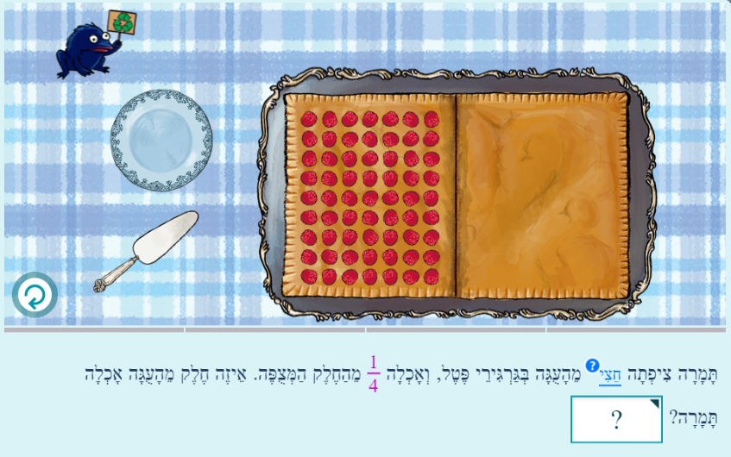*Tom covered half the cake with raspberries and ate 1/4 of it. What part of the cake did Tom eat? | 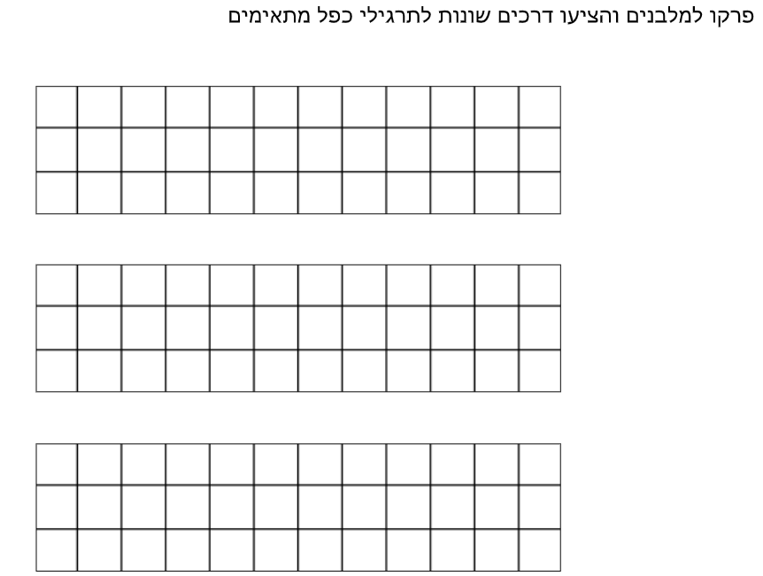  Suggest different ways to calculate the area, based on dividing the rectangles to sub area.
Transition from abstract to concrete | The resource -directs to convert abstractions into visual (and dynamic) representations. | 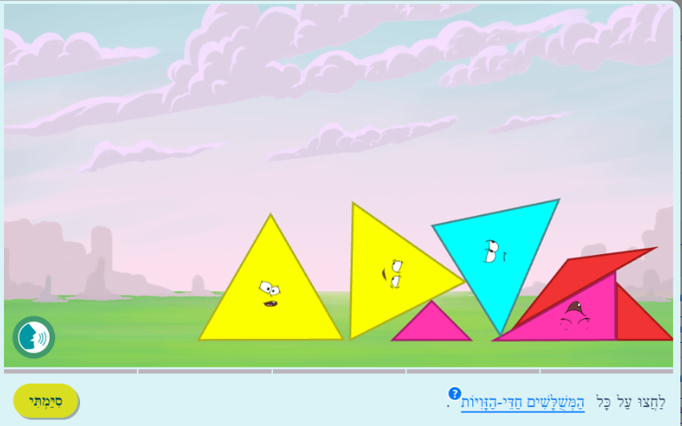 *Press on all the acute triangles. | On 5 identical rectangles, I will ask the students to draw $\frac{1}{4}$ different ways.
Table 1: The required competence regarding representations and its reflection in the resource.
Not all visual elements can be considered mathematical representations. When the visual element was aimed to motivate the user (Ben-Haim, Cohen & Tabach, 2019), it was not considered as mathematical representation. Also, in some cases a quantitative representation may express a change in the level of abstraction, but not a change between the concrete and the abstract. The analysis did not include such cases.

FINDINGS
A distribution of the 42 lessons according to two aspects: The mathematical content and the required competence regarding representations form the basis for answering the two research questions (Table 2).
The mathematical content of the activities |  | The required competence regarding representations
Specific | General | The applet activity |  | The paper & pencil task
 |  | From concrete to abstract | From abstract to concrete | From concrete to abstract | From abstract to concrete
Similar (32) | Whole numbers (14)* | 7 | 1 | 3 | 2
 | Fractions (9) | 5 | 2 | 1 | 2
 | Data and statistics (2) | 2 | -- | 1 | --
 | Geometry (7) | 4 | 3 | 4 | 1
Different (10) | Whole numbers (3) | 1 | -- | -- | --
 | Fractions (7) | 5 | 2 | 1 | 2
 | Data and statistics | -- | -- | -- | --
 | Geometry | -- | -- | -- | --
Total (42) |  | 24 | 8 | 10 | 7
Table 2: The mathematical content and the required competence in the resources.
*The numbers in brackets refer to the distribution of 42 lessons according to the mathematical content (specific /general). In addition, the numbers in the row(s) do not add up to 14. This is because the required competence could be reflected during the same lesson in more than one way and through more than one resource. Alternatively, in some lessons, it may not appear at all.

Research question 1: What connections may be found with respect to the mathematical content between the applet activity and the paper & pencil task?
This question was addressed by examining the matching between the specific mathematics contents of the two resources; and by examining the distributing the 42 lessons into 4 general categories.
As Table 2 show, in 32 lessons both resources referred to the same specific mathematical content. That is, for most teachers the choice of applet from the database was accurate in relation to the mathematical content of other resources in the lesson. This choice might be possible with the aid of the applets classification system, which allowed teachers to identify suitable applets according to learning goals. The teachers could see beyond the interactive elements (visual and dynamic) of the applets, despite the richness of the computerized environment.
When classifying all lessons into 4 general mathematical content area, most of them dealt with whole numbers (17 lessons) and fractions (16 lessons). Small number of lessons dealt with geometry (7 lessons) and only 2 dealt with data and statistics. Contrary to expectations, geometry, whose visualization is an integral part of learning, was not prioritized when using applets. To make sense of these findings, in elementary mathematics curriculum, there is a ratio of 1:6 between geometry lessons and all mathematics lessons. We found that a similar ratio of 7:42 is maintained. We note that for the 42 participating teachers, it was the first time an applet was incorporated into the teaching sequence. Hence, it is possible that what led the teachers in choosing the applets was the representations added value. When it comes to whole numbers and fractions, the applets serve as a significant visual support to the lack of resources in class in general (concrete manipulatives or textbooks). But in geometry, the textbooks include a wealth of relevant representations.

Research question 2: To what extent the applet activity and the paper & pencil task provide opportunity to learn related to the representation competence?
This question was addressed by comparing between and within the applet and the paper & pencil task with respect to identifying the transition between the concrete and the abstract and vice versa.
Comparing the two resources, the applet activity provided a more extensive response to the required competence regarding representations compared to the paper & pencil task. In 31 lessons, the representations in the applet supported the required competence. For 30 of them, the transition was in one direction, from concrete to abstract, or from abstract to concrete. The paper & pencil task supported the required competence in only 17 lessons.
Concerning each part of the required competence separately (from concrete to abstract, or from abstract to concrete): A total of 24 teachers selected an applet that provided an opportunity to learn the transition from concrete to abstract, while only 10 paper & pencil tasks enabled this transition. It seems that the applets environment provided a visual and dynamic richness that made it ideal for activities that provide a transition from the concrete to the abstract. However, in the transition from the abstract to the concrete, the applets (8) did not prove superior to the paper & pencil task (7). These findings raise questions, particularly since the computerized environment is characterized by accuracy in drawing, which might help in moving from the abstract to the concrete. Why did the teachers prefer not to use such visually and dynamically rich environment over one that implement with paper & pencil? A possible explanation for this finding is that the teachers might not consider the accuracy of the drawing as significant. Any activity that enables the transition from the abstract to the concrete, even if not accurate, is sufficient; a different explanation might be that teachers may avoid giving their students activities that are visually and dynamically complex within the applet.
Comparing within each resource, the majority of teachers (24) prefer applets that support students' transition from the concrete to the abstract, and a minority of them prefer applets that support the transition from the abstract to the concrete (8). It is difficult to determine whether this ratio of 1:3 reflects the existing ratio of applets in the technological environment. For the paper & pencil tasks, teachers also preferred the transition from the concrete to the abstract, although the proportion was lower than in the applet. We can conclude that teachers preferred transition from the concrete to the abstract, regardless of the resource that was in use.
Examining each mathematical content separately: When using the applets for whole numbers and fractions, the teachers preferred the transition from the concrete to the abstract. For data and statistics, the applets served only the transition from concrete to abstract. This may be because this topic is deeply rooted in concrete, everyday life. In geometry, there was no difference between transition from concrete to abstract (4) or abstract to concrete (3) when using the applets. It seems that for the teachers the applet environment did not offer any significant advantages over the visual environment in the textbooks. Teachers might not attribute much mediating value to the dynamic applets over paper & pencil tasks in geometry. In the paper & pencil tasks, the most noticeable difference was in fractions and geometry. In fractions, there were more tasks involved the transition from the abstract to concrete (4) and not from the concrete to abstract (2). In geometry the activities from the concrete to abstract (4) were more than the abstract to concrete (1). It might be because the teachers tried to avoid giving their students tasks that required precise drawings.

SUMMERY AND DISCUTION
Our study examined how applet activities and paper & pencil tasks were used as resources in mathematics lessons. This was done by focusing on two mathematical aspects: the mathematical content and the required competence when engaging with representations. The two research questions guide the discussion.

Research question 1: What connections may be found with respect to the mathematical content between the applet activity and the paper & pencil task?
In this study, most teachers selected both resources so that the specific mathematical content in the applet activity was in coherence with the paper & pencil task. We assumed that this finding can be explained by the applet classification system the teachers used, which was accurate in relation to the specific mathematical content. This finding is consistent with the study by Cabezuelo (2021). The researcher sheds light on the complexity involved in designing those systems. Indeed, it appears that the design solution of applet categorization, based on the domain's conceptual system, helped locating resources in the database.
As for the general mathematical content, only a sixth of the lessons dealt with geometry. This was contrary to our expectation that the visual richness of the technological platform would encourage teachers to conduct geometry lessons incorporating applets. Our findings are in line with Polly's study (2017). He found that only 9.28% of teachers reported enriching the curriculum with additional resources in geometry, using internet resources. Hance, we may assume that curriculum contents available to teachers in the field of geometry (in textbooks, for example) are sufficient.

Research question 2: To what extent the applet activity and the paper & pencil task provide opportunity to learn related to the representation competence?
For the transition from abstract to concrete, teachers showed no preference for resource type. However, for the transition from concrete to abstract, teachers preferred applets activity over paper & pencils task. This finding may be explained based on Lee and Tan (2014). According to the researchers "virtual manipulative (is) narrowing (…) the cognitive gap between the concrete and pictorial representations" (p.108). They add, that the ultimate goal, however, is to move from pictorial to abstract representations. Given that, our study may indicate teachers' pedagogical preference of dynamic over pictorial representations to scaffold students' ability in abstraction.
Within each resource, teachers preferred activities that deal with the transition from the concrete to the abstract, regardless of the resource they used. Teachers' view, in our study, is in line with the Concrete-Pictorial-Abstract approach to mathematics teaching, that guide planning lessons that enable movement from the concrete to the abstract. According to this approach, in order to reach abstraction, one must first deal with the concrete (Lee & Tan, 2014).
Within each resource, using applets, teachers preferred the transition from the concrete to the abstract for three mathematics contents: whole numbers, fractions and data & statistics. In paper & pencil tasks, teachers preferred the transition from concrete to abstract only in geometry. Also, they preferred the transition from the abstract to the concrete only in fractions. In their study, Divrik and Pilten (2021) examined students' performance in paper & pencil tasks on fraction. They found that in two fraction tasks, one dealing with the transition from abstract to concrete and the other dealing with the transition from concrete to abstract, the students achieved similar levels of success (90% and 88% respectively). These findings do not provide sufficient explanation, and this question requires further investigation.

References
Adler, J. (2000). Conceptualising resources as a theme for teacher education. Journal of Mathematics Teacher Education, 3(3), 205-224.‏‏
Ben-Haim, E., Cohen, A., & Tabach, M. (2019). Types of graphic interface design and their role in learning via mathematical applets at the elementary school. Eleventh Congress of the European Society for Research in Mathematics Education, Utrecht University, Utrecht, Netherlands.
Cabezuelo, S. A. (2021). Development of a classification system for Mathematical Logic. Journal of Information Science, 47(2), 143-160.‏
Calder, N., & Campbell, A. (2016). Using mathematical apps with reluctant learners. Digital experiences in mathematics education, 2(1), 50-69.
Divrik, R., & Pilten, P. (2021) Analysis of the Primary School 3rd Graders' Errors on Fractional Numbers in Terms of the Unit Fraction, Symbol, and Model .‏Journal of Educational Theory and Practice Research, 7 (1), 62-73.
Israel National Mathematics Primary School Curriculum (INMPSC) (2006). Retrieved January 9 ,2023, from: https://meyda.education.gov.il/files/mazkirut_pedagogit/matematika/tochnyotlemud/mavo1.pdf
Kay, R. (2018). Creating a framework for selecting and evaluating educational apps. Proceedings of the 12th International Technology, Education and Development Conference, Valencia, Spain, 374–382.
Lantz-Andersson, A., Linderoth, J., & Saljo, R. (2009). What’s the problem? Meaning making and learning to do mathematical word problems in the context of digital tools. Instructional Science, 37(4), 325-343.‏
Lee, N. H., & Tan, B. L. J. (2014). The role of virtual manipulatives on the concrete-pictorial-abstract approach in teaching primary mathematics. Electronic Journal of Mathematics and Technology, 8(2), 102-122.‏
Lingefjard, T., & Ghosh, J. (2022). Enhancing students mathematical thinking using applets. Journal of Mathematics and Science Teacher, 2(2).‏
Loong, E. Y. K. (2014). Fostering mathematical understanding through physical and virtual manipulatives. Australian Mathematics Teacher, 70(4), 3-10.‏
Meziane, F., Onn, C. W., Labadin, J., & Harris, R. (1999). Towards a framework for developing educational software.‏ Computers & Education, 30(3/4), 237-274.‏
Moyer, P. S., Bolyard, J. J., & Spikell, M. A. (2002). What are virtual manipulatives? Teaching children mathematics, 8(6), 372-377.‏
Moyer-Packenham, P. S., & Bolyard, J. J. (2016). Revisiting the definition of a virtual manipulative. In Moyer-Packenham P. S. (Ed.) International perspectives on teaching and learning mathematics with virtual manipulatives (pp. 3-23). Springer.‏
Ng, O. L., Shi, L., & Ting, F. (2020). Exploring differences in primary students’ geometry learning outcomes in two technology-enhanced environments: dynamic geometry and 3D printing. International Journal of STEM Education, 7(1), 1-13.‏
Polly, D. (2017). Elementary school teachers’ uses of mathematics curricular resources. Journal of Curriculum Studies, 49(2), 132-148.‏
Reimer, K., & Moyer, P. S. (2005). Third-graders learn about fractions using virtual manipulatives: A classroom study. Journal of Computers in Mathematics and Science Teaching, 24(1), 5-25.‏
Suh, J. (2010). Leveraging cognitive technology tools to expand opportunities for critical thinking in elementary mathematics. Journal of Computers in Mathematics and Science Teaching, 29(3), 289-302.‏

